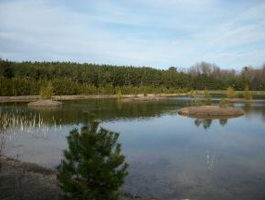
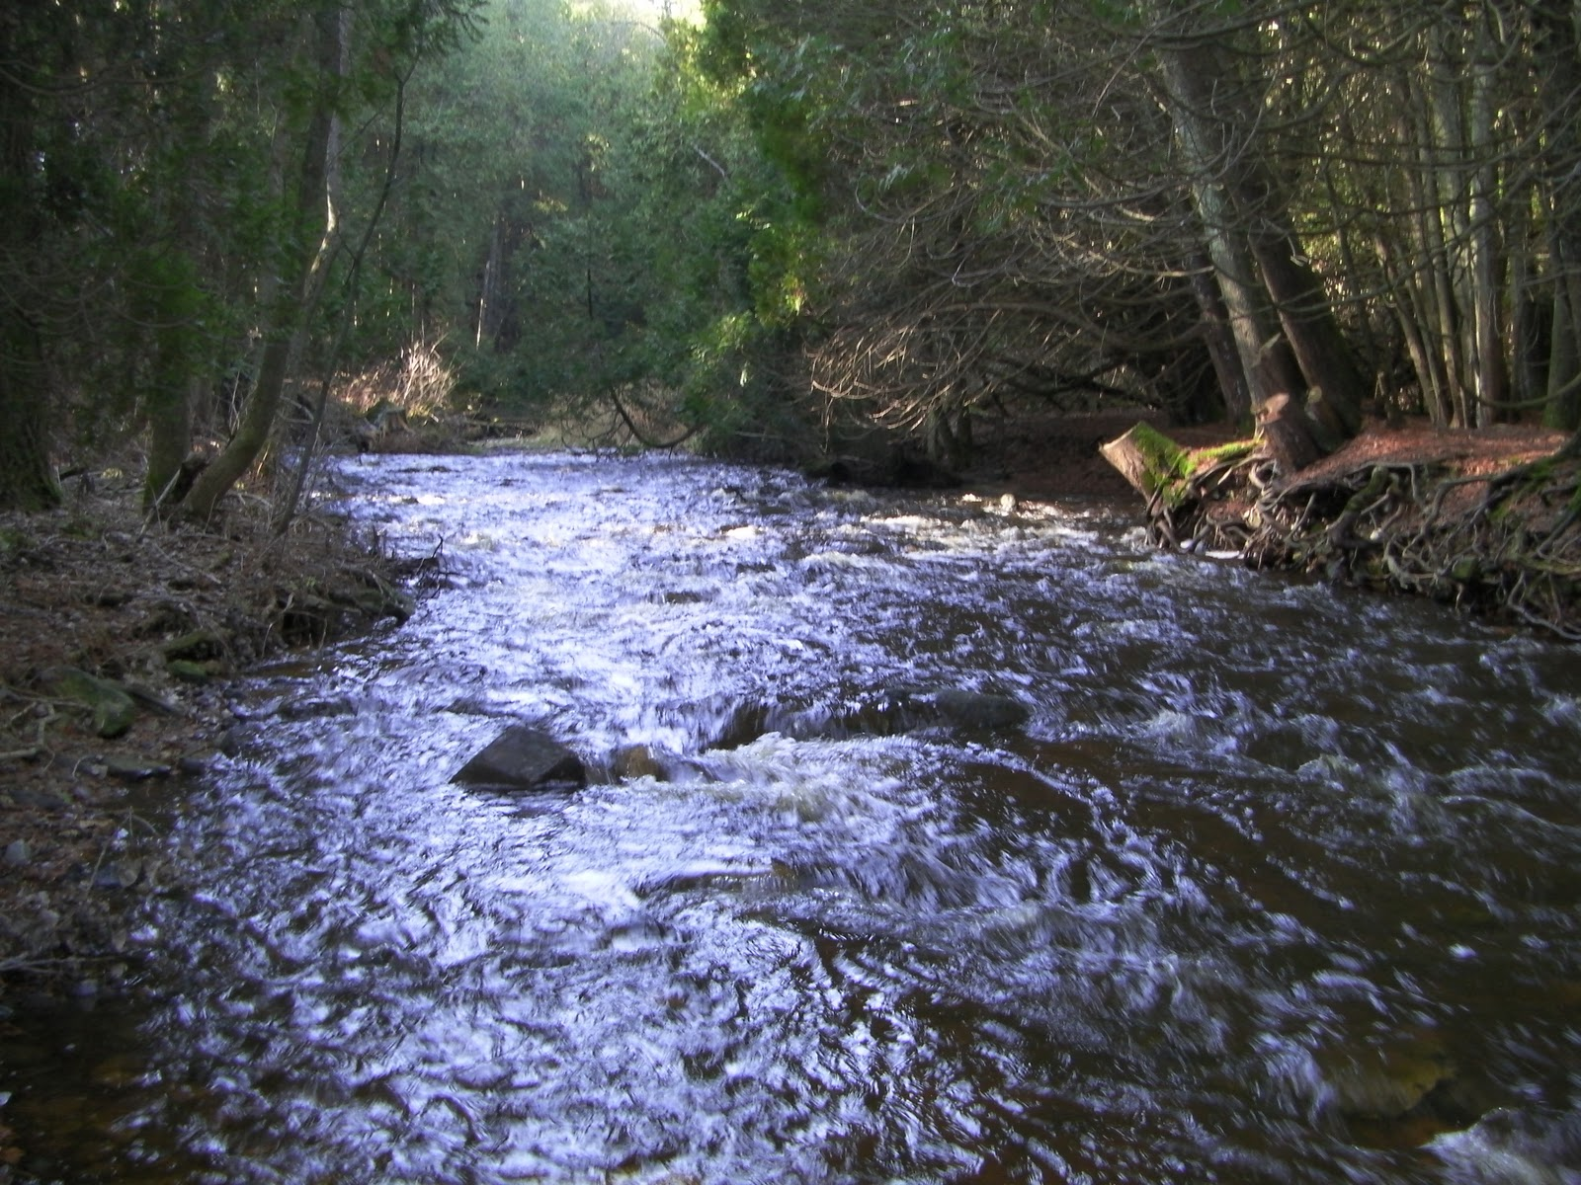

East Twin River Watershed (TK02)

[Type the abstract of the document here. The abstract is typically a short summary of the contents of the document. Type the abstract of the document here. The abstract is typically a short summary of the contents of the document.]
  - A Watershed Report created by the Bureau of Water Quality in support of the Clean Water Act.

Contents
Watershed Details 2
About the Watershed 2
Population and Land Use 2
Hydrology 2
Ecological Landscapes 3
Historical Note 3
Watershed Condition 4
Overall Condition 4
River and Stream Condition 4
Lake Health 5
Beach Health 6
Wetland Health 6
Groundwater 6
Point and Nonpoint Pollution 6
Waters of Note 7
Trout Waters 7
Outstanding and Exceptional Resource Waters 7
Impaired Waters 7
Fish Consumption 8
Aquatic Invasive Species 8
Species of Special Concern 8
State Natural and Wildlife Areas 10
Watershed Actions 13
Monitoring Projects 15
Basin/Watershed Partners 18
Priority Issues 18
Recommendations 18
Contributors 19
List of Monitored Waters in the TK02 Watershed 0
Appendices – Watershed Maps 4

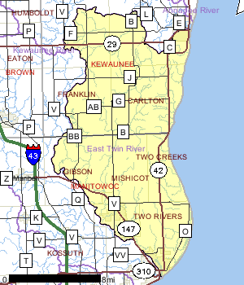
Watershed Details

About the Watershed
The East Twin River Watershed is bordered on the east by Lake Michigan in Kewaunee and Manitowoc counties and is 117,493 acres in size. The watershed contains 314 miles of streams and river, 12,446 acres of lakes and 14,181 acres of wetlands. The watershed is dominated by agriculture (75%) and wetlands (12%) and is ranked high for nonpoint source issues affecting streams, lakes and groundwater.

Streams in the East Twin Watershed flow south-eastward through southern Kewaunee County and northern Manitowoc County to the City of Two Rivers were it enters Lake Michigan. The 101,196 acre watershed is split nearly evenly between Kewaunee and Manitowoc Counties with 42,932 acres (42.5%) in Kewaunee County and 58,264 acres (57.5%) in Manitowoc County (WCD 1966 and 1968).

Population and Land Use
East Twin River is located in the East Twin River watershed which is 183.58 mi². Land use in the watershed is primarily agricultural (70.82%), wetland (15.07%) and a mix of forest (6.39%) and other uses (7.71%). This watershed has 314.70 stream miles, 12,446.75 lake acres and 14,181.41 wetland acres (2011 data).
Figure 1 Watershed Location

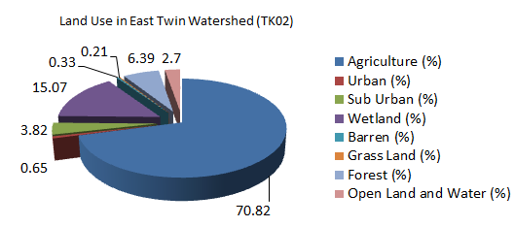
Table 1 East Twin Watershed (TK02)

Land Use Type | Percent
Agriculture (%) | 70.82
Urban (%) | 0.65
Sub Urban (%) | 3.82
Wetland (%) | 15.07
Barren (%) | 0.33
Grass Land (%) | 0.21
Forest (%) | 6.39
Open Land and Water (%) | 2.7

Hydrology
Figure 2 Watershed Location
Lake Michigan is a key ecological and socioeconomic feature. It influences the climate, created unique landforms, and is responsible in part for the presence and distribution of rare species. The shoreline constitutes a major flyway for migratory birds. Most of the major cities in this Ecological Landscape are located at the mouths of rivers entering Lake Michigan or Green Bay. Inland lakes are scarce, and all are small. The Fox River drains Lake Winnebago and runs into Green Bay. The other major rivers here run
Watershed Code | TK02
Watershed Name | East Twin River
Watershed Size (Acres) | 117493.03
Watershed Size (SQ Miles) | 183.58
24K Hydro Stream Miles | 314.7
24K Hydro Lake Acres | 12446.75
WI Wetland Inventory Acres | 14181.41
directly into Lake Michigan, and include the Ahnapee, Kewaunee, East Twin, West Twin, Manitowoc, Sheboygan, and Milwaukee.

Ecological Landscapes
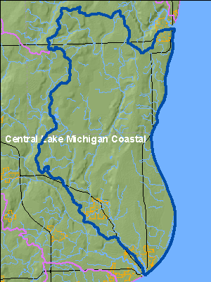
The East Twin River Watershed lies within the Central Lake Michigan Coastal Ecological Landscape which stretches from southern Door County west across Green Bay to the Wolf River drainage, then southward in a narrowing strip along the Lake Michigan shore to central Milwaukee County. Owing to the influence of Lake Michigan in the eastern part of this landscape, summers there are cooler, winters warmer, and precipitation levels greater than at locations farther inland. Dolomites and shales underlie the glacial deposits that blanket virtually all of the Central Lake Michigan Coastal Ecological Landscape. The dolomite Niagara Escarpment is the major bedrock feature, running across the entire landscape from northeast to southwest. Series of dolomite cliffs provide critical habitat for rare terrestrial snails, bats, and specialized plants. The primary glacial landforms are ground moraine, outwash, and lakeplain. The topography is generally rolling where the surface is underlain by ground moraine, variable over areas of outwash, and nearly level where lacustrine deposits are present. Important soils include clays, loams, sands, and gravels. Certain landforms, such as sand spits, clay bluffs, beach and dune complexes, and ridge and swale systems, are associated only with the shorelines of Lake Michigan and Green Bay.
Figure 3 Ecological Landscapes

Historically, most of this landscape was vegetated with mesic hardwood forest composed primarily of sugar maple, basswood, and beech. Hemlock and white pine were locally important, but hemlock was generally restricted to cool moist sites near Lake Michigan. Areas of poorly drained glacial lakeplain supported wet forests of tamarack, white cedar, black ash, red maple, and elm, while the Wolf and Embarrass Rivers flowed through extensive floodplain forests of silver maple, green ash, and swamp white oak. Emergent marshes and wet meadows were common in and adjacent to lower Green Bay, while Lake Michigan shoreline areas featured beaches, dunes, interdunal wetlands, marshes, and highly diverse ridge and swale vegetation. Small patches of prairie and oak savanna were present in the southwestern portion of this landscape

Historical Note
In 1795, French-Canadian Jacques Vieux, the first European to settle in the area, established a fur trading post northwest of present day Mishicot, in the current East Twin River watershed. The early settlers of Mishicot came from many countries, including Germany, Bohemia, Switzerland and Canada. A sawmill was erected in 1844 by Daniel Smith and Mishicot, Wisconsin was born. Daniel Smith named the village after his friend, Chief Mishicott, as a sign of his respect for the leader of the area Potawatomi community. The major component of the local economy has always been agriculture. While many dairy farms dot the countryside surrounding the village, the area's farmers produce much more, including grains, vegetables, meats, and wool. Also of note is that many of the farms in the Mishicot area have been run by the same families for more than a century.

Watershed Condition

Overall Condition
Twenty-six of one hundred seventy three streams in the watershed have been monitored in the last ten years. Of these waters, the mouth of the East Twin River is considered in “good” condition for Fish and Aquatic Life, while the upstream portions are documented as “poor”. Overall only a fraction of the waters are actually assessed, nearly 75% of stream miles “not assessed”. For lakes, approximately 40% are not assessed with the remainder assessed though a mixture of satellite data and water quality sampling. This these condition evaluations are based on assessment data updated in the integrated reporting process.

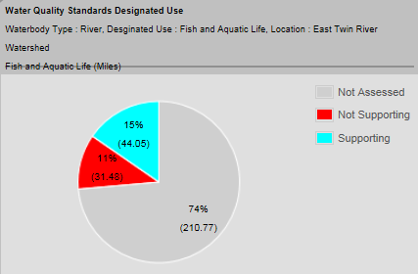
River and Stream Condition
The chart at right shows that of rivers assessed, 11% are not supporting fish and aquatic life, while 15% are supporting and the remaining 74% are not assessed. With DNR’s proclivity to monitor impaired waters or waters known to have problems, this distribution of data is skewed toward identifying the problem waters.

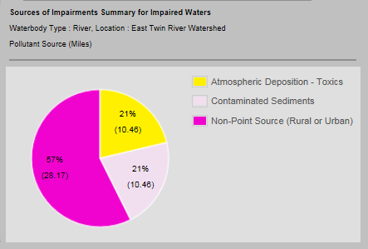
The problems encountered with the assessed waters stem from nonpoint source pollution and atmospheric deposition of toxins as well as in stream deposits of contaminated sediments. Figure at right indicates runoff problems nonpoint source pollutants are the source of 57% of the impairment problems for streams.
Figure 4 River Assessment Results

Streams in the East Twin Watershed flow southeastward through southern Kewaunee County and northern Manitowoc County to the City of Two Rivers were it enters Lake Michigan. The 101,196 acre watershed is split nearly evenly between Kewaunee and Manitowoc Counties with 42,932 acres (42.5%) in Kewaunee County and 58,264 acres (57.5%) in Manitowoc County.
Streams within the watershed range from those that are intermittent to perennial named streams. Classifications of these streams are also widely variable with multiple classifications found on some streams. Of the 98.9 stream miles in the basin, 67.9 miles have had their biological use classified. In this watershed 12.5 miles of stream are classified as trout waters, 26.9 miles are classed as warm water sport fisheries, 13.6 miles as warm water forage fisheries, 9.9 miles as limited forage fisheries and 5 miles of limited aquatic life.
Fisheries in the East Twin River Watershed (TK02)
Figure 5 River Impairment Sources
Fish surveys have been conducted infrequently on the East Twin River, but those studies have found a wide variety of gamefish which range from trout in upper reaches, to smallmouth bass and northern pike in middle reaches to Lake Michigan species in the areas nearest to the lake.
Results from surveys indicate that although Hilsenhoff (HBI) and fish IBI ratings have changed little since earlier surveys, it appears that native warm water gamefish species are nearly absent or low in abundance in many surveyed sections. The absence of gamefish from upper sections of the watershed may be due to low flow conditions or habitat loss, in middle sections due to deep pool loss and in lower sections due to low dissolved oxygen.
Brook trout populations in Tisch Mills Creek have dramatically increased since earlier surveys while those in the East Twin River remain stable and those in Krok Creek have declined. Increases are mostly likely due to improved water quality, while declines most likely are due to changes in flow patterns.
Water temperatures within the watershed are generally good as indicated by dissolved oxygen levels greater than 5 PPM and cool temperatures. However, water quality in the East Twin River below the dam in Mishicot appears to be impaired with high stream temperatures and dissolved oxygen levels below 5 PPM.
Streams within this system are well buffered and feature a variety of large-scale and small-scale habitats for aquatic organisms. Large gamefish habitat however is limited. It is recommended that resource managers use the results from fish surveys to design protection or enhancement strategies for each stream and then enact these strategies with the assistance of local partners. These strategies should use stream bank protection programs (CRP, CREP) to maximize stream bank protection.

Lake Health
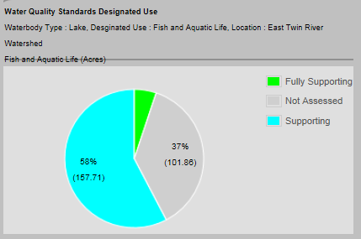
Over 12,446.75 lake acres are documented in the Watershed; of these lakes 37 percent are not yet assessed. However, many of these lakes are considered oligotrophic or mesotrophic, with good water clarity and few sources of runoff or pollutants. These waters do not count the bays, harbors or Lake Michigan, all of which are located downstream and are considered degraded or polluted. The largest portion of waters, 63% are supporting aquatic life use. Within the East Twin River watershed, there are three lakes that have 108 surface acres of water and twenty-two streams with a total of 98.9 miles of water. The three lakes, Engledinger, Heidmann and Shea are impacted by surrounding use. Elevated phosphorus levels in the lakes have resulted in the classification of mesotrophic for Heidmann Lake, with the other two lakes classified as eutrophic (WDNR 1995). Historical records indicate each lake has had winterkill problems, but none recently. The exact status of the fish community in each lake is unknown, but records indicate they are lakes with a largemouth bass-northern pike-bluegill mixture.
Figure 6 Lake Assessment Results

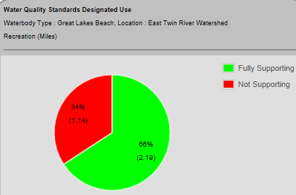
Beach Health
In this watershed, over 56% of the 3.3 miles of beach are fully supporting recreational uses; 34% of Great Lakes Beach miles listed as impaired.

Wetland Health
Based on Wisconsin’s wetlands inventory, 14,181.41 acres are located in the watershed.

Groundwater
Potential Sources of Contamination
Agricultural activities in the watershed combined with the groundwater/ surface water vulnerability associated with the karst topography is presents tremendous risk for surface and groundwater contamination.
Figure 7 Great Lakes Beach Assessments

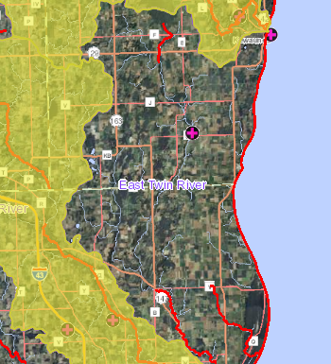
Point and Nonpoint Pollution
A runoff event in 2006 where a pump failed on a manure storage facility 1500 - 2000 gallons discharged to ground. This event occurred in Kewaunee County, T. of Montpelier. In 2005 winter applied manure from two separate fields ran off into unnamed tributaries to Lake Michigan. In addition to these discrete events, the overall vulnerability of groundwater and surface water to the predominantly agricultural land use is of concern.
Figure 8 Fish Kill Events

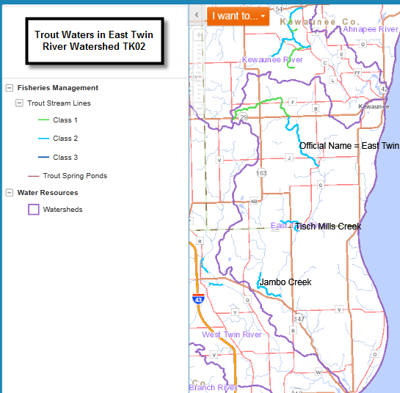
Waters of Note

Trout Waters
Class I trout streams are high quality trout waters that have sufficient natural reproduction to sustain populations of wild trout, at or near carry capacity. Consequently, streams in this category require no stocking of hatchery trout. These streams or stream sections are often small and may contain small or slow-growing trout, especially in the headwaters. Class II trout streams may have some natural reproduction, but not enough to utilize available food and space. Therefore, stocking is required to maintain a desirable sport fishery. These streams have good survival and carryover of adult trout, often producing some fish larger than average size. Class III trout streams are marginal trout habitat with no natural reproduction occurring. They require annual stocking of trout to provide trout fishing. Generally, there is no carryover of trout from one year to the next. Four segments of streams/rivers are either class I or II trout waters.
Figure 9 Trout Waters
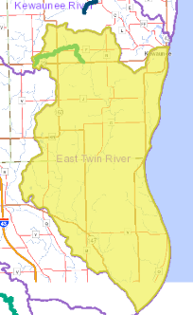
Official Name | Trout Class | Segment Start and End Mile |  | Trout Segment Length (miles)
Jambo Creek | CLASS II | 0 | 3.91 | 3.91
Tisch Mills Creek | CLASS II | 0.01 | 2.26 | 2.25
East Twin River | CLASS II | 26.4 | 34.18 | 7.78
East Twin River | CLASS I | 34.18 | 40.91 | 6.73

http://dnr.wi.gov/fish/species/trout/streamclassification.html

Outstanding and Exceptional Resource Waters
The East Twin River is listed as exceptional resource water from mile 34.18 to 49.90 for 6.73 miles.

Impaired Waters
- Krock Creek is listed as impaired due to a degraded biological community from excess total phosphorus.
- East Twin River is listed for Contaminated Fish Tissue from PCBs, Mercury.
- Molash Creek is listed for Total Phosphorus from nonpoint source pollution (runoff analysis).
- Lake Michigan Shoreline listed for PCBs, Mercury affecting Contaminated Fish Tissue and contaminated fish tissue.
Figure 10 Outstanding & Exceptional Waters

Fish Consumption
Wisconsin’s fish consumption advisory is based on the work of public health, water quality, and fisheries experts from eight Great Lakes states. Based on the best available scientific evidence, these scientists determined how much fish is safe to eat over a lifetime based on the amount of contaminants found in the fish and how those contaminants affect human health. Advisories are based on concentrations of the following contaminants along with angler habits, fishing regulations, and other factors.
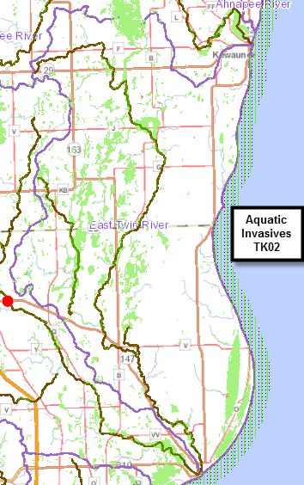
Studies indicate the people exposed to PCBs are at greater risk for a variety of health problems. Infants and children of women who have eaten a lot of contaminated fish may have lower birth weights and be delayed in physical development and learning. PCBs may affect reproductive function and the immune system and are also associated with cancer risk. Once eaten, PCBs are stored in body fat for many years. Each time you ingest PCBs the total amount of PCB in your body increases (Lowndes & Helmuth. Proposed Guidance for the Classification, Assessment, & Management of Wisconsin Surface Waters, March 12, 2007).

Aquatic Invasive Species
Aquatic invasive species in the watershed include:
- Rusty Crayfish
- Reed Canary Grass

Species of Special Concern
State’s Natural Heritage Inventory (NHI) at http://dnr.wi.gov/topic/nhi/.
The following animals and natural communities are located in the vicinity of the East Twin River Watershed (TK02).
Figure 11 Aquatic Invasives

Scientific Name | Common Name | WI  Status |  | Group
Hendersonia occulta | Cherrystone Drop | THR |  | Rare Aquatic and Terrestrial Snails
Vertigo elatior | Tapered Vertigo | SC/N |  | Rare Aquatic and Terrestrial Snails
Vertigo nylanderi | Deep-throated Vertigo | SC/N |  | Rare Aquatic and Terrestrial Snails
Strobilops affinis | Eightfold Pinecone | SC/N |  | Rare Aquatic and Terrestrial Snails
Paravitrea multidentata | Dentate Supercoil | SC/N |  | Rare Aquatic and Terrestrial Snails
Striatura exigua | Ribbed Striate | SC/N |  | Rare Aquatic and Terrestrial Snails
Vitrina angelicae | Transparent Vitrine Snail | SC/N |  | Rare Aquatic and Terrestrial Snails
Heterosternuta wickhami | A Predaceous Diving Beetle | SC/N |  | Rare Beetles
Ixobrychus exilis | Least Bittern | SC/M |  | Rare Birds
Nycticorax nycticorax | Black-crowned Night-Heron | SC/M |  | Rare Birds
Falco peregrinus | Peregrine Falcon | END |  | Rare Birds
Bartramia longicauda | Upland Sandpiper | THR |  | Rare Birds
Phalaropus tricolor | Wilson's Phalarope | SC/M |  | Rare Birds
Hydroprogne caspia | Caspian Tern | END |  | Rare Birds
Chlidonias niger | Black Tern | END |  | Rare Birds
Tyto alba | Barn Owl | SC/M |  | Rare Birds
Sturnella neglecta | Western Meadowlark | SC/M |  | Rare Birds
Xanthocephalus xanthocephalus | Yellow-headed Blackbird | SC/M |  | Rare Birds
Somatochlora hineana | Hine's Emerald | END |  | Rare Dragonflies and Damselflies
Acipenser fulvescens | Lake Sturgeon | SC/H |  | Rare Fishes
Notropis anogenus | Pugnose Shiner | THR |  | Rare Fishes
Lepomis megalotis | Longear Sunfish | THR |  | Rare Fishes
Erigenia bulbosa | Harbinger-of-spring | END |  | Rare Plants
Jeffersonia diphylla | Twinleaf | SC |  | Rare Plants
Cakile lacustris | American Sea-rocket | SC |  | Rare Plants
Chamaesyce polygonifolia | Seaside Spurge | SC |  | Rare Plants
Viola rostrata | Long-spurred Violet | SC |  | Rare Plants
Calamagrostis stricta | Slim-stem Small Reed Grass | SC |  | Rare Plants
Calamovilfa longifolia var. magna | Sand Reedgrass | THR |  | Rare Plants
Polystichum acrostichoides | Christmas Fern | SC |  | Rare Plants
Lake--deep, hard, seepage | Lake--Deep, Hard, Seepage | NA |  | Lakes
Migratory Bird Concentration Site | Migratory Bird Concentration Site | SC |  | Miscellaneous Elements
Shrub-carr | Shrub-carr | NA |  | Shrub Communities
Alder thicket | Alder Thicket | NA |  | Shrub Communities
Open bog | Open Bog | NA |  | Shrub Communities
Northern mesic forest | Northern Mesic Forest | NA |  | Upland Forests
Floodplain forest | Floodplain Forest | NA |  | Wetland Forests
Northern wet-mesic forest | Northern Wet-mesic Forest | NA |  | Wetland Forests
Northern wet forest | Northern Wet Forest | NA |  | Wetland Forests
Hardwood swamp | Hardwood Swamp | NA |  | Wetland Forests
Emergent marsh | Emergent Marsh | NA |  | Wetland Herbaceous Communities
Northern sedge meadow | Northern Sedge Meadow |  | NA | Wetland Herbaceous Communities

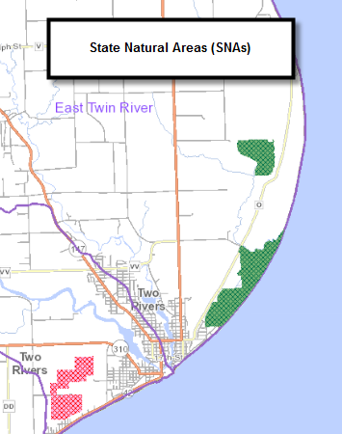
State Natural and Wildlife Areas
- Point Beach Ridges
- Nippissing Swamp
  - Flicker Site
- Two Creeks Buried Forest

Point Beach Ridges
Point Beach Ridges is a 558-acre (226 ha) topography of alternating ridges and swales in Manitowoc County, Wisconsin.^{[1]} The area is located within Point Beach State Forest.^{[2]} It was designated a Wisconsin State Natural Area in 1971 and a National Natural Landmark in 1980. Consisting of alternating ridges and swales, Point Beach Ridges was formed by previous water levels of Lake Michigan. The site exhibits a range of successional vegetation states.
Figure 12 State Natural Areas
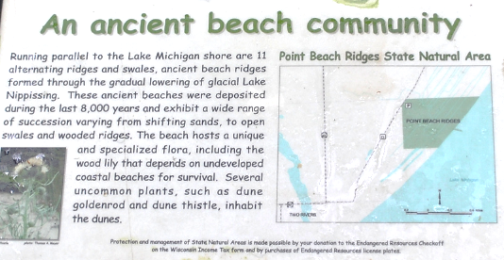

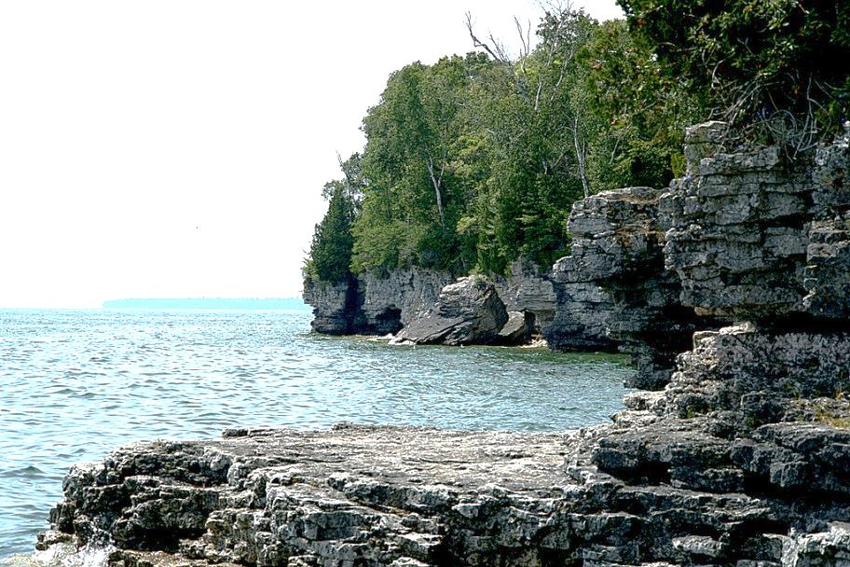
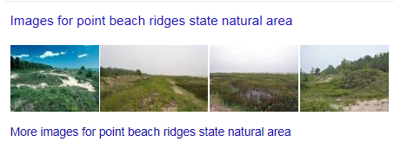
Point Beach Ridges State Natural Area
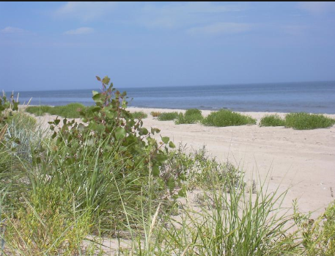
Nippissing Swamp
Despite its #24, Nipissing Swamp is actually a relatively new SNA. It is located within the boundaries of Point Beach State Forest. It is almost directly across the highway from the SNA it replaced at #24, Wilderness Ridge. I asked the DNR about why Wilderness Ridge was delisted but haven't heard back yet. (Side note: a similar thing happened with #35 which used to be Ripon Prairie and is now Muehl Springs).

Two Creeks Buried Forest
Joshua Mayer By: Joshua Mayer
Wisconsin State Natural Area #49
Figure 13 Point Beach Ridges
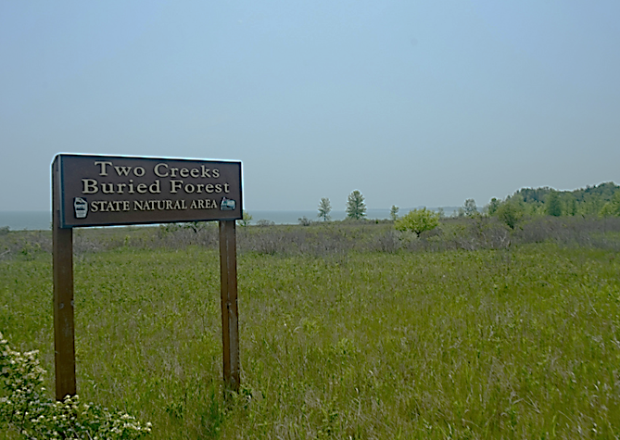
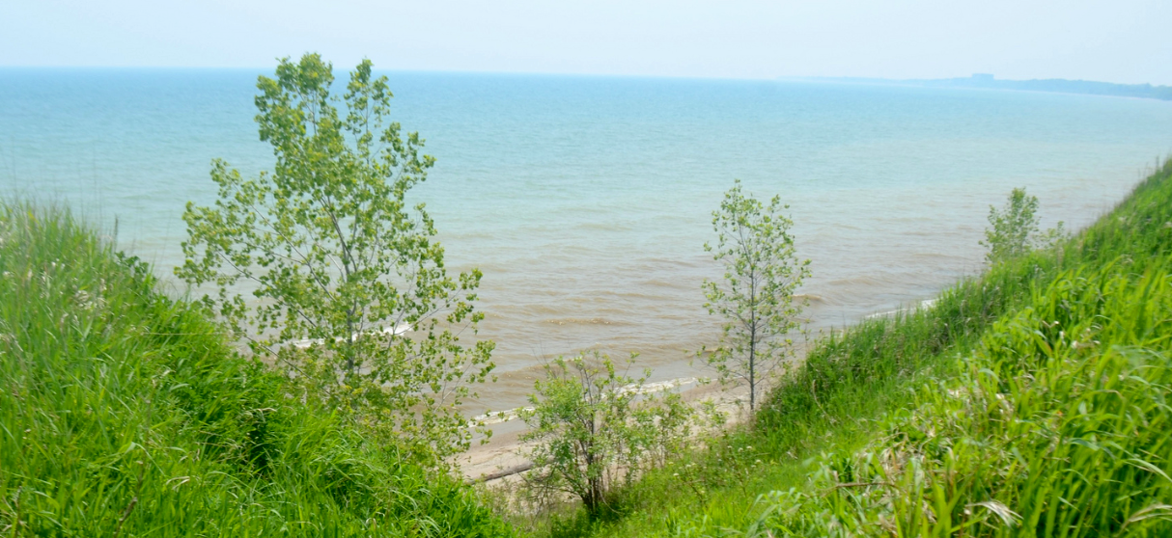
Description of the area….
Figure 14 Two Creeks Buried Forest

Watershed Actions
Click on the list of projects below to learn more about the DNR funded activities in this watershed.
Project Name  (Click for Details) | Year Awarded
Aquatic Invasives County Coordinator - Kewaunee County (proposed) | 2011
Aquatic Invasives County Coordinator - Manitowoc County | 2011
KEWAUNEE COUNTY: Dairy Manure Storage | 2011
KEWAUNEE COUNTY: Farm Manure Storage | 2011
MANITOWOC COUNTY: Manitowoc County Shoreland Zoning | 2011
GLACIERLAND RC&D, INC.: Glacierland RCD Tri-County Clean Boats Project | 2010
KEWAUNEE COUNTY: Kewaunee County Shoreland Ordinance Revision Project | 2010
MANITOWOC COUNTY LAKES ASSN: Manitowoc County AIS Educ, Prevention & Control | 2010
MANITOWOC COUNTY: Manitowoc County Shoreland Ordinance Revision Project | 2010
MANITOWOC COUNTY LAKES ASSN: Harpt's Lake Mgmt Planning Project Ph 1 | 2009
MANITOWOC COUNTY LAKES ASSN: Harpt's Lake Mgmt Planning Project Ph 2 | 2009
Waterbody use designation for the Unnamed Tributary to the East Twin River NER_03_10 | 2009
East Twin River at Paddlers Park | 2008
KEWAUNEE COUNTY: Manure Storage | 2008
KEWAUNEE COUNTY: Brothers Manure Storage | 2008
MANITOWOC COUNTY LAKES ASSN: Manitowoc County "Stop the Hitchhikers" Campaign | 2008
MANITOWOC COUNTY LAKES ASSN: Manitowoc Cty AIS Education & Planning Project | 2008
LAKESHORE NATURAL RESOURCES PARTNERSHIP INC.: Lakeshore River Partnership Initiative | 2007
MANITOWOC COUNTY: Manitowoc County "Beetle Mania" Education, Control & Research Project | 2007
WOODLAND DUNES NATURE CENTER: Twin Rivers Stewardship Organization & Development | 2006
KEWAUNEE COUNTY LCD: Wakker Farm Project | 2005
KEWAUNEE COUNTY: Hall Manure Storage System | 2005
MANITOWOC COUNTY LAKES ASSN: Manitowoc Cnty Shoreland Restoration Demonstration | 2001
KEWAUNEE COUNTY: Kewaunee County lakes Protection Ordinance Project | 1998
MANITOWOC COUNTY: Manitowoc County-wide Lake Evaluation & Class Study | 1998
MANITOWOC COUNTY: Manitowoc County Lake Watershed Management Planning | 1996

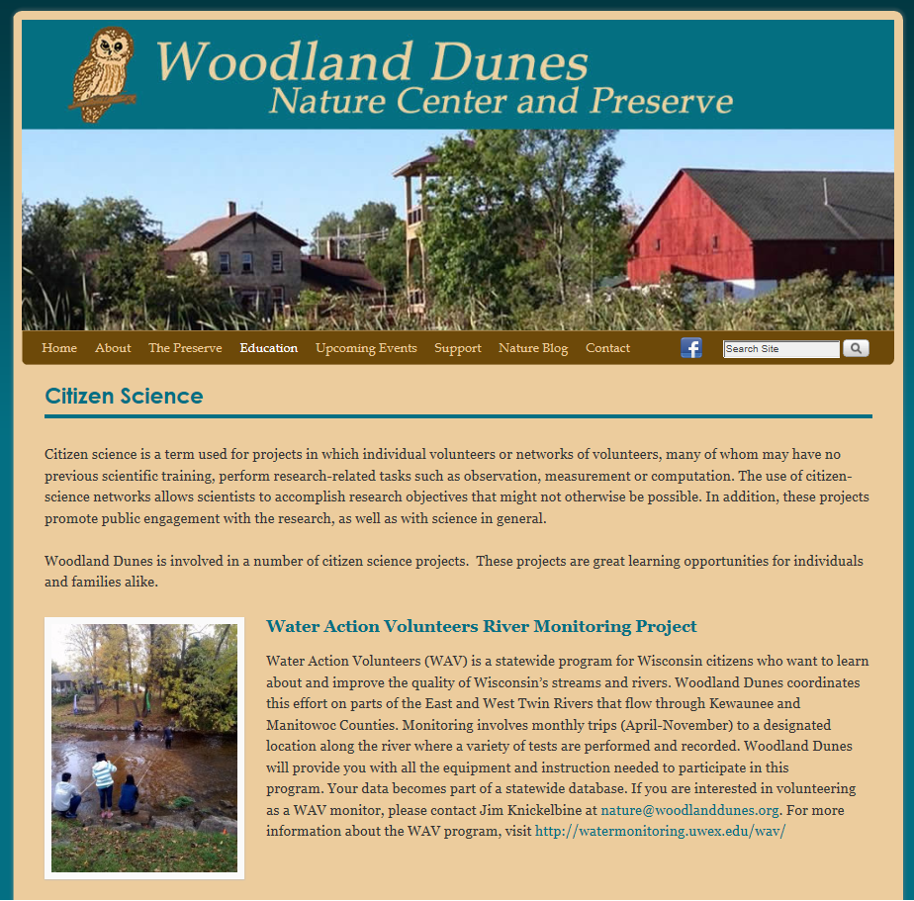
Project Spotlight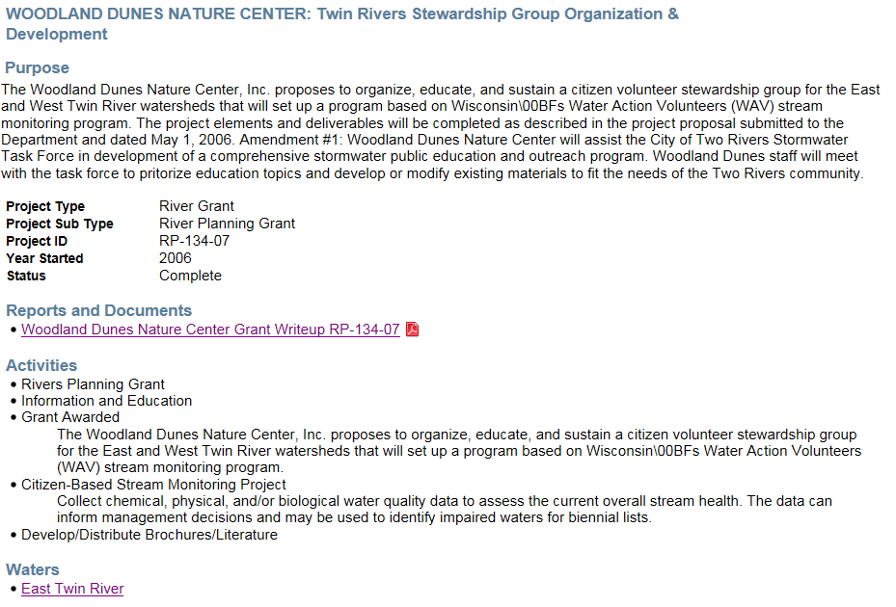
To the left Is a screen shot of the Woodland Dunes Nature Center website where Citizen Science and the stream volunteers are highlighted.

Monitoring Projects

AIS Bridge Snapshot Day 2014
The River Alliance in partnership with more than two dozen local AIS coordinators and partners around the state are hosting a statewide AIS Bridge Snapshot Day on September 13, 2014. The River Alliance and the Wisconsin DNR, and local AIS coordinators are working to ensure that our volunteers' data compliments the new efforts of WDNR watershed biologist staff to monitor for AIS in rivers. On a single day volunteers were trained on invasive species monitoring, then sent to priority bridge crossings, and monitored prohibited and restricted NR 40 invasive species. The volunteers reconvened to submit their findings.

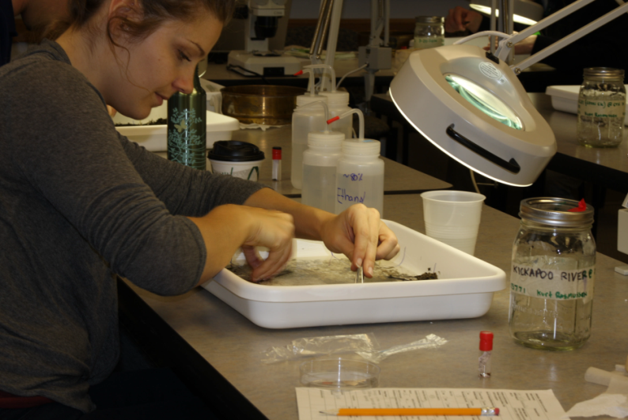
New Zealand Mudsnail 2013
Response monitoring for New Zealand Mudsnail. In October 2013, 1,080 New Zealand mudsnails (Potamopyrus antipodarum) were identified in benthic samples collected from a site near South Valley Road on Black Earth Creek west of the town of Black Earth in October 2012. In response to this discovery, benthic samples taken from the same site in December 2011/January 2012 were reexamined and identified 83 New Zealand mudsnails.
New Zealand mudsnails are a non-native invasive species that could have negative impact on trout, but we are not sure what to expect. They primarily graze on algae and can displace the native benthic community, reducing food for fish. Mudsnails provide little nutrition to fish and western states have reported reduced body condition and abundance of trout. New Zealand mudsnails are very small (no more than 4-6 mm) and reproduce asexually. Each adult is born with about 230 juveniles in brood pouches. Their small size makes them very transferable. New Zealand mudsnails have broad physical and chemical thresholds. They can live out of water in a damp environment for up to 26 days. Black Earth Creek is a renowned trout stream in southern Wisconsin and is visited by transient anglers, researchers, and restoration contractors.

Natural Community Stratified Sites 2010-2014
This project selects sites from all wadeable streams (88,00 miles, which includes ephemeral and macroinvertebrate streams). The random sites stratified by natural community (nc) and Region by Weigel. Two-hundred sites are sampled per year (approximately 25 sites per natural community per basin). This is a five year study. The sites are mapped on SWDV. April-October sampling for 1 fish IBI, one macroinvertebrate IBI, Qualitative Habitat, Temp, pH, D.O.,conductivity, 1TP sample in June, July OR August.

EPA National Lakes Survey 2012
During the summer of 2012, the U.S. Environmental Protection Agency (EPA), states, tribes and other partners conducted the second nationwide survey of the condition of the nation’s lakes. The National Lakes Assessment (NLA) will help citizens and governments measure the health of our waters, take actions to prevent pollution, and evaluate the effectiveness of protection and restoration efforts. The NLA 2012 is one in a series of national surveys of the condition of the nation’s waters (see http://www.epa.gov/aquaticsurveys ). Designed to estimate the percentage of lakes that are in good, fair, or poor condition, the survey serves as a scientific report card on lakes which examines ecological, water quality, and recreational indicators, and assesses how widespread key stressors (such as nitrogen, phosphorus, and acidification) are across the country.

The survey is a collaborative effort that involves dozens of state environmental and natural resource agencies, federal agencies, universities and other organizations. In most states, state water quality staff will conduct the water quality sampling and habitat assessments.

Lake Michigan Basin Wetland Intensification Study
Monitoring data will be gathered to assess the health of existing wetlands and measure the success of restoration projects. It is clear that to report a more complete picture on the status of wetlands we will need to develop more measures of wetland quality. DNR has worked with EPA to develop methods to assess wetland health, known “condition assessments” to continue to work on additional methods. The EPA conducted a national condition assessment survey of the nation’s wetlands in 2011. DNR was part of the work group that designed the national survey. This is an intensification of the national survey that to focus in on Wisconsin wetlands, most likely within a particular watershed or river basin.

High N/P Ratio Monitoring
Through a previous project known as the “nutrient impacts study”, DNR and USGS identified thresholds in relationships between phosphorus (P) and nitrogen (N) and stream biological metrics in Wisconsin streams and rivers (Robertson et al. 2006, Robertson et al. 2008, Wang et al. 2007). The P thresholds were more distinct and consistent among biological response variables than the N thresholds, which in part led to the development of P criteria before N criteria. One factor that may have limited the ability to identify N thresholds is that there were few sites in the dataset with high N and low P concentrations. Filling this “gap” in the dataset would increase the statistical power of any additional analyses of N thresholds. The proposed project is a targeted sampling of streams with high N:P ratios. The methods used by Robertson et al. (2006) will be used to sample sites for this study. These methods consist of six monthly nutrient samples (May-October) and one-time biological sampling (fish, habitat, invertebrates, and diatoms). We identified characteristics of the few sites in the nutrient impacts dataset with high N:P ratios. These sites generally have flat watersheds with permeable soils and intensive row crop agriculture (but relatively little animal agriculture). This type of stream is common in the central sands region and in Rock and Walworth Counties. We will select 25 sites in these areas for preliminary sampling (May-June nutrient sampling). We will continue sampling nutrients at approximately 18 of these sites with the highest N:P ratios through October, and will collect biological samples at each of these sites. In addition to the ~18 primary sites, we will collect biological samples at 10 Watershed Rotation sites that had high N:P ratios, but were not biologically sampled. Following this sampling effort, Science Services staff (Diebel and Weigel) will conduct a variety of statistical analyses to describe the relationships between N concentrations and stream biological communities, and will prepare a report for internal review. The computer code used to conduct these statistical analyses will be formatted so that as additional nutrient and associated biological data are collected, the analyses can be re-run.

Least Disturbed Monitoring Sites
EPA provided funding to sample 50 "least-disturbed" wadeable stream sites thought out the Southeast Wisconsin Till Plains, Driftless Area, and North Central Hardwood Forests ecoregions in Wisconsin in 2008. Stream sites were selected based upon evaluation of watershed land use characteristics upstream of candidate sampling sites. USGS collected various water chemistry measures six times (bi-monthly) at all sites and DNR collected quantitative habitat, macroinvertebrate and fish data at all sites.

Natural Community Stream Reference Sites
This study involves reference site selection and monitoring using the 2008 Streams Natural Communities dataset, which was based on stream flow and temperature modeled by WDNR Integrated Science Services and USGS Region V States. This study evaluates highest quality streams representative of each of the eleven proposed natural communities. The purpose of the study is to provide the range of biological and ecological conditions for specific communities through determining the "potential biological use" of each and to gather information that will provide insight into the value of the 11 distinct natural communities for state assessment and water quality standards work.

Northeast Region Nonwadeable Watershed Rotation Sites
Stream water quality monitoring covering primarily biological, chemical, and habitat related monitoring to determine ambient conditions at "pour point" locations for each of state's 330 watersheds.

Additional Studies
- Great Lakes Beaches - 2002 Pilot Project 1/1/1960 Complete Monitoring for pathogens at Great Lakes to help assessment beach quality under the state's Recreational Use Designation.
- NER NC Stream Stratified Sites 2010, 2011 5/24/2010 Complete Project for Natural Communities. This project selects sites from all wadeable streams (83,500 miles, which includes ephemeral and macroinvertebrate streams). The random sites stratified by natural community (nc) and Region by Weigel. Two-hundred sites are sampled per year (approximately 25 sites per natural community per basin). This is a five year study. The sites are mapped on SWDV. April-October sampling
- NER NC Stream Stratified Sites 2012 7/1/2012 Active Project for Natural Communities. This project selects sites from all wadeable streams (83,500 miles, which includes ephemeral and macroinvertebrate streams). The random sites stratified by natural community (nc) and Region by Weigel. Two-hundred sites are sampled per year (approximately 25 sites per natural community per basin). This is a five year study. The sites are mapped on SWDV. April-October sampling

Volunteer Monitoring
There are five sites where volunteer monitoring is conducted in the watershed:
CBSM-10043182 | East Twin River at Mishicot Village Park | 01/30/2015
CBSM-10040490 | East Twin River at Paddler's Park | 12/28/2014
CBSM-10040489 | East Twin River at Hillcrest Rd | 12/28/2014
CBSM-10031871 | Unnamed DS Lakeshore Rd | 05/01/2013
CBSM-10008211 | Tisch Mills Creek at Cty Hwy BB | 07/12/2012

Basin/Watershed Partners

Priority Issues

Recommendations

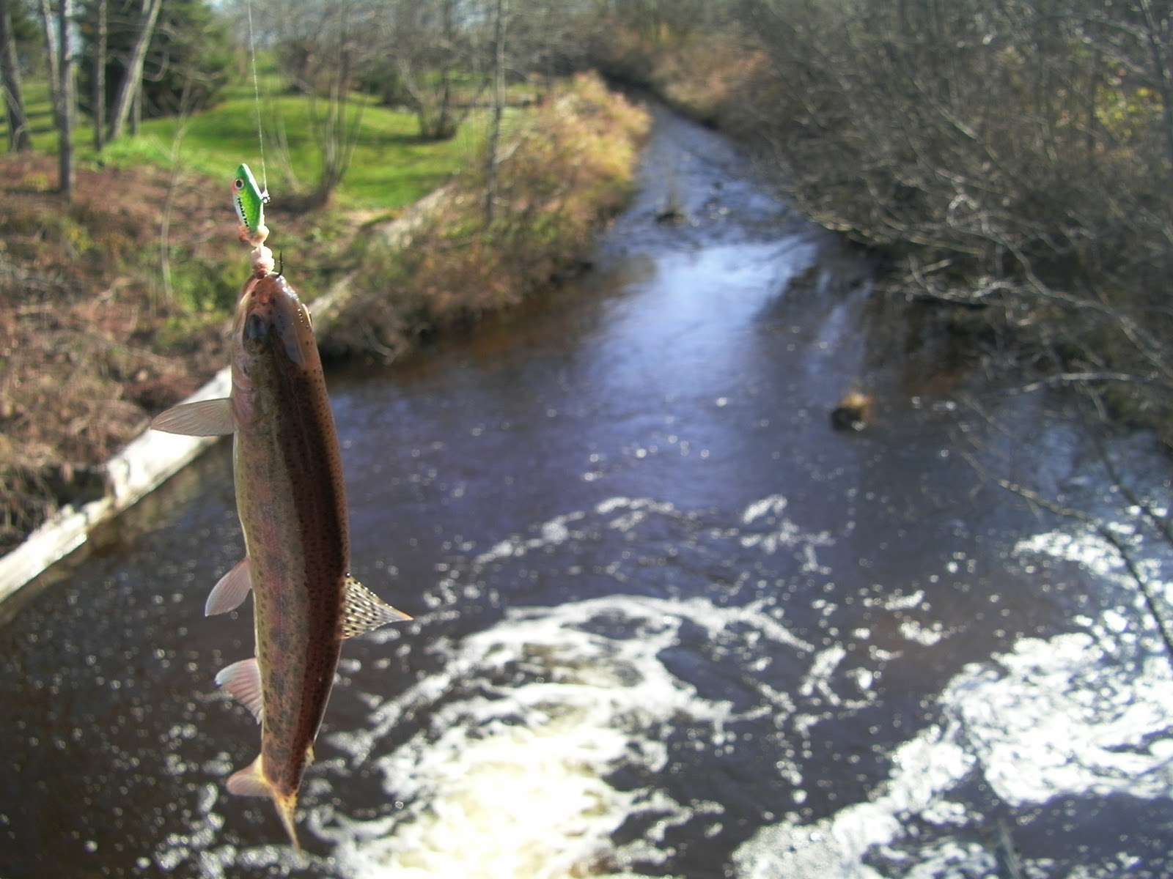
This document is available electronically on the WDNR’s website. The Wisconsin Department of Natural Resources provides equal opportunity in its employment, programs, services, and functions under an Affirmative Action Plan.
midwestfisherman.blogspot.com-1600

Contributors

Ruth Person, Lisa Helmuth, Steve Hoegler, Mary Gansberg

If you have any questions, please write to Equal Opportunity Office, Department of the Interior, Washington, D.C. 20240. This publication is available in alternate format (large print, Braille, audio tape, etc.) upon request. Please call 608-267-7694 for more information.
WDNR PUB-WY- 063-2015
Wisconsin Department of Natural Resources
101 S. Webster Street • PO Box 7921 • Madison, Wisconsin 53707-7921 608-266-2621

List of Monitored Waters in the TK02 Watershed
(Assessment may not be conducted yet) Sorted by waterbody name (i.e., “unknown” represents Fish and Aquatic Life assessments).
WBIC | WATERS ID | LOCAL NAME | START MILE | END MILE | WATER SIZE | MONITORED YEAR | Fish and Aquatic Life Condition | ORW/_ERW | TROUT
85000 | 10151 | Chadha Lake |  |  | 7.0 Acres | 2014 | Unknown
84000 | 18071 | East Twin River | 0.03 | 10.49 | 10.5 Miles | 2016 | Good
84000 | 4700226 | East Twin River | 10.49 | 26.4 | 15.9 Miles | 2016 | Unknown
84000 | 10205 | East Twin River | 26.4 | 34.18 | 7.8 Miles | 2012 | Poor |  | CLASS II
84000 | 10206 | East Twin River | 34.18 | 40.91 | 6.7 Miles | 2015 | Poor | ERW | CLASS I
85300 | 10153 | Engledinger Lake |  |  | 52.0 Acres | 2014 | Fair
84600 | 10149 | Harpt Lake |  |  | 31.0 Acres | 2016 | Excellent
85200 | 10152 | Heidman Lake (Bolt) |  |  | 24.0 Acres | 2016 | Good
84300 | 10146 | Jambo Creek | 8 | 9 | 1.0 Miles | 2015 | Suspected Poor
84300 | 10145 | Jambo Creek | 3.91 | 7.99 | 4.1 Miles | 2013 | Unknown
84300 | 10144 | Jambo Creek | 0 | 3.91 | 3.9 Miles | 2010 | Good |  | CLASS II
84100 | 10143 | Johnson Creek | 0 | 7 | 7.0 Miles | 2015 | Good
86700 | 10162 | Krok Creek | 0.01 | 0.68 | 0.7 Miles | 2008 | Poor
86700 | 903433 | Krok Creek | 0.69 | 3.33 | 2.6 Miles | 2008 | Poor
90100 | 10164 | Molash Creek | 0 | 7.76 | 7.8 Miles | 2015 | Poor
84700 | 10150 | Mott Lake |  |  | 7.0 Acres | 2014 | Unknown
20 | 481979 | Neshota Park Beach |  |  | 0.7 Acres | 2015 | Unknown
20 | 482011 | Point Beach State Park Beach |  |  | 1.5 Acres | 2015 | Unknown
83100 | 10142 | Seidel Lake |  |  | 12.0 Acres | 2014 | Unknown
20 | 1452524 | Selner Park, Lake Michigan |  |  | 1.1 Acres | 2014 | Unknown
85400 | 10154 | Shea Lake |  |  | 32.0 Acres | 2016 | Good
85500 | 18056 | Tisch Mills Creek | 0.01 | 2.26 | 2.3 Miles | 2015 | Good |  | CLASS II
85500 | 10155 | Tisch Mills Creek | 2.6 | 5.51 | 2.9 Miles | 2008 | Fair
47 | 482709 | Two Rivers Harbor |  |  | 11.4 | 2013 | Poor
83700 | 26200 | Un Lake |  |  | 15.2 Acres | 2011 | Unknown
5020832 | 3994857 | Unnamed | 0 | 6.37 | 6.4 Miles | 2014 | Poor
5552390 | 32031 | Unnamed |  |  | 3.5 Acres | 2014 | Suspected Poor
84900 | 4000342 | Unnamed | 0 | 0.16 | 0.2 Miles | 2013 | Unknown
3000211 | 5534458 | Unnamed | 0 | 3.38 | 3.4 Miles | 2012 | Unknown
86600 | 1479552 | Unnamed Ditch | 0 | 1.39 | 1.4 Miles | 2011 | Unknown
5022207 | 5501805 | Unnamed Stream | 0 | 1.7 | 1.7 Miles | 2015 | Unknown
5021866 | 5501674 | Unnamed Stream | 0 | 0.58 | 0.6 Miles | 2014 | Unknown
5022137 | 5501704 | Unnamed Stream | 0 | 3.1 | 3.1 Miles | 2014 | Unknown
5019988 | 5500769 | Unnamed Stream | 0 | 0.57 | 0.6 Miles | 2013 | Unknown
5019833 | 5500736 | Unnamed Stream | 0 | 1.35 | 1.4 Miles | 2013 | Unknown
3000213 | 5500585 | Unnamed Stream | 0 | 0.38 | 0.4 Miles | 2011 | Poor
5020517 | 5498113 | Unnamed Stream | 0 | 2.84 | 2.8 Miles | 2011 | Unknown
3000212 | 5500551 | Unnamed Stream | 0 | 1.93 | 1.9 Miles | 2009 | Poor
5021266 | 5501343 | Unnamed Stream | 0 | 1.45 | 1.5 Miles | 2001 | Unknown
5019298 | 5499827 | Unnamed Stream | 0 | 2.07 | 2.1 Miles | 2001 | Unknown
5020126 | 5499160 | Unnamed Stream | 0 | 1.72 | 1.7 Miles | 1985 | Unknown
86400 | 18058 | Unnamed Trib 22n 24e S9 Nwsw | 0 | 4 | 4.0 Miles | 2011 | Fair
84400 | 10147 | Unnamed Trib T21n, R23e, S15 Nene | 0 | 4 | 4.0 Miles | 2015 | Unknown
85100 | 18055 | Unnamed Trib T21n, R24e, S25 Nene | 0 | 1 | 1.0 Miles | 2013 | Unknown
87000 | 18050 | West Twin River | 0 | 5.9 | 5.9 Miles | 2015 | Poor

Appendices – Watershed Maps

