A 2017 Assessment

of

The Beaver Creek Watershed

HUC 12(070900010903)

Columbia and Dodge Counties

In fulfillment of Targeted Watershed Project: South_TWA_4_2017

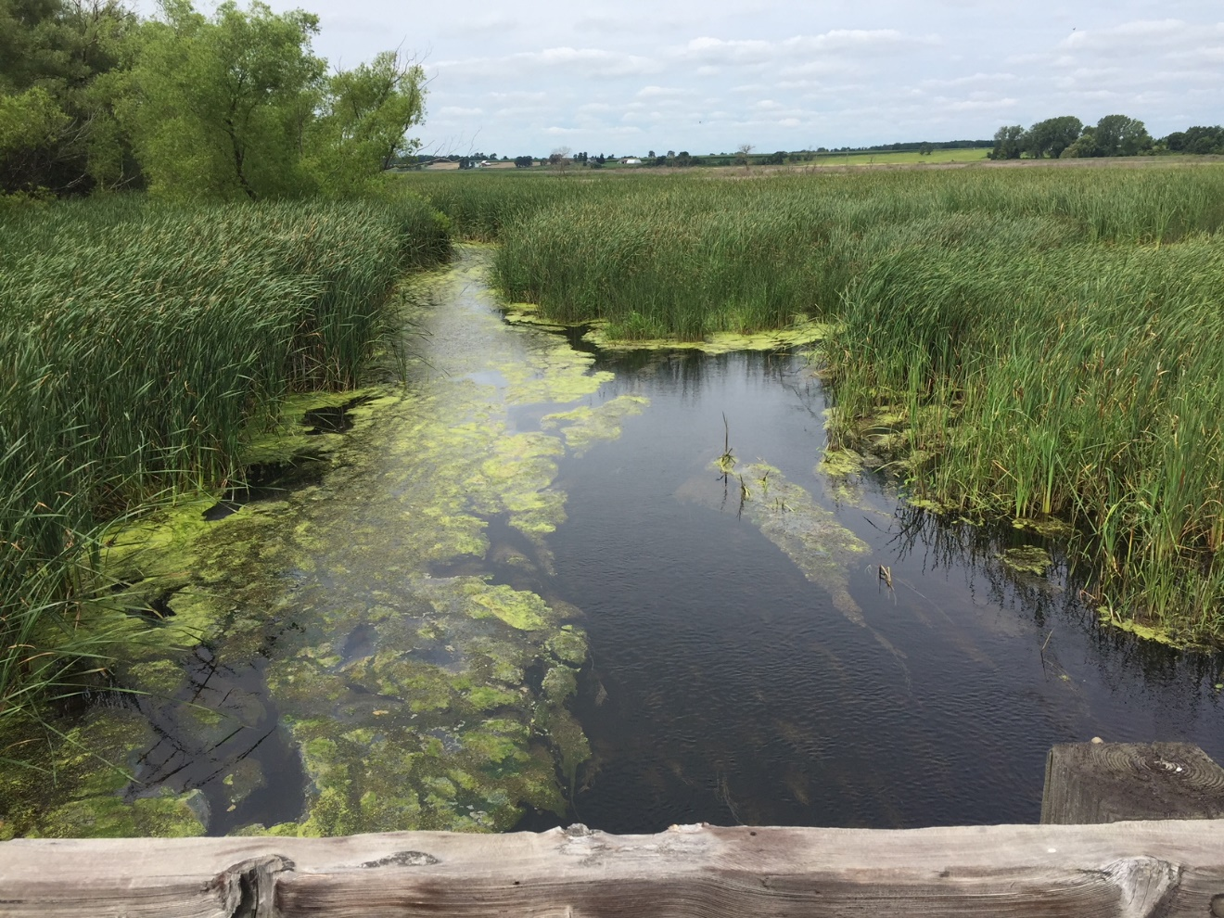
Beaver Creek looking upstream from CTH DG (downstream of Paradise Marsh)

By James Amrhein and Michael Sorge
Water Quality Biologists, Southern District

February 2019
The Beaver Creek HUC 12 (070900010903) encompasses 33 square miles (21,320 acres) and straddles eastern Columbia and western Dodge counties. Beaver Creek is the main waterbody that flows through this watershed. It is a 14-mile long low gradient tributary that has its origin west of the Village of Randolph and flows 6 miles southwest before turning northeast in the Paradise Marsh Wildlife area and flowing another 8 miles until it joins Beaver Dam Lake. Most of the watershed is in cropland or pasture (See figure at right). The watershed also contains many wetlands and includes 2 state properties – the Paradise March Wildlife Area which encompasses 1800 acres and the Glacial Habitat Restoration Area which contains 380 acres. The Village of Randolph discharges its wastewater to an unnamed tributary of Beaver Creek. The headwaters tributaries exhibit parallel drainage disciplined by drumlins oriented in a northeast – southwest direction. Since wetland swale drainage is the prime water source, fluctuating water levels are an annual problem. A majority of the stream has been straightened to enhance drainage (WDNR, 1965).
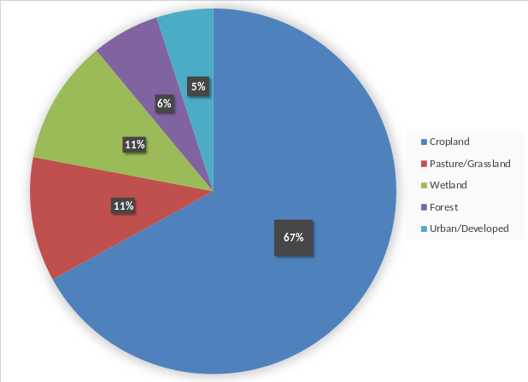

Beaver Creek was added to the state’s 303(d) list of impaired waters during the 2016 listing cycle because total phosphorus data exceeded the 2016 WisCALM criteria (WDNR, 2017) and because of biologic impairment.

Until recently, there has been little monitoring in the watershed except for 3 fish surveys conducted over the past 15 years on Beaver Creek itself. In 2017, the Beaver Dam Lake Improvement Association received a Lake Management Planning Grant to look at ways to protect/improve water quality and habitat of the lake. As part of this grant, students from the University of Wisconsin – Madison Water Resource Management Program conducted a study to evaluate nutrient and sediment delivery from the watershed through Beaver Creek. In coordination with this project, the department initiated a targeted watershed assessment to obtain contemporary data on the fish, habitat, and macroinvertebrates of the streams in the watershed and potentially identify areas of management to help the gamefish and other non-game species to thrive in this agriculturally dominated watershed.

Methods
The 2017 watershed survey was conducted by water resources biologists on 10 sites in the HUC 12 (Figure 1). Six sites were surveyed on Beaver Creek, 3 on an unnamed tributary (WBIC = 836550) and 1 on another unnamed tributary (WBIC = 5030365).

The fisheries assemblage was determined by electroshocking a section of stream with a minimum station length of 35 times the mean stream width (Lyons, 1992). A stream tow barge with a generator and two probes was used at most sites. A backpack shocker with a single probe was used at sites generally less than 2 meters wide. All fish were collected, identified, and counted. All gamefish were measured for length. At each site, qualitative notes on average stream width and depth, riparian buffers and land use, evidence of sedimentation, fish cover and potential management options were also recorded. A qualitative habitat survey (Simonson, et. al., 1994) was also performed at each site. Macroinvertebrate samples were obtained at 8 sites by kick sampling and collecting using a D-frame net in fall, 2017 and sent to the University of Wisconsin-Stevens Point for analysis.

Results
The results of the fisheries surveys are summarized in Table 1. The Wisconsin Streams model (Lyons, 2008) predicted most of the waters in the watershed to be cool transitional waters or warm waters. The natural community verification process developed by Lyons (2015) showed the fishery assemblage to indicate a warm transitional (cool-warm)

Figure 1: Sample Sites in the Beaver Creek Watershed 2017
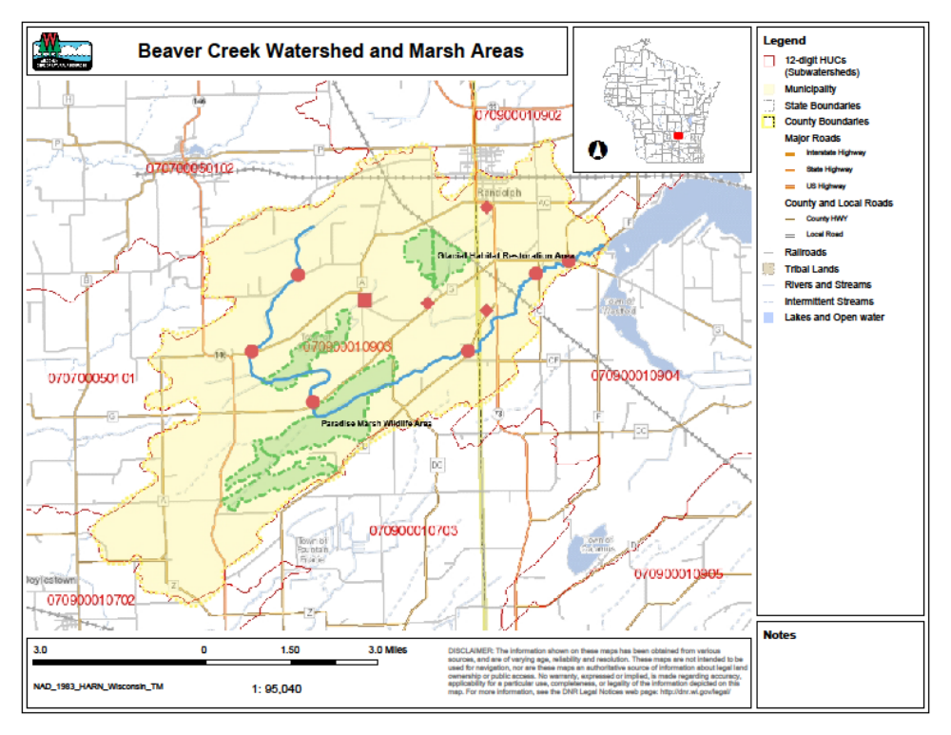

community at all but 1 of the sites. Therefore, the coolwater index of biotic integrity (IBI) developed by Lyons (2012) was applied to all streams.

A total of 19 fish species were collected in the 2017 surveys. Central mudminnow, green sunfish, and white sucker were the most widely distributed species. All species found in
Table 1: Fish Assemblage, Natural Community, and IBI for Streams in the Beaver Creek Watershed - 2017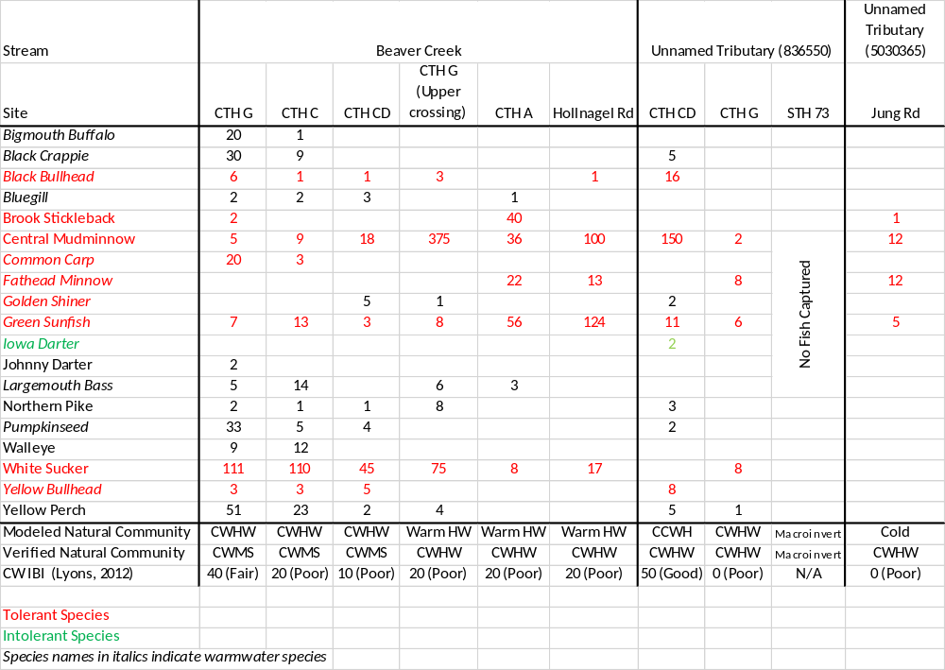
the watershed represent cool transitional or warm thermal regimes (Ibid). Several game species, including walleye, northern pike, and largemouth bass were found in certain sections of Beaver Creek. Pike were also found at the most downstream station on unnamed tributary (WBIC = 836550). Several panfish species such as bluegill, pumpkinseed, black crappie, and yellow perch were also found. Most game and panfish present were smaller sizes representing young-of-the-year (YOY) or yearling fish. Tolerant species became more prevalent as one moved upstream on Beaver Creek as well as in the tributaries.

Overall qualitative habitat scores (Table 2) ranged from 35 (fair) in the unnamed tributary (836550) to 73 (good) at a site on Beaver Creek. The lower sections of Beaver Creek consistently had the best scores. The upper sections of Beaver Creek and the tributaries were consistently fair to good. Riparian buffer width was excellent at most sites. The width-to-depth ratio was good at most sites. Pools and riffles were virtually absent as runs dominated these systems. Bank erosion and fine sediments varied by site, but did not correlate with one another. Fish cover was limited at most sites save for the most downstream sites on Beaver Creek.

Table 2: Qualitative Habitat Assessment of Streams in the Beaver Creek Watershed
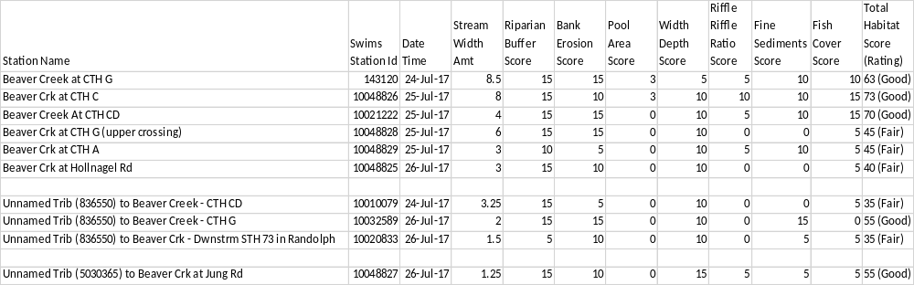

Macroinvertebrates collected in fall were analyzed and the macroinvertebrate IBI (MIBI) developed by Weigel (2003) and the Hilsenhoff Biotic Index (HBI) (Hilsenhoff, 1987) were applied to the data. The MIBI ranged from 2.17 (poor) to 5.49 (good), with most sites being in the “fair” category based on WisCALM (WDNR, 2017) thresholds. The HBI, which is an indicator of organic loading, varied from 5.58 (fair) to 7.30 (fairly poor), with most sites showing fairly significant to significant organic pollution indicated.

Discussion
Fish of the lower Beaver Creek contain a subset of the species found in Beaver Dam Lake. Habitat here is best, with the most fish cover. Upstream of CTH DG, large wetland complexes, including the ones making up the Paradise Marsh State Wildlife area, predominate. The complexes serve as habitat for aquatic and terrestrial species, spawning areas for fish, reptiles and amphibians, as well as floodwater, sediment and nutrient retention (NCSU, 1976), but because they contain a large amount of decaying organic matter, they tend to become anoxic during the warmer summer months when
Table 3: Macroinvertebrate Data for Streams in the Beaver Creek Watershed
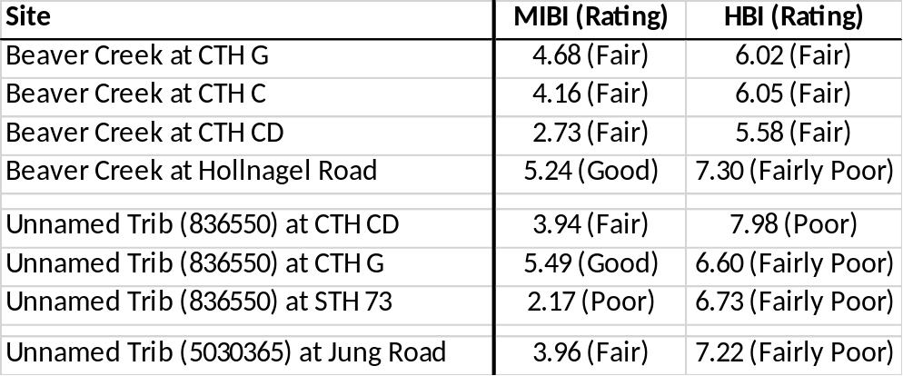

water temperatures are highest, and decomposition occurs at the highest rate. As such, fish in these systems either must be very tolerant of low dissolved oxygen (D.O.) levels, find refuge further upstream (such as at the upper CTH G crossing) where D.O. levels are sufficient and where they remain isolated during the rest of the summer, or seek refuge in the more highly oxygenated waters of the lower portions of Beaver Creek or the lake itself. Biologists noted the dissolved oxygen levels on days when surveys were completed ranged between 1 to 5 ppm although the section from CTH A downstream to CTH G was in the 6 to 9 ppm range. By contrast, a D.O. reading taken on August 25th on Beaver Creek at CTH DG – immediately downstream of Paradise Marsh - showed the concentration to be 0.28 mg/l (or 3% saturation).

It was not surprising to find the greatest diversity of species at some distance downstream from the large wetland complexes, not only because of the barrier caused by naturally low D.O. levels, but also because the habitat was favorable and because it the lower locations offered easy access to and from the lake. It was also not surprising to find species such as central mudminnow prevalent throughout the watershed. This species is distributed throughout the state and is known for inhabiting the low gradient, wetland streams. It is associated with clearer waters with moderate to dense vegetation, and prefers water lacking flow. It can survive where oxygen levels are very low because it has alveoli and gas absorbing and secreting organs in the swim bladder and can also gulp air to meet its oxygen needs (Becker, 1983). White sucker and green sunfish are 2 other tolerant species can thrive in the channelized, featureless types of systems that have little fish cover, and high sediment. They tend to be predominant in hydrologically modified areas where it was common to straighten streams to facilitate drying of wet areas to accommodate agriculture.
Central Mudminnow NANFA
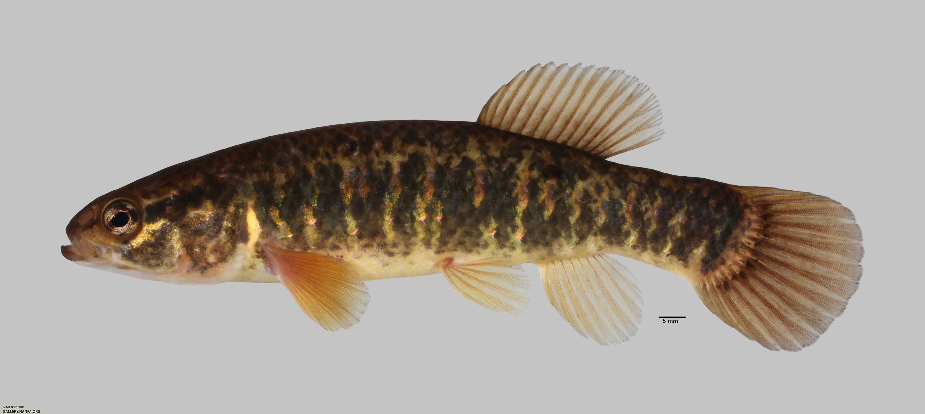

Wetlands can provide good spawning habitat for any number of species. Some of the young remain behind to grow and mature. However, it is likely the walleye found in the lower section of Beaver Creek were part of the large fingerling crop that was stocked in Beaver Dam Lake in 2016. They migrated up the stream and found refuge and food to sustain them there while they mature. It’s possible that northern pike found in the system are of similar nature, however there may be some natural reproduction of pike in the large marshes of the watershed.

It was thought that sampling in spring could reveal a different species assemblage where certain migratory spawners were more prevalent, so in April 2018, biologists surveyed Beaver Creek at CTH CD and CTH G (lower crossing). The results were somewhat surprising in that there was dearth of fish numbers and species (Table 4). The lower CTH G site, which had the highest diversity of species in the summer 2017 survey had only 3 individual fish. The CTH CD site contained 4 species, but central mudminnow made up 97% of the total fish number. This survey shows the difficulty in surveying tributaries where spawning migrations, driven by water temperature and photoperiod, may last but a few days. Despite the lack of fish on this particular day, one cannot overstate the importance of these tributaries to seasonal migrations which link fish with preferred spawning habitat.

Table 4: Spring, 2018 Beaver Creek Fish Survey
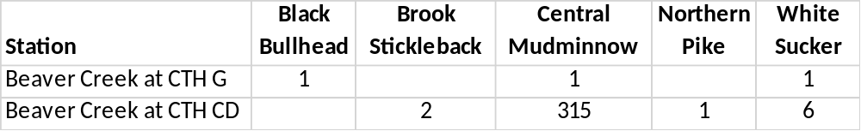

The overall health of the fishery in the Beaver Creek watershed as described by the warm transitional (cool-warm) IBI reflects the difficulty in assessing systems that run through large wetland complexes where naturally low D.O. levels are common. The fishery assemblage reflects the species which can tolerate such an environment. So, while the IBIs tend to be low in these areas, it does not necessarily indicate a biotic impairment. As mentioned earlier, these streams likely contain a more diverse species assemblage at certain times of the year – outside the approved sampling period (WDNR, 2018) - as
these complexes serve as important spawning areas for particular species. To declare these streams as impaired because of the low IBI is overly simplistic.

Wetlands are also naturally high in detritus and organic material, which is not favorable habitat for a number of species, and in particular those which would score higher on the warm transitional IBI scale (Lyons, 2012). The lack of intolerant species, coupled with the high number of tolerant omnivores, tend to depress the warm transitional score, but are not unusual for systems like these. The lack of benthic invertivores was not surprising because of the monotonous run environment that was high in sediment. One would have expected a few more native minnow species, particularly in the lower sections of Beaver Creek where the gradient was better and habitat more diverse.

Habitat surveys showed the creeks to be in fair to good condition overall. The wetland complexes serve as de facto buffers in certain areas. The well vegetated wetland corridor and low gradient also lend themselves to low streambank erosion. Still, it is difficult to ignore the past and current environmental perturbations which are also a part of this watershed’s characteristics. The low gradient, excessive sedimentation and nutrification, and channelized nature of many sections leads to a monotonous run, that is high in fine sediments and low in fish cover. Except for the lower 3 stations on Beaver Creek, most of the fish cover was limited to aquatic macrophytes and overhanging vegetation.

Phosphorus sampling conducted on various sections of Beaver Creek (Table 5) show concentrations well in excess of the state’s criteria of 0.075 mg/l for streams (WDNR, 2017). This is likely due to several factors. Historic agricultural practices allowed high amounts of sediment and phosphorus to be lost, only to be captured in the sediments and ultimately plants in the wetlands. Even in the advent of improved agricultural practices, these wetlands - through the natural decomposition processes - then become a continuous source of phosphorus to the streams (Reddy, et. al. 1999; Dunne, et. al. 2010; Nair et. al., 2015).
Keep Out!
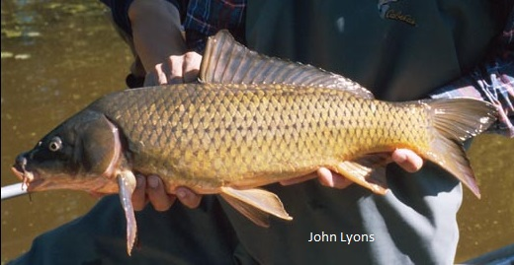

Common Carp (Cyprinus carpio) were identified as one of the factors limiting water quality of Beaver Dam Lake. To reduce carp populations in the lake, it is desirable to keep carp out of the wetland complexes of Beaver Creek where they prefer to spawn. An electrical barrier was placed across Beaver Creek at the (lower) CTH G crossing to prevent them from moving upstream into the marshes to spawn. Fisheries management operates the barrier annually. It is typically turned on in mid-to-late May, after northern pike, white sucker, and walleye have had an opportunity to move upstream and back downstream in the spring, but before the carp begin to spawn. It operates throughout the summer months and is turned off in the fall. It is hoped that reducing carp reproduction opportunities, as well as other methods to reduce carp populations in the lake will result in improved water quality.

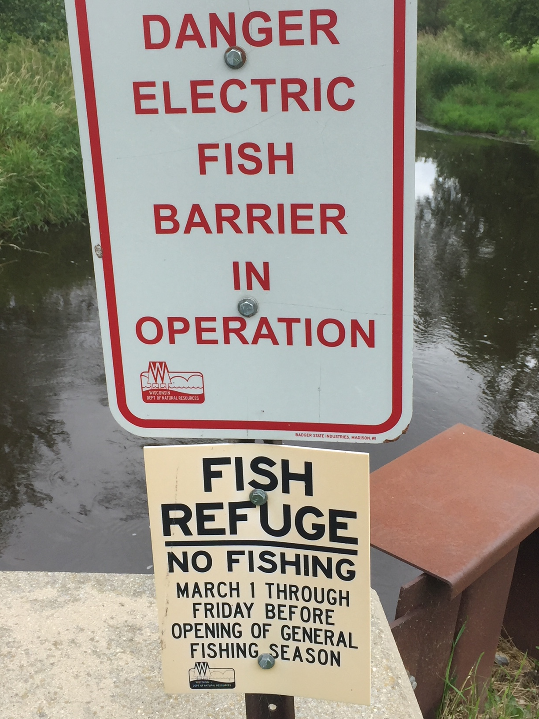

The macroinvertebrate data showed the environmental quality to be stressed by habitat and water quality issues. Low gradient systems like Beaver Creek tend to lack riffle/run complexes which in turn lack the higher oxygen levels preferred by more sensitive macroinvertebrate species. High sedimentation caused by nonpoint source pollution, favors the presence of more tolerant species. The HBI indicated high organic enrichment of the system, which is supported by the relatively low D.O. readings reported in the summer. Weigel (2003) found that watershed and local-scale (i.e. riparian) variables equally explained significant portions of the variance among sites in the Central-Southeast region. Overall, the macroinvertebrate community seems to accurately reflect the condition of the watershed.

As mentioned in the introduction, the University of Wisconsin – Madison Water Resources (WRM) program concurrently conducted a study of Beaver Creek and Beaver Dam Lake in 2017. The group collected water quality, discharge, and sediment phosphorus data to provide insight into phosphorus loading to Beaver Dam Lake (UW-Madison, Nelson Institute for Environmental Studies, 2018). The stream phosphorus data collected in 2017 (and shown in Table 5) was a part of this study and confirmed that Beaver Creek clearly exceeds the state’s water quality standard for phosphorus. In addition, they looked at land use and geographical data to ascertain areas that were most
Table 5: Total Phosphorus Concentrations in Beaver Creek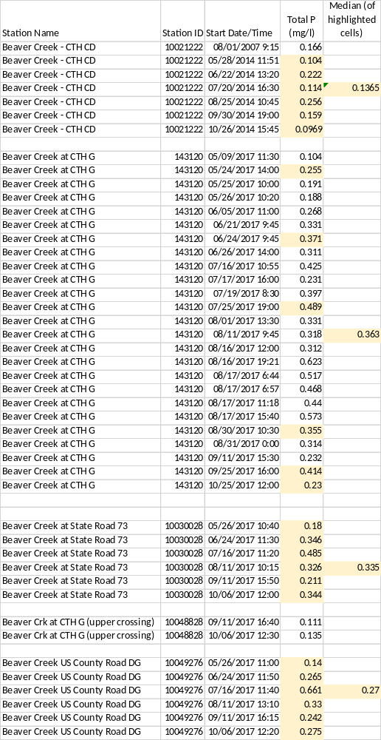
s vulnerable to erosion. In combination with soil sampling, this gave indications on which areas were likely to contribute the highest nutrient and sediment loads to the creek from the watershed. The WRM students also looked at macroinvertebrates and qualitative habitat at certain sites. Their data were consistent with what WDNR found for these respective measures. Their recommendations were likewise consistent with the general recommendations listed below and are included as an addendum to this report.

Conclusions and Recommendations
Even though there has been historic degradation of the streams of the watershed due to hydrologic modification and nonpoint source pollution, the wetlands themselves present natural limitations to the aquatic ecosystem. This also limits the management actions that can be taken to improve the health of the biotic community.

As was pointed out in the narrative, the species assemblage reflects the nature of the watershed, including its’ periods of naturally low D.O. It would be difficult to change this paradigm as it is part of a fully functioning wetland, therefore it may be best to focus on reducing phosphorus delivery to Beaver Dam Lake. This could be accomplished through working with landowners in the watershed by promoting healthy soils to keep sediment and nutrient losses to a practical minimum. Working in conjunction with Beaver Dam Lake Improvement Association, the Dodge County Farmers for Healthy Soil and Healthy Water and the Dodge County Alliance for Healthy Soil and Healthy Water, the Dodge County and Columbia County Land and Water Conservation Departments, partnerships should be developed to work with producers in the watershed to implement practices such as reduced tillage, cover crops, buffers, and grassed waterways which keep soil and water in place while allowing for a viable agricultural economy.

The UW- Madison Water Resources Management practicum (Ibid) determined that the stream contains excess phosphorus in the way of both total phosphorus (TP) and dissolved reactive phosphorus (DRP). That DRP concentrations during storm events do not differ much from baseflow concentrations and are in exceedance of the state’s phosphorus standard is consistent with what has been found in other streams (Dane County LWRD, 2016). This may point to sediment bedload as a source of DRP. The practicalities and cost/benefit of addressing the phosphorus in the bedload of sediment in Beaver Creek and its tributaries would have to be explored.

References:
Becker, George C. 1983. Fishes of Wisconsin. The University of Wisconsin Press. 1051 pp.

Dane County Land and Water Resources Department. 2016. Impacts of Conservation and Legacy Sediment on Water Quality within the Dorn Creek Watershed. Presentation to the Clean Lakes Alliance. October 14, 2016. https://www.youtube.com/watch?v=rNVIHLCy3Sg&t=1829s

Dunne. E.J., M.W. Clark, J. Mitchell, J.W. Jawitz and K.R. Reddy. 2010. Soil Phosphorus Flux from Emergent Marsh Wetlands and Surrounding Grazed Pasture Uplands. Ecological Engineering. 36:10, 1392-1400.

Hilsenhoff, William L. 1987. An Improved Biotic Index of Organic Stream Pollution. The Great Lakes Entomologist. 20: 31-39.

Lyons, John. 1992. Using the Index of Biotic Integrity (IBI) to Measure Environmental Quality in Warmwater Streams of Wisconsin. United States Department of Agriculture. General Technical Report NC-149.

Lyons, John. 2008. Using the Wisconsin Stream Model to Estimate the Potential Natural Community of Wisconsin Streams (DRAFT). Wisconsin Department of Natural Resources Fish and Aquatic Life Research Section. November, 2008.

Lyons, John. 2012. Development and Validation of Two Fish-based Indices of Biotic Integrity for Assessing Perennial Coolwater Streams In Wisconsin, USA. Ecological Indicators 23 (2012) 402-412.

Lyons, John. 2015. Methodology for Using Field Data to Identify and Correct Wisconsin Stream “Natural Community” Misclassifications. Version 5. May 29, 2015.

Nair, Vimala. Mark Clark and Konda Reddy. 2015. Evaluation of Legacy Phosphorus Storage and Release from Wetland Soils. Journal of Environmental Quality. 10.2134/jeq2015.0

NSCU. 2018. Functions of Wetlands. Marjut H. Turner and Richard Gannon. North Carolina State University. http://www.water.ncsu.edu/watershedss/info/wetlands/function.html

Reddy, K.R., R.H. Kadlec, E. Flaig, and P.M. Gale. 1999. Phosphorus Retention in Streams and Wetlands: A Review. Critical Reviews in Environmental Science and Technology. 29:1, 83-146.

Simonson, Timothy D., J. Lyons, and P.D. Kanehl. 1994. Guidelines for Evaluating Fish Habitat in Wisconsin Streams. U.S. Department of Agriculture. Forest Service. General Technical Report NC-164.

University of Wisconsin – Madison. Nelson Institute for Environmental Studies. 2018. Addressing Impairment in Beaver Dam Lake and Beaver Creek. Water Resources Management Practicum Report 2017. Anita Thompson, Faculty Advisor.

WDNR, 1965. Surface Water Resources of Columbia County: Lake and Stream Classification Project. By Ronald Poff and C.W. Threinen. Wisconsin Department of Conservation. Madison, WI.

WDNR. 2017. Wisconsin 2018 Consolidated Assessment and Listing Methodology (WisCALM). Clean Water Act Section 305(b), 314, and 303(d) Integrated Reporting. Wisconsin Department of Natural Resources. Bureau of Water Quality Program Guidance. September, 2013.

WDNR, 2018. Guidelines for Assessing Fish Communities of Wadable Streams in Wisconsin. Draft SOP. Revised from March 2001. Originally from Simonson and Lyons, 1993. Evaluation of the Wisconsin Priority Watersheds for Improving Stream Fish Communities.

Weigel, Brian. 2003. Development of Stream Macroinvertebrate Models That Predict Watershed and Local Stressors in Wisconsin. Journal of the North American Benthological Society. 22(1): 123-142.

Addendum:

From: University of Wisconsin – Madison. Nelson Institute for Environmental Studies. Water Resources Management Practicum Report 2017. Addressing Impairment in Beaver Dam Lake and Beaver Creek. Anita Thompson, Faculty Advisor. Practicum Participants: Haley Briel, Jack Cotrone, Marty Dillenburg, Alexandra Delvoye, Sarah Fanning, Falon French, Yiyi Hu, Alex Jeffers, Thor Jeppson, Yu Li, Suzan Limberg, Ryan McGuire, Thomas Pearce, Catherine Schumak, Yi Wang.

Chapter 7 – Recommendations Our recommendations are divided into three categories: improving stakeholder engagement, Beaver Creek water quality, and Beaver Dam Lake water quality.

7.1 – Stakeholder Engagement 7.1.1 – Local School Partnerships and Water Studies To continue collecting water quality, vegetation, and physical data in Beaver Dam Lake and Beaver Creek, the BDLIA could begin partnering with local school districts to create field trip and science study opportunities for students. Classes could visit the lake and/or creek to collect a series of data similar to the data our Beaver Creek group collected. This data could then be analyzed over years to show trends. Students and their families would get involved in lake issues and be exposed to BDLIA and community efforts toward water quality improvements.

Local schools that could potentially serve as partners include Beaver Dam High School, Randolph High School, and Wayland Academy. Biology, chemistry, or environmental science classes could take field trips once per semester or year to Beaver Dam Lake or Beaver Creek. These classes could be split up to collect data on water chemistry, clarity, and physical characteristics, as well as macroinvertebrates, habitat, and vegetation. Depending on the time of year, students could also survey bird species or people who are taking part in various recreational activities as well.

If several classes collect data over several years, this citizen science effort could produce a strong baseline of water quality data while giving high school students (and possibly their parents) exposure to these important water bodies and their pressing health issues. BDLIA could spearhead this effort and supply equipment if the schools are in need and teach data collection methods to the students.

7.1.2 – Workshops and Volunteer Events To build more awareness of and interest in positive lake efforts, the BDLIA can structure an ongoing series of events and workshops. These could be tailored to a variety of interests and commitment levels in the public and take place in a variety of places. If the BDLIA can only support a few activities in the first year, it should work toward an eventual series of monthly events during the summer season (April – October).

Workshops could include a "Lake Issues 101" boat tour of Beaver Dam Lake to provide general audiences with background information on lake studies and how the connected issues of high phosphorus, carp, and algae affect the lake ecosystem. It should also offer management strategies and teach the audience about the time, human resources, and finances needed to implement each. Such a class should also make time for the participants to state their interests in the lake and share ideas for how to improve lake health. This will reveal the talents and potential connections of the group to the BDLIA.

Another workshop idea is to arrange for a private homeowner to teach a group (preferably lakeshore property owners) about native plantings for protection from shoreline erosion and general landscaping for polluted-water runoff reduction. Beaver Dam Lake residents need to realize that they are responsible for some portion (albeit a small one) of the water quality issues in the lake and that they can make changes at home to prevent pollution and sediments from entering the lake. Also, lake property owners can protect shoreline susceptible to erosion by strategically planting trees, restoring wetland plants, and reducing lawn cover along the shore. This workshop should cover these points and teach participants about the costs and ongoing management necessary to make landscape changes effective over the long-term.

In addition, the BDLIA could arrange volunteer efforts aimed at citizen science, clean ups, and invasive species removal and vegetation plantings. The need for lake and tributary data collection will be ongoing. Groups of citizens could fill this need during a series of meetups over the summer season with BDLIA's technical assistance. To reduce shoreline erosion and retain sediment from waters while maintaining or even improving biological health, work parties could be assembled in spring, summer, or fall to remove invasive plants and plant or maintain native vegetation on public land or private property, if landowners are willing to establish a cooperative partnership.

7.1.3 – Farmer-Led Council in Columbia County Recently, Dodge County established the Farmers for Healthy Soil & Healthy Water Council, a volunteer-led group of producers that shares strategies and information about cover cropping, nutrient management, and reduced tillage. This group hosted a two-day indoor workshop about these and other practices in February 2017. They also organized a cover-cropping field day in October 2017 with stops at three different farms. Participants learned about the resources needed and on-the-ground examples from farmers on the council.

BDLIA should work with Dodge County Land and Water Conservation staff to develop a similar farmer-led council in Columbia County. This effort will require building relationships with farmers in Columbia County and organizing time and space for them to share soil management practices. From our producer interviews and in our cohort's communication with staff from both counties, it appears that groups of farmers already meet to share information. BDLIA should work to find these voluntary groups and expand their influence through a farmer-led council that works for Columbia County.
7.1.4 – Bring Producers onto the BDLIA Board Finally, BDLIA should work to get more producers involved with lake improvement efforts by recruiting a producing landowner to the association’s board. This needs to be a person willing to dedicate energy to BDLIA efforts as well as someone respected and listened to by other producers in the watershed. The greatest benefit of having a producer in this position is to expose other producers to BDLIA's efforts and work to create positive relationships between agriculture and Beaver Dam Lake interests in the watershed.

7.2 – Beaver Dam Lake Water Quality 7.2.1 – Active Carp Management Plan Based on our combined analyses, we believe that carp removal should be the priority for Beaver Dam Lake restoration efforts. The Wisconsin Department of Natural Resources has been hiring commercial fishers to harvest carp in the lake every year since 2014. According to the BDLIA, 1.4 million pounds (635,000 kilograms) of carp were harvested from Beaver Dam Lake in 2014 alone. Decreasing carp density is such a high priority because these fish reproduce quickly and can carry up to 2,000,000 eggs each year (Swee & McCrimmon, 1966). As a result, even after aggressive commercial efforts, populations have the capacity to rebound quickly to high densities (Harris and Gehrke, 1997; Barton, Kelton and Eedy, 2000).

Effect of Carp Removal Maintaining a lower carp density will be essential in maintaining a clearer lake and reducing carp-induced phosphorus. Studies have shown that decreasing carp densities to less than 100 kilograms per hectare (kg/ha), or 89.3 pounds per acre (lbs/acre), allows aquatic vegetation to exist with relatively little damage (Mehner et al., 2004; Bajer, Sullivan and Sorensen, 2009). Similarly, numerous other studies have suggested a population reduction of 70% is necessary to see biotic improvements, which would equate to a post-harvest carp density of 99 lbs/acre (111 kg/ha) in Beaver Dam Lake (Meijer et al., 1999; Schrage & Downing, 2004).

Adequate harvest rates and population densities must be maintained because carp have high fecundity rates, and studies have suggested that they respond to harvest in a density dependent, or compensatory, nature (Weber et al., 2016). That is, without maintaining a low enough carp density, populations may increase at a faster rate than prior to the harvest. A study performed at a lake similar to Beaver Dam Lake in Iowa estimated a doubling of carp biomass in 2.7 years if continued removal was not performed (Colvin et al., 2012). However, if harvest occurs prior to seasonal periods of increased natural mortality, such as winter, it is more likely to be compensatory and increase population growth, while harvest taking place after or during periods of increased natural mortality is more likely to be additive in nature and decrease the compensatory effect (Hudson et al., 1997; Boyce et al., 1999; Ratikainen et al., 2008).

Water clarity may dramatically increase with appropriate removal rates due to processes directly and indirectly related to carp removal. Reducing carp density decreases the impact of their foraging. Especially in a shallow water body such as Beaver Dam Lake, carp foraging can significantly decrease water clarity as the fish root through the sediment and expel non-food items through their gills as they search for invertebrates (Breukelaar et al., 1994; Zambrano et al., 2001). A large carp may root as deep as 30 centimeters (12 inches) into sediments while foraging for food (Panek, 1987). Decreased foraging reduces levels of sediment-bound phosphorus that become available to organisms when resuspended, thereby decreasing nutrients available to phytoplankton populations. A large reduction in phosphorus from carp feces also occurs as the population is reduced, which further decreases available nutrients for phytoplankton and adds to clarity (Lougheed et al., 2004; Morgan & Hicks, 2013).

A reduction in the carp population also enables an increase in the zooplankton community, which leads to greater water clarity. Zooplankton feed on phytoplankton, but large zooplankton are the primary food source for carp under 100 centimeters in length (larger carp feed on benthic invertebrates) (Britton et al., 2007; Weber & Brown, 2009). As the carp population is reduced, the zooplankton population grows and acts to control phytoplankton levels (Gliwicz, 2002). A key part of this mechanism is the shift from smaller zooplankton species to larger zooplankton such as Daphnia. Larger zooplankton are more efficient at eating phytoplankton, but they are also easier prey for carp (Shapiro & Wright, 1984; Carpenter et al., 1985). Maintaining lower carp levels also helps large zooplankton feed more efficiently as water clarity increases due to a reduction in carp-induced sediment disturbance (Hart, 1988; Kirk, 1991).

With the expected increase in water clarity, macrophyte communities should improve in both diversity and abundance (Schrage & Downing, 2004). As suspended solid levels caused by foraging carp are reduced, light can penetrate farther into the water column, allowing submerged vegetation to grow in a much greater area than currently possible in the lake (Lougheed et al., 1998; Skubinna et al., 1995; Hootsmans et al., 1996). Light penetration would also increase with the expected decrease in phytoplankton, which can shade out submerged vegetation (Crowder & Painter, 1991). Along with increased light, an appropriately reduced carp population will be necessary to allow submerged vegetation to reestablish itself, as regrowth is difficult when water is turbid or the plants are disturbed by foraging fish (Painter et al., 1988). Once aquatic vegetation is reestablished, it will be important to maintain decreased carp populations to prevent the fish from rooting up the submerged vegetation.

A reduction in carp density may cause aquatic plants to proliferate for several years due to phosphorus loads both trapped in the sediment of Beaver Dam Lake and entering the lake each year from the watershed (Morgan & Hicks, 2013). While improved water quality and submerged vegetation are preferred to high carp densities and turbid waters, it should be noted that the amount of submerged vegetation present after carp removal may be great enough to impede lake uses such as boat travel, swimming, and fishing. While costly, raking or harvesting some submerged vegetation would remove phosphorus from the system, as opposed to letting the vegetation die, decompose, and become a source of phosphorus. Submerged macrophytes also provide a number of benefits. These plants aid in increasing water clarity as they decrease phytoplankton biomass through nutrient competition, and they help maintain lower suspended sediment levels (James & Barko, 1990; Van Donk et al., 1993; Perrow et al., 1997). Submerged macrophyte restoration has been shown to aid in recruitment of other fish species as well (Scheffer et al., 1993).

As water clarity increases, desired fish populations should increase as the reduction in turbidity enables more efficient foraging (De Robertis et al., 2003, Miner & Stein, 1996). Additional stocking of predators of carp eggs, such as bluegills, would further suppress young carp, which cannot be removed by netting or other methods targeted at adult fish.

Three-Step Carp Control Plan

To ensure effective carp population control, we propose an active carp management plan comprised of three major steps.

The first step is to reassess the carp population by capturing fish around the lake and recording data such as age, weight and length, using methodology similar to that used by DNR in 2014 (Welke & Derks, 2015). These data can be used to build a reproduction model to simulate future population changes.

The second step is to better understand the spatial distribution of carp and determine where they aggregate in winter and where they spawn in the spring. Carp tend to aggregate densely during winter, so by identifying where they aggregate, commercial fishers can efficiently focus on that area (Bajer, Chizinski & Sorensen, 2011).

The third step is to physically remove carp and restore predators. Commercial fishing and other removal methods can reduce the number of mature carp. Stocking predators such as bluegills in the carp’s spawning area can effectively control juvenile fishes, which will help keep the population from rebounding (WSB & Associates, Inc., 2017).

7.2.2 – Carp Exclosure Site Our second recommendation is to conduct a carp exclosure study. A carp exclosure study site involves removing all the carp within a small, physically isolated section of the lake. Such a study would remove the impact of carp to enable a better understanding of how other factors, such as wind and stratification, affect water quality. A carp exclosure experimental site is also a good demonstration to the public on the effectiveness of carp removal on lake quality (National Science Foundation, n.d.). As a reference, Lake Wingra in Madison, Wisconsin, also a shallow eutrophic lake, was the site of a successful experimental carp exclosure site (National Science Foundation, n. d.). In addition, non-native macrophytes can rapidly proliferate following carp removal efforts (Knopik, 2014). A carp exclosure experimental site can demonstrate both positive and negative effects of successful removal of carp in Beaver Dam Lake.

7.2.3 – Shoreline Erosion Assessment Shoreline erosion has been observed along the northeastern portion of the lake, particularly in Rake's Bay. The extent to which this shoreline erosion contributes to total P in-lake, either in the water or sediment, and the magnitude of that contribution is unclear. Our third recommendation is to complete a shoreline erosion assessment to better understand this potential source of phosphorus to the lake. The goal would be to quantify the shoreline erosion, identify erosion hotspots, and test the level of total P and extractable P within those sediments. Erosion hotspots can be identified by surveying shoreline properties, after which soil samples could be taken to determine levels of TP and extractable P.

7.2.4 – Regular Lake Condition Monitoring

A continuous program of lake monitoring is recommended to create a robust dataset and to track changes in lake quality over time. Implemented solutions can then be evaluated for their success over time. This also provides an opportunity for increased engagement with the community as students and interested citizens could partake in such efforts. While BDLIA has been organizing lake sampling volunteer events once each summer, increasing sampling frequency and adding sampling metrics would be beneficial to the management of the whole watershed. Recommended parameters include DO, pH, wind speed, TS, TSS, TP, DRP, sediment TP and extractable P, and TN.

7.3 – Beaver Creek Water Quality 7.3.1 – Update Watershed Plan The Beaver Dam River watershed plan was developed in 1994 and expires in 2019. We recommend developing a watershed-scale plan to focus efforts on restoring Beaver Creek, an impaired waterway, and increase funding opportunities. The EPA has identified nine key planning elements that are critical for protecting and improving water quality (WDNR, 2017). Much of the information-gathering for the nine elements has already been completed for this area through recent studies, including this study, and local management of total maximum daily load (TMDL) of pollutants, required under the U.S. Clean Water Act for restoring impaired waters. Each of the nine key elements and their status relating to this project are listed below.

Element 1. Identify the causes and sources that need to be controlled to achieve Pload reductions within the Beaver Creek watershed. Status: Review the Onterra 2015 and WRM (this study) reports.
Element 2. Estimate the pollutant load reductions expected from selected management measures. Status: Review DNR PRESTO, Onterra, and WRM reports, and possibly Rock River TMDL reports.
Element 3. Describe the management measures that need to be implemented to achieve P-load reductions. Map priority areas for implementing practices. Status: The management measures need to be defined. Use WRM EVAAL modeling results for mapping priority areas.
Element 4. Estimate the amounts of technical and financial assistance needed, associated costs, and/or the sources and authorities that will be relied upon to implement the plan. Status: The counties will need to determine the costs.
Element 5. Develop an information and education component to encourage participation and plan implementation. Status: Use WRM stakeholder recommendations and BDLIA as a resource. Develop a citizen monitoring program.
Element 6. Develop an implementation schedule for the management measures identified above. Status: Utilize the citizen monitoring program and continue collecting monthly water quality samples along the creek. Perform biannual macroinvertebrate and habitat surveys.
Element 7. Describe interim, measurable milestones to assess while the plan is being implemented. Status: Improved water quality would be defined as decreased TP, EC, TS, TSS, and DRP.
Element 8. Identify a set of criteria to evaluate plan objectives. Status: Utilize water quality metrics.
Element 9. Develop a monitoring component to evaluate the effectiveness over time. Status: Elements 6-9 are all related. The schedule would be determined at the county level. A citizen monitoring effort can assist with elements 5 and 9.

7.3.2 – Improve Soil Retention and Stream Habitat through Best Management Practices While it is important to address current water quality and stream health issues in Beaver Creek, it is also possible to prevent the movement of nutrient-laden soils by improving soil retention plans within the Beaver Creek watershed.

Since erosion from farm fields is the largest contributing factor of P entering surface waters (A. Craig, personal communication, September 8, 2017), we recommend using the current EVAAL results to identify and work with producers in priority zones to implement best soil retention practices. These practices can include: • Implementing reduced tillage systems to minimize erosion and runoff. Leaving crop residue from harvest on the soil surface reduces runoff and soil erosion, conserves soil moisture, helps keep nutrients and pesticides on the field, and improves soil health and water and air quality (EPA, 2018). • Using cover crops to protect soil surface from erosion. This practice works well with reduced tillage systems. Cover crops protect the soil surface from raindrop impact, trap eroding particles, and improve infiltration (USDA, 2017). • Managing riparian zones along Beaver Creek to trap eroded sediment and P and manage runoff. Buffer widths of 30-60 feet are most effective, preventing 95% of sediment in runoff from reaching the stream (UW-Extension). Minimally, a buffer width of 10 feet can effectively decrease TP and TN. Buffers can also increase wildlife diversity and aquatic habitat (USDA, 2017). • Installing grass waterways can prevent erosion and slow runoff (USDA, 2017).

Each of these best management practices and its efficiency will be site-specific. On-the-ground evaluation, starting with the EVAAL modeling results, and further field-scale modeling such as

SnapPlus, will help determine what will be most effective. This recommendation can be tied into Element 3 of the watershed management plan update described above. Requiring a combination of these practices in a land-lease agreement will act as a preventative step that helps keep soil-bound nutrients out of Beaver Creek and, ultimately, out of Beaver Dam Lake.

7.3.3 – Encourage CREP, Land Easements, In-line Nutrient Mitigation and Dredging This next set of recommendations is designed to address current stream health issues identified during this study.

First, participation in the Conservation Reserve Enhancement Program (CREP) and land easements can improve habitat along Beaver Creek and provide buffer zones to manage surface runoff. Farmers and landowners can be incentivized through state and federal funding opportunities to participate in these programs.

Second, tile drains can be an important source of P and nutrients into the creek (King et al., 2015; Smith et al., 2015). Identifying and mapping tile drains can be an important first step for managing this input of P through in-line nutrient mitigation practices such as retention ponds and step-pools.

Finally, dredging a creek channel removes sediment high in P. Since this is a costly and laborintensive process, it is important to use sediment data, such as that collected in this study, to identify areas that are high in legacy P, such as the sites located along County Road DG and Highway 73.

These management practices can also be included as part of Element 3 of the watershed management plan update described above.

7.3.2 – Future Watershed Studies Since one purpose of this study was to establish baseline stream health conditions for Beaver Creek, our first recommendation is to continue studying Beaver Creek's subwatershed, as well as other subwatersheds, to evaluate their interactions with Beaver Dam Lake. Doing so will help identify specific management needs not addressed in the scope of our study.

First, we suggest determining the P contribution of tributaries that flow into Beaver Dam Lake to refine P-load estimates into the lake. It would also be beneficial to evaluate erosion potential within these tributary subwatersheds using EVAAL. Areas to consider include Trestle Works Bay and the unnamed creek on the eastern side of Beaver Dam Lake.

It would also be beneficial to continue monitoring Beaver Creek to evaluate the efficacy of management measures. The biotic surveys done in our study could also be expanded. We suggest incorporating fish surveys to better understand the biological community within Beaver Creek. We also suggest utilizing more comprehensive habitat surveys that take channel diversity, streambed composition, algae cover, macrophyte diversity, and riparian land use into consideration.

Further, we recommend a more in-depth analysis of Paradise Marsh to evaluate whether it behaves as a source and/or sink of P. Then an assessment can be performed to determine the impacts of P flux from the marsh on aquatic life both in and downstream of the marsh.

Finally, county conservationists can lead the development of a watershed-scale plan that evaluates agricultural producer practices within the Beaver Creek subwatershed. Effective nutrient management plans, including manure and fertilizer management, are essential to controlling producer costs as well as improving creek water quality.

