The Aquatic Plant Community
of
Crooked Lake,

Adams County, Wisconsin

2005

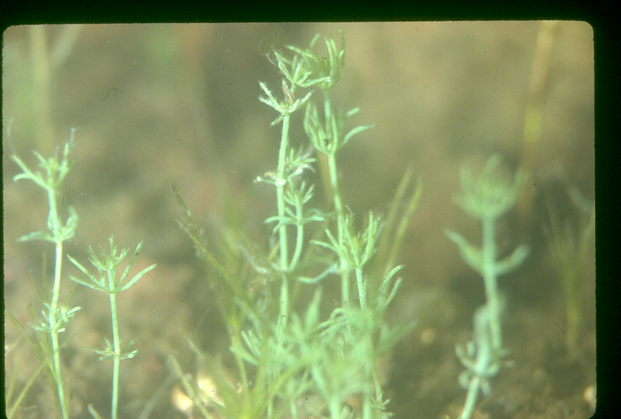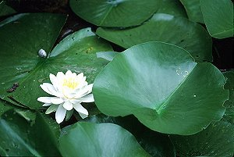

Wisconsin Department of Natural Resources
Eau Claire, WI
April 2006

The Aquatic Plant Community

of

Crooked Lake,

Adams County, Wisconsin

2005

Submitted by:

Deborah Konkel
Wisconsin Department of Natural Resources
Eau Claire, WI
April 2006

Executive Summary
Crooked Lake is a borderline mesotrophic/oligotrophic lake with good-to-very good water quality and clarity. Filamentous algae was common, abundant at depths greater than 1.5 feet. The aquatic plant community colonized approximately two-thirds of the total lake area of Crooked Lake, but colonized 100% of the littoral zone to a maximum rooting depth of 12.5 feet. The 0-1.5ft depth zone supported the most abundant aquatic plant growth.

Chara spp. was the dominant species within the 23-species aquatic plant community, dominating all depth zones and exhibiting a dense form of growth. Nymphaea odorata was sub-dominant, also exhibiting a growth form of above average density. The most common species were found distributed throughout the lake.

An endangered species was found in Crooked Lake, Eleocharis quadrangluata.
The invasive, exotic species, Eurasian watermilfoil, was also found in Crooked Lake. Eurasian milfoil was found at the boat landing and along the shoreline immediately across from the boat landing, occurring scattered in these areas, in water less than 4 feet deep, at low densities.

The Crooked Lake aquatic plant community is characterized by above average quality and very good species diversity. The plant community is in the top quartile of lakes in the region, the group of lakes closest to an undisturbed condition and with an above average tolerance to disturbance.

A healthy aquatic plant community plays a vital role within the lake community. This is due to the role plants play in improving water quality, providing valuable habitat resources for fish and wildlife, resisting invasions of non-native species and checking excessive growth of tolerant species that could crowd out the more sensitive species, thus reducing diversity.

Management Recommendations
- All lake residents shall practice best management on their lake properties.
- Residents should become involved in the Self-Help Volunteer Lake Monitoring Program.
- Adams County should designate sensitive areas within Crooked Lake.
- Lake residents start an ongoing Eurasian watermilfoil removal project.
- Lake residents shall protect natural shoreline around Crooked Lake. Evidence that disturbance on shore is impacting the aquatic plant community is the lower FQI Index lack of the endangered and most sensitive species and higher abundance of the most tolerant species at disturbed sites. Disturbed shoreline sites have a lower quality, less plant species and more filamentous algae as compared to natural shoreline.
- The Lake Association should investigate regulation of boat speed in the shallow water areas to reduce disturbance to the plant beds.
- All lake users shall protect the aquatic plant community in Crooked Lake.
TABLE OF CONTENTS

Page number
INTRODUCTION 1
METHODS 2
RESULTS
Physical Data 3
Macrophyte Data 9
DISCUSSION 19
CONCLUSIONS 22
LITERATURE CITED 27
APPENDICES 28

LIST OF FIGURES
1. Variation in chlorophyll a and phosphorus in Crooked Lake, 1992-2005 5
2. Water clarity in Crooked Lake, 1992-2005 5
3. Sediment distribution in Crooked Lake, 2005 7
4. Frequency of occurrence of aquatic plant species in Crooked Lake, 2005 10
5. Mean density of aquatic plant species in Crooked Lake, July 2005 11
6. Dominance within the aquatic plant community in Crooked Lake, 2005 11
7. Frequency of occurrence of prevalent aquatic plant species by depth zone 12
8. Density of prevalent aquatic plant species in Crooked Lake, by depth zone 12
9. Distribution of aquatic plants in Crooked Lake, 2005 13
10. Location of Eurasian watermilfoil in Crooked Lake, 2005 14
11. Predicted maximum rooting depth based on water clarity, 1992-2005 15
12. Total occurrence and total density of plants in Crooked Lake, by depth zone 16
13. Species Richness in Crooked Lake, by depth zone, 2005 16

LIST OF TABLES
1. Trophic Status 3
2. Sediment Composition in Crooked Lake, 2005 6
3. Shoreline Land Use - Crooked Lake, 2005 8
4. Crooked Lake Aquatic Plant Species, 2005 9
5. Aquatic Macrophyte Community Index, Crooked Lake, 2005 17
6. Floristic Quality and Coefficient of Conservatism of Crooked Lake 18
7. Comparison of the Plant Community at Natural vs Disturbed Shoreline Sites 21
8. Fish and Wildlife Uses of Aquatic Plants in Crooked Lake 23
The Aquatic Plant Community in Crooked Lake,
Adams County, 2005

I. INTRODUCTION
A study of the aquatic macrophytes (plants) in Crooked Lake was conducted during July 2005 by Water Resources staff of the West Central Region - Department of Natural Resources (DNR) and Adams County Land and Water Conservation. This was the first quantitative vegetation study of Crooked Lake by the DNR.

A study of the diversity, density, and distribution of aquatic plants is an essential component of understanding a lake ecosystem due to the important ecological role of aquatic vegetation in the lake and the ability of the vegetation to characterize the water quality (Dennison et al. 1993).

Ecological Role: All other life in the lake depends on the plant life - the beginning of the food chain. Aquatic plants and algae provide food and oxygen for fish, wildlife, and the invertebrates that in turn provide food for other organisms. Plants provide habitat, improve water quality, protect shorelines and lake bottoms, add to the aesthetic quality of the lake and impact recreation.

Characterize Water Quality: Aquatic plants serve as indicators of water quality because of their sensitivity to water quality parameters, such as water clarity and nutrient levels (Dennison et. al. 1993).

The present study will provide information that is important for effective management of the lake, including fish habitat improvement, protection of sensitive habitat, aquatic plant management and water quality protection. The baseline data that it provides will be compared to future aquatic plant inventories and offer insight into changes occurring in the lake.

Background and History: Crooked Lake is a 48-acre seepage lake in southeast Adams County, Wisconsin. Crooked Lake has a maximum depth of 56 feet and a mean depth of 14 feet.

Eurasian watermilfoil was found in Crooked Lake during the survey, at the boat landing and along the shoreline immediately across from the boat landing. This is where fragments from the boat landing likely drifted.

There may have been herbicide treatments in the past for aquatic plant control. Requests for treatment of aquatic plants with arsenic around a swim raft were made in 1948, but no permit applications or treatment records exist; a permit application for chemical treatment of aquatic plants was approved in 1986, but no record exists for chemical treatment; an incomplete permit application for chemical treatment was returned to the riparian in 1989 and no completed application was submitted. The status of these treatment requests is uncertain.
II.METHODS
Field Methods
The study design was based on the rake-sampling method developed by Jessen and Lound (1962), using stratified random placement of the transect lines. The shoreline was divided into 16 equal segments and a transect, perpendicular to the shoreline, was randomly placed within each segment (Appendix IV), using a random numbers table.

One sampling site was randomly located in each depth zone (0-1.5ft, 1.5-5ft, 5-10ft and 10-20ft) along each transect. Using a long-handled, steel, thatching rake, four rake samples were taken at each sampling site, one from each quarter of a 6-foot diameter quadrat. The aquatic plant species that were present on each rake sample were recorded. Each species was given a density rating (0-5), the number of rake samples on which it was present at each sampling site.
a rating of 1 indicates that a species was present on one rake sample at that site
a rating of 2 indicates that a species was present on two rake samples at that site
a rating of 3 indicates that it was present on three rake samples
a rating of 4 indicates that it was present on all four rake samples
a rating of 5 indicates that a species was abundantly present on all 4 rake samples at that site.

Visual inspection and periodic samples were taken between transect lines to record the presence of any species that did not occur at the sampling sites. Specimens of all plant species present were collected and saved in a cooler for later preparation of voucher specimens. Nomenclature was according to Gleason and Cronquist (1991).

The type of shoreline cover was recorded at each transect. A section of shoreline, 50 feet on each side of the transect intercept with the shore and 30 feet deep, was evaluated. The percent cover of each land use category within this 100' x 30' rectangle was visually estimated and verified by a second researcher.

Data Analysis
The percent frequency of each species was calculated (number of sampling sites at which it occurred/total number of sampling sites) (Appendix I). Relative frequency was calculated (number of occurrences of a species/sum of all species occurrences) (Appendix I). The mean density was calculated for each species (sum of a species' density ratings/number of sampling sites) (Appendix II). Relative density was calculated (sum of a species density/sum of all plant densities). "Mean density where present" was calculated for each species (sum of a species' density ratings/number of sampling sites at which the species occurred) (Appendix II). The relative frequency and relative density of each species were summed to obtain a dominance value for each species (Appendix III). Species diversity was measured by Simpson's Diversity Index (Appendix I).

The Aquatic Macrophyte Community Index (AMCI) developed by Nichols (2000) was applied to Crooked Lake. Measures for each of seven categories that characterize a plant community are converted to values between 0 and 10 and summed to measure the quality of the plant community.

The Average Coefficient of Conservatism and Floristic Quality Index were calculated, as outlined by Nichols (1998), to measure disturbance in the plant community. A coefficient of conservatism is an assigned value, 0-10, the probability that a species will occur in an undisturbed habitat. The Average Coefficient of Conservatism is the mean of the coefficients for all species found in the lake. The Floristic Quality Index is calculated from the Coefficient of Conservatism (Nichols 1998) and is a measure of a plant community's closeness to an undisturbed condition.

III. RESULTS
PHYSICAL DATA
Many physical parameters impact the aquatic plant community. Water quality (nutrients, algae, water clarity and water hardness) influence the plant community as the plant community can in turn modify these parameters. Lake morphology, sediment composition and shoreline use also impact the aquatic plant community.

WATER QUALITY - The trophic state of a lake is a classification of its water quality. Phosphorus concentration, chlorophyll concentration and water clarity data are collected and combined to determine the trophic state.
Eutrophic lakes are high in nutrients and support a large biomass.
Oligotrophic lakes are low in nutrients and support limited plant growth and smaller populations of fish.
Mesotrophic lakes have intermediate levels of nutrients and biomass.

Nutrients
Phosphorus is a limiting nutrient in many Wisconsin lakes and is measured as an indication of nutrient enrichment in a lake. Increases in phosphorus in a lake can feed algae blooms and, occasionally, excess plant growth.
2005 Mean Summer Phosphorus concentration in Crooked Lake: 20.7 ug/l
This concentration of phosphorus in Crooked Lake is indicative of a mesotrophic lake (Table 1).

Table 1. Trophic Status
 | Quality Index | Phosphorus ug/l | Chlorophyll ug/l | Secchi Disc ft.
Oligotrophic | Excellent | <1 | <1 | > 19
 | Very Good | 1-10 | 1-5 | 8-19
Mesotrophic | Good | 10-30 | 5-10 | 6-8
 | Fair | 30-50 | 10-15 | 5-6
Eutrophic | Poor | 50-150 | 15-30 | 3-4
Crooked Lake 2004 Mean Summer | Very Good | 20.7 | 4.6 | 10.3
After Lillie & Mason (1983) & Shaw et. al. (1993)

Algae
Chlorophyll concentrations provide a measure of the amount of algae in lake water. Algae are natural and essential in lakes, but high algae populations can increase turbidity and reduce the light available for plant growth.
2004 Mean summer chlorophyll concentration in Crooked Lake: 4.6 ug/l.
The chlorophyll concentration in Crooked Lake was in the oligotrophic range (Table 1).

Filamentous algae occurred at 38% of all sample sites in 2005. Filamentous algae occurred at:
12% of the sites in the 0-1.5ft depth zone
50% of the sites in the 1.5-5ft depth zone
44% of the sites in the 5-10ft depth zone
46% of the sites in the 10-20ft depth zone

Water Clarity
Water clarity is a critical factor for aquatic plants. When plants receive less than 1 - 2% of the surface illumination, they can not survive. Water clarity is reduced by turbidity (suspended materials such as algae and silt) and dissolved organic chemicals that color the water. Water clarity is measured with a Secchi disc that shows the combined effect of turbidity and color
2004 Mean Summer Secchi Disc clarity in Crooked Lake was 10.3 ft.
Water clarity indicates (Table 1) that Crooked Lake was an oligotrophic lake with very good water clarity.

The combination of phosphorus concentration, chlorophyll concentration and water clarity indicates that Crooked Lake is a borderline oligotrophic/mesotrophic lake with good-to-very good water quality. This trophic state should favor moderate plant growth and occasional summer algae blooms.

Water quality was sampled in Crooked Lake by the DNR in 1992 and Adams County Land Conservation staff in 2004 and 2005. The sampling has not been conducted long enough or frequent enough to reveal trends. Chlorophyll (algae) and water clarity have varied within the oligotrophic range (Figure 1, 2) during the years sampled. Phosphorus (nutrients) has varied between oligotrophic and mesotrophic (Figure 1). Much of the nutrients may be going into filamentous algae growth, resulting in better water clarity and lower chlorophyll than would be predicted based on nutrient concentration.

Figure 1. Variation in chlorophyll a and phosphorus concentration in Crooked Lake, 1992-2005.
Figure 2. Water clarity in Crooked Lake, 1992-2005.

Hardness
The hardness or mineral content of lake water also influences aquatic plant growth. The 2004-2005 hardness values in Crooked Lake ranged from of 172-201mg/l CaCO3. Lakes with hardness values greater than 120mg/l CaCO3 are considered hard water lakes. Hard water lakes tend to support more plant growth than soft water lakes.

LAKE MORPHOMETRY - The morphometry of a lake is an important factor in determining the distribution of aquatic plants. Duarte and Kalff (1986) found that the slope of the littoral zone could explain 72% of the observed variability in the growth of submerged plants. Gentle slopes support more plant growth than steep slopes (Engel 1985).

Crooked Lake has an irregularly-shaped basin with a gradually-sloped littoral zone and shallow depths in the northern three-quarters of the lake. The south quarter of the lake has more steeply-sloped littoral zone (Appendix IV). Gradual slopes provide a more stable rooting base and broader area of shallow water that would favor plant growth.

SEDIMENT COMPOSITION – The most common sediment in Crooked Lake was peat, especially at depths greater than 5 feet (Table 2). Marl/silt mixtures were common overall and were most common in the shallowest zone (0-1.5ft). Marl and mixtures of marl with other sediment types were also common in the 1.5-5ft depth zone (Figure 3).

Table 2. Sediment Composition: Crooked Lake, 2005
Sediment Type |  | 0-1.5' Depth | 1.5-5' Depth | 5-10' Depth | 10-20’ Depth | Percent of all Sample Sites
Soft  Sediments | Peat | 12% | 19% | 38% | 33% | 25%
Soft  Sediments | Marl/Silt | 31% | 25% | 12% | 25% | 23%
Soft  Sediments | Marl | 12% | 25% | 19% | 17% | 18%
Soft  Sediments | Silt | 6% | 12% |  | 17% | 8%
Soft  Sediments | Marl/Peat |  | 25% | 19% | 8% | 8%
Soft  Sediments | Peat/Silt |  | 12% | 12% |  | 7%
Soft  Sediments | Muck/Peat | 19% |  |  |  | 5%
Mixed  Sediments | Sand/Marl | 19% |  |  |  | 5%

INFLUENCE OF SEDIMENT - Some plants depend on the sediment in which they are rooted for their nutrients. The richness or sterility and texture of the sediment will determine the type and abundance of plant species that can survive in a location. The availability of mineral nutrients for growth is highest in sediments of intermediate density, such as silt, so these sediments are considered most favorable for plant growth (Barko and Smart 1986).

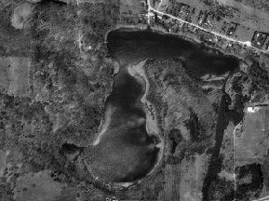
Peat Sediment - Flocculent
Mixed Sediment Types
Marl Sediment

Silt Sediment – Most Favorable for Plant Growth

Figure 3. Sediment distribution in Crooked Lake, 2005.
Peat was the overall dominant sediment found in Crooked Lake and can be limiting for plant growth due to its flocculent nature. Silt, the most favorable sediment for plant growth was not commonly occurring in Crooked Lake, except it was common when mixed with marl sediment. All sites were vegetated in Crooked Lake, irregardless of the sediment type. It appears that sediment is not a major factor determining plant distribution in Crooked Lake.

SHORELINE LAND USE – Land use can strongly impact the aquatic plant community and therefore the entire aquatic community. Land use can directly impact the plant community through increased erosion and sedimentation and increased run-off of nutrients, fertilizers and toxics applied to the land. These impacts occur in both rural and residential settings.

Native herbaceous plant cover was the most frequently encountered shoreline cover at the transects and had the highest mean coverage. Wooded and shrub cover also had high occurrences and coverage (Table 3).

Table 3. Shoreline Land Use - Crooked Lake, 2005
Cover Type |  | Frequency of Occurrences at Transects | Mean % Coverage
Natural  Shoreline | Native Herbaceous | 100% | 53%
Natural  Shoreline | Wooded | 62% | 20%
Natural  Shoreline | Shrub | 81% | 20%
Total Natural |  |  | 93%
Disturbed  Shoreline | Cultivated Lawn | 12% | 6%
Total Disturbed |  |  | 6%

Some type of natural shoreline (wooded, shrub, native herbaceous) was found at all of the sites, having a mean coverage of 93%.

A type of disturbed shoreline, cultivated lawn covered 6% of the shore (Table 3).

MACROPHYTE DATA
SPECIES PRESENT
Of the 23 species found in Crooked Lake, 7 were emergent species, 4 were floating-leaf species and 12 were submergent species (Table 4).
One endangered species was found: Eleocharis quadrangulata
One exotic invasive species was found: Myriophyllum spicatum

Table 4. Crooked Lake Aquatic Plant Species, 2005
Scientific Name Common Name I. D. Code
_____________________________________________________________________
Emergent Species
1) Carex spp. sedge carsp
2) Eleocharis quadrangulata (Michx.) Roem&Schult square-stem spikerush elequ
3) Eleocharis smallii Britt. creeping spikerush elesm
4) Sagittaria spp. arrowhead sagsp
5) Scirpus validus Vahl. softstem bulrush sciva
6) Sparganium eurycarpum Engelm. giant bur-reed spaeu
7) Typha latifolia L. common cattail typla

Floating-leaf Species
8) Lemna minor L. small duckweed lemmi
9) Nuphar variegata Durand. bull-head pond lily nupva
10) Nymphaea odorata Aiton. white water lily nymod
11) Spirodela polyrhiza (L.) Schleiden. great duckweed spipo

Submergent Species
12) Ceratophyllum demersum L. coontail cerde
13) Chara sp. muskgrass chasp
14) Myriophyllum heterophyllum Michx. variable-leaf watermilfoil myrhe
15) Myriophyllum sibiricum Komarov. common watermilfoil myrsi
16) Myriophyllum spicatum L. Eurasian watermilfoil myrsp
17) Najas flexilis (Willd.) Rostkov & Schmidt. slender naiad najfl
18) Potamogeton gramineus L. variable-leaf pondweed potgr
19) Potamogeton natans L. floating-leaf pondweed potna
20) Potamogeton pectinatus L. sago pondweed potpe
21) Potamogeton zosteriformis Fern. flatstem pondweed potzo
22) Utricularia gibba L. small bladderwort utrgi
23) Utricularia vulgaris L. great bladderwort utrvu
FREQUENCY OF OCCURRENCE
Chara spp. was the most frequently occurring species in Crooked Lake in 2005, (97% of sample sites) (Figure 4). Myriophyllum sibiricum, Nuphar variegata, Nymphaea odorata, Potamogeton natans, P. zosteriformis, Scirpus validus and Utricularia vulgaris were also commonly occurring species, (44%, 23%, 64%, 30%, 23%, 31%, 43% respectively).
Figure 4. Frequency of occurrence of aquatic plant species in Crooked Lake, 2005.

DENSITY
Chara spp. was also the species with the highest mean density in Crooked Lake (3.59 on a density scale of 0-4) (Figure 5).

Chara spp. had a “mean density where present” of 3.71 (Appendix II). The “mean density where present” indicates that, where Chara occurred, it exhibited a dense growth form in Crooked Lake. Eleocharis quadrangulata, Nymphaea odorata and Scirpus validus also had “densities where present” of 2.5 or more, indicating that they also exhibited an aggregated growth form or a growth form of above average density (Appendix II). However, E. quadrangulata was aggregated in only one area in Crooked Lake and was not commonly occurring.
Figure 5. Mean density of aquatic plant species in Crooked Lake, July 2005.

DOMINANCE
Combining the relative frequency and relative density of a species into a Dominance Value illustrates how dominant that species is within the aquatic plant community (Appendix III). Based on the Dominance Value, Chara spp. was the dominant aquatic plant species in Crooked Lake (Figure 6). Nymphaea odorata was sub-dominant.
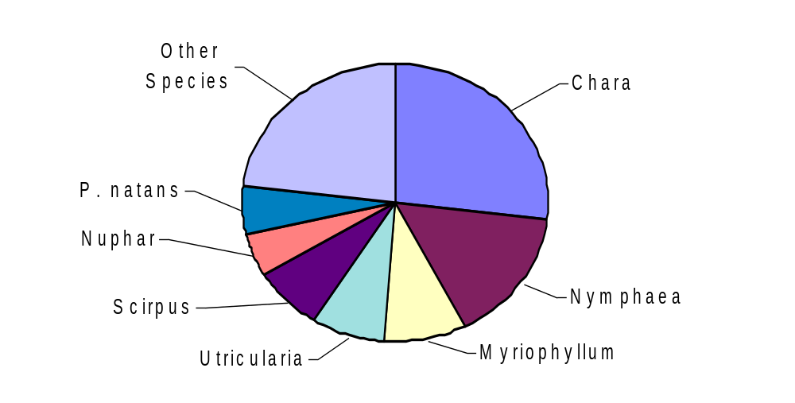
Figure 6. Dominance within the aquatic plant community, of the most prevalent
species in Crooked Lake, 2005.
Chara spp., the dominant species overall, dominated all depth zones. Chara occurred at its highest frequency and density in the 1.5-5ft depth zone (Figure 7, 8).

Figure 7. Frequency of occurrence of prevalent aquatic plant species in Crooked
Lake, by depth zone, 2005.

Figure 8. Density of prevalent plant species in Crooked Lake by depth zone, 2005.

DISTRIBUTION
Aquatic plants occurred throughout the entire littoral zone of Crooked Lake, at all of the sampling sites to a maximum rooting depth of 12.5 feet (Figure 9). Approximately 32 acres of the lake (67%) was vegetated. Of these 32 acres, about 15 acres (31% of the lake) supported floating-leaf vegetation and about 2 acres (4% of the lake) supported emergent vegetation. Chara was found at the greatest depth (19 feet) but is not a truly
Submergent Vegetation
Floating-leaf (Lily Beds)
Emergent Vegetation

Figure 9. Distribution of aquatic vegetation in Crooked Lake, 2005.

Figure 10. Location of Eurasian watermilfoil in Crooked Lake, July 2005.
rooted species. Potamogeton zosteriformis occurred at the maximum rooting depth. The dominant and common plant species were found throughout the lake.

Myriophyllum spicatum, Eurasian watermilfoil, was found in Crooked Lake at the boat landing and along the shoreline immediately across from the boat landing. This is where fragments from the boat landing likely drifted. M. spicatum occurred scattered along the shore opposite the landing, at low densities at depths up to 4 feet (Figure 10) and ranked at the bottom as far as species abundance (Appendices I-III).

Secchi disc water clarity data can be used to calculate a predicted maximum rooting depth for plants in a lake (Dunst 1982).
Predicted Rooting Depth (ft.) = (Secchi Disc (ft.) * 1.22) + 2.73
Based on the 2005 Secchi disc clarity, the predicted maximum rooting depth in Crooked Lake would be 15.3 ft.
The actual maximum rooting depth is less than the predicted maximum rooting depth based on water clarity for 2005 (Figure 11) and may be due to the steep littoral zone in the deeper areas of the lake. These steep slopes provide a less stable base for plant colonization.

Figure 11. Predicted maximum rooting depth based on water clarity, 1992-2005.

The 0-1.5ft depth zone supported the greatest amount of plant growth. The highest total occurrence and total density of plant growth was recorded in the 0-1.5ft depth zone (Figure 12) and declined with increasing depth.

Figure 12. Total occurrence and total density of plants in Crooked Lake by depth zone.

The greatest species richness (mean number of species per site) was also recorded in the 0-1.5 ft. depth zone (Figure 13), declining with increasing depth. Overall species richness in Crooked Lake was 4.6 species per site.

Figure 13. Species richness in Crooked Lake, by depth zone, 2005.
THE COMMUNITY
Simpson's Diversity Index was 0.90, indicating very good species diversity. A rating of 1.0 would mean that each plant in the lake was a different species (the most diversity achievable).

The Aquatic Macrophyte Community Index (AMCI) for Crooked Lake (Table 5) is 53. This value is above average for lakes in the North Central Hardwoods Region and average for lakes in Wisconsin and indicates that the aquatic plant community in Crooked Lake is of average to above average quality.

Table 5. Aquatic Macrophyte Community Index, Crooked Lake 2005
Category |  | Value
Maximum Rooting Depth | 3.8 meters | 7
% Littoral Zone Vegetated | 100% | 10
% Submergent Species | 65% Relative Freq. | 6
# of Species | 25 | 9
% Exotic Species | 0.4% | 6
Simpson's Diversity Index | 0.899 | 8
% Sensitive Species | 16.5% Relative Freq. | 7
Totals |  | 53
* The highest value for this index is 70.

The Average Coefficient of Conservatism for Crooked Lake was in the lowest quartile of Wisconsin lakes and below average for lakes in the North Central Hardwood Region (Table 6). This suggests that the aquatic plant community in Crooked Lake is less sensitive to disturbance than the average lake in the region and among the lakes in the state least sensitive to disturbance. This is likely due to selection of species by past disturbance.

Table 6. Floristic Quality and Coefficient of Conservatism of Crooked Lake, Compared to Wisconsin Lakes and Northern Wisconsin Lakes.
 | Average Coefficient of Conservatism † | Floristic Quality ‡
Wisconsin Lakes | 5.5, 6.0, 6.9 * | 16.9, 22.2, 27.5
NCHR | 5.2, 5.6, 5.8 * | 17.0, 20.9, 24.4
Crooked Lake 2005 | 5.48 | 25.10
* - Values indicate the highest value of the lowest quartile, the mean and the lowest value of the upper quartile.
† - Average Coefficient of Conservatism for all Wisconsin lakes ranged from a low of 2.0 (the most disturbance tolerant) to a high of 9.5 (least disturbance tolerant).
‡ - lowest Floristic Quality was 3.0 (farthest from an undisturbed condition) and the high was 44.6 (closest to an undisturbed condition).

The Floristic Quality Index of the aquatic plant community in Crooked Lake was above average for Wisconsin lakes and in the highest quartile of North Central Hardwood Region lakes (Table 67). This indicates that the plant community in Crooked Lake is closer to an undisturbed condition than the average lake in Wisconsin and within the group of lakes in the region closest to an undisturbed condition.

Disturbances can be of many types:
- Physical disturbances to the plant beds result from activities such as boat traffic, plant harvesting, chemical treatments, the placement of docks and other structures and fluctuating water levels.
- Indirect disturbances are the result of factors that impact water clarity and thus stress species that are more sensitive: resuspension of sediments, sedimentation from erosion and increased algae growth due to nutrient inputs.
- Biological disturbances include competition from the introduction of a non-native or invasive plant species, grazing from an increased population of aquatic herbivores and destruction of plant beds by a fish or wildlife population.

The major disturbances in Crooked Lake are likely:
- the introduction of non-native aquatic plant species
- damage by motor boats in the shallow water areas
IV. DISCUSSION
Based on water clarity, chlorophyll and phosphorus data, Crooked Lake is a borderline oligotrophic/mesotrophic lake with good-to-very good water clarity and water quality. Filamentous algae occurred at 38% of the sites and was abundant at depths greater than 1.5 feet.

Adequate nutrients, good water clarity, hard water, the large shallow areas in the lake and the gradually sloped littoral zone in Crooked Lake would favor plant growth.

Aquatic plants colonized 67% of the lake area (32 acres), but throughout the entire littoral zone, to a maximum rooting depth of 12.5 feet. Potamogeton zosteriformis occurred at the maximum rooting depth. The highest total occurrence of plants, highest total density of plants and the greatest species richness occurred in the 0-1.5ft depth zone. Overall species richness was 4.6.

Twenty-three (23) species of aquatic plants were recorded in Crooked Lake in 2005.
•Chara spp. was the dominant plant species in Crooked Lake. It dominated all depth zones, was found at nearly every sample site, grew in water up to 19 feet deep and exhibited a dense form of growth in Crooked Lake.
•Nymphaea odorata was sub-dominant and also grew at above average densities. •The endangered species, Eleocharis quadrangulata, was found along the south shore of the lake.
Six (6) other species were commonly occurring and two (2) other species exhibited an aggregated or dense growth form in Crooked Lake. However, the other species that exhibited dense growth forms were not common and occurred at limited locations in the lake. The dominant and common species were found throughout the lake.

Eurasian watermilfoil was found in Crooked Lake at the boat landing and along the shoreline immediately across from the boat landing. This is where fragments from the boat landing likely drifted. Eurasian watermilfoil occurred scattered in these areas, in water less than 4 feet deep, at low densities and was one of the least abundant species in Crooked Lake.

The Aquatic Macrophyte Community Index (AMCI) for Crooked Lake was 54, indicating that the quality of the plant community in Crooked Lake is above average for lakes in Wisconsin and the region. Simpson's Diversity Index (0.90) indicates that the aquatic plant community had a very good diversity of plant species.

The Average Coefficient of Conservatism and the Floristic Quality Index indicate that Crooked Lake has a below average sensitivity to disturbance and is in the upper quartile of lakes (top 25%) in the North Central Hardwood Region, the group of lakes in the region closest to an undisturbed condition. When compare to lakes over the whole state, Crooked Lake was above average, closer to an undisturbed condition than the average lake. Damage by motor boats in the shallow areas and the introduction of Eurasian watermilfoil are likely the biggest disturbance in Crooked Lake.

Shoreline Impacts
Crooked Lake has protection from abundant natural shoreline cover (wooded, shrub, native herbaceous growth), 93% of the shore. Cultivated lawn occurred in a few locations.

Shorelines with cultivated lawn can impact the plant community through increased run-off of lawn fertilizers, pesticides and pet wastes into the lake and also speed run-off to the lake without filtering these pollutants. Protecting the buffer of natural vegetation around Crooked Lake will help prevent shoreline erosion and reduce additional nutrient/chemical run-off that can add to algae growth and sedimentation of the lake bottom.

To determine if there was a difference in the aquatic plant community at the sites with lawn, the aquatic plant transect sites off sites with 100% natural shoreline were compared to aquatic plant transect sites off shoreline that contained any amount lawn or other disturbance (Appendices V-VIII).

The comparison of various parameters indicate that disturbance on the shore has impacted the aquatic plant community at those sites. The Floristic Quality Index indicates that the aquatic plant community at natural shoreline sites is closer to an undisturbed condition (within the upper quartile of region lakes – group closest to undisturbed condition) than the plant community at the disturbed sites (closer to undisturbed than the average lake in the region) (Table 7). The most sensitive species (the endangered Eleocharis qualdrangulata and sensitive Utricularia gibba) in Crooked Lake (Nichols 2000) occurred only at natural shoreline transects (Table 7). Conversely, the most disturbance tolerant species in Crooked Lake (cattail) occurred at a higher frequency at disturbed shoreline transects and where it occurred exhibited a dense growth form (Table 7). This corroborates the impact disturbed shoreline has on the aquatic plant community.

These small areas of disturbance in Crooked Lake have been impacted. The quality of the plant community at natural shoreline sites (Aquatic Plant Community Index) was slightly higher (Table 7), indicating that natural shoreline supported a slightly higher quality aquatic plant community.

The disturbance has impacted the habitat in the lake. The number of species recorded at natural shoreline sites was greater, hinting at greater diversity that would support greater diversity in the fish and wildlife community.

Filamentous algae had a slightly higher occurrence at disturbed shoreline and may suggest nutrient enrichment at developed shores (Table 7) from lawn fertilizers, failing or poorly maintained septic systems, pet wastes and poorer filtering capacity of mowed lawn.

Table 7. Comparison of the Aquatic Plant Community at Natural Shoreline Sites and Disturbed Shoreline Sites.
Parameter |  | Natural Shoreline | Disturbed Shoreline
Floristic Quality Index |  | 25.10 | 22.00
AMCI |  | 53 | 52
Number of Species |  | 22 | 17
Most Tolerant Species Cattail | Frequency | 5% | 12%
Most Tolerant Species Cattail | Density where present | 1.33 | 3.00
Most Sensitive Species | Eleocharis quadrangulata | 2% | 0%
Most Sensitive Species | Utricularia gibba | 2% | 0%
Filamentous Algae Occurrence |  | 36% | 38%

V. CONCLUSIONS
Crooked Lake is a borderline mesotrophic/oligotrophic lake with good-to-very good water quality and clarity. Filamentous algae was common, occurring at more than one-third of the sites, and abundant at depths greater than 1.5 feet.

The aquatic plant community colonized approximately two-thirds of Crooked Lake. However, 100% of the littoral zone was vegetated, to a maximum rooting depth of 12.5 feet. The 0-1.5ft depth zone supported the most abundant aquatic plant growth.

Chara spp. was the dominant species within the 23-species aquatic plant community, dominating all depth zones and exhibiting a dense form of growth. Nymphaea odorata was sub-dominant, also exhibiting a growth form of above average density. The most common species were found distributed throughout the lake.

An endangered species was found in Crooked Lake, Eleocharis quadrangluata.
The invasive, exotic species, Eurasian watermilfoil, was also found in Crooked Lake. Eurasian milfoil was found at the boat landing and along the shoreline immediately across from the boat landing, occurring scattered in these areas, in water less than 4 feet deep, at low densities.

The Crooked Lake aquatic plant community is characterized by above average quality and very good species diversity. The plant community is in the top quartile of lakes in the region, the group of lakes closest to an undisturbed condition and with an above average tolerance to disturbance.

A healthy aquatic plant community plays a vital role within the lake community. This is due to the role plants play in
1) improving water quality 2) providing valuable habitat resources for fish and wildlife 3) resisting invasions of non-native species and 4) checking excessive growth of tolerant species that could crowd out the more sensitive species, thus reducing diversity.

Aquatic plant communities improve water quality in many ways (Engel 1985):
they trap nutrients, debris, and pollutants entering a water body;
they absorb and break down some pollutants;
they reduce erosion by damping wave action and stabilizing shorelines and lake
bottoms;
they remove nutrients that would otherwise be available for algae blooms.

Aquatic plant communities provide important fishery and wildlife resources. Plants and algae start the food chain that supports many levels of wildlife, and at the same time produce oxygen needed by animals. Plants are used as food, cover and nesting/spawning sites by a variety of wildlife and fish (Table 8). Plant cover within the littoral zone of Crooked Lake is 100% and over the whole lake is 75% and is appropriate (25-85%) to support a balanced fishery.

Table 8. Wildlife and Fish Use of Aquatic Plants in Crooked Lake
Aquatic Plants | Fish | Water  Fowl | Song and Shore  Birds | Upland Game  Birds | Muskrat | Beaver | Deer
Submergent Plants
Ceratophyllum demersum | F,I*, C, S | F(Seeds*), I, C |  |  | F
Chara sp. | F*, S | F*, I*
Myriophyllum heterophyllum | I*, C | I* F(Seeds, Foliage)
Myriophyllum sibiricum | F*, I*, S | F(Seeds, Foliage) | F(Seeds) |  | F
Myriophyllum spicatum | F, C
Najas flexilis | F, C | F*(Seeds, Foliage) | F(Seeds)
Potamogeton gramineus | F, I, S*,C | F*(Seeds, Tubers) |  |  | F* | F | F
Potamogeton natans | F, I, S*,C | F*(Seeds, Tubers) |  |  | F* | F | F
Potamogeton pectinatus | F, I, S*,C | F* |  |  | F* | F | F
Potamogeton zosteriformis | F, I, S*,C | F*(Seeds) |  |  | F* | F | F
Utricularia gibba | F, C, I* | I* |  |  | F
Floating-leaf Plants
Lemna minor | F | F*, I | F | F | F | F
Nuphar variegata | F,C, I, S | F, I | F |  | F* | F | F*
Nymphaea odorata | F,I, S, C | F(Seeds) | F |  | F | F | F
Spirodela polyrhiza | F | F |  | F

Aquatic Plants | Fish | Water  Fowl | Song and Shore  Birds |  | Upland Game  Birds | Muskrat |  | Beaver | Deer
Emergent Plants
Carex spp. | S* | F*(Seeds), C | F*(Seeds) |  | F*(Seeds) | F |  | F | F
Eleocharis smallii (palustris) | I | F, C
Eleocharis quadrangulata |  | F
Sagittaria sp. |  | F*, C | F(Seeds), C |  | F, C | F |  | F
Scirpus validus | F, C, I | F (Seeds)*, C | F(Seeds, Tubers), C |  | F (Seeds) | F |  | F | F
Sparganium eurycarpum | I | F(Seeds), C | F, C |  |  |  | F |  | F*
Typha latifolia | I, C, S | F(Entire), C | F(Seeds), C, Nest |  | Nest | F* (Entire), C*, Lodge |  | F
F=Food, I= Shelters Invertbrates, a valuble food source C=Cover, S=Spawning
*=Valuable Resource in this category
*Current knowledge as to plant use. Other plants may have uses that have not been determined.
After Fassett, N. C. 1957. A Manual of Aquatic Plants. University of Wisconsin Press. Madison, WI
Nichols, S. A. 1991. Attributes of Wisconsin Lake Plants. Wisconsin Geological and Natural History Survey. Info. Circ. #73

Compared to non-vegetated lake bottoms, plant beds support larger, more diverse invertebrate populations that in turn will support larger and more diverse fish and wildlife populations (Engel 1985). Additionally, mixed stands of aquatic plants support 3-8 times as many invertebrates and fish as monocultural stands (Engel 1990). Diversity in the plant community creates more microhabitats for the preferences of more species. Aquatic plant beds of moderate density support adequate numbers of small fish without restricting the movement of predatory fish (Engel 1990).
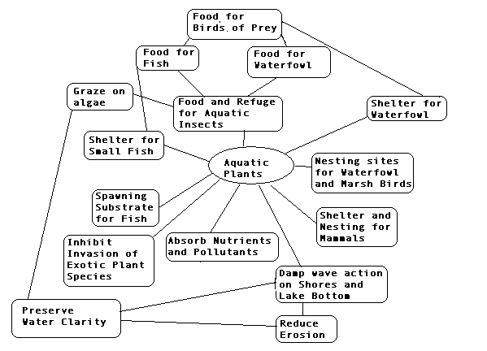
Management Recommendations
- All lake residents practice best management on their lake properties. Crooked Lake is borderline between oligotrophic and mesotrophic. A small increase in nutrients could push the lake into another trophic state, resulting in noticeably worse water quality. Conversely, reducing nutrients could have a noticeable favorable impact on water quality.
    - Keep septic systems cleaned and in proper condition
    - Use no lawn fertilizers
    - Clean up pet wastes
    - Do not compost near the water or allow yard wastes and clippings to enter the lake
- Residents become involved in the Self-Help Volunteer Lake Monitoring Program, monitoring water quality to track seasonal and year-to-year changes.
- Adams County should designate sensitive areas within Crooked Lake. These are areas within the lake that are most important for habitat and maintaining water quality and for preserving endangered and rare species.
- Lake residents attempt an ongoing Eurasian watermilfoil removal project. This exotic species should be controlled and maybe eliminated before it spreads. Initially, hand-pulling could be attempted.
- Lake residents protect natural shoreline around Crooked Lake. Crooked Lake has protection from natural shoreline buffers. Cultivated lawn covers 6% of the shore. Comparison of the plant communities at natural shoreline and the small amount of disturbed shoreline on the lake show that shoreline disturbance is impacting the aquatic plant community. Evidence that disturbance on shore is impacting the plant community in the water is that disturbed shoreline sites in Crooked Lake have a lower FQI Index (farther from an undisturbed condition), does not support lower the endangered and most sensitive species and supports a higher frequency and density of the most tolerant species. Disturbed shoreline sites support an aquatic plant community:
  - of lower quality (AMCI Index)
  - with fewer plant species that may support less diversity in the fish and wildlife community
  - that is impacted by nutrient enrichment. Filamentous algae occurred at a higher percentage of sites at disturbed shoreline as compared to natural shoreline.
- The Lake Association investigate regulation of boat speed in the shallow water areas to reduce disturbance to the plant beds.
- All lake users protect the aquatic plant community in Crooked Lake. The standing-water emergent community, floating-leaf community and submergent plant community are all unique plant communities. Each of these plant communities provides their own benefits for fish and wildlife habitat and water quality protection.

LITERATURE CITED
Barko, J. and R. Smart. 1986. Sediment-related mechanisms of growth limitation in submersed macrophytes. Ecology 61:1328-1340.

Dennison, W., R. Orth, K. Moore, J. Stevenson, V. Carter, S.Kollar, P. Bergstrom, and R. Batuik. 1993. Assessing water quality with submersed vegetation. BioScience 43(2):86-94.

Duarte, Carlos M. and Jacob Kalff. 1986. Littoral slope as a predictor of the maximum biomass of submerged macrophyte communities. Limnol. Oceanogr. 31(5):1072-1080.

Dunst, R.C. 1982. Sediment problems and lake restoration in Wisconsin. Environmental International 7:87-92.

Engel, Sandy. 1990. Ecosystem Response to Growth and Control of Submerged Macrophytes: A Literature Review. Technical Bulletin #170. Wisconsin Department of Natural Resources. Madison, WI.

Engel, Sandy. 1985. Aquatic Community Interactions of Submerged Macrophytes. Wisconsin Department of Natural Resources. Technical Bulletin No. 156. Madison, WI

Fassett, Norman C. 1957. A Manual of Aquatic Plants. University of Wisconsin Press. Madison, WI.

Gleason, H. and A. Cronquist. 1991. Manual of Vascular Plants of Northeastern United States and Adjacent Canada (Second Edition). New York Botanical Gardens, NY.

Jessen, Robert and Richard Lound. 1962. An evaluation of a survey technique for submerged aquatic plants. Minnesota Department of Conservation. Game Investigational Report No. 6.

Lillie, R. and J. Mason. 1983. Limnological Characteristics of Wisconsin Lakes. Wisconsin Department of Natural Resources Tech. Bull. #138. Madison, WI.

Nichols, Stanley, S. Weber, B. Shaw. 2000. A proposed aquatic plant community biotic index for Wisconsin lakes. Environmental Management 26:491-502.

Nichols, Stanley. 1998. Floristic quality assessment of Wisconsin lake plant communities with example applications. Journal of Lake and Reservoir Management 15(2):133-141.

Nichols, Stanley A. and James G. Vennie. 1991. Attributes of Wisconsin Lake Plants. Wisconsin Geological and Natural History Survey. Information Circular 73.

Shaw, B, C. Mechenich and L. Klessig. 1993. Understanding Lake Data. University of Wisconsin – Extension. Madison, WI

Appendix IV. Aquatic Plant Study Transect Location on Crooked Lake, 2005
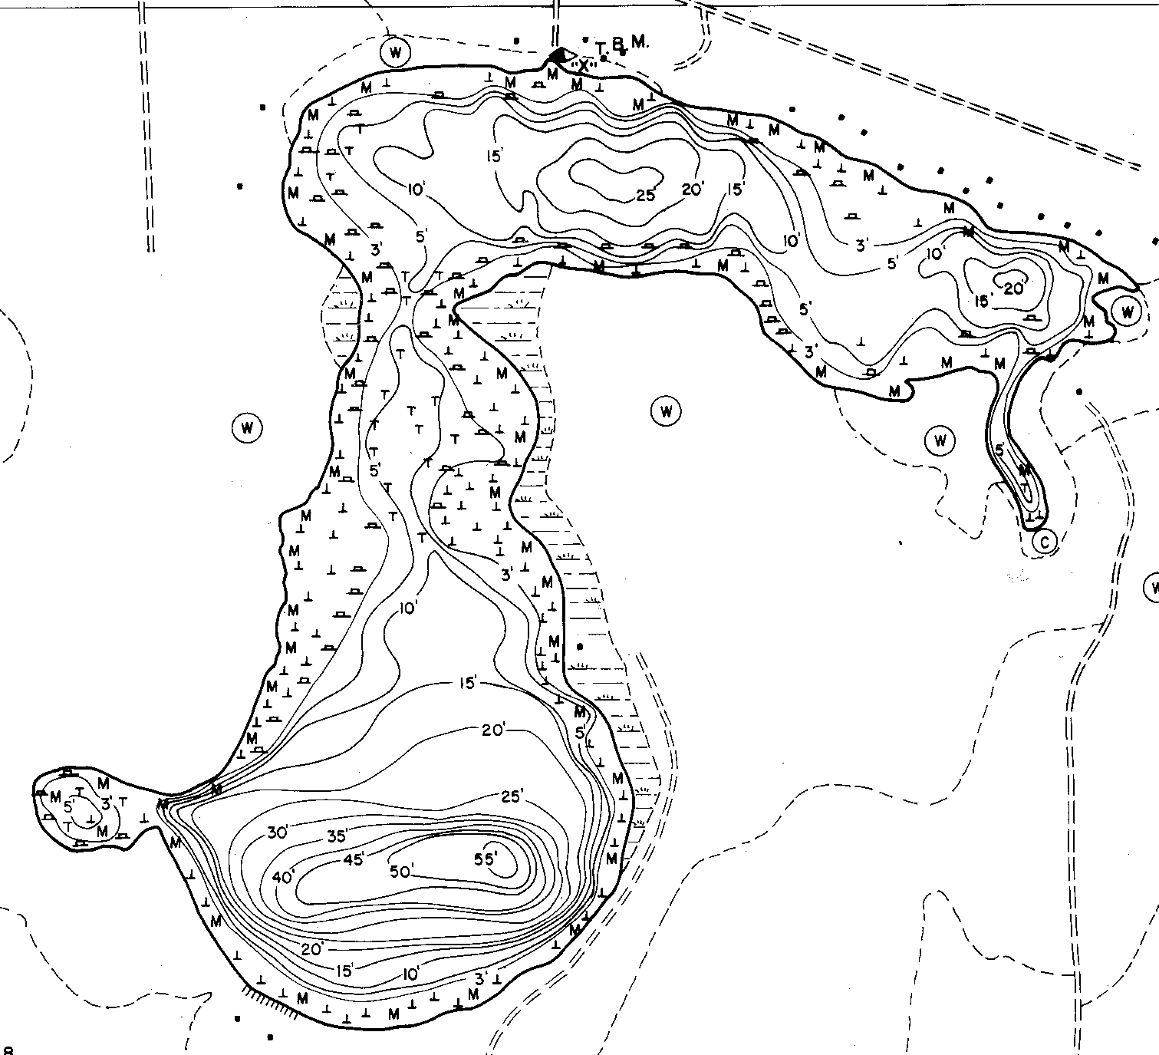
16
15
14
13
12
11
10
9
3
8
7
6
5
4
1
2

