The Aquatic Plant Community
of
Fenner Lake,

Adams County, Wisconsin

2005
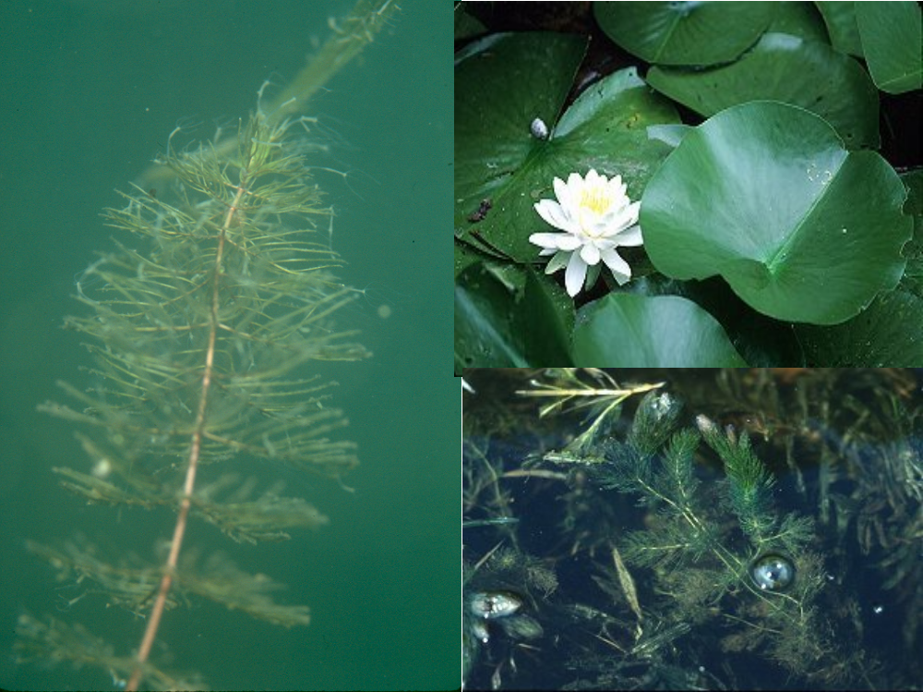

Wisconsin Department of Natural Resources
Eau Claire, WI
March 2006

The Aquatic Plant Community

of

Fenner Lake,

Adams County, Wisconsin

2005

Submitted by:

Deborah Konkel
Wisconsin Department of Natural Resources
Eau Claire, WI
March 2006

Executive Summary
Fenner Lake is a mesotrophic lake with good water quality and clarity. Water clarity has decreased since 1993. Filamentous algae is common in Fenner Lake, abundant in the 10-20ft depth zone. The aquatic plant community colonized approximately three-quarters of Fenner Lake, 100% of the littoral zone to a maximum rooting depth of 15 feet. The 0-1.5ft depth zone supported the most abundant aquatic plant growth.

Myriophyllum sibiricum was the dominant species within the 29-species aquatic plant community, especially in the 5-10ft depth zone. Nymphaea odorata and Ceratophyllum demersum were sub-dominant. The most common species were found distributed throughout the lake. The Fenner Lake aquatic plant community is characterized by high quality and excellent species diversity. The plant community is in the top quartile of lakes in the state and region, the group of lakes closest to an undisturbed condition and with an average sensitivity to disturbance.

Eurasian watermilfoil, an exotic invasive species was found near the boat landing, but was not observed at other locations in the lake.

A healthy aquatic plant community plays a vital role within the lake community. This is due to the role plants play in improving water quality, providing valuable habitat resources for fish and wildlife, resisting invasions of non-native species and checking excessive growth of tolerant species that could crowd out the more sensitive species, thus reducing diversity.
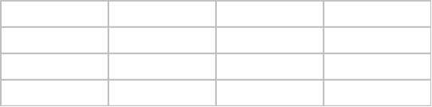
Management Recommendations
- All lake residents practice best management on their lake properties.
- Residents continue involvement in the Volunteer Lake Monitoring Program.
- Adams County should designate sensitive areas within Fenner Lake.
- Lake residents protect natural shoreline around Fenner Lake. Comparison of the plant communities at natural shoreline and disturbed shoreline suggest shoreline disturbance is already impacting the aquatic plant community. Disturbed shoreline sites support an aquatic plant community:
  - of lower quality (AMCI Index)
  - with lower Species Richness
  - with less cover of important habitat structure
  - less able to resist invasions of exotic species.
  - impacted by nutrient enrichment.
  - lower frequency and density of the most sensitive species
- All lake users protect the aquatic plant community in Fenner Lake.
- Residents keep watch for introduction and spread of Eurasian watermilfoil in the lake.
- DNR maintain educational signs at boat landing concerning the spread of exotic species.
TABLE OF CONTENTS

Page number
INTRODUCTION 1
METHODS 2
RESULTS
Physical Data 3
Macrophyte Data 11
DISCUSSION 19
CONCLUSIONS 23
LITERATURE CITED 27
APPENDICES 28

LIST OF FIGURES
1. Mean summer phosphorus and chlorophyll in Fenner Lake, 2003-2005 4
2. Change in water clarity in Fenner Lake, 1993-2005 5
3. Change in water clarity during the growing season in Fenner Lake 6
4. Sediment distribution in Fenner Lake, 2005 7
5. Dominance within the aquatic plant community in Fenner Lake, 2005 12
6. Frequency of occurrence of prevalent aquatic plant species by depth zone 13
7. Density of prevalent aquatic plant species in Fenner Lake, by depth zone 13
8. Distribution of aquatic plants in Fenner Lake, 2005 15
9. Total occurrence and total density of plants in Fenner Lake, by depth zone 14
10. Species Richness in Fenner Lake, by depth zone, 2005 16

LIST OF TABLES
1. Trophic Status 3
2. Sediment Composition in Fenner Lake, 2005 8
3. Influence of Sediment in Fenner Lake, 2005 9
4. Shoreline Land Use - Fenner Lake, 2005 10
5. Fenner Lake Aquatic Plant Species, 2005 11
6. Aquatic Macrophyte Community Index, Fenner Lake, 2005 17
7. Floristic Quality and Coefficient of Conservatism of Fenner Lake 17
8. Aquatic Macrophyte Community Index, Natural vs Disturbed Shoreline Sites 20
9. Comparison of the Plant Community at Natural vs Disturbed Shoreline Sites 22
10. Fish and Wildlife Uses of Aquatic Plants in Fenner Lake 24
The Aquatic Plant Community in Fenner Lake,
Adams County
2005

I. INTRODUCTION
A study of the aquatic macrophytes (plants) in Fenner Lake was conducted during July 2005 by Water Resources staff of the West Central Region - Department of Natural Resources (DNR) and Adams County Land and Water Conservation. This was the first quantitative vegetation study of Fenner Lake by the DNR.

A study of the diversity, density, and distribution of aquatic plants is an essential component of understanding a lake ecosystem due to the important ecological role of aquatic vegetation in the lake and the ability of the vegetation to characterize the water quality (Dennison et al. 1993).

Ecological Role: All other life in the lake depends on the plant life - the beginning of the food chain. Aquatic plants and algae provide food and oxygen for fish, wildlife, and the invertebrates that in turn provide food for other organisms. Plants provide habitat, improve water quality, protect shorelines and lake bottoms, add to the aesthetic quality of the lake and impact recreation.

Characterize Water Quality: Aquatic plants serve as indicators of water quality because of their sensitivity to water quality parameters, such as water clarity and nutrient levels (Dennison et. al. 1993).

The present study will provide information that is important for effective management of the lake, including fish habitat improvement, protection of sensitive habitat, aquatic plant management and water quality protection. The baseline data that it provides will be compared to future aquatic plant inventories and offer insight into changes occurring in the lake.

Background and History: Fenner Lake is a 33-acre seepage lake on the east boundary of Adams County, Wisconsin. Fenner Lake has a maximum depth of 30 feet and an average depth of 5 feet.

II.METHODS
Field Methods
The study design was based on the rake-sampling method developed by Jessen and Lound (1962), using stratified random placement of the transect lines. The shoreline was divided into 10 equal segments and a transect, perpendicular to the shoreline, was randomly placed within each segment (Appendix IV), using a random numbers table.

One sampling site was randomly located in each depth zone (0-1.5ft, 1.5-5ft, 5-10ft and 10-20ft) along each transect. Using a long-handled, steel, thatching rake, four rake samples were taken at each sampling site, one from each quarter of a 6-foot diameter quadrat. The aquatic plant species that were present on each rake sample were recorded. Each species was given a density rating (0-5), the number of rake samples on which it was present at each sampling site.
a rating of 1 indicates that a species was present on one rake sample at that site
a rating of 2 indicates that a species was present on two rake samples at that site
a rating of 3 indicates that it was present on three rake samples
a rating of 4 indicates that it was present on all four rake samples
a rating of 5 indicates that a species was abundantly present on all 4 rake samples at that site.

Visual inspection and periodic samples were taken between transect lines to record the presence of any species that did not occur at the sampling sites. Specimens of all plant species present were collected and saved in a cooler for later preparation of voucher specimens. Nomenclature was according to Gleason and Cronquist (1991).

The type of shoreline cover was recorded at each transect. A section of shoreline, 50 feet on each side of the transect intercept with the shore and 30 feet deep was evaluated. The percent cover of each land use category within this 100' x 30' rectangle was visually estimated and verified by a second researcher.

Data Analysis
The percent frequency of each species was calculated (number of sampling sites at which it occurred/total number of sampling sites) (Appendix I). Relative frequency was calculated (number of occurrences of a species/sum of all species occurrences) (Appendix I). The mean density was calculated for each species (sum of a species' density ratings/number of sampling sites) (Appendix II). Relative density was calculated (sum of a species density/sum of all plant densities). "Mean density where present" was calculated for each species (sum of a species' density ratings/number of sampling sites at which the species occurred) (Appendix II). The relative frequency and relative density of each species was summed to obtain a dominance value for each species (Appendix III). Species diversity was measured by Simpson's Diversity Index (Appendix I).

The Aquatic Macrophyte Community Index (AMCI) developed by Nichols (2000) was applied to Fenner Lake. Measures for each of seven categories that characterize a plant community are converted to values between 0 and 10 and summed to measure the quality of the plant community.

The Average Coefficient of Conservatism and Floristic Quality Index were calculated, as outlined by Nichols (1998), to measure disturbance in the plant community. A coefficient of conservatism is an assigned value, 0-10, the probability that a species will occur in an undisturbed habitat. The Average Coefficient of Conservatism is the mean of the coefficients for all species found in the lake. The Floristic Quality Index is calculated from the Coefficient of Conservatism (Nichols 1998) and is a measure of a plant community's closeness to an undisturbed condition.

III. RESULTS
PHYSICAL DATA
Many physical parameters impact the aquatic plant community. Water quality (nutrients, algae, water clarity and water hardness) influence the plant community as the plant community can in turn modify these parameters. Lake morphology, sediment composition and shoreline use also impact the aquatic plant community.

WATER QUALITY - The trophic state of a lake is a classification of its water quality. Phosphorus concentration, chlorophyll concentration and water clarity data are collected and combined to determine the trophic state.
Eutrophic lakes are high in nutrients and support a large biomass.
Oligotrophic lakes are low in nutrients and support limited plant growth and smaller populations of fish.
Mesotrophic lakes have intermediate levels of nutrients and biomass.

Nutrients
Phosphorus is a limiting nutrient in many Wisconsin lakes and is measured as an indication of nutrient enrichment in a lake. Increases in phosphorus in a lake can feed algae blooms and, occasionally, excess plant growth.
2005 Mean summer phosphorus concentration in Fenner Lake was 33 ug/l.
This concentration of phosphorus in Fenner Lake is indicative of a mesotrophic lake (Table 1).

Table 1. Trophic Status
 | Quality Index | Phosphorus ug/l | Chlorophyll ug/l | Secchi Disc ft.
Oligotrophic | Excellent | <1 | <1 | > 19
 | Very Good | 1-10 | 1-5 | 8-19
Mesotrophic | Good | 10-30 | 5-10 | 6-8
 | Fair | 30-50 | 10-15 | 5-6
Eutrophic | Poor | 50-150 | 15-30 | 3-4
Fenner Lake 2005 | Good | 33.4 | 3.44 | 9.75
After Lillie & Mason (1983) & Shaw et. al. (1993)

Algae
Chlorophyll concentrations provide a measure of the amount of algae in lake water. Algae are natural and essential in lakes, but high algae populations can increase turbidity and reduce the light available for plant growth.
2005 Mean summer chlorophyll concentration in Fenner Lake was 3.4 ug/l.
The chlorophyll concentration in Fenner Lake was in the oligotrophic range (Table 1).
Filamentous algae occurred at 36% of all sample sites. Filamentous algae occurred at:
20% of the sites in the 0-1.5ft depth zone
50% of the sites in the 1.5-5ft depth zone
11% of the sites in the 5-10ft depth zone
71% of the sites in the 10-20ft depth zone

Phosphorus has decreased slightly since 2003 and chlorophyll has remained stable (Figure 1).

Figure 1. Mean summer phosphorus and chlorophyll in Fenner Lake, 2003-2005

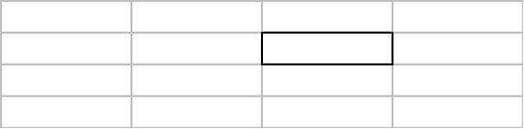
Water Clarity
Water clarity is a critical factor for aquatic plants. When plants receive less than 1 - 2% of the surface illumination, they can not survive. Water clarity is reduced by turbidity (suspended materials such as algae and silt) and dissolved organic chemicals that color the water. Water clarity is measured with a Secchi disc that shows the combined effect of turbidity and color
August 2005 Secchi Disc clarity in Fenner Lake was 9.75 ft.
Water clarity data indicates (Table 1) that Fenner Lake is an oligotrophic lake with good water clarity.

The combination of phosphorus concentration, chlorophyll concentration and water clarity indicates that Fenner Lake is a mesotrophic lake with good water quality. This trophic state would favor moderate plant growth and occasional summer algae blooms.
Residents on Fenner Lake have been involved in the Self-Help Volunteer Lake Monitoring Program, collecting water clarity data using a Secchi Disc. Francis Schalk collected data 1993-1996; Richard and Althea Lillie collected data 1993-1998; Ann Weigel has collected data 2000-2005. This data is valuable because it is collected more frequently than the DNR water quality data, over a longer period during the growing season and for a period of more contiguous years.

Volunteer monitoring data indicate that water clarity in Fenner Lake has declined since 1993 (Figure 2).
Figure 2. Change in water clarity in Fenner Lake, 1993-2005

Because the volunteer data has been collected over several years and over the entire ice-off season, changes in clarity during the growing season can be seen. Data collected at the same time during the year was averaged. The water clarity in Fenner Lake remains relatively stable during the growing season until clarity increases sharply in October as the water cools (Figure 3).

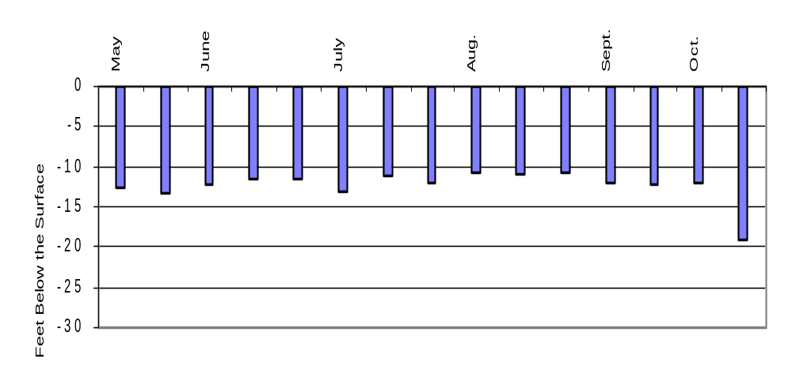
Figure 3. Change in water clarity during in the growing season in Fenner Lake.

Hardness
The hardness or mineral content of lake water also influences aquatic plant growth. The hardness value in Fenner Lake has varied between 100-104 mg/l CaCO3 during 2003-2005. Lakes with hardness values of 61-120mg/l CaCO3 are considered moderately hard water lakes. Hard water lakes tend to support more plant growth than soft water lakes.

LAKE MORPHOMETRY - The morphometry of a lake is an important factor in determining the distribution of aquatic plants. Duarte and Kalff (1986) found that the slope of the littoral zone could explain 72% of the observed variability in the growth of submerged plants. Gentle slopes support more plant growth than steep slopes (Engel 1985).

Fenner Lake has an oval basin with a gradually sloped littoral zone (Appendix IV). Gradual slopes provide a more stable rooting base and broader area of shallow water that would favor plant growth.

SEDIMENT COMPOSITION – The dominant sediment in Fenner Lake was peat, especially at depths greater than 1.5ft (Table 2). A hard, high-density sediment, sand, was common in the shallow zone, alone and mixed with silt. Silt/peat mixtures were common at depths of 1.5-10 feet (Figure 4).

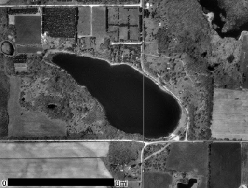Figure 4. Sediment Distribution in Fenner Lake, 2005.
Mixed Hard and Soft Sediment Types
Peat – Flocculent Sediment
Mixed Soft Sediment Types
Intermediate-Density Silt Sediment most favorable for plant growth.
Mixed High-Density Hard Sediment Types
Sand – A High-Density Hard Sediment

Table 2. Sediment Composition: Fenner Lake, 2005
Sediment Type |  | 0-1.5' Depth | 1.5-5' Depth | 5-10' Depth | 10-20’ Depth | Percent of all Sample Sites
Soft  Sediments | Peat | 20% | 50% | 67% | 86% | 53%
Soft  Sediments | Silt/Peat | 10% | 30% | 22% |  | 17%
Soft  Sediments | Peat/Muck |  |  | 11% |  | 3%
Mixed  Sediments | Sand/Silt | 20% | 10% |  |  | 6%
Mixed  Sediments | Sand /Muck | 10% | 10% |  |  | 6%
Hard  Sediments | Sand | 30% |  |  | 14% | 11%
Hard  Sediments | Sand/Gravel | 10% |  |  |  | 3%

INFLUENCE OF SEDIMENT - Some plants depend on the sediment in which they are rooted for their nutrients. The richness or sterility and texture of the sediment will determine the type and abundance of plant species that can survive in a location. The availability of mineral nutrients for growth is highest in sediments of intermediate density, such as silt, so these sediments are considered most favorable for plant growth (Barko and Smart 1986).

Peat was the overall dominant sediment found in Fenner Lake and sand was common in the shallow zone. Peat is a loosely consolidated sediment that may be too flocculent for stable plant rooting and sand is a high-density sediment that may be limiting for plant growth due to lower nutrient availability (Barko and Smart 1986). However, all sites were vegetated in Fenner Lake, irregardless of the sediment type (Table 3). It appears that sediment is not a major factor determining plant distribution in Fenner Lake.

Table 3. Influence of Sediment in Fenner Lake, 2005
Sediment Type |  | Percent of all Sample Sites | Percent Vegetated
Soft  Sediments | Peat | 53% | 100%
Soft  Sediments | Silt/Peat | 17% | 100%
Soft  Sediments | Peat/Muck | 3% | 100%
Mixed  Sediments | Sand/Silt | 6% | 100%
Mixed  Sediments | Sand /Muck | 6% | 100%
Hard  Sediments | Sand | 11% | 100%
Hard  Sediments | Sand/Gravel | 3% | 100%

SHORELINE LAND USE – Land use can strongly impact the aquatic plant community and therefore the entire aquatic community. Land use can directly impact the plant community through increased erosion and sedimentation and increased run-off of nutrients, fertilizers and toxics applied to the land. These impacts occur in both rural and residential settings.

Native herbaceous plant cover was the most frequently encountered shoreline cover at the transects and had the highest mean coverage. Other natural shoreline cover types had high occurrences (Table 4).

Cultivated lawn and hard structures were also commonly occurring (Table 4).
Table 4. Shoreline Land Use - Fenner Lake, 2005
Cover Type |  | Frequency of Occurrences at Transects | Mean % Coverage
Natural | Native Herbaceous | 100% | 50%
Shoreline | Wooded | 60% | 18%
 | Shrub | 80% | 9%
 | Bare Sand | 40% | 7%
Total Natural |  |  | 85%
Disturbed | Cultivated Lawn | 50% | 11%
Shoreline | Hard Structures | 30% | 2%
 | Pavement | 10% | 3%
Total Disturbed |  |  | 16%

Some type of natural shoreline (wooded, shrub, native herbaceous, sand) was found at all of the sites, having a mean coverage of 85%.

Some type of disturbed shoreline (cultivated lawn, hard structures and rip-rap) was found at 50% of the sites and had a mean coverage of 16%.

MACROPHYTE DATA
SPECIES PRESENT
Of the 29 species found in Fenner Lake, 7 were emergent species, 3 were floating-leaf species and 19 were submergent species (Table 5).
No threatened or endangered species were found.
One exotic invasive species was found: Myriophyllum spicatum. This species was found near the boat landing.

Table 5. Fenner Lake Aquatic Plant Species, 2005
Scientific Name Common Name I. D. Code
_____________________________________________________________________
Emergent Species
1) Calamagrostis canadensis (Michx.) P.Beauv. bluejoint grass calca
2) Carex comosa Boott. bristly sedge carco
3) Eleocharis smallii Britt. creeping spikerush elesm
4) Glyceria canadensis (Michx) Trin. rattlesnake manna grass glyca
5) Juncus brevicaudatus (Englem) Fern. rush junbr
6) Rumex orbiculatus Gray. great water dock rumob
7) Scirpus validus Vahl. softstem bulrush sciva

Floating-leaf Species
8) Nuphar variegata Durand. bull-head pond lily nupva
9) Nymphaea odorata Aiton. white water lily nymod
10) Polygonum amphibium L. water smartweed polam

Submergent Species
11) Ceratophyllum demersum L. coontail cerde
12) Chara sp. muskgrass chasp
13) Eleocharis acicularis (L.) R & S. needle spikerush eleac
14) Elodea canadensis Michx. common waterweed eloca
15) Myriophyllum heterophyllum Michx. variable-leaf water-milfoil myrhe
16) Myriophyllum sibiricum Komarov. common water milfoil myrsi
17) Myriophyllum spicatum L. Eurasian water milfoil myrsp
18) Najas flexilis (Willd.) Rostkov & Schmidt. slender naiad najfl
19) Najas guadalupensis (Spreng.) magnus. common water-nymph najgu
20) Potamogeton amplifolius Tuckerman. large-leaf pondweed potam
21) Potamogeton foliosus Raf. leafy pondweed potfo
22) Potamogeton gramineus L. variable-leaf pondweed potgr
23) Potamogeton illinoensis Morong. Illinois pondweed potil
24) Potamogeton natans L. floating-leaf pondweed potna
25) Potamogeton pectinatus L. sago pondweed potpe
26) Potamogeton pusillus L. small pondweed potpu
27) Potamogeton zosteriformis Fern. flatstem pondweed potzo
28) Utricularia gibba L. small bladderwort utrgi
29) Utricularia vulgaris L. great bladderwort utrvu
FREQUENCY OF OCCURRENCE
Myriophyllum sibiricum was the most frequently occurring species in Fenner Lake in 2005, (80% of sample sites) (Appendix IX). Ceratophyllum demersum , Chara spp., Elodea canadensis, Najas flexilis, Nymphaea odorata, Potamogeton gramineus, P. natans and P. zosteriformis were also commonly occurring species, (56%, 44%, 50%, 33%, 44%, 30%, 39%, 22% respectively).

DENSITY
Myriophylum sibiricum was also the species with the highest mean density in Fenner Lake (2.19 on a density scale of 0-4) (Appendix X).

Myriophylum sibiricum had a “mean density where present” of 2.72. The “mean density where present” indicates that, where M. sibiricum occurred, it exhibited a growth form of above average density in Fenner Lake (Appendix II). Ceratophyllum demersum, Chara, Glyceria, Najas guadalupensis, Nymphaea odorata, Potamogeton natans, also had “densities where present” of 2.5 or more, indicating that they also exhibited an aggregated growth form or a growth form of above average density.

DOMINANCE
Combining the relative frequency and relative density of a species into a Dominance Value illustrates how dominant that species is within the aquatic plant community (Appendix III). Based on the Dominance Value, Myriophyllum sibiricum was the dominant aquatic plant species in Fenner Lake (Figure 5). Ceratophyllum demersum and Nymphaea odorata were sub-dominant.
Figure 5. Dominance within the aquatic plant community, of the most prevalent
plant species in Fenner Lake, 2005.
Myriophyllum sibiricum, the dominant species overall, was the most frequently occurring species in the 0-1.5 ft depth zone and the dominant species in the 5-10ft depth zone. M. sibiricum occurred at its highest frequency and density in the 5-10ft depth zone (Figure 6, 7). Nymphaea odorata, one of the sub-dominant species overall, was the dominant species in the 1.5-5ft depth zone and the species with the highest mean density in the 0-1.5ft depth zone. N. odorata occurred at its highest frequency and density in the 1.5-5ft depth zone (Figure 6, 7). Ceratophyllum demersum the other sub-dominant, was dominant in the 10-20ft zone (Figure 6, 7).

Figure 6. Frequency of occurrence of prevalent aquatic plant species in Fenner
Lake, by depth zone, 2005.
Figure 7. Density of prevalent plant species in Fenner Lake by depth zone, 2005.

DISTRIBUTION
Aquatic plants occurred throughout the entire littoral zone of Fenner Lake, at all of the sampling sites to a maximum depth of 15 feet (Figure 8). Myriophyllum sibiricum occurred at the maximum rooting depth. Approximately 25 acres of the entire lake (76%) was vegetated. Of these 25 acres, about 11 acres (33% of the lake) supported floating-leaf vegetation and about 6 acres (18% of the lake) supported emergent vegetation. The dominant and common plant species were found throughout the lake.
Eurasian watermilfoil was found near the boat landing. Boats and trailers are a major vector of introduction of exotic species into lakes.

Secchi disc water clarity data can be used to calculate a predicted maximum rooting depth for plants in a lake (Dunst 1982).
Predicted Rooting Depth (ft.) = (Secchi Disc (ft.) * 1.22) + 2.73
Based on the 2005 Secchi disc clarity, the predicted maximum rooting depth in Fenner Lake would be 14.6 ft.
The actual maximum rooting depth is close to the predicted maximum rooting depth based on water clarity.

The 0-1.5ft depth zone supported the greatest amount of plant growth. The highest total occurrence and total density of plant growth was recorded in the 0-1.5ft depth zone (Figure 9).

Figure 9. Total occurrence and total density of plants in Fenner Lake by depth zone.

The greatest species richness (mean number of species per site) was also recorded in the 0-1.5 ft. depth zone (Figure 10). Overall species richness in Fenner Lake was 5.9 species per site.

Submergent Vegetation
Floating-leaf Vegetation
Emergent Vegetation
Figure 8. Aquatic plant distribution in Fenner Lake, 2005.

Figure 10. Species richness in Fenner Lake, by depth zone, 2005.

THE COMMUNITY
Simpson's Diversity Index was 0.94, indicating excellent species diversity. A rating of 1.0 would mean that each plant in the lake was a different species (the most diversity achievable).

The Aquatic Macrophyte Community Index (AMCI) for Fenner Lake (Table 6) is 60. This is in the upper quartile of lakes in Wisconsin and the North Central Hardwoods Region of the state. This value places Fenner Lake in the top 25% of lakes in the state and region with the highest quality aquatic plant communities.

Table 6. Aquatic Macrophyte Community Index, Fenner Lake 2005
Category |  | Value
Maximum Rooting Depth | 4.57 meters | 8
% Littoral Zone Vegetated | 100% | 10
% Submergent Species | 69% Relative Freq. | 8
# of Species | 29 | 10
% Exotic Species | occurred | 6
Simpson's Diversity Index | 0.94 | 10
% Sensitive Species | 18% Relative Freq. | 8
Totals |  | 60
* The highest value for this index is 70.

The Average Coefficient of Conservatism for Fenner Lake was average for Wisconsin lakes and in the highest quartile for lakes in the North Central Hardwood Region (Table 7). This suggests that the aquatic plant community in Fenner Lake has an average sensitivity to disturbance for Wisconsin lakes and a high sensitivity for lakes in the region.

Table 7. Floristic Quality and Coefficient of Conservatism of Fenner Lake, Compared to Wisconsin Lakes and Northern Wisconsin Lakes.
 | Average Coefficient of Conservatism † | Floristic Quality ‡
Wisconsin Lakes | 5.5, 6.0, 6.9 * | 16.9, 22.2, 27.5
NCHR | 5.2, 5.6, 5.8 * | 17.0, 20.9, 24.4
Fenner Lake 2005 | 5.93 | 31.37
* - Values indicate the highest value of the lowest quartile, the mean and the lowest value of the upper quartile.
† - Average Coefficient of Conservatism for all Wisconsin lakes ranged from a low of 2.0 (the most disturbance tolerant) to a high of 9.5 (least disturbance tolerant).
‡ - lowest Floristic Quality was 3.0 (farthest from an undisturbed condition) and the high was 44.6 (closest to an undisturbed condition).

The Floristic Quality Index of the aquatic plant community in Fenner Lake was in the upper quartile of Wisconsin lakes and North Central Hardwood Region lakes (Table 7). This indicates that the plant community in Fenner Lake is within the group of lakes in the state and region closest to an undisturbed condition.

Disturbances can be of many types:
- Physical disturbances to the plant beds result from activities such as boat traffic, plant harvesting, chemical treatments, the placement of docks and other structures and fluctuating water levels.
- Indirect disturbances are the result of factors that impact water clarity and thus stress species that are more sensitive: resuspension of sediments, sedimentation from erosion and increased algae growth due to nutrient inputs.
- Biological disturbances include competition from the introduction of a non-native or invasive plant species, grazing from an increased population of aquatic herbivores and destruction of plant beds by a fish or wildlife population.
IV. DISCUSSION
Based on water clarity, chlorophyll and phosphorus data, Fenner Lake is a mesotrophic lake with good water clarity and quality. However, trend analysis suggests water quality has declined during 1993-2005. The current trophic state would support moderate plant growth and occasional algae blooms. Filamentous algae occurred at 36% of the sites and was common in the 0-5ft depth zone and abundant in the 10-20ft depth zone.

Adequate nutrients (trophic state), the good water clarity, the moderately hard water and the gradually sloped littoral zone in Fenner Lake would favor plant growth. The abundance of high-density sand sediments in the shallowest zone and dominance of flocculent sediments overall in Fenner Lake could limit plant growth.

Aquatic plants occurred throughout the entire littoral zone, 76% of the lake, to a maximum depth of 15 feet. This maximum rooting depth is in agreement with the predicted maximum rooting depth, based on water clarity. The highest total occurrence of plants, highest total density of plants and the greatest species richness occurred in the 0-1.5ft depth zone.

Twenty-nine (29) species of aquatic plants were recorded in Fenner Lake in 2005. Myriophyllum sibiricum was the dominant plant species in Fenner Lake, especially in the 5-10ft depth zone, occurring at more than three-quarters of the sample sites, to the maximum rooting depth and exhibiting a growth form of above average density. Six (6) other species exhibited an aggregated or dense growth form in Fenner Lake. Ceratophyllum demersum and Nymphaea odorata were sub-dominant: C. demersum especially in the 10-20ft depth zone and N. odorata especially in the 1.5-5ft depth zone. The dominant and common species were found throughout the lake. Myriophyllum spicatum, Eurasian watermilfoil, was found near the boat landing.

The Aquatic Macrophyte Community Index (AMCI) for Fenner Lake was 60, indicating that the quality of the plant community in Fenner Lake is high, in the top quartile of lakes in Wisconsin and the region. Simpson's Diversity Index (0.93) indicates that the aquatic plant community had an excellent diversity of plant species.

The Average Coefficient of Conservatism and the Floristic Quality Index indicate that Fenner Lake has an average sensitivity to disturbance and is in the upper quartile of lakes (top 25%) in the state and region, the group of lakes closest to an undisturbed condition.

Shoreline Impacts
Fenner Lake has protection from abundant natural shoreline cover (wooded, shrub, native herbaceous growth), but disturbed shoreline covered 16% of the shore. Two types of disturbed cover, cultivated lawn and hard structures, were commonly occurring and cultivated lawn covered 11% of the shoreline.

Shorelines with cultivated lawn can impact the plant community through increased run-off of lawn fertilizers, pesticides and pet wastes into the lake. Hard structures and mowed lawn also speed run-off to the lake without filtering these pollutants. Expanding and protecting the buffer of natural vegetation along the shore will help prevent shoreline erosion and reduce additional nutrient/chemical run-off that can add to algae growth and sedimentation of the lake bottom.

The aquatic plant transect sites off sites with 100% natural shoreline were compared to aquatic plant transect sites off shoreline that contained any amount disturbance (Appendices V-VIII). The comparison of various parameters indicate that disturbance on the shore has impacted the aquatic plant community at those sites.

The dominant species was the same at disturbed and natural shoreline communities, but the sub-dominant species was different. At natural shoreline sites, Nymphaea odorata, a species that is a premier habitat species was sub-dominant. At disturbed shoreline, Ceratophyllum demersum was sub-dominant. C. demersum is more tolerant of disturbance and can grow to nuisance levels with nutrient enrichment, becoming too dense to provide quality habitat.

The quality of the aquatic plant community at the natural shoreline sites (AMCI – 65) is greater than the quality of the plant community at the disturbed sites (AMCI – 60). The higher quality is due to a higher frequency of occurrence of sensitive aquatic plant species (Nichols 2000) at natural shoreline communities and lack of exotic species at natural shoreline sites (Table 8).

Table 8. Aquatic Macrophyte Community Index, Natural vs. Disturbed Shoreline
Category | Values for parameter
 | Natural Shoreline | Disturbed Shoreline
Maximum Rooting Depth | 9 | 9
# of Species | 9 | 10
% Exotic species | 10 | 6 (EWM present)
% Littoral Zone Vegetated | 10 | 10
Simpson's Diversity | 10 | 10
% Sensitive Species | 9 | 7
% Submergent Species | 8 | 8
AMCI Index Totals | 65 | 60

In addition to a higher quality plant community at the natural shoreline sites, Species Richness (the mean number of species per site) is also greater at natural shoreline sites, especially in the 1.5-10ft depth zones (Table 9). This suggests greater diversity of aquatic plant species at natural sites.

The cover of submergent vegetation, emergent vegetation and floating-leaf vegetation was higher at natural shoreline plant communities (Table 9). The higher occurrence of emergent and floating-leaf species at natural sites is particularly important from the habitat view. These species are especially valuable for habitat and, with the submergent vegetation, they add a diversity of structural types which supports greater diversity in the fish and wildlife community.

The most sensitive species in Fenner Lake (Nichols 2000) occurred at a much higher frequency, grew at a higher density and had a higher dominance at the sites near natural shoreline (Table 10). This corroborates the impact disturbed shoreline has on the aquatic plant community.

Eurasian watermilfoil was only recorded at disturbed shoreline sites. Disturbance creates an ideal condition for the invasion of exotic species such as Eurasian watermilfoil.

Filamentous algae occurred at a higher percentage of sites at disturbed shoreline as compared to natural shoreline. This suggests nutrient enrichment at disturbed shoreline sites (Table 9). Nutrient sources could be lawn fertilizers, failing or poorly maintained septic systems, pet wastes and poorer filtering capacity of hard surfaces and mowed lawns.

Table 9. Comparison of the Aquatic Plant Community at Natural Shoreline Sites and Disturbed Shoreline Sites.
Parameter |  | Natural Shoreline | Disturbed Shoreline
AMCI Quality Index (Table 8) |  | 65 | 60
Species Richness | Overall | 6.15 | 5.78
Species Richness | 0-1.5ft Depth Zone | 8.75 | 9.83
Species Richness | 1.5-5ft Depth Zone | 5.25 | 4.33
Species Richness | 5-10ft Depth Zone | 6.33 | 5.83
Vegetation Types - % Occurrence | Floating-leaf | 69% | 56%
Vegetation Types - % Occurrence | Emergent | 31% | 22%
Vegetation Types - % Occurrence | Submergent | 100% | 96%
Most Sensitive Species: Utricularia gibba | Overall Dominance | 0.06 | 0.02
Most Sensitive Species: Utricularia gibba | Frequency | 23% | 9%
Most Sensitive Species: Utricularia gibba | Mean Density | 0.31 | 0.09
Filamentous Algae Occurrence |  | 15% | 48%
Exotic Species | Eurasian watermilfoil (EWM) | Not found | Occurred
V. CONCLUSIONS
Fenner Lake is a mesotrophic lake with good water quality and clarity. Water clarity has decreased since 1993. Filamentous algae is common, abundant in the 10-20ft depth zone.

The aquatic plant community colonized approximately three-quarters of Fenner Lake, 100% of the littoral zone to a maximum rooting depth of 15 feet. The 0-1.5ft depth zone supported the most abundant aquatic plant growth.

Myriophyllum sibiricum was the dominant species within the 29-species aquatic plant community, especially in the 5-10ft depth zone. Nymphaea odorata and Ceratophyllum demersum were sub-dominant. The most common species were found distributed throughout the lake.

The Fenner Lake aquatic plant community is characterized by high quality and excellent species diversity. The plant community is in the top quartile of lakes in the state and region, the group of lakes closest to an undisturbed condition and with an average sensitivity to disturbance.

A healthy aquatic plant community plays a vital role within the lake community. This is due to the role plants play in
1) improving water quality 2) providing valuable habitat resources for fish and wildlife 3) resisting invasions of non-native species and 4) checking excessive growth of tolerant species that could crowd out the more sensitive species, thus reducing diversity.

Aquatic plant communities improve water quality in many ways (Engel 1985):
trap nutrients, debris, and pollutants entering a water body;
absorb and break down some pollutants;
reduce erosion by damping wave action, stabilizing shorelines and lake bottoms;
remove nutrients that would otherwise be available for algae blooms.

Aquatic plant communities provide important fishery and wildlife resources. Plants and algae start the food chain that supports many levels of wildlife, and at the same time produce oxygen needed by animals. Plants are used as food, cover and nesting/spawning sites by a variety of wildlife and fish (Table 10). Plant cover within the littoral zone of Fenner Lake is 100% and over the whole lake is 75%. This is appropriate (25-85%) to support a balanced fishery.

Compared to non-vegetated lake bottoms, plant beds support larger, more diverse invertebrate populations that in turn will support larger and more diverse fish and wildlife populations (Engel 1985). Additionally, mixed stands of aquatic plants support 3-8 times as many invertebrates and fish as monocultural stands (Engel 1990). Diversity in the plant community creates more microhabitats for the preferences of more species. Aquatic plant beds of moderate density support adequate numbers of small fish without restricting the movement of predatory fish (Engel 1990).

Table 10. Wildlife and Fish Uses of Aquatic Plants in Fenner Lake
Aquatic Plants | Fish | Water  Fowl | Song and Shore  Birds | Upland Game  Birds | Muskrat | Beaver | Deer
Submergent Plants
Ceratophyllum demersum | F,I*, C, S | F(Seeds*), I, C |  |  | F
Chara sp. | F*, S | F*, I*
Eleocharis acicularis | S | F |  |  | F
Elodea canadensis | C, F, I | F(Foliage) I
Myriophyllum heterophyllum | I*, C | I* F(Seeds, Foliage)
Myriophyllum sibiricum | F*, I*, S | F(Seeds, Foliage) | F(Seeds) |  | F
Myriophyllum spicatum | F, C
Najas flexilis | F, C | F*(Seeds, Foliage) | F(Seeds)
Najas guadalupensis | F, C | F*(Seeds, Foliage)
Potamogeton amplifolius | F, I, S*,C | F*(Seeds) |  |  | F* | F | F
Potamogeton foliosus | F, I, S*,C | F*(All) |  |  | F* | F | F
Potamogeton gramineus | F, I, S*,C | F*(Seeds, Tubers) |  |  | F* | F | F
Potamogeton illinoensis | F, I, S*,C | F*(Seeds) | F |  | F* | F | F
Potamogeton natans | F, I, S*,C | F*(Seeds, Tubers) |  |  | F* | F | F
Potamogeton pectinatus | F, I, S*,C | F* |  |  | F* | F | F
Potamogeton pusillus | F, I, S*,C | F*(All) |  |  | F* | F | F
Potamogeton zosteriformis | F, I, S*,C | F*(Seeds) |  |  | F* | F | F
Utricularia gibba | F, C, I* | I* |  |  | F
Floating-leaf Plants
Nuphar variegata | F,C, I, S | F, I | F |  | F* | F | F*
Nymphaea odorata | F,I, S, C | F(Seeds) | F |  | F | F | F
Polygonum amphibium | F, C | F*(Seeds) | F | F | F |  | F
Emergent Plants
Calamagrostis spp. |  |  |  |  | F* |  | F*
Carex comosa | S* | F*(Seeds), C | F*(Seeds) | F*(Seeds) | F | F | F
Eleocharis smallii (palustris) | I | F, C
Glyceria spp. |  | F |  |  | F* |  | F*
Juncus sp. | S |  |  |  | F
Rumex spp. |  | F (Seeds) | F | F |  |  | F*
Scirpus validus | F, C, I | F (Seeds)*, C | F(Seeds, Tubers), C | F (Seeds) | F | F | F
F=Food, I= Shelters Invertbrates, a valuble food source C=Cover, S=Spawning
*=Valuable Resource in this category
After Fassett, N. C. 1957. A Manual of Aquatic Plants. University of Wisconsin Press. Madison, WI
Nichols, S. A. 1991. Attributes of Wisconsin Lake Plants. Wisconsin Geological and Natural History Survey. Info. Circ. #73

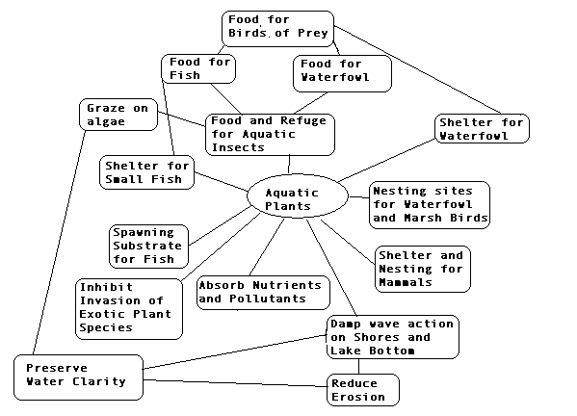
Management Recommendations
- All lake residents practice best management on their lake properties. Decrease in water clarity since 1993 and higher filamentous algae occurrence at developed shoreline may be an early warning that nutrient enrichment is impacting the lake and is coming from developed shoreline.
    - Keep septic systems cleaned and in proper condition
    - Use no lawn fertilizers
    - Clean up pet wastes
    - Do not compost near the water or allow yard wastes and clippings to enter the lake
- Residents continue involvement in the Self-Help Volunteer Lake Monitoring Program, monitoring water quality to track seasonal and year-to-year changes.
- Adams County should designate sensitive areas within Fenner Lake. These are areas within the lake that are most important for habitat and maintaining water quality.
- Lake residents protect natural shoreline around Fenner Lake. Fenner Lake has protection from natural shoreline buffers on much of the lake, but disturbed shoreline (cultivated lawn and hard structures are common) covers 16% of the shore. Unmowed native vegetation reduces shoreline erosion and run-off into the lake and filters the run-off that does enter the lake. Comparison of the plant communities at natural shoreline and disturbed shoreline suggest shoreline disturbance is already impacting the aquatic plant community. Evidence that disturbance on shore is impacting the plant community in the water is that disturbed shoreline sites in Fenner Lake support lower frequency and density of the most sensitive species. Disturbed shoreline sites support an aquatic plant community:
  - of lower quality (AMCI Index)
  - with lower Species Richness that may support less diversity in the fish and wildlife community
  - with less cover of important habitat structure (submergent vegetation, emergent vegetation and floating-leaf vegetation) that will support less diversity in the fish and wildlife community.
  - less able to resist invasions of exotic species. Eurasian watermilfoil was only recorded at disturbed shoreline sites.
  - impacted by nutrient enrichment. Filamentous algae occurred at a higher percentage of sites at disturbed shoreline as compared to natural shoreline.
- All lake users protect the aquatic plant community in Fenner Lake. The standing-water emergent community, floating-leaf community and submergent plant community are all unique plant communities. Each of these plant communities provides their own benefits for fish and wildlife habitat and water quality protection.
- Lake residents need to monitor the Fenner Lake regularly for further introductions and spread of exotic species. If an exotic plant species is confirmed, it needs to be pulled as soon as possible to prevent its spread. Eurasian watermilfoil, Myriophyllum spicatum, was found near the boat landing. This exotic species is commonly spread by boats and trailers and has he potential to spread quickly in a lake, becoming nuisance vegetation and crowding out the native species that are valuable for habitat.
- DNR maintain exotic species informational signage at the boat landing. If the signs are damaged or stolen, contact the local DNR office for replacements.

LITERATURE CITED
Barko, J. and R. Smart. 1986. Sediment-related mechanisms of growth limitation in submersed macrophytes. Ecology 61:1328-1340.

Dennison, W., R. Orth, K. Moore, J. Stevenson, V. Carter, S.Kollar, P. Bergstrom, and R. Batuik. 1993. Assessing water quality with submersed vegetation. BioScience 43(2):86-94.

Duarte, Carlos M. and Jacob Kalff. 1986. Littoral slope as a predictor of the maximum biomass of submerged macrophyte communities. Limnol. Oceanogr. 31(5):1072-1080.

Dunst, R.C. 1982. Sediment problems and lake restoration in Wisconsin. Environmental International 7:87-92.

Engel, Sandy. 1990. Ecosystem Response to Growth and Control of Submerged Macrophytes: A Literature Review. Technical Bulletin #170. Wisconsin Department of Natural Resources. Madison, WI.

Engel, Sandy. 1985. Aquatic Community Interactions of Submerged Macrophytes. Wisconsin Department of Natural Resources. Technical Bulletin No. 156. Madison, WI

Fassett, Norman C. 1957. A Manual of Aquatic Plants. University of Wisconsin Press. Madison, WI.

Gleason, H. and A. Cronquist. 1991. Manual of Vascular Plants of Northeastern United States and Adjacent Canada (Second Edition). New York Botanical Gardens, NY.

Jessen, Robert and Richard Lound. 1962. An evaluation of a survey technique for submerged aquatic plants. Minnesota Department of Conservation. Game Investigational Report No. 6.

Lillie, R. and J. Mason. 1983. Limnological Characteristics of Wisconsin Lakes. Wisconsin Department of Natural Resources Tech. Bull. #138. Madison, WI.

Nichols, Stanley, S. Weber, B. Shaw. 2000. A proposed aquatic plant community biotic index for Wisconsin lakes. Environmental Management 26:491-502.

Nichols, Stanley. 1998. Floristic quality assessment of Wisconsin lake plant communities with example applications. Journal of Lake and Reservoir Management 15(2):133-141.

Nichols, Stanley A. and James G. Vennie. 1991. Attributes of Wisconsin Lake Plants. Wisconsin Geological and Natural History Survey. Information Circular 73.

Shaw, B, C. Mechenich and L. Klessig. 1993. Understanding Lake Data. University of Wisconsin – Extension. Madison, WI

Appendices

Appendix IV. Transect Locations in Fenner Lake Aquatic Plant Study, 2005
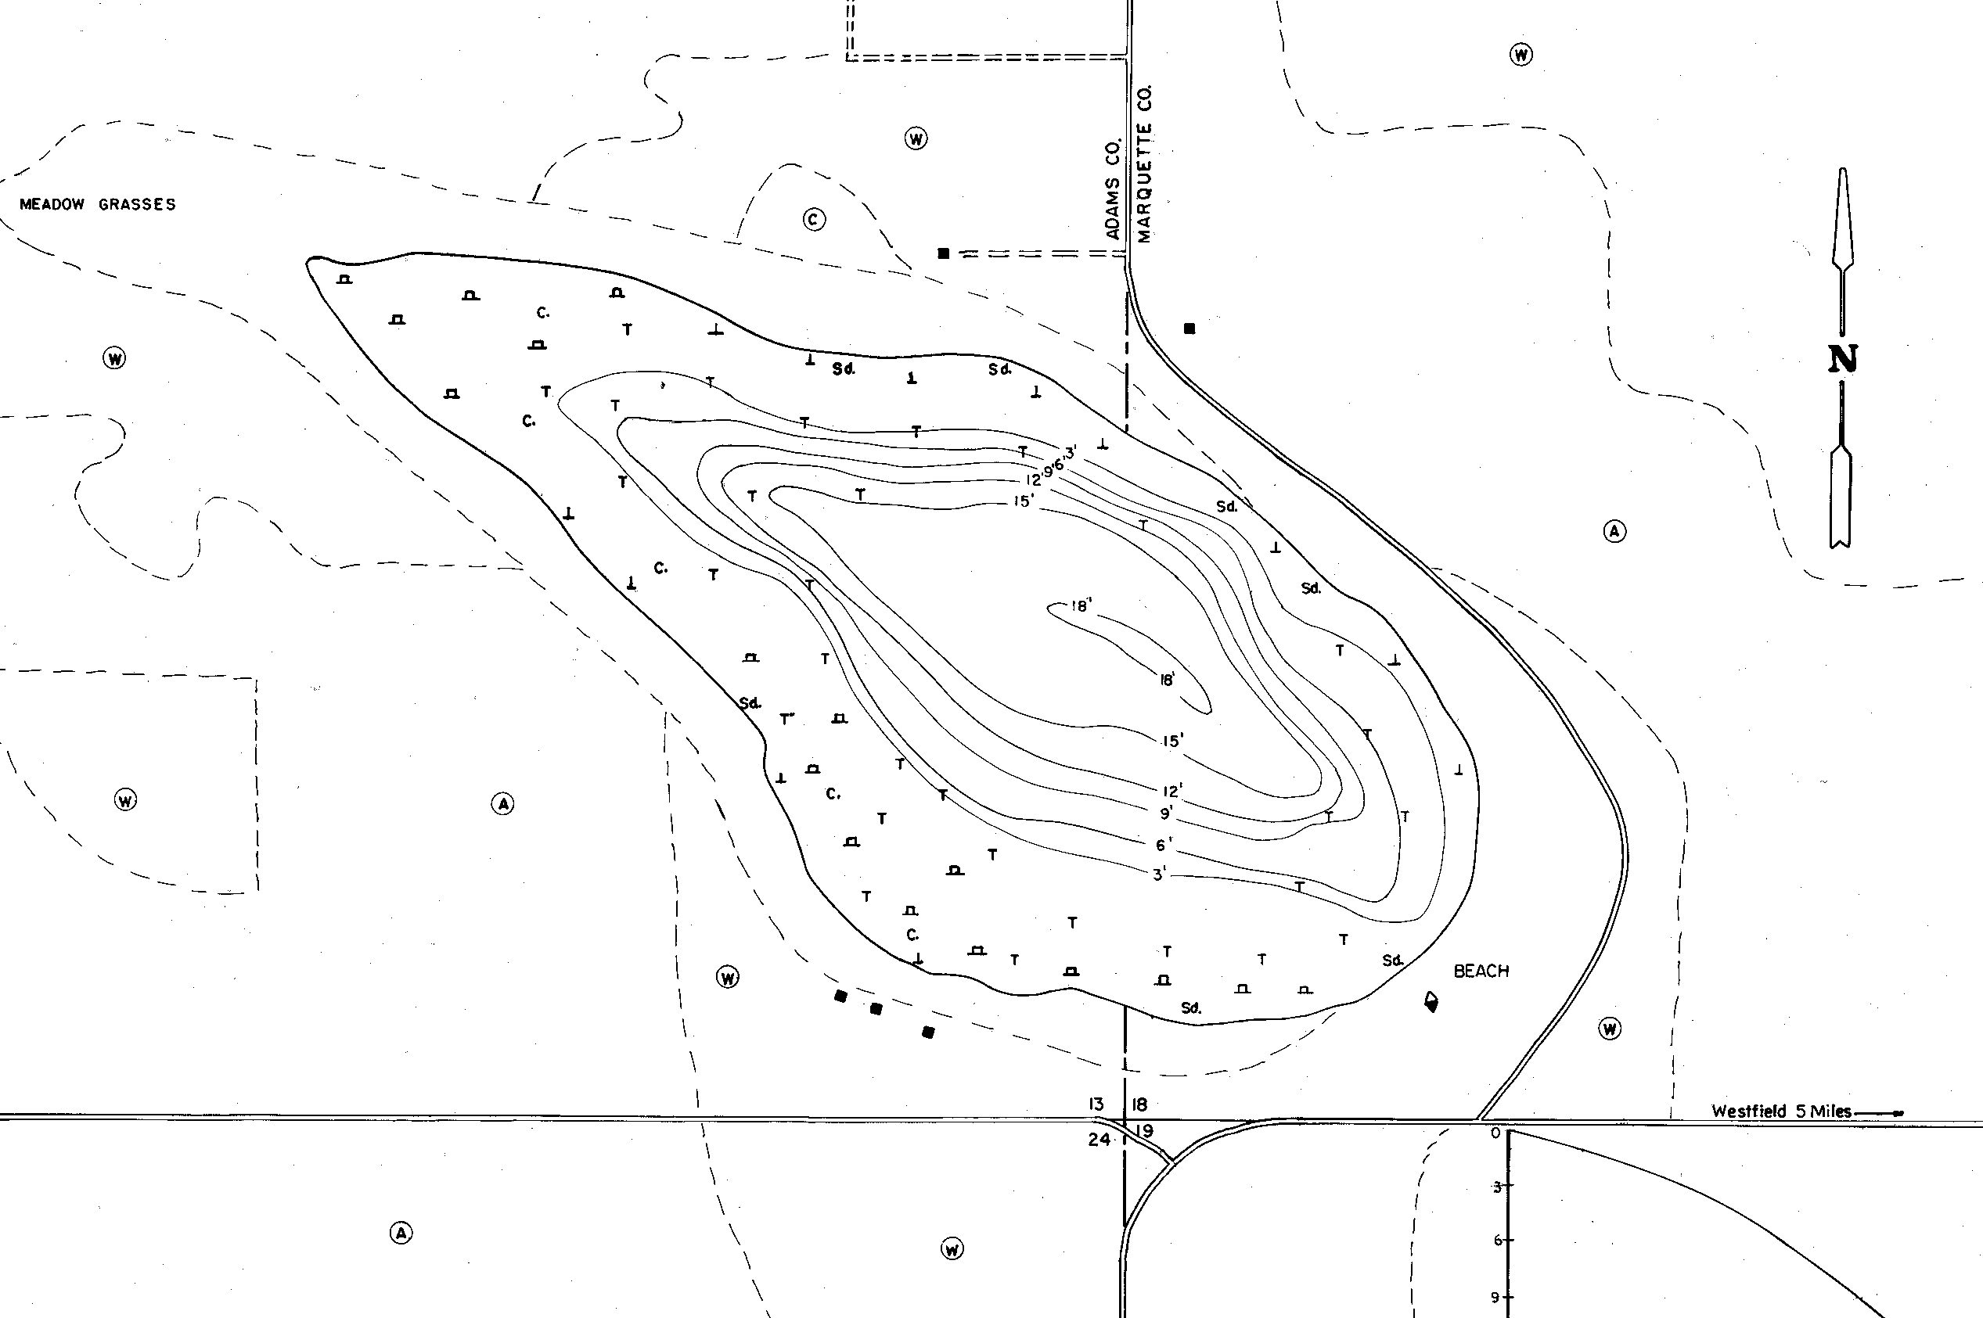
1
3
4
5
6
7
8
9
10
2

