The Aquatic Plant Community
of
Hatfield Lake,

St. Croix County, Wisconsin

2006

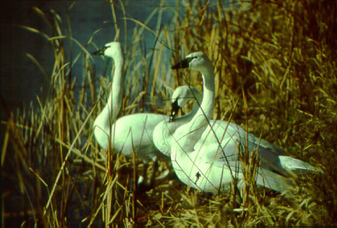

Submitted by:
Deborah Konkel
Wisconsin Department of Natural Resources
Eau Claire, WI
May 2007

Executive Summary
Hatfield Lake is a hypereutrophic wetland/shallow lake complex with very poor water clarity and quality. Filamentous algae and films of planktonic algae occurred at low frequencies in the lake.

Aquatic plant community colonized less than half of the littoral zone, less than one-third of the total lake area, to a maximum depth of 3 feet. Plant growth occurred as scattered growth and nearly all occurred in the 0-1.5ft depth zone.

Twenty (20) aquatic plant species were recorded in Hatfield Lake. Potamogeton pectinatus (sago pondweed) and Typha angustifolia (cattail) were the dominant species and Zosterella dubia (water stargrass) was the sub-dominant species, all occurring at less than one-fifth of the sites. All species in the lake occurred at low mean densities and none were commonly occurring.

The aquatic plant community in Hatfield Lake is characterized by low quality, excellent species diversity, a high tolerance to disturbance and a condition that is average in its closeness to an undisturbed condition. The lake appears to be a haven for waterfowl and other bird species.

A healthy aquatic plant community plays a vital role within the lake community. This is due to the role plants play in improving water quality, providing valuable habitat resources for fish and wildlife, resisting invasions of non-native species and checking excessive growth of tolerant species that could out-compete sensitive species, thus reducing diversity.

Management Recommendations
- City and airport preserve the natural shoreline buffer that is found around Hatfield Lake. Wooded cover, shrubs and native herbaceous growth protected nearly all of the shoreline.
  - Maintaining natural shoreline cover is critical to maintaining water quality and wildlife habitat.
  - Cutting or trees and shrub growth only to maintain prairie habitat around the lake.
- Any future development on the lake use best management practices on shoreland property to prevent nutrient enrichment and stormwater run-off to the lake.
  - Eliminate fertilization near shoreline and use no-phosphorus fertilizer on remainder
  - Minimize use of toxic chemicals and no disposal of chemicals in the lake
  - Use and maintain erosion barriers during any construction
  - Inspect and maintain septic systems
  - Reduce size of areas with hard surface
  - Design landscaping so that stormwater run-off does not enter lake
- Designate lake as electric motor lake only
- DNR to consider designating critical habitat areas.
TABLE OF CONTENTS

Page number
INTRODUCTION 1
METHODS 2
RESULTS
Physical Data 3
Macrophyte Data 10
DISCUSSION 19
CONCLUSIONS 21
LITERATURE CITED 28
APPENDICES 29

LIST OF FIGURES
1. Occurrence of filamentous and planktonic algae in Hatfield Lake, July 2006 4
2. Distribution of sediment types in Hatfield Lake, 2006 7
3. Frequency of aquatic plant species in Hatfield Lake, 2006 11
4. Mean densities of aquatic plant species in Hatfield Lake, 2004 11
5. “Density where present”, density of growth form in Hatfield Lake, 2006 12
6. Dominance within the plant community of the most prevalent species, 2006 13
7. Distribution of aquatic plants in Hatfield Lake, 2006 14
8. Total occurrence and total density of aquatic plants by depth zone, 2006 15
9. Percent of vegetated sites and Species Richness in Hatfield Lake by depth 16
10. Benefits of aquatic plants in the lake ecosystem 22

LIST OF TABLES
1. Trophic Status 5
2. Sediment Composition in Hatfield Lake, 2006 6
3. Sediment Influence on Plant Growth in Hatfield Lake, 2006 8
4. Shoreline Land Use - Hatfield Lake, 2006 9
5. Hatfield Lake Aquatic Plant Species, 2006 10
6. Aquatic Macrophyte Community Index, Hatfield Lake, 2006 17
7. Floristic Quality Index and Coefficient of Conservatism of Hatfield Lake 17
8. Wildlife and Fish Uses of Aquatic Plants in Hatfield Lake 25

The Aquatic Plant Community in Hatfield Lake,
St. Croix County
2006

I. INTRODUCTION
A study of the aquatic macrophytes (plants) in Hatfield Lake was conducted during July 2006 by Water Resources staff of the West Central Region - Department of Natural Resources (DNR). This was the first quantitative vegetation study of Hatfield Lake by the DNR.

A study of the diversity, density and distribution of aquatic plants is an essential component of understanding a lake due to the important ecological role of aquatic vegetation in the lake ecosystem and the ability of the vegetation to characterize the water quality (Dennison et al. 1993).

Ecological Role: All other life in the lake depends on the plant life (including algae) - the beginning of the food chain. Aquatic plants provide food and shelter for fish, wildlife and the invertebrates that in turn provide food for other organisms. Plants can improve water quality, protect shorelines and lake bottoms, add to the aesthetic quality of the lake and impact recreation.

Characterize Water Quality: Aquatic plants serve as indicators of water quality because of their sensitivity to water quality parameters, such as water clarity and nutrients (Dennison et. al. 1993).

The present study will provide information that is important for effective management of the lake, including fish habitat improvement, protection of critical habitat areas, aquatic plant management and water resource regulations. The baseline data that it provides will be compared to future plant inventories and offer insight into any changes occurring in the lake.

Background and History: Hatfield Lake is a 47-acre shallow water resource located with a maximum depth of 10 feet. With the northern wetland basins that are connected and the emergent stands, though, the lake/wetland complex measures 121 acres.

A public park is located on the south shore and the New Richmond airport is along the northeast shore. The fish population in the lake is composed of bass, northern pike and panfish. The City, in cooperation with the WI-DNR, installed an aerator in 2001 to rehabilitate the fishery in the lake.

Abundant and diverse birdlife was observed on the day of the plant study: geese, cormorants, snowy egrets, great blue herons, trumpeter swans and various gulls.

II.METHODS
Field Methods
The study design was based on the rake-sampling method developed by Jessen and Lound (1962), using stratified random placement of the transect lines. The shoreline was divided into 19 equal segments and a transect, perpendicular to the shoreline, was randomly placed within each segment (Appendix IV), using a random numbers table.

One sampling site was randomly located in each depth zone (0-1.5ft, 1.5-5ft and 5-10ft) along each transect. Using a long-handled, steel, thatching rake, four rake samples were taken at each sampling site, taken from each quarter of a 6-foot diameter quadrat. The aquatic plant species that were present on each rake sample were recorded. Each species was given a density rating (0-5), the number of rake samples on which it was present at each sampling site.
A rating of 1 indicates that a species was present on one rake sample
a rating of 2 indicates that a species was present on two rake samples
a rating of 3 indicates that it was present on three rake samples
a rating of 4 indicates that it was present on all four rake samples
a rating of 5 indicates that a species was abundantly present on all rake samples at that site.

Visual inspection and periodic samples were taken between transect lines to record the presence of any species that did not occur at the sampling sites. Specimens of all plant species present were collected and saved in a cooler for preparation of voucher specimens. Nomenclature was according to Gleason and Cronquist (1991).

The type of shoreline cover was recorded at each transect. A section of shoreline, 50 feet on each side of the transect intercept with the shore and 30 feet deep was evaluated. The percentage of each shore cover type (Table 4) within this 100' x 30' rectangle was visually estimated and verified by a second researcher.

Data Analysis
The percent frequency of each species was calculated (number of sampling sites at which it occurred/total number of sampling sites) (Appendix I). Relative frequency was calculated (number of occurrences of a species/total occurrence of all species) (Appendix I). The mean density was calculated for each species (sum of a species' density ratings/number of sampling sites) (Appendix II). Relative density was calculated (sum of a species density/total plant density). A "density where present" was calculated for each species (sum of a species' density ratings/number of sampling sites at which that species occurred) (Appendix II). The relative frequency and relative density of each species was summed to obtain a dominance value for each species (Appendix III). Species diversity was measured by Simpson's Diversity Index 1-(∑(Relative Frequency²)) (Appendix I).

The Aquatic Macrophyte Community Index (AMCI) developed for Wisconsin Lakes by Nichols (2000) was applied to Hatfield Lake (Table 6) to quantify the quality of the plant community. Values between 0 and 10 are given for each of seven categories that characterize a plant community and summed.

The Average Coefficient of Conservatism and Floristic Quality Index were calculated, as outlined by Nichols (1998), to determine disturbance in the plant community. A coefficient of conservatism is an assigned value, 0-10, the probability that a species will occur in an undisturbed habitat. The Average Coefficient of Conservatism is the mean of the coefficients for all species found in the lake. The Floristic Quality Index is calculated from the Average Coefficient of Conservatism (Nichols 1998) and is a measure of a plant community's closeness to an undisturbed condition.

III. RESULTS
PHYSICAL DATA
Many physical parameters impact the aquatic plant community. Water quality (nutrients, algae and clarity) influence the plant community as the plant community can in turn modify these parameters. Lake morphology, sediment composition and shoreline use also impact the aquatic plant community.

WATER QUALITY - The trophic state of a lake is an indication of its water quality. Nutrient, algae and water clarity data are collected and combined to determine the trophic state.
Eutrophic lakes are high in nutrients and support a large biomass.
Oligotrophic lakes are low in nutrients and support limited plant growth and smaller populations of fish.
Mesotrophic lakes have intermediate levels of nutrients and biomass.

Nutrients
Phosphorus is a limiting nutrient in many Wisconsin lakes and is measured as an indication of the nutrients in a lake. Increases in phosphorus in a lake can feed algae blooms and, occasionally, excess plant growth.
No nutrient data was found for Hatfield Lake.

Algae
Chlorophyll a concentrations measure the amount of algae in lake water. Algae are natural and essential in lakes, but high algae populations can increase turbidity and reduce the light available for plant growth.
No chlorophyll data was found for Hatfield Lake.

Filamentous algae was not comomon, occurring at only at 4% of the sample sites in Hatfield Lake. A thick film of planktonic algae occurred, but was not common in the lake either, occurring at 6% of the sites (Figure 1).

Figure 1. Occurrence of filamentous algae and planktonic algae films in Hatfield Lake, July 2006.

Water Clarity
Water clarity is a critical factor for plants. When plants receive less than 1 - 2% of the surface illumination, they can not survive. Water clarity is reduced by turbidity (suspended materials such as algae and silt) and dissolved organic chemicals that color the water. Water clarity is measured with a Secchi disc that shows the combined effect of turbidity and color; Secchi disc clarity can be estimated from satellite images
July 2001 Satellite estimated Secchi disc water clarity in Hatfield Lake was 1.9 ft.
Water clarity indicates (Table 1) that Hatfield Lake was a hypereutrophic lake with very poor water clarity and very poor water quality. This trophic state would favor dense plant growth and very frequent algae blooms.

Table 1. Trophic Status
 | Quality Index | Phosphorus ug/l | Chlorophyll ug/l | Satellite Estimated Secchi Disc ft.
Oligotrophic | Excellent | <1 | <1 | > 19
 | Very Good | 1-10 | 1-5 | 8-19
Mesotrophic | Good | 10-30 | 5-10 | 6-8
 | Fair | 30-50 | 10-15 | 5-6
Eutrophic | Poor | 50-150 | 15-30 | 3-4
Hypereutrophic | Very Poor | >150 | >30 | >3
Hatfield Lake – 2001 | Very Poor |  |  | 1.9 ft.
After Lillie & Mason (1983) & Shaw et. al. (1993)

LAKE MORPHOMETRY - The morphometry of a lake is an important factor in determining the distribution of aquatic plants. Duarte and Kalff (1986) found that the slope of the littoral zone could explain 72% of the observed variability in the growth of submerged plants. Gentle slopes support more plant growth than steep slopes (Engel 1985).

Hatfield Lake has a shallow basin with a gradually-sloped littoral zone over most of the lake. No depth greater than 10 feet was found in the lake. Gradual slopes provide a more stable substrate for rooting and a broad band of water shallow enough for plant growth.

SEDIMENT COMPOSITION – A mixture of sand and silt sediment was the most common sediment in Hatfield Lake (Table 2). A mixture of sand and gravel was common in the 0-1.5ft depth zone. Pure sand was common in the 0-5ft depth zone; organic muck was common in the 1.5-10ft depth zone and silt was dominant in the 5-10ft depth zone (Figure 2).

Table 2. Sediment Composition, 2006
Sediment Type |  | 0-1.5' Depth | 1.5-5' Depth | 5-10' Depth | Percent of all Sample Sites
Hard  Sediment | Sand | 21% | 22% | 9% | 18%
Hard  Sediment | Sand/Gravel | 26% | 6% |  | 12%
Mixed Sediment | Sand/Silt | 26% | 22% | 18% | 23%
Mixed Sediment | Sand/Peat | 10% | 6% | 9% | 8%
Soft Sediment | Muck | 5% | 22% | 27% | 17%
Soft Sediment | Silt |  |  | 36% | 8%
Soft Sediment | Muck/Peat | 10% |  |  | 4%
Soft Sediment | Silt/Peat |  | 11% |  | 4%
Soft Sediment | Silt/Muck |  | 6% |  | 2%
Soft Sediment | Peat |  | 6% |  | 2%

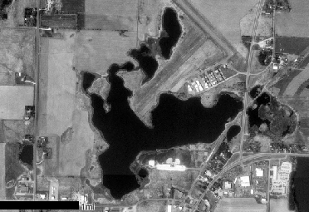
Mixed Sediment Types
Mixed Hard Sediments
Silt
Mixed Soft Sediments
Organic Muck
Peat
Sand
Figure 2. Sediment distribution in Hatfield Lake, 2006.
INFLUENCE OF SEDIMENT - Some plants depend on the sediment in which they are rooted for their nutrients. The richness or sterility and texture of the sediment will determine the type and abundance of plant species that can survive in a location.

Silt sediments are intermediate density sediments and considered most favorable for plant growth. The availability of mineral nutrients for growth is highest in sediments of intermediate density (Barko and Smart 1986). Silt only occurred in Hatfield Lake in the deepest water and supported no vegetation, likely due to light limitation (Table 2, 3). However, mixed with sand, silt was the most common sediment, especially in the 0-5ft depth zone. This sediment supported plants at nearly half the sites.

Pure sand was common in the 0-5ft depth zone and can be limiting to plant growth due to its high density and lower nutrient availability. Sand supported vegetation at nearly half the sites also. Sand/gravel mixtures were common in the shallowest zone and supported abundant vegetation.

Organic muck was common in the 1.5-5ft dept zone and supported vegetation at only one-quarter of the sites. Mixtures of organic muck with peat or silt were not common but supported the most abundant plant growth (Table 3).

Table 3. Sediment Influence on Plant Growth
Sediment Type |  | Percent of all Sample Sites | Percent Vegetated
Hard  Sediment | Sand | 18% | 44%
Hard  Sediment | Sand/Gravel | 12% | 83%
Mixed Sediment | Sand/Silt | 23% | 45%
Mixed Sediment | Sand/Peat | 8% | 25%
Soft Sediment | Muck | 17% | 25%
Soft Sediment | Silt | 8% | 0%
Soft Sediment | Muck/Peat | 4% | 100%
Soft Sediment | Silt/Peat | 4% | 50%
Soft Sediment | Silt/Muck | 2% | 100%
Soft Sediment | Peat | 2% | 0%

SHORELINE LAND USE – Land use can strongly impact the aquatic plant community and therefore the entire aquatic community. Land use can directly impact the plant community by increased erosion and sedimentation and increased run-off of nutrients, fertilizers and toxics applied to the land. These impacts occur in both rural and residential settings.

Herbaceous growth was the most frequently encountered shore cover and had the highest mean coverage. Shrub cover was also abundant (Table 4). A narrow ring of bare sand surrounded much of the lake, but did not have a high mean cover. Some type of natural shoreline occurred at all sites and covered approximately 97% of the shore.

Disturbed shoreline (hard structure, rip-rap,mowed lawn) was found at 10% of the sites and covered 3% of the shore (Table 4).

Table 4. Shoreline Land Use, 2006
Cover Type |  | Frequency of Occurrences at Transects | Mean % Coverage
Natural  Shoreline | Native Herbaceous | 100% | 71%
Natural  Shoreline | Shrub | 47% | 15%
Natural  Shoreline | Wooded | 16% | 4%
Natural  Shoreline | Bare Sand | 52% | 7%
Total Natural |  |  | 97%
Disturbed  Shoreline | Mowed Lawn | 5% | 1%
Disturbed  Shoreline | Rip-Rap | 5% | 1%
Disturbed  Shoreline | Hard Structure | 5% | 1%
Total Disturbed |  |  | 3%

MACROPHYTE DATA
SPECIES PRESENT
Twenty (20) aquatic plant species were found in Hatfield Lake in 2006: 3 emergent species, 5 floating-leaf species and 12 submergent species (Table 5).
No threatened or endangered species were found in the survey.
One non-native species was found: Potamogeton crispus (curly-leaf pondweed).

Table 5. Hatfield Lake Aquatic Plant Species, 2006
Scientific Name Common Name I. D. Code
________________________________________________________________________
Emergent Species
1) Scirpus acutus Muhl. hardstem bulrush sciac
2) Sparganium eurycarpum Engelm. giant bur-reed spaeu
3) Typha angustifolia L. narrow-leaf cattail typan

Floating-leaf Species
4) Lemna minor L. small duckweed lemmi
5) Lemna trisulca L. forked duckweed lemtr
6) Nuphar variegata Durand. bull-head pond lily nupva
7) Nymphaea odorata Aiton. white water lily nymod
8) Polygonum amphibium L. smartweed polam

Submergent Species
9) Ceratophyllum demersum L. coontail cerde
10) Chara sp. muskgrass chasp
11) Eleocharis acicularis (L.) Roemer & Schultes. needle spikerush eleac
12) Elodea canadensis Michx. common waterweed eloca
13) Myriophyllum sibiricum Komarov. common water milfoil myrsi
14) Najas flexilis (Willd.) Rostkov & Schmidt. slender naiad najfl
15) Potamogeton crispus L. curly-leaf pondweed potcr
16) Potamogeton natans L. floating-leaf pondweed potna
17) Potamogeton pectinatus L. sago pondweed potpe
18) Potamogeton pusillus L. small pondweed potpu
19) Potamogeton zosteriformis Fern. flatstem pondweed potzo
20) Zosterella dubia (Jacq.) Small water stargrass zosdu

FREQUENCY OF OCCURRENCE
Potamogeton pectinatus (sago pondweed) was the most frequently occurring species in Hatfield Lake in 2006 (17% of sample sites) (Figure 3). However, no aquatic plant species were commonly occurring in Hatfield Lake (Figure 3).
Figure 3. Frequency of aquatic plant species in Hatfield Lake, 2006.

DENSITY
Typha angustifolia (narrow-leaf cattail) was the species with the highest mean density (0.38 on a density scale of 0-4) in Hatfield Lake (Figure 4). Mean densities of all aquatic plant species were very low in Hatfield Lake.
Figure 4. Mean densities of aquatic plant species in Hatfield Lake, 2006.

“Density where present” measures whether a species exhibits a dense or aggregated growth form in a waterbody (Figure 5). Eleocharis acicularis (needle spikerush) had the highest “density where present”, indicating it exhibited an aggregated growth form in Hatfield Lake, although it occurred in limited locations. E. acicularis is a low-growing, turf-forming species. Elodea canadensis (common waterweed) exhibited a dense growth form in Hatfield Lake, but occurred at only one location and Typha angustifolia (narrow-leaf cattail) exhibited a growth form of above average density, occurring in dense beds around less than half of the shore in Hatfield Lake.
Figure 5. “Density where present” of aquatic plant species in Hatfield Lake, 2006.

DOMINANCE
Combining the relative frequency and relative density of a species into a Dominance Value illustrates how dominant a species is within the plant community (Appendix III). Based on the Dominance Value, Potamogeton pectinatus (sago pondweed) and Typha angustifolia (narrow-leaf cattail) were co-dominant aquatic plant species in Hatfield Lake (Figure 6). Zosterella dubia (water stargrass) was sub-dominant.
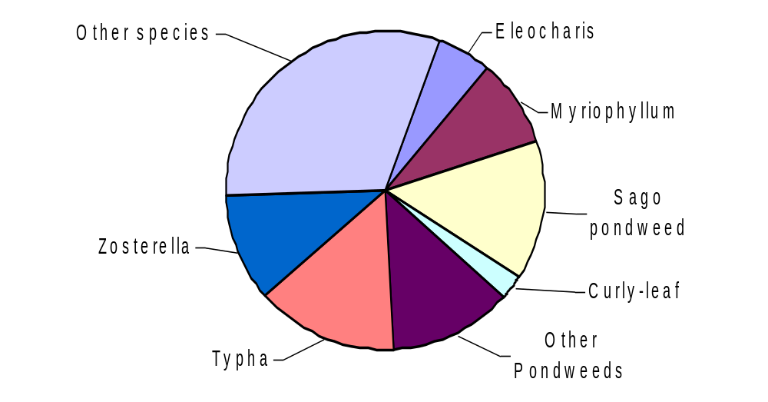
Figure 6. Dominance within the plant community, of the most prevalent aquatic plant species in Hatfield Lake, 2006.

DISTRIBUTION
Aquatic plants occurred throughout Hatfield Lake but were mainly restricted to the shallowest depth zone. All aquatic plant species in Hatfield Lake occurred in scattered locations in the lake. Nuphar variegata (yellow pond lily) and Ceratophyllum demersum (coontail) occurred at the maximum rooting depth, in one location at a depth of 3-feet.

Vegetation colonized 44% of the littoral zone, 31% of the lake surface (38 acres). In 2006, approximately 21 acres (17% of the lake surface, 31% of the littoral zone) was vegetated with submergent vegetation. Rooted, floating-leaf species colonized approximately 5 acres (4% of the lake surface; 10% of the littoral zone). Emergent vegetation colonized about 17 acres (14% of the lake surface, 23% of the littoral zone) (Figure 7). Because free-floating species can move across a water body with shifts in wind and the mats can expand or contract with changes in growing conditions, is not appropriate to map them as permanent cover. In July 2006, they colonized 13% of the littoral zone.

Floating-leaf Vegetation
Emergent Vegetation
Scattered Submergent Vegetation
Figure 7. Distribution of aquatic plants in Hatfield Lake, St. Croix County, 2006.
Water clarity data can be used to calculate a predicted maximum rooting depth for plants in a lake (Dunst 1982).
Predicted Rooting Depth (ft.) = (Secchi Disc (ft.) * 1.22) + 2.73
Based on the July 2001 Secchi disc water clarity (1.9 ft), the predicted maximum rooting depth in Hatfield Lake would be 5.0 feet.
The maximum rooting depth of 3 feet is less than the predicted maximum rooting depth based on water clarity. This may be due to less reliable water clarity estimates with satellite imagery or using water clarity data from a different year than the plant study was conducted.

Nearly all aquatic plant growth occurred in the shallowest zone: the highest total occurrence, highest total density, greatest percent of vegetated sites and greatest Species Richness (Figure 8, 9). Overall Species Richness (number of species per site) in Hatfield Lake was 1.27.
Figure 8. Total occurrence and total density of aquatic plants by depth zone in Hatfield Lake, 2006.

Figure 9. Percent of vegetated sites and Species Richness (mean number of species per sample site) by depth zone in Hatfield Lake, 2006.

THE COMMUNITY
Simpson's Diversity Index was 0.93 (Appendix I), indicating excellent species diversity. A rating of 1.0 would mean that each plant in the lake would be a different species (the most diversity achievable).

The Aquatic Macrophyte Community Index (AMCI) for Hatfield Lake (Table 6) is 45, indicating a low quality plant community. This value places Hatfield Lake in the lowest quartile of lakes in the North Central Hardwood Region and below average for lakes in Wisconsin. The shallow rooting depth is the most limiting factor for quality of the aquatic plant community.

Table 6. Aquatic Macrophyte Community Index: Hatfield Lake 2006
Category |  | Value
Maximum Rooting Depth | 0.9 meters | 1
% Littoral Zone Vegetated | 44% | 8
% Submergent Species | 60.6% Rel. Freq. | 6
# of Species | 20 | 9
% Exotic species | 3% | 6
Simpson's Diversity | 0.93 | 10
% Sensitive Species | 7% Relative Freq. | 5
Totals |  | 45
The highest value for this index is 70.

The Average Coefficient of Conservatism for Hatfield Lake was in the lowest quartile of lakes in Wisconsin and the North Central Hardwood Region (Table 7). This suggests that the aquatic plant community in Hatfield Lake is within the group of lakes most tolerant of disturbance. This is likely due to past disturbances.

Table 7. Floristic Quality and Coefficient of Conservatism of Hatfield Lake,
Compared to Wisconsin Lakes and Northern Wisconsin Lakes.
 | Average Coefficient of Conservatism† | Floristic Quality ‡
Wisconsin Lakes * | 5.5, 6.0, 6.9 | 16.9, 22.2, 27.5
NCH Region * | 5.2, 5.6, 5.8 | 17.0, 20.9, 24.4
Hatfield Lake 2006 | 4.85 | 21.69
* - Values indicate the highest value of the lowest quartile, the mean and the lowest value of the upper quartile.
† - Average Coefficient of Conservatism for all Wisconsin lakes ranged from a low of 2.0 (the most disturbance tolerant) to a high of 9.5 (least disturbance tolerant).
‡ - lowest Floristic Quality was 3.0 (farthest from an undisturbed condition) and the high was 44.6 (closest to an undisturbed condition).

The Floristic Quality Index of the plant community in Hatfield Lake is above average for lakes in the North Central Hardwood Region and below average for lakes in Wisconsin lakes (Table 7). This suggests that the plant community in Hatfield Lake is average in its closeness to an undisturbed condition.

Disturbances can be of many types:
- Direct disturbances to the plant beds result from activities such as boat traffic, plant harvesting, chemical treatments, the placement of docks and other structures and fluctuating water levels.
- Indirect disturbances are the result of factors that impact water clarity and thus stress species that are more sensitive: resuspension of sediments from wave action and boat traffic, sedimentation from erosion and increased algae growth due to nutrient inputs.
- Biological disturbances include the introduction of a non-native or invasive plant species, grazing from an increased population of aquatic herbivores and destruction of plant beds by the fish population.

Disturbance in Hatfield Lake is likely due to the introduction of exotic, invasive aquatic plant species and run-off from the road and construction.

IV. DISCUSSION
Hatfield Lake is a 121-acre shallow water/wetland complex resource. The lake appears to be haven for birdlife. Based on 2001 satellite estimated water clarity data, Hatfield Lake is a hypereutrophic lake with very poor water clarity and water quality. Filamentous algae occurred at 4% of sample sites and a thick scum of planktonic algae occurred at 6% of the sites.

Abundant nutrients (trophic state), the prevalence of favorable silt sediments mixed with sand, the gradually-sloped littoral zone and the shallow depths in Hatfield Lake would favor plant growth. The very poor water clarity may limit plant growth.

Aquatic plants occurred scattered around most of the shoreline and shallow water of Hatfield Lake, colonizing 44% of the littoral zone (31% of the lake surface), to a maximum depth of 3 feet. Game fish populations have been found to decline when submerged aquatic vegetation is less than 10% and greater than 60% (Valley et. al. 2004). Nearly all plant growth occurred in the shallowest depth zone, 0-1.5ft. The highest total occurrence of plants, highest total density of plants, highest percent of vegetated sites and the greatest Species Richness occurred in the shallowest depth zone (0-1.5ft).

Twenty (20) aquatic plant species were recorded in Hatfield Lake. Potamgeton pectinatus (sago pondweed) and Typha angustifolia (narrow-leaf pondweed) were the dominant plant species in Hatfield Lake, occurring at less than 20% of the sample sites. Zosterella dubia (water stargrass) was the sub-dominant plant species, also occurring at less than 20% of the sites in Hatfield Lake. One non-native aquatic plant species was found in Hatfield Lake: Potamogeton crispus (curly-leaf pondweed), but was not common and occurred at a low mean density. All aquatic plant species were found at low densities and none were commonly occurring in the lake. Three species did exhibit aggregated growth forms (above average density, but occurring only in limited locations). One of the dominant species, T. angustifolia, and two other species, Eleocharis acicularis (needle spikerush) and Elodea canadensis (common waterweed), exhibited this aggregated growth form.

The Aquatic Macrophyte Community Index (AMCI) for Hatfield Lake was 45, indicating that Hatfield Lake’s aquatic plant community is of low quality compared to other Wisconsin lakes and lakes in the North Central Hardwood Region. The Simpson's Diversity Index (0.93) for Hatfield Lake indicates that the aquatic plant community had excellent diversity of species. Species Richness was 1.27 species per sample site.

The Average Coefficient of Conservatism and the Floristic Quality Index suggests that Hatfield Lake has a high tolerance of disturbance and is average in its closeness to an undisturbed condition. This is likely due to past and current disturbance in the lake (introduction of exotic, invasive aquatic plant species and run-off from the road and construction).

Hatfield Lake is protected by natural shoreline cover (wooded, shrub, native herbaceous growth and natural sand bench) at 97% of the shore. Nearly all of the shoreline is protected by natural cover. Preserving this natural shoreline is critical to maintaining water quality and wildlife habitat. Conversion of the natural shoreline to lawn, rip-rap or hard structures would result in significant loss of shoreline habitat loss for wildlife. The loss of natural shoreline would also destroy the buffer that infiltrates stormwater run-off to the lake. Run-off volume from developed lawn is approximately 10 times greater than run-off from natural wooded cover and more run-off events occurred at sites with lawn (Graczyk et. al. 2003). This increased run-off carries more nutrients to the lake. Nitrogen and phosphorus input was 10-100 times greater at developed lawn than wooded areas (Hunt et. al. 2006).
V. CONCLUSIONS
Hatfield Lake is a hypereutrophic, wetland/shallow lake complex with very poor water clarity and very poor water quality. Filamentous algae and films of planktonic algae occurred at low frequencies in the lake.

Aquatic plant community colonized less than half of the littoral zone, less than one-third of the total lake area, to a maximum depth of 3 feet. Plant growth occurred as scattered growth and nearly all growth occurred in the 0-1.5ft depth zone.

Twenty (20) aquatic plant species were recorded in Hatfield Lake. Potamogeton pectinatus (sago pondweed) and Typha angustifolia (narrow-leaf cattail) were the dominant species and Zosterella dubia (water stargrass) was the sub-dominant species, all occurring at less than one-fifth of the sites. All species in the lake occurred at low mean densities and none were commonly occurring. Three species exhibited aggregated growth forms (above average density, but occurring only in limited locations: T. angustifolia, Eleocharis acicularis and Elodea canadensis.

The aquatic plant community in Hatfield Lake is characterized by low quality, excellent species diversity, a high tolerance to disturbance and a condition that is average in its closeness to an undisturbed condition.

A healthy aquatic plant community plays a vital role within the lake community. This is due to the role plants have 1) improving water quality 2) providing valuable habitat resources for fish and wildlife 3) resisting invasions of non-native species and 4) checking excessive growth of tolerant species that could out compete sensitive species, thus reducing diversity (Figure 10).

Aquatic plant communities improve water quality in many ways; they trap nutrients, debris, and pollutants entering a water body; absorb and break down some pollutants; reduce erosion by damping wave action and stabilizing shorelines and lake bottoms; remove nutrients that would otherwise be available for algae blooms (Engel 1985).

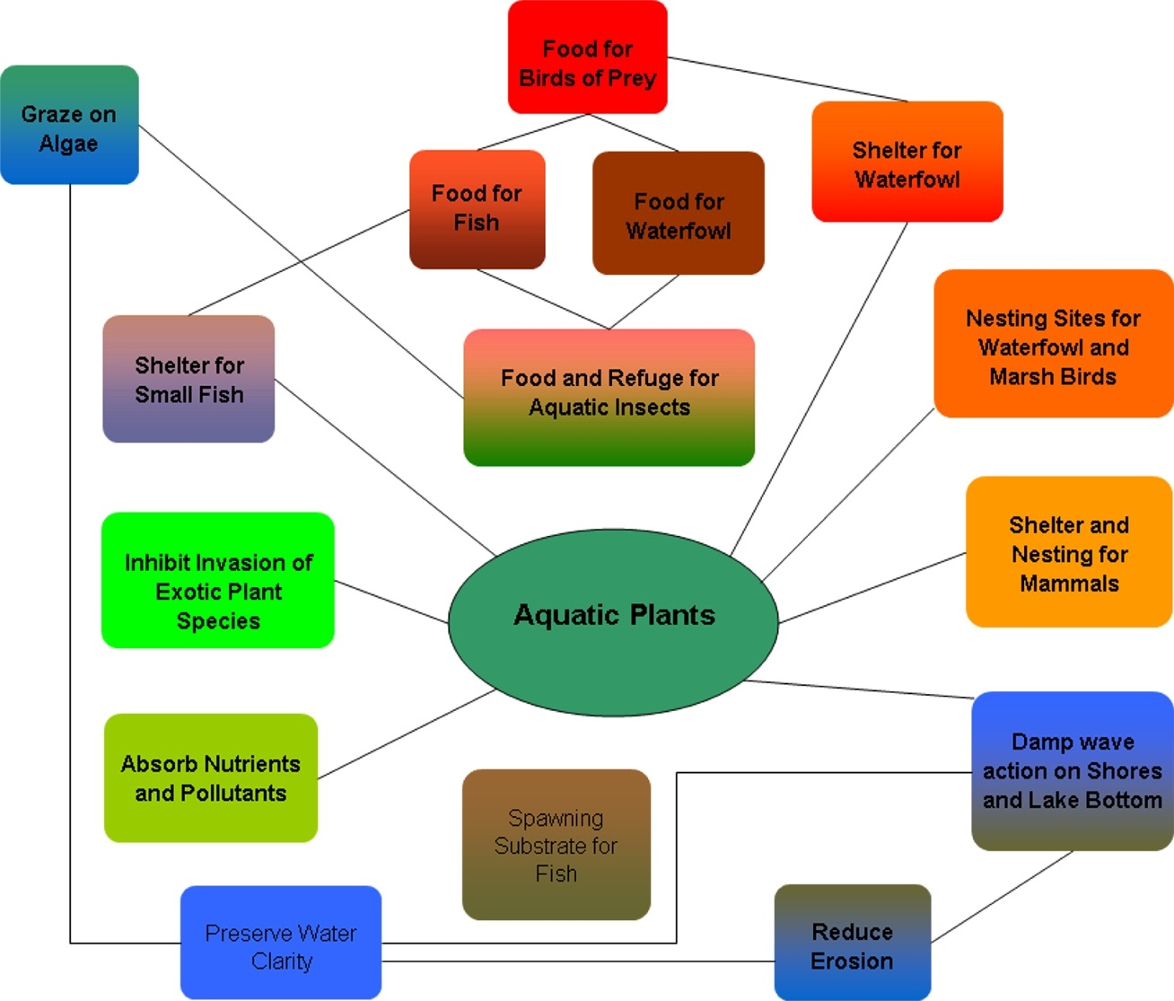
Figure 10. Benefits of aquatic plants in the lake ecosystem

Aquatic plant communities provide important fishery and wildlife resources. Plants (including algae) start the food chain that supports many levels of wildlife, and at the same time produce oxygen needed by animals. Plants are used as food, cover and nesting/spawning sites by a variety of wildlife and fish (Table 8). Game fish populations have been found to decline when submerged aquatic vegetation is less than 10% and greater than 60% (Valley et. al. 2004). Plant cover within the littoral zone of Hatfield Lake is 44% and over the entire lake is 31%, which is appropriate to support a balanced fishery.

Compared to non-vegetated lake bottoms, plant beds support larger, more diverse invertebrate populations that in turn will support larger and more diverse fish and wildlife populations (Engel 1985). Additionally, mixed stands of plants support 3-8 times as many invertebrates and fish as monocultural stands (Engel 1990). Diversity in the plant community creates more microhabitats for the preferences of more species. Plant beds of moderate density support adequate numbers of small fish without restricting the movement of predatory fish (Engel 1990).

Table 10. Wildlife and Fish Uses of Aquatic Plants in Hatfield Lake
Aquatic Plants | Fish | Water  Fowl | Song and Shore  Birds | Upland Game  Birds | Muskrat | Beaver | Deer
Submergent Plants
Ceratophyllum demersum | F,I*, C, S | F(Seeds*), I, C |  |  | F
Chara sp. | F*, S | F*, I*
Eleocharis acicularis | S | F |  |  | F
Elodea canadensis | C, F, I | F(Foliage) I
Myriophyllum sibiricum | F*, I*, S | F(Seeds, Foliage) | F(Seeds) |  | F
Najas flexilis | F, C | F*(Seeds, Foliage) | F(Seeds)
Potamogeton crispus | F, C, S | F(Seeds, Tubers)
Potamogeton natans | F, I, S*,C | F*(Seeds, Tubers) |  |  | F* | F | F
Potamogeton pectinatus | F, I, S*,C | F* |  |  | F* | F | F
Potamogeton pusillus | F, I, S*,C | F*(All) |  |  | F* | F | F
Potamogeton zosteriformis | F, I, S*,C | F*(Seeds) |  |  | F* | F | F
Zosterella dubia | F, C, S | F(Seeds)
Floating-leaf Plants
Lemna minor | F | F*, I | F | F | F | F
Lemna trisulca | F, I | F*, I
Nuphar variegata | F,C, I, S | F, I | F |  | F* | F | F*
Nymphaea odorata | F,I, S, C | F(Seeds) | F |  | F | F | F
Polygonum amphibium | I, S | F*(Seeds) |  | F(Seeds) | F(Seeds) |  | F(Seeds)
Emergent Plants
Scirpus acutus | F, S, C, I | F*(Seeds, tubers) | F(Seeds, Tubers), C | F | F*
Sparganium eurycarpum | I | F(Seeds), C | F, C |  | F |  | F*
Typha angustifolia | S, C |  |  |  |  | F
F=Food, I= Shelters Invertebrates, a valuable food source C=Cover, S=Spawning
*=Valuable Resource in this category
*Current knowledge as to plant use. Other plants may have uses that have not been determined.
After Fassett, N. C. 1957. A Manual of Aquatic Plants. University of Wisconsin Press. Madison, WI
Nichols, S. A. 1991. Attributes of Wisconsin Lake Plants. Wisconsin Geological and Natural History Survey. Info. Circ. #73

Management Recommendations
- City and airport preserve the natural shoreline buffer that is found around Hatfield Lake. Wooded cover, shrubs and native herbaceous growth protected nearly all of the shoreline.
  - Maintaining natural shoreline cover is critical to maintaining water quality and wildlife habitat.
  - Cutting or trees and shrub growth only to maintain prairie habitat around the lake.
- Any future development on the lake use best management practices on shoreland property to prevent nutrient enrichment and stormwater run-off to the lake.
  - Eliminate fertilization near shoreline
  - Use no-phosphorus fertilizer on remainder of the property
  - Minimize use of toxic chemicals and no disposal of chemicals in the lake
  - Use and maintain erosion barriers during any construction
  - Inspect and maintain septic systems
  - Reduce size of areas with hard surface
  - Design landscaping so that stormwater run-off runs away from the lake, onto porous land cover and/or into rain barrels or rain gardens
- Designate lake as electric motor lake only
- DNR to consider designating critical habitat areas within Hatfield Lake. These are areas that are most important for habitat and maintaining water quality.

LITERATURE CITED
Barko, J. and R. Smart. 1986. Sediment-related mechanisms of growth limitation in submersed macrophytes. Ecology 61:1328-1340.

Dennison, W., R. Orth, K. Moore, J. Stevenson, V. Carter, S.Kollar, P. Bergstrom, and R. Batuik. 1993. Assessing water quality with submersed vegetation. BioScience 43(2):86-94.

Duarte, Carlos M. and Jacob Kalff. 1986. Littoral slope as a predictor of the maximum biomass of submerged macrophyte communities. Limnol. Oceanogr. 31(5):1072-1080.

Dunst, R.C. 1982. Sediment problems and lake restoration in Wisconsin. Environmental International 7:87-92.

Engel, Sandy. 1990. Ecosystem Response to Growth and Control of Submerged Macrophytes: A Literature Review. Technical Bulletin #170. Wisconsin Department of Natural Resources. Madison, WI.

Engel, Sandy. 1985. Aquatic Community Interactions of Submerged Macrophytes. Wisconsin Department of Natural Resources. Technical Bulletin No. 156. Madison, WI

Fassett, Norman C. 1957. A Manual of Aquatic Plants. University of Wisconsin Press. Madison, WI.

Gleason, H. and A. Cronquist. 1991. Manual of Vascular Plants of Northeastern United States and Adjacent Canada (Second Edition). New York Botanical Gardens, NY.

Graczyk, David, R. Hunt, S. Greb, C. Buchwald and J. Krohelski. 2003. Hydrology, Nutrient Concentrations and Nutrient Yields in Nearshore Areas of Four Lakes in Northern Wisconsin, 1999-2001. USGS Water Resources Investigations Report 03-4144.

Hunt, Randall, S. Greb and D. Gracyzk. 2006. Evaluating the Effects of Nearshore Development on Wisconsin Lakes. USGS Fact Sheet 2006-3033.

Jessen, Robert and Richard Lound. 1962. An evaluation of a survey technique for submerged aquatic plants. Minnesota Department of Conservation. Game Investigational Report No. 6.

Lillie, R. and J. Mason. 1983. Limnological Characteristics of Wisconsin Lakes. Wisconsin Department of Natural Resources Tech. Bull. #138. Madison, WI.

Nichols, Stanley, S. Weber, B. Shaw. 2000. A proposed aquatic plant community biotic index for Wisconsin lakes. Environmental Management 26:491-502.

Nichols, Stanley. 1998. Floristic quality assessment of Wisconsin lake plant communities with example applications. Journal of Lake and Reservoir Management 15(2):133-141.

Nichols, Stanley A. and James G. Vennie. 1991. Attributes of Wisconsin Lake Plants. Wisconsin Geological and Natural History Survey. Information Circular 73.

Shaw, B, C. Mechenich and L. Klessig. 1993. Understanding Lake Data. University of Wisconsin – Extension. Madison, WI

Valley, Ray, T. Cross and P. Radomski. 2004. The Role of Submersed Aquatic Vegetation as Habitat for Fish in Minnesota Lakes, Including the Implications of Non-Native Plant Invasions and Their Management. Minnesota Department of Natural Resources Special Publication 16
Appendix IV. Location of Aquatic Plant Survey Transects on Hatfield Lake.
11
12
13
14
15
16
17
18
19
10
9
8
7
6
5
4
3
2
1

