Pleasant Valley Branch
and
Kittleson Valley Creek
A contemporary assessment of the status of the fishery, habitat, and macroinvertebrates 5 years after completion of the watershed project and the 2013 assessment of to remove Pleasant Valley from the State’s 303(d) list of impaired waters.

In fulfillment of Project: South_1_CMP18

Dane County, WI

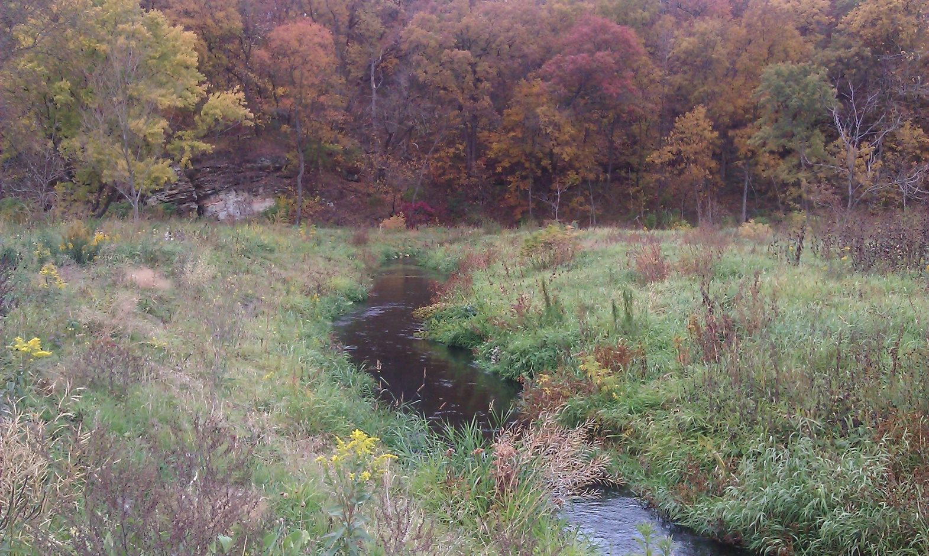
Kittleson Valley Creek – Upstream of STH 78

By James Amrhein
Water Quality Biologist, South District
March 2020

Pleasant Valley Branch and Kittleson Valley Creek are 2 streams in southwest Dane County that have been the subject of intense riparian rehabilitation and watershed work (Figure 1). The department, in cooperation with the Dane County Land and Water Conservation Department, began working to improve the riparian corridor of these streams in 2003. In 2006, a consortium of public and private partners, under the auspices of the Wisconsin Buffer Initiative (WBI), worked with landowners in the watershed to reduce the amount of sediment and nutrient runoff from agricultural lands and pastures and improve barnyards. In 2009, implementation of “soft practices” such as no-till, or reduced till farming, use of cover crops, crop rotational changes, and emphasis on nutrient management began. That was followed by implementation of so-called “hard practices” such as barnyard runoff systems, fencing and stream crossings, and installation of water and sediment control basins from 2011 to 2013. The successes of all these efforts in improving the water quality of Kittleson Valley Creek have been previously reported (WDNR, 2014; TNC, 2014; Carvin, et. al., 2018). Carvin, et. al. (2018) specifically reported that there was a statistically significant decrease in phosphorus loads and an apparent reduction in suspended sediment to the creek compared to a control watershed.
Figure 1: Pleasant Valley Branch and Kittleson Valley Creek sub-watershed
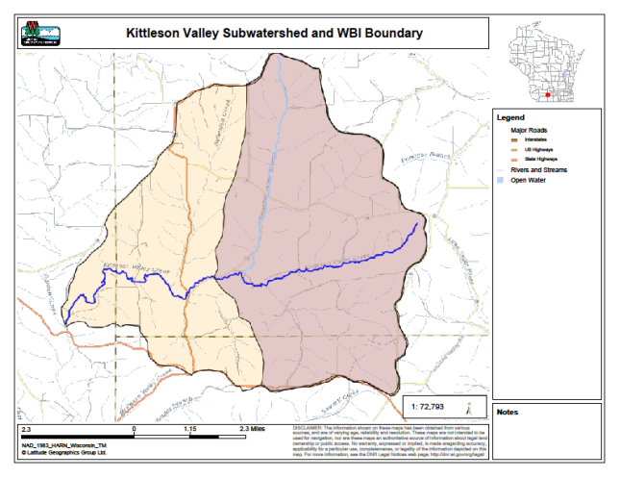
Pleasant Valley in light blue, Kittleson Valley in dark blue
Kittleson Valley sub-watershed boundary in orange and pink, Wisconsin Buffer Initiative (WBI) boundary in pink only

In 2013, the department conducted surveys on both Pleasant Valley Branch and Kittleson Valley Creek to determine the status of the fishery, habitat, and macroinvertebrate community after implementation of these practices (WDNR, 2014). A secondary goal was to determine if Pleasant Valley Branch was meeting its attainable use and could be removed from the impaired waters list. After assessing the results of the surveys, the department petitioned the USEPA to remove Pleasant Valley Branch from the state’s 303(d) list of impaired waters in 2016. The state formally received approval to remove the stream from the list in 2018. Another recommendation of that 2013 study was for the department’s Bureau of Fisheries Management to consider Pleasant Valley as a Class II trout water. In 2016, the entire length of Pleasant Valley Branch was given that designation.
Because work in the riparian corridor and watershed was so extensive, and because there was documentation of reductions in total phosphorus loads and suspended sediment to the stream, the department planned on repeating the studies 5 years later to determine the status of the fish and habitat, with particular emphasis toward determining if sediment distribution had changed or reached a steady state.
Methods
The 2018 surveys attempted to repeat the 2013 study as much as possible. This included surveys on the same 3 sites on each respective stream. Fishery data was also included on Kittleson Valley Creek at Truman Road as this is a fisheries management trend site. The fishery assemblage was determined by electrofishing the same station lengths to the extent practicable using protocols developed by Lyons (1992). A stream tow barge with a generator and two probes was used at most sites. A backpack shocker with a single probe was used at Perry Center Road on Kittleson Valley Creek. All fish were collected, identified, and counted. All gamefish were measured. At each site, qualitative notes on average stream width and depth, riparian buffers and land use, evidence of sedimentation, fish cover and potential management options were also recorded. Because these systems are modeled to be coldwater communities (Lyons, 2008) and have been verified to be coldwater systems (WDNR, 2019), the Coldwater Index of Biotic Integrity (IBI) (Lyons, et. al., 1996) was applied to the data. A summary of the fisheries data is found in Table 1.
Quantitative habitat surveys (Simonson et. al., 1994) were also conducted on the same 6 sites, attempting to use the same transects and total station length as in previous studies. Measurements of stream width, bank erosion, width-to-depth ratio, riffle and/or pool ratio, percent soft sediment, and fish cover are incorporated into this survey. The results are summarized in Table 2.
Macroinvertebrate samples were obtained by kick sampling and collecting using a D-frame net at each of the sites on both streams and sent to the University of Wisconsin-Stevens Point for analysis. The macroinvertebrate IBI (Weigel, 2003) and Hilsenhoff Biotic Index (HBI) (Hilsenhoff, 1987) were applied to the data.
Table 1: Fisheries Data for Pleasant Valley Branch & Kittleson Valley Creek Pre and Post Rehabilitation
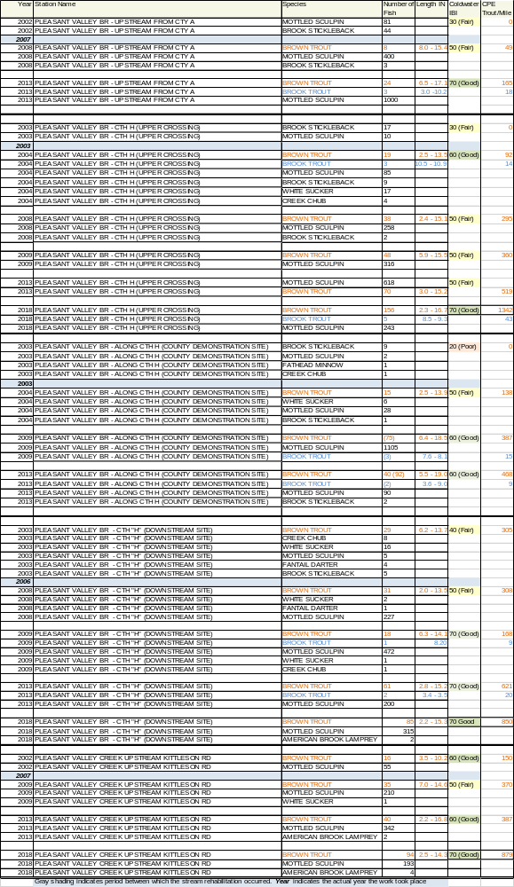
Table 1: (Continued)
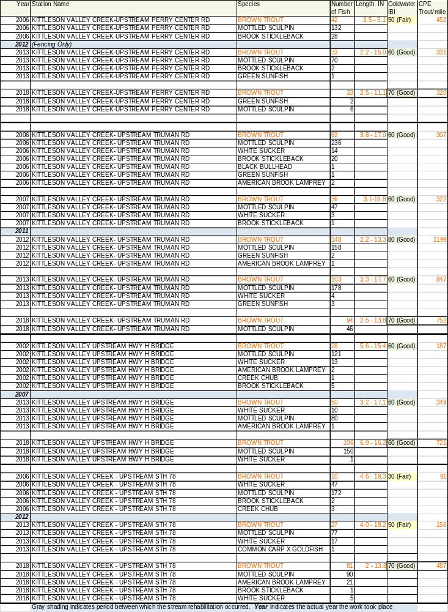
Table 2: Quantitative Habitat Surveys for Pleasant Valley Branch and Kittleson Valley Creek: A Comparison of Pre to Post Rehabilitation
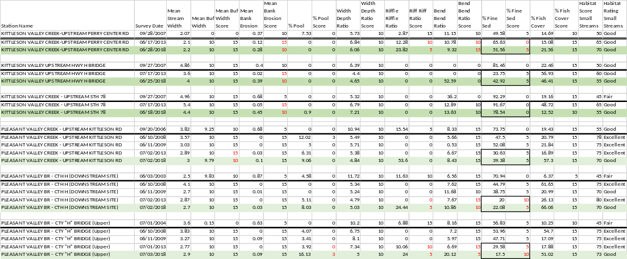
Numbers in red indicate a difference in scores for respective metrics between the 2013 and 2018 studies.
Results and Discussion
Fish
As shown in Table 1, the health of the fishery, as measured by the coldwater IBI and catch-per-unit effort (CPE), which is an extrapolated number of trout per mile, continue to show both systems have improved. All sections have improved to a condition of “good” on the IBI scale. IBI scores were 70 (good) at all sites except for one on Kittleson Valley. As shown in Table 3, all sites on Pleasant Valley scored 70, but the top-level carnivore score is depressed by 10 points merely because of the abundance of mottled sculpin – an intolerant, coldwater species. This similarly occurred at some sites on Kittleson Valley. A coldwater IBI score of 80 (good) is as high as one can get in the absence of brook trout.
Trout numbers have continued to increase at most stations where habitat improvement was initiated. Trout CPE numbers have shown a steady increase over the past 15 years, with some sites seeing an increase in trout populations by over 1000 percent compared to prior to the project. The highest improvements came at sites where habitat structures such as rock barbs, vortex weirs, and Little Underwater Neighborhoods Encompassing Rheotactic Salmonids (LUNKERS) were employed. Habitat structures were not used at the site on Kittleson Valley at Perry Center Road, but instead was only fenced to reduce cattle access. This site was the only one to see a decrease in overall trout numbers (from pre-rehabilitation levels), however several year classes have been present in that section of stream during the last 2 surveys as opposed to exclusively young-of-the-year (YOY) trout as found in 2006.
Table 3: Coldwater IBIs for Pleasant Valley Branch and Kittleson Valley Creek - 2018
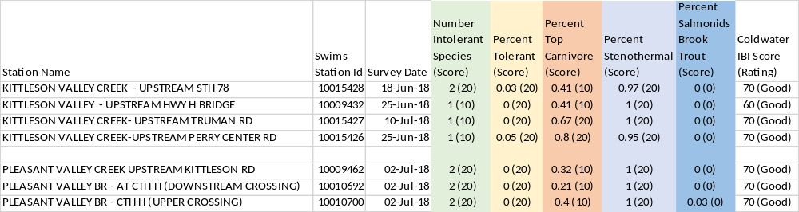
As shown in Table 4, in comparison to other trout streams in the Driftless area of southwestern Wisconsin, Pleasant Valley is consistently above the 50th and 75th percentiles for numbers of fish of all size classes. Kittleson Valley is more variable, with sites/size structures more likely in the 25th to 75th percentiles. Any YOY trout that were captured (trout less than 4” in length) in this 2018 study are presumed to be naturally reproduced as stocking has not occurred in either stream since 2015 (WDNR, unpublished data). There is a lack of smaller fish (< 4 inches) in the lower sites of Kittleson Valley (CTH H and STH 78) presumably due to lack of suitable habitat for spawning and/or cover for young fish.
Habitat
Overall habitat scores remained in the good to excellent category as shown in Table 2. As was previously reported (WDNR, 2014), one of the reasons Pleasant Valley was taken off the impaired waters list was because soft sediment - as measured by percent fines - was greatly reduced. One of the biggest questions was whether the sediment reduction in both streams would continue, or if a steady state had been achieved. For both creeks, percent fine sediment showed no significant changes from 2013 to 2018. There were slight variations in the “% fine sediment” metric and the actual score as assigned to the data varied at 2 sites on Pleasant Valley and 1 on Kittleson Valley. However, on Pleasant Valley, the scores were near the 20 percent breakpoint assigned between fair (5) and good (10) and thus resulted in some
Table 4: Brown Trout Population and Size Structure for Pleasant Valley Branch and Kittleson Valley Creek in Comparison to other Driftless Area Brown Trout Streams
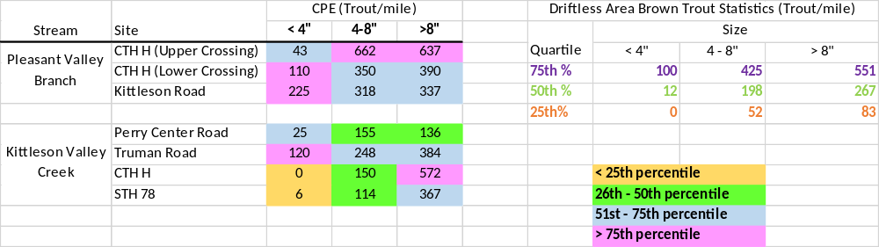
changes in the score assigned to those sites. While the actual precision of sediment deposition has not been determined (Simonson, et. al., 1994), the actual differences in percentages were relatively low and could be explained by slight differences in transects or sample points within the transect. Kittleson Valley Creek showed 2 areas of lower percent fines and one higher compared to 2013, but nothing consistent. Compared to pre-rehabilitation measures, there has still been a major decrease in the amount of fine substrate in these creeks.

Scores for some of the other metrics (percent pools, riffles, bends and percent fish cover) varied slightly, but these slight variations are often artifacts of water level differences and/or interpretational differences by biologists. On the other hand, fish cover is a metric that varies widely if looking at the actual percentage of fish cover. However, there is enough fish cover at most sites that the minimum of 15% cover is attained resulting in the maximum of 15 points assigned to the metric. Again, differences in cover percentage may be a result of changes in water levels which may allow for more inclusion of habitat features, or slight variation in where the transect occurs. Either way, there is consistently enough habitat for the rating to be in the “excellent” category.
There were no consistent trends or changes in a specific metric that would signal an overall change to the habitat characteristic(s) of either stream. A possible exception to this would be the bank erosion metric on Kittleson Valley Creek. All three sites saw an increase in the amount of bank erosion, and thus a drop in score. Mean bank erosion in 2018 crept up to levels similar to pre-rehabilitation days. Biologists noted that lateral recession had occurred, primarily on outside bends of the creek. This may be the result of several high flow events that have occurred over the past 5 years, an increase in baseflow due to higher annual precipitation, or a combination of both. This is similar to what is being seen on the West Branch Sugar River, where banks have receded to the point where they are now cutting behind habitat structures (WDNR, 2018). This phenomenon will have to continue to be monitored to see if it has a similar impact on both of these streams. The department is already working with the Dane County Land and Water Conservation Department to address some of these areas.
Macroinvertebrates
Macroinvertebrates were collected at each of the 6 sites in this study (Table 5). The macroinvertebrate IBI (MIBI) was consistent for Pleasant Valley in the “fair” to “good” range. Kittleson Valley varied a bit more from “excellent” upstream at Perry Center Road to “fair” at STH 78.

With the exception of the Perry Center Road site, it is surprising that the macroinvertebrate community is not better representing both the condition of the riparian corridor as well as the condition of the

Table 5: Macroinvertebrate Data for Pleasant Valley Branch and Kittleson Valley Creeks
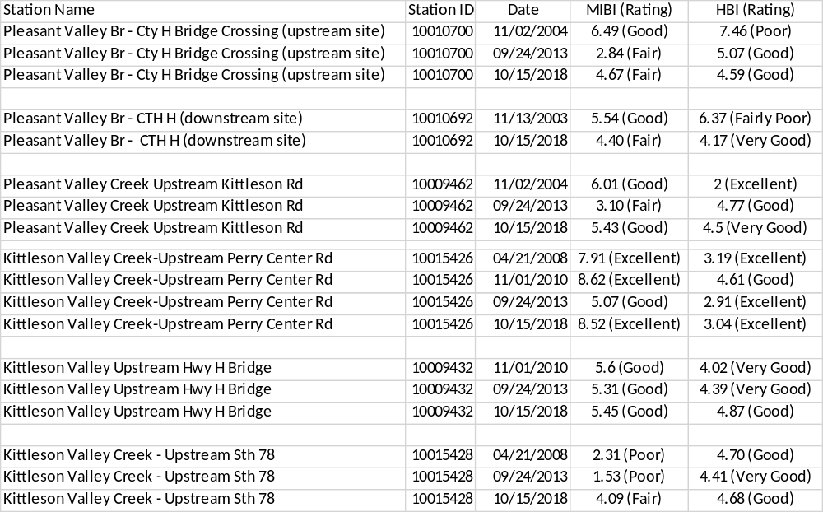
watershed. While the MIBI’s rebounded from the 2013 ratings, they still have not achieved consistently “good” to “excellent” scores. This is perhaps because, in some cases, such as Pleasant Valley Branch at the upper CTH H crossing, and Kittleson Valley Creek at CTH H, the riparian corridor projects had already been completed by the time the initial bug samples were taken. Therefore, it’s possible those initial bug assemblages were already reflecting the improved condition of the riparian corridor but have not improved much since then. In 2013, the depressed ratings could be attributed to the high number of striped blackfly larvae (Simulium vittatum) that were present in the samples (WDNR, 2014). 2016, 2017 and 2018 were above normal in precipitation (Wisconsin State Climatology Office, 2018), but it is not clear if this resulted in higher than normal runoff or additional sediment and nutrient loads. Riparian land use has remained largely the same in the past 5 years, so the repressed scores likely cannot be explained simply owing to high pollutant loads or stream corridor recession. The HBI still consistently shows very low organic loading.

Conclusions and Recommendations
Overall, the project continues to be a success, particularly based on the fishery. Habitat metrics continue to hold steady, with some confounding variables (i.e. bank erosion) that may be influenced by higher water levels. If this trend continues in the advent of climate change, resource managers will have to plan to address these issues in the coming years as well as take this knowledge forth in designing future projects. Based on personal observations, it cannot be overstated that this watershed is one of the finest in south-central Wisconsin. The combination of work in the watershed as well as the streambank and habitat work, along with changes in land use along the riparian corridor have resulted in a high-quality resource. It is hoped that the land use practices adopted during the project will continue to allow farm sustainability along with resource protection.
- The department should work with the Dane County LCD to identify areas of bank erosion and work to repair and mitigate further damage to the riparian corridor.

- The department should repeat this study on a 5-year basis to assess long-term ecosystem response to such an intensive project. This will require working with the Dane County LCD to identify changes in land use in the watershed to ascertain the potential influence of changes on the fish, habitat, and water quality.

*************************************************************************************
Total Phosphorus
While it was not an original goal of the project, it is interesting to look at median total phosphorus concentrations and compare it to the department’s phosphorus standard of 0.075 mg/l. Total phosphorus samples were collected at 2 sites (Figure 2) in 2017 by taking monthly grab samples during the May through October growing season in accordance with Wisconsin Consolidated Assessment and Listing Methodology (WisCALM) protocol (WDNR, 2020). Samples were collected on Pleasant Valley Branch at Kittleson Road and a Kittleson Valley Creek at CTH H. The latter site was the same site where a United States Geological Survey (USGS) station collected samples for the aforementioned watershed project. As such, samples for both baseline and events were collected and yearly trends can be noted.
Figure 2: Total Phosphorus Sample Stations
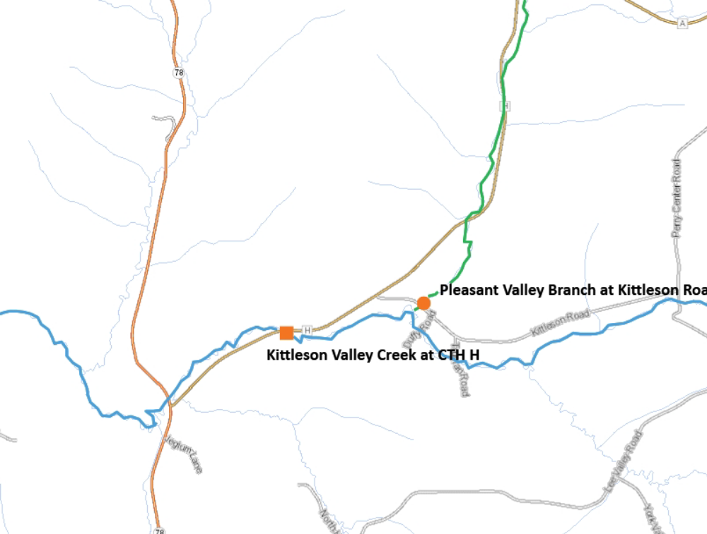
As shown in Table 6 and Figure 3, in 2017 both streams had roughly the same phosphorus concentration and trends throughout the season. The exception was May when Kittleson Valley was at a higher concentration than Pleasant Valley. Both streams steadily decreased through the summer, going below the total phosphorus criteria of 0.075 mg/l in August. Concentrations rebounded slightly into the fall months on September and October but remained below the criteria. Such sampling reveals the variability in grab sampling, which can be influenced by season and recent precipitation events. As has been shown in other studies (Carpenter, et. al., 2018; Rattan, et. al. 2017; Lathrop and Carpenter, 2014), spring runoff and heavy precipitation events tend to lead to the highest sediment and nutrient loads because of the vulnerability of bare or recently planted ground. Therefore, growing season sampling may be suitable for the purposes of impairment determination compared to the criteria but does not give a good indication of the sediment or phosphorus loading to a system nor does it lend itself to tracking improvements in water quality.
Table 6: Total Phosphorus during the Growing Season, 2017.
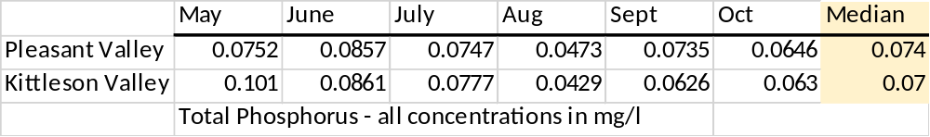

Figure 3: 2017 Growing Season Phosphorus: Pleasant Valley Branch and Kittleson Valley Creek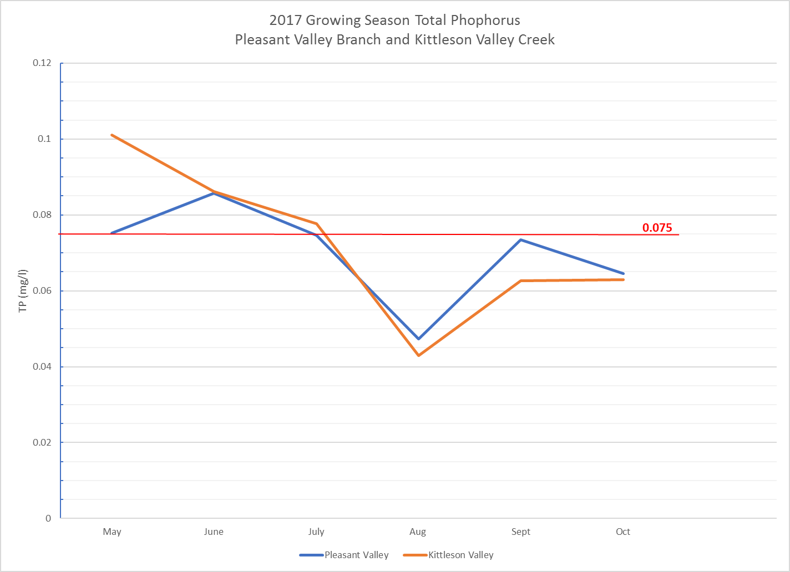
Figure 4 shows the median concentration of phosphorus during the growing seasons from 2007 to 2017. With the exception of 2017, the trend median data is taken from samples collected by USGS on the 15th of each month (Rebecca Carvin, personal communication). The period from 2007 to 2010 is considered “baseline” for the stream since few best management practices were enacted in the watershed during that time. It should be noted, however, that streambank work had begun on Pleasant Valley Branch in 2003 and had continued up through 2007. Therefore, total phosphorus contributions from banks or legacy sediment on Pleasant Valley Branch may already have been mitigated prior to the initiation of this sampling. The period from 2010 to 2013 is considered the treatment phase, whereby soft (conservation tillage, cover crops and crop rotations) and hard (fencing, stream crossings, barnyard runoff management) practices were put in place in the watershed. The period after 2013 is considered the “post-treatment” period. There was a drop in the median total phosphorus concentration from 2007 to 2008, and then the concentration appeared to steadily decline from 0.073 to 0.051 mg/l over the next 6 years. The median rose in 2015 to 0.087 mg/l, above the standard. This rise cannot be

Figure 4: Median Total Phosphorus Concentration Trend: Kittleson Valley Creek
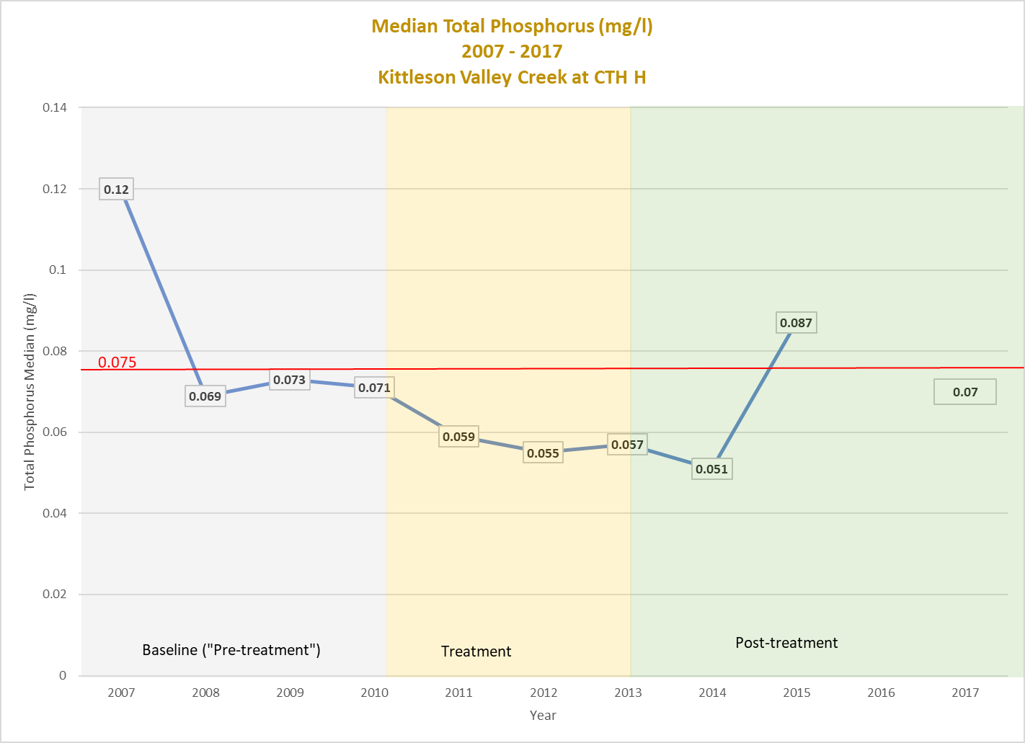
explained, other than it may have been coincidental to precipitation events. The USGS gaging station was removed after the 2015 water year so no sampling was conducted in 2016. The median concentration in 2017 was 0.07 mg/l which is below the criteria, but above the concentrations recorded during the treatment and the beginning of the post-treatment phases. While there was a general downward trend in median concentration, there are no correlations with the phases of the project.
These 2 examples show the difficulty of tracking improvements in watersheds by periodic grab sampling to compare results to a beginning or a target concentration. It would be difficult to find a watershed in the highly agricultural landscape of south-central Wisconsin where there was a more concentrated effort to enact agricultural best management practices combined with bank stabilization within the riparian corridor. Despite this, we still see total phosphorus concentrations at, near, or even occasionally above the criteria. While the project was able to show a statistically significant reduction in total phosphorus loading to the creeks (Carvin, et. al. 2018), concentration wise, the difference was not significant.
One of the confounding issues with doing this analysis was that the baseline monitoring had not begun until 2007 and that comparable total phosphorus data prior to that date is lacking. As mentioned earlier, work in the watershed, particularly streambank stabilization, had already begun in 2003. Over 2 miles of streambank had been stabilized on Pleasant Valley by 2007 and could have affected the bank and bedload contributions at the initiation of the sample period (i.e. total phosphorus might have been higher in 2003 due to these additional sources). As work continued in 2007 on Kittleson Valley Branch, it is possible this work, which disturbs bank and legacy sediment, could influence the initial 2007 median which was 0.12 mg/l and higher than any other median for the recorded period. Despite the statistical uncertainty, the overall success of the project – in terms of partnerships, land use, phosphorus and sediment load reduction, and fishery and habitat improvements should not be underestimated.
*************************************************************************************
References
Carvin, Rebecca, L.W. Good, C. Diehl, K. Songer, K.J. Meyer, J.C. Panuska, S. Richter, and K. Walley. 2018. Testing a two-scale focused conservation strategy for reducing phosphorus and sediment loads from agricultural watersheds. Journal of Soil and Water Conservation. 73(3): 298-309.
Carpenter, Stephen R., Eric G. Booth, Christopher J. Kucharik. 2018. Extreme Precipitation and Phosphorus Loads from Two Agricultural Watersheds. Limnology and Oceanography. 63(3): 1039-1447.
Hilsenhoff, William L. 1987. An Improved Biotic Index of Organic Stream Pollution. The Great Lakes Entomologist. 20: 31-39.
Lathrop, R.C. and S.R. Carpenter. 2014. Water Quality Implications from Three Decades of Phosphorus Loads and Trophic Dynamics in the Yahara Chain of Lakes. Inland Waters. 4:1-14. Doi:10.5268/IW-4.1.680.
Lyons, John. 1992. Using the Index of Biotic Integrity (IBI) to Measure Environmental Quality in Warmwater Streams of Wisconsin. United States Department of Agriculture. General Technical Report NC-149.
Lyons, John. L. Wang, and T. Simonsen. 1996. Development and Validation of an Index of Biotic Integrity for Coldwater Streams in Wisconsin. North American Journal of Fisheries Management. 16:241-256.
Lyons, John. 2008. Using the Wisconsin Stream Model to Estimate the Potential Natural Community of Wisconsin Streams (DRAFT). Wisconsin Department of Natural Resources Fish and Aquatic Life Research Section. November 2008.
Rattan, K.J., J.C. Corriveau, R.B. Brua, J.M. Culp, A.G. Yates, and P.A. Chambers. Quantifying seasonal variation in total phosphorus and nitrogen from Prairie Streams in the Red River Basin, Manitoba Canada. Science of the Total Environment. 575 (2017) 649-659.
Simonson, Timothy D., J. Lyons and P. Kanehl. 1994. Guidelines for Evaluating Fish Habitat in Wisconsin Streams. United States Department of Agriculture. Forest Service. General Technical Report NC-164.
TNC. 2014. Targeting Conservation Practices Within a Watershed: Lessons Learned from the Pleasant Valley Project. The Nature Conservancy. Pecatonica Webinar Final. By Steve Richter and Laura Ward Good. http://cswea.org/wp-content/uploads/2017/09/4_Richter-and-Good-Pecatonica-webinar-final-1-1.pdf
WDNR. 2014. An Assessment of Pleasant Valley Branch and Kittleson Valley Creek Stream Rehabilitation Projects. A Proposal for Delisting Pleasant Valley Branch from the state’s 303(d) list of Impaired Waters. By James Amrhein. December 2014. EGAD #3200-2013-07
WDNR. 2018. A 2017 Assessment of the West Branch Sugar River. The Contemporary Condition of the West Branch Sugar River 15 Years after Rehabilitation. By James Amrhein. May 2018. javascript:showDocument(180009109).
WDNR. 2019. Aquatic Life Use Designation through Natural Community Verification. WDNR Streams Technical Team Guidance Document. (DRAFT) V.1, Revised 2/20/2019.
References (continued)
WDNR. 2020. Wisconsin 2018 Consolidated Assessment and Listing Methodology (WisCALM). Clean Water Act Section 305(b), 314, and 303(d) Integrated Reporting. Wisconsin Department of Natural Resources. Bureau of Water Quality Program Guidance. September 2017.
Weigel, Brian. 2003. Development of Stream Macroinvertebrate Models that Predict Watershed and Local Stressors in Wisconsin. Journal of North American Benthological Society. 22(1): 123-142.
Wisconsin State Climatology Office. 2018: http://www.aos.wisc.edu/~sco/clim-history/7cities/madison.html#Precip

