Targeted Watershed Assessment of the Lake Weyauwega Sub-watershed of the Waupaca River Watershed
Waupaca County, Wisconsin

August 2018
David Bolha-Water Quality Biologist-Oshkosh
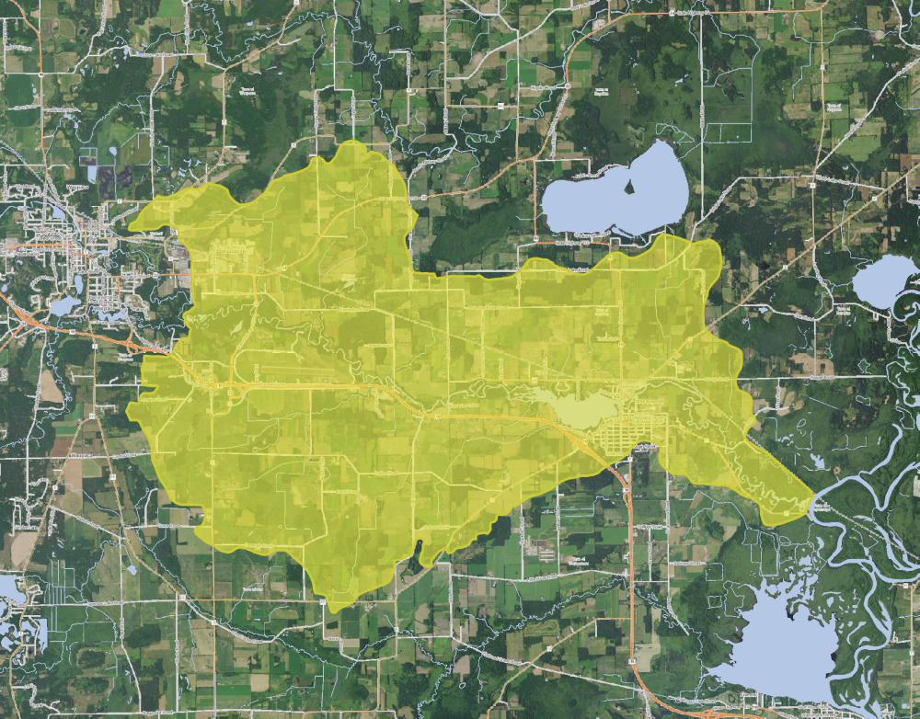
Purpose

The Lake Weyauwega sub-watershed indicated some of the highest nutrient concentrations and poorest water quality in the Tomorrow-Waupaca River Watershed during a watershed assessment in 2016. This project provided baseline water quality data in support of the Natural Resource Conservation Service’s and Waupaca County Land and Water Conservation Department’s efforts to write an EPA Nine Key Element Plan and reduce nutrient and sediment runoff within the watershed.
Methods
During the growing season of 2017, Total Phosphorus (TP) samples were collected at 11 locations twice per month in May and June, and once per month in July through October (Table 1, Map 1). In addition, Total Nitrogen (TN) samples were also collected twice per month in May and June 2017 and once per month in July through October at the 11 locations listed in Table 1. Thirdly, Nitrates + Nitrites as Nitrogen (NO₃ +NO₂ as N) samples were collected at 6 of the sites in Table 1. All samples were collected using the standard WDNR grab sampling method for a total of 224 samples (WDNR 2015). Neither baseflow nor storm or snowmelt event sampling were targeted during this project, following the protocol of Wisconsin Consolidated Assessment and Listing Methodology (WisCALM 2016). All nutrient samples were shipped to Wisconsin State Laboratory of Hygiene (WISLOH) for analysis. The WISLOH entered all sample analysis data into the WDNR Surface Water Integrated Monitoring System (SWIMS) database.
SWIMS Station ID | Site Name | Surface Water WBIC
10045054 | Un Trib to Waupaca River at Hwy 54 | 258100
10047758 | Un Trib to Waupaca River at Harrington Rd | 258000
10047755 | Un Trib to Waupaca River US Galilee Rd | 257900
10044256 | Un Trib to Waupaca River at Airport Rd | 257800
10047757 | Un Trib to the Waupaca River US Harrington Rd | 5020550
10048056 | Un Trib to Waupaca River US 325m Galilee Rd | 5021414
10047759 | Un Trib to Waupaca River at Galilee Rd | 5021414
10044777 | Un Trib to Waupaca River US Den Ed Rd | 5021414
10048060 | Un wetland outlet ditch to Lake Weyauwega | NA
10048059 | Un Trib to Lake Weyauwega US County AA | 5020640
10047756 | Whiskey Creek US Hwy 10 | 5021203
Table 1: Inorganic Chemistry Monitoring Sites Sampled in the Lake Weyauwega-Waupaca River Watershed May Through October.
Map 1: Lake Weyauwega-Waupaca River Watershed Sample Locations.
Five locations were sampled for aquatic macroinvertebrates (insects and bugs) in October 2017 (Map 1, Table 2). All sites were sampled using the WDNR Guidelines for the Collection of Macroinvertebrate Samples from Wadeable Streams (2017). A D-shaped kicknet with 600 micron mesh was used at all sites by standing upstream from the net and placing it firmly on the stream bed while digging into the substrate with the heel or toe to free the macroinvertebrates from the substrate. Riffles were targeted at each of the sites, but if none were present then overhanging vegetation, woody debris, or other vegetation would be sampled. This was done by jabbing the net into the vegetation to free the invertebrates. For a representative sample of the aquatic macroinvertebrate community, a minimum of 100 aquatic macroinvertebrates collected in each sample was targeted. The aquatic macroinvertebrates were preserved in a 70-80% ethanol solution inside quart “Mason” jars. If necessary, multiple “Mason” jars were used per sample depending upon how much sediment and organic material was collected with the aquatic macroinvertebrates. Within the next 24 hours, the samples were re-preserved with another 70-80% ethanol solution. Samples were taken to the UWSP Aquatic Biomonitoring Laboratory (ABL) for lowest possible taxonomic identification. Staff at the ABL entered the data into the SWIMS database in 2018.

SWIMS Station ID | Site Name | Surface Water WBIC
10047758 | Un Trib to Waupaca River at Harrington Rd | 258000
10044256 | Un Trib to Waupaca River at Airport Rd | 257800
10047757 | Un Trib to the Waupaca River US Harrington Rd | 5020550
10047759 | Un Trib to Waupaca River at Galilee Rd | 5021414
10047756 | Whiskey Creek US Hwy 10 | 5021203
Table 2: Aquatic Macroinvertebrate Monitoring Locations Sampled in the Lake Weyauwega-Waupaca River Watershed.
During July and August 2017, wadable fish surveys were conducted at 8 sites (Map 1, Table 3). The 8 wadable fish surveys were conducted following the WDNR Guidelines for Assessing Fish Communities of Wadable Streams in Wisconsin (2001). All 8 wadable sites were surveyed in July and August 2017 during the guidance-recommended summer time survey period. Stream flow and water chemistry data were recorded at each wadable site prior to conducting the fish survey. The wadable fish survey stations were a minimum of 35 times the mean stream width (overall minimum of 100 meters, overall maximum of 400 meters). A 12 Volt, 18 Amp Hour battery-powered backpack shocker was used for all 8 sites based upon the streams’ smaller width and depth. Catch per effort sampling procedures were used for this project (no particular species was targeted, all captured). A single upstream pass was made using 0.125 inch mesh nets to collect the fish. At the end of the station, captured fish were identified and counted and all game fish were measured for length. Once all data was collected, the fish were returned to the creek. Fish survey data was entered into the WDNR Fisheries and Habitat Management Database (FHMD) by WDNR Water Resources staff.
SWIMS Station ID | Site Name | Surface Water WBIC
10045054 | Un Trib to Waupaca River at Hwy 54 | 258100
10047758 | Un Trib to Waupaca River at Harrington Rd | 258000
10047755 | Un Trib to Waupaca River US Galilee Rd | 257900
10044256 | Un Trib to Waupaca River at Airport Rd | 257800
10047757 | Un Trib to the Waupaca River US Harrington Rd | 5020550
10047759 | Un Trib to Waupaca River at Galilee Rd | 5021414
10044777 | Un Trib to Waupaca River US Den Ed Rd | 5021414
10047756 | Whiskey Creek US Hwy 10 | 5021203
Table 3: Wadable Fish Survey Locations Sampled in the Lake Weyauwega-Waupaca River Watershed during July and August.
Onset Hobo Pendant thermistors were deployed to collect temperature data from May through October at 6 locations in the Weyauwega Lake-Waupaca River Watershed (Table 4, Map 1). Stream temperature measurements were taken once per hour at each location from May through October. Temperature measurements were taken with an Onset Hobo Pendant thermistor attached to a fence post driven into the stream bed of the creek. The thermistor was attached to the fence post in such a manner as to suspend the thermistor in the water column low enough to stay under water in low flow conditions and high enough to not get buried in bottom substrate (~ 6 inches above the bottom). The thermistor was placed in a shaded location when possible. Temperature data were uploaded into the SWIMS database by WDNR Water Resources staff.
SWIMS Station ID | Site Name | Surface Water WBIC
10047758 | Un Trib to Waupaca River at Harrington Rd | 258000
10047755 | Un Trib to Waupaca River US Galilee Rd | 257900
10047757 | Un Trib to the Waupaca River US Harrington Rd | 5020550
10047759 | Un Trib to Waupaca River at Galilee Rd | 5021414
10044777 | Un Tributary to Waupaca River US Den Ed Rd | 5021414
10047756 | Whiskey Creek US Hwy 10 | 5021203
Table 4: Temperature Monitoring Locations in the Lake Weyauwega-Waupaca River Watershed Sampled from May through October.
Qualitative habitat surveys were conducted at 8 locations in the Weyauwega Lake-Waupaca River Watershed in July and August 2017 (Table 5, Map 1). All sites were surveyed following the WDNR Guidelines for Qualitative Physical Habitat Evaluation of Wadeable Streams (2007). Each qualitative habitat survey station length was 35 times the mean stream width of the survey station. Qualitative habitat surveys rapidly assess characteristics such as bank erosion, width to depth ratio, % fine sediments, and cover for fish. WDNR Water Resources staff entered the qualitative habitat data into the FHMD.
SWIMS Station ID | Site Name | Surface Water WBIC
10045054 | Un Trib to Waupaca River at Hwy 54 | 258100
10047758 | Un Trib to Waupaca River at Harrington Rd | 258000
10047755 | Un Trib to Waupaca River US Galilee Rd | 257900
10044256 | Un Trib to Waupaca River at Airport Rd | 257800
10047757 | Un Trib to the Waupaca River US Harrington Rd | 5020550
10047759 | Un Trib to Waupaca River at Galilee Rd | 5021414
10044777 | Un Trib to Waupaca River US Den Ed Rd | 5021414
10047756 | Whiskey Creek US Hwy 10 | 5021203
Table 5: Qualitative Habitat Survey Locations in the Lake Weyauwega-Waupaca River Watershed Conducted in July and August.
Results
The 2017 TP sample analysis results in the Weyauwega Lake-Waupaca River Watershed ranged from 0.026 mg/L at the Unnamed (Un) Tributary (Trib) at Hwy 54 in May to 0.901 mg/L at the Un Trib upstream of Galilee Rd West in June (Table 6, Chart 1). All 11 locations in this project had an average TP concentration (mg/L) exceeding the Wisconsin Administrative Code ch. NR 102.06(3)(b) water quality criteria (WQC) for creeks at 0.075 mg/L (Table 6, Chart 1). The average TP concentrations for the 11 sites in this project ranged from 0.088 mg/L at Whiskey Creek at Hwy 10 to 0.218 mg/L in the Un Trib upstream of Galilee Rd West (Table 6, Chart 1).

Location | May (1) | May (2) | June (1) | June (2) | July | Aug. | Sep. | Oct. | Ave.
Un Trib to Waupaca R at Hwy 54 | 0.026 | 0.076 | 0.163 | 0.179 | 0.192 | 0.096 | 0.053 | 0.089 | 0.109
Un Trib to Waupaca R at Harrington Rd West | 0.039 | 0.107 | 0.216 | 0.294 | 0.202 | 0.216 | 0.06 | 0.105 | 0.155
Un Trib to Waupaca R US Harrington Rd East | 0.064 | 0.099 | 0.153 | 0.155 | 0.167 | 0.1 | 0.082 | 0.125 | 0.118
Un Trib to Waupaca R US Galilee Rd West | 0.052 | 0.094 | 0.245 | 0.901 | 0.111 | 0.145 | 0.071 | 0.123 | 0.218
Un Trib to Waupaca R at Airport Rd | 0.040 | 0.080 | 0.176 | 0.232 | 0.094 | 0.112 | 0.105 | 0.110 | 0.119
Un Trib to Waupaca R US 325m Galilee Rd East | 0.054 | 0.120 | 0.143 | 0.399 | 0.182 | 0.132 | 0.100 | 0.108 | 0.155
Un Trib to Waupaca R at Galilee Rd East | 0.063 | 0.117 | 0.159 | 0.396 | 0.182 | 0.152 | 0.114 | 0.097 | 0.160
Un Trib to Waupaca R US Den Ed Rd | 0.063 | 0.115 | 0.115 | 0.269 | 0.130 | 0.129 | 0.095 | 0.089 | 0.126
Un wetland outlet ditch to Lake Weyauwega | 0.092 | 0.104 | 0.170 | 0.188 | 0.204 | 0.140 | 0.178 | 0.119 | 0.149
Un Trib to Lake Weyauwega US County AA | 0.041 | 0.076 | 0.200 | 0.124 | 0.270 | 0.168 | 0.159 | 0.109 | 0.143
Whiskey Creek US Hwy 10 | 0.041 | 0.055 | 0.113 | 0.093 | 0.101 | 0.097 | 0.094 | 0.107 | 0.088
Table 6: Total Phosphorus Concentrations and Averages of Samples Collected in the Lake Weyauwega-Waupaca River Watershed.

Chart 1: Total Phosphorus Concentrations and Averages of Samples Collected in the Lake Weyauwega-Waupaca River Watershed (with 0.075 mg/L WQC red line).
TN analysis was also conducted on samples collected at all 11 project locations during the same sampling events as TP in 2017. TN samples were collected twice per month in May and June, and once per month in July through October (Table 7, Chart 2). The TN concentrations in the Waupaca River watershed ranged from 0.66 mg/L at the Un Trib to Lake Weyauwega at County AA in September to 18.3 mg/L in June in the Un Trib to Waupaca River 325m upstream of Galilee Rd East (Table 7, Chart 2).
Location | May (1) | May (2) | June (1) | June (2) | July | Aug. | Sep. | Oct. | Ave.
Un Trib to Waupaca R at Hwy 54 | 1.03 | 1.57 | 1.73 | 1.98 | 1.83 | 1.35 | 1.32 | 1.42 | 1.53
Un Trib to Waupaca R at Harrington Rd West | 1.33 | 1.84 | 2.27 | 2.14 | 2.12 | 2.04 | 1.72 | 1.63 | 1.89
Un Trib to Waupaca R US Harrington Rd East | 1.40 | 1.63 | 1.76 | 1.84 | 2.23 | 2.03 | 2.10 | 1.38 | 1.80
Un Trib to Waupaca R US Galilee Rd West | 4.41 | 5.48 | 4.71 | 7.92 | 10.7 | 5.88 | 9.24 | 4.43 | 6.60
Un Trib to Waupaca R at Airport Rd | 3.88 | 5.02 | 4.79 | 6.44 | 9.87 | 7.92 | 9.99 | 4.66 | 6.57
Un Trib to Waupaca R 325m Galilee Rd East | 9.90 | 6.99 | 18.3 | 12.1 | 13.4 | 7.56 | 9.69 | 6.62 | 10.6
Un Trib to Waupaca R at Galilee Rd East | 10.4 | 6.51 | 16.5 | 11.8 | 12.3 | 7.11 | 9.27 | 6.28 | 10.0
Un Trib to Waupaca R US  Den Ed Rd | 8.85 | 7.30 | 14.6 | 11.1 | 11.2 | 7.92 | 8.52 | 6.38 | 9.48
Un wetland ditch at Haire Rd | 2.09 | 1.82 | 1.80 | 2.56 | 3.26 | 0.73 | 0.96 | 2.15 | 1.92
Un Trib to Lake Weyauwega US County AA | 0.72 | 0.87 | 0.87 | 1.40 | 1.06 | 0.67 | 0.66 | 1.60 | 0.98
Whiskey Creek US Hwy 10 | 6.30 | 4.38 | 4.89 | 3.80 | 1.97 | 2.16 | 2.17 | 2.69 | 3.55
Table 7: Total Nitrogen Concentrations and Averages of Samples Collected in the Lake Weyauwega-Waupaca River Watershed.

Chart 2: Total Nitrogen Concentrations and Averages of Samples Collected in the Lake Weyauwega-Waupaca River Watershed.
At 6 of the locations listed in Table 1, NO₃+NO₂ as N analysis was also conducted on samples collected in May through October 2017 (Table 8, Chart 3). The NO₃+NO₂ as N concentrations in the Waupaca River watershed ranged from no detection at the Un Trib to Waupaca River at Hwy 54 in June to 8.77 mg/L in September in the Un Trib to Waupaca River at Airport Rd (Table 8, Chart 3).
Location | May (1) | May (2) | June (1) | June (2) | July | Aug. | Sep. | Oct. | Ave.
Un Trib to Waupaca R at Hwy 54 | 0.036 | 0.037 | 0.083 | ND | 0.192 | 0.143 | 0.249 | 0.040 | 0.102
Un Trib to Waupaca R at Harrington Rd West | 0.287 | 0.437 | 0.527 | 0.130 | 0.924 | 0.787 | 0.807 | 0.201 | 0.513
Un Trib to Waupaca R US Harrington Rd East | 0.752 | 0.910 | 0.868 | 0.686 | 1.47 | 1.50 | 1.74 | 0.423 | 1.04
Un Trib to Waupaca R US Galilee Rd West | 2.61 | 3.39 | 2.31 | 3.40 | 8.76 | 4.13 | 7.96 | 2.12 | 4.34
Un Trib to Waupaca R at Airport Rd | 2.79 | 4.02 | 2.56 | 3.76 | 8.52 | 6.72 | 8.77 | 2.33 | 4.93
Whiskey Cr US Hwy 10 | 5.28 | 3.94 | 4.54 | 2.54 | 1.30 | 1.49 | 1.32 | 1.44 | 2.73
Table 8: Dissolved Nitrates + Nitrites as Nitrogen Concentrations of Samples Collected in the Lake Weyauwega-Waupaca River Watershed. (ND= No Detection) (Limit of Detection 0.036 mg/L Used for Average Concentration Calculation)
Chart 3: Dissolved Nitrates + Nitrites as Nitrogen Concentrations of Samples Collected in the Lake Weyauwega-Waupaca River Watershed.
Aquatic insect communities were sampled at 5 locations in October 2017 (Table 2). Some aquatic insect species are tolerant of environmental degradation, while some species are moderately tolerant, and some others are intolerant. Based upon the representative insects collected and their associated tolerance to environmental degradation, an Index of Biotic Integrity (MIBI) was calculated to indicate the water quality condition of the stream (Table 9, Chart 4). In general, the higher the MIBI score, the better the water quality rating for a waterbody. The MIBI scores ranged from 2.73 in the Un Trib at Harrington Road West to 4.49 in the Un Trib at Airport Road (Table 9, Chart 4). The Condition Categories for the 5 sites were all Fair, indicating significant impacts from environmental degradation.
SWIMS Station ID | Stream Name and Location | Macroinvertebrate IBI Score | Condition Category
10047758 | Un Trib to Waupaca R US Harrington Rd West | 2.73 | Fair
10047757 | Un Trib to Waupaca R at Harrington Rd East | 2.86 | Fair
10044256 | Un Trib to Waupaca R at Airport Rd | 4.49 | Fair
10047759 | Un Trib to Waupaca R at Galilee Rd East | 2.77 | Fair
10047756 | Whiskey Creek US Hwy 10 | 3.79 | Fair
Table 9: Aquatic Macroinvertebrate Index of Biotic Integrity Scores and Water Quality Condition Categories in the Lake Weyauwega-Waupaca River Watershed.
Chart 4: Aquatic Macroinvertebrate Index of Biotic Integrity Scores and Water Quality Condition Categories in the Lake Weyauwega-Waupaca River Watershed.
During July and August 2017, 8 sites in the Lake Weyauwega-Waupaca River Watershed were surveyed for representative fish communities. Some fish species are tolerant of environmental degradation, while some species are moderately tolerant, and some others are intolerant. Based upon the representative fish collected during the survey and their associated tolerance to environmental degradation, an Index of Biotic Integrity (FIBI) was calculated to indicate the water quality of each creek or river (Table 10, Chart 5). The FIBI scores ranged from 30 in the Un Trib at Den Ed Rd, to 100 in the Un Trib at Harrington Rd West (Table 10, Chart 5). Five of the sites scored a Condition Category of Fair, with one site each scoring as Poor, Good, and Excellent. The 8 fish surveys demonstrate that these streams range from no apparent environmental degradation to significant environmental degradation.
Each fish community surveyed was used to verify or update the modeled Natural Community for that stream segment. Each of the 8 tributary streams’ Natural Community was verified or changed based upon the fish caught in the survey (and any historical known surveys in that stream segment). Verifying or changing the modeled Natural Community was important since the Natural Community determines which FIBI was used to determine the water quality of that stream segment. The results of the calculated FIBI calculations displayed in Table 10 and Chart 5 are based upon the verified or changed Natural Community.
SWIMS Station ID | Site Name | Fish IBI Score | Condition Category | Natural Community
10045054 | Un Trib to Waupaca River at Hwy 54 | 40 | Fair | Cool-Warm Headwater
10047758 | Un Trib to Waupaca R at Harrington Rd West | 100 | Excellent | Cool-Warm Headwater
10047757 | Un Trib to Waupaca R US Harrington Rd East | 90 | Good | Cool-Cold Headwater
10044256 | Un Trib to Waupaca R at Airport Rd | 60 | Fair | Cool-Warm Headwater
10047755 | Un Trib to Waupaca R at Galilee Rd West | 50 | Fair | Cool-Warm Headwater
10047759 | Un Trib to Waupaca R at Galilee Rd East | 40 | Fair | Cool-Cold Headwater
10044777 | Un Trib to Waupaca R US Den Ed Rd | 30 | Poor | Cool-Cold Headwater
10047756 | Whiskey Creek US Hwy 10 | 50 | Fair | Cool-Cold Headwater
Table 10: Fish Survey Results in the Lake Weyauwega-Waupaca River Watershed Conducted in July and August.
Chart 5: Fish Survey Results in the Lake Weyauwega-Waupaca River Watershed Conducted in July and August.
Water temperature data was collected from May through October 2017 at 6 locations in the Lake Weyauwega-Waupaca River Watershed (Table 4, Map 1). Monthly average temperatures were reported for months with complete data only (Table 11, Chart 6). The stream water temperatures at the sites monitored in 2017 during the time of deployment ranged from 46.5F at the Un Trib at Harrington Rd East on 10/16/2017 to 77.1F in the Un Trib at Galilee Rd East on 7/18/2017. The average monthly temperatures ranged from 56.4F in the Un Trib at Galilee Rd West in September to 66.9F in the Un Trib at Galilee Rd East and Whiskey Creek upstream of Hwy 10 in July (Table 11, Chart 6). The Maximum Daily Averages (MDM) ranged from 66.8F in the Un Trib at Den Ed Rd to 70.6F in the Whiskey Creek upstream of Hwy 10 (Table 11, Chart 6).

Location | June | July | Aug. | Sept. | Max. Daily Ave.
Un Trib to Waupaca R at Harrington Rd West | 62.5 | 65.5 | 61.6 | 59.3 | 69.5
Un Trib to Waupaca R at Harrington Rd East | 60.7 | 62.9 | 59.7 | 57.3 | 66.9
Un Trib to Waupaca R at Galilee Rd West | 61.2 | 60.5 | 59.2 | 56.4 | 67.6
Un Trib to Waupaca R at Galilee Rd East | 64.1 | 66.9 | 63.2 | 60.3 | 70.5
Un Trib to Waupaca R at Den Ed Rd | 61.3 | 63.5 | 61.9 | 59.4 | 66.8
Whiskey Creek US Hwy 10 | 63.6 | 66.9 | 63.9 | 60.7 | 70.6
Table 11: Monthly Average and Maximum Daily Average Temperatures in the Lake Weyauwega-Waupaca River Watershed.
Chart 6: Monthly Average and Maximum Daily Average Temperatures in the Lake Weyauwega-Waupaca River Watershed.
In June through September 2017, qualitative habitat surveys were conducted at 8 locations in the Lake Weyauwega-Waupaca River Watershed (Table 5, Map 1). The qualitative habitat surveys were conducted at the same locations as the fish survey locations following Guidelines for Qualitative Physical Habitat Evaluation of Wadeable Streams (2007). WDNR Water Resources staff entered the habitat data into the FHMD. Based upon the habitat information collected during the 2017 surveys, a habitat rating was calculated for the 8 locations in Table 5 (Table 12, Chart 7). The habitat scores ranged from 15 at the Un Trib to the Waupaca River at Galilee Rd West to 72 at the Un Trib to the Waupaca River at Airport Rd. Three sites scored a Condition Category of Good, four sites had a Condition Category of Fair, and one site rated as poor (Table 12, Chart 7).

SWIMS Station ID | Stream Name and Site Location | Qualitative Habitat Score | Condition Category
10045054 | Un Trib to Waupaca R at Hwy 54 | 53 | Good
10047758 | Un Trib to Waupaca R at Harrington Rd West | 43 | Fair
10047757 | Un Trib to Waupaca R at Harrington Rd East | 68 | Good
10047755 | Un Trib to Waupaca R at Galilee Rd West | 15 | Poor
10044256 | Un Trib to Waupaca R at Airport Rd | 72 | Good
10047759 | Un Trib to Waupaca R at Galilee Rd East | 30 | Fair
10044777 | Un Trib to Waupaca R at Den Ed Rd | 35 | Fair
10047756 | Whiskey Creek US Hwy 10 | 42 | Fair
Table 12: Qualitative Habitat Survey Scores and Condition Categories for the Lake Weyauwega-Waupaca River Watershed.
Chart 7: Qualitative Habitat Survey Scores and Condition Categories for the Lake Weyauwega-Waupaca River Watershed.

Discussion
This project provided baseline water quality data in support of the Waupaca County Land and Water Conservation Department’s efforts to write an EPA Nine Key Element Plan (9KE) and their efforts (along with other partners) to reduce nutrient and sediment runoff within the watershed. “Watershed plans consistent with EPA’s 9KE provide a framework for improving the contributing causes and sources of non-point source pollution, involve key stakeholders and prioritize restoration and protection strategies to address water quality problems” (WDNR 2018). Having an approved 9KE plan can increase opportunities for federal and state funding for the installation of agricultural best management practices (BMPs), which focus on reducing the discharge of non-point source pollutants into the surface waters of the sub-watershed. The monitoring during this project provided the current water quality conditions of the surface waters in the sub-watershed and data that can be compared to the water quality conditions after BMPs have been installed. The monitoring conducted in the Lake Weyauwega-Waupaca River sub-watershed indicates the need and opportunity for water quality improvements. The nutrient, aquatic insect, and fish monitoring in this project demonstrated that the water quality in the Lake Weyauwega-Waupaca River sub-watershed is between poor and excellent condition.

The Lake Weyauwega sub-watershed of the Tomorrow-Waupaca River watershed drains a 20,743-acre area, which is about 11% of the Tomorrow-Waupaca River watershed. The sub-watershed drains into about 17 miles of the Waupaca River which starts on the East side of the City of Waupaca until it empties into the Wolf River near the City of Weyauwega. There is one significant impoundment of the Waupaca River, 253-acre Lake Weyauwega in the City of Weyauwega, which is both influenced by and has an impact on the water quality of the river. The Lake Weyauwega-Waupaca River sub-watershed is dominated by agricultural land use at 46%, with some forested and open areas. About 13% of the sub-watershed is considered developed. Typically, as increases in agricultural land use occur, there is a correlating increase in TP and TN concentrations in creeks in the watersheds in Wisconsin. The monitoring of this project indicated high concentrations of TP and TN in most creeks of the sub-watershed (Table 6-7, Chart 1-2).

All 11 of the sites monitored for TP had an average concentration greater than the Wisconsin Administrative Code ch. NR 102 Water Quality Criteria (WQC) for streams at 0.075 mg/L. Therefore, an impairment assessment was conducted to verify whether the Lake Weyauwega sub-watershed TP concentrations met the WQC or if the waterbodies should be placed on the EPA Clean Water Act Section 303d Impaired Waters List (CWA 303d IWL). The sampling requirements to demonstrate if WQC for TP were being met, clearly exceeded, or overwhelmingly exceeded were accomplished through this project. The impairment assessment protocol requires a parametric statistical approach to assess stream and river TP data against the applicable water quality criterion (WisCALM 2016). This approach involves the calculation of a 90% confidence limit around the median of a TP sample dataset. If the lower 90% confidence limit (LCL) exceeds the criterion for TP, then that stream segment (assessment unit) is considered to be exceeding the criterion. The LCLs were calculated for each complete set of TP samples (Table 13). Two of the 11 Waupaca River tributary sample sets met the WQC of 0.075mg/L. Of the 11 tributaries, 73% of the LCLs exceeded (LCL of >0.075mg/L) the water quality criterion for TP (Table 13, Chart 8). The stream TP WQC does not apply to the wetland ditch to Lake Weyauwega upstream of Haire Rd; however, the LCL was calculated for reference.

Location | TP Lower 90%  Confidence Limit | Criterion Exceedance Level
Un Trib to Waupaca R at Hwy 54 | 0.062 | Meets
Un Trib to Waupaca R at Harrington Rd West | 0.11 | Exceeds
Un Trib to the Waupaca R US Harrington Rd East | 0.0936 | Exceeds
Un wetland outlet ditch to Lake Weyauwega US Haire Rd | 0.1343 | N/A
Un Trib to Lake Weyauwega US County AA | 0.1053 | Exceeds
Un Trib to Waupaca R US Galilee Rd West* | 0.077 | Exceeds
Un Trib to Waupaca R at Airport Rd | 0.078 | Exceeds
Un Trib to Waupaca R US 325m Galilee Rd East | 0.0733 | Meets
Un Trib to Waupaca R at Galilee Rd East | 0.0832 | Exceeds
Un Trib to Waupaca R US Den Ed Rd | 0.0856 | Exceeds
Whiskey Creek US Hwy 10 | 0.0826 | Exceeds
Table 13: Total Phosphorus Lower 90% Confidence Limits in the Lake Weyauwega-Waupaca River Watershed. *Only the first June 2017 sample was used to calculate the LCL.

Chart 8: Total Phosphorus Lower 90% Confidence Limits in the Lake Weyauwega-Waupaca River Watershed. Red line indicates the NR 102 WQC for Total Phosphorus for the Tributaries.

In 2017, concentrations of Total Nitrogen were significantly higher in the streams on the south side of the Waupaca River than those on the north. The median TN concentrations of the 5 locations on the north side of the Waupaca River were less than 2 mg/L. Whereas, the 6 monitoring sites on the south side of the river had median TN concentrations ranging from 3.2 to 9.8 mg/L (Chart 9). This, along with the physical-habitat conditions of the watershed, is contributing to the depressed FIBI scores in the streams on the south side of the river.

Chart 9: Total Nitrogen Median Values in the Lake Weyauwega Watershed.

Conclusions

The monitoring in 2017 indicate water quality in the tributaries of the Lake Weyauwega sub-watershed ranges from poor to excellent. Some of the land use characteristics observed during the 2017 monitoring project that can have a negative impact to the water quality of the tributaries to the Waupaca River were limited buffer protection along the stream corridors, wetland ditching, eroding streambanks, cropland erosion, channelization, cattle access, tile drainage, presence of aquatic invasive species, and sedimentation of fish and aquatic life habitat (Photo 1-2). There are opportunities to install practices to lower the nutrients and sediment reaching the Waupaca River and Lake Weyauwega. Continuing efforts to work with landowners, farmers, municipalities, the county and Natural Resource Conservation Service staff to promote protection and restoration of the streams and wetlands by practices including, but not limited to, streambank and buffer protection, cover crops, nutrient management planning, reduced tillage, wetland protection and restoration, and water and sediment control basins.

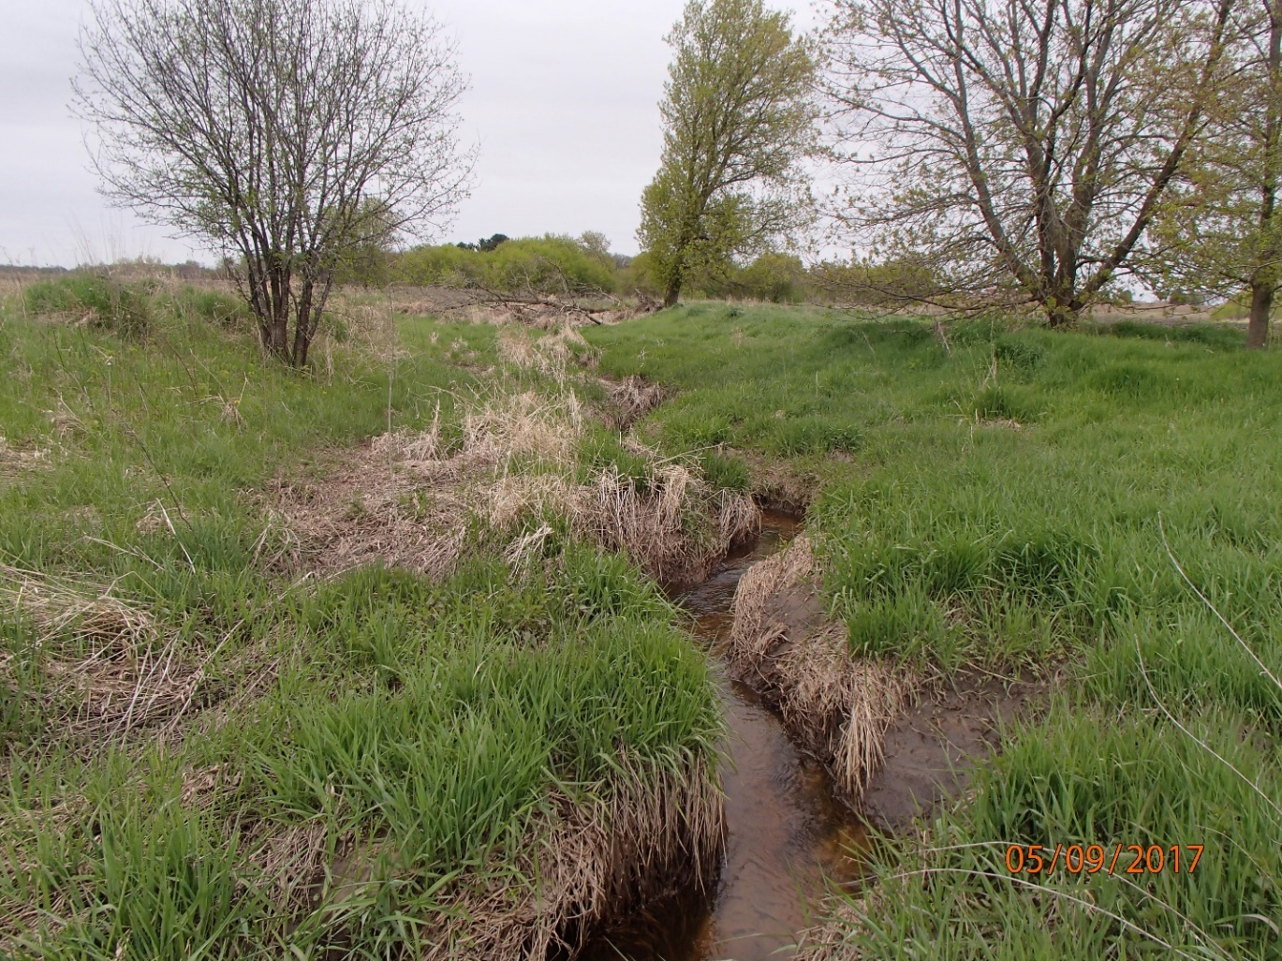
Photo 1: Unnamed Tributary to the Waupaca River at Galilee Road near Weyauwega. Photo taken by D. Bolha on May 9th, 2017.

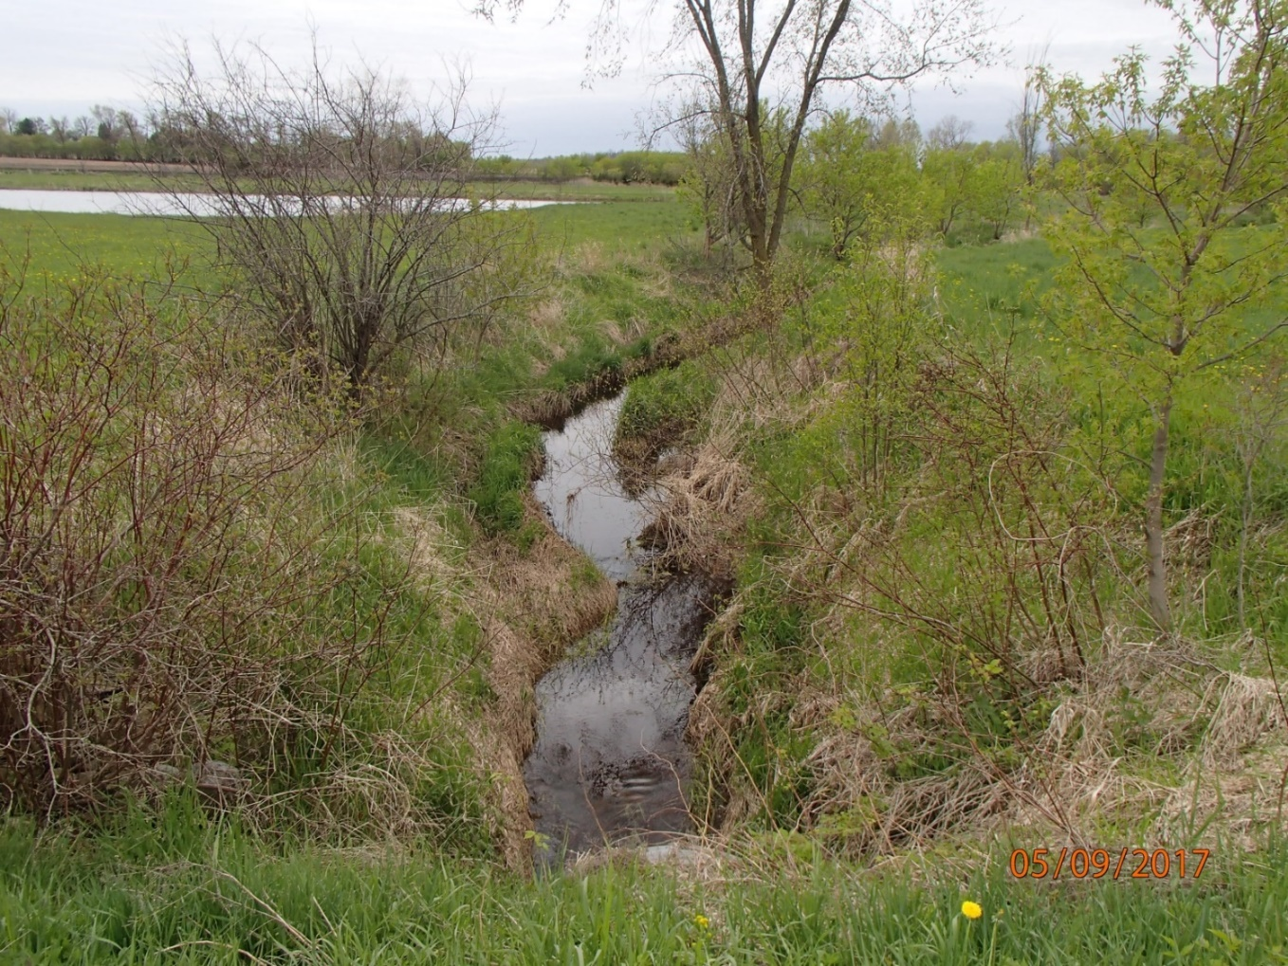
Photo 2: Unnamed Tributary to the Waupaca River at Galilee Road near Weyauwega. Photo taken by D. Bolha on May 9th, 2017.

References

WDNR (Wisconsin Department of Natural Resources). 2001. Guidelines for Assessing Fish Communities of Wadable Streams in Wisconsin.

WDNR (Wisconsin Department of Natural Resources). 2007. Guidelines for Qualitative Physical Habitat Evaluation of Wadable Streams.

WDNR (Wisconsin Department of Natural Resources). 2010. Wisconsin Administrative Code ch. NR 102: Water Quality Standards for Wisconsin Surface Waters.

WDNR (Wisconsin Department of Natural Resources). 2015. Nutrient Chemistry Grab Sampling (V3.2) DNR Water Quality Monitoring Program.

WDNR (Wisconsin Department of Natural Resources). 2016. Wisconsin Consolidated Assessment and Listing Methodology Guidance Document.

WDNR (Wisconsin Department of Natural Resources). 2017. Guidelines for the Standard Collection of Macroinvertebrate Samples from Wadeable Streams (v2.0).

