Fenwood Creek Watershed Assessment
HUC 12: 070700021602
Marathon County
2016-2017

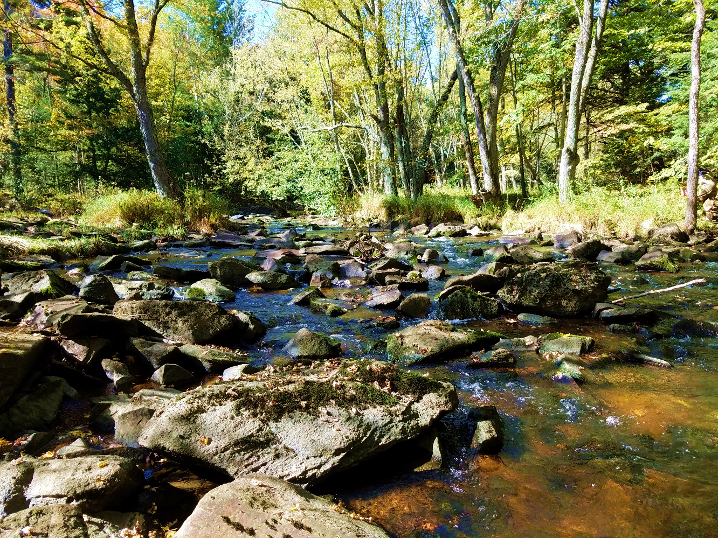

Prepared by:
Taylor Hasz and Chris Willger
March 2020
Introduction
The Fenwood Creek watershed is a sub watershed of the Lake Dubay – Big Eau Pleine River watershed located in Marathon County. The Fenwood Creek watershed drains approximately 24,958 acres (39 mi²) of land into the Big Eau Pleine Reservoir. The watershed consists of two primary named streams, Fenwood and Rocky Run Creeks, and several smaller unnamed streams. Land use in the watershed is dominated by agriculture and consists of croplands (65%), woodlands (25%), and other miscellaneous land use types (10%). In 2015, Marathon County developed a Nine Key Element Plan to help address agricultural runoff in the Fenwood Creek Watershed.
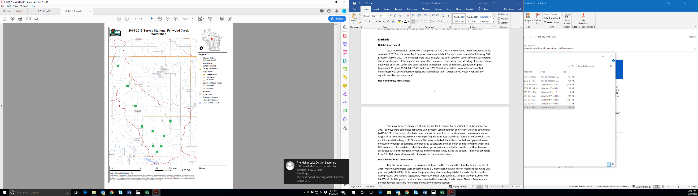
A watershed assessment was completed by DNR staff in the Fenwood Creek HUC 12 watershed in 2016 and 2017. The purpose of this watershed assessment was to evaluate current stream health and get a baseline understanding of conditions within the watershed. Prior to the assessment, there was very limited data available for streams in the drainage area. The current assessment will also support agricultural best management practice implementation activities throughout the watershed, as the county implements their water quality plan.

Biological, chemical, and physical water quality data was collected throughout the watershed. Monitoring activities were completed at ten sites and included qualitative habitat assessments, fish and macroinvertebrate community assessments, and flow measurements (Figure 2). Growing season total phosphorus (May – October) was collected at four sites by volunteers and a single total phosphorus grab sample was collected by Wisconsin Department of Natural Resources (WDNR) staff at seven sites within the watershed.
Figure 2. 2016-2017 Survey stations in the Fenwood Creek watershed

Methods
Habitat Assessment
Qualitative habitat surveys were completed at nine sites in the Fenwood Creek watershed in the summer of 2017. Surveys were completed in conjunction with fish community assessment and followed DNR protocol (WDNR, 2007). Sites were visually evaluated and scored using seven different parameters for streams less than ten meters. Scores for each of these parameters were then summed to provide an overall rating of stream habitat quality for each site. Scores corresponded to a habitat rating of excellent, good, fair, or poor (excellent ≥75, good 50-74, fair 25-49, and poor <25). Visual observations were also documented indicating more specific substrate types, significance of bank erosion, riparian habitat types, water clarity, water level, and if any aquatic invasive species were present.
Fish Community Assessment
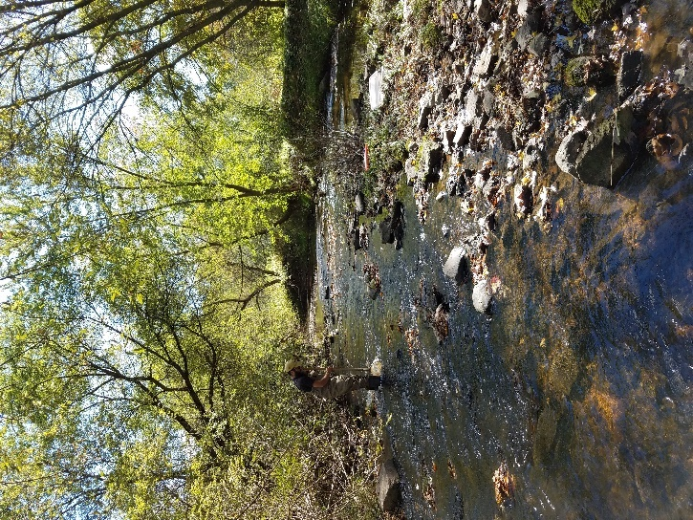
Fish surveys were completed at nine sites in the Fenwood Creek watershed in the summer of 2017. Surveys were completed following DNR protocol using backpack and stream shocking equipment (WDNR, 2018). At each site, fish were collected within a section of the stream with a minimum station length of 35 times the mean stream width (MSW). Station’s less than three meters in width would have a minimum station length of 100 meters. Fish were collected, identified, counted, and used to calculate the fish Index of Biotic Integrity (fIBI). The fIBI was built to reflect structural changes in fish assemblages in response to local and watershed-level disturbance, riparian condition and local habitat quality. IBI scores can range from 0 to 100 where stream quality increases as the score increases (Lyons, 1992).
Macroinvertebrate Assessment
Macroinvertebrate samples were collected in fall of 2016 at ten sites in the Fenwood Creek watershed. Macroinvertebrates were collected using a D-frame kick net with micron mesh and following DNR protocol (WDNR, 2017). Riffles were the primary targeted sampling habitat for each site. If no riffles were present, overhanging vegetation, logjams, or snags were sampled. Samples were preserved with 80-85% alcohol (isopropyl or ethanol) and sent to the University of Wisconsin - Stevens Point Aquatic Biomonitoring Laboratory for sorting and taxonomic identification.
Samples were evaluated using the Macroinvertebrate Index of Biotic Integrity (mIBI) and the Hilsenhoff Biotic Index (HBI). The mIBI is used to evaluate human disturbances, land use, and pollution within and around streams to better understand the overall quality of each stream (Weigel, 2003). The mIBI score can range from 0 to 10, where overall stream quality increases as the score increases. The HBI evaluates the tolerance value of the macroinvertebrate community in each sample to understand organic loading in each stream (Hilsenhoff, 1987). The HBI score can range from 0 to 10, where overall stream quality decreases as the score increases.
Water Chemistry Sampling
Monthly growing season (May through October) total phosphorus samples were collected in 2017 by volunteers at four sites on Fenwood and Rocky Run Creeks. In addition, single grab samples were collected at seven sites in the watershed. All water chemistry samples were completed following WDNR sampling guidelines (WDNR, 2015). Growing season samples were analyzed following principles in the Wisconsin 2016 Consolidated Assessment and Listing Methodology (WisCALM) (WDNR, 2016). The total phosphorus water quality criterion for wadeable streams in the state of Wisconsin is 0.075 mg/l according to NR 102.06 of Wisconsin Administrative Code. Exceedance of this value could result in a stream being listed as impaired.
Results
Rocky Run Creek
Rocky Run Creek is a six-mile-long cool-warm headwater stream that flows into Fenwood Creek. Electrofishing surveys were completed at three sites on Rocky Run Creek. The community consisted of a diverse forage fishery and was dominated by creek chubs, fantail and johnny darters, western blacknose and southern redbelly daces, and white suckers. All three sites had an IBI score of 100 with a rating of “good” (Table 4).
All three habitat surveys on Rocky Run Creek were rated as “Good” (Table 2). Substrate consisted primarily of cobble and gravel, but boulders and sand were also present. All sites had a large riparian buffer consisting of woodlands, shrubs, and grasses with minimal bank erosion along the stream margin. The diversity of riffles, runs, pools, and bends decreased moving downstream with more runs and pools at the most downstream station. Fish cover was fairly limited throughout all stations.
Macroinvertebrate IBI and HBI scores varied between the three sites. mIBI ratings increased moving downstream from “fair” to “good” to “excellent” (Table 1). HBI ratings ranged from “excellent” at the most upstream site to “good” and “very good” at the other two downstream sites indicating minimal organic loading.
Growing season total phosphorus collected at Fairview Road had a median value of 0.0604 mg/l (low = 0.0485 mg/l, high = 0.127 mg/l) which does not exceed the statewide criteria (0.075mg/l) (WDNR, 2017).
Unnamed Creek at Schnelle Road
Unnamed Creek is a small cool-warm headwater tributary of Rocky Run Creek. The fish community consisted of a diversity of forage fish including creek chubs, darters, northern redbelly and western blacknose daces, green sunfish, and white suckers. This site had an IBI score of 70 with a rating of “good” (Table 4). It should be noted that electrofishing was challenging, due to shallow water depth and coarse substrate.
The qualitative habitat score for this unnamed creek was 50 with a rating of “good” (Table 2). Substrate consisted of mainly cobble and boulders. This site had a large riparian buffer consisting mainly of woodlands and shrubs with many overhanging tag alders. Bank erosion was minimal, with habitat consisting of a shallow run due to the water level being so low. Lack of fish cover was a limiting factor to habitat quality. A large patch of curly leaf pondweed was also spotted within the station.
Both the macroinvertebrate IBI and HBI scored “good” and “very good,” respectively indicating low amounts of pollution and disturbances within this stream (Table 1).
Fenwood Creek
Fenwood Creek is a 17-mile-long tributary that flows into the Big Eau Pleine River. Fish communities and habitat were assessed at five sites along Fenwood Creek. Fish IBI scores ranged between 90 and 100 with a rating of either “good” or “excellent” (Table 4). This stream supported a cool-warm fishery dominated by brook sticklebacks, central mudminnows, common shiners, creek chubs, rainbow and johnny darters, western blacknose daces, and white suckers.
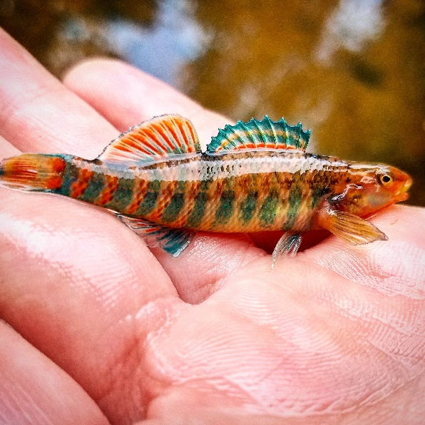
Qualitative habitat varied a great deal throughout Fenwood Creek (Table 2). The most upstream site, showed very little habitat diversity with a score of 10 and a rating of “poor.” There was little to no riparian buffer with high levels of bank erosion as a result of cattle pasturing in the stream corridor. This section of stream was primarily run habitat with a few pools and very minimal fish cover. Substrate was comprised mainly of sand and gravel with some areas of cobble and silt. Eurasian watermilfoil was abundant in bridge pools and curly leaf pondweed was found at the start of the station.
Only one site, Fenwood at County Highway N, had a rating of “good” and a score of 68. This station had a large riparian buffer consisting of shrubs, meadow grasses, and scattered hardwood trees with no bank erosion. The station contained many pools and runs with a sufficient amount of fish cover. Substrate type was mostly comprised of sand with areas of cobble and gravel scattered throughout. The other three sites, Fenwood Creek at Blackberry Road, County Highway M, and Fairview Road had habitat scores that ranged between 35 to 45 with a rating of “fair.” These sites had a large riparian buffer consisting of woodland areas, shrubs, and grasses with little to moderate levels of bank erosion. Habitat was monotonous at these sites consisting mainly of runs with a few pools. Substrate types of gravel, cobble, boulders, and sand. Fine sediments were most prevalent at the site on Blackberry Road with the other two sites having minimal fine sediments. The presence and quantity of fine sediments at these sites could be a contributing factor to the higher phosphorus concentrations observed in Fenwood Creek. Fish cover was limited at all three sites.
Macroinvertebrates were sampled at six sites in Fenwood Creek. mIBI ratings ranged from fair (upstream) to good (downstream sites) (Table 1). HBI ratings showed a similar trend ranging from poor at the most upstream site (Elderberry) to excellent at the most downstream site. The lower macroinvertebrate ratings at the upper most site may be a result of pastured land use and/or low flow conditions in the headwater areas of the stream.
Growing season total phosphorus samples were collected at three sites on Fenwood Creek which include: Blackberry Road, Fairview Road, and Highway 153. Median values were 0.245 mg/l (low = 0.154 mg/l, high = 0.464 mg/l), 0.141 mg/l (low = 0.114 mg/l, high = 0.287 mg/l), and 0.104 mg/l (low = 0.0949 mg/l, high = 0.197 mg/l), respectively. All sites exceed the statewide total phosphorus criteria of 0.075 mg/l (WDNR, 2017). Single grab total phosphorus samples were collected at four additional sites on Fenwood Creek. These concentrations were similar to the respective growing season samples suggesting concentrations are comparable throughout the stream and exceed the water quality standard (Table 3). Fenwood Creek is currently listed on the Section 303d Clean Water Act impaired waters list and these data support the listing.
Discussion
Land use in the Fenwood Creek Watershed is dominated by agricultural crop fields with some riparian cattle pasturing. These land use types can result in excessive sedimentation and nutrients to surface water if not properly managed on the land. Median growing season total phosphorus concentrations in Fenwood Creek all exceeded the statewide criteria and confirms the existing 303(d) impaired waters listing. Median growing season total phosphorus concentrations on Rocky Run Creek did not exceed the statewide criteria.
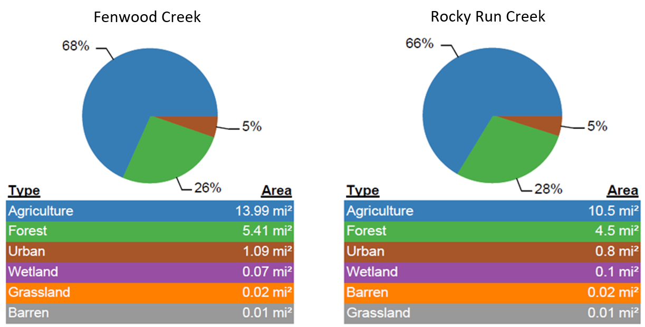
Figure 3. Land use comparison between Fenwood Creek and Rocky Run Creek.

Total phosphorus concentrations were nearly twice as much at every station on Fenwood Creek compared to Rocky Run Creek (Table 3). After reviewing the differences in management and land use between Fenwood Creek and Rocky Run Creek, there is not a remarkable difference in land use, which suggest that changes in land use is not the cause of higher phosphorus in the Fenwood watershed. (Figure 3). Considering these land uses are so similar, it is assumed that farming practices are also similar. This suggests the differences in phosphorus concentrations are a result of natural variability in topography, soils, and groundwater inputs.
Soil in the Fenwood Creek watershed is higher in clay content which allows for the potential of higher phosphorus adsorption whereas soil in the Rocky Run Watershed is higher in sand and therefore may have less phosphorus adsorption. Also, a preliminary review of flows in the two streams, indicates a stronger baseflow in Rocky Run which may indicate groundwater dilution of total phosphorous concentrations. Further investigation of the soils, and groundwater inputs would be needed to fully explain the apparent natural differences in the two streams.
All streams in the Fenwood Creek Watershed were modeled as cool-cold headwaters. The modeled natural communities were verified using fish communities collected during these surveys following procedures outlined by Department protocol (Lyons, 2013). Fish communities were evaluated to verify the natural community of streams within this watershed. Following this protocol, the natural community of streams were verified as cool-warm headwaters or cool-warm mainstem.
There was a total of 29 different species of fish found within the Fenwood Creek watershed (Table 5). The most common species collected throughout the watershed were brook stickleback, creek chub, fantail and johnny darters, western blacknose dace, and white sucker. A few gamefish species were also collected including largemouth bass, yellow perch, and bluegills. Of the 29 species present, four were intolerant, nine were tolerant, and 16 were intermediate. The cool-warm water fish IBI’s vary slightly from site to site, but generally show “good” or “excellent” quality fish communities (Table 4). Ratings such as these indicate a healthy and diverse fish community.
In-stream habitat ratings were generally “good” or “fair” with only one site at Elderberry Road having a “poor” rating. This site was heavily pastured and as a result, habitat quality was limited by excessive bank erosion, sedimentation, lack of riffles and fish cover. Limiting factors at the other sites were lack of fish cover and absence of diversity in habitat due to minimal flow and shallow water conditions. Minimal flow doesn’t allow for suitable habitat because these conditions can restrict dissolved oxygen supply and can cause wide variations in water temperature. Outside many of the stations sampled, submergent vegetation such as Eurasian watermilfoil and curly leaf pondweed were found which could be acting as beneficial fish and macroinvertebrate habitat even though they are invasive species. Invasive species can become overabundant, however, and should be monitored.
Generally, most sites surveyed had a riparian buffer greater than ten meters, however, aerial maps found additional areas along the stream with limited buffers especially in the headwater reaches of Fenwood and Rocky Run Creeks. Areas with no riparian buffer have a greater chance of allowing excess phosphorus and sedimentation to runoff into nearby streams.
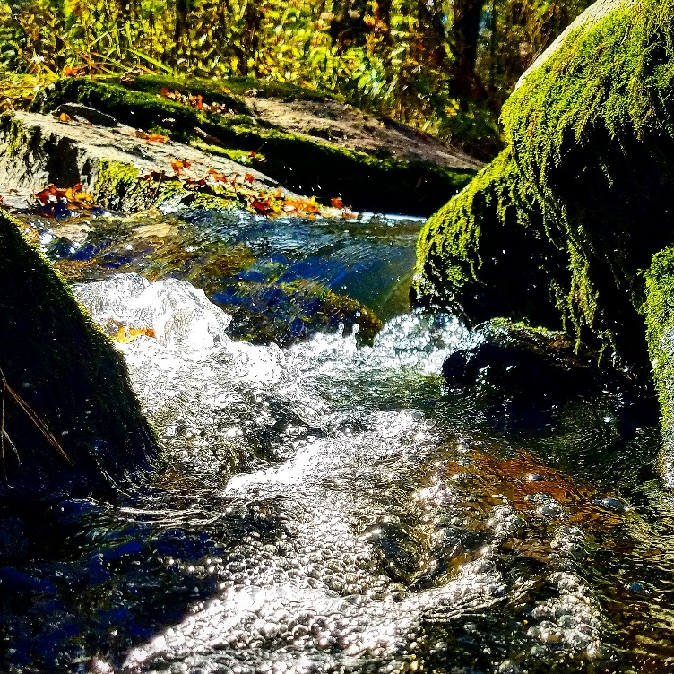
Macroinvertebrate data is beneficial to analyze due to macroinvertebrates limited mobility, and the presence or absence of a species can indicate if organic pollution is present. Many of the sites in the Fenwood Creek watershed had mIBI ratings of “good” or “excellent” with only two sites having a “fair” rating (Table 1). HBI ratings showed a similar trend with only one station having a rating of “poor.” Fenwood Creek at Eldeberry Road had the lowest mIBI and HBI ratings. The riparian corridor was heavily grazed, and streambanks were eroding increasing sedimentation and possibly organic loading. This segment of stream also appears to be impacted by low flow conditions, which reduces habitat quality. Low flow conditions may result in lower oxygen concentrations from the lack of aeration and atmospheric exchange. However, this was not measured during this study. Beneficial macroinvertebrates such as mayflies, stoneflies, and caddisflies require high flow streams with immense levels of dissolved oxygen to survive. These low flow conditions in the headwaters of both Fenwood and Rocky Run Creeks did not provide suitable habitat conditions for these species.
In this watershed, mIBI scores increased in quality moving downstream. There could be many reasons for the variation including habitat selected for sampling (riffle, run, or pool), flow, water level, organic pollution levels at each site, or just natural variation between each site. Headwater areas tended to have higher levels of bank erosion and limited riparian buffers decreasing the chance for any excess nutrients to be absorbed before entering the streams. The headwater areas also had very limited flow and low water levels.
Conclusion
Overall, streams within the Fenwood Creek watershed are in fair condition. Streams flowing through agricultural dominated land use can have higher levels of phosphorus and degraded aquatic habitat, if land use practices are improperly managed. Efforts in this watershed should focus on practices that reduce non-point source runoff from crop fields, pastures and other sources of sediment and nutrients as identified in the County’s Nine Key Element Plan. The Department should seek opportunities to work collaboratively with Marathon county and other land conservation efforts in the area, and provide support through grants, partnerships and education.
Management Recommendations
- Provide outreach and educate landowners about water quality concerns within the watershed and how they can help to reduce erosion and nutrient inputs
- Identify primary sources of phosphorus and implement various land practices to ensure a decrease in pollutants
  - Partners should identify and prioritize work in areas where there are willing landowners, and/or in areas with the highest sources of pollutants.
- Support Marathon County in the implementation of the Fenwood Creek Nine Key Element Plan
- Continue to protect riparian habitat along the stream banks and identify areas where riparian habitat is needed and seek support from partners to implement BMP’s
- Identify areas where wetlands have been disturbed and work with partners to restore wetlands
- Educate and work with landowners on the benefits of no-till farming, reduction of fall tillage, cover crops, and creation and implementation of a nutrient management plan, and other BMP’s that reduce runoff to surface waters.
- Educate landowners about the benefit of managing grazelands and rotational grazing
- Provide education on aquatic invasive species (AIS) prevention and management to interested partners
- Follow up monitoring of both Fenwood and Rocky Run Creek, should occur when significant implementation has occurred and can be demonstrated through modeling.

Appendix A: References
Hilsenhoff, William L. 1987. An Improved Biotic Index of Organic Stream Pollution. The Great Lakes Entomologist. 20: 31-39.

Lyons, John. 1992. Using the Index of Biotic Integrity (IBI) to Measure Environmental Quality in Warmwater Streams of Wisconsin. United States Department of Agriculture. General Technical Report NC-149.

Lyons, John. L. Wang and T. Simonson. 1996. Development and Validation of an Index of Biotic Integrity
for Coldwater Streams in Wisconsin. North American Journal of Fisheries Management, 16:2, 241-256.

Lyons, John. 2012. Development and Validation of Two Fish-based Indices of Biotic Integrity for Assessing Perennial Coolwater Streams in Wisconsin, USA. Ecological Indicators 23 (2012) 402-412.

Lyons, John. 2013. Methodology for Using Field Data to Identify and Correct Wisconsin Stream “Natural Community” Misclassifications. Version 4. May, 2013.

Marathon County Conservation, Planning and Zoning Department. 2016. Fenwood Creek Watershed Management Plan.

WDNR. 2017. Guidelines for the Standard Collection of Macroinvertebrate Samples from Wadeable Streams v2.0. Wisconsin Department of Natural Resources. Bureau of Fisheries Management and Habitat Protection Monitoring and Data Assessment Section. November, 2017.

WDNR. 2018. Guidelines for Assessing Fish Communities of Wadeable Streams in Wisconsin v2.0. Wisconsin Department of Natural Resources. Bureau of Fisheries Management and Habitat Protection Monitoring and Data Assessment Section. April, 2018.

WDNR. 2007. Guidelines for Qualitative Physical Habitat Evaluation of Wadeable Streams. Wisconsin
Department of Natural Resources. Bureau of Fisheries Management Monitoring and Data Analysis Section. June, 2007.

WDNR. 2016. Wisconsin 2016 Consolidated Assessment and Listing Methodology (WisCALM) for CWA Section 303(d) and 305(b) Integrated Reporting. Wisconsin Department of Natural Resources. Bureau of Water Quality Program Guidance. March, 2016.

WDNR. 2017. Guidance for Implementing Wisconsin’s Phosphorus Water Quality Standards for Point Source Discharges. Wisconsin Department of Natural Resources. Bureau of Water Quality Program. February, 2017.

Weigel, Brian. 2003. Development of Stream Macroinvertebrate Models that Predict Watershed and Local Stressors in Wisconsin. Journal of the North American Benthological Society. 22(1): 123-142.

Appendix B. Figures and Graphs

Table 1. Macroinvertebrate mIBI and HBI in Fenwood Creek HUC 12, 2016
Stream Name and Site Location | mIBI | mIBI Rating | HBI | HBI Rating
Fenwood at Elderberry St | 3.27817 | Fair | 7.503 | Poor
Fenwood at CTH N | 5.92349 | Good | 4.447 | Very good
Fenwood at Blackberry Rd | 6.13662 | Good | 6.013 | Fair
Fenwood at CTH M | 6.37918 | Good | 4.714 | Good
Fenwood at Fairview Rd | 6.38932 | Good | 3.321 | Excellent
Fenwood at HWY 153 | 6.68535 | Good | 3.457 | Excellent
Rocky Run above Still Hill Rd | 4.67659 | Fair | 3.32 | Excellent
Rocky Run at Still Hill Rd | 5.78076 | Good | 4.764 | Good
Rocky Run at Fairview Rd | 7.50574 | Excellent | 4.673 | Good
Unnamed at Schnelle Rd | 6.70248 | Good | 4.414 | Very Good

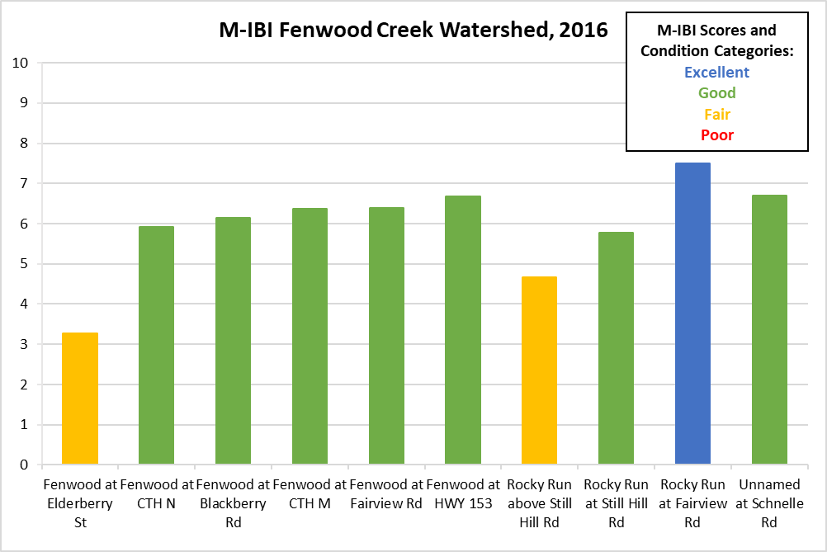
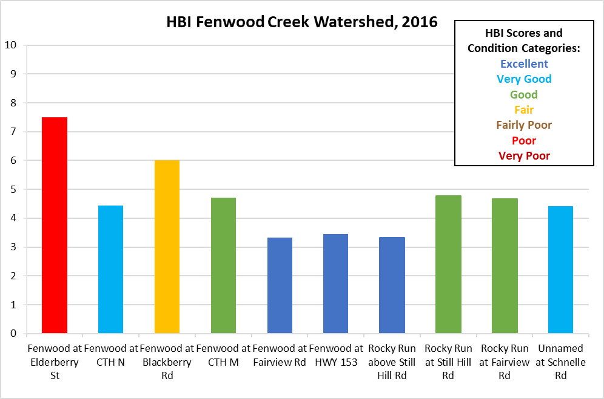

Table 2. Qualitative habitat scores in Fenwood Creek HUC 12, 2017
Stream Name and Site Location | Qualitative Habitat Score | Condition Category
Fenwood at Elderberry St | 10 | Poor
Fenwood at CTH N | 68 | Good
Fenwood at Blackberry Rd | 43 | Fair
Fenwood at CTH M | 35 | Fair
Fenwood at Fairview Rd | 45 | Fair
Rocky Run above Still Hill Rd | 73 | Good
Rocky Run at Still Hill Rd | 60 | Good
Rocky Run at Fairview Rd | 53 | Good
Unnamed at Schnelle Rd | 50 | Good

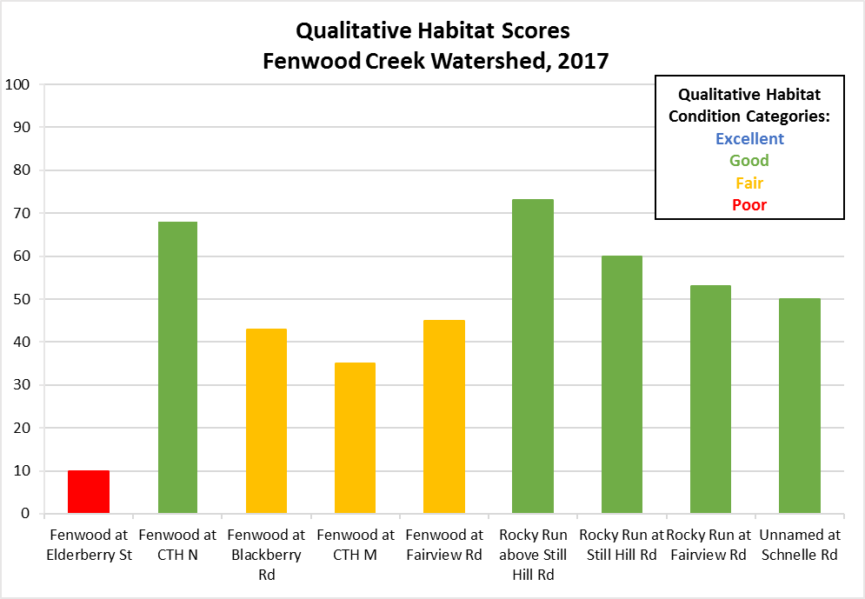

Table 3. Total Phosphorus in Fenwood Creek HUC 12, 2017
Stream Name and Site Location | Total Phosphorus (mg/L)
Fenwood at Elderberry St | 0.183
Fenwood at CTH N | 0.175
Fenwood at Blackberry Rd | 0.245 (median)
Fenwood at CTH M | 0.271
Fenwood at Fairview Rd | 0.141 (median)
Fenwood at HWY 153 | 0.104 (median)
Unnamed at Schnelle Rd | 0.067
Rocky Run above Still Hill Rd | 0.0897
Rocky Run at Still Hill Rd | 0.105
Rocky Run at Fairview Rd | 0.0604 (median)

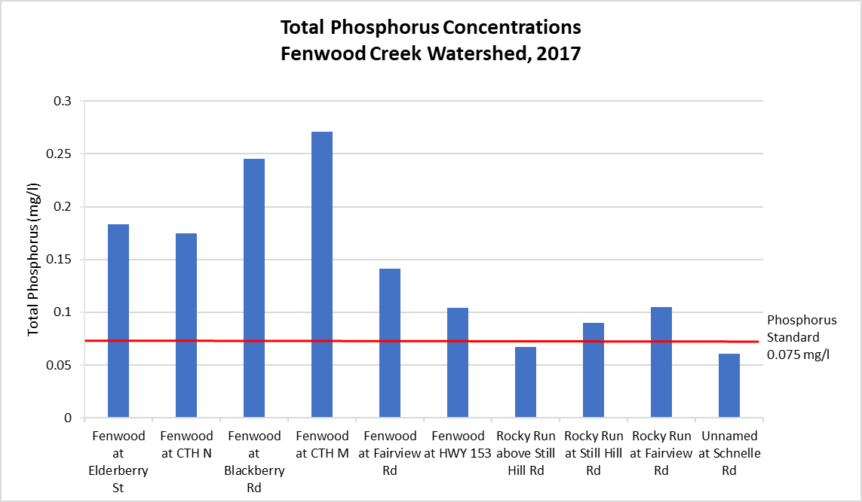

Table 4. Fish IBI Scores and Condition in the Fenwood Creek HUC 12, 2016
Stream Name and Site Location | F-IBI | Condition Category
Fenwood at Elderberry St | 100 | Good
Fenwood at CTH N | 100 | Good
Fenwood at Blackberry Rd | 100 | Good
Fenwood at CTH M | 90 | Excellent
Fenwood at Fairview Rd | 100 | Excellent
Rocky Run above Still Hill Rd | 100 | Good
Rocky Run at Still Hill Rd | 100 | Good
Rocky Run at Fairview Rd | 100 | Excellent
Unnamed at Schnelle Rd | 70 | Good

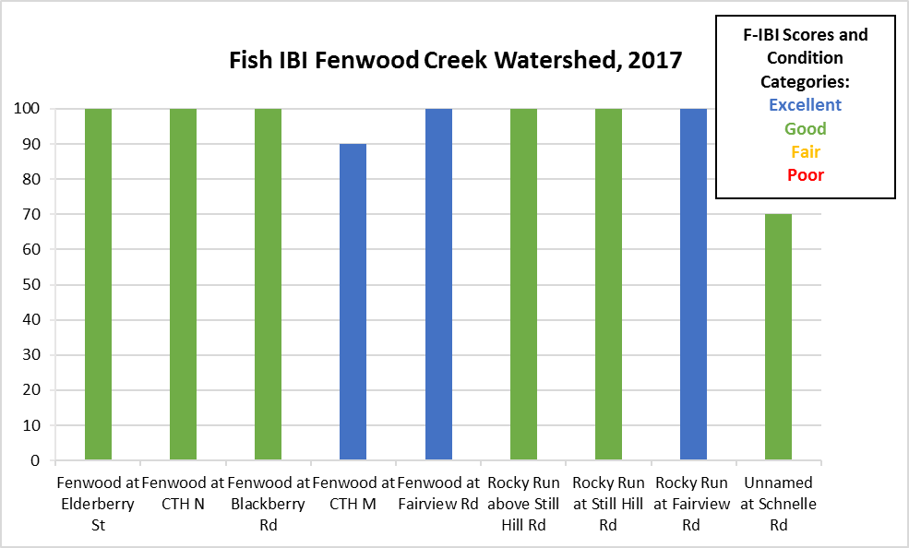

Species | Tolerance | Fenwood at Elderberry St | Fenwood at CTH N | Fenwood at Blackberry Rd | Fenwood at CTH M | Fenwood at Fairview Rd | Rocky Run above Still Hill Rd | Rocky Run at Still Hill Rd | Rocky Run at Fairview Dr |  | Unnamed at Schnelle Rd
Bigmouth Shiner | Intermediate |  | 1 |  | 47 |  |  |  | 1
Black Bullhead | Tolerant |  |  |  |  |  |  |  | 2
Blackside Darter | Intermediate |  |  |  | 4 | 5 |  | 3 | 20
Bluegill | Intermediate |  |  |  |  | 5
Bluntnose Minnow | Tolerant |  |  | 5 | 10 | 4 |  |  | 1
Brook Stickleback | Tolerant | 116 | 50 | 8 | 53 |  | 1 | 9 | 6 | 4
Burbot | Intermediate |  |  |  |  |  |  |  | 2
Central Mudminnow | Tolerant | 54 | 5 | 51 | 15 |  |  | 4 | 4 | 1
Common Shiner | Intermediate | 8 | 8 | 8 | 105 | 73 |  |  | 74
Creek Chub | Tolerant | 20 | 4 | 37 | 183 | 33 | 29 | 122 | 110 | 18
Fantail Darter | Intermediate | 1 | 1 | 7 | 6 | 10 | 24 | 43 | 3 | 5
Fathead Minnow | Tolerant | 1
Green Sunfish | Tolerant |  |  | 44 | 6 | 12 | 6 | 18 | 43 | 5
Hornyhead Chub | Intermediate |  |  |  |  | 8
Iowa Darter | Intolerant |  |  | 1 |  |  |  | 26
Johnny Darter | Intermediate | 14 | 60 | 60 | 161 | 23 | 9 | 89 | 21 | 11
Largemouth Bass | Intermediate |  |  |  |  | 1
Logperch | Intermediate |  |  |  | 17 | 14 | 1 | 9 | 47
Northern Hog Sucker | Intolerant |  |  |  |  | 4
Northern Redbelly Dace | Intermediate | 15 | 6
Rainbow Darter | Intolerant |  | 1 | 18 | 74 | 33 | 1 |  | 116 | 8
Redbelly Dace | Intermediate |  |  | 18
Redside Dace | Intolerant |  |  |  |  |  | 5 | 9 | 15
Shorthead Redhorse | Intermediate |  |  |  |  | 2
Southern Redbelly Dace | Intermediate |  |  |  | 84 | 8 | 12 | 22 | 34
Stonerollers | Intermediate |  |  |  | 3 | 66 | 1 |  | 12
Western Blacknose Dace | Tolerant |  | 7 | 5 | 99 | 14 | 46 | 116 | 79 | 17
White Sucker | Tolerant |  | 9 | 23 | 211 | 21 | 18 | 29 | 96 | 2
Yellow Perch | Intermediate |  |  | 3 | 1 |  |  |  | 2
Table 5. Quantity of fish collected at each site during electrofishing survey

