An Evaluation of Spring Creek
to
determine current habitat impairment status

WBIC = 877000
Green County, WI

Water Resources Monitoring Project: South_02_CMP21

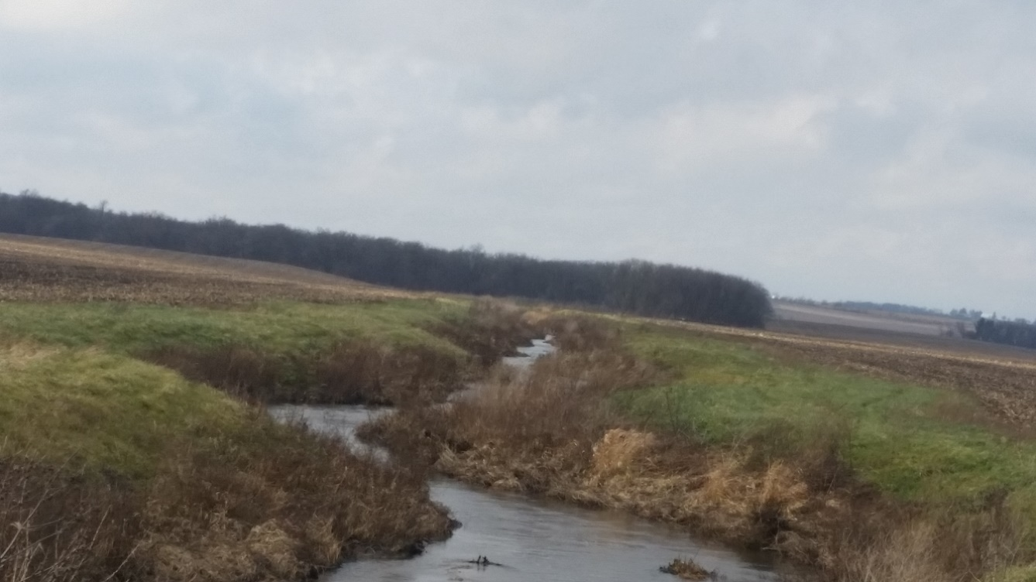
By Camille Bruhn and James Amrhein
Water Quality Biologists
Wisconsin Department of Natural Resources – South District
February 2022
Spring Creek is located in southeastern Green County and is part of the Lower Sugar River watershed. Originating about 4 miles south of Juda, it flows to the east-northeast for ten miles before it drains into the Sugar River, south of Brodhead. The western headwaters portion of the stream has good gradient as it meanders through pasture and farmland. The lower half of the watershed is broader with less gradient. Much of the stream length has been ditched for cropland drainage and it has many steep eroding banks (WDNR, 1980). The stream is home to a variety of cool transitional and warm water non-game fish as well as the occasional brown trout. Other species, particularly northern pike and smallmouth bass make seasonal migrations up into Spring Creek. In 1998, the lower ten miles of the stream were placed on the state’s 303(d) list of impaired waters for degraded habitat due to sedimentation from nonpoint sources. In the Sugar and Pecatonica Basin Report (WDNR, 2003), it was recommended that buffer strips and bank stabilization would enhance this stream. In 2005, a Total Maximum Daily Load (TMDL) was approved which outlined steps for sediment control (WDNR, 2005).
Table 1: Practices Implemented in the Spring Creek Watershed
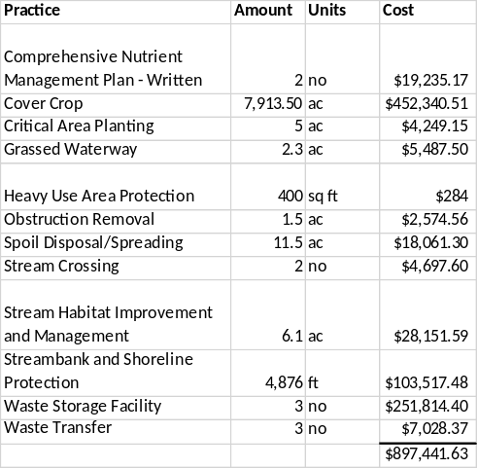
In 2018, the Green County office of the Natural Resources Conservation Service (NRCS) approached the department with a proposal to use National Water Quality Initiatives (NWQI) funding to incorporate best management practices (BMPs) in the watershed.
From 2016 through 2019, almost $900,000 was spent in the watershed (Table 1). Nearly 8,000 acres were planted in cover crops. Three waste storage facilities were built. Grassed waterways and stream (cattle) crossings were put in. Almost a mile of streambank protection was funded through NWQI with an additional 6,000 feet paid for by a landowner (Figure 1).
In 2021, biologists conducted monitoring on the stream with the goal of determining whether it is meeting its attainable biological use, to assess the habitat, and determine whether it can be removed from the impaired waters list.
Methods
During the summer of 2021, the department surveyed 6 sites on the stream. For all sites, the fisheries assemblage was determined by electroshocking a section of stream with a minimum station length of 35 times the mean stream width (Lyons, 1992). A stream tow barge with a generator and two probes was used at most sites. A backpack shocker with a single probe was used at the CTH G site due to frequent log jams, which also led to about half the minimum station length being surveyed. All fish were collected, identified, and counted. All gamefish were measured for length. At each site, qualitative notes on average stream width and depth, riparian buffers and land use, evidence of sedimentation, fish cover and potential management options were also recorded. Quantitative habitat surveys were conducted at 5 of the 6 sites according to Simonson, et. al. (1994). A qualitative habitat survey (Ibid) was conducted at CTH G.

Figure 1: Spring Creek Streambank Stabilization Projects (in red)
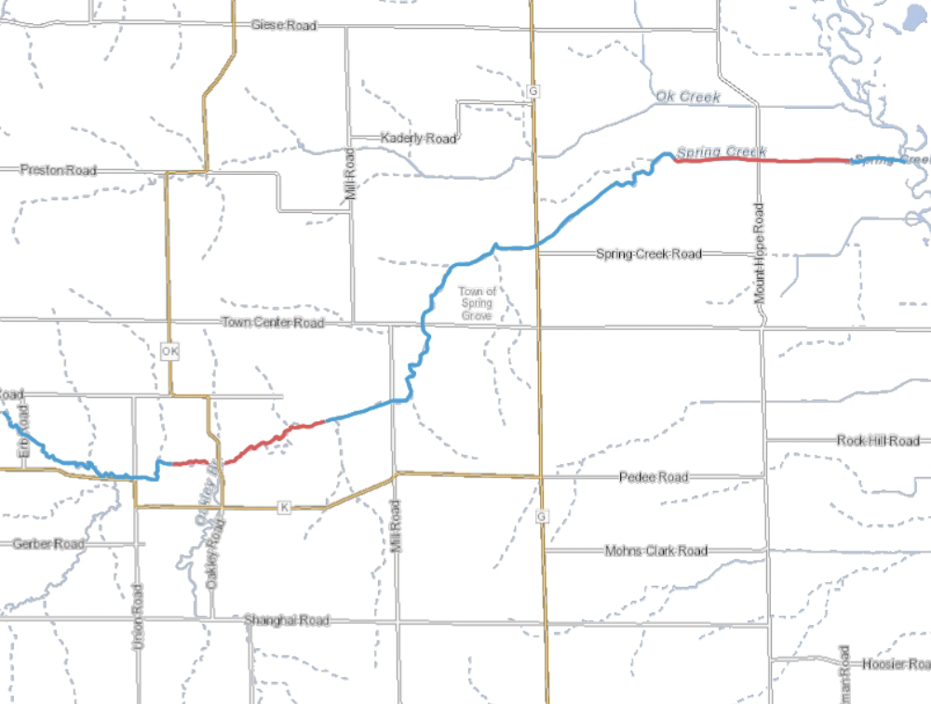
Results
Fisheries surveys found a variety of cool transitional and warmwater species, with often a dozen or more species present at each site (Table 2). The most variety of species was found at Mt. Hope Road, the furthest downstream site that was surveyed. Creek chubs, white suckers, fantail and johnny darters were found at all sites. Several intolerant species were found, mostly at Mount Hope Road and in small numbers. Smallmouth bass were found at 4 of the 6 sites. All but one were young-of-the-year, indicating that adult bass had migrated upstream into Spring Creek to spawn. Several specimens of brown trout, a coldwater indicator species, were found amongst 3 of the sites. Simple lithophil* spawning fish made up about a third of the species present. A specimen of redfin shiner, a state threatened species, was found at one of the sites. This was the first time this species has been reported in this stream.
All sections of Spring Creek were purported to be cold-transitional (cold-cool) according to the Wisconsin streams model (Lyons, 2008). The natural community verification process (WDNR, 2019) showed all of the sites to be warm-transitional (cool-warm) according to the species assemblage. As such, the coolwater index of biotic integrity (IBI) (Lyons, 2012) was applied to those data. The warm transitional IBIs ranged from poor to excellent, with the higher scores being lower in the watershed.

As shown in Table 3, overall quantitative habitat scores from 2021 ranged from 40 (fair) to 68 (good). With the exception of the site at Town Center Road, which was in pasture, most sites had an excellent riparian buffer score.

*Species that broadcast their eggs on clean gravel or cobble and do not build a nest or provide parental care

The width to depth ratio was good at all sites. Pools were virtually absent. Riffles were common at most
sites, and the bend to bend ratio varied based on whether the site had been channelized or not. Fish cover varied by site but was generally scarce. Fine sediment was “poor” to “fair” with most sites containing from 45 to 55% fines.

Discussion

Since waters added to the 1998 impaired waters listings had little documentation, there is no known quantitative or qualitative data on which the original listing was based. Historical data collected over the past 2 decades suggests that there was a similar fishery assemblage to the current one, including a diversity of simple lithophils as well as nest building species like hornyhead chub and smallmouth bass. This would suggest that enough hard substrate existed for these species to proliferate. However, the abundance of disturbance tolerant species such as creek chub, white sucker, and western blacknose dace (the latter two also being simple lithophils) also suggest environmental degradation.

In the 2014 surveys, it was noted that the coarse woody debris not only provided cover for fish, but also scoured holes up to 1 meter deep to provide more variety of habitat. However, those same trees shaded the banks which prevented good vegetative growth with good root systems to hold soil in place. When the trees fall, they create large areas of steep eroding banks which exacerbate sedimentation. This process also resulted in an overly wide and shallow channel in the absence of scattered scour holes. There was some concern among biologists that removal of the trees would result in an open canopy that would allow more light penetration. This light would then result in an over-abundance of macrophyte and/or algae growth in the nutrient rich environment, cause severe oxygen swings, and thus reduce the diversity of the fishery. The 2021 surveys showed this was not the case in that most of the species found in the 2014 surveys were still present in 2021.

It was hoped that bank stabilization and other practices could help reduce the amount of sediment that enters the stream and becomes part of the bedload. However, because a comprehensive quantitative habitat evaluation – and particularly that of the stream bed - was not done on the stream prior to BMP implementation, it is more difficult to ascertain what progress was made. Another confounding factor is that a direct comparison is difficult because there is very little overlap between historical sites surveyed, sites that had riparian work done on them, and sites surveyed in this study.

That said, some comparisons are obvious, such as those displayed in Figure 2. The pre-project photos show very steep banks (some greater than 2 meters high) that are very susceptible to erosion. After the project, the banks are sloped, grassed, and stable. Width to depth ratios decreased. There is also a 10+ meter buffer of grasses present. The area also had a higher amount of precipitation than normal from 2015 to 2020 (WDNR, 2020) which resulted in higher flows that likely compromised stabilization of some of the newly established vegetation. Flood events also destroyed some of the work that was done. As a result, repairs were still being made in summer of 2021. Qualitative bank erosion scores from prior surveys indicated very poor banks. Quantitative bank erosion scores conducted in this study ranged from fair to excellent. It is hoped this would mitigate some of the bedload of sediment that was coming from bank erosion.

The amount of soft sediment present before and after the projects is difficult to ascertain. Biologists noted the presence of soft sediment, but also an abundance of hard substrate in the thalweg and riffle

Table 2: Fisheries Assemblages of Spring Creek in 2021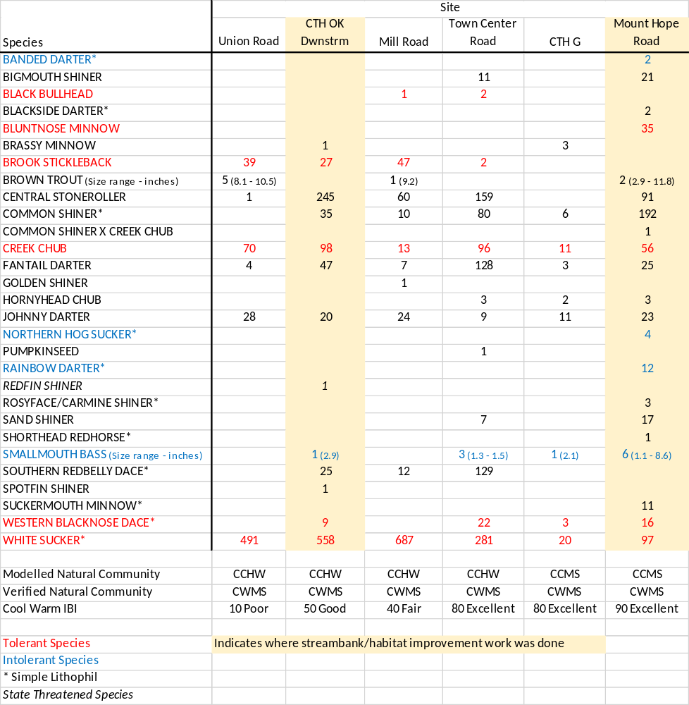
Table 3: Quantitative and Qualitative Habitat Assessments for Spring Creek
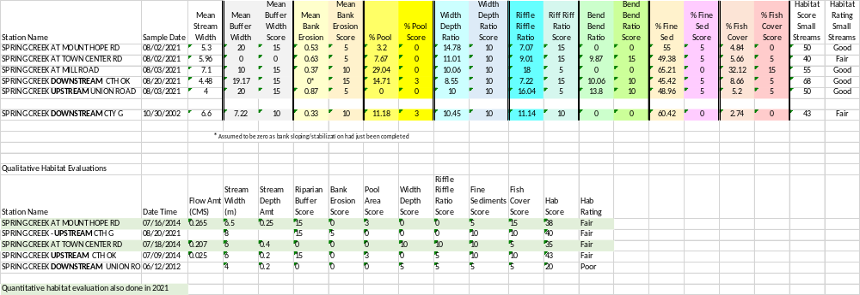

areas. The presence of a number of simple lithophil species throughout the last 20 years of surveys seems to bear this out. More recent surveys, such as those conducted in 2014 indicated “fair” to “good” bottom substrates. This 2021 study showed fine substrate made up less than 50% of the bottom in 3 of the 5 quantitative surveys conducted and 55% and 65% at Mount Hope Road and Mill Road, respectively. The latter site may have been impacted by the streambank stabilization work that occurred immediately upstream of that site, which may have mobilized some sediments into this area.

In summary, while there is still soft sediment present, it isn’t the overwhelming substrate. It is concentrated in certain, more quiescent areas, particularly behind major grade breaks. At many sites, it makes up less than 50% of the substrate, meaning there are many areas of gravel or coarser substrate. It is also important to note that the stream is meeting it’s purported attainable use from a fishery standpoint. There are many species present which need coarse substrate to complete their life cycle. Of the sediment that is present, and since the last of the projects was put in place in 2018 – or repaired in 2021 - it may be that enough time has not passed for legacy sediment to make its way out of the system.

Given this is the case, and that improvements are likely to be seen as time passes, it is recommended that Spring Creek be removed from the state’s 303(d) list of impaired waters. The county should continue to work with willing landowners on further streambank improvement projects as well as other management practices to reduce sediment and nutrients from entering the stream such as fencing cattle out of the riparian corridor.

References
Lyons, John. 1992. Using the Index of Biotic Integrity (IBI) to Measure Environmental Quality in Warmwater Streams of Wisconsin. United States Department of Agriculture. General Technical Report NC-149.
Lyons, John. 2008. Using the Wisconsin Stream Model to Estimate the Potential Natural Community of Wisconsin Streams (DRAFT). Wisconsin Department of Natural Resources Fish and Aquatic Life Research Section. November 2008.
Lyons, John, T. Zorn, J. Stewart, P. Seelbach, K. Wehrly, and L. Wang. 2009. Defining and Characterizing Coolwater Streams and Their Fish Assemblages in Michigan and Wisconsin, USA. North American Journal of Fisheries Management. 29: 1130-1151.
Lyons, John. 2012. Development and Validation of Two Fish-based Indices of Biotic Integrity for Assessing Perennial Coolwater Streams in Wisconsin, USA. Ecological Indicators 23 (2012) 402-412.
Simonson, Timothy D., J. Lyons, and P.D. Kanehl. 1994. Guidelines for Evaluating Fish Habitat in Wisconsin Streams. U.S. Department of Agriculture. Forest Service. General Technical Report NC-164.
WDNR. 1980. Surface Water Resources of Green County. Lake and Stream Classification Project, Second Edition. By Donald Bush, Richard Cornelius, Dennis Engel and Clifford Brynildson. Madison, WI.
WDNR. 2003. The State of the Sugar and Pecatonica River Basins. Wisconsin Department of Natural Resources.
WDNR. 2005. TMDLs for Sediment Impaired Streams in the Sugar-Pecatonica River Basin. June 28, 2005. http://dnr.wi.gov/water/wsSWIMSDocument.ashx?documentSeqNo=41875607.
WDNR. 2019. Aquatic Life Use Designation through Natural Community Verification. WDNR Streams Technical Team Guidance Document. (DRAFT) V.1 Revised 2/20/2019.
WDNR. 2020. Natural Community Verification App (v2.2). Antecedent Weather. Extensive Weather Analysis. Created by Matt Diebel and Alex Latzka. Wisconsin Department of Natural Resources. Bureau of Water Resources. http://34.223.230.186:3838/shuprm/NC_App/

Figure 2: Spring Creek Streambank Stabilization and Rehabilitation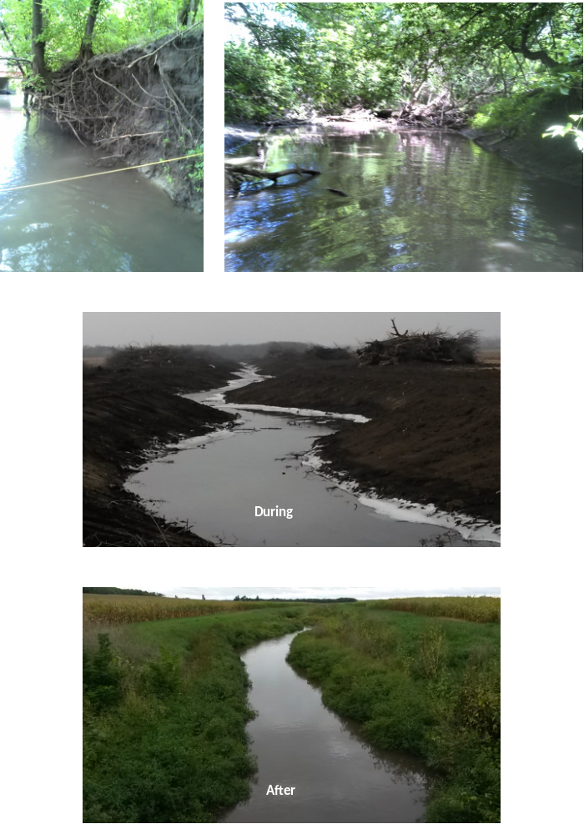
Before
Before

