Desair Lake Restoration, Inc. Wetland Habitat Restoration Grant
Lake Protection Grant Project LPT66920
Henkel Catchment Basin Reconstruction Report
On August 21, 2021 Nathan Walker, Water Management Specialist WDNR, certified our Catchment basin restoration and permitted us to proceed to complete our project on the Phil and Connie Henkel property, parcel 042-0200-10-010, east of County V and south of 24th Ave in Barron County.

After reviewing the design of the basin by hydrologist, Nicole Hodkiewicz, I used the backhoe to pull away plant overgrowth and steep banks scoured by the erosive flow. The detention berm was seven feet high with a nearly vertical slope. Both slopes were shaped at about 45 degrees with no disturbance of the streambed.
Two yards of compaction gravel was brought in up three feet and well compacted into a swale. It took two yards of compaction gravel to make the swale (3’ high x 10’ long x 15’ wide) tamping it down solidly. Once covered with permanent ground cloth, three yards of 6”x 16” quartzite cobble was puzzled in position. The landowner, Phil Henkel and I completed the basin in two days. Curlex ground cloth was established on a small, exposed bank and seeded. Please see photos describing the progress.
There was a heavy 2.5” rain with flow confirming the structure worked properly.
The materials for the basin were paid for last year and no fuel and labor was donated. No further expenses were incurred and no request for reimbursement will be needed.

Design and permit: 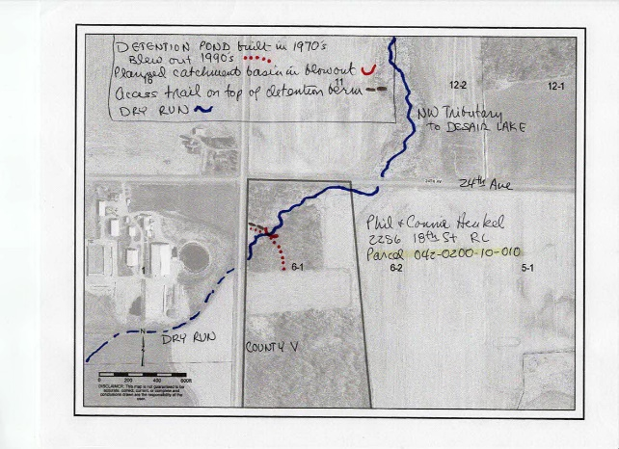
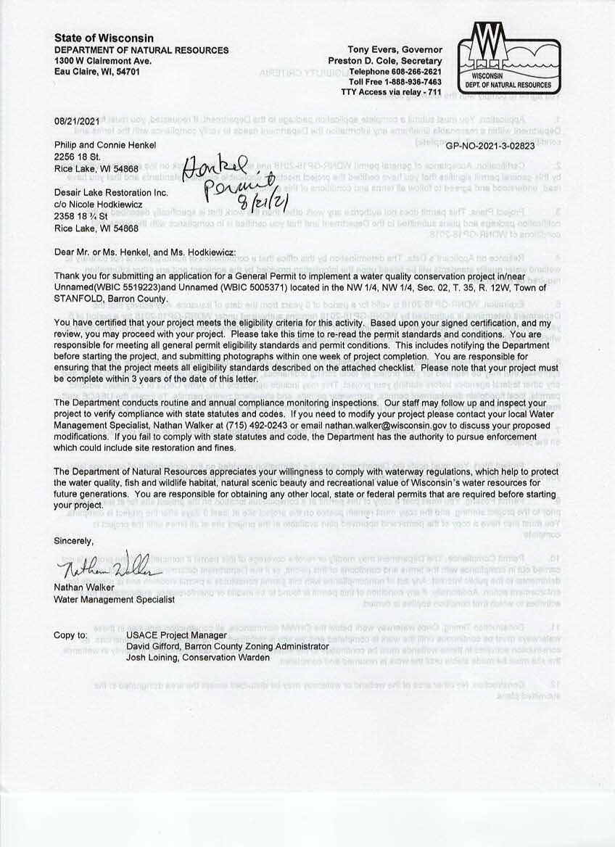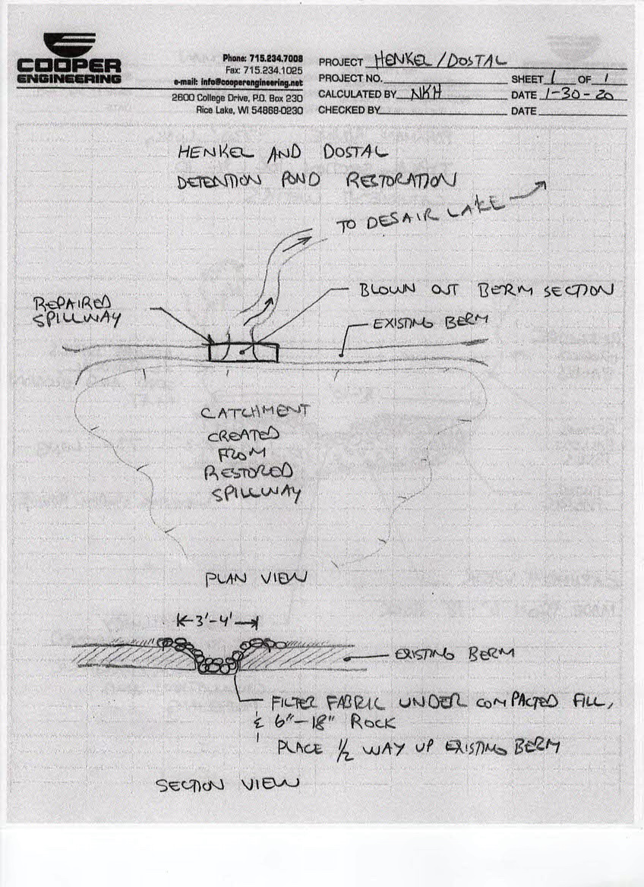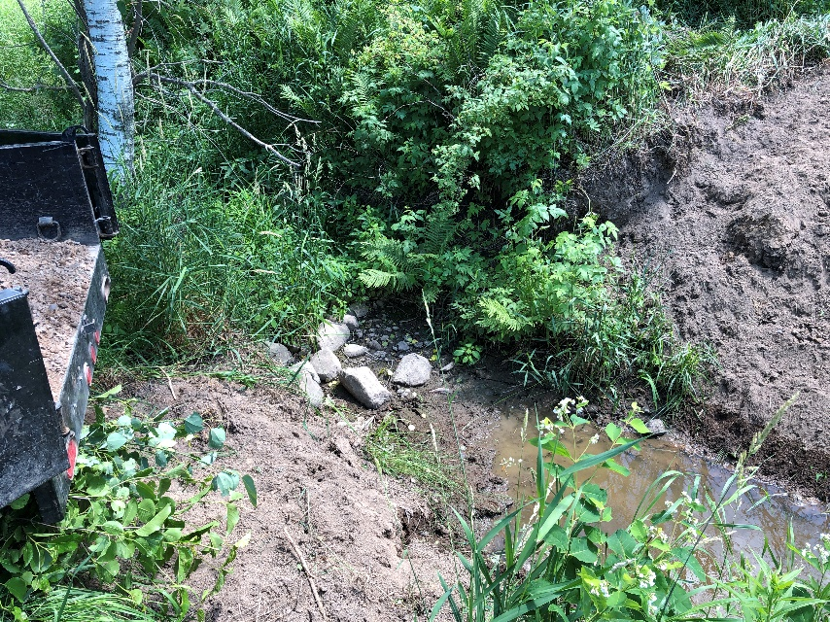
The streambed shaped as per hydrology design
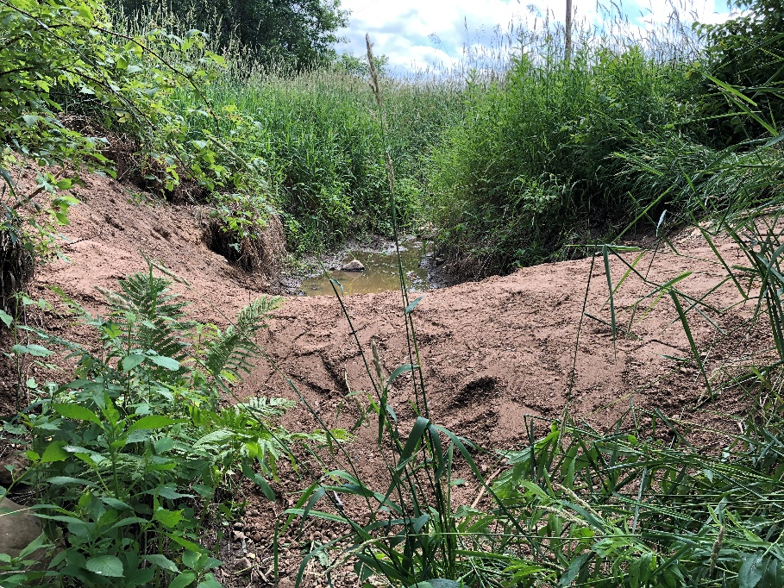
Compacted swale in place, 3’ high by 10’ long and 15’ wide
.
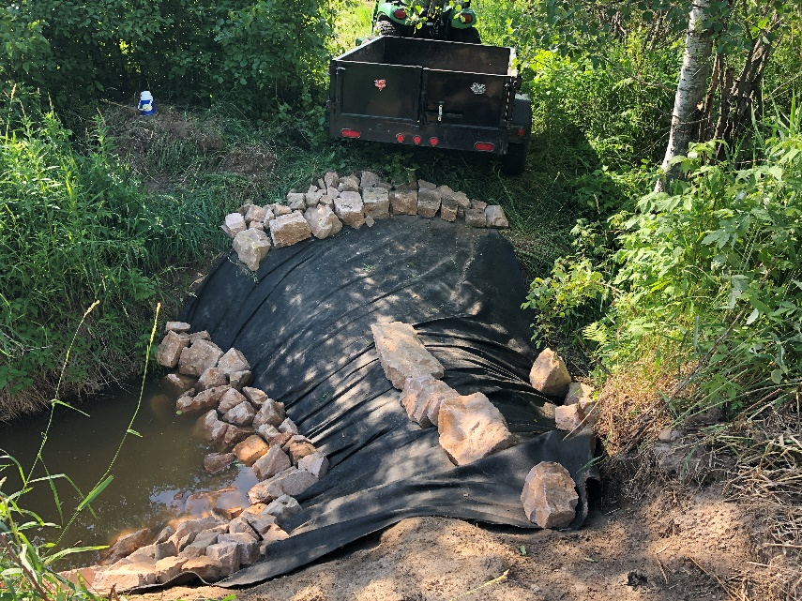
Compaction gravel, swale shape and ground cloth in place with each rock hand carried and puzzled into position.

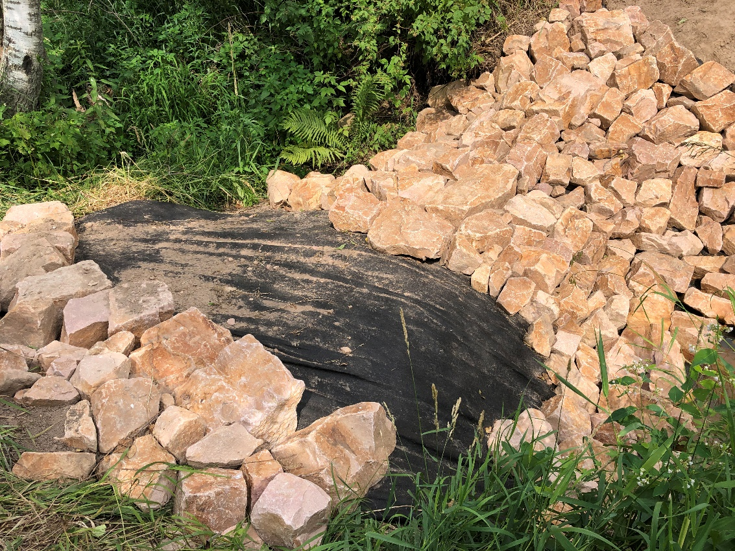
Quartzite rock was positioned into place
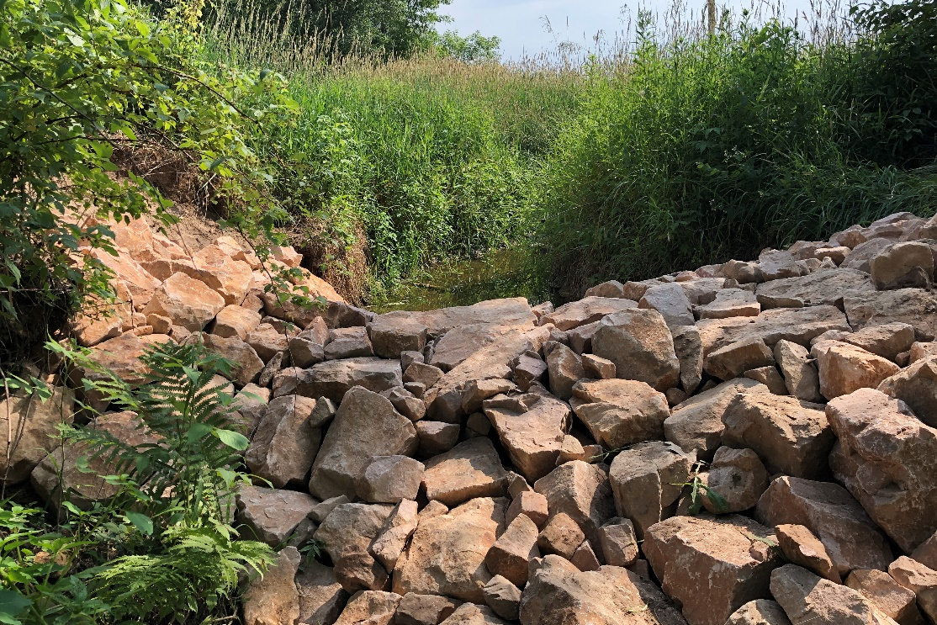
All the quartzite rock was locked into place with a 3’ rise from the streambed, 10’ long and 15’ wide swale.
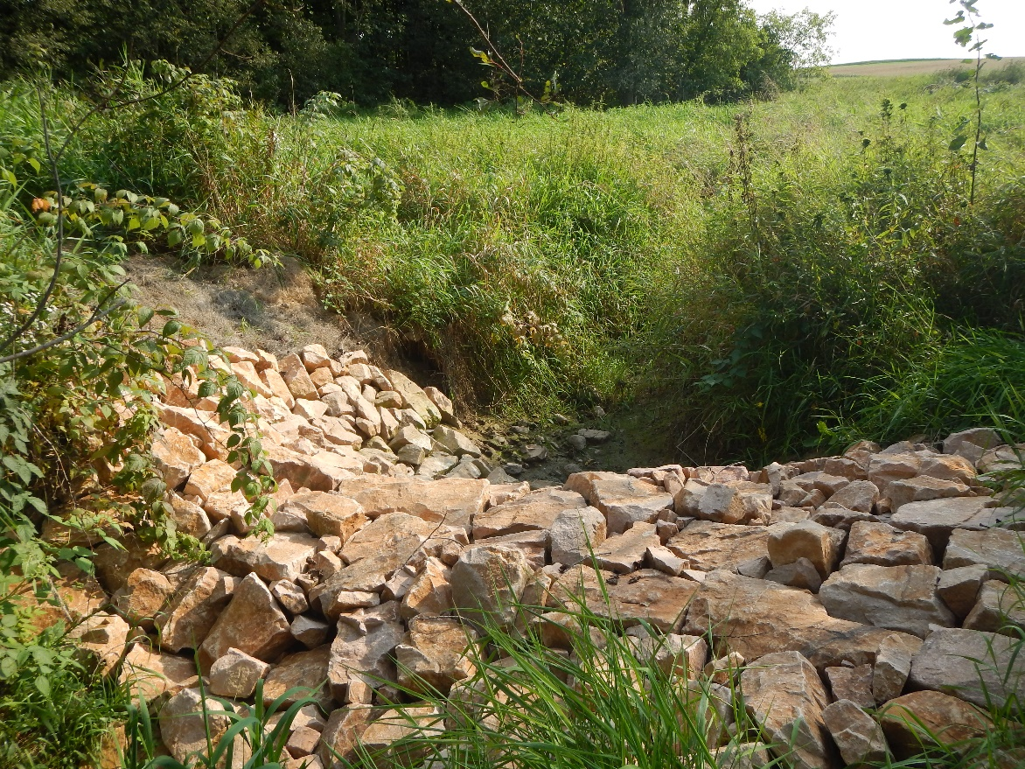
Henkel Detention Pond Restoration
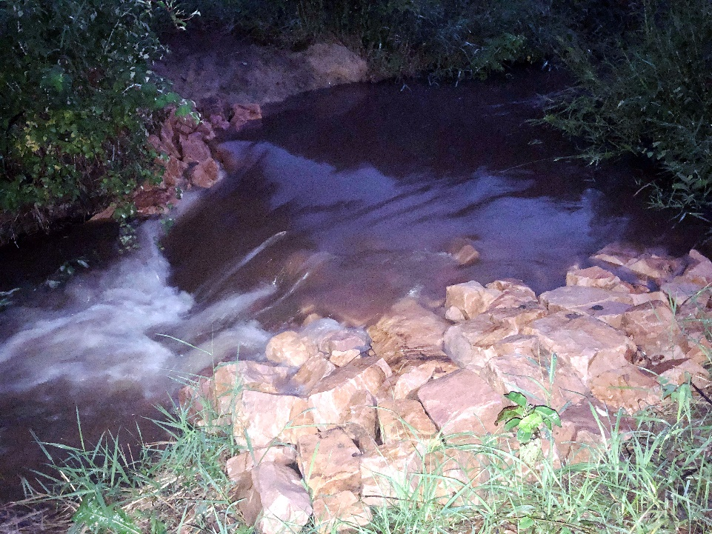
With the basin in place a 2.5” downpour had the dry run flowing and the catchment basin worked perfectly.

