Mecan River Water Quality Report and Watershed Management Plan

Marquette and Waushara County, Wisconsin

David Bolha, Water Quality Biologist, Oshkosh
Wisconsin Department of Natural Resources

February 2023

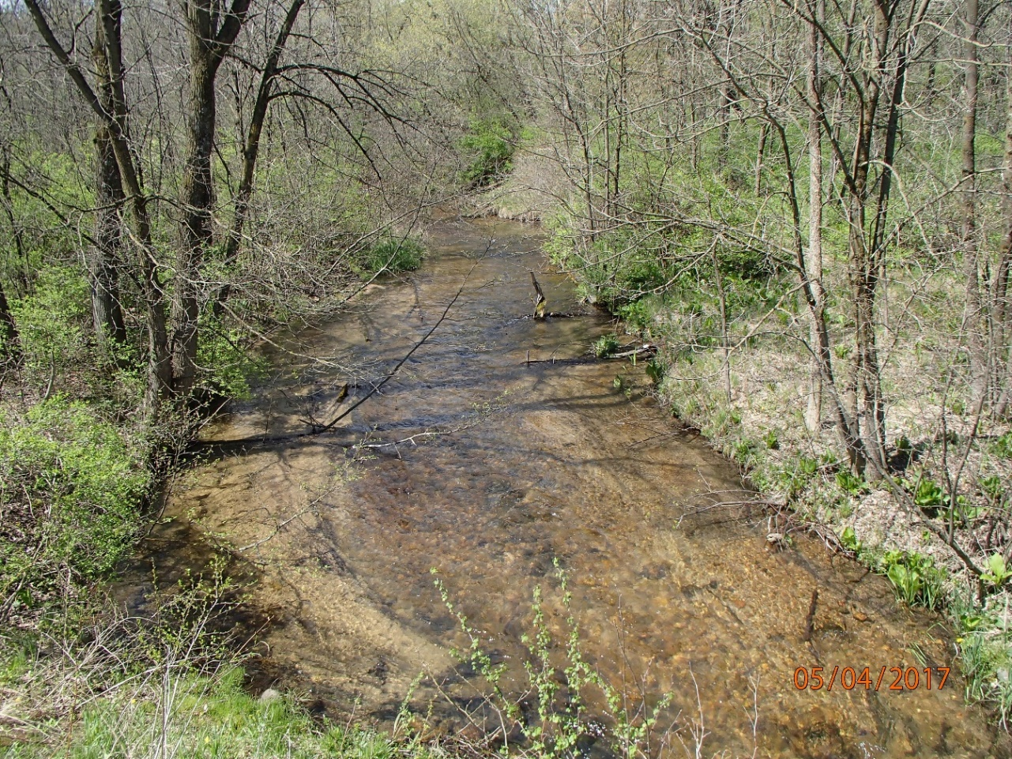

Introduction

The Mecan River is one of Wisconsin’s premier destinations for its scenic beauty and outdoor exploring opportunities and is well-known in the Central Sands Region for its fine trout fishing. The Mecan River originates at the beautiful Mecan Springs in West-Central Waushara County. The crystal-clear, groundwater-fed waters of the Mecan River flow from the Springs 37 miles Southeast to the Fox River near the City of Princeton. The Mecan River has 4 named tributaries: Chaffee, Wedde, Schmudlack, and Little Pine Creeks. The Mecan River Fishery Area, which includes the Mecan River upstream of the Germania Marsh, Chaffee, Wedde, Schmudlack and Little Pine Creeks, provides abundant spawning and rearing habitat for Brown, Brook, and Rainbow trout, and is considered to be an ecologically important site because it encompasses the best examples of rare and high-quality natural communities, documented occurrences of rare species populations, and/or opportunities for ecological restoration or connections (WDNR 2020). Much of the Mecan River’s and its tributaries’ corridors are in public ownership, protected for generations to come.

Purpose

The purpose of this Targeted Watershed Assessment (TWA) was to conduct biological and physical surveys of the streams within the watershed to better understand the current water quality conditions which will serve as a reference for future protections.

Methods

Between October 2016 & 2017, the Mecan River was sampled at 13 locations for aquatic macroinvertebrates (Table 1, Map 1-2). All sites were sampled using the WDNR Guidelines for the Standard Collection of Macroinvertebrate Samples from Wadable Streams v2.0 (WDNR 2017). A D-shaped kicknet with 600-micron mesh was used at all sites by standing upstream from the net and placing it firmly on the stream bed while digging into the substrate with the heel or toe to free the macroinvertebrates from the substrate. Riffles were targeted at each of the sites, but if none were present then, available gravel, overhanging vegetation, woody debris, or other vegetation would be sampled. For a representative sample of the aquatic macroinvertebrate community, a minimum of 100 aquatic macroinvertebrates collected in each sample was targeted. The aquatic macroinvertebrates were preserved in a 70-80% ethanol solution inside quart “Mason” jars. If necessary, multiple “Mason” jars were used per sample depending upon how much sediment and organic material was collected with the aquatic macroinvertebrates. Within the next 24 hours, the samples were re-preserved with another 70-80% ethanol solution. Samples were taken to the UWSP Aquatic Biomonitoring Laboratory (ABL) for lowest possible taxonomic identification. Staff at the ABL entered the data into the SWIMS database.
SWIMS Station ID | Site Name
10049297 | County GG
10033877 | 9th Ave
10038885 | Hwy 21
10029345 | County B
10039319 | Cumberland Rd
10010707 | 11th Rd
10020692 | West Of County Y
10010709 | County Y
10049296 | Crystal Lake Access Road
10041822 | 14th Ave
10029369 | Dixie Ave
10028746 | Dover Avenue
10049295 | County E
Table 1: Aquatic Macroinvertebrate Monitoring Locations in the Mecan River in 2016 and 2017.

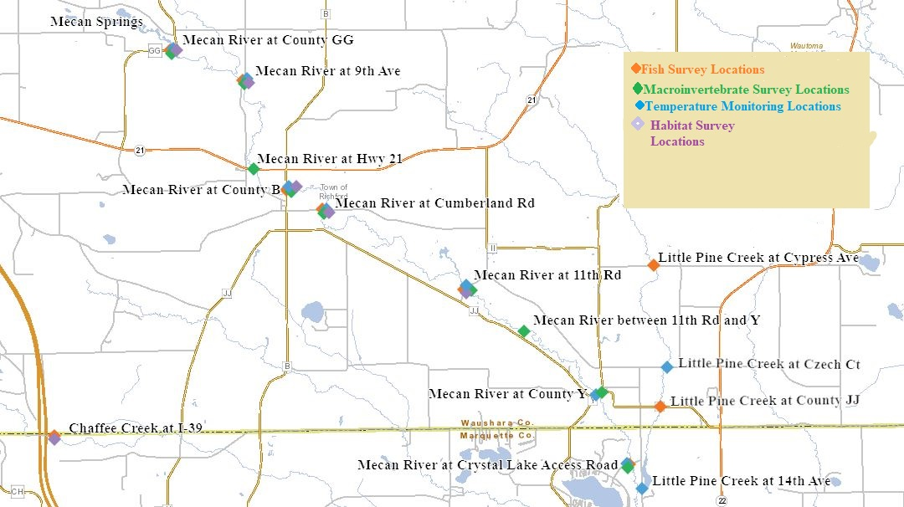
Map 1: Upstream Sample Locations in the Mecan River Watershed in 2016-2021.
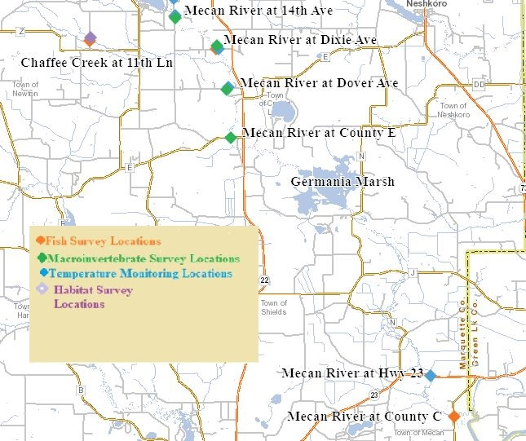
Map 2: Downstream Sample Locations in the Mecan River Watershed in 2016-2021.
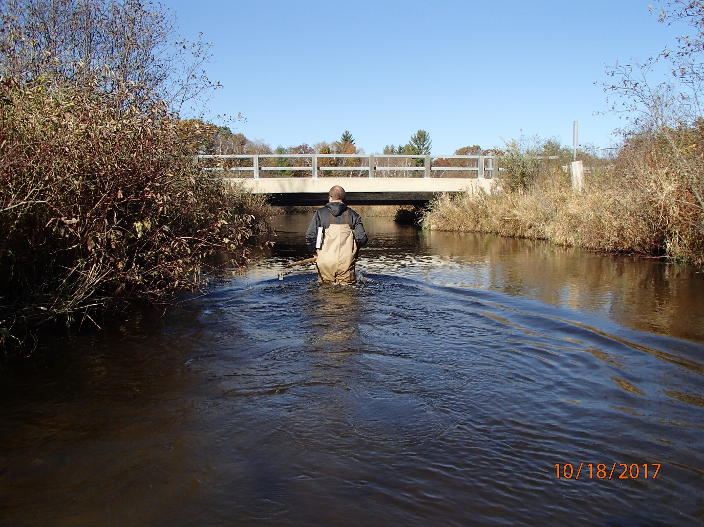 Photo 1: Aquatic Macroinvertebrate Collection Event. Photo by D. Bolha on October 18, 2017.
During the aquatic macroinvertebrate sampling events on October 17th and 18th, 2017, 11 of the locations listed in Table 1 were sampled for Nitrate + Nitrite (NO₃+NO₂ as N) concentrations (Table 2). The 11 samples were collected following the WDNR Nutrient Chemistry Grab Sampling Method V3.3 (WDNR 2015). Sampling was conducted by wading into the river, moving upstream, triple-rinsing the bottle, and collecting the sample 3-6 inches below the surface while avoiding any surface scum or particles. Analysis of the samples was conducted by the Wisconsin State Laboratory of Hygiene.
SWIMS Station ID | Site Name
10033877 | 9th Ave
10029345 | County B
10039319 | Cumberland Rd
10010707 | 11th Rd
10020692 | West Of County Y
10010709 | County Y
10049296 | Crystal Lake Access Road
10041822 | 14th Ave
10029369 | Dixie Ave
10028746 | Dover Avenue
10049295 | County E
Table 2: NO₃+NO₂ as N Monitoring Locations in the Mecan River in 2017.
Between August 2019 and August 2021, wadable fish surveys were conducted at 8 locations on the Mecan River, 2 locations on Chaffee Creek, and 2 locations on Little Pine Creek (Table 3, Map 1-2). The 12 wadable fish surveys were conducted following the WDNR Guidelines for Assessing Fish Communities of Wadeable Streams in Wisconsin v2.0 (WDNR 2018). All 12 wadable sites were surveyed during the guidance-recommended summer-time survey period. The wadable fish survey stations were a minimum in length of 35 times the mean stream width (overall minimum of 100 meters, overall maximum of 400 meters). An otter sled stream shocker with a 4500 Peak Watt generator was used for the wadable sites. Catch per effort sampling procedures were used for this project (no particular species was targeted, all captured). A single upstream pass was made using 0.125-inch mesh nets to collect the fish. At the end of the station, captured fish were identified and counted and all game fish were measured for length. Once all data was collected, the fish were returned to the creek. In addition to the wadable fish surveys, a non-wadable fish survey was conducted near the outlet of the Mecan River to the Fox River (Table 3). The fish survey at the mouth of the Fox River was conducted following the Guidelines for Assessing Fish Communities of Non-Wadeable Rivers in Wisconsin v3.2. (WDNR 2019). The non-wadable fish survey protocol required a flat-bottom, mini-boom boat with a single anode 3-4 meters off the front. The survey was conducted by driving the boat downstream from a starting point and proceeding 1600 meters (1 mile) to an endpoint. One person at the front of the boat, using a net of 3/8” bar mesh, attempted to capture all fish seen. Netted fish are placed in a holding tank until weight, length, and species were determined. Processed fish were then returned to the river. Fish survey data was entered into the WDNR Fisheries Management Information System (FMIS) by WDNR Water Resources staff.
SWIMS Station ID | Site Name
10049297 | Mecan River at County GG
10033877 | Mecan River at 9th Ave
10029345 | Mecan River at County B
10039319 | Mecan River at Cumberland Rd
10010707 | Mecan River at 11th Rd
10049296 | Mecan River at Crystal Lake Access Road
10041822 | Mecan River at 14th Ave
10029369 | Mecan River at Dixie Ave
393005 | Mecan River at County C
10038675 | Little Pine Creek at Cypress Ave
10055762 | Little Pine Creek at County JJ
10010715 | Chaffee Creek Downstream I-39
10030589 | Chaffee Creek Downstream 11th Lane
Table 3: Wadable and Nonwadable Fish Survey Locations in the Mecan River Watershed.
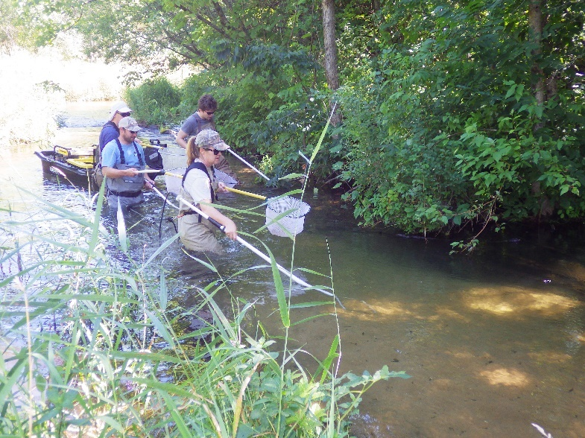 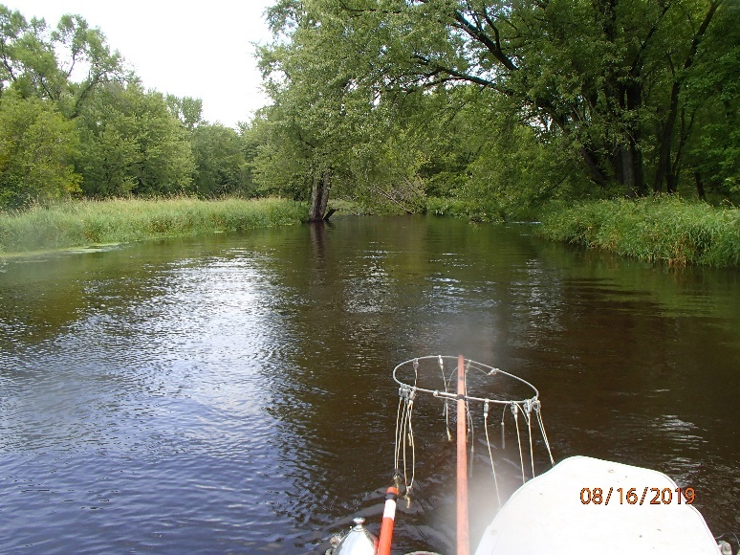Photo 2-3: Wadable (Left taken by Tom Lager) and Nonwadable (Right taken by D. Bolha) Fish Surveys
Qualitative habitat surveys were conducted at 7 locations in the Mecan River Watershed between August and September 2019 (Table 4, Map 1-2). All sites were surveyed following the WDNR Guidelines for Evaluating Habitat of Wadable Streams (WDNR 2002). Each qualitative habitat survey station length was 35 times the mean stream width of the survey station. Qualitative habitat surveys rapidly assess characteristics such as bank erosion, width to depth ratio, % fine sediments, and cover for fish. WDNR Water Resources staff entered the qualitative habitat data into the FMIS.
SWIMS Station ID | Site Name
10049297 | Mecan River at County GG
10033877 | Mecan River at 9th Ave
10029345 | Mecan River at County B
10039319 | Mecan River at Cumberland Rd
10010707 | Mecan River at 11th Rd
10010715 | Chaffee Creek Downstream I-39
10030589 | Chaffee Creek Downstream 11th Lane

Table 4: Qualitative Habitat Survey Locations in the Mecan River Watershed.
Thermistors were deployed to collect in-stream temperature data from July through September 2019 at 13 locations in the Mecan River Watershed (Table 5, Map 1-2). The 13 temperature surveys were conducted following the WDNR Guidelines and Procedures for Continuous Temperature Monitoring (WNDR 2005).
Temperature measurements were taken once per hour at each location from July through September. Temperature measurements were taken with the thermistor attached to a fence post driven into the stream bed of the creek or river. The thermistor was attached to the fence post in such a manner as to suspend the thermistor in the water column low enough to stay under water in low flow conditions and high enough to not get buried in bottom substrate (~ 6 inches above the bottom). The thermistor was placed in a shaded location. Temperature data were uploaded into the SWIMS database by WDNR Water Resources staff.

SWIMS Station ID | Site Name
10049297 | Mecan River at County GG
10033877 | Mecan River at 9th Ave
10029345 | Mecan River at County B
10039319 | Mecan River at Cumberland Rd
10010707 | Mecan River at 11th Rd
10010709 | Mecan River at County Y
10049296 | Mecan River at Crystal Lake Access Road
10041822 | Mecan River at 14th Ave
10029369 | Mecan River at Dixie Ave
10028746 | Mecan River at Dover Ave
10030495 | Mecan River at Hwy 23
10011387 | Little Pine Creek at Czech Ct
10049315 | Little Pine Creek at 14th Ave
Table 5: Temperature Monitoring Locations in the Mecan River Watershed.
Results

Aquatic macroinvertebrate communities were sampled at 13 locations in October between 2016-2017. Some aquatic macroinvertebrate species are tolerant of environmental degradation, while some species are moderately tolerant, and some others are intolerant. Based upon the representative macroinvertebrate sample collected and their associated tolerance to environmental degradation, an Index of Biotic Integrity (MIBI) was calculated to indicate the water quality condition of the stream or river on a scale of 0-10+ (Table 6, Chart 1). In general, the higher the MIBI score, the better the water quality rating for a wadable stream in Wisconsin. The MIBI scores in the Mecan River ranged from 3.98 downstream from County GG to 10.55 at 14th Ave (Table 6, Chart 1). The water quality condition categories based upon the macroinvertebrate community for the 13 sites ranged from Fair to Excellent. The macroinvertebrate community at County GG is located just downstream from the Mecan Springs and is influenced by the Springs’ water quality and temperatures (Photo 4-5). The relatively warm water temperatures coming out of the Springs may be limiting the oxygen holding capacity of the water which could favor the more tolerant species; thus, lowering the IBI score. Cold groundwater influx directly into the river and the cold flow from Schmudlack Creek brought the river temperatures down by 9th Ave and oxygen levels more tolerable for the macroinvertebrate community. Downstream of County GG at all other locations, the Mecan River macroinvertebrate community indicated some slight to no apparent environmental degradation with scores in the Good to Excellent Condition Category.

Mecan River Location | Macroinvertebrate IBI Score | Condition Category
County GG | 3.98 | Fair
9th Ave | 8.68 | Excellent
Hwy 21 | 8.81 | Excellent
County B | 6.61 | Good
Cumberland Rd | 6.11 | Good
11th Rd | 5.45 | Good
West Of Cty Y | 6.36 | Good
County Y | 7.52 | Excellent
Crystal Lake Access Road | 7.55 | Excellent
14th Ave | 10.55 | Excellent
Dixie Ave | 9.32 | Excellent
Dover Ave | 8.84 | Excellent
County E | 6.58 | Good
Table 6: Aquatic Macroinvertebrate Index of Biotic Integrity Scores and Water Quality Condition Category in the Mecan River in 2016-2017.
Chart 1: Macroinvertebrate Index of Biotic Integrity Scores and Water Quality Condition Category in the Mecan River in 2016-2017.
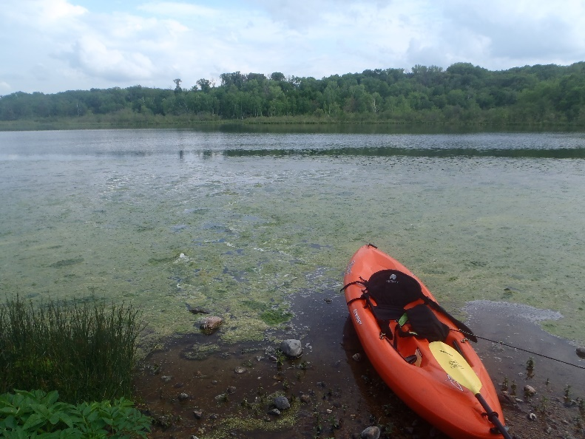 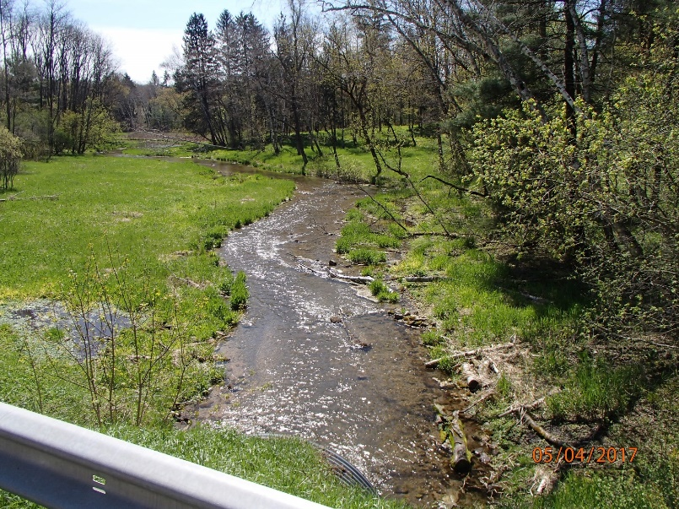Photo 4: Mecan Springs taken by D. Bolha. Photo 5: Mecan River at County GG taken by D. Bolha

In October 2017, NO₃+NO₂ as N samples were collected in the Mecan River at 11 locations. The NO₃+NO₂ as N concentrations ranged from 2.19 mg/L at County B to 3.32 mg/L at the West of County Y location (Table 6, Chart 2). The concentration of NO₃+NO₂ as N started near 2.3 mg/L at 9th Ave, then jumped to 3.3 mg/L at 11th Road before slowly decreasing as sampling continued downstream.
Site Name | NO₃+NO₂ as N
9th Ave | 2.31
County B | 2.19
Cumberland Rd | 2.38
11th Rd | 3.3
West Of County Y | 3.32
County Y | 3.18
Crystal Lake Access Road | 3.08
14th Ave | 2.95
Dixie Ave | 2.82
Dover Avenue | 2.55
County E | 2.52
Table 6: NO₃+NO₂ as N Concentrations in the Mecan River in 2017.
Chart 2: NO₃+NO₂ as N Concentrations in the Mecan River in 2017.
Between August 2019 and August 2021, 13 locations were surveyed for representative fish communities. Some fish species are tolerant of environmental degradation, while some species are moderately tolerant, and some others are intolerant. Based upon the representative fish collected during the survey and their associated tolerance to environmental degradation, an Index of Biotic Integrity (FIBI) was calculated to indicate the water quality of each creek or river on a scale of 0-100 (Table 7, Chart 3-4, Photos 6-7). The FIBI scores in the Mecan River ranged from 20 at County GG to 100 at Dixie Ave (Table 7, Chart 3). As with the macroinvertebrates, being that the fish community at County GG is located just downstream from the Mecan Springs, it is influenced by the Springs’ water quality and temperatures. The higher water temperatures and lower oxygen holding capacity likely favored more tolerant fish species and lowered the FIBI score at County GG. Although diverse, the fish community at County GG was dominated by Creek Chubs and Western Blacknose Dace, two degradation-tolerant fish species. As the Mecan River flows downstream from the Springs, the fish community improved, becoming more coldwater, sensitive fish species dominated, with more Brown Trout and Mottled Sculpin captured. The Large River non-wadable fish survey on the Mecan River at Hwy C indicated a healthy, diverse fish community and good water quality. The FIBI scores in the Little Pine and Chaffee Creeks ranged from 70 to 100, indicating slight to no apparent environmental degradation (Table 7, Chart 4).
Each fish community surveyed was used to verify or update the modeled Natural Community for that stream segment. Verifying or changing the modeled Natural Community was important since the Natural Community determines which FIBI was used to determine the water quality of that stream segment. The Mecan River is modeled as having a Natural Community of Coldwater from the Springs downstream until its confluence with Little Pine Creek near the 14th Ave Crossing. The fish community transitions between Cumberland Ave and the confluence with Little Pine Creek from a community dominated by coldwater-preferring (stenothermal) species to a Cold Transition Mainstem Natural Community, dominated by more temperature-tolerant (eurythermal) fish species. Being that some eurythermal fish species collected during the surveys are also pollution tolerant, it is difficult to verify whether the fish community change is natural/temperature related or some form of degradation (further discussion in the discussion section). As the percentage of pollution tolerant fish collected during those two surveys was too high to change the Natural Community, the FIBI score at 11th Rd and the Crystal Lake Access Rd was calculated based on the modeled Natural Community of Coldwater. The transition longitudinally in the Mecan River from Coldwater and Cold Transition Mainstem may vary in different years depending on precipitation and water flow. The results of the calculated FIBI displayed in Table 7 and Chart 3-4 are based upon the verified or updated Natural Community.

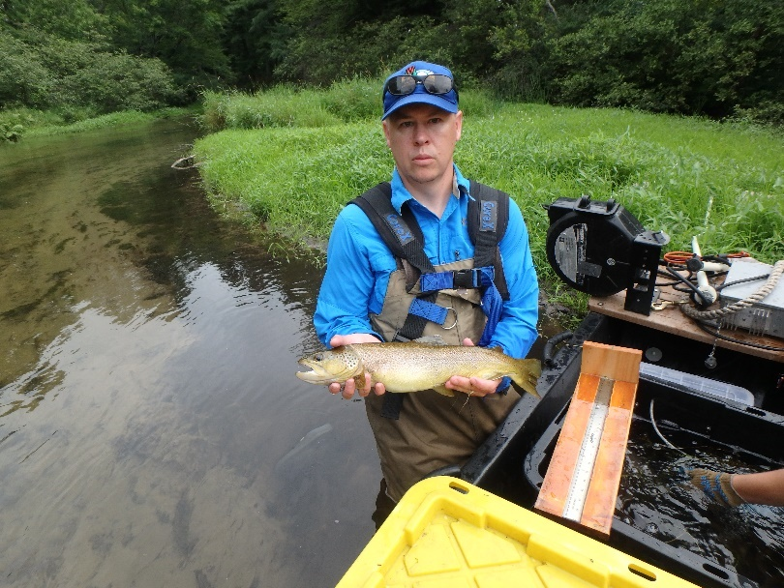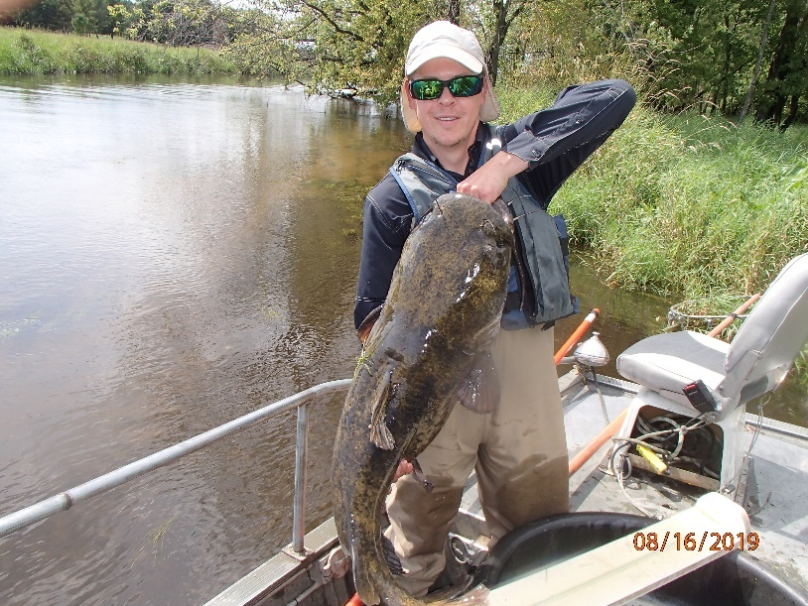
Photo 6-7: Brown Trout Collected During a Wadable Fish Survey and Flathead Catfish Collected during Non-wadable Fish Survey in the Mecan River taken by WDNR staff.

Site Name | Fish IBI Score | Condition Category | Natural Community
Mecan River at County GG | 20 | Poor | Coldwater
Mecan River at 9th Ave | 40 | Fair | Coldwater
Mecan River at County B | 70 | Good | Coldwater
Mecan River at Cumberland Rd | 70 | Good | Coldwater
Mecan River at 11th Rd | 40 | Fair | Coldwater
Mecan River at Crystal Lake Access Road | 40 | Fair | Coldwater
Mecan River at 14th Ave | 80 | Excellent | Cold Transition Mainstem
Mecan River at Dixie Ave | 100 | Excellent | Cold Transition Mainstem
Mecan River at County C | 75 | Good | Warm Transition Mainstem
Little Pine Creek at Cypress Ave | 80 | Good | Coldwater
Little Pine Creek at County JJ | 70 | Good | Coldwater
Chaffee Creek Downstream I-39 | 70 | Good | Coldwater
Chaffee Creek Downstream 11th Ln | 100 | Excellent | Cold Transition Mainstem
Table 7: Fish Survey Results in the Mecan River Watershed Conducted 2019-2021.
Chart 3: Fish Index of Biotic Integrity Scores and Condition Categories in the Mecan River 2019-2021.

Chart 4: Fish Index of Biotic Integrity Scores and Condition Categories in the Mecan River Tributaries 2019-2021.
Between August and September 2019, qualitative habitat surveys were conducted at 7 locations in the Mecan River Watershed. Based upon the assessment data collected during the 2019 surveys, a habitat rating was calculated for all sites on a scale of 0-100. The habitat rating scores ranged from 45 at the Mecan River at County GG to 85 in Chaffee Creek downstream of 11th Lane (Table 8, Chart 5). The Mecan River habitat ratings were lower at County GG and 11th Road due to the dominance of fine sediments or lack of rocky substrate and the lack of riffles and bends. The habitat ratings in the Mecan River between 9th Ave and Cumberland Road indicated a good to excellent condition due to the lower amounts of fine sediments, increases in the observed thalweg depth relative to its stream width, and higher amounts of riffles or bends. The habitat in Chaffee Creek was observed as good to excellent.
Site Name | Fish IBI Score | Condition Category
Mecan River at County GG | 45 | Fair
Mecan River at 9th Ave | 83 | Excellent
Mecan River at County B | 78 | Excellent
Mecan River at Cumberland Rd | 77 | Excellent
Mecan River at 11th Rd | 48 | Fair
Chaffee Creek Downstream I-39 | 70 | Good
Chaffee Creek Downstream of 11th Ln | 85 | Excellent
Table 8: Qualitative Habitat Scores and Condition Categories in the Mecan River Watershed in 2019.
Chart 5: Qualitative Habitat Scores and Condition Categories in the Mecan River Watershed in 2019.
Water temperature data was collected from July through September 2019 at 13 locations in the Mecan River Watershed (Table 9, Map 1-2). The average monthly temperatures ranged from 57.5ºF in Little Pine Creek at Czech Ct. in September to 74.2ºF in the Mecan River at Hwy 23 in July (Table 9, Chart 6). The average monthly temperatures were reported for complete months only. The Maximum Daily Averages (MDM) ranged from 67.2ºF in the Mecan River at 11th Road to 78.7ºF in the Mecan River at Hwy 23. The Mecan River monthly averages and MDM began elevated beyond the preferred temperatures of coldwater fish species downstream of the Mecan Springs, cooled to more suitable temperatures by 9th Avenue, then generally increased as the water flowed downstream. The water temperatures in the Little Pine Creek upstream of Lake Christine were cold and suitable for Brook and Brown trout and Mottled Sculpin. Downstream of the lake, water temperatures were 3º-4ºF warmer than upstream and very similar to the Mecan River temperatures at 14th Ave.

Site Name | July Monthly Average (ºF) | August Monthly Average (ºF) | September Monthly Average (ºF) | Maximum Daily Average (ºF)
Mecan River at County GG | 73.8 | 68.2 | 62.8 | 77.6
Mecan River at 9th Ave | 67.7 | 63.4 | 59.8 | 70.8
Mecan River at County B | 66.1 | 62.2 | 59.0 | 68.9
Mecan River at Cumberland Rd | 65.1 | 61.4 | 58.6 | 67.8
Mecan River at 11th Rd | 64.7 | 60.9 | 58.2 | 67.2
Mecan River at County Y | 65.9 | 61.8 | 58.9 | 68.6
Mecan River at Crystal Lake Access Road | 66.6 | 62.4 | 59.3 | 69.5
Mecan River at 14th Ave | 68.3 | 63.9 | 60.5 | 71.1
Mecan River at Dixie Ave | 68.6 | 64.0 | 60.5 | 71.4
Mecan River at Dover Ave | 68.2 | 63.2 | 60.2 | 70.7
Mecan River at Hwy 23 | 74.3 | 68.7 | 63.8 | 78.7
Little Pine Creek at Czech Ct | 63.7 | 58.1 | 57.5 | 69.2
Little Pine Creek at 14th Ave | 67.2 | 62.9 | 60.2 | 70.7
Table 9: Monthly Average and Maximum Daily Average Temperatures in the Mecan River and Little Pine Creek in 2019.

Chart 6: Monthly Average and Maximum Daily Average Temperatures in the Mecan River and Little Pine Creek in 2019.

Discussion

The purpose of this project was to conduct biological and physical surveys of the streams within the watershed to better understand the current water quality conditions which will serve as a reference for future protections. The aquatic macroinvertebrate, temperature, and fish monitoring in this TWA demonstrated that the water quality in the Mecan River Watershed is between poor and excellent condition, with most assessments indicating good to excellent water quality. The habitat within the Mecan River and its tributaries are in fair to excellent condition, with most in good to excellent condition.

To protect the water quality of the Mecan River and its tributaries, it is sensible to identify potential sources of negative impacts and encourage activities to preserve or improve the health of the surface water resources. Some of the watershed activities or characteristics observed during the monitoring project that can have a negative impact to the water quality of the Mecan River and its tributaries were limited buffers, streambank erosion, improperly sized road culverts and reduced connectivity, thermal inputs from artificially raised water levels, barriers to fish passage, cropland erosion, application of commercial pesticides and fertilizers to crops, high-capacity groundwater withdrawal, and sedimentation of fish and aquatic life habitat (Photo 8-14, Chart 8-9).

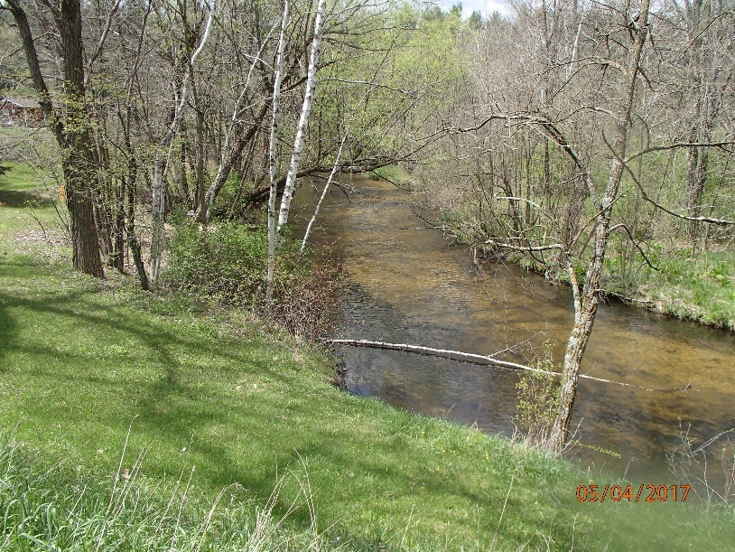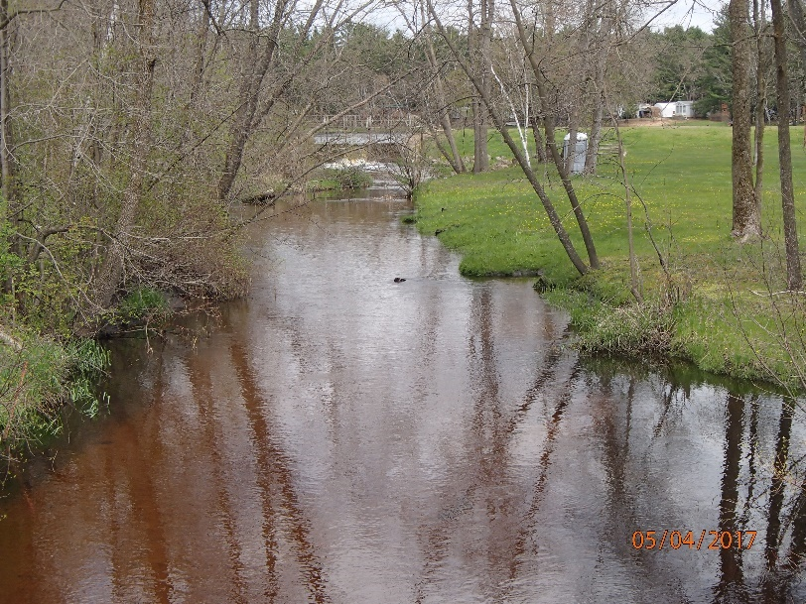
Photo 8-9: Limited buffer protections along surface waters within the Mecan River Watershed taken by D. Bolha.
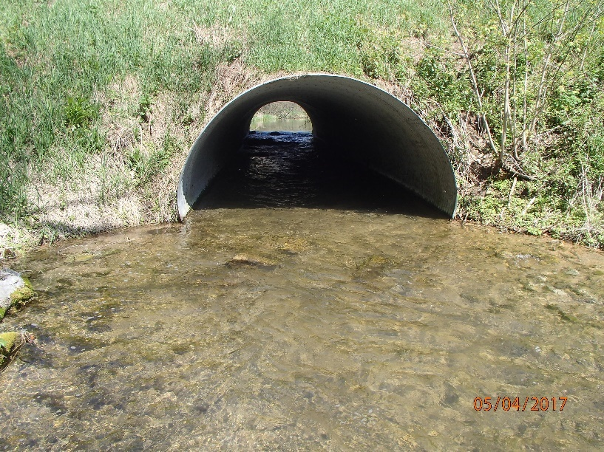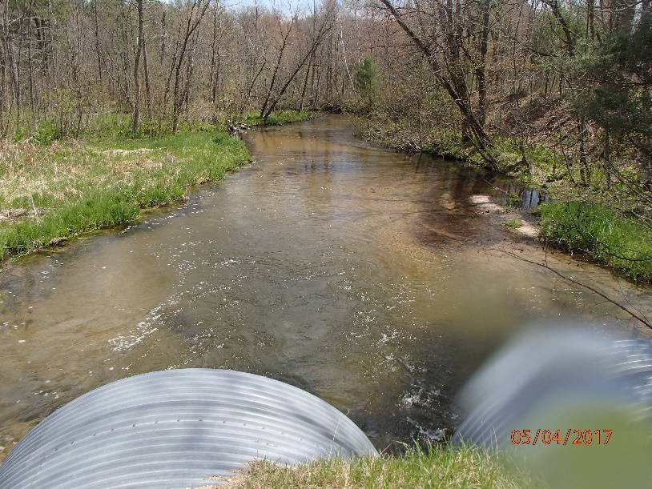
Photo 10-11: Improperly sized culverts within the Mecan River Watershed taken by D. Bolha.

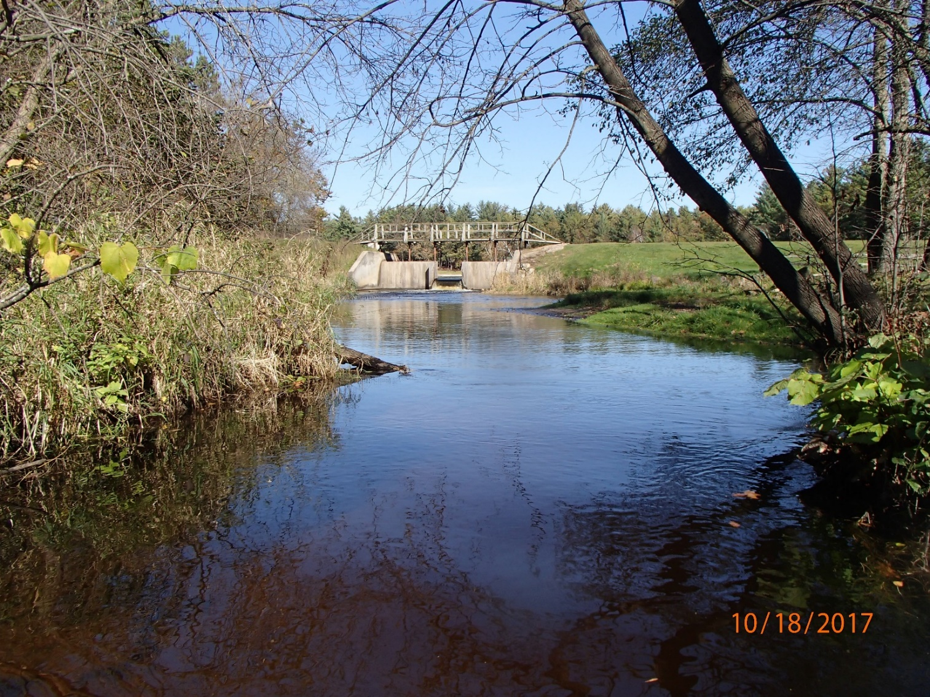
Photo 12: Example of artificially raised water level and fish barrier within the Mecan River Watershed taken by D. Bolha.

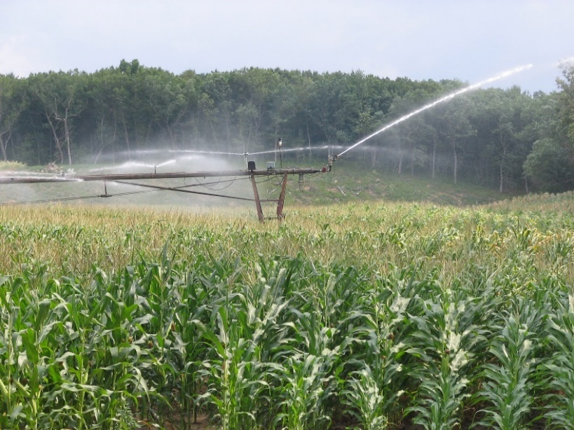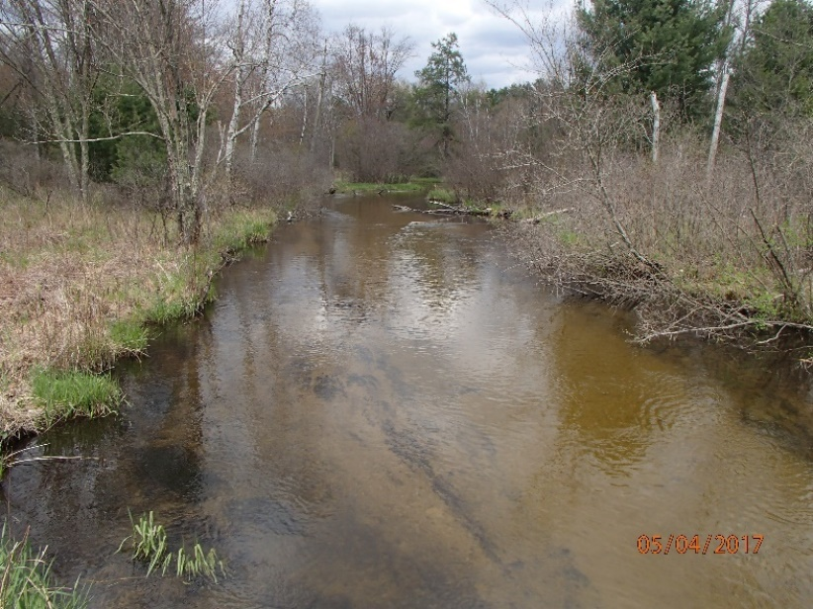
Photo 13-14: High-Capacity Agricultural Irrigation (Left) and Instream Sediment Deposition (Right) within the Mecan River Watershed taken by D. Bolha.

Streambank and adjacent riparian corridors are critical habitat for the functioning of the water resources in the Mecan River Watershed. Healthy streambanks and riparian corridors provide habitat for adult macroinvertebrate life stages, turtles, snakes, frogs, and other wildlife while connecting the creek or river to its floodplain. A good linkage to the floodplain disperses the floodwaters during snowmelt and rain events, while reducing streambank erosion and incised streams channels (Miller et al. 2014).

Stream connectivity refers to the pathways and movement of water, energy, and aquatic life in streams. In natural landscapes, streams tend to be better connected than those that have been heavily influenced and disturbed by human impacts. For fish and macroinvertebrates specifically, both upstream and downstream migration are critical for river and stream stability and productivity. Dams, culverts, and some bridges fragment streams and are barriers to energy distribution and movement of fish and aquatic life (Photo 10-12). Reduced connectivity can result in lower stream productivity if fish and aquatic life cannot reach habitats that are seasonally important (Miller et al. 2014). The connectivity needs of the fish and aquatic life in the Mecan River, and its tributaries can vary from very small to miles. Trout and the macroinvertebrates in the Mecan River and its tributaries produce large numbers of offspring that disperse to avoid predation and find suitable habitat. Increasing the stream connectivity can have a significant positive impact on the health of the Mecan River, and Chaffee, Wedde, and Schudlack Creeks.

The Mecan River flow is fed by and depends upon groundwater influx as it meanders downstream to maintain its biotic and geomorphological integrity. Due to the porous, sandy soils of this area of Wisconsin and the shallow groundwater aquifer, there is an easy connection between what happens on the surface of the landscape and what ends up in the groundwater. The Wisconsin Department of Natural Resources (WDNR) recently estimated that 10-15% of private drinking wells are over the Nitrate Drinking Water Standard of 10mg/L (typically measured as NO₃+NO₂ as N) in Waushara and Marquette Counties, with multiple townships surrounding the Mecan River with >20% private wells exceeding the 10 mg/L standard (WDNR 2022). There is a direct correlation between nitrates in groundwater and the surface water streams that into which it flows. Higher nitrates in the Mecan Springs and River and its tributaries can lead to more algae blooms and stress on fish and macroinvertebrates (Photo 4 & 15, Table 6, Chart 2). To develop water quality criteria for wadeable streams in Wisconsin, the United States Geological Survey (USGS), in cooperation with the WDNR, surveyed streams across Wisconsin for numerous water quality parameters and biota (USGS 2006). During that monitoring effort, USGS established reference levels unimpacted by human influences for Total Nitrogen (TN) (which includes NO₃+NO₂ as N). Reference levels statewide for Wisconsin wadable streams is between 0.6-0.7 mg/L TN. In addition to reference levels, USGS established thresholds in nutrient concentrations where a small change in nutrient concentrations corresponded to a relatively large change in the biotic community. The threshold for response of the FIBI to changes in nitrate concentration is 3.46 mg/L (USGS 2006). The nitrate concentration in the Mecan River was above Wisconsin refence levels. Between Cumberland Rd and 11th Rd, the concentration increased to 3.3 mg/L, very close to the response threshold established by USGS. The lower FIBI scores at 11th Rd and Crystal Lake Access Rd may be correlated with the jump in nitrate concentrations. The main sources of nitrates to groundwater are agricultural practices in Wisconsin (WDNR 2022). Typically, as increases in agricultural land use occur, there is a correlating increase in nitrogen concentrations in creeks as well. Of the 102,458 acres within the Mecan River Watershed, 10,583 acres (10.3%) are in cropland and 21,930 acres (21.4%) are in pasture/grassland which are likely sources of nitrates leaching into the groundwater (Chart 7) (WDNR 2020). There are more opportunities to install practices or implement nutrient management to lower nitrates leaching into the groundwater and eventually the Mecan River. The water quality in the Mecan River Watershed was generally in good to excellent condition, so protecting it is critical for this unique resource.

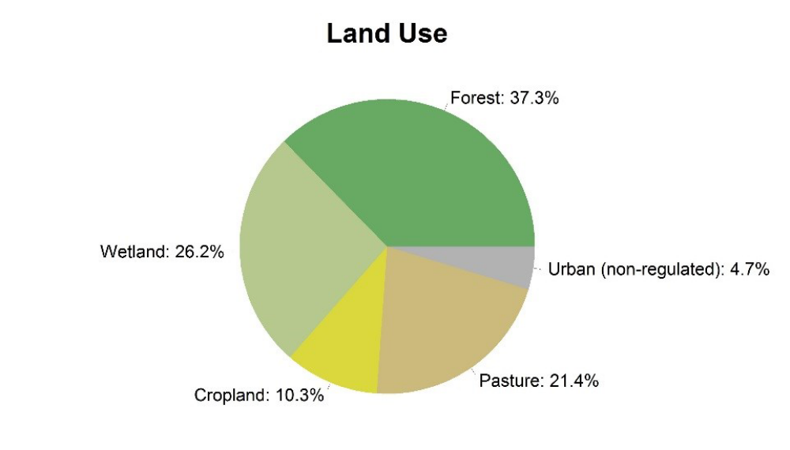
Chart 7: Land Uses within the Mecan River Watershed (WDNR 2012).

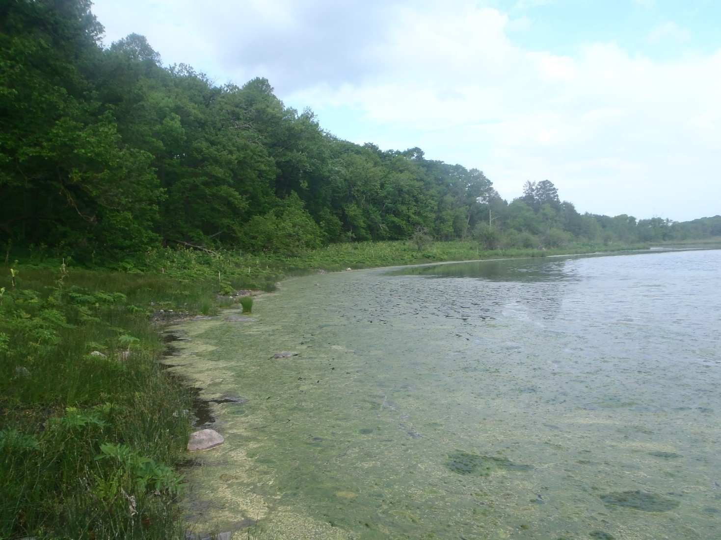
Photo 15: Mecan Springs taken by D. Bolha.
The Mecan River flows into the Upper Fox River near the City of Princeton. The Upper Fox and Wolf River Basins (UFW) are two separate basins that converge within a series of pool lakes in Winnebago County before finally flowing collectively into Lake Winnebago. All the surface water drainage to Lake Winnebago is contained within these two basins. The WDNR, together with many partners throughout the basins, are working to improve water quality within the Upper Fox and Wolf Rivers, which includes many lakes and tributaries. A Total Maximum Daily Load (UFW TMDL) study was conducted and the implementation plan (approved by United States Environmental Protection Agency in 2020) provides a strategic framework for water quality improvement in the UFW (WDNR 2020). The target pollutants in the UFW TMDL are Total Phosphorus (TP) and Total Suspended Solids (TSS). Phosphorus is another nutrient that plants and algae need to grow; however, excessive amounts can lead to problems much like nitrogen. TSS is a measure of the concentration of particulates such as algae and sediment in water (how dirty the water is). Reduced water clarity, increased water temperatures, reduced dissolved oxygen in the water, and sedimentation of fish and aquatic life habitat are associated with higher concentrations of TSS. Within the UFW TMDL development effort, baseline (pre-implementation) TP and TSS loads were calculated for each sub-basin. The Mecan River Watershed (sub-basin) has a modeled baseline load of 21,740 pounds TP per year and 1,107,385 pounds TSS per year being delivered to the Upper Fox River (Map 2). Cropland is listed as the major source of TP and TSS loading, 48.8% and 70.2%, respectively, in the Mecan River Watershed (Chart 8-9). To meet the goals of the UFW TMDL, an estimated reduction percentage of baseline loading from agricultural sources is 83% of TP and 47% of TSS, respectively. Reducing the sources of TP and TSS will protect and improve water quality within the Mecan River and the Upper Fox River downstream.
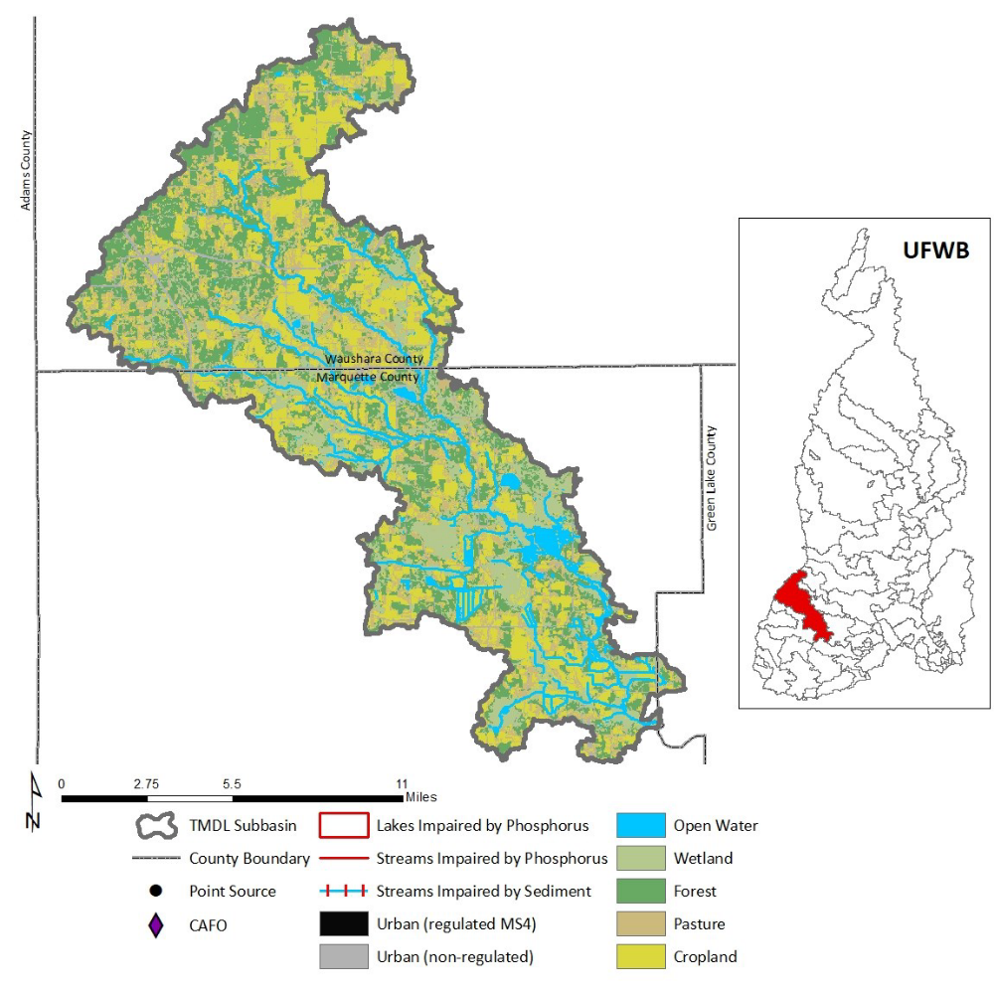
Map 2: Map of the Mecan River Watershed within the Upper Fox-Wolf River Basin (WDNR 2012).
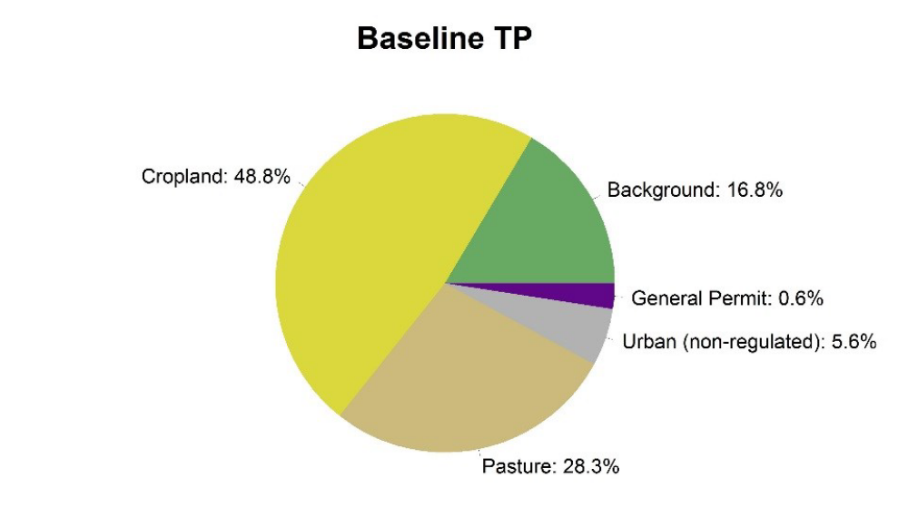
Chart 8: Sources of Total Phosphorus within the Mecan River Watershed (WDNR 2012).

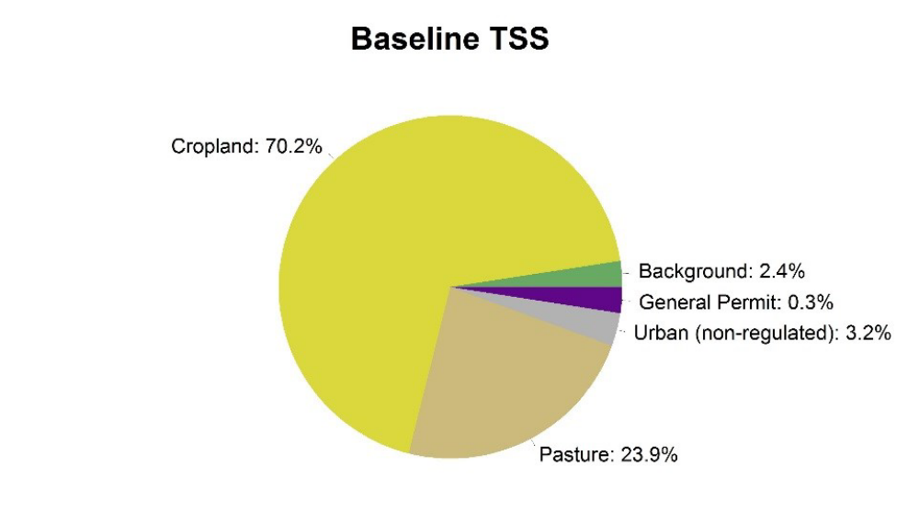
Chart 9: Sources of Total Suspended Solids within the Mecan River Watershed (WDNR 2012).

One of the greatest qualities of the Mecan River Watershed is the amount of land in public ownership through the Mecan River Fishery Area and Germania Marsh Wildlife Area (Map 3-4). The Mecan River Fishery Area contains some of the finest trout streams in central Wisconsin. The Mecan River and its tributaries offer a variety of Class 1 Brook, Brown, and Rainbow Trout fishing that invoke heavy public use. Chaffee and Wedde Creeks and the Mecan River are three of only a few streams in the entire state that have naturally reproducing rainbow trout populations. At nearly 6,700 acres, the Mecan River Fishery Area provides multiple recreational opportunities beyond fishing, such as hunting, portions of the Ice Age National Scenic Trail, skiing, wildlife viewing, and canoeing/kayaking while protecting the corridor of the Mecan River at its tributaries.

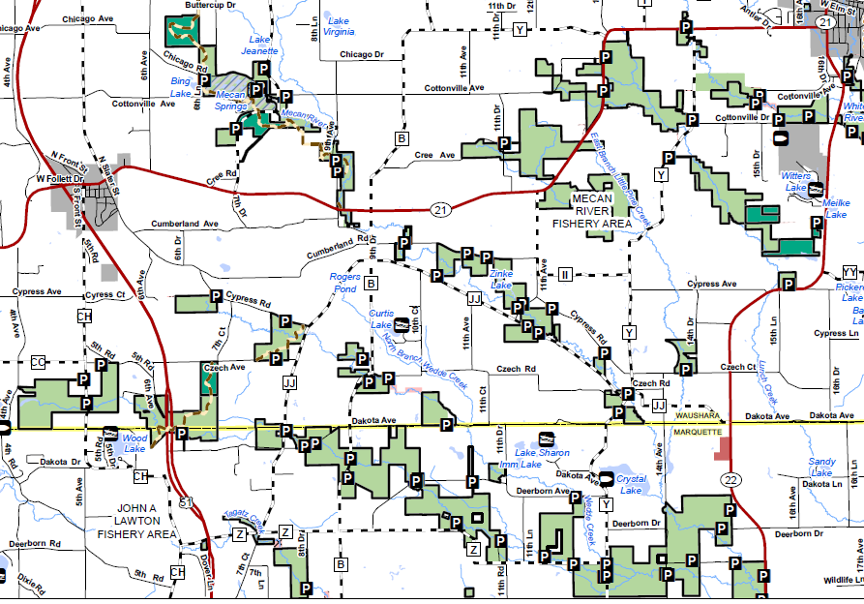
Map 3: Mecan River Fishery Area Public Lands (shaded in green).

Just a few river miles downstream of the Mecan River Fishery Area, the Mecan River flows into and out of the Germania Marsh. The Germania Marsh Wildlife Area provides 2,400 acres of recreational opportunities, such as fishing, waterfowl hunting, birding, canoeing, and kayaking (Map 4). Downstream of the Germania Marsh, the Mecan River again flows on a meandering path to the Upper Fox River (~6 miles as the crow flies). This stretch of the Mecan River has a healthy, diverse warmwater fish community (Photo 16). Ample opportunities for fishing, wildlife viewing, canoeing, and kayaking are provided as the Mecan River flows to the Upper Fox River.

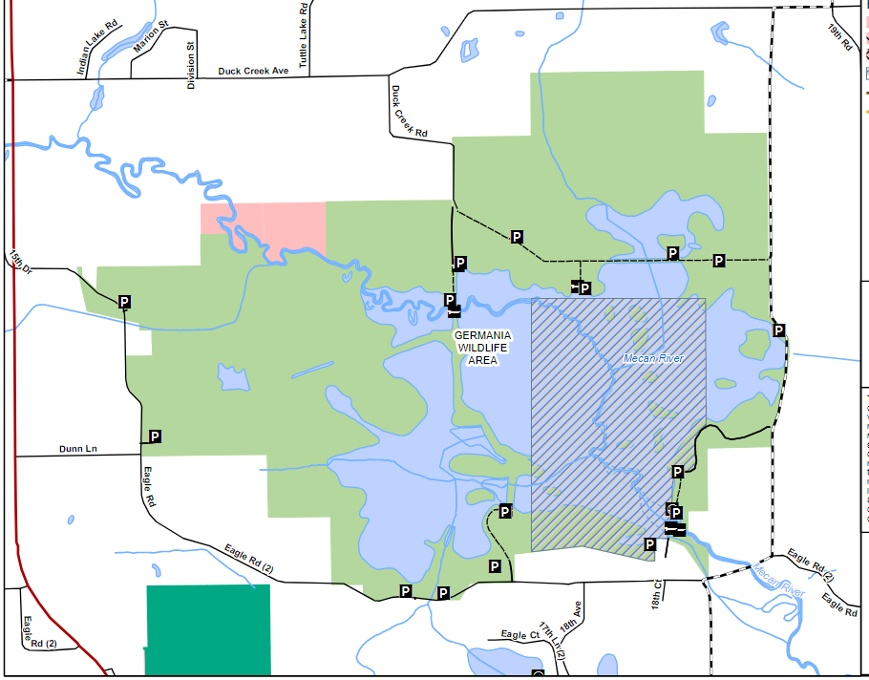 Map 4: Germania Wildlife Area Public Lands (shaded in light green).

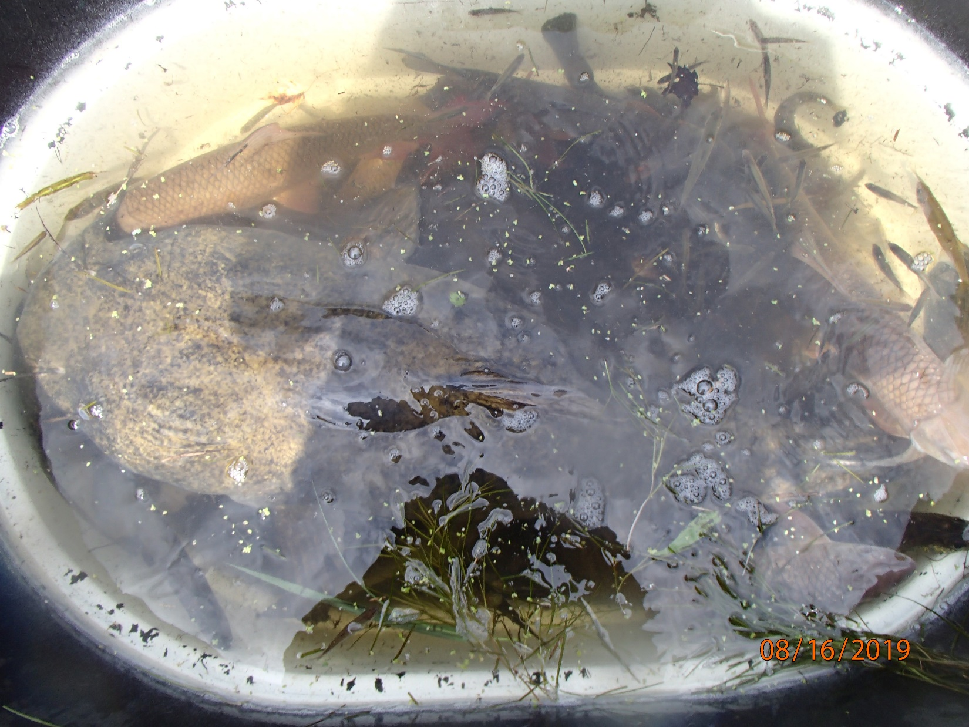
Photo 16: Fish Community surveyed in the Mecan River at County C near the Upper Fox River taken by D. Bolha.

Conclusions and Management Recommendations

The Mecan Springs, River and its tributaries are, in general, in good to excellent health. These unique water resources provide ample opportunities for the public to explore their natural beauty. There are some risks to the water quality and fish and aquatic life of the Mecan Springs, River and tributaries that can be reduced or prevented. There are some aspects of the habitat, riparian corridor, and watershed that can be improved. Below is a list of management recommendations that will preserve the integrity of the water resources and watershed for years and generations to come.

- Reduce Nitrate concentrations in the Mecan River and Chaffee, Schmudlack, and Wedde Creeks and their groundwater sources
- Reduce TP and TSS loading from the Mecan River Watershed to meet the yield targets of the UFW TMDL
- Increase the implementation of agricultural Best Management Practices such as nutrient management planning, cover crops, no-till, rotational grazing, grassed waterways, and low-disturbance manure application
- Limit cattle access to streams and rivers to reduce erosion and sedimentation
- Promote soil health to improve nutrient retention and increased yield and soil moisture
- Increase stream buffers to a minimum 35 feet with >100 feet optimum for sediment removal
- Reduce streambank erosion by promoting floodplain connections
- Limit placement of riprap along the streambanks of the Mecan River and its tributaries
- Improve riparian corridor ecosystem health through terrestrial invasive species management
- Develop and implement an instream Neonicotinoid pesticide monitoring strategy
- Increase instream fish spawning and adult habitat in the creeks and river
- Restore and/or protect wetlands within the watershed
- Pursue fishing easements and Simple Fee land acquisition opportunities
- Establish a network of recreational user groups, such as resorts, fishing/hunting clubs, Ice Age Trail volunteers, Trout Unlimited, and local municipalities
- Reduce the width:depth ratio of the Mecan River
- Conduct a road crossing inventory in the watershed to prioritize connectivity improvements
- Replace improperly sized road culverts and remove fish barriers while increasing flood resiliency
- Reduce thermal and organic load impacts from impoundments
- Protect and promote a healthy, native mussel population in the Mecan River
- Develop and implement a volunteer nutrient and water chemistry monitoring program in the Watershed

A thing is right when it tends to preserve the integrity, stability, and beauty of the biotic community.
-- Aldo Leopold, 1949

References

Miller, Michael A., Songer, Katie, Dolen, Ron. 2014. Field guide to Wisconsin streams: plants, fishes, invertebrates, amphibians, and reptiles. The University of Wisconsin Press.

USGS (United States Geological Survey) (Robertson, D.M. et al.). 2006. Nutrient Concentrations and Their Relations to the Biotic Integrity of Wadeable Streams in Wisconsin.

WDNR. 2002. Guidelines for Evaluating Habitat of Wadable Streams.
WDNR. 2005. Guidelines and Procedures for Continuous Temperature Monitoring.
WDNR. 2015. Nutrient Chemistry Grab Sampling Method V3.3.
WDNR. 2017. Guidelines for the Standard Collection of Macroinvertebrate Samples from Wadeable Streams v2.0.
WDNR. 2018. Guidelines for Assessing Fish Communities of Wadeable Streams in Wisconsin v2.0.
WNDR. 2019. Guidelines for Assessing Fish Communities of Non-Wadeable Rivers in Wisconsin v3.2.
WDNR. 2020. Total Maximum Daily Loads for Total Phosphorus and Total Suspended Solids Upper Fox and Wolf Basins. https://dnr.wisconsin.gov/topic/TMDLs/FoxWolf/index.html.
WDNR. 2020. Rapid Ecological Assessment for the Central Sand Hills Ecological Landscape: An Inventory and Analysis of Rare Plants and Animals and High-quality Natural Communities in Support of a Master Plan.
WDNR. 2022. Wisconsin Groundwater Coordinating Council Report to the Legislature.

