Lake Winnebago Pool Lake Tributary Water Chemistry Evaluation

David Bolha
Water Quality Biologist-Oshkosh
Wisconsin Department of Natural Resources

January 2024

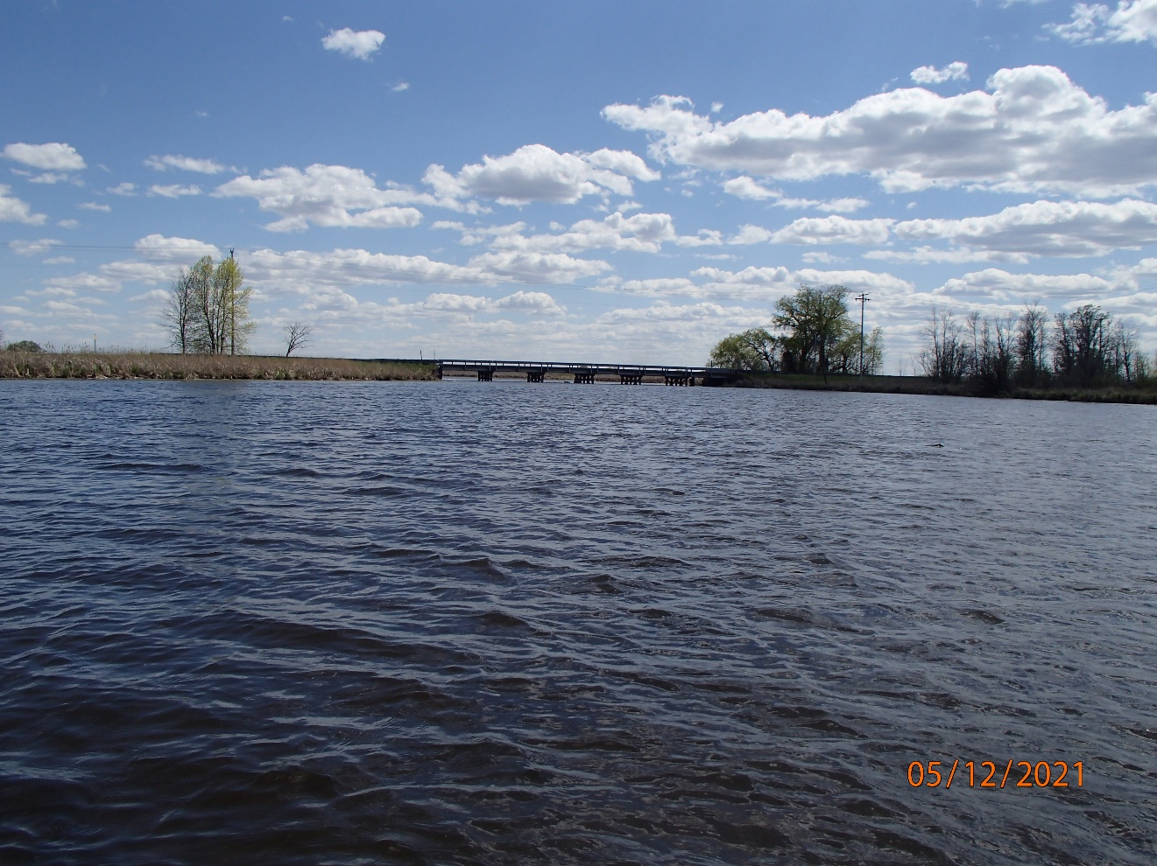
Willow Creek at County D

Purpose

This project evaluated the water chemistry fluctuations within 5 tributaries to the Lake Winnebago Pool Lakes to gage the extent of burden on the fish and aquatic life in these systems.

Table of Contents

Purpose…………………………………………………………………………………………………………….1
Table of Contents………………………………………………………………………………………………….2
Map List…………………………………………………………………………………………………...2
Table List………………………………………………………………………………………………….2
Chart List………………………………………………………………………………………………….3
Photo List………………………………………………………………………………………………….4
Terms……………………………………………………………………………………………………...4
Introduction……………………………………………………………………………………………………..…5
Methods………………………………………………………………………………………………………......11
Study Results…………………………………………………………………………………………………….21
Discussion………………………………………………………………………………………………………..36
Conclusions………………………………………………………………………………………………………42
References………………………………………………………………………………………………………..42
Map List

Map 1: Lake Winnebago Pool Lakes and Major Tributaries Monitored in 2021.
Map 2: Instantaneous Water Chemistry Monitoring Locations in Lake Winnebago Pool Lake Tributaries in 2021.
Map 3: Longitudinal Instantaneous Water Chemistry Survey Locations in Willow Creek in 2021.
Map 4: Longitudinal Instantaneous Water Chemistry Survey Locations in Pumpkinseed Creek in 2021.
Map 5: Longitudinal Instantaneous Water Chemistry Survey Locations in the Pine River in 2021.
Map 6: Longitudinal Instantaneous Water Chemistry Survey Locations in the Rat River in 2021.
Map 7: Multiparameter Sonde Deployment Location in Willow Creek in 2021.
Map 8: Multiparameter Sonde Deployment Location in Pumpkinseed Creek in 2021.
Map 9: Multiparameter Sonde Deployment Locations in the Pine River in 2021.
Map 10: Multiparameter Sonde Deployment Locations in the Rat River in 2021.
Map 11: Multiparameter Sonde Deployment Locations in Spring Brook in 2021.
Map 12: Non-Wadable Fish Survey Locations in the Pool Lake Tributaries in 2021.
Map 13: Longitudinal Water Chemistry Survey Locations of Willow Creek in August 2023.

Table List

Table 1: Instantaneous Water Chemistry Monitoring Events in Willow Creek in 2021.
Table 2: Instantaneous Water Chemistry Monitoring Events in Pumpkinseed Creek in 2021.
Table 3: Instantaneous Water Chemistry Monitoring Events in the Pine River in 2021.
Table 4: Instantaneous Water Chemistry Monitoring Events in the Rat River in 2021.
Table 5: Instantaneous Water Chemistry Monitoring Events in Spring Brook in 2021.
Table 6: Longitudinal Instantaneous Water Chemistry Survey Locations in Willow Creek in 2021.
Table 7: Longitudinal Instantaneous Water Chemistry Survey Locations in Pumpkinseed Creek in 2021.
Table 8: Longitudinal Instantaneous Water Chemistry Survey Locations in the Pine River in 2021.
Table 9: Longitudinal Instantaneous Water Chemistry Survey Locations in the Rat River in 2021.
Table 10: Multiparameter Sonde Deployment Location in Willow Creek in 2021.
Table 11: Multiparameter Sonde Deployment Location in Pumpkinseed Creek in 2021.
Table 12: Multiparameter Sonde Deployment Locations in Pine River in 2021.
Table 13: Multiparameter Sonde Deployment Locations in Rat River in 2021.
Table 14: Multiparameter Sonde Deployment Locations in Spring Brook in 2021.
Table 15: Chemical Oxygen Demand Monitoring Locations in the 5 Pool Lake tributaries in 2021.
Table 16: Non-Wadable Fish Survey Locations in the Pool Lake Tributaries in 2021.
Table 17: Instantaneous Water Chemistry Monitoring Results in Willow Creek in 2021.
Table 18: Instantaneous Water Chemistry Monitoring Results in Pumpkinseed Creek in 2021.
Table 19: Instantaneous Water Chemistry Monitoring Results in the Pine River in 2021.
Table 20: Instantaneous Water Chemistry Monitoring Results in the Rat River in 2021.
Table 21: Instantaneous Water Chemistry Monitoring Results in Spring Brook in 2021.
Table 22: Longitudinal Water Chemistry Surveys in the Pool Lake Tributaries in 2021.
Table 23: Water Chemistry from 5-day Sonde Deployments in the Pool Lake Tributaries in 2021.
Table 24: Chemical Oxygen Demand in the 5 Pool Lake Tributaries in 2021.
Table 25: Non-Wadable Fish Community Evaluations in the Pool Lake Tributaries in 2021.
Table 26: Multiparameter Sonde Deployment Sensor Drift Assessment on August 4th, 2021.
Table 27: Longitudinal Water Chemistry Survey of Willow Creek Upstream and Through the Auroraville Millpond in August 2023.

Chart List

Chart 1: Weekly to Bi-weekly Dissolved Oxygen Concentrations in the Pool Lake Tributaries in 2021.
Chart 2: Weekly to Bi-weekly Dissolved Oxygen Percent Saturations in the Pool Lake Tributaries in 2021.
Chart 3: Weekly to Bi-weekly Temperatures in the Pool Lake Tributaries in 2021.
Chart 4: Weekly to Bi-weekly pH values in the Pool Lake Tributaries in 2021.
Chart 5: Weekly to Bi-weekly Specific Conductivity Concentrations in the Pool Lake Tributaries in 2021.
Chart 6: Longitudinal Dissolved Oxygen Surveys in the Pool Lake Tributaries in 2021.
Chart 7: Willow Creek Dissolved Oxygen and % Saturation during 5-day Deployment.
Chart 8: Pumpkinseed Creek Dissolved Oxygen and % Saturation during 5-day Deployment.
Chart 9: Lower Pine River at 9th Ave Dissolved Oxygen and % Saturation during 5-day Deployment.
Chart 10: Pine River at Anderson Farm Road Dissolved Oxygen and % Saturation during 5-day Deployment.
Chart 11: Rat River at County II Dissolved Oxygen and % Saturation during 5-day Deployment.
Chart 12: Rat River at Island Road Dissolved Oxygen and % Saturation during 5-day Deployment.
Chart 13: Spring Brook at Spring Brook Road Dissolved Oxygen and % Saturation during 5-day Deployment.
Chart 14: Spring Brook Upstream of Spring Brook Road Dissolved Oxygen and % Saturation during 5-day Deployment.
Chart 15: Chemical Oxygen Demand in the 5 Pool Lake Tributaries in 2021.
Chart 16: Non-Wadable Fish Community Evaluations in the Pool Lake Tributaries in 2021.
Chart 17: Lower Pine River at 9th Ave 5-Day Deployment Dissolved Oxygen Corrected for Total Drift.
Chart 18: Lower Pine River at 9th Ave 5-Day Deployment Dissolved Oxygen Corrected for Total Drift.
Chart 19: Longitudinal Water Chemistry Survey of Willow Creek Upstream and Through the Auroraville Millpond in August 2023.

Photo List

Photo 1: Willow Creek at County D. Photo taken by D. Bolha on July 20th, 2021.
Photo 2: Pine River at Anderson Farm Road. Photo taken by D. Bolha on June 1st, 2018.
Photo 3: Pumpkinseed Creek at County D. Photo taken by D. Bolha on June 17th, 2021.
Photo 4: Rat River at County II. Photo taken by D. Bolha on July 27th, 2021.
Photo 5: Spring Brook at Spring Brook Road. Photo taken by D. Bolha on June 15th, 2021.
Photo 6: Example Sonde Deployment Setup. Photo taken by D. Bolha on August 3rd, 2018.
Photo 7: Multiparameter Sonde Deployment Location in Pumpkinseed Creek in 2021. Taken by D. Bolha on June 24th, 2021.
Photo 8: Spring Brook at Hwy 21 Fish Survey. Photo taken by D. Bolha on May 24th, 2021.
Photo 9: Willow Creek at County D Fish Survey. Photo taken by D. Bolha on May 18th, 2021.
Photo 10: Auroraville Millpond Dam at Hwy 49. Photo taken by D. Bolha on May 1st, 2013.
Photo 11: Johnny Darter Egg Nest Inside Shell of Freshwater Mussel in Willow Creek. Photo taken by D. Bolha on May 18th, 2021.
Photo 12: Multiparameter Sonde Post-Deployment in Pine River at Anderson Farm Road. Photo taken by D. Bolha on August 4th, 2021.
Photo 13: Willow Creek at 29th Lane. Photo taken by D. Bolha on August 17th, 2023.
Photo 14: Willow Creek Channel in Auroraville Millpond. Photo taken by D. Bolha on August 17th, 2023.

Terms List

Bio-fouling: Biological growth on the surface of water chemistry sensors of multiparameter sondes which will cause sensor drift.
Chemical Oxygen Demand (COD): A measure of how much oxygen is consumed while chemically breaking down materials in the water. The higher the COD in water, the higher the amount of oxygen consumed and unavailable to fish and aquatic life.
Diel: Involving a 24-hour time-period.
Dissolved Oxygen (DO): The concentration of oxygen that is dissolved in water at a specific temperature and atmospheric pressure, usually derived from photosynthesis or atmospheric diffusion.
Dissolved Oxygen % Saturation (DO % Saturation): How close the dissolved oxygen concentration value is to the equilibrium value for that temperature and air pressure. The closer to 100%, the better for rivers.
Diurnal: The daily cycle between daytime and nighttime conditions often used interchangeably with diel.
Electrical/Mechanical Drift: The measured amount of sensor drift post-deployment after deducting the influence from bio-fouling.
Longitudinal: Referring to a line along the channel of a river from upstream to downstream or vice versa.
Non-wadable/Non-wadeable River: A river having at least 3 kilometers of contiguous river channel too deep to be sampled effectively by wading during base flow.
Riparian: Located along a riverbank or streambank or along the shoreline of a lake
Sensor Drift: Extent of sensor performance that determines if a correction factor is needed as a result of bio-fouling or electrical/mechanical problems.
Specific Conductivity: Field Conductivity, which is a measure of how easily electricity flows through water, standardized to 25 ˚C.
Stenothermal Fish: Fish species capable of surviving only a narrow range of temperatures.
Thalweg: A line connecting the lowest or deepest points along a stream bed, typically with highest flow.
Water Quality Criteria (WQC): Refers to Wisconsin Administrative Code NR 102: Water Quality Standards for Wisconsin Surface Waters.

Introduction

In 2019, very low instantaneous dissolved oxygen levels and very poor fish communities were found in the Rat River, Willow Creek, and Pumpkinseed Creek. These 3 flowing waters are major tributaries to the Lake Winnebago Pool Lakes. Lakes Poygan, Winneconne, and Butte des Morts (Pool Lakes) are 3 large, shallow lakes that receive the flow from the Upper Fox-Wolf River Basin, before emptying into Lake Winnebago in Oshkosh, Wisconsin (Map 1). The Rat River, and Willow and Pumpkinseed Creeks provide fish and aquatic life refuges and habitat for the variety of species in the Winnebago System. The Pine River and Spring Brook are also major tributaries to the Pool Lakes and together with the other tributaries provide accessible habitat for spawning, rearing, and adult habitat for fish that live in Lake Winnebago and the Pool Lakes and the Wolf and Fox Rivers.

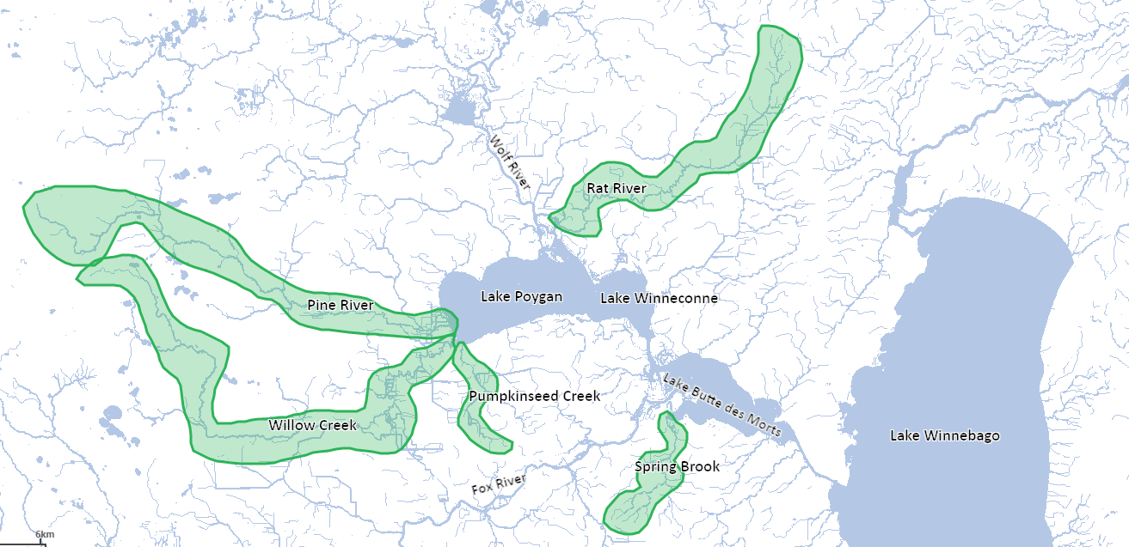
Map 1: Lake Winnebago Pool Lakes and Major Tributaries Monitored in 2021.

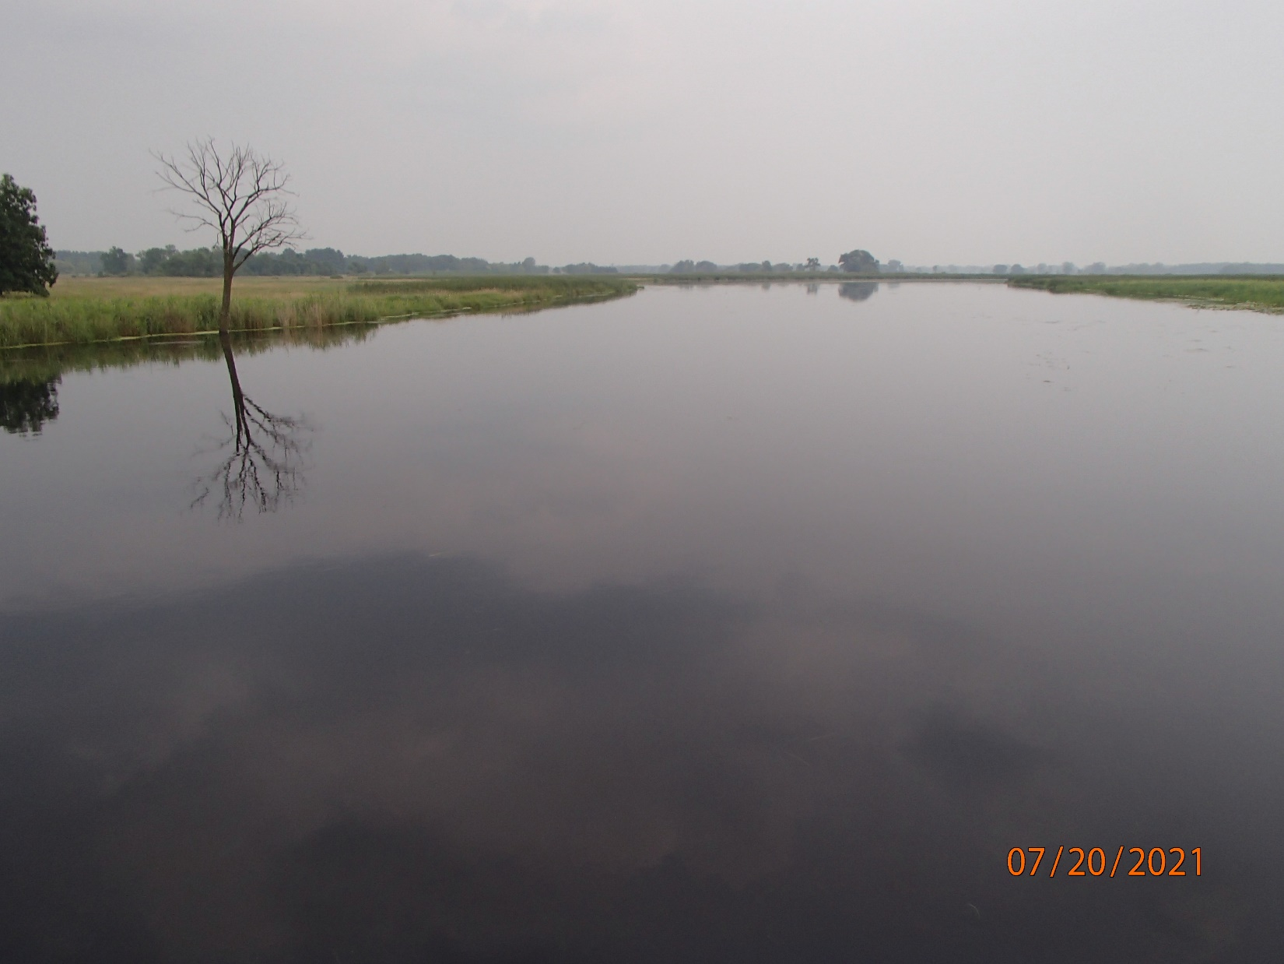
Photo 1: Willow Creek at County D. Photo taken by D. Bolha on July 20th, 2021.

Willow Creek is a 43-mile-long tributary to the southwest corner of Lake Poygan (Map 1, Photo 1). The riparian land along most of the river is publicly owned, providing great opportunities for a variety of recreational uses. Most of the creek has water temperatures cold enough for stenothermal fish like trout. Downstream of the Auroraville Millpond, Willow Creek flows into the Poygan Marsh before eventually discharging into Lake Poygan. The Willow Creek Watershed is dominated by Forest land use (31%); however, has a significant portion of Cropland (19%), Wetlands (19%) and Pasture/Grasslands (23%).

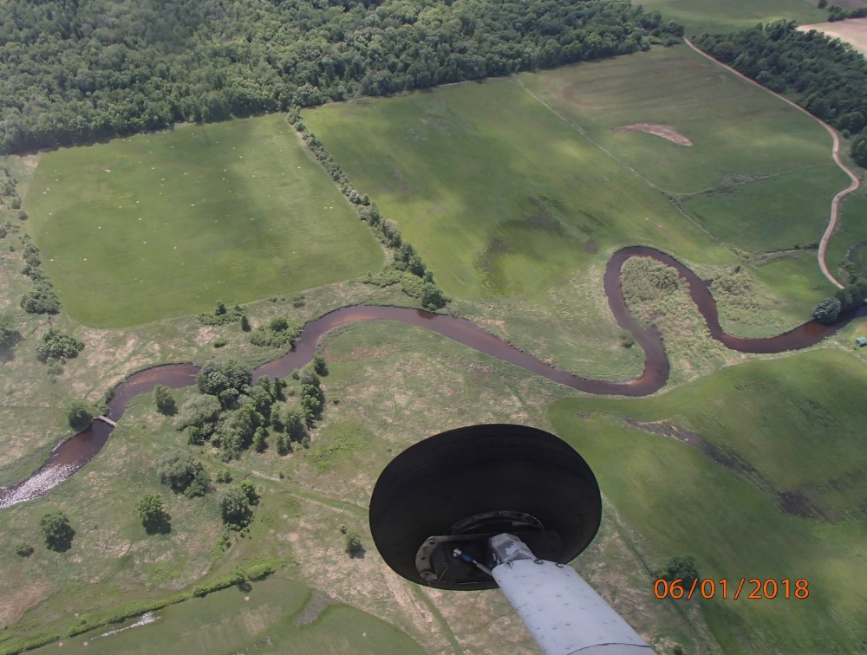
Photo 2: Pine River at Anderson Farm Road. Photo taken by D. Bolha on June 1st, 2018.

The Pine River is a 28-mile-long tributary to the northwest corner of Lake Poygan (Map 1, Photo 2). Like Willow Creek, most of the Pine River is cold enough for trout, but it warms through a series of millponds until becoming unsuitable for thermally sensitive trout near Poy Sippi. Downstream of the Poy Sippi Millpond, the Pine River flows into the Poygan Marsh before eventually discharging into Lake Poygan. The Pine River Watershed is dominated by Forest land use (50%); however, Wetlands (22%) and Pasture/Grasslands (24%) make up a significant portion of its land use as well.

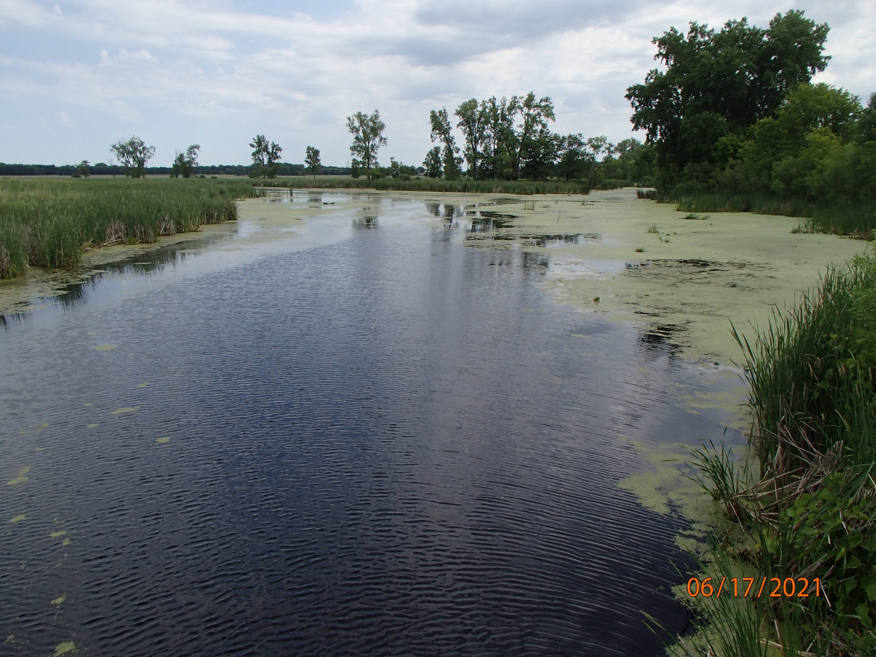
Photo 3: Pumpkinseed Creek at County D. Photo taken by D. Bolha on June 17th, 2021.

Pumpkinseed Creek is a 6-mile-long tributary to the southwest corner of Lake Poygan (Map 1, Photo 3). Pumpkinseed Creek originates in wetlands and much of the creek has been ditched for agricultural land use. Pumpkinseed Creek has elevated levels of phosphorus and a poor aquatic life community. Prior to flowing into Lake Poygan, Pumpkinseed Creek flows through the Poygan Marsh. The Pumpkinseed Creek Watershed is comprised of Wetlands and Wetlands converted into Cropland.

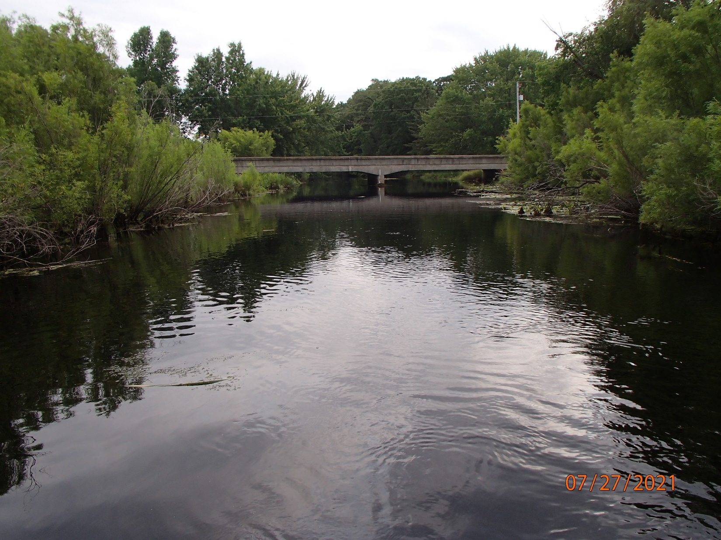
Photo 4: Rat River at County II. Photo taken by D. Bolha on July 27th, 2021.

The Rat River is a 24-mile-long tributary of the Wolf River just upstream of where the Wolf River empties into Lake Poygan (Map 1, Photo 4). The upper portion of the Rat River Watershed, north of Hwy 96, is dominated by agricultural land use with a minor amount of development along the riparian corridor. Downstream of Hwy 96, the Rat River flows through the Rat River Wildlife Area/Marsh. This portion of the riparian watershed is dominated by wetlands with heavy agricultural land use in the upland areas. The entire watershed is primarily Cropland land use (38%), Wetlands (15%), and Pasture/Grasslands (32%). The Rat River has elevated levels of phosphorus and a poor aquatic life community.

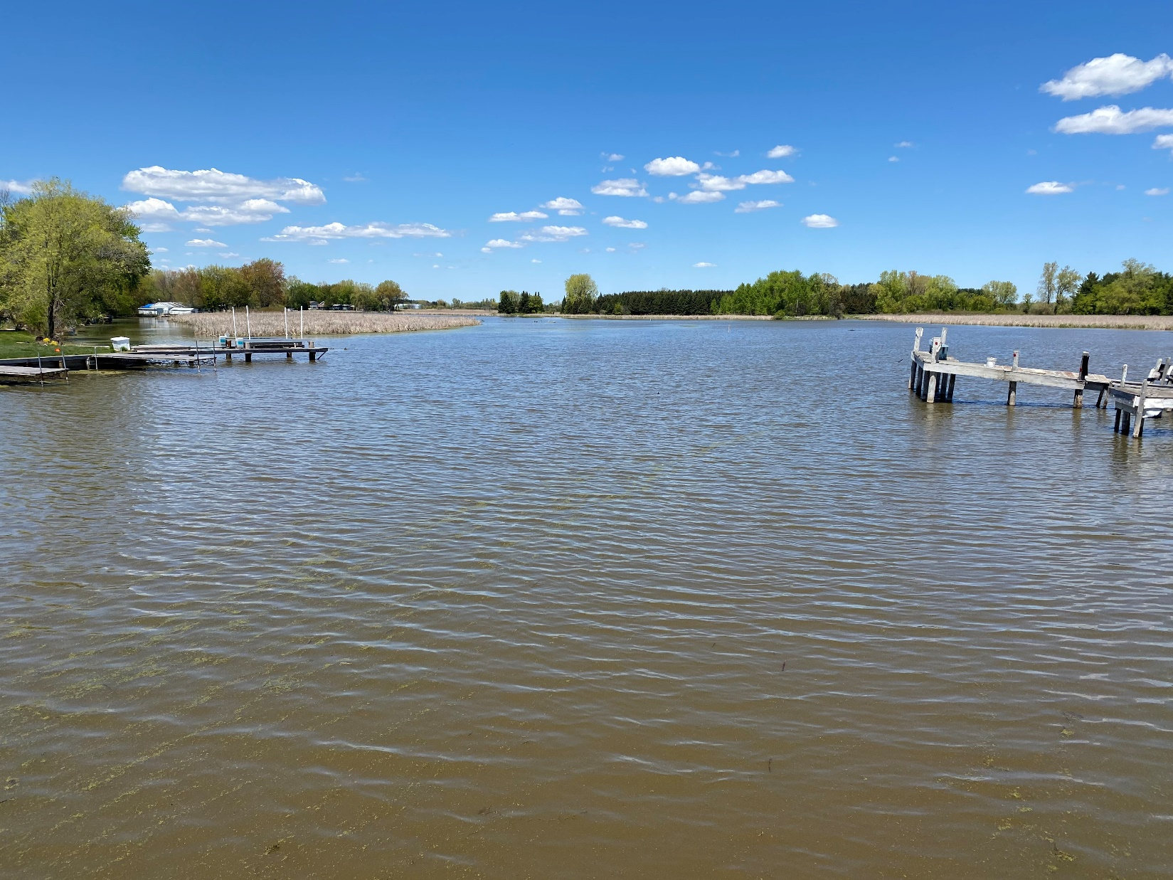
Photo 5: Spring Brook at Spring Brook Road. Photo taken by D. Bolha on June 15th, 2021.

Spring Brook is a 9-mile-long tributary of Lake Butte des Morts. The Spring Brook Watershed is dominated by Cropland land use (73%); however, has a significant portion of Pasture/Grasslands (23%) as well. Spring Brook has elevated levels of phosphorus and a poor aquatic life community. The lower portion of Spring Brook has limited flow during most of the year, dominated by aquatic plants between Spring Brook Road and Hwy 21, and struggles with high suspended solids (Map 1, Photo 5).

Methods

Instantaneous Water Chemistry

Beginning in April 2021, weekly to bi-weekly instantaneous water chemistry checks were conducted using a Hydrolab MS5 multiparameter sonde. Water chemistry was assessed in the thalweg and 6-12 inches below the water’s surface. Instantaneous water chemistry checks were conducted during 6-8 monitoring events on each of the 5 tributaries (Map 2, Table 1-5). A total of 34 monitoring events occurred to collect water chemistry information between April and August 2021.

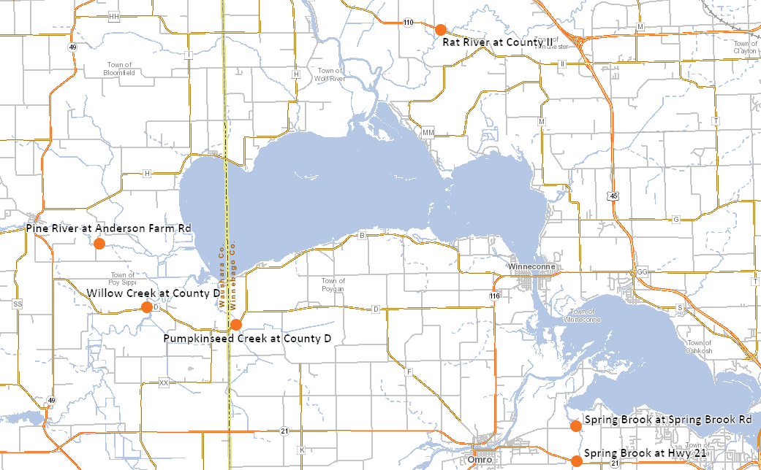
Map 2: Instantaneous Water Chemistry Monitoring Locations in Lake Winnebago Pool Lake Tributaries in 2021.

Location | Date of Monitoring Event
Willow Creek at County D | 4/15/2021
Willow Creek at County D | 5/12/2021
Willow Creek at County D | 6/1/2021
Willow Creek at County D | 6/17/2021
Willow Creek at County D | 7/7/2021
Willow Creek at County D | 7/15/2021
Willow Creek at County D | 7/20/2021
Table 1: Instantaneous Water Chemistry Monitoring Events in Willow Creek in 2021.

Location | Date of Monitoring Event
Pumpkinseed Creek at County D | 4/15/2021
Pumpkinseed Creek at County D | 5/12/2021
Pumpkinseed Creek at County D | 6/1/2021
Pumpkinseed Creek at County D | 6/17/2021
Pumpkinseed Creek at County D | 6/24/2021
Pumpkinseed Creek at County D | 6/29/2021
Pumpkinseed Creek at County D | 7/7/2021
Table 2: Instantaneous Water Chemistry Monitoring Events in Pumpkinseed Creek in 2021.

Location | Date of Monitoring Event
Pine River at Anderson Farm Rd | 6/1/2021
Pine River at Anderson Farm Rd | 6/17/2021
Pine River at Anderson Farm Rd | 7/7/2021
Pine River at Anderson Farm Rd | 7/20/2021
Pine River at Anderson Farm Rd | 7/29/2021
Pine River at Anderson Farm Rd | 8/4/2021
Table 3: Instantaneous Water Chemistry Monitoring Events in the Pine River in 2021.

Location | Date of Monitoring Event
Rat River at County II | 5/12/2021
Rat River at County II | 6/1/2021
Rat River at County II | 6/17/2021
Rat River at County II | 6/30/2021
Rat River at County II | 7/7/2021
Rat River at County II | 7/20/2021
Rat River at County II | 7/22/2021
Rat River at County II | 7/27/2021
Table 4: Instantaneous Water Chemistry Monitoring Events in the Rat River in 2021.

Location | Date of Monitoring Event
Spring Brook at Hwy 21 | 4/15/2021
Spring Brook at Hwy 21 | 5/12/2021
Spring Brook at Hwy 21 | 6/1/2021
Spring Brook at Spring Brook Rd | 6/17/2021
Spring Brook at Spring Brook Rd | 7/7/2021
Spring Brook at Spring Brook Rd | 8/4/2021
Table 5: Instantaneous Water Chemistry Monitoring Events in Spring Brook in 2021.
Longitudinal Water Chemistry Surveys

When dissolved oxygen levels began to drop below 5 mg/L during the daytime measurements, downstream to upstream (longitudinal) water chemistry surveys of 4 Pool Lake tributaries were conducted to observe any significant changes or sources of DO depletions (DO sags) for a total of 18 locations monitored between June 24th and August 10th, 2021 (Maps 3-6, Table 6-9). Instantaneous water chemistry checks were conducted using a Hydrolab MS5 multiparameter sonde. Water chemistry was assessed mid-channel, in the greatest flow, and 6-12 inches below the water’s surface. Due to the uniformity in channel profile and road access of Spring Brook, a longitudinal survey was not necessary (see Instantaneous Water Chemistry results for representative data).

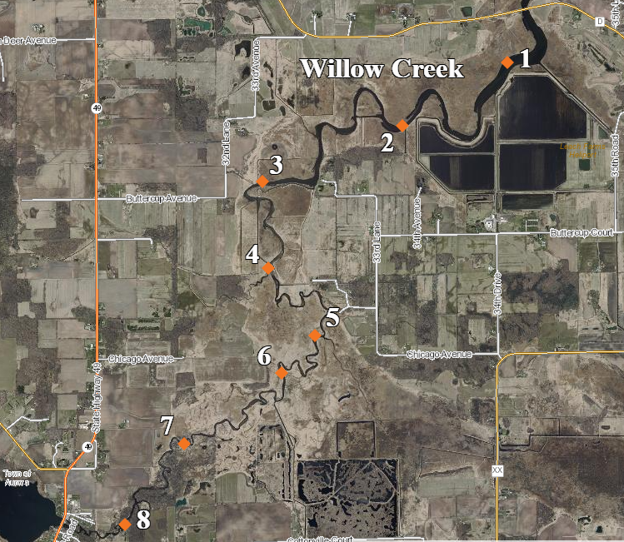
Map 3: Longitudinal Instantaneous Water Chemistry Survey Locations in Willow Creek in 2021.

Location | Date | Latitude | Longitude | Site #
Willow Creek US 0.5 miles County D | 8/10/2021 | 44.09532 | -88.93458 | 1
Willow Creek US 0.8 miles County D | 8/10/2021 | 44.08979 | -88.94789 | 2
Willow Creek US 3.3 miles County D | 8/10/2021 | 44.0849 | -88.96555 | 3
Willow Creek US 4.1 miles County D | 8/10/2021 | 44.07704 | -88.96507 | 4
Willow Creek US 5.0 miles County D | 8/10/2021 | 44.07093 | -88.95934 | 5
Willow Creek US 5.6 miles County D | 8/10/2021 | 44.06754 | -88.96349 | 6
Willow Creek US 6.8 miles County D | 8/10/2021 | 44.06118 | -88.97582 | 7
Willow Creek DS 0.5 miles Hwy 49 | 8/10/2021 | 44.05391 | -88.98331 | 8
Table 6: Longitudinal Instantaneous Water Chemistry Survey Locations in Willow Creek in 2021.

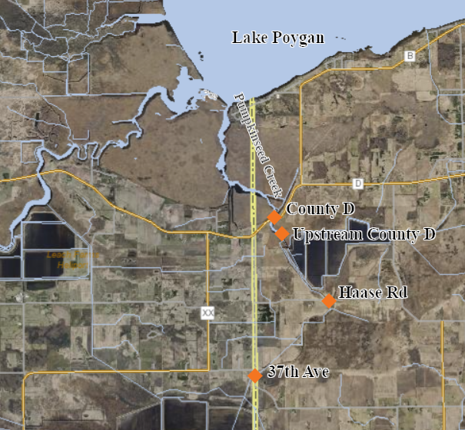
Map 4: Longitudinal Instantaneous Water Chemistry Survey Locations in Pumpkinseed Creek in 2021.

Location | Date | Latitude | Longitude
Pumpkinseed Creek at County D | 6/24/2021 | 44.09187 | -88.88197
Pumpkinseed Creek US County D | 6/24/2021 | 44.08885 | -88.87871
Pumpkinseed Creek at Haase Rd | 6/24/2021 | 44.08002 | -88.87015
Pumpkinseed Creek at 37th Ave | 6/24/2021 | 44.06799 | -88.88608
Table 7: Longitudinal Instantaneous Water Chemistry Survey Locations in Pumpkinseed Creek in 2021.
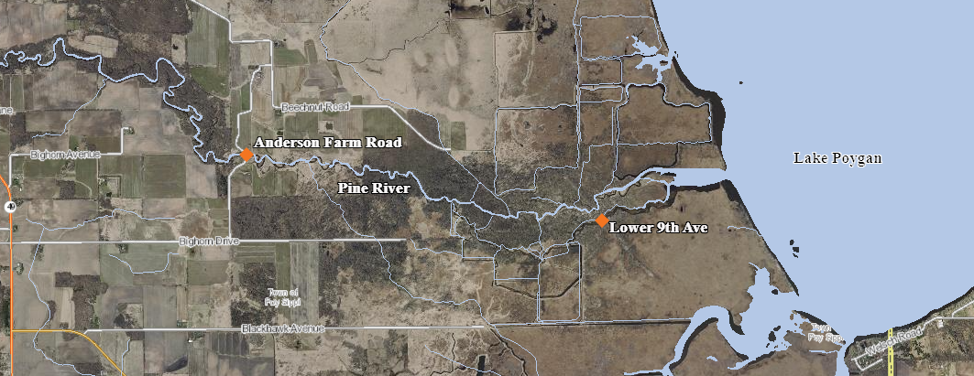
Map 5: Longitudinal Instantaneous Water Chemistry Survey Locations in the Pine River in 2021.

Location | Date | Latitude | Longitude
Lower Pine River at 9th Ave | 7/29/2021 | 44.1212 | -88.91864
Pine River at Anderson Farm Rd | 7/29/2021 | 44.12663 | -88.95913
Table 8: Longitudinal Instantaneous Water Chemistry Survey Locations in the Pine River in 2021.

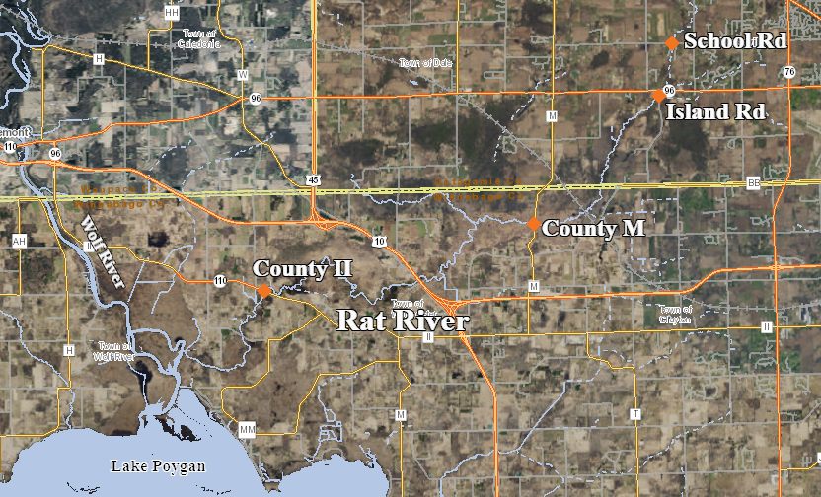
Map 6: Longitudinal Instantaneous Water Chemistry Survey Locations in the Rat River in 2021.

Location | Date | Latitude | Longitude
Rat River at County II | 7/22/2021 | 44.21334 | -88.76153
Rat River at County M | 7/22/2021 | 44.23241 | -88.64609
Rat River at Island Road/Hwy 96 | 7/22/2021 | 44.2712 | -88.59253
Rat River at School Road | 7/22/2021 | 44.28708 | -88.58653
Table 9: Longitudinal Instantaneous Water Chemistry Survey Locations in the Rat River in 2021.

Water Chemistry Sonde Deployments
Between June 24th and August 17th, 2021, Hydrolab MS5 multiparameter sondes were deployed for a 5-day period to monitor water chemistry diel fluctuations in the 5 Pool Lake tributaries. A total of 8 5-day deployments occurred in the 5 tributaries (Maps 7-11, Table 10-14). Water chemistry measurements were collected once every 30 minutes. The sonde deployments were conducted following the WDNR Guidelines for Deployment of Continuous Dissolved Oxygen Meters, Data Evaluation, and Storage (WDNR 2007). A deployment site was selected on the outside bend and/or thalweg in the best available current velocity. The multiparameter sondes were attached to a fence post driven into the streambed, with the sensors suspended above the substrate (Photo 6).

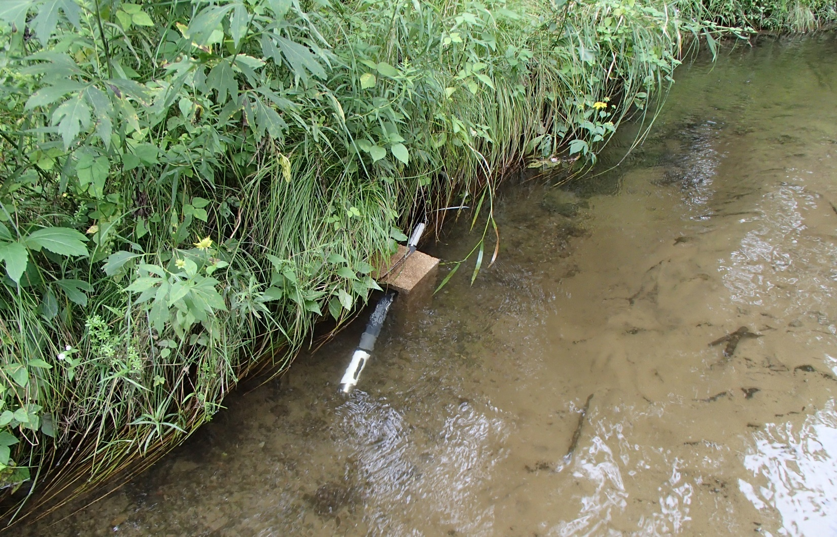
Photo 6: Example Sonde Deployment Setup. Photo taken by D. Bolha on August 3rd, 2018.
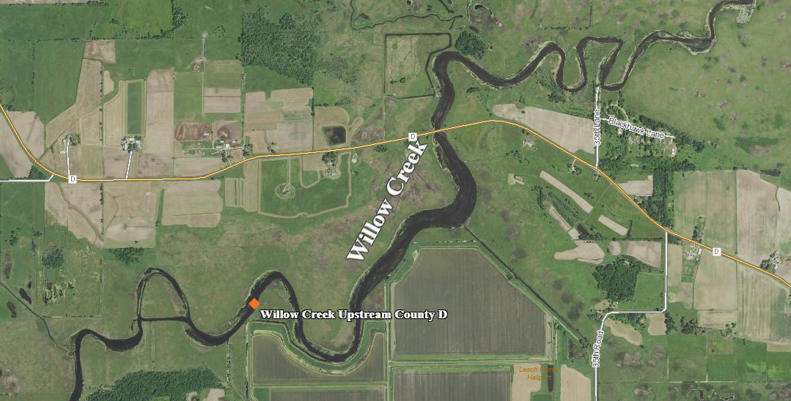
Map 7: Multiparameter Sonde Deployment Location in Willow Creek in 2021.

Location | Deployment Date | Retrieval Date | Latitude | Longitude
Willow Creek Upstream County D | 8/12/2021 | 8/17/2021 | 44.09146 | -88.94556
Table 10: Multiparameter Sonde Deployment Location in Willow Creek in 2021.

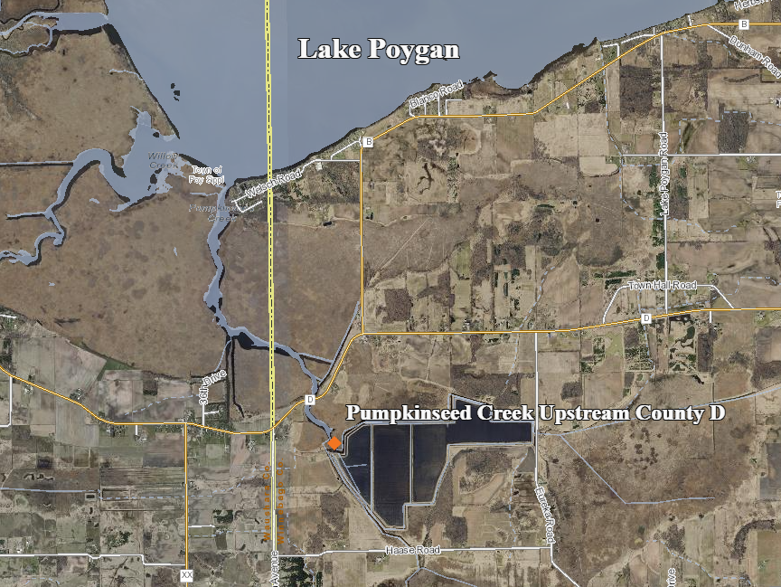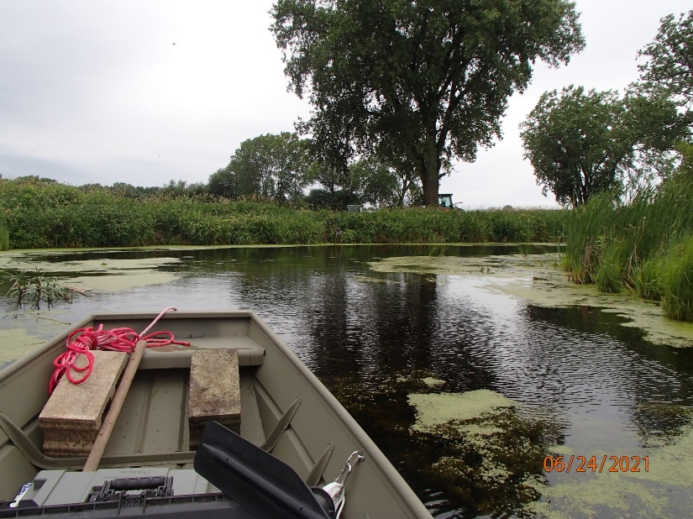
Map 8: Multiparameter Sonde Deployment Location in Pumpkinseed Creek in 2021. Photo 7: Taken by D. Bolha on June 24th, 2021.

Location | Deployment Date | Retrieval Date | Latitude | Longitude
Pumpkinseed Creek Upstream County D | 6/24/2021 | 6/29/2021 | 44.08885 | -88.87871
Table 11: Multiparameter Sonde Deployment Location in Pumpkinseed Creek in 2021.

Map 9: Multiparameter Sonde Deployment Locations in the Pine River in 2021.

Location | Deployment Date | Retrieval Date | Latitude | Longitude
Lower Pine River at 9th Ave | 7/29/2021 | 8/4/2021 | 44.1212 | -88.91864
Pine River at Anderson Farm Rd | 7/29/2021 | 8/4/2021 | 44.12663 | -88.95913
Table 12: Multiparameter Sonde Deployment Locations in the Pine River in 2021.

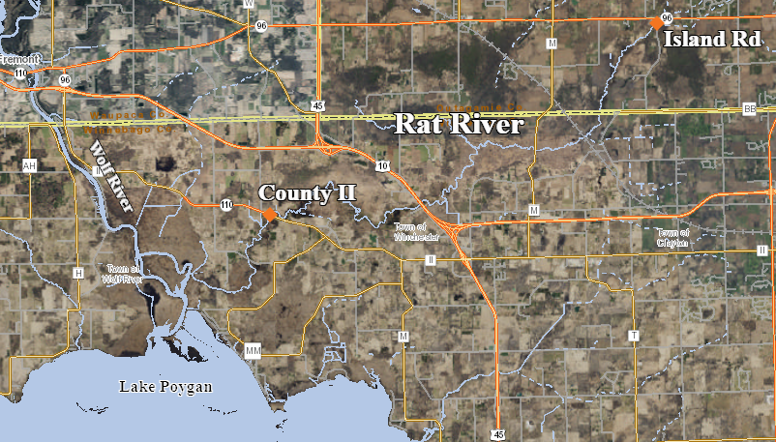
Map 10: Multiparameter Sonde Deployment Locations in the Rat River in 2021.

Location | Deployment Date | Retrieval Date | Latitude | Longitude
Rat River at County II | 7/22/2021 | 7/27/2021 | 44.21334 | -88.76153
Rat River at Island Road | 7/22/2021 | 7/27/2021 | 44.2712 | -88.59253
Table 13: Multiparameter Sonde Deployment Locations in the Rat River in 2021.

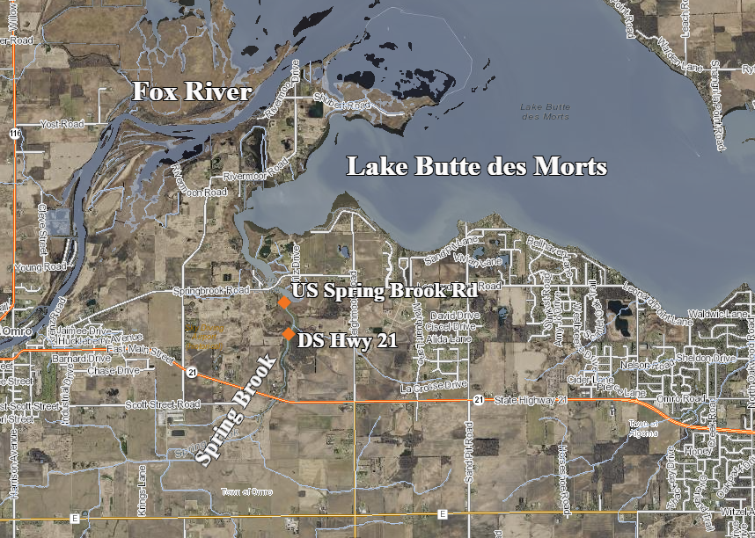
Map 11: Multiparameter Sonde Deployment Locations in Spring Brook in 2021.

Location | Deployment Date | Retrieval Date | Latitude | Longitude
Spring Brook Upstream Spring Brook Rd | 8/4/2021 | 8/9/2021 | 44.04599 | -88.68581
Spring Brook Downstream Hwy 21 | 8/4/2021 | 8/9/2021 | 44.04183 | -88.68503
Table 14: Multiparameter Sonde Deployment Locations in Spring Brook in 2021.

Chemical Oxygen Demand Sampling

Chemical Oxygen Demand (COD) samples were collected in each of the 5 Pool Lake tributaries for a total of 11 samples (Map 7-11, Table 15) between June 24th and August 10th, 2021. All samples were collected using the standard WDNR Nutrient Chemistry Grab Sampling v3.3 (WDNR 2015).

Location | Date
Willow Creek at County D | 8/10/2021
Willow Creek Upstream 5.0 Miles County D | 8/10/2021
Willow Creek Downstream 0.5 Miles Hwy 49 | 8/10/2021
Pumpkinseed Creek at County D | 6/29/2021
Pumpkinseed Creek Upstream County D | 6/24/2021
Lower Pine River at 9th Rd | 7/29/2021
Pine River at Anderson Farm Rd | 8/4/2021
Rat River at County II | 7/22/2021
Rat River at Island Rd | 7/22/2021
Spring Brook at Spring Brook Rd | 8/4/2021
Spring Brook at Hwy 21 | 8/4/2021
Table 15: COD Monitoring Locations in the 5 Pool Lake tributaries in 2021.

Non-Wadable Fish Surveys

Non-wadable fish surveys were conducted in 3 Pool Lake tributaries at 8 locations in 2021 (Map 12, Table 16). The fish surveys were conducted following the Guidelines for Assessing Fish Communities of Non-Wadeable Rivers in Wisconsin v3.2. (WDNR 2019). The non-wadable fish survey protocol required a flat-bottom, mini-boom boat with a single anode 3-4 meters off the front. The surveys were conducted by driving the boat downstream from a starting point and proceeding 1600 meters (1 mile) to an endpoint. One person at the front of the boat, using a net of 3/8” bar mesh, attempted to capture all fish seen. Netted fish were placed in a holding tank until weight, length, and species were determined. Processed fish were then returned to the river. Surveys were conducted in May 2021 at 5 locations and at 3 locations in August 2021 to assess fish community assemblage changes from the Spring when oxygen levels were above the Water Quality Criteria (WQC) 5 mg/L to the Summer when oxygen levels had dropped below the WQC. If the Spring fish community survey indicated a Poor or Very Poor Index of Biotic Integrity Score, no follow-up survey was conducted during the Summer at that location.
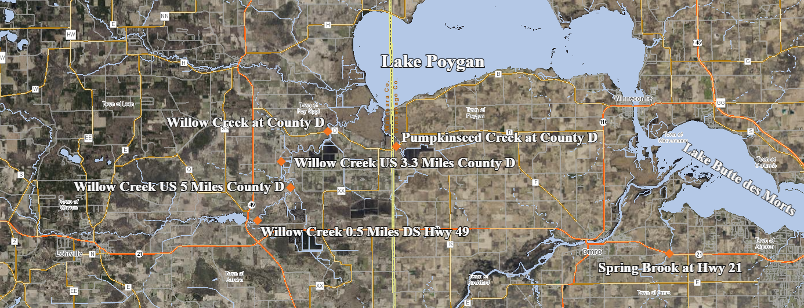Map 12: Non-Wadable Fish Survey Locations in the Pool Lake Tributaries in 2021.

Location | Date | Survey Start Latitude | Survey Start Longitude
Willow Creek at County D | 5/18/2021 | 44.10181 | -88.9314
Willow Creek at County D | 8/10/2021 | 44.10181 | -88.9314
Willow Creek US 3.3 Miles County D | 5/18/2021 | 44.08478 | -88.9661
Willow Creek US 5.0 Miles County D | 5/18/2021 | 44.0708 | -88.9594
Willow Creek US 5.0 Miles County D | 8/10/2021 | 44.0708 | -88.9594
Willow Creek DS 0.5 Miles Hwy 49 | 8/10/2021 | 44.05389 | -88.9834
Pumpkinseed Creek at County D | 5/24/2021 | 44.09291 | -88.8813
Spring Brook at Hwy 21 | 5/24/2021 | 44.03395 | -88.6872
Table 16: Non-Wadable Fish Survey Locations in the Pool Lake Tributaries in 2021.

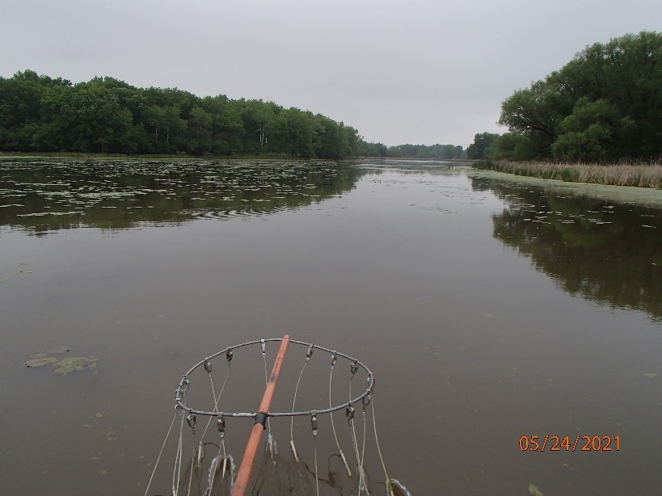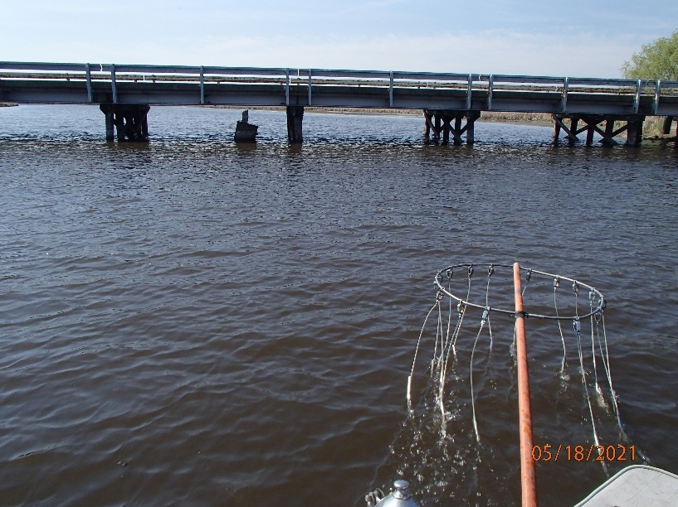
Photo 8-9: Spring Brook at Hwy 21 and Willow Creek at County D Fish Surveys. Photos taken by D. Bolha in May 2021.

Results

Instantaneous Water Chemistry

Weekly to bi-weekly instantaneous water chemistry monitoring was conducted in the 5 Pool Lake tributaries between April 15th and August 4th, 2021. A total of 34 monitoring events collected instantaneous water chemistry information at the locations on Map 2. In all Pool Lake tributaries, water temperature increased as the Summer progressed. DO and DO % Saturation decreased as the Spring progressed into Summer in all tributary systems. DO decreased the least amount in the Pine River (2.5mg/L). The greatest decrease in DO concentration from Spring through Summer 2021 was at Spring Brook and Willow Creek, 12.2 mg/L and 11.6 mg/L, respectively. At all sites except the Pine River and Spring Brook, pH decreased through the Summer. The specific conductivity decreased from Spring through Summer at all sites except the Pine River (Table 17-21, Chart 1-5).

Date | DO mg/L | DO % Saturation | Temp ºF | pH | Sp Cond uS/cm
4/15/2021 | 11.3 | 97.5 | 46.7 | 8 | 326.8
5/12/2021 | 11.6 | 122 | 62.9 | 8.83 | 317
6/1/2021 | 8.17 | 92.7 | 68.9 | 8.35 | 327.8
6/17/2021 | 10.82 | 131.6 | 74.9 | 8.25 | 338.4
7/7/2021 | 3.17 | 37.8 | 73.2 | 7.23 | 319.2
7/15/2021 | 3.02 | 35.5 | 72.4 | 7.14 | 226.7
7/20/2021 | 0 | 0 | 77.4 | 6.77 | 249.9
Table 17: Instantaneous Water Chemistry Monitoring Results in Willow Creek in 2021.

Date | DO mg/L | DO % Saturation | Temp ºF | pH | Sp Cond uS/cm
4/15/2021 | 12.88 | 110.6 | 46.2 | 8.1 | 499.8
5/12/2021 | 9.92 | 107.4 | 65.1 | 8 | 554
6/1/2021 | 7.69 | 85.7 | 67.5 | 7.87 | 462.4
6/17/2021 | 1.65 | 19.3 | 71.6 | 7.45 | 427.3
6/24/2021 | 3.72 | 41.4 | 66.6 | 7.59 | 448.7
6/29/2021 | 2.7 | 30.8 | 71.2 | 7.44 | 415
7/7/2021 | 1.47 | 17.5 | 73.0 | 7.21 | 462.7
Table 18: Instantaneous Water Chemistry Monitoring Results in Pumpkinseed Creek in 2021.

Date | DO mg/L | DO % Saturation | Temp ºF | pH | Sp Cond uS/cm
6/1/2021 | 9.6 | 101.3 | 62.6 | 8.19 | 336
6/17/2021 | 9.76 | 110.5 | 68.6 | 8.08 | 359.6
7/7/2021 | 7.1 | 78.6 | 66.3 | 7.53 | 270.7
7/20/2021 | 8.26 | 96.1 | 71.2 | 7.84 | 353.9
7/29/2021 | 7.8 | 94.2 | 74.0 | 7.69 | 303.2
8/4/2021 | 8.54 | 96.8 | 69.0 | 8.02 | 368.1
Table 19: Instantaneous Water Chemistry Monitoring Results in the Pine River in 2021.

Date | DO mg/L | DO % Saturation | Temp ºF | pH | Sp Cond uS/cm
5/12/2021 | 10.93 | 112.6 | 61.3 | 7.77 | 584.4
6/1/2021 | 8.15 | 91.2 | 67.7 | 7.83 | 575
6/17/2021 | 9.79 | 122.2 | 77.5 | 8.53 | 599
6/30/2021 | 1.51 | 18.2 | 74.8 | 6.97 | 346
7/7/2021 | 0.38 | 4.4 | 70.5 | 7.04 | 415.5
7/20/2021 | 0 | 0 | 76.6 | 6.92 | 372.2
7/22/2021 | 0.46 | 5 | -- | -- | --
7/27/2021 | 0.85 | 10.3 | 76.5 | 7.12 | 428.6
Table 20: Instantaneous Water Chemistry Monitoring Results in the Rat River in 2021.
Date | DO mg/L | DO % Saturation | Temp ºF | pH | Sp Cond uS/cm
4/15/2021 | 11.5 | 110 | 54.0 | 8.7 | 679
5/12/2021 | 14.4 | 156 | 66.0 | 8.34 | 704.6
6/1/2021 | 6.3 | 70.4 | 67.8 | 8.04 | 702
6/17/2021 | 7.36 | 89.6 | 74.0 | 8.14 | 626
7/7/2021 | 2.16 | 24.3 | 68.7 | 7.15 | 375
Table 21: Instantaneous Water Chemistry Monitoring Results in Spring Brook in 2021.

Chart 1: Weekly to Bi-weekly Dissolved Oxygen Concentrations in the Pool Lake Tributaries in 2021.

Chart 2: Weekly to Bi-weekly Dissolved Oxygen Percent Saturations in the Pool Lake Tributaries in 2021.

Chart 3: Weekly to Bi-weekly Temperatures in the Pool Lake Tributaries in 2021.

Chart 4: Weekly to Bi-weekly pH values in the Pool Lake Tributaries in 2021.

Chart 5: Weekly to Bi-weekly Specific Conductivity Concentrations in the Pool Lake Tributaries in 2021.
Longitudinal Water Chemistry

Between June 24th and August 10th, 2021, longitudinal water chemistry surveys of 4 Pool Lake tributaries were conducted for a total of 18 monitoring events (Maps 3-6, Table 6-9). The longitudinal profiles of the creeks and rivers indicated significant changes in DO concentrations and % Saturation from downstream to upstream. In August 2021, starting near the County D road crossing of Willow Creek, DO concentration was measured at <1 mg/L and remained <1 mg/L upstream 4 river miles (Table 22, Chart 6). Near the Auroraville Dam and Hwy 49 (Photo 10), DO was measured at ~ 5 mg/L and ~60% Saturation. Pumpkinseed Creek at County D road crossing in June 2021 indicated DO below the Administrative Code NR 102 WQC of >5 mg/L DO in streams. Pumpkinseed Creek DO and % Saturation improved to above the WQC as monitoring continued upstream until Haase Rd. At 37th Avenue, a DO sag in Pumpkinseed Creek was observed which was likely a function of the land use upstream. Pine River maintained a healthy amount of DO during the Spring and Summer. The longitudinal survey of the Rat River indicated a DO sag at County II/Hwy 110 and County M. DO was well above the WQC in the Rat River at Hwy 96 and School Rd, respectively.

Location | Date | DO mg/L | DO % Saturation | Temp ºF
Willow Creek US 0.5 miles County D | 8/10/2021 | 0.55 | 6 | 74.5
Willow Creek US 0.8 miles County D | 8/10/2021 | 0.61 | 7.4 | 74.7
Willow Creek US 3.3 miles County D | 8/10/2021 | 0.86 | 10.4 | 75.0
Willow Creek US 4.1 miles County D | 8/10/2021 | 0.96 | 11.8 | 75.0
Willow Creek US 5.0 miles County D | 8/10/2021 | 1.74 | 21.1 | 74.1
Willow Creek US 5.6 miles County D | 8/10/2021 | 3.22 | 39 | 74.9
Willow Creek US 6.8 miles County D | 8/10/2021 | 5.18 | 62.5 | 73.6
Willow Creek DS 0.5 miles Hwy 49 | 8/10/2021 | 4.91 | 58.5 | 72.8
Pumpkinseed Creek at County D | 6/24/2021 | 3.72 | 41.4 | 66.6
Pumpkinseed Creek US County D | 6/24/2021 | 6.3 | 71.6 | 68.1
Pumpkinseed Creek at Haase Rd | 6/24/2021 | 5.73 | 62.8 | 65.1
Pumpkinseed Creek at 37th Ave | 6/24/2021 | 1.01 | 11 | 64.3
Lower Pine River at 9th Ave | 7/29/2021 | 7.97 | 95.2 | 73.3
Pine River at Anderson Farm Rd | 7/29/2021 | 7.8 | 94.2 | 74.0
Rat River at County II | 7/22/2021 | 0.46 | 5 | --
Rat River at County M | 7/22/2021 | 0.46 | 5 | 67.3
Rat River at Island Road/Hwy 96 | 7/22/2021 | 8.47 | 89 | 62.0
Rat River at School Road | 7/22/2021 | 9.46 | 96.5 | 59.6
Table 22: Longitudinal Water Chemistry Surveys in the Pool Lake Tributaries in 2021.

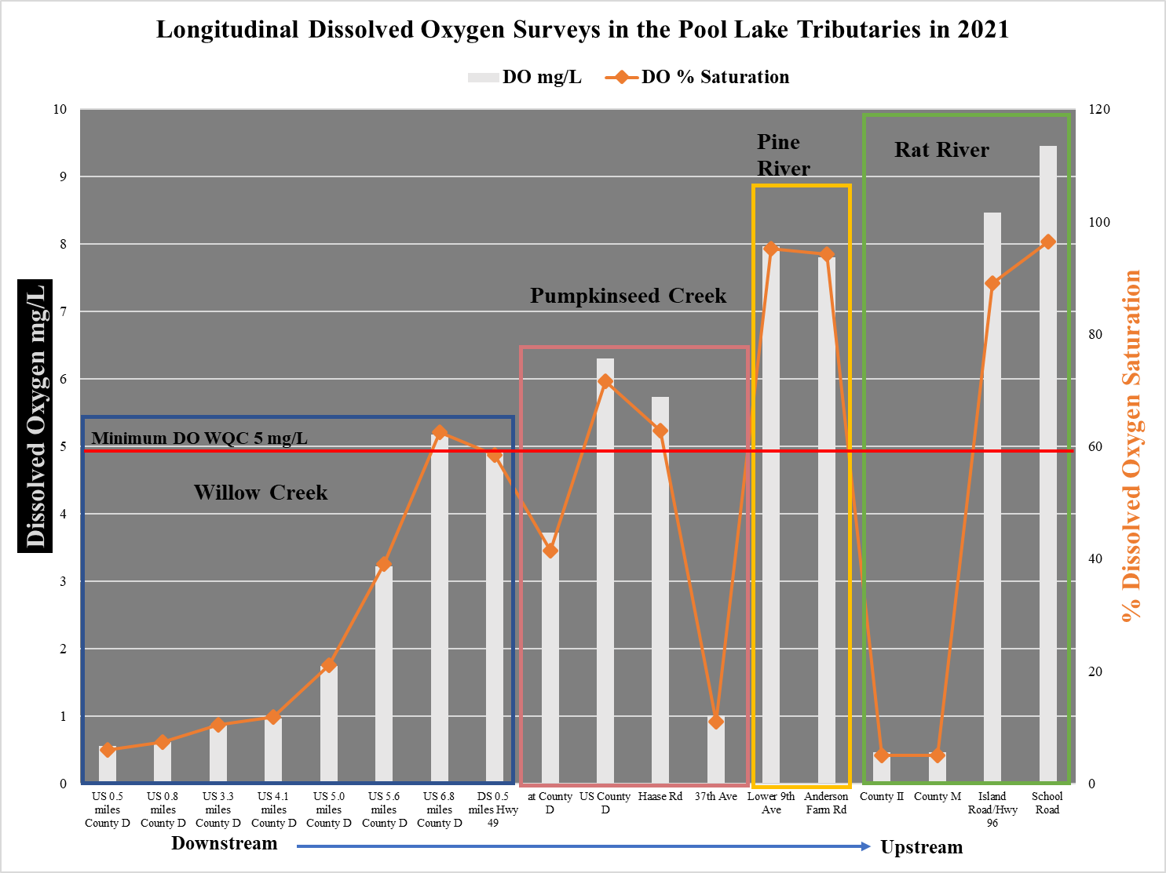
Chart 6: Longitudinal Dissolved Oxygen Surveys in the Pool Lake Tributaries in 2021.

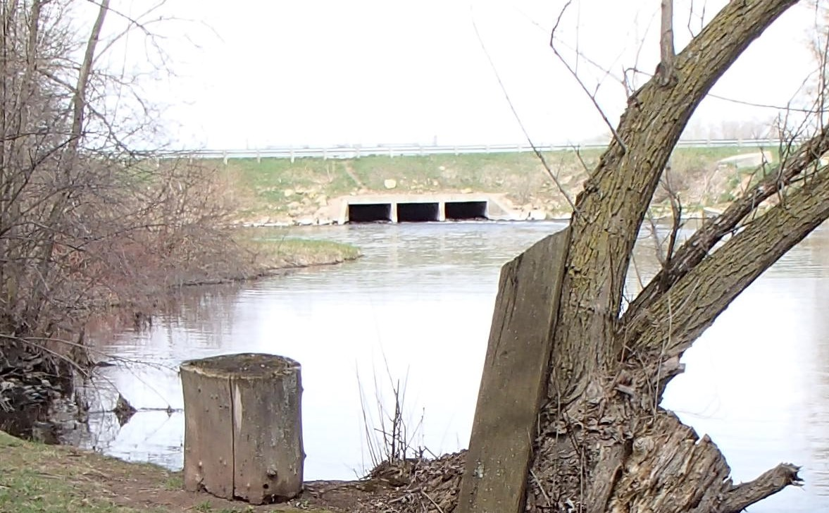
Photo 10: Auroraville Millpond Dam at Hwy 49 facing West. Photo taken by D. Bolha on May 1st, 2013.
5-Day Sonde Deployments

Between June and August 2021, multiparameter sondes were deployed for a 5-day period to monitor water chemistry diel fluctuations at 8 locations in the 5 Pool Lake tributaries (Maps 7-11). The water chemistry data collected during each deployment are summarized in Table 23. The range of water chemistry results varied considerably between deployment locations and over the 5-day recording periods. For example, the DO and DO% in the Rat River at County II (0.0-0.5mg/L and 0.5-5.5%) compared to the Rat River at Island Road (7.1-8.8mg/L and 78.8-100.3%) (Chart 11-12). Another example was DO in Willow Creek at County D (average 0.0 mg/L) compared to the Lower Pine River at 9th Ave (average 6.7 mg/L) (Chart 7 & 9). The deployment locations in Willow Creek and the Lower Pine River at 9th Ave are similar in surrounding riparian wetlands and watershed land uses. The Pine River maintained a healthy amount of DO at both deployment locations (Table 23, Chart 7 & 10). The minimum DO concentration in the Pine River did not fall below the WQC. However, Willow Creek DO was very low (<1 mg/L), well below the 5.0 mg/L WQC for streams. The DO concentration in Pumpkinseed Creek upstream of County D ranged broadly, with a maximum DO of 12.1 mg/L and a minimum of 0.6 mg/L (Table 23, Chart 8). The pH and Specific Conductivity tended to range higher upstream and decreased in the lower, marsh-dominated portions of these watersheds.

Location | Min Temp ˚F | Max Temp ˚F | Ave Temp ˚F | Min SpCond | Max SpCond | Ave SpCond | Min pH | Max pH | Ave pH | Min DO | Max DO | Ave DO | Min DO% | Max DO% | Ave DO%
Willow Creek at County D | 71.1 | 76.0 | 73.6 | 218.0 | 310.0 | 245.6 | 5.0 | 6.8 | 6.1 | 0.0 | 0.2 | 0.0 | 0.0 | 2.7 | 0.3
Pumpkinseed Creek at County D | 65.7 | 73.3 | 69.6 | 281.0 | 734.0 | 471.5 | 7.0 | 7.9 | 7.4 | 0.6 | 12.1 | 3.9 | 7.2 | 143.6 | 45.7
Lower Pine River at 9th Ave | 66.7 | 73.6 | 69.4 | 92.0 | 292.0 | 175.8 | 7.6 | 8.1 | 7.8 | 5.0 | 8.3 | 6.7 | 56.8 | 96.1 | 77.4
Pine River at Anderson Farm Rd | 64.5 | 74.8 | 68.7 | 287.0 | 365.0 | 335.3 | 7.8 | 8.4 | 8.1 | 7.2 | 9.4 | 8.3 | 81.8 | 106.7 | 94.6
Rat River at County II | 71.0 | 77.6 | 74.3 | 382.0 | 429.0 | 404.3 | 7.0 | 7.1 | 7.1 | 0.0 | 0.5 | 0.1 | 0.5 | 5.5 | 1.2
Rat River at Island Rd | 62.3 | 71.3 | 66.4 | 724.0 | 807.0 | 787.5 | 8.0 | 8.3 | 8.1 | 7.1 | 8.8 | 7.8 | 78.8 | 100.3 | 85.9
Spring Brook at Spring Brook Rd | 68.6 | 79.1 | 74.5 | 177.0 | 598.0 | 453.9 | 7.0 | 7.7 | 7.2 | 0.0 | 3.0 | 0.5 | 0.0 | 37.9 | 6.6
Spring Brook US Spring Brook Rd | 67.9 | 73.3 | 71.5 | 178.0 | 614.0 | 457.9 | 7.2 | 8.9 | 8.1 | 0.0 | 6.4 | 3.0 | 0.5 | 73.9 | 34.7
Table 23: Water Chemistry from 5-day Sonde Deployments in the Pool Lake Tributaries in 2021.

Chart 7: Willow Creek Dissolved Oxygen and % Saturation during 5-day Deployment.

Chart 8: Pumpkinseed Creek Dissolved Oxygen and % Saturation during 5-day Deployment.

Chart 9: Lower Pine River at 9th Ave Dissolved Oxygen and % Saturation during 5-day Deployment.

Chart 10: Pine River at Anderson Farm Road Dissolved Oxygen and % Saturation during 5-day Deployment.

Chart 11: Rat River at County II Dissolved Oxygen and % Saturation during 5-day Deployment.

Chart 12: Rat River at Island Road Dissolved Oxygen and % Saturation during 5-day Deployment.

Chart 13: Spring Brook at Spring Brook Road Dissolved Oxygen and % Saturation during 5-day Deployment.

Chart 14: Spring Brook Upstream of Spring Brook Road Dissolved Oxygen and % Saturation during 5-day Deployment.
Chemical Oxygen Demand

Chemical Oxygen Demand (COD) samples were collected in each of the 5 Pool Lake tributaries for a total of 11 samples (Table 24, Chart 15) between June 24th and August 10th, 2021. The COD concentrations ranged from 17.9 mg/L in the Rat River at Island Road to 81.4 mg/L in Pumpkinseed River Upstream of County D. The downstream, marsh monitoring locations of Willow and Pumpkinseed Creeks, and the Rat River had higher COD levels than the Pine River.

Location | Date | COD mg/L
Willow Creek at County D | 8/10/2021 | 46.6
Willow Creek Upstream 5.0 Miles County D | 8/10/2021 | 42.2
Willow Creek Downstream 0.5 Miles Hwy 49 | 8/10/2021 | 55
Pumpkinseed Creek at County D | 6/29/2021 | 64.8
Pumpkinseed Creek Upstream County D | 6/24/2021 | 81.4
Lower Pine River at 9th Rd | 7/29/2021 | 36.4
Pine River at Anderson Farm Rd | 8/4/2021 | 23.4
Rat River at County II | 7/22/2021 | 72.5
Rat River at Island Rd | 7/22/2021 | 17.9
Spring Brook at Spring Brook Rd | 8/4/2021 | 36.4
Spring Brook at Hwy 21 | 8/4/2021 | 35.6
Table 24: Chemical Oxygen Demand in the 5 Pool Lake Tributaries in 2021.

Chart 15: Chemical Oxygen Demand in the 5 Pool Lake Tributaries in 2021.

Non-Wadable Fish Surveys

Non-wadable fish surveys were conducted in 3 Pool Lake tributaries for a total of 8 surveys in 2021 (Table 16, Map 12). Some fish species are tolerant of environmental degradation, while some species are moderately tolerant, and some others are intolerant. Based upon the representative fish captured during the survey and their associated tolerance to environmental degradation, an Index of Biotic Integrity (FIBI) was calculated to indicate the water quality of each waterbody. The FIBI scores in Willow Creek ranged from 10 at County D to 90 0.5 miles downstream of Hwy 49 in August (Table 25, Chart 16). The FIBI scores in Pumpkinseed Creek and Spring Brook were 15 and 20, respectively. The water quality condition categories for the Pool Lake tributaries ranged from Very Poor to Excellent, indicating very severe to no apparent environmental degradation. The fish communities in May tended to have more diversity and overall catch rates than those in August. In August, the survey in Willow Creek indicated a Very Poor fish community near County D; however, continued to improve the further upstream the surveys were conducted. The fish community in August in Willow Creek near Hwy 49 was Excellent, with 19 species captured (Table 25, Chart 16).

Chart 16: Non-Wadable Fish Community Evaluations in the Pool Lake Tributaries in 2021.

Fish Species Common Name | Willow Creek at County D 5/18/2021 | Willow Creek at County D 8/10/2021 | Willow Creek US 3.3 Miles County D 5/18/2021 | Willow Creek US 5 Miles County D 5/18/2021 | Willow Creek US 5 Miles County D 8/10/2021 | Willow Creek DS 0.5 Miles Hwy 49 8/10/2021 | Pumpkinseed Creek at County D 5/24/2021 | Spring Brook at Hwy 21 5/24/2021
Silver Lamprey |  |  | 1
Longnose Gar | 1 |  | 3 | 2 |  |  | 3
Shortnose Gar |  |  |  |  |  |  |  | 1
Bowfin | 1 |  | 7 | 1 | 1 |  | 6 | 2
Central Mudminnow |  |  |  |  |  |  | 3 | 1
Northern Pike | 1 |  |  | 5 |  |  |  | 1
Common Carp | 7 | 1 | 16 |  |  |  | 2 | 4
Hornyhead Chub |  | 6 |  |  |  | 5
Golden Shiner | 1 |  |  |  | 1 |  | 3 | 20
Emerald Shiner | 50 |  | 7 | 4 |  |  |  | 10
Common Shiner | 8 |  | 6 | 12 | 56 | 103
Blackchin Shiner |  |  |  |  |  | 2
Rosyface/Carmine Shiner |  |  |  |  |  | 2
Weed Shiner |  |  |  | 1 | 1
Bluntnose Minnow |  |  |  |  | 1 | 2
White Sucker | 2 |  | 2 | 13 |  | 1 |  | 1
Northern Hog Sucker |  |  |  |  |  | 11
Bigmouth Buffalo |  |  |  |  |  |  |  | 3
Spotted Sucker | 1 |  |  | 4 |  | 4 | 1
Silver Redhorse | 3 |  |  | 9 |  | 1
Shorthead Redhorse |  |  |  | 17 |  | 3
Greater Redhorse |  |  | 1 | 2 |  | 9
Black Bullhead | 2
Yellow Bullhead | 1
Channel Catfish |  |  |  | 1 |  | 11
White Bass |  |  | 1
Rock Bass | 3 |  | 1
Pumpkinseed Sunfish |  |  |  |  |  |  | 7 | 12
Bluegill |  |  |  |  |  |  | 14 | 13
Smallmouth Bass |  |  | 1 | 6 |  | 7
Largemouth Bass | 1 |  | 2 | 1 |  |  | 4 | 4
Black Crappie |  |  |  |  |  | 1
Banded Darter |  |  |  | 1 |  | 1
Yellow Perch | 207 | 2 | 149 | 59 |  | 6 | 240 | 97
Logperch |  |  |  | 1 | 1 | 5
Walleye | 2 |  | 3 | 10 |  | 1
Freshwater Drum | 1 |  | 2 | 2 |  | 14 |  | 1
Total Fish Captured | 292 | 9 | 202 | 151 | 61 | 189 | 283 | 170
Total Species Captured | 17 | 3 | 15 | 19 | 6 | 19 | 10 | 14
Fish IBI Score | 45 | 10 | 30 | 75 | 20 | 90 | 15 | 20
Fish IBI Category | Fair | Very Poor | Poor | Good | Poor | Excellent | Very Poor | Poor
Table 25: Non-Wadable Fish Community Evaluations in the Pool Lake Tributaries in 2021.
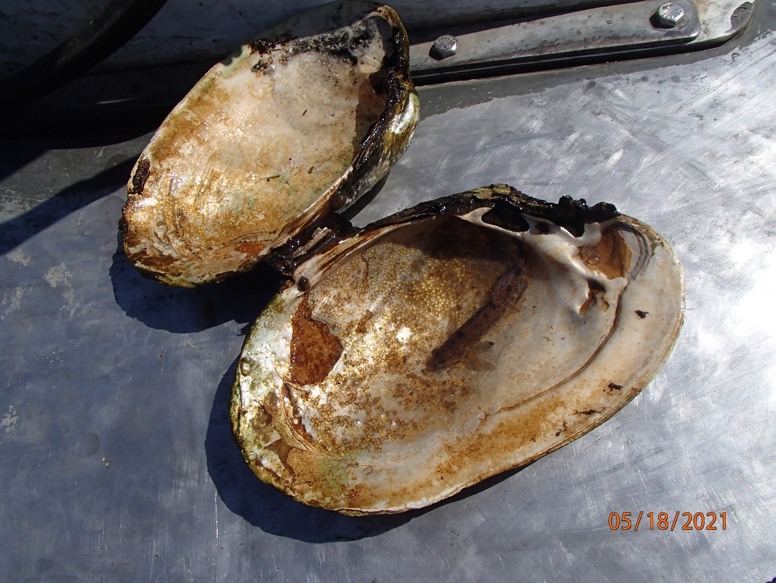
Photo 11: Johnny Darter Egg Nest Inside Shell of Freshwater Mussel in Willow Creek. Photo taken by D. Bolha on May 18th, 2021.

Discussion

The purpose of this project was to evaluate the water chemistry fluctuations within 5 tributaries to the Lake Winnebago Pool Lakes to gage the extent of burden on the fish and aquatic life. The water quality of the Pool Lake Tributaries was Excellent to Very Poor in 2021. The level of dissolved oxygen, COD, and integrity of the fish communities correlated. As the DO levels dropped, so did the fish community diversity and abundance. The locations with the higher levels of COD tended to have lower oxygen and poorer fish communities. Low oxygen levels appear to be a limiting factor for the fish communities. The Pine River was the only tributary that maintained healthy oxygen levels during the Summer. Although a fish survey was not conducted in the Lower Pine River in 2021, a non-wadable fish survey was conducted in 2019. The 2019 Lower Pine River fish community survey collected 19 species and 217 total fish, for an Excellent Fish IBI rating. In 2019, a non-wadable fish survey was conducted in Willow Creek at County D capturing 1 fish.

Prior to the commencement of this project, the following hypothesis was considered as a potential driver behind the DO levels recorded in the 5 Pool Lake Tributaries. Between 2018 and 2020, water flows and levels in each of the 5 Pool Lake Tributaries were elevated above normal, often near or at record levels. The high water flow/level inundated the surrounding marshes which could have been pulling in an organic load which depleted the oxygen levels in these tributaries. In 2021, water flows/levels were back closer to average Summer levels; however, the surrounding marshes were still inundated and continued to add an organic load to the Pool Lake Tributaries. Year to year water level changes are natural, although more frequent heavy precipitation events and periods of drought may be altering that seasonal fluctuation pattern. Regardless, high water levels could not be ruled out as, at least in part, the driver behind the low DO levels in the Pool Lake Tributaries.

When deploying multiparameter sondes, the manufacturer of the equipment used in this project (Ott Hydromet) and WDNR Guidelines for Deployment of Continuous Dissolved Oxygen Meters Data Evaluation and Data Storage (WDNR 2007) recommend measures be taken to avoid and correct for sensor drift. Although the rather rigorous data quality and sensor drift assessment protocol in the guidance (WDNR 2007) was not followed, some measures to minimize the potential drift and assess the data quality were taken. First, the deployment period was restricted to 5-day to limit the potential of sensor drift or failure as recommended by the manufacturer (Ott Hydromet 2021). Second, sites were chosen to minimize opportunity for sensor fouling (i.e. good flow). Lastly, the sondes deployed in the Lower Pine River at 9th and at the Anderson Farm road (Photo 11) were tested and calibrated at retrieval to assess the data quality or amount of sensor drift (Table 26, Chart 17-18). Worth mentioning, the anticipated DO levels in some of the Pool Lake Tributaries were so low that sensor drift was of minimal concern (Charts 11-14). The bio-fouling that occurred at the 9th Ave and Anderson Farm Pine River locations was minimal (0.07 mg/L and 0.01 mg/L, respectively). After the sensor drift from bio-fouling was calculated, the multiparameter sondes were calibrated. Next, the instantaneous water chemistry of the Pine River at each location was collected to calculate the amount of total drift (Table 26). The total drift (combination of bio-fouling and electrical/mechanical drift) was deduced by calculating the difference between the DO mg/L post-cleaning and the DO post-cleaning and calibration. The total drift at 9th Ave was 0.68 mg/L, whereas the total drift at Anderson Farm was 0.42 mg/L (Table 26).

Parameter | Pine River at 9th Ave Pre-cleaning | Pine River at 9th Ave Post-cleaning | Pine River at 9th Ave Post-cleaning and Calibration | Pine River at 9th Ave  DO Total Drift mg/L | Pine River at Anderson Farm Pre-cleaning | Pine River at Anderson Farm Post-cleaning | Pine River at Anderson Farm Post-cleaning and Calibration | Pine River at Anderson Farm  DO Total Drift mg/L
Date/Time | 8/4/2021 12:00 | 8/4/2021 12:00 | 8/4/2021 12:00 |  | 8/4/2021 14:20:00 PM | 8/4/2021 14:20:00 PM | 8/4/2021 14:20:00 PM
DO mg/L | 9.42 | 9.49 | 8.81 | +0.68 | 9.29 | 9.3 | 8.88 | +0.42
DO % Saturation | 108.7 | 109.8 | 101.1 |  | 106.8 | 107.1 | 101.9
Temp ˚F | 69.6 | 69.7 | 69.9 |  | 69.2 | 69.3 | 69.5
pH | 8.22 | 8.2 | 8.16 |  | 8.29 | 8.04 | 8.05
Sp Cond uS/cm | 365.5 | 364.6 | 365.2 |  | 367 | 367 | 367.3
Table 26: Multiparameter Sonde Deployment Sensor Drift Assessment on August 4th, 2021.

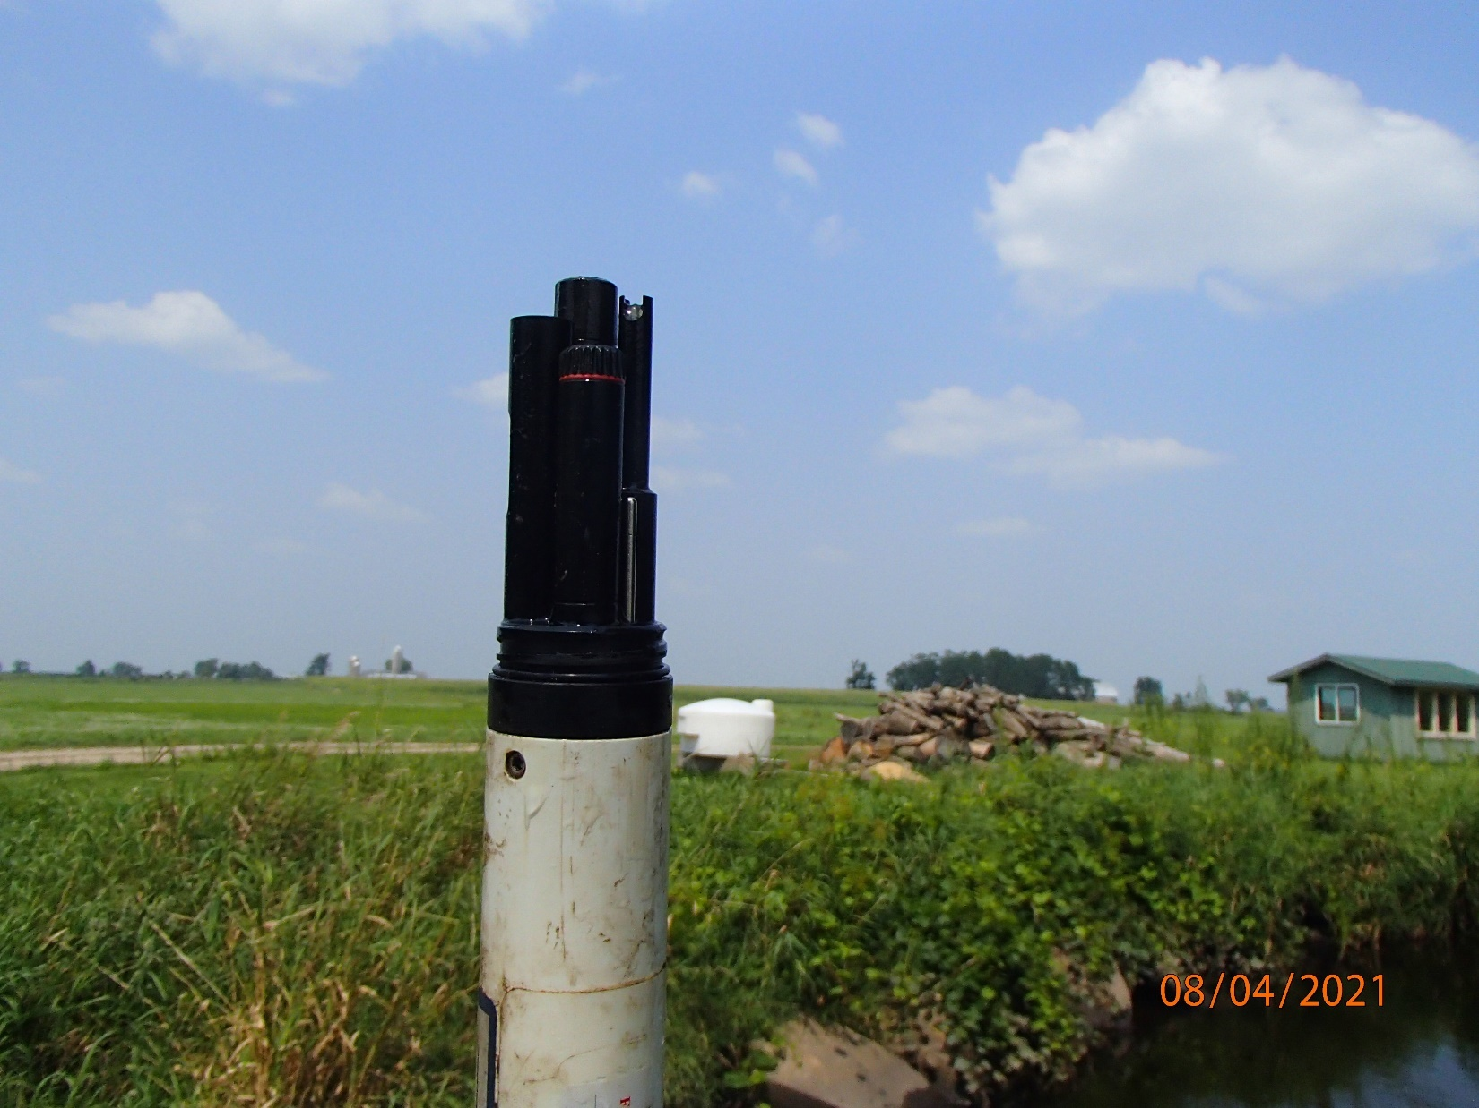
Photo 12: Multiparameter Sonde Post-Deployment in Pine River at Anderson Farm Road.

Chart 17: Lower Pine River at 9th Ave 5-Day Deployment Dissolved Oxygen Corrected for Total Drift.

Chart 18: Lower Pine River at 9th Ave 5-Day Deployment Dissolved Oxygen Corrected for Total Drift.

Similar to the Summer of 2021, in August 2023, a longitudinal water chemistry survey of Willow Creek upstream and through the Auroraville Millpond was conducted for a total of 11 monitoring events (Map 13, Table 27). The longitudinal profile of Willow Creek upstream of Hwy 49 indicate significant changes in the DO concentration and % Saturation from upstream to downstream. On August 17th, 2023, the profile began at the 29th Lane road crossing of Willow Creek, monitoring in the downstream direction. The DO concentration and % Saturation at 29th Lane was measured at ~8 mg/L and ~90%, respectively, and remained near that level until the Auroraville Millpond (Table 27, Chart 19). As the survey continued through the Auroraville Millpond (locations 7-10 on Map 13), the DO and % Saturation dropped dramatically to below WQC. This DO sag and associated organic load as the water flows through the millpond is a significant driver of the decline in water quality downstream of Auroraville.

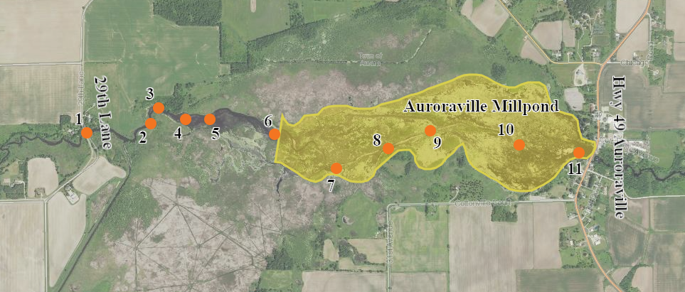
Map 13: Longitudinal Water Chemistry Survey Locations of Willow Creek in August 2023.

Location | DO mg/L | DO % Saturation | Temp ˚F | pH | Sp Cond uS/cm | Latitude | Longitude
29th Lane (1) | 8.34 | 94.1 | 66.9 | 7.98 | 380 | N44.05569 | W-89.02858
2 | 8.03 | 90.7 | 67 | 7.74 | 380 | N44.05614 | W-89.02378
3 | 8.05 | 91.2 | 67 | 8.03 | 381 | N44.05696 | W-89.02325
4 | 8.02 | 90.3 | 67 | 8.07 | 381 | N44.05634 | W-89.02126
5 | 7.81 | 87.9 | 67.3 | 8.02 | 382 | N44.05635 | W-89.01944
6 | 7.12 | 80.7 | 67.4 | 7.93 | 382 | N 44.05548 | W-89.0147
7 | 5.67 | 65.1 | 68.3 | 7.48 | 376 | N44.05367 | W-89.0102
8 | 4.05 | 46.3 | 68.4 | 7.42 | 377 | N44.05468 | W-89.00634
9 | 4.11 | 47.4 | 68.5 | 7.42 | 378 | N 44.05558 | W-89.00325
10 | 3.76 | 43.3 | 68.9 | 7.48 | 378 | N44.05479 | W-88.99674
11 | 6.11 | 70.6 | 68.8 | 7.61 | 372 | N44.05432 | W-88.99237
Table 27: Longitudinal Water Chemistry Survey of Willow Creek Upstream and Through the Auroraville Millpond in August 2023.

Chart 19: Longitudinal Water Chemistry Survey of Willow Creek Upstream and Through the Auroraville Millpond in August 2023.

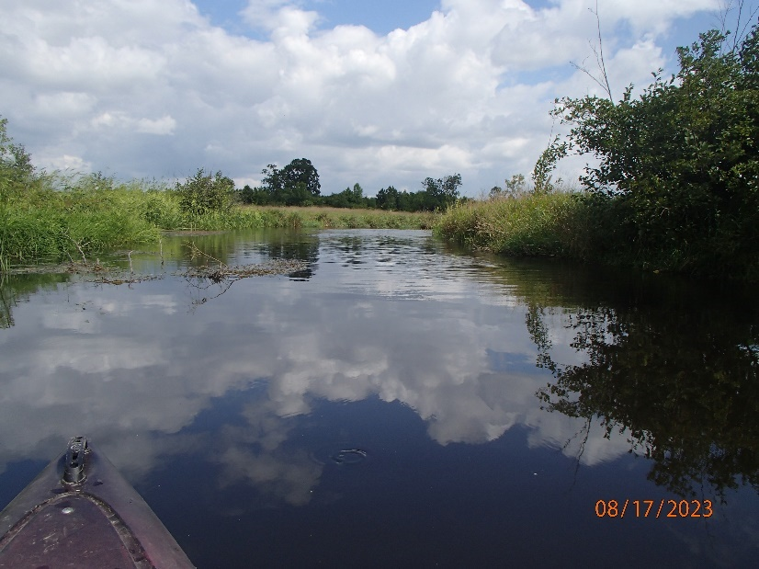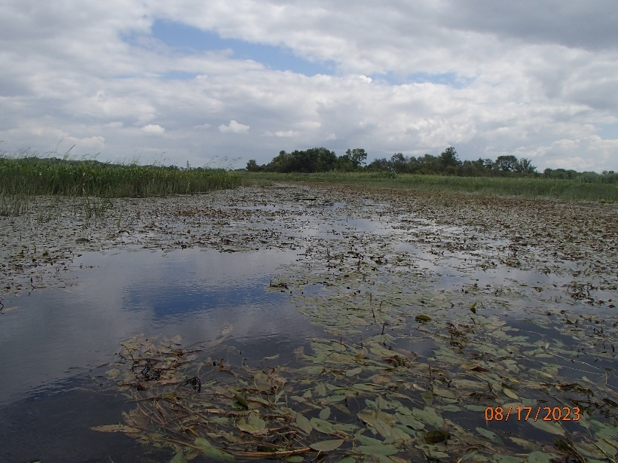
Photo 13-14: Willow Creek at 29th Lane (Left) and in Auroraville Millpond (Right). Photos taken by D. Bolha on August 17th, 2023.

Conclusions

- Dissolved oxygen levels observed in 4 Pool Lake Tributaries were not suitable for a healthy and robust fish community.
- The recent high water levels cannot be ruled out as a driver of poor water quality.
- Auroraville Millpond a significant driver of the water quality in Willow Creek.
- Deploying multiparameter sondes can be a useful tool for assessing water quality in flowing systems.

Management Recommendations

- Reduce the thermal and organic loading impact from Auroraville Millpond to increase oxygen holding capacity of Willow Creek through the millpond and downstream.
- Collaborate with the Auroraville Dam owner and riparian landowners to develop a strategy that can meet the needs of all users and sustain a healthy and robust fish and aquatic life community.
- Collaborate with partners and other WDNR programs on ways to reduce impacts, including nonpoint sources, from riparian land uses.
- Conduct comparable stream profiles and fish community surveys during low water years.

Acknowledgements

A special thank you to Randal Piette, WDNR Large River Monitoring Coordinator, for his time and energy in helping conduct the non-wadable fish surveys. Also, a deep appreciation for the landowners who granted access to conduct water quality monitoring on their land.

References

Ott Hydromet. 2021. Personal communication with multiparameter sonde manufacturer on May 3rd, 2021.

WDNR. 2007. Guidelines for Deployment of Continuous Dissolved Oxygen Meters, Data Evaluation, and Storage.

WDNR. 2015. Nutrient Chemistry Grab Sampling Method V3.3.

WNDR. 2019. Guidelines for Assessing Fish Communities of Non-Wadeable Rivers in Wisconsin v3.2.
WDNR. 2022. Wisconsin Administrative Code ch. NR 102: Water Quality Standards for Wisconsin Surface Waters.

