Tony Evers, Governor
Adam N. Payne, Secretary
Telephone 608-266-2621
Toll Free 1-888-936-7463
TTY Access via relay - 711

State of Wisconsin
DEPARTMENT OF NATURAL RESOURCES
101 S. Webster Street
Box 7921
Madison WI 53707-7921

March 7, 2025

To whom it may concern:

In 2023 and 2024, Bear Lake in Waupaca County was part of the DNR - Directed Lakes Monitoring Program. Through this program, Bear Lake had several sampling procedures completed to help determine overall lake health. This report details the results of these sampling efforts which included the following: aquatic plant point intercept survey, aquatic invasive species survey, water quality sampling and shoreland habitat survey.

Lake Characteristics – Bear Lake, Waupaca County

Lake Type: Deep Lowland Drainage Lake
Surface Area: 194 acres
Maximum Depth: 62 feet
Mean Depth: 24 feet
Trophic State: Mesotrophic

Aquatic Plant – Point intercept Survey

Importance of Aquatic Plants
Aquatic plants form the foundation of healthy lake ecosystems. They not only protect water quality, but also produce life-giving oxygen. Aquatic plants are a lake's own filtering system, helping to clarify the water by absorbing nutrients like phosphorus and nitrogen that could stimulate algal blooms. Plant beds stabilize soft lake bottoms and prevent shoreline erosion by reducing the effect of waves and currents. Healthy native aquatic plant communities help prevent the establishment of invasive non­native plants such as Eurasian water milfoil and curly-leaf pondweed. Native aquatic plants also provide important reproductive, food, and cover habitat for fish, invertebrates, and wildlife. By leaving or restoring a natural buffer area of emergent vegetation along the shoreline, property owners can reduce erosion, help maintain water quality, and provide habitat and travel corridors for wildlife.

Point-Intercept Sampling Method
Based on area and depth specific to Bear Lake, we mapped a 623-point sampling grid over the entire lake surface area. Using a GPS, we navigated by boat to each of the pre-determined grid points. At each point we used a two-sided rake to sample approximately 1 foot along the bottom. The following information was collected at each sampling point: lake depth, substrate type, plant density and species present. Individual plant species were assigned a rake fullness value between 0-3 (figure 1). We also recorded visual sightings of species within six feet of the sample point, as well as any additional species seen in the lake during a general boat survey. For more detailed information on the point-intercept sampling method and how data were collected please visit: https://www3.uwsp.edu/cnr-ap/UWEXLakes/Documents/ecology/Aquatic%20Plants/PI-Protocol-2010.pdf

Frequency of occurrence reflects the percentage of times a species was found out of the total number of points sampled. Littoral frequency of occurrence (given in Table 1) indicates how often a species was found looking only at areas of the lake that can support plant growth (known as the "littoral zone"). The maximum depth of plant growth is the greatest depth at which plants were found in the lake. Species richness is a count of the total number of different plant species found in the lake. The Floristic Quality Index (FQI) is a metric that evaluates the closeness of the flora in a lake to that of an undisturbed condition (Table 2). The higher a FQI value, the closer that plant community is to an undisturbed ecosystem. Statewide and ecoregion averages are calculated from a subset of approximately 250 lakes across Wisconsin.

Table 1: Plant species detected during 2024 aquatic plant survey, Bear Lake, Waupaca County.
Common Name | Scientific Name | Growth Form (Floating, free floating, submerged, emergent) | % Frequency of Occurrence (Littoral)
Coontail | Ceratophyllum demersum | Submerged | 41.4
Wild Celery | Vallisneria americana | Submerged | 32.6
Muskgrasses | Chara sp. | Submerged | 30.8
Clasping-leaf Pondweed | Potamogeton richardsonii | Submerged | 22.5
Fries’ Pondweed | Potamogeton friesii | Submerged | 11.5
Variable Pondweed | Potamogeton gramineus | Submerged | 8.8
Slender Naiad | Najas flexilis | Submerged | 7.5
Common Bladderwort | Utricularia vulgaris | Free floating | 6.2
Flat-stem Pondweed | Potamogeton zosteriformis | Submerged | 5.7
Sago Pondweed | Stuckenia pectinata | Submerged | 5.3
Water Star-grass | Heteranthera dubia | Submerged | 4.0
White Water Crowfoot | Ranunculus aquatilis | Submerged | 4.0
White Water lily | Nymphaea odorata | Floating | 3.5
Common Waterweed | Elodea canadensis | Submerged | 3.1
Forked Duckweed | Lemna trisulca | Free floating | 2.6
Northern Water milfoil | Myriophyllum sibiricum | Submerged | 2.6
Water Marigold | Biden beckii | Submerged | 2.2
Common Watermeal | Wolffia columbiana | Free floating | 1.3
Small Duckweed | Lemna minor | Free floating | 1.3
Starry Stonewort* | Nitellopsis obtuse | Submerged | 0.9
Floating-leaf Pondweed | Potamogeton natans | Floating | 0.4
Hardstem Bulrush | Schoenoplectus acutus | Emergent | 0.4
Large Duckweed | Spirodela polyrhiza | Free floating | 0.4
Spatterdock | Nuphar variegata | Floating | 0.4
Stoneworts | Nitella spp. | Submerged | 0.4
White-stem Pondweed | Potamogeton praelongus | Submerged | 0.4
Common Bur-reed | Sparganium eurycarpum | Emergent | visual
Large-leaf Pondweed | Potamogeton amplifolius | Submerged | visual
* = species is non-native and potentially invasive in Wisconsin

Table 2: Aquatic plant summary statistics (2024).
 | Bear Lake | Statewide Average | NCHF Ecoregion Average
Littoral Frequency of Occurrence (%) | 78.4% | 73.3% | 76%
Maximum Depth of Plant Growth (ft) | 21 | 15.3 | 15.9
Species Richness | 26 | 16.8 | 16.2
Floristic Quality Index (FQI) | 29.4 | 22.2 | 23.3

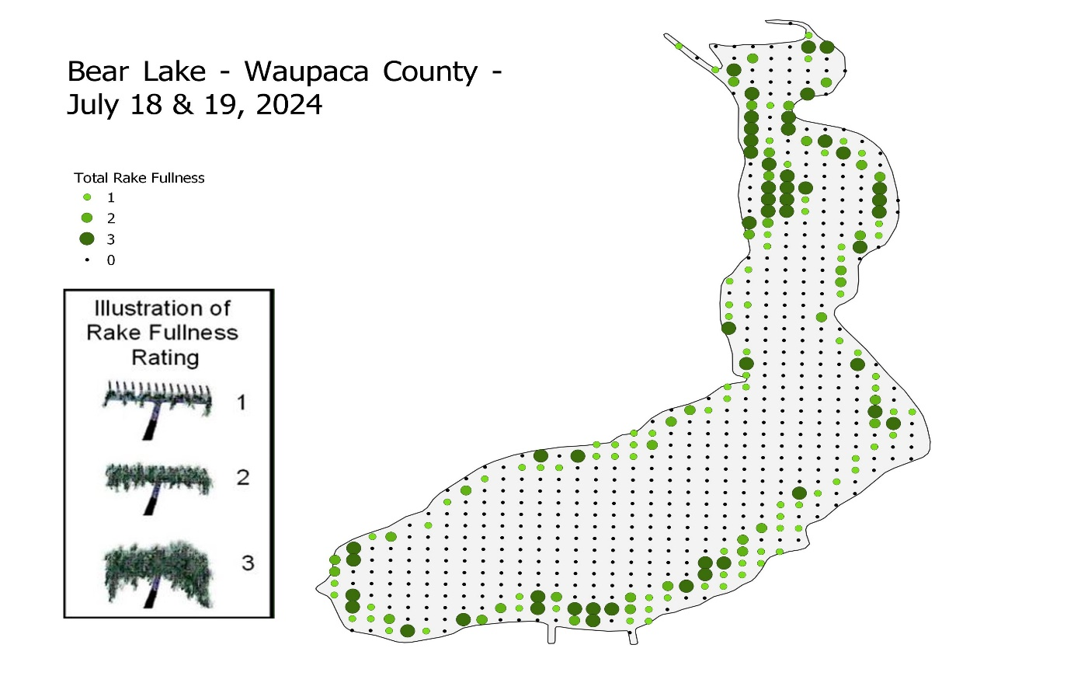
Figure 1: Plant Distribution Map with rake fullness ratings.
Plant Survey Results
Bear Lake has a relatively high frequency of occurrence in the littoral zone when compared to other lakes throughout the state and ecoregion (Tables 1 & 2). The species richness of Bear Lake is greater than the statewide and ecoregion averages with the most common species being Coontail (Ceratophyllum demersum), Wild Celery (Vallisneria americana), Muskgrasses (Chara spp.) and Clasping-leaf pondweed (Potamogeton richardsonii). This combination of high species richness and a diverse group of dominant plants, indicates a very healthy plant community. This can partly be attributed to the lake’s bathymetry, water quality, sediment types and degree of development.

Aquatic Invasive Species Survey

Early Detection Survey Method
Seven locations were selected for monitoring on Bear Lake. Two of the locations were automatically selected, they are the deepest point and the boat launch. Five other sites were selected at random within the littoral zone of the lake. At the boat launch and the random sites, rakes and a D-net were used for ten minutes intervals to sample for any invasive species. At the deepest point on the lake, plankton net tows were conducted for zebra mussel veligers and spiny waterfleas.

AIS Survey Results
Chinese mystery snails, banded mystery snails, zebra mussels and purple loosestrife were reconfirmed to exist in Bear Lake. During the aquatic plant survey, there was a new finding of starry stonewort (Nitellopsis obtuse) at two locations (Figure 2). Starry stonewort is a submerged macroalgae that can cause nuisance conditions by outcompeting native vegetation and form monotypic stands. When found in areas with a healthy native plant community, Starry stonewort does not appear to cause significant problems. Given the current state of the aquatic plant community on Bear Lake, the isolated patches of Starry stonewort are not likely to cause problems.
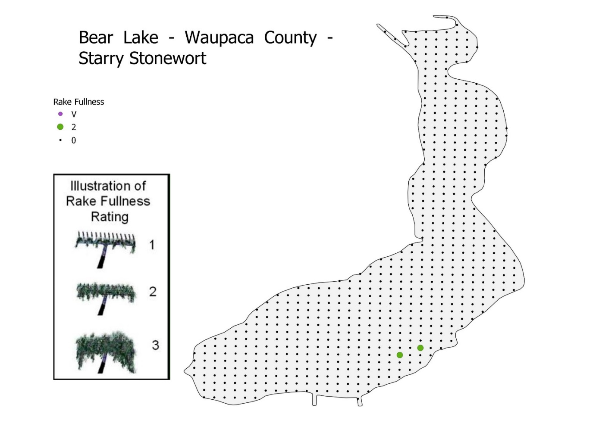
Figure 2: AIS distribution map illustrating the locations where starry stonewort was found.

Water Chemistry

The water chemistry of Bear Lake – Deep Hole Station (WBIC: 279700) was sampled on three different days per year during the 2023 and 2024 summer seasons for a total of 6 sampling events. Sample parameters included:

- Water clarity (secchi disc)
- Temperature
- Dissolved oxygen (D.O.)
- Total Phosphorus (TP)
- Chlorophyll a (Chl. a)
- One midsummer sample for: alkalinity, pH, conductivity, chloride, color, dissolved organic carbon, nitrate and nitrite as nitrogen, total nitrogen and hardness as CaCO₃.

There are three primary parameters that are evaluated when assessing the water quality of a lake: total phosphorus, chlorophyll-a and Secchi disk water clarity. These three parameters are closely correlated to each other and are used to determine the Trophic Status Index (TSI) of lakes. The three trophic states are as follows:

- Oligotrophic: TSI Range 1-40. Clear water, low nutrients, few plants.
- Mesotrophic: TSI Range 40-50. Moderately clear water, increased nutrient level, minor algal blooms.
- Eutrophic: TSI Range 50+. Less clear water, large amounts of plants & algae.
Table 3 contains the water quality results along with associated TSI values for sampling that took place 2023 and 2024. Average TSI values, for all parameters, clearly indicate that Bear Lake is in the mid-range of a mesotrophic state. Mesotrophic lakes are characterized as having moderately clear water with a diverse and healthy aquatic plant community.

Table 3: Water quality Results for sampling conducted by DNR staff in 2023 and 2024 (Station 693041).
Bear Lake – Deepest Point Station ID#: 693041
Date | Secchi depth (ft) | TSI (SD) | Total phosphorus (ug/L) | TSI (TP) | Chlorophyll-a (ug/L) | TSI (CHL) | Water color
7/25/2023 | 14.5 | 38 | 13 | 41 | 3.2 | 42 | BROWN
8/21/2023 | 11.5 | 42 | 19 | 46 | 3.8 | 44 | YELLOW
9/7/2023 | 10 | 44 | 19 | 46 | 5.8 | 48 | BROWN
2023 Avg. | 12 | 41 | 17 | 45 | 4.3 | 45
7/18/2024 | 9.5 | 45 | 22 | 48 | 4.2 | 45 | BROWN
8/22/2024 | 8.5 | 46 | 20 | 47 | 2.2 | 38 | YELLOW
9/4/2024 | 10.5 | 43 | 18 | 45 | 5.1 | 47 | YELLOW
2024 Avg. | 9.5 | 45 | 20 | 47 | 3.8 | 43
TSI(SD), TSI(CHL), TSI(TP) = Trophic state index based on SD, CHL, TP respectively; SD= Secchi depth measured in feet converted to meters; Chi = Chlorophyll a in micrograms per liter (ug/1); TP = Total phosphorus in ug/1, surface sample only.

Dissolved oxygen and temperature profiles were measured by DNR staff at the deep hole station (693041) from July to early September in both 2023 and 2024 (Table 4). During the summer months, lakes of this depth stratify with a gradient developing for both temperature and dissolved oxygen. During periods of stratification, the surface waters (epilimnion) are much warmer and resist mixing with deeper bottom waters (hypolimnion). Without this mixing effect, the hypolimnion is much colder and the decomposition of organic matter from lakebed sediments has the effect of lowering dissolved oxygen levels. This reduction in dissolved oxygen is normal for mesotrophic lakes and is commonly seen throughout the state. During this study, dissolved oxygen levels remained high enough (>3.0 mg/l) in the upper 15-30 feet of the water column to support aquatic life. In addition, there is no record of fish kills occurring from low dissolved oxygen in Bear Lake.

As part of the profile sampling, pH values were also taken at one-meter intervals (Table 4). The pH scale ranges from 0 to 14 with a value of 7 being neutral. Values below 7 are considered acidic while greater than 7 are basic or alkaline. Bear Lake’s pH ranged from 7.3 to 8.7 over the two-year study period and, like most area lakes, is considered to be slightly alkaline. The reason why the pH dropped below 8 is likely due organic matter decomposition from the lakebed sediments releasing greater amounts of carbon dioxide than exist in the surface waters. The increase in carbon dioxide is also evident with the simultaneous lowering of dissolved oxygen. Carbon dioxide lowers pH by dissolving in water and forming carbonic acid. This process increases the concentration of hydrogen ions which leads to a more acidic solution, hence lowering pH.

Other water quality sampling parameters were collected as part of this study. These parameters included the following: Nitrate/nitrate, total nitrogen, alkalinity, chloride, calcium, magnesium, hardness and dissolved organic carbon (Table 5). Not surprisingly, values for hardness and alkalinity were high indicating that Bear Lake’s hydrology is largely fed by very basic limestone or dolomitic parent materials (bedrock). This is the case with most lakes located in Central Wisconsin. All other values were in the normal range and are not of particular concern. Comparison of total nitrogen to total phosphorus concentration values from Bear Lake indicate a nitrogen:phosphorus ratio of 35:1. This finding clearly shows that Bear Lake is phosphorus limited as are the vast majority of Wisconsin lakes.

Table 4. Bear Lake dissolved oxygen and temperature profiles for 2023 and 2024 (Station 693041).

7/25/2023 |  |  |  |  | 8/21/2023 |  |  |  |  | 9/7/2023
Depth (M) | Temperature (F) | Dissolved oxygen (mg/L) | pH |  | Depth (M) | Temperature (F) | Dissolved oxygen (mg/L) | pH |  | Depth (M) | Temperature (F) | Dissolved oxygen (mg/L) | pH
1 | 77.9 | 9.9 | 8.7 |  | 1 | 75.6 | 9.6 | 8.6 |  | 1 | 74.1 | 8.6 | 8.5
2 | 77.4 | 9.9 | 8.7 |  | 2 | 75.2 | 9.6 | 8.6 |  | 2 | 74.1 | 8.6 | 8.5
3 | 75.6 | 9.7 | 8.7 |  | 3 | 74.3 | 9.3 | 8.5 |  | 3 | 74.1 | 8.6 | 8.5
4 | 74.1 | 8.6 | 8.5 |  | 4 | 73.2 | 8.9 | 8.5 |  | 4 | 73.6 | 7.5 | 8.3
5 | 65.1 | 8.4 | 8.0 |  | 5 | 70.9 | 7.4 | 8.2 |  | 5 | 70.7 | 5.5 | 8.0
6 | 57.7 | 13.8 | 8.4 |  | 6 | 61.5 | 3.4 | 7.6 |  | 6 | 64.4 | 0.9 | 7.4
7 | 53.2 | 8.1 | 8.0 |  | 7 | 55.0 | 4.1 | 7.6 |  | 7 | 57.0 | 0.6 | 7.4
8 | 49.1 | 4.2 | 7.8 |  | 8 | 50.7 | 1.6 | 7.5 |  | 8 | 51.1 | 0.6 | 7.4
9 | 46.4 | 2.2 | 7.6 |  | 9 | 48.7 | 0.8 | 7.5 |  | 9 | 48.6 | 0.6 | 7.4
10 | 45.0 | 0.8 | 7.6 |  | 10 | 46.0 | 0.7 | 7.4 |  | 10 | 47.3 | 0.6 | 7.4
11 | 44.4 | 0.7 | 7.6 |  | 11 | 44.8 | 0.6 | 7.4 |  | 11 | 45.5 | 0.6 | 7.4
12 | 44.1 | 0.7 | 7.5 |  | 12 | 44.4 | 0.6 | 7.4 |  | 12 | 44.4 | 0.6 | 7.4
13 | 43.9 | 0.7 | 7.5 |  | 13 | 44.1 | 0.6 | 7.4 |  | 13 | 44.2 | 0.6 | 7.4
14 | 43.7 | 0.6 | 7.5 |  | 14 | 44.1 | 0.6 | 7.4 |  | 14 | 44.1 | 0.6 | 7.4
15 | 43.7 | 0.6 | 7.5 |  | 15 | 43.9 | 0.6 | 7.4 |  | 15 | 44.1 | 0.6 | 7.4
16 | 43.5 | 0.6 | 7.5 |  | 16 | 43.9 | 0.6 | 7.4 |  | 16 | 44.1 | 0.6 | 7.4
17 | 43.5 | 0.6 | 7.5 |  | 17 | 43.7 | 0.6 | 7.4 |  | 17 | 43.9 | 0.6 | 7.4
18 | 43.5 | 0.6 | 7.5 |  | 18 | 43.7 | 0.6 | 7.4 |  | 18 | 43.9 | 0.6 | 7.3

7/18/2024 |  |  |  |  | 8/22/2024 |  |  |  |  | 9/4/2024
Depth (M) | Temperature (F) | Dissolved oxygen (mg/L) | pH |  | Depth (M) | Temperature (F) | Dissolved oxygen (mg/L) | pH |  | Depth (M) | Temperature (F) | Dissolved oxygen (mg/L) | pH
1 | 78.4 | 8.4 | 8.4 |  | 1 | 73.6 | 8.5 | 8.2 |  | 1 | 72.9 | 8.8 | 8.1
2 | 77.7 | 8.3 | 8.4 |  | 2 | 73.2 | 8.2 | 8.1 |  | 2 | 72.7 | 8.7 | 8.1
3 | 77.0 | 8.3 | 8.4 |  | 3 | 72.5 | 6.6 | 7.8 |  | 3 | 72.5 | 8.6 | 8.0
4 | 69.1 | 2.7 | 7.6 |  | 4 | 70.7 | 3.4 | 7.4 |  | 4 | 71.2 | 5.0 | 7.6
5 | 66.4 | 1.2 | 7.5 |  | 5 | 66.7 | 3.3 | 7.5 |  | 5 | 67.3 | 2.0 | 7.4
6 | 59.7 | 0.6 | 7.5 |  | 6 | 61.9 | 0.8 | 7.3 |  | 6 | 61.5 | 0.9 | 7.4
7 | 54.7 | 0.7 | 7.5 |  | 7 | 56.7 | 0.6 | 7.4 |  | 7 | 56.5 | 0.7 | 7.4
8 | 52.2 | 0.8 | 7.5 |  | 8 | 53.2 | 0.6 | 7.4 |  | 8 | 53.4 | 0.6 | 7.3
9 | 50.0 | 0.8 | 7.5 |  | 9 | 50.0 | 0.6 | 7.4 |  | 9 | 49.6 | 0.6 | 7.3
10 | 48.6 | 0.6 | 7.5 |  | 10 | 48.7 | 0.6 | 7.4 |  | 10 | 47.5 | 0.6 | 7.3
11 | 46.6 | 0.6 | 7.5 |  | 11 | 46.6 | 0.6 | 7.4 |  | 11 | 46.4 | 0.6 | 7.3
12 | 45.9 | 0.6 | 7.6 |  | 12 | 46.0 | 0.6 | 7.4 |  | 12 | 45.7 | 0.6 | 7.3
13 | 45.5 | 0.6 | 7.6 |  | 13 | 45.5 | 0.6 | 7.3 |  | 13 | 45.5 | 0.6 | 7.3
14 | 45.3 | 0.6 | 7.6 |  | 14 | 45.3 | 0.6 | 7.3 |  | 14 | 45.5 | 0.6 | 7.3
15 | 45.1 | 0.6 | 7.6 |  | 15 | 45.1 | 0.6 | 7.3 |  | 15 | 45.3 | 0.6 | 7.3
16 | 45.0 | 0.6 | 7.6 |  | 16 | 45.1 | 0.6 | 7.3 |  | 16 | 45.3 | 0.6 | 7.3
17 | 45.0 | 0.6 | 7.6 |  | 17 | 45.1 | 0.6 | 7.3 |  | 17 | 45.1 | 0.6 | 7.3
18 | 44.8 | 0.6 | 7.6 |  | 18 | 45.0 | 0.6 | 7.3 |  | 18 | 45.1 | 0.6 | 7.3

Table 5. Additional water quality data collected from Bear Lake in 2023 and 2024 ((Station 693041).

Date | NO₃ + NO₂ (mg/l) | TN (mg/l) | Alkalinity (mg/l) | Chloride (mg/l) | Calcium (mg/l) | Magnesium (mg/l) | Hardness (mg/l) | DOC (ppm)
8/21/2023 | ND* | 0.619 | 181 | 12 | 35.3 | 26.6 | 198 | 7.23
8/22/2024 | ND* | 0.685 | 151
* - below the limit of detection

Shoreland Habitat

As part of this project, shoreland habitat was evaluated and the quality and complexity of downed trees (coarse woody debris) were recorded and geospatially mapped (Figure 3). As compared to other area lakes, Bear Lake has very good habitat. Large communities of emergent and floating leafed plant communities exist along both the developed and undeveloped shorelines of the lake. Dominant species include both white and yellow (spadderdock) water lilies, common bur-reed and hardstem bulrush. Protection of these communities should be a priority to the lake residents as they directly effect the quality of the fishery along with protecting shorelines from erosion. In addition, these plant communities provide critical water quality and ecological benefits to the lake.

Figure 3 shows the locations of 133 separate pieces of downed trees (coarse woody debris) that were located and mapped with the lake. These trees were found in clusters primarily along the undeveloped western shoreline of the lake. Many scientific studies have been conducted on the importance of downed trees in lakes. The following is a partial list of some of the ecological benefits that downed trees provide:

- Habitat – submerged trees provide critical shelter for young-of-the-year fish, birds, amphibians, and turtles.
- Water quality – submerged trees can filter water by trapping sediment and lowering wave energy that can erode shorelines. The surface of downed trees provides a place for beneficial algae called periphyton to grow. Periphyton tie up phosphorus that otherwise would lower water quality.
- Food Source: decaying wood supports a diverse food web, including insects and invertebrates that are critical food for fish and other organisms.

Conclusions

The results of this study indicate that Bear Lake has good water quality and above average habitat for lakes located in Central Wisconsin. It is recommended to conduct a similar water quality study within the next 5-10 years. Water quality studies are important to repeat as it allows for trend analysis. In other words, future studies can be compared to the one DNR completed in 2023-2024. It is important to know if any changes to water quality or habitat are occurring over time. For example, if the water quality of Bear Lake decreases, it may be necessary to undertake active management to reverse this potential negative trend.

If you have any questions regarding the survey results from Bear Lake, please feel free to contact me at 920-362-0181 or at TedM.Johnson@wisconsin.gov.


Lakes Biologist - WDNR
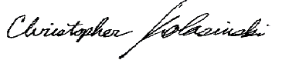
Water Resources Management Specialist - WDNR
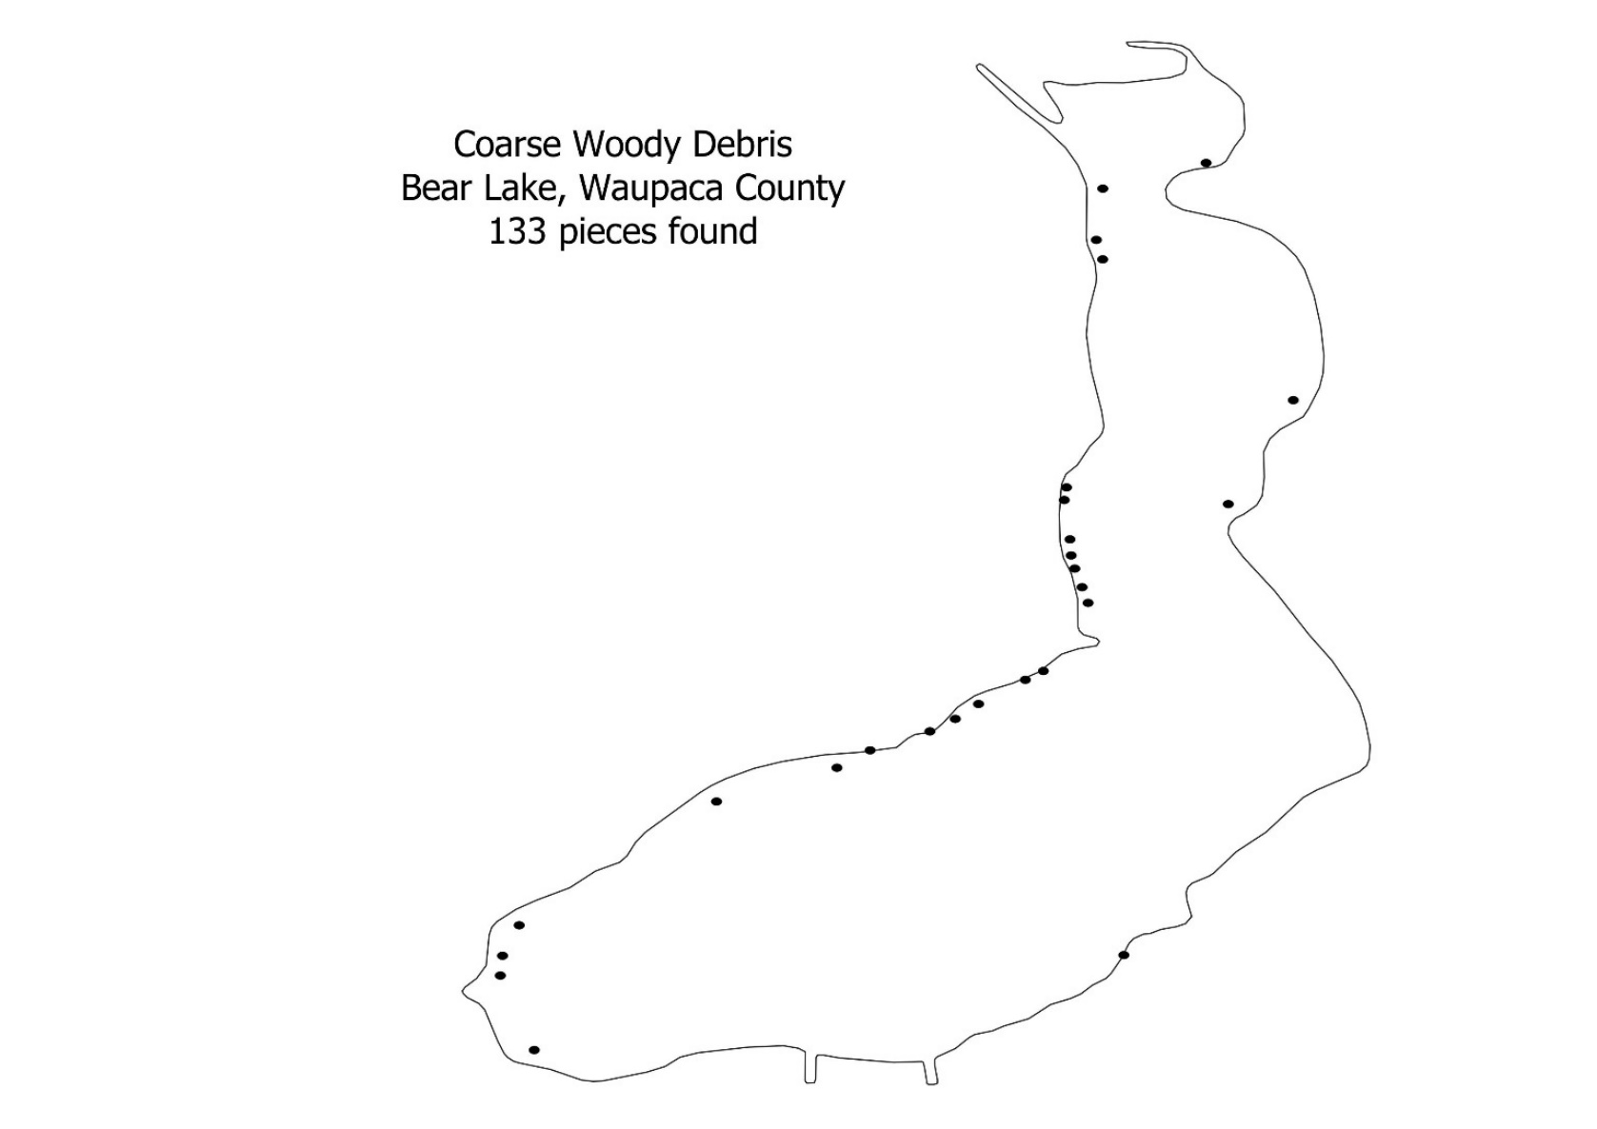

Figure 3. Locations of 133 pieces of woody debris found in Bear Lake on May 31, 2023.

