

DATE: October 2nd, 2026 FILE REF: NA

TO: Sarah Luck, Limit Calculator; Kenzie Ostien, Compliance Engineer

FROM: Kimberly Kuber, Stream Biologist; Diane Figiel, Limit Calculator Coordinator; Justin Chenevert, Waterbody Assessment Coordinator

SUBJECT: Spring Green Golf Club Sanitary District #2 WWTF, Unnamed Tributary of Lowery Creek (WBIC 1241450), Sauk County

Overview of issue
In preparation for reissuance of the Spring Green Golf Club Sanitary District #2 WWTF permit, staff were requested to do a site visit to determine the appropriate stream classifications for the receiving waters. Spring Green Golf Club is a continuous discharger, with an annual average design flow of 0.089 MGD (0.138 cubic feet per second (cfs)).

The immediate receiving water is an Unnamed Tributary to Lowery Creek (WBIC 1241450) (Segment 1 on Map 1). From the outfall, the Unnamed Tributary flows 0.2 miles east before meeting Lowery Creek. From the confluence, Lowery Creek flows 0.2 miles south and then joins the Wisconsin River (Segment 2 on Figure 1). The Unnamed Tributary and Lowery Creek are not listed in ch. NR 104. The facility’s previous permit limits were based on limited aquatic life (LAL), with downstream protection limits for ammonia and phosphorus for Lowery Creek.

A site visit to the Unnamed Tributary to Lowery Creek (WBIC 1241450) was conducted by Kimberly Kuber (Water Quality Biologist) on September 2, 2025, and a fish survey and qualitative habitat survey were completed by Kimberly Kuber and Camille Bruhn (Water Quality Biologist) on September 3, 2025. The main objective of these site visits was to determine the appropriate Natural Community and Designated Use for this Unnamed Tributary.

Summary of previous and proposed stream class recommendations
- Segment 1: Unnamed Tributary to Lowery Creek (WBIC 1241450)
  - Currently codified Designated Use: not in ch. NR 104 as LAL or LFF and not classified as trout water
  - Classification used for previous permit issuance: LAL
  - Previous stream class recommendations: LAL, from the outfall in the NW ¼ NW ¼ T8N R4E S30 to the confluence with Lowery Creek
  - Modeled Natural Community: Cool Cold Headwater
  - New recommended Natural Community and Designated Use: Macroinvertebrate NC, LAL DU
- Segment 2: Lowery Creek (WBIC 1241400) (0.2 mile downstream from the outfall location)
  - Currently codified Designated Use: not in ch. NR 104 as LAL or LFF and not classified as trout water
  - Classification used for previous permit issuance: Warm Water Sport Fish Community
  - Previous stream class recommendations: None
  - Modeled Natural Community: Cool Cold Mainstem
  - New recommended Natural Community & Designated Use: Cool Warm Mainstem, Warm Water Sport Fish DU

Site overview map

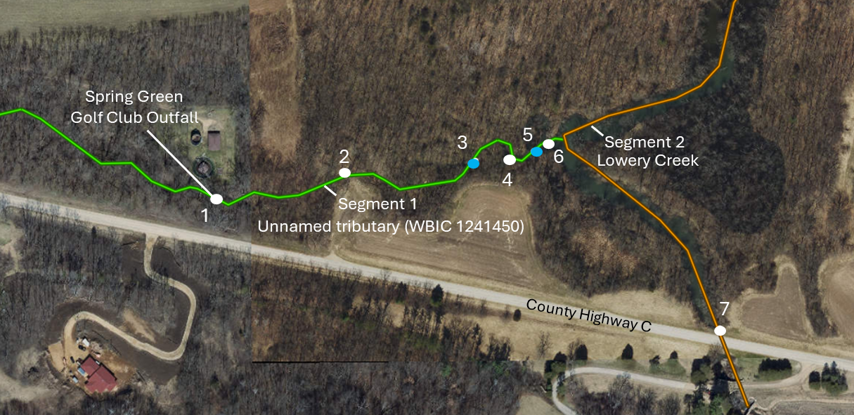
Figure 1. Map of Unnamed Tributary to Lowery Creek (WBIC 1241450) and its connection to mainstem Lowery Creek showing the breakdown of the segments evaluated on September 2nd and 3rd, 2025. The green thread represents Segment 1 and the orange thread represents Segment 2. White dots indicate locations where photos were taken. Blue dots indicate the start and end points of the fish survey. More specific information about these locations can be found in Table 1. Imagery from Surface Water Data Viewer.

Table 1. Locations where photos and data were collected during site visits on September 2nd and 3rd, 2025.
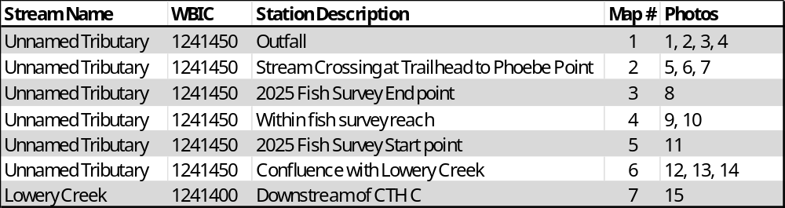
Table 2. Water chemistry parameters measured during site visit on September 2, 2025.
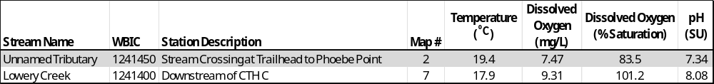

Site observations and habitat survey results
Segment 1: Unnamed Tributary to Lowery Creek (WBIC 1241450)
The Spring Green Golf Club Sanitary District outfall is the origin of Unnamed Tributary to Lowery Creek (WBIC 1241450) (Point 1 on map, Photos 1 and 2). No flow was observed in the dry channel upstream of the wastewater treatment outfall, which also had abundant terrestrial plant growth (Photo 3). Neither flow nor water quality parameters were measured at the outfall due to insufficient water depth (Photo 4). Unnamed Tributary to Lowery Creek (WBIC 1241450) has an overall watershed size of 0.5 square miles and based on data from the facility, an estimated average flow rate of 0.026 MGD (0.017 cfs) in 2025. In the week prior to the field visit on September 2 and 3, 2025, the flow rate was slightly higher than the average at 0.035 MGD (0.023 cfs).

Downstream of the outfall to Unnamed Tributary (WBIC 1241450) at the trailhead to the Phoebe Point segment of the Driftless Trail, there is a stream crossing comprised of two culverts. Water was flowing through the left culvert (when facing downstream) (Point 2 on site map, Photo 6). There was no flow in the right culvert, but the bottom of the culvert tube was wet. On the downstream end of the culvert, there was enough depth to collect water chemistry information (Table 2). The parameters measured were within typical ranges for this region.

A qualitative habitat survey was completed and scored 40, rating fair (Table 3). The stream flows through a well buffered forested corridor before it meets Lowery Creek and it did not exhibit significant bank erosion, so it rated excellent for both metrics. It rated good for width to depth ratio but received poor scores in other metrics due to lack of pool areas, the monotonous nature of the habitat, abundant fine sediments, and lack of cover for fish. The bottom substrate consisted primarily of sand, with some silt in the margins. The stream channel was narrow and shallow, on average approximately one foot wide and less than one inch deep.

Table 3. Qualitative habitat survey results for Unnamed Tributary (WBIC 1241450) within the fish survey reach.
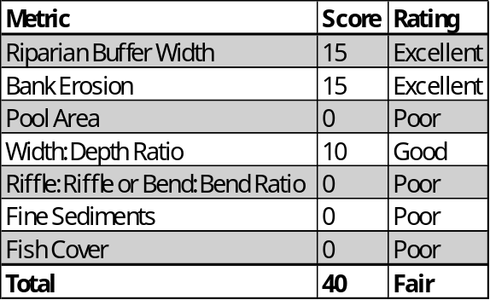

Segment 2: Lowery Creek (WBIC 1241400) (0.2 miles downstream from the Outfall location)
There was a beaver dam on Lowery Creek immediately downstream of where the Unnamed Tributary flows into Lowery Creek (Photo 13). This was impounding water into the mouth of Unnamed Tributary (WBIC 1241450) (Photo 12).

This segment was not evaluated as part of this site visit; however, water chemistry was measured less than 0.1 miles upstream on Lowery Creek on the south side of the County Highway C bridge (Photo 15, Table 2). Water quality parameters were all within normal ranges observed in this system.
A qualitative habitat survey was completed upstream of the confluence with Unnamed Tributary (WBIC 1241450) in 2021 and scored 30, rating fair (Table 4). The stream flowed through a forested meadow corridor and had some wide meanders. The bottom substrate was comprised mostly of clayey silt and fine sand, which made for difficult wading conditions. Bank height ranged from 1-6 feet. The stream had a well-protected riparian corridor with some muddy benches with vegetated banks, while other areas were grassed and stable. Extensive sedimentation was evident throughout this reach. Fish habitat was generally lacking, despite the presence of some woody debris. The Taliesin Pond upstream of this segment was recently drained at the time of the survey, which potentially influenced the fish survey results.

Table 4. Results from qualitative habitat survey conducted on June 7, 2021, by water quality staff.
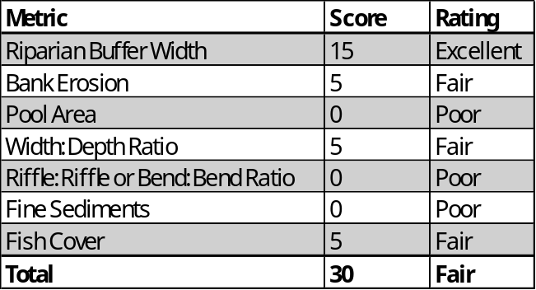

Fish survey results
Segment 1: Unnamed Tributary to Lowery Creek (WBIC 1241450)
Pulsed DC backpack electrofishing gear was used to shock approximately 100 meters of Unnamed Tributary to Lowery Creek (WBIC 1241450) on September 3, 2025. The stream was narrow and shallow with limited flow and no fish were captured (Table 5).

A portion of this segment was also surveyed by Jean Unmuth (Retired Water Quality Biologist) on July 5, 2018. A 20-meter segment was shocked using backpack electrofishing gear and no fish were captured. Survey notes indicated that there was no flow, the stream was intermittent, and stagnant pools were observed.

Segment 2: Lowery Creek (WBIC 1241400) (0.2 of a mile downstream from the Outfall location)

A fish survey was not completed in this segment as part of this evaluation. However, there is data available from fish surveys completed immediately upstream of the confluence of Lowery Creek and the Unnamed Tributary in 2018 and 2021.

On July 5, 2018, a fish survey was conducted by water quality staff using pulsed DC backpack electrofishing gear. A 96-meter segment of Lowery Creek was shocked and eleven species of fish were captured, all of which are associated with medium to large streams (Table 6). Smallmouth bass were the most abundant species found in the survey. A single tolerant individual, a white sucker, was captured. All other fish captured are considered intolerant or intermediately tolerant to environmental degradation. This survey was not used to verify the Natural Community, nor was it used to calculate an Index of Biotic Integrity (IBI) score because the survey was shorter than the minimum station length requirement of 100 meters or 35 times the mean stream width.

A fish survey was conducted on June 7, 2021 by water quality staff using tow barge stream electrofishing equipment with two probes. A 160-meter segment was shocked and fourteen species were captured (Table 7). White sucker was the most abundant species, and bluegill were also common. A single individual of eleven other species were captured. A few coldwater individuals, brook trout and mottled sculpin, were present, however a majority of the fish captured were transitional or warmwater species. Most species were also indicative of medium to large streams, which is often the case when shocking the lower segments of tributaries to large rivers, like the Wisconsin River. The fish assemblage was comprised of mostly intermediate and tolerant species. Two intolerant species were present.

This stream segment is modeled as a cold transition mainstem. The fish assemblage captured indicates that this is a warm transition mainstem Natural Community. Therefore, the cool-warm IBI was applied and received a score of 60, rating good (Table 8). Note that the proportion of tolerant individuals was outside the expected range for the warm transition mainstem natural community. However, the fish assemblage captured does not fit with the modeled Natural Community (cold transition mainstem) either. The survey was completed under normal weather conditions and captured more warmwater fish and fewer coldwater fish (2 individuals) than would be expected for a cold transition mainstem. No coldwater species were captured in the 2018 survey at this location, providing additional support for a warm transition mainstem Natural Community.

Table 5. Summary of fish surveys completed by water quality staff in Segments 1 and 2, including date sampled, coordinates, station length, and gear used.
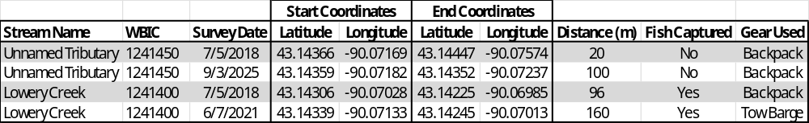

Table 6. Results from Lowery Creek fish survey conducted on July 5, 2018, by water quality staff prior to the Taliesin Pond draw down.
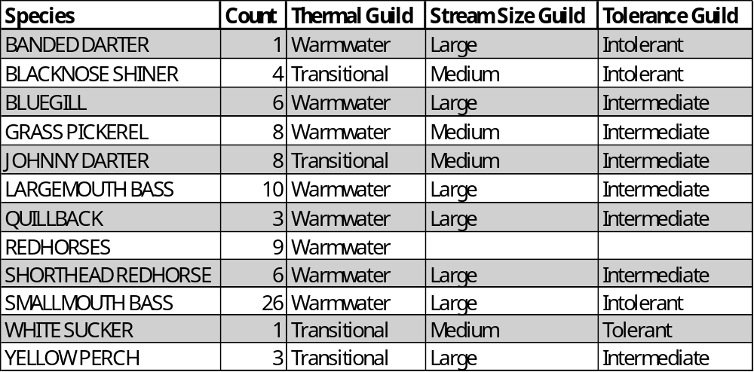

Table 7. Results from Lowery Creek fish survey conducted on June 7, 2021, by water quality staff, during the draw down of the Taliesin pond.
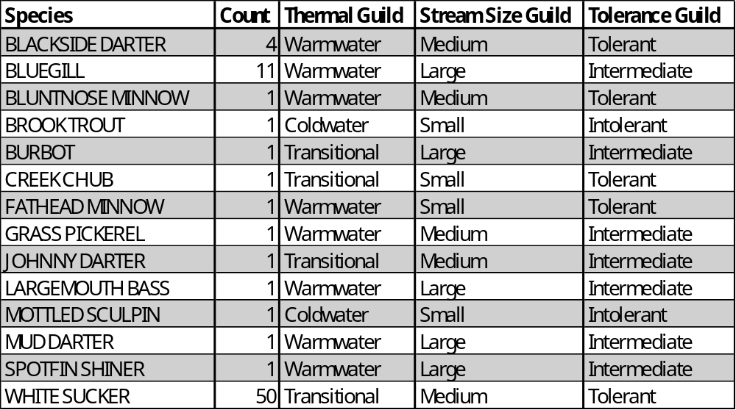

Table 8. Warm transitional IBI metric scores and ratings based on fish survey conducted on June 7, 2021, by water quality staff.
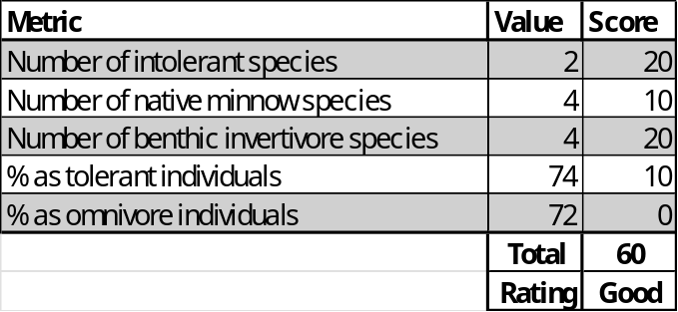

Discussion and Designated Use Recommendations
Note: Recommendations from this site visit are shown at the top of this memo.
Two fish surveys have been completed on Unnamed Tributary to Lowery Creek (WBIC 1241450) and neither caught fish. Habitat and flow are limited in this stream. The 2018 survey noted that the stream was intermittent with no flow and that only stagnant pools were present. Stream flow was observed at the time of the 2025 survey; however, the stream was so shallow that fish were unlikely to inhabit the stream. There was no flow observed upstream of the Spring Green Golf Club outfall and the overall watershed size is small.

Although the qualitative habitat scored fair, it is unlikely that this stream can support a fish community. Staff were unable to measure flow due to insufficient stream depth. On average, the stream was approximately one foot wide and less than one inch deep on September 2nd and 3rd, 2025. Despite being a continuous discharger, records indicate that effluent rates often fall below 0.03 cfs, which is the long-term average annual exceedance threshold that has been determined to be a good indicator of conditions suitable to support permanent fish populations. Pioneer species like brook stickleback, central mudminnow, creek chub, green sunfish, and fathead minnows are tolerant fishes that are often present in headwaters systems. None were observed in the Unnamed Tributary, providing some evidence that it should be considered LAL and classified as a Macroinvertebrate Natural Community.

Fish data is available for the lower segment of Lowery Creek, with surveys completed in 2018 and 2021. The Natural Community was unable to be verified for the 2018 survey, but the fish captured were mostly warmwater species, with some transitional species that inhabit medium to large streams. All but one individual fell within intolerant or intermediate tolerance guilds. The species assemblage from the 2021 survey indicates that the Natural Community is a cool-warm mainstem. The differences in survey results may be due in part to the different gears used and conditions at the time of these surveys. Survey crews using backpack electrofishing gear would likely have been limited to the margins of the stream, potentially preventing them from collecting fish in deeper areas of Lowery Creek. Water clarity differed between the two surveys as well. Transparency was 58 centimeters (cm) at the time of the 2018 survey and only 18 cm at the time of the survey conducted in 2021, which could be one of the reasons why fewer small fish were captured. Wading conditions were very difficult in this segment due to heavy amounts of silt.

Taliesin Pond was present for the 2018 fish survey on Lowery Creek, but the pond was drawn down in June 2019 for dam repair and maintenance and continued to be drawn down when this segment was surveyed in 2021. This may be another contributing factor to the differences in fish assemblages captured in Lowery Creek.

Are code changes and/or a Use Attainability Analysis needed?

Segment 1: Unnamed Tributary to Lowery Creek (WBIC 1241450)

Limited aquatic life is recommended for Segment 1 because the ditch’s poor habitat and low intermittent flows would not support a fish community. We recommend adding this segment to ch. NR 104 as an LAL. This would require a use attainability analysis (UAA) and a code revision. However, if effluent flows increased or became continuous, the designated use would need to be reevaluated.

Attachments
- Attachment 1: Photolog
- Attachment 2: Natural Community Verification Report

Attachment 1: Photolog

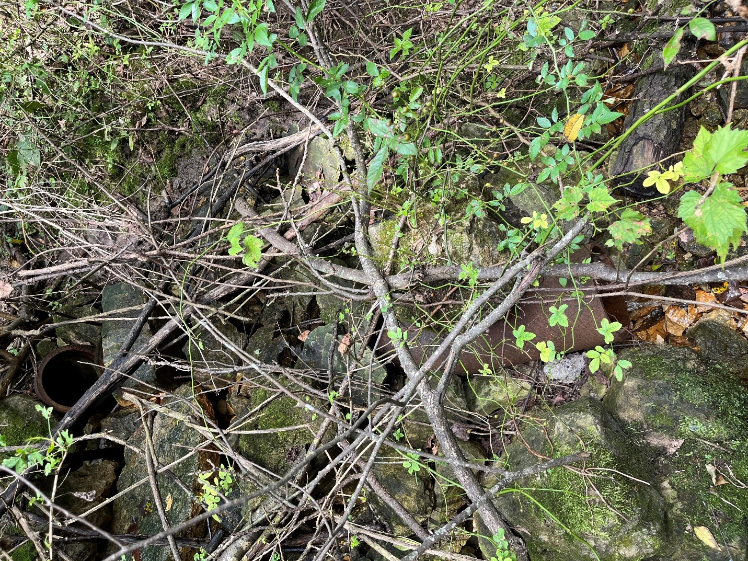
Photo 1. Spring Green Golf Club outfall zoomed in (Point 1 on map).

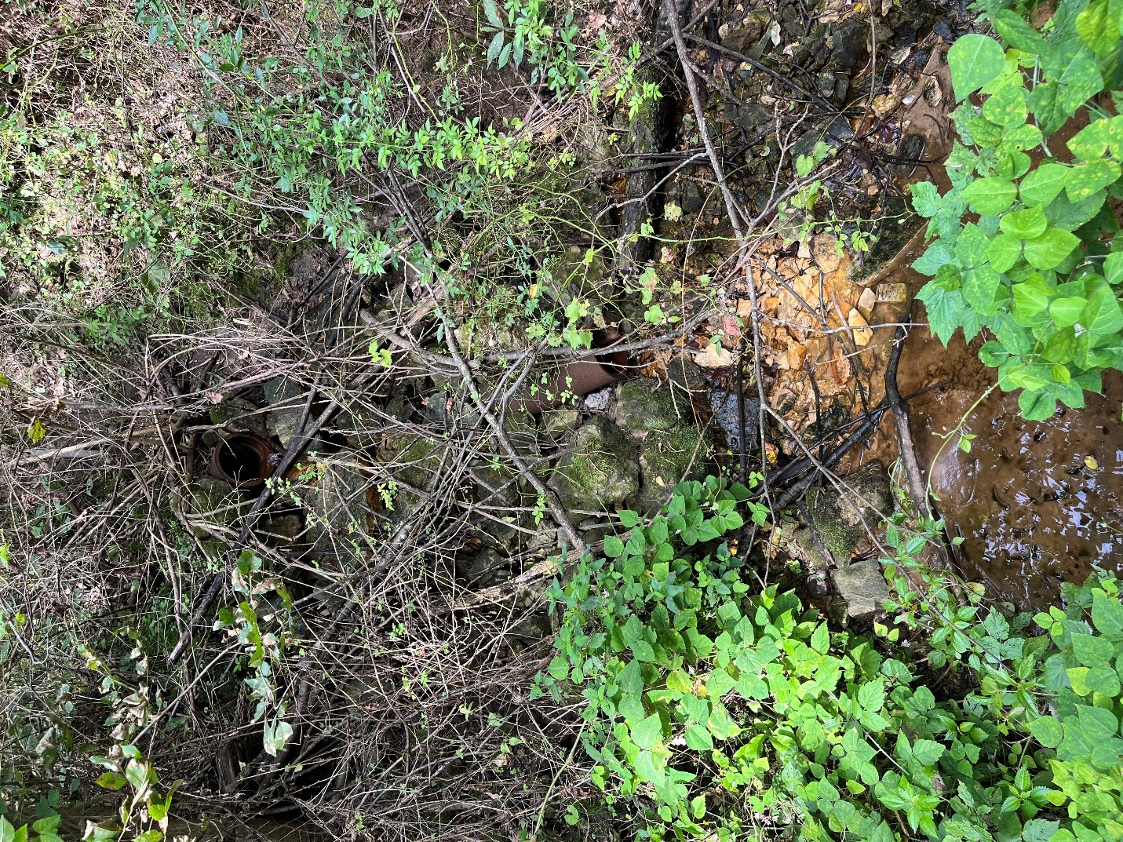
Photo 2. Spring Green Golf Club outfall pipes (Point 1 on map).

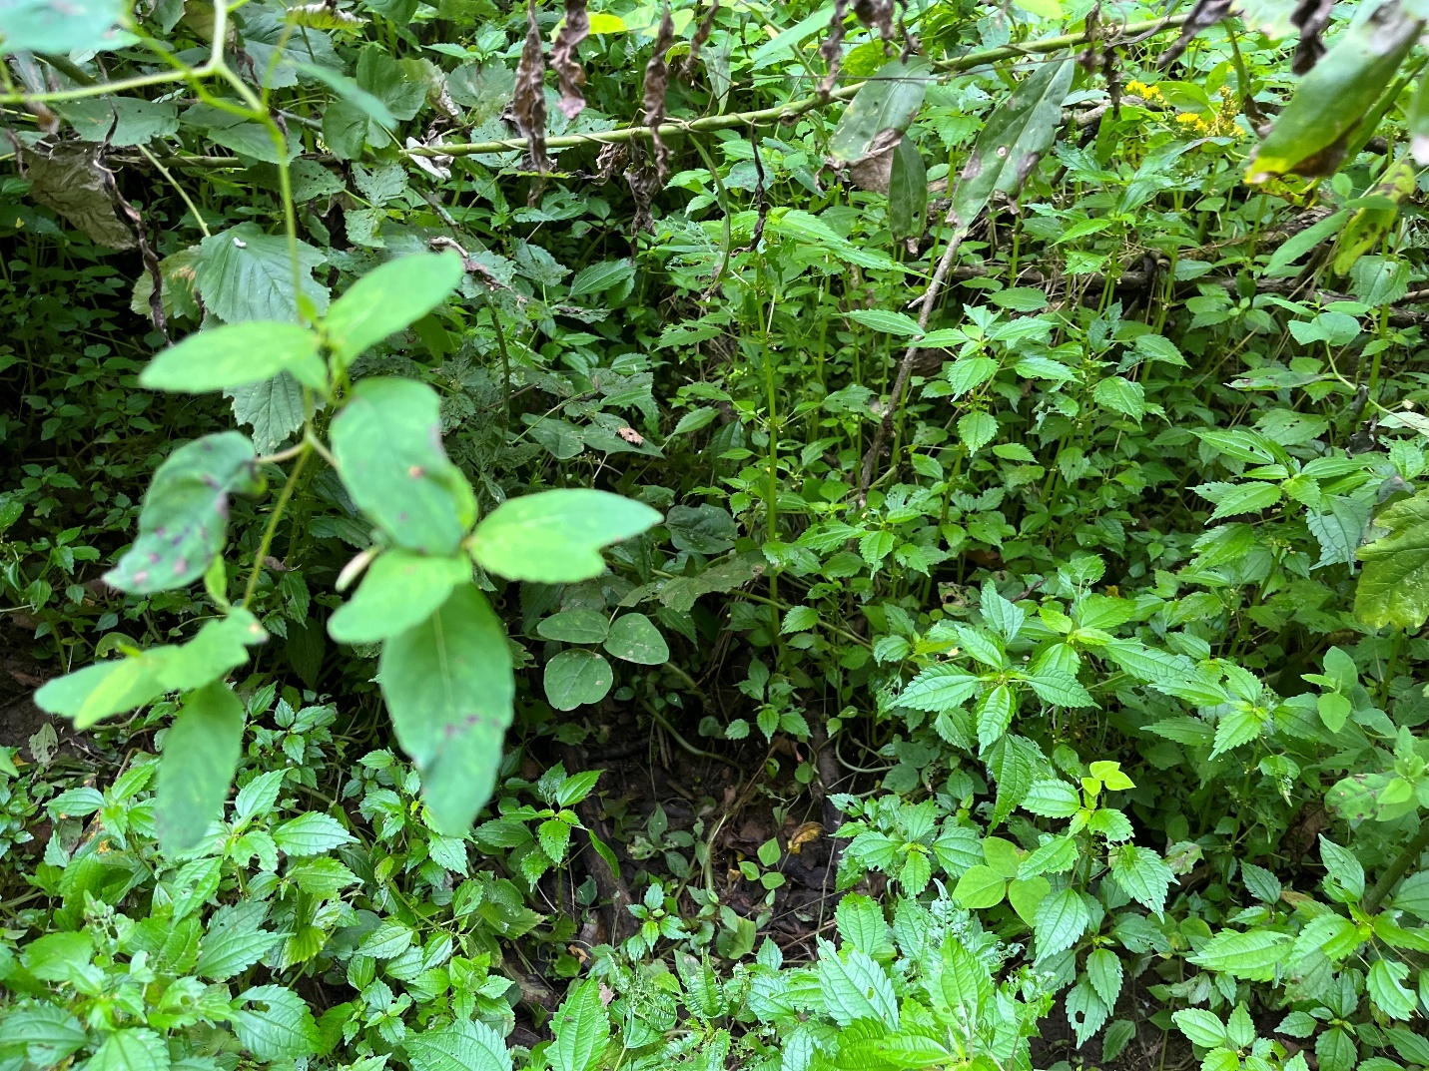
Photo 3. Upstream of outfall was dry, with no flow or defined channel and abundant terrestrial vegetation (Point 1 on map).

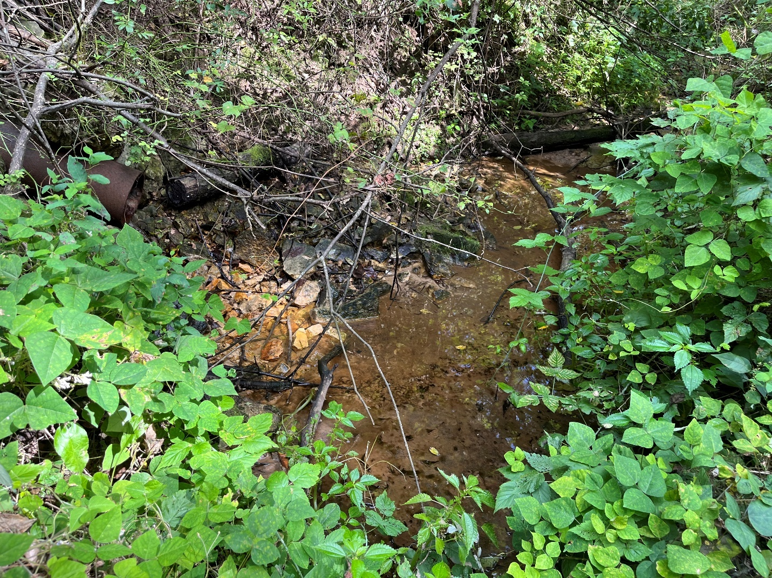
Photo 4. Spring Green Golf Club outfall pipe and downstream segment of Unnamed Tributary (WBIC 1241450) (Point 1 on map).

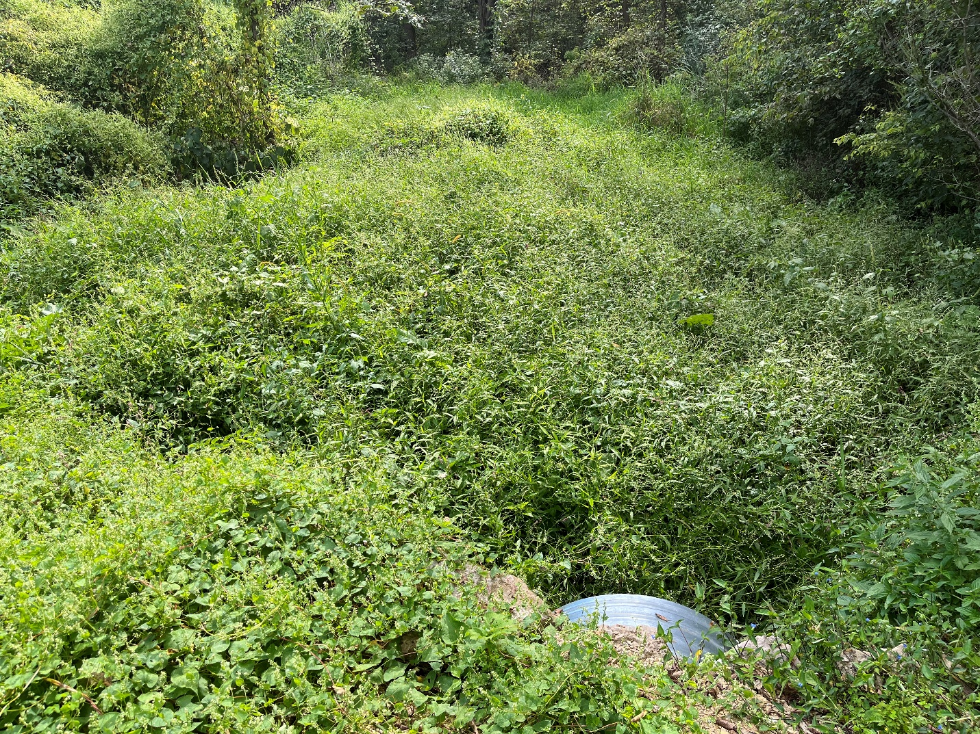
Photo 5. Standing on culverts on Unnamed Tributary (WBIC 1241450) stream crossing at trailhead to the Phoebe Point segment of the Driftless Trail facing upstream (Point 2 on map).
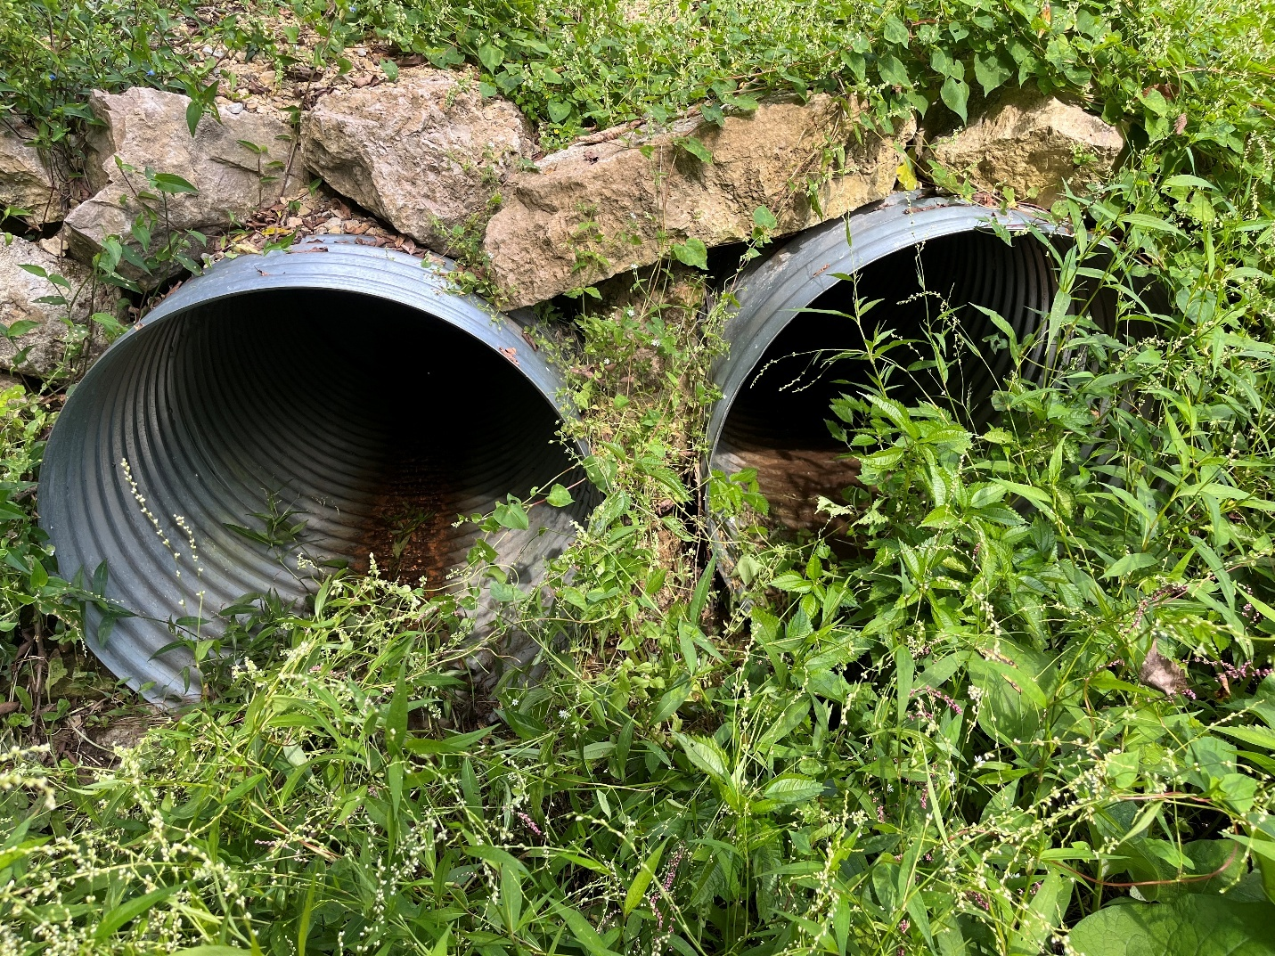
Photo 6. Upstream side of the two culverts (facing downstream). No flow in right culvert tube, but it is wet. Stream flowing in left culvert tube (Point 2 on map).

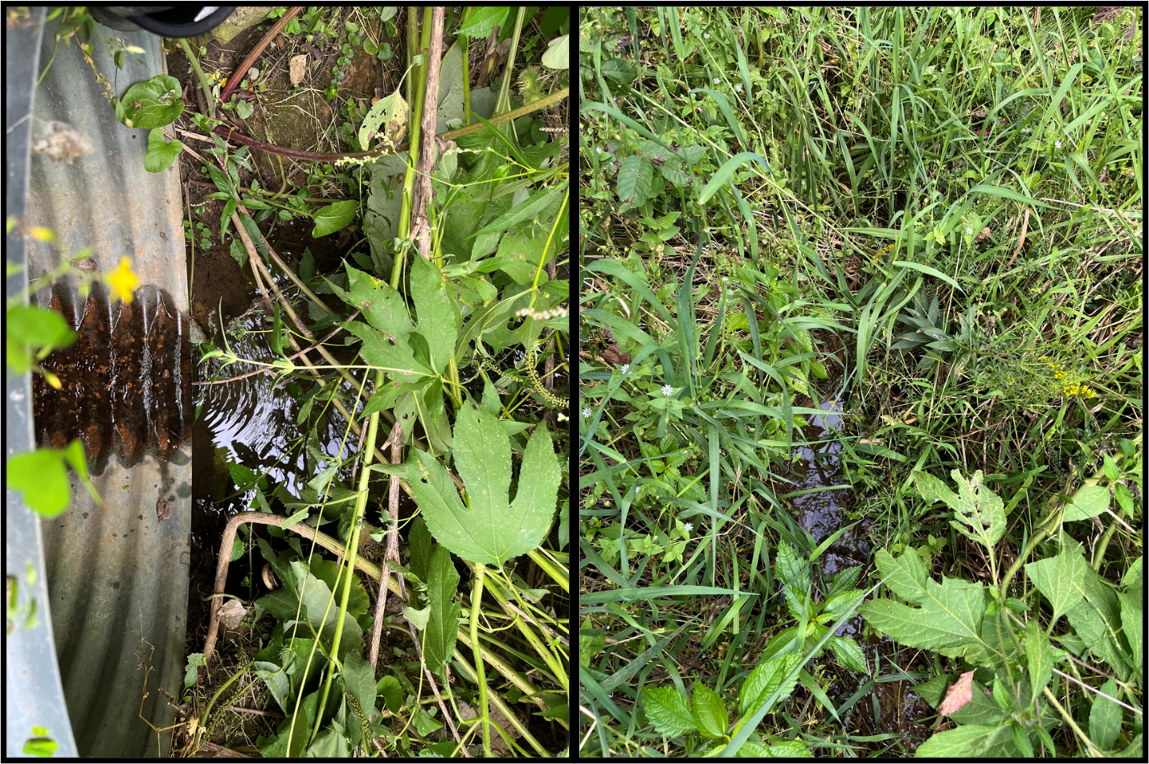
Photo 7. Left image: Downstream side of culvert, note perched culvert and flowing water. Right image, stream thread downstream of culvert (Point 2 on map).

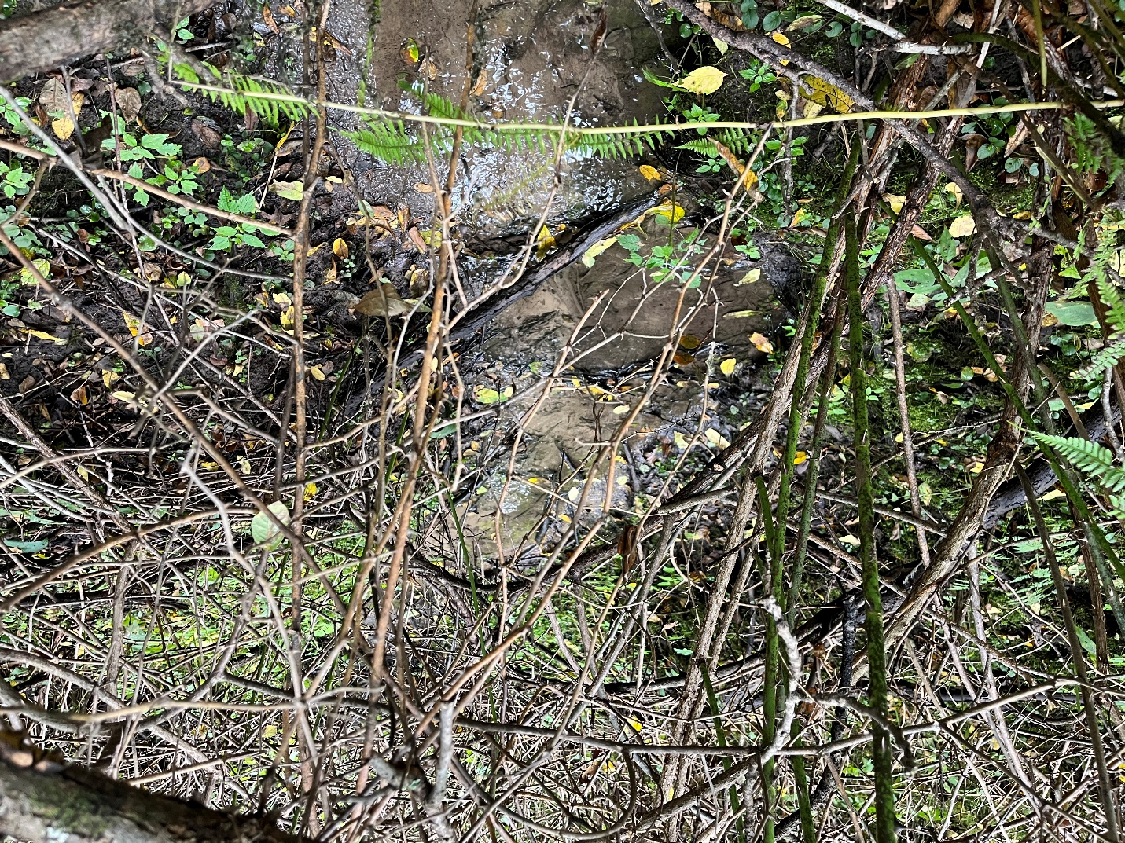
Photo 8: End location of fish and habitat surveys completed on September 3rd, 2025 (Point 3 on map).

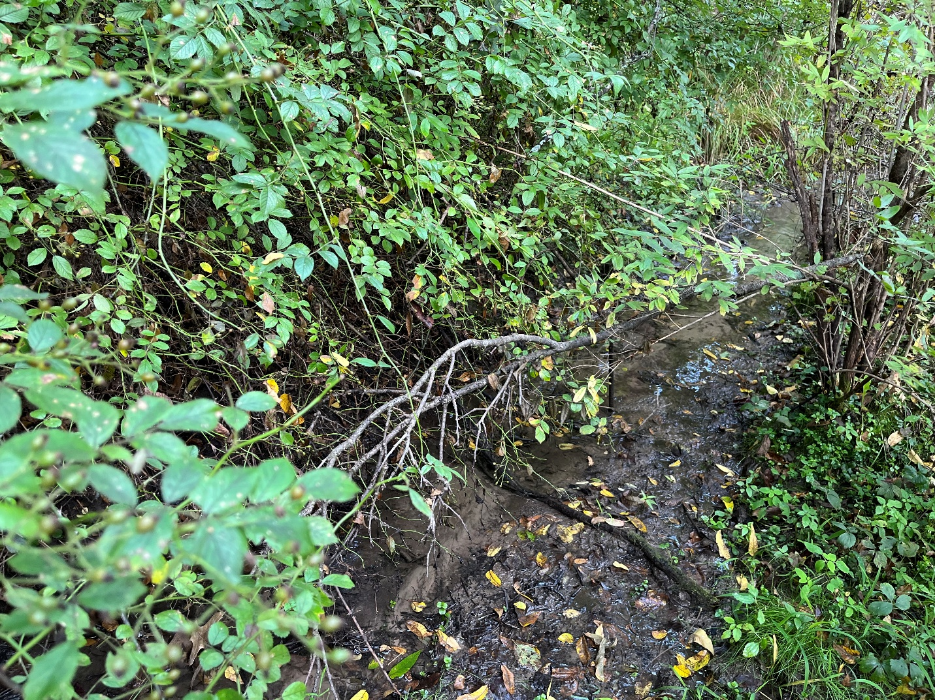
Photo 9. Stream segment where fish and qualitative habitat surveys were completed on September 3rd, 2025 (Point 4 on map).

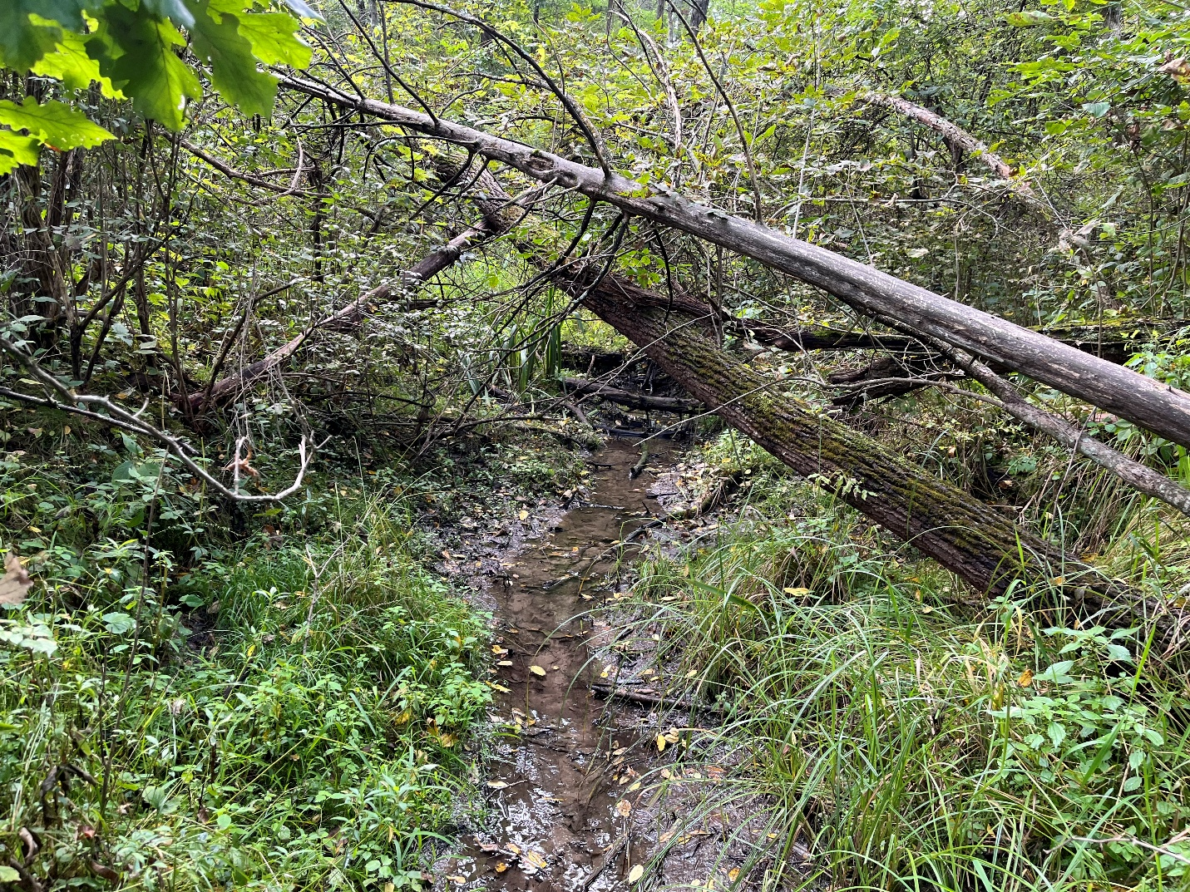
Photo 10. Stream segment where fish and qualitative habitat surveys were completed on September 3rd, 2025 (Point 4 on map).

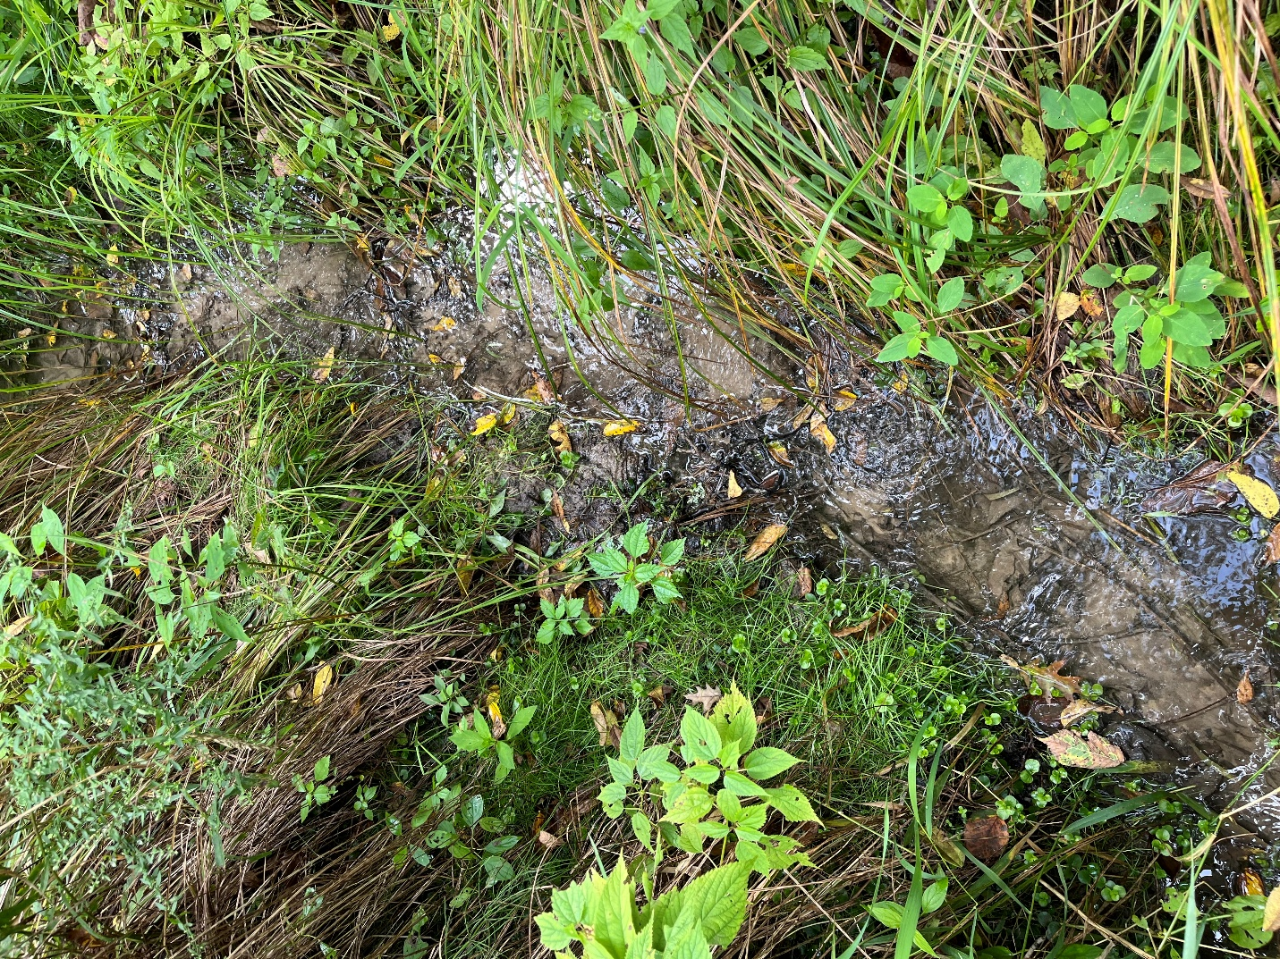
Photo 11. Start location of fish and habitat surveys completed on September 3rd, 2025 (Point 5 on map).

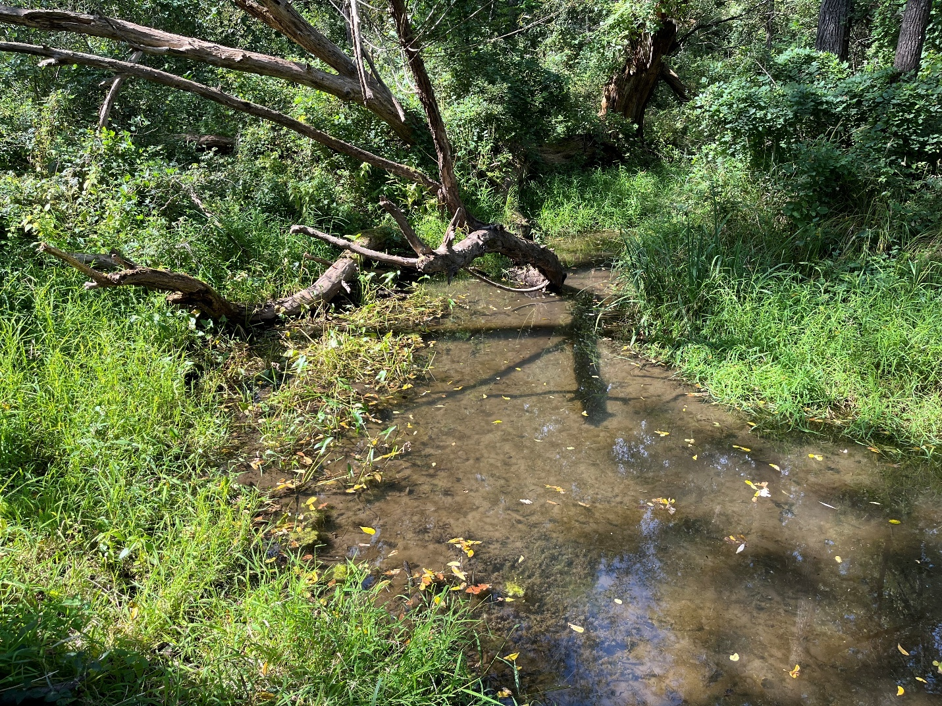
Photo 12. Looking upstream at Unnamed Tributary (WBIC 1241450) at confluence with Lowery Creek (Taken from Point 6 on map).

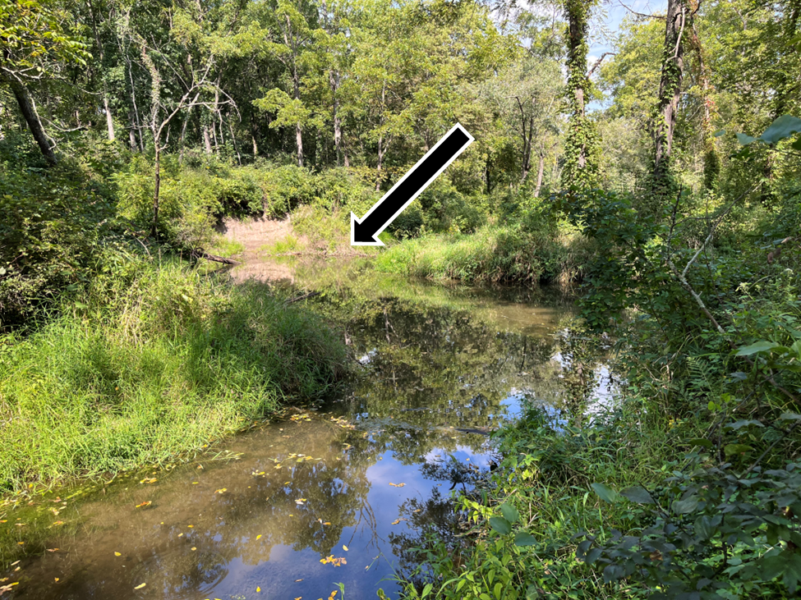
Photo 13. Unnamed Tributary (WBIC 1241450) at confluence with Lowery Creek facing downstream. Note: Beaver dam approximately 15 meters downstream of confluence, which is impounding water into the Unnamed Tributary. Black and white arrow shows location of beaver dam (Taken from Point 6 on map).
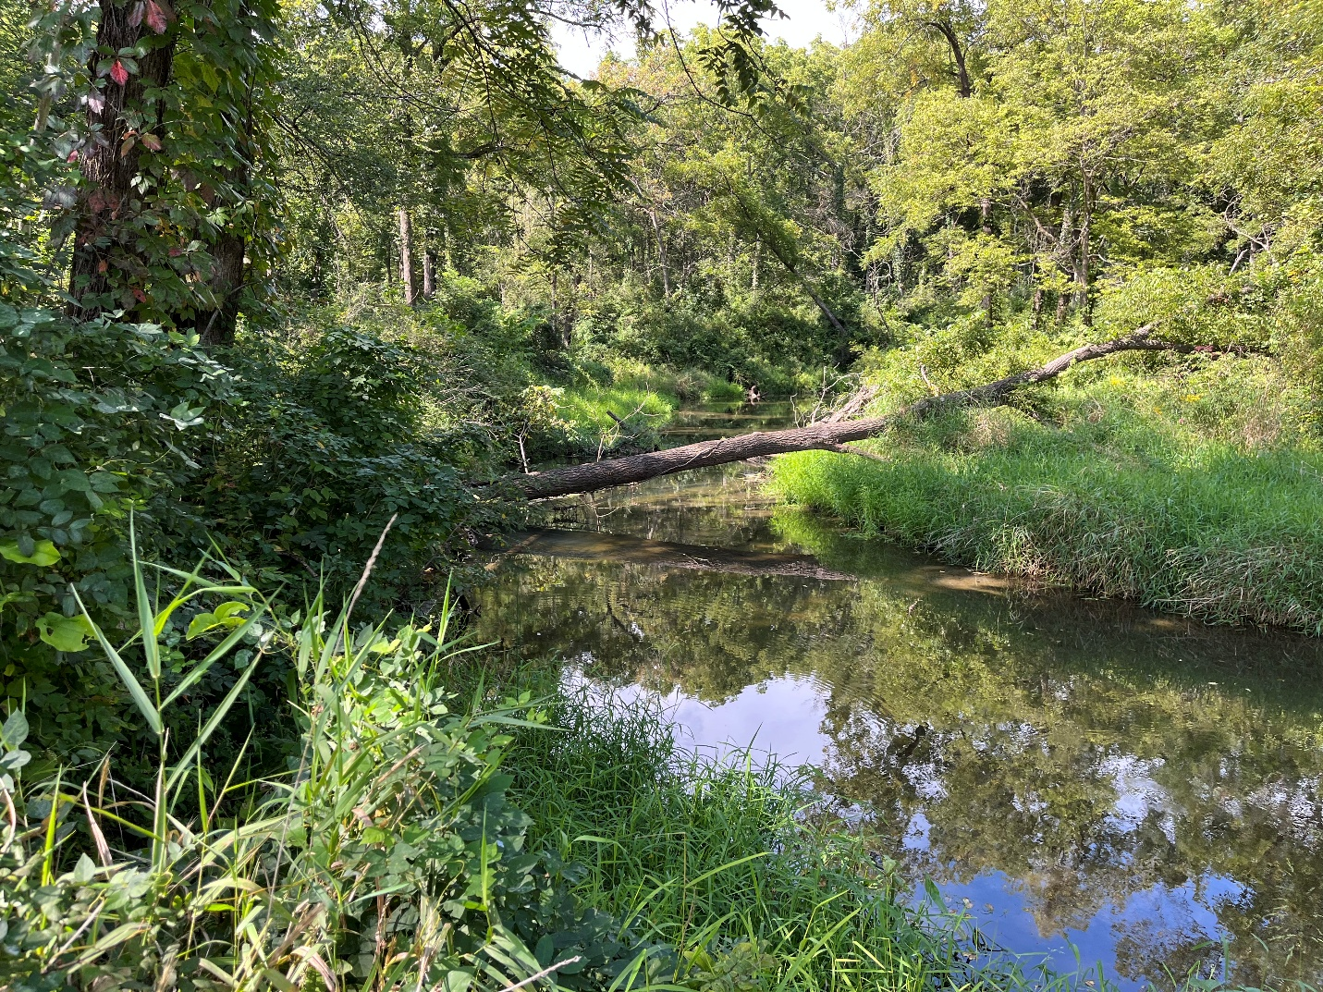
Photo 14. Lowery Creek upstream of confluence with Unnamed Tributary (WBIC 1241450) (Point 6 on map).
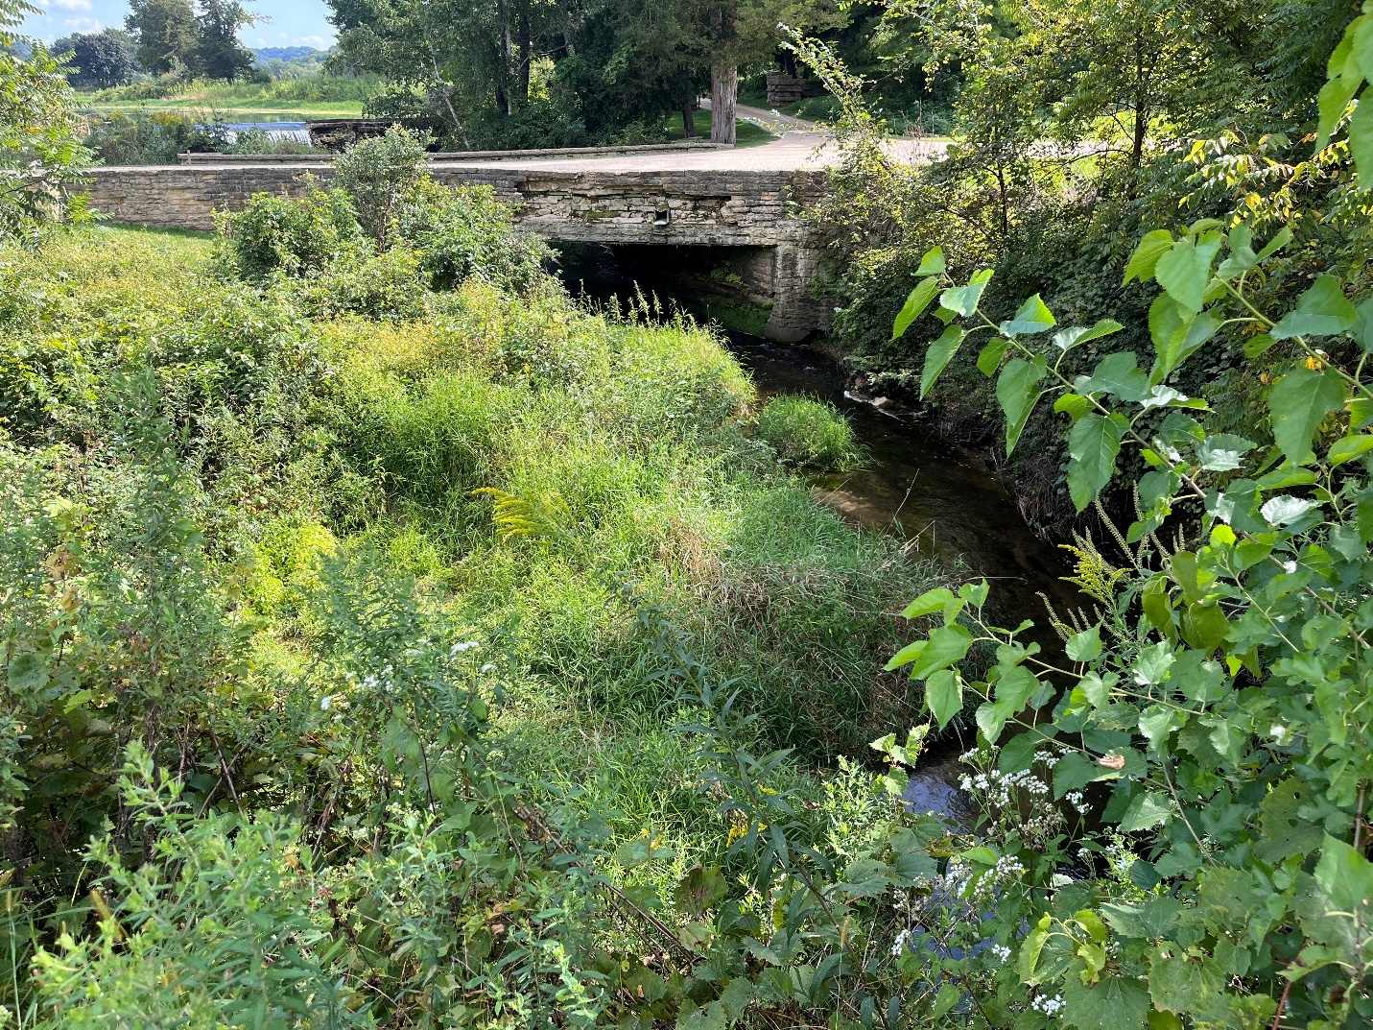
Photo 15. Lowery Creek at County Highway C (Point 7 on map).

