Wolf River TMDL Monitoring 2010-2012
Parent project: NER 303d and TMDL
NER_02_11
Purpose
This is the third year of monitoring for the Upper Fox Basin and the first year of monitoring for the Wolf River Basin. NER biologists and CO SWAT will collect water samples from the Upper Fox Basin waterbodies of Fox River, Puchyan River, Fond du Lac River, Montello River, Waukau Creek, the Wolf Basin waterbodies of the Wolf River, Little Wolf River, Embarrass River, Waupaca River, and lakes Poygan, Winneconne, Butte des Morts, and Winnebago to be analyzed for TSS, Total Phosphorus, and Dissolved Phosphorus that will be used in modeling the sediment and phosphorus loads to Lake Winnebago. Also in collaboration with the USGS, sediment core samples will be collected from Lake Winnebago, Lake Poygan, Lake Winneconne, and Lake Butte des Morts to be used for the quantification of the existing internal nutrient load within the system. Results of the modeling will be used in developing a TMDL for Lake Winnebago to drive management practices in the Upper Fox Basin. 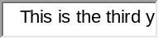
NER_06_CMP12
Purpose
Finish the monitoring requirements of the Upper Fox Basin. **2nd year of monitoring for the Wolf River Basin. NER biologists and CO SWAT will collect water samples from the Upper Fox Basin waterbodies of Fox River, Puchyan River, Fon du Lac River, Montello River, Waukau Creek, the Wolf Basin waterbodies of the Wolf River, Little Wolf River, Embarrass River, Waupaca River, and lakes Poygan, Winneconne, Butte des Morts, and Winnebago to be analyzed for TSS, Total Phosphorus, and Dissolved Phosphorus that will be used in modeling the sediment and phosphorus loads to Lake Winnebago. Results of the modeling will be used in developing a TMDL for Lake Winnebago to drive management practices in the Upper Fox Basin.
17 Stations in projects NER_02_11 and NER_06_CMP12
Station ID: Station Name:
713245 Lake Winnebago – 3 Mi Oshkosh
713244 Lake Winnebago – Deep Hole-South End
713243 Lake Winnebago – 2 Mi From Neenah
713282 Lake Winneconne – Central (Wi-2)
713279 Lake Poygan – East (P03)
713252 Lake Butte Des Morts – East End Bu3
10022877 Fond du Lac River At W. Arndt St. USGS Site ID 04083545
243020 Fox River at Berlin, WI USGS Site ID 04073500
10022879 Montello River At 11th St. Bridge USGS Site ID 04072845
10022878 Puchyan River At N. Lawson St. Bridge USGS Site ID 04073473
713285 Waukau Creek at Cth E USGS Site ID 04073970
593162 Embarrass River – Near Embarrass, WI USGS Site ID 04078500
10033493 Embarrass River at New London Hwy 54
713002 Fox River - Lake Winnebago Outlet
693217 Little Wolf River at Royalton, WI USGS Site ID 04080000
693161 Waupaca River at Harrington Rd USGS Site ID 04081000
693218 Wolf River at New London, WI USGS Site ID 04079000
CO_02_CMP_13
Purpose
3rd and final year of monitoring for TMDL development for the Wolf River Basin. East District Biologists will collect water samples from the waters of the Wolf River Basin including: the Wolf River (241300), Little Wolf River (272400), Waupaca (257400) and Embarrass River (291900) and the Outlet of Lake Winnebago (117900-LFR). These samples will be analyzed for TSS, TP, and dissolved P and will be used in the modeling to calculate loads for the Upper Fox/Wolf TMDL.
14 sampling events will be covered in the Wolf Basin, with a total of 6 sample sites. Sample collection is projected to end in December 2012. These samples will be analyzed for TSS, TP, and dissolved P and will be used in the modeling to calculate loads for the Upper Fox/Wolf TMDL.
Sampling Method: Samples were taken from bridges above the river. The quart bottle and 250ml bottles were lowered down into the water and rinsed three times before the sample was collected. Samples for Total Phosphorus and Total Suspended Solids were taken for each sampling event. 1ml of H2SO4 was added to every 250ml sample. Every third sample event also collected Total Dissolved Phosphorus. When preparing the Total Dissolved Phosphorus sample, water from the quart bottle was poured into a 60ml NORM-JECT syringe and filtered through a .45um Millipore filter into a 60ml rinsed bottle. One ½ ml of H2SO4 was added to the 60ml sample. The samples were collected once a week March-June, every other week July-November, and monthly December-February.

Rivers monitored for CO_02_CMP13
Station ID: Station Name:
593162 Embarrass River – Near Embarrass, WI USGS Site ID 04078500
10033493 Embarrass River at New London Hwy 54
713002 Fox River - Lake Winnebago Outlet
693217 Little Wolf River at Royalton, WI USGS Site ID 04080000
693161 Waupaca River at Harrington Rd USGS Site ID 04081000
693218 Wolf River at New London, WI USGS Site ID 04079000

Counties: Winnebago, Outagamie, Waupaca, Shawano
Samples taken: Total Phosphorus =TP
Total Suspended Solids =TSS
Total Dissolved Phosphorus =TDP (taken every third sample event)

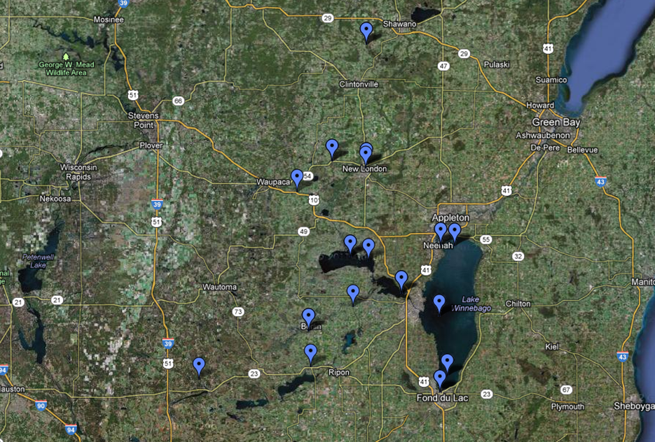
Fox River at Lake Winnebago Outlet
Little Wolf River at Royalton
Wolf River at New London
Embarrass River at New London
Waupaca River near Harrington Rd
Embarrass River- Near Embarrass
17 Stations from projects NER_02_11, NER_06_CMP12, and CO_02_CMP13

Fieldwork start | Embarrass River-Near Embarrass, WI | Waupaca River | Little Wolf River at Royalton | Wolf River at New London | Fox River at Lake Winnebago Outlet | Embarrass River at New London  Total Phosphorus mg/L
07/23/2010 | 0.134 | 0.093 | 0.157 | 0.271 | 0.15
08/05/2010 | 0.09 | 0.049 | 0.103 | 0.254
08/27/2010 | 0.035 | 0.029 | 0.046 | 0.18 | 0.089
09/16/2010 | 0.035 | 0.043 | 0.035 | 0.079
09/25/2010 | 0.105 | 0.078 | 0.156 | 0.195
09/30/2010 | 0.063 | 0.059 | 0.072 | 0.115 | 0.083
11/12/2010 | 0.018 | 0.032 | 0.026 | 0.052 | 0.051
03/17/2011 | 0.063 | 0.054 | 0.115 | 0.051 | 0.06
03/30/2011 | 0.043 | 0.042 | 0.047 | 0.063 | 0.046
04/07/2011 | 0.092 | 0.052 | 0.057 | 0.041 | 0.044 | 0.075
04/14/2011 | 0.065 | 0.033 | 0.034 | 0.043 | 0.048 | 0.069
04/20/2011 | 0.035 | 0.049 | 0.053 | 0.062 | 0.054 | 0.043
04/28/2011 | 0.042 | 0.051 | 0.077 | 0.026 | 0.06 | 0.073
05/06/2011 | 0.028 | 0.03 | 0.031 | 0.055 | 0.038 | 0.042
05/13/2011 | 0.043 | 0.071 | 0.137 | 0.072 | 0.037 | 0.115
05/20/2011 | 0.083 | 0.035 | 0.044 | 0.123 | 0.031 | 0.034
05/25/2011 | 0.047 | 0.047 | 0.072 | 0.104 | 0.03 | 0.13
06/01/2011 | 0.049 | 0.043 | 0.06 | 0.101 | 0.039 | 0.112
06/08/2011 | 0.053 | 0.043 | 0.053 | 0.074 | 0.07 | 0.115
06/16/2011 | 0.051 | 0.048 | 0.05 | 0.132 | 0.08 | 0.108
06/23/2011 | 0.123 | 0.156 | 0.181 | 0.146 |  | 0.172
06/26/2011 |  |  |  |  |  | 0.117
06/30/2011 | 0.08 | 0.067 | 0.102 | 0.122 | 0.088 | 0.148
07/12/2011 | 0.055 | 0.057 | 0.083 | 0.168 | 0.074 | 0.141
07/26/2011 | 0.059 | 0.066 | 0.136 | 0.102 | 0.116 | 0.146
08/11/2011 | 0.095 | 0.049 | 0.091 | 0.098 | 0.181 | 0.135
08/25/2011 | 0.042 | 0.037 | 0.033 | 0.066 | 0.172 | 0.089
09/08/2011 | 0.028 | 0.027 | 0.038 | 0.062 | 0.207 | 0.064
09/22/2011 | 0.039 |  | 0.028 | 0.045 | 0.147 | 0.041
10/06/2011 | 0.037 | 0.025 | 0.04 | 0.071 | 0.104 | 0.089
10/20/2011 | 0.034 | 0.019 | 0.037 | 0.055 | 0.155 | 0.061
11/18/2011 | 0.02 | 0.02 | 0.034 | 0.048 | 0.118 | 0.046
12/21/2011 | 0.038 | 0.038 | 0.038 | 0.038 |  | 0.038
01/11/2012 | 0.03 | 0.03 | 0.03 | 0.03 |  | 0.03
02/17/2012 | 0.3 | 0.03 | 0.032 | 0.03 |  | 0.053
03/10/2012 | 0.156 | 0.083 | 0.153 | 0.152 |  | 0.192
03/20/2012 | 0.07 | 0.037 | 0.03 | 0.062 |  | 0.083
03/23/2012 | 0.071 | 0.044 | 0.068 | 0.068 | 0.07 | 0.082
03/30/2012 | 0.05 | 0.058 | 0.054 | 0.064 | 0.135 | 0.084
04/06/2012 | 0.037 | 0.026 | 0.037 | 0.059 | 0.057 | 0.082
04/10/2012 | 0.029 | 0.02 | 0.034 | 0.07 | 0.048 | 0.065
04/18/2012 | 0.027 | 0.02 | 0.035 | 0.066 | 0.082 | 0.059
04/24/2012 | 0.034 |  | 0.044 | 0.062 | 0.054 | 0.062
05/02/2012 | 0.032 | 0.033 | 0.039 | 0.064 | 0.069 | 0.065
05/09/2012 | 0.066 | 0.066 | 0.064 | 0.079 | 0.044 | 0.094
05/16/2012 | 0.043 | 0.038 | 0.044 | 0.089 | 0.068 | 0.099
05/24/2012 | 0.035 | 0.04 | 0.03 | 0.067 | 0.092 | 0.089
05/30/2012 | 0.053 | 0.049 | 0.065 | 0.065 | 0.081 | 0.105
06/06/2012 | 0.036 | 0.032 | 0.046 | 0.059 | 0.072 | 0.09
06/13/2012 | 0.035 | 0.037 | 0.033 | 0.065 | 0.087 | 0.082
06/20/2012 | 0.082 | 0.051 | 0.067 | 0.066 | 0.114 | 0.086
06/27/2012 | 0.075 | 0.041 | 0.054 | 0.07 | 0.108 | 0.111
07/05/2012 | 0.057 | 0.045 | 0.058 | 0.066 | 0.098 | 0.106
07/17/2012 | 0.046 | 0.047 | 0.049 | 0.074 | 0.194 | 0.083
08/01/2012 | 0.046 | 0.039 | 0.054 | 0.058 | 0.193 | 0.114
08/15/2012 | 0.031 | 0.089 | 0.032 | 0.052 | 0.226 | 0.076
08/28/2012 | 0.033 | 0.073 | 0.034 | 0.048 | 0.2 | 0.07
09/13/2012 | 0.031 | 0.035 | 0.025 | 0.055 | 0.263 | 0.065
09/25/2012 | 0.018 | 0.055 | 0.016 | 0.038 | 0.148 | 0.029
10/17/2012 | 0.046 | 0.067 | 0.074 | 0.049 | 0.313 | 0.071
10/26/2012 | 0.034 | 0.046 | 0.038 | 0.055 | 0.108 | 0.065
11/06/2012 | 0.014 | 0.023 | 0.015 | 0.028 | 0.084 | 0.037
Average | 0.05640984 | 0.047389831 | 0.059344262 | 0.08072131 | 0.103461538 | 0.08550943

Total Suspended Solids
Fieldwork start | Embarrass River-Near Embarrass, WI | Waupaca River | Little Wolf River at Royalton | Wolf River at New London | Fox River at Lake Winnebago Outlet | Embarrass River at New London
07/23/2010 | 33 | 27 | 20 | 5 | 22
08/05/2010 | 6 | 8 | 8 | 4
08/27/2010 | 4 | 6 | 4 | 22 | 3
09/16/2010 | 3 | 10 | 4 | 18
09/25/2010 | 32 | 30 | 41 | 27
09/30/2010 | 6 | 12 | 9 | 9 | 8
11/12/2010 |  | 5 | 5 | 6 | 5
03/17/2011 | 4 | 14 | 23 | 5 | ND
03/30/2011 | 4 | 8 | 7 | 9 | 3
04/07/2011 | 14 | 15 | 13 | 5 | 4 | 7
04/14/2011 | 14 | 7 | 5 | 8 | 11 | 8
04/20/2011 | 3 | 15 | 12 | 9 | 12 | 4
04/28/2011 | 8 | 13 | 14 | 6 | 20 | 10
05/06/2011 | 3 | 9 | 6 | 10 | 17 | 6
05/13/2011 | 5 | 21 | 48 | 12 | 9 | 28
05/20/2011 | 5 | 11 | 6 | 14 | 8 | 11
05/25/2011 | 8 | 14 | 12 | 12 | 5 | 17
06/01/2011 | 6 | 15 | 12 | 20 | 3 | 20
06/08/2011 | 11 | 12 | 13 | 12 | 2 | 40
06/16/2011 | 8 | 14 | 12 | 29 | 3 | 39
06/23/2011 | 28 | 31 | 32 | 20 |  | 38
06/26/2011 |  |  |  |  |  | 8.1
06/30/2011 | 8 | 18 | 14 | 6 | 4 | 3
07/12/2011 | 8 | 21 | 16 | 15 | 2 | 43
07/26/2011 | 3 | 13 | 12 | 7 | 5 | 32
08/11/2011 | 9 | 11 | 11 | 20 | 6 | 30
08/25/2011 | 5 | 7 | 4 | 22 | 7 | 31
09/08/2011 | 2 | 7 | 5 | 20 | 19 | 24
09/22/2011 | 10 | 6 | 6 | 14 | 11 | 11
10/06/2011 |  | 6 | 6 | 16 | 13 | 16
10/20/2011 |  |  |  |  | 12
11/18/2011 |  | 4 | 4 | 4 | 37 | 4
12/21/2011 | 2.9 | 5.1 | 4.8 | 3.5 |  | 5.7
01/11/2012 | 2.8 | 8.9 | 9.5 | 2.9 |  | 2.5
02/17/2012 | 8.6 | 14 | 12 | 9.5 |  | 23
03/10/2012 | 14 | 12 | 18 | 40 |  | 22
03/20/2012 | 12 | 15.4 | 14.2 | 9.5 |  | 25.2
03/23/2012 | 6 | 9 | 13 | 6 | 15 | 11
03/30/2012 | 5 | 15 | 11 | 10 | 47 | 17
04/06/2012 | 4 | 6 | 7 | 18 | 13 | 18
04/10/2012 | 3 | 5 | 6 | 25 | 9 | 18
04/18/2012 | 5 | 5 | 13 | 20 | 19 | 19
04/24/2012 | 8 | 7 | 12 | 17 | 6 | 17
05/02/2012 | 8 | 12 | 12 | 24 | 11 | 28
05/09/2012 | 15 | 14 | 14 | 13 | 5 | 13
05/16/2012 | 4 | 15 | 7 | 13 | 5 | 16
05/24/2012 | 9 | 16 | 8 | 18 | 5 | 33
05/30/2012 | 8 | 23 | 19 | 19 | 5 | 51
06/06/2012 | 6 | 13 | 13 | 22 | 6 | 41
06/13/2012 | 4 | 13 | 7 | 17 | 7 | 33
06/20/2012 | 15 | 22 | 16 | 17 | 17 | 28
06/27/2012 | 5 | 12 | 5 | 17 | 6 | 38
07/05/2012 | 4 | 14 | 11 | 10 | 5 | 26
07/17/2012 | 3 | 16 | 30 | 14 | 21 | 16
08/01/2012 | 3 | 11 | 29 | 12 | 24 | 54
08/15/2012 | 3 | 14 | 5 | 12 | 24 | 38
08/28/2012 |  | 13 | 3 | 13 | 23 | 30
09/13/2012 |  | 11 |  | 16 | 30 | 31
09/25/2012 | 2 | 4 | 3 | 11 | 51 | 11
10/17/2012 | 6 | 8 | 21 | 14 | 98 | 23
10/26/2012 | 2 | 5 | 5 | 15 | 14 | 21
11/06/2012 |  | 2 | 2 | 3 | 8 | 3
Average | 7.746296296 | 12.17333333 | 12.11016949 | 13.79 | 14.21568627 | 21.97115385

Total Dissolved Phosphorus
Fieldwork start | Embarrass River-Near Embarrass, WI | Waupaca River | Little Wolf River at Royalton | Wolf River at New London | Fox River at Lake Winnebago Outlet | Embarrass River at New London
08/27/2010 | 0.014 | 0.016 | 0.033 | 0.124 | 0.078
09/25/2010 | 0.026 | 0.021 | 0.041 | 0.082
03/17/2011 | 0.044 | 0.027 | 0.058 |  | 0.045
04/07/2011 | 0.036
04/14/2011 |  | 0.026 | 0.033 | 0.038 | 0.018 | 0.045
05/13/2011 | 0.022 | 0.029 | 0.045 | 0.03 | 0.009 | 0.047
06/08/2011 |  | 0.022 | 0.028 | 0.051 | 0.043 | 0.038
06/23/2011 | 0.056 | 0.076 | 0.096 | 0.079 |  | 0.079
06/26/2011 |  |  |  | 0.093 |  | 0.118
07/12/2011 | 0.02 | 0.025 | 0.049 | 0.111 | 0.057 | 0.022
08/11/2011 | 0.068 | 0.029 | 0.059 | 0.055 | 0.125 | 0.08
10/06/2011 | 0.029 | 0.012 | 0.023 | 0.043 | 0.06 | 0.06
11/18/2011 | 0.012 | 0.01 | 0.02 | 0.032 | 0.016 | 0.03
12/21/2011 | 0.038 | 0.038 | 0.038 | 0.038 | 0.013 | 0.038
01/11/2012 | 0.03 | 0.03 | 0.03 | 0.03 |  | 0.03
02/17/2012 | 0.03 | 0.03 | 0.03 | 0.03 |  | 0.03
03/10/2012 | 0.13 | 0.049 | 0.083 | 0.05 |  | 0.127
03/20/2012 | 0.159 | 0.03 | 0.03 | 0.03 |  | 0.03
03/23/2012 | 0.042 | 0.019 | 0.033 | 0.04 |  | 0.052
04/10/2012 | 0.022 | 0.008 | 0.015 | 0.026 | 0.011 | 0.031
05/02/2012 | 0.016 | 0.013 | 0.018 | 0.026 | 0.024 | 0.027
05/24/2012 | 0.007 | 0.01 | 0.01 | 0.022 | 0.064 | 0.012
06/13/2012 | 0.022 | 0.014 | 0.017 | 0.021 | 0.056 | 0.026
07/05/2012 | 0.046 | 0.02 | 0.044 | 0.038 | 0.074
08/15/2012 | 0.026 | 0.069 | 0.02 | 0.028 | 0.127 | 0.029
09/25/2012 | 0.013 | 0.046 | 0.01 | 0.019 | 0.037 | 0.014
11/06/2012 | 0.01 | 0.018 | 0.01 | 0.018 | 0.051 | 0.022
Average | 0.03825 | 0.02748 | 0.03492 | 0.04616 | 0.050444444 | 0.044863636

Stations from CO_02_CMP13
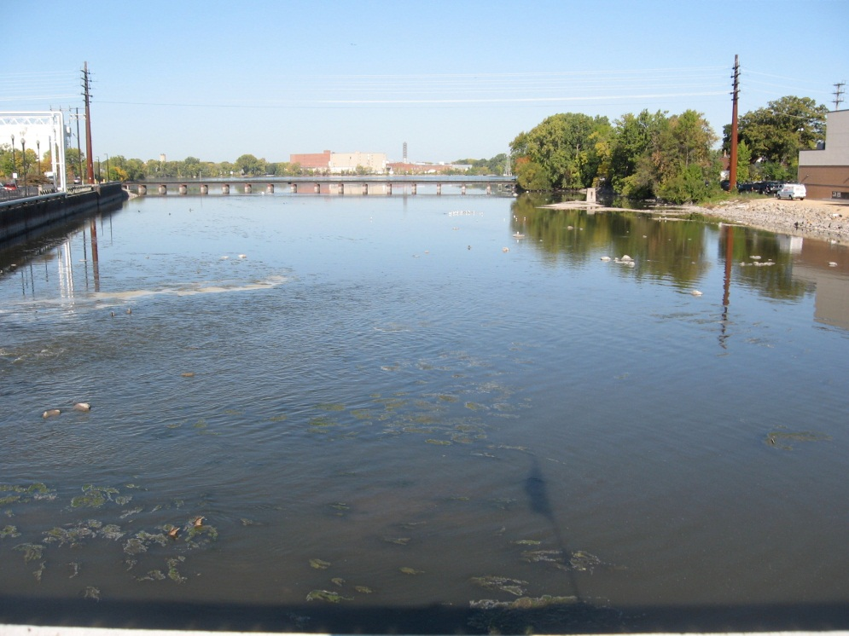
Fox River - Lake Winnebago Outlet Station ID: 713002
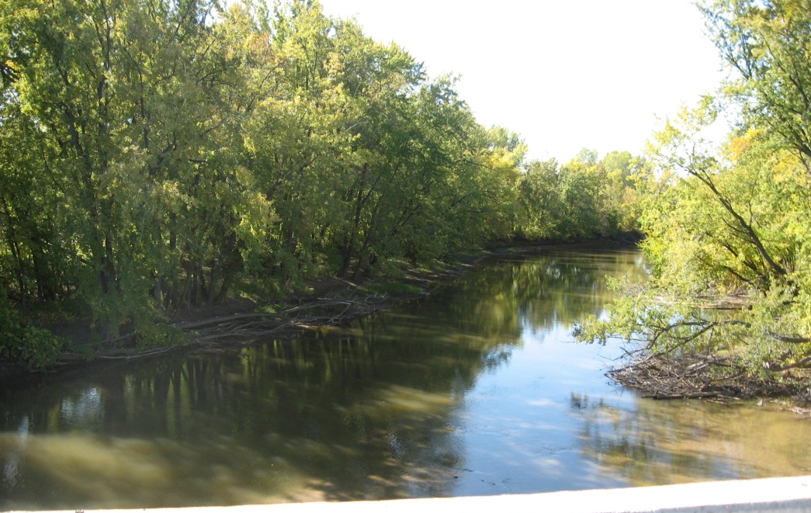
Embarrass River at New London Hwy 54 Station ID: 10033493
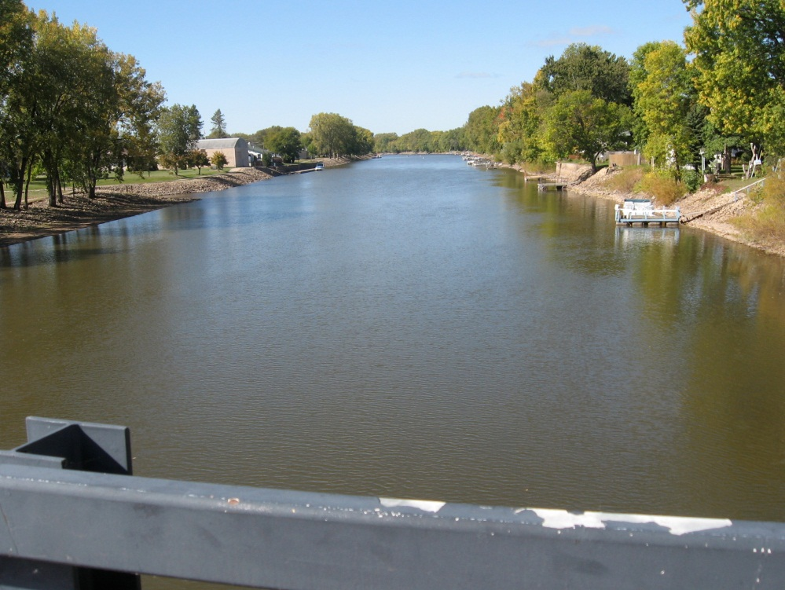
Wolf River at New London, WI USGS Site ID 04079000 Station ID: 693218
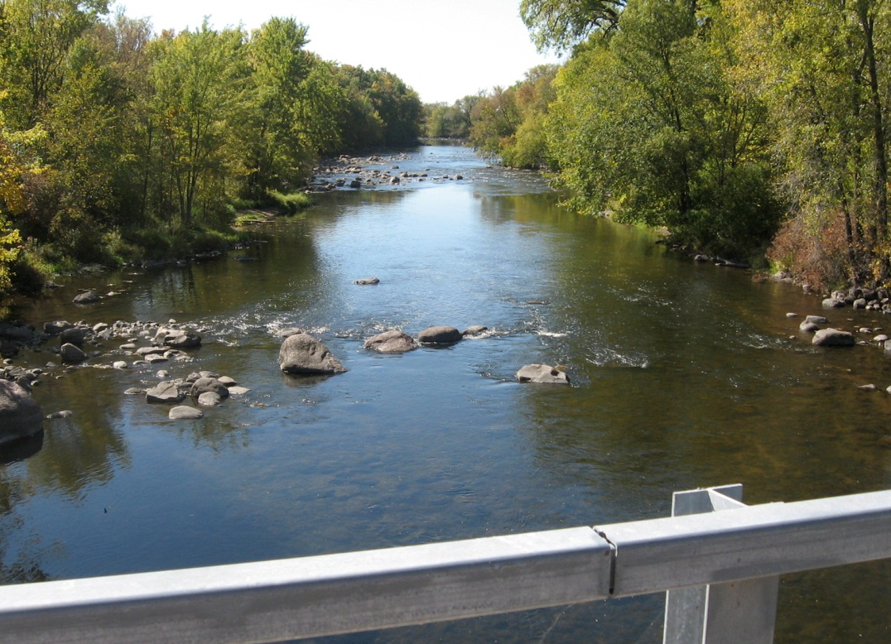
Little Wolf River at Royalton, WI USGS Site ID 04080000 Station ID: 693217
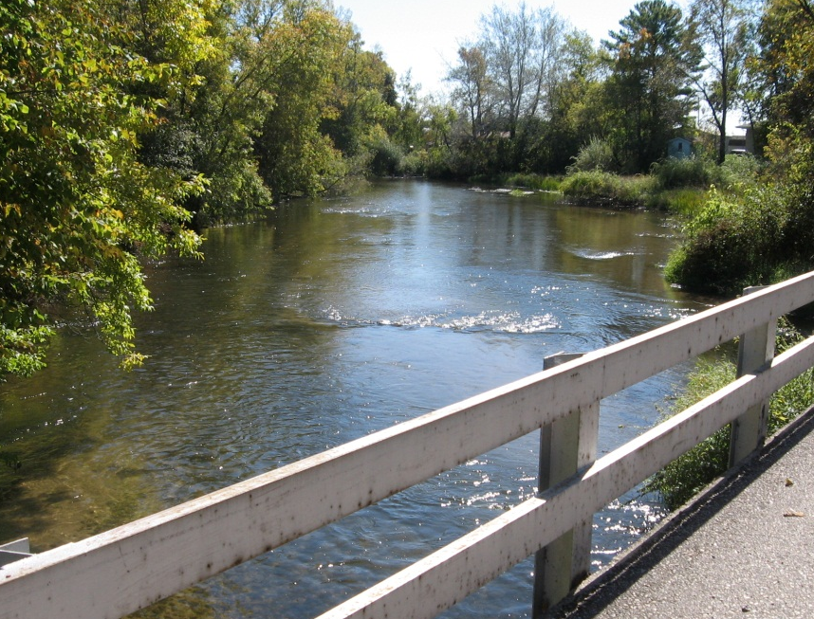
Waupaca River at Harrington Rd USGS Site ID 04081000 Station ID: 693161
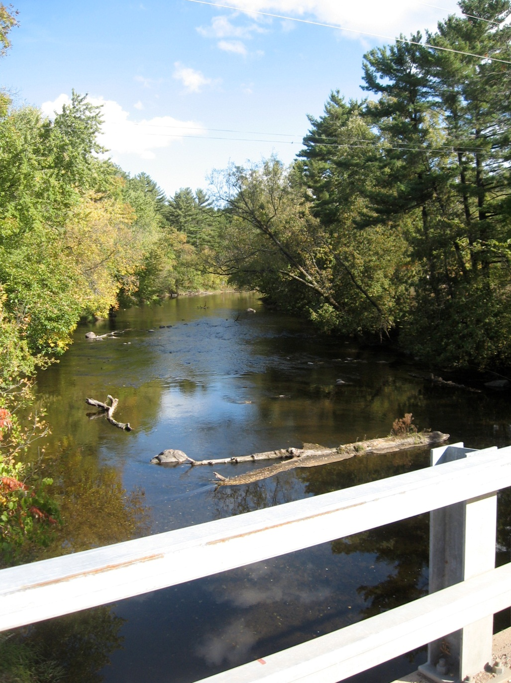
Embarrass River – Near Embarrass, WI USGS Site ID 04078500 Station ID: 593162

