Grand River Total Phosphorus Report

Purpose

Samples were collected to determine background total phosphorus (TP) concentrations for wastewater facility permit effluent limit calculations for facilities at Fairwater, Markesan, and Kingston. The TP concentrations were also used to determine whether in-stream water quality standards were being met in the Grand River.

Methods

Four monthly grab samples for Total Phosphorus were collected in 250 mL bottles upstream of wastewater treatment facility discharge points to the Grand River at Fairwater (Lat/Long 43°43’53’’N,88°52’55’’W), Markesan (Lat/Long 43°42’19’’N,88°59’23’’W), and Kingston (Lat/Long 43°42’7’’N,89°8’27’’W). The samples were collected on 07/18/2012, 08/20/2012, 09/17/2012, and 10/16/2012 and sent on ice to the State Lab of Hygiene.

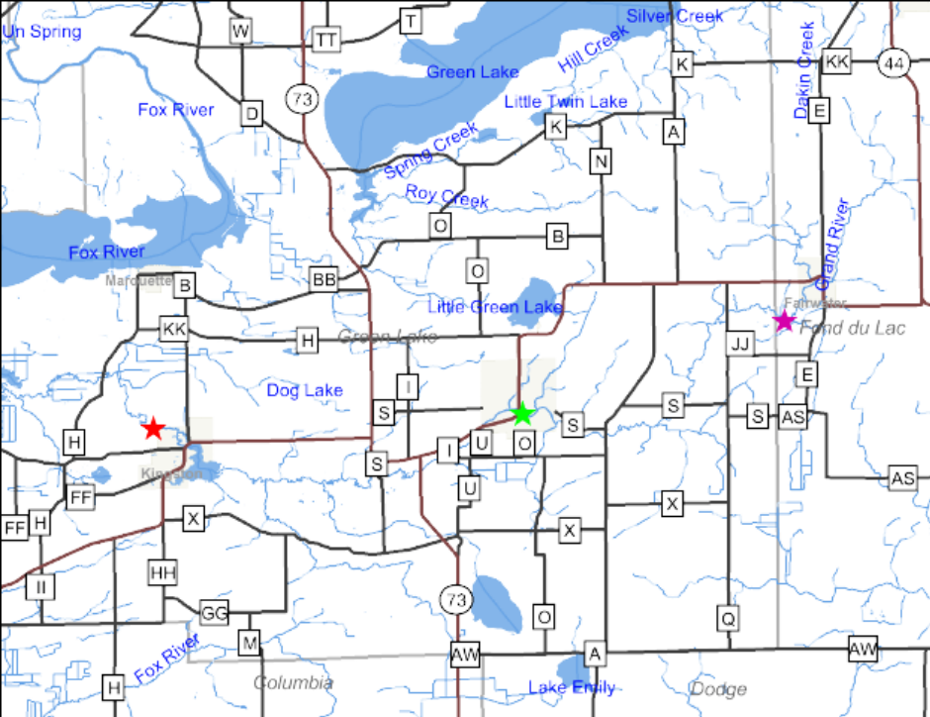
Fairwater
Markesan
Kingston

Results & Discussion

 |  | Total Phosphorus(mg/L)
 | Fairwater | Markesan | Kingston
18-Jul | 0.196 | 0.521 | 0.359
20-Aug | 0.154 | 0.169 | 0.202
17-Sep | 0.131 | 0.299 | 0.182
16-Oct | 0.209 | 0.160 | 0.099
Average | 0.173 | 0.287 | 0.211

WQ standard
0.075 mg/L

All collected samples exceeded the stream water quality standard of 0.075 mg/L. In order to determine whether the Grand River is impaired for TP, and can be added to the 303d list, it is recommended that two additional water samples be collected in June and July of 2013. In addition to the water sampling, macro invertebrate samples would also be collected to assist with the impairment determination. It is also recommended that downstream sections of the Grand River receive monitoring to determine the extent of impairment to the river. It is likely that downstream sections are also impaired but current sampling locations are too far upstream to assist with this determination.

