Silver Spring Creek

Water Chemistry Sampling Project
2011-2012

Lafayette County, Wisconsin

In fulfillment of Water Resources Special Projects
SCR_09_CMP12 and SCR_04_CMP13

By James Amrhein
Water Quality Biologist, Water District South

Silver Spring Creek is a 5 mile long spring-fed stream that originates about 1.5 miles northwest of the small community of Wiota and flows south until it meets the Pecatonica River about a mile northeast of the village of Gratiot. It is managed as a Class II trout fishery. It was placed on the state’s 303(d) list of impaired waters in 1998 due to habitat degradation caused by sediment from nonpoint source pollution (Amrhein, 2011).

Approximately 85 percent of this 3986 acre sub-watershed is in agriculture, which includes about 1642 acres in row crops and 1756 acres in pasture. Another 392 acres are in woodland.

Sampling of the biotic community in 2010 showed very little carryover of trout from year to year. The coldwater index of biotic integrity is “very poor”. Below Silver Spring Road, the creek is rather sluggish with a U-shaped channel and limited habitat. Between Silver Spring Road and Walnut Road, the habitat improves, but impacted by pasturing and barnyards. The fish species is made up a variety of non-game species, with many of those tolerant to disturbed habitat and low dissolved oxygen. While the stream is small above Walnut Road, it shows potential for trout spawning habitat with abundant gravel and spring seeps (Ibid).

In 2009, the department, Lafayette County Land Conservation Department, the University of Wisconsin, and other private organizations began a project to look at ways to reduce sediment and nutrient runoff in the watershed. The University of Wisconsin Platteville began an inventory of fields in the sub-watershed to determine which fields had the highest nutrient values and potential for sediment and nutrient loss.

The goal of this project was to obtain water chemistry data prior to implementation of any management actions to serve as a baseline condition for which to compare concentrations at some point after implementation of best management practices (BMPs).

Methods
A local volunteer monitor collected monthly grab samples from 2 sites on Silver Spring Creek and 1 site at each of 3 tributaries during the growing season of 2011 and 2012 (Figures 1a and b). Sites sampled were:

Silver Spring Creek (WBIC = 917700) at Walnut Road and Silver Spring Road.
Unnamed Tributary (WBIC = 5040863) at Walnut Road
Unnamed Tributary (WBIC = 917900) at Walnut Road
Unnamed Tributary (WBIC = 917800) at Tish Road

It should be noted that the furthest downstream sampling point at Silver Spring Road is still approximately a mile upstream of the stream’s confluence with the Pecatonica River but all of the major tributaries input to this system upstream of this point.

The volunteer was instructed to avoid sampling immediately after events and allow stream flows to return to baseflow as much as possible. Samples were analyzed for total suspended solids, total phosphorus, and the nitrogen series consisting of nitrate/nitrite, ammonia, and total kjeldahl nitrogen. Samples taken for nutrients were fixed with sulfuric acid and placed on ice. Samples for total suspended solids were simply placed on ice. All samples were sent to the Wisconsin State Laboratory of Hygiene for analysis.

Results
Sample data was obtained for all sites during the 6 months of each respective growing season for phosphorus and the nitrogen series. In 2012, total suspended solids were not collected for the months of May and June due to a communication issue. Samples were not able to be obtained from the unnamed tributary (WBIC = 5040863) at Walnut Road after June because of a lack of water. Results are reported in Tables 1a - e. Sample results with an asterisk were flagged because the ice was melted by the time the sample reached the laboratory. The data is treated as real for the purposes of this report.

Discussion
Rainfall was below the 20 year average in both 2011 and 2012 during the growing season period (Wisconsin State Climatology Office, 2013). This was in stark contrast to the previous 3 years which experienced above average precipitation. Because of the previous 3 years of higher precipitation, groundwater levels were higher than average and resulted in higher than average flows, particularly for groundwater dominated systems. The USGS operates a gauging station on the Pecatonica River in southwest Green County about 12 miles from the study site. While the scale is certainly different than Silver Spring Creek, this gauge showed flows did not return to baseline, as measured by the median daily discharge, until July 2011 (USGS, 2013). Flows were below the long term median starting in July, 2012.

The purpose of this study is to collect background data for implementation of a watershed wide project to reduce sediment and nutrient loads to Silver Spring Creek. The intent was not to compare data between 2011 and 2012 and therefore such a statistical analysis will not be performed. However, there are certain data tendencies which can be summarized (Table 2).

The mean and median phosphorus concentration was at or above the department’s water quality criteria of 0.075 mg/l at all sites. Mean phosphorus, ammonia, and total kjeldahl nitrogen concentrations were highest at the unnamed tributary (WBIC =5040863) at Walnut Road. The median phosphorus concentration was also highest at this site. Inorganic nitrogen based on nitrate/nitrite concentrations ranged from 8.3 to 16 mg/l and would generally be considered high, but is not atypical for this portion of the state. Ammonia made up only as small portion of the organic nitrogen based on median concentrations.

Because grab samples are being taken and no flow information is being collected, nutrient and sediment loads cannot be calculated. Progress at nutrient reduction will have to be conducted via concentration based data taken under baseflow conditions. This will be difficult to do given the factors which effect baseflow concentrations, not the least of which is precipitation. During periods of below average precipitation or flow, concentrations of nutrients and sediment can be artificially low due to the lack of events which affect both nutrient runoff overland, as well as bank and bedload sources. Of course, the reverse is also true. Concentrations would be quicker to respond to event flows than baseflows as BMPs are more readily designed to mitigate the high flow events.

Modeling may be able to predict reduction in nutrient and sediment load from the implementation of BMPs. However, water chemistry sampling alone may not be able to detect these changes for decades, if at all, due to lag effect (Meals, et. al. 2010). Ideally, a stream gauge with automatic sampling to catch both event and baseflows could be employed. Unfortunately, cost limitations prevent more robust sampling at this time. One way to strengthen the statistical viability of the grab sampling to detect changes in concentration would be to collect more samples. If the implementation of land management practices is slated to proceed, further review of sampling rigor would be recommended.

***************************************************************

References

Amrhein, James. An Assessment of Water Quality in the Lower Pecatonica Watershed 2010-2011. Water Resources Project SCR06_11. WDNR Water Assessment Tracking and Electronic Reporting System (WATERS). November, 2011.

Meals, Donald W., S. Dressing and T. Davenport. Lag Time in Water Quality Response to Best Management Practices: A Review. J. Environ. Qual. 39:85-96.

USGS. 2013. United States Geological Survey. Current Water Data for Wisconsin. http://waterdata.usgs.gov/wi/nwis/rt.

Wisconsin State Climatology Office. 2013. John Young. Director and Emeritus Professor. http://www.aos.wisc.edu/~sco/clim-history/7cities/madison.html.

Figure 1a: Total Phosphorus in Silver Spring Creek and Tributaries (2011 and 2012)
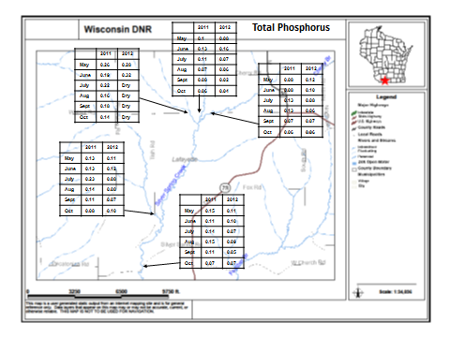
Figure 1b: Nitrate and Nitrite in Silver Spring Creek and Tributaries (2011 and 2012)
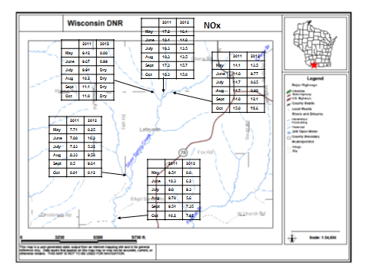
Figure 1c: Total Suspended Solids in Silver Spring Creek and Tributaries (2011 and 2012)
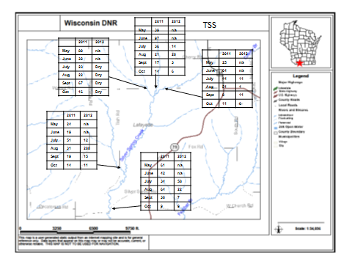

Table 1a: Total Suspended Solids in Silver Spring Creek and Tributaries (2011 and 2012)
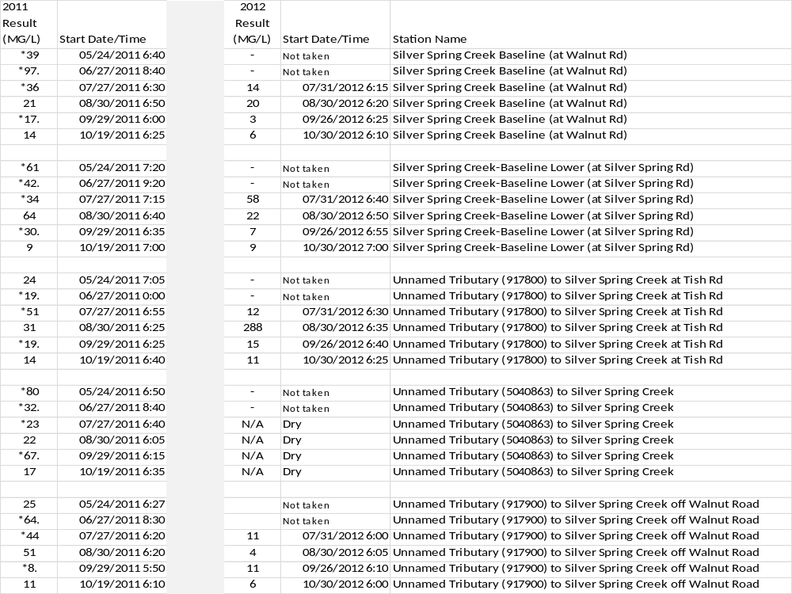

Table 1b: Ammonia in Silver Spring Creek and Tributaries (2011-2012)
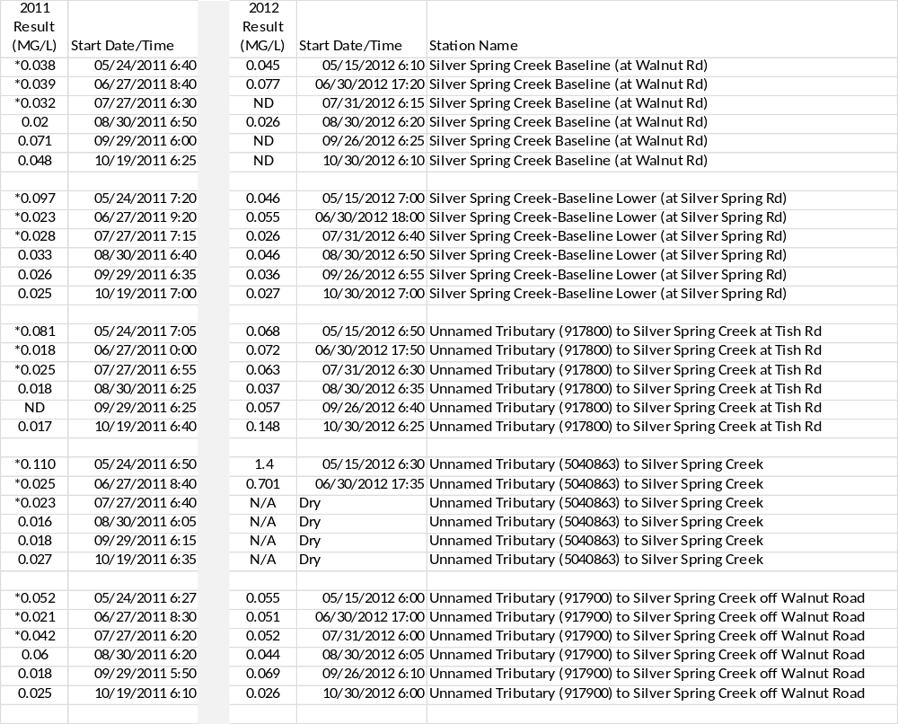

Table 1c: Total Kjeldahl Nitrogen in Silver Spring Creek and Tributaries (2011-2012)
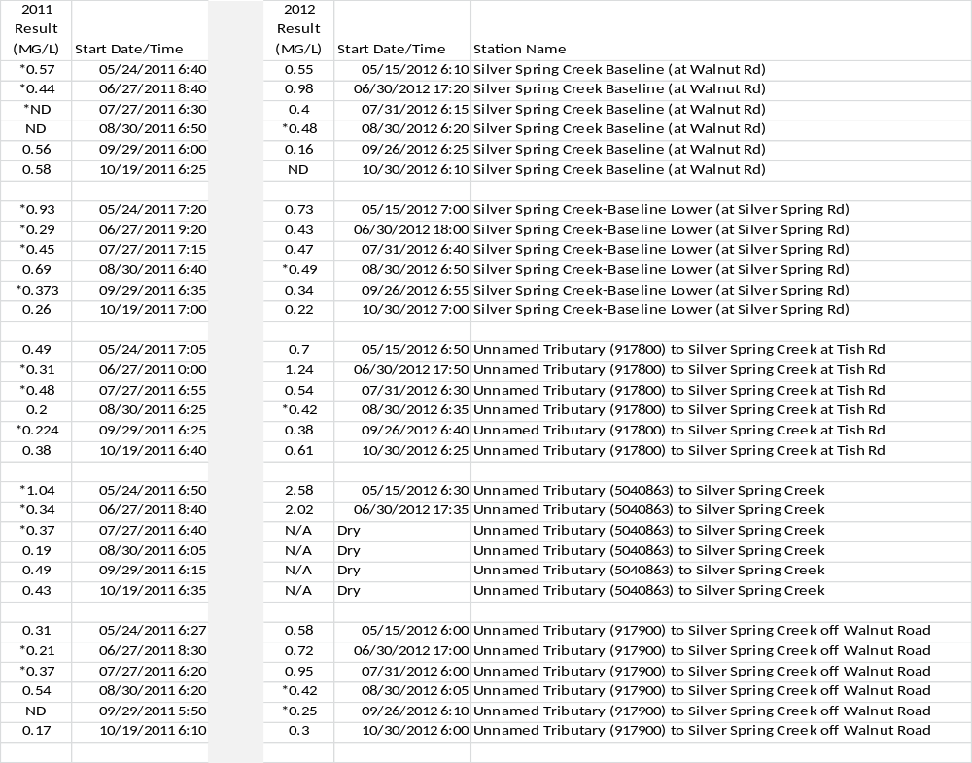

Table 1d: Nitrate and Nitrite in Silver Spring Creek and Tributaries (2011-2012)
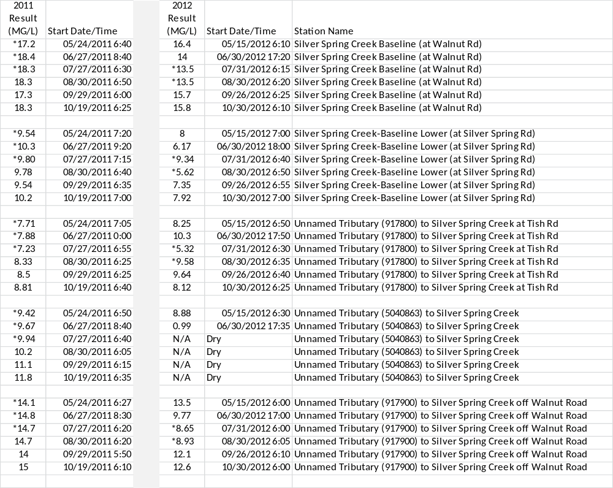

Table 1e: Total Phosphorus in Silver Spring Creek and Tributaries (2011-2012)
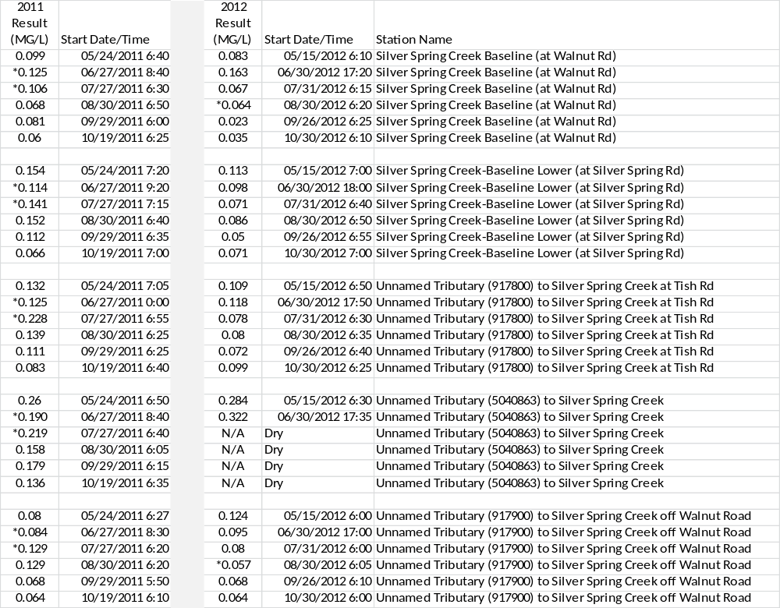
Table 2: Mean and Median Values for Chemistry Samples Taken from Silver Spring and Tributaries in 2011 and 2012
Site | Phosphorus Mean (Median) | NO2/NO3 Mean (Median) | NH3 Mean (Median)¹ | TKN Mean (Median)¹ | TSS Mean (Median)
Silver Spring Creek Baseline (at Walnut Rd) | 0.081 (0.075) | 16.4 (16.8) | 0.035 (0.035) | 0.41 (0.46) | 26.7 (18.5)
Silver Spring Creek-Baseline Lower (at Silver Spring Rd) | 0.102 (0.105) | 8.63 (9.44) | 0.039 (0.031) | 0.47 (0.44) | 33.6 (32)
Unnamed Tributary (917800) to Silver Spring Creek at Tish Rd | 0.115 (0.110) | 8.31 (8.29) | 0.051 (0.047) | 0.50 (0.45) | 48.4 (19)
Unnamed Tributary (5040863) to Silver Spring Creek | 0.219 (0.205)² | 9.0 (9.81)² | 0.43 (0.026)² | 0.93 (0.46)² | 40.2 (27.5)³
Unnamed Tributary (917900) to Silver Spring Creek off Walnut Road | 0.087 (0.080) | 12.7 (13.8) | 0.043 (0.048) | 0.41 (0.34) | 23.5 (11)
 | All Values reported as mg/l
 | 1. Concentrations which were below detection were treated as half the detection limit of 0.015 mg/l for NH3 and 0.14 mg/l for TKN
 | 2. Mean and median based on 8 samples, not 12
 | 3. Mean and median based on 6 samples, all taken in 2011.

