PROGRESS REPORT OUTLINE
USEPA-Great Lakes Restoration Initiative Projects

Grant or IA Number GL00E00486
Project Title GLRI Wisconsin Partnership for Invasive Species
Reporting Period Covered Semi Annual Report (10/1/2012 to 4/1/2013)
Principal Investigator Bob Wakeman, AIS Coordinator

The principal investigator of grants, cooperative agreements, and interagency agreements (IA) is required to submit to USEPA project officer a [quarterly or semi-annually] progress report. This report can be as brief as one page as long as you can provide the requested information. The items listed below should be addressed as appropriate.

Project Scope:

- Student Watercraft Inspection
- AIS Monitoring
- AIS Monitoring and Outreach Specialists
- County AIS Partnerships
- State Coordination

- What work was accomplished for this reporting period? Report should quantify results as measureable products, i.e. number of acres, contacts, improvements in water quality, habitat, etc.

- Student Watercraft Inspection

Targeted Outputs:

- 100 new watercraft inspectors trained
- 30 new boat landing visited
- 4,000 additional hours spent conducting watercraft inspection
- 8.000 additional boats inspected
- 10,000 additional people contacted during inspections
- Additional information on boater behavior and awareness of AIS

Performance:

From the grant start date (9/15/2010) to this reporting period (March 31, 2013) the Department and its many partners have exceeded all of the above target outcomes. Appendix 1 summarizes Wisconsin watercraft inspection data for the Great Lakes basin.

Additional information can be found at our website;

http://dnr.wi.gov/lakes/invasives/WatercraftSummary.aspx

The GLRI funding provided 9 inspectors each year, (6 – Lake Michigan, 3 – Lake Superior) to be stationed along the Great Lakes coastline. Since 2011, 38 new boat landings were staffed by these inspectors and information on boater awareness and compliance was surveyed. In addition, the Department contracted with the University of Wisconsin – Oshkosh and hired as many as 15 interns each year to be stationed at the boat launches along the Fox River, Wolf River and Winnebago Pool system. These systems are a considered to be significant sources of AIS to the rest of the state, due to their regional significance to anglers and boaters and the presence of AIS (VHS, Eurasian Water Milfoil, Curly Leaf Pond Weed, etc.).

The number of hours, boats inspected and boaters surveyed have greatly exceeded the targeted outputs for this effort. In addition, the number new boat launches, and inspectors trained have also been exceeded.

Boater behavior and awareness has been surveyed in a couple of ways. The Department continues to collect awareness data from the watercraft inspection surveys conducted at boat launches and as is displayed in appendix 1 AIS awareness is over 90%. In an attempt to ground truth this self-reported data the Department initiated an Observational Study to assess compliance with the state’s AIS laws. Appendix two summarizes the information that was collected from the first year of the Observational Survey. Only 1376 surveys were collected from this initial effort but it did help to identify areas where the survey could be improved or enhanced to improve accuracy. The Observational Survey will be continued in 2013 and is expected to improve on our knowledge of boater behavior. During this reporting period the Department conducted five focus group surveys around the state. These surveys drew upon boater registration and fishing license records to invite boaters and anglers to a discussion (survey) of their knowledge and compliance with AIS laws, outreach campaigns, and media products. The results of these focus group surveys can be found at;

http://dnr.wi.gov/lakes/invasives/FocusGroups.aspx

- AIS Monitoring

Targeted Outputs

Citizen Lake Monitoring Network
- 200 new citizen lake monitors trained and actively participating in AIS lake monitoring in the Great Lakes Basin
- 150 new inland lakes in the Great Lakes Basin monitored for AIS

Project Riverine Early Detectors (RED)
- 50 new citizens trained to identify early detection invasive species in river corridors within the Great Lakes Basin
- 100 additional miles of tributaries to the Great Lakes monitored for AIS

Purple Loosestrife Monitoring and Biocontrol
- 25 new citizen groups (involving at least 50 active individuals) trained to raise and release purple loosestrife biocontrol beetles in Great Lakes Basins to complement over 200 groups that are raising, or have already raised biocontrol beetles in the basins
- 80 citizen groups trained to monitor for purple loosestrife an other wetland invasives in Great Lakes Basin wetlands
- 32 citizen groups trained to monitor for purple loosestrife biocontrol success in Great Lakes Basins
- At least 50 new wetlands treated with beetles in Great Lakes Basins
- 450,000 new purple loosestrife biocontrol beetles raised and relased in Great Lakes Basins

Performance Measures

Citizen Lake Monitoring Network

Train-the-trainer sessions for citizen monitoring programs (i.e., Citizen Lake Monitoring Network, Project RED, and Purple Loosestrife Biocontrol) and statewide AIS lake monitoring (for professional staff) are being planned and will be held this spring.

Project RED

Between April 2012 and March 2013, eleven workshops on Project RED were held around the state. Four of those workshops (Franklin Town Hall, Harborside Academy, Bailey’s Harbor Town Hall and Manitowish Waters) were conducted in the Great Lakes Basin. Approximately 60 volunteers were trained in the Great Lakes Basin with an additional 46 individuals trained around the state. Ten rivers were surveyed for AIS using the Project RED protocol. The following table summarizes the known workshops and number of volunteers trained and river miles surveyed during this reporting period.

River/Stream | Volunteers Trained | Miles Surveyed
- Branch River (Great Lakes Basin) | 19 | 2.6
- Sugar River | Unknown | Unknown
- Rice Creek (Great Lakes Basin) | Unknown | Unknown
- Wisconsin River | 12 | 22
- Kickapoo River | Unknown | Unknown
- Black River | Unknown | Unknown
- Blue River | Unknown | Unknown
- Pleasant Valley Creek | Unknown | Unknown
- Flambeau River | Unknown | Unknown
- Oconto River | 0 | 3
- Kangaroo Lake | 13 | Unknown

Purple Loosestrife Monitoring and Biocontrol

Train-the-trainer sessions for citizen monitoring programs (i.e., Citizen Lake Monitoring Network, Project RED, and Purple Loosestrife Biocontrol) and statewide AIS lake monitoring (for professional staff) are being planned and will be held this spring.

- AIS Monitoring and Outreach Specialist

Three regional AIS Monitoring and Outreach Specialists have been positioned in the Great Lakes Basin from the beginning of this grant. They are located in Sheboygan County, Brown County and Ashland County. Their responsibilities are listed in appendix 3.

In 2012, DNR continued a multi-year statewide AIS baseline monitoring effort of lakes that have boat landings. DNR staff and county partners searched 179 lakes for aquatic invasive species (and will monitor a new set of lakes for at least the next three years). These lakes were selected using a geographically stratified model and were split between Great Lakes basin counties (N=56) and Mississippi River Basin counties (N=123). This monitoring effort will allow a statistically sound evaluation of all of the lakes in Wisconsin and enable us to:
- Establish baseline data on statewide AIS distribution.
- Track the rate of AIS spread among Wisconsin lakes.
- Evaluate the effectiveness of outreach and education efforts aimed at stopping the spread of AIS.

A list of lakes included in the baseline monitoring effort is attached below.
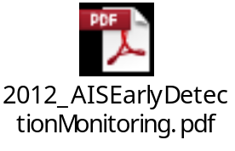
A handful of new aquatic plant populations have been found by the regional teams each year and control and containment planning have been initiated by the regional DNR AIS coordinator. During 2012 new EWM populations were found in four lakes and more intensive surveys were completed to determine the invasive plant distribution within the lakes. For example Eurasian water-milfoil (EWM) plants were discovered in Anvil Lake in Vilas County by a monitoring team during a July survey. The discovery led to a more thorough survey to map the extent of the population and a substantial coordinated effort by the Anvil Lake Association, GLIFWC, Onterra (a lake management consultant) and DNR to handpull over 60 EWM plants. The lake will be revisited in upcoming years to determine if the rapid response action was successful.

DNR also collected stream macroinvertebrate samples from 555 stream segments (with 235 in the Great Lakes Basin) that are being checked for invasive species. The laboratory is still processing these samples and approximately 38 have been analyzed thus far. To date, no AIS have been found in 2012 samples. Analysis of samples from 577 stream segments in 2011 was completed and zebra mussels, Echinogammarus ischnus and rusty crayfish were found at 3, 1 and 13 sties respectively.

Monitoring data collected as part of this effort are entered into the statewide Surface Water Integrated Monitoring System (SWIMS) and revealed on DNR’s website for responsive reporting of findings. This departmental effort improved our ability to report AIS information. Live updates of watercraft inspection and AIS monitoring (both citizen and staff) findings are made every 15 minutes on the website and new information is posted about the status of AIS (e.g. location, prevention steps, control efforts, and grants available). Project RED (Riverine Early Detection) volunteer monitoring data as well as purple loosestrife bio-control and wetland invasive species volunteer monitoring data are now being tracked through the DNR SWIMS database as well.
DNR conducted at least 15 “train the trainer” sessions in the Great Lakes Basins to train staff and members of the public about the Citizen Lake Monitoring Network (CLMN) (eight sessions), Purple Loosestrife (two sessions) and Project RED (five sessions) opportunities. These data are all entered into the SWIMS database. Importantly, all training included both monitoring and safety and disinfection protocols. No accidents involving injuries were reported in 2012.
We will continue to monitor at least 500 water bodies in the state to gather baseline distribution data and track the rate of inland spread in 2013.
No problems have been encountered to date. The rate of expenditure is commensurate with the progress of this element.

Sustaining this effort is very important to the Department. The AIS Monitoring Coordinator is a critical position to be sustained. While Scott Van Egeren recently took a new permanent position within the Department, Maureen Ferry has accepted the responsibilities of the Coordinator position. Regional staff remained in place during the 2012 season and will be ready for 2013.

- County AIS Partnerships

It is important to support our county AIS partnerships. This has been accomplished through the use of our AIS grants which are currently supporting the following counties;

Sponsor | Project | Award Amount | Cumulative Amount
Douglas County LWCD | Implementing the Douglas Co. AIS Strategic Plan | $150,000 | $ 150,000
Washburn County LWCD | Washburn Co. AIS Strategic Plan Implementation Project | $150,000 | $ 300,000
Washington County | Washington Co. AIS Education and Prevention Program | $150,000 | $ 450,000
Shawano County LCD | Shawano County AIS County Coordinator | $100,000 | $ 550,000
Dane County Office of Lakes and Watersheds | Dane County AIS Prevention and Control Plan Implementation | $ 50,000 | $ 600,000
Oneida County LWCD | Oneida Co. AIS Education and Prevention and Monitoring Project | $ 45,705 | $ 645,705
Oconto County LCD | Oconto County AIS Coordinator | $100,000 | $ 745,705
Ashland County LCD | Ashland County AIS Program/Coordinator | $117,989 | $ 863,694
Door County SWCD | Door County AIS Education, Prevention & Planning | $ 86,550 | $ 950,244
Glacierland RCD | Sheboygan County AIS Control | $99,755 | $1,050,000

Grants awarded in 2011

Grants awarded in 2012

No additional grants have been awarded from GLRI funds since the 2012 awards.

- Statewide Coordination

Managing through partnerships is sustainable, efficient, and effective. It does, require a significant amount of state-level coordination in order to be successful and ensure a high level of quality. Stepped up aquatic invasive species prevention efforts along the Great Lakes coastline will result in an increased need for coordination in the following areas;

Building AIS programs and networks along the Great Lakes coastline especially in counties without an AIS Coordinator, facilitate communication between the Great Lakes AIS network and statewide AIS partnership effort, develop Great Lakes specific outreach messages and ensure a common message in the Great Lakes basin, assist with outreach tools and resource development, and provide access to publications and other educational materials

The Department contracted with the UW Sea Grant office to fund a Great Lakes Outreach Specialists to work on these objectives. This position connects with shoreline communities to encourage their participating in AIS prevention, containment and control activities.
Position Goals

- Build AIS programs and networks along the Great Lakes, especially in counties without an AIS County Coordinator

This position has continued to build AIS networks along the Great Lakes region. Eighteen presentations were given to community and professionals, 12 meetings were attended, seven trade shows were staffed, and 30 meetings, conferences, and webinars on AIS issues were attended. Local presentations utilized information gained from attending regional and national conferences, while state and regional level presentations utilized information learned from working on a local level.

The AIS network has grown and solidified during the reporting period. Stakeholders know the Specialist as a resource for AIS information and programs within the Lake Michigan Basin and the state. The Specialist has had some success incorporating AIS information into existing programs including an AIS day for the Watershed Ambassadors Camp sponsored by the Wisconsin Maritime Museum and the incorporation of AIS info into the HookedUp101 Fishing Education curriculum. The Specialist has worked with the Wisconsin Bass Federation to incorporate the Stop Aquatic Hitchhikers message into their tournament operations.

Future work will include working more closely with coastal communities to get them to build AIS capacity by better understanding the traffic at their access points and by taking advantage of the Wisconsin DNR grants program. This position will work to develop a fishing guide AIS network throughout the Great Lakes Basin.

- Facilitate communication between the Great Lakes AIS network and a statewide AIS partnership
This position has facilitated communication between the Great Lakes AIS network and the statewide AIS partnership by attending state and regional conferences, participating in statewide meetings, and being involved with local stakeholder groups. Involvement in national and regional conferences has enabled the flow of information in both directions.

- Develop Great-Lakes-specific outreach messages and ensure a common message in the Great Lakes basin
This position provides a consistent prevention and containment message to the Great Lakes areas. The two projects highlighted emphasize the containment of existing species and the preventing the introduction of new ones.

Watercraft Decontamination

This project has really expanded in the past year. The Specialist built off the solid base of research and investigating to expand decontamination knowledge within Wisconsin. These efforts involved numerous public presentations and participation on a multiagency decontamination policy team.

A decontamination policy team was formed to define what decontamination is, what decontamination actions are recommended for various water user groups, and to prioritize resource allotment for decontamination efforts. The policy team consists of representatives from federal, state, and local government, as well as representatives from the university system and nonprofit organizations. The policy team met four times from December 2012 through February 2013 to outline the science of decontamination, what efforts are occurring nationwide, and what challenges might exist throughout Wisconsin’s water resources.

The decontamination policy team will make final recommendations and priorities. The policy team met in February 2013 to officially draft decontamination recommendations for water user groups and to prioritize resource allotment for decontamination efforts. The results of the February meeting will be presented at the 2013 Wisconsin Lakes Convention in Green Bay. New decontamination outreach materials will be developed to reflect the recommendations for each user group. Further work will include developing outreach signs at new and existing units to educate water users about the decontamination options that are available to them.

Other decontamination related activities of note include organizing at decontamination station at The Bass Federation Northern Divisional Tournament in La Crosse and presenting about decontamination in Wisconsin at the Upper Midwest Invasive Species Conference in La Crosse. The production of a decontamination pamphlet was also completed in 2012. The pamphlet will accompany existing WDNR decontamination units as well as any existing pressure washing stations throughout the state.

The Specialist met with various municipalities and stakeholders within the state about incorporating decontamination equipment or outreach materials at their boat ramps. Communities that already have pressure washing equipment at municipal ramps (Menasha, La Crosse) have expressed interest in having outreach signs installed at the stations to help citizens understand how to use the stations. The Specialist met with other stakeholder groups (Port Washington, Racine, Two Rivers, Waterford Water Management District) about purchasing decontamination equipment or incorporating it into an existing project.

Habitattitude

The Specialist promoted Habitattitude campaign last February. There was a general consensus among AIS coordinators and WDNR staff that pet release was an important pathway of AIS, yet except for the NR-40 regulations that prohibit potentially invasive species there were few options available for owners of unwanted pets. The Habitattitude campaign provides guidance on alternatives to pet release and has proved a good place to start in reaching out to aquarium owners and pet stores.

- Assist with outreach tools and resource development
The Specialist created a watercraft decontamination brochure as well as an AIS prevention card targeted to the diving community. Both outreach pieces were developed in conjunction with the WDNR. The decontamination brochure will be distributed with existing watercraft decontamination units while the Stop Aquatic Hitchhikers diving card was handed out at the Ghost Ships Festival in Milwaukee and will be distributed throughout diving shops in Wisconsin.

The Specialist assisted in the development of outreach materials for the Great Lakes Sea Grant Network AIS Prevention for Fishing Tournaments project. Best management practices are being developed for fishing tournament organizers and anglers, and a corresponding test to certify fishing clubs and tournaments organizers as “AIS certified.”

- Provide access to publications and other educational efforts
The Specialist has in general provided stakeholders with access to the library of Sea Grant and Wisconsin DNR communications.

- What if any, changes were made from the Object Class Categories listed in Sec. B of the SF 424A or Box 29 of the IA, as applicable?

No changes were made to the Object Class Categories.

- If a problem was encountered, what action was taken to correct it?

Our ability to meet the targeted outputs in the Citizen Lake Monitoring, Project RED, and Purple Loosestrife volunteer based monitoring elements has been challenging. A couple of issues have been identified;

- Records keeping at training workshops don’t accurately capture number of volunteers trained.
- Success of training prior to GLRI has saturated the landscape in some areas, making it difficult to find pools of new volunteers.
- More dedicated effort on these programs should be made to increase program participation.

During the 2013 spring AIS Coordinators meeting, the need to keep better records at training workshops will be emphasized. Staff will be encouraged to take the time to complete training registration forms and submit this information to SWIMS for recording. In some area in the state these programs are already fairly well established and it is difficult to find new pools of volunteers. The early success of these programs (prior to GLRI funding) is now making it difficult to meet the targeted outputs. A more concentrated effort in some of these volunteer based programs is expected to increase participation. This was recognized in the Project RED program and we are optimistic that an increase effort in 2013 will result in an increase level of participation.

- What work is projected for the new reporting period activity?

The grant period ends in September 2013 so there will be a continuation of the above reported activities during the remainder of this period.

- Is the project work on schedule? List activities from the Work Plan, and any required Quality System Documentation, and report as percent completed.
- This reporting period
- For the project

The project is on schedule for completion. The budget drawdown appears to be lagging behind due to the AIS grants element but this is being closely monitored and has been discussed with EPA Project Officer Jamie Schardt. A project extension may be required to allow for the AIS grant recipients to submit their payment requests. This will be evaluated again.

- Does the project funding rate support the work progress? Report as percent spent of budgeted amounts for Federal and non=-Federal.

The total budget drawn down to date is $770,021 which is 78% of the federal grant amount. Voluntary match for this grant was $1,590,000 for the two years (2011 – 2012). This was going to be accomplished through the state’s AIS grant program for prevention and control grans. Over $4 million has been distributed to local sponsors for AIS prevention and control activities in the Great Lakes basin. A summary of these grants can be found in appendix 4.

- Is there a change in principal investigator?

No change in principal investigator

- Will the project take longer than the approved project period? If so, have you formally requested an amendment in writing?

We have discussed the need for a possible extension with Project Officer Jamie Schardt and will evaluate this again in June, 2013.

- What is the date and amount of your latest drawdown request? If no request has been submitted, please explain.

Last draw was done on 03/15/13 for $64,744.

- What is the date of your latest entry into the Great Lakes Accountability System? If no recent entry has been submitted, please explain.

Last entry in GLAS was 4/1/2013.

Please reference the USEPA project number on your report and all correspondence.

Appendix 1.
Summary of Watercraft Inspection (Clean Boats Clean Waters, Clean Water Inspection Volunteer Inspections) in the Great Lakes Basin

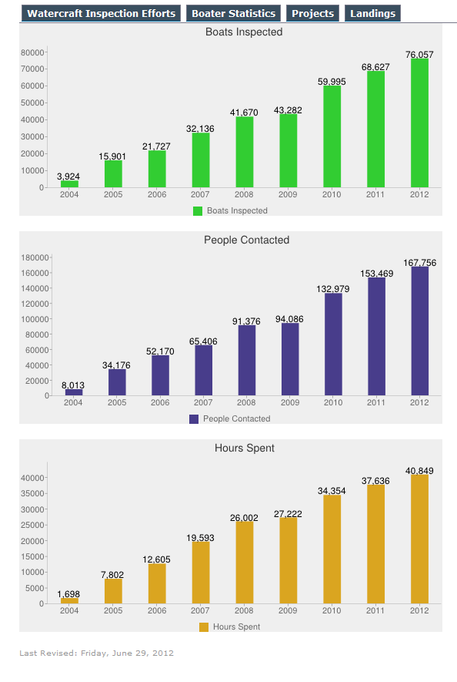

Appendix 1 (Continued)

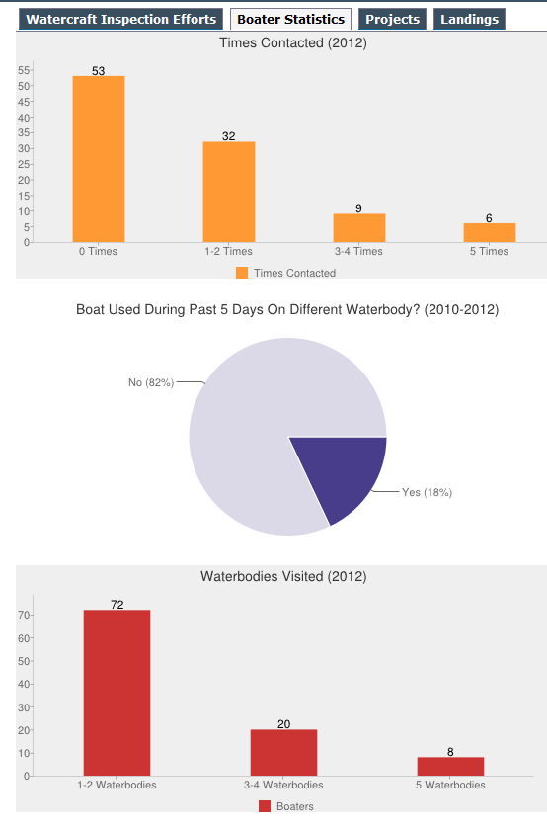

Appendix 1 (Continued)

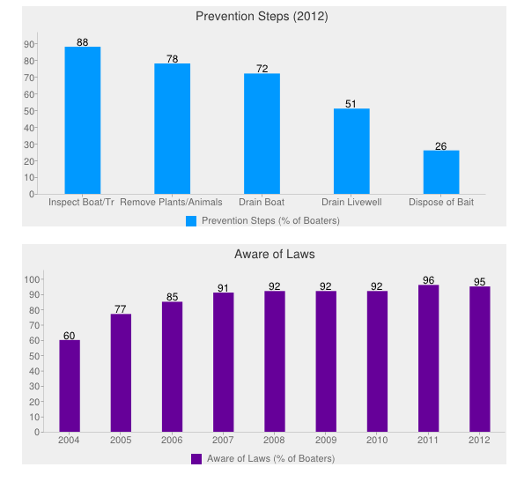

Appendix 2.
Observation Survey Results



Appendix 3.
Position Responsibilities for AIS Monitoring and Outreach Specialists

Responsibilities of Duties:

40 % Monitoring

Implement the comprehensive early detection AIS sampling protocol to aid in evaluating the rate of spread of AIS across the state and to detect new infestations of AIS. The monitoring will occur in the rivers, streams, wetlands, inland lakes and nearshore area of the Great Lakes. Disinfect all sampling equipment per existing statewide protocols between waterbodies.

Prepare AIS samples for identification and verification when necessary. Enter monitoring results into the statewide database (SWIMS) and assist in the preparation of a year end sampling report.

Respond to regional complaints and discoveries of new AIS infections. Assist in regional rapid response effort to contain, and control or eradicate new AIS.

Enter data into SWIMS.

Attend training sessions to learn proper sampling and disinfection techniques, and to train others as well.

Attend AIS Program planning meetings.

40 % Outreach

Become trained as Clean Boats Clean Waters (CBCW) and Citizen Lake Monitoring Network (CLMN) trainer.

Work to expand CBCW network in the Great Lakes Basin by training volunteers or paid staff. Work with local units of government, nonprofit conservation organizations, lake organizations and other existing networks to expand the CBCW network.

Conduct watercraft inspections at launch sites and provide information and educational materials about AIS to boaters and user groups. Recruit and train citizen volunteer monitors.

Work to replace old AIS signs at boat launches with the new signs.

Work with local law enforcement staff, conservation wardens and water guards to promote compliance with AIS laws.

Work to expand the CLMN in the Great Lakes Basin by becoming trained and training others. Work with local units of government, nonprofit conservation organizations, lake organizations and other existing networks to expand the CLMN.

Assist in the dissemination of informational materials to help educate the public. Attend workshops, conferences, fairs, and other events to provide information, give presentations and talk with the public about the AIS Partnership.

Explore opportunities to form new partnerships with existing organizations or groups to increase the distribution of the AIS message.

10 % Biocontrol of Purple Loosestrife

Assist in the expansion of the Biocontrol of Purple Loosestrife project in the Great Lakes Basin. Aid in the dissemination of information to help educate the public. Assist in securing and training additional volunteers to raise beetles and disseminate materials to targeted wetland complexes.

Assist in the monitoring of wetlands and other aquatic habitats for purple loosestrife and other AIS.

Attend meetings, conferences and present information on the Biocontrol of Purple Loosestrife project to the public statewide.

10 % Project Riverine Early Detectors (RED)

Become trained in the identification of river corridor AIS and the Project RED sampling techniques.

Assist in securing additional Project RED volunteers in the Great Lakes Basin. Train volunteers and aid in the monitoring of riverine corridors for invasive species.

Work with the River Alliance of Wisconsin (RAW) to expand project RED cooperators in the state.

Appendix 4.
Summary of State AIS Grants Distributed to Local Partners in the
Great Lakes Basin (2011 – 2012)

Total State
Grant # Grant Type Start Date End Date Award Award Org.

AIRR-097-11 | AIS_EARLY_DETECT | 01/01/2011 | 06/30/2014 | 30,070 | 20,000 | Forest Lake
AIRR-105-11 | AIS_EARLY_DETECT | 02/01/2011 | 06/30/2013 | 5,393 | 4,025 | Rolling Stone Lake
AEPP-281-11 | AIS_EDUCATION | 04/01/2011 | 12/31/2011 | 13,317 | 9,988 | Pelican Lake
AEPP-286-11 | AIS_EDUCATION | 04/01/2011 | 12/31/2011 | 18,630 | 6,030
AEPP-284-11 | AIS_EDUCATION | 04/01/2011 | 12/31/2011 | 18,618 | 9,714 | Lake Lucerne
AEPP-276-11 | AIS_EDUCATION | 04/01/2011 | 12/31/2011 | 9,875 | 5,925 | Whitefish Lake
AEPP-267-11 | AIS_EDUCATION | 04/01/2011 | 12/31/2011 | 14,361 | 9,986
AEPP-304-11 | AIS_EDUCATION | 04/01/2011 | 06/30/2012 | 20,543 | 14,675 | Norwegian Lake
AEPP-283-11 | AIS_EDUCATION | 04/01/2011 | 06/30/2012 | 4,000 | 3,000 | Nagawicka Lake
AEPP-291-11 | AIS_EDUCATION | 04/01/2011 | 06/30/2012 | 20,620 | 15,465 | Big Roche a Cri
AEPP-275-11 | AIS_EDUCATION | 04/01/2011 | 06/30/2012 | 4,573 | 3,430 | Pewaukee Lake
AEPP-278-11 | AIS_EDUCATION | 04/01/2011 | 06/30/2012 | 5,448 | 2,724
AEPP-298-11 | AIS_EDUCATION | 04/01/2011 | 12/31/2012 | 177,300 | 132,379 | Big Eau Pleine River
AEPP-285-11 | AIS_EDUCATION | 04/01/2011 | 12/31/2012 | 4,000 | 3,000 | Lower Phantom Lake
AEPP-303-11 | AIS_EDUCATION | 04/01/2011 | 12/31/2012 | 28,110 | 19,450 | North Branch Pike River
AEPP-292-11 | AIS_EDUCATION | 04/01/2011 | 12/31/2012 | 23,564 | 16,173 | Lake Owen
AEPP-274-11 | AIS_EDUCATION | 04/01/2011 | 12/31/2012 | 11,237 | 7,304 | Unnamed
AEPP-301-11 | AIS_EDUCATION | 04/01/2011 | 06/30/2013 | 161,477 | 113,912 | Crooked Lake
AEPP-271-11 | AIS_EDUCATION | 04/01/2011 | 06/30/2013 | 13,000 | 9,750 | Superior Bay
AEPP-294-11 | AIS_EDUCATION | 04/01/2011 | 06/30/2013 | 164,621 | 122,979
AIRR-099-11 | AIS_EARLY_DETECT | 04/01/2011 | 06/30/2013 | 10,140 | 7,140 | Green Lake
AIRR-100-11 | AIS_EARLY_DETECT | 04/01/2011 | 06/30/2013 | 19,158 | 14,369 | Oneida Lake
ACEI-093-11 | AIS_CONTROL | 04/01/2011 | 06/30/2013 | 270,197 | 173,333 | Tomahawk Lake
ACEI-101-11 | AIS_CONTROL | 04/01/2011 | 06/30/2013 | 81,074 | 52,698 | Bridge Lake
AEPP-270-11 | AIS_EDUCATION | 04/01/2011 | 06/30/2013 | 11,290 | 8,468 | Mid Lake
AEPP-290-11 | AIS_EDUCATION | 04/01/2011 | 12/31/2013 | 105,925 | 49,904 | Turtle Flambeau Flowage
AEPP-288-11 | AIS_EDUCATION | 04/01/2011 | 12/31/2013 | 40,308 | 30,231
ACEI-100-11 | AIS_CONTROL | 04/01/2011 | 12/31/2013 | 183,225 | 137,419 | Chute Pond
AEPP-289-11 | AIS_EDUCATION | 04/01/2011 | 12/31/2013 | 47,154 | 30,650 | Lake Sherwood
AEPP-282-11 | AIS_EDUCATION | 04/01/2011 | 12/31/2013 | 9,748 | 6,208
AEPP-293-11 | AIS_EDUCATION | 04/01/2011 | 12/31/2013 | 199,600 | 149,700
AEPP-296-11 | AIS_EDUCATION | 04/01/2011 | 06/30/2014 | 126,404 | 94,803
AIRR-107-11 | AIS_EARLY_DETECT | 04/01/2011 | 06/30/2014 | 24,112 | 18,084 | Marl Lake
ACEI-098-11 | AIS_CONTROL | 04/01/2011 | 06/30/2014 | 130,594 | 84,886 | Metonga Lake
ACEI-094-11 | AIS_CONTROL | 04/01/2011 | 06/30/2014 | 145,446 | 96,190 | St Croix Flowage
AIRR-101-11 | AIS_EARLY_DETECT | 04/19/2011 | 12/31/2012 | 9,467 | 6,913 | Lake Lime
AIRR-123-12 | AIS_EARLY_DETECT | 07/01/2011 | 06/30/2013 | 7,920 | 5,940 | Arrowhead Lake
AIRR-111-12 | AIS_EARLY_DETECT | 07/01/2011 | 06/30/2013 | 26,667 | 20,000 | Squash Lake
AIRR-116-12 | AIS_EARLY_DETECT | 07/01/2011 | 12/31/2013 | 12,953 | 9,715 | Shadow Lake
AIRR-119-12 | AIS_EARLY_DETECT | 07/01/2011 | 06/30/2014 | 21,980 | 16,485 | Silver Lake
AIRR-121-12 | AIS_EARLY_DETECT | 07/01/2011 | 06/30/2014 | 34,694 | 20,000 | Harris Lake
AIRR-120-12 | AIS_EARLY_DETECT | 07/01/2011 | 06/30/2014 | 26,621 | 19,966
AIRR-122-12 | AIS_EARLY_DETECT | 07/01/2011 | 06/30/2014 | 16,043 | 11,272 | Wisconsin River
AIRR-112-12 | AIS_EARLY_DETECT | 07/15/2011 | 06/30/2015 | 26,667 | 20,000 | George Lake
AIRR-124-12 | AIS_EARLY_DETECT | 08/01/2011 | 06/30/2013 | 19,141 | 14,355 | Pelican Lake
AIRR-113-12 | AIS_EARLY_DETECT | 08/16/2011 | 06/30/2012 | 35,828 | 20,000
AIRR-110-12 | AIS_EARLY_DETECT | 09/01/2011 | 12/31/2013 | 6,375 | 2,775 | Lake Helen
AIRR-117-12 | AIS_EARLY_DETECT | 09/15/2011 | 12/31/2015 | 24,631 | 18,473 | Long Lake
AIMC-007-12 | AIS_MAINT_CONT | 09/20/2011 | 09/20/2011 | 695 | 695
AEPP-307-12 | AIS_EDUCATION | 10/01/2011 | 12/31/2012 | 15,150 | 9,750
ACEI-111-12 | AIS_CONTROL | 10/01/2011 | 12/31/2012 | 15,438 | 7,719 | Sandstone Flowage
AEPP-311-12 | AIS_EDUCATION | 10/01/2011 | 12/31/2012 | 8,605 | 4,000 | Unnamed
AEPP-328-12 | AIS_EDUCATION | 10/01/2011 | 12/31/2012 | 16,000 | 12,000 | Upper Saint Croix Lake
ACEI-106-12 | AIS_CONTROL | 10/01/2011 | 06/30/2013 | 48,794 | 24,397 | Boot Lake
AEPP-317-12 | AIS_EDUCATION | 10/01/2011 | 06/30/2013 | 60,940 | 45,705
AEPP-323-12 | AIS_EDUCATION | 10/01/2011 | 06/30/2013 | 33,374 | 25,031
AEPP-334-12 | AIS_EDUCATION | 10/01/2011 | 12/31/2013 | 132,000 | 86,550
AEPP-309-12 | AIS_EDUCATION | 10/01/2011 | 12/31/2013 | 13,268 | 9,951 | Porters Lake
AEPP-330-12 | AIS_EDUCATION | 10/01/2011 | 12/31/2014 | 217,668 | 150,000
AEPP-331-12 | AIS_EDUCATION | 10/01/2011 | 12/31/2014 | 199,706 | 147,887
AEPP-335-12 | AIS_EDUCATION | 10/01/2011 | 12/31/2014 | 133,007 | 99,755 | Elkhart Lake
AEPP-324-12 | AIS_EDUCATION | 10/01/2011 | 12/31/2014 | 32,758 | 24,568 | Squash Lake
ACEI-103-12 | AIS_CONTROL | 10/01/2011 | 12/31/2014 | 181,016 | 90,508
AIRR-115-12 | AIS_EARLY_DETECT | 10/05/2011 | 12/31/2013 | 5,700 | 4,275 | Little Lake Butte Des Morts
AIRR-118-12 | AIS_EARLY_DETECT | 11/22/2011 | 12/31/2013 | 27,200 | 20,000 | Moshawquit Lake
AIMC-009-12 | AIS_MAINT_CONT | 12/19/2011 | 12/19/2011 | 1,270 | 1,270 | Legend Lake
AEPP-349-12 | AIS_EDUCATION | 04/01/2012 | 12/31/2012 | 6,040 | 4,530
AEPP-343-12 | AIS_EDUCATION | 04/01/2012 | 12/31/2012 | 6,543 | 4,907 | Whitefish Lake
AEPP-342-12 | AIS_EDUCATION | 04/01/2012 | 12/31/2012 | 13,333 | 10,000 | Pelican Lake
AEPP-340-12 | AIS_EDUCATION | 04/01/2012 | 12/31/2012 | 9,000 | 6,750
AEPP-358-12 | AIS_EDUCATION | 04/01/2012 | 12/31/2012 | 19,648 | 9,824 | Lake Lucerne
ACEI-121-12 | AIS_CONTROL | 04/01/2012 | 06/30/2013 | 122,773 | 90,148 | Crystal Lake
AEPP-338-12 | AIS_EDUCATION | 04/01/2012 | 06/30/2013 | 13,030 | 9,773 | Ostrowski Lake
AEPP-362-12 | AIS_EDUCATION | 04/01/2012 | 12/31/2013 | 165,609 | 124,207 | McAllister Lake
AEPP-350-12 | AIS_EDUCATION | 04/01/2012 | 12/31/2013 | 38,545 | 28,748
ACEI-115-12 | AIS_CONTROL | 04/01/2012 | 12/31/2013 | 81,701 | 40,851 | Legend Lake
AEPP-347-12 | AIS_EDUCATION | 04/01/2012 | 12/31/2013 | 4,000 | 3,000 | Pike Lake
AEPP-336-12 | AIS_EDUCATION | 04/01/2012 | 12/31/2013 | 6,540 | 4,840 | Lake Michigan
ACEI-123-12 | AIS_CONTROL | 04/01/2012 | 06/30/2014 | 54,430 | 40,822 | Totagatic River
AEPP-351-12 | AIS_EDUCATION | 04/01/2012 | 06/30/2014 | 65,745 | 49,309
AEPP-363-12 | AIS_EDUCATION | 04/01/2012 | 06/30/2014 | 150,778 | 113,084
AEPP-359-12 | AIS_EDUCATION | 04/01/2012 | 12/31/2014 | 154,000 | 97,020 | Wisconsin River
AEPP-361-12 | AIS_EDUCATION | 04/01/2012 | 12/31/2014 | 208,209 | 150,000
AEPP-356-12 | AIS_EDUCATION | 04/01/2012 | 12/31/2014 | 66,666 | 50,000
ACEI-117-12 | AIS_CONTROL | 04/01/2012 | 06/30/2015 | 59,408 | 29,704 | English Lake
ACEI-124-12 | AIS_CONTROL | 04/01/2012 | 12/31/2016 | 188,690 | 94,345 | Cloverleaf Chain
ACEI-112-12 | AIS_CONTROL | 04/01/2012 | 12/31/2016 | 123,231 | 80,100
ACEI-120-12 | AIS_CONTROL | 04/01/2012 | 12/31/2016 | 71,419 | 35,710 | Washington Lake
AIRR-138-13 | AIS_EARLY_DETECT | 07/01/2012 | 06/30/2014 | 4,650 | 3,488 | Horsehead Lake
AIRR-125-13 | AIS_EARLY_DETECT | 07/01/2012 | 06/30/2014 | 31,295 | 20,000 | Tilleda Pond
AIRR-146-13 | AIS_EARLY_DETECT | 07/01/2012 | 06/30/2014 | 26,720 | 20,000 | Squash Lake
AIRR-136-13 | AIS_EARLY_DETECT | 07/01/2012 | 06/30/2014 | 25,321 | 18,991
AIRR-145-13 | AIS_EARLY_DETECT | 07/01/2012 | 12/31/2014 | 20,728 | 15,484 | Big Lake
AIRR-131-13 | AIS_EARLY_DETECT | 07/01/2012 | 06/30/2015 | 26,667 | 20,000 | Kelly Lake
AIRR-143-13 | AIS_EARLY_DETECT | 07/01/2012 | 06/30/2015 | 26,663 | 19,997 | Kentuck Lake
AIRR-147-13 | AIS_EARLY_DETECT | 07/01/2012 | 06/30/2015 | 26,632 | 19,974 | Virgin Lake
AIRR-132-13 | AIS_EARLY_DETECT | 07/01/2012 | 12/31/2015 | 28,007 | 20,000 | Boulder Lake
AIRR-135-13 | AIS_EARLY_DETECT | 07/01/2012 | 12/31/2015 | 22,500 | 16,875 | Unnamed
AIRR-134-13 | AIS_EARLY_DETECT | 07/01/2012 | 06/30/2016 | 26,667 | 20,000 | Upper Eau Claire Lake
AIRR-133-13 | AIS_EARLY_DETECT | 07/01/2012 | 06/30/2016 | 26,667 | 20,000 | Middle Eau Claire Lake
AIRR-144-13 | AIS_EARLY_DETECT | 07/04/2012 | 06/30/2016 | 29,688 | 16,685 | Anvil Lake
AIRR-130-13 | AIS_EARLY_DETECT | 09/05/2012 | 12/31/2014 | 26,516 | 19,887 | North Lake
AIRR-126-13 | AIS_EARLY_DETECT | 09/27/2012 | 06/30/2013 | 19,141 | 14,355 | Pelican Lake
AIRR-141-13 | AIS_EARLY_DETECT | 09/27/2012 | 06/30/2014 | 16,958 | 12,718 | Pelican Lake
AEPP-369-13 | AIS_EDUCATION | 10/01/2012 | 12/31/2013 | 8,615 | 4,000 | Unnamed
AEPP-370-13 | AIS_EDUCATION | 10/01/2012 | 12/31/2013 | 4,768 | 3,576 | Eagle Spring Lake
AEPP-373-13 | AIS_EDUCATION | 10/01/2012 | 12/31/2013 | 67,521 | 47,253
AEPP-372-13 | AIS_EDUCATION | 10/01/2012 | 12/31/2013 | 9,184 | 4,000 | Crescent Lake
AEPP-379-13 | AIS_EDUCATION | 10/01/2012 | 12/31/2013 | 16,500 | 12,250 | Upper Saint Croix Lake
AEPP-384-13 | AIS_EDUCATION | 10/01/2012 | 06/30/2014 | 100,046 | 75,000
AEPP-378-13 | AIS_EDUCATION | 10/01/2012 | 12/31/2014 | 62,883 | 47,162 | Fourteenmile Creek
ACEI-125-13 | AIS_CONTROL | 10/01/2012 | 12/31/2014 | 65,020 | 42,263 | Lake Montello
AEPP-367-13 | AIS_EDUCATION | 10/01/2012 | 12/31/2014 | 15,650 | 9,950
AEPP-380-13 | AIS_EDUCATION | 10/01/2012 | 06/30/2015 | 201,100 | 150,000
AEPP-374-13 | AIS_EDUCATION | 10/01/2012 | 06/30/2015 | 44,922 | 31,779
AEPP-382-13 | AIS_EDUCATION | 10/01/2012 | 12/31/2015 | 168,823 | 123,222
ACEI-129-13 | AIS_CONTROL | 10/01/2012 | 12/31/2016 | 176,684 | 132,513 | Lake Morris
ACEI-128-13 | AIS_CONTROL | 10/01/2012 | 12/31/2016 | 103,574 | 77,681 | White Lake
ACEI-126-13 | AIS_CONTROL | 10/01/2012 | 12/31/2017 | 263,681 | 197,761 | Kettle Moraine Lake
AIRR-129-13 | AIS_EARLY_DETECT | 10/15/2012 | 12/31/2014 | 13,683 | 10,262 | Lake Michigan
 |  |  |  | Total Awarded | 4,758,741

