An Assessment of

Water Quality

in

The Middle and Lower Grant River Watersheds

2012

Grant County, Wisconsin

Project SCR02_13

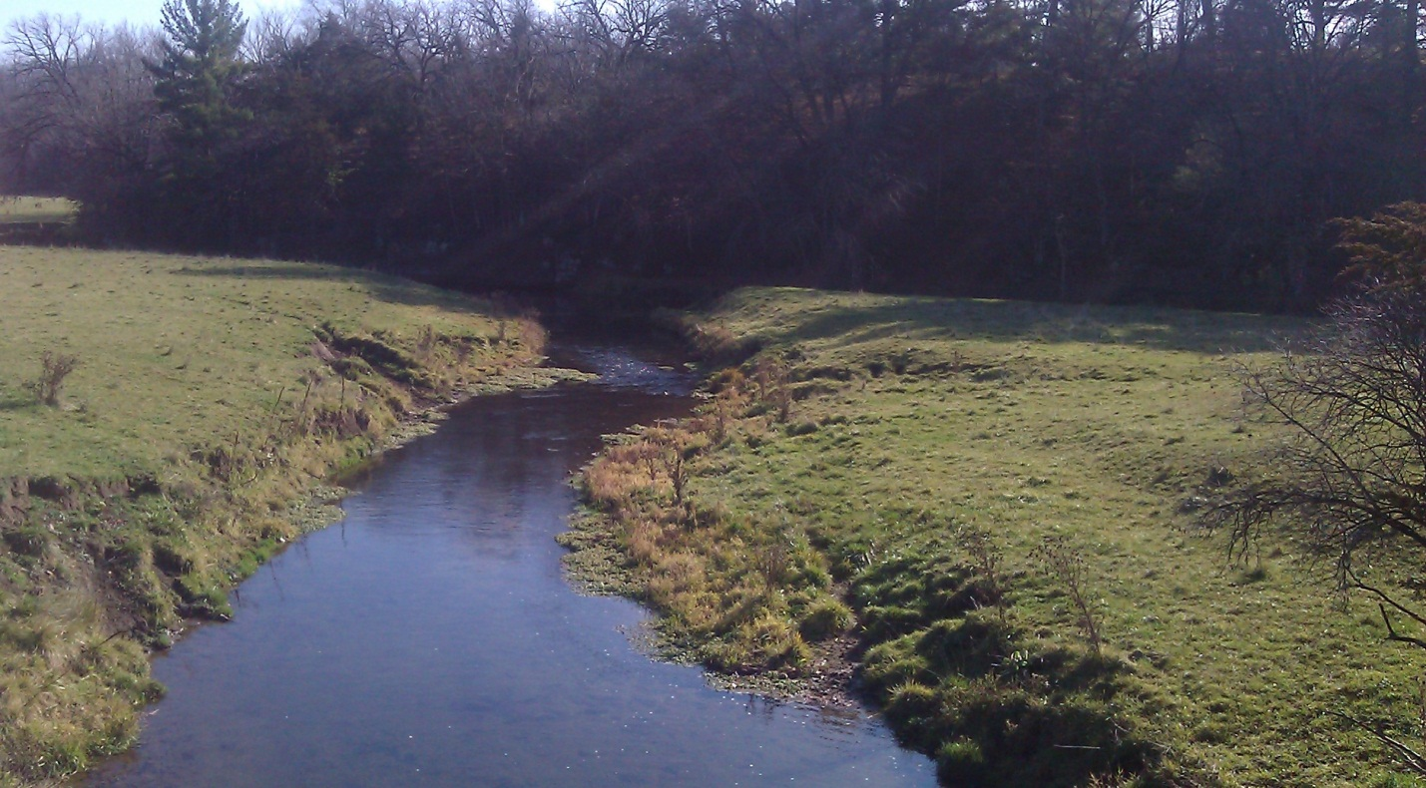
Rattlesnake Creek looking downstream from Muskellounge Road

By James Amrhein
Water Quality Biologist – Water District South
December, 2013

Introduction
The Middle Grant River and Lower Grant River watersheds together cover 225 square miles of southwestern Grant County. The Grant River drains both watersheds with Pigeon Creek and Blake Fork making up major tributaries in the Middle Grant watershed and Rattlesnake Creek and Boice Creek serving as major tributaries in the Lower Grant River Watershed (Figure 1).

The topography is gently to moderately rolling land with steep-sided valleys and broad ridge tops. In certain areas, bedrock outcroppings are readily visible on the stream bottoms and along the stream corridors. Agriculture makes up approximately 90 percent of the land cover. Generally, 55-70% of the landcover in the subwatersheds is in cropland while 21-25% is in pasture. While the hilltops are generally cropped, the stream valleys are pastured and the highly agricultural landscape and steep slopes lend themselves to delivery of high sediment loads to the streams that drain the valleys. Bank erosion is a major problem in the watershed. The steep gradients of the streams prevents buildup of sediment in the streams themselves save for the deeper pools, but the problem is moved downstream to larger, lower gradient systems like the lower Grant River and the Mississippi River. The Grant River has historically carried one of the highest sediment loads in the state, which can be evidenced by the delta of eroded sediments that has developed at the river’s mouth (WDNR, 2001).

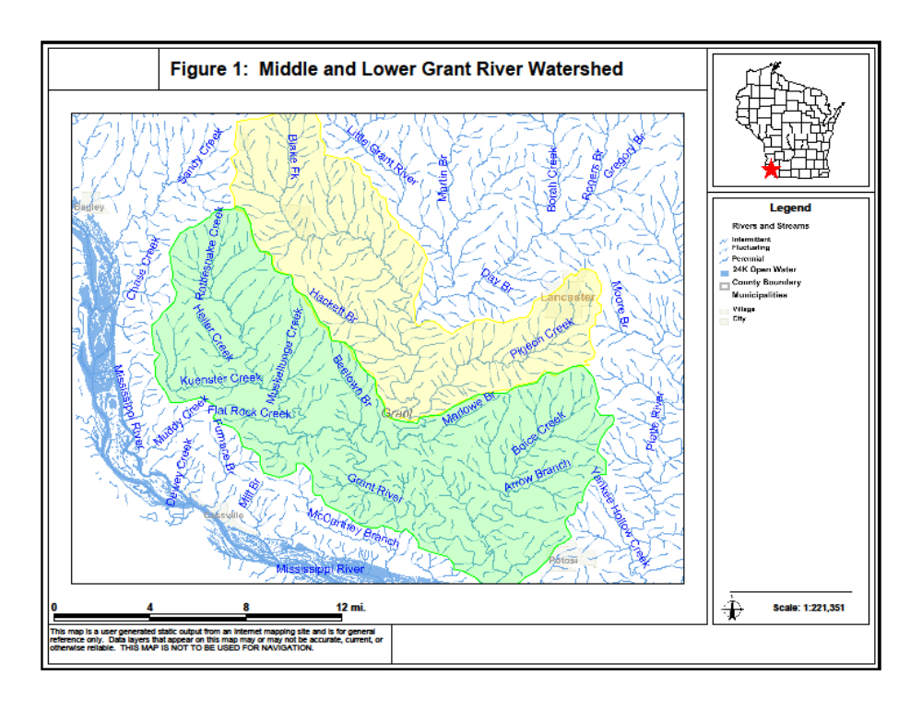

In the 1980’s the lower and middle Grant watersheds were subject to intense studies which resulted in a good appraisal of the watersheds. The studies showed the major impacts to streams to be reduced dissolved oxygen levels causing occasional fish-kills. Of secondary importance was habitat loss due to silt on the streambed filling in the pools. Diurnal oxygen variations during high flow events caused fish mortality. The low level oxygen was likely due to high levels of organic matter from manure entering the streams (WDNR, 1991). The Lower Grant River watershed was selected as Wisconsin non-point source abatement priority watershed project in 1989. The 10 year project was designed to enlist willing landowners in the watershed to install non-point source best management practices to protect water resources and improve farm conservation practices. The voluntary nature of the priority watershed project limited its success to some extent (WDNR, 2001).

Methods
The 2012 watershed survey was conducted by water resource biologists on 32 sites in the watershed. Sites were selected to cover named streams or major unnamed tributaries in the watersheds. The fisheries assemblage was determined by electroshocking a section of stream with a minimum station length of 35 times the mean stream width (Lyons, 1992). The exception to this was for the sites on Rattlesnake Creek. In an effort to reflect a similar sampling design to the annual trend site conducted on this stream, an attempt was made to sample approximately 400 meters in which all species were collected for an Index of Biotic Integrity (IBI) calculation and an additional 600 meters was sampled that targeted gamefish only. A stream tow barge with a generator and two probes was used at most sites. Three probes were used at the Rattlesnake Creek sites. A backpack shocker with a single probe was used at sites generally less than 2 meters wide. All fish were collected, identified, and counted. All gamefish were measured. At each site, qualitative notes on average stream width and depth, riparian buffers and land use, evidence of sedimentation, fish cover and potential management options were also recorded. A qualitative habitat survey (Simonson, et. al., 1994) was also performed at each site. Macroinvertebrate samples were obtained by kick sampling and collecting using a D-frame net at 24 sites in the watershed in fall, 2012 and sent to the University of Wisconsin-Stevens Point for analysis.

Results
Results of the fisheries surveys are summarize in Table 1. Because the natural communities model (Lyons, 2008) indicates most of the waters in these watersheds to be cool transitional waters, the coolwater IBI (Lyons, 2012) was applied to all streams. A total of 35 species were found throughout the watershed. White sucker, johnny and fantail darters, creek chub, common shiner, central stoneroller and bluntnose minnow were the most widely distributed species. Smallmouth bass were found at 21 of the 32 sites. Most species found were either coolwater transitional species or warmwater species (Ibid). Brown trout, a stenothermal coldwater species was found at 3 sites in limited numbers.

Qualitative habitat surveys (Table 2) showed most sites to be “fair” to “good” in habitat rating. A majority of stream sites had poor to fair buffer scores due to the prevalence of pasturing in stream valleys throughout the watershed. However, while many of the banks were noted as trampled, many remained grassed and thus the bank erosion scores were generally “good” to “excellent”. Many of the systems received good to excellent scores for riffle-to-riffle ratio, fine sediments, and fish cover owing to the good gradient of the streams in this area which allows for scouring of sediments and provides good riffle-run-pool complexes.

Macroinvertebrate analysis (Table 3) looked at both the macroinvertebrate index of biotic integrity (MIBI) (Weigel, 2003) and the Hilsenhoff Biotic Index (HBI) (Hilsenhoff, 1987). The majority of sites in the watersheds showed the MIBI to be “poor” with only two sites in the “good” range. Meanwhile the HBIs ranged from “fairly poor” to “very good” with most sites getting “fair” to “good” ratings.

Discussion
The streams of these two watersheds have historically contained populations of smallmouth bass and a diversity of nongame species. While the Grant River itself was not surveyed as part of this study, it offers a source of species recruitment, a conduit for fish movement, and a refuge for larger fish during the winter and low water years. The tributaries to the Grant River contain a subset of its species assemblage. Rattlesnake Creek supports a fishable population of smallmouths as does Boice Creek albeit to a lesser extent. The other streams in the watershed are home to high populations of nongame species, but can also serve as nursery streams for smallmouth bass and provide an important role in maintaining healthy bass populations. Several small unnamed headwater streams, which are primarily spring and seepage fed, contained limited numbers of fish, not only due to their small size, but likely also because their water temperatures were too cold to be tolerated by the majority of species making up these watersheds.

This area has also been historically impacted by chronic nonpoint source pollution problems. The priority watershed project which took place in the early 1990’s documented flashy nature of these high gradient systems, the inherent erosion, and the large sediment loads being delivered from the Grant River watersheds. The priority watershed project conducted in the 1990’s was only partially successful at reaching the goals of sediment and nutrient reduction (WDNR, 2001).

Approximately 90 percent of the land use in these watersheds is in agriculture, either row crops or grazing. For the most part, conservation practices such as contouring and strip cropping are practiced throughout the watersheds. Spring melt and early season rains, especially before crops are of sufficient size to reduce rain impact, can greatly increase the amount of sediment and nutrients reaching the streams.

Nutrient enrichment has been a problem in these watersheds. In the late 1980’s, dissolved oxygen levels approaching 0 mg/l were reported following rain events and
Table 1: Fishery Assemblage, Coolwater IBI, and Natural Community Analysis for sites in the Lower and Middle Grant River Watersheds – 2012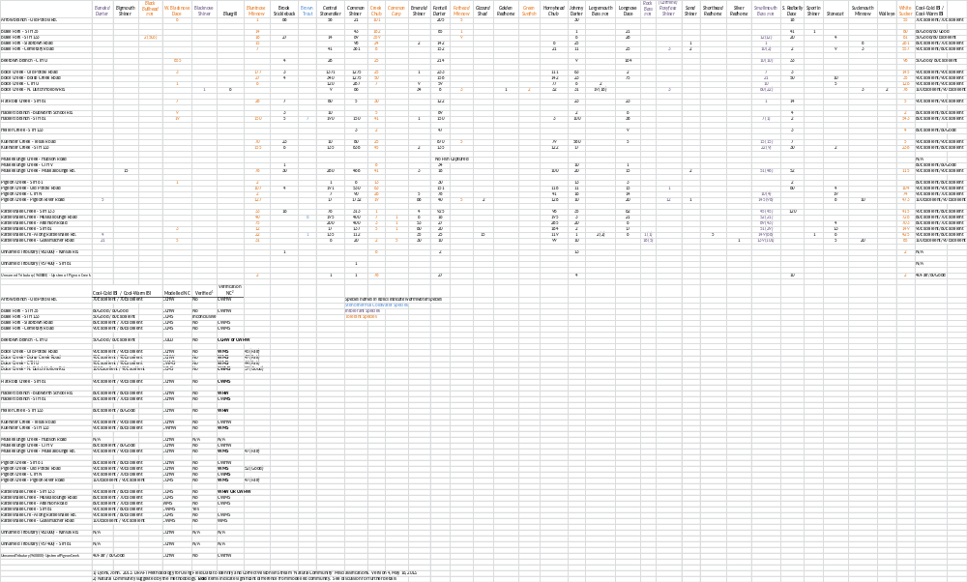
Table 2: Qualitative Habitat Surveys of sites in the Lower and Middle Grant River Watersheds - 2012

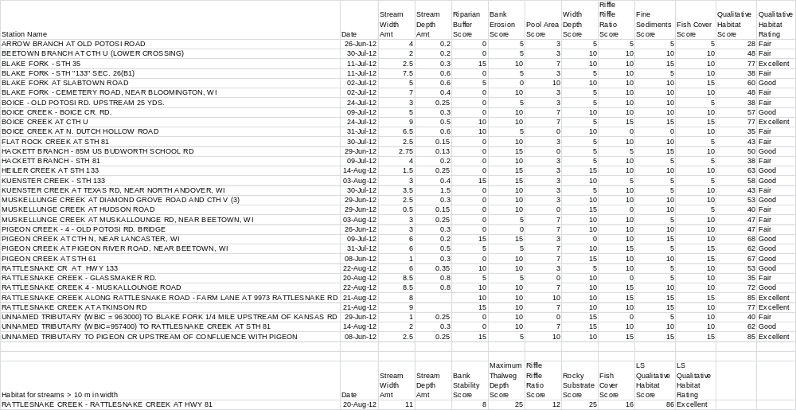

Table 3: Macroinvertebrates in the Lower/Middle Grant River Watersheds
Site | IBI (Rating) | HBI (Rating)
Arrow Br – Old Potosi Rd | 1.07 (Poor) | 6.351 (Fair)
Blake Fork – STH 35 | 1.06 (Poor) | 5.045 (Good)
Blake Fork – STH 133 | 2.07 (Poor) | 5.040 (Good)
Blake Fork – Slabtown Road | 3.35 (Fair) | 4.940 (Good)
Blake Fork – Cemetary Road | 2.36 (Poor) | 5.193 (Good)
Beetown Branch – CTH U | 3.76 (Fair) | 4.885 (Good)
Boice Creek – Old Potosi Road | 0.36 (Poor) | 5.119 (Good)
Boice Creek – Boice Creek Road | 1.58 (Poor) | 5.468 (Good)
Boice Creek – CTH U | 2.22 (Poor) | 5.207 (Good)
Boice Creek – N. Dutch Hollow Road | 2.87 (Fair) | 4.551 (Good)
Flat Rock Creek – STH 81 | 1.54 (Poor) | 6.117 (Fair)
Hackett Branch – Budworth School Rd | 0.59 (Poor) | 6.516 (Fairly Poor)
Hackett Branch – STH 81 | 3.05 (Fair) | 4.421 (Very Good)
Heiler Creek – STH 133 | 5.42 (Good) | 7.914 (Poor)
Kuenster Creek – Texas Road | 1.86 (Poor) | 5.497 (Good)
Kuenster Creek – STH 133 | 1.29 (Poor) | 4.964 (Good)
Muskellunge Creek – Hudson Road | 5.35 (Good) | 7.881 (Poor)
Muskellunge Creek – CTH V | 1.64 (Poor) | 6.903 (Fairly Poor)
Muskellunge Creek – Muskallounge Rd | 0.96 (Poor) | 5.753 (Fair)
Pigeon Creek – STH 61 | 1.69 (Poor) | 5.977 (Fair)
Pigeon Creek – Old Potosi Road | 0.02 (Poor) | 5.656 (Fair)
Pigeon Creek – CTH N | 3.54 (Fair) | 6.171 (Fair)
Pigeon Creek – Pigeon River Road | -0.32 (Poor) | 5.590 (Fair)
Rattlesnake Creek – STH 133 | 0.62 (Poor) | 4.778 (Good)
Rattlesnake Creek – Muskallounge Rd | 1.13 (Poor) | 5.321 (Good)
Rattlesnake Creek – Atkinson Road | 0.85 (Poor) | 5.564 (Fair)
Rattlesnake Creek – STH 81 | 2.74 (Fair) | 5.270 (Good)
Rattlesnake Cr – Along Rattlesnake Rd | 1.86 (Poor) | 5.037 (Good)
Rattlesnake Creek – Glassmacher Rd | 3.72 (Fair) | 4.478 (Very Good)
Unnamed Trib. (963000) – Kansas Rd | 0.40 (Poor) | 6.966 (Fairly Poor)
Unnamed Trib. (957400) – STH 81 | 3.58 (Fair) | 7.516 (Poor)
Unnamed Trib. (960800) | Not Available | Not Available

subsequently resulted in fish mortality (WDNR, 1991). The nutrient enrichment is
also evident in the enhanced numbers of fish, particularly omnivores, present in a system. Biologists noted that, in conducting these shocking surveys, it was impossible to capture the shear biomass (numbers of fish). Despite capturing hundreds and even thousands of fish at some sites, biologist estimated that they were only successful in capturing one-third to one-half of the fish present in many of the surveys. The nutrient loads enhance algal and periphyton growth, which then enhances available food for grazers and this pattern is repeated up the food chain. Contrary to the conventional thinking that more fish equates to a healthier system, the enhanced abundance of fish is actually a sign of nonpoint source pollution impact, and while these streams may not necessarily be considered as impaired, it does indicate excessive eutrophication of these systems.

In the past, these systems would have been measured using either the warm or cold IBI. Using these IBIs, one would likely consider the streams of the Middle and Lower Grant River as degraded warmwater systems even though they had diverse communities, some pollution intolerant species, and sometimes good smallmouth bass fisheries. Over the past 10 years however, new information has been shed on the potential of many streams in the driftless area. Modeling of stream flow and temperature has shown that instead of trying to categorize the streams in this region as “warm” or “cold” and using those specific biotic indices to measure their quality, new information suggests that these streams should be considered “coolwater transitional”, that is, they have summer water temperatures suitable for both coldwater and warmwater species (Lyons, et. al. 2009). As Table 1 shows, most of the stream segments of the Lower and Middle Grant River watersheds are modeled to be cool-cold transitional systems. The department has recently developed a draft method to determine whether or not the modeled natural community is accurate based on the fishery assemblage and climate conditions (Lyons, 2013). Almost universally, the fishery data indicated that most of the systems resemble cool-warm systems rather than cool-cold systems, with several trending toward warm systems. Since 2012 was an unusually warm year in which southern Wisconsin also experienced a drought (Wisconsin State Climatology Office, 2013), no changes to the modeled natural community are suggested at this time. However, certain systems, such as Beetown Branch, Boice Creek, Flatrock Creek, and Pigeon Creek appear to be misclassified from a thermal and/or flow regime and should be reexamined as data becomes available in a more normal weather year. Additionally, the other streams in these watershed could be examined to determine if most of these systems are more cool-warm rather than cool-cold streams.

Although the coolwater IBIs would indicate these being higher quality cool-cold systems based strictly on the higher of the two IBI scores, the scores are well within the margin of variability (20 points) for the metric (Lyons, personal communication). As mentioned above, the thermal composition of species (cold, warm, or transitional) would trend more toward these being cool-warm sites as coldwater species are virtually absent while transitional and warmwater species are common. One could argue there is evidence of environmental degradation which is lending itself to the presence of more warmwater species and an absence of coldwater ones. However, with the exception of low numbers of brown trout which remain from historical stocking, these watersheds have historically been devoid of coldwater indicator species (Becker, 1983) and the coolwater IBIs for both thermal regimes are still showing strong good to excellent scores. Additionally, the draft process for natural community validation shows the percentage of tolerant species to be well within accepted limits for most sites, indicating that environmental perturbation is not a strong reason for the disparity between the modeled natural community and the community indicated by the fishery assemblage. Therefore in general and based on current modeling data, it may be most appropriate to consider them as “good” coolwater systems, keeping in mind that water temperature is only one factor affecting species assemblage, and acknowledging they are still impacted by nutrient enrichment.

The macroinvertebrate community (Table 3) tells a different story, however. Almost two out of three sites sampled in the watershed for macroinvertebrates showed an index of biotic integrity of < 2.5 or “poor”. The macroinvertebrate IBI has shown the combination of watershed land cover and local riparian and instream conditions strongly influence one another (Weigel, 2003). While watershed and local variables explain a significant portion of variance among sites, Weigel found that in the driftless region, localized stressors were of greater importance to explain the IBI than in other parts of the state. Livestock grazing measured disturbance intensity and indicated its proximity to the stream. Not surprisingly, a majority of stream sites had poor to fair buffer scores due to the prevalence of pasturing in stream valleys throughout the watershed. A look at historical macroinvertebrate data collected over the past 30 years corroborates the poor macroinverterbrate IBIs for all of the major streams in these two watersheds (Appendix 2).

Still, as Table 2 shows, the overall qualitative habitat scores were “fair” to “good” and influenced by the other the other metrics of bank erosion score: width/depth ratio, riffle-to-riffle ratio; fine sediments; and fish cover that all contribute to the overall score. No ratings were “poor” and a little over half of the sites exhibited “good” to “excellent” habitat. This may explain the relative health of the fishery, which is more responsive to habitat, compared to the health of the macroinvertebrate community, which is more responsive to water quality (Lyons, personal communication). The MIBI and HBI scores would seem to indicate there is a fair amount of localized stress on these systems in addition to organic enrichment due to runoff from forage and row crop fields, leading to potential impairment of the macroinvertebrate community. Although fish kills have been reported historically, agricultural practices have changed to reduce soil and nutrient loss. There have been no major fish kills reported within the past 10 years in these two watersheds. Despite this, it is reasonable to assume that the gradient and habitat of the streams in these watersheds mask problems caused by sediment and nutrient loading. High gradient and an abundance of riffles mitigate dissolved oxygen sags. The lack of soft sediment and low residence time of nutrients precludes the growth of excessive macrophytes, thus limiting dissolved oxygen swings and allowing for a fishery community that is impacted, but not impaired.

This survey was conducted in the summer of 2012, which was warmer and dryer than average (Wisconsin State Climatology Office, 2013). As a result of the drought conditions which prevailed, runoff was mitigated and streams generally ran clear throughout the summer. Smallmouth bass reproduction has been shown to be greatest in the years of little runoff, particularly in the important spawning months of May and June (Forbes, 1989). The 2012 surveys showed that the drought conditions were very beneficial for smallmouth bass reproduction. Twenty one of the 32 sites sampled contained smallmouth bass. In some cases, such as a Rattlesnake Creek at STH 133, Blake Fork at STH 133, Kuenster Creek at Texas Road and Beetown Branch at CTH U, young-of-the-year (y.o.y.) smallmouth made up the entirety of the population. It is unknown if these fish were hatched in these locations or migrated there due to pressure (bass density) from such a highly productive year (Lyons, personal communication). Either way, it does emphasize the importance of these smaller tributaries or headwaters as nursery streams. Other sites contained y.o.y. bass as well as 1+ year old fish in varying numbers (See Appendix 1 for specific stream narratives).

A portion of this study was devoted to determining smallmouth bass size structure in Rattlesnake Creek. For the past two decades, the department’s Fisheries and Habitat Research section has been conducting annual surveys of smallmouth bass population structure on streams in the driftless region, including a site on Rattlesnake Creek between Rattlesnake Road and STH 81 (Lyons and Kanehl, 2012). In order to look at smallmouth bass populations on other portions of Rattlesnake Creek and put them in context with the annual monitoring site, it was decided to expand monitoring of smallmouth bass at sites on Rattlesnake Creek beyond the normal 35 times the mean stream width, and expand that length to 1000 meters to be consistent with the length of stream sampled by research (see the Rattlesnake Creek stream narrative in Appendix 1 for more details). Rattlesnake Creek holds fair to good smallmouth bass numbers and is considered the best smallmouth fishery of the Grant River tributaries. Their annual surveys show bass reproduction highly susceptible to runoff conditions. In 2012, large numbers of smallmouth bass were produced in all trend streams and catches were the second highest since sampling began in 1989-1991 (Figure 2).

Figure 2: Rattlesnake Creek Smallmouth Bass Population Trend Analysis

Being that weather conditions are beyond control, there are human induced factors which can also dictate the success of the smallmouth bass populations in waters of the Grant River watersheds and other streams of southwestern Wisconsin. Maintaining good water quality and habitat will allow multiple year classes of bass to thrive in these systems and will allow bass to reach maturity so they can reproduce. Controlling sediment and nutrient - particularly manure - runoff will 1) enhance spawning habitat and prevent valuable spawning areas from becoming covered in silt; 2) maintain good pool depth so that older fish can seek refuge in winter or in periods of low flow; and 3) prevent potentially fatal dissolved oxygen sags or ammonia induced toxicity.

Summary
The fish communities of the Middle and Lower Grant River watersheds have shown themselves to be resilient and have responded favorably to land conservation practices that have already been enacted in these areas. Details on specific streams can be found in Appendix 1. The department should continue to work with the Grant County Land Conservation Department to encourage best management practices in these watersheds to enhance water quality:

- Proper manure management such good housekeeping of barnyards and no spreading on steep slopes and during periods of ice and snow cover
would reduce the delivery of potentially deadly amounts of nutrients.

- Managed grazing would help protect streambanks and reduce sediment loads from bank erosion.

- The planting of cover crops would help prevent soil erosion during the vulnerable months (Figure 3).

Based on the 2014 Wisconsin Consolidated Assessment and Listing Methodology (WisCALM) guidance (WDNR, 2013 ), the fishery IBI scores indicating a non-impaired status are in contrast to the macroinvertebrate community would indicate an impaired status for all or parts of many streams in these two watersheds. While the data should be reviewed in the context of reference site data to determine if there is the potential of climatic influence from the warm, dry summer of 2012 on these assemblages, historic macroinvertebrate data suggests this is more of a chronic issue. If it is deemed that the stream community in these watersheds was not impacted by climatic influence, then the department should re-sample some of these streams in the context of an overall monitoring strategy to determine if the natural community fits the model prediction and also to determine if the fish and/or macroinvertebrate community is impaired.

Figure 3: Planting of cover crops on a corn silage field in the Lower Grant Watershed
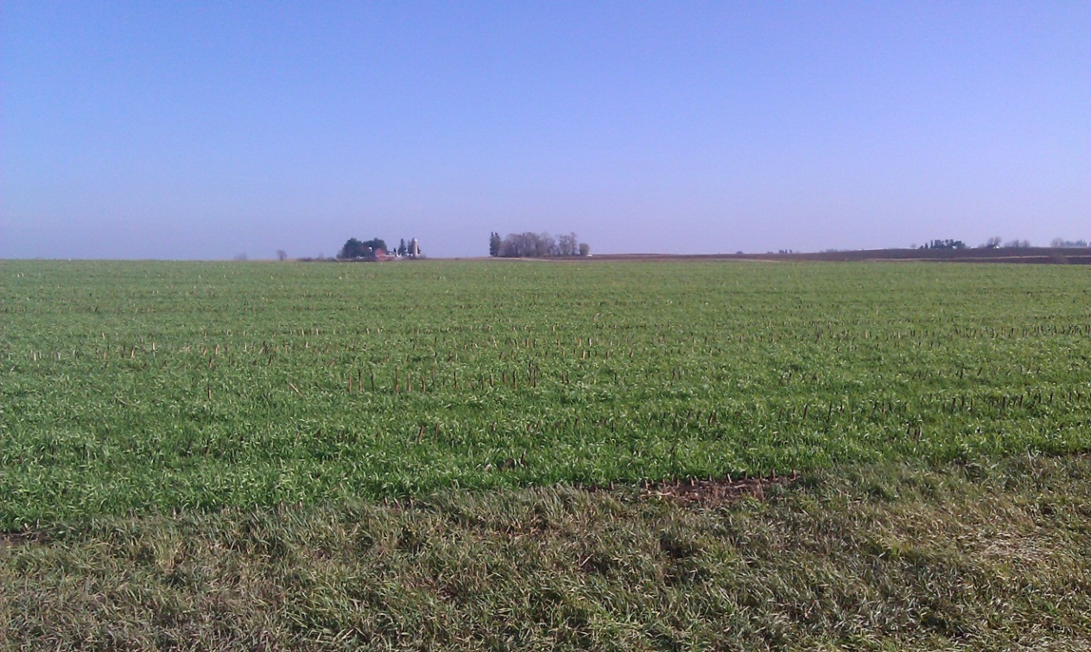
References

Becker, George C. 1983. Fishes of Wisconsin. The University of Wisconsin Press. 1051 pp.

Forbes, Ann. 1989. Population Dynamics of Smallmouth Bass (Micropterus dolomieui) in the Galena (Fever) River and One of Its Tributaries. WDNR. Tech. Bull. No. 165. 20 pp.

Hilsenhoff, William L. 1987. An Improved Biotic Index of Organic Stream Pollution. The Great Lakes Entomologist. 20: 31-39.

Lyons, John, A.M. Forbes, and M. Staggs. 1987. Fish Species Assemblages in Southwestern Wisconsin Streams with Implications for smallmouth bass Management. WDNR. Tech. Bull. No. 161. 25 pp.

Lyons, John. 2008. Using the Wisconsin Stream Model to Estimate the Potential Natural Community of Wisconsin Streams (DRAFT). Wisconsin Department of Natural Resources Fish and Aquatic Life Research Section. November, 2008.

Lyons, John. T. Zorn, J. Stewart, P. Seelbach, K. Wehrly, and L. Wang. 2009. Defining and Characterizing Coolwater Streams and Their Fish Assemblages in Michigan and Wisconsin, USA. North American Journal of Fisheries Management. 29:1130-1151.

Lyons, John. 2012. Development and Validation of Two Fish-based Indices of Biotic Integrity for Assessing Perennial Coolwater Streams In Wisconsin, USA. Ecological Indicators 23 (2012) 402-412.

Lyons, John and Paul Kanehl. 2012. Status and Trends in Sportfish Populations of Southwestern Wisconsin Warmwater Streams. Period Covered: July 1, 2012 – June 30, 2013. Fisheries and Habitat Research Section. Project F-95-P.

Lyons, John. 2013. Methodology for Using Field Data to Identify and Correct Wisconsin Stream “Natural Community” Misclassifications. Version 4. May 16, 2013. IN DRAFT.

Simonson, Timothy D., J. Lyons, and P.D. Kanehl. 1994. Guidelines for Evaluating Fish Habitat in Wisconsin Streams. U.S. Department of Agriculture. Forest Service. General Technical Report NC-164.

WDNR. 1972. Surface Water Resources of Grant County. Lake and Stream Classification Project. By Tom D. Smith and Joseph R. Ball. 1971.

WDNR. 1991. A Nonpoint Source Control Plan for the Lower Grant River Priority Watershed. Wisconsin Nonpoint Source Water Pollution Abatement Program. Publication WR 293-91. December, 1991.

WDNR. 2001. The State of the Grant, Platte, and Galena River Basins. Wisconsin Department of Natural Resources. PUBL-WT-660-2001.

WDNR. 2013. Wisconsin 2014 Consolidated Assessment and Listing Methodology (WisCALM). Clean Water Act Section 305(b), 314, and 303(d) Integrated Reporting. Wisconsin Department of Natural Resources. Bureau of Water Quality Program Guidance. September, 2013.

Weigel, Brian. 2003. Development of Stream Macroinvertebrate Models That Predict Watershed and Local Stressors in Wisconsin. Journal of the North American Benthological Society. 22(1): 123-142.

Wisconsin State Climatology Office. 2013. John Young, Director and Emeritus Professor. http://www.aos.wisc.edu/~sco/clim-history/7cities/madison.html
Appendix 1: Stream Narratives

Arrow Branch
Beginning in south central Grant County, this stream flows 4 miles southwest entering Boice Creek two miles northwest of Potosi. Willow Creek, its only tributary, enters the central portion of the stream from the southeast (WDNR, 1972). In 2012, the stream was sampled at Old Potosi Road, upstream of the confluence with Willow Branch. This site was heavily pastured with banks in poor condition and silt was prevalent in runs and pools. Species diversity was moderate with tolerant species making up about half of the assemblage. While the coolwater IBI (Lyons, 2012) showed an “excellent” rating, biologist noted that habitat likely limited species diversity and overall fish population. The stream would benefit from managed grazing and control of nonpoint source pollution to reduce sediment and nutrient loading.

Beetown Branch
Beetown Branch is a high-gradient, spring-fed stream that originates 1 mile north of the village that gives the stream its name. It flows 3.4 miles downstream and enters the Grant River. Portions of the stream have been straightened and flow through a highway ditch in the village of Beetown. Downstream from that point, it meanders its way through an area of intense pasturing. The 2012 survey conducted at CTH U downstream from town showed the fisheries assemblage to be dominated by western blacknose dace. Fantail darter, longnose dace, and white sucker were also quite prevalent. Ten young-of-the-year smallmouth bass were also collected at this site. The steep gradient flowing through areas of intensive urban and agricultural use make the stream vulnerable to flashy flows and moderate to high bank erosion. The heavy precipitation events of 2008 caused the channel to move as much as 15 feet in some areas (Amrhein, personal observation). On the positive side, the high gradient also keeps the bottom scoured of sediment. The high numbers of fish are an indication of nutrient enrichment. The stream would benefit from managed grazing to help keep banks stable and reduce sediment loss.

Blake Fork
This 18 mile long spring and seepage fed stream begins within the Village of Patch Grove. It flows southeast through Bloomington and then into the Grant River six miles west of Lancaster. Much of this stream flows through a fairly broad valley of pastureland. The stream is characterized by areas of long, flat runs and pools and severely eroding banks. Surveys conducted in the mid to late 1990’s showed the stream to be in fair condition, but the macroinvertebrate community suggested it is impacted by degradation caused by nonpoint source pollution (WDNR, 2001). The 2012 survey looked at 4 sites on Blake Fork. Overall, the stream contains nice riffle-run-pool complexes. The species assemblage is typical of the streams in southwest Grant County. Smallmouth bass, including young-of-the-year were found in the stream. The coolwater IBIs (Lyons, 2012) ranged from “good” to “excellent”. While it its size limits it to a nursery stream, it can provide a refuge for young bass. High, raw banks likely add large amounts of sediment to the system. High sedimentation of pools was noted by biologists. In addition to an effort to slope and stabilize the banks to mitigate erosion and act as flood control, the entire stream corridor would benefit from a grazing plan.

Boice Creek
Boice Creek is a good sized stream in the Lower Grant River watershed that begins as a spring and seepage stream about 3 miles south of Lancaster and flows 16 miles southwest where it joins the Grant River about 2 miles west of Potosi (WDNR, 1972). The topography of this subwatershed is steeper than much of the rest of the watershed. As such, cropping is less intense than in other subwatersheds, but grazing is still prevalent in the stream valley (WDNR, 2001). The 2012 monitoring showed a fish species assemblage was about what was expected for the area. Biologists noted the sheer number of fish in the upper half of the stream was staggering. While thousands of fish were collected, they noted that they were successful in only capturing about ½ of the fish encountered. This proliferation of fish is an indication of eutrophication of the stream from runoff from pastures, fields and barnyards. While not necessarily impaired, it is evidence of the stream being impacted by excessive nutrification.

Boice Creek contains a population of smallmouth bass. Yearling fish were found at all sites. Young-of-the-year were only found at the lower most site at North Dutch Hollow Road, along with several other year classes (Figure A1). This furthest downstream site was larger in size and had a lower gradient than the upstream sites. Given its proximity to the Grant River, it is not surprising that the species assemblage contained several other species such as walleye, bluegill, and largemouth bass that were not seen in the other sites. As with other streams in the watershed, the water quality and habitat could be improved by stream bank stabilization and managed grazing. It should be preserved as a smallmouth bass nursery.

Figure A1: Boice Creek Smallmouth Bass Length Frequency 2012

Flat Rock Creek
This appropriately named 4 mile long moderate gradient stream originates 4 miles north of Cassville and flows easterly to join Rattlesnake Creek about 3 miles southwest of Beetown (WDNR, 1972). Not surprisingly, much of the bottom is made up of broken bedrock as well as some areas rubble/cobble and gravel. The species assemblage is typical for streams in this watershed where central stoneroller, common shiners, and fantail darters are abundant. One yearling smallmouth bass was found in the 2012 survey. Much of the stream flows through pastureland which results in trampled banks. While biologists noted good numbers of fish for such a small stream, sediment accumulation was moderate to high for a stream with good gradient. Moderate amounts of filamentous algae were present indicating nutrient enrichment. Because of its small size, Flat Rock Creek will probably be limited in use as a good non-game fishery with the occasional smallmouth bass at its lower end. It would benefit from managed grazing and other best management practices designed to reduce runoff.

Hackett Branch
Hackett Branch is a 6 mile long spring fed stream that serves as a tributary to the Grant River in the Middle Grant River watershed. The numerous spring tributaries contribute flow and keep the stream temperatures lower than other streams in the watershed. The department recommended possible trout stocking in the past (WDNR, 1972). Hackett Branch was surveyed at 2 sites in 2012 (STH 81 and Budworth School Road). Indeed, a handful of brown trout ranging from 7 to 12 inches were encountered at STH 81 although department stocking records show nothing has been stocked in the stream in the past 12 years. The rest of the species assemblage was more typical of streams in this area with fantail darter, central stoneroller, and common shiner being prevalent. Several yearling and 1 young-of-the-year smallmouth bass were also found at STH 81. Habitat was “fair” to “good” in this high gradient system. The gradient also is beneficial in flushing sediment from the pastured riparian corridor. Biologists noted several areas of heavy use that could lend themselves to erosion and nutrient input (Figure A2).

Figure A2: Cattle Feeding area along Hackett Branch

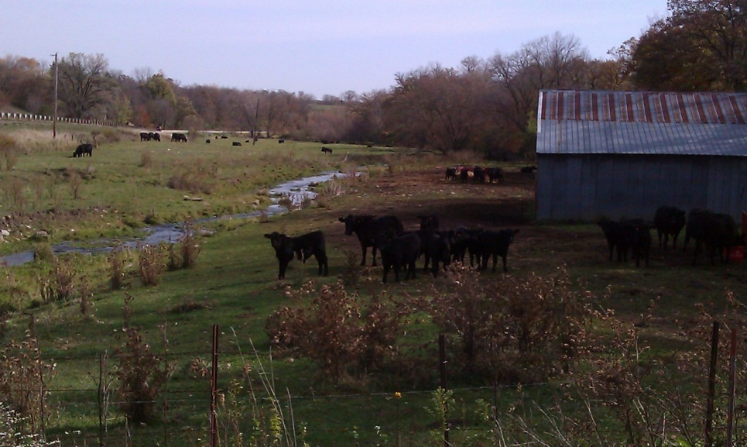

Hackett Branch was placed on the state’s 303(d) list of impaired waters in 1998 because of habitat impairment caused by sedimentation. Subsequent sampling conducted in the mid-1990’s showed “fair” water quality and “fair” to “good” habitat (WDNR, 2001). Consequently, the stream was removed from the state’s list of impaired waters in 2002. While the fish IBI shows an “excellent” rating, the stream is susceptible to enhanced sediment and nutrient loading. Managed grazing and streambank stabilization would help enhance the habitat and water quality of this thermally unique coolwater stream.

Heiler Creek
Heiler Creek is a small, 3 mile long spring-fed stream that feeds into Rattlesnake Creek near North Andover. It contains a limited number of nongame species such as fantail darter, longnose dace, white sucker and common shiners. The bottom of this high gradient stream is mostly rubble/cobble and broken bedrock. Its size limits the stream potential, but it would benefit from managed grazing.

Kuenster Creek
Over 90 percent of subwatershed containing this stream is in agriculture. Watershed appraisals conducted during the mid-1990’s showed very high sediment loads being transported by the stream (WDNR, 2001). The 2012 surveys found a species assemblage typical of streams in this area. There were good numbers of fish, which can also be an indication of eutrophication of this system. Yearling and young-of-the-year smallmouth bass were found at the two sites sampled, indicating this stream can function as a bass nursery stream. Biologists noted a moderate to high amount of sediment in the stream and especially in pools. The stream would benefit from managed grazing along the stream corridor as well as use of cover crops and no-till farming to reduce the amount of erosion from crop fields.

Marlowe Branch
This 5 mile long tributary to the Grant River was not surveyed as part of this study, but instead was surveyed in 2010 as part of a natural community monitoring project. The upper half flows through a broad valley with much of the land in agriculture. The lower half flows through a narrow valley bounded by steeply wooded hillsides. The 2010 survey at Irish Hollow Road showed a predominance of fantail darter, some southern redbelly dace, and a couple of specimens of bluntnose minnow and central stoneroller. It is unknown if this is representative of the rest of the stream. The broken bedrock created a “stair-step” morphology with very little sediment, but also limiting habitat to some extent. It is possible runoff from upstream adds a significant nutrient load as some small areas of filamentous algae were present.

Muskellunge Creek
Muskellunge is a 5 mile long tributary to Rattlesnake Creek. Over 90 percent of this subwatershed is in agriculture (Figure A3). The rolling hills of the upper half of the stream give way to steeply sided valleys downstream marked with row crops in the uplands and grazing along the stream corridor with steep woodlands and bedrock outcroppings in between. The stream originates from spring seeps north of Hudson Road and flows

Figure A3: Muskellunge Creek looking upstream from CTH V
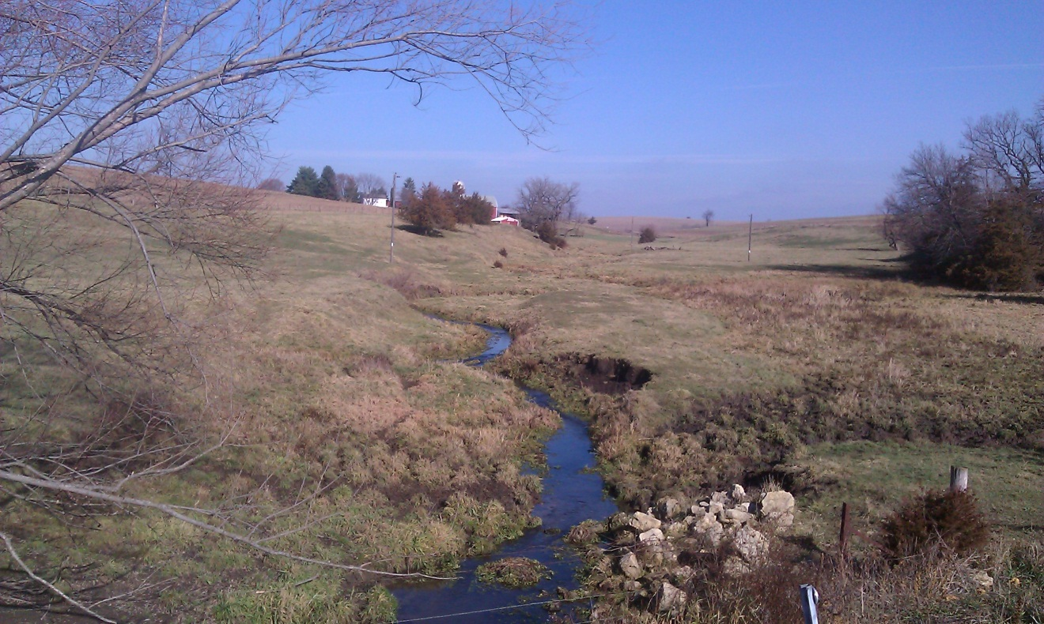

southward, joining Rattlesnake Creek about a mile downstream of Muskallounge Road. Most of the stream bottom is rubble/cobble or gravel. Silt becomes more prevalent as one moves from upstream to downstream. The fishery resembles that of other streams in the area. Biologists noted “cooler” water temperatures in the upper half of the stream and a limited number of fish at CTH V. The site at Muskallounge Road contained high numbers and a diversity of fish, including several dozen young-of-the-year smallmouth bass. Sedimentation and nutrient loading impact the stream. The stream would benefit from managed grazing along the stream corridor as well as use of cover crops and no-till farming to reduce the amount of erosion from crop fields.

Pigeon Creek
Pigeon Creek is a major tributary to the Grant River in the Middle Grant River watershed. It originates on the east side of Lancaster and flows southwest before joining the Grant River 14 miles downstream. The village of Lancaster discharges to an unnamed tributary of Pigeon Creek. As such, Pigeon Creek receives nutrient loads from both point and nonpoint sources. The species assemblage was similar to other streams in the watershed. Smallmouth bass were found in the lower stations (CTH N and Pigeon Creek Road). The 2012 surveys showed the presence of multiple year classes of smallmouth (Figure A4), but because of its size, Pigeon Creek acts more like a nursery stream rather than one able to support numbers of creel sized bass.

Figure A4: Pigeon Creek Smallmouth Bass Length Frequency 2012

The large numbers of fish found, particularly at Pigeon Creek Road, indicate some level of impact from excessive nutrient loading. Filamentous algae found on the rocks in the upper sections also shows the impact of nonpoint source nutrient loading as well as impacts from wastewater treatment discharge. Excessive sedimentation is not prevalent, mainly because the good gradient of the steam allows for scouring of the bottom. Some sediment was reported in pools and especially in the lower stream segments. Pigeon Creek would benefit from managed grazing, maintaining adequate buffer widths in areas with row crops, and also from use of cover crops in the non-growing season.

Rattlesnake Creek
Rattlesnake Creek is the major tributary draining the western half of the Lower Grant River watershed. This 21 mile long stream begins in the rolling agricultural fields west of Bloomington and flows southward, joining the Grant River about 2 miles south of Beetown. Along the way, it picks up the flows of Heiler Creek, Kuenster Creek, Muskellunge Creek, and Flat Rock Creek. Approximately 90% of its watershed is in agriculture with the rolling uplands of the upper half of the watershed giving way to picturesque bedrock outcroppings and steeply wooded hillsides downstream of STH 133 at North Andover. Row crops line the hill tops and are also present in the valleys alongside areas of grazing. This stream has historically been one of the best smallmouth bass streams in southwest Wisconsin (WDNR, 2001, Lyons and Kanehl, 2012). The populations of smallmouth tend to fluctuate. The key factor in this fluctuation seems to be the presence or absence of runoff events during the critical spawning period for bass in May and June. Smallmouth bass tend to pull off really good hatches in hot and dry years (John Lyons, personal communication). Another factor is periodic fish kills caused by excessive nutrient loads which lead to low dissolved oxygen levels.

In order to look at smallmouth bass populations on other portions of Rattlesnake Creek and put them in context with the annual monitoring site, it was decided to expand monitoring of smallmouth bass at sites on Rattlesnake Creek beyond the normal 35 times the mean stream width, and expand that length to 1000 meters to be consistent with the length of stream sampled by research for the annual survey. The 2012 surveys were conducted during a year of record heat and drought with very little in the way of runoff. As such, the 2012 year class of smallmouth rivaled that of 1988 and 1989, which were also dry years (Ibid). All 6 sites surveyed in 2012 showed a large amount and diversity of fish. Smallmouth were present at all sites, with multiple year classes present at most sites (Figure A5).

Figure A5: Rattlesnake Creek Smallmouth Bass Length Frequency 2012

The habitat ratings ranged from 35, or “fair” at Glassmacher Road to 85, or “excellent” at Muskallounge Road. The site at Glassmacher Road was very low in the watershed, just upstream from its confluence with the Grant River. As such, the gradient was lower, the sediment quantity was higher and the stream lacked riffles and pools. Other portions of the stream generally contained nice riffle/pool/run complexes and hard bottoms of rubble/cobble and broken bedrock. While silt was present in pools, the high gradient of the stream keeps the majority of the bottom scoured, providing favorable habitat for a diversity of cool transitional and warmwater fish. Rattlesnake Creek has a smallmouth bass habitat suitability index comparable to the Galena River which is widely considered the best smallmouth bass stream in southern Wisconsin (Lyons, et. al., 1987). While Rattlesnake Creek does contain a good fishery, studies conducted in the 1990’s showed the stream does deliver a significant amount of sediment to the Grant River (WDNR, 2001). While much of the watershed is already n row crops and buffer strips, Rattlesnake Creek and its tributaries would benefit from managed grazing, cover crops, and manure management. With the large number of smallmouth bass being produced in 2012, the department should inform and work with the Grant County Land Conservation Department to work with landowners on protecting this valuable resource so these fish can grow to maturity to provide a valuable fishing opportunity and a population of sexually mature fish for future reproduction.

Willow Creek
Willow Creek is a small spring-fed tributary to Arrow Branch. During 2012, it was so choked with watercress, sampling was impossible.

