Progress Report:
Comprehensive Survey of Loon Lake, Burnett County, Wisconsin – Phase 1

Prepared for:
The Loon Lake Property Owner’s Association, the Town of Jackson, and the Wisconsin Department of Natural Resources

Prepared by:

Lake & Pond Resource
isconsin
LLC
W

P.O. Box 109
Berlin, WI 54923-0109
920-361-4088

July 17, 2006

Introduction
Loon Lake is located in northwestern Wisconsin in Burnett County approximately 25 miles northwest of Spooner in Sections 1, 7, 12 and 31 of Townships 40 and 41 North, Range 15 West (Figures 1 and 2). It has an area of 228 acres with a maximum depth of approximately 28 feet and an average depth of 10 feet. Loon Lake supports a fishery of northern pike, large mouth bass, and panfish.

Loon Lake has a unique hydrology in that it is attached directly to Cadotte Lake forming a single waterbody. In the 1930’s an earthen spillway dam was constructed at the headwaters of Loon Creek, on the north end of Loon Lake, causing Loon and Cadotte to become one lake. Cadotte Lake includes 127 acres of water surface extending south from Loon Lake. Although the two lakes constitute one water surface and interact directly with one another, Loon Lake has been and will continue to be the primary focus of this study.

Loon Lake is a hard water, seepage lake which receives additional surface water from a number of sources. A small stream connects Hanscom Lake to Kilkare Marsh which in turn is attached directly to the east shore of Loon Lake. Shoal Lake also drains from the southwest into Cadotte Lake through a short stream. Also Bogey Lake is located within a matter of feet to the west of Cadotte Lake. Although there is no surface interaction between Bogey and Cadotte, there is subsurface groundwater exchange.

The north end of the Loon Lake has thick aquatic vegetation and a few areas of floating bogs. The 108 acres of adjoining wetlands are used by muskrats, as well as nesting and migratory waterfowl.

Voyager Village is a 6,000-acre recreational community located near Loon Lake developed in the 1960’s and which owns and manages a number of properties within the Loon/Cadotte Lakes watershed. As a result, Cadotte Lake has a 200-ft setback on shoreline properties. This is not the case for Loon Lake, which has homes much closer to shore. Voyager Village also includes a 9-hole executive golf course and an 18-hole championship golf course adjacent to Kilkare Marsh. Voyager Village draws water from the marsh to supply the sprinkler systems for the two courses.

Loon lake has one public boat launch located near the dam. In addition there are two private marinas on Cadotte Lake.

The Loon Lake Property Owners Association represents the interests of approximately 75 shoreline property owners and other lake users. Property owners have expressed a number of concerns which are to be addressed over this two-year study. Members of the lake association are concerned that in recent years, the presence of the Voyager Village complex and specifically the golf course, may be having a detrimental effect on their lake. One concern is in regards to the current water quality in Loon Lake. Historic data for Loon Lake is available from sampling conducted in 1975 and more recently through
Figure 1. Loon Lake and surrounding area, Burnett County, Wisconsin.

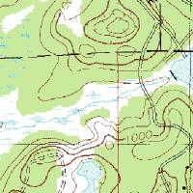
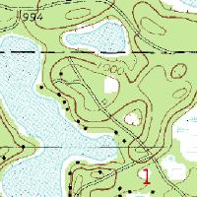
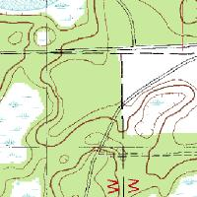
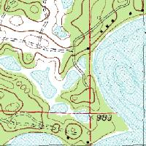
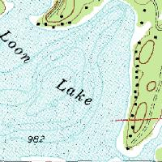
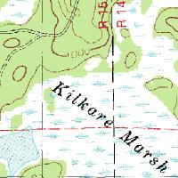
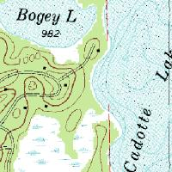
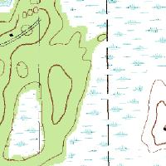
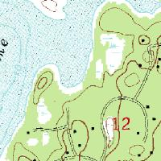
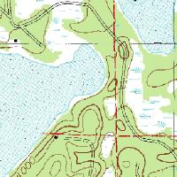
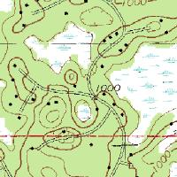
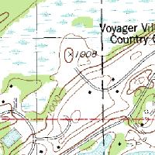

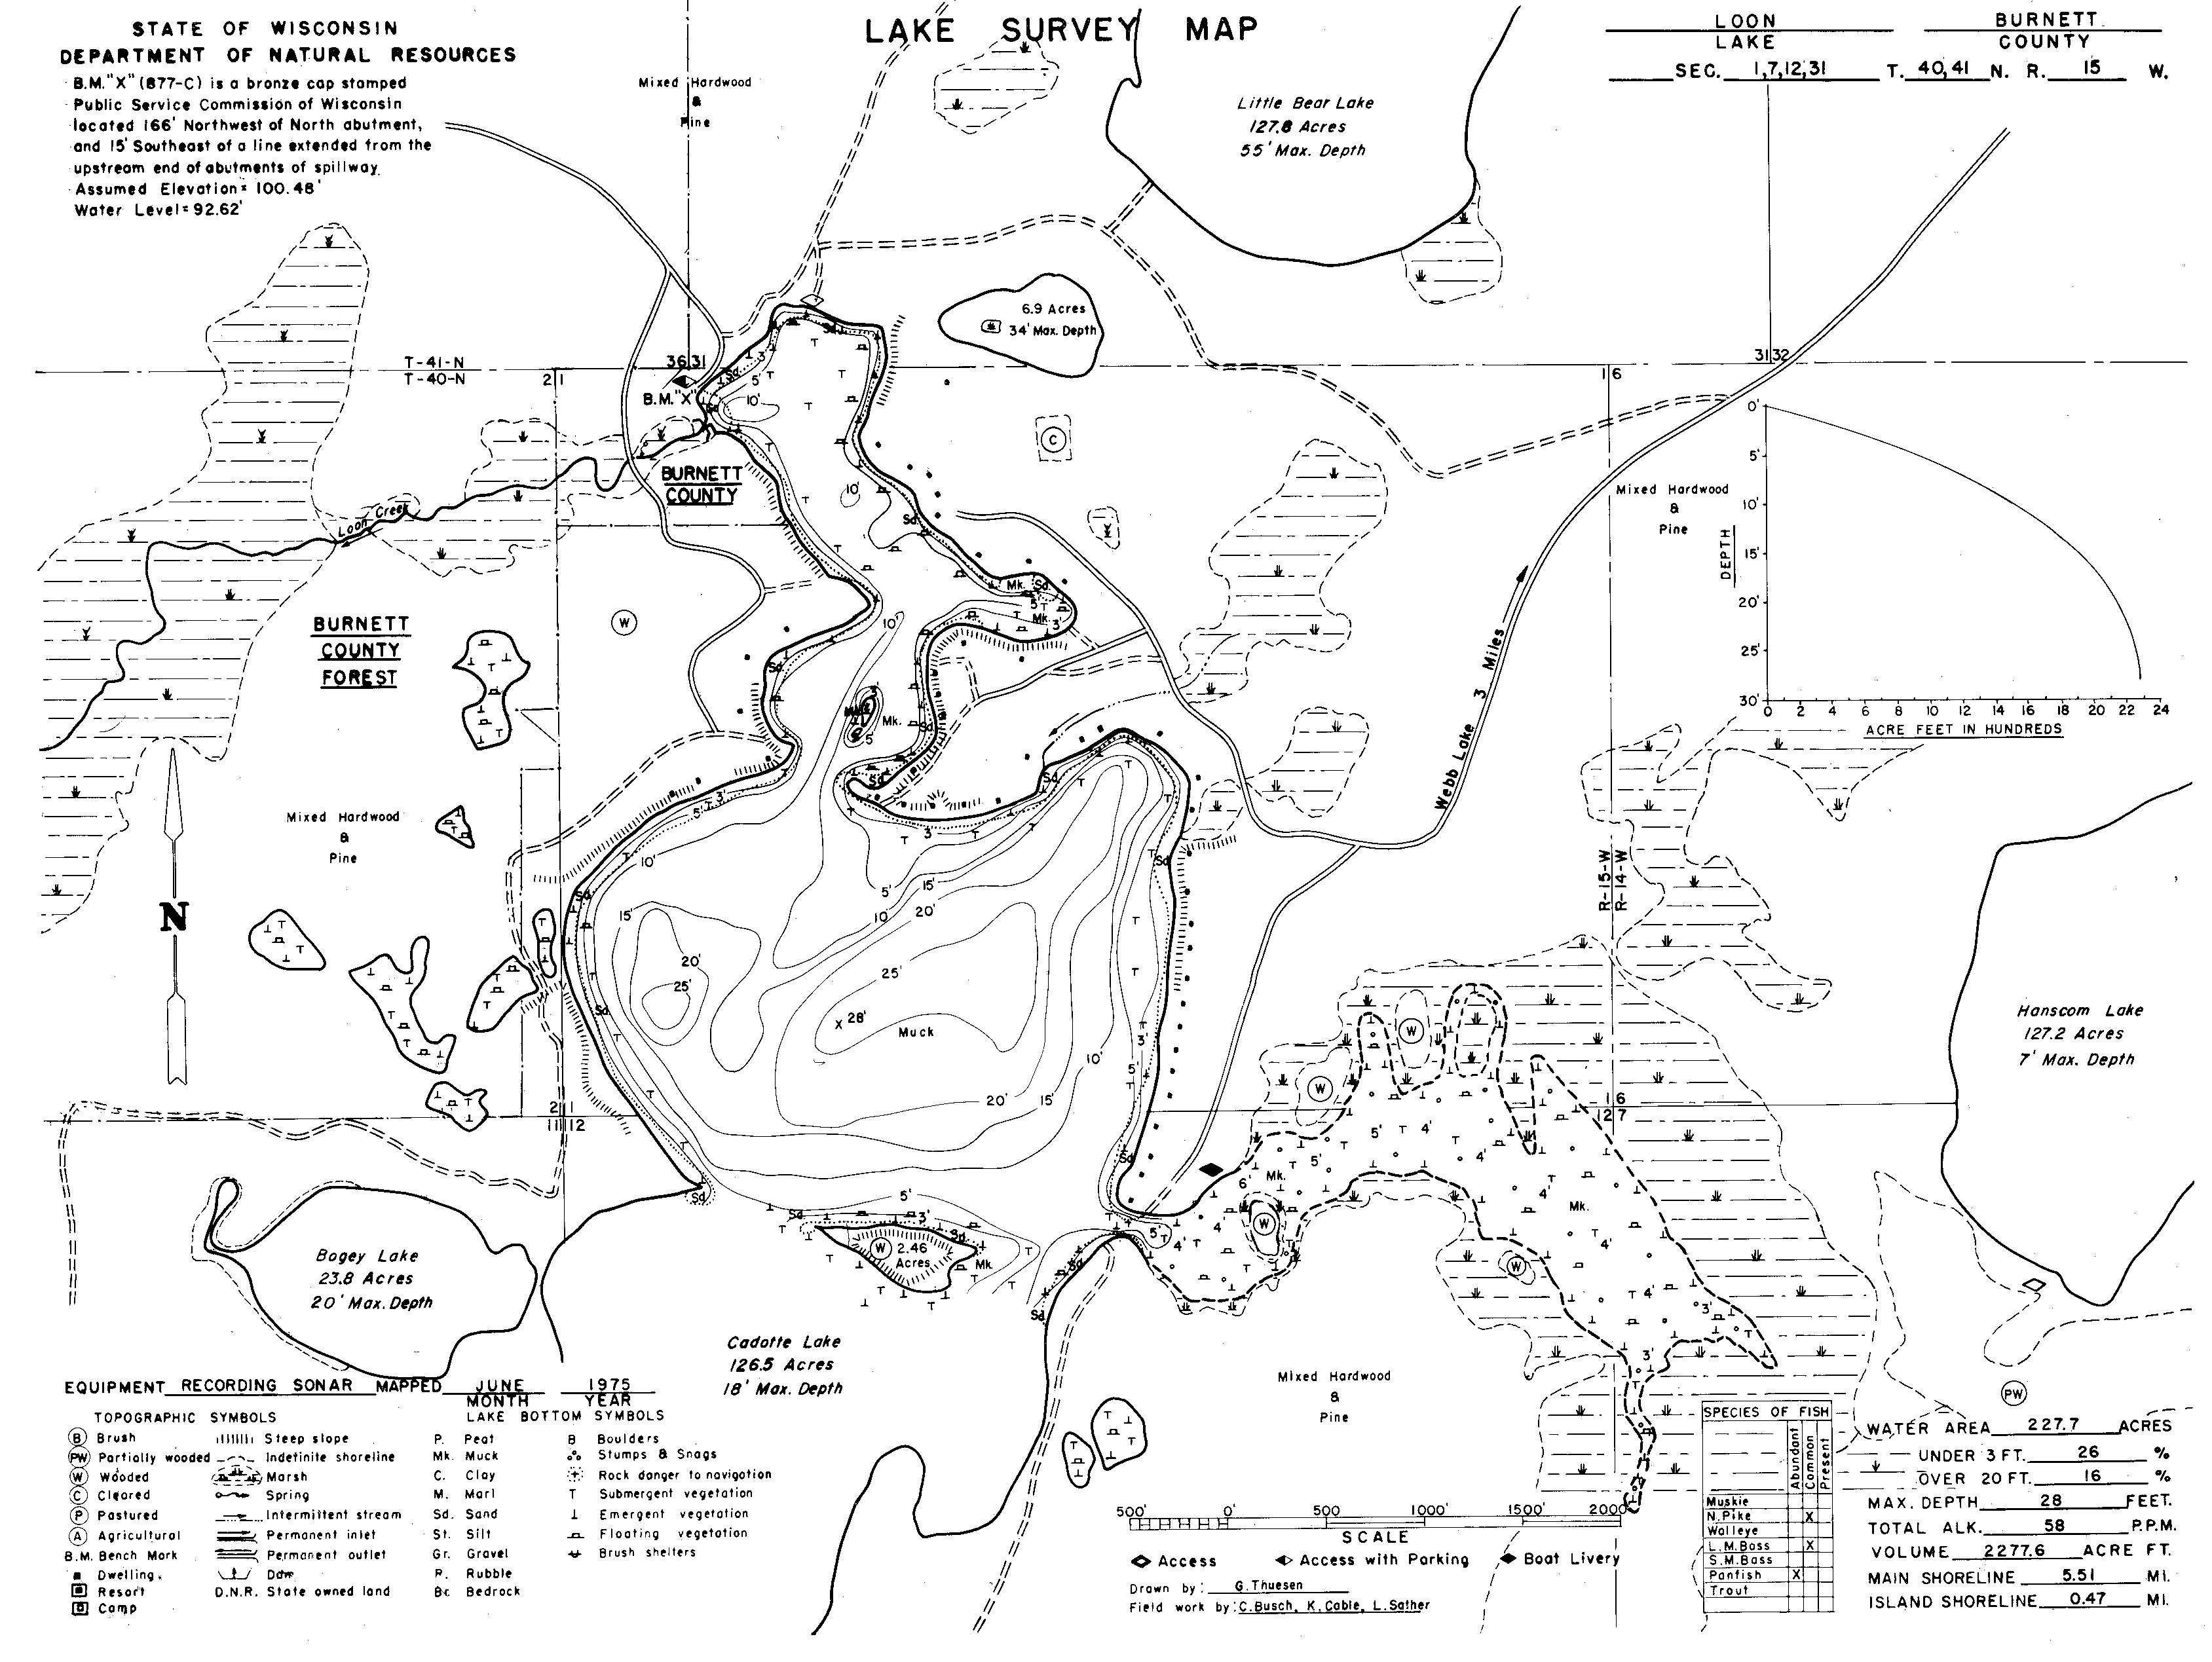
Figure 2. Loon Lake, Burnett County Wisconsin

the Environmental Task Force Lab’s Lake Program at the University of Wisconsin – Stevens Point from 2001-2003. The 1975 sampling was limited in water quality parameters and instead focused predominantly on the fish and wildlife communities. More recent sampling focused heavily on water quality and included analysis of a number of nutrient and inorganic parameters. Results of the data collected during both time periods indicate that the water quality for Loon Lake was generally good thirty years ago as well as in more recent years (Table 1). However, due to the limited amount of water quality data available prior to 2001, particularly prior to the development of Voyager Village, few conclusions can be drawn regarding the effect the golf course may be having on the lake without further investigation. Transparency data collected from 2001-2004 (Figure 3) range between depths of 6 to 14 feet. Although such fluctuations are to be expected due to seasonal variability, there is a slight decrease in water clarity of approximately 1 foot over this four-year time period.

Members of the Loon Lake Property Owners Association fear that within the last couple of years in particular, the quality of the lake may have declined. Their concerns stem in part from the recent upgrade to the irrigation system at the Voyager Village Golf Course. Association members have expressed concerns over the possibility of increased water use and nutrient loading from Voyager Village. They feel the golf course, and in particular this upgrade, may be having negative impacts on the lake community and be in part the cause for fluctuating lake water levels in recent years. Other related concerns include a recent observed increase in aquatic vegetation, particularly near the entrance to Kilkare Marsh and the possible invasion of exotic species. These areas of concern have been and continue to be the focus of this two-year study.

Through the Jackson Township, the Association received funding to assist in the first phase of a proposed two-year comprehensive survey of Loon Lake. Work carried out in 2005 focused on assessments of water quality, watershed influences, and lake water levels. Phase 2 of this study will focus on the aquatic plant communities, continued surface water flow monitoring and expanded water chemistry assessment.

Figure 3. Water transparency data for Loon Lake, Burnett County, 2001-2004.
Table 1. Historic water quality data collected on Loon Lake, Burnett County.

Parameter | Units | 1975 | 8/12/2001 | 4/20/2002 | 11/8/2002 | 4/26/2003
Total Phosphorus | mg/L | na | 0.014 | 0.013 | 0.032 | 0.029
Dissolved (ortho) Phosphorus | mg/L | 0.000 | 0.006 | 0.007 | 0.006 | 0.003
Total Inorganic Nitrogen | mg/L | na | 0.02 | 0.05 | na | na
Total Kjeldahl Nitrogen | mg/L | na | 0.43 | 0.61 | 0.41 | 0.52
Total Nitrogen | mg/L | na | 0.43 | 0.65 | 0.41 | 0.52
Nitrate + Nitrite as N | mg/L | na | <0.02 | 0.04 | <0.02 | <0.02
Ammonia as N | mg/L | na | 0.02 | 0.01 | <0.01 | <0.01
Turbidity | NU | na | 1.1 | 1.1 | 0.7 | 2.8
pH | SU | 8.8 | 8.17 | 7.53 | 7.82 | 7.56
Conductivity | μmhos/cm | 104 | 108 | 117 | 114 | 113
Alkalinity | mg/L | 58 | 63 | 61 | 59 | 62
Magnesium | mg/L CaCO₃ | na | 16 | 10 | 10 | 17
Calcium | mg/L CaCO₃ | na | 40 | 42 | 38 | 37
Total Hardness | mg/L CaCO₃ | na | 56 | 52 | 48 | 54
Chloride | mg/L | 1 | <0.5 | 1 | <0.5 | 1.5
Color | SU | na | 8 | 16 | 15 | 17
Sulfate | mg/L | na | 0.8 | 1.2 | 0.8 | 1.3
Sodium | mg/L | na | 2.1 | 2.6 | 2.1 | 2.4
Potassium | mg/L | na | 0.2 | 0.9 | 0.5 | 1
Chlorophyll a | μg/L | na | na | na | na | na
Dissolved Oxygen | mg/L | na | na | na | na | na
Temperature | ºC | na | na | na | na | na
Total Dissolved Solids | mg/L | na | na | na | na | na
Total Suspended Solids | mg/L | na | na | na | na | na
Secchi depth | ft | 9 | na | na | na | na

Methods

Water Quality

Starting in 2005, volunteers from Loon Lake began water chemistry analysis through the Wisconsin Department of Natural Resources Self-Help Monitoring program. The main body of Loon Lake was sampled during the spring and fall turnovers and in June, July, and August. Sampling parameters included water transparency, phosphorus, chlorophyll, dissolved oxygen, and temperature.

Because lake property owners are concern over the potential impact of the Voyager Village golf course on the lake, additional water sampling was conducted in two locations in Kilkare Marsh; where the marsh borders the lake and adjacent to the golf course (Figure 3). During the May 2, 2005 sampling event, the “golf course” sample was obtained by boating into Kilkare Marsh and obtaining a sample from a location as close to the golf course as possible. Because of the difficulty in navigating through the marsh, the pond near the golf course’s pumping station was selected for subsequent sampling. This location is closer to the golf course and was deep enough to allow for more meaningful profiles for dissolved oxygen and temperature. By including additional sampling locations, the Association wished to identify whether elevated nutrient levels exist in the waters adjacent to the golf course and if so what possible effects these nutrients may be having on the Loon Lake system.

All “seasonal” water quality analyses were conducted during the same periods as the Self-Help monitoring: spring and fall turnovers and in June, July, and August. These analyses included:

- Total phosphorus
- Nitrate and Nitrite as N
- Chlorophyll a
- pH
- Water transparency (Secchi depth)
- Dissolved oxygen profile
- Temperature profile

Water samples were taken approximately one foot below the surface. Dissolved oxygen, temperature, pH and Secchi depth were analyzed in the field. All other samples were sent to the Sate Lab of Hygiene for analysis. Chlorophyll a, total phosphorus and Secchi depth were used to quantify the productivity of the lake (Trophic State Index).

A
B
C
Figure 3. Locations of Water quality sampling on Loon Lake Burnett County

Site A: Self-Help monitoring and “complete” water sampling

Site B: Seasonal water sampling lake/marsh border

Site C: Seasonal water sampling adjacent to golf course

In August 2005, additional water quality analyses were conducted. Because water chemistry concentrations can fluctuate under varying oxygen levels, samples were collected from the lake surface as well as from just above the sediment layer. These samples were taken in the lake’s main body at the same location as the Self-Help monitoring and included:

- Nutrient analysis
- Dissolved (ortho) phosphorus
- Total nitrogen (Kjeldahl)
- Ammonia as N
- Suspended solids
- Total dissolved solids
- Dissolved oxygen profile
- Temperature profile
- Alkalinity
- Conductivity
- Color
- Chloride
- pH
- Water clarity

Lake Water Level Assessment

A number of features, which may impact the volume of water, were investigated. These include the height and flow of water at the earthen dam, additional seepage of water through the dam, removal of surface water through pumping, direction and strength of groundwater flow, and the flow of water from Shoal and Hanscom Lakes. It is important to note that Hanscom Creek was not included in the flow analysis until October because it was unknown to the researchers and many of the property owners. Rates of precipitation and evaporation were also investigated as possible contributing factors to lake fluctuation.

One land use feature, which is of concern to a number of property owners and which was specifically investigated, is the pumping of water by the Voyager Village Country Club for irrigation of their golf course. Special investigations were made into the amount of water pumped, when pumping occurs and the potential impact this pumping has on the lake water level.

During April, 18 groundwater-monitoring devices called mini-piezometers were placed around the shoreline of Loon Lake (Figure 4). The mini-piezometers were used to determine the relative strength and direction of groundwater. Findings were used to assess areas of significant groundwater exchange.

Flow meters were used to determine the direction and rate of flow at the dam and the creeks leading from Shoal and Hanscom Lakes. Additionally, the earthen dam was visually inspected for any significant quantity of water seeping through the dam itself.

Watershed Assessment

The boundary of Loon Lake’s watershed was delineated and its physical characteristics described by using topographic maps. Land use patterns, vegetative cover, potential nutrient loading sources, and environmentally sensitive areas were further assessed by ground surveys.

9
13
11
Figure 4. Locations of piezometers for groundwater analysis on Loon Lake Burnett County

3
2
4
5
6
8
7
1
10
14
12
17
18

16
15
Results and Discussion

Water Quality Assessment

Dissolved Oxygen and Temperature Profiles
Oxygen concentration is one of the greatest limiting factors in aquatic ecosystems. Because water is incapable of holding high levels of oxygen relative to air, oxygen is easily depleted by respiration and decomposition unless continually replenished. Atmospheric diffusion and photosynthesis are the main sources of dissolved oxygen for a lake such as Loon Lake. The water quality standard for oxygen in a lake of this type is approximately 5 mg/L. This is the minimum amount needed for most fish species including bass and panfish to survive and grow. Oxygen levels in late summer are often on the low end for lakes since warm water encourages higher rates of biological activity which in turn consumes oxygen. As is evident in Figure 5, the upper portion of Loon Lake consistently had sufficient oxygen levels. It is only when depths around 15 feet were reached that oxygen levels drop off during the summer months. These same trends were also seen at the golf course; sufficient oxygen at the surface, low levels at the bottom. This can be a concern because under anaerobic conditions, nutrients can be released from the sediments and are able to further fuel weed and algae growth causing a detriment to the quality of the water. Data collected on May 2, 2005 within Kilkare Marsh showed dissolved oxygen concentrations between 10 and 12 mg/L and temperature near 40º F. The entrance to the marsh was not deep enough to show much variation in either dissolved oxygen or temperature. Water depths ranged between 4.9 and 5.5 feet throughout the season. However, the dense vegetation and organic sediments made often made it difficult to obtain dissolved oxygen readings near the sediment. Generally speaking, water temperatures were within ranges expected for a lake of this type at the time of sampling. See Appendix A for all dissolved oxygen and temperature data collected during this phase of the study.

pH
pH is the measure of a lake’s acidity level. A pH of 7 is neutral. Values below 7 are considered acidic while those above 7 are considered alkaline. Low pH values are much more detrimental to a lake system than higher pH levels. The pH values recorded for Loon Lake in 2005 ranged from 6.9 to 8.86 (Table 1). pH levels of this type are common for hard water lakes throughout Wisconsin. These levels are often attributed to plant metabolism and/or geologic conditions.

Nitrogen
Nitrogen concentrations in the Loon Lake system were generally low. The only location that showed detectable amounts of nitrates and nitrites was at the Voyager Village pumping station. It is likely that these levels are a result of nutrient inputs from the golf course into the holding pond. However, these levels should not be of concern at this time since the samples from Kilkare Marsh and Loon Lake itself showed levels that were not detectable. Therefore any nitrogen contributions from the golf course do not appear to be reaching the lake and nitrogen is not playing a significant role in the water quality of Loon Lake.
Figure 5. Dissolved oxygen and temperature profiles for Loon Lake, Burnett County, Wisconsin.
Figure 5 (continued). Dissolved oxygen and temperature profiles for Loon Lake,
Burnett County, Wisconsin.

Phosphorus
Total phosphorus is one of the most important water quality indicators. Phosphorus levels can play a significant role in determining the amount of plant and algae growth in a lake. Phosphorus can come from the watershed (fertilizers, livestock) or to a lesser extent, from groundwater (septic systems). It can also come from within the lake as it is released from bottom sediments. Phosphorus levels throughout the system were generally 20 – 30 μg/l (0.02 – 0.03 mg/l). These levels indicate good to very good water quality. The average phosphorus level for natural lakes in Wisconsin is approximately 25. Ideally, concentrations below 20 μg/l are most desirable to prevent nuisance algal growth. The highest reading for phosphorus was from the sample collected from near the golf course in early May. Again this sample was within Kilkare Marsh in water approximately 2 feet deep. Phosphorus concentrations at the time were 67 μg/l. Although this value was high, the levels for the remainder of the season from samples collected closer to the golf course remained relatively low. It is interesting to note that with the exception of the first sampling date, phosphorus concentrations in the main body of the lake were higher that those measured at the entrance to Kilkare Marsh. It is likely additional nutrients are coming from elsewhere in the system.

Chlorophyll
Chlorophyll is the pigment found in all green plants including algae that give them their green color. Chlorophyll absorbs sunlight that is used as the energy source to convert carbon dioxide and water to oxygen and sugars. Chlorophyll data is collected because it is the green pigment found in algae and can be used to estimate how much algal growth is occurring in a lake. Generally speaking, the more nutrients there are in the water and the warmer the water, the higher the production of algae (chlorophyll). No consistent trend was seen in the chlorophyll data collected for Loon Lake. Early in the season, the highest chlorophyll concentration was recorded at the shallow site in the marsh near Voyager Village while the lowest concentrations were found in the main body of the Lake. By the end of the season, the opposite was seen. In most cases, early season concentrations are some of the lowest for chlorophyll. By August concentrations would be expected to be at their highest. However, the concentration of 52 mg/L was almost seven times higher than any other chlorophyll sample in 2005..

Secchi transparency
A Secchi disc is a weighted black and white disc, used to visually measure the water clarity in a lake. Water clarity or Secchi transparency is often used as a quick and easy test for a lake’s overall water quality, especially in relation to the amount of algae present. Secchi disc readings for Loon Lake ranged from two to three meters in depth. This is indicative of fair to good water quality. Some of the readings taken in the marsh were inconclusive because the disc was either seen resting at the bottom or was obscured by aquatic plant growth.

Table 1. 2005 seasonal water chemistry data for Loon Lake, Burnett County
May 2, 2005
 | Parameter
 |  | Nitrogen | Phosphorus | Chlorophyll | Secchi depth
Location | pH | (mg/l) | (mg/l) | (μg/l) | (m)
Main Body | -- | -- | 0.019 | 2.47 | 1.9
Kilkare Marsh | -- | -- | 0.020 | 3.89 | na*
Voyager Village* | -- | -- | 0.067 | 52 | 1.7
May 28, 2005
 | Parameter
 |  | Nitrogen | Phosphorus | Chlorophyll | Secchi
Location | pH | (mg/l) | (mg/l) | (μg/l) | (m)
Main Body | 7.5 | -- | 0.029 | 2.47 | 3.7
Kilkare Marsh | 7.0 | nd | 0.019 | 2.98 | na*
Voyager Village | 7.5 | 0.88 | 0.031 | 19.9 | 2.3
July 5, 2005
 | Parameter
 |  | Nitrogen | Phosphorus | Chlorophyll | Secchi
Location | pH | (mg/l) | (mg/l) | (μg/l) | (m)
Main Body | 8.32 | -- | 0.032 | 6.6 | 2.4
Kilkare Marsh | 6.9 | nd | 0.021 | 1.43 | na*
Voyager Village | 7.5 | 0.6 | 0.032 | 3.94 | 1.8
August 11, 2005
 | Parameter
 |  | Nitrogen | Phosphorus | Chlorophyll | Secchi
Location | pH | (mg/l) | (mg/l) | (μg/l) | (m)
Main Body | 8.55 | nd | 0.018 | 6.18 | 2.2
Kilkare Marsh | 8.86 | nd | 0.011 | 3.7 | na*
Voyager Village | 7.58 | 1.74 | 0.025 | 2.19 | 2.3
October 14, 2005
 | Parameter
 |  | Nitrogen | Phosphorus | Chlorophyll | Secchi
Location | pH | (mg/l) | (mg/l) | (μg/l) | (m)
Main Body | 8.42 | -- | 0.021 | 7.7 | 2.7
Kilkare Marsh | 8.33 | nd | 0.019 | 4.42 | na*
Voyager Village | 7.86 | 1.24 | 0.020 | 1.28 | 2.6
* Sample collected within Kilkare Marsh near Voyager Village, subsequent samples were collected from a location closer to the golf course
na = Secchi depth readings were inconclusive due to the shallow depths and thick plant growth.
nd = not detected/ below detection limits

August water sampling results
The results of sampling on August 11, 2005 can be found in Table 2. It is useful to compare sample results from the surface with those near the sediment layer. Oxygen depleted conditions can often arise at the bottom of a lake during the warmest times of the year. This can have a dramatic effect on water chemistry. Often under anaerobic conditions nutrients, which are otherwise tied up in the lake sediments, are released into the water column. In August, oxygen levels dropped off significantly around a depth of 16 feet. Results of the water chemistry analyses conducted on August 11 illustrate this effect, however are not cause for alarm. As an example, nutrient levels at the lake bottom were slightly higher than the levels at the surface. However, overall these levels were relatively low. In the case of nitrate and nitrite and ammonia, levels for these forms of nitrogen were undetectable at the surface and bottom. Levels for all other parameters including solids, alkalinity, etc. did not show much difference between the surface and bottom samples. Data collected for these parameters were all within acceptable ranges.

Table 2. "Complete" water quality data collected on Loon Lake, August 2005.
Parameter | Units | Limit of Detection | Loon Lake surface | Loon Lake bottom | Kilkare Marsh | Voyager Village
Total phosphorus | mg/L | 0.005 | 0.018 | 0.022 | 0.011 | 0.025
Dissolved (ortho) phosphorus | mg/L | 0.002 | 0.003 | 0.011 | -- | --
Total Kjeldahl nitrogen | mg/L | 0.14 | 0.43 | 0.36 | -- | --
Nitrate + nitrite as N | mg/L | 0.019 | nd | nd | nd | 1.74
Ammonia as N | mg/L | 0.015 | nd | nd | -- | --
Chlorophyll a | μg/L |  | 6.18 | -- | 3.7 | 2.19
Total Dissolved Solids | mg/L | 50 | 78 | 80 | -- | --
Total Suspended Solids | mg/L | 2 | nd | nd | -- | --
pH | SU | -- | 8.55 | 7.4 | 8.86 | 7.58
Alkalinity | mg/L | -- | 51 | 56 | -- | --
Conductivity | μMhos/cm | -- | 113 | 129 | -- | --
Chloride | mg/L | 0.6 | 3.1 | 4.5 | -- | --
Color | SU | -- | 20 | 15 | -- | --
nd = not detected/ below detection limits

Trophic State
The trophic state or productivity of a lake is an indicator of water quality. When productivity is discussed, it is normally a reflection of the amount of plant and animal biomass a lake produces or has the potential to produce. The most significant and often detrimental effect of increased productivity is large amounts of algae – an indication of high nutrient input and generally low water quality in a lake. Lakes can be categorized into three trophic levels:

- oligotrophic - low productivity, high water quality
- mesotrophic - medium productivity and water quality
- eutrophic - high productivity, low water quality

Oligotrophic lakes are typically deep and clear with exposed rock bottoms and limited plant growth. Eutrophic lakes are often shallow and marsh-like, typically having heavy layers of organic silt and abundant plant growth. Mesotrophic lakes are typically deeper than eutrophic lakes with significant plant growth, and areas of exposed sand, gravel or cobble bottom substrates.

Lakes can naturally become more eutrophic with time, however trophic state is more influenced by nutrient inputs than by time. Although lakes can naturally evolve from oligotrophic conditions to eutrophic, this process is often highly influenced by human activity, a process referred to as cultural eutrophication. A sudden influx of available nutrients may cause a rapid change in a lake’s ecology. Opportunistic plants such as algae may be able to out-compete macrophytes. The resultant appearance is often typical of poor water quality.

Total phosphorus, chlorophyll a and Secchi depth are often used as trophic state indicators for lakes. Measurements of these parameters can be used to calculate Trophic State Index (TSI) values (Figure 6). Because the data collected for these parameters can vary throughout a lake at any given time, TSI values will also vary. As a result, this index can be a useful tool to compare trophic data collected throughout a lake system. The TSI is particularly useful because it can take water quality results which alone have little meaning to the average homeowner and present them instead in a more qualitative and meaningful manner.

Phosphorus is the best estimate of late-season peaks in trophic index values because levels of phosphorus are usually not as dependent upon seasons and changes in the weather as chlorophyll or Secchi transparency are. Often earlier in the spring water temperature are lower and day lengths are shorter. As a result the levels of chlorophyll in the form of algae have not reached seasonal peaks. There is a strong relationship between phosphorus and chlorophyll a concentrations in lakes. As a response to rising levels of phosphorus, chlorophyll a levels increase and transparency values decrease.

Trophic State Index values for the main body of Loon Lake (Table 3) consistently fell between 45 and 50. This range is indicative of a mesotrophic system with generally good water quality. Most of the values calculated for Kilkare Marsh and the Voyager Village golf course were also within this range. Again, the obvious exception is the high TSI value calculated in the marsh near the golf course as a result of a seemingly anomalous chlorophyll concentration in early May.

Figure 6. Relationship between trophic state in lakes and parameters including water transparency and concentrations of chlorophyll a and total phosphorus.
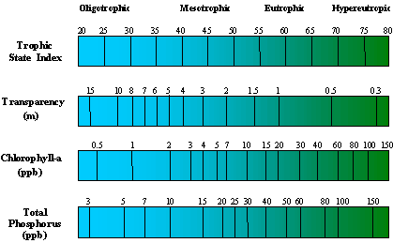

Table 4. Trophic State Index data for Loon Lake, Burnett County
May 2, 2005
 | Parameter
 | Phosphorus | Chlorophyll | Secchi | Average
Location | TSI | TSI | TSI | TSI
Main Body | 46.61 | 39.47 | 50.71 | 45.60
Kilkare Marsh | 47.35 | 43.93 | -- | 45.64
Voyager Village | 64.78 | 69.36 | 52.35 | 62.17
May 28, 2005
 | Parameter
 | Phosphorus | Chlorophyll | Secchi | Average
Location | TSI | TSI | TSI | TSI
Main Body | 52.71 | 39.47 | 41.31 | 44.50
Kilkare Marsh | 46.61 | 41.31 | -- | 43.96
Voyager Village* | 53.67 | 59.94 | 48.00 | 53.87
July 5, 2005
 | Parameter
 | Phosphorus | Chlorophyll | Secchi | Average
Location | TSI | TSI | TSI | TSI
Main Body | 54.13 | 49.11 | 47.16 | 50.13
Kilkare Marsh | 48.05 | 34.11 | -- | 48.69
Voyager Village | 54.13 | 44.05 | 51.30 | 49.83
August 11, 2005
 | Parameter
 | Phosphorus | Chlorophyll | Secchi | Average
Location | TSI | TSI | TSI | TSI
Main Body | 45.83 | 48.47 | 48.57 | 47.62
Kilkare Marsh | 38.73 | 43.43 | -- | 47.08
Voyager Village | 50.57 | 38.29 | 48.28 | 45.71
October 14, 2005
 | Parameter
 | Phosphorus | Chlorophyll | Secchi | Average
Location | TSI | TSI | TSI | TSI
Main Body | 48.05 | 50.62 | 45.86 | 48.18
Kilkare Marsh | 46.61 | 45.18 | -- | 45.89
Voyager Village | 47.35 | 33.02 | 46.28 | 42.22

* Sample collected within Kilkare Marsh near Voyager Village, subsequent samples were collected from a location closer to the golf course

Watershed Assessment

As probably would be expected, the watershed of Loon Lake which stretches beyond Shoal and Hanscom Lakes and encompasses much of Voyager Village is relatively benign (Figures 7 and 8). The watershed is approximately 3.76 square miles. It contains mixed coniferous and deciduous forests (53.5%), wetlands, (17.4%), neighboring lakes (15.5%), and some shrubland (3.3%). In particular, the eastern most portions of the watershed have significant amounts of emergent, lowland shrub and forested wetland (Kilkare Marsh). The 1975 report showed that there were no agriculture practices within the drainage areas around the lake and that 99% of the area was wooded or “wild”. Although some development has occurred since 1975, the watershed is still overwhelmingly dominated by forest and wetlands. Currently approximately 0.5 % of the watershed is characterized as general agriculture. The most urban areas are immediately surrounding the lakes (shoreline property owners) and the Voyager Village complex. These areas make up the reminder of the watershed.

Soils
The soils found within the Loon Lake watershed fall within two general categories (Table 5). Approximately 58.9 % of the watershed has sandy soils characterized as being moderately well to excessively drained. In addition, 12.5% of the watershed contains more hydric (wet) soils that are somewhat to very poorly drained. These soils are typically unsuitable for farming, which in part accounts for the small percentage of agriculture in the area. The remaining 29.1% of the watershed is lakes and other surface waters. With permeable sandy soils, throughout most of the watershed, it is only the areas closest to the lake which would have a significant surface impact to the lake. The obvious concern is Voyager Village. However, the water quality data collected thus far do not indicate that the golf course is causing significant detriment to the Loon Lake system in terms of water quality parameters. In general, there were no obvious point-sources of pollution or nutrient loading sources seen within the watershed.

Environmentally sensitive areas
There are a number of designations that a waterbody in Wisconsin can be given based on a number of ecological factors. According to the Wisconsin DNR, Loon Lake has been designated an Area of Special Natural Resources Interest (ASNRI). This common designation is used to identify waterbodies which “possess significant scientific value.” In the case of Loon Lake, it is a result of it being identified as a wild rice waterbody by the Department and the Great Lakes Indian Fish and Wildlife Commission. In addition Loon Lake has been designated as a Priority Navigable Waterway (PNW). The PNW designation is also generally common and includes “navigable waterways which contain sensitive fish and aquatic habitat.”

The designation of environmentally sensitive areas is intended to specifically “preserve significant environmental features” and protect these features from encroachment or destruction. In the state of Wisconsin, areas such as lakes and streams as well as near-shore areas are designated as environmentally sensitive areas. In addition, all delineated wetlands listed in the Wisconsin Wetland Inventory also carry this designation. These areas play a number of important environmental roles including storing stormwater and floodwater, trapping pollutants and providing wildlife habitat. Other areas can be specifically identified as Sensitive Areas. These are “areas of aquatic vegetation identified by the Department as offering critical or unique fish and wildlife habitat, including seasonal or lifestage requirements, or offering water quality or erosion control benefits to the body of water.” No additional areas within the Loon Lake watershed were found to have this designation.

Figure 7. The watershed surrounding Loon Lake, Burnett County, WI.
0
0.5
1.0 mile
0.5
Loon Lake watershed
Loon Lake Road
Hanscom Lake Trail Way
Voyager Road
Long Lake Road
Whispering Pines Lane
Loon Creek Trail
Kilkare Road
Voyager Village Country Club
Loon
Lake
Figure 8. Watershed analysis of Loon Lake, Burnett County, Wisconsin
0
0.5
1.0 mile
0.5
Table 5. Soils types found in the Loon Lake watershed, Burnett County, WI

Soil type | Percent of Watershed | Drainage Class
Graycalm-Menahga complex, 6 to 12 percent slopes | 29.7 | Excessively drained
Graycalm-Menahga complex, 12 to 30 percent slopes | 14.6 | Excessively drained
Graycalm-Menahga complex, 0 to 6 percent slopes | 7.4 | Excessively drained
Seelyeville and Markey soils, 0 to 1 percent slopes | 6.3 | Very poorly drained
Saprists, Aquents, and Aquepts, 0 to 1 percent slopes, ponded, flooded | 4.4 | Very poorly drained
Grettum loamy sand, 6 to 12 percent slopes | 2.9 | Moderately well drained
Grettum loamy sand, 0 to 6 percent slopes | 1.3 | Moderately well drained
Meehan loamy sand, 0 to 2 percent slopes | 1.1 | Somewhat poorly drained
Karlsborg-Grettum-Perida complex, 1 to 6 percent slopes | 1 | Moderately well drained
Menahga and Mahtomedi soils, 30 to 45 percent slopes | 0.7 | Excessively drained
Loxley mucky peat, 0 to 1 percent slopes | 0.6 | Very poorly drained
Karlsborg-Grettum-Perida complex, 6 to 12 percent slopes | 0.6 | Somewhat excessively drained
Wurtsmith loamy sand, 0 to 3 percent slopes | 0.2 | Moderately well drained
Bowstring muck, 0 to 1 percent slopes, frequently flooded | 0.1 | Very poorly drained
Water | 29.1
Lake Water Level Assessment

Groundwater monitoring data collected during the June sampling event were used to determine the general intensity and direction of groundwater flow in and around Loon Lake. In general, results indicate that groundwater flow is in a northerly direction (Figure 9, Table 6). The greatest area of groundwater inflow was found in Kilkare Marsh (including the areas adjacent to the golf course). This is often the case in wetland areas. Another area of relatively high groundwater inflow was along the northern shores of Cadotte Lake. Much of the main body of Loon Lake had relatively little or no groundwater movement. However, the greatest area of groundwater flow was located near the dam to the north. The intensity of outflow was six times as powerful as the intensity of inflow at the marsh. This would clearly explain why when the lake levels dropped in July, Loon Creek continued to flow below the dam when no water was flowing over the dam. Because it is an earthen dam surrounding by permeable sandy soils, water can easily flow out of the lake through the ground to feed the creek.

Figure 9. Relative groundwater flow in and around Loon Lake Burnett County, Wisconsin. (positive values indicate inflow, negative values indicate outflow)
0
.
2
0
0
.
2
M
i
l
e
s
N
E
W
S
Piezometer level
< ⁻350 mm
⁻350 - ⁻300 mm
⁻300 - ⁻250 mm
⁻250 - ⁻200 mm
⁻200 - ⁻150 mm
⁻150 - ⁻100 mm
⁻100 - ⁻50 mm
⁻50 - 0 mm
0 - 50 mm
50 - 100 mm

#
#
#
#
#
#
#
#
#
#
1
2
3
8
5
7
4
6
9
10
11
13
12
14
15
16
17
18
#
#
#
#
#
#
#
#
#
#
#
#
#
#
#
#
#
#

Table 6. GPS coordinates, relative intensity, and substrate type recorded during groundwater flow analysis on Loon Lake, Burnett County, Wisconsin.

Site | GPS Coordinates | Piezometer level (mm) | Substrate
1 | N 45º 59.016' | -45 | sand
1 | W 92º 10.299' | -45 | sand
2 | N 45º 58.849' | -2 | sand/muck
2 | W 92º 10.072' | -2 | sand/muck
3 | N 45º 58.676' | +6 | sand
3 | W 92º 10.311' | +6 | sand
4 | N 45º 58.628' | 0 | sand/muck
4 | W 92º 09.902' | 0 | sand/muck
5 | N 45º 58.492' | +6 | sand
5 | W 92º 09.932' | +6 | sand
6 | N 45º 58.308' | 0 | sand/muck
6 | W 92º 09.963' | 0 | sand/muck
7 | N 45º 58.399' | +4 | muck
7 | W 92º 09.747' | +4 | muck
8 | N 45º 57.886' | +30 | sand
8 | W 92º 09.111' | +30 | sand
9 | N 45º 58.039' | +56 | sand/muck
9 | W 92º 09.269' | +56 | sand/muck
10 | N 45º 58.333' | +6 | muck
10 | W 92º 09.812' | +6 | muck
11 | N 45º 58.255' | +4 | sand
11 | W 92º 10.053' | +4 | sand
12 | N 45º 58.106' | +15 | sand
12 | W 92º 10.284' | +15 | sand
13 | N 45º 58.242' | +13 | sand/muck
13 | W 92º 10.668' | +13 | sand/muck
14 | N 45º 58.338' | +5 | sand
14 | W 92º 10.505' | +5 | sand
15 | N 45º 58.549' | -14 | sand
15 | W 92º 10.675' | -14 | sand
16 | N 45º 58.712' | +40 | sand
16 | W 92º 10.384' | +40 | sand
17 | N 45º 58.833' | +7 | sand
17 | W 92º 10.291' | +7 | sand
18 | N 45º 58.971' | -335 | sand
18 | W 92º 10.478' | -335 | sand
Surface water flow was also monitored in order to quantify the amount of water entering and leaving the system through streams. The first consideration in this analysis was the volume of water within Loon and Cadotte Lakes (including associated wetlands). It is estimated that there is a total of approximately 4,619 acre-feet of standing water at any given time in the Loon Lake system (Table 7). A majority of this is located in Loon Lake, which is a larger and deeper lake than Cadotte Lake.

Table 7. Volume of water in Loon and Cadotte Lakes

 | Gallons | Acre-feet
Cadotte | 384,830,539 | 1,181
Loon | 1,120,277,216 | 3,438
Total | 1,505,107,755 | 4,619

By measuring the flow of surface water flowing over the Loon Lake dam and in the streams entering from Shoal and Hanscom Lakes, it is possible to calculate the volume of water moving through the system at the time of sampling (Table 8).

Table 8. Rates of surface water flow into and out of Loon and Cadotte Lakes

Flow over Loon Lake dam
 | ft³/sec | gal/day | acre-ft/day
June | 3.35 | 2,162,896 | 6.64
July | 0.62 | 398,177 | 1.22
August | 0 | 0 | 0
October | 8.71 | 5,629,782 | 17.28
Stream from Shoal
 | ft³/sec | gal/day | acre-ft/day
June | 4.58 | 2,957,219 | 9.08
July | 2.97 | 1,922,787 | 5.90
August | 3.57 | 2,307,499 | 7.08
October | 3.24 | 2,091,224 | 6.42
Hanscom Creek
 | ft³/sec | gal/day | acre-ft/day
June | -- | -- | --
July | -- | -- | --
August | -- | -- | --
October | 1.09 | 705,823 | 2.17

With the negative reputation golf courses have in terms of chemical and water use, it was important to include a review of the water use data provided by Voyager Village to determine whether or not their pumping is having a negative impact to the lake as some fear. Table 9 presents the information provided by the Golf Course Superintendent. It gives estimations of total water use on a month by month basis for a typical year. The total water use for one year is estimated at just over 36 million gallons or 111 acre-feet. Assuming this value is accurate, this volume is equivalent to approximately 4 inches of water off the surface of the lakes.

Table 9. Annual water use estimates provided by the Voyager Village Golf Course

 | Total gallons | Acre-feet
 | per month | per month
January | 0 | 0
February | 0 | 0
March | 0 | 0
April | 668,800 | 2
May | 6,320,760 | 19
June | 7,063,871 | 22
July | 9,487,621 | 29
August | 7,361,979 | 23
September | 4,251,284 | 13
October | 924,568 | 3
November | 0 | 0
December | 0 | 0
Total | 36,078,883 | 111

Precipitation data obtained from the Eau Claire State Climatology Office indicated that approximately 16 inches of precipitation fell during the time period of this study. In addition average pan evaporation data obtained from the St. Paul Climatological Observatory indicated that approximately 35.1 inches of water was lost through evaporation in 2005. As a result a net loss of nearly 20 inches of water can be attributed to climate alone.

Lake water level measurements were obtained from a depth gauge monitored by the Loon Lake Association dating back to November 2000. These data (Figure 10, Table 10) indicate that Loon Lake has fluctuated by approximately 17 inches over the past 5 years. These data do not show a downward trend but rather varied fluctuations. If the water use data provided by the golf course and the climatological data obtained are accurate, it is likely that a majority of this fluctuation is due primarily to climate. Data prior to 2000 could not be located.

Figure 10. Relative water level for Loon Lake, Burnett County from November 24,
2000 to October 15, 2005.

Table 10. Water gauge depth data for Loon Lake, Burnett County from November 24, 2000 to October 15, 2005.
Date | Gauge depth (in) | Date | Gauge depth (in)
11/24/2000 | 14 | 4/22/2004 | 30
4/20/2001 | 25.5 | 4/28/2004 | 28.5
6/14/2001 | 27 | 6/18/2004 | 28.5
9/2/2001 | 20.5 | 6/24/2004 | 27.5
11/10/2001 | 19.5 | 8/28/2004 | 27
1/26/2002 | 22.5 | 11/1/2004 | 29
5/10/2002 | 28.5 | 7/22/2005 | 23.5
9/13/2002 | 29.5 | 8/8/2005 | 21
12/15/2002 | 27 | 8/23/2005 | 18
7/1/2003 | 31 | 9/16/2005 | 20.25
9/5/2003 | 23 | 10/15/2005 | 28.5
10/20/2003 | 23
Conclusions

Data collected from the first phase of this study indicate that Loon Lake has general good water quality. They also show that in terms of parameters such as nutrients and water clarity, any impact from Voyager Village appears to be short lived and does not reach out to Loon Lake itself. However, little data is available prior to 2001. If more historic data were available, a better assessment of the impact of Voyager Village on the lake could be made. In addition, data collected during the investigation of fluctuating lake water levels suggest that these fluctuations are due primarily to climate and other natural processes versus any physical removal of water. It is important to note that before final conclusions and recommendations are made, the second phase of the study should be carried out as planned.

Second phase of the study
Project work elements in 2006 will focus on further water quality and surface flow monitoring, and an evaluation of the aquatic plant community. The water quality monitoring will be expanded and will include the same sampling locations as before as well as nutrient analysis from the streams connecting Shoal Lake and Hanscom Lakes to Loon Lake and from water flowing over the dam. Since phosphorus levels in the main body of Loon Lake were almost always higher than the levels at the marsh entrance, further testing is warranted to better understand possible sources of nutrients into the system. Surface flow rates will again be measured at the dam and the two inlet streams.

To address the Associations concern regarding the recent increase in aquatic plant growth near the entrance to Kilkare Marsh, an aquatic plant survey will be conducted in 2006. This will consist of point-intercept survey covering both Loon and Cadotte Lakes. Special attention will be made to determine if any exotic aquatic plants are present in Loon Lake. If found, the extent of their distributions will be determined and recorded.

An attempt will also be made to obtain an even more accurate estimation of water use from Voyager Village through the cooperation of the grounds crew. The final product of this two-year study will be a detailed report outlining the work which was conducted, the results of data analyses and management recommendations for the Association as well as individual property owners.

Appendix A

- 2005 dissolved oxygen and temperature data for Loon Lake, Burnett County.

