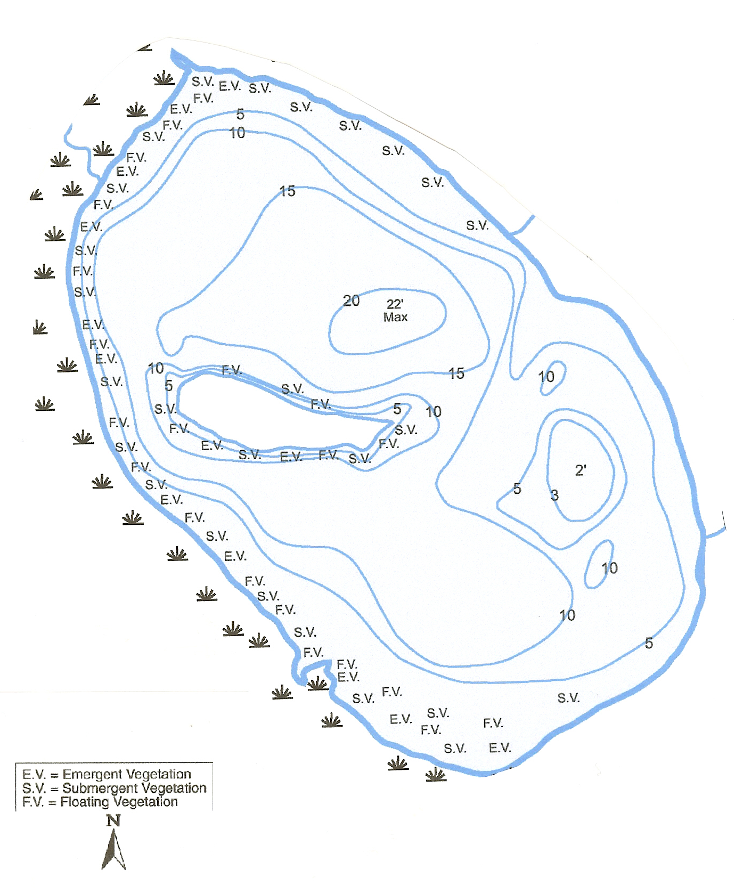
Figure 2. Loon Lake 2002 submergent plant survey transects.

A

B

C

D

E

F

L

K

J

H

I

G

