Curly-leaf pondweed (Potamogeton crispus)
Fall Turion Survey
Long Lake – WBIC: 2478200
Polk County, Wisconsin

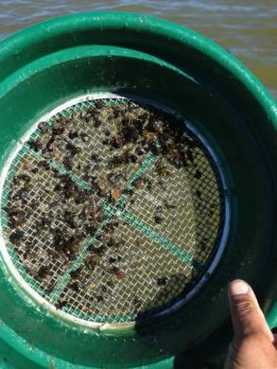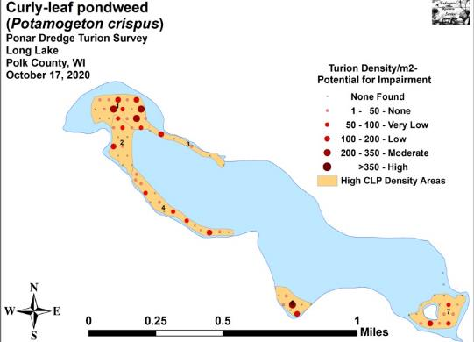
Sieve with Turions (Berg 2013) 2020 Fall Turion Density and Distribution

Project Initiated by:
Long Lake Protection and Rehabilitation District, Harmony Environmental, and the Wisconsin Department of Natural Resources – (Grant ACEI20218)
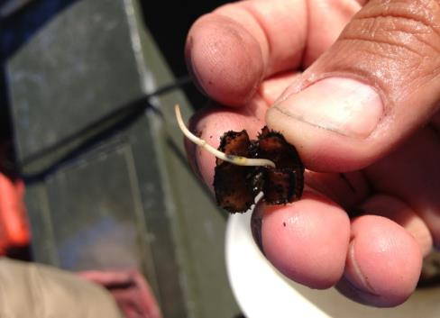
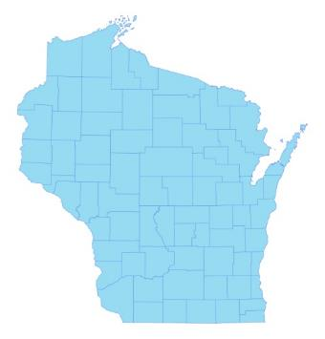

* Long Lake

Sprouting CLP Turion (Berg 2013)

Survey Conducted by and Report Prepared by:
Endangered Resource Services, LLC
Matthew S. Berg, Research Biologist
St. Croix Falls, Wisconsin
October 17, 2020
TABLE OF CONTENTS

Page
LIST OF FIGURES AND TABLES..……..……………………………………………….. ii

INTRODUCTION……….…..……..………………………………………………………. 1

BACKGROUND AND STUDY RATIONALE………………………….………………... 1

CLP LIFE HISTORY AND STUDY OBJECTIVES…………………….………………... 3

METHODS……………………………………………………………….………………… 4

DATA ANALYSIS………………………………………………………………………… 6

RESULTS AND DISCUSSION……………………………………………………………. 7

2013 Fall Ponar Dredge CLP Turion Survey……………………………………... 7

2014 Fall Ponar Dredge CLP Turion Survey...…………………………………… 8

2015 Fall Ponar Dredge CLP Turion Survey...…………………………………… 10

2016 Fall Ponar Dredge CLP Turion Survey...…………………………………… 12

2017 Fall Ponar Dredge CLP Turion Survey...…………………………………… 14

2018 Fall Ponar Dredge CLP Turion Survey...…………………………………… 16

2019 Fall Ponar Dredge CLP Turion Survey...…………………………………… 18

2020 Fall Ponar Dredge CLP Turion Survey...…………………………………… 20

Considerations for Future Management…………....……………………………... 22

LITERATURE CITED……….……………………….……………………………………. 22

APPENDIXES……….…….………………………………………………….……………. 23

I: Survey Sample Points and Historic High CLP Density Areas……………………….. 23

II: 2013-2020 Fall CLP Turion Density and Distribution Maps………………………… 25

LIST OF FIGURES AND TABLES

Page
Figure 1: Long Lake Bathymetric Map………………….….……………….……….……. 1
Figure 2: 2018, 2019, and 2020 Pretreatment CLP Density and Distribution and
Proposed CLP Treatment Areas………….…………………………….…….……….……. 2
Figure 3: Germinating CLP Turion……………………………………..…………………. 3
Figure 4: Turion Survey Sample Points………………………………...…………..……… 4
Figure 5: Ponar Grab and Turion Sieving……………..………………..………………….. 5
Figure 6: Predicted Navigation Impairment Based on Turion Density.…….……………... 6
Figure 7: 2013 Fall CLP Turion Survey Density and Distribution.…..……………………. 7
Figure 8: 2014 Fall CLP Turion Survey Density and Distribution...………………………. 8
Table 1: CLP Turion Surveys - Summary Statistics – Long Lake, Polk County
November 10, 2013 and October 19, 2014………………….……………………………… 9

Figure 9: 2015 Fall CLP Turion Survey Density and Distribution..……………………… 10
Table 2: CLP Turion Surveys - Summary Statistics – Long Lake, Polk County
October 19, 2014 and October 25, 2015…………………….……………………………… 11

Figure 10: 2016 Fall CLP Turion Survey Density and Distribution..……………………… 12
Table 3: CLP Turion Surveys - Summary Statistics – Long Lake, Polk County
October 25, 2015 and October 28-29, 2016….……………………………………………... 13

Figure 11: 2017 Fall CLP Turion Survey Density and Distribution..……………………… 14

Table 4: CLP Turion Surveys - Summary Statistics – Long Lake, Polk County
October 28-29, 2016 and October 27-28, 2017….…………………………………………. 15

Figure 12: 2018 Fall CLP Turion Survey Density and Distribution..……………………… 16

Table 5: CLP Turion Surveys - Summary Statistics – Long Lake, Polk County
October 27-28, 2017 and October 27-28, 2018….…………………………………………. 17

Figure 13: 2019 Fall CLP Turion Survey Density and Distribution..……………………… 18

Table 6: CLP Turion Surveys - Summary Statistics – Long Lake, Polk County
October 27-28, 2018 and October 27-28, 2019….…………………………………………. 19

Figure 14: 2020 Fall CLP Turion Survey Density and Distribution..……………………… 20

Table 7: CLP Turion Surveys - Summary Statistics – Long Lake, Polk County
October 27-28, 2019 and October 17, 2020…..….…………………………………………. 21
INTRODUCTION:
Long Lake (WBIC 2478200) is a 272 acre seepage lake in central Polk County, Wisconsin in the Town of Balsam Lake (T34N R17W S07 NE NE). It reaches a maximum depth of just over 17ft in the central basin and has an average depth of approximately 11ft (Busch et al. 1969) (Figure 1). The lake is eutrophic trending toward hypereutrophic, and visibility is generally poor with summer Secchi readings averaging 4.9ft since 1992; however, the 2020 mean reading of 9.0ft was the highest since 1995 (WDNR 2020). The bottom substrate in the lake’s bays and central basin is predominately thick organic muck, while exposed points and most north/south shorelines are dominated by gravel and sand.

Figure 1: Long Lake Bathymetric Map

BACKGROUND AND STUDY RATIONALE:
Long Lake and the Long Lake Protection and Rehabilitation District (LLPRD) have an extended history of battling Curly-leaf pondweed (Potamogeton crispus) (CLP) - an exotic invasive plant species that thrives in the nutrient-rich sediments found in many parts of the lake. In the past, CLP often grew so densely in the spring and early summer that it made lake access and boating difficult for residents. CLP’s late-June to early-July senescence was also cited in past studies by Barr Engineering and the Polk County Land and Water Conservation Department (PCLWCD) as a significant contributor to the lake’s overall phosphorus load, and it was at least partially responsible for the lake’s frequent late-summer toxic blue-green algae blooms.

In 2010, after years of study, the LLPRD and the Wisconsin Department of Natural Resources (WDNR) authorized an initial lakewide herbicide treatment of over 65 acres of CLP. The LLPRD treated nearly 57 acres again in 2011, and 58 acres in 2012. After updating the District’s WDNR approved Aquatic Plant Management Plan (APMP) in 2012, it was decided to treat just 27 acres in 2013, and only 20 acres in 2014. Although the 2010-2013 treatments resulted in highly significant reductions in both CLP coverage and density on the lake, the 2014 treatment showed no significant change from pretreatment levels. A follow-up survey of CLP turions in the lake’s sediment also suggested 2015 CLP levels would likely be very low in most parts of the lake. Based on these data, and following a discussion with the lake’s executive board and APMP director Cheryl Clemens (Harmony Environmental) in the fall of 2014, it was decided not to treat CLP in 2015.
Because both the 2015 June CLP point-intercept monitoring survey and the fall CLP turion sediment data suggested CLP had made a significant rebound throughout much of the lake, it was decided that herbicide treatments (not to exceed 35 acres) would resume in the future. Ultimately, the LLPRD decided to treat 34.97 acres in 2016 and 33.65 acres in 2017. However, due to low spring CLP levels, the planned treatments in 2018, 2019, and 2020 were cancelled (Figure 2).

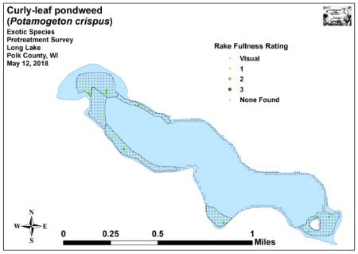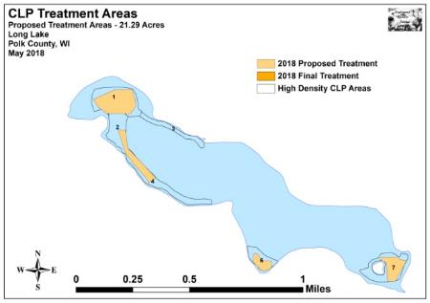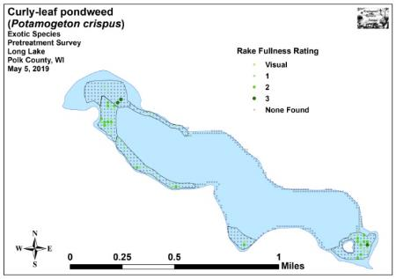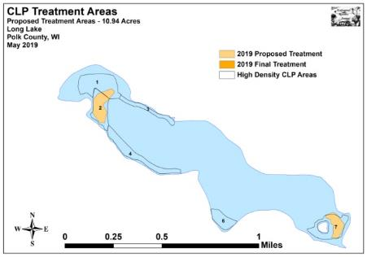
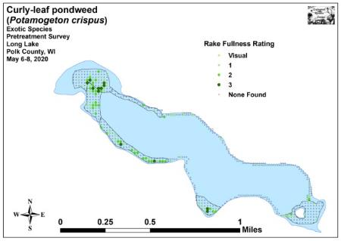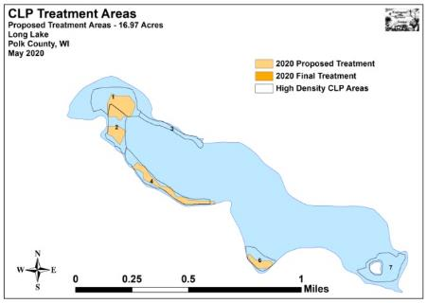
Figure 2: 2018, 2019, and 2020 Pretreatment CLP Density and Distribution and Proposed CLP Treatment Areas

CLP LIFE HISTORY AND STUDY OBJECTIVES:
Although Curly-leaf pondweed occasionally reproduces by seed, the vast majority of plants resprout from stiff overwintering buds called turions that are normally produced in number by the plants prior to their late June/early July senescence (Figure 3). After the pinecone-like turions germinate in late fall or early winter, plants continue to grow slowly under the ice. Following ice out, growth accelerates, and plants rapidly canopy allowing them a competitive advantage over slower growing native species (Capers 2005).

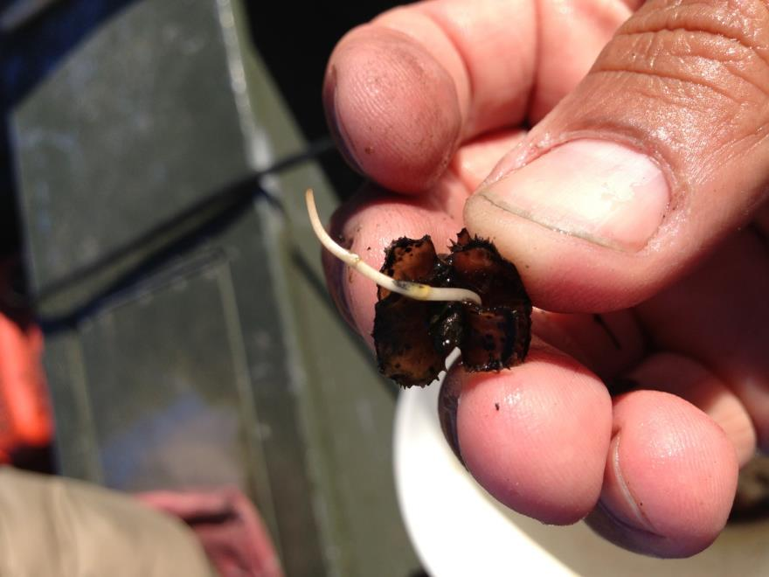
Figure 3: Germinating CLP Turion

Research suggests approximately 50% of turions germinate in a growing season while the rest remain dormant until the following growing season when another 50% will germinate (Johnson 2012). Depending on the level of turions at a given location and knowing that latent turions may be able to survive for over 5 years in the sediment, it may take several years of control to exhaust the “turion bank” (R. Newman – U of M unpublished data).

Following the 2020 summer growing season, we conducted a fall turion survey. The goals of the survey were to determine the level of remaining CLP turions within the lake’s historic high density CLP areas; and, if there were any present, to predict whether their numbers suggested there would likely be enough to cause navigation issues in 2021. This report is the summary analysis of that survey conducted on October 17, 2020.

METHODS:
Fall Ponar Dredge Turion Survey:
Within the initial 2013 proposed treatment area shapefile, we used Hawth’s Analysis Tools Extension to ArcGIS 9.3.1 to generate offset regular points at the rate of 2/acre. We also added 10 additional points in thin areas of the polygons where there were no points, or in areas that fell outside the polygons that we thought had the potential for CLP growth.
This same sampling grid was also used from 2014-2020 to allow for the most accurate comparisons possible (Figure 4) (Appendix I). For ease in determining the total impact of the current treatment program, we also left the 2013-2020 narratives in the results section of this report.

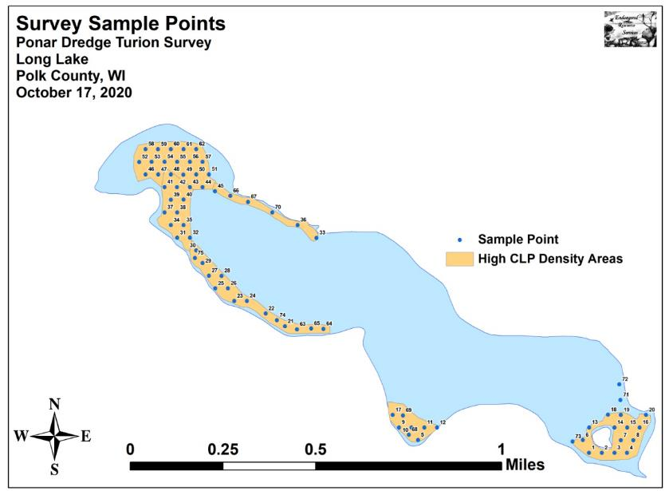
Figure 4: Turion Survey Sample Points

During the surveys, we located each point with a handheld mapping GPS unit (Garmin 76CSx) and used a Petite Ponar dredge with a 0.0232m² (36in²) sample area to take a bottom sediment grab from each side of the boat at each location. These samples were then rinsed in a fine sieve to separate out the sediment (Figure 5). Samples with high numbers of turions or significant amounts of detritus were bagged for later analysis; at which time we discarded all rotten turions, tallied all live turions, and multiplied the combined total live turions from the two samples by 21.53 to estimate turions/m² at each location. This value gives an idea of how many CLP plants will germinate in an area during the 2021 growing season.

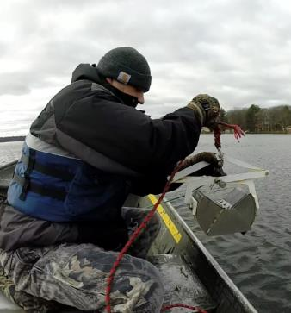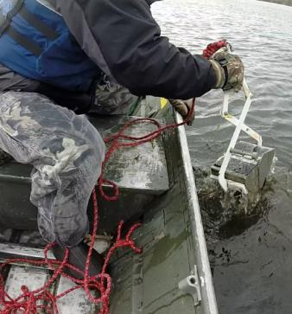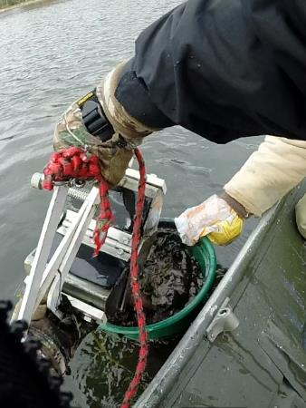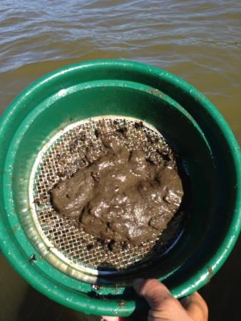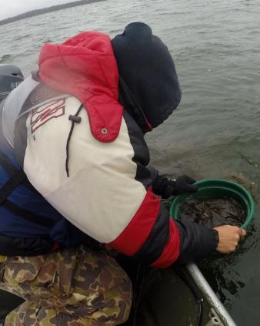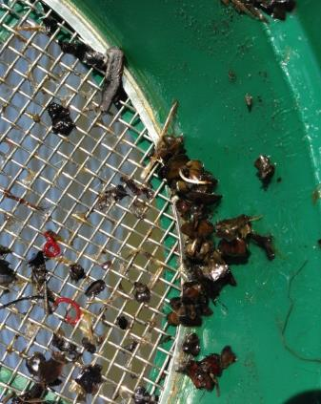
CLP Turions
Figure 5: Ponar Grab and Turion Sieving

DATA ANALYSIS:
We entered all data collected into an Excel spreadsheet and used standard formulas in the data analysis tool pack to calculate the following:

Total number of points sampled: This value is the total number of points on the lake within each study area. We took two Ponar samples at each point.

Total number of live turions: This value includes all live turions found at all sites within a study area.

Total number of points with live turions: This number includes all survey sites that had at least one turion in either of the Ponar samples taken at the site.

Frequency of occurrence: The frequency of turions is generally reported as a percentage of occurrences at all sample points. The value is used to extrapolate coverage within the study area. For example, if 20% of all sample sites have turions, it suggests that 20% of the study area will have at least some Curly-leaf pondweed coverage the following year.

Points at or above nuisance level: This value gives the number of survey sites within the study area that were above the predicted nuisance threshold (Figure 6). Research suggests that when the turion density is at or above 200/m², the following year’s CLP growth has the potential to at least moderately impair navigation (Johnson 2012).

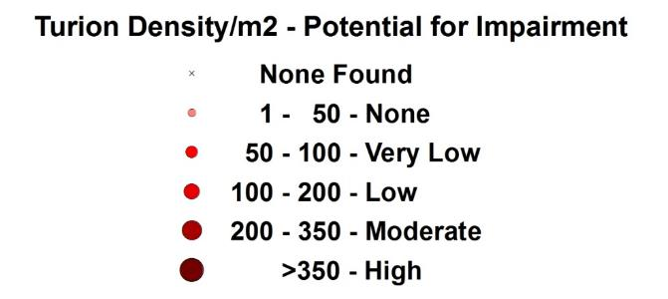
Figure 6: Predicted Navigation Impairment Based on Turion Density

Percent nuisance level: The percentage of nuisance points divided by the total number of survey points can be extrapolated to determine what percent of the study area has the potential to have at least moderate navigation impairment during the next growing season.

Mean turions/m²: This value is the average number of turions/m² when pooling the data from all survey sites regardless of whether or not they had turions present.

Standard deviation of turions/m²: This value tells us how far apart the data is from the mean. A low standard deviation suggests most points have a turion density that was similar to the mean, while a high value suggests there was greater variability in turion density within the sample area.
Year-over-year Significant Differences:
Data from the 2013-2020 surveys was compared using paired t-tests as we returned to the same sites during each survey. Year-over-year differences were determined to be significant at p<0.05, moderately significant at p<0.01, and highly significant at p<0.001 (Tables 1-7).

RESULTS AND DISCUSSION:
2013 Fall Ponar Dredge CLP Turion Survey:
During the November 10, 2013 Ponar dredge survey, we counted a total of 56 CLP turions at 28 of 75 survey points (37.3% coverage). Of these, none exceeded the expected “nuisance level” of 200/m², and only six points topped 50/m² (Figure 7) (Appendix II).

We found the overall mean density was just 16.07 turions/m² with Area 1 having the highest mean density at 34.19 turions/m². These low values suggest that, even at its worst, CLP was unlikely to cause significant navigation impairment in 2014. Broken down by area, it appeared the latent turion bank in Areas 3, 4, and 7 may have been nearly exhausted. We also noted that the deeper edges of Areas 2 and 6 looked to be nearly turion free. Only Area 1 seemed likely to have CLP over most of its area in 2014.

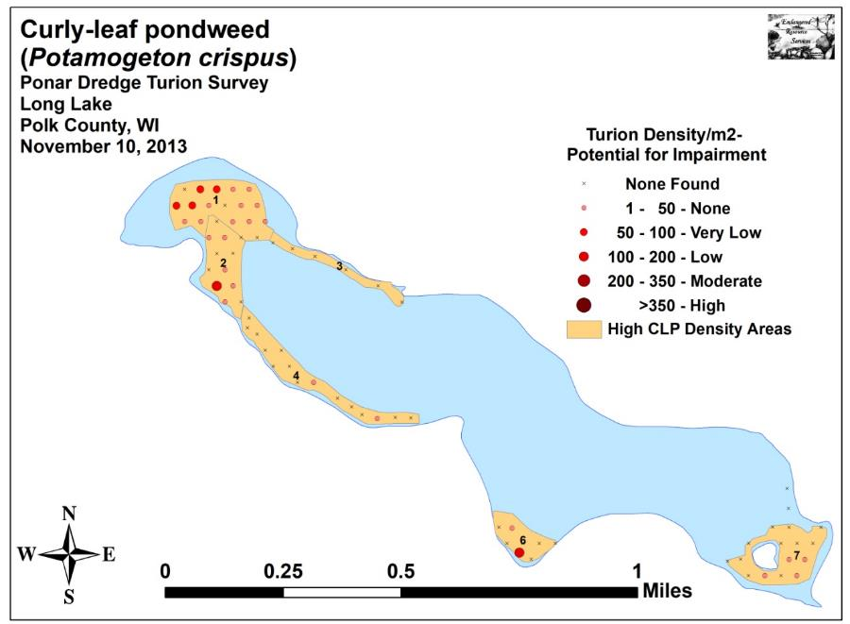
Figure 7: 2013 Fall CLP Turion Survey Density and Distribution

2014 Fall Ponar Dredge CLP Turion Survey:
Following the unsuccessful herbicide treatment in the spring of 2014, we found a total of 59 CLP turions at 27 of 75 survey points (36.0% coverage) during the October 19, 2014 survey (nearly identical to the 56 turions found at 28 points in 2013). Of these, none exceeded the expected “nuisance level” of 200/m², and just eight points (up from six in 2013) topped 50 turions/m² (Figure 8) (Appendix II). Comparing these results to the 2013 turion survey, we found that the increase in lakewide turion levels was not significant (p=0.43) as the mean density/m² increased only slightly from 16.07 turions/m² in 2013 to 16.94 turions/m² in 2014 (Table 1).

As in 2013, Area 1 had the highest mean density (32.92/m²), and four points suggested the possibility of at least some very low to low navigation impairment. Areas 6 experienced a slight increase in density that was not significant (p=0.46), and Area 7 showed a nearly significant increase (p=0.05); however, neither of these two areas had any points that suggested there might be anything greater than a very low chance of navigation impairment in 2015. Area 2 also had regular turions, and, although the turion survey did not capture the data, the exploratory and posttreatment surveys suggested that CLP was reestablishing in the central and eastern ends of Area 4.

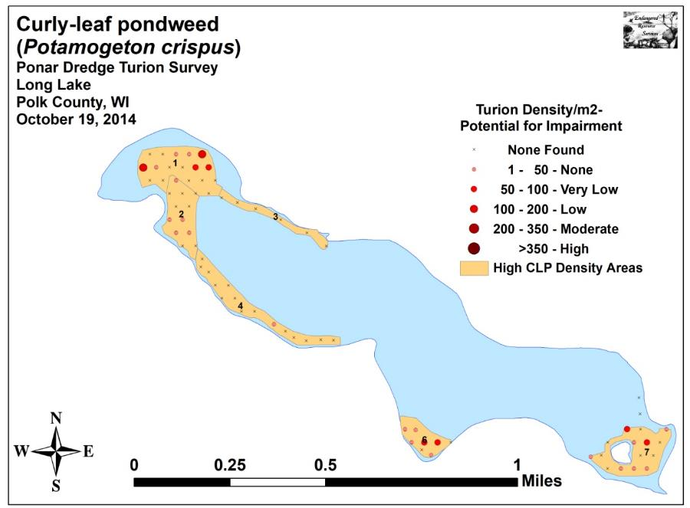
Figure 8: 2014 Fall CLP Turion Survey Density and Distribution
Table 1: CLP Turion Surveys - Summary Statistics
Long Lake, Polk County
November 10, 2013 and October 19, 2014

2013 2014
Summary Statistics: | All | HDA  1 | HDA  2 | HDA  3 | HDA  4 | HDA  6 | HDA  7 | All | HDA  1 | HDA  2 | HDA  3 | HDA  4 | HDA  6 | HDA  7
Total number of points sampled | 75 | 17 | 12 | 6 | 15 | 8 | 17 | 75 | 17 | 12 | 6 | 15 | 8 | 17
Total live turions | 56 | 27 | 12 | 0 | 2 | 10 | 5 | 59 | 26 | 6 | 0 | 1 | 11 | 15
Total # of points with live turions | 28 | 14 | 6 | 0 | 2 | 2 | 4 | 27 | 7 | 5 | 0 | 1 | 6 | 8
Freq. of occurrence (in percent) | 37.3 | 82.4 | 50.0 | 0.0 | 13.3 | 25.0 | 23.5 | 36.0 | 41.2 | 41.7 | 0.0 | 6.7 | 75.0 | 47.1
# at/above nuis. level (+200/m²) | 0 | 0 | 0 | 0 | 0 | 0 | 0 | 0 | 0 | 0 | 0 | 0 | 0 | 0
% nuisance level | 0.0 | 0.0 | 0.0 | 0.0 | 0.0 | 0.0 | 0.0 | 0.0 | 0.0 | 0.0 | 0.0 | 0.0 | 0.0 | 0.0
Maximum turions/m² | 194 | 86 | 108 | 0 | 22 | 194 | 43 | 172 | 172 | 43 | 0 | 22 | 65 | 86
Mean turions/m² | 16.07 | 34.19 | 21.53 | 0.00 | 2.87 | 26.91 | 6.33 | 16.94 | 32.92 | 10.76 | 0.00 | 1.44 | 29.60 | 19.00
Standard deviation/m² | 31.07 | 27.50 | 31.80 | 0.00 | 7.57 | 67.83 | 12.66 | 33.63 | 58.02 | 14.51 | 0.00 | 5.56 | 25.57 | 26.24
Standard error of the paired diff. |  |  |  |  |  |  |  | 0.23 | 0.65 | 0.44 | 0.00 | 0.12 | 1.37 | 0.34
Degrees of freedom |  |  |  |  |  |  |  | 74 | 16 | 11 | 5 | 14 | 7 | 16
t-statistic |  |  |  |  |  |  |  | +0.18 | -0.09 | -1.15 | Div/0 | -0.56 | +0.09 | +1.71
p - value |  |  |  |  |  |  |  | 0.43 | 0.46 | 0.14 | Div/0 | 0.29 | 0.46 | 0.05

Significant differences = * p<0.05, ** p<0.01, *** p<0.001

2015 Fall Ponar Dredge CLP Turion Survey:
Following a year without management, we found Curly-leaf pondweed turion numbers experienced a dramatic increase. During the October 25, 2015 survey, we counted 167 CLP turions at 55 of 75 survey points (73.3% coverage). This was nearly triple the total turions and double the distribution of CLP when compared to the 2014 and 2013 surveys (59 turions found at 27 survey points (36.0% coverage) in 2014 and 56 turions at 28 points (37.3% coverage) in 2013). In 2015, only one point (in Bed 1) exceeded the expected “navigation nuisance level” of 200/m², but 27 (up from eight in 2014 and six in 2013) topped 50/m² (Figure 9) (Appendix II).

As expected, the lakewide increase in mean density from 16.94 turions/m² in 2014 (16.07 in 2013) to 47.94 turions/m² in 2015 was highly significant (p<0.001) (Table 2). We also noticed that the standard deviation in 2015 (51.11 turions/m²) was only slightly higher than the mean, while the standard deviation in 2014 (33.63 turions/m²) had been over twice the mean. This suggested that CLP coverage was more uniform in 2015 than in 2014.

Broken down by polygon, we found that the mean turion density increase in each of the six areas. This increase was highly significant in Area 4 (p<0.001), and significant in Area 1 (p=0.02), Area 3 (p=0.04), and Area 6 (p=0.02).

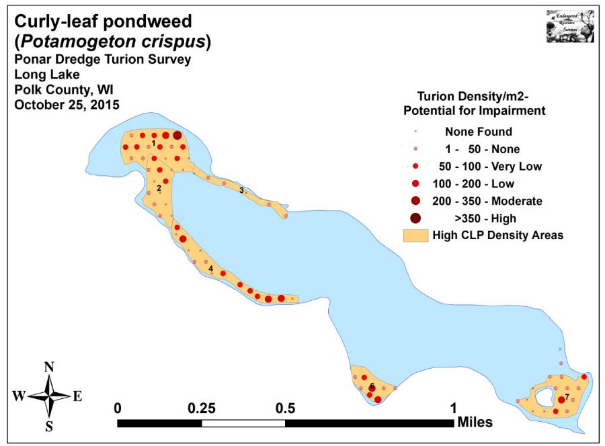
Figure 9: 2015 Fall CLP Turion Survey Density and Distribution

Table 2: CLP Turion Surveys - Summary Statistics
Long Lake, Polk County
October 19, 2014 and October 25, 2015

2014 2015
Summary Statistics: | All | HDA  1 | HDA  2 | HDA  3 | HDA  4 | HDA  6 | HDA  7 | All | HDA  1 | HDA  2 | HDA  3 | HDA  4 | HDA  6 | HDA  7
Total number of points sampled | 75 | 17 | 12 | 6 | 15 | 8 | 17 | 75 | 17 | 12 | 6 | 15 | 8 | 17
Total live turions | 59 | 26 | 6 | 0 | 1 | 11 | 15 | 167 | 45 | 15 | 5 | 43 | 30 | 29
Total # of points with live turions | 27 | 7 | 5 | 0 | 1 | 6 | 8 | 55 | 14 | 7 | 4 | 10 | 8 | 12
Freq. of occurrence (in percent) | 36.0 | 41.2 | 41.7 | 0.0 | 6.7 | 75.0 | 47.1 | 73.3 | 82.4 | 58.3 | 66.7 | 66.7 | 100.0 | 70.6
# at/above nuis. level (+200/m²) | 0 | 0 | 0 | 0 | 0 | 0 | 0 | 1 | 1 | 0 | 0 | 0 | 0 | 0
% nuisance level | 0.0 | 0.0 | 0.0 | 0.0 | 0.0 | 0.0 | 0.0 | 1.3 | 5.9 | 0.0 | 0.0 | 0.0 | 0.0 | 0.0
Maximum turions/m² | 172 | 172 | 43 | 0 | 22 | 65 | 86 | 237 | 237 | 86 | 43 | 194 | 194 | 194
Mean turions/m² | 16.94 | 32.92 | 10.76 | 0.00 | 1.44 | 29.60 | 19.00 | 47.94 | 56.99 | 26.91 | 17.94 | 61.71 | 80.73 | 36.72
Standard deviation/m² | 33.63 | 58.02 | 14.51 | 0.00 | 5.56 | 25.57 | 26.24 | 51.11 | 55.90 | 30.62 | 16.21 | 60.27 | 54.89 | 46.15
Standard error of the paired diff. |  |  |  |  |  |  |  | 0.28 | 0.51 | 0.49 | 0.31 | 0.73 | 0.96 | 0.63
Degrees of freedom |  |  |  |  |  |  |  | 74 | 16 | 11 | 5 | 14 | 7 | 16
t-statistic |  |  |  |  |  |  |  | +5.19 | +2.18 | +1.52 | +2.71 | +3.86 | +2.47 | +1.32
p - value |  |  |  |  |  |  |  | ***<0.001 | *0.02 | 0.08 | *0.04 | ***<0.001 | *0.02 | 0.10

Significant differences = * p<0.05, ** p<0.01, *** p<0.001

2016 Fall Ponar Dredge CLP Turion Survey:
The 2016 spring treatment produced a highly significant reduction in CLP throughout the lake’s entire littoral zone. Consequently, our October 28-29, 2016 survey found Curly-leaf pondweed turion numbers were greatly reduced. In total, we tallied 89 turions at 37 survey points (49.3% coverage). Although this was down sharply from the 2015 survey which found 167 turions at 55 of 75 survey points (73.3% coverage), it was still well above the 59 turions recorded at 27 points (36.0% coverage) in 2014 and the 56 turions at 28 points (37.3% coverage) in 2013. Our 2016 survey didn’t find any points that were above the “navigation nuisance level” of 200/m², but 15 predicted 50 turions/m² or higher (Figure 10) (Appendix II). This was also down from 27 in 2015, but still much above the eight in 2014 and six in 2013.

The lakewide decline in mean density from 47.94 turions/m² (standard deviation of 51.11 turions/m²) in 2015 to 25.55 turions/m² in 2016 (standard deviation of 38.40 turions/m²) was highly significant (p<0.001) (Table 3). All areas experienced a year-over-year reduction in turion levels with the exception of Area 2 which was unchanged. Area 4 saw a moderately significant decline (p<0.001), and Areas 3 and 7 showed significant declines (p=0.02). Area 1’s decline was also nearly significant (p=0.05).

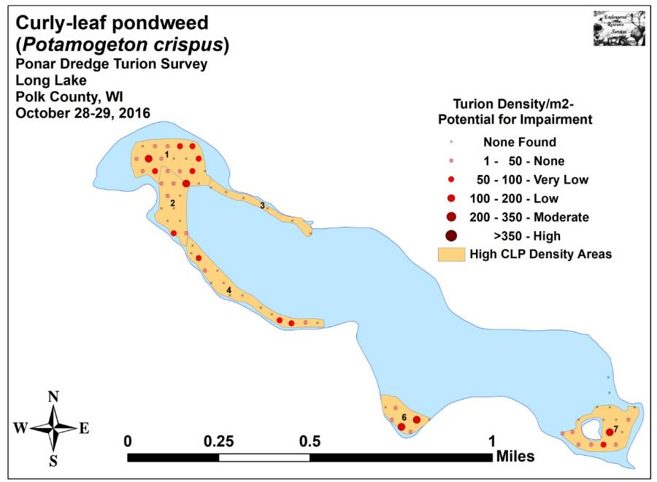
Figure 10: 2016 Fall CLP Turion Survey Density and Distribution
Table 3: CLP Turion Surveys - Summary Statistics
Long Lake, Polk County
October 25, 2015 and October 28-29, 2016

2015 2016
Summary Statistics: | All | HDA  1 | HDA  2 | HDA  3 | HDA  4 | HDA  6 | HDA  7 | All | HDA  1 | HDA  2 | HDA  3 | HDA  4 | HDA  6 | HDA  7
Total number of points sampled | 75 | 17 | 12 | 6 | 15 | 8 | 17 | 75 | 17 | 12 | 6 | 15 | 8 | 17
Total live turions | 167 | 45 | 15 | 5 | 43 | 30 | 29 | 89 | 28 | 15 | 0 | 12 | 16 | 18
Total # of points with live turions | 55 | 14 | 7 | 4 | 10 | 8 | 12 | 37 | 12 | 7 | 0 | 5 | 5 | 8
Freq. of occurrence (in percent) | 73.3 | 82.4 | 58.3 | 66.7 | 66.7 | 100.0 | 70.6 | 49.3 | 70.6 | 58.3 | 0.0 | 33.3 | 62.5 | 47.1
# at/above nuis. level (+200/m²) | 1 | 1 | 0 | 0 | 0 | 0 | 0 | 0 | 0 | 0 | 0 | 0 | 0 | 0
% nuisance level | 1.3 | 5.9 | 0.0 | 0.0 | 0.0 | 0.0 | 0.0 | 0.0 | 0.0 | 0.0 | 0.0 | 0.0 | 0.0 | 0.0
Maximum turions/m² | 237 | 237 | 86 | 43 | 194 | 194 | 194 | 172 | 108 | 129 | 0 | 65 | 151 | 172
Mean turions/m² | 47.94 | 56.99 | 26.91 | 17.94 | 61.71 | 80.73 | 36.72 | 25.55 | 35.46 | 26.91 | 0.00 | 17.22 | 43.06 | 22.79
Standard deviation/m² | 51.11 | 55.90 | 30.62 | 16.21 | 60.27 | 54.89 | 46.15 | 38.40 | 33.99 | 37.99 | 0.00 | 27.23 | 60.89 | 42.70
Standard error of the paired diff. |  |  |  |  |  |  |  | 0.28 | 0.58 | 0.70 | 0.31 | 0.61 | 1.50 | 2.18
Degrees of freedom |  |  |  |  |  |  |  | 74 | 16 | 11 | 5 | 14 | 7 | 16
t-statistic |  |  |  |  |  |  |  | -3.78 | -1.74 | 0.00 | -2.57 | -3.37 | -1.17 | -2.18
p - value |  |  |  |  |  |  |  | ***<0.001 | 0.05 | 0.50 | *0.02 | **0.002 | 0.28 | *0.02

Significant differences = * p<0.05, ** p<0.01, *** p<0.001

2017 Fall Ponar Dredge CLP Turion Survey:
As in 2016, the May 2017 treatment of 33.65 acres produced a highly significant decline in Curly-leaf pondweed throughout the lake’s entire littoral zone. During the October 27-28, 2017 survey, we found 54 turions at 31 survey points (41.3% coverage). This was a further reduction from the 89 turions at 37 points (49.3% coverage) we found in 2016 after the peak of 167 turions at 55 of 75 survey points (73.3% coverage) in 2015. It also represented a return to levels seen prior to the 2015 interruption in the treatment program (59 turions found at 27 points (36.0% coverage) in 2014 and 56 turions at 28 points (37.3% coverage) in 2013). Similar to 2016, our 2017 survey didn’t find any points that were above the “navigation nuisance level” of 200/m²; and the five points predicted to have 50 turions/m² or higher (Figure 11) (Appendix II) was the lowest since surveying began (15 in 2016; 27 in 2015; eight in 2014; and six in 2013).

The lakewide decline in mean density from 25.55 turions/m² in 2016 (standard deviation of 38.40 turions/m²) in 2016 to 15.50 turions/m² in 2017 (standard deviation of 24.92 turions/m²) was significant (p=0.02) (Table 4). All polygons experienced a year-over-year decline, but this was not significant for any one individual area.

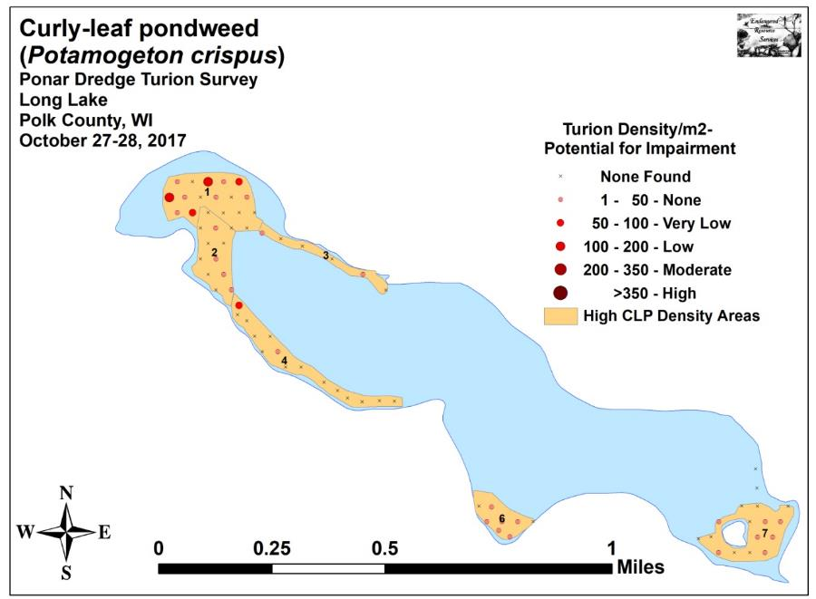
Figure 11: 2017 Fall CLP Turion Survey Density and Distribution
Table 4: CLP Turion Surveys - Summary Statistics
Long Lake, Polk County
October 28-29, 2016 and October 27-28, 2017

2016 2017
Summary Statistics: | All | HDA  1 | HDA  2 | HDA  3 | HDA  4 | HDA  6 | HDA  7 | All | HDA  1 | HDA  2 | HDA  3 | HDA  4 | HDA  6 | HDA  7
Total number of points sampled | 75 | 17 | 12 | 6 | 15 | 8 | 17 | 75 | 17 | 12 | 6 | 15 | 8 | 17
Total live turions | 89 | 28 | 15 | 0 | 12 | 16 | 18 | 54 | 26 | 6 | 2 | 5 | 8 | 7
Total # of points with live turions | 37 | 12 | 7 | 0 | 5 | 5 | 8 | 31 | 10 | 4 | 2 | 2 | 6 | 7
Freq. of occurrence (in percent) | 49.3 | 70.6 | 58.3 | 0.0 | 33.3 | 62.5 | 47.1 | 41.3 | 58.8 | 33.3 | 33.3 | 13.3 | 75.0 | 41.2
# at/above nuis. level (+200/m²) | 0 | 0 | 0 | 0 | 0 | 0 | 0 | 0 | 0 | 0 | 0 | 0 | 0 | 0
% nuisance level | 0.0 | 0.0 | 0.0 | 0.0 | 0.0 | 0.0 | 0.0 | 0.0 | 0.0 | 0.0 | 0.0 | 0.0 | 0.0 | 0.0
Maximum turions/m² | 172 | 108 | 129 | 0 | 65 | 151 | 172 | 108 | 108 | 43 | 22 | 86 | 43 | 22
Mean turions/m² | 25.55 | 35.46 | 26.91 | 0.00 | 17.22 | 43.06 | 22.79 | 15.50 | 32.92 | 10.76 | 7.18 | 7.18 | 21.53 | 8.86
Standard deviation/m² | 38.40 | 33.99 | 37.99 | 0.00 | 27.23 | 60.89 | 42.70 | 24.92 | 38.15 | 17.17 | 11.12 | 22.53 | 16.27 | 10.92
Standard error of the paired diff. |  |  |  |  |  |  |  | 0.23 | 0.50 | 0.63 | 0.21 | 0.47 | 1.00 | 0.47
Degrees of freedom |  |  |  |  |  |  |  | 74 | 16 | 11 | 5 | 14 | 7 | 16
t-statistic |  |  |  |  |  |  |  | -2.03 | -0.24 | -1.19 | 1.58 | -1.00 | -1.00 | -1.38
p - value |  |  |  |  |  |  |  | *0.02 | 0.41 | 0.13 | 0.09 | 0.17 | 0.18 | 0.09

Significant differences = * p<0.05, ** p<0.01, *** p<0.001

2018 Fall Ponar Dredge CLP Turion Survey:
After a year with no active management, the expectation would be that 2018 fall turion levels would experience a highly significant increase over 2017 levels. However, this turned out not to be the case and seemed to support our anecdotal observations during the June follow-up survey that many plants in deep water didn’t form turions as they grew only a few feet before falling over and dying. During the October 27-28, 2018 survey, we found 68 turions at 30 of 75 survey points (40.0% coverage). This was an increase from 54 total turions found in 2017, but a reduction from the 31 survey points with turions (41.3% coverage) seen in 2017. Although this was higher than the posttreatment levels documented in 2013 (56 turions at 28 points - 37.3% coverage) and 2014 (59 turions found at 27 points - 36.0% coverage), it was still far less than the peak values observed in 2015 (167 turions at 55 points - 73.3% coverage) and 2016 (89 turions at 37 points - 49.3% coverage).

Similar to our 2016 and 2017 surveys, we didn’t find any points that were above the “navigation nuisance level” of 200/m². The 12 points that were predicted to have 50 turions/m² or higher (Figure 12) (Appendix II) was up from five points in 2017, but still less than the 15 points above this level in 2016 and 27 points in 2015.

The lakewide increase in mean density from 15.50 turions/m² in 2017 (standard deviation of 24.92 turions/m²) to 19.52 turions/m² in 2018 (standard deviation of 31.49 turions/m²) was NOT significant (p=0.16) (Table 5). Broken out by polygon, Areas 1, 2, 4, and 7 all increased, although only Area 2’s increase was significant (p=0.04). Conversely, Areas 3 and 6 actually declined, but neither was significant.

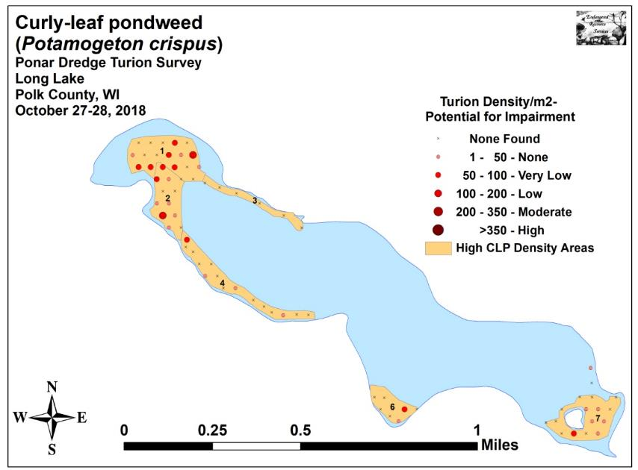
Figure 12: 2018 Fall CLP Turion Survey Density and Distribution
Table 5: CLP Turion Surveys - Summary Statistics
Long Lake, Polk County
October 27-28, 2017 and October 27-28, 2018

2017 2018
Summary Statistics: | All | HDA  1 | HDA  2 | HDA  3 | HDA  4 | HDA  6 | HDA  7 | All | HDA  1 | HDA  2 | HDA  3 | HDA  4 | HDA  6 | HDA  7
Total number of points sampled | 75 | 17 | 12 | 6 | 15 | 8 | 17 | 75 | 17 | 12 | 6 | 15 | 8 | 17
Total live turions | 54 | 26 | 6 | 2 | 5 | 8 | 7 | 68 | 26 | 20 | 0 | 7 | 5 | 10
Total # of points with live turions | 31 | 10 | 4 | 2 | 2 | 6 | 7 | 30 | 9 | 8 | 0 | 4 | 2 | 7
Freq. of occurrence (in percent) | 41.3 | 58.8 | 33.3 | 33.3 | 13.3 | 75.0 | 41.2 | 40.0 | 52.9 | 66.7 | 0.0 | 26.7 | 25.0 | 41.2
# at/above nuis. level (+200/m²) | 0 | 0 | 0 | 0 | 0 | 0 | 0 | 0 | 0 | 0 | 0 | 0 | 0 | 0
% nuisance level | 0.0 | 0.0 | 0.0 | 0.0 | 0.0 | 0.0 | 0.0 | 0.0 | 0.0 | 0.0 | 0.0 | 0.0 | 0.0 | 0.0
Maximum turions/m² | 108 | 108 | 43 | 22 | 86 | 43 | 22 | 129 | 129 | 129 | 0 | 65 | 86 | 65
Mean turions/m² | 15.50 | 32.92 | 10.76 | 7.18 | 7.18 | 21.53 | 8.86 | 19.52 | 32.92 | 35.88 | 0 | 10.05 | 13.45 | 12.66
Standard deviation/m² | 24.92 | 38.15 | 17.17 | 11.12 | 22.53 | 16.27 | 10.92 | 31.49 | 41.07 | 40.36 | 0 | 19.71 | 30.31 | 18.73
Standard error of the paired diff. |  |  |  |  |  |  |  | 0.19 | 0.58 | 0.63 | 0.21 | 0.19 | 0.53 | 0.23
Degrees of freedom |  |  |  |  |  |  |  | 74 | 16 | 11 | 5 | 14 | 7 | 16
t-statistic |  |  |  |  |  |  |  | +0.98 | 0.00 | +1.86 | -1.58 | +1.69 | -0.70 | +0.77
p - value |  |  |  |  |  |  |  | 0.16 | 0.50 | *0.04 | 0.09 | 0.25 | 0.50 | 0.23

Significant differences = * p<0.05, ** p<0.01, *** p<0.001

2019 Fall Ponar Dredge CLP Turion Survey:
Following two years without active management, turions levels rose sharply. During the October 27-28, 2019 survey, we found 128 turions at 51 of 75 survey points (68.0% coverage) – the highest total since the 2015 peak of 167 turions at 55 points (73.3% coverage). It was also nearly double the 2018 survey when we found 68 total turions at 30 points (40% coverage), and a further increase from 2017 when 31 points (41.3% coverage) had 54 total turions.

Similar to our 2016, 2017, and 2018 surveys, we didn’t find any points that were above the “navigation nuisance level” of 200/m². The 21 points that were predicted to have 50 turions/m² or higher (Figure 13) (Appendix II) was up from 12 points in 2018, five points in 2017, and 15 points in 2016; however, it was still below the 27 points at this level in 2015.

The lakewide change in mean density from 19.52 turions/m² in 2018 (standard deviation of 31.49 turions/m²) to 36.74 turions/m² in 2019 (standard deviation of 40.93 turions/m²) represented a highly significant increase (p<0.001) (Table 6). Broken out by polygon, Areas 1, 3, 4, 6, and 7 all increased, although only the changes in Area 1, 3 and 7 were significant (p=0.02/p=0.02/p=0.03). Conversely, Area 2 actually declined, but it was not significant.

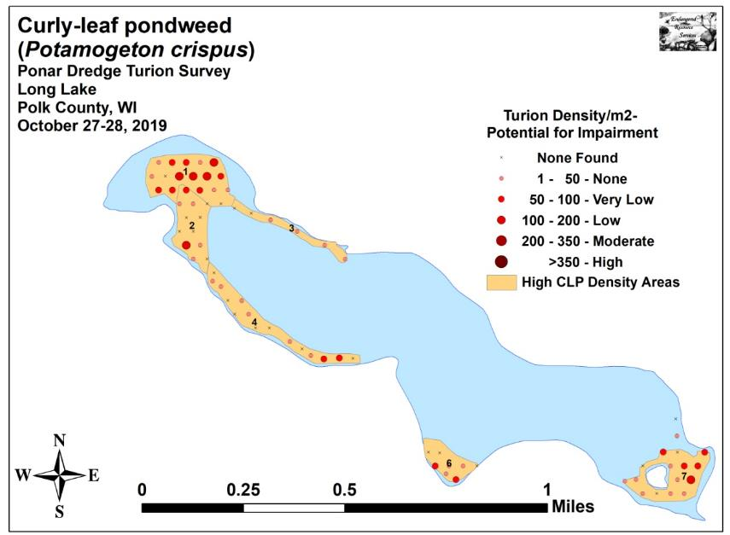
Figure 13: 2019 Fall CLP Turion Survey Density and Distribution
Table 6: CLP Turion Surveys - Summary Statistics
Long Lake, Polk County
October 27-28, 2018 and October 27-28, 2019

2018 2019
Summary Statistics: | All | HDA  1 | HDA  2 | HDA  3 | HDA  4 | HDA  6 | HDA  7 | All | HDA  1 | HDA  2 | HDA  3 | HDA  4 | HDA  6 | HDA  7
Total number of points sampled | 75 | 17 | 12 | 6 | 15 | 8 | 17 | 75 | 17 | 12 | 6 | 15 | 8 | 17
Total live turions | 68 | 26 | 20 | 0 | 7 | 5 | 10 | 128 | 47 | 17 | 7 | 15 | 12 | 30
Total # of points with live turions | 30 | 9 | 8 | 0 | 4 | 2 | 7 | 51 | 15 | 6 | 4 | 8 | 5 | 13
Freq. of occurrence (in percent) | 40.0 | 52.9 | 66.7 | 0.0 | 26.7 | 25.0 | 41.2 | 68.0 | 88.2 | 50.0 | 66.7 | 53.3 | 62.5 | 76.5
# at/above nuis. level (+200/m²) | 0 | 0 | 0 | 0 | 0 | 0 | 0 | 0 | 0 | 0 | 0 | 0 | 0 | 0
% nuisance level | 0.0 | 0.0 | 0.0 | 0.0 | 0.0 | 0.0 | 0.0 | 0.0 | 0.0 | 0.0 | 0.0 | 0.0 | 0.0 | 0.0
Maximum turions/m² | 129 | 129 | 129 | 0 | 65 | 86 | 65 | 194 | 129 | 172 | 43 | 86 | 86 | 194
Mean turions/m² | 19.52 | 32.92 | 35.88 | 0 | 10.05 | 13.45 | 12.66 | 36.74 | 59.52 | 30.50 | 25.12 | 21.53 | 32.29 | 37.99
Standard deviation/m² | 31.49 | 41.07 | 40.36 | 0 | 19.71 | 30.31 | 18.73 | 40.93 | 40.65 | 49.82 | 21.17 | 26.99 | 36.39 | 46.63
Standard error of the paired diff. |  |  |  |  |  |  |  | 0.22 | 0.56 | 0.33 | 0.40 | 0.39 | 0.77 | 0.57
Degrees of freedom |  |  |  |  |  |  |  | 74 | 16 | 11 | 5 | 14 | 7 | 16
t-statistic |  |  |  |  |  |  |  | +3.57 | +1.75 | -0.76 | +2.91 | +1.37 | +1.14 | +2.06
p - value |  |  |  |  |  |  |  | ***<0.001 | *0.02 | 0.23 | *0.02 | 0.10 | 0.15 | *0.03

Significant differences = * p<0.05, ** p<0.01, *** p<0.001

2020 Fall Ponar Dredge CLP Turion Survey:
After three years without active management, we expected that turions levels would have again increased significantly, but this did not turn out to be the case. During the October 17, 2020 survey, we found 154 turions at 41 of 75 survey points (54.7% coverage). Although this was the highest total number of turions since the 2015 peak of 167 turions at 55 points (73.3% coverage), it represented a 19.6% decline in distribution from 2019 when we found 128 turions at 51 points (68.0% coverage). Most of the areas that showed lower turions numbers relative to 2019 anecdotally had large amounts of Northern water-milfoil (Myriophyllum sibiricum). It may be that increased competition from this native species is limiting CLP growth.

Unlike our 2016, 2017, 2018, and 2019 surveys when we didn’t have any points that were above the “navigation nuisance level” of 200/m², in 2020 we found four points that exceeded this threshold – three in Area 1 in the northwest bay, and one in the south-central bay in Area 6. Despite this increase, there were still only 20 points that predicted any navigation impairment (50 turions/m² or higher) (Figure 14) (Appendix II). This was down from 21 points in 2019, but up from 12 points in 2018, five points in 2017, and 15 points in 2016. It was, however, still below the high mark of 27 points at this level in 2015.

The lakewide increase in mean density from 36.74 turions/m² in 2019 (standard deviation of 40.93 turions/m²) to 44.20 turions/m² in 2020 (standard deviation of 66.30 turions/m²) was not significant (p=0.18) (Table 7). Broken out by polygon, Areas 1, 2, 4, and 6 all increased, while Areas 3 and 7 actually declined; however, none of these changes were significant.

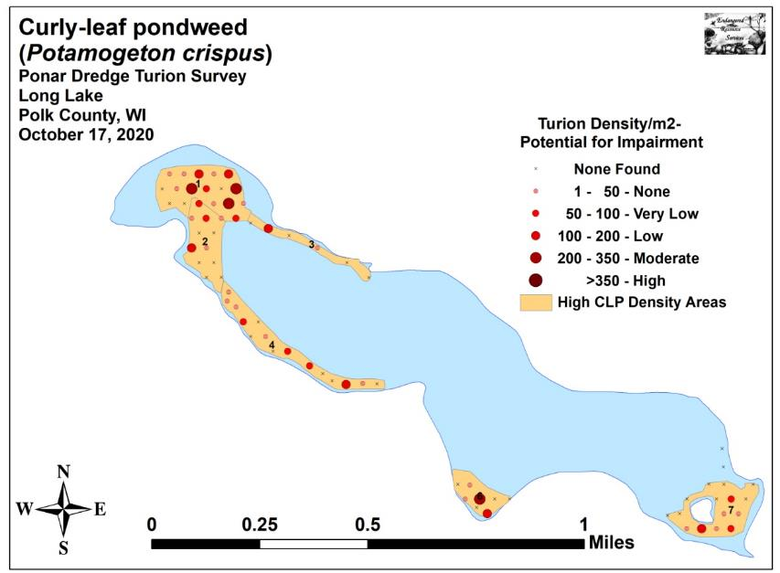
Figure 14: 2020 Fall CLP Turion Survey Density and Distribution
Table 7: CLP Turion Surveys - Summary Statistics
Long Lake, Polk County
October 27-28, 2019 and October 17, 2020

2019 2020
Summary Statistics: | All | HDA  1 | HDA  2 | HDA  3 | HDA  4 | HDA  6 | HDA  7 | All | HDA  1 | HDA  2 | HDA  3 | HDA  4 | HDA  6 | HDA  7
Total number of points sampled | 75 | 17 | 12 | 6 | 15 | 8 | 17 | 75 | 17 | 12 | 6 | 15 | 8 | 17
Total live turions | 128 | 47 | 17 | 7 | 15 | 12 | 30 | 154 | 65 | 19 | 6 | 26 | 18 | 20
Total # of points with live turions | 51 | 15 | 6 | 4 | 8 | 5 | 13 | 41 | 13 | 6 | 2 | 9 | 4 | 7
Freq. of occurrence (in percent) | 68.0 | 88.2 | 50.0 | 66.7 | 53.3 | 62.5 | 76.5 | 54.7 | 76.5 | 50.0 | 33.3 | 60.0 | 50.0 | 41.2
# at/above nuis. level (+200/m²) | 0 | 0 | 0 | 0 | 0 | 0 | 0 | 4 | 3 | 0 | 0 | 0 | 1 | 0
% nuisance level | 0.0 | 0.0 | 0.0 | 0.0 | 0.0 | 0.0 | 0.0 | 5.3 | 17.6 | 0.0 | 0.0 | 0.0 | 12.5 | 0.0
Maximum turions/m² | 194 | 129 | 172 | 43 | 86 | 86 | 194 | 323 | 323 | 172 | 108 | 194 | 237 | 129
Mean turions/m² | 36.74 | 59.52 | 30.50 | 25.12 | 21.53 | 32.29 | 37.99 | 44.20 | 82.31 | 34.09 | 21.53 | 37.31 | 48.44 | 25.33
Standard deviation/m² | 40.93 | 40.65 | 49.82 | 21.17 | 26.99 | 36.39 | 46.63 | 66.30 | 93.91 | 50.66 | 43.06 | 51.76 | 84.36 | 38.23
Standard error of the paired diff. |  |  |  |  |  |  |  | 0.38 | 1.04 | 1.01 | 1.11 | 0.52 | 1.41 | 0.72
Degrees of freedom |  |  |  |  |  |  |  | 74 | 16 | 11 | 5 | 14 | 7 | 16
t-statistic |  |  |  |  |  |  |  | +0.91 | +1.02 | +0.16 | -0.15 | +1.41 | +0.53 | -0.82
p - value |  |  |  |  |  |  |  | 0.18 | 0.16 | 0.44 | 0.44 | 0.09 | 0.31 | 0.21

Significant differences = * p<0.05, ** p<0.01, *** p<0.001

CONSIDERATIONS FOR FUTURE MANAGMENT:
The 2020 turion survey suggests there will again be Curly-leaf pondweed throughout much of Long Lake in 2021; especially in the northwest bay were navigation impairment is becoming more likely. Despite this, the decision to not actively manage in 2020 again appears to have been the correct one as 2021 CLP densities are not expected to cause more than low navigation impairment in most other parts of the lake. These continued low impairment levels, coupled with the strong regrowth and increasing richness and diversity of native species, may mean that the lake is trending towards a more balanced plant community that won’t require active management in the future. Although treatment is still planned in 2021 (pers. comm. with LLPRD board), the low turion levels, especially in deep water, suggest that the total surface acreage and volume of water treated would likely still be less than what was treated in 2016 and 2017. Ultimately, the results of the 2021 pretreatment survey coupled with the level of CLP growth the board is comfortable with will determine how much, if any, of the lake is treated.

LITERATURE CITED

Busch, C., G. Lund, L. Sather, and C. Holt. 1969. Long Lake Map. Available from http://dnr.wi.gov/lakes/maps/DNR/2478200a.pdf (2020, October).

Capers, R.S., G.J. Bugbee, R. Selsky and J.C. White. 2005. A guide to invasive aquatic plants in Connecticut. Conn. Agric. Exp. Sta. Bull. 997.

Clemens, C. 2013. Aquatic Plant Management Plan - Long Lake Polk County, WI. Sponsored by Long Lake Protection and Rehabilitation District - Prepared by Harmony Environmental – October 2013. Available from https://www.co.polk.wi.us/vertical/Sites/%7BA1D2EAAA-7A29-46D6-BF1A-12B71F23A6E1%7D/uploads/Long_Lake_Lake_LMP_2013(2).pdf (2020, October).

UWEX Lakes Program. [online]. 2010. Aquatic Plant Management in Wisconsin. Available from http://www.uwsp.edu/cnr-ap/UWEXLakes/Pages/ecology/aquaticplants/default.aspx (2020, October).

UWEX Lakes Program. [online]. 2010. Pre/Posttreatment Herbicide Comparison. Available from http://www.uwsp.edu/cnr-ap/UWEXLakes/Documents/ecology/Aquatic%20Plants/Appendix-D.pdf (2020, October).

WDNR. [online]. 2020. Citizen Lake Monitoring Water Quality Data Report for Long Lake. http://dnr.wi.gov/lakes/waterquality/Station.aspx?id=493102 (2020, October).

Appendix I: Survey Sample Points in Historic High CLP Density Areas

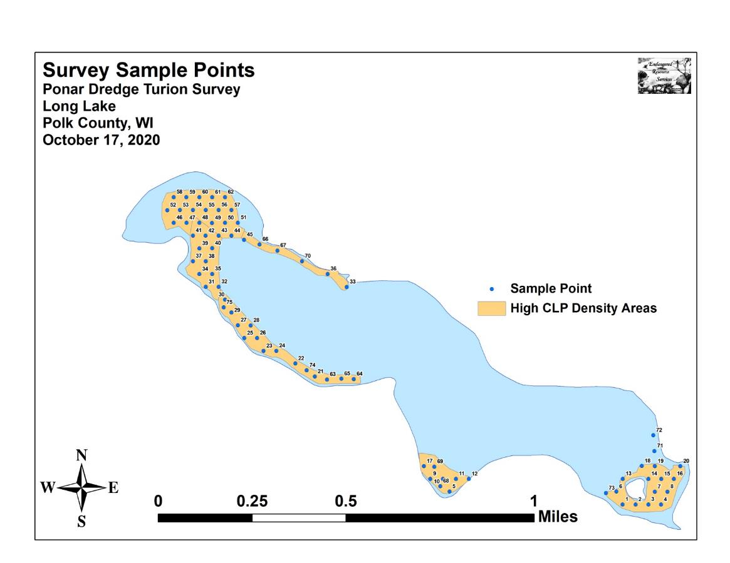

Appendix II: 2013, 2014, 2015, 2016, 2017, 2018, 2019, and 2020
Fall CLP Turion Density and Distribution Maps
