Curly-leaf pondweed (Potamogeton crispus)
Pretreatment and Follow-up Surveys
Long Lake - WBIC: 2478200
Polk County, Wisconsin

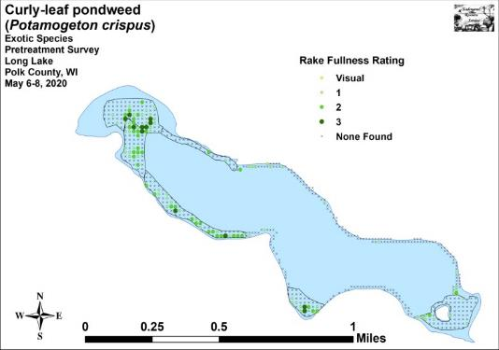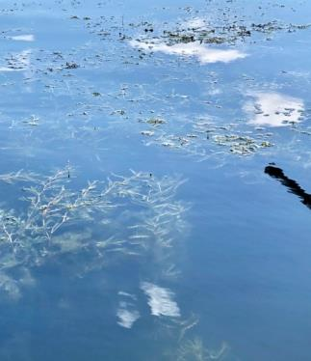
CLP Pretreatment Density and Distribution 5/6-8/20 Patchy Canopied CLP in northwest bay 6/12/20

Project Initiated by:
Long Lake Protection and Rehabilitation District, Harmony Environmental, and the Wisconsin Department of Natural Resources – (Grant ACEI20218)

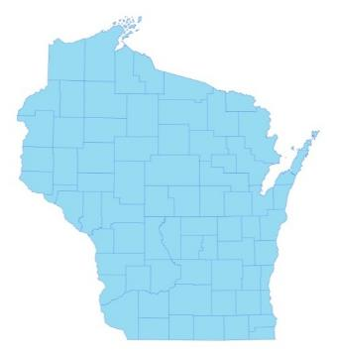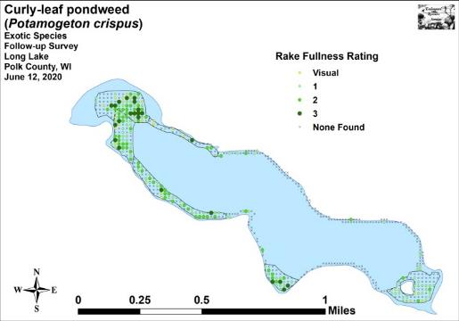

* Long Lake
2020 CLP Follow-up Survey Density and Distribution

Surveys Conducted by and Report Prepared by:
Endangered Resource Services, LLC
Matthew S. Berg, Research Biologist
St. Croix Falls, Wisconsin
May 6-8 and June 12, 2020
TABLE OF CONTENTS

Page
LIST OF FIGURES..……………....……..…………………………………..…….. ii

LIST OF TABLES………………….……..………………………………………... iii

INTRODUCTION………………………………………………………………….. 1

BACKGROUND AND STUDY RATIONALE…………………………………… 1

METHODS…………………………………………………………………………. 2

RESULTS AND DISCUSSION……………………………………………………. 3

Finalization of Treatment Areas…………………………………………………... 3

Pretreatment/Follow-up Surveys………………………………………………….. 4

LITERATURE CITED……………………….…………………………………….. 20

APPENDIXES……………….……………………………………………………... 21

I: CLP Pretreatment/Follow-up Survey Sample Points/Final Treatment Areas… 21

II: Vegetative Survey Data Sheet.………………………………………………... 24

III: Pretreatment/Follow-up Habitat Variables…………………………………… 26

IV: Pretreatment/Follow-up Littoral Zone, Native Species Richness and
Total Rake Fullness.………………………………………………………….. 29

V: CLP Pretreatment/Follow-up Density and Distribution………………………. 36

VI: Pretreatment Native Species Density and Distribution….……….…………... 39

VII: Follow-up Native Species Density and Distribution………………………… 49

LIST OF FIGURES

Page
Figure 1: Long Lake Bathymetric Map…………………………..………………... 1
Figure 2: Rake Fullness Ratings…..………………….…….…………………….... 2
Figure 3: Pretreatment/Follow-up Survey Sample Points and
Final CLP Treatment Areas………………………………………………………… 3

Figure 4: CLP Area Depths and Bottom Substrate………………………………… 4
Figure 5: Pretreatment/Follow-up Littoral Zone…………………………………... 5
Figure 6: Pretreatment/Follow-up Native Species Richness..….…….…….…….... 5
Figure 7: Pretreatment/Follow-up Total Rake Fullness.………………….………... 6
Figure 8: Pretreatment/Follow-up CLP Density and Distribution…………...…….. 7
Figure 9: Whole Lake – Changes in CLP Rake Fullness Ratings..………………... 7
Figure 10: High Density Areas - Changes in CLP Rake Fullness Ratings………… 8
Figure 11: Low Density Areas - Changes in CLP Rake Fullness Ratings.…….….. 8
Figure 12: Pre/Follow-up Coontail Density and Distribution……………………… 9
Figure 13: Pre/Follow-up Water Star-grass Density and Distribution……………... 9
Figure 14: Pre/Follow-up Northern Water-milfoil Density and Distribution………. 10
Figure 15: Pre/Follow-up Common Waterweed Density and Distribution.……..… 10
Figure 16: Pre/Follow-up Small Pondweed Density and Distribution.…………..… 11
Figure 17: Whole Lake Pretreatment/Follow-up Native Species Changes..………. 16
Figure 18: High Density Areas - Pretreatment/Follow-up Native Species Changes. 17
Figure 19: Low Density Areas - Pretreatment/Follow-up Native Species Changes.. 18
Figure 20: 2017 Posttreatment/2018, 2019, and 2020 Follow-up
Changes for All Species…………………………………………………………….. 19

LIST OF TABLES

Page
Table 1: 2020 Spring CLP Treatment Summary – Long Lake, Polk Co…………... 3

Table 2: Pretreatment/Follow-up Surveys Summary Statistics –
Long Lake, Polk County - May 5-8 and June 12, 2020.…………………………..... 4

Table 3: Frequencies and Mean Rake Sample of Aquatic Macrophytes
Pretreatment Survey – High CLP Density Areas
Long Lake, Polk County May 5-8, 2020…………………………………………... 12

Table 4: Frequencies and Mean Rake Sample of Aquatic Macrophytes
Pretreatment Survey – Low CLP Density Areas
Long Lake, Polk County May 5-8, 2020…………………………………………... 13

Table 5: Frequencies and Mean Rake Sample of Aquatic Macrophytes
Follow-up Survey – High CLP Density Areas
Long Lake, Polk County June 12, 2020……………………….…………..……….. 14

Table 6: Frequencies and Mean Rake Sample of Aquatic Macrophytes
Follow-up Survey – Low CLP Density Areas
Long Lake, Polk County June 12, 2020…………………….……….……………... 15

INTRODUCTION:
Long Lake (WBIC 2478200) is a 272 acre seepage lake in central Polk County, Wisconsin in the Town of Balsam Lake (T34N R17W S07 NE NE). It reaches a maximum depth of just over 17ft in the central basin and has an average depth of approximately 11ft (Busch et al. 1969) (Figure 1). The lake is eutrophic trending toward hypereutrophic, and visibility is generally poor with summer Secchi readings averaging 4.9ft since 1992; however, the 2020 mean reading of 9.0ft was the highest since 1995 (WDNR 2020). The bottom substrate in the lake’s bays and central basin is predominately thick organic muck, while exposed points and most north/south shorelines are dominated by gravel and sand.

Figure 1: Long Lake Bathymetric Map

BACKGROUND AND STUDY RATIONALE:
Long Lake and the Long Lake Protection and Rehabilitation District (LLPRD) have an extended history of battling Curly-leaf pondweed (Potamogeton crispus) (CLP) - an exotic invasive plant species that thrives in the nutrient-rich sediments found in many parts of the lake. In the past, CLP often grew so densely in the spring and early summer that it made lake access and boating difficult for residents. CLP’s late-June to early-July senescence was also cited in past studies by Barr Engineering and the Polk County Land and Water Conservation Department (PCLWCD) as a significant contributor to the lake’s overall phosphorus load, and it was at least partially responsible for the lake’s frequent late-summer toxic blue-green algae blooms.

In 2010, after years of study, the LLPRD and the Wisconsin Department of Natural Resources (WDNR) authorized an initial lakewide herbicide treatment of over 65 acres of CLP. The LLPRD treated nearly 57 acres again in 2011, and 58 acres in 2012. After updating the District’s WDNR approved Aquatic Plant Management Plan (APMP) in 2012, it was decided to treat just 27 acres in 2013, and only 20 acres in 2014. Although the 2010-2013 treatments resulted in highly significant reductions in both CLP coverage and density on the lake, the 2014 treatment showed no significant change from pretreatment levels. A follow-up survey of CLP turions in the lake’s sediment also suggested 2015 CLP levels would likely be very low in most parts of the lake. Based on these data, and following a discussion with the lake’s executive board and APMP director Cheryl Clemens (Harmony Environmental) in the fall of 2014, it was decided not to treat CLP in 2015.
Because both the 2015 June CLP point-intercept monitoring survey and the fall CLP turion sediment data suggested CLP had made a significant rebound throughout much of the lake, it was decided that herbicide treatments (not to exceed 35 acres) would resume in the future. Ultimately, the LLPRD decided to treat 34.97 acres in 2016 and 33.65 acres in 2017. However, due to low CLP levels, treatments in 2018 and 2019 were cancelled.

Prior to the planned 2020 herbicide application, we conducted a pretreatment survey of the lake on May 5-8th to determine initial CLP levels and finalize treatment areas. Because this survey found CLP levels did not exceed the APMP’s treatment threshhold, it was decided to cancel the 2020 treatment. However, in order to see how CLP and native plant populations responded to skipping treatment for the third year in a row, it was requested that we do a follow-up survey on June 12th. This report is the summary analysis of these two surveys.

METHODS:
Pre/Follow-up Treatment Surveys:
Following three years (2010-12) of doing extensive plant surveys as was required for the lakewide herbicide treatments, it was established that most midlake sandy/rocky shorelines that had narrow littoral areas supported extremely low densities of CLP. Because of this, these areas were annually greatly reduced or eliminated from treatment plans. In 2013, we divided the lake into high/low CLP density areas. Within the high density areas (HDAs), we used Hawth’s Analysis Tools Extension to ArcGIS 9.3.1 to generate Pre/Posttreatment survey points at 25m resolution within that year’s 50 acres of proposed treatment areas. The resulting sampling grid contained 323 points which approximated to 6.5 points/acre. In the historically low density areas (LDAs), we constructed an alternative 200 point grid at 18m resolution where we conducted exploratory CLP point-intercept surveys to monitor for any potential resurgence in CLP. Because of the expansion of CLP in 2015, all 523 points were used for both the pre and posttreatment (follow-up) surveys in 2016, 2017, 2018, 2019, and 2020 (Appendix I).

Prior to each survey, we uploaded the points to a handheld mapping GPS unit (Garmin 76CSx) and then located them on the lake. At each point, we used a rake to sample an approximately 2.5ft section of the bottom and recorded the depth and bottom substrate. CLP was assigned a rake fullness value of 1-3 as an estimation of abundance (Figure 2). We also recorded visual sightings of CLP within six feet of the sample point. However, because visual sightings are not calculated into the Pre/Posttreatment statistical formulas, we only assigned a rake fullness value for non-CLP plants. A cumulative rake fullness value was also noted at each site.
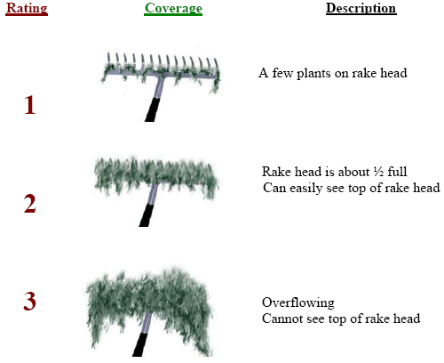
Figure 2: Rake Fullness Ratings
We entered all data collected into the standard APM spreadsheet (Appendix II). Data was analyzed using the linked statistical summary sheet (UWEX 2010). For pre/post differences of individual plant species as well as count data, we used the Chi-square analysis on the WDNR pre/post survey worksheet (UWEX 2010). For comparing averages (mean species/point and mean rake fullness/point), we used t-tests. Differences were determined to be significant at p<0.05, moderately significant at p<0.01 and highly significant at p<0.001.

RESULTS AND DISCUSSION:
Finalization of Treatment Areas:
Of the seven areas identified by Barr Engineering as having Curly-leaf pondweed in 2009, we have consistently found high density CLP in only six of them in an area covering 49.88 acres (Table 1). Following analysis of the 2020 pretreatment survey, we found there were just 16.97 acres that had significant amounts of CLP (Figure 3). As this did not meet the 25 acre minimum outlined in the AMPM, the LLPRD decided to cancel treatment in all areas in 2020 (Appendix I).

Table 1: 2020 Spring CLP Treatment Summary - Long Lake, Polk Co.

High Density  CLP Area | Potential  Treatment  (acres) | Proposed  Treatment  (acres) | Final  Treatment  (acres) | Difference  (+/-)
1 | 13.34 | 6.77 | 0.00 | -6.77
2 | 8.46 | 2.59 | 0.00 | -2.59
3 | 3.84 | 0.00 | 0.00 | 0.00
4 | 9.51 | 5.40 | 0.00 | -5.40
6 | 4.88 | 2.22 | 0.00 | -2.22
7 | 9.85 | 0.00 | 0.00 | 0.00
 | 49.88 | 16.97 | 0.00 | -16.97

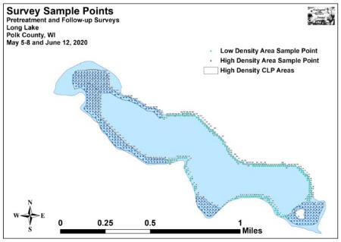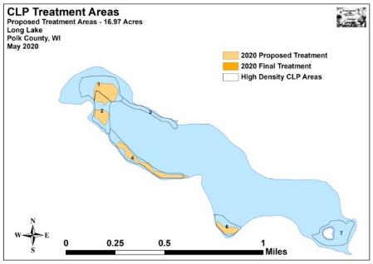
Figure 3: 2020 Pretreatment/Follow-up Survey Sample Points and
Final CLP Treatment Areas

Pretreatment/Follow-up Surveys:
All Curly-leaf pondweed areas occurred in water between 1.0ft and 15.5ft deep (Figure 4). During the pretreatment survey, we found the mean and median depth of plant growth in the high density areas was 7.3ft and 7.0ft respectively. In June, they were 8.0ft and 7.0ft with this increase likely related to the expansion of CLP and Small pondweed (Potamogeton pusillus) – two species that dominated the lake’s deep-water plant community (Table 2). In the low density areas, the pretreatment mean was 7.1ft and the median was 7.0ft before increasing slightly to 7.4ft and 7.5ft in June. Most CLP within the HDAs occurred over organic muck, although the western edge of Bed 7 near the island was established over sandy/rocky substrates. LDAs were dominated by sand and rock (Figure 4) (Appendix III).

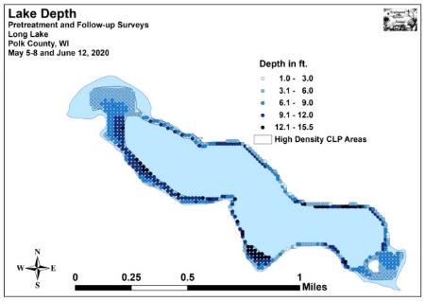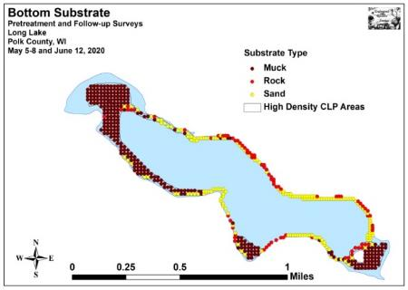
Figure 4: CLP Area Depths and Bottom Substrate

Table 2: Pretreatment/Follow-up Surveys Summary Statistics
Long Lake, Polk County
May 5-8 and June 12, 2020
Summary Statistics: | Pre-High | June-High | Pre-Low | June- Low
Total number of points sampled | 323 | 323 | 200 | 200
Total number of sites with vegetation | 263 | 302 | 106 | 84
Total number of sites shallower than the maximum depth of plants | 311 | 315 | 195 | 197
Frequency of occurrence at sites shallower than max. depth of plants | 84.6 | 95.9 | 54.4 | 42.6
Simpson Diversity Index | 0.70 | 0.79 | 0.75 | 0.85
Mean Coefficient of Conservatism | 5.4 | 5.4 | 5.7 | 5.9
Floristic Quality Index | 15.2 | 20.9 | 15.1 | 18.7
Average number of all species per site (shallower than max depth) | 1.37 | 2.12 | 0.78 | 0.78
Average number of all species per site (veg. sites only) | 1.62 | 2.21 | 1.43 | 1.82
Ave. number of native species/site (shallower than max depth) | 1.06 | 1.56 | 0.68 | 0.68
Ave. number of native species/site (sites with native plants only) | 1.37 | 1.77 | 1.33 | 1.74
Species Richness | 9 | 16 | 8 | 11
Maximum depth of plants (ft) | 13.0 | 14.0 | 14.0 | 15.0
Mean depth of plants (ft) | 7.3 | 8.0 | 7.1 | 7.4
Median depth of plants (ft) | 7.0 | 7.0 | 7.0 | 7.5
Mean Rake Fullness (veg. sites only) | 1.78 | 2.05 | 1.20 | 1.25
The littoral zone extended to 14.0ft in May (13.0ft HDAs/14.0ft LDAs) and 15.0ft in June (14.0ft HDAs/15.0ft LDAs) (Figure 5) (Appendix IV). Within this zone, the frequency of plants encountered in the HDAs increased from 84.6% pretreatment to 95.9% during the follow-up. In the LDAs, plant levels unexpectedly declined from a frequency of 54.4% in May to 42.6% in June. Richness in the HDAs rose from 9 species in May to 16 in June, while the LDAs increased only slightly from eight to 11 species. This also helped the Simpson’s Diversity Index increase in the HDAs (0.70 May/0.79 June) and the LDAs (0.75 May/0.85 June). The Floristic Quality Index (another measure of the native plant community health) in the HDAs increased from 15.2 in May to 20.9 in June. In the LDAs, the FQI increased from 15.1 pre to 18.7 during the follow-up.

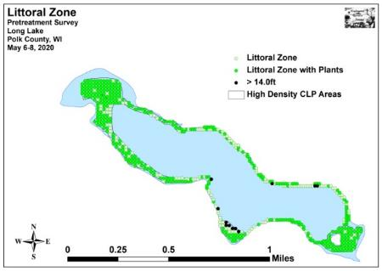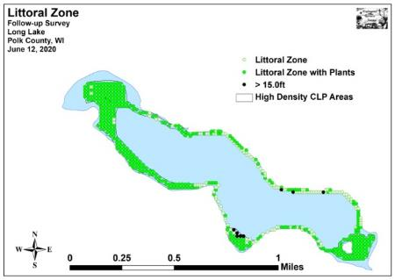
Figure 5: Pretreatment/Follow-up Littoral Zone

We found localized native species richness to be quite low throughout the lake. In the high density areas, mean richness at points with native plants increased from 1.37 species/site in May to 1.77 species/site in June. In low density areas, this value increased from 1.33 species/site in May to 1.74 species/site in June. When combined, these areas experienced a highly significant increase (p<0.001) in mean native species richness from 1.36 species/site in May to 1.77 species/site in June. Analysis of the maps showed these increases were a lakewide event (Figures 6) (Appendix IV).

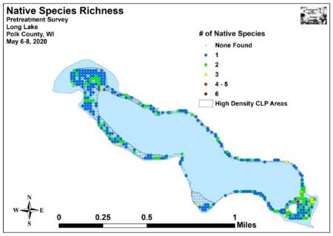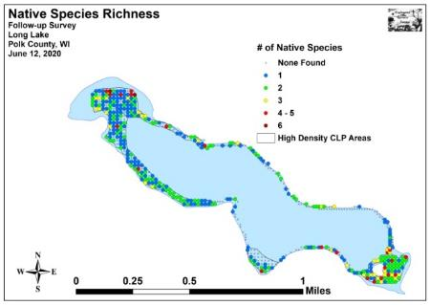
Figure 6: Pretreatment/Follow-up Native Species Richness

Total mean rake fullness in the HDAs was a low/moderate 1.78 in May before increasing to a moderate 2.05 in June (up from 1.90 in June 2019, 1.65 in June 2018, and 1.43 in June 2017). In the LDAs, where the May mean rake fullness was an very low 1.20, we found this level increased only slightly to 1.25 in June (Figures 7) (Appendix IV). Cummulatively, mean rake fullness experienced a highly significant increase (p<0.001) from a low/moderate 1.61 in May to a moderate 1.88 in June.

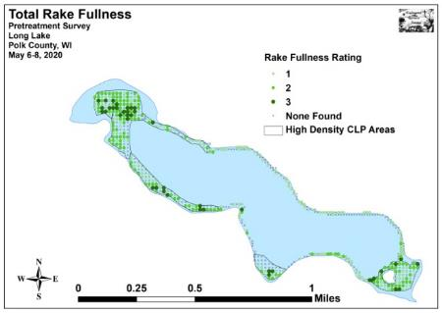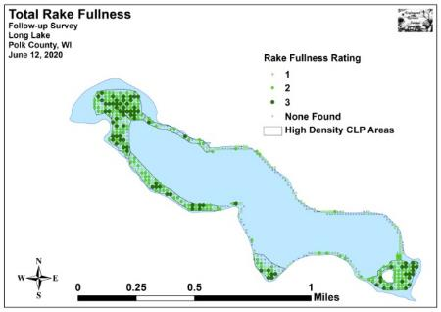
Figure 7: Pretreatment/Follow-up Total Rake Fullness

During the May 2020 survey, we found Curly-leaf pondweed at 115 of 523 total sites with a mean rake fullness of 1.54. This approximated to 22.0% coverage and represented a 69.1% incrase over the 2019 May survey when CLP was present at 68 of 523 total sites (13.0% coverage/mean rake fullness of 1.37). It was also up from 46 points (8.8% coverage/mean rake of 1.20) with CLP in 2018; however, it was still well below the 209 points (40.0% coverage/mean rake of 1.71) with CLP prior to the last chemical treatment in 2017.

Ninety six of the 115 points occurred within the high density area’s 323 points (29.7% coverage), and 19 occurred within the low density area’s 200 points (9.5% coverage) (Figure 8) (Appendix V). The HDAs had 12 points with a rake fullness rating of 3, 36 points that rated a 2, and 48 that were a 1. This produced a mean rake fullness of 1.63 (up from 1.38 in 2019 and 1.20 in 2018, but still down from 1.71 in 2017). In the LDA’s, no points rated a 3, two were a 2, and the remaining 17 were a 1 for a mean rake of 1.11. Collectively, 50 points had a significant infestation (rake fullness of 2 or 3) and this approximated to 15.5% coverage.

In June, we found CLP at 196 points (37.5% coverage) (up from 167 points /31.9% coverage in 2019 and 132 points/25.2% coverage in 2018) with 23 additional visual sightings. Of these, 23 rated a 3, 64 were a 2, and the remaining 109 were a 1 (Figure 8). This produced a low/moderate mean rake fullness of 1.56 – down from 1.87 in 2019, but up from 1.44 in 2018. These results suggested that total, compared to May, CLP levels had undergone a highly significant increase (p<0.001) in total distribution, rake fullness 1, and visual sightings; and a moderately significant increase (p=0.007) in rake fullness 2 (Figure 9). However, and somewhat surprisingly, the mean density was also almost identical to the May survey as most of the expansion seen in June was low density in deep water.
All but 19 points with CLP (177 total sites) occurred in the high density areas (54.8% coverage) and 82 points (25.4% coverage) had a significant infestation (rake fullness of 2 or 3). Compared to May, this represented a highly significant increase (p<0.001) in total CLP, rake fullness 1 and visual sightings, and a significant increase (p=0.01) in rake fullness 2 (Figure 10). Interestingly, the levels of dense CLP declined compared to the June 2019 survey when we found 101 points (31.3% coverage) with a significant infestation. However, it was still higher than the 2018 follow-up survey when there were 50 points (15.5% coverage) with a significant infestation.

In the LDAs, the 19 points with CLP (9.5% coverage) was identical to May. Although the mean rake fullness increased to 1.26, none of the changes – either pooled or separated by rake rating – were significant (Figure 11). Total distribution was almost identical to the 18 points with CLP in June 2019, but up from seven points in June 2018.

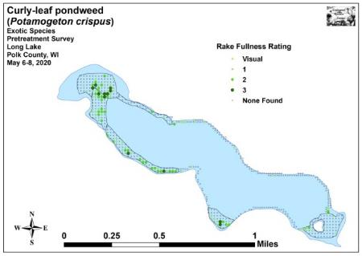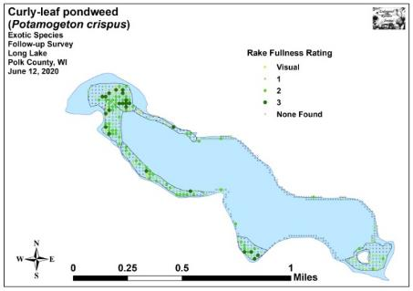
Figure 8: Pretreatment/Follow-up CLP Density and Distribution
+***
+***
+**
+***
Significant differences = * p<0.05, ** p<0 .01, *** p<0.001
Figure 9: Whole Lake – Changes in CLP Rake Fullness Ratings
+*
+***
+***
+***
Significant differences = * p<0.05, ** p<0 .01, *** p<0.001
Figure 10: High Density Areas - Changes in CLP Rake Fullness Ratings

Significant differences = * p<0.05, ** p<0 .01, *** p<0.001
Figure 11: Low Density Areas - Changes in CLP Rake Fullness Ratings
Lakewide, we found Coontail (Ceratophyllum demersum) was the most common native species during both the pretreatment and follow-up surveys (Figure 12) (Tables 3-6). Present at 227 sites with a mean rake fullness of 1.61 during the pretreatment survey, we found it underwent a non-significant increase (p=0.46) in distribution to 239 sites and a highly significant increase (p<0.001) in density to a mean rake of 1.84 by June. It was especially common in the nutrient-rich organic muck substrates that dominate the HDA's.

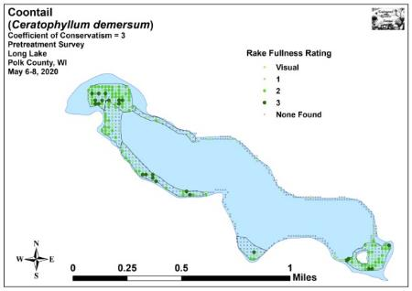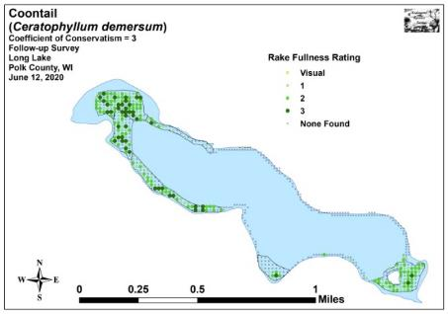
Figure 12: Pre/Follow-up Coontail Density and Distribution

Present over most sand and gravel substrates, Water star-grass (Heteranthera dubia) was the second most common native species pretreatment (72 sites/mean rake 1.18) (Figure 13). Although it was only the fourth most common species in June, neither it decline in distribution (56 sites) or density (mean rake 1.14) were significant (p=0.13/p=0.29).

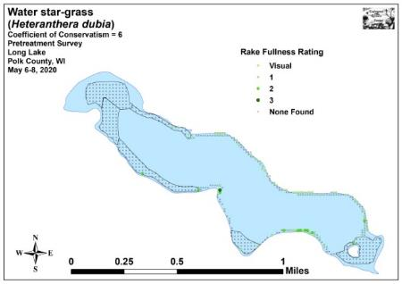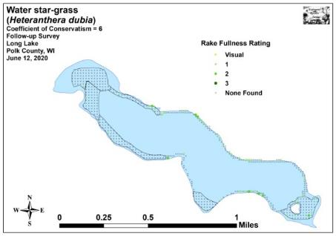
Figure 13: Pre/Follow-up Water Star-grass Density and Distribution

Northern water-milfoil (Myriophyllum sibiricum) jumped from the third most common native species pretreatment to the second most common during the follow-up survey (Figure 14). Its increase in distribution from 59 sites in May to 88 sites in June was moderately significant (p<0.01), and its increase in density from a mean rake of 1.42 to 1.64 was also significant (p=0.04). This rooted species is coming to dominate many parts of the lake, and is potentially a driving force behind increases in water clarity and declines in CLP’s dominance.
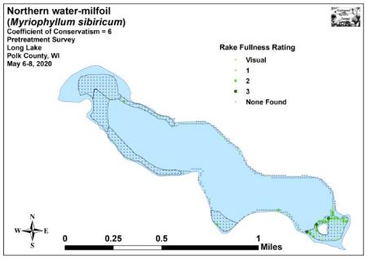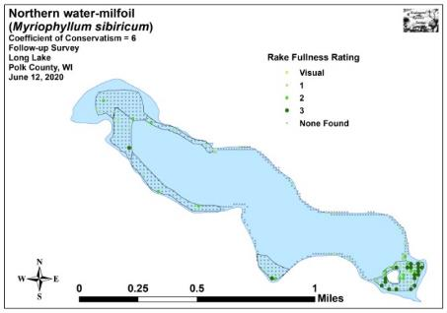
Figure 14: Pre/Follow-up Northern Water-milfoil
Density and Distribution

Historically, Common waterweed (Elodea canadensis) has been a dominant native species on the lake as it has been able to exploit high nutrient levels and vacant habitat to form dense floating mats of vegetation - this was especially true following past herbicide treatments. During the pretreatment survey, the fifth most common species was present at 35 sites with a mean rake fullness of 1.14 (Figure 15). In June, both of these values experienced non-significant declines (p=0.29/p=0.36) as it fell to the seventh ranked native species (27 sites/1.11 mean rake).

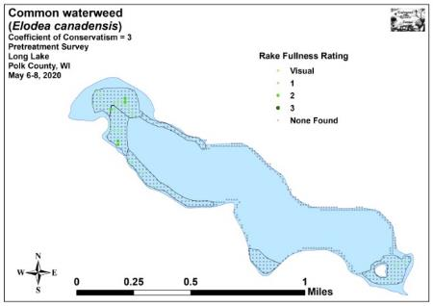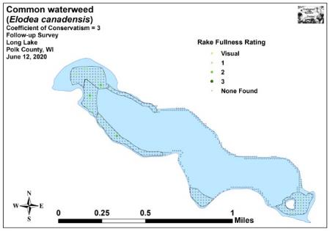
Figure 15: Pre/Follow-up Common Waterweed Density and Distribution

Present at 18 sites in May, Small pondweed (Potamogeton pusillus) was just the sixth most common native species before undergoing a highly significant increase (p<0.01) in distribution to become the third most common (72 sites) (Figure 16). However, its accompanying increase in density from 1.11 to 1.19 was not significant (p=0.18). First detected as a visual at a single point during the 2016 full lake point-intercept survey, Small pondweed has become an increasingly common species in the lake and now grows in most organic muck bottom areas around the central basin in water from 8-12ft – a habitat that formerly supported little other than CLP and scattered Coontail.
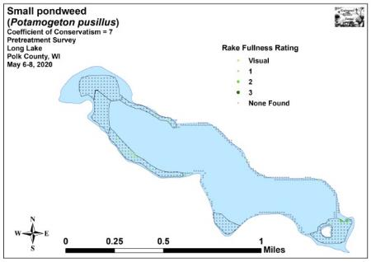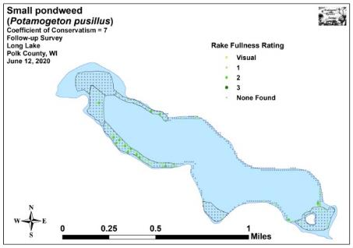
Figure 16: Pre/Follow-up Small Pondweed Density and Distribution

As is typical, many later-growing native species that were largely dormant during the pretreatment survey showed significant lakewide increases by June (Figure 17). In addition to the previously mentioned Small pondweed, Slender naiad (Najas flexilis), White water lily (Nymphaea odorata), and Large duckweed (Spirodela polyrhiza) demonstrated highly significant increases; and Northern water-milfoil , Small duckweed (Lemna minor), and Common watermeal (Wolffia columbiana) experienced moderately significant increases (Maps of all native species from the pretreatment and follow-up surveys are located in Appendixes VI and VII).

Beyond the lakewide changes, breaking the data out between high density areas and low density areas provided limited additional information. In HDA's, we found that filamentous algae saw a moderately significant decline (Figure 18). In LDA, Water star-grass suffered a moderately significant decline and Coontail had a significant decline (Figure 19).

Comparing the 2017 posttreatment and the 2018, 2019, and 2020 June surveys (Figure 20) showed significant recoveries in native species; especially those that are sensitive to Endothall such as Coontail, Northern water-milfoil, and Small pondweed. The increases in Water star-grass, Northern water-milfoil, and Small pondweed at depths previously unseen also suggests plants are responding to improvements in water clarity.

Although the continued increase in CLP is disappointing, the increases in native populations during three consecutive “rest” years is a definite positive. The strong regrowth and increasing richness and diversity of native species may mean that the lake is trending towards a more balanced plant community that won’t require active management in the future.
Table 3: Frequencies and Mean Rake Sample of Aquatic Macrophytes
Pretreatment Survey – High CLP Density Areas - Long Lake, Polk County
May 5-8, 2020

Species | Common Name | Total  Sites | Relative Freq. | Freq. in Veg. | Freq. in Lit. | Mean Rake | Visual  Sight.
Ceratophyllum demersum | Coontail | 205 | 48.24 | 77.95 | 65.92 | 1.65 | 0
 | Filamentous algae | 135 | * | 51.33 | 43.41 | 1.21 | 0
Potamogeton crispus | Curly-leaf pondweed | 96 | 22.59 | 36.50 | 30.87 | 1.63 | 0
Myriophyllum sibiricum | Northern water-milfoil | 43 | 10.12 | 16.35 | 13.83 | 1.47 | 0
Elodea canadensis | Common waterweed | 35 | 8.24 | 13.31 | 11.25 | 1.14 | 0
Lemna trisulca | Forked duckweed | 18 | 4.24 | 6.84 | 5.79 | 1.06 | 0
Potamogeton pusillus | Small pondweed | 15 | 3.53 | 5.70 | 4.82 | 1.13 | 0
Heteranthera dubia | Water star-grass | 7 | 1.65 | 2.66 | 2.25 | 1.29 | 0
Eleocharis acicularis | Needle spikerush | 4 | 0.94 | 1.52 | 1.29 | 2.00 | 0
Chara sp. | Muskgrass | 2 | 0.47 | 0.76 | 0.64 | 1.50 | 0

* Excluded from relative frequency analysis

Table 4: Frequencies and Mean Rake Sample of Aquatic Macrophytes
Pretreatment Survey – Low CLP Density Areas - Long Lake, Polk County
May 5-8, 2020

Species | Common Name | Total  Sites | Relative Freq. | Freq. in Veg. | Freq. in Lit. | Mean Rake | Visual  Sight.
Heteranthera dubia | Water star-grass | 65 | 42.76 | 61.32 | 33.33 | 1.17 | 0
 | Filamentous algae | 62 | * | 58.49 | 31.79 | 1.24 | 0
Ceratophyllum demersum | Coontail | 22 | 14.47 | 20.75 | 11.28 | 1.18 | 0
Lemna trisulca | Forked duckweed | 21 | 13.82 | 19.81 | 10.77 | 1.05 | 0
Potamogeton crispus | Curly-leaf pondweed | 19 | 12.50 | 17.92 | 9.74 | 1.11 | 0
Myriophyllum sibiricum | Northern water-milfoil | 16 | 10.53 | 15.09 | 8.21 | 1.31 | 0
Eleocharis acicularis | Needle spikerush | 4 | 2.63 | 3.77 | 2.05 | 1.00 | 0
Potamogeton pusillus | Small pondweed | 3 | 1.97 | 2.83 | 1.54 | 1.00 | 0
Chara sp. | Muskgrass | 2 | 1.32 | 1.89 | 1.03 | 1.00 | 0

* Excluded from relative frequency analysis

Table 5: Frequencies and Mean Rake Sample of Aquatic Macrophytes
Follow-up Survey - High CLP Density Areas - Long Lake, Polk County
June 12, 2020

Species | Common Name | Total  Sites | Relative Freq. | Freq. in Veg. | Freq. in Lit. | Mean Rake | Visual  Sight.
Ceratophyllum demersum | Coontail | 229 | 34.28 | 75.83 | 72.70 | 1.86 | 0
Potamogeton crispus | Curly-leaf pondweed | 177 | 26.50 | 58.61 | 56.19 | 1.59 | 23
 | Filamentous algae | 95 | * | 31.46 | 30.16 | 1.22 | 0
Myriophyllum sibiricum | Northern water-milfoil | 70 | 10.48 | 23.18 | 22.22 | 1.79 | 0
Potamogeton pusillus | Small pondweed | 55 | 8.23 | 18.21 | 17.46 | 1.22 | 0
Nymphaea odorata | White water lily | 34 | 5.09 | 11.26 | 10.79 | 1.32 | 0
Elodea canadensis | Common waterweed | 27 | 4.04 | 8.94 | 8.57 | 1.11 | 0
Lemna trisulca | Forked duckweed | 21 | 3.14 | 6.95 | 6.67 | 1.05 | 0
Heteranthera dubia | Water star-grass | 16 | 2.40 | 5.30 | 5.08 | 1.13 | 0
Spirodela polyrhiza | Large duckweed | 11 | 1.65 | 3.64 | 3.49 | 1.82 | 0
Lemna minor | Small duckweed | 9 | 1.35 | 2.98 | 2.86 | 1.67 | 0
Wolffia columbiana | Common watermeal | 9 | 1.35 | 2.98 | 2.86 | 2.00 | 0
Eleocharis acicularis | Needle spikerush | 3 | 0.45 | 0.99 | 0.95 | 1.00 | 0
Najas flexilis | Slender naiad | 2 | 0.30 | 0.66 | 0.63 | 1.00 | 0
Sagittaria graminea | Grass-leaved arrowhead | 2 | 0.30 | 0.66 | 0.63 | 1.00 | 0
Stuckenia pectinata | Sago pondweed | 2 | 0.30 | 0.66 | 0.63 | 2.00 | 0
Nitella sp. | Nitella | 1 | 0.15 | 0.33 | 0.32 | 1.00 | 0

* Excluded from relative frequency analysis

Table 6: Frequencies and Mean Rake Sample of Aquatic Macrophytes
Follow-up Survey - Low CLP Density Areas - Long Lake, Polk County
June 12, 2020

Species | Common Name | Total  Sites | Relative Freq. | Freq. in Veg. | Freq. in Lit. | Mean Rake | Visual  Sight.
 | Filamentous algae | 126 | * | 150.00 | 63.96 | 1.17 | 0
Heteranthera dubia | Water star-grass | 40 | 26.14 | 47.62 | 20.30 | 1.15 | 0
Lemna trisulca | Forked duckweed | 24 | 15.69 | 28.57 | 12.18 | 1.00 | 0
Potamogeton crispus | Curly-leaf pondweed | 19 | 12.42 | 22.62 | 9.64 | 1.26 | 0
Myriophyllum sibiricum | Northern water-milfoil | 18 | 11.76 | 21.43 | 9.14 | 1.06 | 0
Potamogeton pusillus | Small pondweed | 17 | 11.11 | 20.24 | 8.63 | 1.12 | 0
Najas flexilis | Slender naiad | 12 | 7.84 | 14.29 | 6.09 | 1.00 | 0
Ceratophyllum demersum | Coontail | 10 | 6.54 | 11.90 | 5.08 | 1.40 | 0
Chara sp. | Muskgrass | 6 | 3.92 | 7.14 | 3.05 | 1.83 | 0
Eleocharis acicularis | Needle spikerush | 5 | 3.27 | 5.95 | 2.54 | 1.20 | 0
Nitella sp. | Nitella | 1 | 0.65 | 1.19 | 0.51 | 1.00 | 0
Nymphaea odorata | White water lily | 1 | 0.65 | 1.19 | 0.51 | 1.00 | 0

* Excluded from relative frequency analysis

+**
+**
+***
+***
+***
+***
+**
Significant differences = * p<0.05, ** p<0 .01, *** p<0.001
Figure 17: Whole Lake Pretreatment/Follow-up Native Species Changes
+**
+**
+***
+***
+***
+**
+*
-**
Significant differences = * p<0.05, ** p<0 .01, *** p<0.001
Figure 18: High Density Areas - Pretreatment/Follow-up Native Species Changes
+**
-**
-*
+***
+***
Significant differences = * p<0.05, ** p<0 .01, *** p<0.001
Figure 19: Low Density Areas - Pretreatment/Follow-up Native Species Change
-**
-***
-***
+*
+**
-***
-**
-***
+**
+***
-***
-***
+***
+**
+***
+***
+***
+*
+***
+**
+*
+***
+*
+**
+**
+***
-*
+***
Significant differences = * p<0.05, ** p<0 .01, *** p<0.001
Figure 20: 2017 Posttreatment, and 2018, 2019, and 2020 Follow-up – Changes for All Species
LITERATURE CITED

Busch, C., G. Lund, L. Sather, and C. Holt. 1969. Long Lake Map. Available from http://dnr.wi.gov/lakes/maps/DNR/2478200a.pdf (2020, October)

UWEX Lakes Program. [online]. 2010. Aquatic Plant Management in Wisconsin. Available from http://www.uwsp.edu/cnr-ap/UWEXLakes/Pages/ecology/aquaticplants/default.aspx (2020, October).

UWEX Lakes Program. [online]. 2010. Pre/Follow-up Herbicide Comparison. Available from http://www.uwsp.edu/cnr-ap/UWEXLakes/Documents/ecology/Aquatic%20Plants/Appendix-D.pdf (2020, October).

WDNR. [online]. 2020. Citizen Lake Monitoring Water Quality Data Report for Long Lake. http://dnr.wi.gov/lakes/waterquality/Station.aspx?id=493102 (2020, October)

Appendix I: CLP Pretreatment/Follow-up Survey Sample Points and
Final Treatment Areas
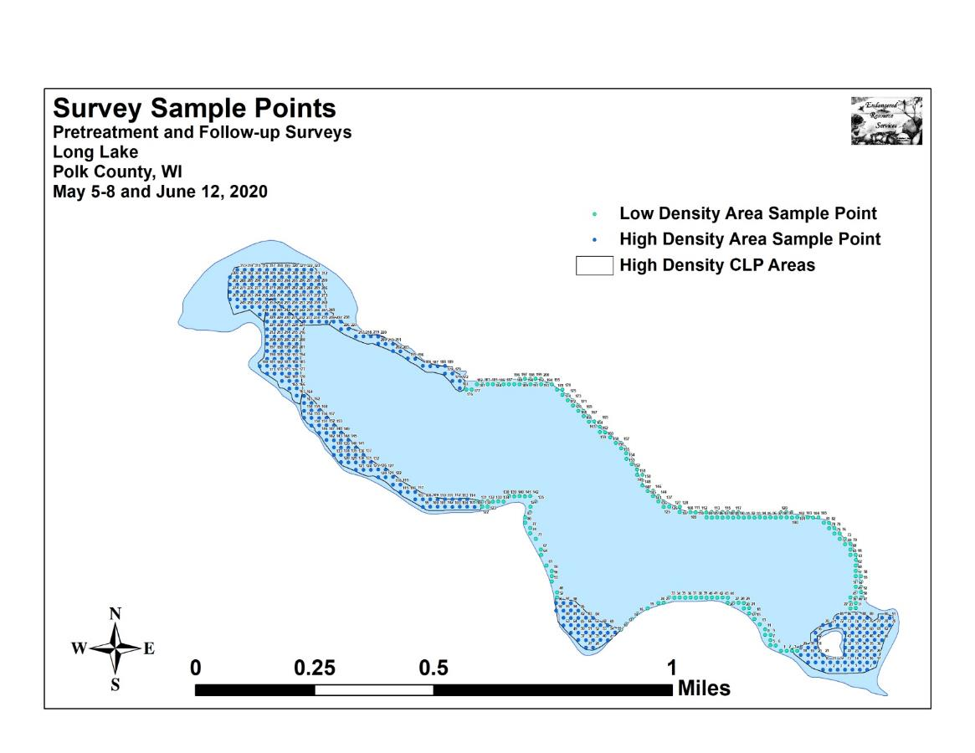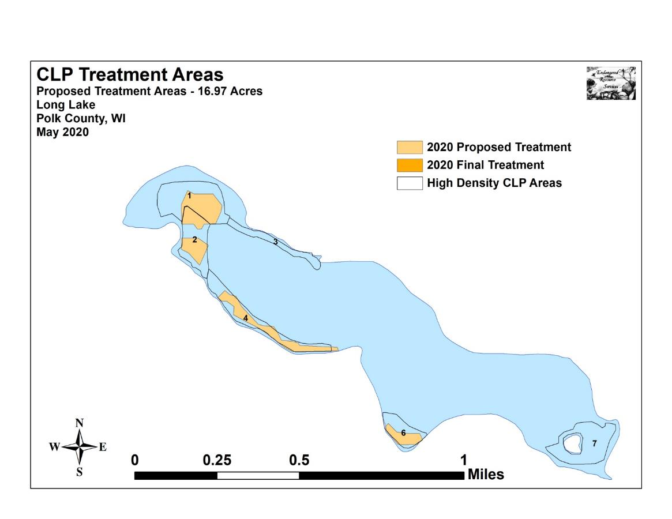

Appendix II: Vegetative Survey Data Sheet

Observers for this lake: names and hours worked by each:
Lake: |  |  |  |  |  |  |  |  | WBIC |  |  |  |  |  |  |  |  | County |  |  |  |  |  | Date:
Site # | Depth (ft) | Muck (M), Sand (S), Rock (R) | Rake pole (P) or rake rope (R) | Total Rake Fullness | CLP | CLP | 1 | 2 | 3 | 4 | 5 | 6 | 7 | 8 | 9 | 10 | 11 | 12 | 13 | 14 | 15 | 16 | 17 | 18 | 19
1
2
3
4
5
6
7
8
9
10
11
12
13
14
15
16
17
18
19
20

Appendix III: Pretreatment/Follow-up Habitat Variables
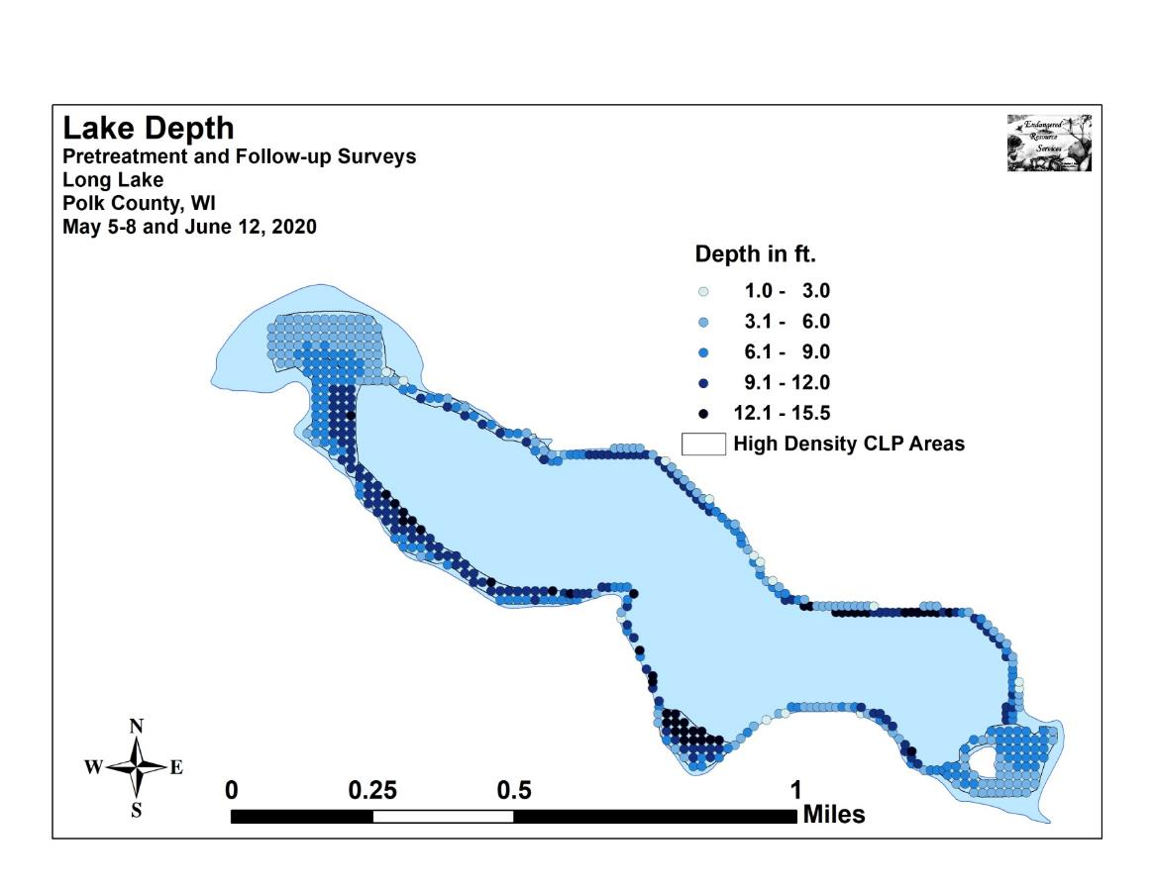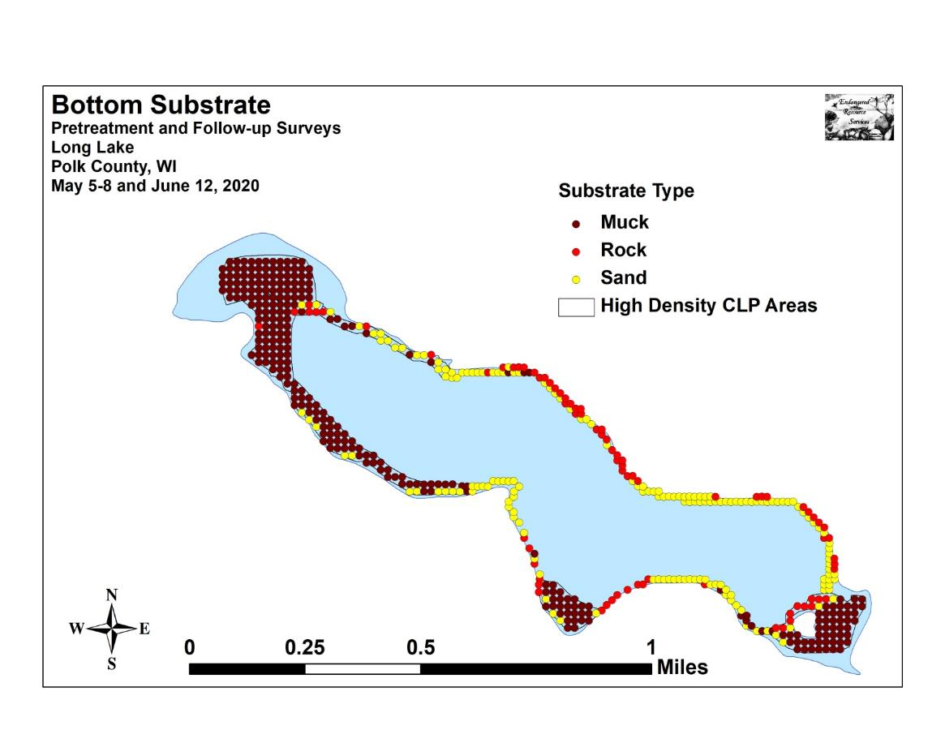

Appendix IV: Pretreatment/Follow-up Littoral Zone,
Native Species Richness, and Total Rake Fullness
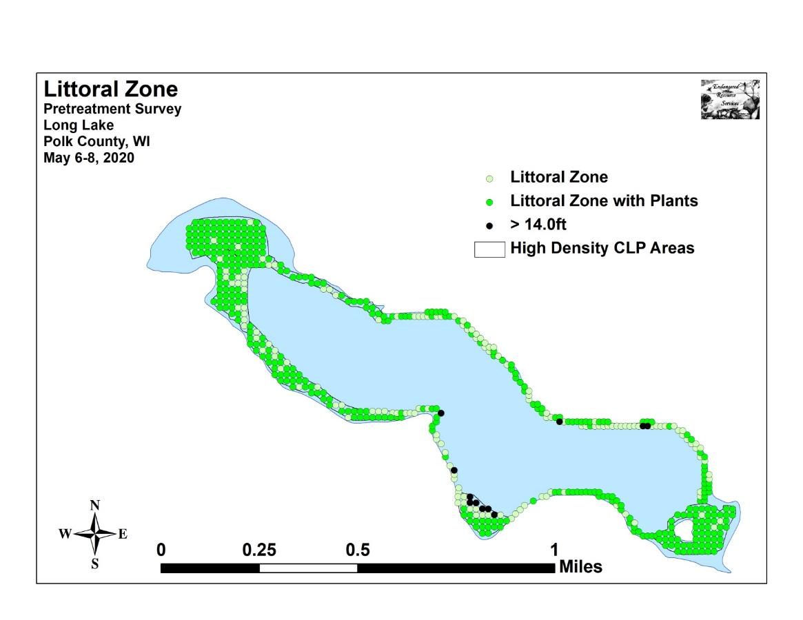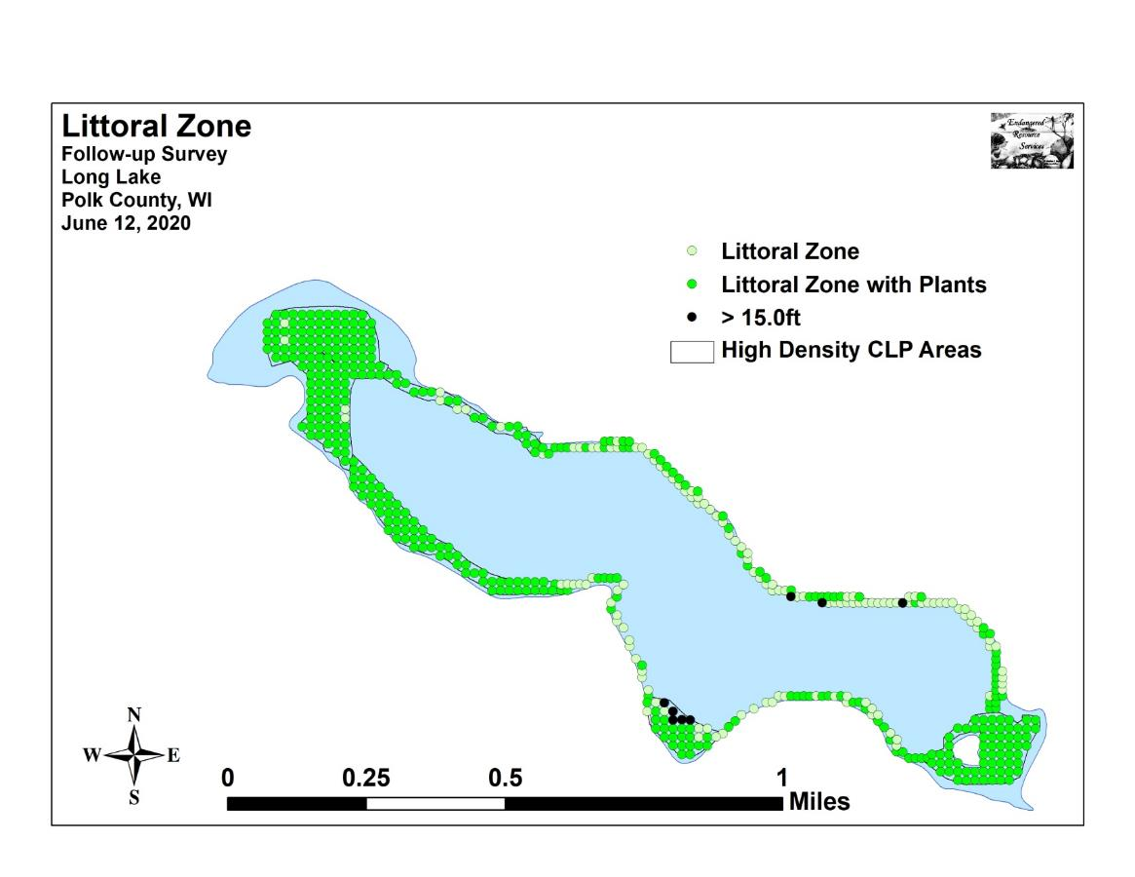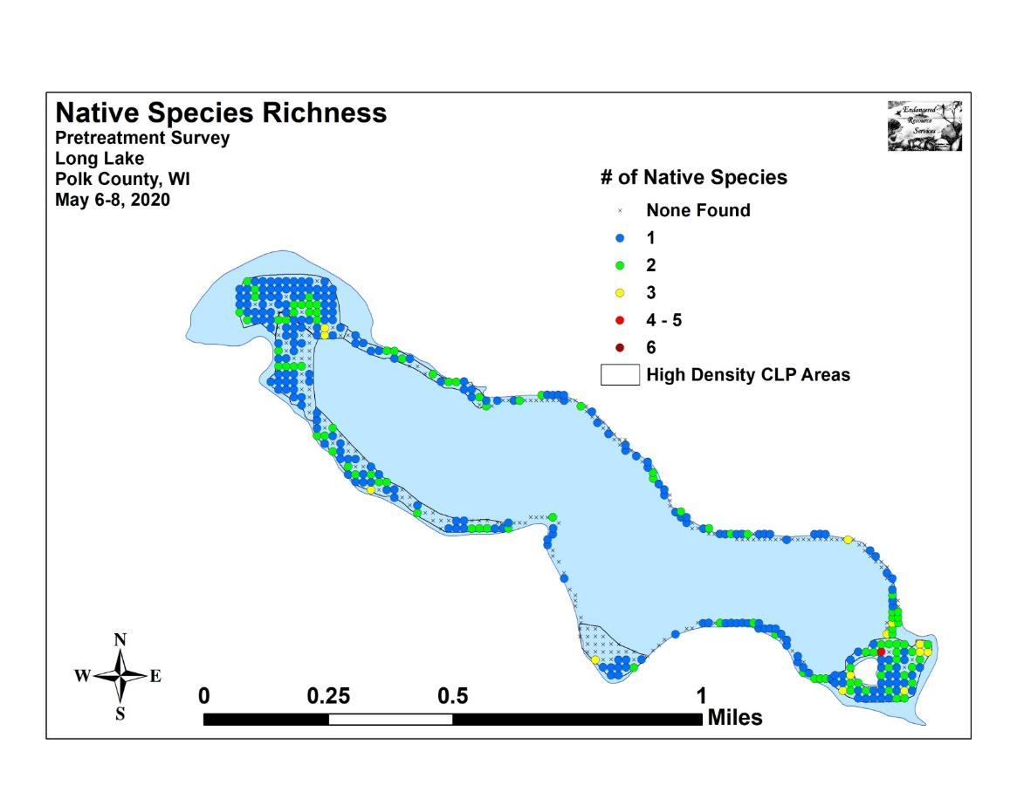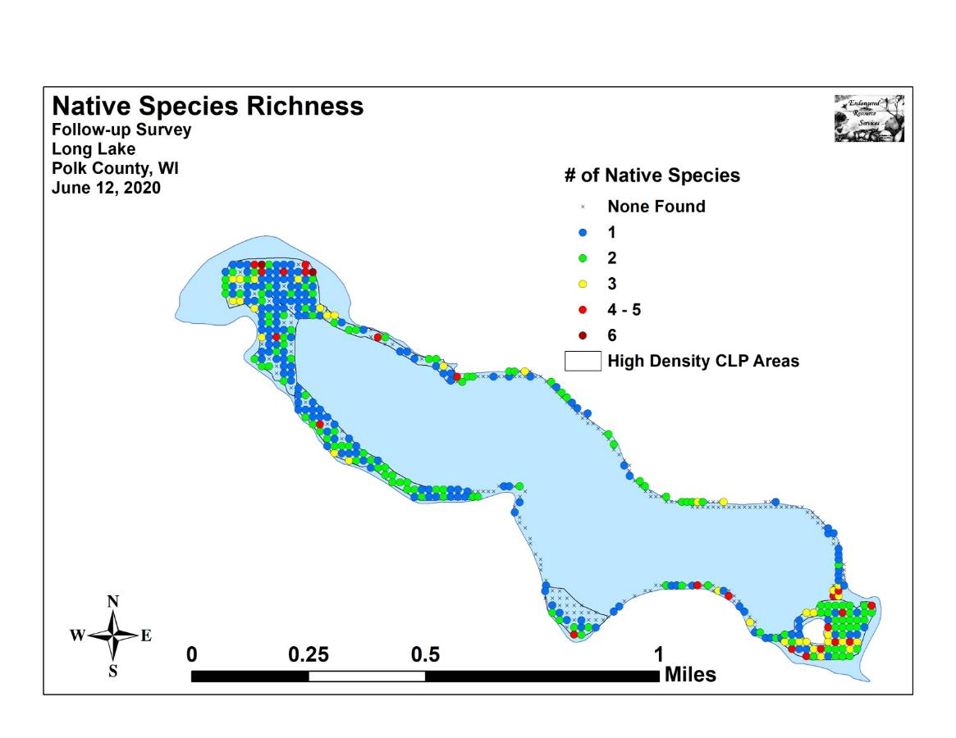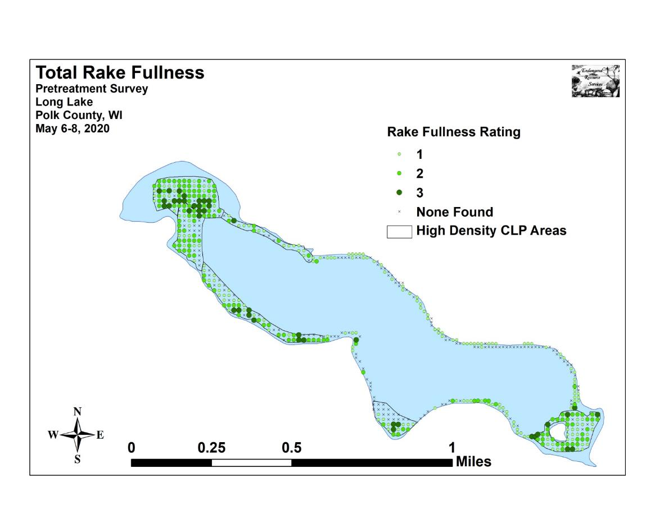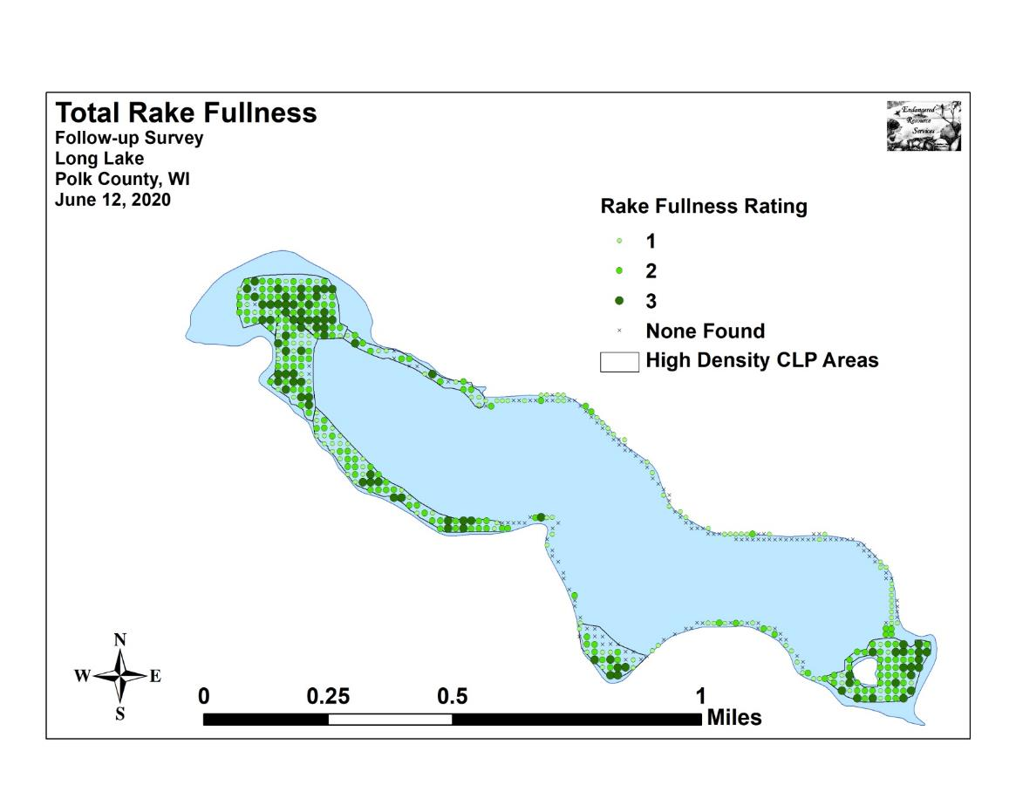

Appendix V: CLP Pretreatment/Follow-up Density and Distribution
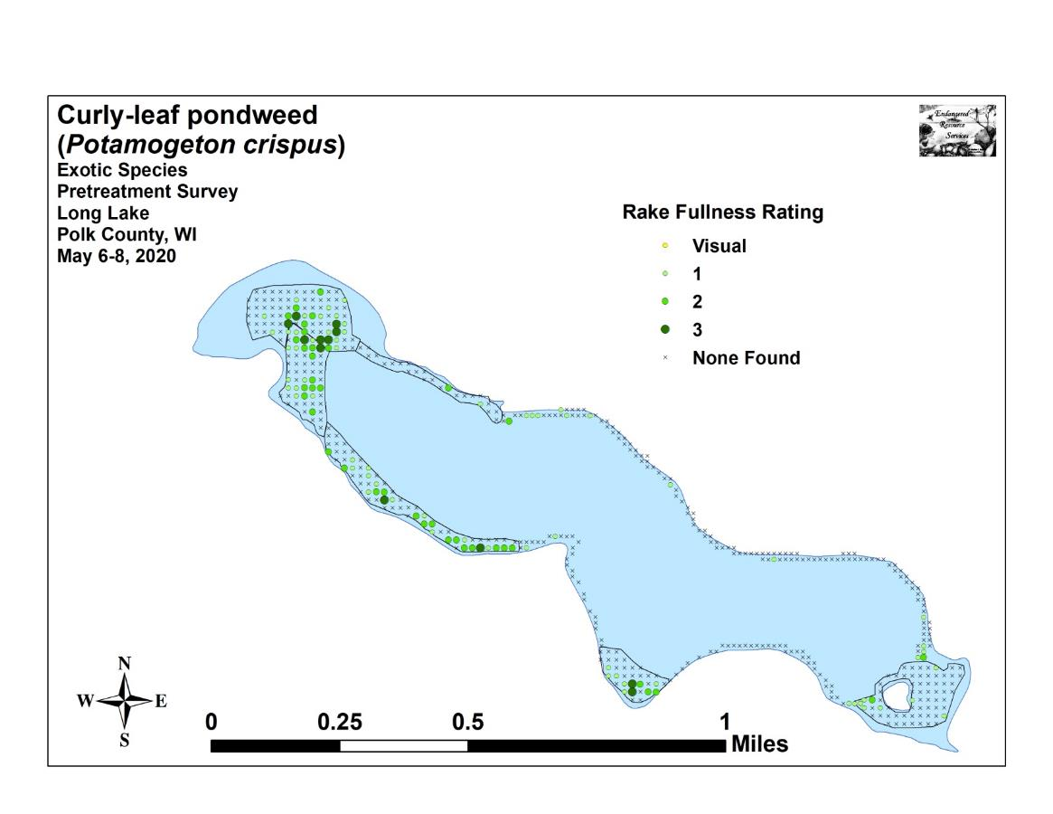
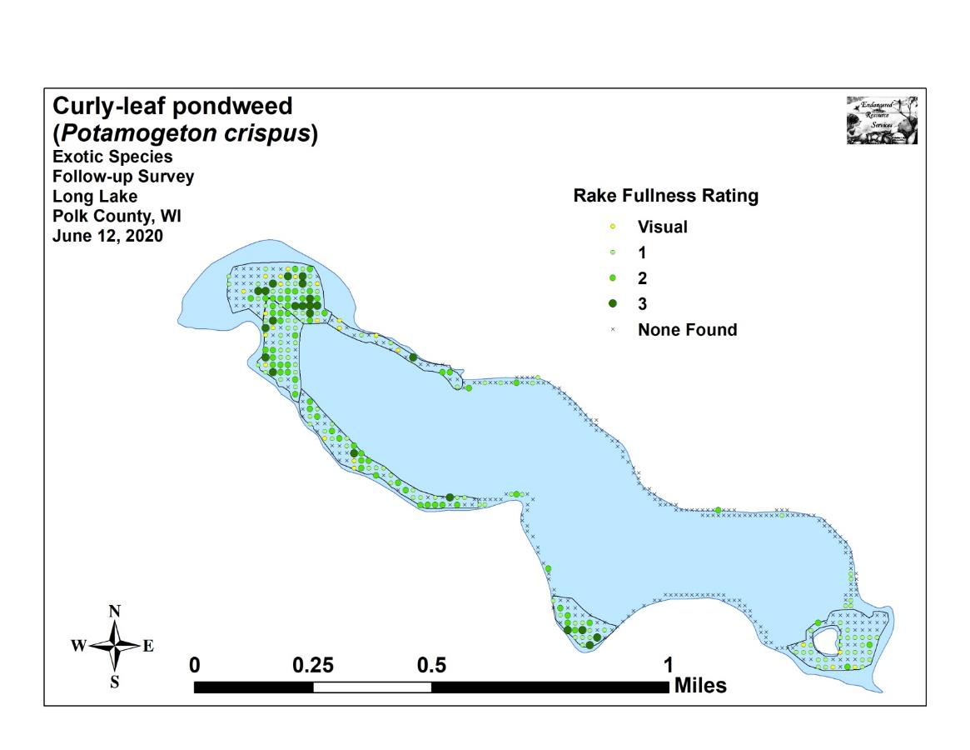

Appendix VI: Pretreatment Native Species Density and Distribution
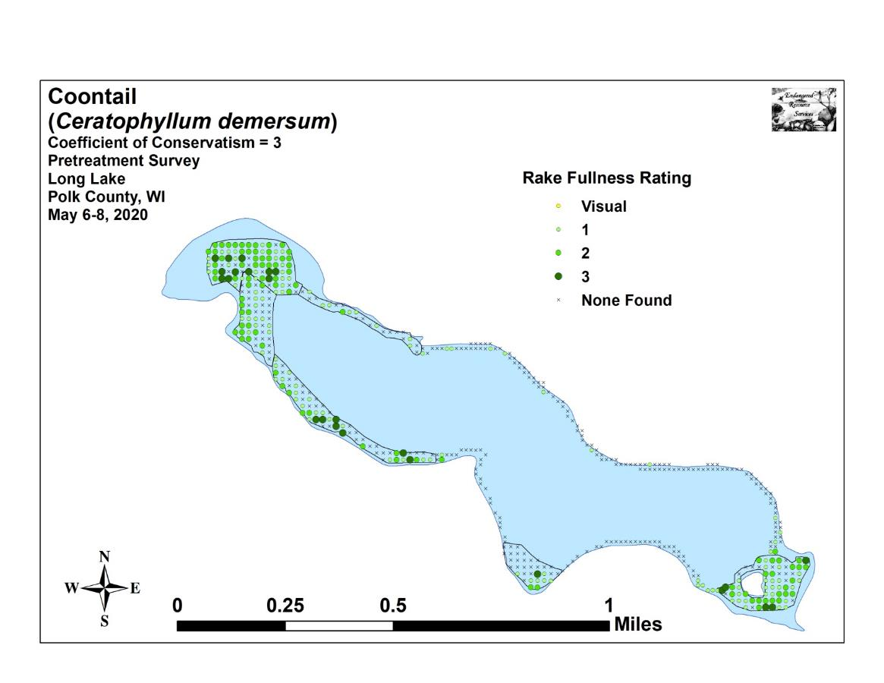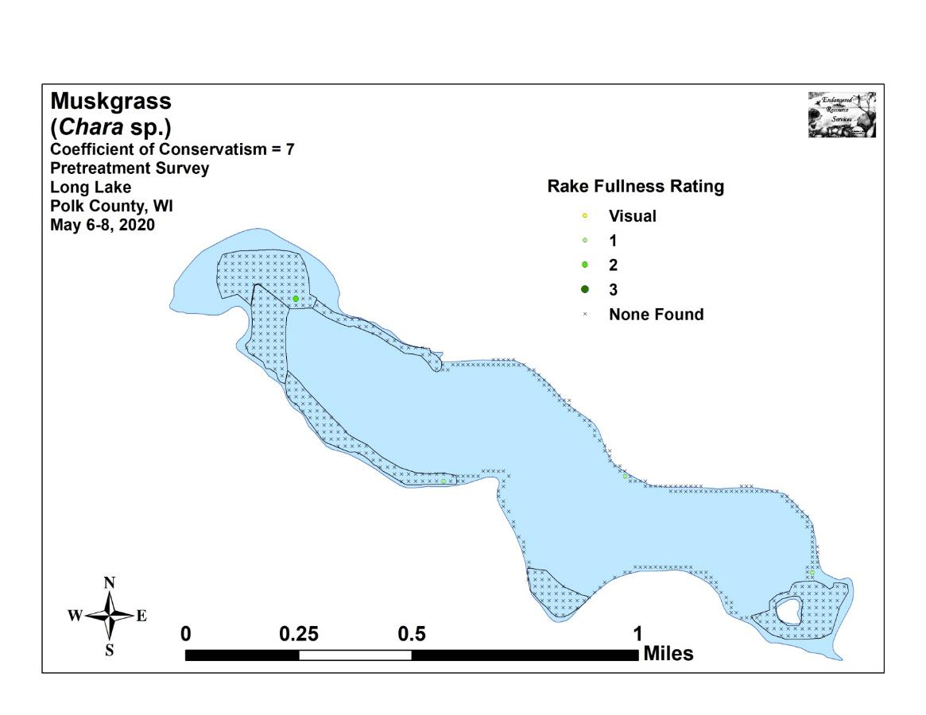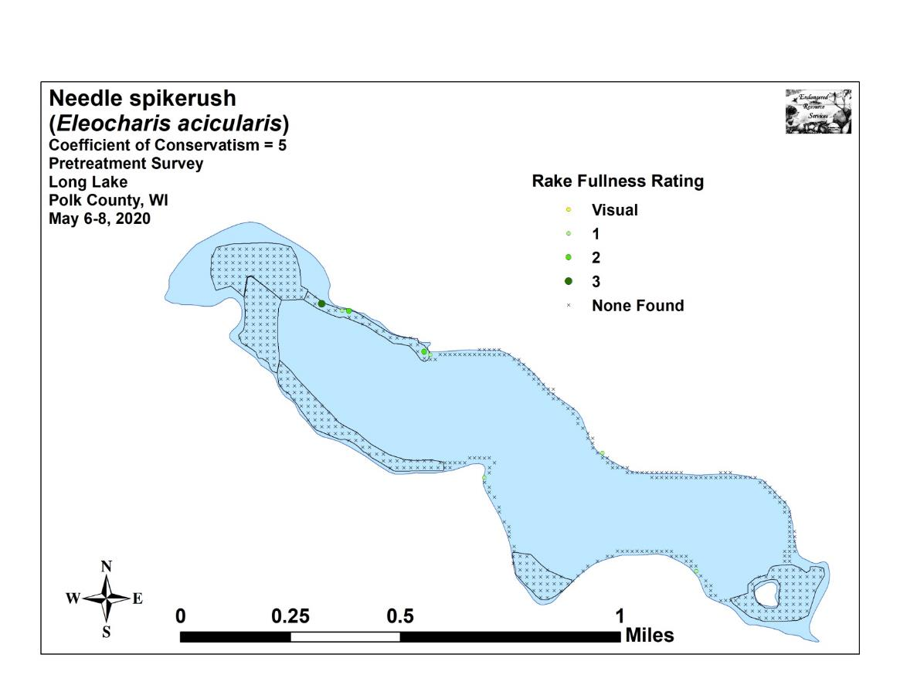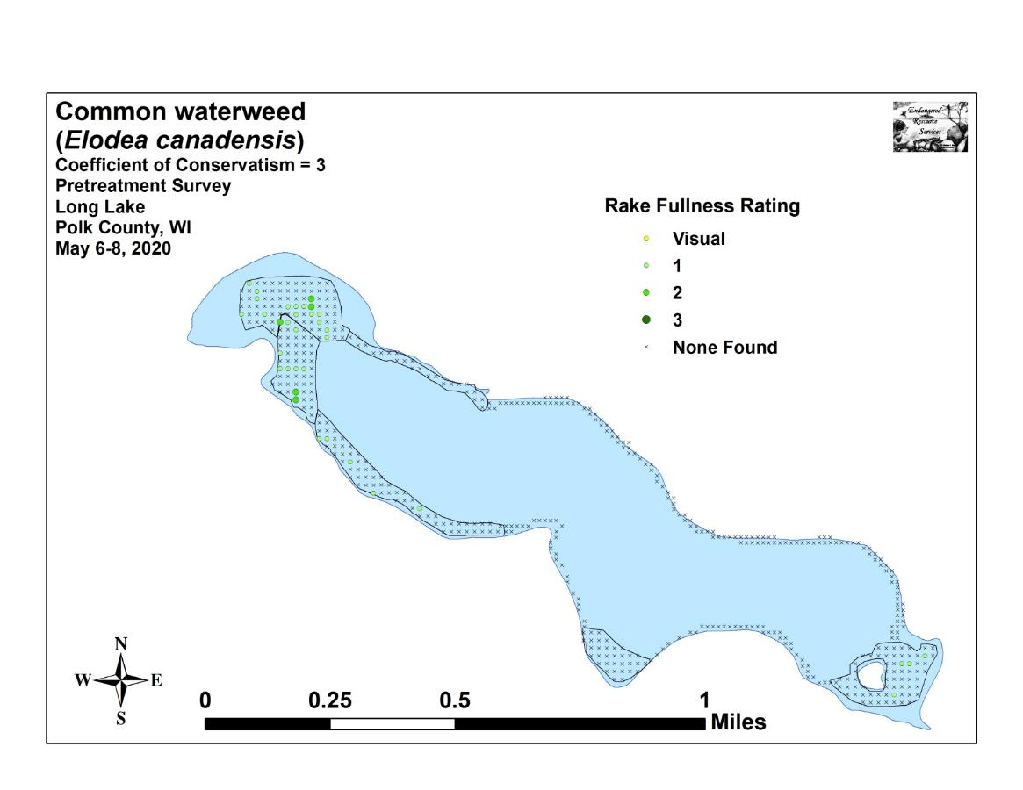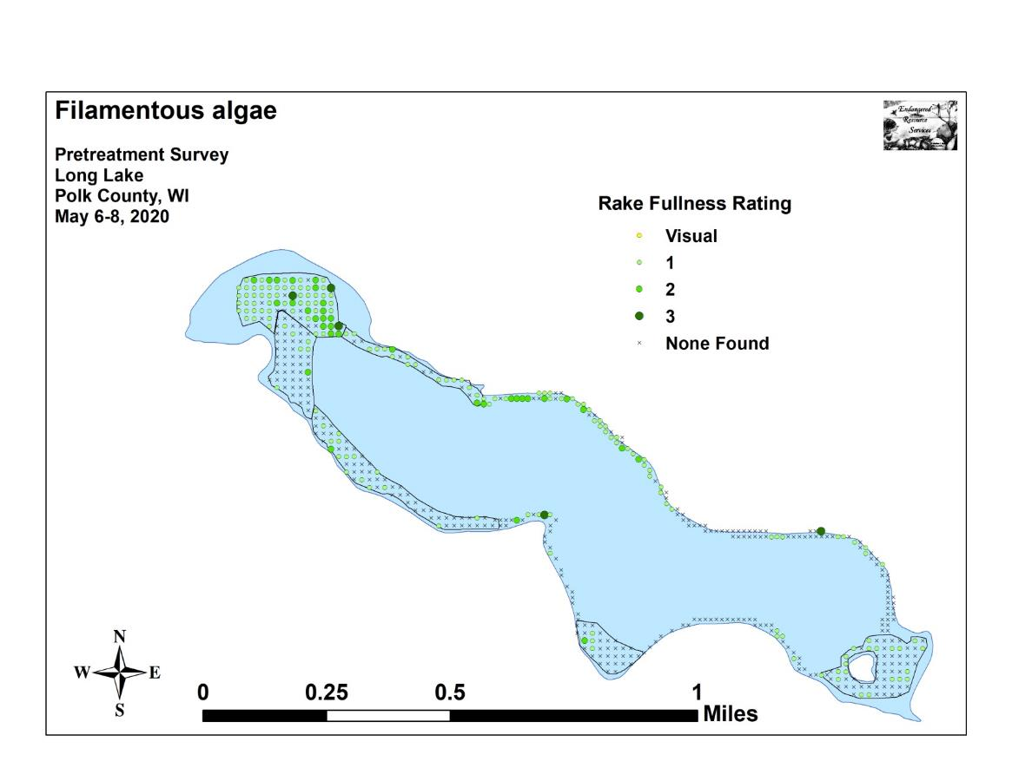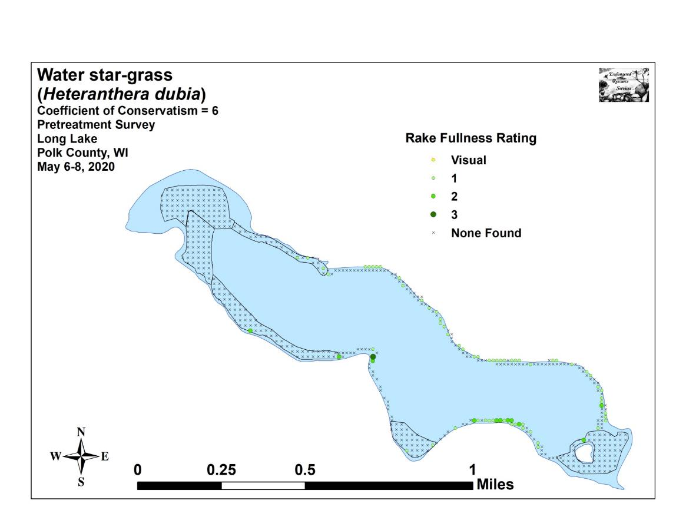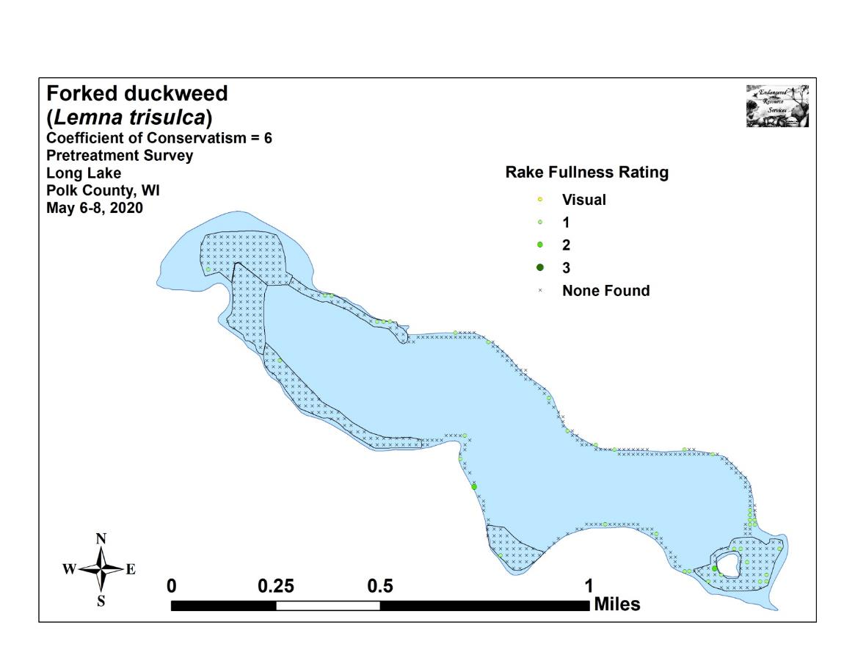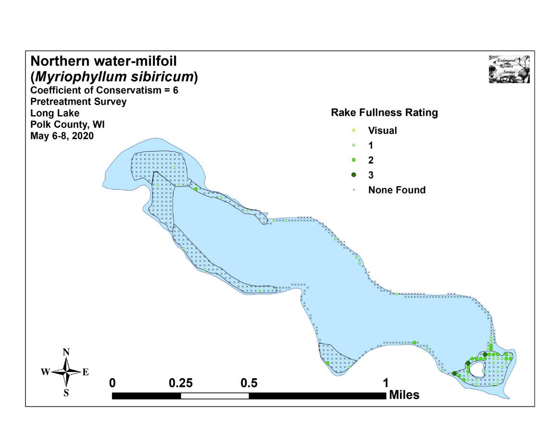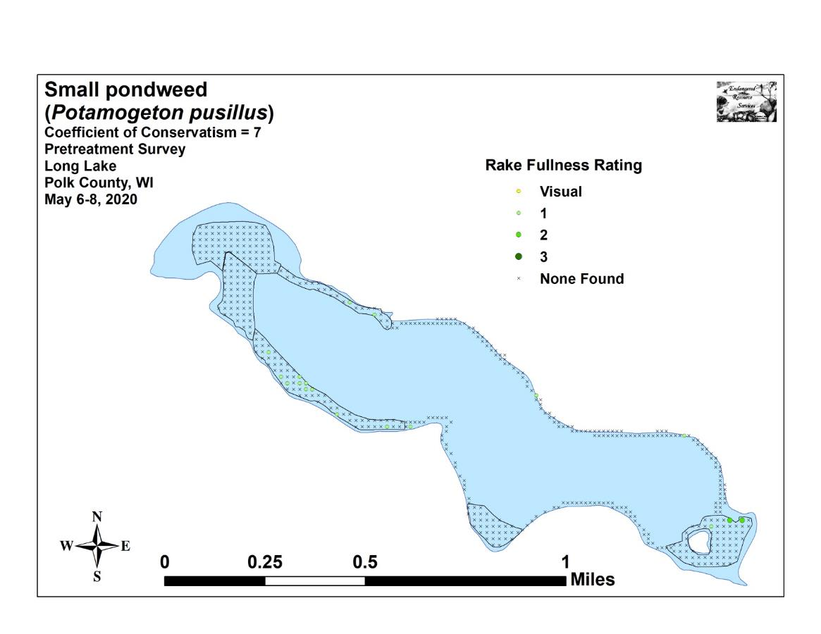

Appendix VII: Follow-up Native Species Density and Distribution
