Curly-leaf pondweed (Potamogeton crispus)
Point-intercept and Bed Mapping Surveys, and
Warm-water Point-intercept Macrophyte Survey
Long Lake (WBIC: 2478200) – Polk County, Wisconsin

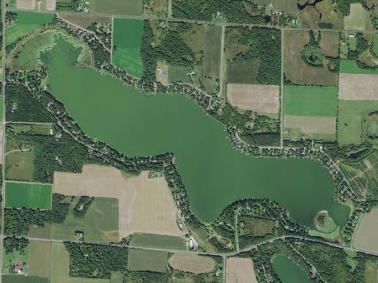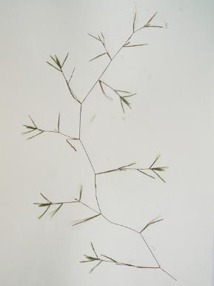
Long Lake Aerial Photo (2015) Small pondweed (Cameron 2019)

Project Initiated by:
Long Lake Protection and Rehabilitation District, Harmony Environmental, and the Wisconsin Department of Natural Resources

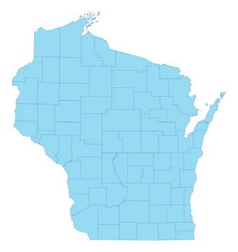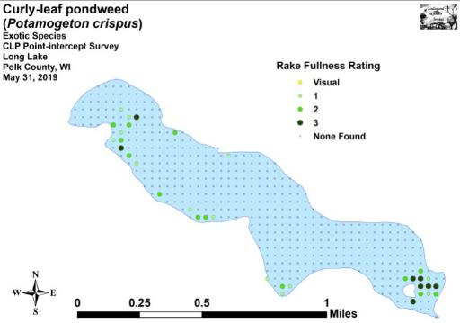

* Long Lake
2019 Spring CLP Density and Distribution

Surveys Conducted by and Report Prepared by:
Endangered Resource Services, LLC
Matthew S. Berg, Research Biologist
St. Croix Falls, Wisconsin
May 31, June 12, and July 26, 2019
TABLE OF CONTENTS

Page
ABSTRACT………………………..……..…………………………………………………….……. ii
LIST OF FIGURES ………………………………………………………………………………….. iii
LIST OF TABLES …………………………………………………………………………………… iv
INTRODUCTION …………………………………………………………………………………… 1
BACKGROUND AND STUDY RATIONALE…..……………………………………….………… 1
METHODS.……………………………………………………………….………………………….. 2
DATA ANALYSIS…………………………………………………………………………….…….. 3
RESULTS............................................................................................................................................. 7
Curly-leaf Pondweed Point-intercept Survey......................................................................... 7
Comparison of Curly-leaf Pondweed in 2016 and 2019 …………………………………… 7
Curly-leaf Pondweed Bed Mapping Survey………..……………………………...……….. 8
Descriptions of Past and Present Curly-leaf Pondweed Beds ……………………………… 9
Warm-water Full Point-intercept Macrophyte Survey………………………………….….. 11
Long Lake Plant Community ……………………………………………………………..... 14
Comparison of Native Macrophyte Species in 2016 and 2019…....……………………….. 19
Comparison of Floristic Quality Indexes in 2016 and 2019.……………………….…….… 27
Comparison of Filamentous Algae in 2016 and 2019…....……………………………...…. 29
Comparison of Summer Curly-leaf Pondweed in 2016 and 2019………....……………….. 29
Other Exotic Plant Species …………………………………………………………………. 30
DISCUSSION AND CONSIDERATIONS FOR MANAGEMENT……………………….……….. 32
LITERATURE CITED……….……………………….…………………………………….……….. 33
APPENDIXES……….…….………………………………………………….…………….……….. 34
I: Survey Sample Points Map.………………………………..…….……..…………………..….. 34
II: Boat and Vegetative Survey Datasheets..……………………………………………………… 36
III: 2016 and 2019 Early-season CLP Density & Distribution, and 2015 & 2019 CLP Bed Maps.. 39
IV: Habitat Variable Maps……………………………………...………..……………………........ 44
V: 2016 and 2019 Littoral Zone, Native Species Richness and Total Rake Fullness Maps.……… 47
VI: 2019 July Native Plant Species Density and Distribution Maps ………………………………. 54
VII: 2019 July CLP and Other Exotic Species Density and Distribution Maps ……………………. 77
VIII: Aquatic Exotic Invasive Plant Species Information …………………………………………… 81
IX: Glossary of Biological Terms……………….…………...……………………….………........ 90
X: 2019 Raw Data Spreadsheets.…………………………………………………………………. 94

ABSTRACT
Long Lake (WBIC 2478200) is a 272 acre seepage lake in central Polk County, Wisconsin. In 2010, the Long Lake Protection and Rehabilitation District, under the direction of Harmony Environmental, developed an Aquatic Plant Management Plan that authorized chemical treatment of the lake’s Curly-leaf pondweed (Potamogeton crispus) infestation. Following an alum treatment in 2018, the LLPRD and the Wisconsin Department of Natural Resources authorized three lakewide surveys 2019 to compare how the lake’s vegetation had changed since the last point-intercept surveys in 2016. We completed a CLP density survey on May 31st, a CLP bed mapping survey on June 12th, and a full point-intercept survey for all aquatic macrophytes on July 26, 2019. During the cold-water survey, we found CLP at 34 points (7.5% coverage with a mean rake fullness of 1.85) with 21 of these having a rake fullness of 2 or 3 (4.6% of the lake had a significant infestation). Compared to 2016 when we didn’t find CLP anywhere in the lake following a limited herbicide treatment, this represented a highly significant increase (p<0.001) in density, distribution, and rake fullness 2 and 1; and a moderately significant increase (p=0.004) in rake fullness 3. However, when compared to 2010 pretreatment levels, our 2019 results demonstrated highly significant long term declines (p<0.001) in total CLP distribution and rake fullness 3; a moderately significant decline (p=0.003) in rake fullness 2; and a significant decline (p=0.03) in rake fullness 1. Collectively, the 2019 results suggest CLP is still both less widespread and less abundant than it was in 2010. In 2015, following a year without treatment, we mapped 13 Curly-leaf pondweed beds totaling 43.21 acres (15.9% of the lake’s surface area). Following a limited herbicide treatment, the 2016 bed mapping survey didn’t find any canopied CLP in the lake; but, in 2019, we mapped nine CLP beds totaling 22.25 acres (8.2% coverage). This represented a 20.96 acre decline (-48.5%) from the 2015 survey. It was also 63.26 acres less than (-74.0%) the 2009 Barr survey. During the July 2019 full point-intercept survey, we found macrophytes growing at 160 sites which approximated to 35.3% of the entire lake bottom and 66.7% of the 16.0ft littoral zone. This was a non-significant increase (p=0.50) over the 2016 survey when plants were present at 152 points (33.6% of the bottom and 60.8% of the then 15.0ft littoral zone). Overall diversity was high with a Simpson Index value of 0.90 – up from 0.87 in 2016. Total richness was low with 20 species in the rake and 25 total found growing in and immediately adjacent to the water (both down slightly from 23/27 species in 2016). There was an average of 3.15 native species/site with native vegetation – a moderately significant increase (p=0.006) from 2.59 native species/site in 2016. Total rake fullness experienced a nearly significant increase (p=0.10) from a moderate 1.93 in 2016 to a moderate 2.05 in 2019. Coontail (Ceratophyllum demersum), Small pondweed (Potamogeton pusillus), Small duckweed (Lemna minor), and Large duckweed (Spirodela polyrhiza) were the most common species in 2019. Found at 70.00%, 33.13%, 28.75%, and 28.13% of sites with vegetation, they captured 48.95% of the total relative frequency. In 2016, Coontail, White water lily (Nymphaea odorata), Small duckweed, and Large duckweed were the most common species (74.34%, 30.92%, 25.66%, and 25.66% of sites with vegetation/59.50% of the total relative frequency). Lakewide, from July 2016-2019, seven species showed significant changes in distribution: Northern water-milfoil (Myriophyllum sibiricum) and Small pondweed enjoyed highly significant increases; Curly-leaf pondweed and Leafy pondweed (Potamogeton foliosus) saw moderately significant increases; and filamentous algae experienced a significant increase. Conversely, Nitella (Nitella sp.) and Hybrid cattail (Typha X glauca) suffered significant declines. The 20 native index species found in the rake during the July 2019 survey (down from 21 in 2016) produced a slightly below average mean Coefficient of Conservatism of 5.5 (up from 5.1 in 2016). The Floristic Quality Index of 24.4 (up from 23.3 in 2016) was, however, above the median FQI for this part of the state. Filamentous algae (107 points with a mean rake fullness of 1.51) underwent a significant increase (p=0.03) in distribution and a moderately significant increase (p=0.003) in density compared to 2016 (83 points/mean rake of 1.28). Curly-leaf pondweed was still present at a 19 points (mean rake fullness 1.11) in July 2019 (down from five points/mean rake 1.00 in 2016). Other than CLP, we found two other exotic species growing in and immediately adjacent to Long Lake: Reed canary grass (Phalaris arundinacea) was present along shorelines throughout; and Hybrid cattail dominated most emergent beds on the lake. In an effort to promote continued native plant expansion, we encourage the LLPRD to strive for minimal herbicide applications that still meet their CLP management goals; and to continue their Clean Boats/Clean Waters landing monitoring program to help decrease the likelihood of Eurasian water-milfoil (Myriophyllum spicatum) or any other Aquatic Invasive Species entering the lake.
LIST OF FIGURES

Page
Figure 1: Long Lake Bathymetric Map……………………………………………..……... 1
Figure 2: Rake Fullness Ratings……………………………….…….…………………….. 2
Figure 3: 2016 and 2019 Early-season Curly-leaf Pondweed Density and Distribution.….. 7
Figure 4: 2010-2019 Changes in Early-season CLP Rake Fullness…………...………….. . 8
Figure 5: 2015 and 2019 Early-season Curly-leaf Pondweed Beds……………………….. 8
Figure 6: Lake Depth and Bottom Substrate. …………………………………………….… 11
Figure 7: 2016 and 2019 Littoral Zone………………………………..…………………… 12
Figure 8: 2016 and 2019 Plant Colonization Depth Chart …………………………….…… 12
Figure 9: 2016 and 2019 Native Species Richness………………………………….……... 13
Figure 10: 2016 and 2019 Total Rake Fullness ……………………………………………. 14
Figure 11: Macrophytes Showing Significant Changes from 2016-2019………..………... 20
Figure 12: 2016 and 2019 Coontail Density and Distribution……………………………... 25
Figure 13: 2016 and 2019 Small Pondweed Density and Distribution…………………….. 25
Figure 14: 2016 and 2019 White Water Lily Density and Distribution...……..…………... 26
Figure 15: 2016 and 2019 Common Waterweed Density and Distribution …………........... 26
Figure 16: 2016 and 2019 Northern Water-milfoil Density and Distribution…..…………. 27
Figure 17: 2016 and 2019 Filamentous Algae Density and Distribution.…………………. 29
Figure 18: 2016 and 2019 Summer CLP Density and Distribution.……….………………. 29
Figure 19: 2016 Reed Canary Grass Density and Distribution and Inflorescence ................ 30
Figure 20: 2019 Hybrid Cattail Density & Distribution and Stand at the Southeast Outlet.. 30
Figure 21: Exotic Hybrid and Native Broad-leaved Cattail Identification.......……….…… 31

LIST OF TABLES

Page
Table 1: Curly-leaf Pondweed Bed Summary –
Long Lake, Polk County – June 13, 2015 and June 12, 2019..……………………………... 10

Table 2: Aquatic Macrophyte P/I Survey Summary Statistics - Long Lake, Polk Co. –
July 24-25, 2010, July 25, 2011, July 27-28, 2012, July 23-24, 2016, and July 26, 2019….. 13

Table 3: Frequencies and Mean Rake Sample of Aquatic Macrophytes
Long Lake, Polk County – July 23-24, 2016……………………………………………….. 21

Table 4: Frequencies and Mean Rake Sample of Aquatic Macrophytes
Long Lake, Polk County – July 26, 2019…………………………………………………… 23

Table 5: Floristic Quality Index of Aquatic Macrophytes
Long Lake, Polk County July 23-24, 2016.…………………………..………………..…… 27

Table 6: Floristic Quality Index of Aquatic Macrophytes
Long Lake, Polk County – July 26, 2019…………………………………….…………….. 28

INTRODUCTION:
Lake (WBIC 2478200) is a 272 acre seepage lake in central Polk County, Wisconsin in the Town of Balsam Lake (T34N R17W S07 NE NE). It reaches a maximum depth of just over 17ft in the central basin and has an average depth of approximately 11ft (Busch et al. 1969) (Figure 1). The lake is eutrophic trending toward hypereutrophic, and visibility is generally poor with summer Secchi readings averaging 4.7ft since 1992; however, the mean in 2019 was 6.8ft which was the highest reading since 2008 (WDNR 2019). The bottom substrate in the lake’s bays and central basin is predominately thick organic muck, while exposed points and most north/south shorelines are dominated by gravel and sand.

Figure 1: Long Lake Bathymetric Map

BACKGROUND AND STUDY RATIONALE:
Long Lake and the Long Lake Protection and Rehabilitation District (LLPRD) have an extended history of battling Curly-leaf pondweed (Potamogeton crispus) (CLP) - an exotic invasive species that thrives in the nutrient-rich sediments found in many parts of the lake. In the past, CLP often grew so densely in the spring and early summer that it made lake access and boating difficult for Long Lake residents. CLP’s late June-early July senescence was also cited in past studies by Barr Engineering and the Polk County Land and Water Conservation Department (PCLWCD) as a significant contributor to the lake’s overall phosphorus load and was at least partially responsible for the lake’s frequent late summer toxic blue-green algae blooms.

In 2010, after years of study, the LLPRD and the Wisconsin Department of Natural Resources (WDNR) authorized an initial lakewide herbicide treatment of over 65 acres of CLP. The LLPRD treated nearly 57 acres again in 2011, and 58 acres in 2012. After updating the District’s WDNR approved Aquatic Plant Management Plan (APMP) in 2012, it was decided to treat just 27 acres in 2013, and only 20 acres in 2014. Although the 2010-2013 treatments resulted in highly significant reductions in both CLP coverage and density on the lake, the 2014 treatment showed no significant change from pretreatment levels. A follow-up survey of CLP turions in the lake’s sediment also suggested 2015 CLP levels would likely be very low in most parts of the lake. Based on these data, and following a discussion with the lake’s executive board and APMP director Cheryl Clemens (Harmony Environmental) in the fall of 2014, it was decided not to treat CLP in 2015.
Because both the 2015 June CLP point-intercept monitoring survey and the fall CLP turion sediment data suggested CLP had made a significant rebound throughout much of the lake, it was decided that herbicide treatments (not to exceed 35 acres) would resume in the future. Ultimately, the LLPRD decided to treat 34.97 acres in 2016 and 33.65 acres in 2017. However, due to low CLP levels, treatment in 2018 and 2019 was cancelled.

Per WDNR expectations, plant surveys are normally repeated every five to seven years to remain current (Pamela Toshner/Alex Smith, WDNR – pers. comm.). Although the last full lake surveys occurred in 2016 and the last plan was updated in 2017, it was hoped the 2018 alum treatment would improve water clarity and allow native species to expand. Because of this, the board, under the direction of Harmony Environmental, authorized three lakewide surveys in 2019. On May 31st, we conducted an early-season CLP point-intercept survey. This was followed by a CLP bed mapping survey on June 12th and a warm-water point-intercept survey of all macrophytes on July 26th. The surveys’ objectives were to document the current levels of CLP in the lake; determine if Eurasian water-milfoil (Myriophyllum spicatum) or any other new exotic plants had invaded the lake; and to compare data from 2016 and 2019 to identify any significant changes in the lake’s vegetation over this time. This report is the summary analysis of these field surveys.

METHODS:
Curly-leaf Pondweed Point-intercept Survey:
Using a standard formula that takes into account the shoreline shape and distance, islands, water clarity, depth, and total acreage, Michelle Nault (WDNR) generated the original 453 point sampling grid used for Long Lake in 2010, 2011, 2012, and 2016 (Appendix I). Using this same grid in 2019, we completed a density survey where we sampled for Curly-leaf pondweed at each point in the lake. We located each survey point using a handheld mapping GPS unit (Garmin 76CSx) and used a rake to sample an approximately 2.5ft section of the bottom. When found, CLP was assigned a rake fullness value of 1-3 as an estimation of abundance (Figure 2). We also noted visual sightings of CLP within six feet of the sample point.

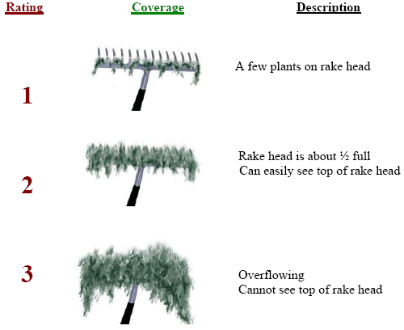
Figure 2: Rake Fullness Ratings (UWEX 2010)
Curly-leaf Pondweed Bed Mapping Survey:
During the bed mapping survey, we searched the lake’s visible littoral zone. By definition, a “bed” was determined to be any area where we visually estimated that CLP made up >50% of the area’s plants, was generally continuous with clearly defined borders, and was canopied or close enough to being canopied that it would likely interfere with boat traffic. After we located a bed, we motored around the perimeter of the area taking GPS coordinates at regular intervals. We also estimated the rake density range and mean rake fullness of the bed (Figure 2), the maximum depth of the bed, whether it was canopied, and the impact it was likely to have on navigation (none – easily avoidable with a natural channel around or narrow enough to motor through/minor – one prop clear to get through or access open water/moderate – several prop clears needed to navigate through/severe – multiple prop clears and difficult to impossible to row through). These data were then mapped using ArcMap 9.3.1, and we used the WDNR’s Forestry Tools Extension to determine the acreage of each bed to the nearest hundredth of an acre (Table 1).

Warm-water Full Point-intercept Macrophyte Survey:
Prior to beginning the July point-intercept survey, we conducted a general boat survey to regain familiarity with the lake’s macrophytes (Appendix II). All plants found were identified (Voss 1996; Boreman et al. 1997; Chadde 2002; Crow and Hellquist 2009; and Skawinski 2018), and a datasheet was built from the species present. We again located each survey point with a GPS, recorded a depth reading with a metered pole rake, and took a rake sample. All plants on the rake, as well as any that were dislodged by the rake, were identified and assigned a rake fullness value of 1-3 as an estimation of abundance (Figure 2). We also recorded visual sightings of all plants within six feet of the sample point not found in the rake. In addition to a rake rating for each species, a total rake fullness value was also noted. Substrate (bottom) type was assigned at each site where the bottom was visible or it could be reliably determined using the rake.

DATA ANALYSIS:
We entered all data collected into the standard APM spreadsheet (Appendix II) (UWEX 2010). From this, we calculated the following:

Total number of sites visited: This included the total number of points on the lake that were accessible to be surveyed by boat.

Total number of sites with vegetation: These included all sites where we found vegetation after doing a rake sample. For example, if 20% of all sample sites have vegetation, it suggests that 20% of the lake has plant coverage.

Total number of sites shallower than the maximum depth of plants: This is the number of sites that are in the littoral zone. Because not all sites that are within the littoral zone actually have vegetation, we use this value to estimate how prevalent vegetation is throughout the littoral zone. For example, if 60% of the sites shallower than the maximum depth of plants have vegetation, then we estimate that 60% of the littoral zone has plants.
Frequency of occurrence: The frequency of all plants (or individual species) is generally reported as a percentage of occurrences within the littoral zone. It can also be reported as a percentage of occurrences at sample points with vegetation.

Frequency of occurrence example:

Plant A is sampled at 70 out of 700 total littoral points = 70/700 = .10 = 10%
This means that Plant A’s frequency of occurrence = 10% when considering the entire
littoral zone.

Plant A is sampled at 70 out of 350 total points with vegetation = 70/350 = .20 = 20%
This means that Plant A’s frequency of occurrence = 20% when only considering the
sites in the littoral zone that have vegetation.

From these frequencies, we can estimate how common each species was at depths
where plants were able to grow, and at points where plants actually were growing.
Note the second value will be greater as not all the points (in this example, only ½)
had plants growing at them.

Simpson’s Diversity Index: A diversity index allows the entire plant community at one location to be compared to the entire plant community at another location. It also allows the plant community at a single location to be compared over time thus allowing a measure of community degradation or restoration at that site. With Simpson’s Diversity Index, the index value represents the probability that two individual plants (randomly selected) will be different species. The index values range from 0 -1 where 0 indicates that all the plants sampled are the same species to 1 where none of the plants sampled are the same species. The greater the index value, the higher the diversity in a given location. Although many natural variables like lake size, depth, dissolved minerals, water clarity, mean temperature, etc. can affect diversity, in general, a more diverse lake indicates a healthier ecosystem. Perhaps most importantly, plant communities with high diversity also tend to be more resistant to invasion by exotic species.

Maximum depth of plants: This indicates the deepest point that vegetation was sampled. In clear lakes, plants may be found at depths of over 20ft, while in stained or turbid locations, they may only be found in a few feet of water. While some species can tolerate very low light conditions, others are only found near the surface. In general, the diversity of the plant community decreases with increased depth.

Mean and median depth of plants: The mean depth of plants indicates the average depth in the water column where plants were sampled. Because a few samples in deep water can skew this data, median depth is also calculated. This tells us that half of the plants sampled were in water shallower than this value, and half were in water deeper than this value.

Number of sites sampled using rope/pole rake: This indicates which rake type was used to take a sample. We use a 20ft pole rake and a 35ft rope rake for sampling.

Average number of species per site: This value is reported using four different considerations. 1) shallower than maximum depth of plants indicates the average number of plant species at all sites in the littoral zone. 2) vegetative sites only indicate the average number of plants at all sites where plants were found. 3) native species shallower than maximum depth of plants and 4) native species at vegetative sites only excludes exotic species from consideration.

Species richness: This value indicates the number of different plant species found in and directly adjacent to (on the waterline) the lake. Species richness alone only counts those plants found in the rake survey. The other two values include those seen at a sample point during the survey but not found in the rake, and those that were only seen during the initial boat survey or inter-point. Note: Per DNR protocol, filamentous algae, freshwater sponges, aquatic moss and the aquatic liverworts Riccia fluitans and Ricciocarpus natans are excluded from these totals.

Average rake fullness: This value is the average rake fullness of all species in the rake. It only takes into account those sites with vegetation (Table 2).

Relative frequency: This value shows a species’ frequency relative to all other species. It is expressed as a percentage, and the total of all species’ relative frequency will add up to 100%. Organizing species from highest to lowest relative frequency value gives us an idea of which species are most important within the macrophyte community (Tables 3 and 4).

Relative frequency example:

Suppose that we sample 100 points and found 5 species of plants with the following results:

Plant A was located at 70 sites. Its frequency of occurrence is thus 70/100 = 70%
Plant B was located at 50 sites. Its frequency of occurrence is thus 50/100 = 50%
Plant C was located at 20 sites. Its frequency of occurrence is thus 20/100 = 20%
Plant D was located at 10 sites. Its frequency of occurrence is thus 10/100 = 10%

To calculate an individual species’ relative frequency, we divide the number of sites a plant is sampled at by the total number of times all plants were sampled. In our example that would be 150 samples (70+50+20+10).

Plant A = 70/150 = .4667 or 46.67%
Plant B = 50/150 = .3333 or 33.33%
Plant C = 20/150 = .1333 or 13.33%
Plant D = 10/150 = .0667 or 6.67%

This value tells us that 46.67% of all plants sampled were Plant A.

Floristic Quality Index (FQI): This index measures the impact of human development on a lake’s aquatic plants. The 124 species in the index are assigned a Coefficient of Conservatism (C) which ranges from 1-10. The higher the value assigned, the more likely the plant is to be negatively impacted by human activities relating to water quality or habitat modifications. Plants with low values are tolerant of human habitat modifications, and they often exploit these changes to the point where they may crowd out other species. The FQI is calculated by averaging the conservatism value for each native index species found in the lake during the point-intercept survey**, and multiplying it by the square root of the total number of plant species (N) in the lake (FQI=(Σ(c1+c2+c3+…cn)/N)*√N). Statistically speaking, the higher the index value, the healthier the lake’s macrophyte community is assumed to be. Nichols (1999) identified four eco-regions in Wisconsin: Northern Lakes and Forests, North Central Hardwood Forests, Driftless Area and Southeastern Wisconsin Till Plain. He recommended making comparisons of lakes within ecoregions to determine the target lake’s relative diversity and health. Long Lake is in the North Central Hardwood Forests Ecoregion (Tables 5 and 6).

** Species that were only recorded as visuals or during the boat survey, and species found in the rake that are not included in the index are excluded from FQI analysis.

Comparison to Past Surveys: We compared data from our 2010, 2011, 2012, 2016, and 2019 CLP point-intercept surveys (Figure 4), and 2016 and 2019 warm-water point-intercept surveys (Figure 11) (Tables 3 and 4) to see if there were any significant changes in the lake’s vegetation. For individual plant species as well as count data, we used the Chi-square analysis on the WDNR Pre/Post survey worksheet. For comparing averages (mean species/point and mean rake fullness/point), we used t-tests. Differences were considered significant at p<0.05, moderately significant at p<0.01 and highly significant at p<0.001 (UWEX 2010). It should be noted that when comparing the spring Curly-leaf pondweed point-intercept surveys, we used the number of littoral points from the original 2010 survey (236 points) as the basis for “sample points” for all surveys as we felt this gave us the best chance to capture real differences following years of active management and changes in water clarity/quality. For the warm-water point-intercept surveys, we used the number of littoral points with plants (153 in 2016/160 in 2019).
RESULTS:
Curly-leaf Pondweed Point-intercept Survey:
During the 2019 early-season point-intercept survey, we found Curly-leaf pondweed in the rake at 34 sites. This extrapolated to 7.5% of the entire lake and 19.9% of the 12.5ft spring littoral zone having at least some CLP present. Of these, eight rated a rake fullness value of 3, 13 were a 2, and the remaining 13 were a 1 for a combined mean rake fullness of 1.85 (Figure 3) (Appendix III). The 21 points with a rake fullness of a 2 or a 3 suggested 4.6% of the entire lake and 12.3% of the spring littoral zone had a significant infestation.

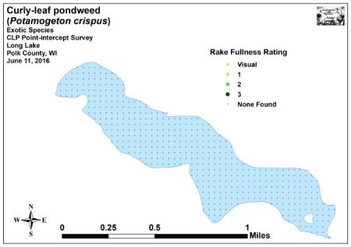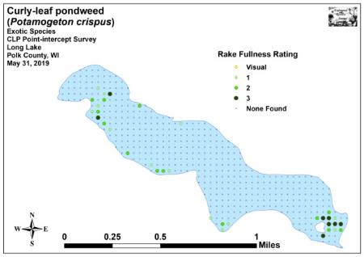
Figure 3: 2016 and 2019 Early-season Curly-leaf Pondweed
Density and Distribution

Comparison of Curly-leaf Pondweed in 2016 and 2019:
Following a 35 acre herbicide treatment in May 2016 (12.9% of the lake’s surface area), it appeared that a whole lake treatment was achieved as our June 11, 2016 survey did not find Curly-leaf pondweed present in the rake at any point (Figure 3) (Appendix III). This was similar to the May 22, 2012 CLP point-intercept survey when we found CLP at a single point following a 58 acre herbicide treatment (21.3% of the lake’s surface area).

No herbicide treatments occurred in 2018 or 2019. Because of this, it was not surprising that, compared to 2016, our 2019 survey represented a highly significant increase (p<0.001) in density, distribution, and rake fullness 2 and 1; and a moderately significant increase (p=0.004) in rake fullness 3 (Figure 4). However, when compared to pretreatment levels in 2010 when CLP was present at 90 points (19.9% of the lake’s surface area) and 64 points had a rake fullness of 2 or 3 (14.1% significant infestation), our 2019 results demonstrated highly significant long term declines (p<0.001) in total CLP distribution and rake fullness 3; a moderately significant decline (p=0.003) in rake fullness 2; and a significant decline (p=0.03) in rake fullness 1. Collectively, the 2019 results suggest CLP is still both less widespread and less abundant than it was in 2010.

+**
-***
-*
+***
-***
+***
-***
+***
-***
-*
Significant differences = * p<0.05, ** p<0.01, *** p<0.001

Figure 4: 2010 – 2019 Changes in Early-season CLP Rake Fullness

Curly-leaf Pondweed Bed Mapping Survey:
No bed mapping surveys were conducted from 2010-2014 as there was little canopied Curly-leaf pondweed anywhere in the lake following the herbicide treatments. In 2015, following a spring without treatment, we located and mapped 13 CLP beds totaling 43.21 acres (15.9% of the lake’s surface area) (Figure 5) (Appendix III). The biggest was 15.79 acres (Bed 1 in the western bay), and the smallest was just 0.09 acre (Bed 8 on the north shoreline midlake) (Table 1). Despite this significant increase, it was still 42.30 acres less than (-49.5%) the original 85.51 acres (31.4% of the lake’s surface area) mapped by Barr Engineering in 2009 prior to the beginning of the expanded treatment program.

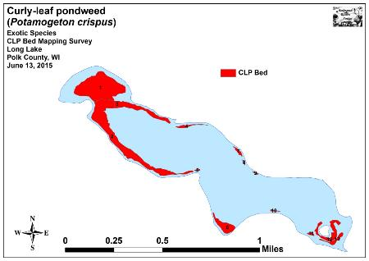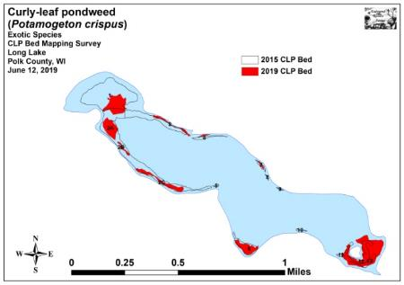
Figure 5: 2015 and 2019 Early-season Curly-leaf Pondweed Beds
Following a return to chemical treatment in 2016, our June survey found there was no canopied CLP left anywhere in the lake. No bed mapping surveys occurred in 2017 or 2018, but our 2019 survey located nine beds totaling 22.25 acres (8.2% of the lake’s surface area) (Table 1). The biggest was 9.28 acres (southeast bay) and the smallest was 0.18 acre (Bed 4). Despite only two years of active management from 2015-2019, this represented a 20.96 acre decline (-48.5%) from the 2015 survey. It was also 63.26 acres less than (-74.0%) the 2009 Barr survey (Figure 5) (Appendix III).

Descriptions of Past and Present Curly-leaf Pondweed Beds:
Bed 1 – The bed in the lake’s northwest bay was canopied and moderately dense, but it was also mixed with native species – especially Coontail (Ceratophyllum demersum) and Common waterweed (Elodea canadensis). Although residents were keeping navigation lanes open, it appeared to be with some effort.

Bed 2 (2A/2B/2C) – This formerly solid bed was patchy with most deepwater areas having low density CLP that was just below the surface and likely nothing more than a minor impairment. However, in the northwest corner of the bed, canopied plants were likely causing at least moderate impairment. The gap between Beds 2A and 2B appeared to be made by residents regularly using the same channel to access open water.

Beds 3 and 4 – Similar to other CLP beds established over sand and rock, these low-density areas were likely little more than a minor impairment. The narrowness of the beds also helped residents access open water, and we noted regular boat traffic in/out of docking areas appeared to be keeping channels open.

Bed 5 – We saw almost no CLP in this former small bed off the lake’s south-central point.

Bed 6 – The bed in the south-central bay would have likely cause moderate impairment if boaters tried to go straight through its center. Fortunately, lower density areas over sand and rock along the east and west shorelines seemed to offer residents reasonable navigation channels to access open water.

Bed 7 – This bed was established over sand and rock along a relatively undeveloped shoreline area. A narrow low-density strip, it likely wasn’t more than a minor impairment.

Beds 8-10 – We found almost no CLP in these former low-density beds. Even if there had been CLP present, the narrowness of the littoral zone along this shoreline would likely have made them a non-issue.

Beds 11-13 – These three areas merged into a single super cluster in 2019, and CLP, along with native vegetation, likely produced moderate impairment. Despite this challenge for shoreline owners, the tendency for boaters to motor along the same path was keeping a reasonable navigation channel open around the island.

Table 1: CLP Bed Summary
Long Lake, Polk County - June 13, 2015 and June 12, 2019

Bed Number | 2019  Acreage | 2015  Acreage | 2019  Acreage Change | 2019  Rake Range | 2019  Mean  Rake Fullness | 2019 Range and Mean  Depth of CLP | 2019 Canopied | 2019 Potential Navigation Impairment  Level
1 | 4.28 | 15.79 | -11.51 | <1-3 | 2 | 4-9; 7 | Near | Moderate
2 (Merged) | 5.26 | 15.13 | -9.87 | --- | --- | --- | --- | ---
2A | 2.69 | Merged | --- | <1-3 | 2 | 5-10; 8 | Yes | Moderate
2B | 0.45 | Merged | --- | <1-2 | 1 | 6-10; 8 | No | Minor
2C | 2.12 | Merged | --- | <1-2 | 1 | 5-10; 8 | No | Minor
3 | 0.86 | 4.15 | -3.29 | <1-2 | 1 | 3-8; 6 | Near | Minor
4 | 0.18 | 0.63 | -0.45 | <1-2 | 1 | 4-9; 7 | Near | Minor
5 | 0.00 | 0.10 | -0.10 | <<<1 | --- | --- | --- | None
6 | 2.19 | 2.63 | -0.44 | <1-3 | 2 | 4-12; 9 | Near | Moderate
7 | 0.20 | 0.41 | -0.21 | <1-2 | 1 | 4-9; 7 | Near | Minor
8 | 0.00 | 0.09 | -0.09 | <<<1 | --- | --- | --- | None
9 | 0.00 | 0.10 | -0.10 | <<<1 | --- | --- | --- | None
10 | 0.00 | 0.14 | -0.14 | <<<1 | --- | --- | --- | None
11-13 (Merged) | 9.28 | 4.04 | 5.24 | <1-3 | 2 | 4-9; 7 | Near | Moderate
11 | Merged | 0.24 | --- | --- | --- | --- | --- | ---
12 | Merged | 2.79 | --- | --- | --- | --- | --- | ---
13 | Merged | 1.01 | --- | --- | --- | --- | --- | ---
Total Acres | 22.25 | 43.21 | -20.96

Warm-water Full Point-intercept Macrophyte Survey:
Depth readings taken at Long Lake’s 453 survey points (Appendix I) revealed both the northwest and southwest bays were shallow flats that dropped off gradually until they reached the central basin. Around this basin, the north and south shorelines fell rapidly into 12-16ft of water on the western half of the lake and 16-21ft on the eastern half (Figure 6). Analysis of the 2019 depth data suggested lake levels increased approximately 1.3ft relative to the 2016 survey (Appendix IV).

We characterized the lake’s substrate as 51.7% muck and sandy muck (234 points), 39.5% pure sand (179 points), and 8.8% rock (40 points). Nutrient-rich organic muck dominated the northwest, southeast and southern bay midlake while the central basin was a combination of sandy muck on the lake’s western half that trended toward pure sand on the eastern half. Sand also dominated the shoreline around the central basin with areas of cobble and gravel primarily located around points, and north and west of the lake’s eastern island (Figure 6) (Appendix IV).

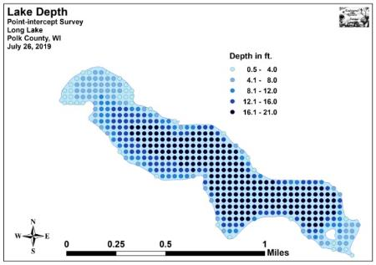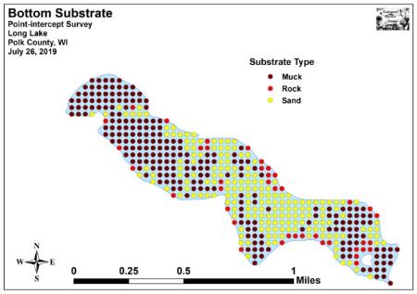
Figure 6: Lake Depth and Bottom Substrate

At the time of the survey, Secchi disc readings were in the 7-8ft range. This fair water clarity produced a littoral zone that extended to 16.0ft and included 240 of the lake’s 453 survey points (Table 2). This was a non-significant decline (p=0.50) compared to the 250 littoral points in 2016’s 15.0ft littoral zone (Figure 7) (Appendix V).

We found plants at 160 points (35.3% of the bottom and 66.7% of the littoral zone). This was a non-significant increase (p=0.58) over the 2016 survey when plants were present at 152 points (33.6% of the bottom and 60.8% of the littoral zone). It also represents a continued increase and the highest number of points with plants of any of the five surveys (119 points in 2010/129 points in 2011/142 points in 2012).

Growth in 2019 was slightly skewed to deep water as the mean plant depth of 7.3ft was more than the median depth of 6.5ft. Both of these values were higher than in 2016 when the mean was 5.6ft and the median was 4.5ft (Figure 8). They were also higher than any other survey dating back to 2010 suggesting that vegetation is spreading back into deeper water.
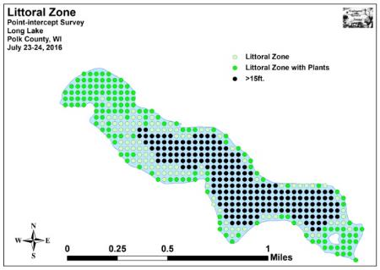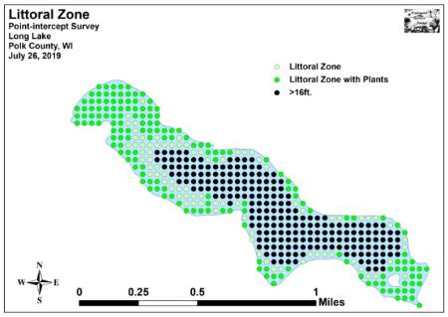
Figure 7: 2016 and 2019 Littoral Zone

Figure 8: 2016 and 2019 Plant Colonization Depth Chart

Table 2: Aquatic Macrophyte P/I Survey Summary Statistics
Long Lake, Polk County
July 24-25, 2010, July 25, 2011, July 27-28, 2012,
July 23-24, 2016, and July 26, 2019

Summary Statistics: | 2010 | 2011 | 2012 | 2016 | 2019
Total # of points sampled | 249 | 231 | 453 | 453 | 453
Total # of sites with vegetation | 119 | 129 | 142 | 152 | 160
Total # of sites shallower than the max. depth of plants | 237 | 176 | 181 | 250 | 240
Freq. of occur. at sites shallower than max. depth of plants | 50.2 | 73.3 | 78.5 | 60.8 | 66.7
Simpson Diversity Index | 0.85 | 0.89 | 0.88 | 0.87 | 0.90
Maximum depth of plants (ft) | 14.0 | 11.5 | 10.5 | 15.0 | 16.0
Mean depth of plants (ft) | 3.6 | 4.4 | 4.3 | 5.6 | 7.3
Median depth of plants (ft) | 3.5 | 4.0 | 4.0 | 4.5 | 6.5
Ave. # of all species per site (shallower than max depth) | 1.50 | 2.18 | 2.55 | 1.60 | 2.18
Ave. # of all species per site (veg. sites only) | 2.99 | 2.98 | 3.25 | 2.63 | 3.27
Ave. # of native species per site (shallower than max depth) | 1.47 | 2.06 | 2.55 | 1.58 | 2.10
Ave. # of native species per site (sites with native veg. only) | 2.92 | 2.93 | 3.25 | 2.59 | 3.15
Species richness | 17 | 18 | 17 | 23 | 20
Species richness (including visuals) | 17 | 18 | 17 | 24 | 23
Species richness (including visuals and boat survey) | 17 | 18 | 18 | 27 | 25
Mean total rake fullness (veg. sites only) | 2.16 | 2.38 | 2.15 | 1.93 | 2.05

Plant diversity was high in 2019 with a Simpson Index value of 0.90 – up from 0.87 in 2016. Total richness was low with 20 species found in the rake – down from 23 in 2016. This total increased to 25 species when including visuals and plants seen during the boat survey – also down from 27 in 2016. Most of the species seen in 2016 that were absent in 2019 were emergents that likely disappeared in response to rising water levels.

Mean native species richness at sites with native vegetation was 3.15 species/site in 2019 (Figure 9) (Appendix V). This was a moderately significant increase (p=0.006) from 2.59 native species/site in 2016.

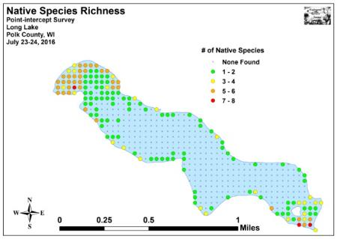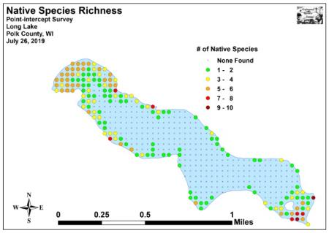
Figure 9: 2016 and 2019 Native Species Richness

Total rake fullness experienced a nearly significant increase (p=0.10) from a moderate 1.93 in 2016 to a moderate 2.05 in 2019. Visual analysis of the maps showed this average increase was primarily due to expansion along the southwest and northwest shorelines and, to a lesser extent, in the southeast bay (Figure 10) (Appendix V).

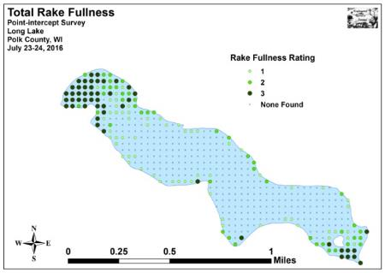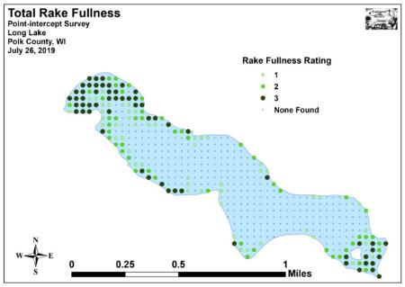
Figure 10: 2016 and 2019 Total Rake Fullness

Long Lake Plant Community:
The Long Lake ecosystem is home to a diverse plant community that is typical of high-nutrient lakes with fair to poor water clarity. This community can be subdivided into four distinct zones (emergent, shallow submergent, floating-leaf, and deep submergent) with each zone having its own characteristic functions in the aquatic ecosystem. Depending on the local bottom type (sand, sandy muck, or nutrient-rich organic muck), these zones often had somewhat different species present.

In shallow areas, beds of emergent plants prevent erosion by stabilizing the lakeshore, break up wave action, provide a nursery for baitfish and juvenile gamefish, offer shelter for amphibians, and give waterfowl and predatory wading birds like herons a place to hunt. These areas also provide important habitat for invertebrates like dragonflies and mayflies.

Exposed sandy and rocky shorelines around the lake’s central basin had few emergents other than Reed canary grass (Phalaris arundinacea). In organic and sandy-muck areas encircling the lake’s northwest and southeast bays, we found scattered patches of Softstem bulrush (Schoenoplectus tabernaemontani) and Common bur-reed (Sparganium eurycarpum), and dense stands of Hybrid cattail (Typha X glauca).

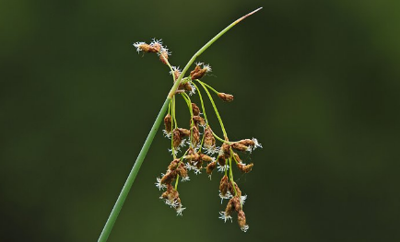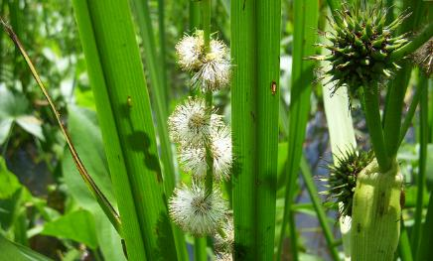
Softstem bulrush (Schwarz 2011) Common bur-reed (Raymond 2011)
Just beyond the emergents, in sheltered muck-bottomed areas in up to 4ft of water, the floating-leaf species White-water lily (Nymphaea odorata) was common throughout the lake’s bays. The canopy cover it provides is often utilized by panfish and bass for protection.

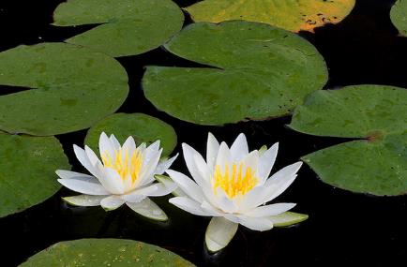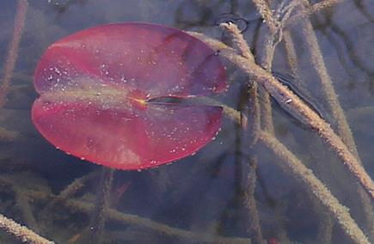
White water lily (Falkner 2012) Early growing lily pad showing typical red color (Raymond 2019)

Growing between gaps in the lilypads, we also frequently encountered the submergent species Coontail, Common waterweed, and Curly-leaf pondweed. In addition to these plants, a large number of “duckweeds” were found floating amongst the lilypads and emergents. Forked duckweed (Lemna trisulca) was the most widely distributed species in this group, and we documented it throughout the lake’s littoral zone. Large duckweed (Spirodela polyrhiza), Small duckweed (Lemna minor), and Common watermeal (Wolffia columbiana) were also common, but they tended to be more restricted to shallow sheltered areas. Along with the duckweeds in the northwest bay, we also documented a limited number of the aquatic liverwort Slender riccia (Riccia fluitans) and the carnivorous Common bladderwort (Utricularia vulgaris) floating among the lilypads. Rather than drawing nutrients up through roots like other macrophytes, bladderworts trap zooplankton and minute insects in their bladders, digest their prey, and use the nutrients to further their growth.

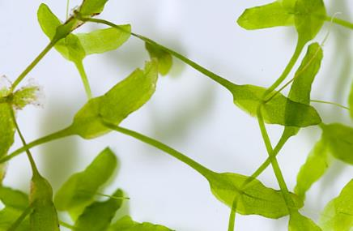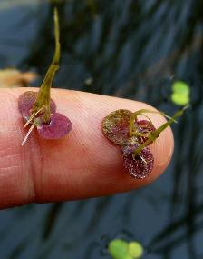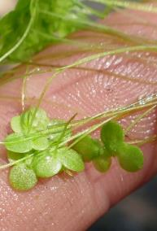
Forked duckweed (Curtis 2010) Large duckweed (Thomas 2014) and Small duckweed (Kramer 2013)

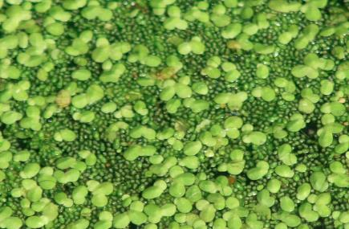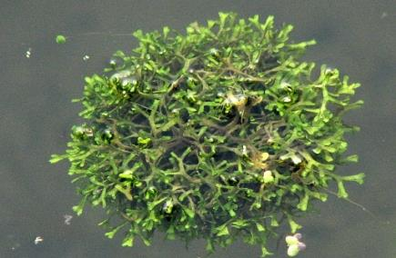
Small duckweed and Common watermeal (Kieron 2010) Slender riccia (Barth 2016)

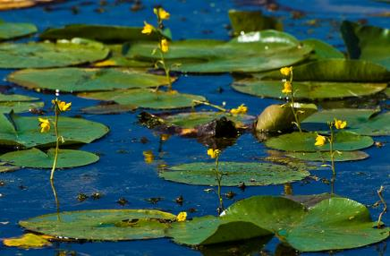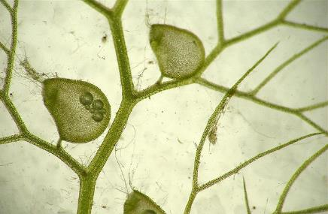
Common bladderwort flowers among lilypads (Hunt, 2010) Bladders for catching plankton and insect larvae (Wontolla, 2007)

Shallow rocky areas were almost entirely devoid of plants. However, in areas with at least some sand, in water up to 5ft deep, we noted the macrophyte community was dominated by submergent species like Muskgrass (Chara sp.), Needle spikerush (Eleocharis acicularis), Slender naiad (Najas flexilis), and Grass-leaved arrowhead (Sagittaria graminea). These fine-leaved plants tend to form a carpet that stabilizes the bottom.

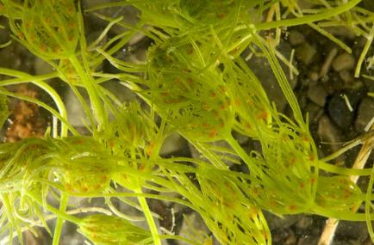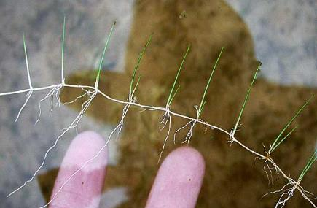
Muskgrass (Gibbons 2012) Needle spikerush (Fewless 2005)

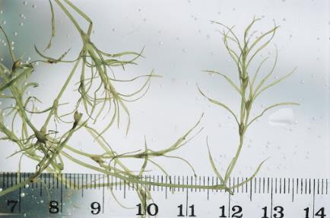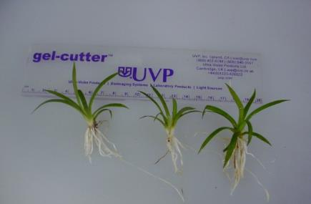
Slender naiad (Koshere 2002) Grass-leaved arrowhead (USDA 2012)

Shallow sandy-muck areas tended to support slightly broader-leaved species like Water star-grass (Heteranthera dubia) and Northern Water-milfoil (Myriophyllum sibiricum). In this environment, we also found limited numbers of Leafy pondweed (Potamogeton foliosus), Clasping-leaf pondweed (Potamogeton richardsonii), Sago pondweed (Stuckenia pectinata), and Wild celery (Vallisneria americana). The roots, shoots, and seeds of these plants are heavily utilized by waterfowl for food. They also provide important habitat for the lake’s fish throughout their lifecycles, as well as a myriad of invertebrates like scuds, dragonfly and mayfly nymphs, and snails.

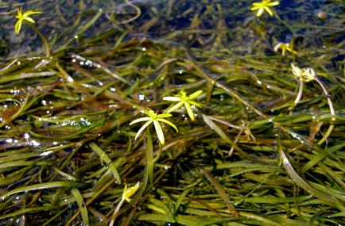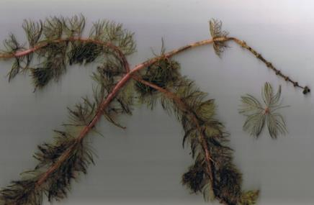
Water star-grass (Mueller 2009) Northern water-milfoil (Berg 2007)

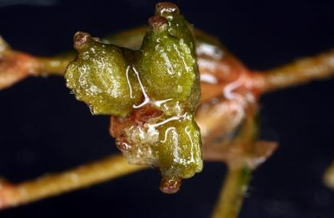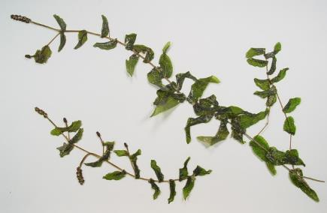
Keeled nutlets of Leafy pondweed (Kleinman 2009) Clasping-leaf pondweed (Cameron 2013)

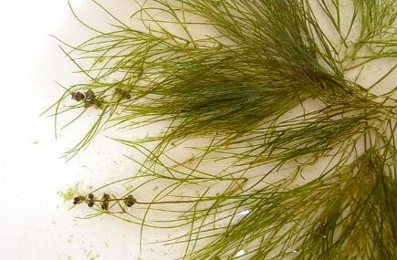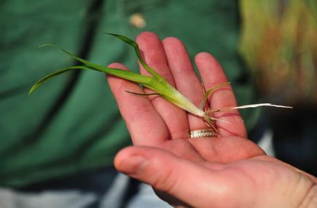
Sago pondweed (Hilty 2012) Wild celery (Dalvi 2009)

Organic and sandy-muck areas in water greater than 5ft were dominated by the submergent species Coontail, Common waterweed, Northern water-milfoil, Nitella (Nitella sp.), Small pondweed (Potamogeton pusillus berchtoldii), and, especially in the spring, Curly-leaf pondweed. Predatory fish like the lake’s pike are often found along the edges of these deep beds waiting in ambush.

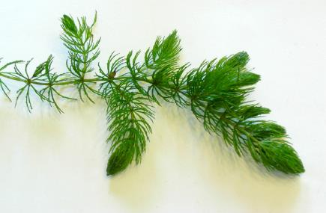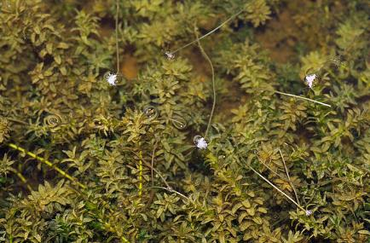
Coontail (Hassler 2011) Common waterweed (Fischer 2009)

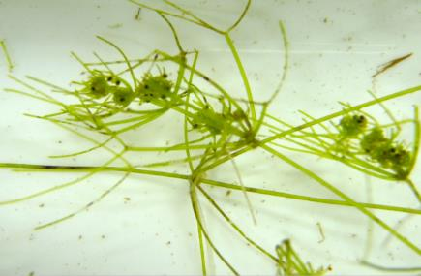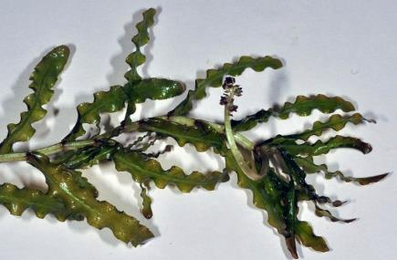
Nitella (USGS 2012) Curly-leaf pondweed (USGS 2016)

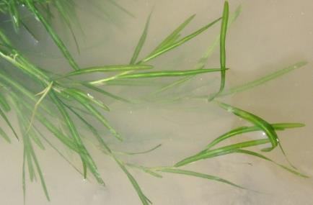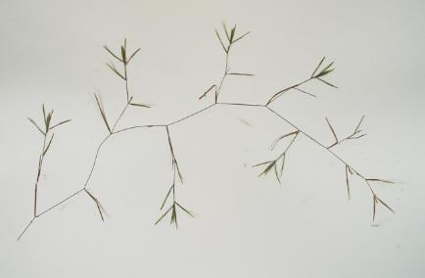
Small pondweed (Villa 2011) Small pondweed turions (Cameron 2019)

Comparison of Native Macrophyte Species in 2016 and 2019:
In July 2016, we documented Coontail, White water lily, Small duckweed, and Large duckweed as the most common species (Table 3). Present at 74.34%, 30.92%, 25.66%, and 25.66% of sites with vegetation, they accounted for 59.50% of the total relative frequency. Common watermeal (8.75%), Common waterweed (7.00%), Forked duckweed (5.50%), and Slender naiad (4.75%) were the only other species that had relative frequencies over 4.0% (Density and distribution maps for all native plant species found in 2016 and survey data from all previous surveys can be found in the CD attached to this report).

During our July 2019 survey, Coontail, Small pondweed, Small duckweed, and Large duckweed were the most common species. They were found at 70.00%, 33.13%, 28.75%, and 28.13% of sites with vegetation (Table 4). Collectively, they captured 48.95% of the total relative frequency. Common watermeal (8.60%), Common waterweed (8.03%), White water lily (8.03%), Northern water-milfoil (7.07%), and Forked duckweed (4.02%) also had relative frequencies over 4.0% (Density and distribution maps for all native plant species found in 2019 are located in Appendix VI).

Lakewide, seven species showed significant changes in distribution from 2016 to 2019 (Figure 11). Northern water-milfoil and Small pondweed enjoyed highly significant increases; Curly-leaf pondweed and Leafy pondweed saw moderately significant increases; and filamentous algae experienced a significant increase. Conversely, Nitella and Hybrid cattail suffered significant declines.
+**
+***
+***
+**
-*
-*
+*
Significant differences = * p<0.05, ** p<0.01, *** p<0.001
Figure 11: Macrophytes Showing Significant Changes from 2016-2019

Table 3: Frequencies and Mean Rake Sample of Aquatic Macrophytes
Long Lake, Polk County
July 23-24, 2016

Species | Common Name | Total  Sites | Relative Freq. | Freq. in Veg. | Freq. in Lit. | Mean Rake | Visual  Sight.
Ceratophyllum demersum | Coontail | 113 | 28.25 | 74.34 | 45.20 | 1.59 | 3
 | Filamentous algae | 83 | * | 54.61 | 33.20 | 1.28 | 1
Nymphaea odorata | White water lily | 47 | 11.75 | 30.92 | 18.80 | 2.45 | 6
Lemna minor | Small duckweed | 39 | 9.75 | 25.66 | 15.60 | 1.67 | 0
Spirodela polyrhiza | Large duckweed | 39 | 9.75 | 25.66 | 15.60 | 1.62 | 0
Wolffia columbiana | Common watermeal | 35 | 8.75 | 23.03 | 14.00 | 1.43 | 0
Elodea canadensis | Common waterweed | 28 | 7.00 | 18.42 | 11.20 | 1.68 | 0
Lemna trisulca | Forked duckweed | 22 | 5.50 | 14.47 | 8.80 | 1.14 | 0
Najas flexilis | Slender naiad | 19 | 4.75 | 12.50 | 7.60 | 1.32 | 1
Heteranthera dubia | Water star-grass | 10 | 2.50 | 6.58 | 4.00 | 1.10 | 0
Chara sp. | Muskgrass | 7 | 1.75 | 4.61 | 2.80 | 1.43 | 0
Nitella sp. | Nitella | 7 | 1.75 | 4.61 | 2.80 | 1.43 | 1
Typha X glauca | Hybrid cattail | 7 | 1.75 | 4.61 | 2.80 | 2.57 | 6
Eleocharis acicularis | Needle spikerush | 5 | 1.25 | 3.29 | 2.00 | 1.00 | 0
Potamogeton crispus | Curly-leaf pondweed | 5 | 1.25 | 3.29 | 2.00 | 1.00 | 4
Sparganium eurycarpum | Common bur-reed | 5 | 1.25 | 3.29 | 2.00 | 2.20 | 3
Myriophyllum sibiricum | Northern water-milfoil | 3 | 0.75 | 1.97 | 1.20 | 1.00 | 2
Potamogeton foliosus | Leafy pondweed | 2 | 0.50 | 1.32 | 0.80 | 1.00 | 0
Riccia fluitans | Slender riccia | 2 | * | 1.32 | 0.80 | 1.00 | 2
Schoenoplectus tabernaemontani | Softstem bulrush | 2 | 0.50 | 1.32 | 0.80 | 2.00 | 3

*Excluded from relative frequency analysis

Table 3 (cont’): Frequencies and Mean Rake Sample of Aquatic Macrophytes
Long Lake, Polk County
July 23-24, 2016

Species | Common Name | Total  Sites | Relative Freq. | Freq. in Veg. | Freq. in Lit. | Mean Rake | Visual  Sight.
Carex comosa | Bottle brush sedge | 1 | 0.25 | 0.66 | 0.40 | 1.00 | 0
Juncus effusus | Common rush | 1 | 0.25 | 0.66 | 0.40 | 1.00 | 0
Phalaris arundinacea | Reed canary grass | 1 | 0.25 | 0.66 | 0.40 | 1.00 | 4
Sagittaria graminea | Grass-leaved arrowhead | 1 | 0.25 | 0.66 | 0.40 | 1.00 | 1
Typha latifolia | Broad-leaved cattail | 1 | 0.25 | 0.66 | 0.40 | 2.00 | 2
Potamogeton pusillus | Small pondweed | ** | ** | ** | ** | ** | 1
Sagittaria latifolia | Common arrowhead | *** | *** | *** | *** | *** | ***
Utricularia vulgaris | Common bladderwort | *** | *** | *** | *** | *** | ***
Vallisneria americana | Wild celery | *** | *** | *** | *** | *** | ***

** Visual only *** Boat survey only
Table 4: Frequencies and Mean Rake Sample of Aquatic Macrophytes
Long Lake, Polk County
July 26, 2019

Species | Common Name | Total  Sites | Relative Freq. | Freq. in Veg. | Freq. in Lit. | Mean Rake | Visual  Sight.
Ceratophyllum demersum | Coontail | 112 | 21.41 | 70.00 | 46.67 | 1.82 | 2
 | Filamentous algae | 107 | * | 66.88 | 44.58 | 1.51 | 0
Potamogeton pusillus | Small pondweed | 53 | 10.13 | 33.13 | 22.08 | 1.49 | 2
Lemna minor | Small duckweed | 46 | 8.80 | 28.75 | 19.17 | 1.48 | 1
Spirodela polyrhiza | Large duckweed | 45 | 8.60 | 28.13 | 18.75 | 1.87 | 1
Wolffia columbiana | Common watermeal | 45 | 8.60 | 28.13 | 18.75 | 1.49 | 1
Elodea canadensis | Common waterweed | 42 | 8.03 | 26.25 | 17.50 | 1.26 | 1
Nymphaea odorata | White water lily | 42 | 8.03 | 26.25 | 17.50 | 2.02 | 7
Myriophyllum sibiricum | Northern water-milfoil | 37 | 7.07 | 23.13 | 15.42 | 1.46 | 9
Lemna trisulca | Forked duckweed | 21 | 4.02 | 13.13 | 8.75 | 1.00 | 1
Potamogeton crispus | Curly-leaf pondweed | 19 | 3.63 | 11.88 | 7.92 | 1.11 | 7
Najas flexilis | Slender naiad | 18 | 3.44 | 11.25 | 7.50 | 1.89 | 0
Potamogeton foliosus | Leafy pondweed | 12 | 2.29 | 7.50 | 5.00 | 1.33 | 0
Chara sp. | Muskgrass | 9 | 1.72 | 5.63 | 3.75 | 1.22 | 0
Heteranthera dubia | Water star-grass | 8 | 1.53 | 5.00 | 3.33 | 1.00 | 2
Eleocharis acicularis | Needle spikerush | 7 | 1.34 | 4.38 | 2.92 | 1.29 | 0
Sagittaria graminea | Grass-leaved arrowhead | 2 | 0.38 | 1.25 | 0.83 | 1.50 | 0
Stuckenia pectinata | Sago pondweed | 2 | 0.38 | 1.25 | 0.83 | 1.00 | 0
Nitella sp. | Nitella | 1 | 0.19 | 0.63 | 0.42 | 1.00 | 0
Riccia fluitans | Slender riccia | 1 | * | 0.63 | 0.42 | 1.00 | 0
Typha X glauca | Hybrid cattail | 1 | 0.19 | 0.63 | 0.42 | 3.00 | 3
Utricularia vulgaris | Common bladderwort | 1 | 0.19 | 0.63 | 0.42 | 2.00 | 0

*Excluded from relative frequency analysis

Table 4 (cont’): Frequencies and Mean Rake Sample of Aquatic Macrophytes
Long Lake, Polk County
July 26, 2019

Species | Common Name | Total  Sites | Relative Freq. | Freq. in Veg. | Freq. in Lit. | Mean Rake | Visual  Sight.
Phalaris arundinacea | Reed canary grass | ** | ** | ** | ** | ** | 1
Schoenoplectus tabernaemontani | Softstem bulrush | ** | ** | ** | ** | ** | 1
Sparganium eurycarpum | Common bur-reed | ** | ** | ** | ** | ** | 1
Potamogeton richardsonii | Clasping-leaf pondweed | *** | *** | *** | *** | *** | ***
Vallisneria americana | Wild celery | *** | *** | *** | *** | *** | ***

** Visual only *** Boat survey only
Coontail, the most common species in both 2016 (113 sites) and 2019 (112 sites), was almost unchanged in distribution. However, there was a significant increase (p=0.01) in mean rake fullness from 1.59 in 2016 to 1.82 in 2019. The majority of this expansion occurred in shallow areas of the northwest bay and along the southwestern shoreline (Figure 12).

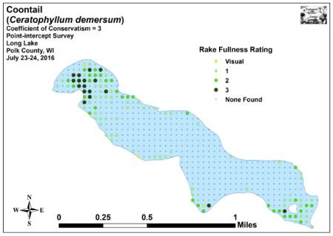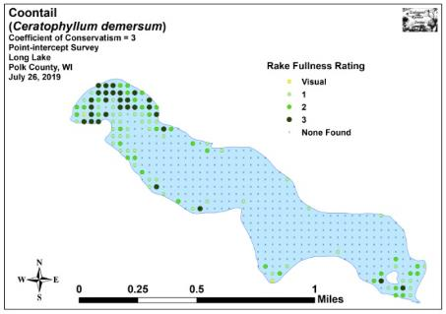
Figure 12: 2016 and 2019 Coontail Density and Distribution

Prior to 2016, we had never seen Small pondweed in the lake. During the July 2016 survey, we documented it as a visual at a single point and noted just a handful of additional plants in the southeast bay. By 2019, this species had undergone a highly significant increase (p<0.001) in distribution (53 points) and density (mean rake fullness of 1.49) to become the second most common species. Visual analysis of the maps showed it had expanded into deep water just outside the northwest bay in areas formerly dominated by Curly-leaf pondweed. It was also common to abundant in the southeast bay (Figure 13).

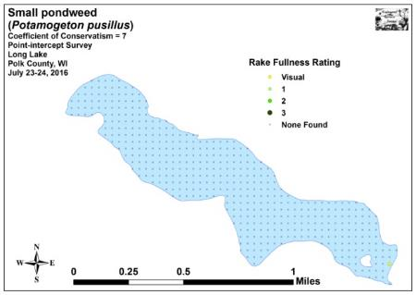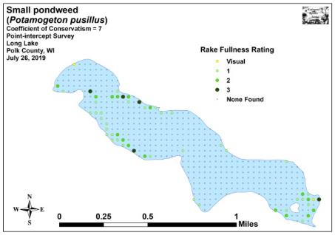
Figure 13: 2016 and 2019 Small Pondweed Density and Distribution

White water lily was the second most common species in 2016 (47 sites) and tied as the sixth most common in 2019 (42 sites) (Figure 14). Although this was a non-significant decline (p=0.36) in distribution, its decline in density from a mean rake fullness of 2.45 in 2016 to a mean rake of 2.02 in 2019 was moderately significant (p=0.006).

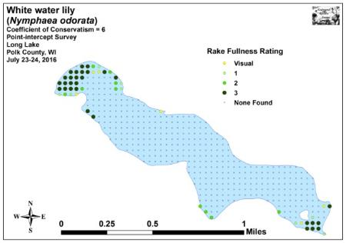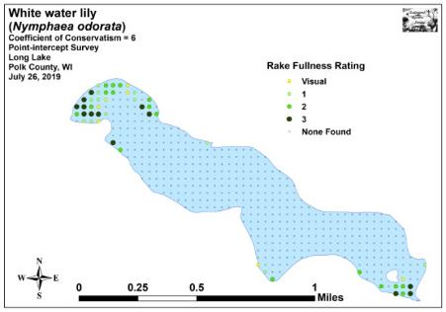
Figure 14: 2016 and 2019 White Water Lily Density and Distribution

Common waterweed (the sixth most common species in each survey) underwent a nearly significant increase (p=0.10) in distribution from 28 sites in 2016 to 42 sites in 2019 (Figure 15). Conversely, low density expansion in deep water coupled with a decline in shallow areas produced a moderately significant decline (p=0.006) in mean rake fullness from 1.68 in 2016 to 1.26 in 2019.

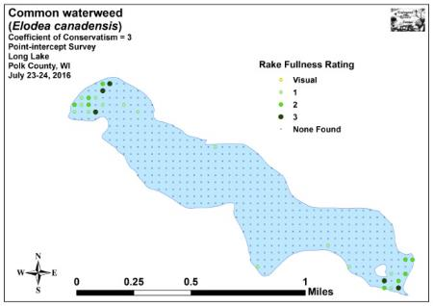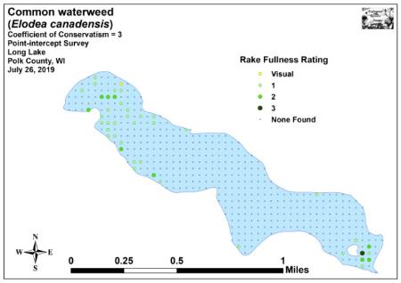
Figure 15: 2016 and 2019 Common Waterweed Density and Distribution

After nearly disappearing from the lake in the early 2010’s, Northern water-milfoil experienced highly significant increases (p<0.001) in both distribution (three sites in 2016/37 in 2019) and density (mean rake fullness 1.00 in 2016/1.46 in 2019) (Figure 16). An important habitat producing plant, it dominated much of the southeast bay in areas formerly occupied by dense Curly-leaf pondweed in the spring and Coontail in the summer.

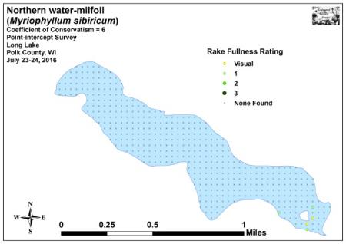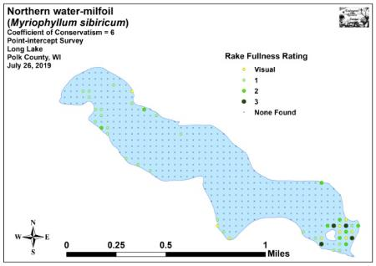
Figure 16: 2016 and 2019 Northern Water-milfoil
Density and Distribution

Comparison of Floristic Quality Indexes in 2016 and 2019:
In 2016, we found 21 native index species in the rake during the point-intercept survey (Table 5). They produced a mean Coefficient of Conservatism of 5.1 and a Floristic Quality Index of 23.3.

Table 5: Floristic Quality Index of Aquatic Macrophytes
Long Lake, Polk County
July 23-24, 2016

Species | Common Name | C
Carex comosa | Bottle brush sedge | 5
Ceratophyllum demersum | Coontail | 3
Chara sp. | Muskgrass | 7
Eleocharis acicularis | Needle spikerush | 5
Elodea canadensis | Common waterweed | 3
Heteranthera dubia | Water star-grass | 6
Lemna minor | Small duckweed | 4
Lemna trisulca | Forked duckweed | 6
Myriophyllum sibiricum | Northern water-milfoil | 6
Najas flexilis | Slender naiad | 6
Nitella sp. | Nitella | 7
Nymphaea odorata | White water lily | 6
Potamogeton foliosus | Leafy pondweed | 6
Riccia fluitans | Slender riccia | 7
Sagittaria graminea | Grass-leaved arrowhead | 9
Schoenoplectus tabernaemontani | Softstem bulrush | 4
Sparganium eurycarpum | Common bur-reed | 5
Spirodela polyrhiza | Large duckweed | 5
Typha latifolia | Broad-leaved cattail | 1
Typha X glauca | Hybrid cattail | 1
Wolffia columbiana | Common watermeal | 5
N |  | 21
Mean C |  | 5.1
FQI |  | 23.3

During the 2019 survey, we found a total of 20 native index species in the rake during the point-intercept survey. They produced a mean Coefficient of Conservatism of 5.5 and a Floristic Quality Index of 24.4 (Table 6). All of these values were similar to 2016 totals. They were, however, higher than the values found during any of the other previous surveys (16 species/Mean C 4.8/FQI 19.0 in 2012; 17 species/Mean C 5.2/FQI 21.3 in 2011; 16 species/Mean C 5.3/FQI 21.3 in 2010). Nichols (1999) reported an average mean C for the North Central Hardwood Forests Region of 5.6 putting Long Lake just below average for this part of the state. The FQI was, however, above the median FQI of 20.9 for the North Central Hardwood Forests (Nichols 1999).

Table 6: Floristic Quality Index of Aquatic Macrophytes
Long Lake, Polk County
July 26, 2019

Species | Common Name | C
Ceratophyllum demersum | Coontail | 3
Chara sp. | Muskgrass | 7
Eleocharis acicularis | Needle spikerush | 5
Elodea canadensis | Common waterweed | 3
Heteranthera dubia | Water star-grass | 6
Lemna minor | Small duckweed | 4
Lemna trisulca | Forked duckweed | 6
Myriophyllum sibiricum | Northern water-milfoil | 6
Najas flexilis | Slender naiad | 6
Nitella sp. | Nitella | 7
Nymphaea odorata | White water lily | 6
Potamogeton foliosus | Leafy pondweed | 6
Potamogeton pusillus | Small pondweed | 7
Riccia fluitans | Slender riccia | 7
Sagittaria graminea | Grass-leaved arrowhead | 9
Spirodela polyrhiza | Large duckweed | 5
Stuckenia pectinata | Sago pondweed | 3
Typha sp. | Hybrid cattail | 1
Utricularia vulgaris | Common bladderwort | 7
Wolffia columbiana | Common watermeal | 5
N |  | 20
Mean C |  | 5.5
FQI |  | 24.4

Comparison of Filamentous Algae in 2016 and 2019:
Filamentous algae, normally associated with excessive nutrients in the water column, underwent a significant increase (p=0.03) in distribution from 83 points in 2016 to 107 points in 2019 (Figure 17). It also saw a moderately significant increase (p=0.003) in density from a mean rake fullness of 1.28 in 2016 to 1.51 in 2019. The majority of these increases occurred along the north and northeast shorelines of the northwest bay where algal mats frequently clogged our motor intakes during the survey.

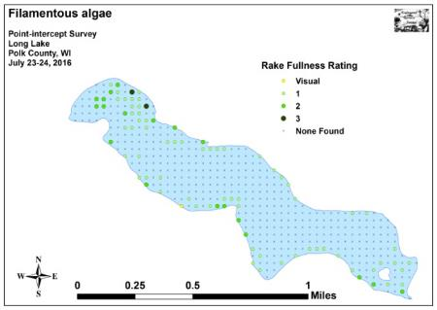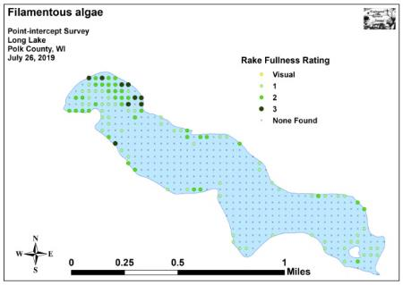
Figure 17: 2016 and 2019 Filamentous Algae Density and Distribution

Comparison of Summer Curly-leaf Pondweed in 2016 and 2019:
Curly-leaf pondweed normally completes its annual life cycle by late June, and most plants have set turions and senesced by early July. During our 2016 survey, CLP was still present at five points (mean rake fullness 1.00). In 2019, we documented it at 19 points with a mean rake fullness of 1.11 (Figure 18). This represented a moderately significant increase (p=0.003) in distribution, but a non-significant increase in density (p=0.08) (Appendix VII).

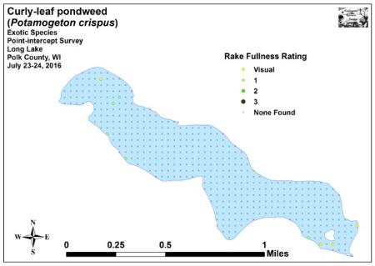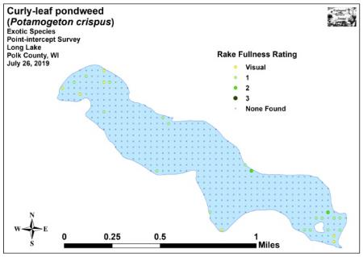
Figure 18: 2016 and 2019 Summer CLP Density and Distribution

Other Exotic Plant Species:
We did NOT find any evidence or Eurasian water-milfoil in Long Lake during any of our surveys. However, in addition to Curly-leaf pondweed, we documented two other exotic species growing around the lake: Reed canary grass (RCG) and Hybrid cattail (HC).

Despite only being recorded as a visual at one point in 2019, RCG occurred throughout in adjacent wetlands and next to mowed or otherwise disturbed shoreline areas (Figure 19). A ubiquitous plant in the state, there’s likely little that can be done about it (For more information on a sampling of aquatic exotic invasive plant species, see Appendix VIII).

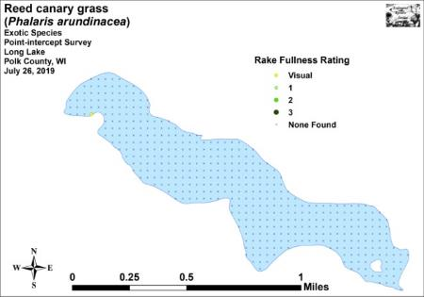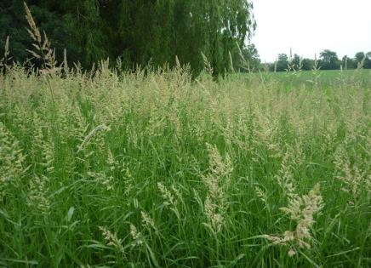
Figure 19: 2019 Reed Canary Grass
Density and Distribution and Inflorescence

Native to southern but not northern Wisconsin, Narrow-leaved cattail and its hybrids with Broad-leaved cattail are becoming increasingly common in northern Wisconsin where they also tend to be invasive. This species suffered a significant decline in distribution (p=0.03) from seven points in 2016 to just one point in 2019 – likely because of rising water levels. Despite this, it now dominates areas around the southeastern island, the lake outlet, and the sunken island in the northwest bay where it appears to have crowded out most other emergent species (Figure 20).

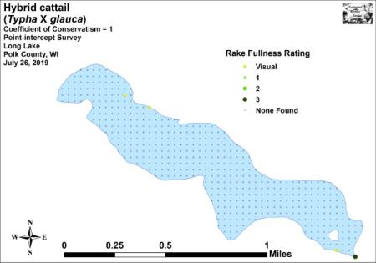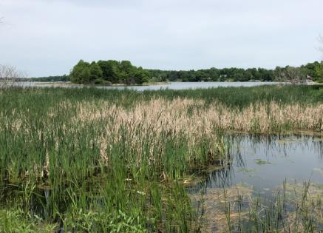
Figure 20: 2019 Hybrid Cattail Density and Distribution
and Stand at the Southeast Outlet
Besides having narrower leaves, the exotics can be told from our native cattails by having a relatively narrower and longer “hotdog-shaped” tan female cattail flower, whereas our native species tends to produce a fatter and shorter “bratwurst-shaped” dark chocolate colored female flower. Narrow-leaved cattail and its hybrids also have a male flower that is separated from the female flower by a thin green stem while the native Broad-leaved cattail has its male and female flowers connected (Figure 21) (Appendix VII).

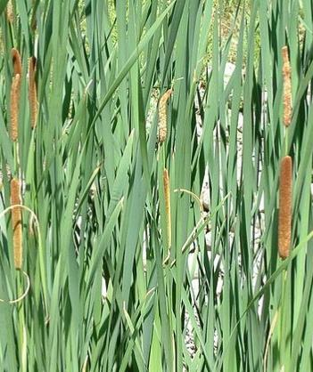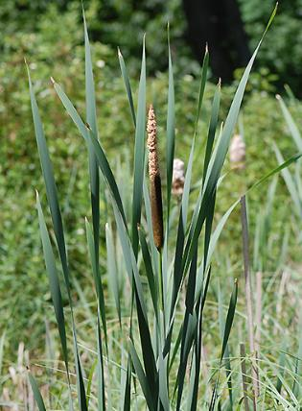
Figure 21: Exotic Hybrid and Native Broad-leaved Cattail Identification

DISCUSSION AND CONSIDERATIONS FOR MANAGEMENT:
Water Clarity and the Role of Native Macrophytes:
Like trees in a forest, a lake’s native plants are the basis of the aquatic ecosystem. They capture the sun’s energy and turn it into usable food, “clean” the water of excess nutrients, and provide habitat for other organisms like aquatic invertebrates and the lake’s fish populations. Because of this, preserving them is critical to maintaining the lake’s overall health.

Over the past ten years, we’ve observed that fluctuations in water clarity and quality appear to be a significant driving factor in native plant growth as well as annual diversity. Specifically, in years where there were major algal blooms, we have found that more sensitive native species tend to have population crashes; conversely, in years with better water clarity, they often carpet the bottom. Unlike Curly-leaf pondweed, most rooted native species have a low growth profile that doesn’t interfere with watercraft navigation, and they are photosynthetic late into the summer meaning they continue to pull nutrients out of the water column after CLP has completed its annual senescence. Unfortunately, when phosphorus and nitrogen levels exceed what the lake’s macrophytes can utilize, it tends to promote the algae blooms which impact these sensitive species as well as general lake esthetics. Hopefully, the alum treatment will improve water clarity and quality, allow these native plants to continue to expand, and promote an environment that Curly-leaf pondweed no longer has a large competitive advantage over these less aggressive native species.

Curly-leaf Pondweed Management:
Past aggressive management of Curly-leaf pondweed in Long Lake has significantly reduced the overall area and density of this exotic invasive species. With improvements in water clarity coupled with a pause in chemical treatments over the last two years, native vegetation has shown an impressive rebound. Many species that were absent in early surveys such as Leafy pondweed, Small pondweed, Clasping-leaf pondweed, and Sago pondweed have colonized the lake and are expanding into areas formerly occupied by CLP. Other non-target species that declined after treatments to the point of being undetectable like Northern water-milfoil – one of the lake’s most important habitat plants – have now firmly reestablished. Many of these newly established natives, especially Leafy and Small pondweed are high sensitive to Endothall and are likely to be severely impacted by future treatments. With that in mind, we continue to encourage the LLPRD to strive for minimal herbicide applications that still meet their CLP management goals.

Eurasian Water-milfoil Prevention:
Eurasian water-milfoil has now expanded into seven lakes in Polk County all of which have public landings and in/out boat traffic. Because of this, we encourage the lake to continue its Clean Boats/Clean Waters program to inspect watercraft. Although there are no guarantees, CBCW monitoring decreases the likelihood that EWM or any other Aquatic Invasive Species will be introduced into the lake.

LITERATURE CITED

Borman, S., R. Korth, and J. Temte 1997. Through the Looking Glass…A Field Guide to Aquatic Plants. Wisconsin Lakes Partnership. DNR publication FH-207-97.

Busch, C., G. Lund, L. Sather, and C. Holt. 1969. Long Lake Map. Available from http://dnr.wi.gov/lakes/maps/DNR/2478200a.pdf (2019, December)

Chadde, Steve W. 2002. A Great Lakes Wetland Flora: A complete guide to the aquatic and wetland plants of the Upper Midwest. Pocketflora Press; 2nd edition

Crow, G. E., C. B. Hellquist. 2009. Aquatic and Wetland Plants of Northeastern North America, Volume I + II: A Revised and Enlarged Edition of Norman C. Fassett's A Manual of Aquatic Plants. University of Wisconsin Press.

Nichols, Stanley A. 1999. Floristic Quality Assessment of Wisconsin Lake Plant communities with Example Applications. Journal of Lake and Reservoir Management 15 (2): 133-141.

Skawinski, Paul. 2018. Aquatic Plants of the Upper Midwest: A photographic field guide to our underwater forests. 3rd Edition, Wausau, WI.

Sullman, Josh. [online] 2010. Sparganium of Wisconsin Identification Key and Description. Available from University of Wisconsin-Madison http://www.botany.wisc.edu/jsulman/Sparganium%20identification%20key%20and%20description.htm (2016, July).

UWEX Lakes Program. [online]. 2010. Pre/Post Herbicide Comparison. Available from http://www.uwsp.edu/cnr-ap/UWEXLakes/Documents/ecology/Aquatic%20Plants/Appendix-D.pdf (2019, November).

Voss, Edward G. 1996. Michigan Flora Vol I-III. Cranbrook Institute of Science and University of Michigan Herbarium.

WDNR. [online]. 2019. Citizen Lake Monitoring Water Quality Data Report for Long Lake. http://dnr.wi.gov/lakes/waterquality/Station.aspx?id=493102 (2019, December)

WDNR. [online]. 2010. Curly-leaf pondweed fact sheet. http://dnr.wi.gov/invasives/fact/curlyleaf_pondweed.htm (2010, August).

WDNR. [online]. 2010. Eurasian Water-milfoil fact sheet. http://dnr.wi.gov/invasives/fact/milfoil.htm (2010, August).

WDNR. [online]. 2019. Lake Information Pages for Long Lake. https://dnr.wi.gov/lakes/lakepages/LakeDetail.aspx?wbic=2478200 (2019, December)

WDNR. [online]. 2010. Purple loosestrife fact sheet. http://dnr.wi.gov/invasives/fact/loosestrife.htm (2010, August).

WDNR. [online]. 2010. Reed canary grass fact sheet. http://dnr.wi.gov/invasives/fact/reed_canary.htm (2010, August).

Appendix I: Survey Sample Points Map
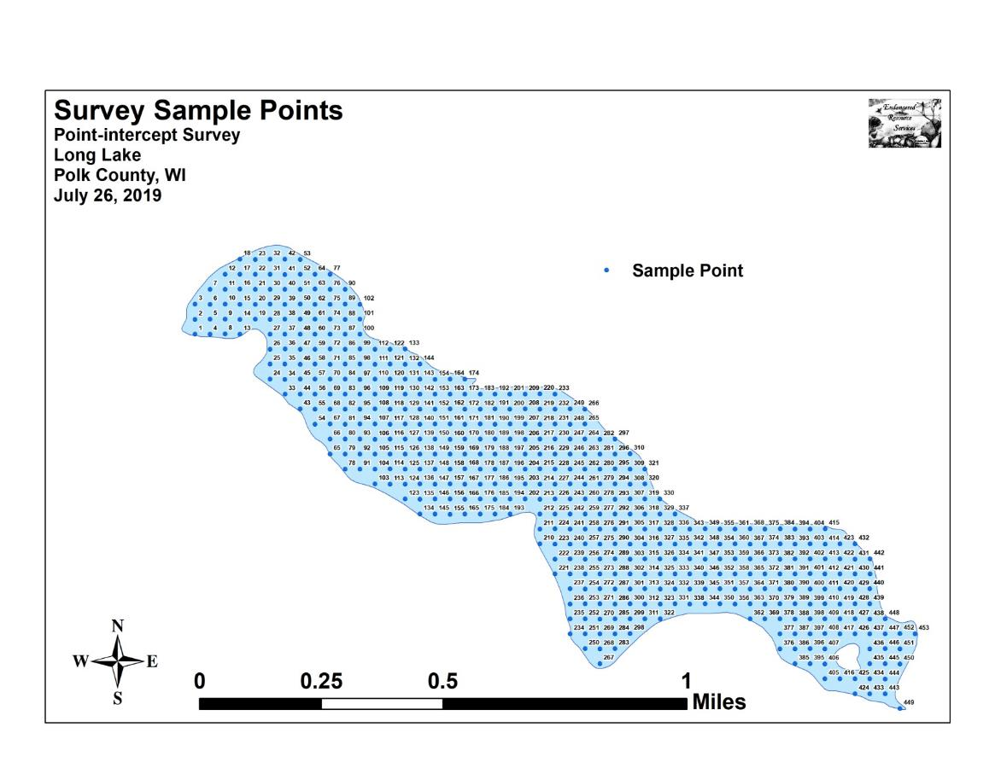

Appendix II: Boat and Vegetative Survey Datasheets

Boat Survey
Lake Name
County
WBIC
Date of Survey
(mm/dd/yy)
workers
Nearest Point | Species seen, habitat information

Observers for this lake: names and hours worked by each:
Lake: |  |  |  |  |  |  |  |  | WBIC |  |  |  |  |  |  |  |  | County |  |  |  |  |  | Date:
Site # | Depth (ft) | Muck (M), Sand (S), Rock (R) | Rake pole (P) or rake rope (R) | Total Rake Fullness | EWM | CLP | 1 | 2 | 3 | 4 | 5 | 6 | 7 | 8 | 9 | 10 | 11 | 12 | 13 | 14 | 15 | 16 | 17 | 18 | 19
1
2
3
4
5
6
7
8
9
10
11
12
13
14
15
16
17
18
19
20

Appendix III: 2016 and 2019 Early-season Curly-leaf Pondweed Density and Distribution, and 2015 and 2019 CLP Bed Maps
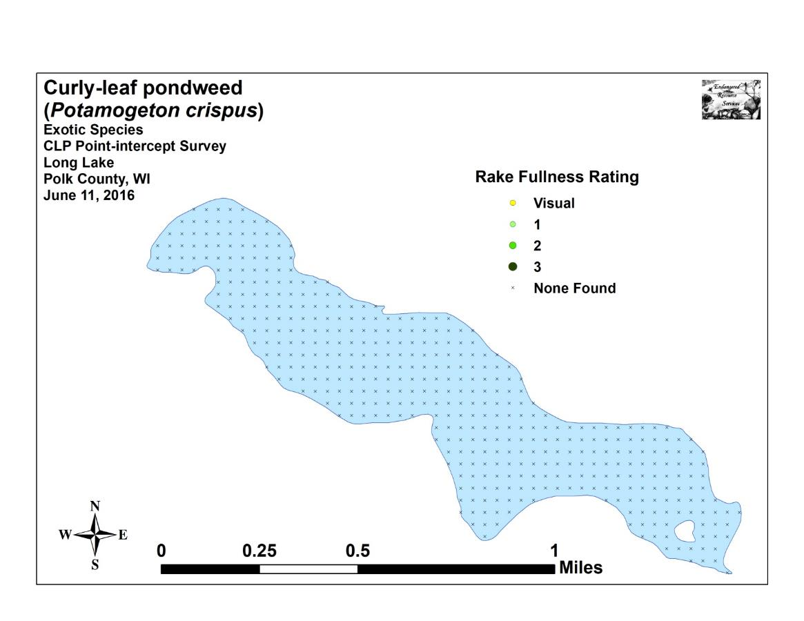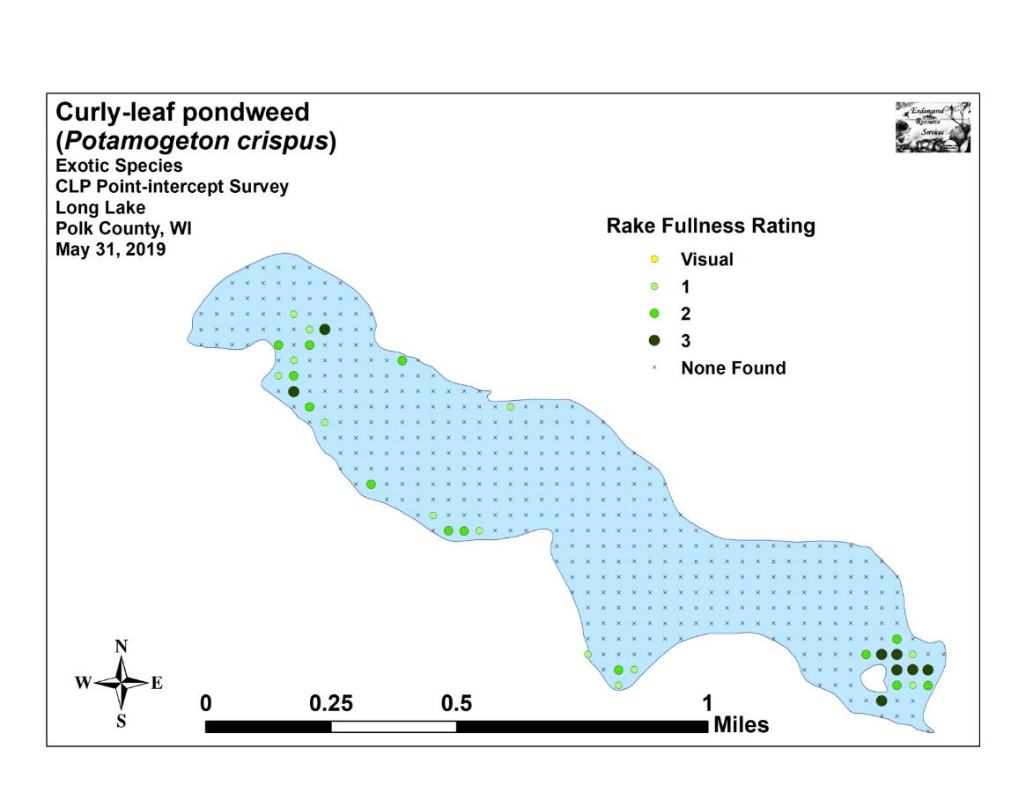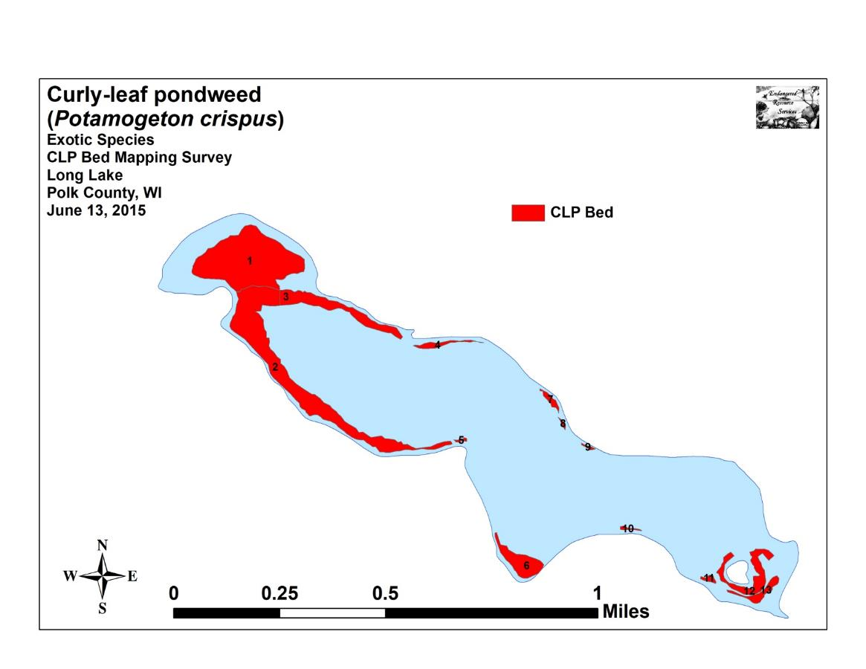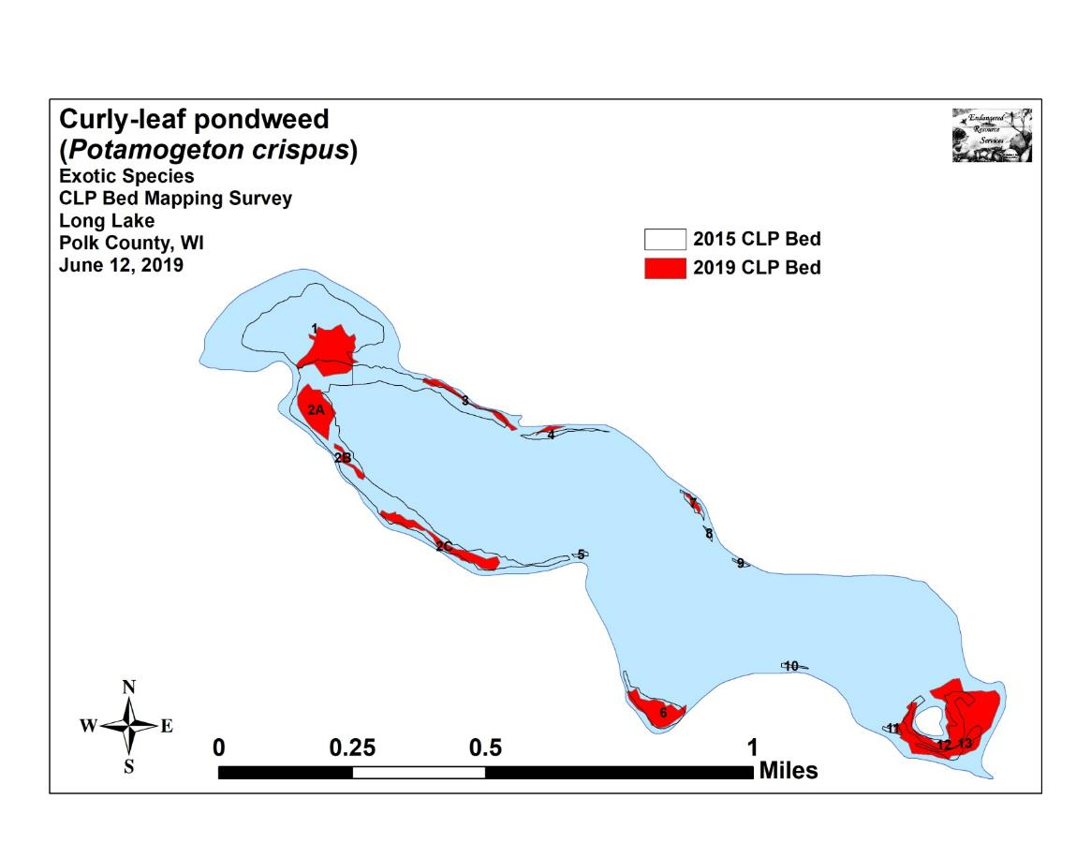

Appendix IV: Habitat Variable Maps
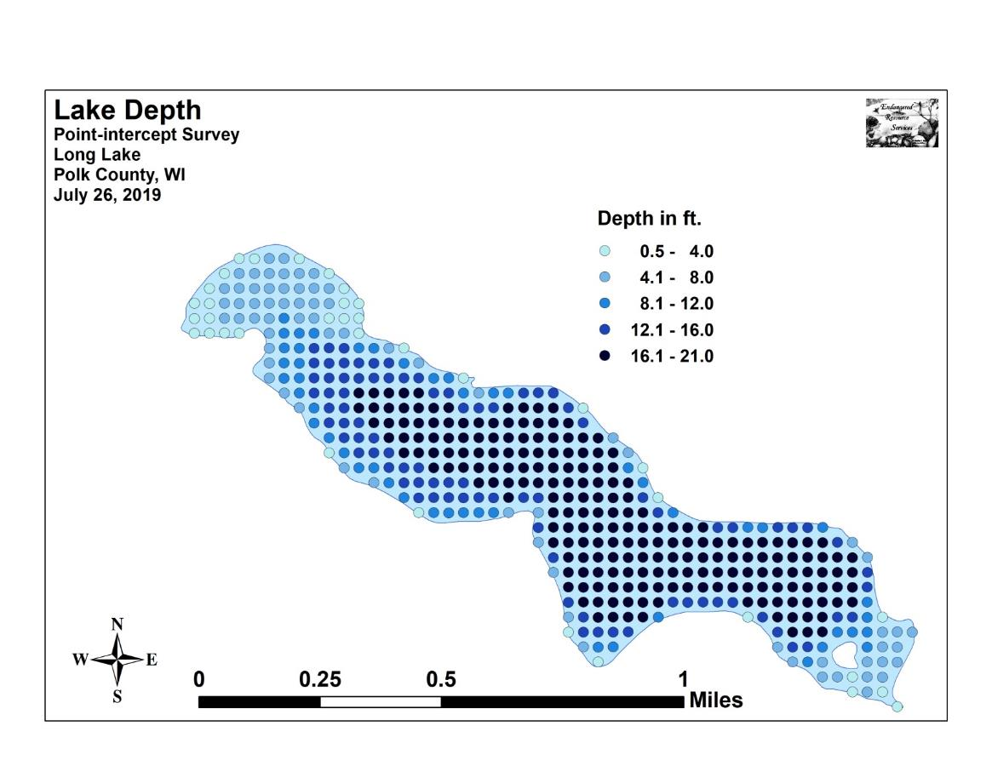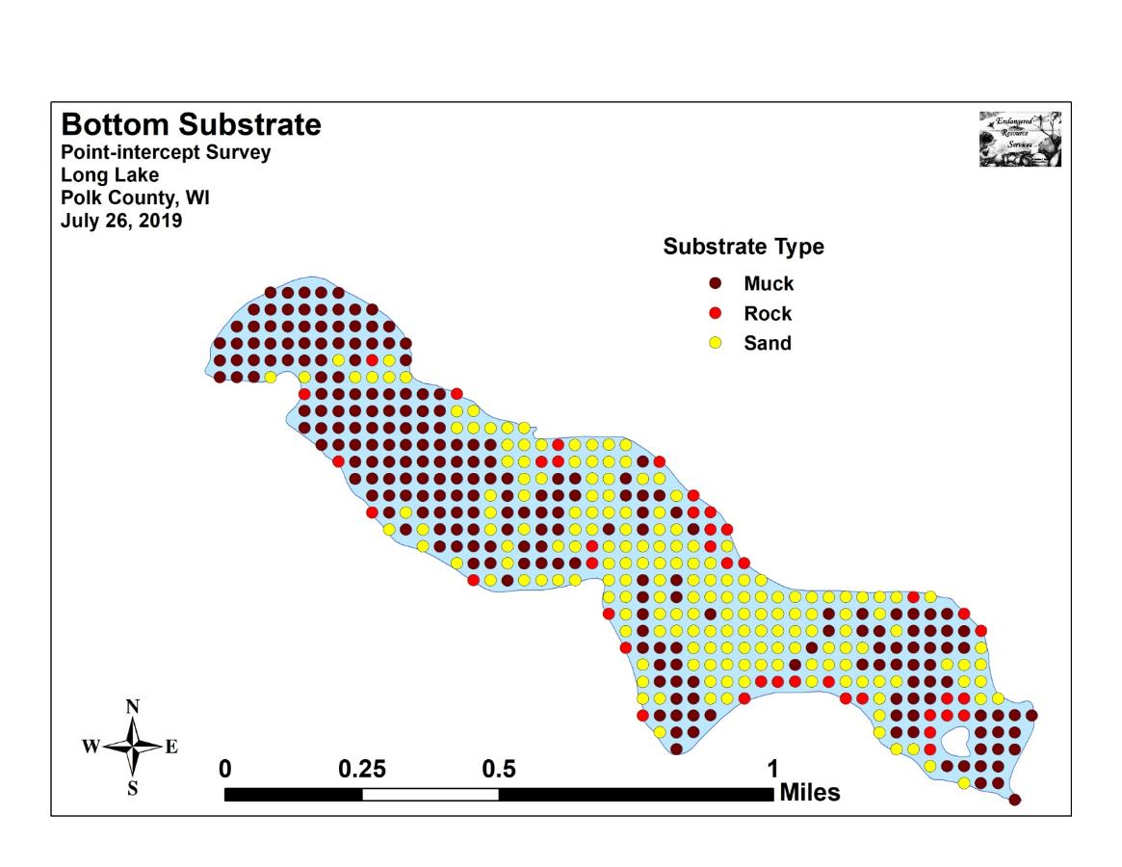

Appendix V: 2016 and 2019 Littoral Zone,
Native Species Richness, and Total Rake Fullness Maps
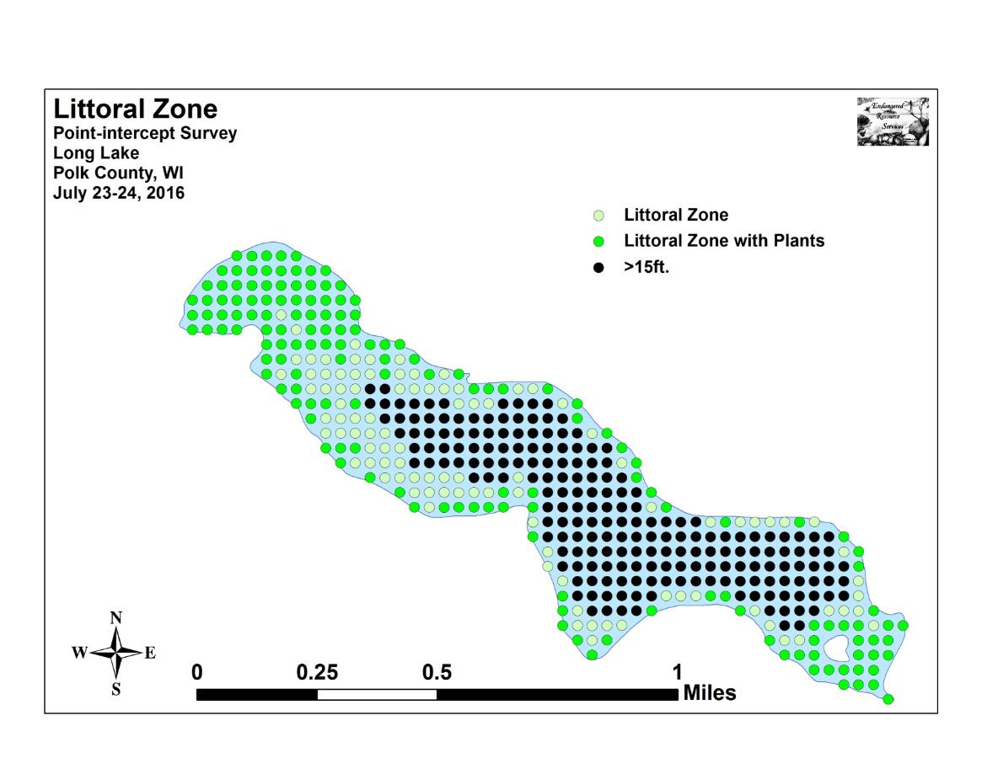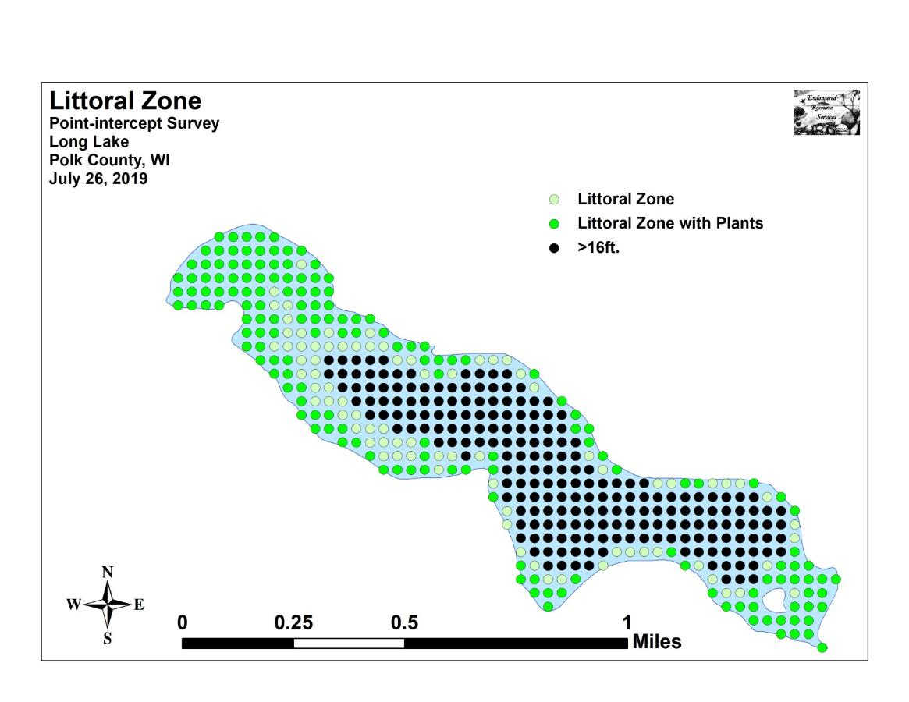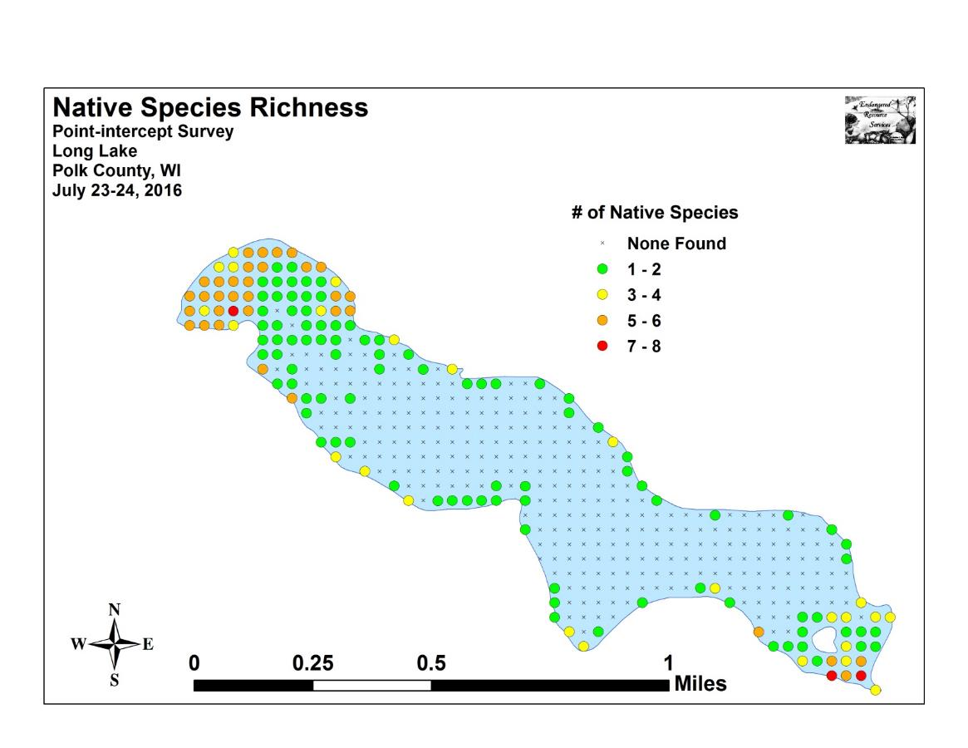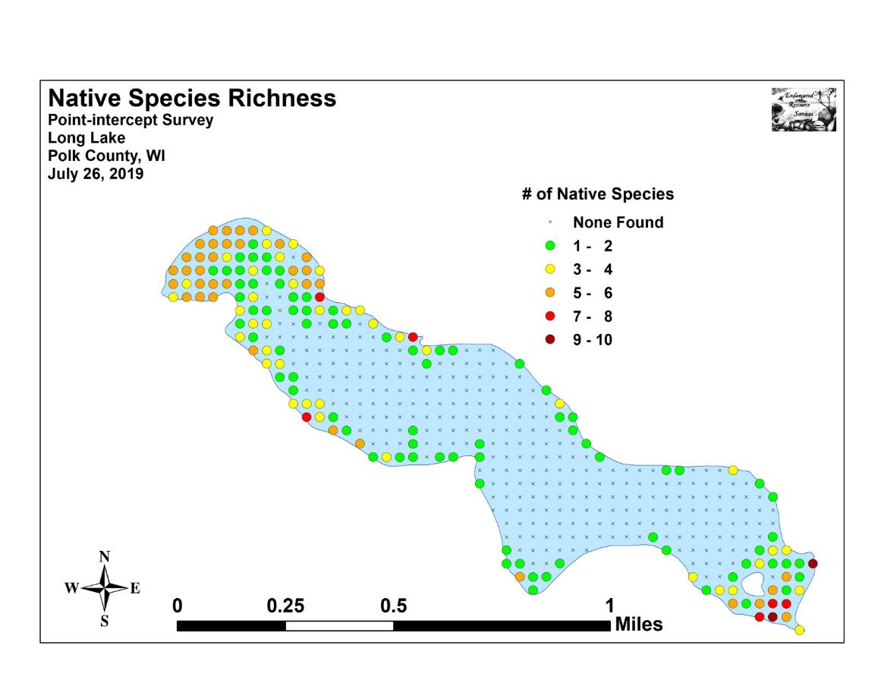
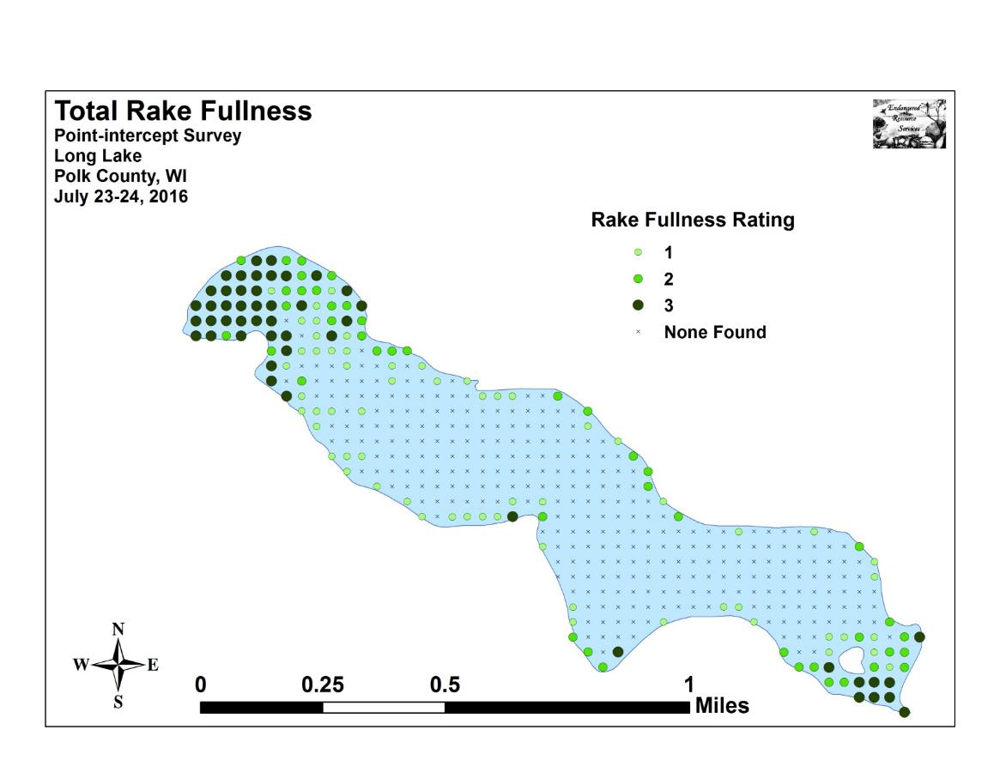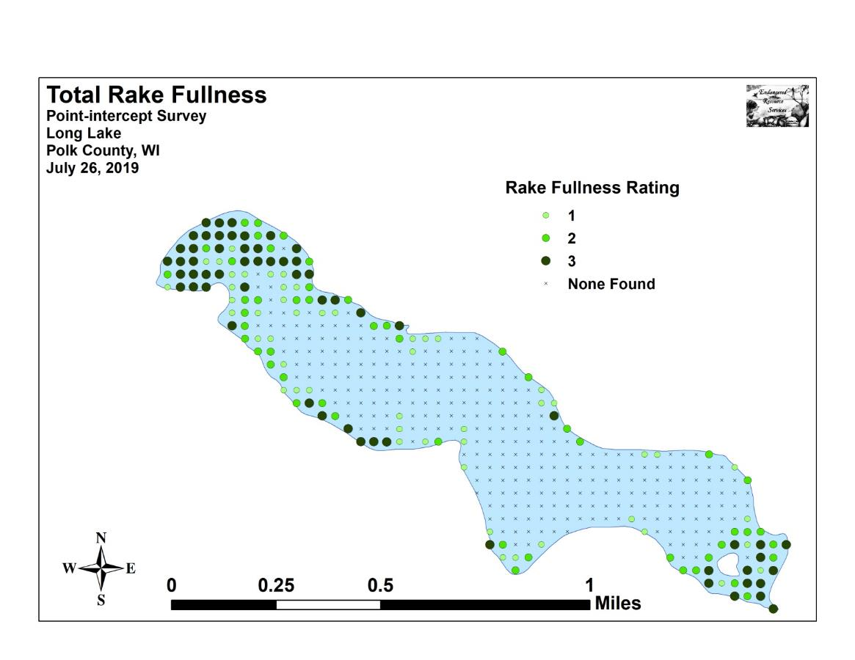

Appendix VI: 2019 July Native Plant Species
Density and Distribution Maps
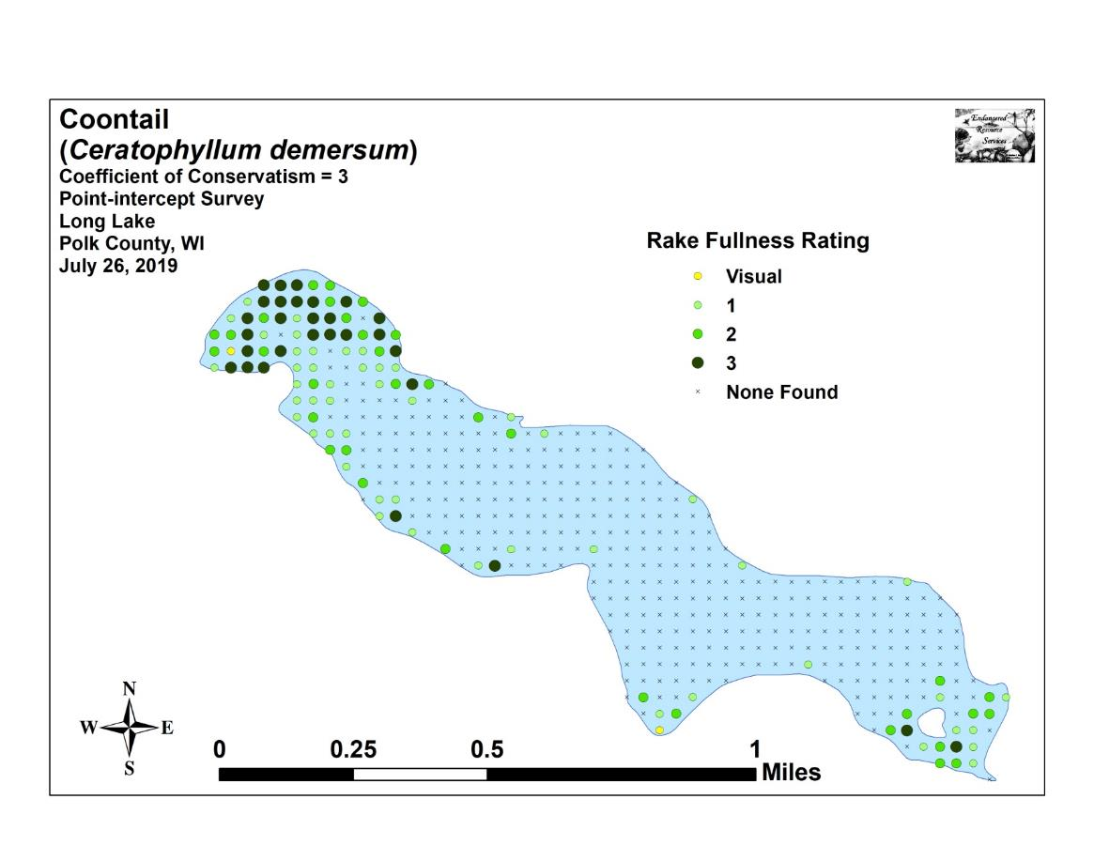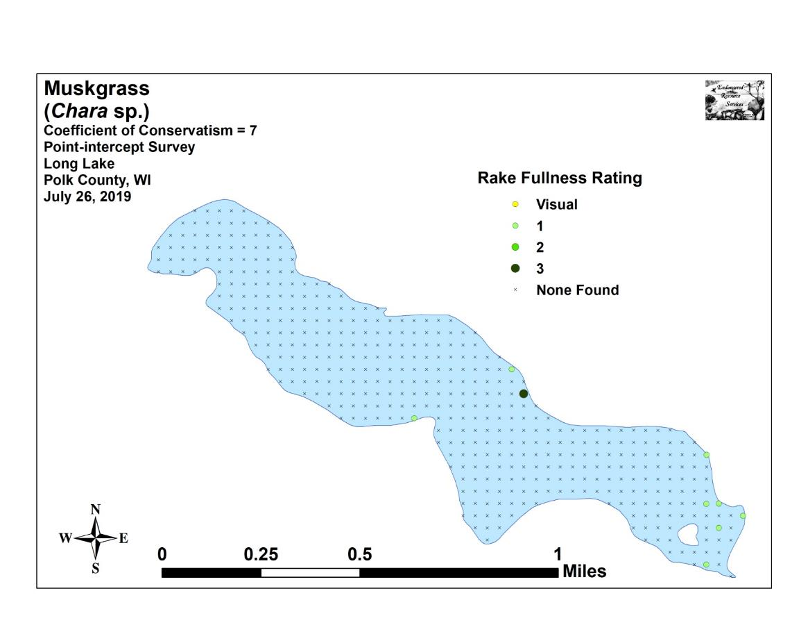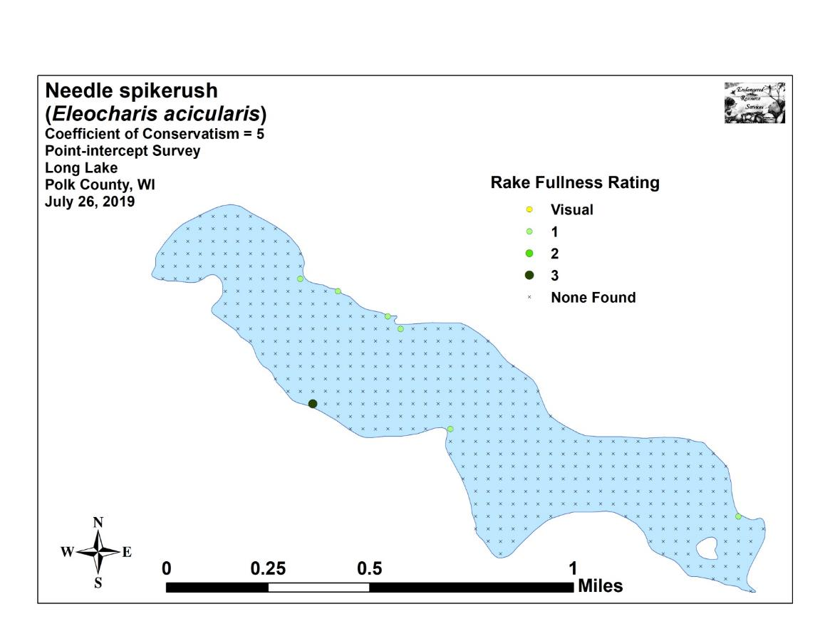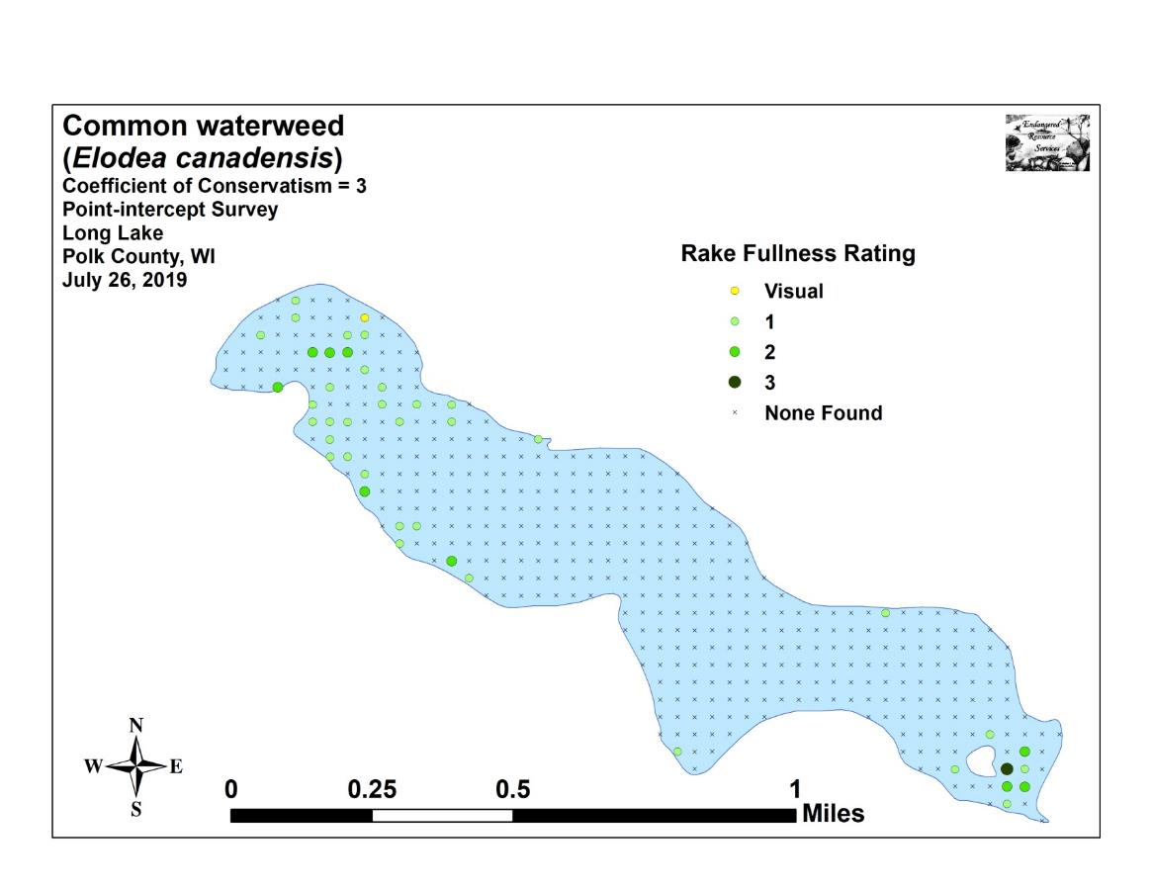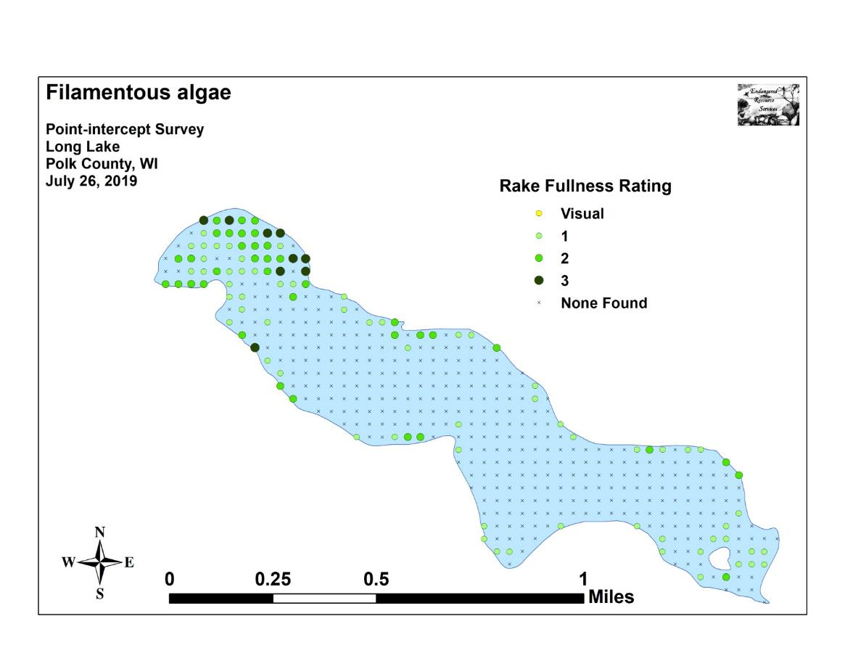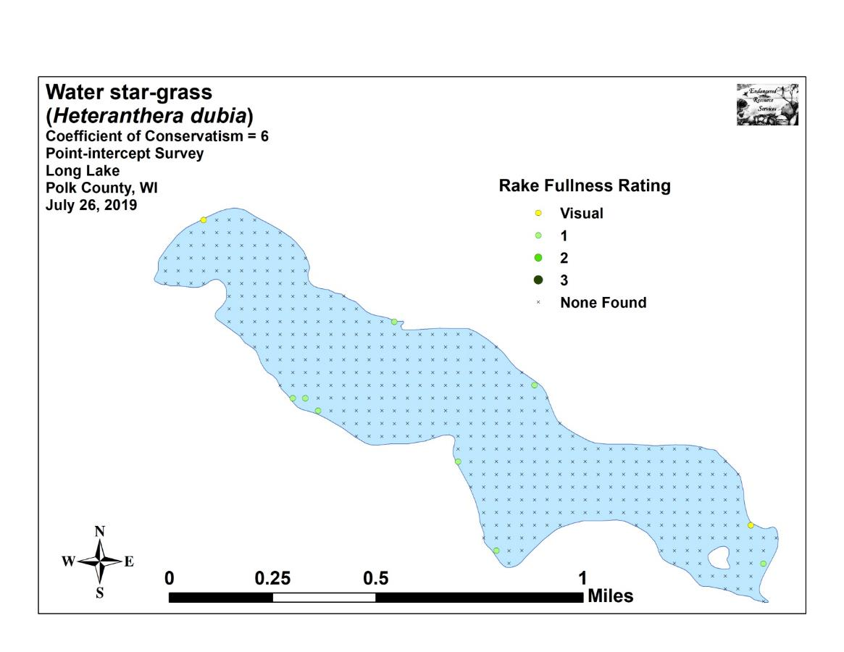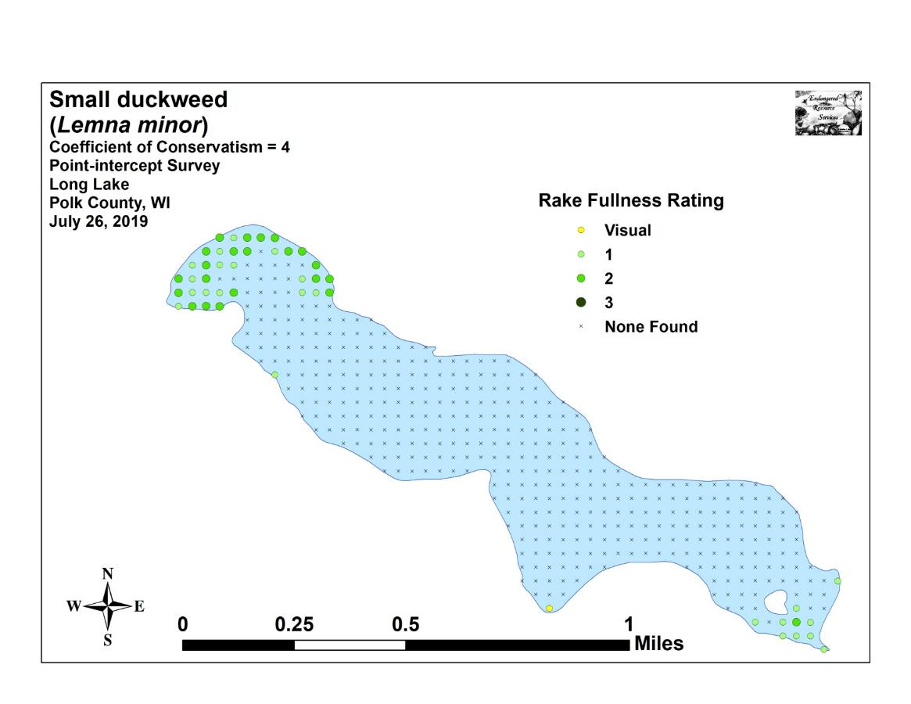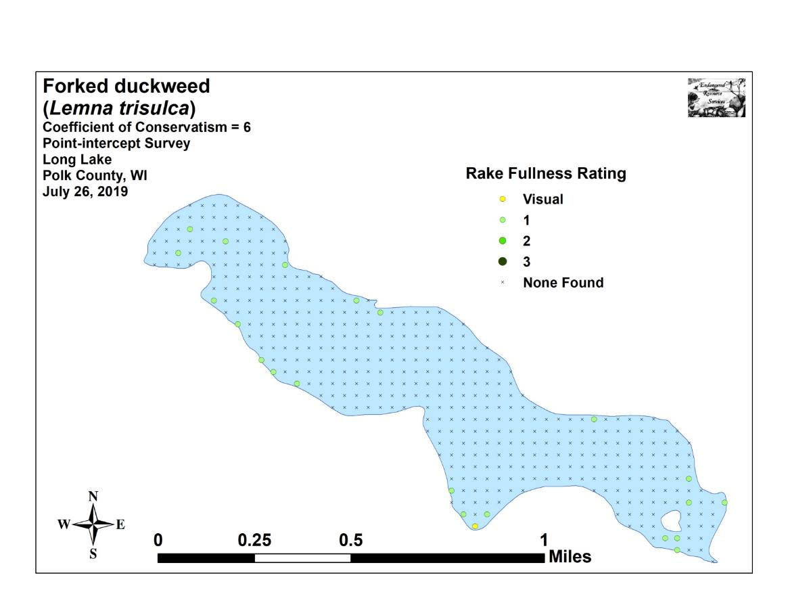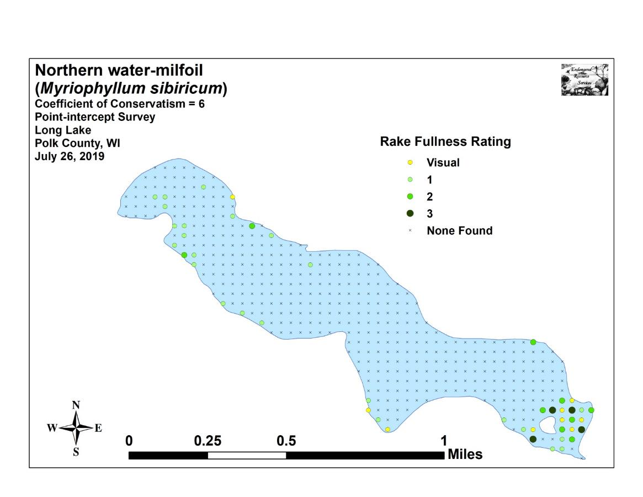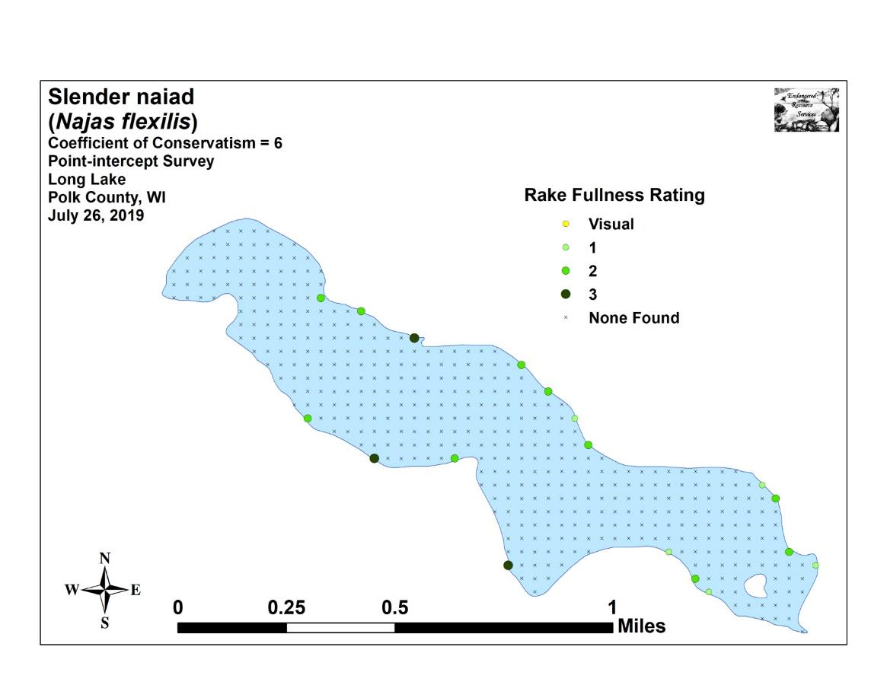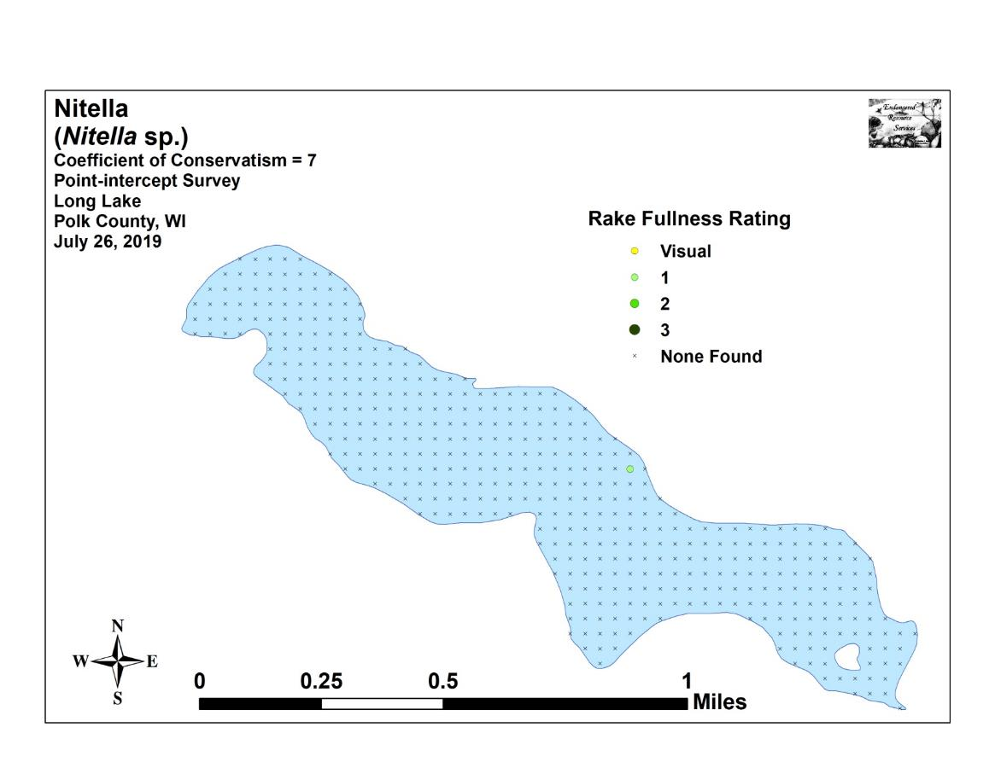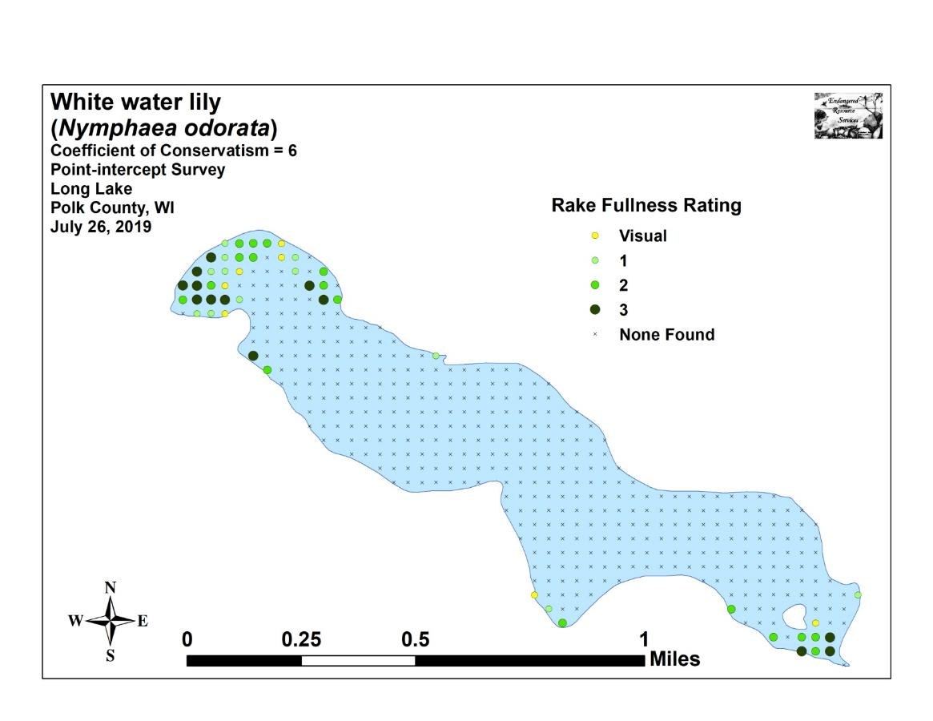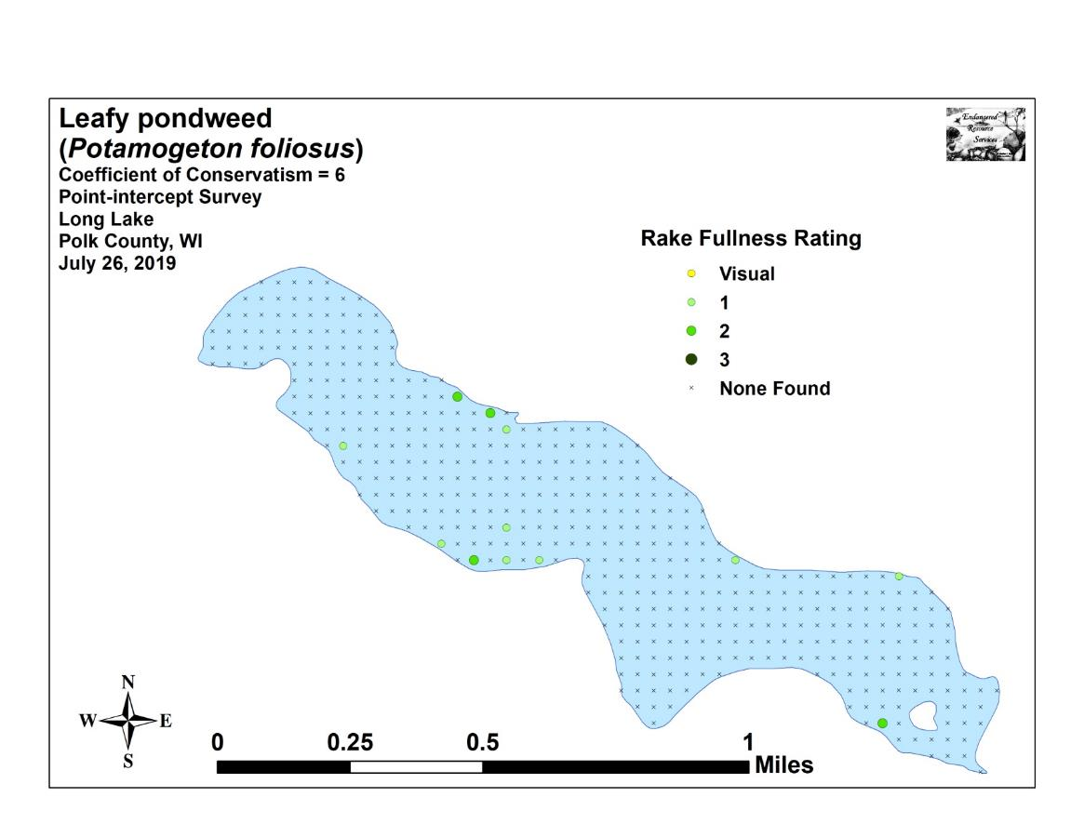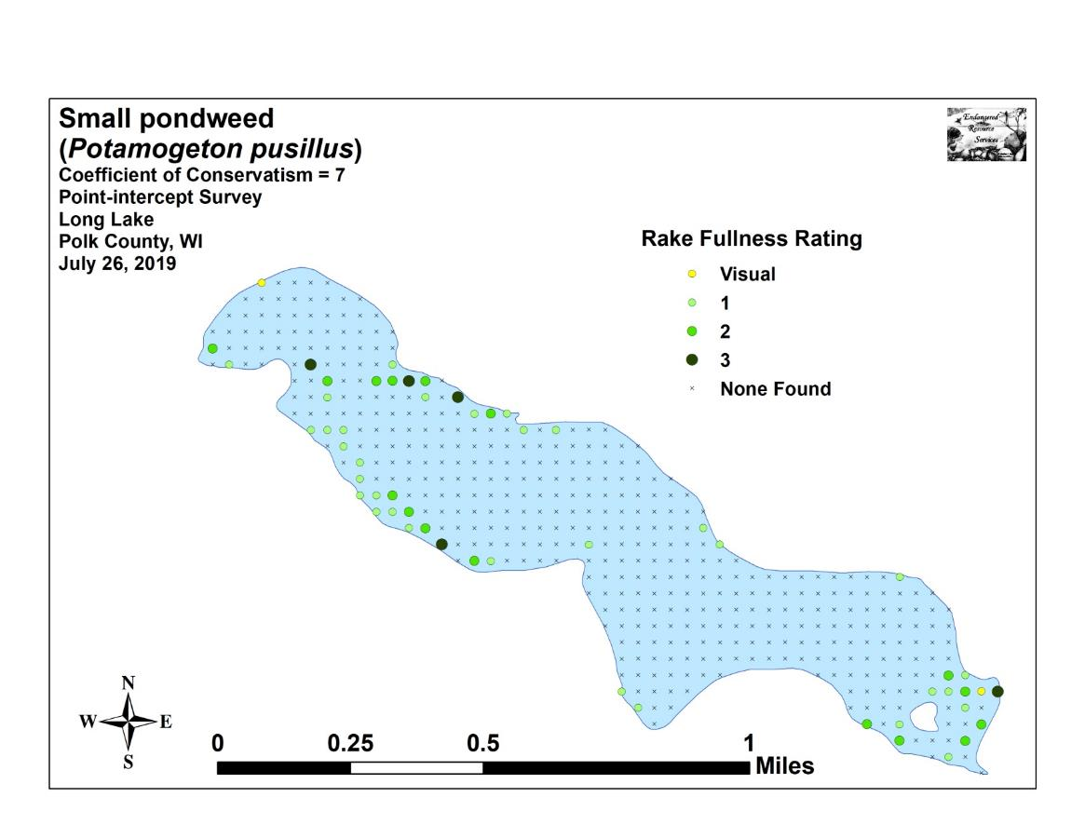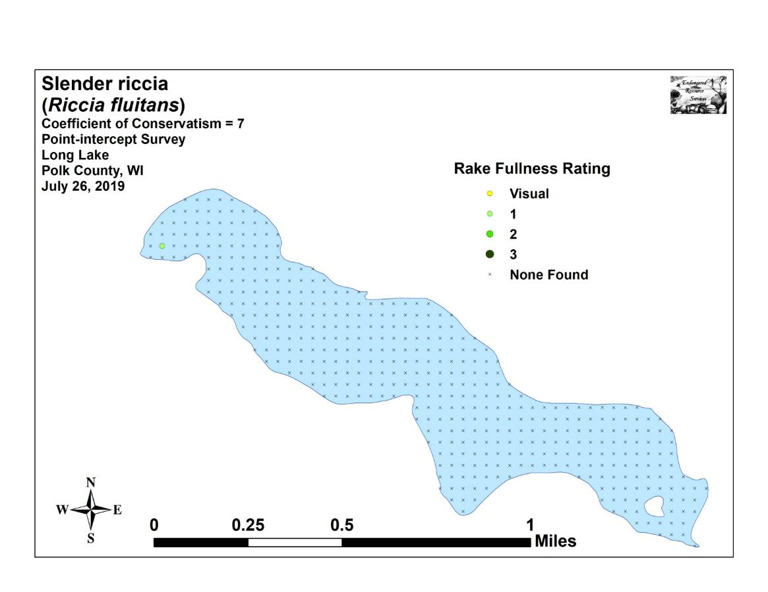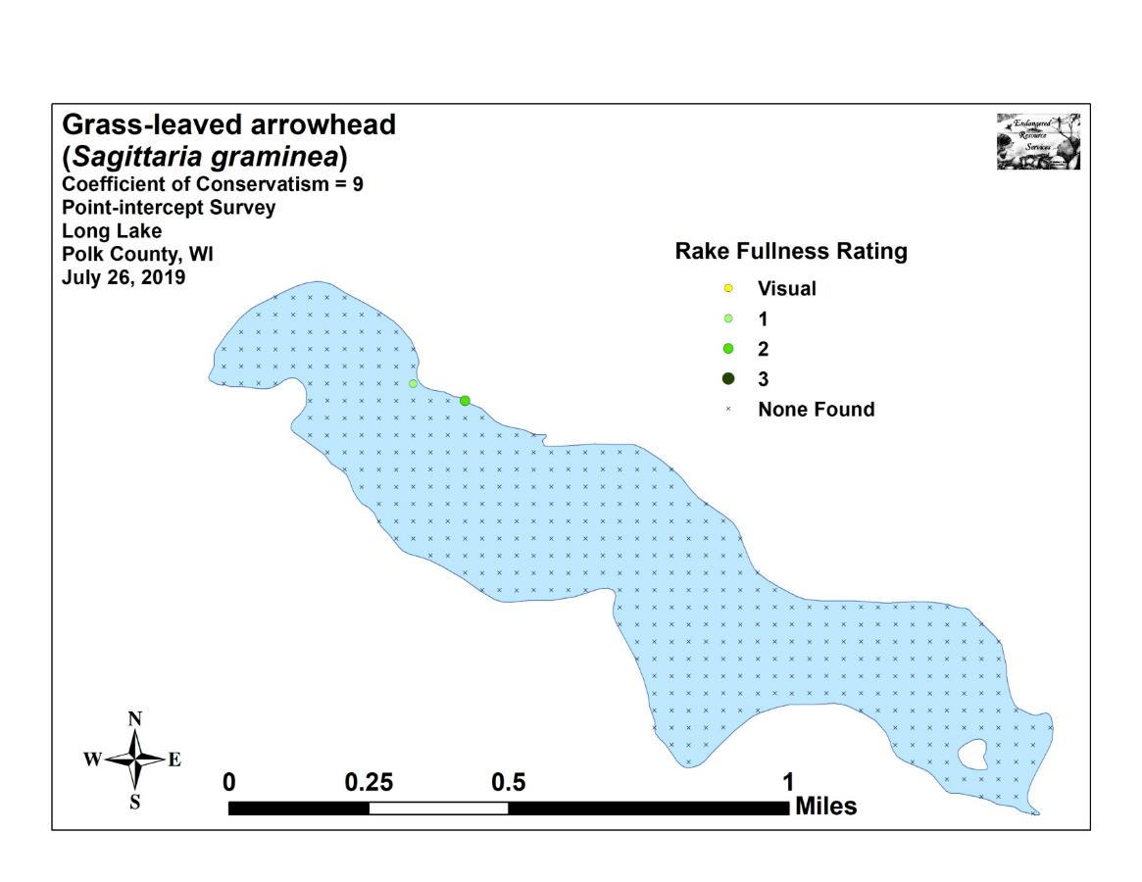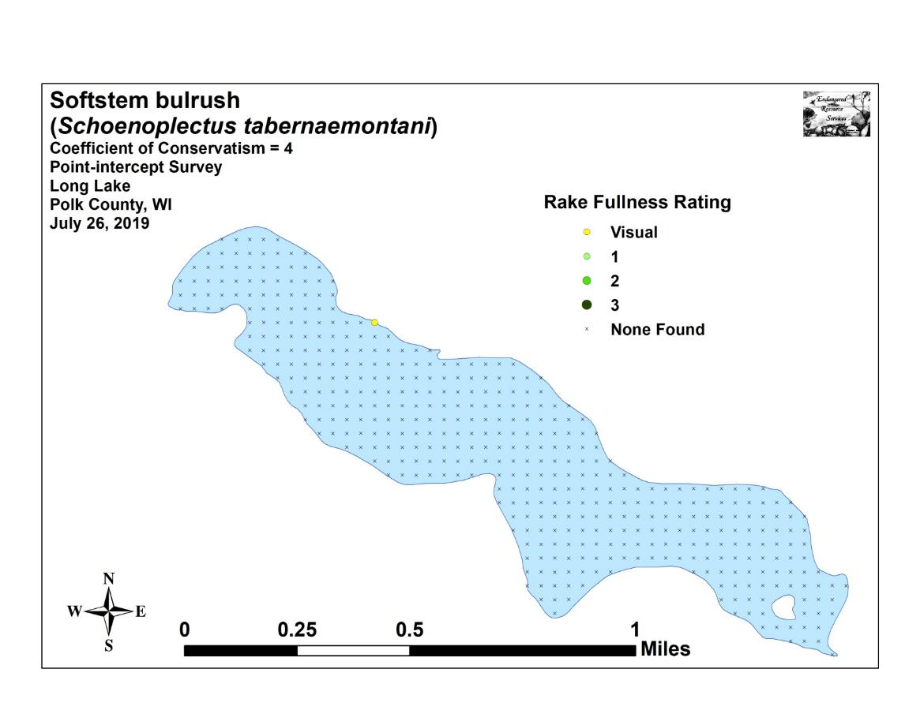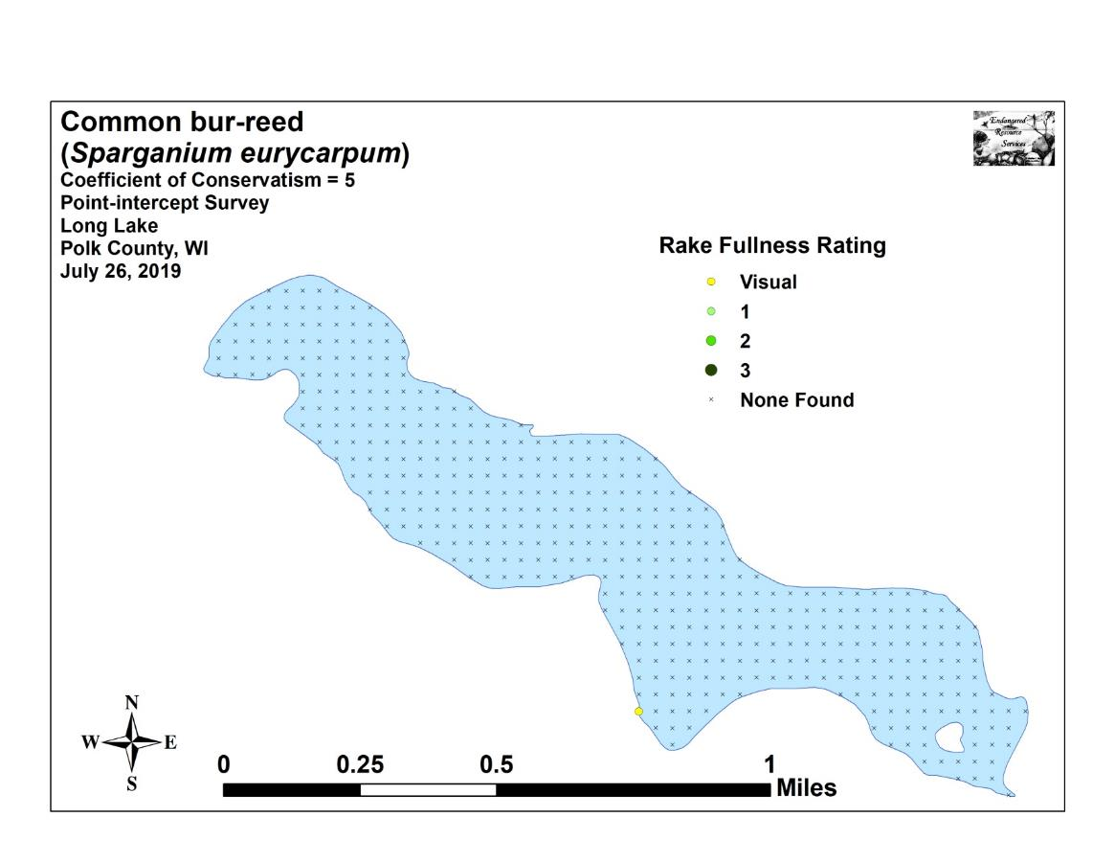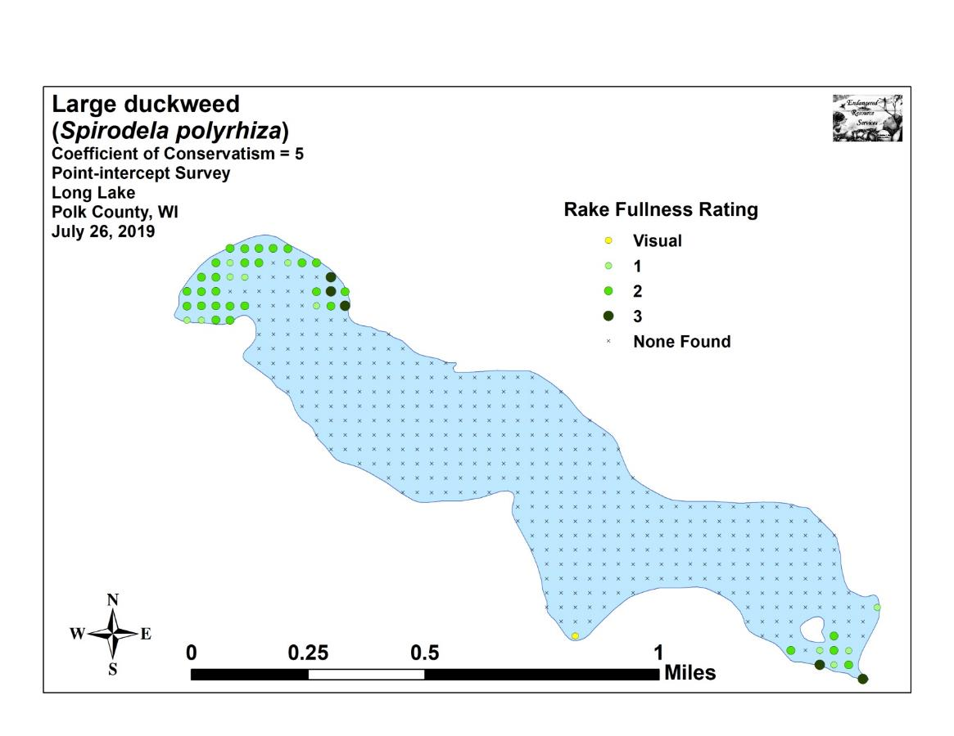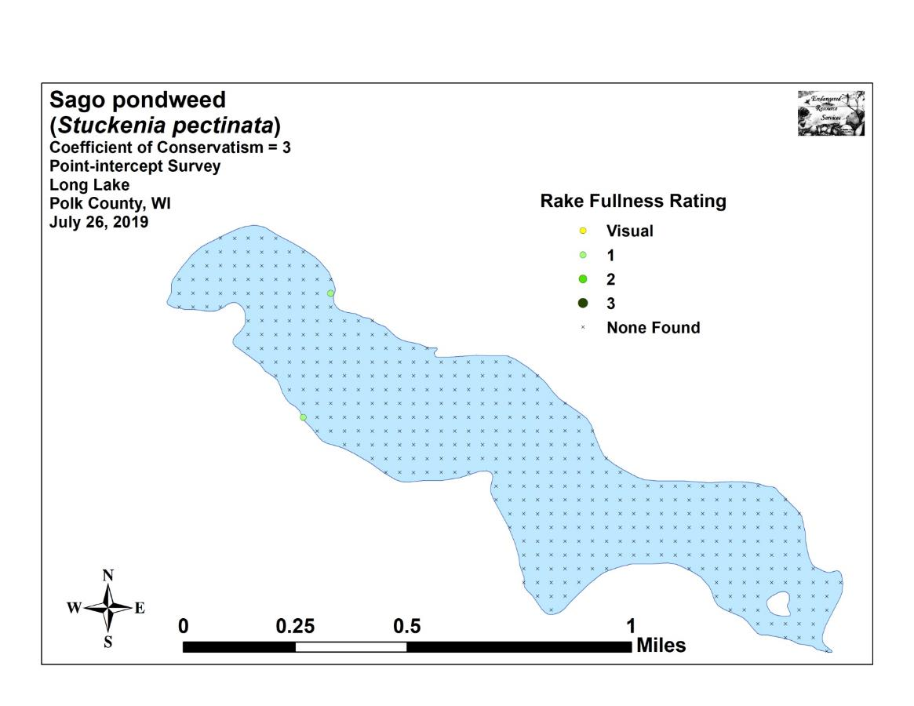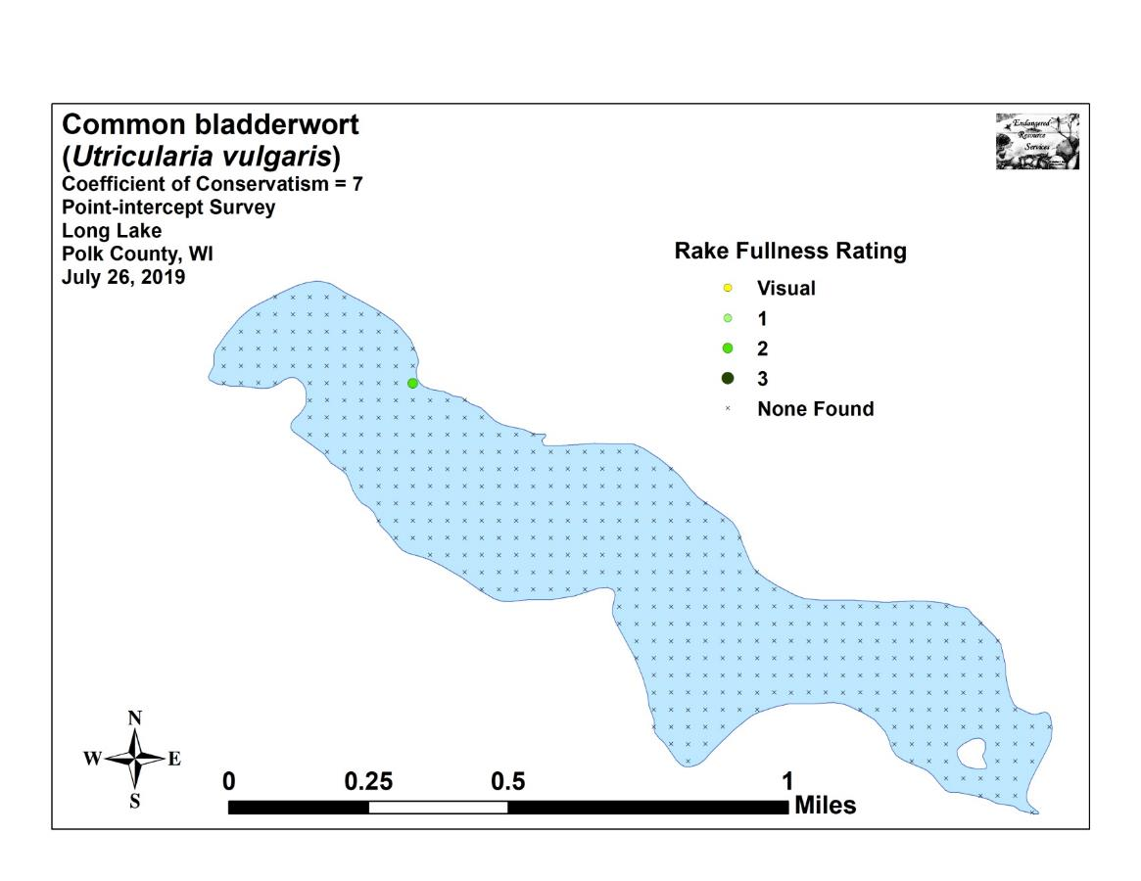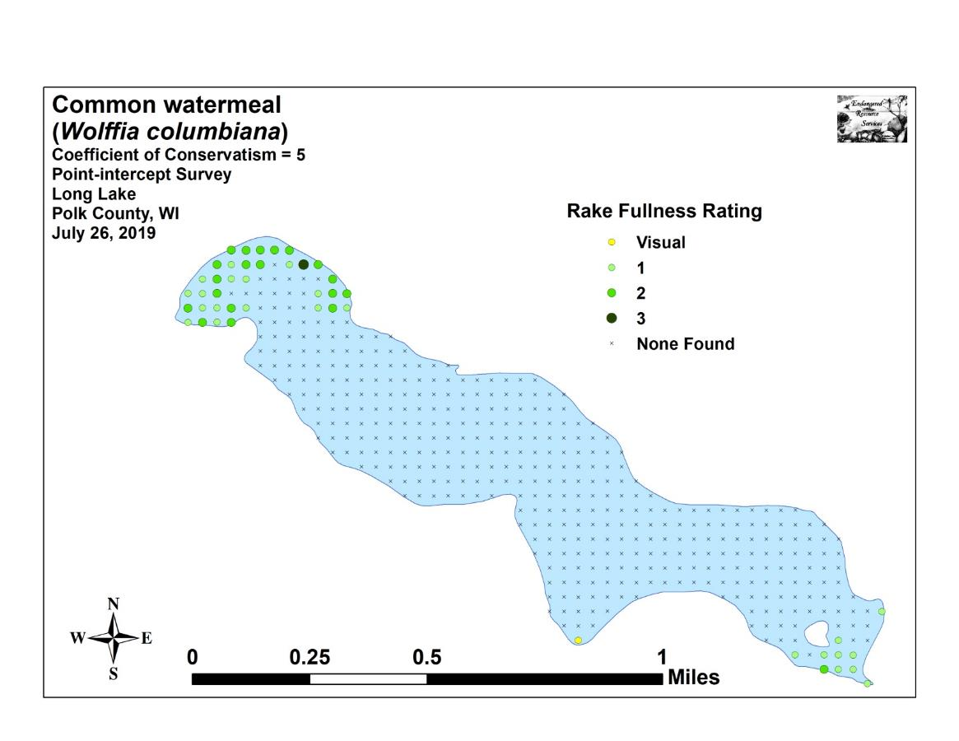

Appendix VII: 2019 July CLP and Other Exotic Species
Density and Distribution Maps
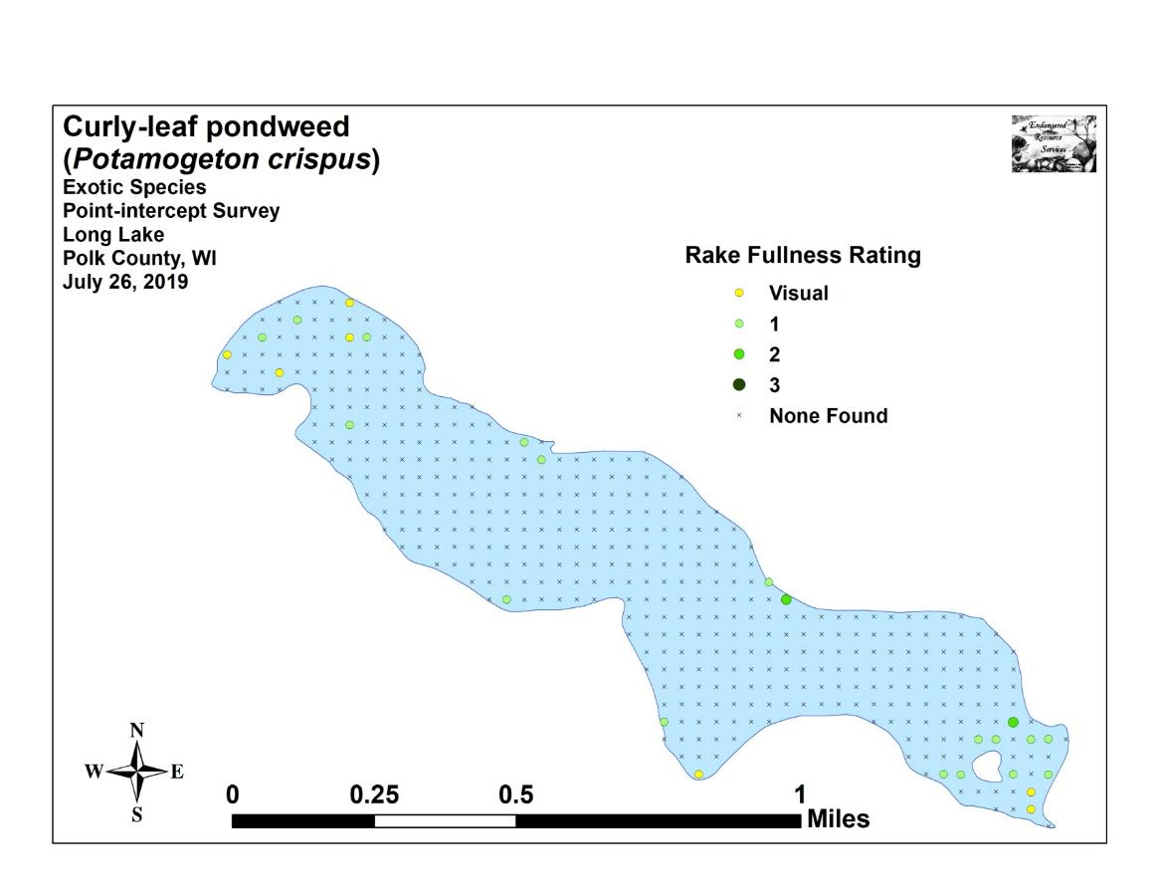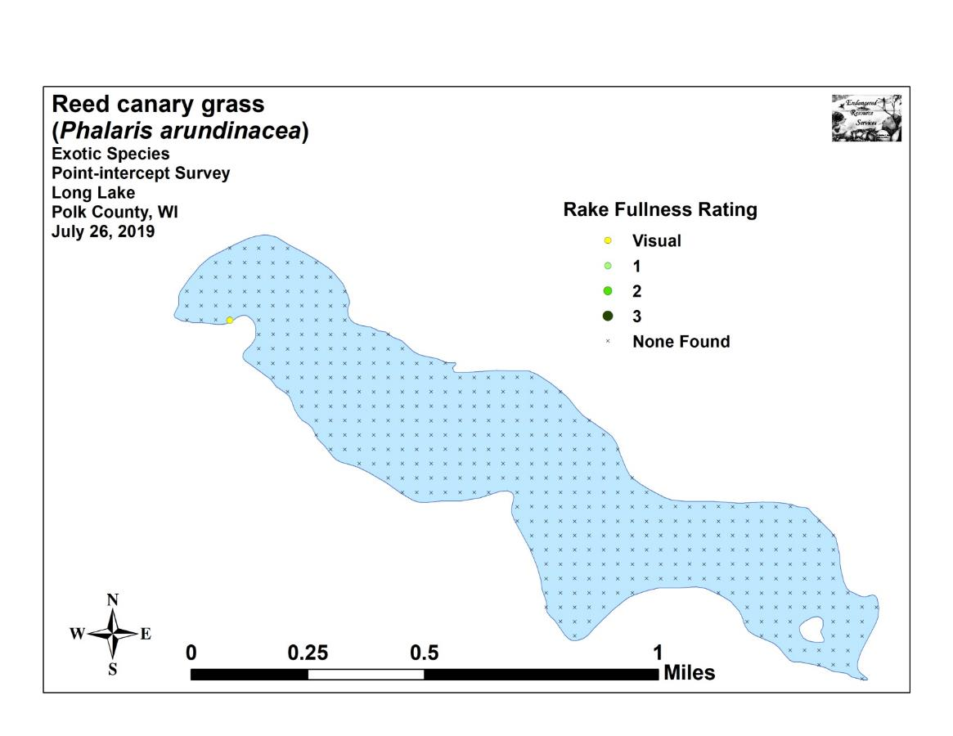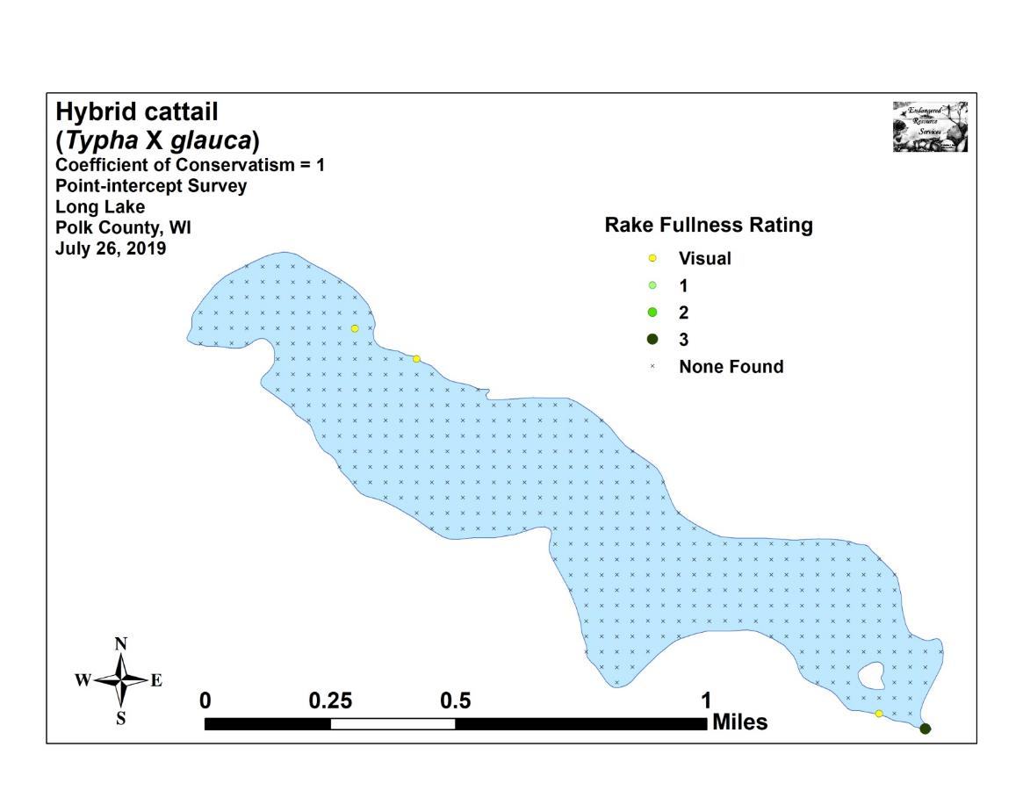

Appendix VIII: Aquatic Exotic Invasive Plant Species Information

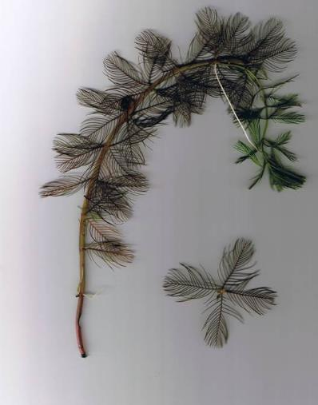
Eurasian Water-milfoil
DESCRIPTION: Eurasian Water-milfoil is a submersed aquatic plant native to Europe, Asia, and northern Africa. It is the only non-native milfoil in Wisconsin. Like the native milfoils, the Eurasian variety has slender stems whorled by submersed feathery leaves and tiny flowers produced above the water surface. The flowers are located in the axils of the floral bracts, and are either four-petaled or without petals. The leaves are threadlike, typically uniform in diameter, and aggregated into a submersed terminal spike. The stem thickens below the inflorescence and doubles its width further down, often curving to lie parallel with the water surface. The fruits are four-jointed nut-like bodies. Without flowers or fruits, Eurasian Water-milfoil is nearly impossible to distinguish from Northern Water-milfoil. Eurasian Water-milfoil has 9-21 pairs of leaflets per leaf, while Northern milfoil typically has 7-11 pairs of leaflets. Coontail is often mistaken for the milfoils, but does not have individual leaflets.
DISTRIBUTION AND HABITAT: Eurasian milfoil first arrived in Wisconsin in the 1960's. During the 1980's, it began to move from several counties in southern Wisconsin to lakes and waterways in the northern half of the state. As of 1993, Eurasian milfoil was common in 39 Wisconsin counties (54%) and at least 75 of its lakes, including shallow bays in Lakes Michigan and Superior and Mississippi River pools.
Eurasian Water-milfoil grows best in fertile, fine-textured, inorganic sediments. In less productive lakes, it is restricted to areas of nutrient-rich sediments. It has a history of becoming dominant in eutrophic, nutrient-rich lakes, although this pattern is not universal. It is an opportunistic species that prefers highly disturbed lake beds, lakes receiving nitrogen and phosphorous-laden runoff, and heavily used lakes. Optimal growth occurs in alkaline systems with a high concentration of dissolved inorganic carbon. High water temperatures promote multiple periods of flowering and fragmentation.
LIFE HISTORY AND EFFECTS OF INVASION: Unlike many other plants, Eurasian Water-milfoil does not rely on seed for reproduction. Its seeds germinate poorly under natural conditions. It reproduces vegetatively by fragmentation, allowing it to disperse over long distances. The plant produces fragments after fruiting once or twice during the summer. These shoots may then be carried downstream by water currents or inadvertently picked up by boaters. Milfoil is readily dispersed by boats, motors, trailers, bilges, live wells, or bait buckets, and can stay alive for weeks if kept moist.
Once established in an aquatic community, milfoil reproduces from shoot fragments and stolons (runners that creep along the lake bed). As an opportunistic species, Eurasian Water-milfoil is adapted for rapid growth early in spring. Stolons, lower stems, and roots persist over winter and store the carbohydrates that help milfoil claim the water column early in spring, photosynthesize, divide, and form a dense leaf canopy that shades out native aquatic plants. Its ability to spread rapidly by fragmentation and effectively block out sunlight needed for native plant growth often results in monotypic stands. Monotypic stands of Eurasian milfoil provide only a single habitat, and threaten the integrity of aquatic communities in a number of ways; for example, dense stands disrupt predator-prey relationships by fencing out larger fish, and reducing the number of nutrient-rich native plants available for waterfowl.
Dense stands of Eurasian Water-milfoil also inhibit recreational uses like swimming, boating, and fishing. Some stands have been dense enough to obstruct industrial and power generation water intakes. The visual impact that greets the lake user on milfoil-dominated lakes is the flat yellow-green of matted vegetation, often prompting the perception that the lake is "infested" or "dead". Cycling of nutrients from sediments to the water column by Eurasian Water-milfoil may lead to deteriorating water quality and algae blooms of infested lakes. (Taken in its entirety from WDNR, 2009 http://www.dnr.state.wi.us/invasives/fact/milfoil.htm)

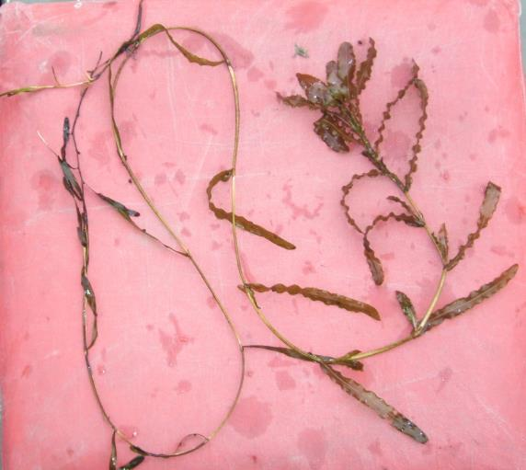
Curly-leaf pondweed
DESCRIPTION: Curly-leaf pondweed is an invasive aquatic perennial that is native to Eurasia, Africa, and Australia. It was accidentally introduced to United States waters in the mid-1880s by hobbyists who used it as an aquarium plant. The leaves are reddish-green, oblong, and about 3 inches long, with distinct wavy edges that are finely toothed. The stem of the plant is flat, reddish-brown and grows from 1 to 3 feet long. The plant usually drops to the lake bottom by early July.
DISTRIBUTION AND HABITAT: Curly-leaf pondweed is commonly found in alkaline and high nutrient waters, preferring soft substrate and shallow water depths. It tolerates low light and low water temperatures. It has been reported in all states but Maine.
LIFE HISTORY AND EFFECTS OF INVASION: Curly-leaf pondweed spreads through burr-like winter buds (turions), which are moved among waterways. These plants can also reproduce by seed, but this plays a relatively small role compared to the vegetative reproduction through turions. New plants form under the ice in winter, making curly-leaf pondweed one of the first nuisance aquatic plants to emerge in the spring.
It becomes invasive in some areas because of its tolerance for low light and low water temperatures. These tolerances allow it to get a head start on and out compete native plants in the spring. In mid-summer, when most aquatic plants are growing, curly-leaf pondweed plants are dying off. Plant die-offs may result in a critical loss of dissolved oxygen. Furthermore, the decaying plants can increase nutrients which contribute to algal blooms, as well as create unpleasant stinking messes on beaches. Curly-leaf pondweed forms surface mats that interfere with aquatic recreation. (Taken in its entirety from WDNR, 2009 http://www.dnr.state.wi.us/invasives/fact/curlyleaf_pondweed.htm)
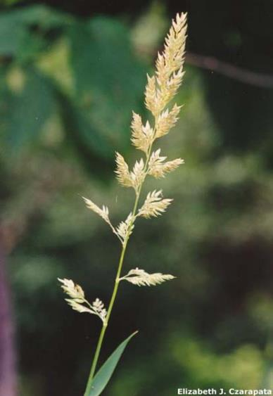
Reed canary grass
DESCRIPTION: Reed canary grass is a large, coarse grass that reaches 2 to 9 feet in height. It has an erect, hairless stem with gradually tapering leaf blades 3 1/2 to 10 inches long and 1/4 to 3/4 inch in width. Blades are flat and have a rough texture on both surfaces. The lead ligule is membranous and long. The compact panicles are erect or slightly spreading (depending on the plant's reproductive stage), and range from 3 to 16 inches long with branches 2 to 12 inches in length. Single flowers occur in dense clusters in May to mid-June. They are green to purple at first and change to beige over time. This grass is one of the first to sprout in spring, and forms a thick rhizome system that dominates the subsurface soil. Seeds are shiny brown in color.
Both Eurasian and native ecotypes of reed canary grass are thought to exist in the U.S. The Eurasian variety is considered more aggressive, but no reliable method exists to tell the ecotypes apart. It is believed that the vast majority of our reed canary grass is derived from the Eurasian ecotype. Agricultural cultivars of the grass are widely planted.
Reed canary grass also resembles non-native orchard grass (Dactylis glomerata), but can be distinguished by its wider blades, narrower, more pointed inflorescence, and the lack of hairs on glumes and lemmas (the spikelet scales). Additionally, bluejoint grass (Calamagrostis canadensis) may be mistaken for reed canary in areas where orchard grass is rare, especially in the spring. The highly transparent ligule on reed canary grass is helpful in distinguishing it from the others. Ensure positive identification before attempting control.

DISTRIBUTION AND HABITAT: Reed canary grass is a cool-season, sod-forming, perennial wetland grass native to temperate regions of Europe, Asia, and North America. The Eurasian ecotype has been selected for its vigor and has been planted throughout the U.S. since the 1800's for forage and erosion control. It has become naturalized in much of the northern half of the U.S., and is still being planted on steep slopes and banks of ponds and created wetlands.
Reed canary grass can grow on dry soils in upland habitats and in the partial shade of oak woodlands, but does best on fertile, moist organic soils in full sun. This species can invade most types of wetlands, including marshes, wet prairies, sedge meadows, fens, stream banks, and seasonally wet areas; it also grows in disturbed areas such as bergs and spoil piles.
LIFE HISTORY AND EFFECTS OF INVASION: Reed canary grass reproduces by seed or creeping rhizomes. It spreads aggressively. The plant produces leaves and flower stalks for 5 to 7 weeks after germination in early spring, then spreads laterally. Growth peaks in mid-June and declines in mid-August. A second growth spurt occurs in the fall. The shoots collapse in mid to late summer, forming a dense, impenetrable mat of stems and leaves. The seeds ripen in late June and shatter when ripe. Seeds may be dispersed from one wetland to another by waterways, animals, humans, or machines.
This species prefers disturbed areas, but can easily move into native wetlands. Reed canary grass can invade a disturbed wetland in less than twelve years. Invasion is associated with disturbances including ditching of wetlands, stream channelization, deforestation of swamp forests, sedimentation, and intentional planting. The difficulty of selective control makes reed canary grass invasion of particular concern. Over time, it forms large, monotypic stands that harbor few other plant species and are subsequently of little use to wildlife. Once established, reed canary grass dominates an area by building up a tremendous seed bank that can eventually erupt, germinate, and recolonize treated sites. (Taken in its entirety from WDNR, 2009 http://www.dnr.state.wi.us/invasives/fact/reed_canary.htm)
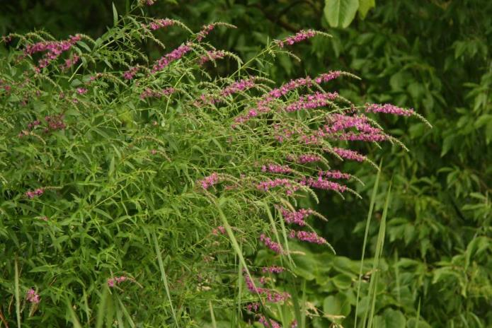
Purple loosestrife
(Photo Courtesy Brian M. Collins)
DESCRIPTION: Purple loosestrife is a perennial herb 3-7 feet tall with a dense bushy growth of 1-50 stems. The stems, which range from green to purple, die back each year. Showy flowers vary from purple to magenta, possess 5-6 petals aggregated into numerous long spikes, and bloom from July to September. Leaves are opposite, nearly linear, and attached to four-sided stems without stalks. It has a large, woody taproot with fibrous rhizomes that form a dense mat.
This species may be confused with the native wing-angled loosestrife (Lythrum alatum) found in moist prairies or wet meadows. The latter has a winged, square stem and solitary paired flowers in the leaf axils. It is generally a smaller plant than the Eurasian loosestrife.
By law, purple loosestrife is a nuisance species in Wisconsin. It is illegal to sell, distribute, or cultivate the plants or seeds, including any of its cultivars.

Distribution and Habitat: Purple loosestrife is a wetland herb that was introduced as a garden perennial from Europe during the 1800's. It is still promoted by some horticulturists for its beauty as a landscape plant, and by beekeepers for its nectar-producing capability. Currently, about 24 states have laws prohibiting its importation or distribution because of its aggressively invasive characteristics. It has since extended its range to include most temperate parts of the United States and Canada. The plant's reproductive success across North America can be attributed to its wide tolerance of physical and chemical conditions characteristic of disturbed habitats, and its ability to reproduce prolifically by both seed dispersal and vegetative propagation. The absence of natural predators, like European species of herbivorous beetles that feed on the plant's roots and leaves, also contributes to its proliferation in North America.
Purple loosestrife was first detected in Wisconsin in the early 1930's, but remained uncommon until the 1970's. It is now widely dispersed in the state, and has been recorded in 70 of Wisconsin's 72 counties. Low densities in most areas of the state suggest that the plant is still in the pioneering stage of establishment. Areas of heaviest infestation are sections of the Wisconsin River, the extreme southeastern part of the state, and the Wolf and Fox River drainage systems.
This plant's optimal habitat includes marshes, stream margins, alluvial flood plains, sedge meadows, and wet prairies. It is tolerant of moist soil and shallow water sites such as pastures and meadows, although established plants can tolerate drier conditions. Purple loosestrife has also been planted in lawns and gardens, which is often how it has been introduced to many of our wetlands, lakes, and rivers.

Life History and Effects of Invasion: Purple loosestrife can germinate successfully on substrates with a wide range of pH. Optimum substrates for growth are moist soils of neutral to slightly acidic pH, but it can exist in a wide range of soil types. Most seedling establishment occurs in late spring and early summer when temperatures are high.
Purple loosestrife spreads mainly by seed, but it can also spread vegetatively from root or stem segments. A single stalk can produce from 100,000 to 300,000 seeds per year. Seed survival is up to 60-70%, resulting in an extensive seed bank. Mature plants with up to 50 shoots grow over 2 meters high and produce more than two million seeds a year. Germination is restricted to open, wet soils and requires high temperatures, but seeds remain viable in the soil for many years. Even seeds submerged in water can live for approximately 20 months. Most of the seeds fall near the parent plant, but water, animals, boats, and humans can transport the seeds long distances. Vegetative spread through local perturbation is also characteristic of loosestrife; clipped, trampled, or buried stems of established plants may produce shoots and roots. Plants may be quite large and several years old before they begin flowering. It is often very difficult to locate non-flowering plants, so monitoring for new invasions should be done at the beginning of the flowering period in mid-summer.

Any sunny or partly shaded wetland is susceptible to purple loosestrife invasion. Vegetative disturbances such as water drawdown or exposed soil accelerate the process by providing ideal conditions for seed germination. Invasion usually begins with a few pioneering plants that build up a large seed bank in the soil for several years. When the right disturbance occurs, loosestrife can spread rapidly, eventually taking over the entire wetland. The plant can also make morphological adjustments to accommodate changes in the immediate environment; for example, a decrease in light level will trigger a change in leaf morphology. The plant's ability to adjust to a wide range of environmental conditions gives it a competitive advantage; coupled with its reproductive strategy, purple loosestrife tends to create monotypic stands that reduce biotic diversity.
Purple loosestrife displaces native wetland vegetation and degrades wildlife habitat. As native vegetation is displaced, rare plants are often the first species to disappear. Eventually, purple loosestrife can overrun wetlands thousands of acres in size, and almost entirely eliminate the open water habitat. The plant can also be detrimental to recreation by choking waterways. (Taken in its entirety from WDNR, 2009 http://www.dnr.state.wi.us/invasives/fact/loosestrife.htm)

Appendix IX: Glossary of Biological Terms
(Adapted from UWEX 2009)

Aquatic:
organisms that live in or frequent water.

Cultural Eutrophication:
accelerated eutrophication that occurs as a result of human activities in the watershed that increase nutrient loads in runoff water that drains into lakes.

Dissolved Oxygen (DO):
the amount of free oxygen absorbed by the water and available to aquatic organisms for respiration; amount of oxygen dissolved in a certain amount of water at a particular temperature and pressure, often expressed as a concentration in parts of oxygen per million parts of water.

Diversity:
number and evenness of species in a particular community or habitat.

Drainage lakes:
Lakes fed primarily by streams and with outlets into streams or rivers. They are more subject to surface runoff problems but generally have shorter residence times than seepage lakes. Watershed protection is usually needed to manage lake water quality.

Ecosystem:
a system formed by the interaction of a community of organisms with each other and with the chemical and physical factors making up their environment.

Eutrophication:
the process by which lakes and streams are enriched by nutrients, and the resulting increase in plant and algae growth. This process includes physical, chemical, and biological changes that take place after a lake receives inputs for plant nutrients--mostly nitrates and phosphates--from natural erosion and runoff from the surrounding land basin. The extent to which this process has occurred is reflected in a lake's trophic classification: oligotrophic (nutrient poor), mesotrophic (moderately productive), and eutrophic (very productive and fertile).

Exotic:
a non-native species of plant or animal that has been introduced.

Habitat:
the place where an organism lives that provides an organism's needs for water, food, and shelter. It includes all living and non-living components with which the organism interacts.

Limnology:
the study of inland lakes and waters.

Littoral:
the near shore shallow water zone of a lake, where aquatic plants grow.

Macrophytes:
Refers to higher (multi-celled) plants growing in or near water. Macrophytes are beneficial to lakes because they produce oxygen and provide substrate for fish habitat and aquatic insects. Overabundance of such plants, especially problem species, is related to shallow water depth and high nutrient levels.

Nutrients:
elements or substances such as nitrogen and phosphorus that are necessary for plant growth. Large amounts of these substances can become a nuisance by promoting excessive aquatic plant growth.

Organic Matter:
elements or material containing carbon, a basic component of all living matter.

Photosynthesis:
the process by which green plants convert carbon dioxide (CO2) dissolved in water to sugar and oxygen using sunlight for energy. Photosynthesis is essential in producing a lake's food base, and is an important source of oxygen for many lakes.

Phytoplankton:
microscopic plants found in the water. Algae or one-celled (phytoplankton) or multicellular plants either suspended in water (Plankton) or attached to rocks and other substrates (periphyton). Their abundance, as measured by the amount of chlorophyll a (green pigment) in an open water sample, is commonly used to classify the trophic status of a lake. Numerous species occur. Algae are an essential part of the lake ecosystem and provides the food base for most lake organisms, including fish. Phytoplankton populations vary widely from day to day, as life cycles are short.

Plankton:
small plant organisms (phytoplankton and nanoplankton) and animal organisms (zooplankton) that float or swim weakly though the water.

ppm:
parts per million; units per equivalent million units; equal to milligrams per liter (mg/l)

Richness:
number of species in a particular community or habitat.

Rooted Aquatic Plants:
(macrophytes) Refers to higher (multi-celled) plants growing in or near water. Macrophytes are beneficial to lakes because they produce oxygen and provide substrate for fish habitat and aquatic insects. Overabundance of such plants, especially problem species, is related to shallow water depth and high nutrient levels.

Runoff:
water that flows over the surface of the land because the ground surface is impermeable or unable to absorb the water.

Secchi Disc:
An 8-inch diameter plate with alternating quadrants painted black and white that is used to measure water clarity (light penetration). The disc is lowered into water until it disappears from view. It is then raised until just visible. An average of the two depths, taken from the shaded side of the boat, is recorded as the Secchi disc reading. For best results, the readings should be taken on sunny, calm days.

Seepage lakes:
Lakes without a significant inlet or outlet, fed by rainfall and groundwater. Seepage lakes lose water through evaporation and groundwater moving on a down gradient. Lakes with little groundwater inflow tend to be naturally acidic and most susceptible to the effects of acid rain. Seepage lakes often have long, residence times. and lake levels fluctuate with local groundwater levels. Water quality is affected by groundwater quality and the use of land on the shoreline.

Turbidity:
degree to which light is blocked because water is muddy or cloudy.

Watershed:
the land area draining into a specific stream, river, lake or other body of water. These areas are divided by ridges of high land.

Zooplankton:
Microscopic or barely visible animals that eat algae. These suspended plankton are an important component of the lake food chain and ecosystem. For many fish, they are the primary source of food.

Appendix X: 2019 Raw Data Spreadsheets

