Curly-leaf pondweed (Potamogeton crispus)
Pre and Posttreatment Surveys
Long Lake - WBIC: 2478200
Polk County, Wisconsin

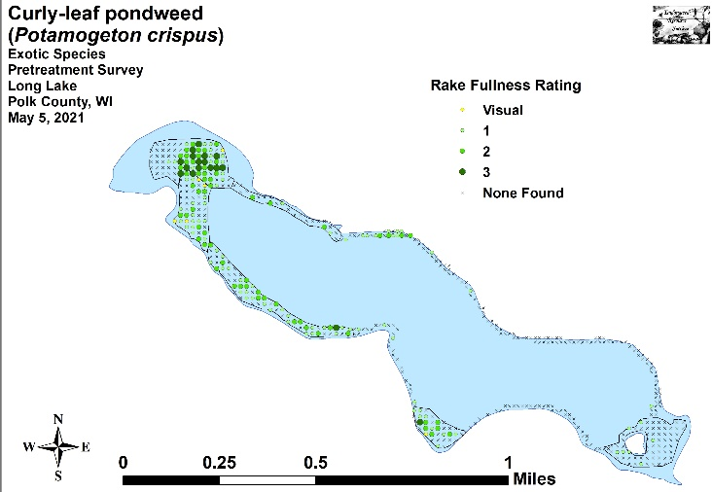 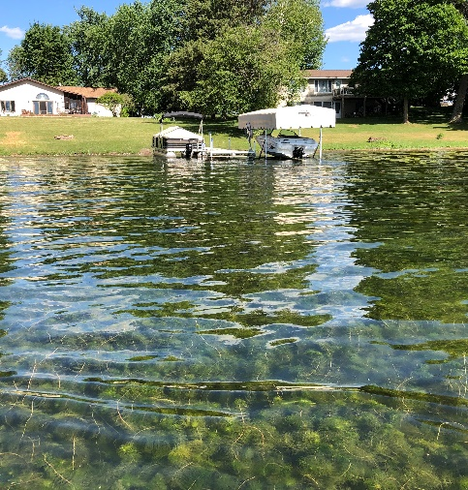
CLP pretreatment density and distribution 5/5/21 Northern water-milfoil in southeast bay 6/14/21

Project Initiated by:
Long Lake Protection and Rehabilitation District, Harmony Environmental, and the Wisconsin Department of Natural Resources – (Grant ACEI20218)

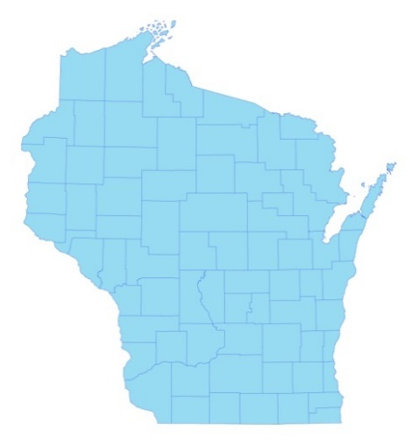 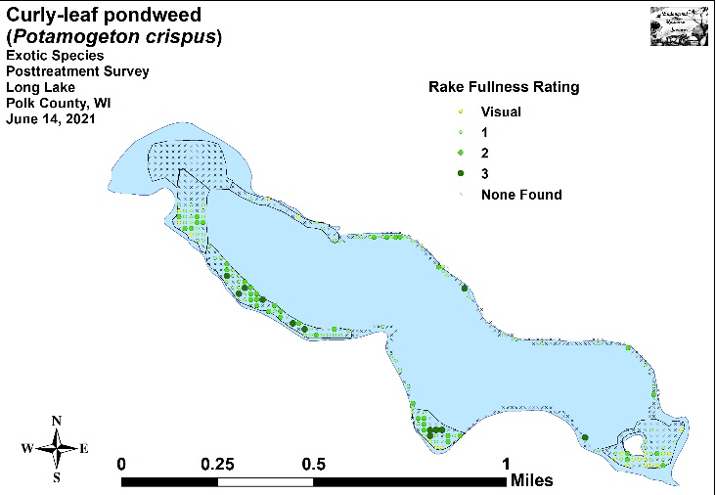 CLP posttreatment density and distribution 6/14/21

* Long Lake

Surveys Conducted by and Report Prepared by:
Endangered Resource Services, LLC
Matthew S. Berg, Research Biologist
St. Croix Falls, Wisconsin
May 5 and June 14, 2021
TABLE OF CONTENTS

Page
LIST OF FIGURES..……………....……..…………………………………..…….. ii

LIST OF TABLES………………….……..………………………………………... iii

INTRODUCTION………………………………………………………………….. 1

BACKGROUND AND STUDY RATIONALE…………………………………… 1

METHODS…………………………………………………………………………. 2

RESULTS AND DISCUSSION……………………………………………………. 3

Finalization of Treatment Areas…………………………………………………... 3

Pre and Posttreatment Surveys………………………………… …………………. 4

CONSIDERATIONS FOR FUTURE MANAGMENT……………………………. 21

LITERATURE CITED……………………….…………………………………….. 22

APPENDIXES……………….……………………………………………………... 23

I: CLP Pre and Posttreatment Survey Sample Points/Final Treatment Areas …... 23

II: Vegetative Survey Data Sheet.………………………………………………... 26

III: Pre and Posttreatment Habitat Variables ……………………………………... 28

IV: Pre and Posttreatment Littoral Zone, Native Species Richness and
Total Rake Fullness.………………………………………………………….. 31

V: CLP Pre and Posttreatment Density and Distribution………………………. … 38

VI: Pretreatment Native Species Density and Distribution….……….…………... 41

VII: Posttreatment Native Species Density and Distribution……………… ……... 56

LIST OF FIGURES

Page
Figure 1: Long Lake Bathymetric Map…………………………..………………... 1
Figure 2: Rake Fullness Ratings…..………………….…….…………………….... 2
Figure 3: Pre and Posttreatment Survey Sample Points and
Final 2021 Curly-leaf Pondweed Treatment Areas ……...…………………………. 3

Figure 4: CLP Area Depths and Bottom Substrate………………………………… 4
Figure 5: Pre and Posttreatment Littoral Zone…………………………………….. 5
Figure 6: Pre and Posttreatment Native Species Richness ………………………… 5
Figure 7: Pre and Posttreatment Total Rake Fullness.………………….………... ... 6
Figure 8: Pre and Posttreatment CLP Density and Distribution…………...…….. ... 7
Figure 9: Whole Lake – Changes in CLP Rake Fullness Ratings..………………... 8
Figure 10: High Density Areas - Changes in CLP Rake Fullness Ratings………… 8
Figure 11: Low Density Areas - Changes in CLP Rake Fullness Ratings.…….….. 9
Figure 12: Pre/Posttreatment Coontail Density and Distribution………………… .. 9
Figure 13: Pre/Posttreatment Northern Water-milfoil Density and Distribution… .. 10
Figure 14: Pre/Posttreatment Water Star-grass Density and Distribution.…………. 10
Figure 15: Pre/Posttreatment Small Pondweed Density and Distribution …………. 11
Figure 16: Pre/Posttreatment Common Waterweed Density and Distribution …….. 11
Figure 17: Whole Lake Pre and Posttreatment Native Species Changes ………….. 17
Figure 18: High Density Areas - Pre and Posttreatment Native Species Changes … 18
Figure 19: Low Density Areas - Pre and Posttreatment Native Species Changes…. 19
Figure 20: 2017 Post, 2018, 2019, and 2020 Follow-up, and 2021 Posttreatment
Changes for All Species…………………………………………………………….. 20

LIST OF TABLES

Page
Table 1: 2021 Spring CLP Treatment Summary – Long Lake, Polk Co…………... 3

Table 2: Pre and Posttreatment Surveys Summary Statistics –
Long Lake, Polk County - May 5 and June 14, 2021.…………………………….... 4

Table 3: Frequencies and Mean Rake Sample of Aquatic Macrophytes
Pretreatment Survey – High CLP Density Areas
Long Lake, Polk County May 5, 2021 ……………………………………………… 13

Table 4: Frequencies and Mean Rake Sample of Aquatic Macrophytes
Pretreatment Survey – Low CLP Density Areas
Long Lake, Polk County May 5, 2021 ……………………………………………… 14

Table 5: Frequencies and Mean Rake Sample of Aquatic Macrophytes
Posttreatment Survey – High CLP Density Areas
Long Lake, Polk County June 14, 2021 ……………………………………………. 15

Table 6: Frequencies and Mean Rake Sample of Aquatic Macrophytes
Posttreatment Survey – Low CLP Density Areas
Long Lake, Polk County June 14, 2021…………………….……….……………... 16

INTRODUCTION:
Long Lake (WBIC 2478200) is a 272-acre seepage lake in central Polk County, Wisconsin in the Town of Balsam Lake (T34N R17W S5, 6, 7, and 8). It reaches a maximum depth of just over 17ft in the central basin and has an average depth of approximately 11ft (Busch et al. 1969) (Figure 1). The lake is eutrophic trending toward hypereutrophic, and visibility is generally poor with summer Secchi readings averaging 5.1ft since 1992; however, the 2021 mean reading of 12.0ft was the highest since records began (WDNR 2021). The bottom substrate in the lake’s bays and central basin is predominately thick organic muck, while exposed points and most north/south shorelines are dominated by gravel and sand.

Figure 1: Long Lake Bathymetric Map

BACKGROUND AND STUDY RATIONALE:
Long Lake and the Long Lake Protection and Rehabilitation District (LLPRD) have an extended history of battling Curly-leaf pondweed (Potamogeton crispus) (CLP) - an exotic invasive plant species that thrives in the nutrient-rich sediments found in many parts of the lake. In the past, CLP often grew so densely in the spring and early summer that it made lake access and boating difficult for residents. CLP’s late-June to early-July senescence was also cited in past studies by Barr Engineering and the Polk County Land and Water Conservation Department (PCLWCD) as a significant contributor to the lake’s overall phosphorus load, and it was at least partially responsible for the lake’s frequent late-summer toxic blue-green algae blooms.

In 2010, after years of study, the LLPRD and the Wisconsin Department of Natural Resources (WDNR) authorized an initial lakewide herbicide treatment of over 65 acres of CLP. The LLPRD treated nearly 57 acres again in 2011, and 58 acres in 2012. After updating the District’s WDNR approved Aquatic Plant Management Plan (APMP) in 2012, it was decided to treat just 27 acres in 2013, and only 20 acres in 2014. Although the 2010-2013 treatments resulted in highly significant reductions in both CLP coverage and density on the lake, the 2014 treatment showed no significant change from pretreatment levels. A follow-up survey of CLP turions in the lake’s sediment also suggested 2015 CLP levels would likely be very low in most parts of the lake. Based on these data, and following a discussion with the lake’s executive board and APMP director Cheryl Clemens (Harmony Environmental) in the fall of 2014, it was decided not to treat CLP in 2015.
Because both the 2015 June CLP point-intercept monitoring survey and the fall CLP turion sediment data suggested CLP had made a significant rebound throughout much of the lake, it was decided that herbicide treatments (not to exceed 35 acres) would resume in the future. Ultimately, the LLPRD decided to treat 34.97 acres in 2016 and 33.65 acres in 2017. However, due to low spring CLP levels, the planned treatments in 2018, 2019, and 2020 were cancelled.

Prior to the planned 2021 herbicide application, we conducted a pretreatment survey of the lake on May 5th to determine initial CLP levels and finalize treatment areas. Although the survey found CLP levels did not exceed the APMP’s treatment threshhold, it was decided to treat the worst area in the northwest bay. To evaluate this treatment we completed a posttreatment survey on June 14th. This report is the summary analysis of these two surveys.

METHODS:
Pre/Posttreatment Treatment Surveys:
Following three years (2010-12) of doing extensive plant surveys as was required for the lakewide herbicide treatments, it was established that most midlake sandy/rocky shorelines that had narrow littoral areas supported extremely low densities of CLP. Because of this, these areas were annually greatly reduced or eliminated from treatment plans. In 2013, we divided the lake into high/low CLP density areas. Within the high density areas (HDAs), we used Hawth’s Analysis Tools Extension to ArcGIS 9.3.1 to generate pre/posttreatment survey points at 25m resolution within that year’s 50 acres of proposed treatment areas. The resulting sampling grid contained 323 points which approximated to 6.5 points/acre. In the historically low density areas (LDAs), we constructed an alternative 200 point grid at 18m resolution where we conducted exploratory CLP point-intercept surveys to monitor for any potential resurgence in CLP. Because of the expansion of CLP in 2015, all 523 points were used for both the pre and posttreatment (follow-up) surveys annually from 2016-2021 (Appendix I).

Prior to each survey, we uploaded the points to a handheld mapping GPS unit (Garmin 76CSx) and then located them on the lake. At each point, we used a rake to sample an approximately 2.5ft section of the bottom and recorded the depth and bottom substrate. CLP was assigned a rake fullness value of 1-3 as an estimation of abundance (Figure 2). We also recorded visual sightings of CLP within six feet of the sample point. However, because visual sightings are not calculated into the pre/posttreatment statistical formulas, we only assigned a rake fullness value for non-CLP plants. A cumulative rake fullness value was also noted at each site.
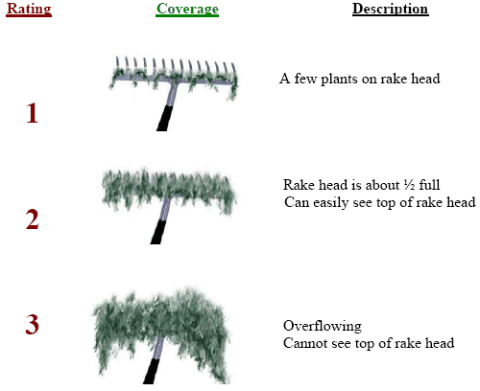
Figure 2: Rake Fullness Ratings
We entered all data collected into the standard APM spreadsheet (Appendix II), and data was analyzed using the linked statistical summary sheet (UWEX 2010). For pre/post differences of individual plant species as well as count data, we used the Chi-square analysis on the WDNR pre/post survey worksheet (UWEX 2010). For comparing averages (mean species/point and mean rake fullness/point), we used t-tests. Differences were determined to be significant at p<0.05, moderately significant at p<0.01 and highly significant at p<0.001.

RESULTS AND DISCUSSION:
Finalization of Treatment Areas:
Of the seven areas identified by Barr Engineering as having Curly-leaf pondweed in 2009, we have consistently found high density CLP in only six of them in an area covering 49.88 acres (Table 1). Following analysis of the 2021 pretreatment survey, we found there were 21.93 acres that had significant amounts of CLP (Figure 3). Although this did not meet the 25 acre minimum outlined in the AMPM, the LLPRD decided to treat the worst 8.61 acre bed (3.17% of the lake’s total surface area) in the northwest bay to relieve navigation impairment. Lake Restoration (Jim Bartlett) applied Aquathol K on May 24th, but provided no treatment report on conditions (Appendix I).

Table 1: 2021 Spring CLP Treatment Summary - Long Lake, Polk Co.

High Density  CLP Area | Potential  Treatment  (acres) | Proposed  Treatment  (acres) | Final  Treatment  (acres) | Difference  (+/-)
1 | 13.34 | 6.86 | 6.86 | 0.00
2 | 8.46 | 5.27 | 1.75 | -2.59
3 | 3.84 | 0.00 | 0.00 | 0.00
4 | 9.51 | 7.25 | 0.00 | -5.40
6 | 4.88 | 2.55 | 0.00 | -2.55
7 | 9.85 | 0.00 | 0.00 | 0.00
 | 49.88 | 21.93 | 8.61 | -13.32

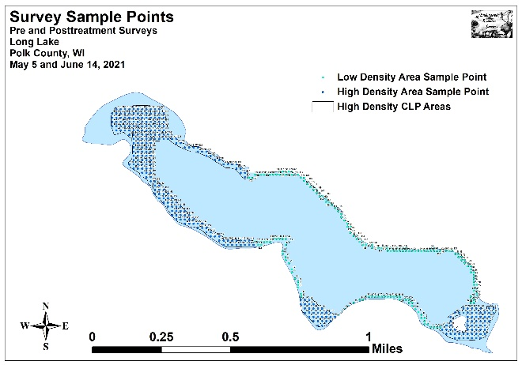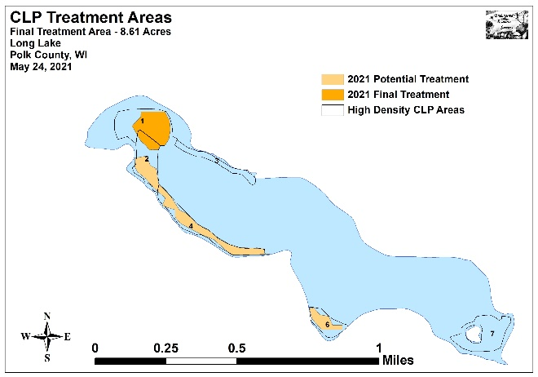
Figure 3: Pre and Posttreatment Survey Sample Points and
Final 2021 Curly-leaf Pondweed Treatment Areas
Pre and Posttreatment Surveys:
All Curly-leaf pondweed areas occurred in water between 1.0ft and 15.5ft deep. During the pretreatment survey, we found the mean and median depth of plant growth in the high density areas was 7.6ft and 7.0ft respectively. In June, they fell to 7.2ft and 6.5ft (Table 2). In the low density areas, the pretreatment mean was 8.1ft and the median was 8.0ft. These values remained almost unchanged at 7.9ft and 8.0ft during the June survey. Most CLP within the HDAs occurred over organic muck, although the western edge of Bed 7 near the island was established over sandy/rocky substrates. LDAs were dominated by sand and rock (Figure 4) (Appendix III).

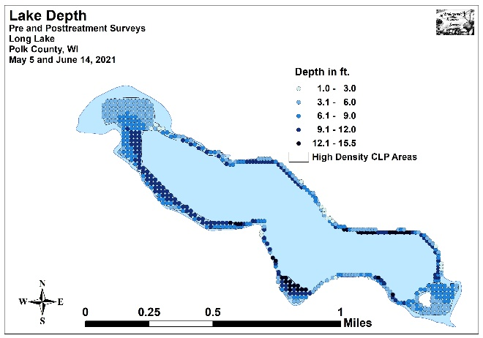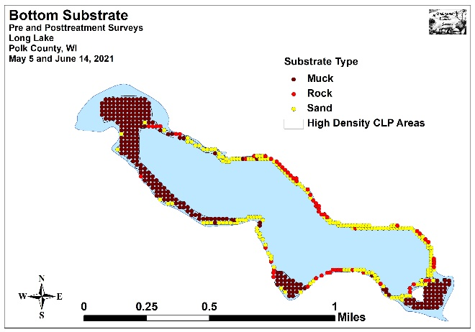
Figure 4: CLP Area Depths and Bottom Substrate

Table 2: Pre and Posttreatment Surveys Summary Statistics
Long Lake, Polk County
May 5 and June 14, 2021
Summary Statistics: | Pre-High | Post-High | Pre-Low | Post- Low
Total number of points sampled | 323 | 323 | 200 | 200
Total number of sites with vegetation | 312 | 313 | 136 | 180
Total number of sites shallower than the maximum depth of plants | 320 | 322 | 194 | 199
Frequency of occurrence at sites shallower than max. depth of plants | 97.5 | 97.2 | 70.1 | 90.5
Simpson Diversity Index | 0.74 | 0.78 | 0.81 | 0.77
Mean Coefficient of Conservatism | 5.8 | 5.2 | 5.6 | 5.4
Floristic Quality Index | 19.3 | 18.9 | 16.7 | 17.8
Average number of all species per site (shallower than max depth) | 1.82 | 2.07 | 1.13 | 1.70
Average number of all species per site (veg. sites only) | 1.87 | 2.12 | 1.61 | 1.88
Ave. number of native species/site (shallower than max depth) | 1.38 | 1.76 | 1.02 | 1.51
Ave. number of native species/site (sites with native plants only) | 1.51 | 1.84 | 1.49 | 1.76
Species Richness | 12 | 14 | 10 | 12
Maximum depth of plants (ft) | 14.5 | 14.5 | 14.5 | 15.5
Mean depth of plants (ft) | 7.6 | 7.2 | 8.1 | 7.9
Median depth of plants (ft) | 7.0 | 6.5 | 8.0 | 8.0
Mean Rake Fullness (veg. sites only) | 2.03 | 2.42 | 1.48 | 1.93

The littoral zone extended to 14.5ft in May (14.5ft HDAs/14.5ft LDAs) and 15.5ft in June (14.5ft HDAs/15.5ft LDAs) (Figure 5) (Appendix IV). Within this zone, the frequency of plants encountered in the HDAs was almost unchanged at 97.5% pretreatment and 97.2% posttreatment. In the LDAs, plant levels increased sharply from a frequency of 70.1% in May to 90.5% in June. Richness in the HDAs rose from 12 species in May to 14 in June, while the LDAs increased from ten to 12 species. Collectively, richness increased from 13 to 17 species. The Simpson’s Diversity Index increased in the HDAs (0.74 May/0.78 June) but declined in the LDAs (0.81 May/0.77 June). Combining the data produced almost no change as the index was 0.79 in May and 0.80 in June. The Floristic Quality Index (another measure of the native plant community health) declined slightly in the HDAs from 19.3 in May to 18.9 in June. In the LDAs, it increased from 16.7 pretreatment to 17.8 posttreatment. Lakewide, it ticked up from 20.5 pre to 21.0 post.

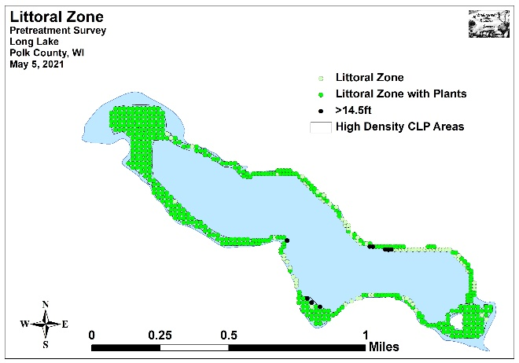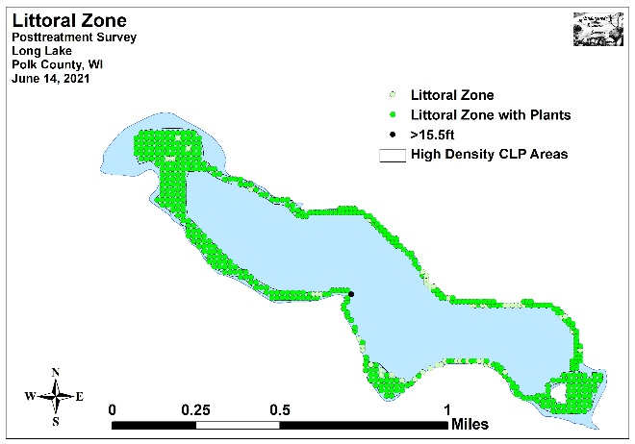
Figure 5: Pre and Posttreatment Littoral Zone

We found localized native species richness to be quite low throughout the lake. In the High Density Areas, mean richness at points with native plants increased from 1.51 species/site in May to 1.84 species/site in June. In low density areas, this value increased from 1.49 species/site in May to 1.76 species/site in June. When combined, these areas experienced a highly significant increase (p<0.001) in mean native species richness from 1.50 species/site in May to 1.81 species/site in June. Analysis of the maps showed that, although these increases were a lakewide event, the proliferation of “duckweed” species in the northwest bay posttreatment was a noticeable contributor (Figures 6) (Appendix IV).

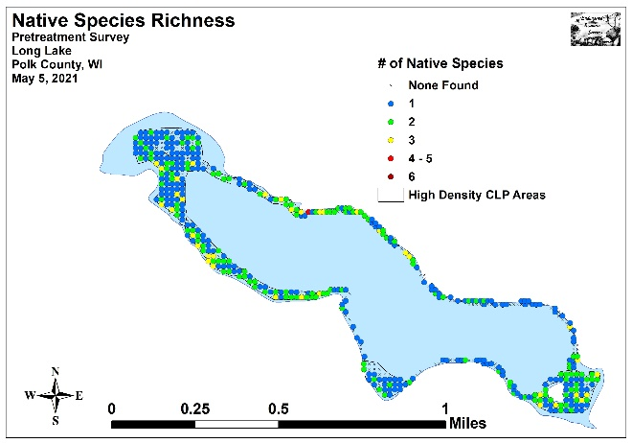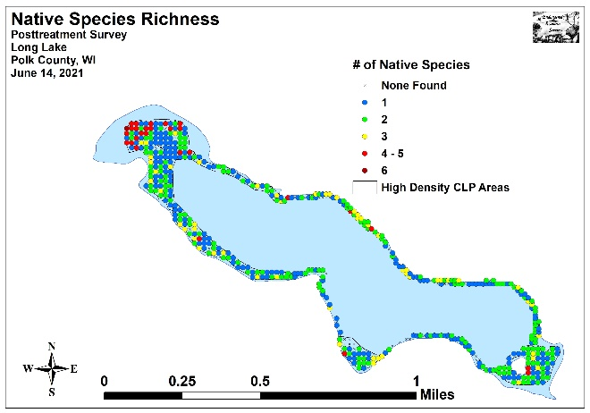
Figure 6: Pre and Posttreatment Native Species Richness
Total mean rake fullness in the HDAs was a moderate 2.03 in May before increasing sharply to a moderately high 2.42 in June. We also documented a sharp rise in the LDAs from a low/moderate 1.48 in May to a moderate 1.93 in June (Figures 7) (Appendix IV). Cumulatively, mean rake fullness experienced a highly significant increase (p<0.001) from a moderate 1.87 in May to a moderately high 2.26 in June.

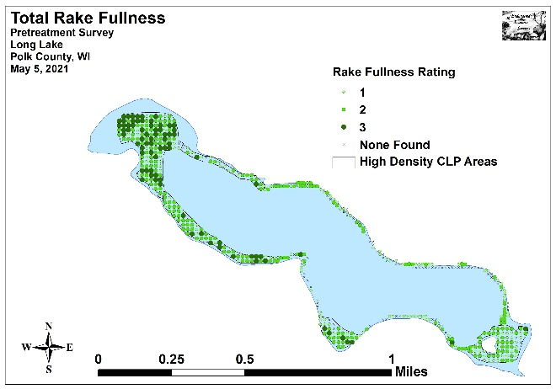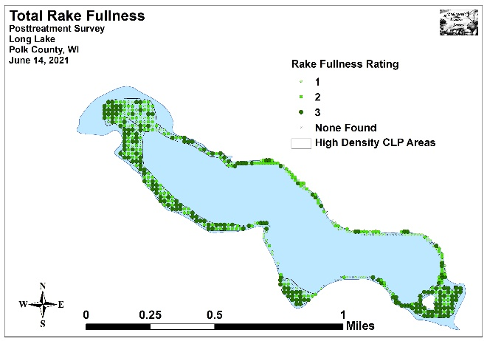
Figure 7: Pre and Posttreatment Total Rake Fullness

During the May 2021 survey, we found Curly-leaf pondweed at 162 of 523 total sites with a mean rake fullness of 1.58 (Figure 8) (Appendix V). This approximated to 31.0% coverage and represented a 40.9% increase over the 2020 May survey when CLP was present at 115 sites (22.0% coverage/mean rake fullness of 1.54). It was also up from the 2019 May survey when CLP was found at 68 points (13.0% coverage/mean rake fullness of 1.37); and the 2018 survey when we located CLP at 46 points (8.8% coverage/mean rake of 1.20). However, it was still below the 209 points (40.0% coverage/mean rake of 1.71) with CLP prior to the last chemical treatment in 2017.

Broken out by area, 141 of the 162 points with CLP occurred in the High Density Area’s 323 points (43.7% coverage), while 21 occurred within the Low Density Area’s 200 points (10.5% coverage). The HDAs had 17 points with a rake fullness rating of 3, 56 points that rated a 2, 68 that were a 1, and six additional visual sightings. This produced a mean rake fullness of 1.64 (nearly identical to 2020’s 1.63; up from 1.38 in 2019 and 1.20 in 2018; but still down from 1.71 in 2017). In the LDAs, no points rated a 3, four were a 2, and the remaining 17 were a 1 for a mean rake of 1.19. Collectively, 77 points had a significant infestation (rake fullness of 2 or 3) and this approximated to 14.7% coverage.

In June, we found CLP at 137 points (26.2% coverage) (down from 196 points/37.5% coverage in 2020 and 167 points /31.9% coverage in 2019; and similar to 132 points/25.2% coverage in 2018) with 21 additional visual sightings (Figure 8) (Appendix V). Of these, 12 rated a 3, 41 were a 2 (10.1% significant infestation), and the remaining 84 were a 1. This produced a low/moderate mean rake fullness of 1.47 – down from 1.56 in June 2020; 1.87 in 2019; and similar to 1.44 in 2018. These results suggested that total CLP, despite only treating a small area, had undergone a nearly-significant decline (p=0.09) in both density and total distribution; and a significant decline (p<0.05) in rake fullness 2 (Figure 9). Visual analysis of the maps showed complete control in the treatment area with typical growing season expansion in most untreated parts of the lake.
Posttreatment, the HDAs had 99 points with CLP (30.7% coverage). Ten points rated a 3, 33 were a 2, and the remaining 56 rated a 1 with 21 additional visual sightings. This produced a mean rake fullness of 1.54 and suggested 13.3% of the HDAs (43 points) still had a significant infestation. This was down sharply from the June 2020 and June 2019 follow-up surveys when 82 points (25.4% coverage) and 101 points (31.3% coverage) rated a 2 or a 3. It was also lower than the 2018 follow-up survey when there were 50 points (15.5% coverage) with a significant infestation. Compared to May, this represented a highly significant decline (p<0.001) in total CLP; a moderately significant decline (p=0.008) in rake fullness 2; and a moderately significant increase (p=0.003) in visual sightings (Figure 10).

In the LDAs, CLP was present at 38 points (19.0% coverage). Two points were a rake fullness of 3, eight points rated a 2 (5% significant infestation), and the remaining 28 points were a 1 for a mean rake fullness of 1.32. Of these changes since May, only the increase in total distribution was significant (p=0.02) (Figure 11). These results also represented a moderately significant increase (p=0.007) in distribution compared to June of 2020 when CLP was present at 19 points (9.5% coverage). It was also higher than the 18 points in 2019, and seven points in 2018.

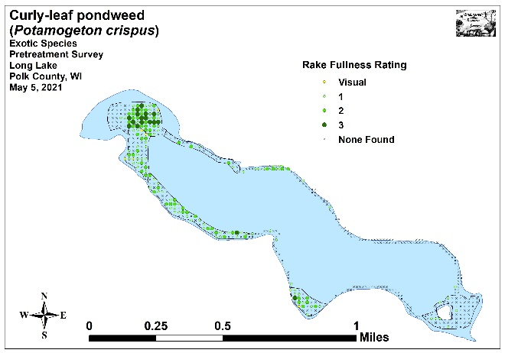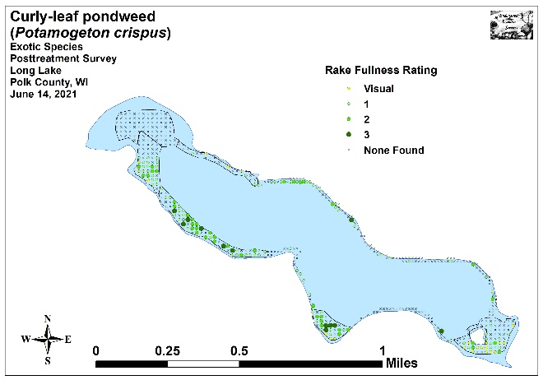
Figure 8: Pre and Posttreatment CLP Density and Distribution

-*
Significant differences = * p<0.05, ** p<0 .01, *** p<0.001
Figure 9: Whole Lake – Changes in CLP Rake Fullness Ratings
-**
+**
-***
Significant differences = * p<0.05, ** p<0 .01, *** p<0.001
Figure 10: High Density Areas - Changes in CLP Rake Fullness Ratings
+*
Significant differences = * p<0.05, ** p<0 .01, *** p<0.001
Figure 11: Low Density Areas - Changes in CLP Rake Fullness Ratings

Lakewide, we found Coontail (Ceratophyllum demersum) was the most common native species pretreatment and the second most common posttreatment (Figure 12) (Tables 3-6). Present at 264 sites with a mean rake fullness of 1.82 in May, we documented a non-significant decline (p=0.71) in distribution to 258 sites and a non-significant increase (p=0.11) in density to a mean rake of 1.90 by June. It was especially common in the nutrient-rich organic muck substrates that dominate the HDAs.

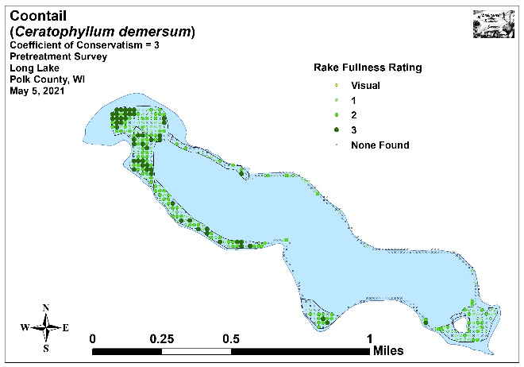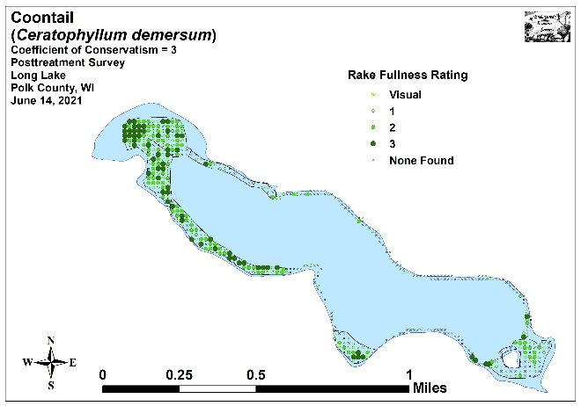
Figure 12: Pre and Posttreatment Coontail Density and Distribution

Northern water-milfoil (Myriophyllum sibiricum) was the second most common native species pretreatment (154 sites/mean rake 1.43) (Figure 13). After highly significant expansions (p<0.001) in distribution (314 sites) and density (mean rake 1.99), it became the most common plant in the June survey. This rooted species is coming to dominate many parts of the lake; especially in the southeast bay where it is excluding most other species and causing severe navigation impairment for local residents (see cover of report). Its dense growth over sandy muck in 4-8ft of water is potentially a driving force behind increases in water clarity and the declines of other previously dominant species like CLP and Coontail.

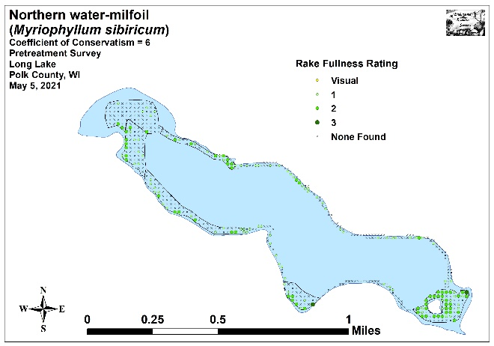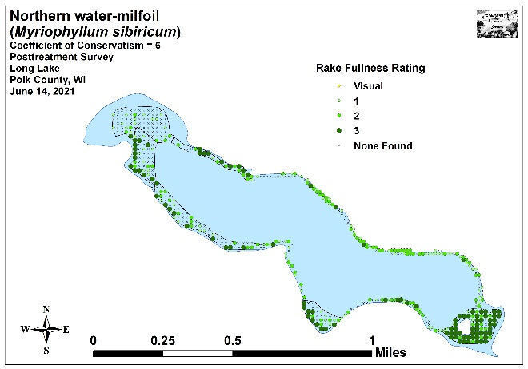
Figure 13: Pre and Posttreatment Northern Water-milfoil
Density and Distribution

Present over most sand and gravel substrates, Water star-grass (Heteranthera dubia) was the third most common native species during both the pretreatment (90 sites/mean rake 1.17) and posttreatment surveys (93 sites/mean rake1.23) (Figure 14). Neither its increases in distribution nor density were significant (p=0.81/p=0.16).

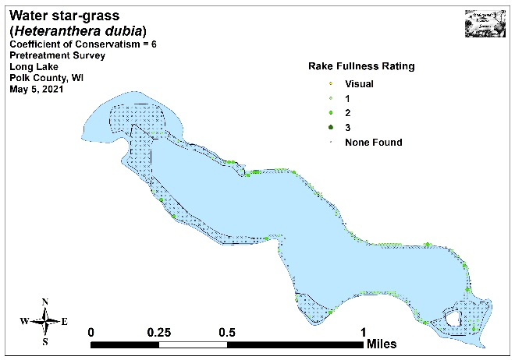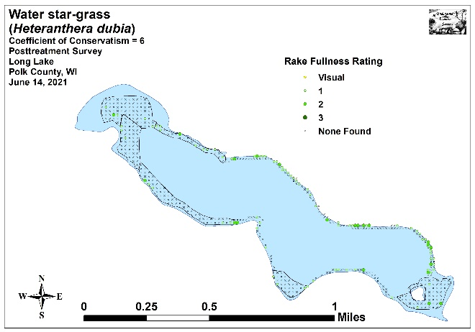
Figure 14: Pre and Posttreatment Water Star-grass
Density and Distribution

Small pondweed (Potamogeton pusillus) was the fourth most common native species during the pretreatment survey when we found it at 58 points with a mean rake fullness of 1.31 (Figure 15). Although it experienced a significant decline (p=0.01) in distribution (35 sites) and a non-significant decline (p=0.12) in density (mean rake 1.20), it remained the fourth most widely-distributed species posttreatment. First detected as a visual at a single point during the 2016 full lake point-intercept survey, Small pondweed has become an increasingly common species in the lake and now grows in most organic muck bottom areas around the central basin in water from 8-12ft – a habitat that formerly supported little other than CLP and scattered Coontail.

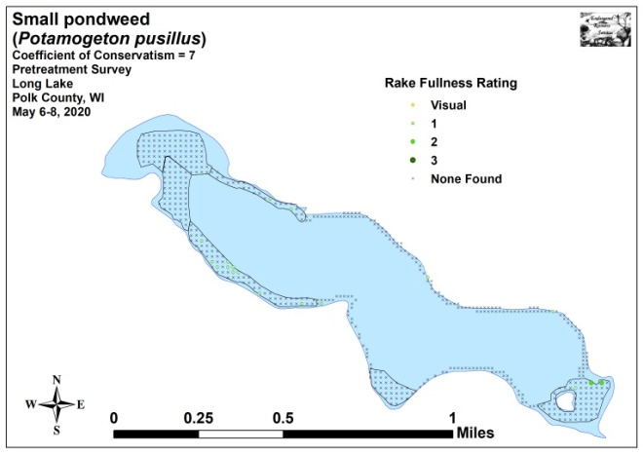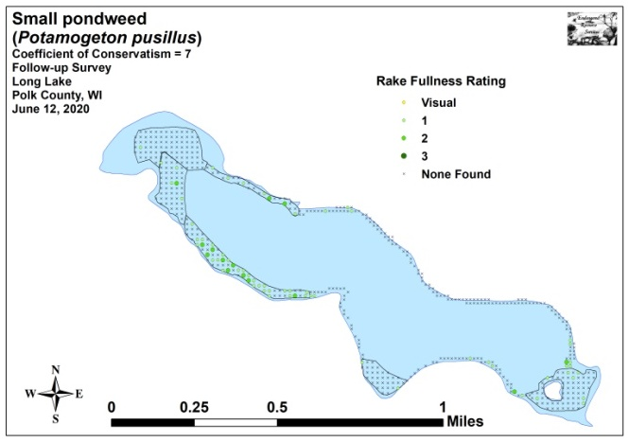
Figure 15: Pre and Posttreatment Small Pondweed
Density and Distribution

Historically, Common waterweed (Elodea canadensis) was a dominant native species on the lake as it exploited high nutrient levels in mucky habitats to form dense floating mats of vegetation - this was especially true following past herbicide treatments. During the pretreatment survey, it was the sixth most common native species – 18 sites with a mean rake fullness of 1.06 (Figure 16). In June, both of these values experienced non-significant increases (p=0.62/p=0.32), but it fell to become the ninth ranked native species (21 sites/1.10 mean rake).

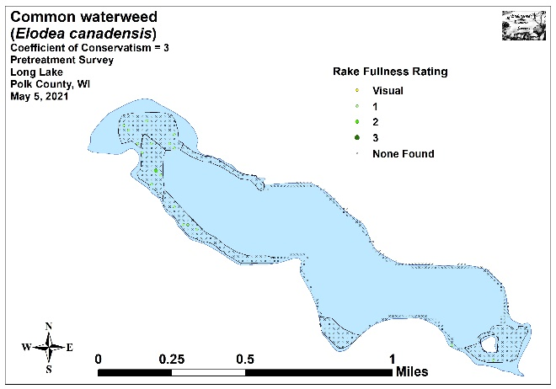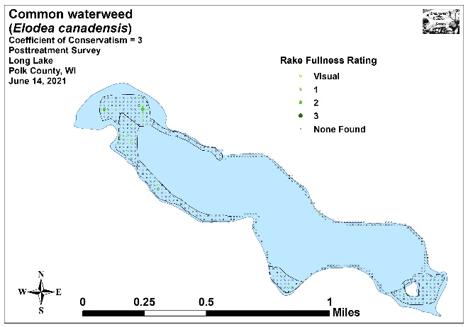
Figure 16: Pre and Posttreatment Common Waterweed
Density and Distribution
As is typical, many later-growing native species that were largely dormant during the pretreatment survey showed significant lakewide increases by June (Figure 17). In addition to the previously mentioned Northern water-milfoil, filamentous algae, Small duckweed (Lemna minor), Large duckweed (Spirodela polyrhiza), and Common watermeal (Wolffia columbiana) all demonstrated highly significant increases (p<0.001) in distribution. We also documented a moderately significant increase (p=0.002) in White water lily (Nymphaea odorata) and a significant increase (p=0.03) in Nitella (Nitella sp.) (Maps of all native species from the pre and posttreatment surveys are located in Appendixes VI and VII).

Beyond the lakewide changes, breaking the data out between High Density Areas and Low Density Areas provided limited additional information. In the HDAs, we found that Small pondweed’s decline in distribution was moderately significant (p=0.002) (Figure 18). As this species is also highly sensitive to Endothall, it’s possible that this loss is related to the treatment. In the LDAs, there were no significant changes in native species that were different than the lakewide data (Figure 19).

Comparing the 2017 posttreatment, the 2018, 2019, and 2020 June follow-up surveys, and the 2021 posttreatment (Figure 20) showed significant recoveries in native species; especially those that are sensitive to Endothall such as Coontail, Northern water-milfoil, and Small pondweed. The increases in Water star-grass, Northern water-milfoil, and Small pondweed at depths previously unseen also suggests plants are responding to improvements in water clarity. Ultimately, this strong regrowth and increasing richness and diversity of native species may mean that the lake is trending towards a more balanced plant community that won’t require significant active management in the future.

Table 3: Frequencies and Mean Rake Sample of Aquatic Macrophytes
Pretreatment Survey – High CLP Density Areas - Long Lake, Polk County
May 5, 2021

Species | Common Name | Total  Sites | Relative Freq. | Freq. in Veg. | Freq. in Lit. | Mean Rake | Visual  Sight.
Ceratophyllum demersum | Coontail | 235 | 40.38 | 75.32 | 73.44 | 1.86 | 0
Potamogeton crispus | Curly-leaf pondweed | 141 | 24.23 | 45.19 | 44.06 | 1.64 | 6
Myriophyllum sibiricum | Northern water-milfoil | 106 | 18.21 | 33.97 | 33.13 | 1.59 | 0
 | Filamentous algae | 102 | * | 32.69 | 31.88 | 1.23 | 0
Potamogeton pusillus | Small pondweed | 42 | 7.22 | 13.46 | 13.13 | 1.29 | 0
Heteranthera dubia | Water star-grass | 21 | 3.61 | 6.73 | 6.56 | 1.29 | 0
Elodea canadensis | Common waterweed | 17 | 2.92 | 5.45 | 5.31 | 1.06 | 0
Lemna trisulca | Forked duckweed | 13 | 2.23 | 4.17 | 4.06 | 1.08 | 0
Eleocharis acicularis | Needle spikerush | 3 | 0.52 | 0.96 | 0.94 | 1.00 | 0
Chara sp. | Muskgrass | 1 | 0.17 | 0.32 | 0.31 | 1.00 | 0
Nymphaea odorata | White water lily | 1 | 0.17 | 0.32 | 0.31 | 1.00 | 0
Potamogeton zosteriformis | Flat-stem pondweed | 1 | 0.17 | 0.32 | 0.31 | 1.00 | 0
Sagittaria graminea | Grass-leaved arrowhead | 1 | 0.17 | 0.32 | 0.31 | 1.00 | 0
 | Aquatic moss | 1 | * | 0.32 | 0.31 | 1.00 | 0

* Excluded from relative frequency analysis

Table 4: Frequencies and Mean Rake Sample of Aquatic Macrophytes
Pretreatment Survey – Low CLP Density Areas - Long Lake, Polk County
May 5, 2021

Species | Common Name | Total  Sites | Relative Freq. | Freq. in Veg. | Freq. in Lit. | Mean Rake | Visual  Sight.
 | Filamentous algae | 71 | * | 52.21 | 36.60 | 1.44 | 0
Heteranthera dubia | Water star-grass | 69 | 31.51 | 50.74 | 35.57 | 1.13 | 0
Myriophyllum sibiricum | Northern water-milfoil | 48 | 21.92 | 35.29 | 24.74 | 1.06 | 0
Ceratophyllum demersum | Coontail | 29 | 13.24 | 21.32 | 14.95 | 1.48 | 0
Potamogeton crispus | Curly-leaf pondweed | 21 | 9.59 | 15.44 | 10.82 | 1.19 | 0
Lemna trisulca | Forked duckweed | 20 | 9.13 | 14.71 | 10.31 | 1.00 | 0
Potamogeton pusillus | Small pondweed | 16 | 7.31 | 11.76 | 8.25 | 1.38 | 0
Chara sp. | Muskgrass | 6 | 2.74 | 4.41 | 3.09 | 1.17 | 0
Eleocharis acicularis | Needle spikerush | 6 | 2.74 | 4.41 | 3.09 | 1.17 | 0
Nitella sp. | Nitella | 3 | 1.37 | 2.21 | 1.55 | 1.00 | 0
Elodea canadensis | Common waterweed | 1 | 0.46 | 0.74 | 0.52 | 1.00 | 0

* Excluded from relative frequency analysis

Table 5: Frequencies and Mean Rake Sample of Aquatic Macrophytes
Posttreatment Survey - High CLP Density Areas - Long Lake, Polk County
June 14, 2021

Species | Common Name | Total  Sites | Relative Freq. | Freq. in Veg. | Freq. in Lit. | Mean Rake | Visual  Sight.
Ceratophyllum demersum | Coontail | 232 | 34.89 | 74.12 | 72.05 | 1.93 | 0
Myriophyllum sibiricum | Northern water-milfoil | 177 | 26.62 | 56.55 | 54.97 | 2.28 | 0
 | Filamentous algae | 161 | * | 51.44 | 50.00 | 1.47 | 0
Potamogeton crispus | Curly-leaf pondweed | 99 | 14.89 | 31.63 | 30.75 | 1.54 | 21
Heteranthera dubia | Water star-grass | 29 | 4.36 | 9.27 | 9.01 | 1.17 | 0
Lemna minor | Small duckweed | 22 | 3.31 | 7.03 | 6.83 | 1.18 | 0
Spirodela polyrhiza | Large duckweed | 22 | 3.31 | 7.03 | 6.83 | 2.00 | 0
Wolffia columbiana | Common watermeal | 22 | 3.31 | 7.03 | 6.83 | 1.59 | 0
Elodea canadensis | Common waterweed | 20 | 3.01 | 6.39 | 6.21 | 1.10 | 0
Potamogeton pusillus | Small pondweed | 18 | 2.71 | 5.75 | 5.59 | 1.22 | 0
Nymphaea odorata | White water lily | 12 | 1.80 | 3.83 | 3.73 | 1.08 | 0
Lemna trisulca | Forked duckweed | 5 | 0.75 | 1.60 | 1.55 | 1.20 | 0
Chara sp. | Muskgrass | 3 | 0.45 | 0.96 | 0.93 | 1.33 | 0
Eleocharis acicularis | Needle spikerush | 2 | 0.30 | 0.64 | 0.62 | 1.50 | 0
Potamogeton richardsonii | Clasping-leaf pondweed | 2 | 0.30 | 0.64 | 0.62 | 1.00 | 0

* Excluded from relative frequency analysis

Table 6: Frequencies and Mean Rake Sample of Aquatic Macrophytes
Posttreatment Survey - Low CLP Density Areas - Long Lake, Polk County
June 14, 2021

Species | Common Name | Total  Sites | Relative Freq. | Freq. in Veg. | Freq. in Lit. | Mean Rake | Visual  Sight.
Myriophyllum sibiricum | Northern water-milfoil | 137 | 40.41 | 76.11 | 68.84 | 1.63 | 0
 | Filamentous algae | 100 | * | 55.56 | 50.25 | 2.11 | 0
Heteranthera dubia | Water star-grass | 64 | 18.88 | 35.56 | 32.16 | 1.25 | 0
Potamogeton crispus | Curly-leaf pondweed | 38 | 11.21 | 21.11 | 19.10 | 1.32 | 0
Ceratophyllum demersum | Coontail | 26 | 7.67 | 14.44 | 13.07 | 1.65 | 0
Lemna trisulca | Forked duckweed | 26 | 7.67 | 14.44 | 13.07 | 1.00 | 0
Potamogeton pusillus | Small pondweed | 17 | 5.01 | 9.44 | 8.54 | 1.18 | 0
Chara sp. | Muskgrass | 12 | 3.54 | 6.67 | 6.03 | 1.25 | 0
Nitella sp. | Nitella | 11 | 3.24 | 6.11 | 5.53 | 1.36 | 0
Eleocharis acicularis | Needle spikerush | 4 | 1.18 | 2.22 | 2.01 | 1.00 | 0
Najas flexilis | Slender naiad | 2 | 0.59 | 1.11 | 1.01 | 1.50 | 0
Elodea canadensis | Common waterweed | 1 | 0.29 | 0.56 | 0.50 | 1.00 | 0
Stuckenia pectinata | Sago pondweed | 1 | 0.29 | 0.56 | 0.50 | 1.00 | 0

* Excluded from relative frequency analysis

+***
+***
+***
+**
+*
-*
+***
+***
Significant differences = * p<0.05, ** p<0 .01, *** p<0.001
Figure 17: Whole Lake Pre and Posttreatment Native Species Changes
+***
+***
+***
+**
+***
-**
+***
Significant differences = * p<0.05, ** p<0 .01, *** p<0.001
Figure 18: High Density Areas - Pre and Posttreatment Native Species Changes
+***
+**
Significant differences = * p<0.05, ** p<0 .01, *** p<0.001
Figure 19: Low Density Areas - Pre and Posttreatment Native Species Change
+*
+*
-***
+**
+**
+***

-***
+***
-**
+***
-***
+***
-***
+*
+***
+***
+***
+**
-**
+**
-*
+***
+**
+*
+*
-***
-***
-**
-***
+*
+*
-***
+**
+***
+***
-***
+*
+**
Significant differences = * p<0.05, ** p<0 .01, *** p<0.001
Figure 20: 2017 Post, 2018, 2019, and 2020 Follow-up, and 2021 Posttreatment – Changes for All Species
CONSIDERATIONS FOR FUTURE MANAGMENT:
Long Lake’s Northern water-milfoil population has exploded, and canopied mats of this species are likely causing significant navigation impairments for residents – especially in the southeast bay. The current state of the lake’s plant community is likely leaving many people to question whether they’ve traded one problem (Curly-leaf pondweed) for another (NWM). Although potentially frustrating, these dense stands of NWM should be viewed as a steppingstone to restoration rather than what the "end product" will look like. NWM is a rooted plant, and, as such, it holds on to nutrients throughout the growing season. It also has some ability to overwinter. In areas where NWM is the densest, CLP has almost disappeared - it is, in effect, out competing CLP for space, nutrients and light.

Although it may sound counterintuitive, the next step in restoration is for more plant species to occur in greater numbers. In most systems we work on, there are several species that compete with NWM and help keep it in balance relative to the overall macrophyte community - Flat-stem pondweed (Potamogeton zosteriformis), Clasping-leaf pondweed (Potamogeton richardsonii), and Wild celery (Vallisneria americana). Collectively, these three species grow with NWM and create mixed beds that support fish, don't canopy and interfere with boat traffic, and tie up nutrients throughout the growing season which helps maintain water clarity.

Fortunately, these species are already present in Long Lake, albeit at low numbers. Flat-stem was a historically dominant plant based on Barr Engineering surveys from the early 2000's. It disappeared when clarity went down and lakewide chemical treatment occurred as it, Small pondweed, and Curly-leaf pondweed are all extremely sensitive to Endothall. The 2021 survey was the first time we have documented this species in the lake despite our having conducted multiple surveys annually since 2009. We found it at several widely-separated locations, and its presence likely signals a water clarity/quality threshold has been achieved – potentially due to the alum treatment. Clasping-leaf pondweed’s return to the lake is also relatively recent as we first found it in 2018. There are now several good-sized beds in the lake, and it appears to be spreading. Wild celery is also present, but currently rare. We didn’t see it anywhere on the lake in 2021, but did see a few individuals in both 2019 and 2020. Hopefully, with continued improvements in water quality, it will also rejoin the plant community in high enough numbers to compete with NWM.

If chemical treatments to control Curly-leaf pondweed continue to occur on the lake, limiting them to the worst CLP areas will hopefully avoid significant collateral damage of beneficial native species. Although Endothall is highly effective at controlling CLP, it can also severely impact the very plants needed to bring CLP back to low levels and to get past the current glut of NWM.

LITERATURE CITED

Busch, C., G. Lund, L. Sather, and C. Holt. 1969. Long Lake Map. Available from http://dnr.wi.gov/lakes/maps/DNR/2478200a.pdf (2021, November)

UWEX Lakes Program. [online]. 2010. Aquatic Plant Management in Wisconsin. Available from http://www.uwsp.edu/cnr-ap/UWEXLakes/Pages/ecology/aquaticplants/default.aspx (2021, November).

UWEX Lakes Program. [online]. 2010. Pre/Posttreatment Herbicide Comparison. Available from http://www.uwsp.edu/cnr-ap/UWEXLakes/Documents/ecology/Aquatic%20Plants/Appendix-D.pdf (2021, November).

WDNR. [online]. 2020. Citizen Lake Monitoring Water Quality Data Report for Long Lake. http://dnr.wi.gov/lakes/waterquality/Station.aspx?id=493102 (2021, November).

Appendix I: CLP Pre and Posttreatment Survey Sample Points and
Final Treatment Areas
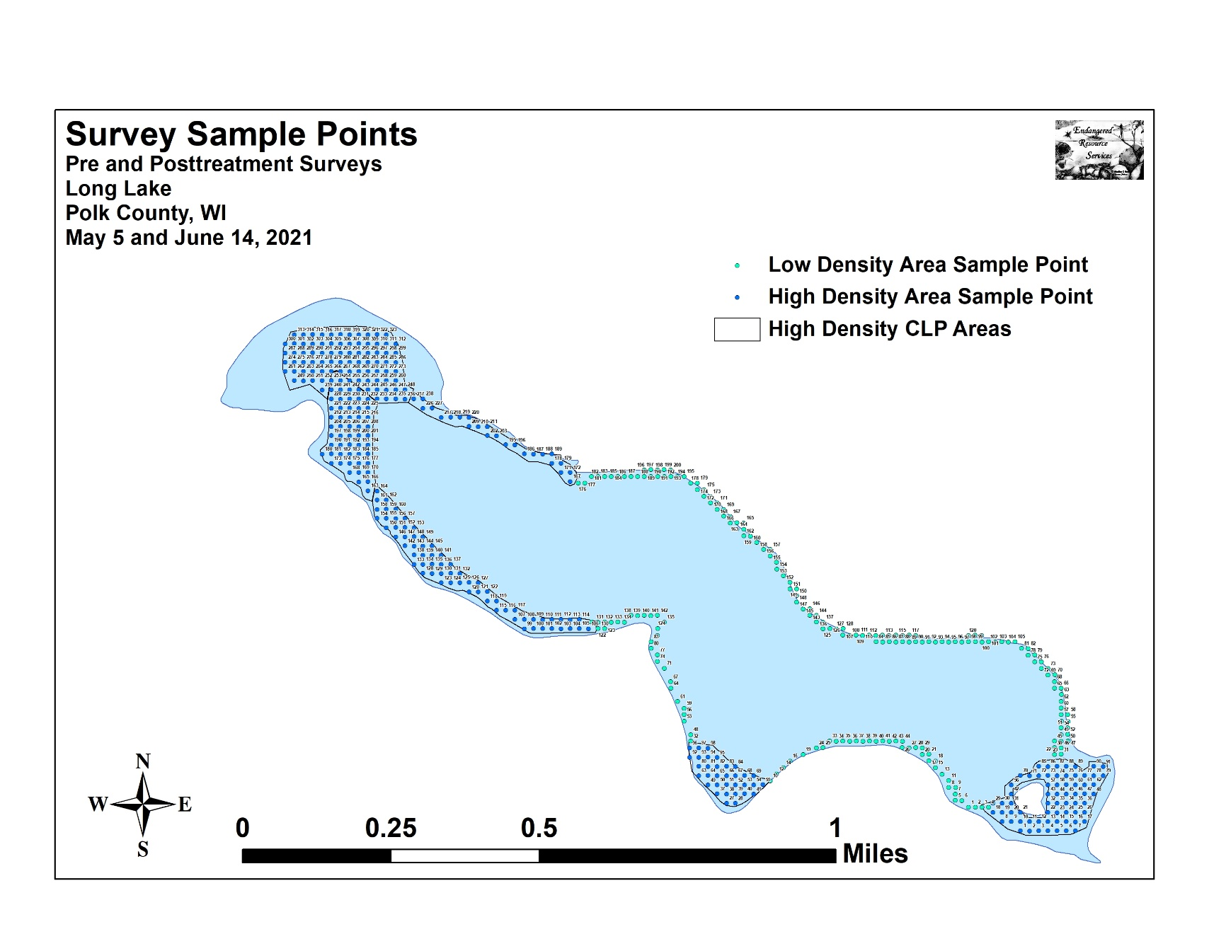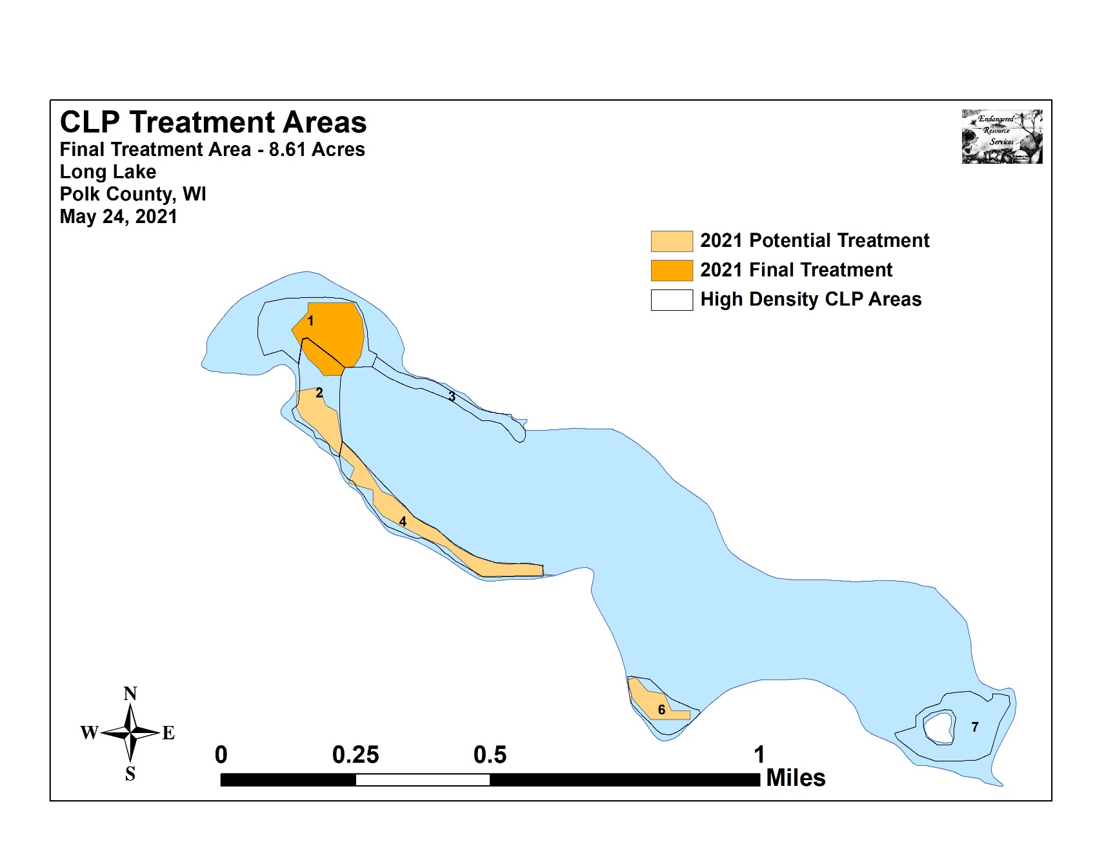

Appendix II: Vegetative Survey Data Sheet

Observers for this lake: names and hours worked by each:
Lake: |  |  |  |  |  |  |  |  | WBIC |  |  |  |  |  |  |  |  | County |  |  |  |  |  | Date:
Site # | Depth (ft) | Muck (M), Sand (S), Rock (R) | Rake pole (P) or rake rope (R) | Total Rake Fullness | CLP | CLP | 1 | 2 | 3 | 4 | 5 | 6 | 7 | 8 | 9 | 10 | 11 | 12 | 13 | 14 | 15 | 16 | 17 | 18 | 19
1
2
3
4
5
6
7
8
9
10
11
12
13
14
15
16
17
18
19
20

Appendix III: Pre and Posttreatment Habitat Variables
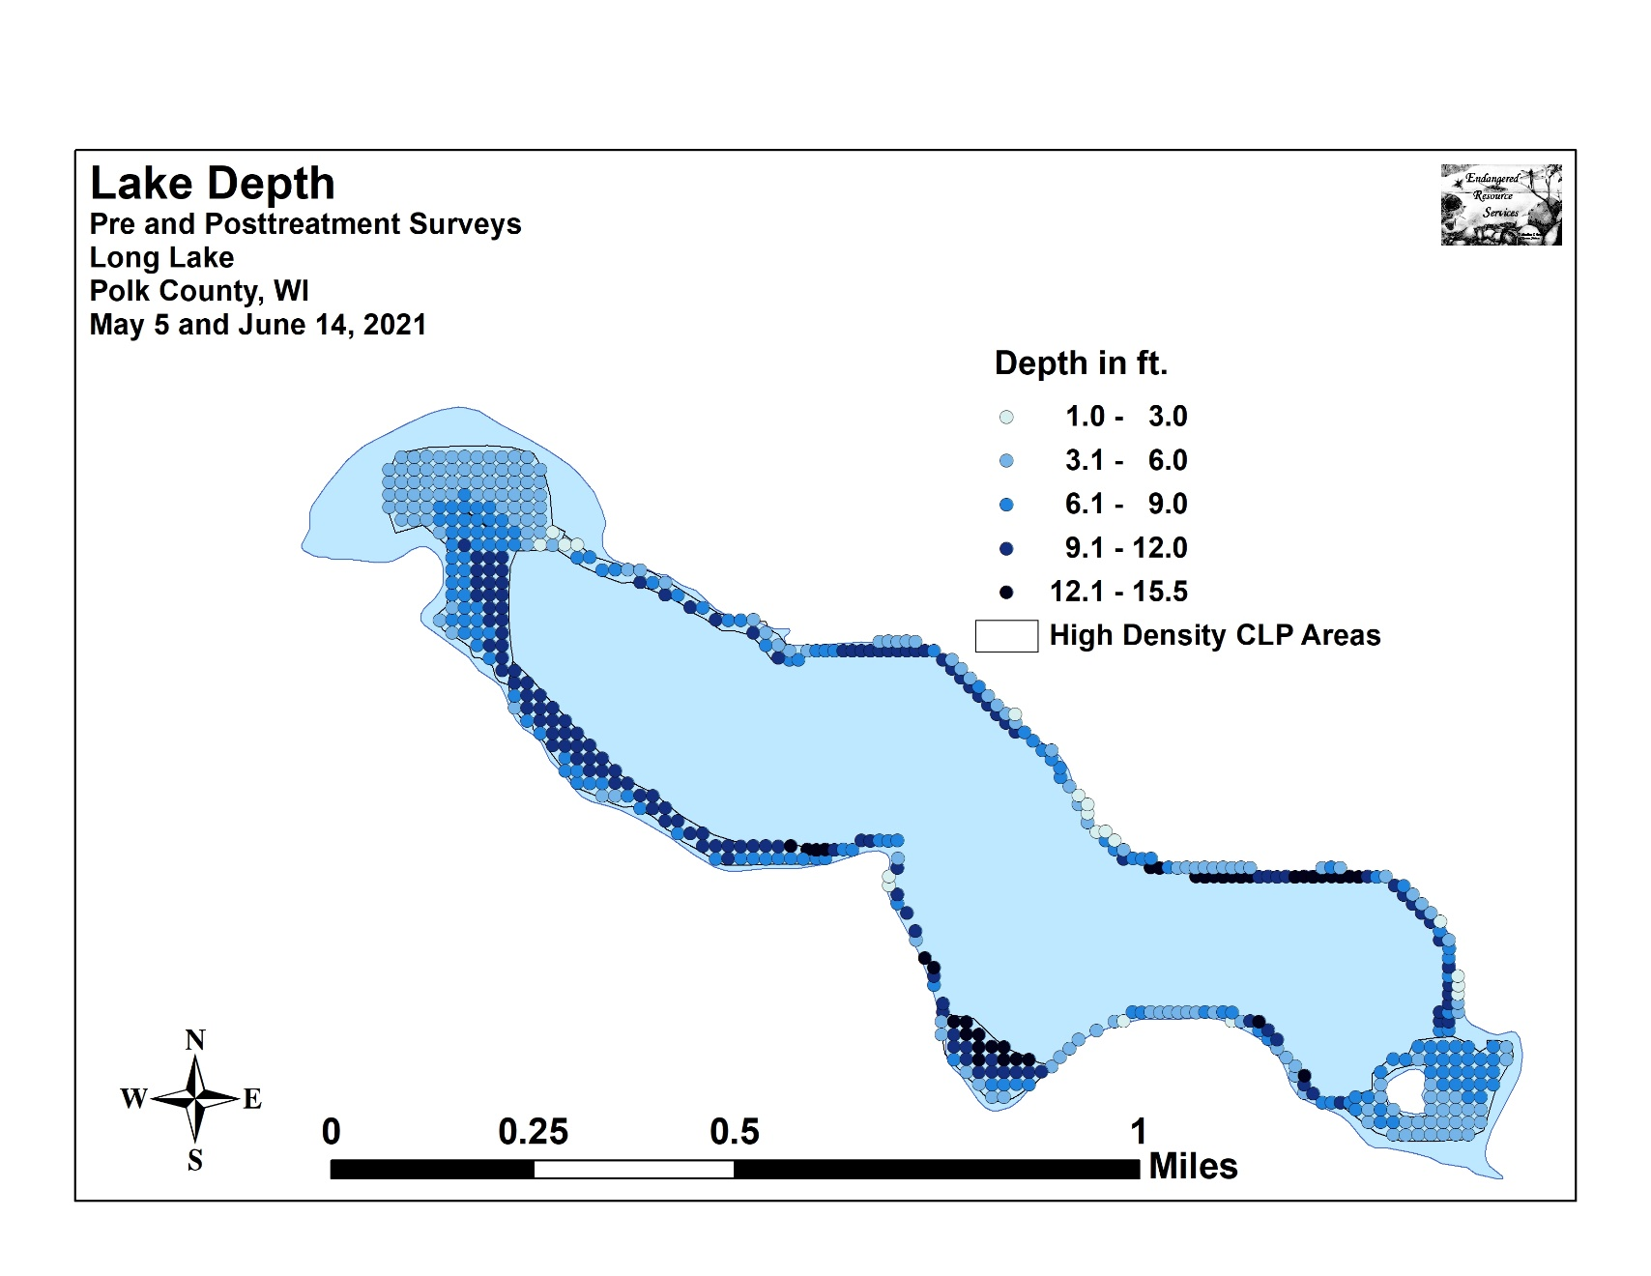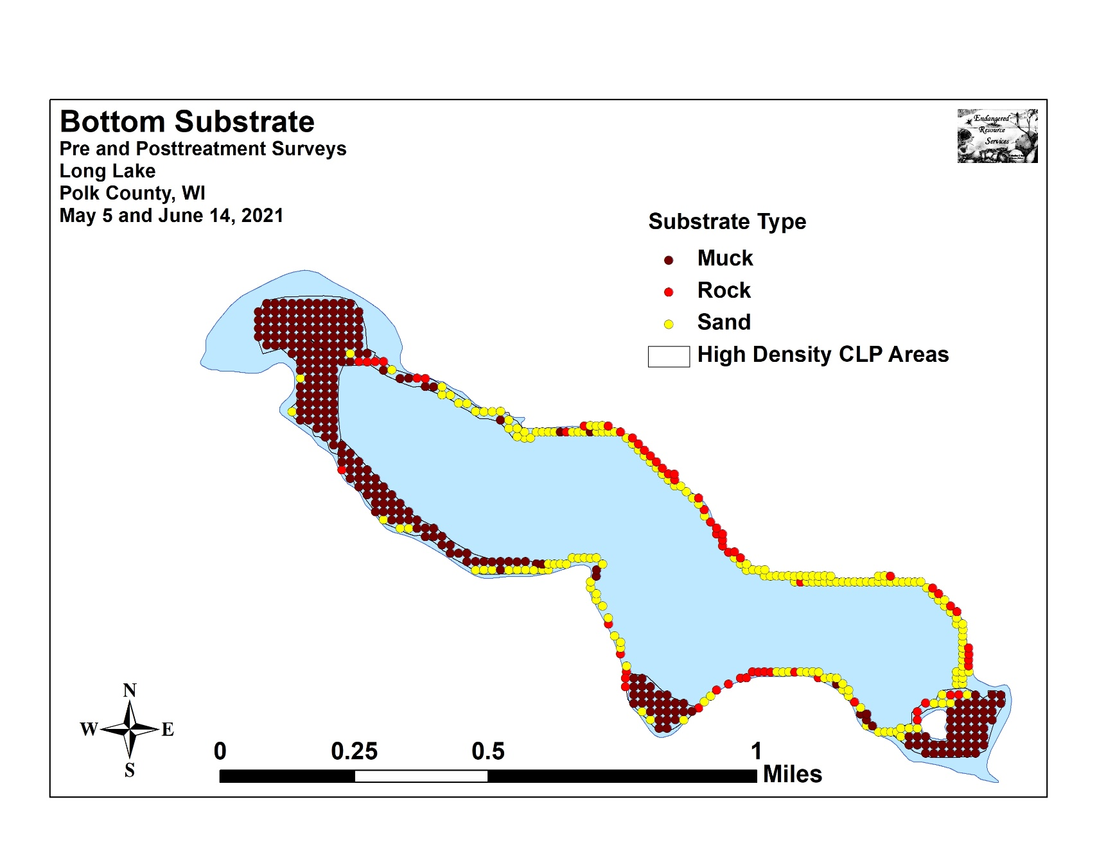

Appendix IV: Pre and Posttreatment Littoral Zone,
Native Species Richness, and Total Rake Fullness
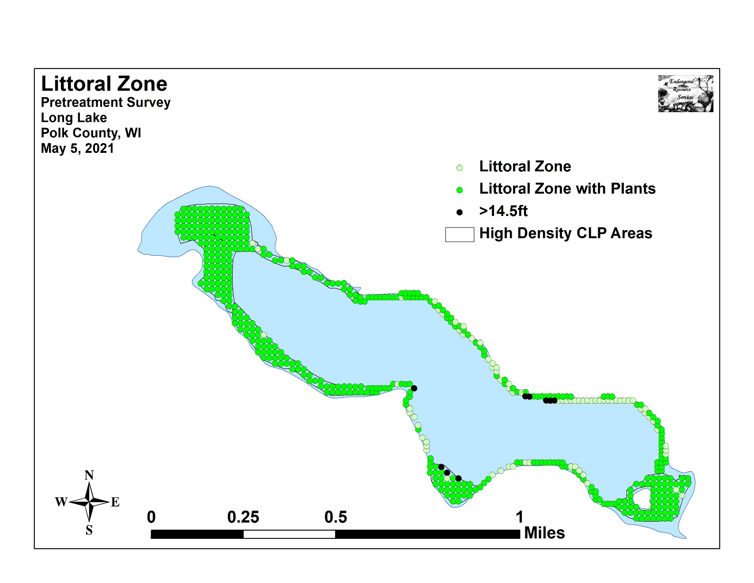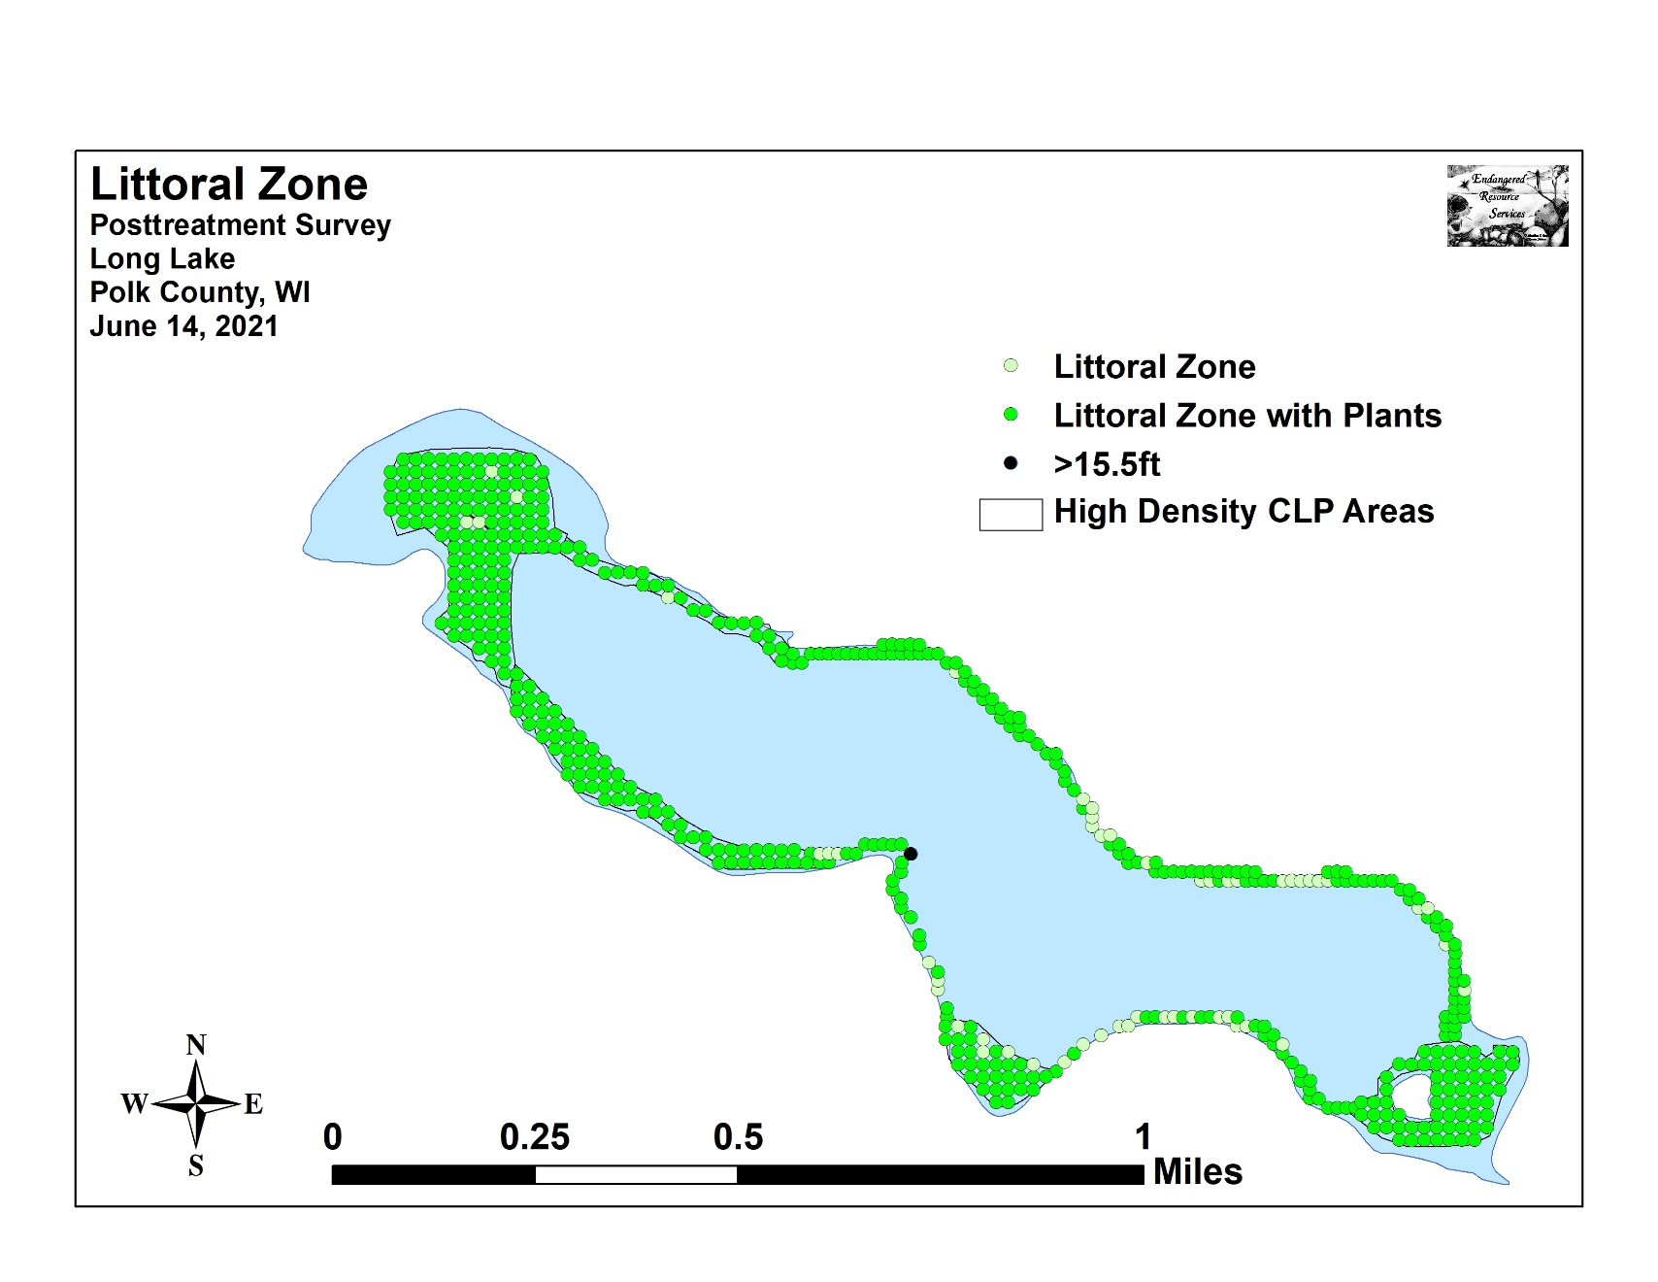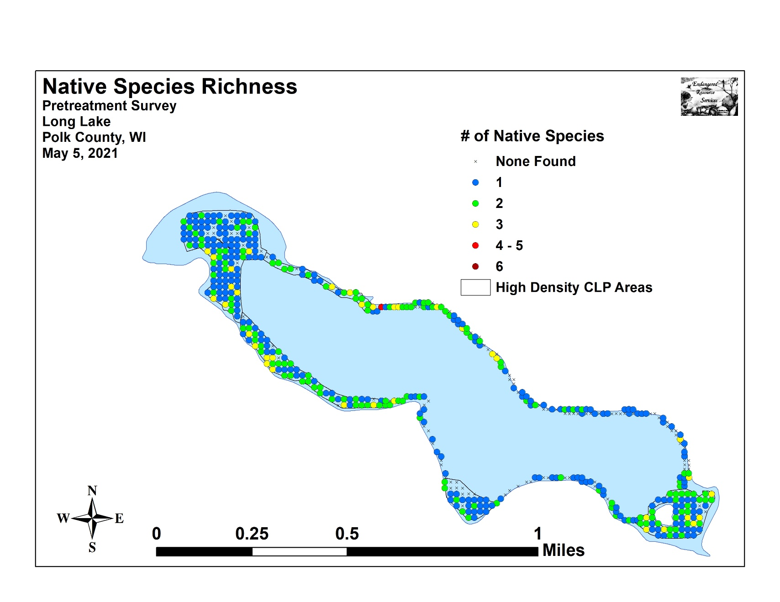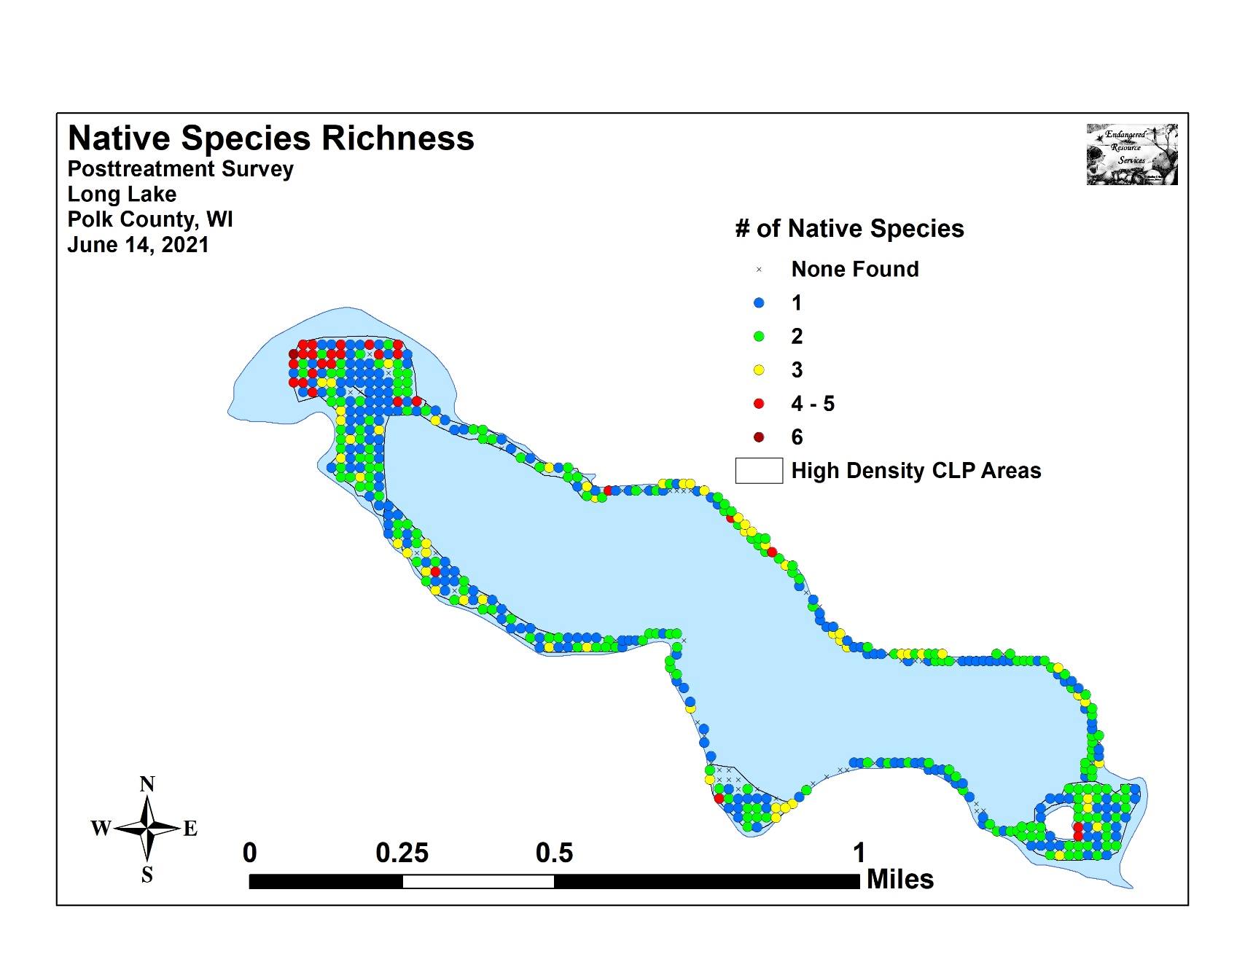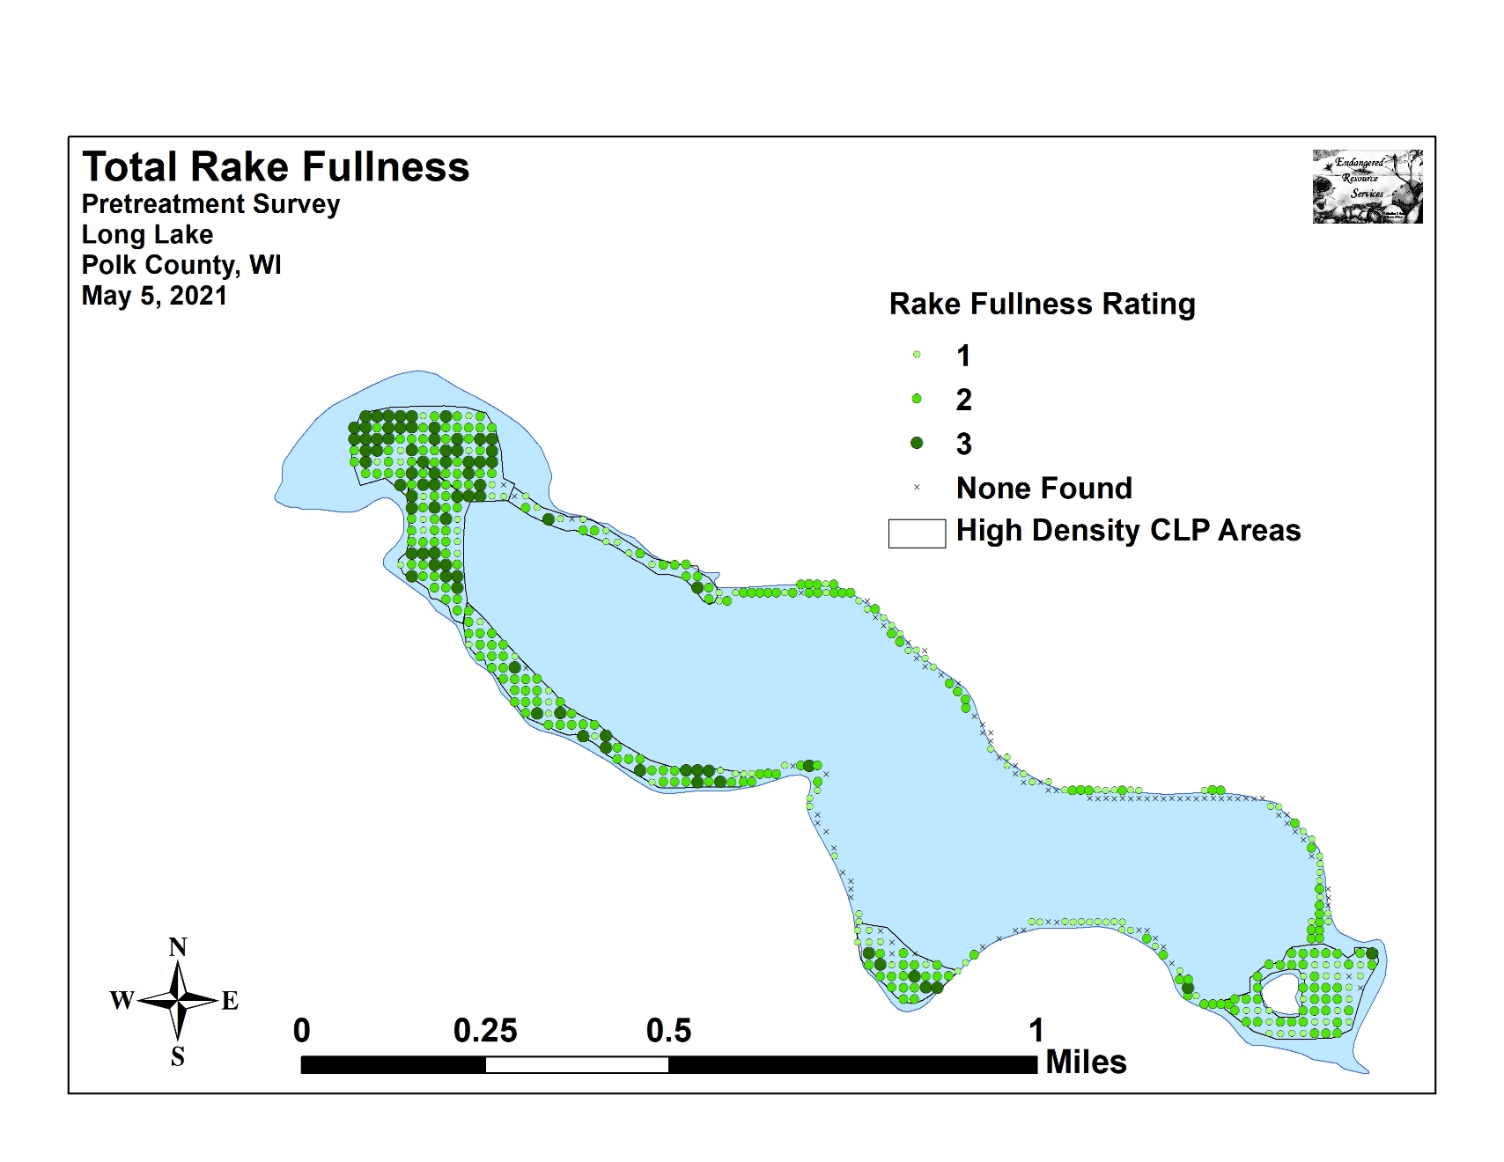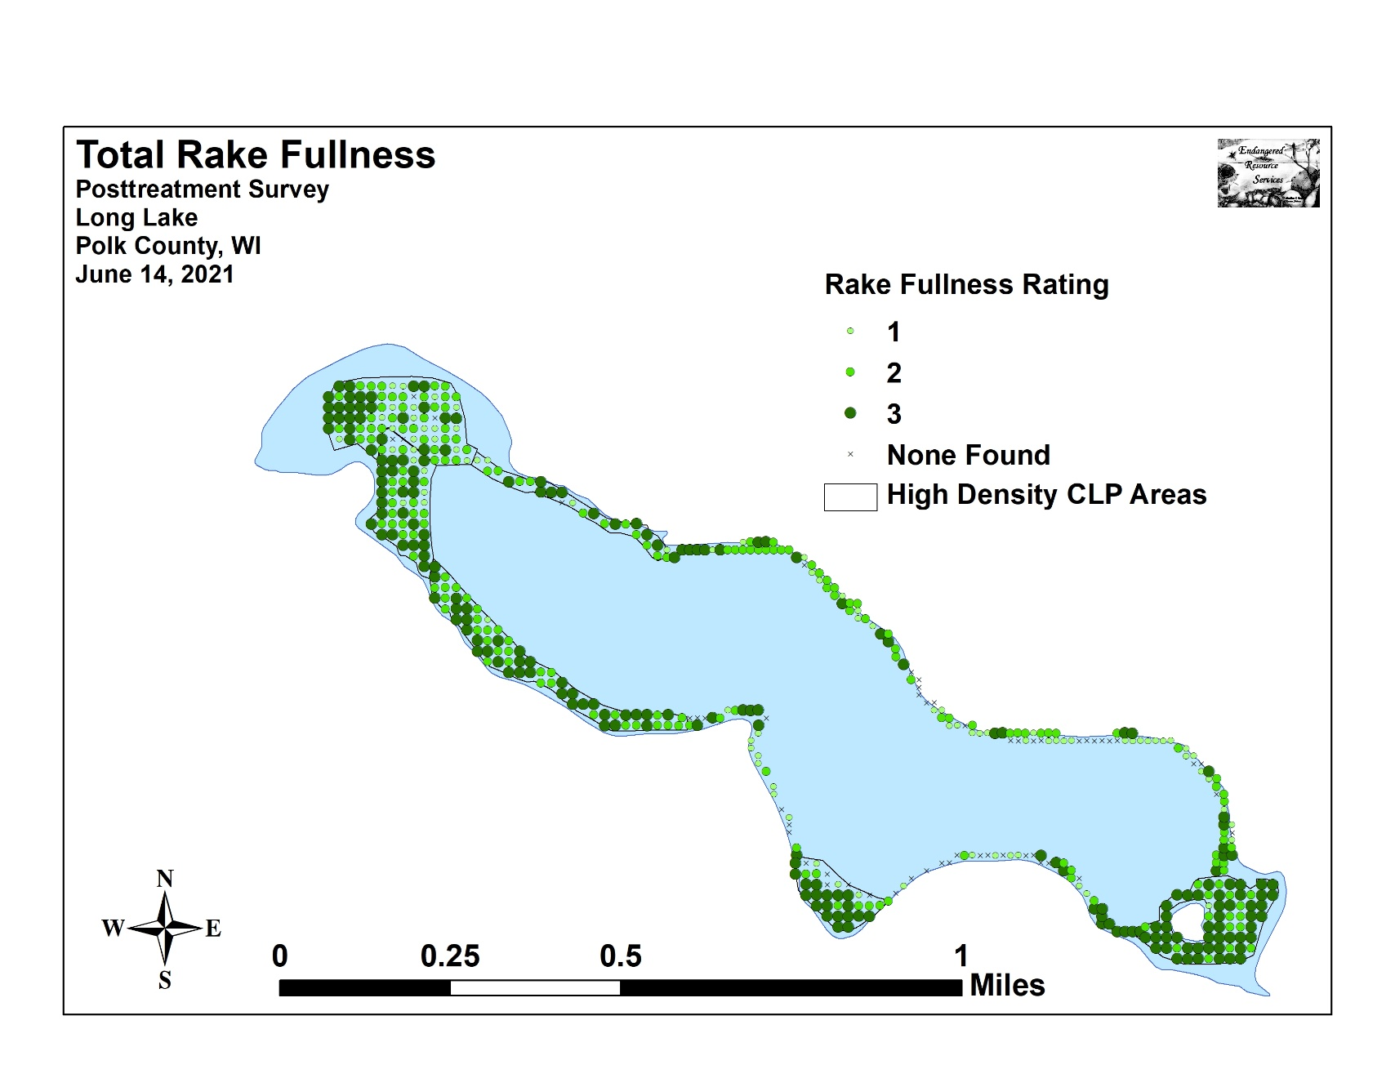

Appendix V: CLP Pre and Posttreatment Density and Distribution
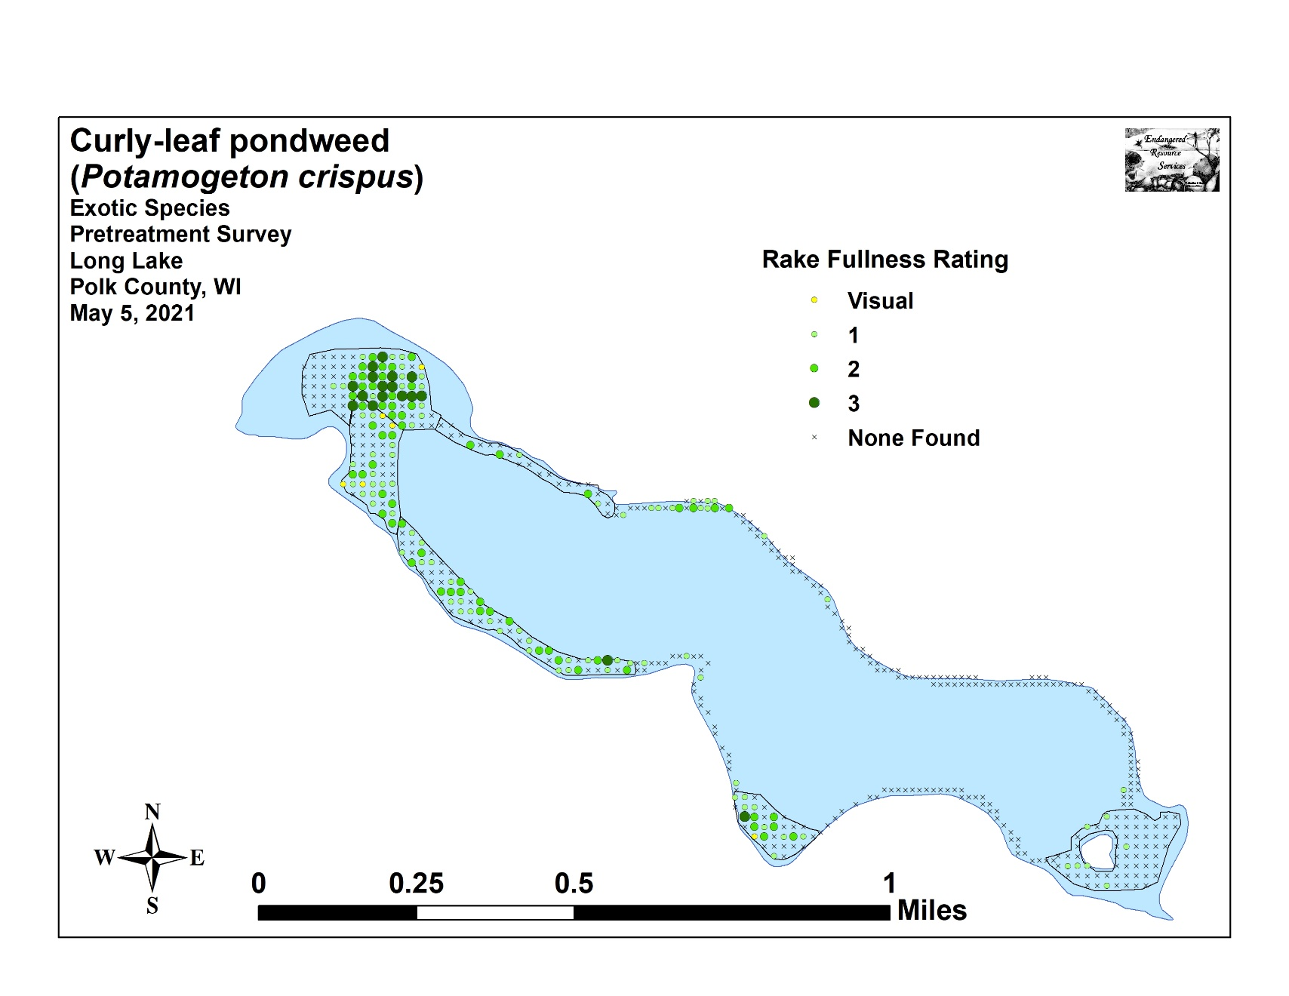
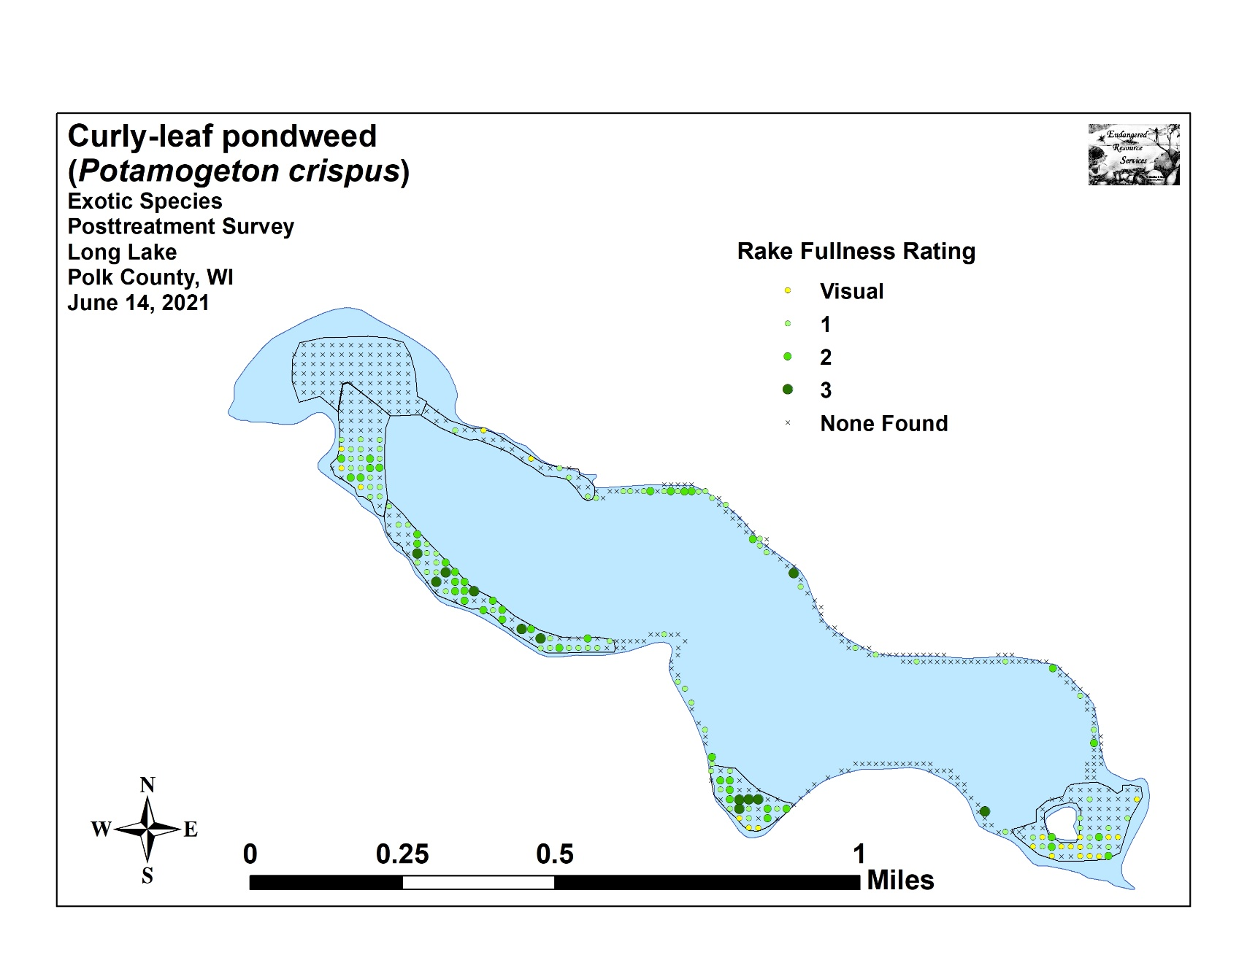

Appendix VI: Pretreatment Native Species Density and Distribution
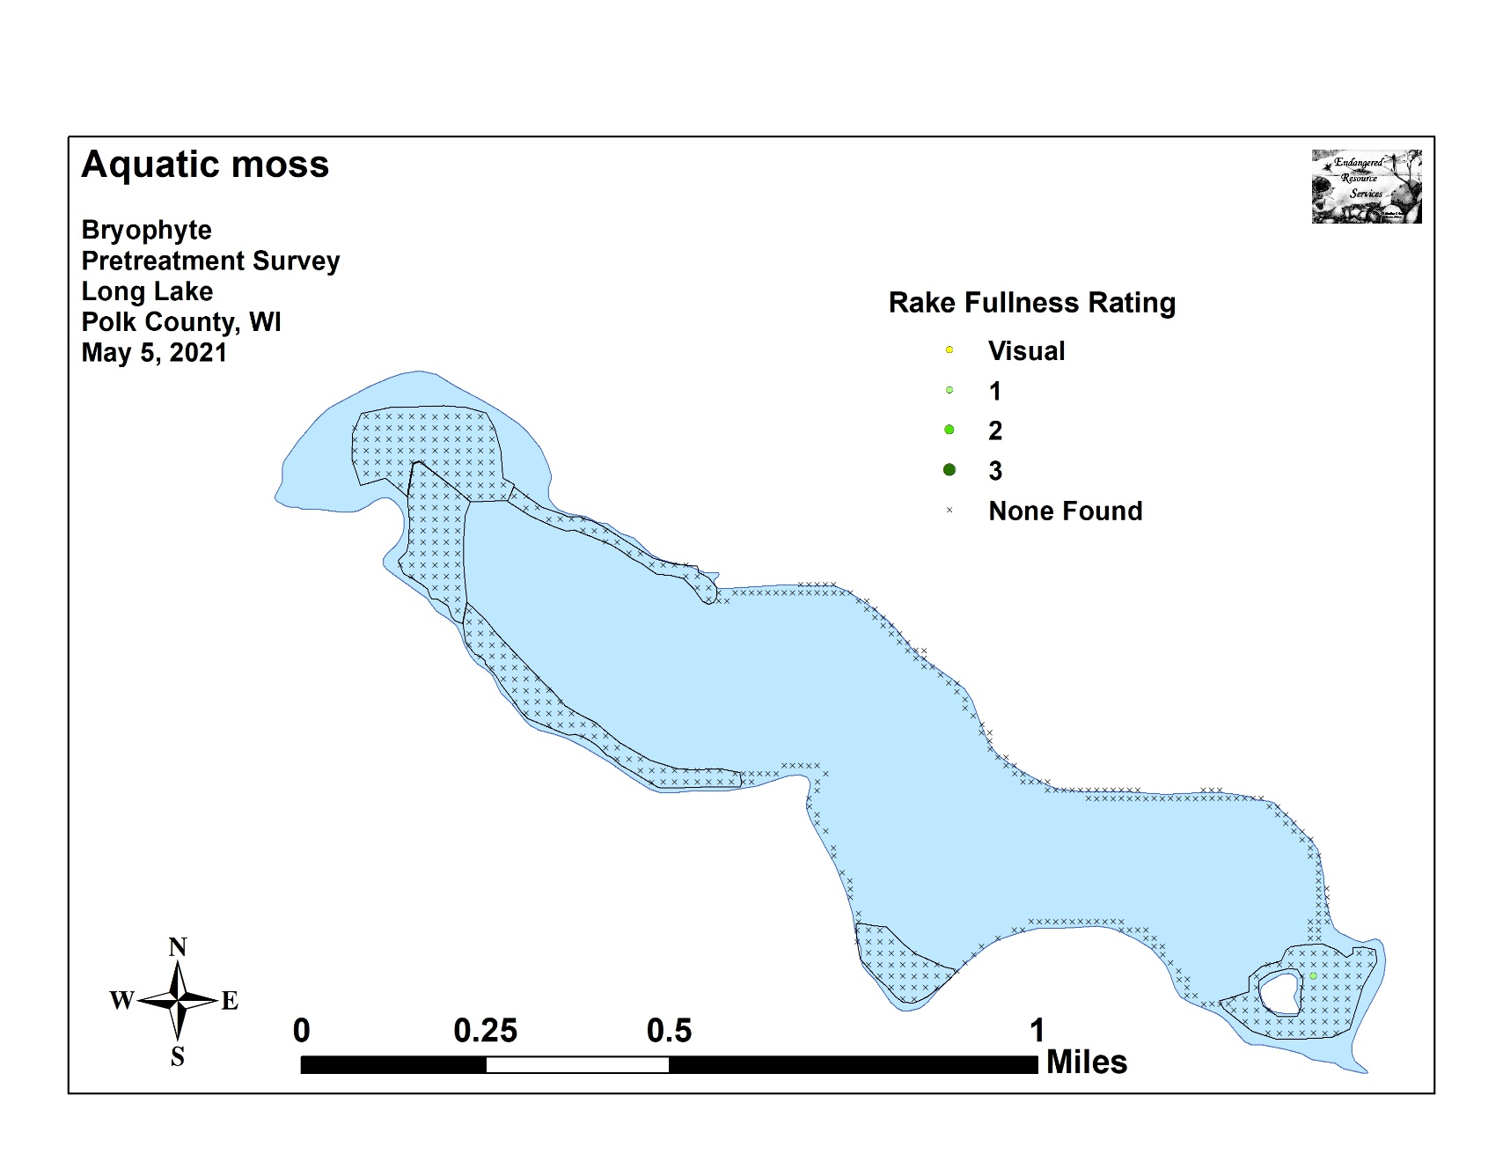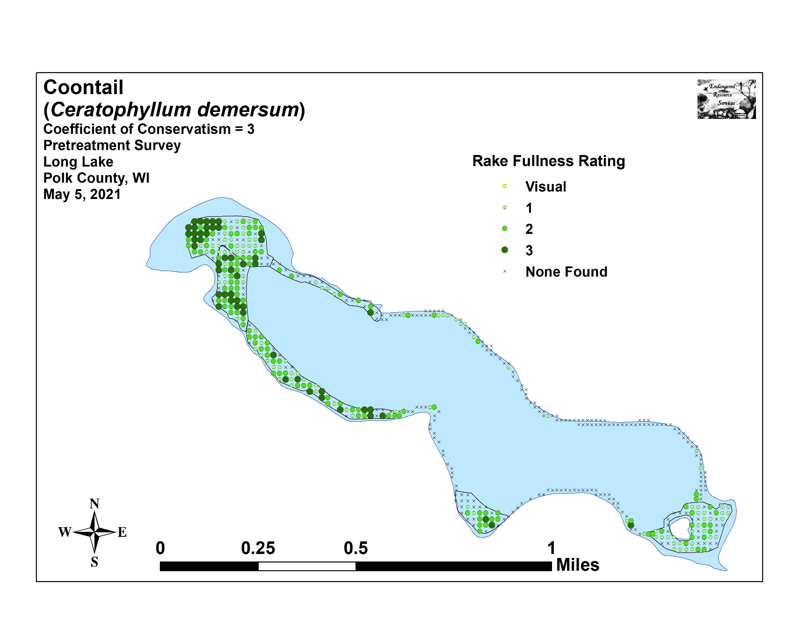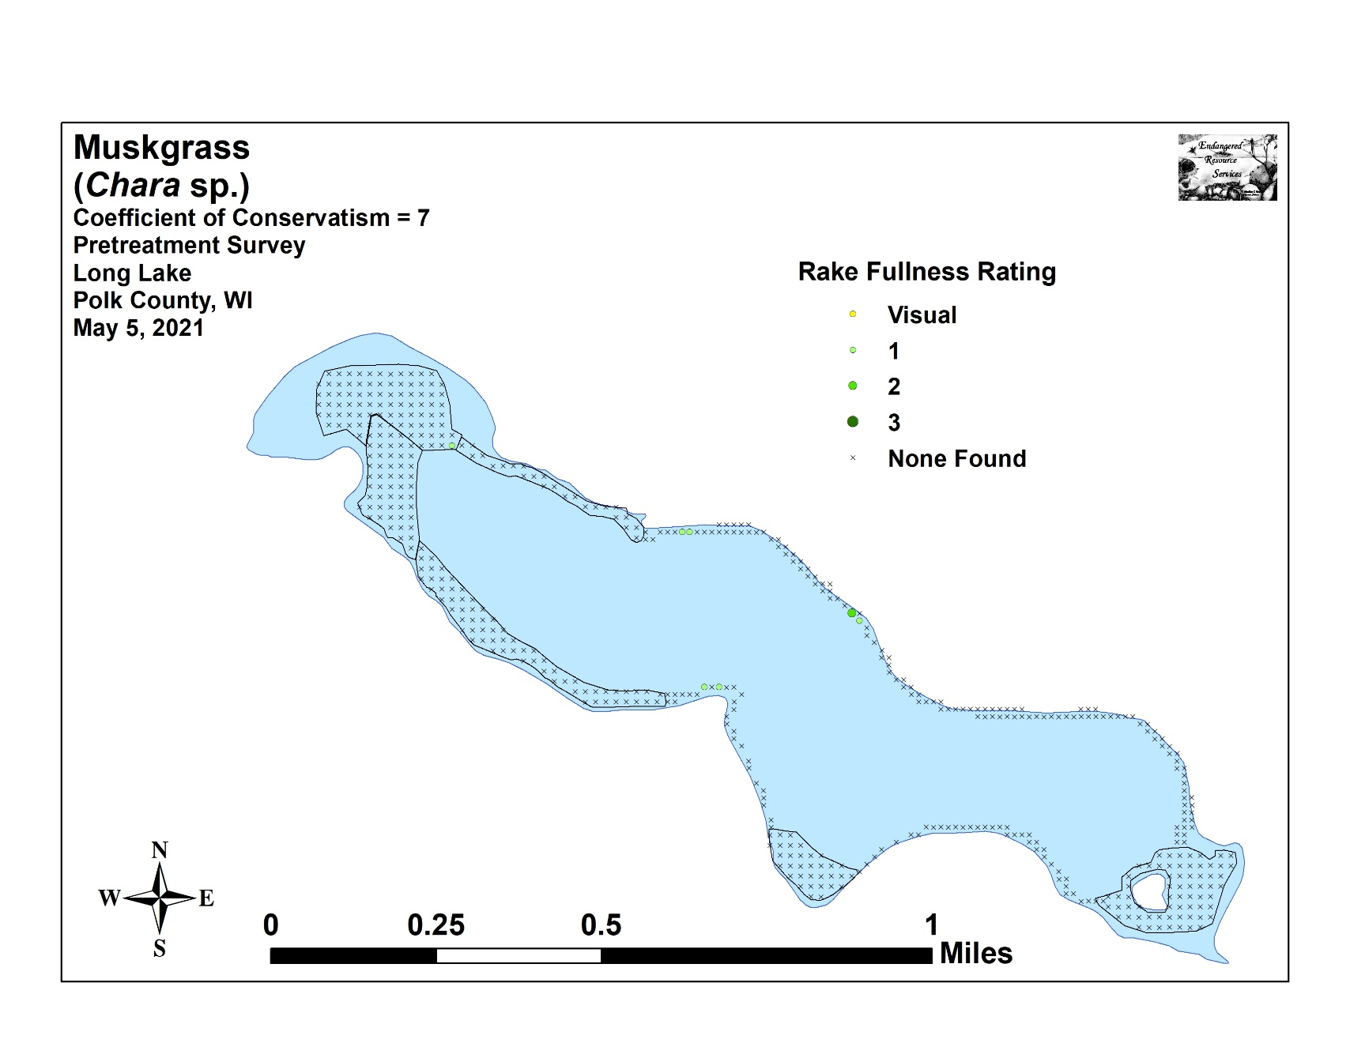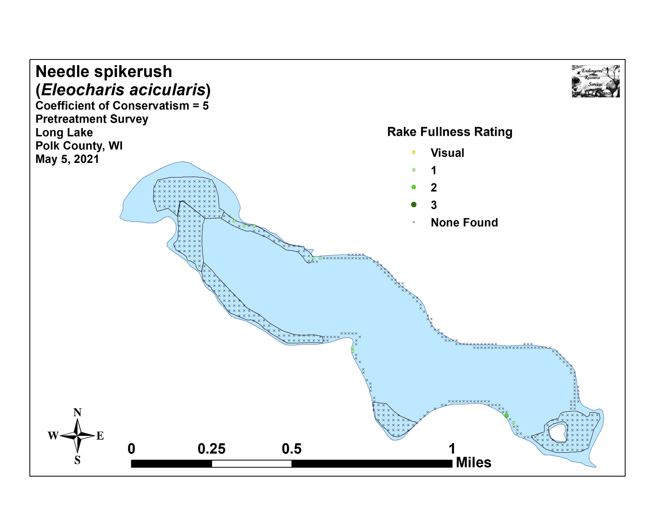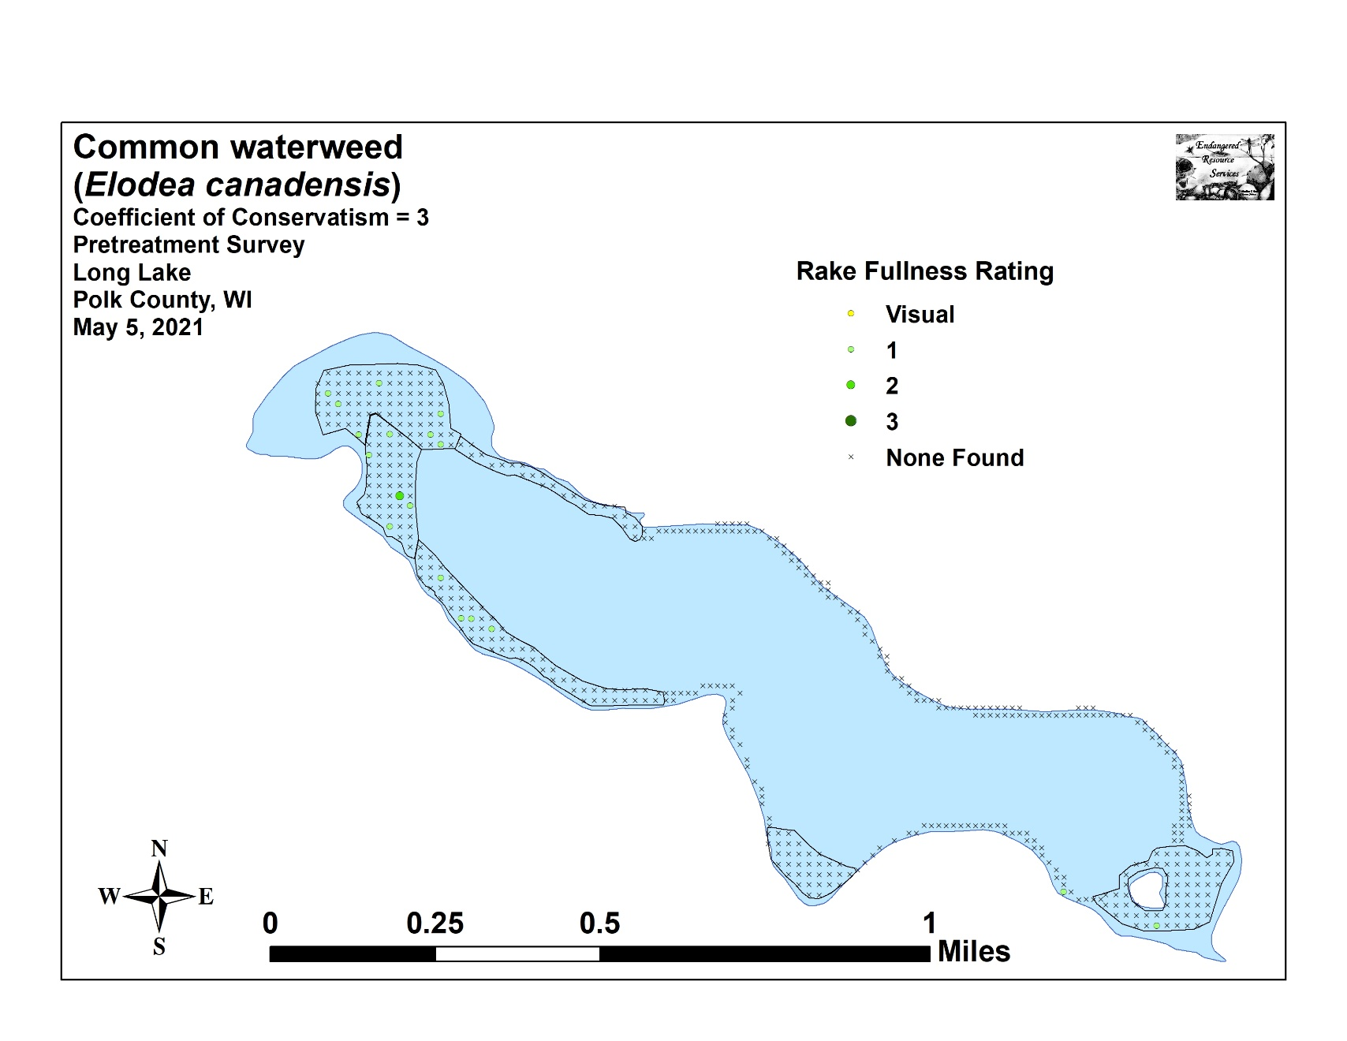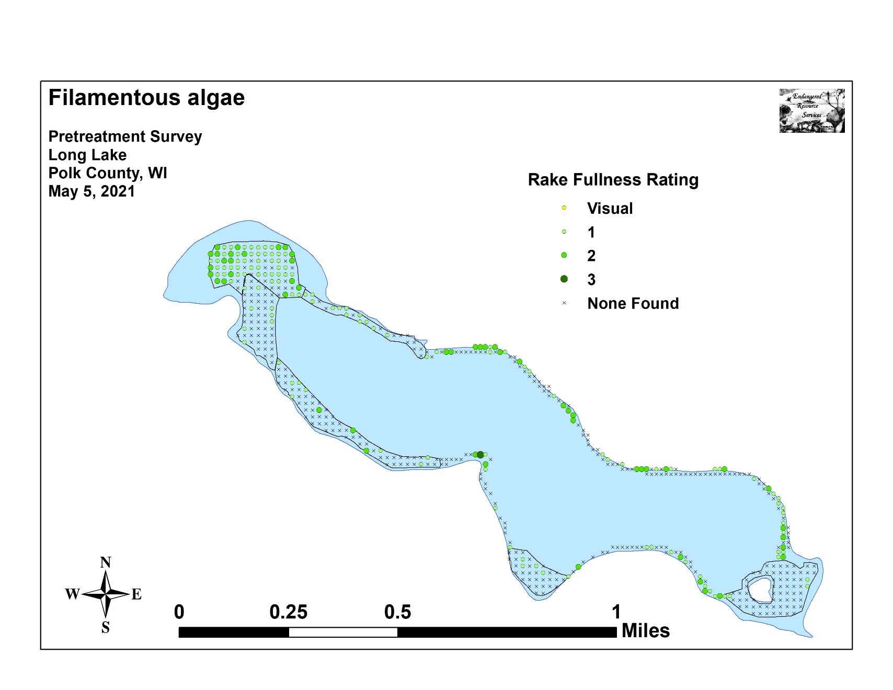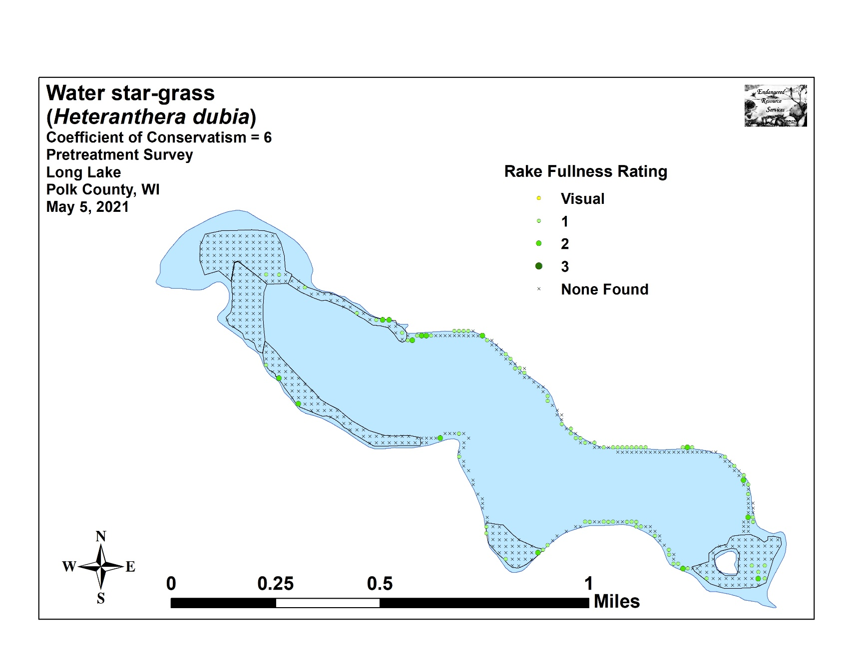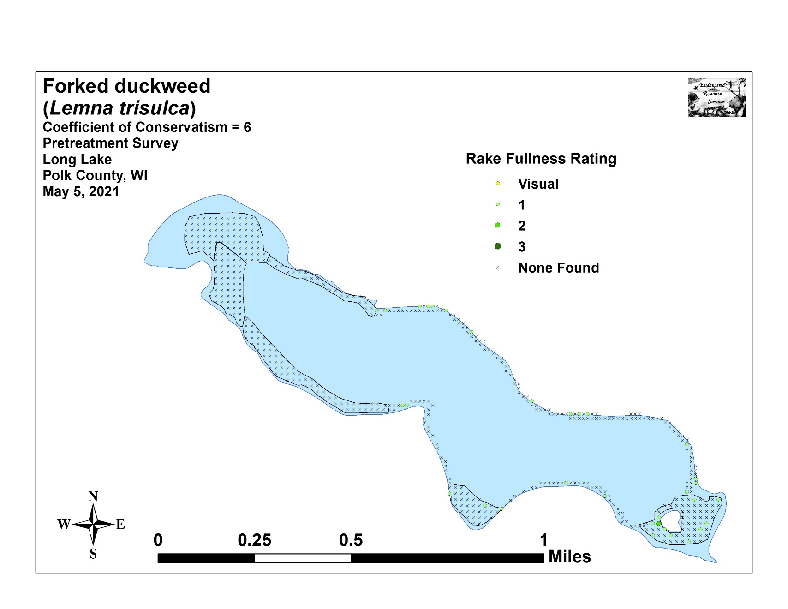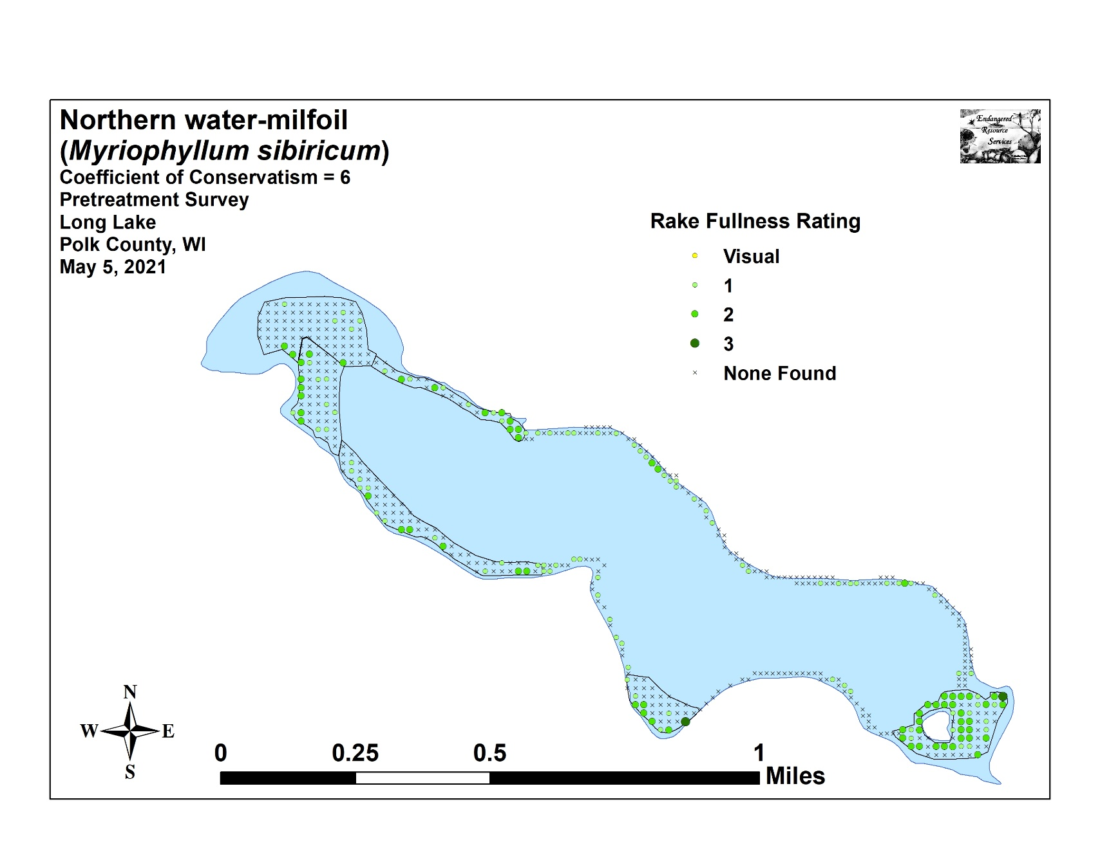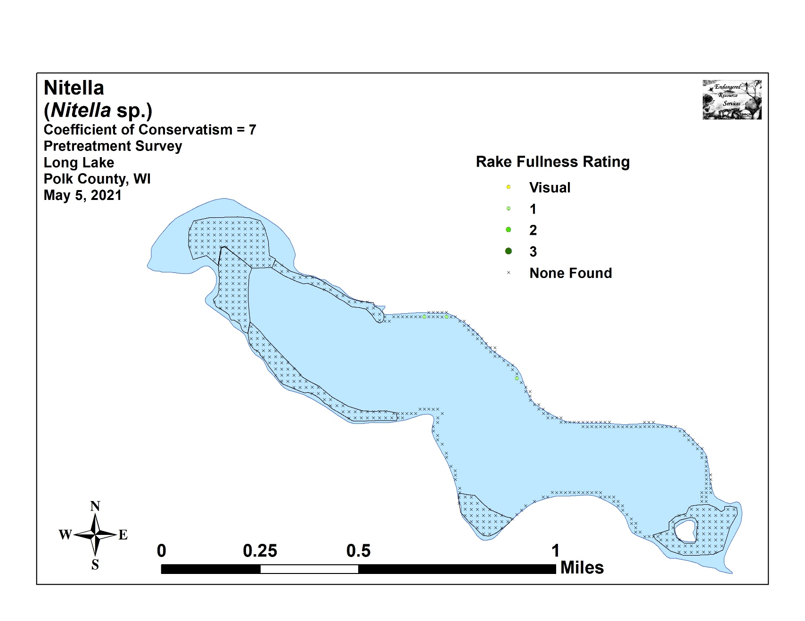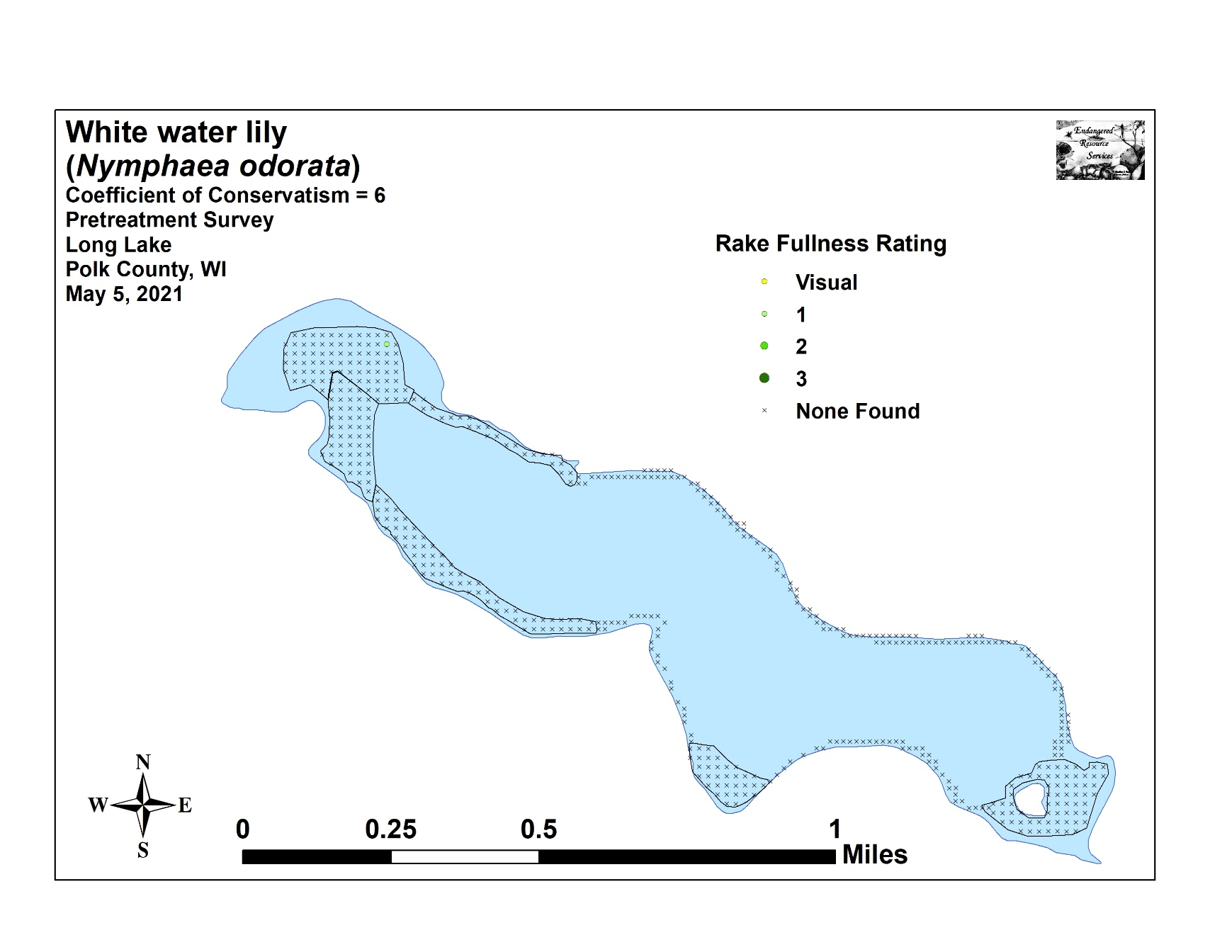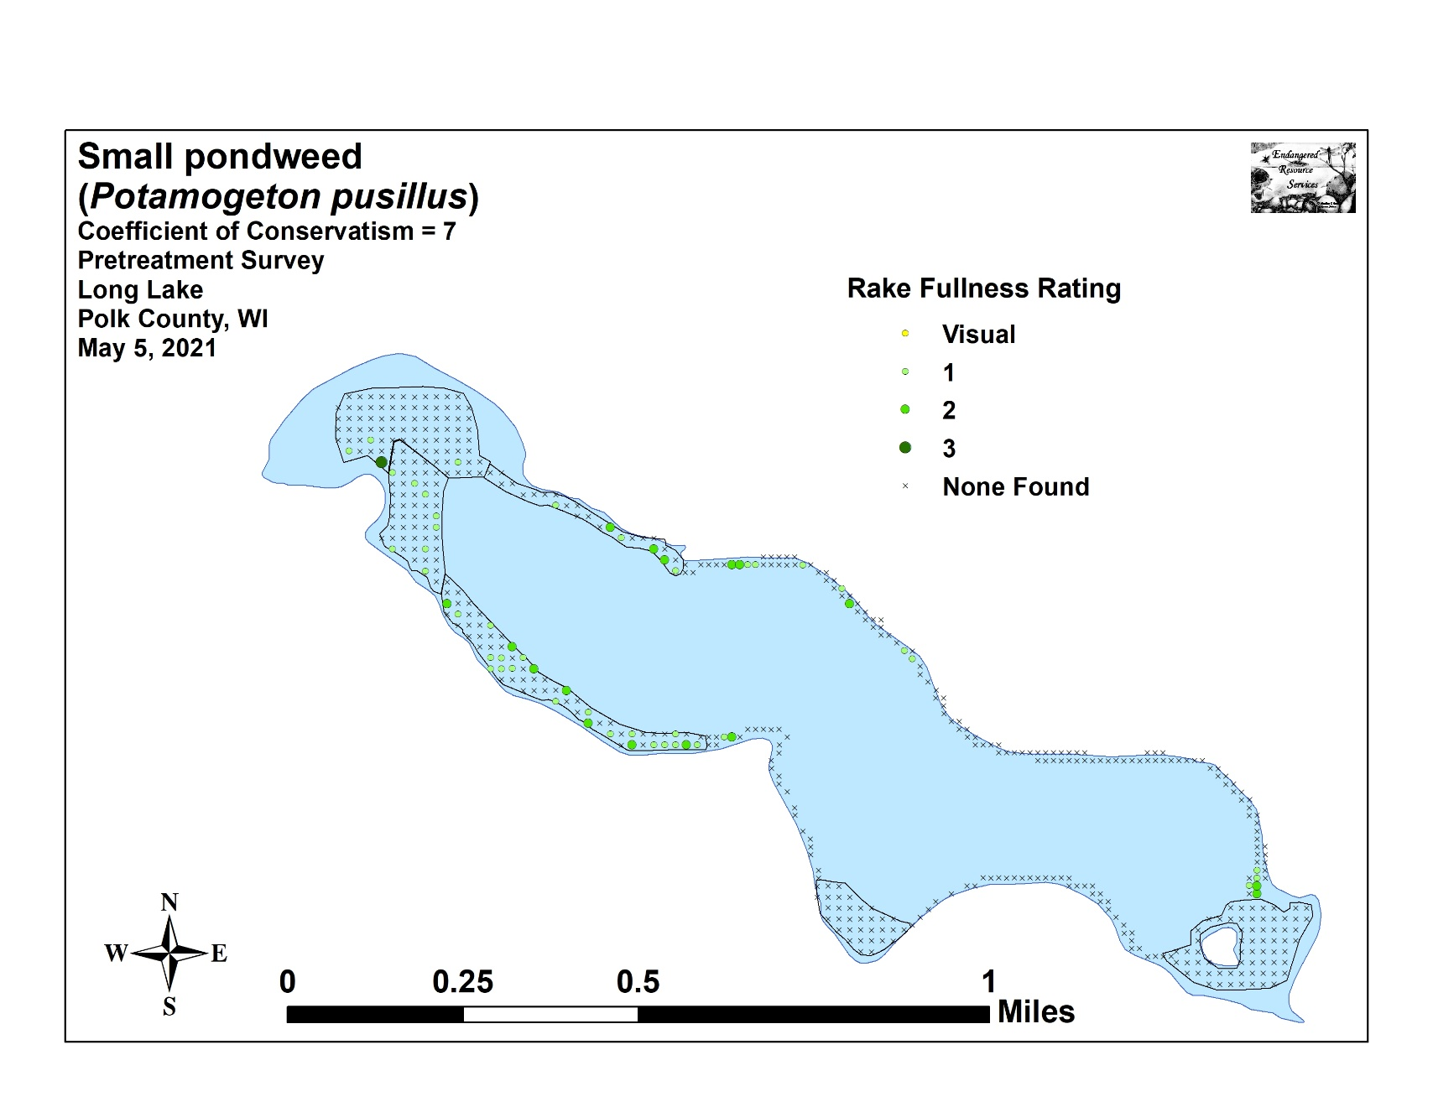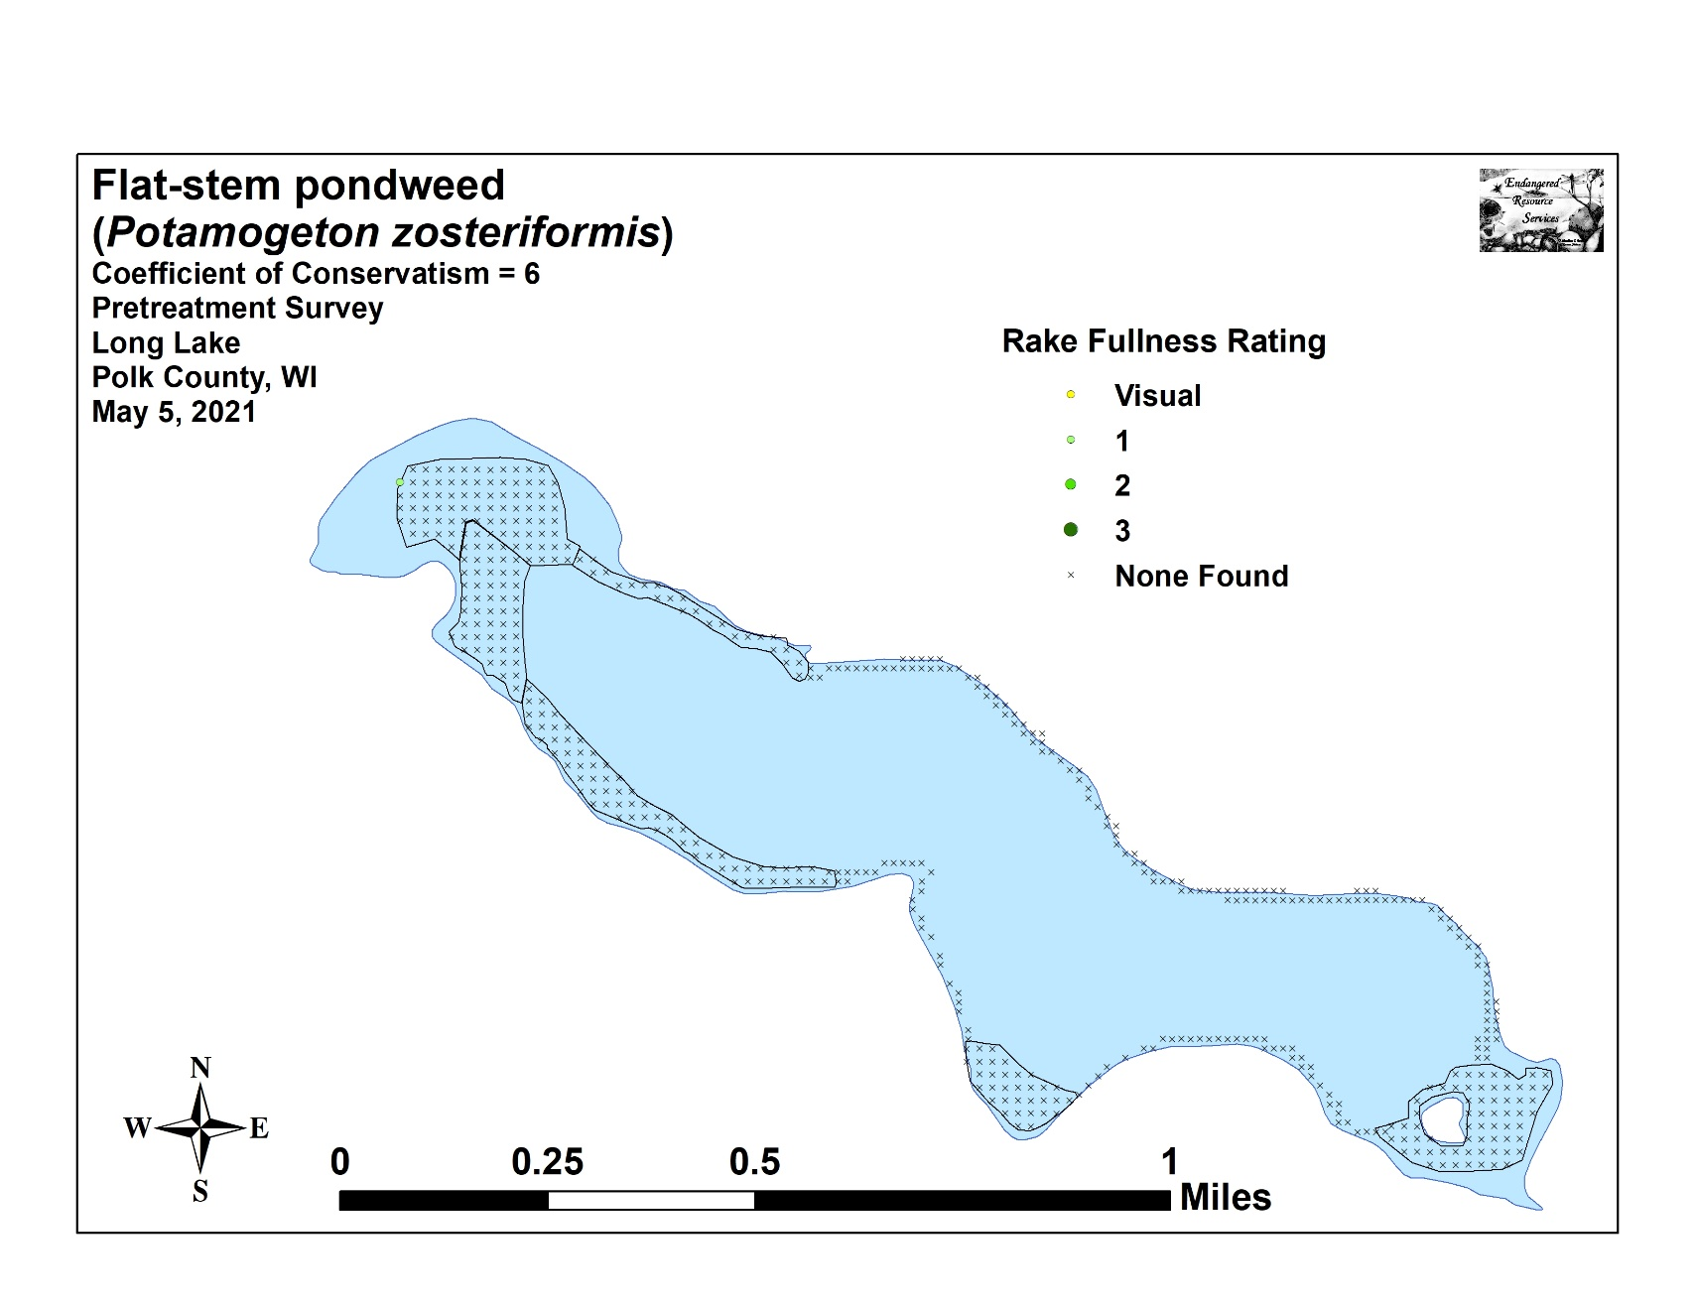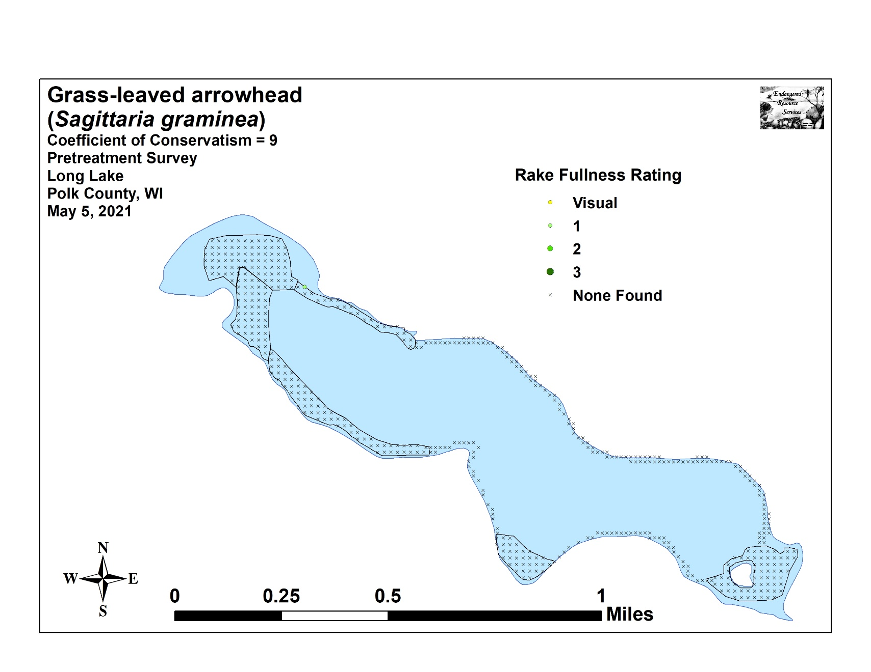

Appendix VII: Posttreatment Native Species Density and Distribution
