Windigo Lake Watercraft Wash/Decontamination Public Communications Compilation
Prepared 12/13/2025 by Barb Pjevach
Starting in 2023 when our lake association began planning to install a watercraft decontamination/wash station, we conducted various communications beginning with newsletter articles in our periodic newsletter. Here is brief list of the different ways we communicated with the public about our project.
- Press Release 5-2025 (page 2-3)
- Newsletter articles (pages 3-7)
- Signage at the boat launch and at the Wash Station itself (page 7)
- Windigo Lake website information (www.windigolake.org)
- Various communications with other lake associations:
  - Grindstone Lake Association (Barb Pjevach, Dick Steininger) We have met and spoken with the President of the Grindstone Lake Association and supplied them with information about our system and application to the DNR.
  - Sawyer County Lakes Forum meetings (Dick Steininger, WLPOA President) Dick has spoken with many other lake associations about our watercraft decontamination/wash station during various meetings in 2025.
  - Discussions with the Spider Lake Association.
- During 2025, WLPOA increased our CBCW landing staffed monitoring significantly from any previous year. In addition to educating boaters about CBCW, our monitors educated them about our decontamination/wash station. Here are the statistics from monitoring activity:
  - Total people spoken to/educated: 917
  - Total days monitored: 71
  - Total boats launched: 260
  - Total boats exiting lake: 187
  - Average boats per day launched: 3.7
  - Average boats per day exiting lake: 2.6
Press Release 5-2025
Windigo Lake Installs Sawyer County’s First Hot Water Decontamination Station to Prevent Invasive Species Introduction
SAWYER COUNTY, WI – 5/14/2025 – The Windigo Lake Property Owners Association (WLPOA) has installed Sawyer County’s first hot water decontamination station, reinforcing the community’s long-standing commitment to keeping its waters clean and prevent introduction of invasive species. The station is located at the lake’s public landing and, under Sawyer County ordinance (2021-112). Sawyer County Ordinance 2021-112 (2A) states “ If a Decontamination Station is available and functioning for use at a public or private access, the owner or user of a Boat or Equipment shall decontaminate the Boat or Equipment entering and exiting out of the waterbody per posted directions and/or inspection protocol using the Decontamination Station provided as set forth herein.”
This proactive step follows the recent confirmation of Chinese mystery snails in Windigo, the lake’s first documented aquatic invasive species (AIS). While not considered highly aggressive, their discovery has galvanized WLPOA to act quickly in order to prevent other AIS introductions to Windigo and other area lakes.
“We’re fortunate that the first AIS we’ve found is relatively manageable,” said Dick Steininger, WLPOA President. “But that doesn’t mean we let our guard down. This station is about protecting everything we love about this lake before the next threat arrives.”
The new station uses high-temperature water to kill and remove invasive species from boats and trailers. Its installation is part of a larger, ongoing prevention effort that includes years of involvement in the Wisconsin DNR’s Clean Boats Clean Waters (CBCW) program. WLPOA manages both paid and volunteer monitors to inspect watercraft and educate lake users.
“We’re proud of our prevention work, and this is a major upgrade,” said Peter Ingarra, WLPOA Lake Environment and Safety Chair. “It’s a modern solution to a growing problem, and it gives us another tool to protect what we’ve all invested in.”
WLPOA also acknowledged recent challenges, including several incidents where boat monitors faced verbal aggression while carrying out their duties. The association is encouraging boaters to approach the new process with understanding and a shared sense of responsibility.
“No one is here to make life harder for boaters,” said Paul Martin, WLPOA Vice President. “Our monitors are your neighbors. They’re not enforcing policy, they’re simply asking for cooperation to help keep the lake healthy. A few minutes at the station can make a real difference.”
The decontamination station was largely funded by a state grant, with additional contributions from WLPOA member dues, fishery donations, and volunteer labor. The association also funds the majority of the CBCW monitoring program locally, meeting grant requirements and demonstrating long-term financial stewardship.
The station's use is enforceable under county law, and compliance is the responsibility of the Sawyer County Sheriff’s Office.
Despite the recent AIS confirmation, Windigo remains one of the cleanest lakes in the region. With this new station in place, WLPOA hopes to ensure it stays that way.
“This lake means something to all of us,” said Steininger. “We’re not just maintaining it. We’re protecting it for the next generation.”

Windigo Lake Property Owners’ Association Newsletters (Published to all property owners and related people including those who are not members of the association. These are also on the windigolake.org website):
3-2023 Newsletter Article
Decontamination Stations
Sawyer County recently passed an ordinance regarding decontamination stations at boat landings. The ordinance doesn’t require the stations to be installed; however, if a decontamination station is available and stocked, it must be used to clean the vessel before entering and exiting the waterbody. Failure to use the station could result in a warning followed by fines for repeated offenses. Washburn, Bayfield, and Ashland counties already passed similar ordinances. Dan Lew has been working with the DNR and the Town of Bass Lake. He also has researched the existing station at Whitefish Lake for planning and specifying the installation of a decontamination station at the Windigo boat landing. The WLPOA Board will be reviewing and working with Dan this Spring to plan next steps. Thanks Dan for all of your work on this project!

7-2023 Newsletter
NEW AIS DECOMTAMINATION LAW AND WINDIGO PLANS
Barb Pjevach
As a reminder, in January 2022, the Sawyer County Board of Supervisors passed a law that requires decontamination of all boats entering and exiting any lake in Sawyer County that has a decontamination station at the boat launch. The ordinance defines a “decontamination station” as “any device provided at a public or private waterway access to remove all potential invasive species”. Penalties will be severe. A first offense will result in a warning letter. The second offense carries a $300 fine plus court costs, and for a third and subsequent citation, $1,000 plus court costs. The ordinance is for the prevention of AIS that are already present in the county, and other species, such as zebra mussels and spiny water fleas, which are present in neighboring counties.
Dan Lew has been leading an effort to install a decontamination station at the Windigo Boat launch. He has facilitated Town of Bass Lake approval and has provided the WLPOA Board with costs plans to install a system and signage similar to what is installed at the Whitefish Lake boat launch. There are grants available from the DNR to help with the costs of installing and operating the system. WLPOA has been approved to apply for these grants and we plan to apply for the grants this fall for implementation in 2024. We cannot thank Dan Lew enough for his efforts on this project. If you see him please thank him!!!
Along with this project, we plan to update signage at the Windigo boat launch. Thanks to Paul Martin for helping with the signage design updates!
3/2024 Newsletter Article
Windigo Decontamination Station
Sawyer County has an ordinance regarding decontamination/wash stations at boat landings. The ordinance doesn’t require the stations to be installed; however, if a decontamination station is available and stocked, it must be used to clean the vessel before entering and exiting the waterbody. Failure to use the station could result in a warning followed by fines for repeated offenses. Washburn, Bayfield, and Ashland counties have similar ordinances. According to the DNR, the main way aquatic invasive species like zebra mussels and Eurasian watermilfoil spread to new waters is often by hitching a ride on the boats and trailers of the very people who enjoy the water the most. They have also noted that lakes that have installed decontamination stations have experienced lessened use by fishing clubs due to time challenges of taking each boat through the decontamination/wash process. A fishing club event on our lake can bring up to 19 boats to the lake in an evening.
As we previously reported, Dan Lew did some excellent preliminary research work with the DNR and the Town of Bass Lake about a potential decontamination station at the Windigo boat landing. Paul Martin joined the effort and along with Dan researched other stations on other lakes and created preliminary specifications and drawings for a hot water based decontamination station at the Windigo boat landing parking lot. Based on their work, we submitted a plan for our decontamination station and requested a grant from the Wisconsin DNR to help fund this project. This was submitted in November 2023. We did acquire approval from the Town of Bass Lake to install the system. (They own the land with the landing and parking lot.) We also acquired letters of support from neighboring lake associations and Sawyer County.
In late February, we received approval of our grant request from the Wisconsin DNR. They will fund $19,750 toward the system. We are currently working on quantifying the ongoing costs of operating the system to make sure we have ample ongoing dollars to cover these costs. The WLPOA Board and team are working on finalizing the design and putting together the detailed project plan. If you have any interest in volunteering to help with any part of this project, please let us know by contacting any board member or emailing us at info@windigolake.org

7-2024 Newsletter
AIS DECOMTAMINATION LAW AND WINDIGO PLANS
As a reminder, in January 2022, the Sawyer County Board of Supervisors passed a law that requires decontamination of all boats entering and exiting any lake in Sawyer County that has an AIS decontamination station at the boat launch. Penalties will be severe. The ordinance is for the prevention of AIS that are already present in the county, and other species, such as zebra mussels and spiny water fleas, which are present in neighboring counties.
As previously reported, we applied for and were approved for a $19,000 grant to help with much of the cost of implementing a decontamination station at the parking lot by the Windigo boat landing. We would also install camera systems with the station. The team working on this project has been evaluating the best method to use for decontamination and the final design of the system. We will keep you posted as we develop more detailed plans and will have a Q&A discussion about this project at our upcoming Annual Meeting on August 10, 2024.

3-2025 Winter Newsletter
Windigo Decontamination Station
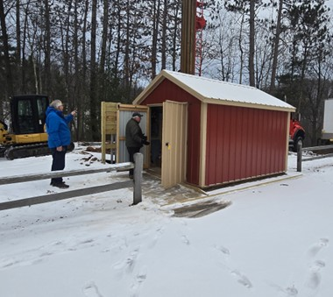
Sawyer County has an ordinance regarding decontamination/wash stations at boat landings. If a decontamination station is available, it must be used to clean the vessel before entering and exiting the waterbody. Failure to use the station could result in a warning followed by fines for repeated offenses. Washburn, Bayfield, and Ashland counties have similar ordinances. According to the DNR, the main way aquatic invasive species like zebra mussels and Eurasian watermilfoil spread to new waters is often by hitching a ride on the boats and trailers. They have also noted that lakes that have installed decontamination stations have experienced lessened use by large groups of boaters due to time challenges of taking each boat through the decontamination/wash process. So, in several ways, wash stations have been proven to reduce spread of AIS.
As we previously reported, last year we received approval of our grant request from the Wisconsin DNR to fund $19,750 toward a decontamination (boat wash) system at the Windigo landing. Dan Lew and Paul Martin did significant work on the system this past fall and we are hoping to have it operational this summer. You can see the shed housing most of the system on the south side of the Windigo landing parking lot.
7-2025 Newsletter
DECOMTAMINATION STATION UPDATE
Barb Pjevach
As a reminder, in January 2022, the Sawyer County Board of Supervisors passed a law that requires decontamination of all watercraft entering and exiting any lake in Sawyer County that has an AIS decontamination station at the boat launch. Penalties will be severe for violations. The ordinance is for the prevention of AIS that are already present in the county, and other species present in neighboring counties.
Thanks to the HUGE dedication of Paul Martin and Dan Lew who donated their time, effort, imagination and supplies to our decontamination wash station at the Windigo boat landing parking lot which was put into operation by the fishing opener on May 3rd.
Initially, most of the usage was during monitoring hours because people lacked awareness of the station and the law about its use for all watercraft entering and exiting Windigo. With the assistance of our boat landing monitors, knowledge of and use of the station have been increasing. Over time, we have been able to tell from our monitoring cameras that voluntary use of the station when monitors are not present is increasing.
We consider that station a huge success and we are certainly helping not only protect Windigo, but are also educating the public about AIS and spread prevention. We have also had inquiries from neighboring lakes who are interested in possibly establishing similar stations. We are working with the Town of Bass Lake to increase signage on Highline and have a project to replace the historical signage at the landing itself.

Signage related to the Decontamination Station
Sign on side of wash station:
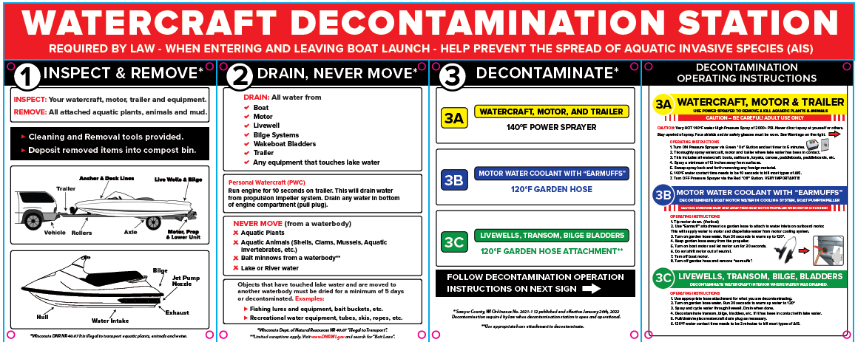
Signs at actual boat launch and also at the Wash Station:
