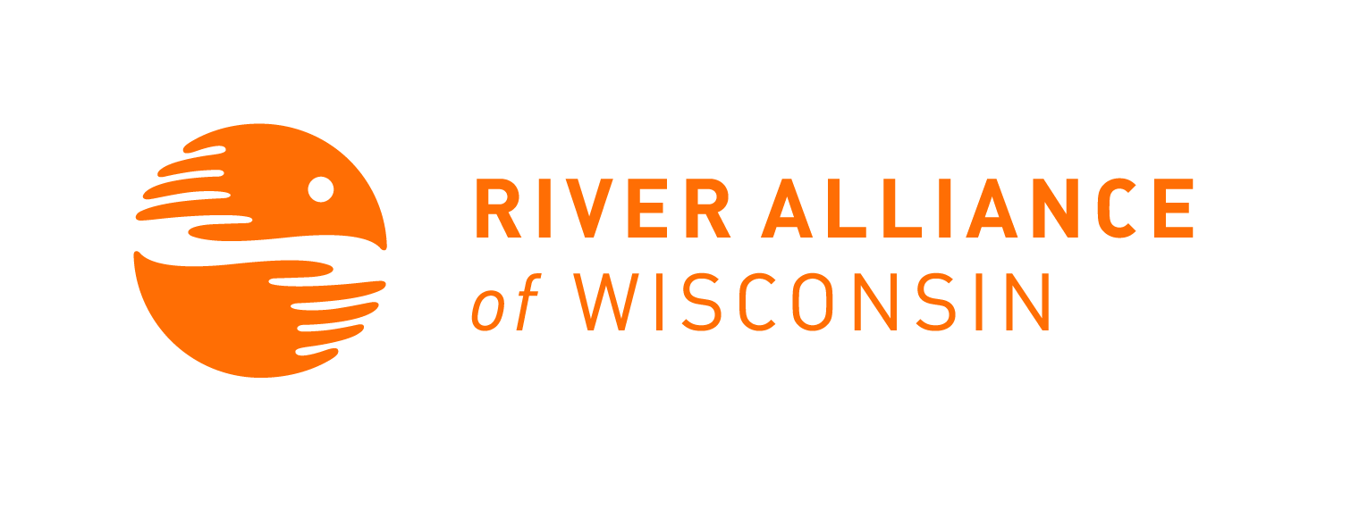
Project RED Sign In

Workshop Location: Viterbo University, La Crosse |  |  | Date: October 14, 2020
Workshop host: Ted Wilson, Limnology professor, Viterbo University | Trainer(s): Ellen Voss | Workshop Start and End times: 1:20-2:20pm
Please Print and fill out sheet completely. We need all the information on this sheet to adequately track volunteers and assessing monitoring locations.

Volunteer Name | Email Address | River Monitored/Requested
Elizabeth Henriksen | ehenri65248@viterbo.edu | In-class training
Esther Rodriguez | erodri68075@viterbo.edu | In-class training
Jessica Janzen | jjanze69895@viterbo.edu | In-class training
Jessie Benson | jbenso66870@viterbo.edu | In-class training
Melissa Edgar | medgar66372@viterbo.edu | In-class training
Mya Snyder | msnyde69444@viterbo.edu | In-class training
Rebecca Knoke | rknoke69357@viterbo.edu | In-class training
Ryan Ellingson | rellin70959@viterbo.edu | In-class training
Ted Wilson | tawilson@viterbo.edu | In-class training
Please Return to: River Alliance AIS Program, 147 S. Butler Street, Suite # 2, Madison WI 53703 or ais@wisconsinrivers.org.
For further assistance contact River Alliance of Wisconsin at (608) 257-2424.

Volunteer Name | Email Address | River Monitored/Requested
Christopher Cieszynski | cciesz70486@viterbo.edu | In-class training
Michael Alfieri | msalfieri@viterbo.edu | In-class training

Project RED Sign In

Workshop Location: Viterbo University, La Crosse |  |  | Date: October 15, 2020
Workshop host: Ted Wilson, Limnology professor, Viterbo University | Trainer(s): Ellen Voss | Workshop Start and End times: 12:30-3:30pm
Please Print and fill out sheet completely. We need all the information on this sheet to adequately track volunteers and assessing monitoring locations.

Volunteer Name | Email Address | River Monitored/Requested
Elizabeth Henriksen | ehenri65248@viterbo.edu | Pettibone Lagoon
Esther Rodriguez | erodri68075@viterbo.edu | Pettibone Lagoon
Jessica Janzen | jjanze69895@viterbo.edu | Pettibone Lagoon
Jessie Benson | jbenso66870@viterbo.edu | Pettibone Lagoon
Melissa Edgar | medgar66372@viterbo.edu | Pettibone Lagoon
Mya Snyder | msnyde69444@viterbo.edu | Pettibone Lagoon
Rebecca Knoke | rknoke69357@viterbo.edu | Pettibone Lagoon
Ryan Ellingson | rellin70959@viterbo.edu | Pettibone Lagoon
Ted Wilson | tawilson@viterbo.edu | Pettibone Lagoon
Please Return to: River Alliance AIS Program, 147 S. Butler Street, Suite # 2, Madison WI 53703 or ais@wisconsinrivers.org.
For further assistance contact River Alliance of Wisconsin at (608) 257-2424.

