Rock Infiltration Trench
Dan and Jolene Wiemann
1736 Sunnyvale Lane

The rock infiltration trench is sized to capture 120 ft³ of runoff water as indicated on the “Post-patio RUNOFF RATING WORKSHEET”. The spaces between the rocks hold runoff water following a rain event, which then soaks slowly into the soil beneath the trench. The filter fabric prevents sediment from filling the pore spaces and thus reducing storage capacity. The soil in the location just downhill from the patio is sandy and therefore good drainage for rock trench installation.

Rock voids provide 40% space, so the trench requires a total volume of 300 ft³. Since the patio is 32.5 feet long, the trench would need to have a width and depth which when multiplied will equal 9.2 feet. For example, the trench might be 5 feet wide and 1.85 feet (1 foot 10”) deep along the patio.

Constructing a rock infiltration trench

- Dig a trench of the specified size. A 1.85 deep feet trench should reach well-drained soils. The width of the trench can be adjusted accordingly as long as the trench volume remains the same.

- You might want to begin the trench a few inches from the patio for stability of the patio surface.

- Line the excavated trench with filter fabric.

- Fill the pit with clean, ¾ to 2 inch washed rock, stopping approximately 4 inches from the top.

- Add a horizontal layer of filter fabric on top of the rock.

- Cover the filter fabric with rock to the surface.
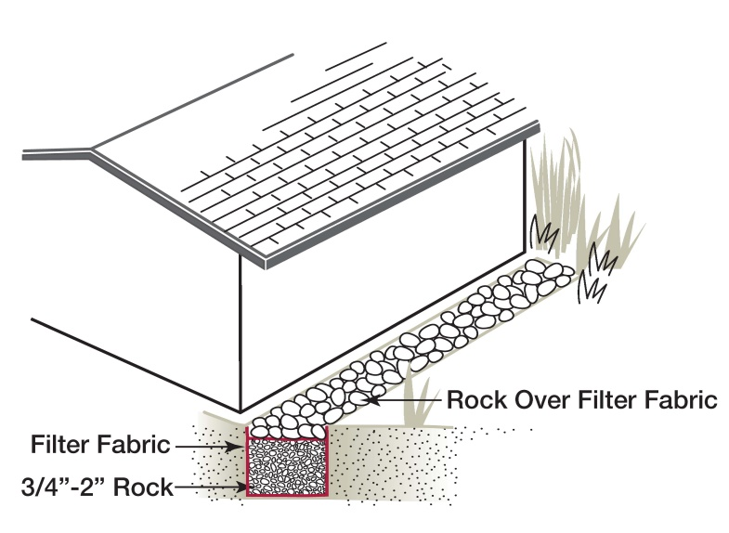

Project quantities

Filter fabric: (15 foot wide, 8 ounce): 33 feet
1.5” rock: 11.1 cubic yards

