Eurasian water milfoil (Myriophyllum spicatum) Pre/Post Herbicide Treatment Surveys
Saint Croix Flowage – West End
WBIC 2740300: Douglas County, Wisconsin

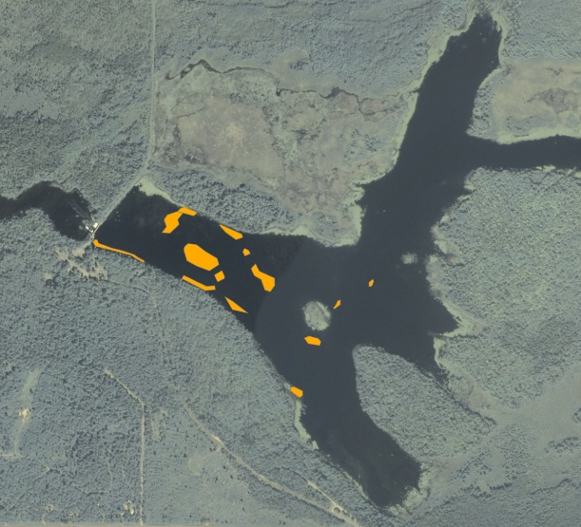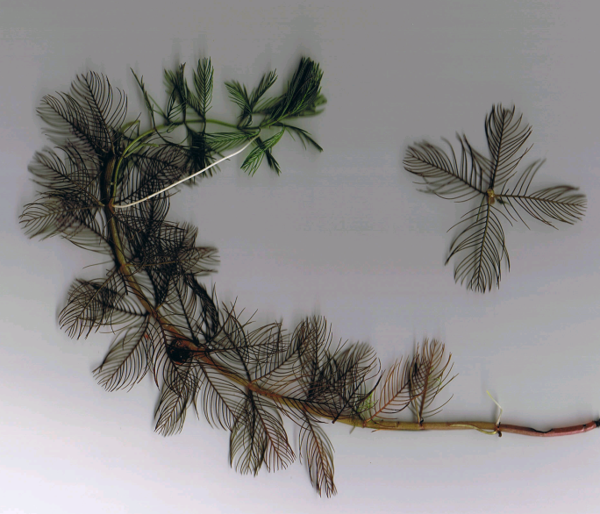

Spring 2013 EWM Treatment Areas EWM (Berg 2007)

Project Initiated by:
Gordon - Saint Croix Flowage Association, Short Elliott Hendrickson Inc., and the Wisconsin Department of Natural Resources

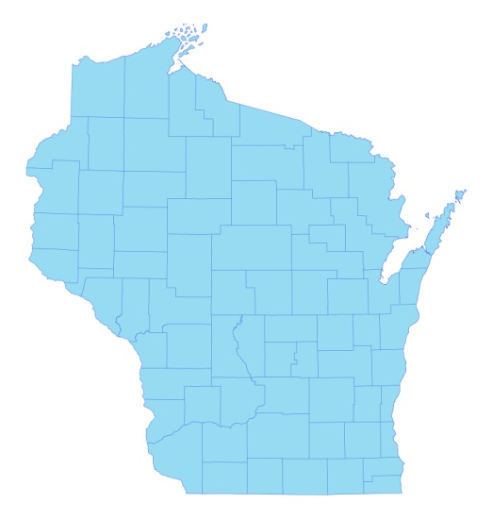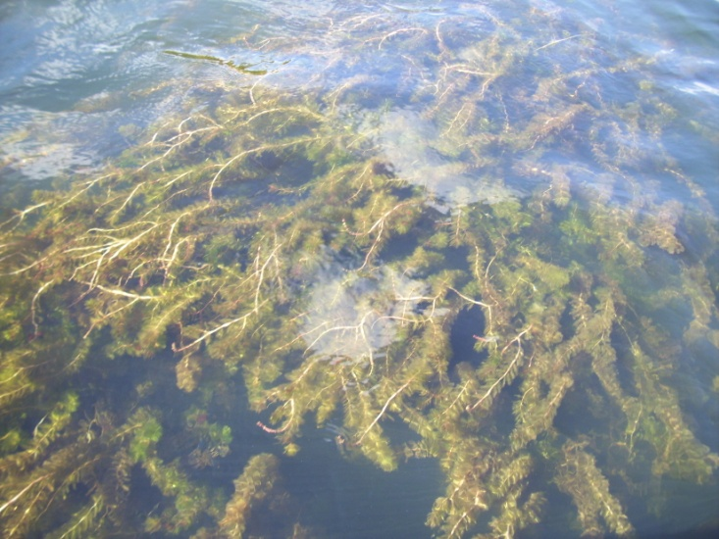

* Saint Croix
Flowage

Canopied EWM on the St. Croix Flowage

Survey Conducted by and Report Prepared by:
Endangered Resource Services, LLC
Matthew S. Berg, Research Biologist
St. Croix Falls, Wisconsin
June 19-20 and July 31, 2013
TABLE OF CONTENTS

Page
LIST OF FIGURES ………………..……..………………………………………………... ii

LIST OF TABLES…………………..……..……………………………………………….. iii

INTRODUCTION……….…..……..………………………………………………………. 1

METHODS……………………………………………………………….………………… 2

RESULTS AND DISCUSSION……………………………………………………………. 3

Finalization of Treatment Areas……………………………………………………. 3

EWM Pre/Post Herbicide Survey…………………………………………………... 4

LITERATURE CITED……….……………………….……………………………………. 12

APPENDIXES……….…….………………………………………………….……………. 13

I: Survey Sample Points and EWM Treatment Areas……..…………………………… 13

II: Vegetative Survey Data Sheet.………………………………………………………. 16

III: Pre/Post Habitat Variable Maps.………………….……………………………...…... 18

IV: Pre/Post Native Species Richness and Total Rake Fullness.………..……………...... 21

V: EWM and CLP Pre/Post Density and Distribution…………………..……………..... 26

VI: Pretreatment Native Species Density and Distribution…...………………………...... 31

VII: Posttreatment Native Species Density and Distribution…...……………………….... 50

LIST OF FIGURES

Page
Figure 1: 2013 Spring EWM Treatment Areas………….….……………….……….…..… 1
Figure 2: Rake Fullness Ratings……………………………….…….…………………….. 2
Figure 3: 2013 Survey Sample Points and Final Treatment Areas………………………… 3
Figure 4: Depths and Bottom Substrate………………..….………..……………………… 4
Figure 5: Pre/Post Native Species Richness…………………………..…………………… 5
Figure 6: Pre/Post Total Rake Fullness………………………………..…………………... 5
Figure 7: Pre/Post EWM Density and Distribution ……………………….………………. 6
Figure 8: Pre/Post Changes in EWM Rake Fullness………………………………………. 6
Figure 9: Pre/Post CLP Density and Distribution……………….…………………………. 7
Figure 10: Pre/Post Fern Pondweed Density and Distribution …………………….……… 7
Figure 11: Pre/Post Common Waterweed Density and Distribution..…. .………………… 8
Figure 12: Pre/Post Macrophyte Changes…………………………. .…………………….. 9

LIST OF TABLES

Page
Table 1: EWM Treatment Summary – St. Croix Flowage – June 25, 2013………………. 3

Table 2: Pre/Post Survey Summary Statistics – St. Croix Flowage, Douglas County –
June 19-20 and July 31, 2013………………………………………………………………. 4

Table 3: Frequencies and Mean Rake Sample of Aquatic Macrophytes
Pretreatment Survey – St. Croix Flowage, Douglas County - June 19-20, 2013..…………. 10

Table 4: Frequencies and Mean Rake Sample of Aquatic Macrophytes
Posttreatment Survey – St. Croix Flowage, Douglas County - July 31, 2013………..……. 11

INTRODUCTION:
The Saint Croix Flowage (WBIC 2740300) is a 1,913 acre stratified drainage lake in south-central Douglas County, Wisconsin in the Town of Gordon (T44N R13W S36 NE SE). The flowage has a maximum depth of 28ft and an average depth of 7ft. It is mesotrophic bordering on eutrophic in nature, and water clarity is fair with summer Secchi readings averaging from 7-12ft in the deep hole by the dam over the past 20 years (WDNR 2013). In 2013, the littoral zone extended to approximately 13.5ft. Bottom substrate is variable with muck bottoms in most bays and along the river channel, and rock/sand areas around the flowage’s numerous islands (Sather et al. 1967).

Figure 1: 2013 Spring EWM Treatment Areas

Eurasian water milfoil (Myriophyllum spicatum) (EWM) was discovered in the summer of 2007 at the boat launch at the Gordon Dam County Park, and the Gordon - Saint Croix Flowage Association (GSCFA) has been working to manage this exotic invasive species ever since. Following the 2012 fall EWM bed mapping survey that found 23 beds totaling 2.3 acres scattered throughout the west end of the flowage, the GSCFA, under the direction of Short Elliott Hendrickson Inc. (SEH), decided to chemically treat 14 areas in 2013. All combined, they totaled 6.34 acres or 0.3% of the flowage’s total surface area (Figure 1).

On June 19-20th, we conducted a pretreatment survey to gather baseline data from the scheduled treatment areas and to allow SEH biologists to finalize treatment plans. Following the June 25th herbicide application, we conducted a July 31st posttreatment survey to evaluate the effectiveness of the treatment. This report is the summary analysis of these two field surveys.
METHODS:
Pre/Post Herbicide Survey:
SEH biologists generated 200 pre/post survey points in the west basin. Of these, approximately 40 occurred within the treatment areas with the other 160 “exploratory” points occurring in areas that have supported EWM in the past. These 40 points equated to approximately 10pts/acre which is the maximum recommended by WDNR protocol (Appendix I).

During the survey, we located each point using a handheld mapping GPS unit (Garmin 76CSx) and used a rake to sample an approximately 2.5ft section of the bottom. All plants on the rake were assigned a rake fullness value of 1-3 as an estimation of abundance, and a total rake fullness for all species was also recorded (Figure 2). Visual sightings of EWM and Curly-leaf pondweed (Potamogeton crispus), another exotic invasive species, were noted if they occurred within 6ft of the point. In addition to plant data, we recorded the lake depth using a hand held sonar (Vexilar LPS-1) and the bottom substrate (bottom type) when we could see it or reliably determine it with the rake.

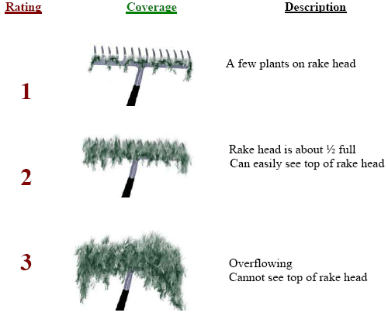
Figure 2: Rake Fullness Ratings

Data Analysis:
We entered all data collected into the standard APM spreadsheet (Appendix II). These data were then analyzed using the linked statistical summary sheet and the WDNR pre/post analysis worksheet (UWEX 2010). Pre/post treatment differences were determined to be significant at p <.05, moderately significant at p <.01, and highly significant at p<.005.

RESULTS AND DISCUSSION:
Finalization of Treatment Areas:
Initial expectations were to treat 11 areas totaling 6.36 acres with granular 2, 4-D (Navigate) at a concentration of 2.0 ppm (Table 1). The pretreatment survey results dictated minor changes including paring down several beds, splitting others into pieces, and expanding or adding other areas. The final treatment carried out by Northern Aquatics Services on June 25th ended up being a nearly identical 6.34 acres (Figure 3).

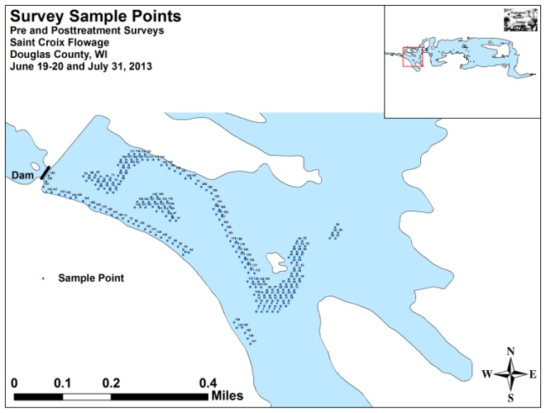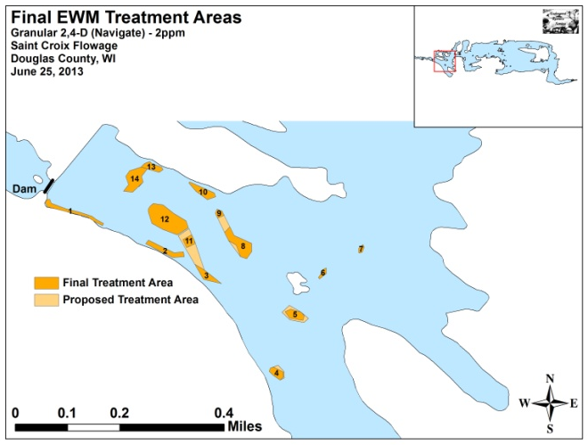
Figure 3: 2013 Survey Sample Points and Final Treatment Areas

Table 1: EWM Treatment Summary
St. Croix Flowage – June 25, 2013

Bed Number | Proposed  Acreage | Final Acreage | Difference  +/-
1 | 0.39 | 0.44 | 0.05
2 | 0 | 0.44 | 0.44
3 | 0 | 0.32 | 0.32
4 | 0.32 | 0.25 | -0.07
5 | 0.55 | 0.32 | -0.23
6 | 0.09 | 0.09 | 0
7 | 0.07 | 0.07 | 0
8 | 1.24 | 0.81 | -0.43
9 | 0 | 0.11 | 0.11
10 | 0.40 | 0.40 | 0
11 | 1.23 | 0.33 | -0.90
12 | 1.71 | 1.71 | 0
13 | 0.18 | 0.28 | 0.10
14 | 0.18 | 0.77 | 0.59
Total Acres | 6.36 | 6.34 | -0.02

EWM Pre/Post Herbicide Survey:
The littoral zone extended to a maximum of 13.5ft during the pretreatment survey and 12.0ft posttreatment. Mean and median depths for all plants were in the 6.5-6.6 range for both the pre and posttreatment surveys (Table 2). Eurasian water milfoil was found throughout the littoral zone in 2-13.5ft of water with most plants growing over organic muck (Figure 4) (Appendix III).

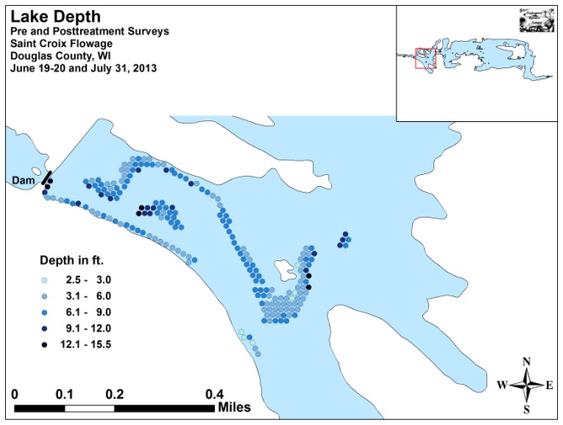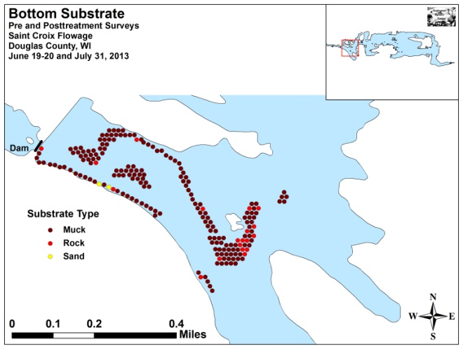
Figure 4: Depths and Bottom Substrate

Table 2: Pre/Post Survey Summary Statistics
St. Croix Flowage, Douglas County
June 19-20 and July 31, 2013

Summary Statistics: | Pre | Post
Total number of points sampled | 200 | 200
Total number of sites with vegetation | 194 | 187
Total number of sites shallower than the maximum depth of plants | 198 | 197
Frequency of occurrence at sites shallower than maximum depth of plants | 97.98 | 94.92
Simpson Diversity Index | 0.89 | 0.89
Floristic Quality Index | 27.1 | 27.1
Maximum depth of plants (ft) | 13.5 | 12.0
Mean depth of plants (ft) | 6.6 | 6.5
Median depth of plants (ft) | 6.5 | 6.5
Average number of all species per site (shallower than max depth) | 3.42 | 3.95
Average number of all species per site (veg. sites only) | 3.49 | 4.17
Average number of native species per site (shallower than max depth) | 2.78 | 3.87
Average number of native species per site (native veg. sites only) | 2.96 | 4.12
Species richness | 20 | 19
Mean rake fullness (veg. sites only) | 2.12 | 2.07

Initial and final diversity within the beds was high with an identical Simpson Diversity Index of 0.89. The Floristic Quality Index, a measure of native species diversity, was also 27.1 for both surveys. Mean native species richness at sites with native vegetation increased from 2.96/site pretreatment to 4.12/site posttreatment (Figure 5). We noted a small decline in mean total rake fullness at sites with vegetation from 2.12 pretreatment to 2.07 posttreatment, but this change was not significant (Figure 6) (Appendix IV).

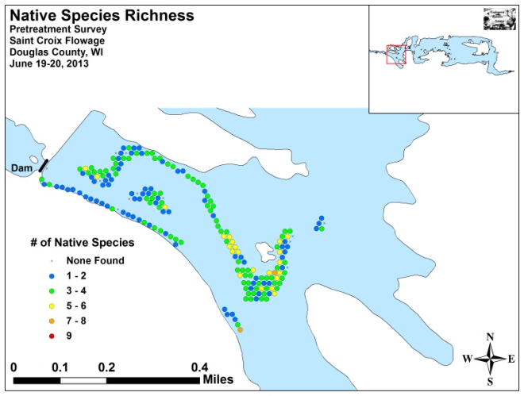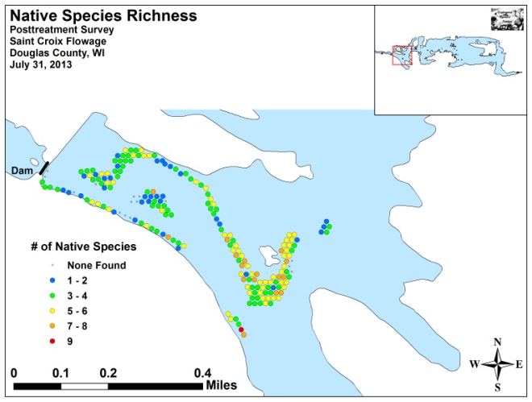
Figure 5: Pre/Post Native Species Richness

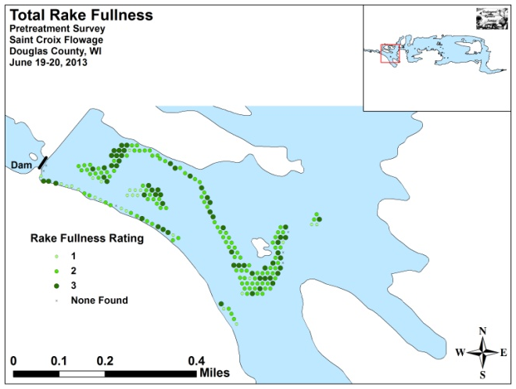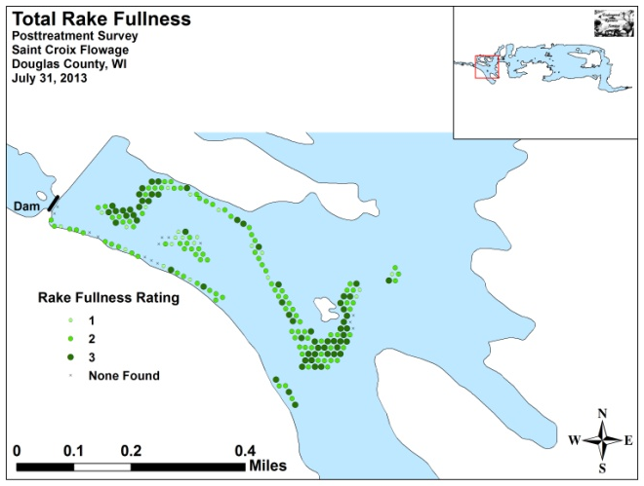
Figure 6: Pre/Post Total Rake Fullness

We found EWM at 28 points during the pretreatment survey (Table 3). Of these, five rated a 3, 11 were a two, and the other 12 had a rake fullness rating of 1 for a mean rake fullness of 1.75. We also recorded EWM as a visual at 25 points. During the posttreatment survey, we found EWM at 16 sites where four rated a 3, four were a 2, and eight were a 1 for an identical mean rake fullness of 1.75 (Table 4). We also noted EWM as a visual at 20 points (Figure 7) (Appendix V). Although all metrics declined posttreatment, none of these changes were significant (Figure 8).

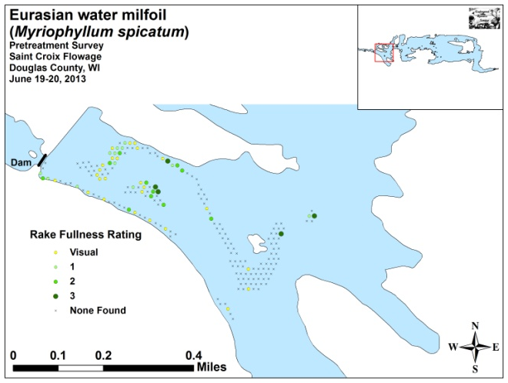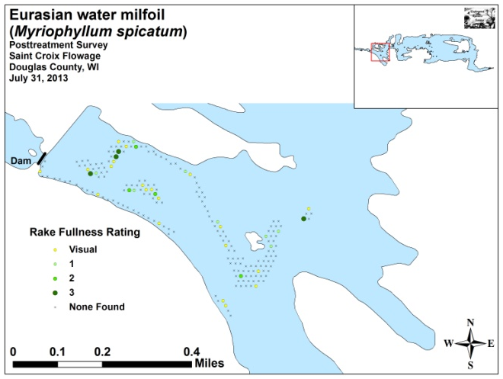
Figure 7: Pre/Post EWM Density and Distribution

Significant differences = * p <. 05, ** p <. 01, *** p <. 005
Figure 8: Pre/Post Changes in EWM Rake Fullness

Curly-leaf pondweed was the second most common species in the pretreatment study area being present at 98 points (Table 3). Of these, 21 had a rake fullness rating of 3, 24 rated a 2, and 53 were a 1 for a mean rake fullness of 1.67. We also noted CLP as a visual at 11 additional points (Figure 9) (Appendix V). During the posttreatment survey, we didn’t find CLP at any points. This highly significant decline was likely a result of this species’ normal late June senescence rather than the herbicide treatment.

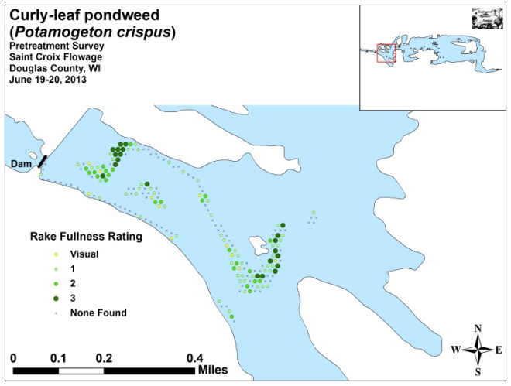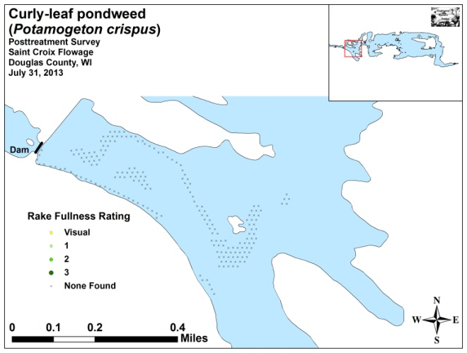
Figure 9: Pre/Post CLP Density and Distribution

Fern pondweed (Potamogeton robbinsii) and Common waterweed (Elodea canadensis) were the two most common native species in both the pre and posttreatment surveys (Tables 3 and 4) (Figures 10 and 11). They were present at 64.43% and 50.00% of survey points with vegetation during the pretreatment survey and 78.07% and 64.71% during the posttreatment survey.

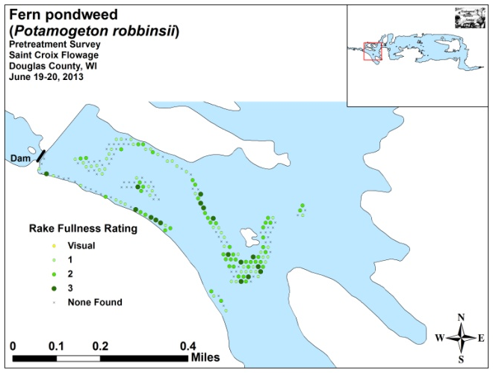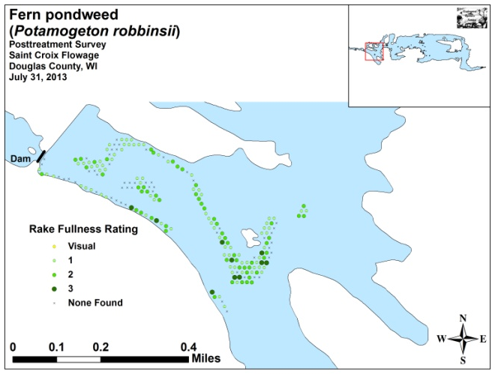
Figure 10: Pre/Post Fern Pondweed Density and Distribution

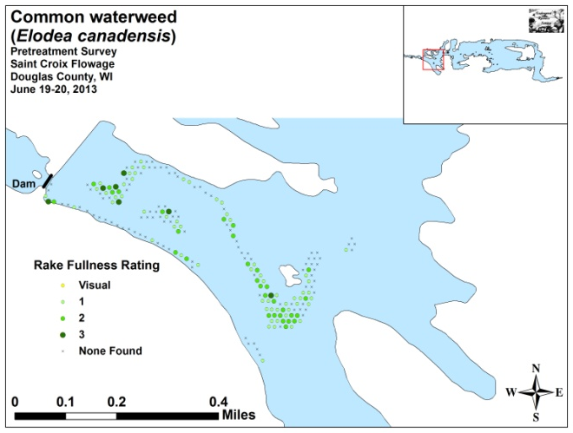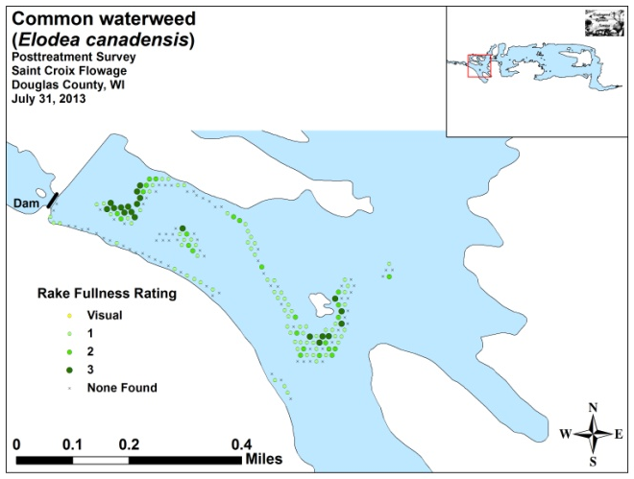
Figure 11: Pre/Post Common Waterweed Density and Distribution

Other than Curly-leaf pondweed, no species showed a significant decline posttreatment (Figure 12). However, Coontail (Ceratophyllum demersum) and Wild celery (Vallisneria americana) showed highly significant increases; Clasping-leaf pondweed (Potamogeton richardsonii) a moderately significant increase; and Fern pondweed, Common water weed, Watershield (Brasenia schreberi), and Water marigold (Bidens beckii) all showed significant increases. These increases are likely the result of normal growing season expansion (Maps for all species from the pre and posttreatment surveys are available in Appendixes VI and VII).

+*
+***
+*
+**
+***
+*
-***
+*
Significant differences = * p <. 05, ** p <. 01, *** p <. 005
Figure 12: Pre/Post Macrophyte Changes
Table 3: Frequencies and Mean Rake Sample of Aquatic Macrophytes
Pretreatment Survey St. Croix Flowage, Douglas County
June 19-20, 2013

Species | Common Name | Total  Sites | Relative Freq. | Freq. in Veg. | Freq. in Lit. | Mean Rake | Visual Sites
Potamogeton robbinsii | Fern pondweed | 125 | 18.46 | 64.43 | 63.13 | 1.67 | 0
Potamogeton crispus | Curly-leaf pondweed | 98 | 14.48 | 50.52 | 49.49 | 1.67 | 11
Elodea canadensis | Common waterweed | 97 | 14.33 | 50.00 | 48.99 | 1.46 | 0
Potamogeton praelongus | White-stem pondweed | 64 | 9.45 | 32.99 | 32.32 | 1.44 | 0
Ceratophyllum demersum | Coontail | 63 | 9.31 | 32.47 | 31.82 | 1.38 | 0
Potamogeton zosteriformis | Flat-stem pondweed | 57 | 8.42 | 29.38 | 28.79 | 1.00 | 0
Potamogeton pusillus | Small pondweed | 40 | 5.91 | 20.62 | 20.20 | 1.15 | 0
Myriophyllum sibiricum | Northern water-milfoil | 35 | 5.17 | 18.04 | 17.68 | 1.29 | 0
Myriophyllum spicatum | Eurasian water milfoil | 28 | 4.14 | 14.43 | 14.14 | 1.75 | 25
Bidens beckii | Water marigold | 26 | 3.84 | 13.40 | 13.13 | 1.08 | 0
Potamogeton richardsonii | Clasping-leaf pondweed | 17 | 2.51 | 8.76 | 8.59 | 1.24 | 0
Potamogeton friesii | Fries' pondweed | 6 | 0.89 | 3.09 | 3.03 | 1.00 | 0
Chara sp. | Muskgrass | 4 | 0.59 | 2.06 | 2.02 | 1.25 | 0
Potamogeton amplifolius | Large-leaf pondweed | 4 | 0.59 | 2.06 | 2.02 | 1.00 | 0
Lemna trisulca | Forked duckweed | 3 | 0.44 | 1.55 | 1.52 | 1.00 | 0
Nitella sp. | Nitella | 3 | 0.44 | 1.55 | 1.52 | 1.00 | 0
Brasenia schreberi | Watershield | 2 | 0.30 | 1.03 | 1.01 | 1.00 | 0
Ranunculus aquatilis | White water crowfoot | 2 | 0.30 | 1.03 | 1.01 | 1.00 | 0
Vallisneria americana | Wild celery | 2 | 0.30 | 1.03 | 1.01 | 1.00 | 0
Nymphaea odorata | White water lily | 1 | 0.15 | 0.52 | 0.51 | 1.00 | 0

Table 4: Frequencies and Mean Rake Sample of Aquatic Macrophytes
Posttreatment Survey St. Croix Flowage, Douglas County
July 31, 2013

Species | Common Name | Total  Sites | Relative Freq. | Freq. in Veg. | Freq. in Lit. | Mean Rake | Visual Sites
Potamogeton robbinsii | Fern pondweed | 146 | 18.74 | 78.07 | 74.11 | 1.52 | 0
Elodea canadensis | Common waterweed | 121 | 15.53 | 64.71 | 61.42 | 1.54 | 0
Ceratophyllum demersum | Coontail | 98 | 12.58 | 52.41 | 49.75 | 1.29 | 0
Potamogeton zosteriformis | Flat-stem pondweed | 70 | 8.99 | 37.43 | 35.53 | 1.17 | 0
Potamogeton praelongus | White-stem pondweed | 68 | 8.73 | 36.36 | 34.52 | 1.59 | 0
Vallisneria americana | Wild celery | 60 | 7.70 | 32.09 | 30.46 | 1.28 | 0
Potamogeton pusillus | Small pondweed | 45 | 5.78 | 24.06 | 22.84 | 1.11 | 0
Bidens beckii | Water marigold | 44 | 5.65 | 23.53 | 22.34 | 1.20 | 0
Potamogeton richardsonii | Clasping-leaf pondweed | 40 | 5.13 | 21.39 | 20.30 | 1.05 | 0
Myriophyllum sibiricum | Northern water-milfoil | 31 | 3.98 | 16.58 | 15.74 | 1.19 | 0
Myriophyllum spicatum | Eurasian water milfoil | 16 | 2.05 | 8.56 | 8.12 | 1.75 | 20
Brasenia schreberi | Watershield | 10 | 1.28 | 5.35 | 5.08 | 1.80 | 0
Nymphaea odorata | White water lily | 8 | 1.03 | 4.28 | 4.06 | 1.75 | 0
Potamogeton amplifolius | Large-leaf pondweed | 5 | 0.64 | 2.67 | 2.54 | 1.00 | 0
Lemna trisulca | Forked duckweed | 4 | 0.51 | 2.14 | 2.03 | 1.00 | 0
Potamogeton friesii | Fries' pondweed | 4 | 0.51 | 2.14 | 2.03 | 1.00 | 0
Ranunculus aquatilis | White water crowfoot | 4 | 0.51 | 2.14 | 2.03 | 1.00 | 0
Nitella sp. | Nitella | 3 | 0.39 | 1.60 | 1.52 | 1.00 | 0
Chara sp. | Muskgrass | 2 | 0.26 | 1.07 | 1.02 | 1.00 | 0

LITERATURE CITED

Sather, L, C. Busch, C., R. Housel, and J. Roth. [online]. 1967. St. Croix Flowage Map.
Available from http://dnr.wi.gov/lakes/maps/DNR/2740300a.pdf (2013, November).

UWEX Lakes Program. [online]. 2010. Aquatic Plant Management in Wisconsin. Available from http://www.uwsp.edu/cnr/uwexlakes/ecology/APMguide.asp (2013, November).

WDNR. [online]. 2013. St. Croix Flowage - Citizen Lake Water Quality Monitoring Database. Available from http://dnr.wi.gov/lakes/lakepages/LakeDetail.aspx?wbic=2740300&page=waterquality (2013, November).

Appendix I: Survey Sample Points and EWM Treatment Areas
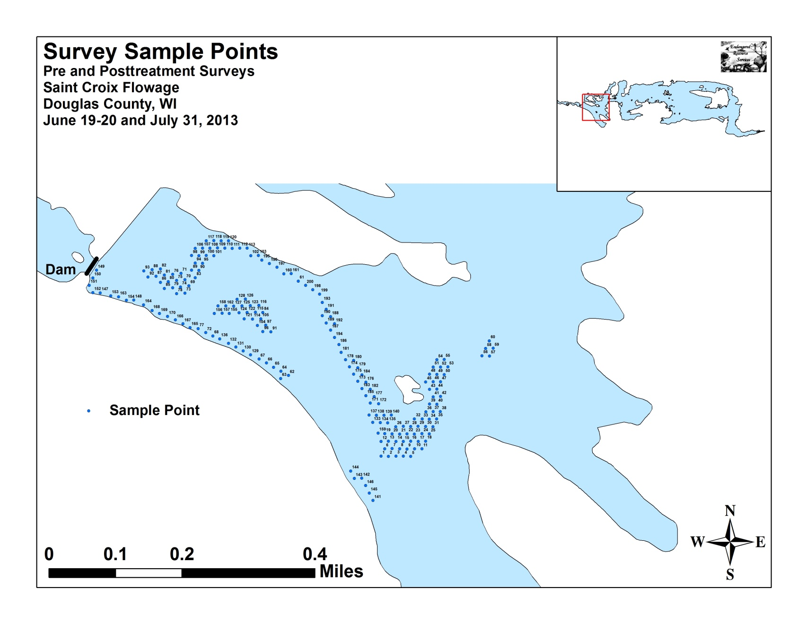
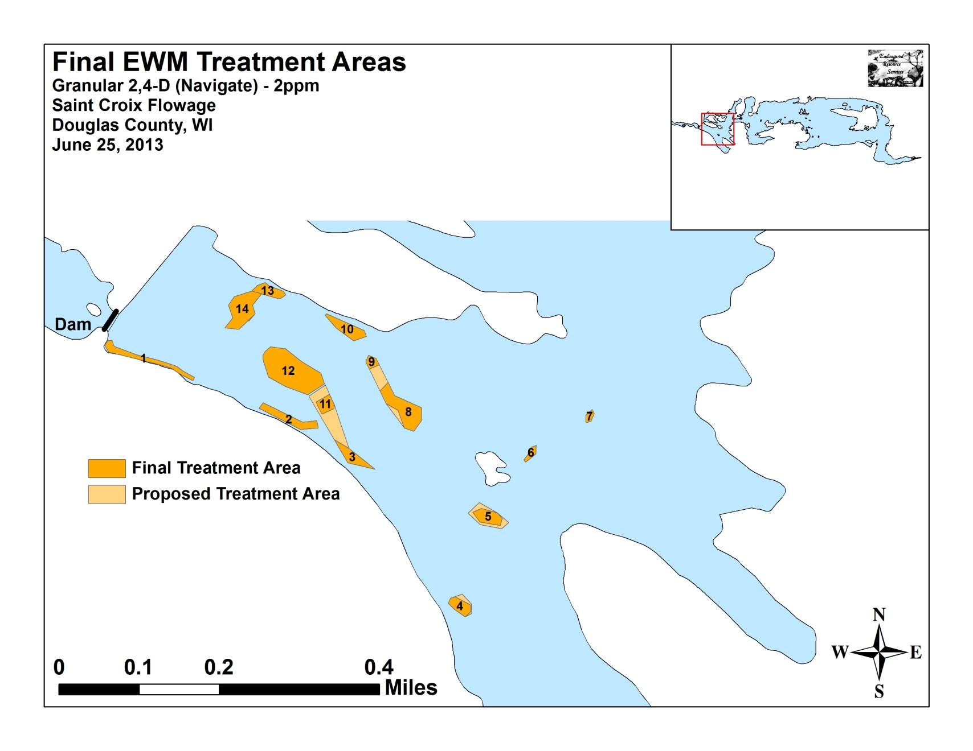

Appendix II: Vegetative Survey Data Sheet

Observers for this lake: names and hours worked by each:
Lake: |  |  |  |  |  |  |  |  | WBIC |  |  |  |  |  |  |  |  | County |  |  |  |  |  | Date:
Site # | Depth (ft) | Muck (M), Sand (S), Rock (R) | Rake pole (P) or rake rope (R) | Total Rake Fullness | EWM | CLP | 1 | 2 | 3 | 4 | 5 | 6 | 7 | 8 | 9 | 10 | 11 | 12 | 13 | 14 | 15 | 16 | 17 | 18 | 19
1
2
3
4
5
6
7
8
9
10
11
12
13
14
15
16
17
18
19
20

Appendix III: Pre/Post Habitat Variable Maps
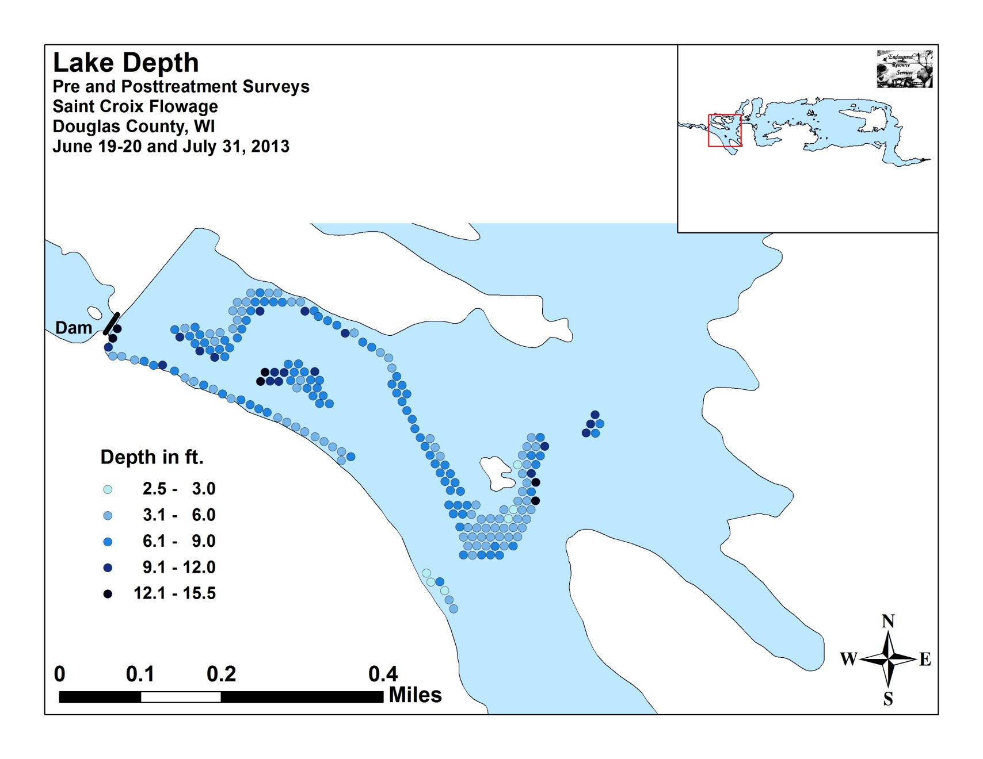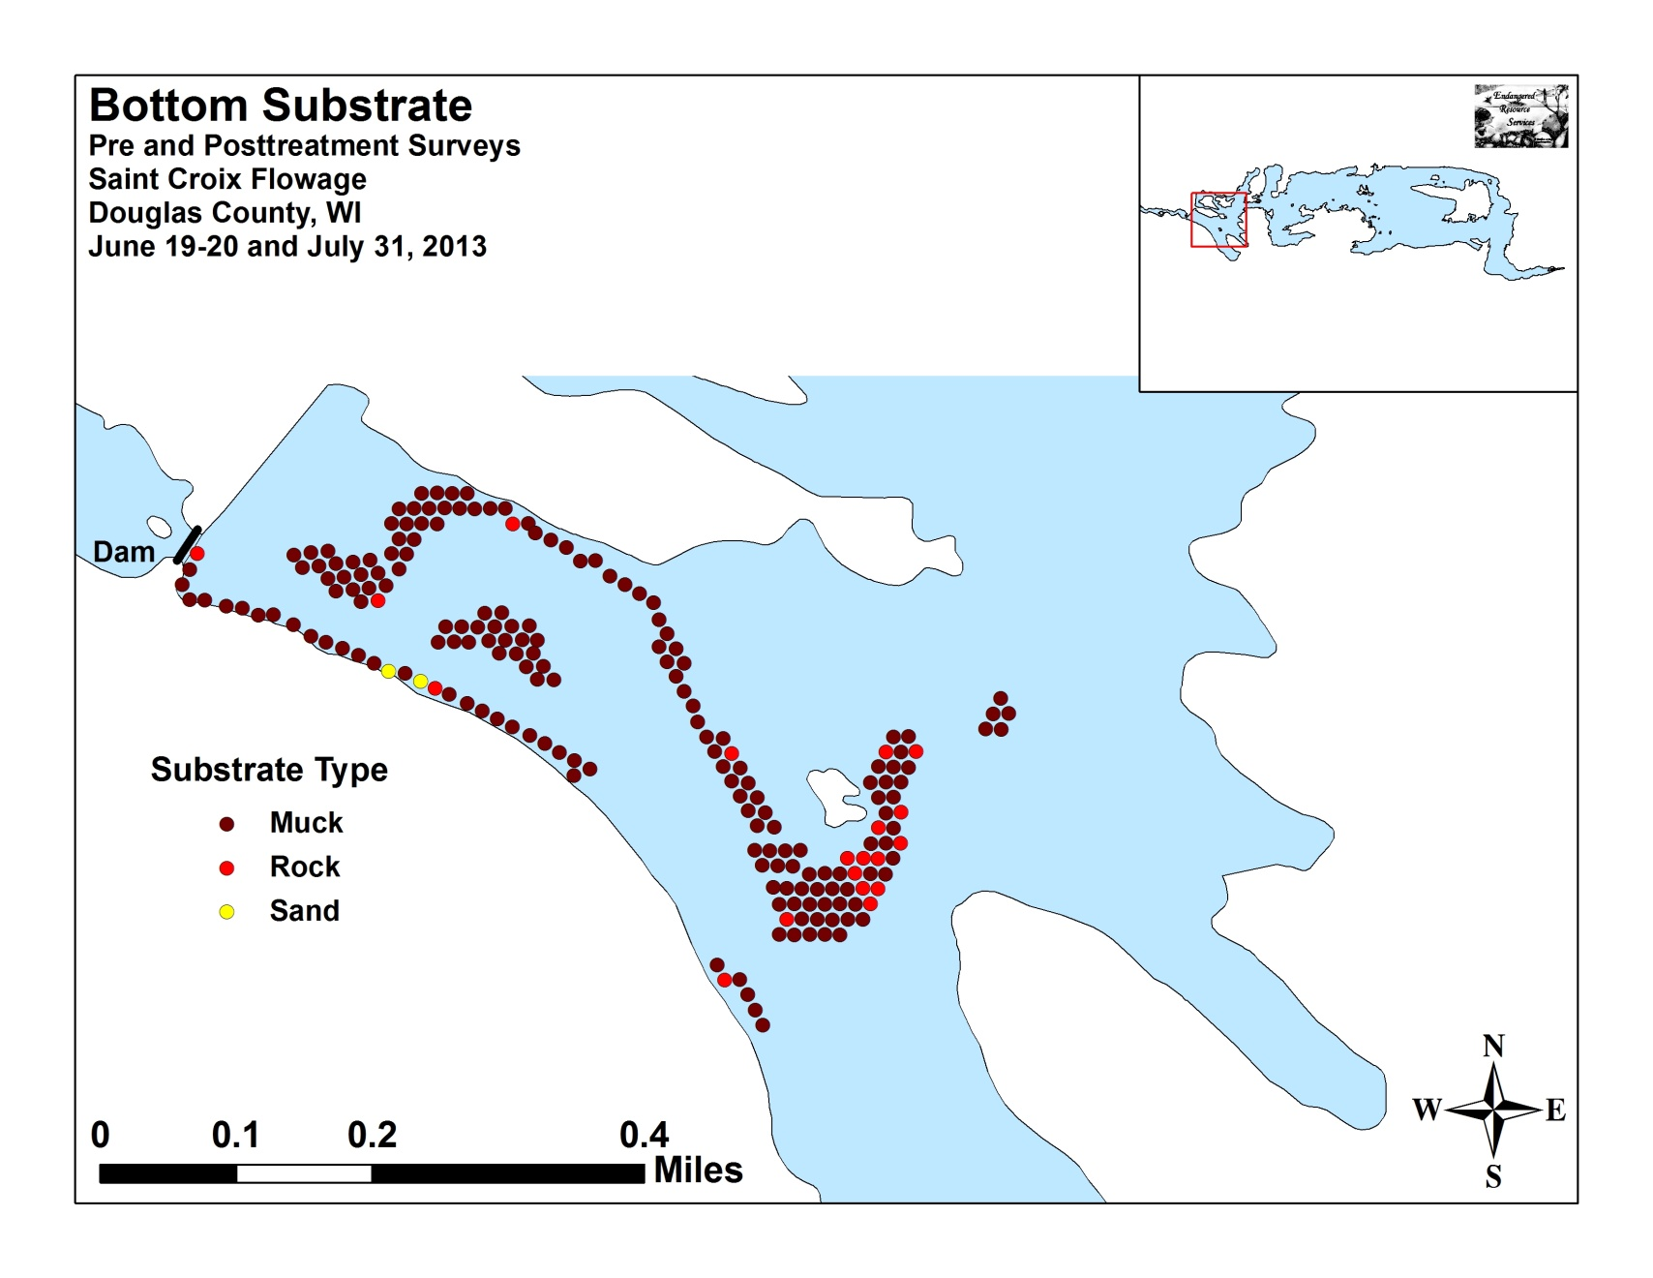

Appendix IV: Pre/Post Native Species Richness and
Total Rake Fullness
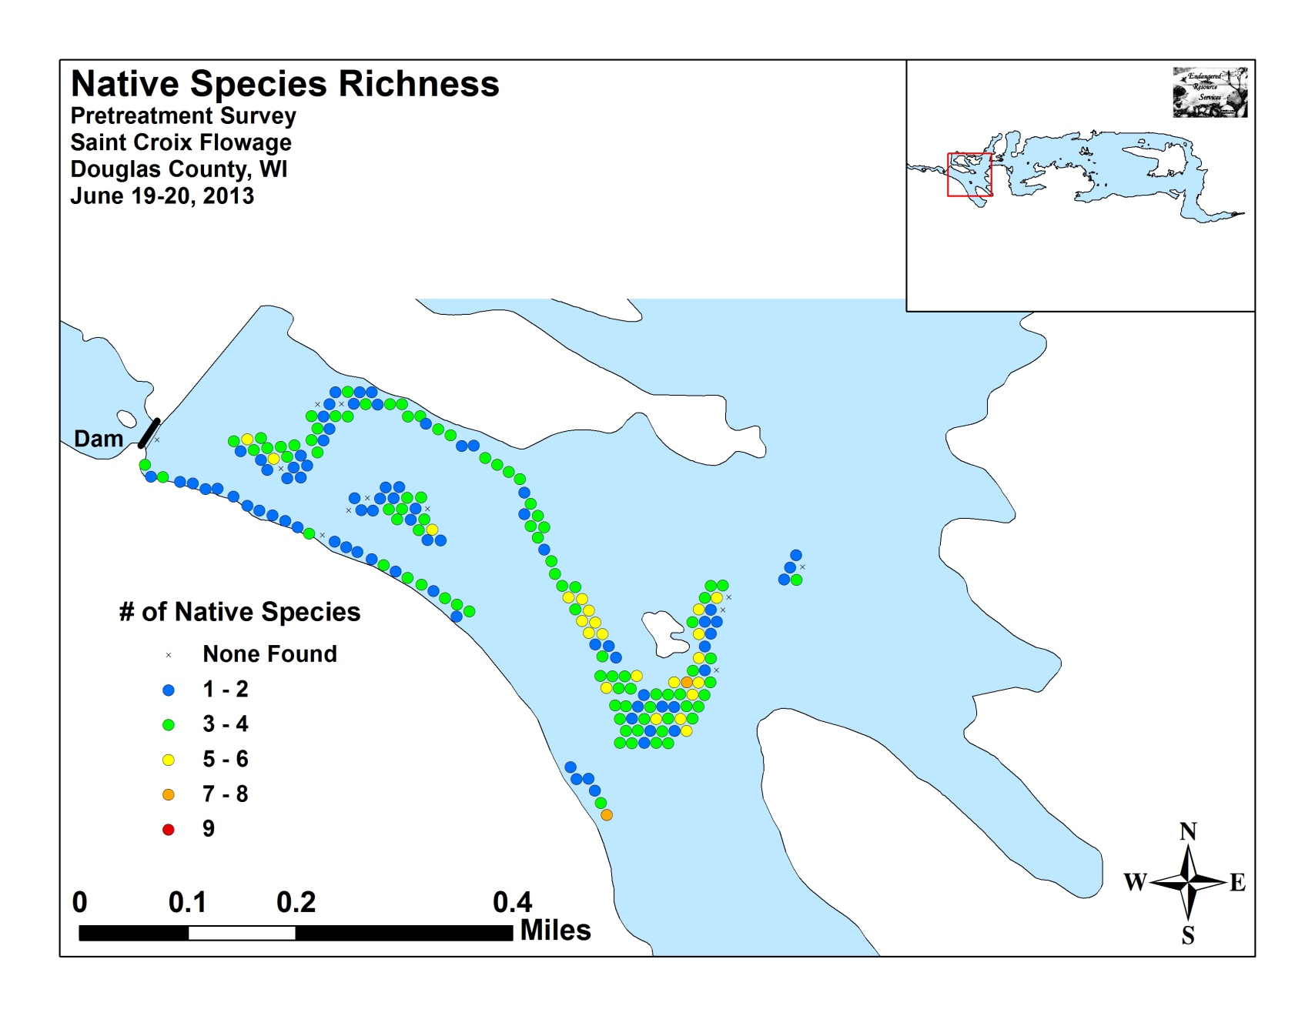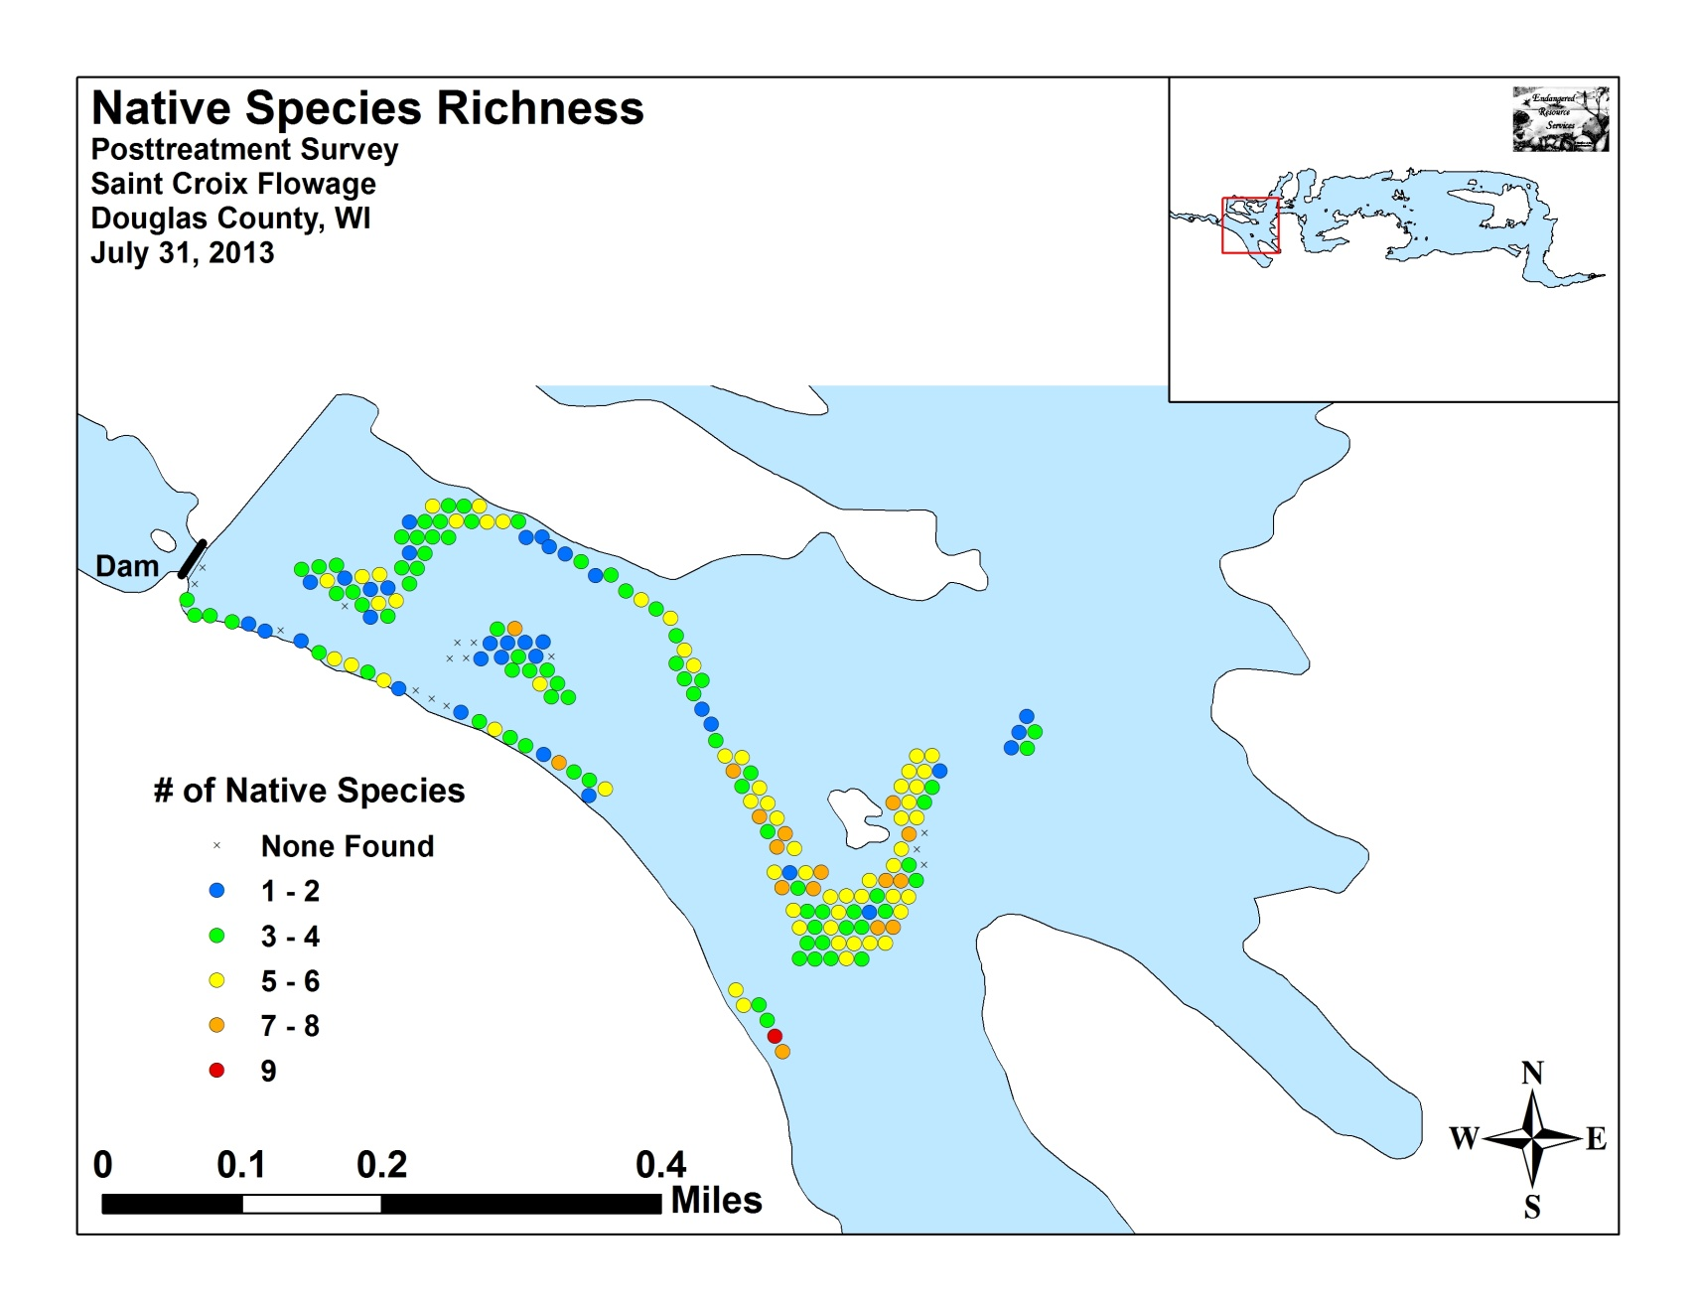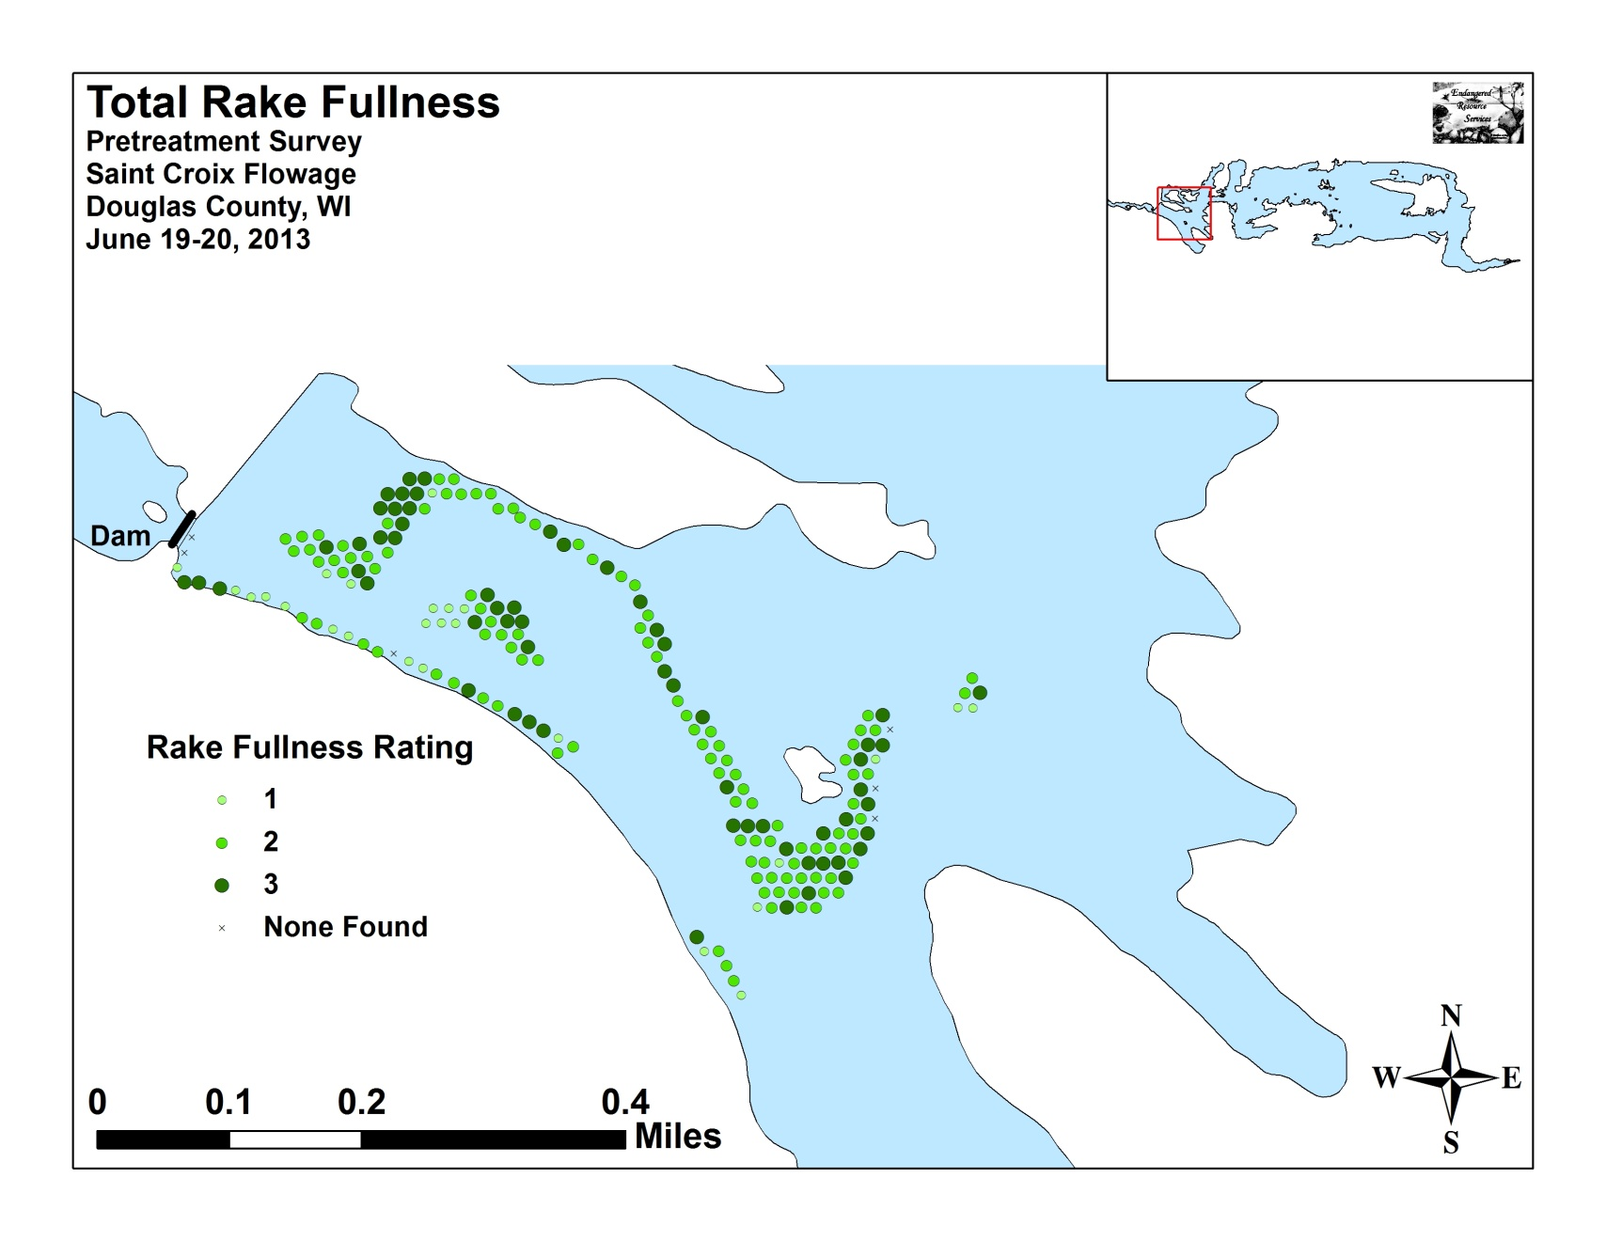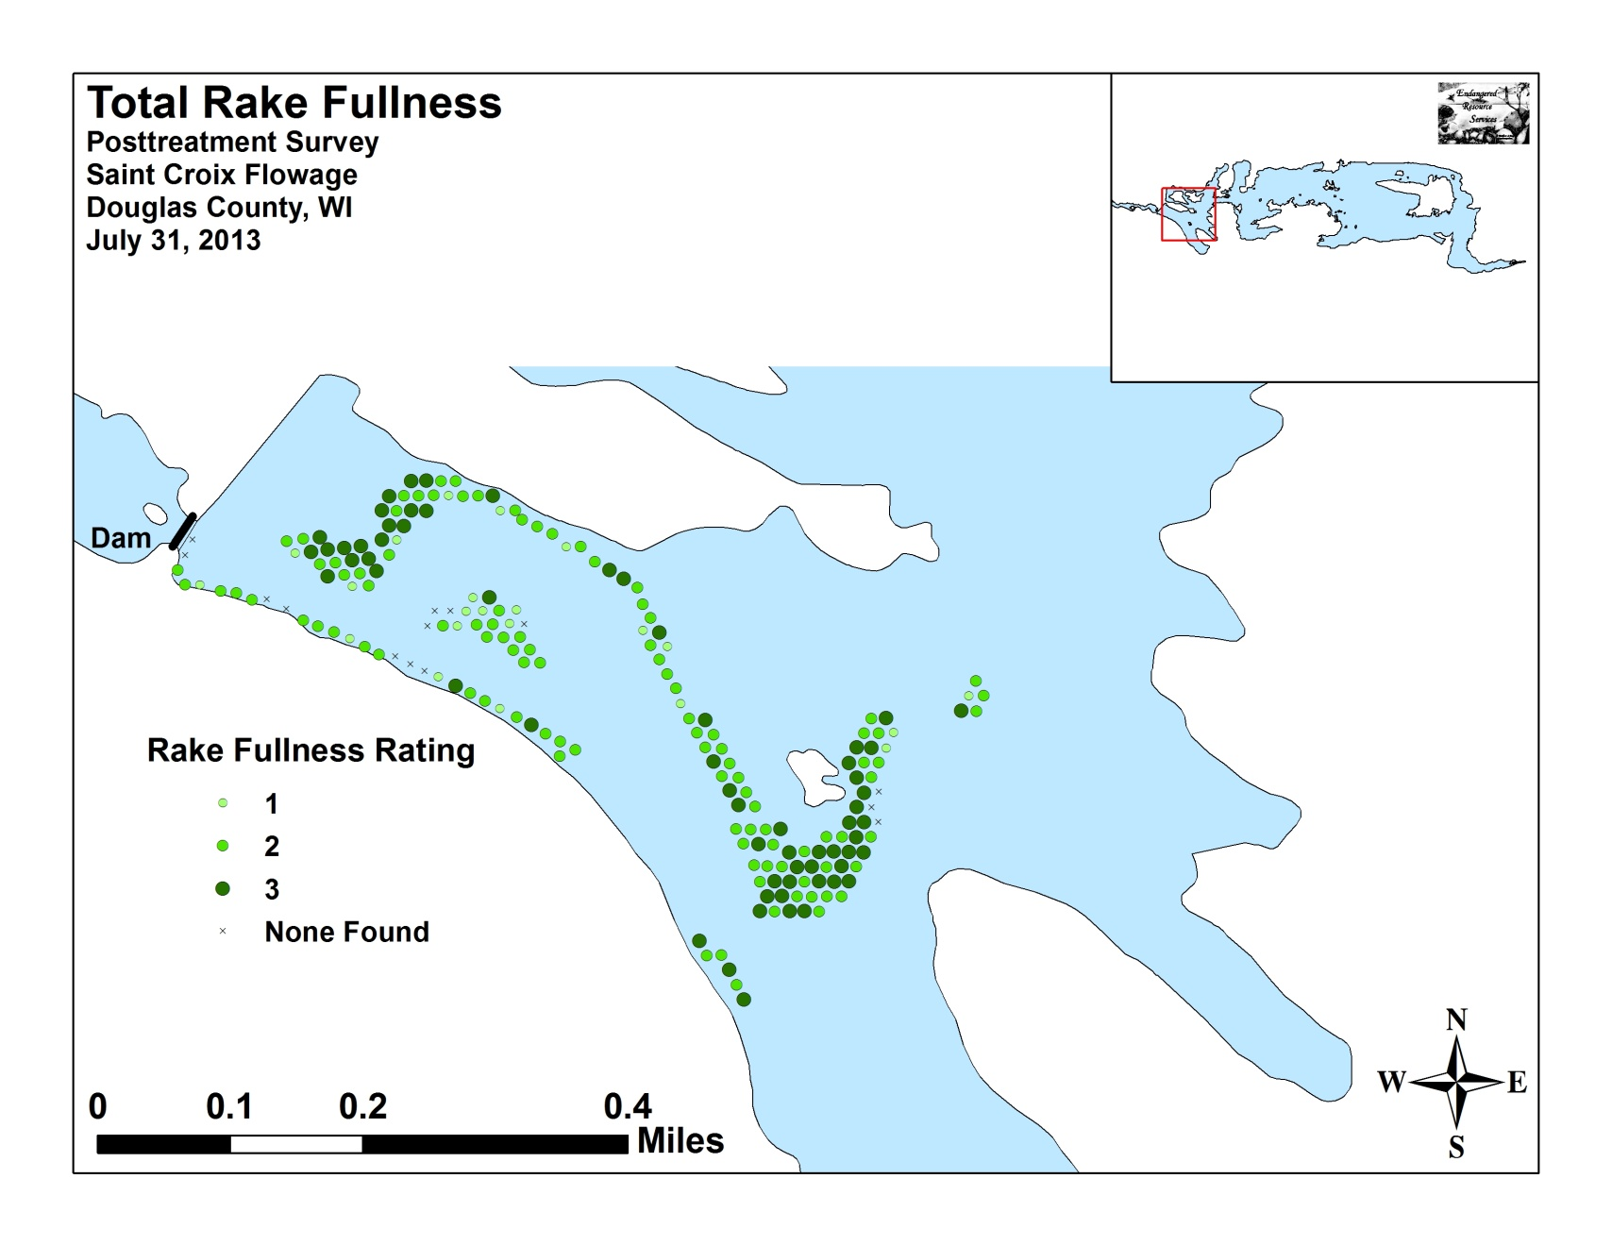

Appendix V: EWM and CLP Pre/Post Density and Distribution

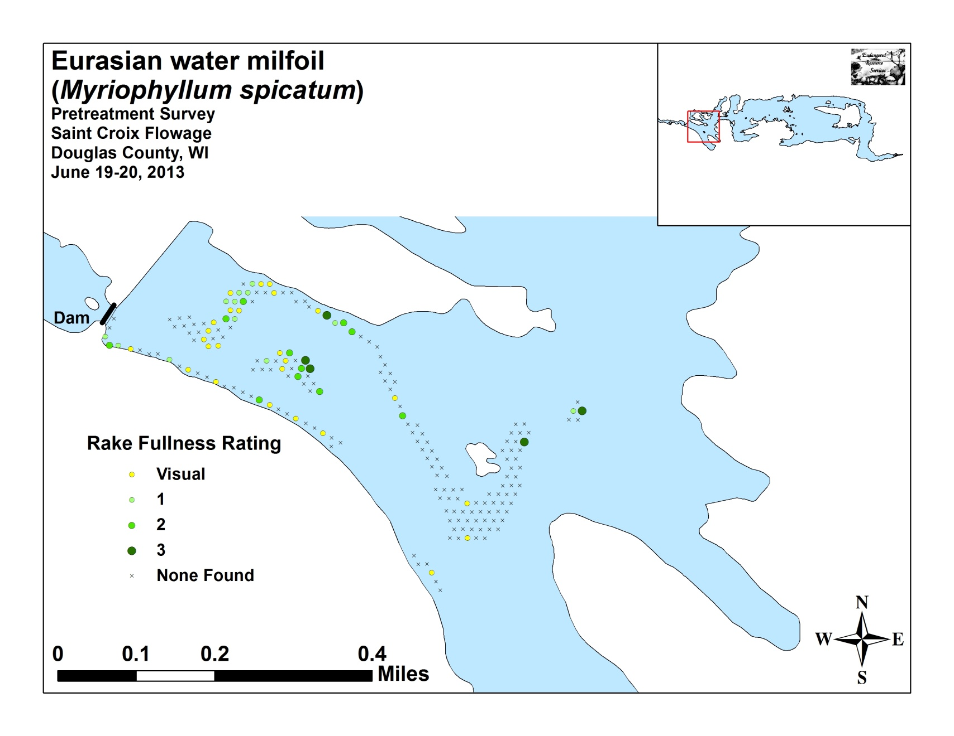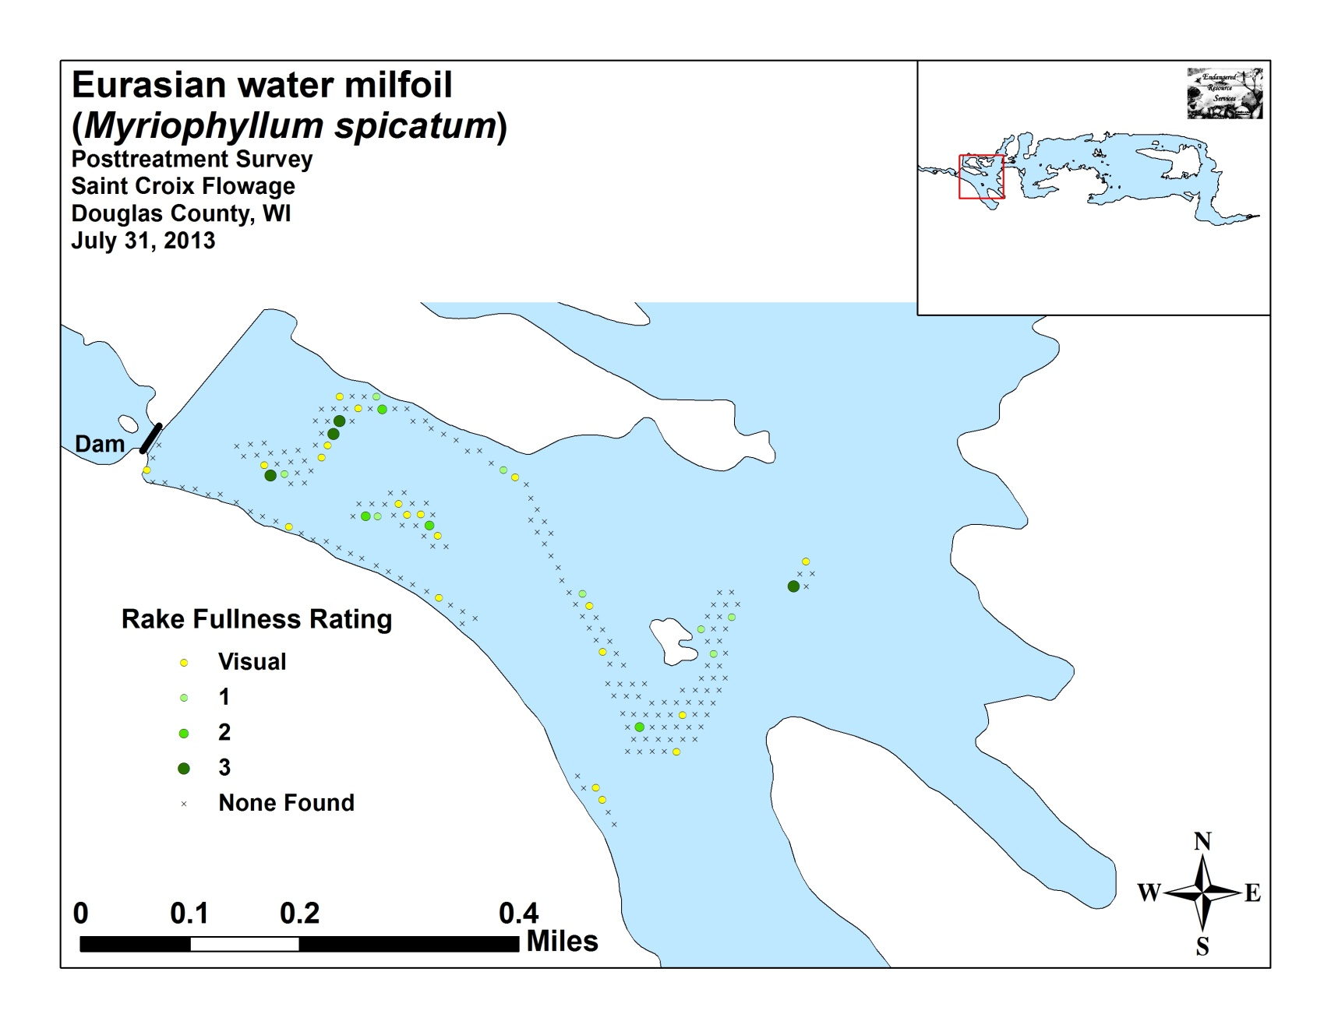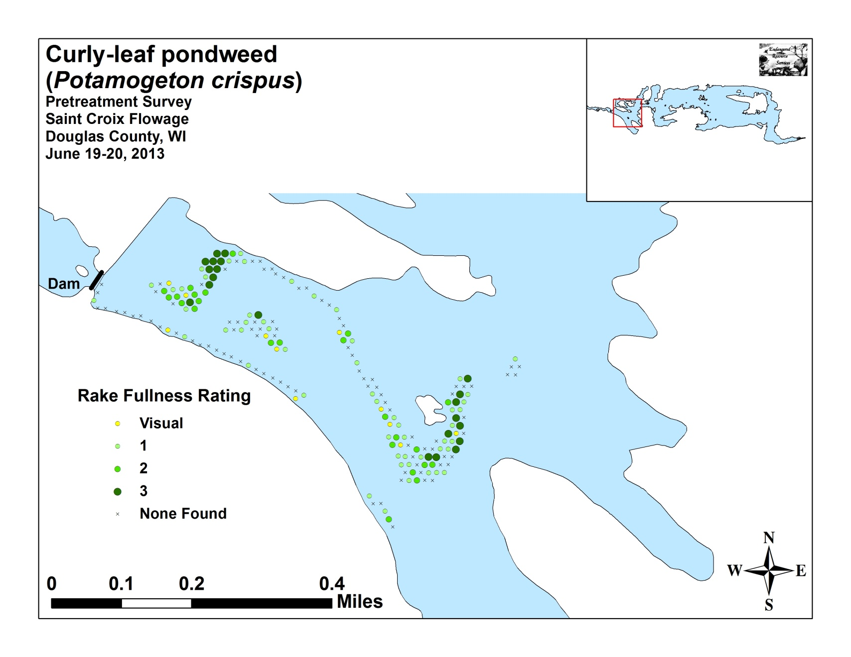
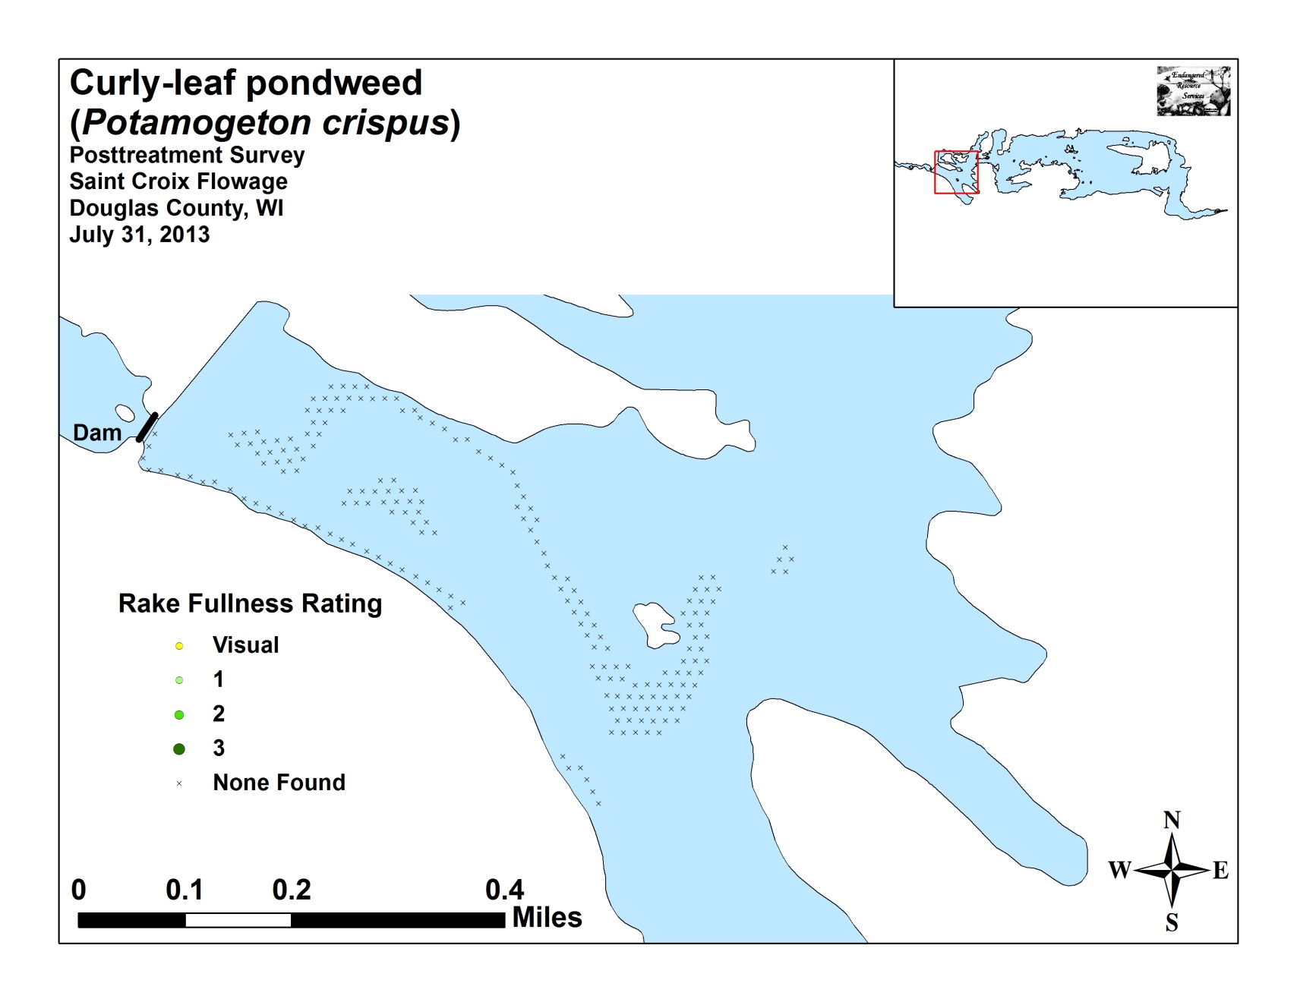

Appendix VI: Pretreatment Native Species Density and Distribution

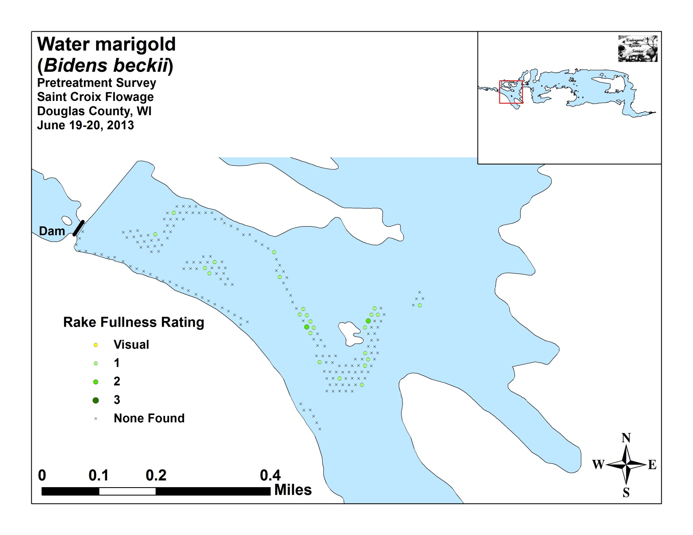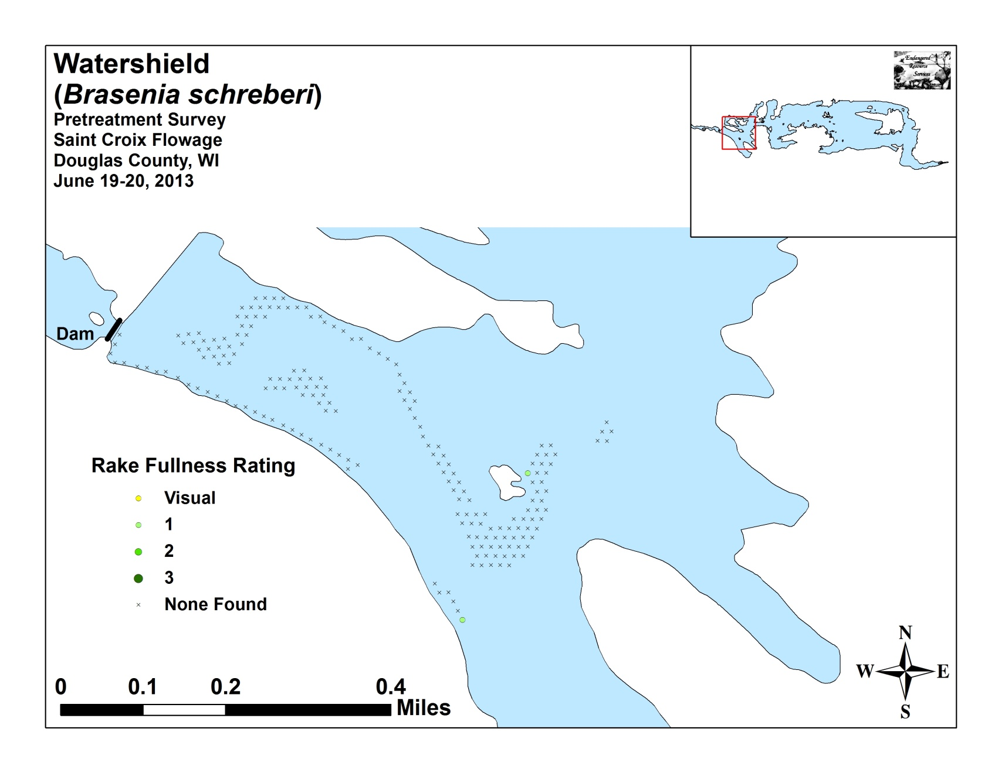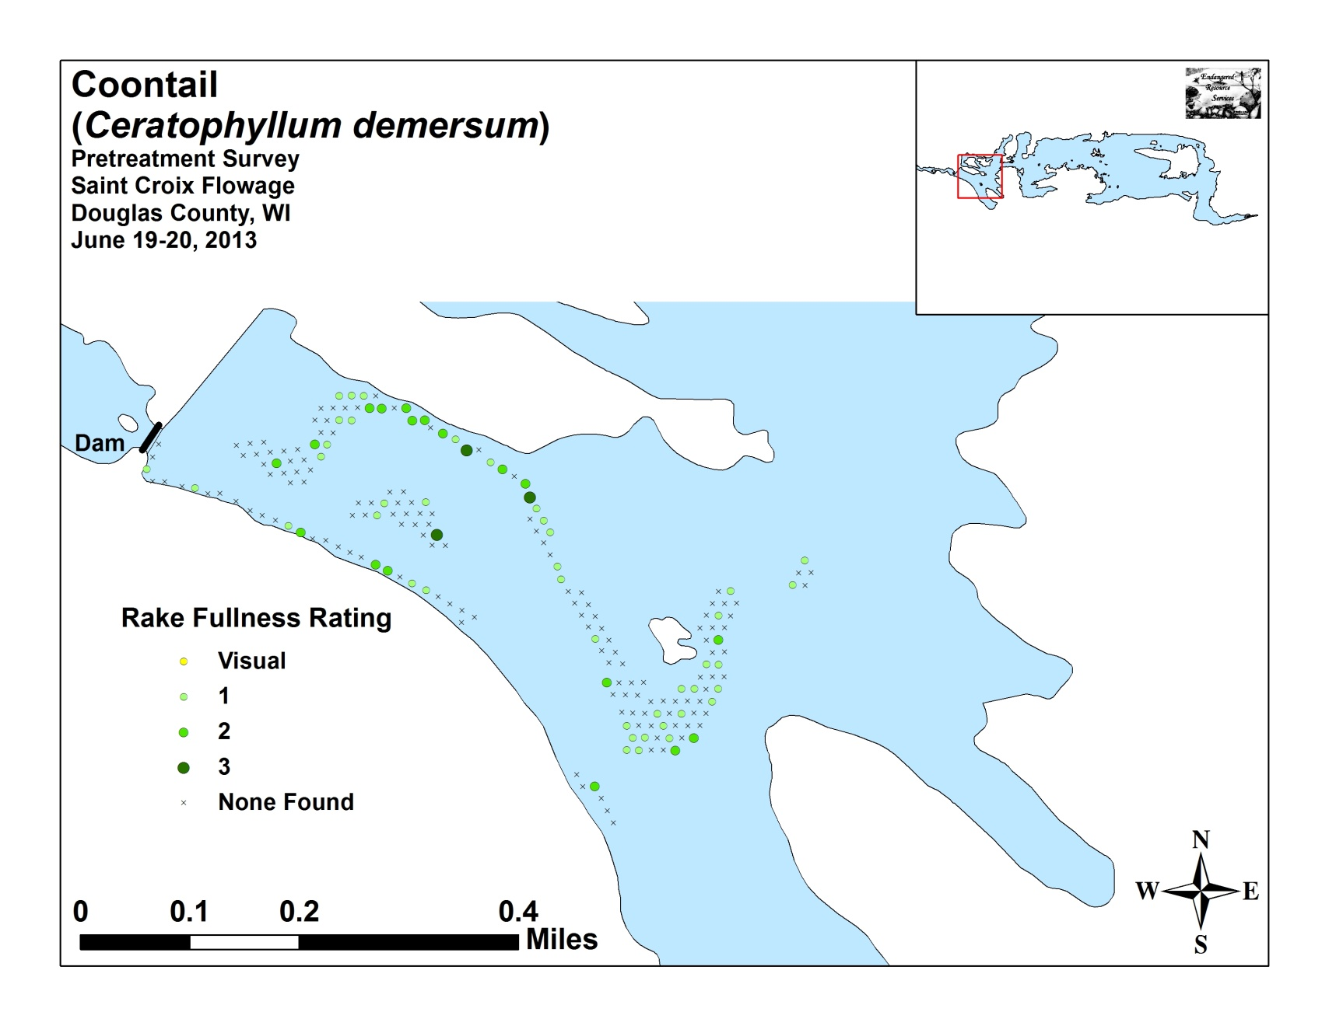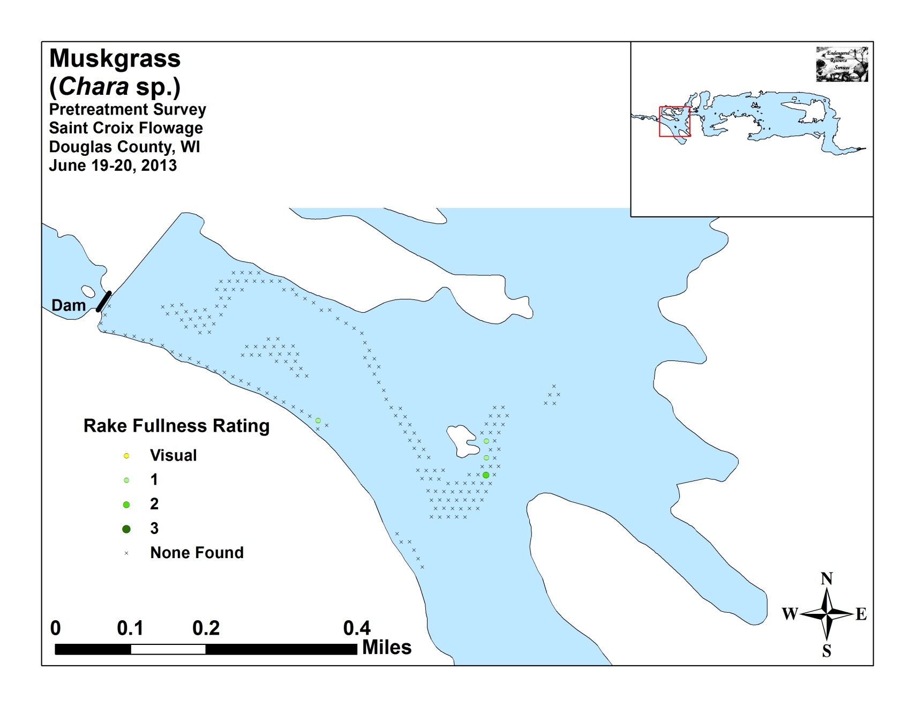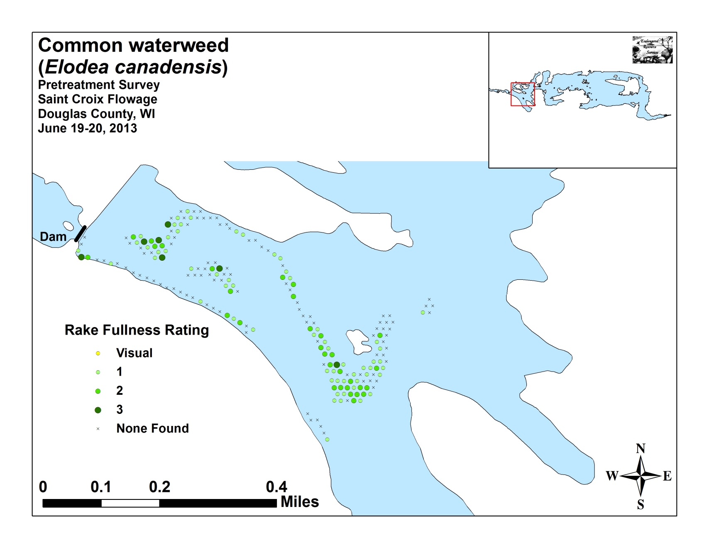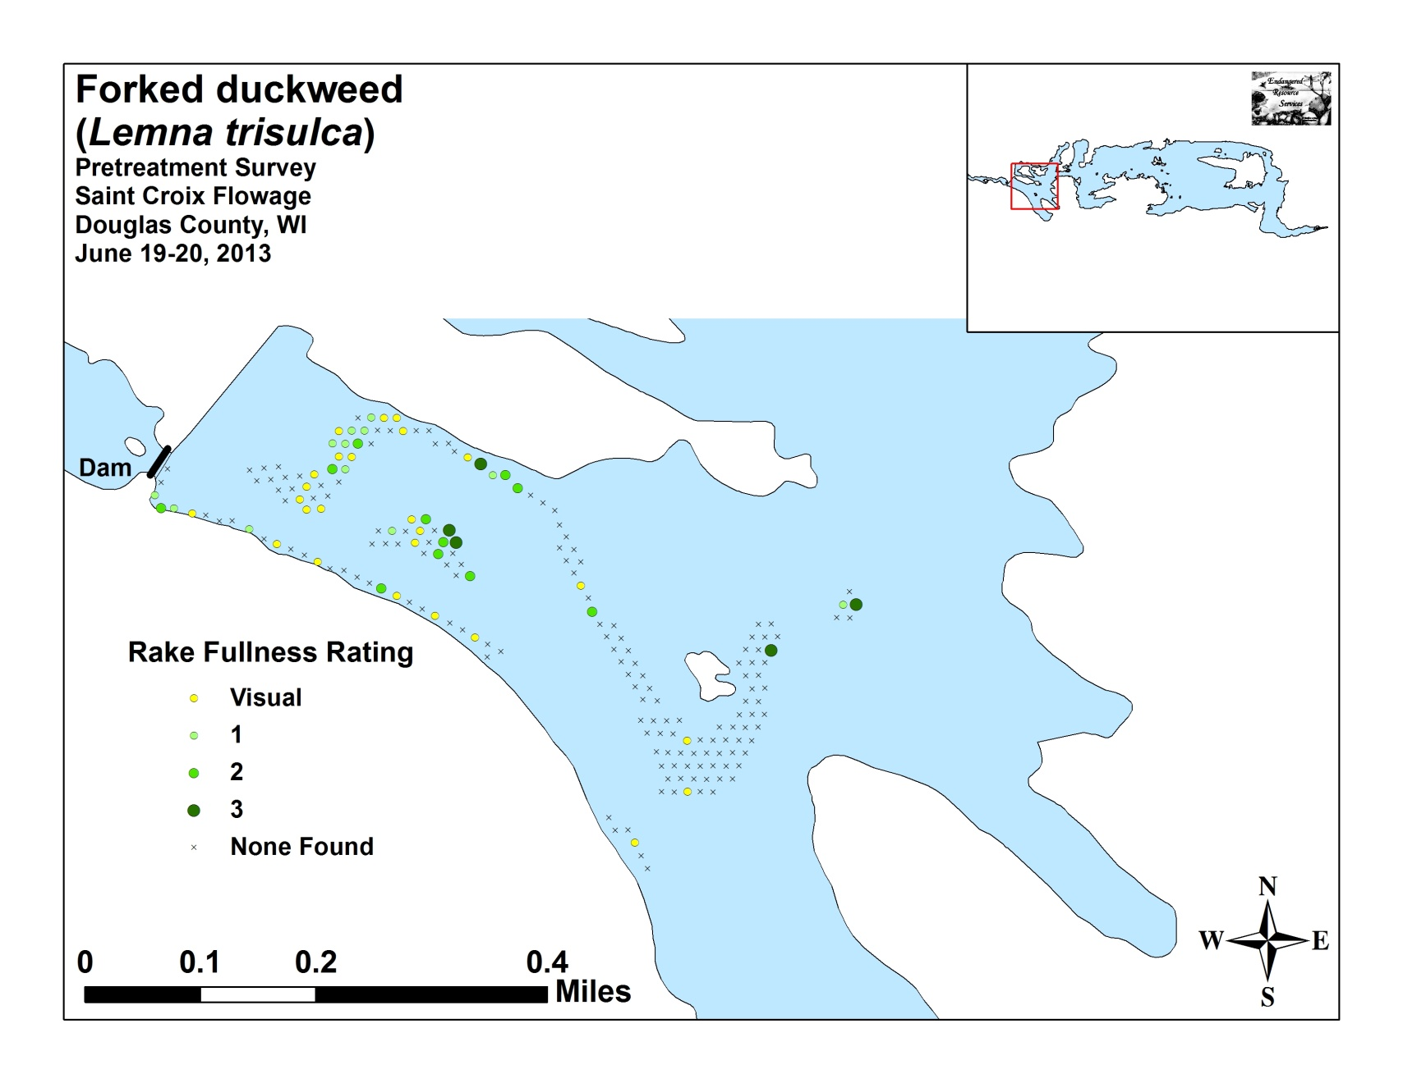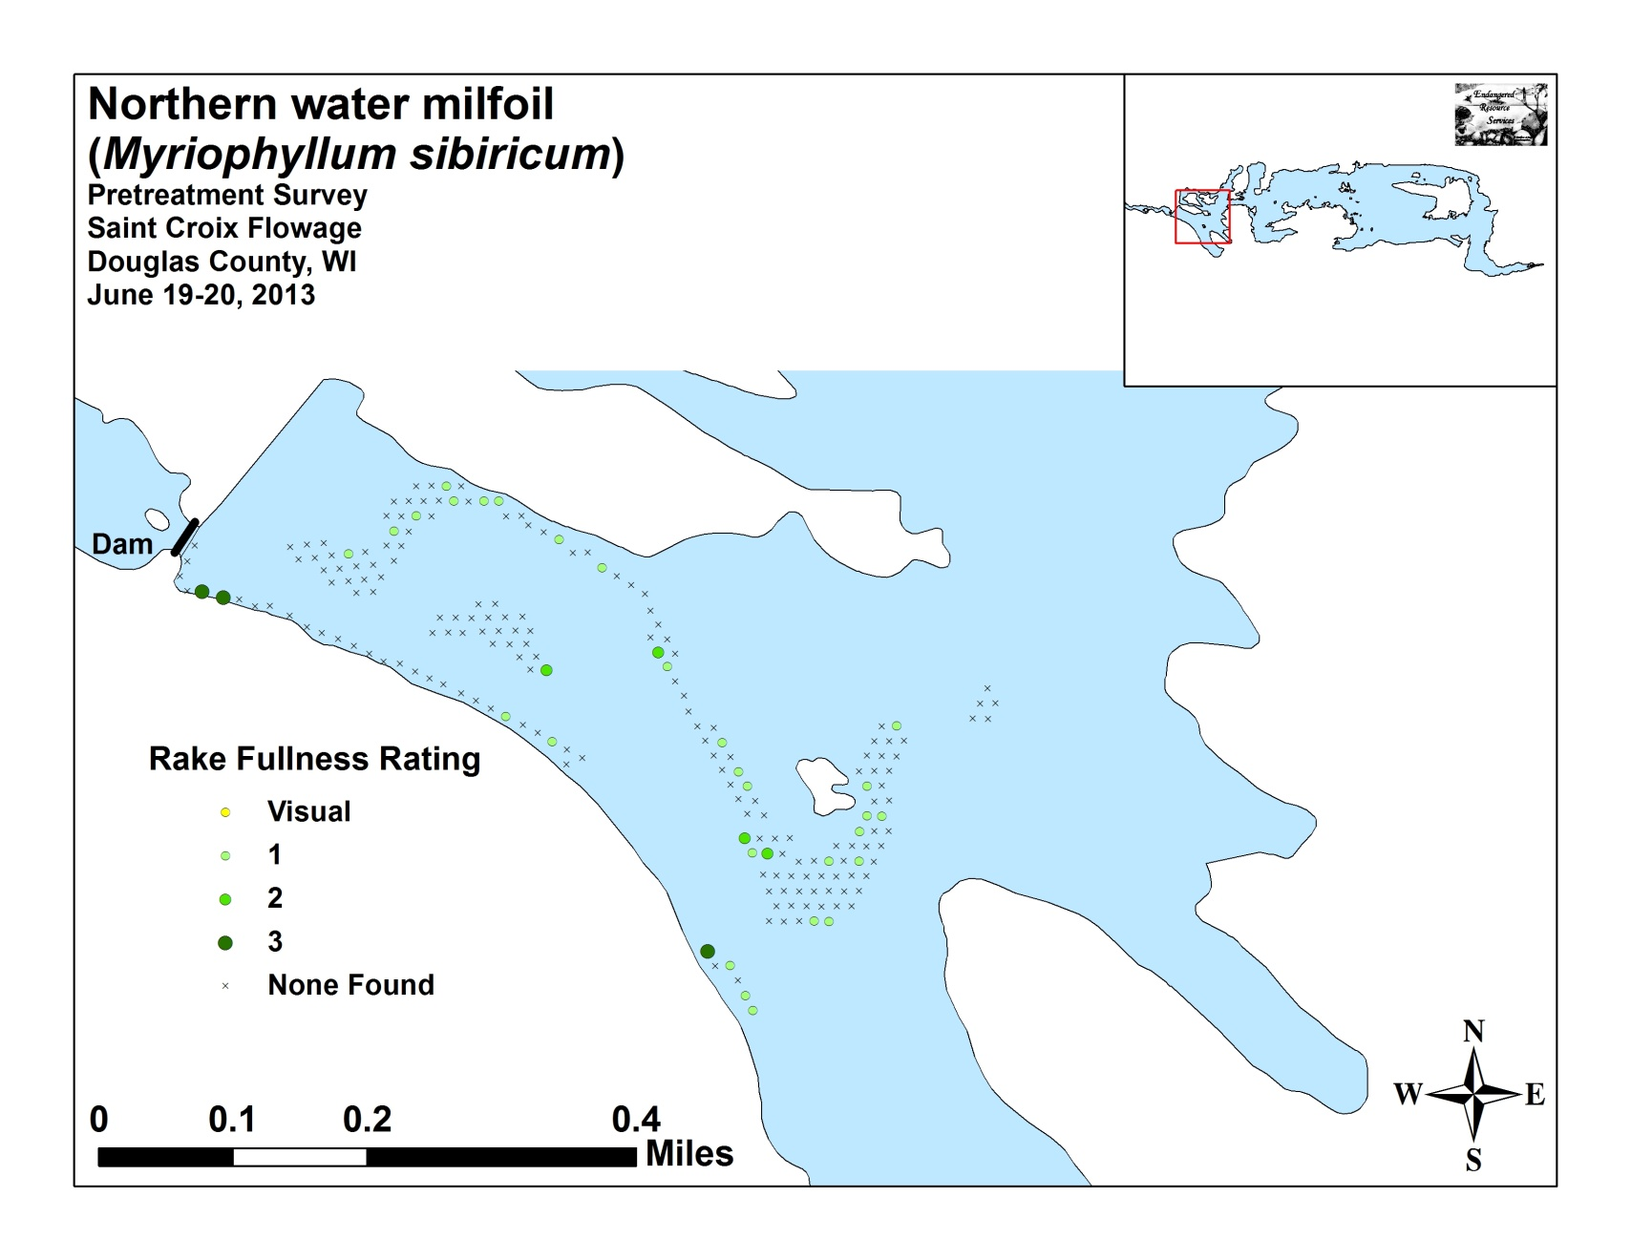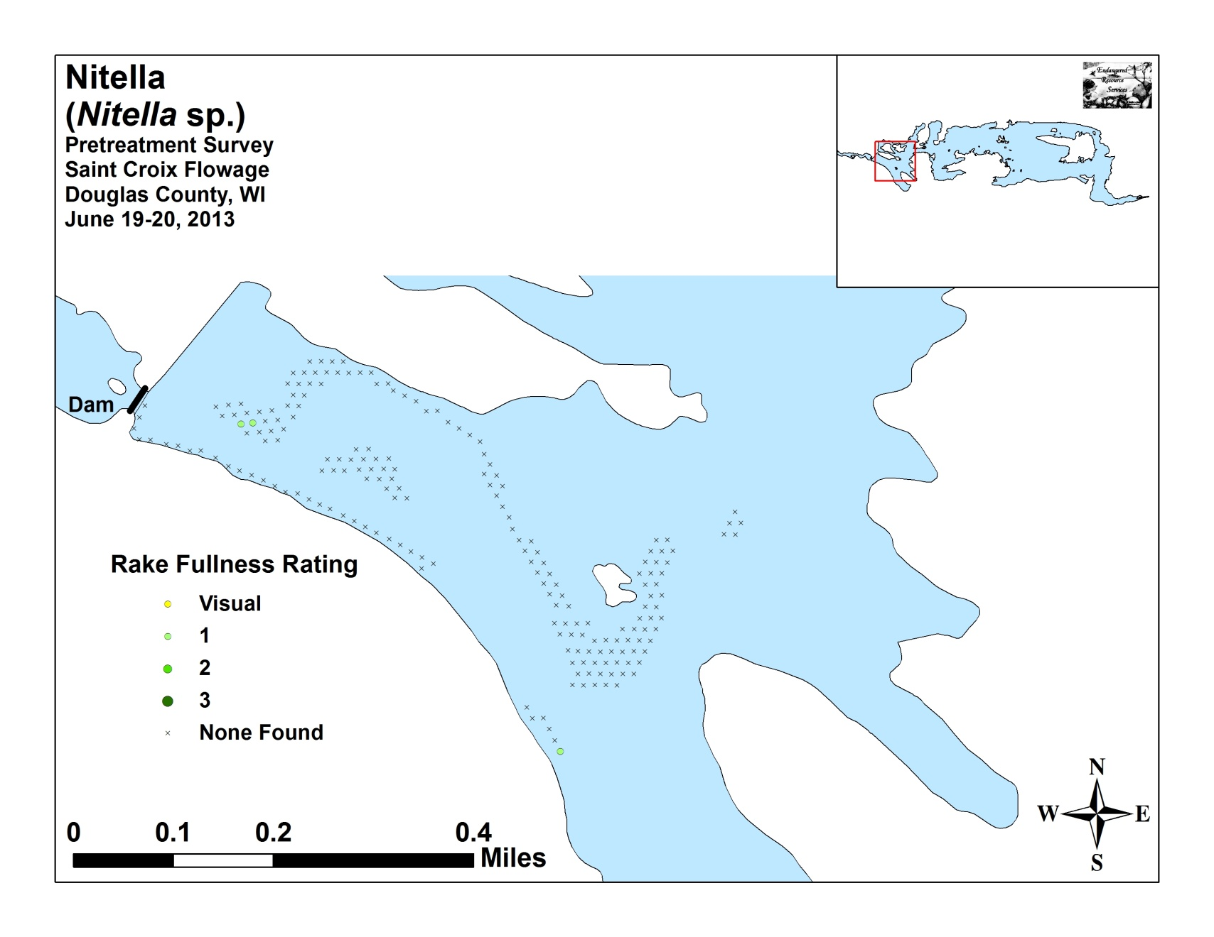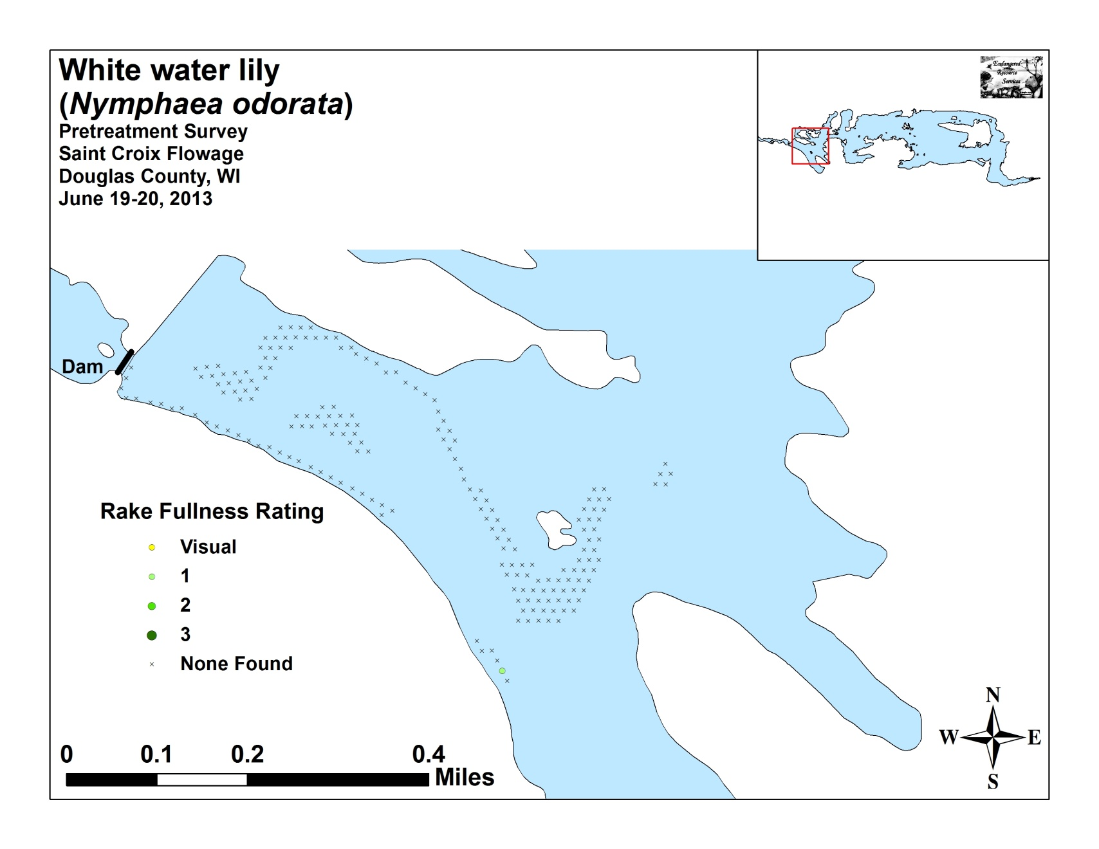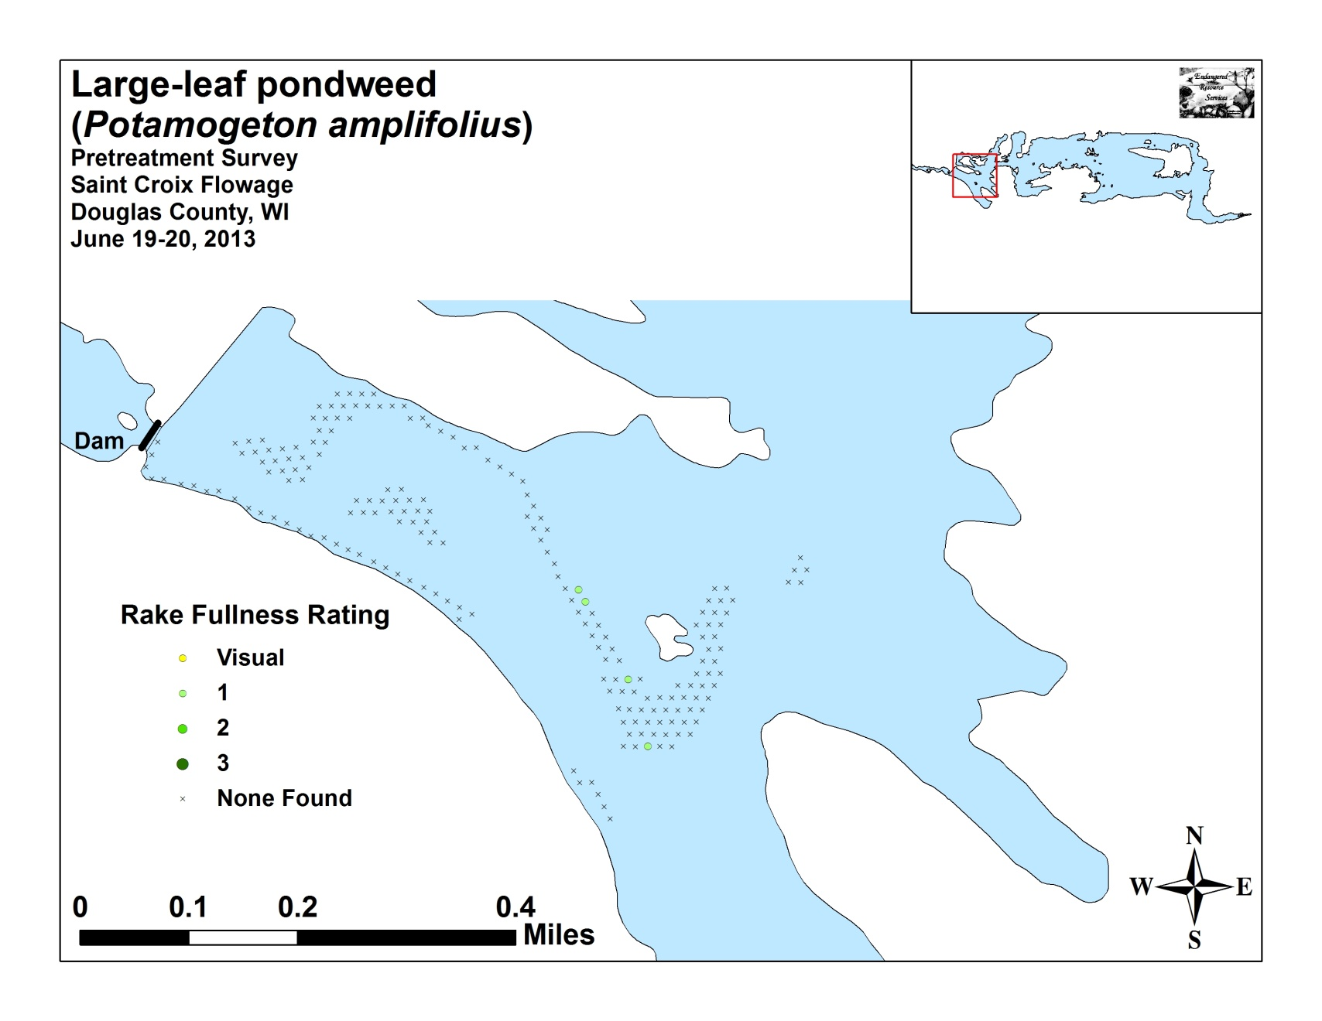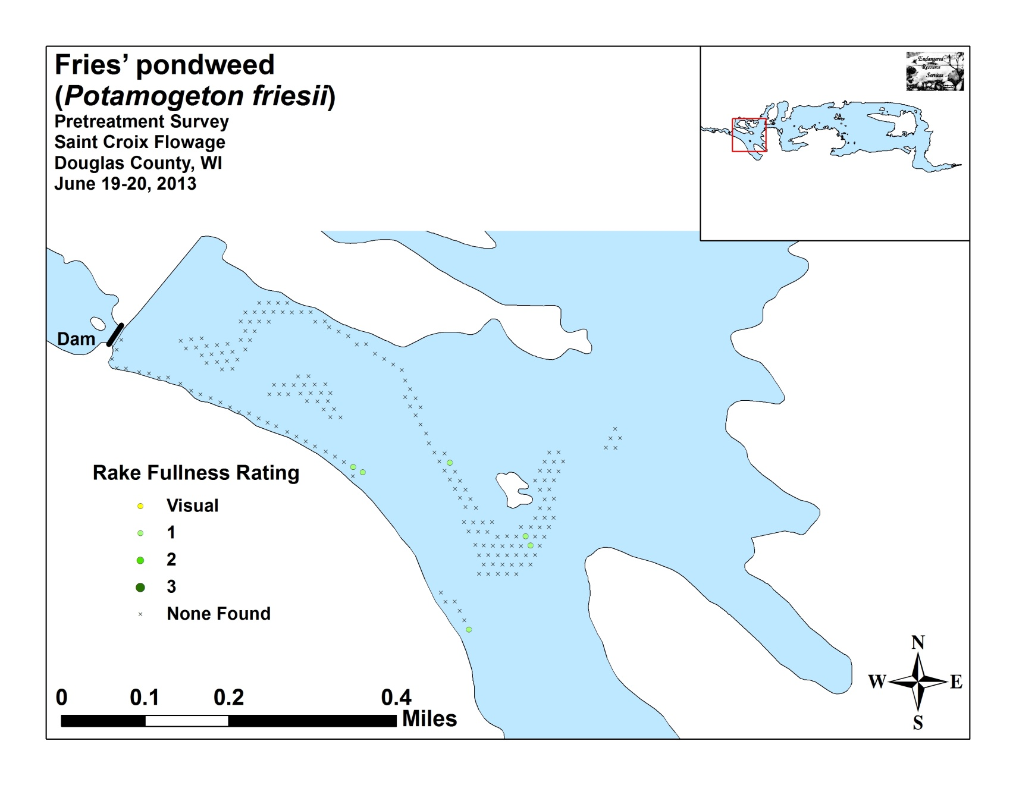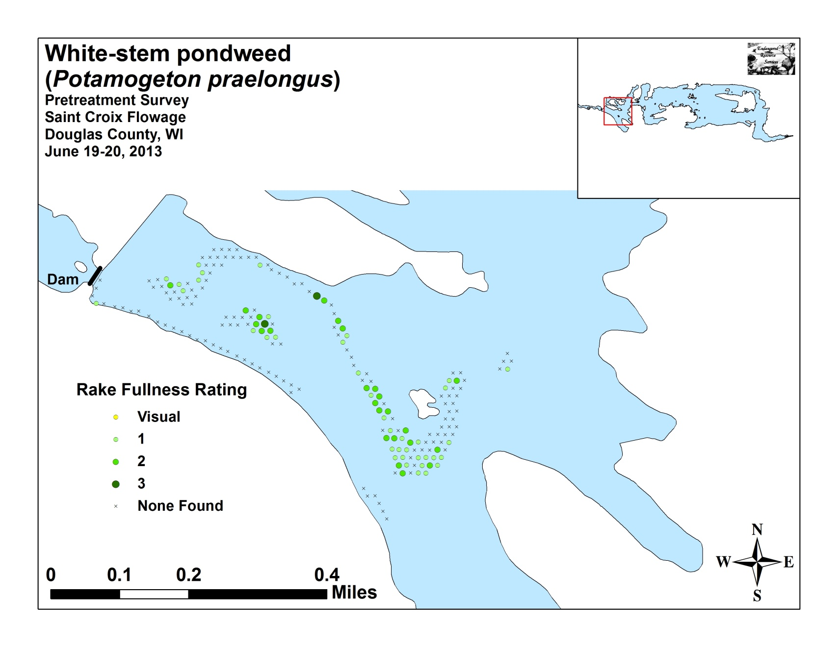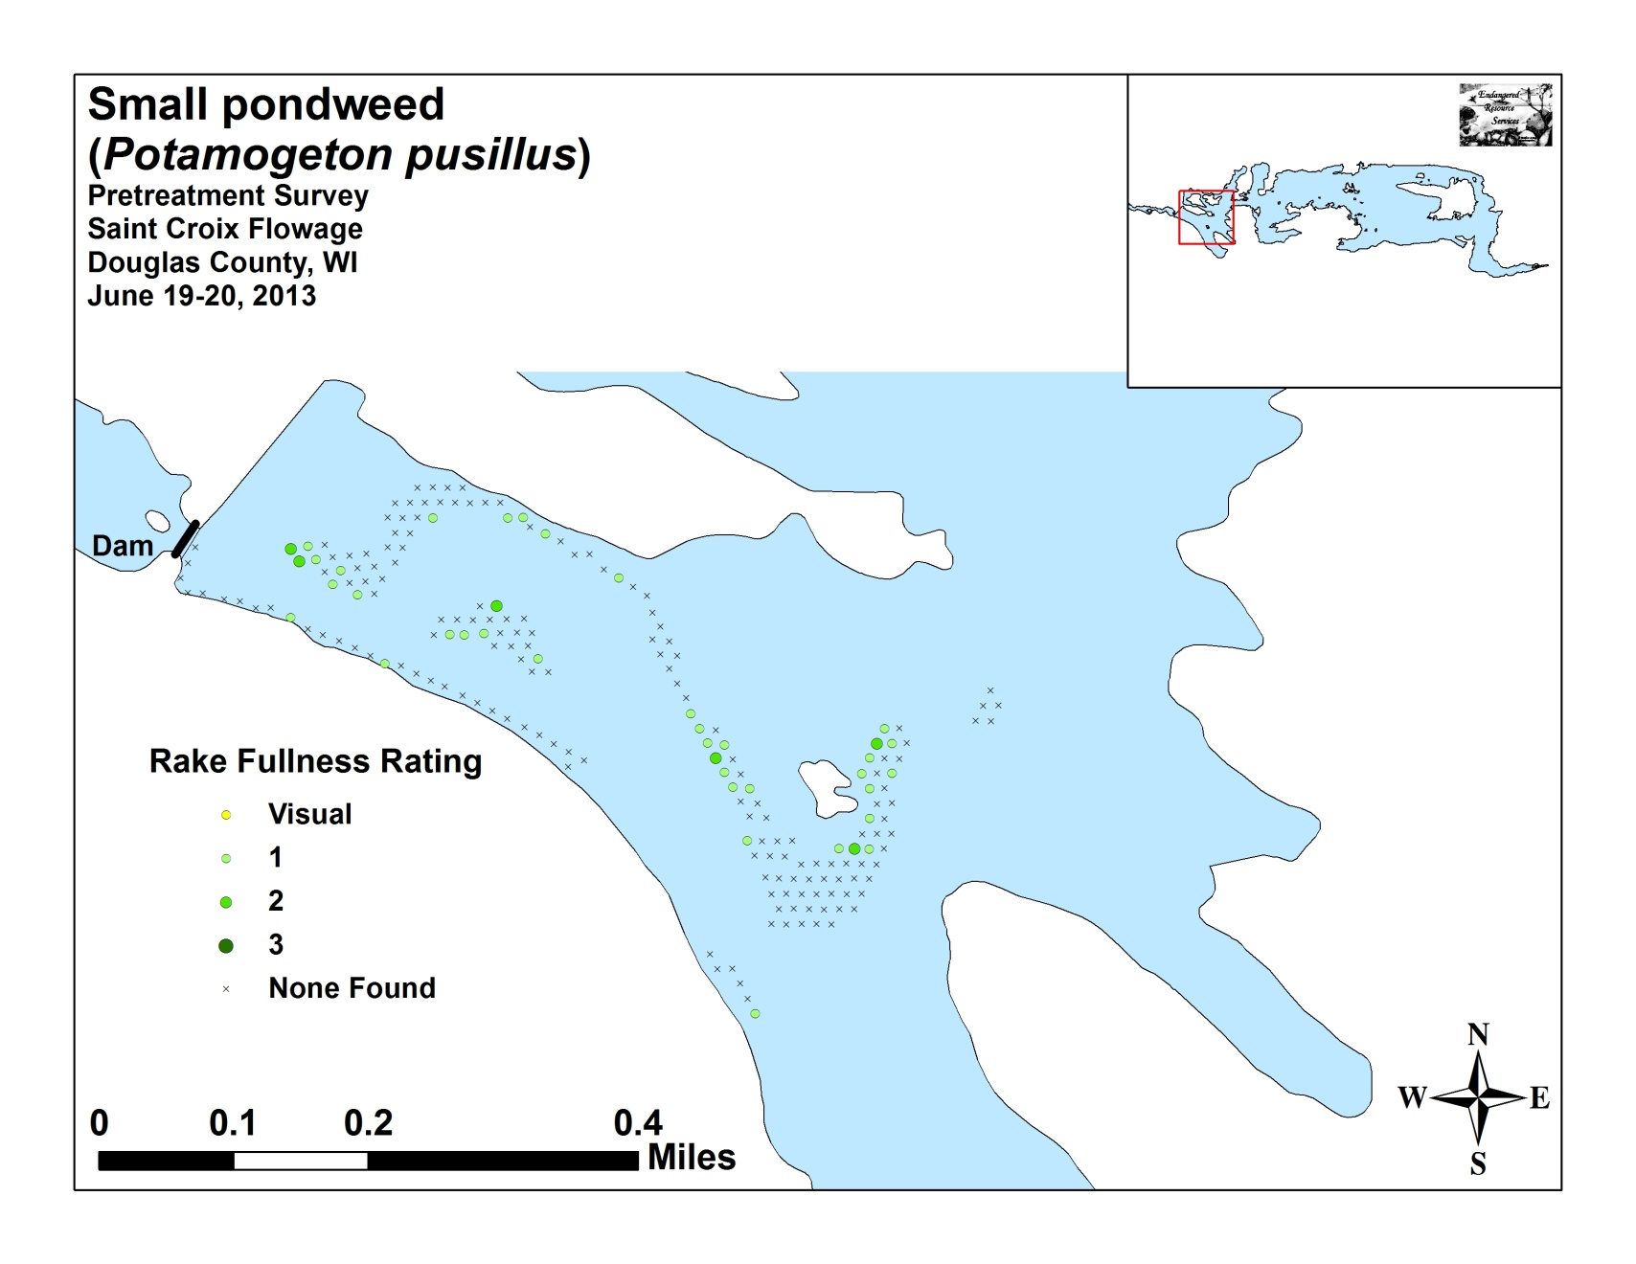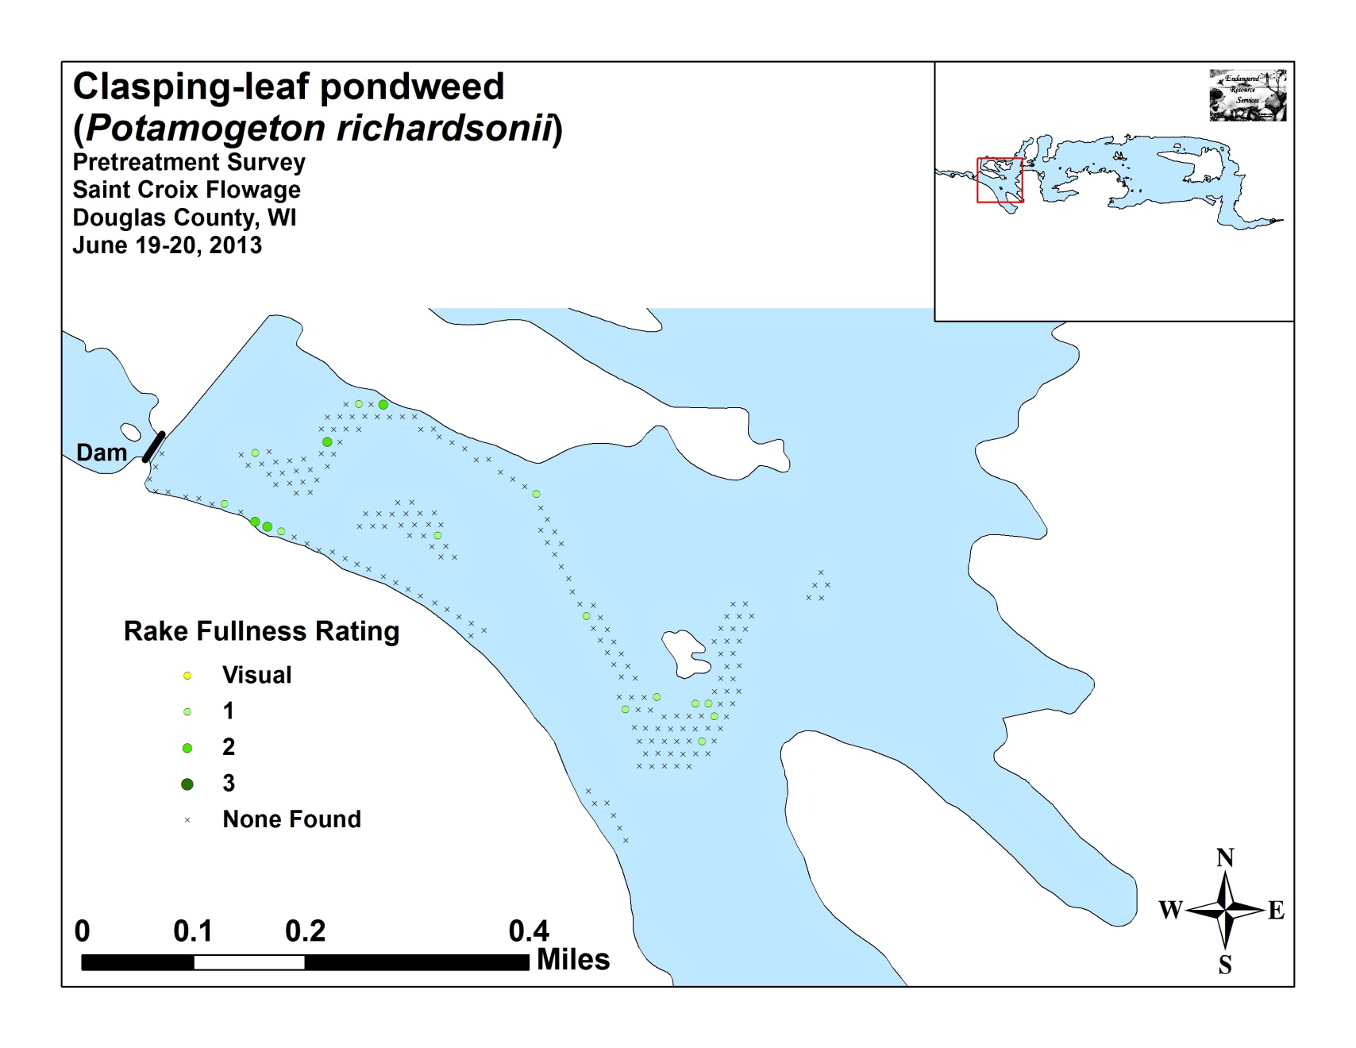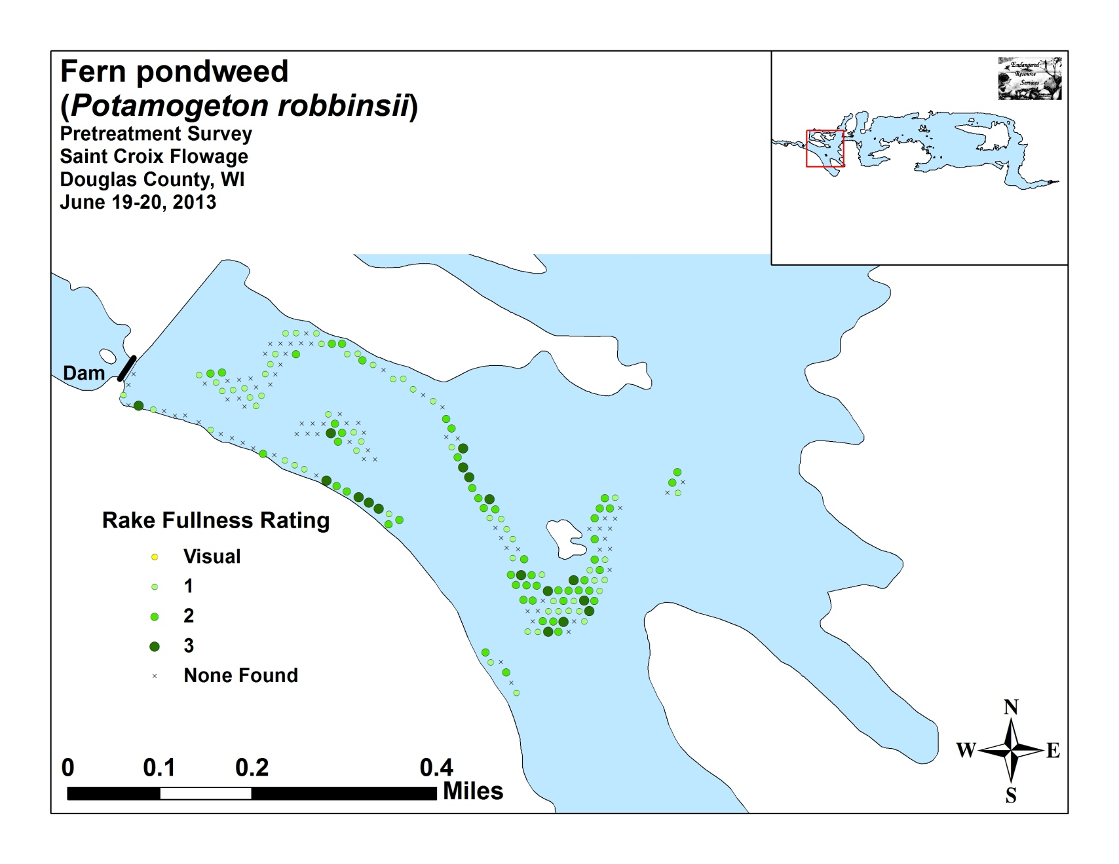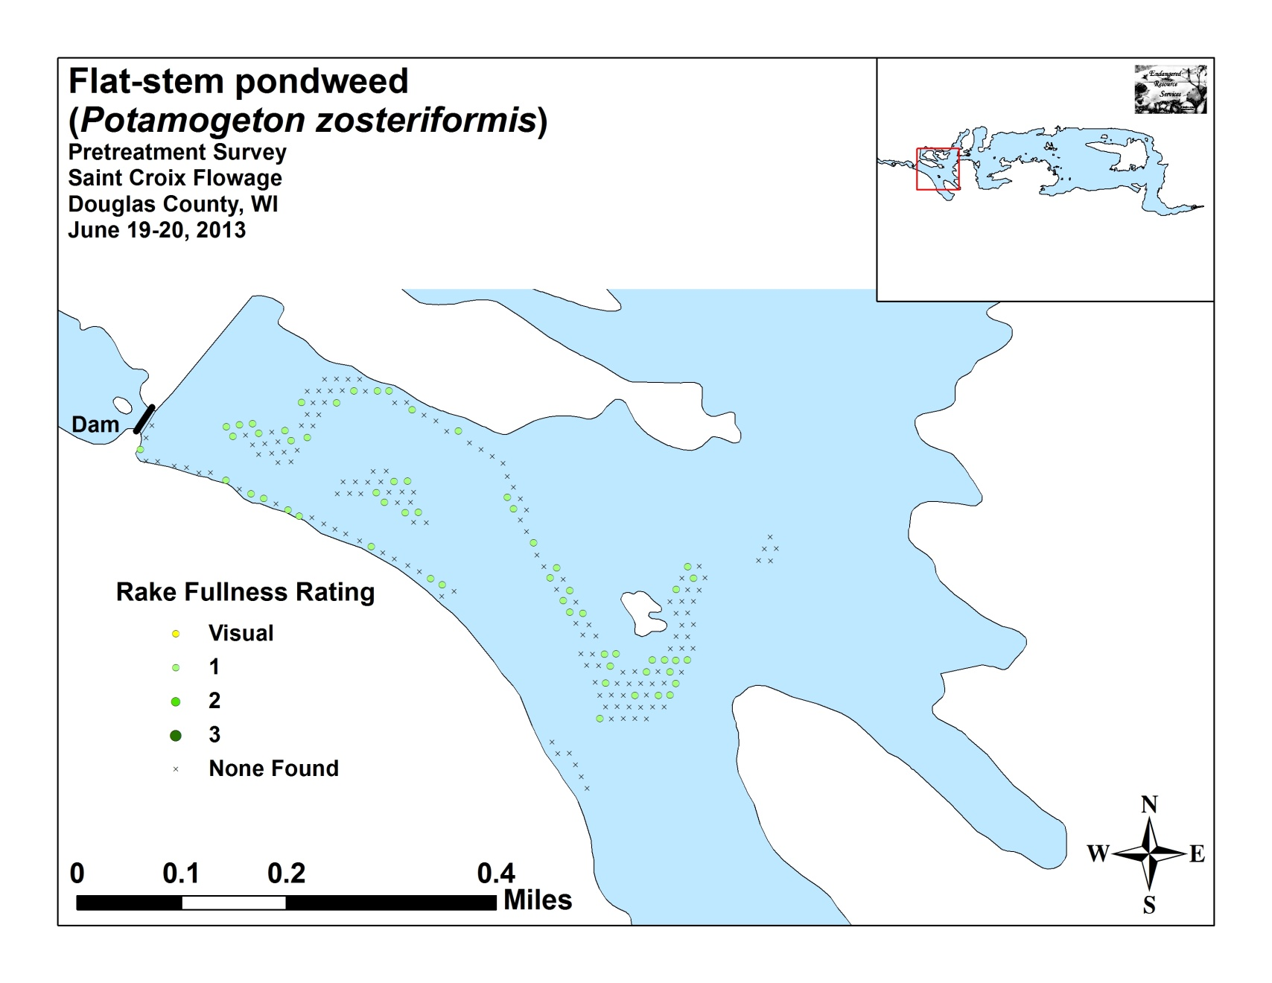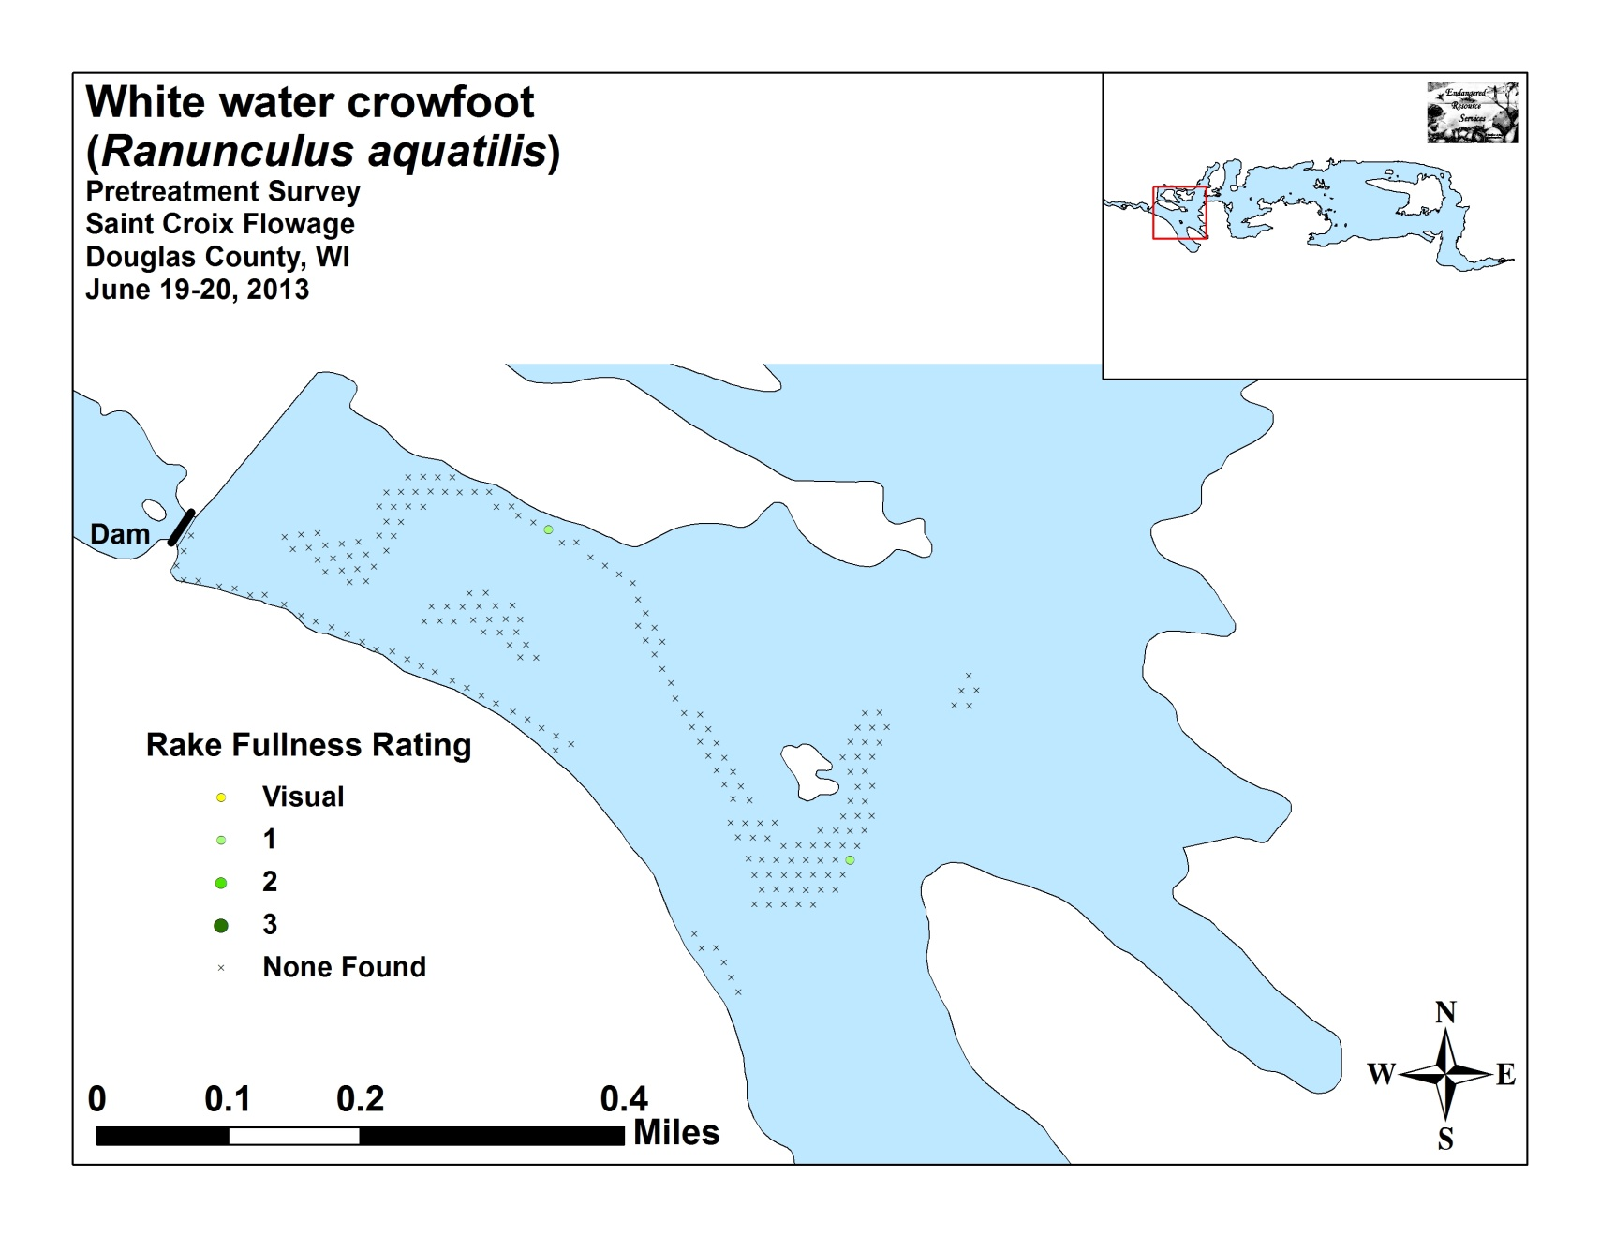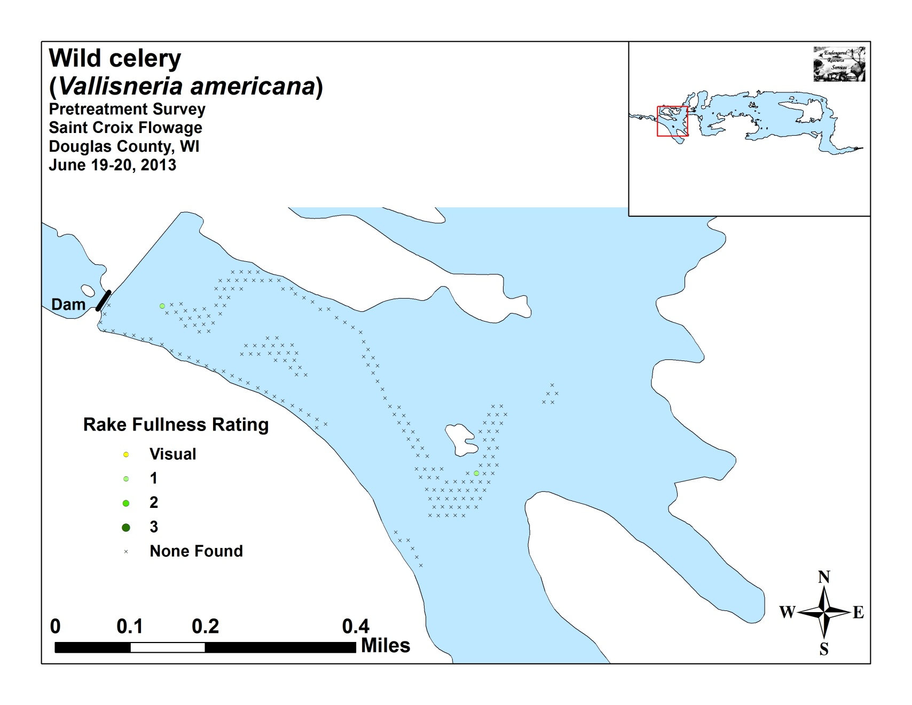

Appendix VII: Posttreatment Native Species Density and Distribution

