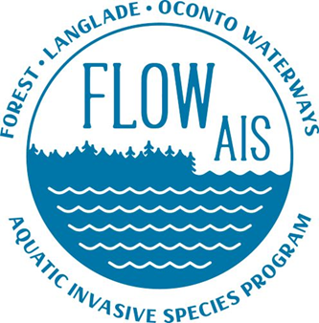

FCAL meeting 5/20/2022

- Snapshot Day is August 20th and is being held as the Lake Lucerne pavilion any lakes that are interested in the program need to let me know by June 3rd. volunteers can still sign up later. The state would like to know the lake locations beforehand.

- Boat Landing Signage Checks have been done at the following lakes.
  - Roberts Lake
  - Bradley
  - Lake Lucerne
  - Arbutus Lake
  - Silver Lake
If anyone on their lake would like to take a picture of their White Stop Aquatic Hitchhikers sign at their landing and email it to me and let me know your lake. I can update the state database then.

- FLOW AIS is continuing to work with the Lake Arbutus Association as they continue their response effort of Eurasian Watermilfoil

- FLOW AIS is in the Very early stages of talking to Roberts Lake and Forest County on what the lake can do about applying for grants moving forward and working to build a dash system.

- Purple Loosestrife is being reared at my house this year for bio control projects in the FLOW area. If you see Purple Loosestrife around your lake or anywhere along the road email me and I can take a look.

- Any lakes that need a Clean Boats Clean Waters training for your upcoming monitor season, email me. The lakes that have a CBCW grant are below

  - Lake Lucerne
  - Lake Metonga
  - Butternut Franklin (has contacted me already)

Any lake interested in applying for a grant for 2023 email me and we can set up a meeting to help you get started.
- Anyone interested in receiving the FLOW AIS newsletter please email me and I will add you to the mailing list. These come out quarterly in conjunction with our Lumberjack meetings. The last newsletter came out in April the next one will be out at the end of July. Newsletters get released in January, April, July and October every year.

- FLOW AIS website https://lumberjackrcd.org/flow-ais-program

