Pipe and North Pipe Lakes: an analysis of hydrologic pathways, soils, land use, precipitation, and water quality trends
Leslie Ludtke, and Joe Magner, Watershed Recovery LLC, and
Jeremy Williamson, Amery WI
Draft December 31st,2021, revised 1-13-22
Key Findings:
- North Pipe Lake had more watershed input than Pipe Lake and requires more buffer/attenuation of pollutant inputs than Pipe Lake. Nearshore groundwater input occurs as Variable Source Area exchange with riparian wetlands and the lake.
- Pipe Lake is uniquely different from North Pipe Lake with a smaller watershed, riparian wetland input and a longer more buffered hydraulic residence time.
- Climate drove the hydrologic pathways and trophic response as shown by both modeling and data collection and trend analysis.
- Soil characteristics point to more micro-overland hydrologic pathways at lake-lot scales vs larger tributary inputs, although stormflow validation will be required.
- Individual lake-lot land use management is likely more important for the future water quality of both lakes given future climate uncertainties.

Introduction:
Pipe and North Pipe Lakes, located in the Town of Johnstown in Northwest Wisconsin, have a tremendous historical data collection ranging back to the early 1990s, most of which was synthesized by residential lake volunteers. Over the past few decades, through the work of the Pipe and North Pipe Lakes Rehabilitation and Protection District, many grants and studies have been awarded and conducted to better understand algal dynamics and now climate change. In 2018, the Pipe and North Pipe Lakes Lake Management Plan for 2018 to 2023 was prepared by the Polk County Land and Water Resources Department and funded by the Wisconsin Department of Natural Resources Lake Planning Grant and Pipe and North Pipe Lakes Protection and Rehabilitation District. The purpose of this study is to document findings from data collected between 2018 and 2021. Covid-19 restrictions hindered planned lab analysis and field data collection in 2020, but through the help of the Lakes District and volunteers, much of the routine data was still collected.
The report is organized to explain the isotope hydrology first, then look at precipitation and field indicators, along with lab data for chlorophyll a and total phosphorus. Certain modules of the Wisconsin Lake Modeling Suite were utilized to compare results from the isotopic monitoring and analysis, modeling results were improved by the isotopic data. Lastly, we present infiltration and penetrometer data along with some recommendations for future action steps.

Data Collection Methods:
Data collection occurred via grab samples into vials and bottles provided by the Water and Environmental Analysis Lab in Stevens Point WI. At the time of sample collection, typically a YSI multiparameter sonde was used to measure temperature, specific conductance, pH, and dissolved oxygen (DO). Vials were given to some residents to collect precipitation for isotope analysis. All vials were sent to the UMN lab where a Picarro L2130i was used to measure δ¹⁸O for oxygen, and δD for deuterium in units of ‰. Samples sent to the Water and Environmental Analysis Lab in Stevens Point WI, were analyzed for nutrients, including Ammonium, NO2 + NO3 as N, TKN, TP, soluble reactive phosphorus, CL, and conductivity. Field flow data gathered was analyzed and used to calibrate and run different lake modeling scenarios. However, tape down measurements and flow calculations did not fit within the modeling scenarios suggesting the specific channels measured did not account for hydrologic lake response. Additionally, HOBO pressure transducer test well data supports did not fit the model. This will be addressed in the recommendations section.
Stable isotopes of hydrogen and oxygen: how does this work?
Isotope data is not presented as a concentration or a % of water that can be directly measured in the field or typical inductive plasm or gas chromatograph mass spectrometry. Instead, we are measuring the ratio of the “heavy” or “enriched” (this is an extra neutron) to the “light” or “depleted” (typically 99.9% of most water) isotopes, the data is expressed as delta (or δ¹⁸O for oxygen, and δD for deuterium) in units of ‰ or per mil, not percent. The values are plotted against each other to express a water identity.
Unless the water was collected near the equator, values tend to be negative. The Black Line (Figure 2) expressed as a slope where y = 8x + 10 is known as the Global Meteoric Water Line (MWL). All precipitation in the world falls somewhere on this line depending on location. Exceptionally light or depleted values are near the north or south poles or high mountain peaks where temperature is cool to cold, whereas heavy or more enriched water with extra neutrons, tends to be found in the warmest places on earth. Temperature drives the presence or absence of neutron enriched precipitation. The MWL is based on differences in temperature over the planet. Near the equator and sea level the warmest temperatures occur giving rise to the most enriched water which can then move as a cloud over land masses. Because Wisconsin is located between the Arctic and Equator, we can observe unique combinations of isotopic water.
The location of a water sample with respect to the MWL tells a story about hydrologic pathway and process. In the Pipe and North Pipe Lake watershed we can define differences in season, winter vs summer and the cloud bank, Arctic air vs Gulf air. These differences occur more at the extremes, and we refer to them as “End Member” vs “mixed” water that reflects varying combinations of light and heavy water.
Another unique water signature can be derived by surface water that evaporates. The heavy hydrogen evaporates slightly faster than the heavy oxygen and creates data which plots to the right of the MWL on a flatter slope pointing to evaporative surface water as a unique fingerprint that guides hydrologic interpretation. This process is known as fractionation.
Source Waters, Storage, Runoff in The Pipe and North Pike Lake Watershed.
Winter snow (depleted values) is stored on top of the soil, in late March or April when the soil thaws snow melts into the soil and recharges groundwater. However, if the temperatures rise quickly, particularly the night temperatures, then the snow will melt and runoff over frozen ground. In 2021, we captured pre- and post-melt water running into both Pipe and North Pipe Lakes. The spring thaw/melt should be considered a lower magnitude, longer duration event; any precipitation intensity is attenuated (or buffered) compared to summer rain because the particle size is soft and small. In northern forests the soil thaw/melt is often the largest flow event of a normal precipitation year. As branches bud-out and leave formation occurs transpiration begins to move water from the soil-water zone through the roots and up the trunk and out the stomata of leaves. Summer rain (enriched with heavy isotopes) is captured by tree canopy, and the upper soil profile with little to no groundwater recharge or overland runoff unless the soil has limited infiltration capacity. Streams can flow in a forested watershed through a rise in the shallow water table in a concave landscape or what is known as “Variable Source Area” (VSA) Figure 1.
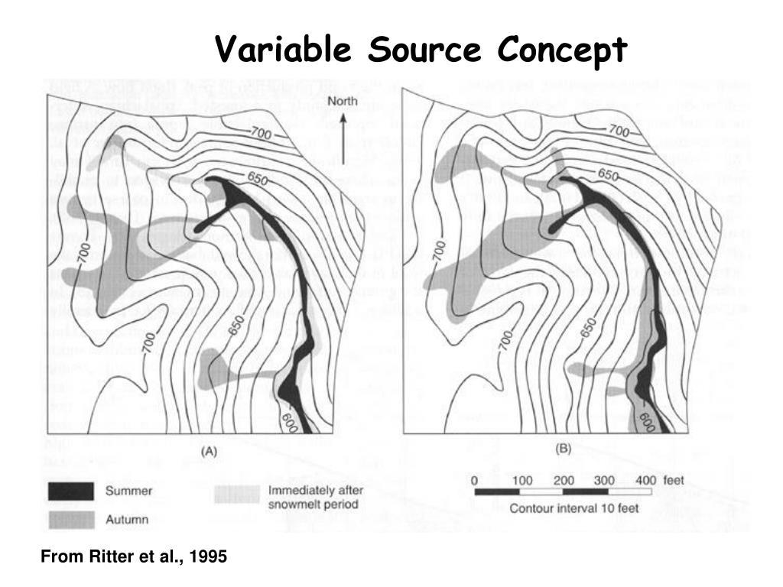
Figure 1. Illustrates VSA concept. A small watershed showing high elevation to low elevation. The dark black area is the surface expression of the water table year-round, and the gray colored areas show the expansion of surface water expression after precipitation input and when evapotranspiration halts.
Intense, short duration summer storm events can produce overland runoff because the delivery rate is faster than water can infiltrate the soil. We measured infiltration and relative bulk density using a dynamic cone penetrometer at several locations and determined that many soil types surrounding the two lakes have a soil texture, structure and bulk density that is more prone to overland runoff because of the most recent glacial activity in Polk County, WI. This will be discussed in more detail later.
Lakes and wetlands store water in the watershed; however, the fingerprint they exert differs based vegetation and hydraulic residence. Lakes store water over a longer period of time and because of the open water column, evaporation is the dominant means of water export followed by outlet flow. Wetlands typically have a shorter hydraulic residence because water is transpired by plants during the growing season, and more commonly spills over a sill at the outlet and flows toward Pipe or North Pipe Lakes.
Isotope Study Results:
Time Series Story:
The data in Figure 2 tell us the steepest isotope slopes occurred in 2019, (5.5 -to- 7) for North Pipe and Pipe Lakes. Further the data points are spread out indicating that new water additions were shifting the lake water isotopic signature with new seasonal inputs - limiting hydraulic residence compared to drier conditions. The Pipe Lake data are more enriched and plot further to the right than North Pipe Lake. This means there is more source water mixing with new incoming water in North Pipe Lake compared to Pipe Lake. Given that 2019 was clearly a wetter precipitation year, both direct precipitation and VSA water exerted considerable influence upon North Pipe Lake. The VSA water from snowmelt and spring rains moved through the soil into North Pipe Lake in a matter of weeks, some water was then retained in small wetlands. Water entering the SedPond had a hydraulic residence time (HRT) of 2-3 weeks in the spring and ~ 90 days during the summer or evapotranspiration period. This to say that measured surface watershed runoff from tributaries into both lakes was a tiny or small part of the overall budget. VSA input is larger than measured surface flow, but this requires more quantification during a normal to wet climatic year (see recommendations).
Pipe Lake showed more of an evaporative dynamic compared to North Pipe Lake given fewer tributary inputs. The watershed surrounding Pipe Lake is exceedingly small and has less influence compared to the watershed feeding North Pipe Lake. These differences are reflected in the 2019 HRT estimates; North Pipe Lake ranged from 1- to 2- years, whereas Pipe Lake ranged from 2- to 4- years. This Pipe Lake dynamic is evident when examining shifts in the intercept for 2019 (-17), to (-36) for 2020 and then back to (-23) in 2021. The intercept shifts in North Pipe Lake are less pronounced; 2019 (-23), to (-28) in 2020 and then back to (-23) in 2021. This tells us that North Pipe Lake is likely buffered by non-measured surface runoff or VSA and concordant groundwater connectivity.
Temperature probing (data in appendix) in 2020 provided some evidence of groundwater along the east side on North Pipe Lake. This was confirmed by differences in the 2021 surface isotope values for North Pipe Lake, where: surface δ¹⁸O/ δD (-5.5/-50) compared to the deep hole or Z-max values observed, [δ¹⁸O/ δD (-7.2/-57)] was observed on July 14th, 2021. These differences did not occur in the surface/deep hole Pipe Lake samples confirming the lack of near shore or at depth groundwater discharge. The deep hole sample collected in North Pipe Lake showed a mixed position between fractionated water and the middle of the VSA cluster of data shown in Figure 3.

Figure 2. Shows the MWL in black dashed line as discussed above, isotope data points collected from the Pipe and North Pipe Lakes, and trendlines that sort differences between years and lakes.
In 2020, isotope slopes flatten out from 2019 (2 -to- 4) with intercepts at (-36) for Pipe and (-28) for North Pipe. What is interesting is the data points begin to cluster more tightly together in North Pipe Lake compared to 2019 indicating that new inputs were minor and not strong enough to see similar dynamic seasonal movement that occurred in 2019. Year 2020 did not begin as a drought year, but it was not as wet as 2019, the summer was drier and then slid into a more clearly visible drought by 2021. This was particularly true for North Pipe Lake where the data clustered tightly around the δ¹⁸O/ δD (-7.5/-51). This tells us that all runoff into North Pipe Lake shut down after the soil thaw/melt. But going into 2021, VSA runoff and direct precipitation coupled with higher evaporation shifted the data to the upper right in Figure 3. This makes sense because during much of the summer of 2021 there was a drought, and when it rained, the water was very enriched providing a unique isotopic addition reflected in the lake water mix.

Figure 3. Similar to Figure 1 - but includes watershed isotope data points from varying North Pipe Lake tributaries and the SedPond.
The HRT calculations reflect this shift, with little to no input, the North Pipe Lake estimates jumped to 7-to 12-years which the model produces when the lake isotope values cluster with time, these estimates drop back down again when new water is added to the lake. The Pipe Lake HRT ranged from 8.8- to 9-years, note this range is tighter than North Pipe Lake because of the larger lake size and buffering capacity of Pipe Lake.
Because 2021 was a drought year, the data plotted off the MWL on an evaporative line that was similar for both lakes. Nevertheless, in Pipe Lake the values barely moved from 2020 into 2021 and clustered tightly together. This suggests neither direct precipitation nor runoff was significant enough to change the Pipe Lake fingerprint. Based on empirical observation, Pipe Lake levels dropped in 2021 about a half-meter which was reflective of large evaporative losses.
In contrast to Pipe Lake data, North Pipe Lake (Figure 3) did cluster but at a more depleted location on Figure 3 - reflective of the background VSA water but not the deeper well groundwater which is more influenced by cold water recharge. The circled area in Figure 3 showed how VSA water plotted on the MWL, whereas the SedPond data plotted off the MWL to the right indicating fractionation except during the March 2020 sampling. The SedPond data over time shifted from very enriched in August 2019 to very depleted in March 2020, and then back to middle values in May 2021. This tells us that water was flushed through the SedPond in days. Rain did occur later in 2021 and when accounting for the later rainfall input the overall average HRT for North Pipe Lake appeared to be ~ 2 years and about 4.5 years for Pipe Lake.
A review of historic data and current conditions for Precipitation, Secchi, Chlorophyll a, Total Phosphorus, and Dissolved Oxygen
Lake Level and Precipitation Monitoring Since 2018
In 2015 and 2016, volunteers were trained to monitor lake level and precipitation on North Pipe and Pipe Lakes. While precipitation has continuously been monitored, lake level has not since 2016. At the time of writing the 2018 management plan, Pipe and North Pipe Lakes were in an unusual moist period. From 2014 until part way into 2020, the Palmer Drought Severity Index for northwest Wisconsin was above 0, meaning there was above average moisture. This is the longest period of time above normal moisture since the beginning of the index record, as seen in the chart below, which was created by the Wisconsin State Climatology Office. While 2019 was the wettest year within the past two decades, 2020 was a very dry year that moved into a moderate drought in 2021. With the abrupt change from wet to dry, it could be beneficial to complete another lake level and precipitation comparative study in the years remaining on the 2018 management plan.
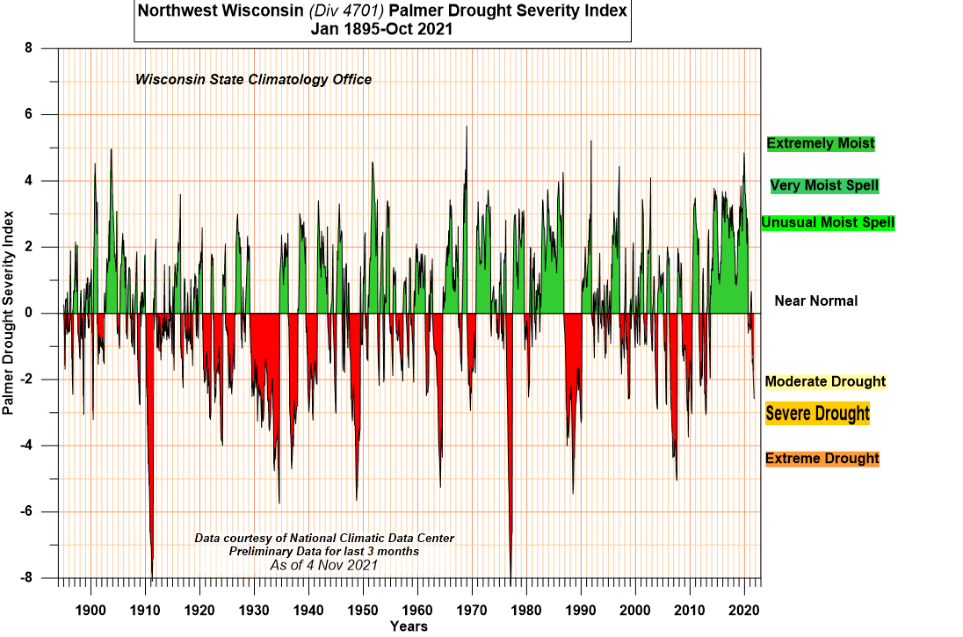
Figure 4. Wisconsin Palmer Drought Severity Index.
While monitoring seasonal precipitation locally is important for understanding many water quality parameters, it is also noteworthy to look at annual precipitation values for the region surrounding the lakes as well. Especially in years where monitoring is more minimal, by looking at trends associated with annual and seasonal monitoring, we can get a better understanding of what went on during that missed time. In the graph below, precipitation values are shown for monitored seasonal precipitation levels from volunteers in warmer months (between June and September) as well as annual precipitation values from the Cumberland weather station, which is located about 10 miles east of Pipe Lake. According to the graph, the lakes recorded the lowest seasonal precipitation in 2020 in the last two decades and the highest in 2010. The area around the lakes recorded the lowest annual precipitation in 2021 within the past two decades and the highest in 2019. While local seasonal summer precipitation saw an increase in 2018, annual precipitation saw a large increase in 2019. The reason for the difference in 2019 is because there was a large amount of precipitation recorded in months outside of June through September. We can possibly assume that from the graph and relationships between the two precipitation datasets that in 2012 and 2013, there was an increase in seasonal summer precipitation, even though there was no monitored data recorded.

Figure 5. A plot of the region weather station in Cumberland and local precipitation measurements.
Secchi Depth
Secchi depth is a measure of how far light is able to penetrate through water. Algae and suspended solids are just a few of the things that can alter the light penetration depth. Secchi depth is determined using a black and white circular piece of metal called a secchi disk, attached to a rope that is lowered into the water. The depth at which you can just barely see the secchi disk is called the secchi depth.
As mentioned in the 2018 management plan, Pipe Lake secchi depth is always significantly larger than North Pipe Lake. This is because North Pipe waters are stained with tannic acid which gives the water a brownish color that is naturally darker than clear water. The largest summer index period average secchi depth, from June through August, for Pipe Lake in the past decade was recorded in 2012 at 18.5 feet, while the lowest was recorded in 2019 at 10.9 feet. On August 18, 2012, the last secchi depth larger than 20 feet was recorded for Pipe Lake. Before then, between 1999 and 2012, there were over 22 secchi depths with values over 20 feet. By looking at the trendlines you will notice that Pipe Lake secchi depth has been steadily decreasing for the last 22 years, and at a faster rate than North Pipe Lake.
The largest summer index period average secchi depth for North Pipe Lake from the past decade was recorded in 2013 at 9.1 feet while the lowest was recorded in 2014 at 3.1 feet. The lowest ever recorded secchi depth was on August 7, 2014, at 2.0 feet while the highest recorded was 14.3 feet on May 14, 2007. Following the 2019 wet year, the drier years of 2020 and 2021 saw secchi depth values decrease in North Pipe Lake and increase in Pipe Lake.

Figure 6. A plot of average Secchi depths, including trendlines for both Pipe and North Pipe Lakes.
Chlorophyll a
Chlorophyll a is a green pigment found in plants that plays a large role in photosynthesis. Chlorophyll a is frequently used to measure water quality and can also be used to assess trophic status of lakes. Mentioned in the 2018 management plan, water clarity is often impacted considerably when chlorophyll a concentrations are higher than 30 µg/l but generally clear when concentrations are less than 15 µg/l.
From 2015 to 2021, chlorophyll a concentrations in Pipe Lake did not go above 10 µg/l for the average between the months of June and September. From the first sample analyzed for chlorophyll a, taken in 1994, the summer month average has never been above 10 µg/l. The highest chlorophyll a concentration recorded for Pipe Lake is 11.3, taken in June of 2019. It’s consistent water clarity helps keep Pipe Lake listed as an Outstanding Resource Water.
North Pipe Lake has seen an increase in chlorophyll a concentration over the past 20 years. June of 2021 saw the highest chlorophyll a concentration recorded at 68 ug/l with the second highest concentration of 62.5 ug/l recorded in July 2003. Chlorophyll a concentrations stayed below 15 µg/l in summers of 2016 and 2019. Average summer concentrations between 15 and 30 µg/l were recorded in 2015, 2017, and 2018. In 2020 and 2021, the chlorophyll levels were higher than 30 µg/l, suggesting poorer water clarity compared to the past years. If you compare secchi depth in the section above, note secchi depth was very low in 2020 and 2021.
Increasing trends in chlorophyll a concentrations suggest that both lakes are becoming more eutrophic. North Pipe Lake shows less buffering compared to Pipe Lake.

Figure 7. A plot of Chlorophyll a data, including trendlines for Pipe and North Pipe Lakes.

Figure 8. A plot of Chlorophyll a data between 2000 and 2021 for Pipe and North Pipe Lakes.
Total Phosphorus
Total phosphorus is a measure of both phosphorus the element and orthophosphate, which is the form of phosphorus that is readily taken up by aquatic organisms including algae. Phosphorus is an essential element required for plant growth and is commonly used in fertilizer for agricultural fields. When a lake gets an overabundance of phosphorus, biological response can increase eutrophication of the lake. Healthy waters in this region can naturally have total phosphorus concentrations of up to 20 µg/l without significant algae blooms.
Between 2015 and 2021 for the months of May to September, the concentrations of total phosphorus at the surface of the Z-max (the deepest hole in Pipe Lake) was below 20 µg/l. While 2020 saw the start of the drought, it still had the highest total phosphorus concentrations out of any sampling year going back until 2000 for Pipe Lake.
North Pipe Lake differs greatly from Pipe Lake regarding surface total phosphorus. Every year between 2015 and 2021 concentrations were higher than 20 µg/l. In 2020 and 2021 the highest concentrations of total phosphorus were observed: 38 µg/l and 36.3 µg/l, respectively.
Total phosphorus concentrations for the Z-max depth for both Pipe and North Pipe and Pipe were higher than lake surface concentrations. Between the months of May and September in 2015 to 2021, the total phosphorus concentrations for Pipe Lake ranged between 22 and 46 µg/l. The summer of 2017 and 2018 saw the highest concentrations of total phosphorus for the Z-max (near bottom of the deep hole).
For North Pipe Lake, between the months of May and September and years 2015 to 2021, the total phosphorus concentrations measured at the bottom of the lake were much higher than Pipe Lake. The values ranged from 103.5 µg/l in 2018 to 242.3 µg/l in 2019. From the graph shown below, it appears the internal loading of total phosphorus for North Pipe Lake is more variable than for Pipe Lake.

Figure 9. A plot of surface and bottom TP data for both lakes.
Dissolved Oxygen
Dissolved oxygen (DO) is a measure of how much oxygen is in a waterbody. Oxygen is required by aquatic organisms and is created through photosynthesis by plants. Because photosynthesis needs sunlight in order for the reaction to occur, deeper parts of lakes are less reactive. Dissolved oxygen profiles provide an indication of lake stratification. Dissolved oxygen profiles measurements have been recorded from the lakes since 2002. As the 2018 management plan explains in detail, there are three distinct zones of lake stratified occurring during summer months. The epilimnion is the layer at the surface which generally has warmer water. The hypolimnion is the layer at the bottom of a lake, which is cooler and less oxygenated. And finally, the thermocline is the middle layer where the lake water transitions from the epilimnion to hypolimnion.
In 2021, North Pipe Lake had a dissolved oxygen concentration of 9.93 mg/L at the surface in July, which decreased down to 7.2 mg/L by the end of October. Pipe lake had a dissolved oxygen concentration of 8.48 mg/L at the surface in July, which then only decreased a small amount to 8.37 mg/L by the end of October. According to the first graph below, North Pipe Lake had a larger amount of oxygen at the surface than Pipe Lake between July and August but then less in September and October. Dissolved oxygen concentrations at the surface are more variable in North Pipe Lake compared to Pipe Lake. For both lakes, the thermoclines visibly lowered in depth and smoothened out over the summer months.
By looking at one month at a time, you can better compare oxygen profiles over the course of different years for each lake. In the month of August for Pipe Lake, 2021 recorded the highest average oxygen level at the surface between 2017 and 2021 while 2019 recorded the lowest. Likewise for North Pipe Lake in the month of August 2021 also had the highest average oxygen level at the surface, while the lowest was in 2020.
The thermocline is at a shorter depth from surface for North Pipe Lake than Pipe Lake because the lake depth for North Pipe Lake is smaller.
The thermocline data:

Figure 10. A plot of DO data collected in Pipe and North Pipe Lakes during the summer of 2021 and several years for each separate lake. Note the contrast between lakes and years compared to the 2021 data.
Infiltration and soil compaction measurements along Pipe and North Pipe Lake shorelands
Nutrient loading into North Pipe and Pipe Lakes has been a concern of the lake residents for several years, prompting several past studies and lake management plans. In 2014, North Pipe Lake was listed as an impaired water for recreation due to an unknown pollutant causing excess algae growth, while Pipe Lake was listed for fish consumption. In the 2009 5-Year Lake Protection Action Plan, for Pipe and North Pipe Lakes, the authors indicated that the data gathered prior suggests that phosphorus was most likely the regulating factor for water clarity for the lakes. The authors also found that Pipe Lake may be more at-risk to phosphorus runoff sensitivity then North Pipe Lake. The reason for this is because the ratio of watershed land to lake area for Pipe Lake is 7 to 1, while the ratio for North Pipe Lake is 17 to 1.
Good soil infiltration is one of the primary ways to reduce nutrient runoff into water bodies. Some of the most effective ways to increase soil infiltration rates are to improve surface ground cover and the amount of continuous plant roots that extend deeper than a few centimeters. Recommendations to improve surrounding shoreland and implement residential best management practices for water infiltration and diversion were part of the 2009 planned management actions. According to the 2018, 5-Year Pipe and North Pipe Lakes Management Plan, several best management practices (BMPs) were suggested to lake residents. Many BMPs were installed, including native planting, rock infiltration, and rain gardens. Numerous surveys conducted with residents around the lakes indicated that more residents were interested in learning about monitoring invasive species and water quality than installing BMPs. This study has sought to gather data to help educate landowners about BMPs applied on their own shoreland may help maintain and possibly improve the lake water clarity in wet runoff years.
Soil infiltration rates differ depending on land use. Undisturbed land such as wetlands and forests are often associated with higher infiltration rates than disturbed land, which include lawns and tilled agricultural fields. Designed vegetation cover can promote more rainfall infiltration, because deeper and more connected roots create macropores that allow for more infiltration to occur than shallow rooted plants. According to the 2018 management plan, 68% of land use in the North Pipe Lake watershed was forest, while 41% was mapped as forest in the Pipe Lake Watershed. Forested land use was the largest land use for both watersheds providing good coverage to limit soil erosion from water droplet impact.
In 2019, a tornado and high winds destroyed many trees within the Pipe and North Pipe Lake watersheds. Information from the USGS Landsat 8 satellite suggests a major shift form a deciduous forest landscape to one that is more dominated by grasslands and a shrub/scrub system (Figure 10). This may take the watershed years to recover from and continued monitoring is imperative. Because of the large loss of trees from the extreme weather event and post-event logging, promoting BMPs along lake shoreland is more important than ever.
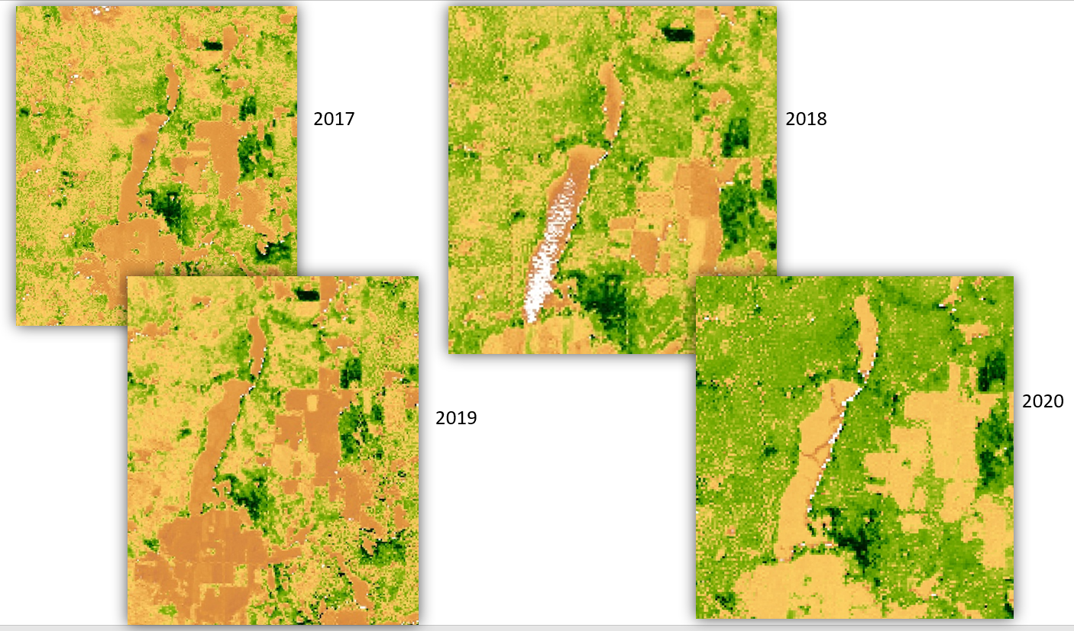
Figure 11. Enhanced Vegetation Index images of the North Pipe and Pile Lake Watersheds from Landsat 8.
The Web Soil Survey (WSS) provides information about properties and suitability for use of soils across the United States. Soil infiltration can be related to the suitability for land surfaces to be turned into lawns, landscaping, and golf fairways. By looking at the results from the WSS in Figure 11, you will notice that the majority of the Pipe and North Pipe Lake watersheds are either very limited (red) or somewhat limited (yellow) for the domestic landscapes. According to the WSS, ~ 70% of the North Pipe Lake watershed and 50% for Pipe Lake is considered very limited for development. Sandy loam is the primary soil texture found within the watersheds with stones and a low cation exchange capacity, suggesting less suitability for lawns.
Normally we tend to think of “sandy’ as being more water conductive than “clay”. In general, this is true, but water infiltration is not just a function of soil texture. Structure and bulk density play an important role in water movement. Because the soil type is a sandy loam and not a pure sand, there is a portion of silt and clay mixed into the soil type. What the elder author of this report has learned over four decades is that silt and clay compacted with sand will limit downward movement of water. There are many “sandy” type soils in Wisconsin and Minnesota that were compacted by the last glaciation. Think of a mile of ice riding on top of the soil moving slowly over a long period of time.
Have you ever wondered why there are so many small wetlands located high up in the watershed landscape? Some of these wetlands dried up in 2021, but the undisturbed wetland plants tell a long-term hydrologic story. This story is foundational to why there are so many little or even tiny hydrologic pathways to flow toward both Pipe and North Pipe Lakes.
Besides suitability for use, the WSS also gives ratings for selected soil properties, including bulk density. Bulk density is a measurement of soil compaction. Soils with bulk density values higher than 1.4 g cm⁻³ often have problems with root penetration and lower water holding capacities since the pore space is smaller. The bulk density graphs are shown in Figures 12 and 13. The soil rating colors are as followed; red < 0.18, orange > 0.18 and < 0.38, green > 0.38 and < 1.5, light blue > 1.5 and < 1.64, and dark blue > 1.64 and < 1.7. From the graphs, the majority of the soils around Pipe and North Pipe Lakes are implied to have bulk densities larger than 1.4 g cm⁻³.
While bulk density can be determined by taking a soil sample and dividing the dry soil weight by the soil volume, there are other ways to infer soil compaction based on “in-situ” field measurements. Penetrometers can measure soil resistance by pushing a metal rod down through the soil profile. Soil resistance is recorded and used to calculate the “California Bearing Ratio”, which estimates soil bearing strength or shear resistance. Both of these parameters were used around both lakes to infer soil compaction.
The SATURO dual head infiltrometer and the dynamic cone penetrometer were used at selected lake home properties around both lakes to validate WSS data.

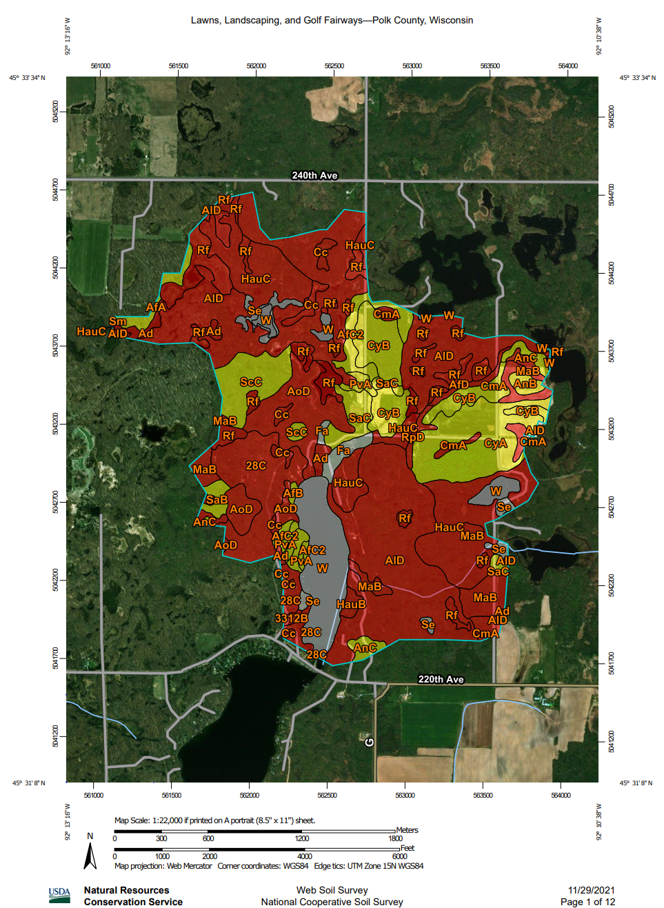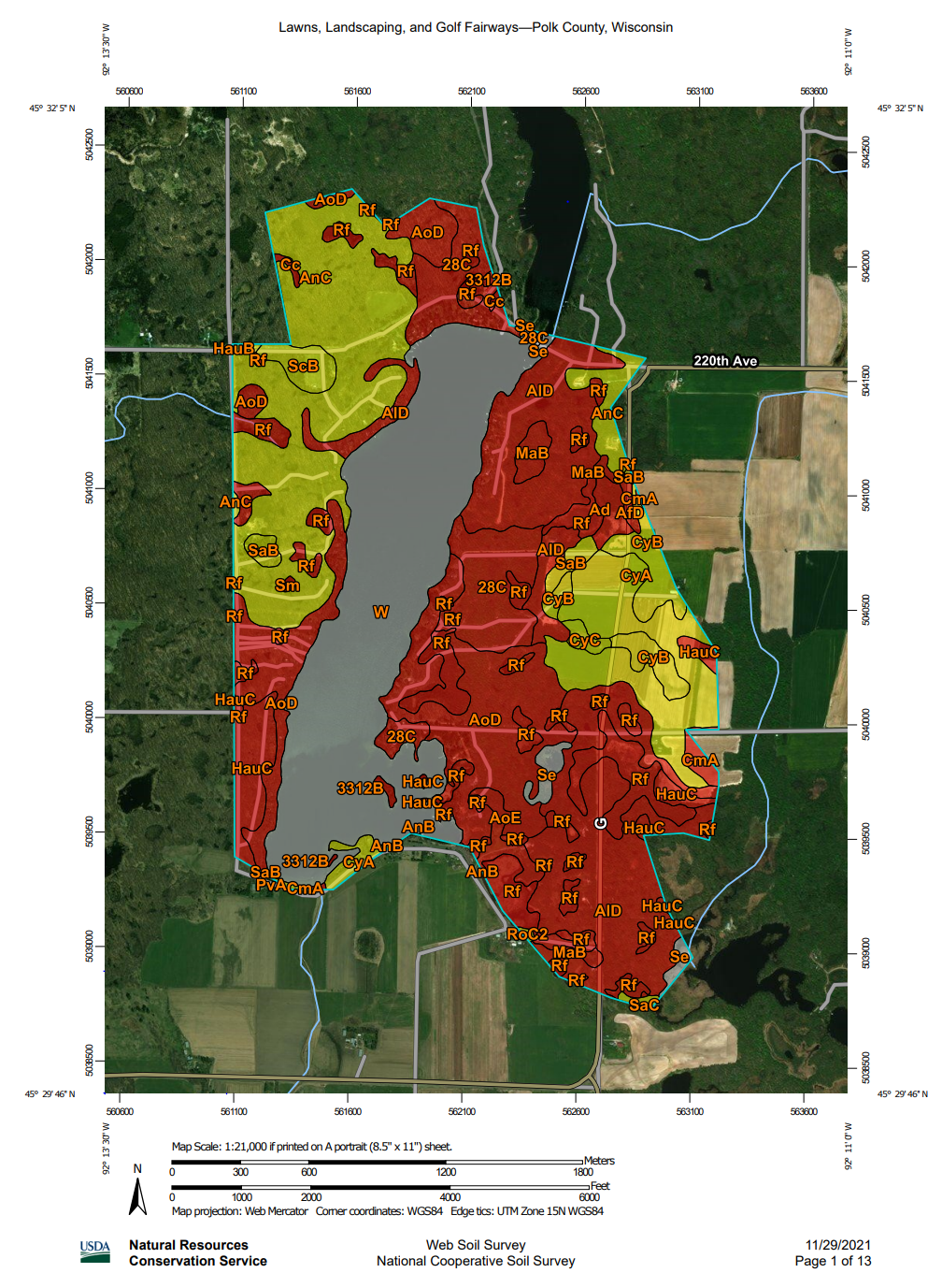
Figure 12. A map showing the Web Soil Survey land use suitability.
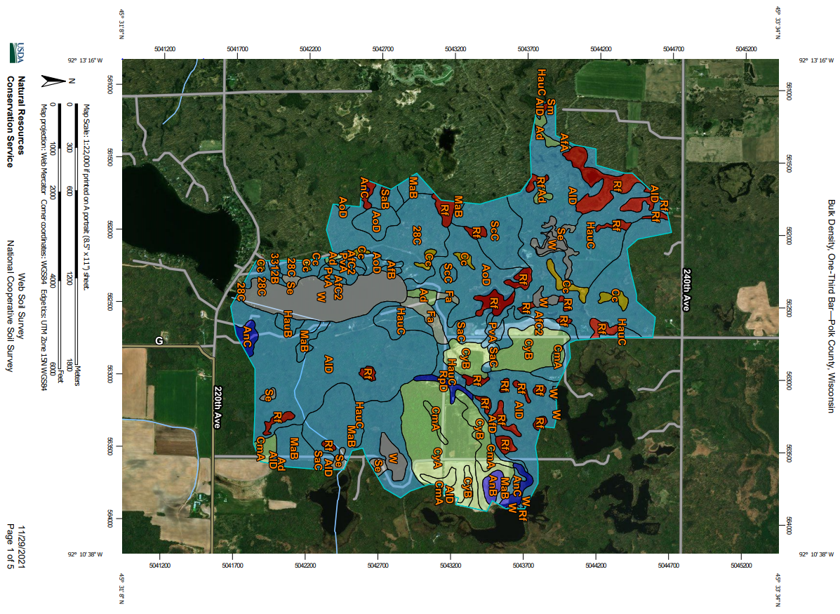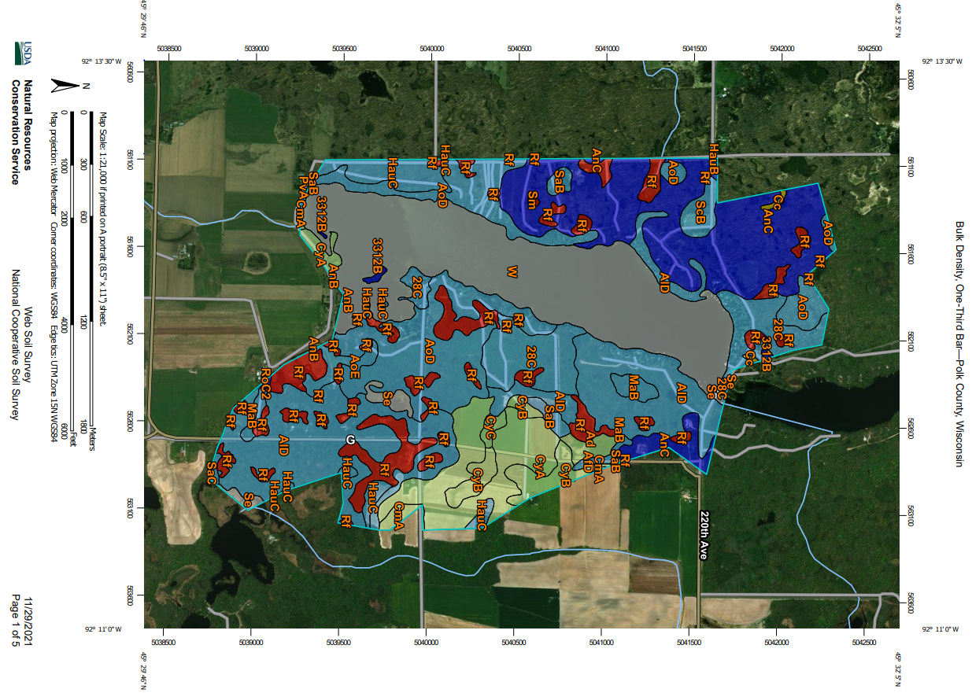
Figure 13. Maps showing codes for WSS soil types.
Methods:
SATURO dual head infiltrometers were used at eight different properties around the lakes: four on North Pipe Lake and four on Pipe Lake. At each property, three distinct infiltration sections were chosen for testing; upper ground, middle ground (often sloped), and lower ground (near shore). Each testing section had between two and five infiltration runs and the type of practice was determined - undisturbed or disturbed with lawn grass. In total, there were 41 infiltration tests taken around both lakes, results were then analyzed and interpreted. Dynamic cone penetrometer testing was applied at three of the same properties used for infiltration testing in the North Pipe Lake watershed to infer soil compaction below the surface soil. A total of nine penetrometer measurements were recorded, each having a total depth measurement ranging between 50-cm to 160-cm.
Results:
Infiltration rates were higher for the properties studied along North Pipe Lake than Pipe Lake. However, soil and vegetation cover differed greatly between sites. Undisturbed sites had higher average infiltration rates than disturbed lawn grass sites. This result was expected, as native plants have deeper root systems than common lawn grasses with less developed root structure.

Figure 14. Bar graphs showing infiltration rates for disturbed and undisturbed test locations for each lake.
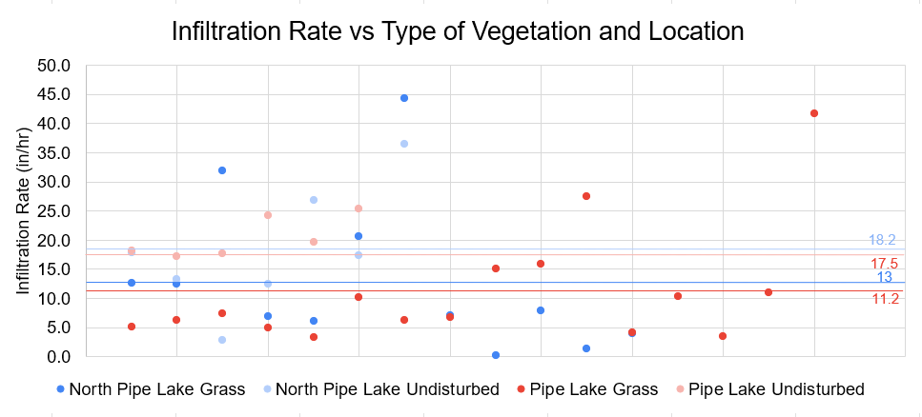
Figure 15. A plot of infiltration data collected for each lake and vegetation type.
When the infiltration rates along North Pipe Lake are grouped together by vegetation, it is clear to see that the average infiltration rates for undisturbed sites are higher than for lawn grass sites, as seen in the graph below. The California Bearing Ratio (CBR) percent values that were calculated when using the dynamic cone penetrometer (DCP) were averaged and plotted alongside infiltration rates. According to the CBR test results, soil near the surface of the ground in turf grass lawns compared to undisturbed areas had higher compaction. The data appears to correlate well with the infiltration data; the more compacted the soil, the slower the infiltration rate.

Figure 16. A plot of DCP CBR percent with depth vs SATURO infiltration rate showing differences between disturbed and undisturbed sites.
In the graph below, penetrometer CBR% results are plotted with infiltration results that were taken from the same property. In the legend, LG stands for lower ground, MG stands for middle ground, UG stands for upper ground, and UD stands for undisturbed. The infiltration runs on the turf grass had lower slower infiltration rates than infiltration runs on undisturbed areas. Regarding the DCP, CBR% data, the majority of the tests on the turf grass areas had higher compaction than the runs on the undisturbed areas. The data indicates that there are “harder” more compact layers in the soil profile at about 50 cm and 80 cm.
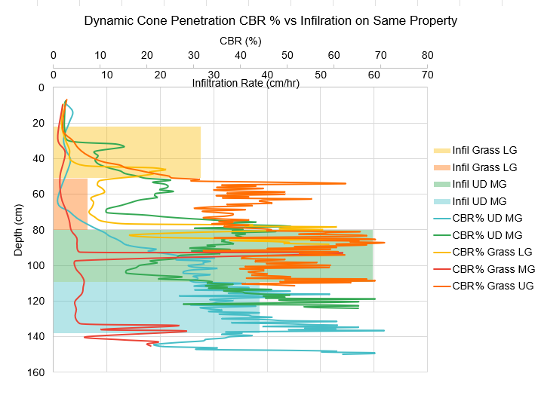
Figure 17. Similar to Figure 15, colored bars show differences in infiltration by vegetation and the concordant CBR %.
Discussion:
An important goal for the Lake District is to decrease nutrient runoff into the lakes. While the 2009 and 2018 management plans sought to decrease the amount of nutrients transported into North Pipe Lake and increase water quality, the main objective for Pipe Lake was to prevent loss of current water quality. One way that lake property owners can help keep their lakes clean for future use is to help stop nutrient runoff flowing through their shoreland into the lake. The DCP data suggests that undisturbed land is less compacted than turf grass, which is most likely due to less lawn equipment compaction and deeper root systems associated with native plants. 40% of the infiltration tests conducted along Pipe and North Pipes Lake showed infiltration rates below 25 cm/hr.
Ways to increase infiltration rates involve BMPs discussed above, such as creating rain gardens and planting native grass buffers along shorelines. A guidance document created by the USDA and Natural Resource Conservation Service, Wisconsin Biology Technical Note #1 – Shoreland Habitat, is a great resource for understanding how to create buffers and provides information on estimating a given landscape. Another great resource is the Shoreland Mitigation Handbook for Barron County, Wisconsin. This gives landowners information about great ways to restore lakeshores so that they function as well as they did before development occurred.
Wisconsin Lake Modeling Suite (WiLMS)
Watershed modeling was completed using modules from the Wisconsin Lake Modeling Suite (WiLMS). Initial hydrologic and geomorphic data entered into the model compared to the monitored data in the lake suggest that changes in residence time due to more prolific and intense storm events may be causing changes in water quality (Figure 16). When monitored precipitation data is inputted into the model and runoff is changed from year to year the areal loading from the North Pipe Lake watershed showed no change as the models were based on annual precipitation input.

Figure 18. Watershed runoff in inches and meters from 2015-2021
The isotopic data suggested that the hydraulic residence time in North Pipe Lake over the study period is ranged from 1-2 years (although some isotopic data suggested 7-12, however, this is unlikely and more a function of sampling error). Using the hydrologic, geomorphic, and monitored precipitation data, the modeling results alien with the isotope data. When changes in hydraulic residence time were modeled against the mean growing season P concentrations the model suggested that the changes in residence time may have been responsible for the periodic algae blooms seen in the lake (Figure 17).

Figure 19. North Pipe Lake vs hydraulic residence time
The model suggested that for Pipe Lake that that hydraulic residence time may not be as large of a factor as the changes in discharge from North Pipe Lake as that lake’s hydraulic residence time changes (Figures 18 & 19).

Figure 20. Pipe Lake vs hydraulic residence time

Figure 21. Pipe Lake areal load of phosphorus vs. the watershed areal load, including discharge from north Pipe Lake
The model indicated that changes int the hydraulic residence time of North Pipe Lake directly influences the water quality of Pipe Lake. As has been suggested in previous lake plans, stormwater management in the North Pipe Lake watershed will have direct implications for the water quality of Pipe Lake. Although basic watershed BMP’s such as shoreline management and restoration will still have a positive impact on the water quality and habitat for riparian and littoral species on both lakes and should not be overlooked. We believe this is the key “take-home” message to protect both lakes from future water quality degradation.

Recommendations based on comments and the January 10th Zoom call:
- Dr. Udai Singh will work closely with Larry Bersina to install “V-notch” weirs at selected tributaries feeding North Pipe Lake, then develop long-term flow rating curves and conduct concentration sampling when possible.
- Tim Larson along with the help of others will attempt to video record stormflow runoff at selected locations to illustrate both at risk sites and the value of water holding BMPs.
- Jeremy Williamson will take the information contained in this report and the report by Dr. Bill James and incorporate changes to upgrade the next Pipe and North Pipe Lake Management Plan.
- Jan Breyer will explore options for improving lake homeowner response to water and soil management. This could include the Lakes District hiring and managing a landscape improvement contractor.
- Dick Hollar will explore options for year-round precipitation measurement and getting more comprehensive lake stage data with new installations.

