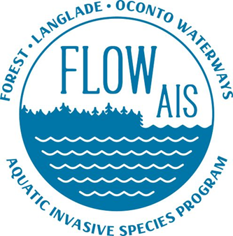

FLOW AIS update for FCAL
Since 6/17/2022
7/15/2022

- FLOW AIS conducted a CBCW Training for Butternut Franklin Lakes on June 27th

- FLOW AIS created an AIS what’s in my lake for Butternut Franklin. It shows all lakes that have invasive species in Forest, Vilas, and Oneida counties. Butternut Franklin plants to put it up at their boat landing. If other lakes in the area are interested, please let me know and I can get a copy to you.

- WISC has an ongoing grant that will allow them to work on the Phragmites population found in Laona

- Ongoing conversations with Steve K about grants for the year 2023. They include a county wide CBCW program and county wide DASH work

- Snapshot Day has been changed to August 19th and volunteer registration is now open. You can register at https://wateractionvolunteers.org/event-page/aquatic-invasive-species-snapshot-day-2022/ They have a note saying our date has changed to August 19th

- Looking forward to Kentuck Days

