Interim Report 2 for AIR25520 – “Green County phragmites control 2019 – 11 sites”
This document represents work from after our first report through the end of the grant (11/01/2020 to 7/2/20).
All sites were cut in winter of 2020 except site 6, which was only partially cut. Site 5, 6, and 7 were completely re-cut in June of 2020. See below for attached photos of cut sites.
Some seeds heads were removed and safely disposed of in dumpsters on sites 1, 2, 3, 4, 5.
Batker (site 5) was already burned and cut when we arrived in winter of 2020 and needs to be re-treated.
In the spring of 2020, Todd Jenson of Green County reported 95% to 100% kill at all sites except 5 (Bakter) which only had 50% kill, likely due to mowing and burning.
Sites 8 and 9, Taco Bell and William Kempf appear to be completely wiped out.
Sites 7, 8, and 11 were broadcast applied with a bio-swale wetland seed mix from Prairie Seed Nursery. Wet sand was mixed with the seed as a spreader and hand sown.
A new three-year grant excluding site 8 and 9 and adding newly verified sites will be applied for in summer 2020.
Sincerely,

Matt Wallrath
Invasive Species Project Coordinator
Upper Sugar River Watershed Association
207 E. Main Street
PO Box 314
Mt. Horeb, WI 53572
Office: (608) 437-7707
matt@uppersugar.org

Site 1:
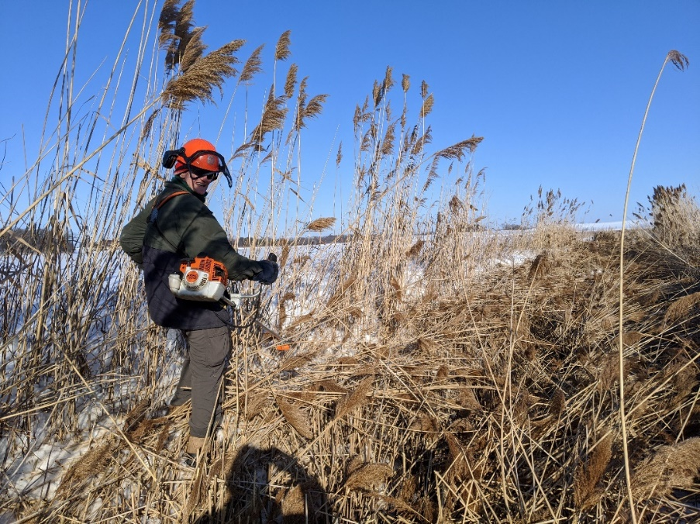
Site 2:
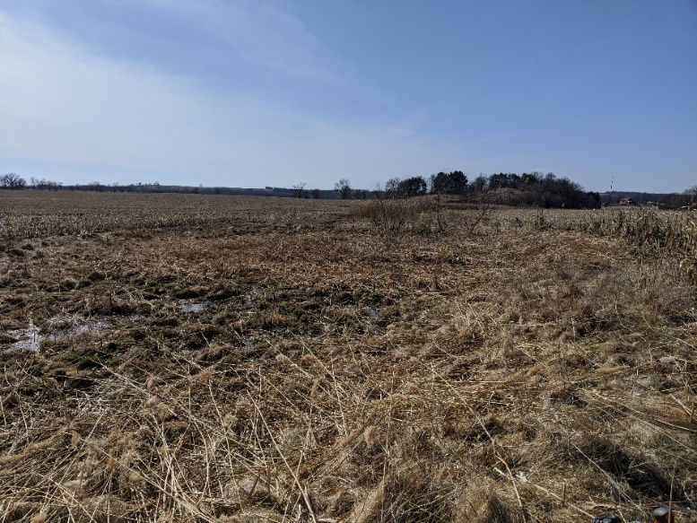
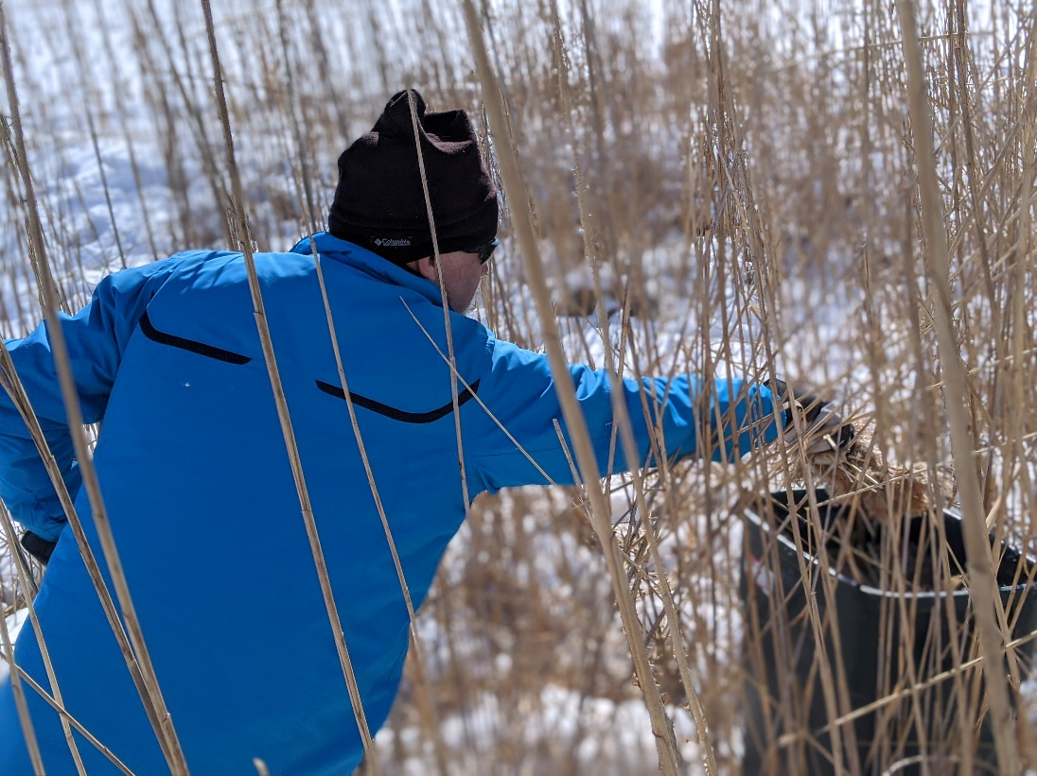
Above: Volunteer removing seed heads for disposal at site 2.
Site 3:
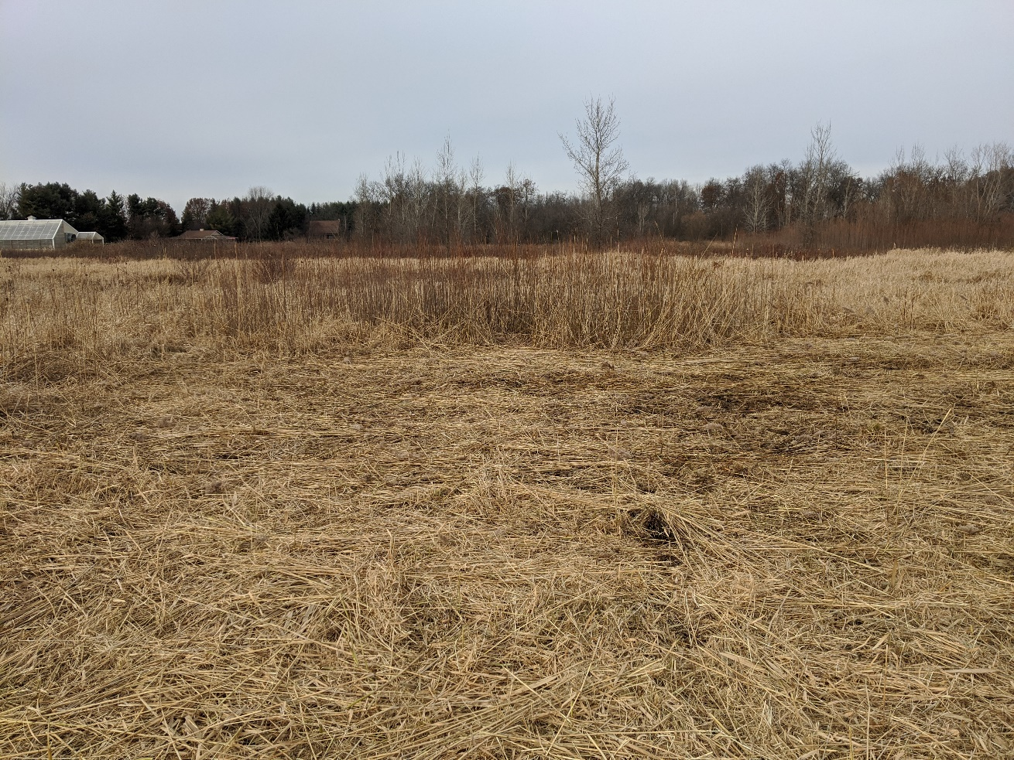
Site 4:
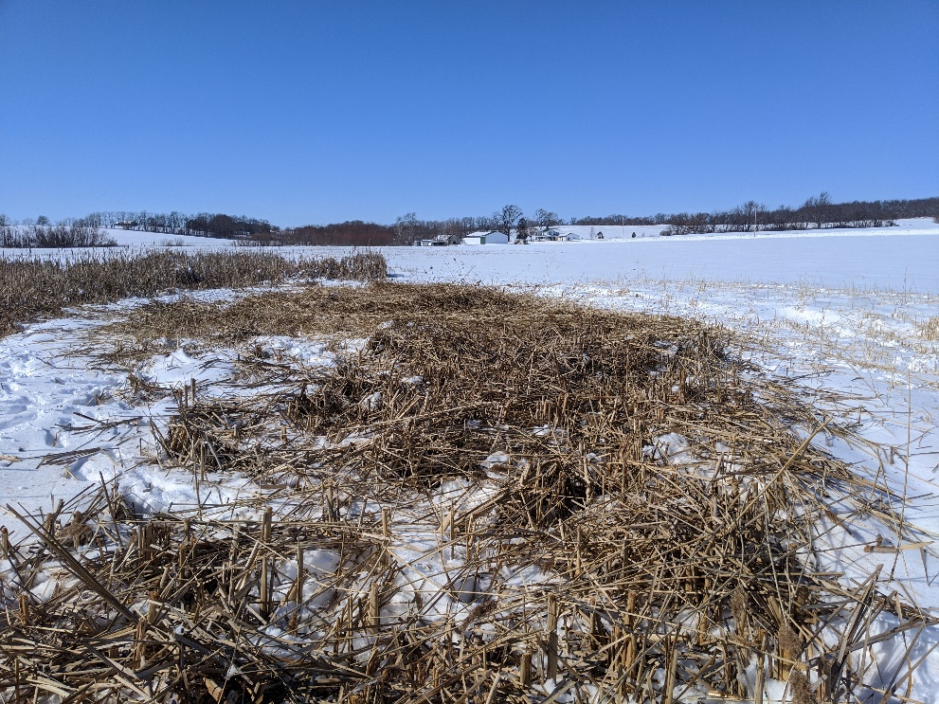
Site 5: (no picture, site was burned)
Site 6: (partial cut)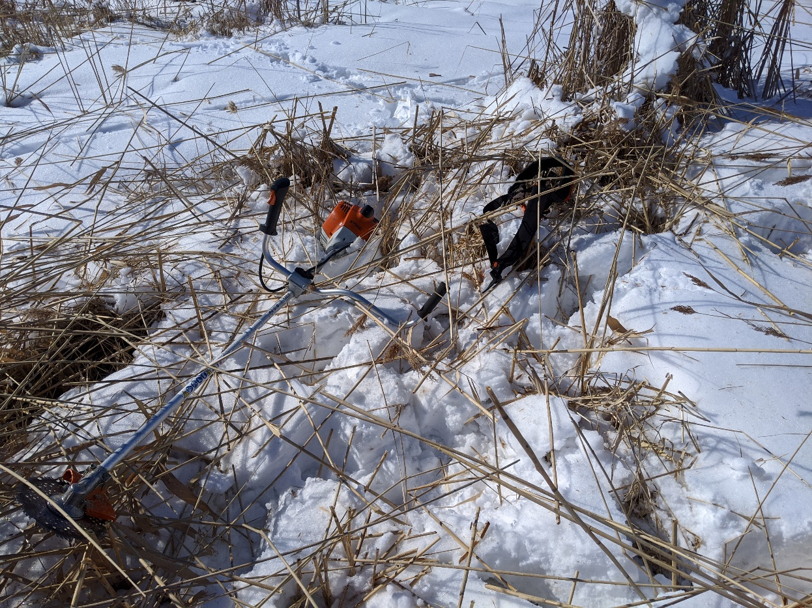
Site 7: (no photo, site was cut)
Site 8: killed
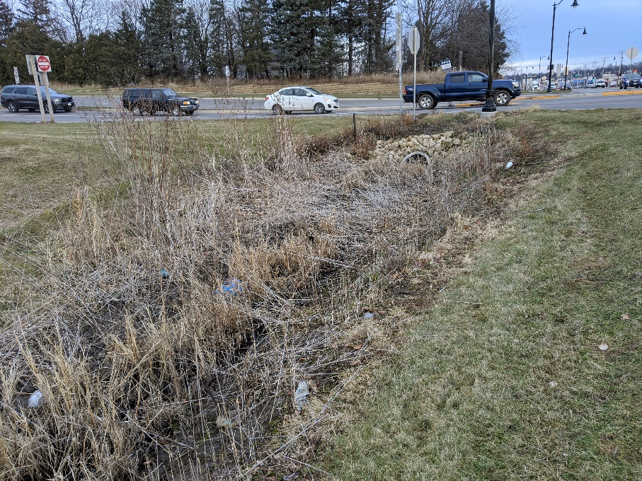

Site 9 was already eradicated when I arrived, no photo.
Site 10:
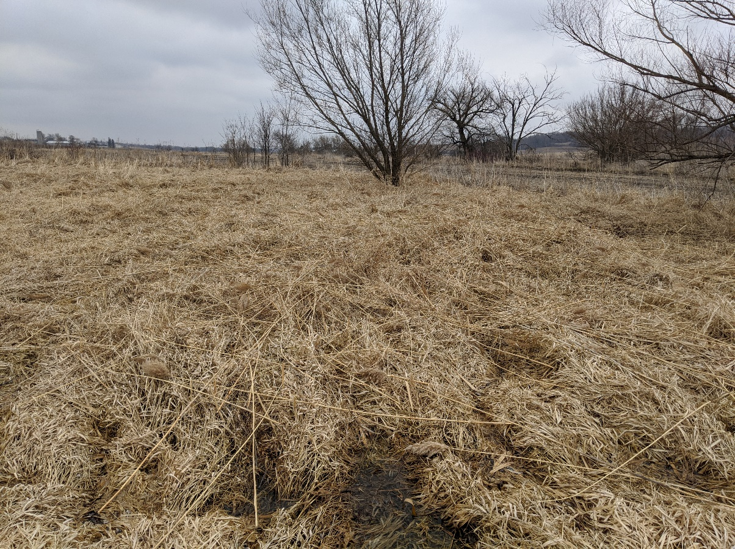

Site 11:
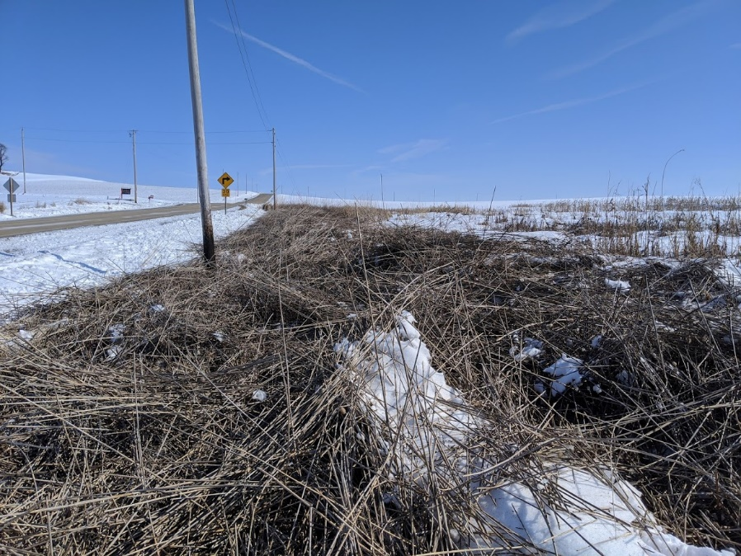

Additional:
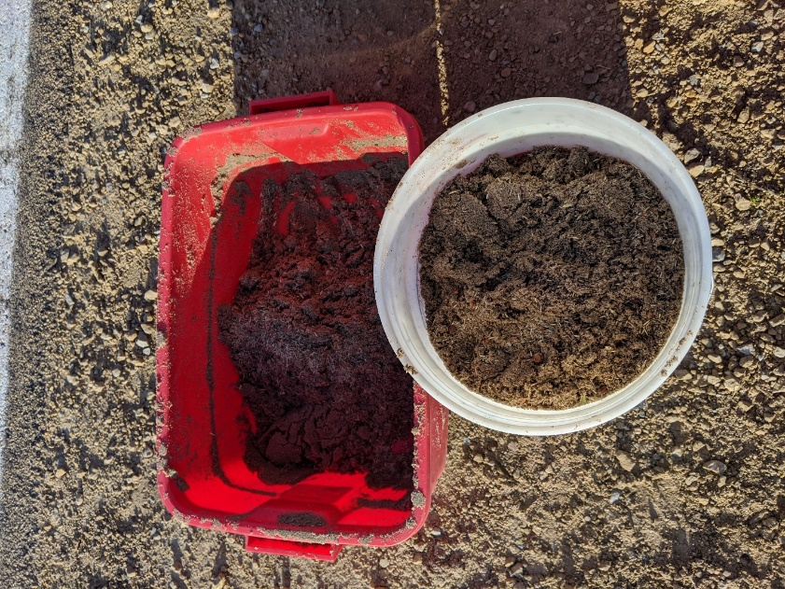
Above: Photo of seed mix.

