Curly-leaf pondweed (Potamogeton crispus)
Point-intercept and Bed Mapping Surveys, and
Warm-water Macrophyte Point-intercept Survey
Ten Mile Lake - WBIC: 2089500
Barron County, Wisconsin

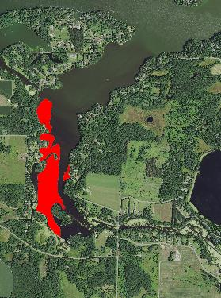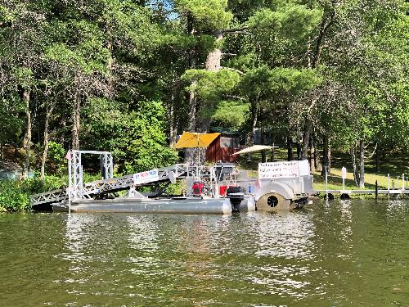
Ten Mile Lake CLP Beds 6/7/22 Harvester on Ten Mile Lake 6/7/22

Project Initiated by:
Chetek Lakes Protection Association, Short Elliott Hendrickson Inc.,
and the Wisconsin Department of Natural Resources

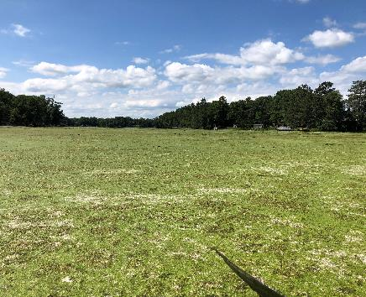
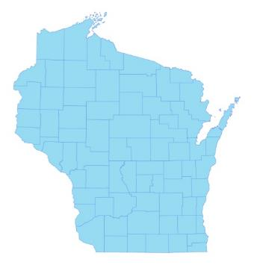
* Ten Mile Lake
Dense algal mat in the southeast bay near the Ten Mile Creek Inlet 7/8/22

Surveys Conducted by and Report Prepared by:
Endangered Resource Services, LLC
Matthew S. Berg, Research Biologist
St. Croix Falls, Wisconsin
June 7 and July 8, 2022
TABLE OF CONTENTS
ABSTRACT………………………..……..…………………………………………………….……. ii
LIST OF FIGURES.………………..……..………………………………………………...…….….. iii
LIST OF TABLES…………………..……..………………………………………………..………... iv
INTRODUCTION………….…..……...………………………………………………………..……. 1
BACKGROUND AND STUDY RATIONALE…..……………………………………….………… 1
METHODS.……………………………………………………………….………………………….. 2
DATA ANALYSIS…………………………………………………………………………….…….. 3
RESULTS............................................................................................................................................. 6
Curly-leaf Pondweed Point-intercept Survey......................................................................... 6
Comparison of Curly-leaf Pondweed in 2011 and 2022…………………………………… . 7
Curly-leaf Pondweed Bed Mapping Survey………..……………………………...……….. 7
Descriptions of Past and Present Curly-leaf Pondweed Beds……………………………… 8
Warm-water Full Point-intercept Macrophyte Survey………………………………….….. 10
Ten Mile Lake Plant Community …….…………………………………………………….. 14
Comparison of Native Macrophyte Species in 2011 and 2022…....……………………….. 21
Comparison of Floristic Quality Indexes in 2011 and 2022.……………………….…….… 32
Comparison of Northern Wild Rice in 2011 and 2022…....……………………………...… 34
Comparison of Filamentous Algae in 2011 and 2022…....……………………………...…. 35
Comparison of July Curly-leaf Pondweed in 2011 and 2022……….…....………………… 36
Other Exotic Plant Species…………………………....…………………………….……… 38
DISCUSSION AND CONSIDERATIONS FOR MANAGEMENT……………………….……….. 40
LITERATURE CITED……….……………………….…………………………………….……….. 41
APPENDIXES……….…….………………………………………………….…………….……….. 42
I: Survey Sample Points Map.………………………………..…….……..…………………..….. 42
II: Boat and Vegetative Survey Datasheets..……………………………………………………… 44
III: 2011 and 2022 Early-season CLP Density and Distribution and CLP Bed Maps………….….. 47
IV: Habitat Variable Maps……………………………………...………..……………………........ 52
V: 2011 and 2022 Littoral Zone, Native Species Richness, and Total Rake Fullness Maps ……… 55
VI: July 2011 Native Species Density and Distribution Maps…………...………………………… 62
VII: Chetek Chain Plant Species Accounts……………………………………………………….… 94
VIII: July 2022 Native Species Density and Distribution Maps…………………………………...... 107
IX: July 2011 and 2022 Exotic Species Density and Distribution Maps and
Aquatic Exotic Invasive Plant Species Information…………………….…………………...... 138
X: Glossary of Biological Terms……………….…………...……………………….………........ 150
XI: June and July 2022 Survey Data Spreadsheets.……….………………………………………. 154
ABSTRACT
Ten Mile Lake (WBIC 2089500) is a 266-acre drainage lake located in southeast Barron County, WI. Following our original point-intercept surveys in 2011, the Chetek Lakes Protection Association (CLPA), under the direction of Dave Blumer (Short Elliott Hendrickson Inc.), developed an initial Aquatic Plant Management Plan and began actively managing Curly-leaf pondweed (Potamogeton crispus) (CLP) – an exotic invasive plant species found throughout the system. As a prerequisite to updating their plan in 2023 and to compare how the lakes’ vegetation had changed since the last point-intercept surveys, the CLPA (Jamey Lideen – President), under the direction of Renee Cance (SEH) and the Wisconsin Department of Natural Resources authorized CLP density and bed mapping surveys on June 7th, and a full point-intercept survey of all aquatic macrophytes on July 8, 2022. During the initial 2011 early-season survey, we found CLP at 146 sites (27.6% coverage with a mean rake fullness of 2.05). Of these, 95 points had a rake fullness of 3 or 2 suggesting 18.0% of the lake had a significant infestation. In 2022, we found CLP at 110 points (20.8% coverage with a mean rake fullness of 1.91) with 68 having a rake fullness of 3 or 2 (12.9% of the lake had a significant infestation). From 2011-2022, our results suggested a nearly significant decline (p=0.09) in CLP density; a significant decline (p=0.04) in total distribution; a moderately significant decline (p=0.008) in rake fullness 3; and a highly significant increase (p<0.001) in visual sightings. In 2022, we mapped three Curly-leaf pondweed beds totaling 42.13 acres (15.84% coverage). They represented a 25.97-acre decline (-38.14%) from 2011 when we mapped seven beds that covered 68.10 acres (25.60% of the lake). During the July 2022 full point-intercept survey, we found macrophytes growing at 252 sites which approximated to 47.6% of the entire lake bottom (all points fell within the 9.0ft littoral zone). This was a moderately significant increase (p=0.008) from 210 sites with vegetation in 2011 (39.6% of the lake and 66.7% of the then 7.0ft littoral zone). Overall diversity was high with a Simpson Index value of 0.90 – up slightly from 0.89 in 2011. Total richness was low/moderate with 26 species in the rake (down from 29 in 2011) and 35 total found growing in and immediately adjacent to the water (up from 34 in 2011). There was an average of 4.68 native species/site with native vegetation – a non-significant increase (p=0.15) from 4.47/site in 2011. Total rake fullness experienced a moderately significant increase (p=0.001) from a moderate 1.91 in 2011 to a moderate 2.13 in 2022. Coontail (Ceratophyllum demersum), Small duckweed (Lemna minor), Common watermeal (Wolffia columbiana), and Large duckweed (Spirodela polyrhiza) were the most common macrophyte species in 2022. Found at 66.67%, 64.29%, 64.29%, and 63.89% of sites with vegetation, they captured 53.88% of the total relative frequency. In 2011, Small duckweed, Large duckweed, Common watermeal, and Coontail, were the most common species (76.19%, 72.86%, 72.38%, and 58.10% of survey points with vegetation/60.21% of the total relative frequency). Lakewide, from 2011-2022, fifteen species showed significant changes in distribution: Common waterweed (Elodea canadensis), White water lily (Nymphaea odorata), filamentous algae, Nitella (Nitella sp.), and Water star-grass (Heteranthera dubia) enjoyed highly significant increases (p<0.001); and Short-stemmed bur-reed (Sparganium emersum) and Arum-leaved arrowhead (Sagittaria cuneata) saw moderately significant increases (p=0.001/p=0.006). Conversely, Curly-leaf pondweed and Blunt-leaf pondweed (Potamogeton obtusifolius) suffered highly significant declines (p<0.001); Small duckweed underwent a moderately significant decline (p=0.006); and Large duckweed (p=0.04), Flat-stem pondweed (Potamogeton zosteriformis) (p=0.02), Fern pondweed (Potamogeton robbinsii) (p=0.01), Forked duckweed (Lemna trisulca) (p=0.02), and Stiff pondweed (Potamogeton strictifolius) (p=0.01) all saw significant declines. The 24 native index species found in the rake during the July 2022 survey (down from 28 in 2011) produced an above average mean Coefficient of Conservatism of 6.1 (down from 6.3 in 2011). The Floristic Quality Index of 29.8 (down from 33.4 in 2011) was also above the median FQI for this part of the state. Northern wild rice (Zizania palustris) was present at six sites with a mean rake of 1.00. This was a nearly significant decline (p=0.10/p=0.08) in both distribution and density compared to 2011 when we found rice at 11 points with a mean rake of 1.18. Despite its value for wildlife, it was unlikely any of the rice beds in the Ten Mile Creek Inlet had human harvest potential. In 2022, filamentous algae were present at 142 points with a mean rake fullness of 1.88. This was a highly significant increase (p<0.001) in distribution, and a nearly-significant increase (p=0.10) in density compared to 2011 when we found these algae at 22 points with a mean rake of 1.68. In July 2022, CLP was still present at 33 points with a mean rake fullness of 1.06. Compared to July 2011 when we found CLP at 54 sites with a mean rake of 1.31, this suggested that CLP had undergone a highly significant summer decline (p<0.001) in distribution; a moderately significant decline (p=0.005) in mean density; and a significant decline in rake fullness 3 (p=0.01), rake fullness 2 (p<0.05), and rake fullness 1 (p=0.02). Other than CLP, Reed canary grass (Phalaris arundinacea) and Hybrid cattail (Typha X glauca) were the only other exotic species found. RCG was present along disturbed shorelines throughout while HC was established along the shoreline in the lake’s southeastern bays and sloughs as well as in scattered patches on the eastern shoreline. If active management of Curly-leaf pondweed on Ten Mile Lake continues in the future, we strongly encourage the CLPA to take a small-scale approach based on annual needs to relieve navigation impairment. By taking a measured approach, it is less likely that any management would collaterally damage the lake’s somewhat limited native plant community and the important habitat it provides. Proactively working to limit nutrients coming into the system as they feed both excessive algal and CLP growth; and educating lakeshore residents on ways to control erosion and nutrient runoff are other future management considerations worth exploring.
LIST OF FIGURES

Page
Figure 1: Ten Mile Lake Bathymetric Map………………..………………..…………....... 1
Figure 2: Rake Fullness Ratings……………………………….…….…………………….. 2
Figure 3: 2011 and 2022 Early-season Curly-leaf Pondweed Density and Distribution..…. 6
Figure 4: 2011 and 2022 Changes in Early-season CLP Rake Fullness..………………….. 7
Figure 5: 2011 and 2022 Early-season Curly-leaf Pondweed Beds.….....…………….…… 8
Figure 6: Lake Depth and Bottom Substrate ………………………………………………… 10
Figure 7: 2011 and 2022 Littoral Zone………………………………..…………………… 11
Figure 8: 2011 and 2022 Plant Colonization Depth Chart.………………………….……... 12
Figure 9: 2011 and 2022 Native Species Richness………………………………….……... 13
Figure 10: 2011 and 2022 Total Rake Fullness…………………….……………………… 13
Figure 11: Macrophytes Showing Significant Changes from 2011-2022 …………………. 22
Figure 12: 2011 and 2022 Coontail Density and Distribution...…………….………….….. 27
Figure 13: 2011 and 2022 Flat-stem Pondweed Density and Distribution……..…………... 28
Figure 14: 2011 and 2022 Fern Pondweed Density and Distribution……..………………... 28
Figure 15: 2011 and 2022 Common Waterweed Density and Distribution ………………... 29
Figure 16: 2011 and 2022 White Water Lily Density and Distribution...……………..…… 30
Figure 17: 2011 and 2022 Spatterdock Density and Distribution …………………………. 30
Figure 18: 2011 and 2022 Nitella Density and Distribution.………….…………………… 31
Figure 19: 2011 and 2022 Water Star-grass Density and Distribution.………….………… 31
Figure 20: 2011 and 2022 Northern Wild Rice Density and Distribution …………………. 34
Figure 21: 2011 and 2022 Filamentous Algae Density and Distribution.…………………. 35
Figure 22: 2011 and 2022 July CLP Density and Distribution ……………………………. 36
Figure 23: 2011 and 2022 Changes in July CLP Rake Fullness………..………………….. 37
Figure 24: 2011 and 2022 Reed Canary Grass Density and Distribution …………………. 38
Figure 25: 2022 Hybrid Cattail Density and Distribution..………………………………... 39
Figure 26: Exotic Hybrid and Native Broad-leaved Cattail Identification.......……….…… 39

LIST OF TABLES

Page
Table 1: Curly-leaf Pondweed Bed Summary –
Ten Mile Lake - Barron County, WI – June 12, 2022………………………………..…….. 9

Table 2: Aquatic Macrophyte P/I Survey Summary Statistics –
Ten Mile Lake - Barron County, WI July 7-8, 2011 and July 8, 2022…………..…………. 11

Table 3: Frequencies and Mean Rake Sample of Aquatic Macrophytes
Ten Mile Lake - Barron County, WI – July 7-8, 2011…………….……………….…..…… 23

Table 4: Frequencies and Mean Rake Sample of Aquatic Macrophytes
Ten Mile Lake - Barron County, WI – July 8, 2022………………………………………... 25

Table 5: Floristic Quality Index of Aquatic Macrophytes –
Ten Mile Lake - Barron County, WI – July 7-8, 2011……………………………………… 32

Table 6: Floristic Quality Index of Aquatic Macrophytes –
Ten Mile Lake - Barron County, WI – July 8, 2022………………………………………... 33

INTRODUCTION:
Ten Mile Lake (WBIC 2089500) is a 266-acre drainage lake located in the Towns of Chetek and Dovre in southeast Barron County (T32 and 33N R10W S3-5, 27-28, and 32-33) (Figure 1). It reaches a maximum depth of 12ft near the outlet to Chetek Lake and has an average depth of 6ft (WDNR 2022). The lake is eutrophic (bordering on hypereutrophic) in nature with Secchi readings from 1987 to 2022 averaging 2.0ft (WDNR 2022). This very poor water clarity produced a littoral zone that reached approximately 9.0ft in 2022. The lake’s bottom substrate is predominantly sandy muck throughout the main basin with more nutrient-rich organic muck in the side bays and Ten Mile Creek Inlet. A ring of sand and rock occurs along most of the shoreline, around the islands, and in the creek channel (Sather et al. 1964).

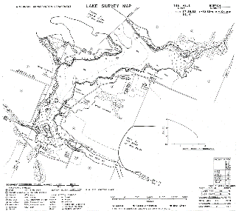
Figure 1: Ten Mile Lake Bathymetric Map

BACKGROUND AND STUDY RATIONALE:
In 2011, the Chetek Lakes Protection Association (CLPA) and the Wisconsin Department of Natural Resources (WDNR) authorized a series of whole lake plant surveys on the chain as a prerequisite to developing the lakes’ initial 2012 Aquatic Plant Management Plan (APMP). These surveys found that the exotic invasive species Curly-leaf pondweed (Potamogeton crispus) (CLP) occurred throughout much of the lakes’ spring littoral zone and occasionally grew so densely in the spring and early summer that it made lake access and boating difficult for residents. Because of this, the CLPA initiated a limited herbicide and harvesting program to relieve navigation impairment. Per WDNR expectations, plant surveys on actively managed lakes are normally repeated every five to seven years to remain current (Pamela Toshner/Alex Smith, WDNR – pers. comm.). Because of this, the CLPA was informed they needed to have the lakes resurveyed so they could update their APMP.

In anticipation of updating their plan in 2023, the CLPA (Jamey Lideen – President), under the direction of Renee Cance - Short Elliott Hendrickson Inc. (SEH), authorized three lakewide surveys on Ten Mile Lake in 2022. On June 7th, we conducted an early-season CLP point-intercept survey and bed mapping survey. This was followed by a warm-water point-intercept survey of all macrophytes on July 8th. The surveys’ objectives were to document the current levels of CLP; determine if Eurasian water-milfoil (Myriophyllum spicatum) or any other new exotic plants had invaded the lake; and to compare data from the original 2011 surveys with the 2022 data to identify any significant changes in the lake’s vegetation over this time. This report is the summary analysis of these three field surveys.
METHODS:
Curly-leaf Pondweed Point-intercept Survey:
Using a standard formula that takes into account the shoreline shape and distance, islands, water clarity, depth, and total acreage, Michelle Nault (WDNR) generated the original 529-point sampling grid for Ten Mile Lake in 2011 (Appendix I). Using this same grid in 2022, we completed a density survey where we sampled for Curly-leaf pondweed at each point in the lake. We located each survey point using a handheld mapping GPS unit (Garmin 76CSx) and used a rake to sample an approximately 2.5ft section of the bottom. When found, CLP was assigned a rake fullness value of 1-3 as an estimation of abundance (Figure 2). We also noted visual sightings of CLP within six feet of the sample point.

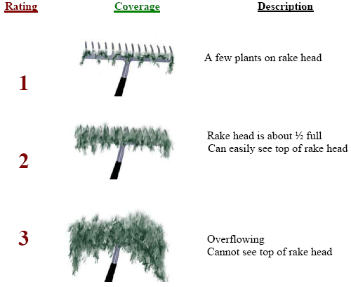
Figure 2: Rake Fullness Ratings (UWEX 2010)

Curly-leaf Pondweed Bed Mapping Survey:
During the bed mapping survey, we searched the lake’s entire visible littoral zone. By definition, a “bed” was determined to be any area where we visually estimated that CLP made up >50% of the area’s plants, was generally continuous with clearly defined borders, and was canopied, or close enough to being canopied that it would likely interfere with boat traffic. After we located a bed, we motored around the perimeter of the area taking GPS coordinates at regular intervals. We also estimated the rake density range and mean rake fullness of the bed (Figure 2), the maximum depth of the bed, whether it was canopied, and the impact it was likely to have on navigation (none – easily avoidable with a natural channel around or narrow enough to motor through/minor – one prop clear to get through or access open water/moderate – several prop clears needed to navigate through/severe – multiple prop clears and difficult to impossible to row through). These data were then mapped using ArcMap 9.3.1, and we used the WDNR’s Forestry Tools Extension to determine the acreage of each bed to the nearest hundredth of an acre (Table 1).
Warm-water Full Point-intercept Macrophyte Survey:
Prior to beginning the July point-intercept survey, we conducted a general boat survey to regain familiarity with the lake’s macrophytes (Appendix II). All plants found were identified (Voss 1996, Boreman et al. 1997; Chadde 2002; Crow and Hellquist 2005; Skawinski 2019), and a datasheet was built from the species present. We again located each survey point with a GPS, recorded a depth reading with a metered pole rake, and took a rake sample. All plants on the rake, as well as any that were dislodged by the rake, were identified and assigned a rake fullness value of 1-3 as an estimation of abundance (Figure 2). We also recorded visual sightings of all plants within six feet of the sample point not found in the rake. In addition to a rake rating for each species, a total rake fullness rating was also noted. Substrate (bottom) type was assigned at each site where the bottom was visible or it could be reliably determined using the rake.

DATA ANALYSIS:
We entered all data collected into the standard Aquatic Plant Management spreadsheet (Appendix II) (UWEX 2010). From this, we calculated the following:

Total number of sites visited: This included the total number of points on the lake that were accessible to be surveyed by boat or kayak.

Total number of sites with vegetation: These included all sites where we found vegetation after doing a rake sample. For example, if 20% of all sample sites have vegetation, it suggests that 20% of the lake has plant coverage.

Total number of sites shallower than the maximum depth of plants: This is the number of sites that are in the littoral zone. Because not all sites that are within the littoral zone actually have vegetation, we use this value to estimate how prevalent vegetation is throughout the littoral zone. For example, if 60% of the sites shallower than the maximum depth of plants have vegetation, then we estimate that 60% of the littoral zone has plants.

Frequency of occurrence: The frequency of all plants (or individual species) is generally reported as a percentage of occurrences within the littoral zone. It can also be reported as a percentage of occurrences at sample points with vegetation.

Frequency of occurrence example:

Plant A is sampled at 70 out of 700 total littoral points = 70/700 = .10 = 10%
This means that Plant A’s frequency of occurrence = 10% when considering the entire
littoral zone.

Plant A is sampled at 70 out of 350 total points with vegetation = 70/350 = .20 = 20%
This means that Plant A’s frequency of occurrence = 20% when only considering the
sites in the littoral zone that have vegetation.

From these frequencies, we can estimate how common each species was at depths
where plants were able to grow, and at points where plants actually were growing.
Note the second value will be greater as not all the points (in this example, only ½)
had plants growing at them.

Simpson’s Diversity Index: A diversity index allows the entire plant community at one location to be compared to the entire plant community at another location. It also allows the plant community at a single location to be compared over time thus allowing a measure of community degradation or restoration at that site. With Simpson’s Diversity Index, the index value represents the probability that two individual plants (randomly selected) will be different species. The index values range from 0 -1 where 0 indicates that all the plants sampled are the same species to 1 where none of the plants sampled are the same species. The greater the index value, the higher the diversity in a given location. Although many natural variables like lake size, depth, dissolved minerals, water clarity, mean temperature, etc. can affect diversity, in general, a more diverse lake indicates a healthier ecosystem. Perhaps most importantly, plant communities with high diversity also tend to be more resistant to invasion by exotic species.

Maximum depth of plants: This indicates the deepest point that vegetation was sampled. In clear lakes, plants may be found at depths of over 20ft, while in stained or turbid locations, they may only be found in a few feet of water. While some species can tolerate very low light conditions, others are only found near the surface. In general, the diversity of the plant community decreases with increased depth.

Mean and median depth of plants: The mean depth of plants indicates the average depth in the water column where plants were sampled. Because a few samples in deep water can skew this data, median depth was also calculated. This tells us that half of the plants sampled were in water shallower than this value, and half were in water deeper than this value.

Number of sites sampled using rope/pole rake: This indicates which rake type was used to take a sample. We used a 20ft pole rake and a 35ft rope rake for sampling.

Average number of species per site: This value is reported using four different considerations. 1) shallower than maximum depth of plants indicates the average number of plant species at all sites in the littoral zone. 2) vegetative sites only indicate the average number of plants at all sites where plants were found. 3) native species shallower than maximum depth of plants and 4) native species at vegetative sites only excludes exotic species from consideration.

Species richness: This value indicates the number of different plant species found in and directly adjacent to (on the waterline) the lake. Species richness alone only counts those plants found in the rake survey. The other two values include those seen at a sample point during the survey but not found in the rake, and those that were only seen during the initial boat survey or inter-point. Note: Per DNR protocol, filamentous algae, freshwater sponges, aquatic moss and the aquatic liverworts Riccia fluitans and Ricciocarpus natans are excluded from these totals.

Average rake fullness: This value is the average rake fullness of all species in the rake. It only takes into account those sites with vegetation (Table 2).

Relative frequency: This value shows a species’ frequency relative to all other species. It is expressed as a percentage, and the total of all species’ relative frequency will add up to 100%. Organizing species from highest to lowest relative frequency value gives us an idea of which species are most important within the macrophyte community (Tables 3 and 4).

Relative frequency example:

Suppose that we sample 100 points and found four species of plants with the following results:

Plant A was located at 70 sites. Its frequency of occurrence is thus 70/100 = 70%
Plant B was located at 50 sites. Its frequency of occurrence is thus 50/100 = 50%
Plant C was located at 20 sites. Its frequency of occurrence is thus 20/100 = 20%
Plant D was located at 10 sites. Its frequency of occurrence is thus 10/100 = 10%

To calculate an individual species’ relative frequency, we divide the number of sites a plant is sampled at by the total number of times all plants were sampled. In our example that would be 150 samples (70+50+20+10).

Plant A = 70/150 = .4667 or 46.67%
Plant B = 50/150 = .3333 or 33.33%
Plant C = 20/150 = .1333 or 13.33%
Plant D = 10/150 = .0667 or 6.67%

This value tells us that 46.67% of all plants sampled were Plant A.

Floristic Quality Index (FQI): This index measures the impact of human development on a lake’s aquatic plants. The species in the index are assigned a Coefficient of Conservatism (C) which ranges from 1-10. The higher the value assigned, the more likely the plant is to be negatively impacted by human activities relating to water quality or habitat modifications. Plants with low values are tolerant of human habitat modifications, and they often exploit these changes to the point where they may crowd out other species. The FQI is calculated by averaging the conservatism value for each native index species found in the lake during the point-intercept survey** and multiplying it by the square root of the total number of plant species (N) in the lake (FQI=(Σ(c1+c2+c3+…cn)/N)*√N). Statistically speaking, the higher the index value, the healthier the lake’s macrophyte community is assumed to be. Nichols (1999) identified four eco-regions in Wisconsin: Northern Lakes and Forests, North Central Hardwood Forests, Driftless Area and Southeastern Wisconsin Till Plain. He recommended making comparisons of lakes within ecoregions to determine the target lake’s relative diversity and health. Ten Mile Lake is in the North Central Hardwood Forests Ecoregion (Tables 5 and 6).

** Species that were only recorded as visuals or during the boat survey, and species found in the rake that are not included in the index are excluded from FQI analysis.

Comparison to Past Surveys: We compared data from our 2011 and 2022 CLP point-intercept surveys (Figure 4) and warm-water point-intercept surveys (Figure 11) (Tables 3 and 4) to see if there were any significant changes in the lake’s vegetation. For individual plant species as well as count data, we used the Chi-square analysis on the WDNR Pre/Posttreatment survey worksheet. For comparing averages (mean species/point and mean rake fullness/point), we used t-tests. Differences were considered significant at p<0.05, moderately significant at p<0.01 and highly significant at p<0.001 (UWEX 2010). It should be noted that when comparing the CLP point-intercept surveys, we used the number of spring littoral points (523 in 2011/493 in 2022); and, for the warm-water point-intercept surveys, we used the number of July littoral points with vegetation (210 in 2011/252 in 2022) as the basis for “sample points”.

RESULTS:
Curly-leaf Pondweed Point-intercept Survey:
The 2022 spring survey documented Curly-leaf pondweed at 110 points which approximated to 20.8% of the entire lake and 22.3% of the 8.0ft spring littoral zone. Of these, we found 32 with a rake fullness value of 3, 36 rated a 2, and the other 42 were a 1 for a combined mean rake fullness of 1.91. We also noted CLP as a visual at 38 points (Figure 3) (Appendix III). The 68 points with a rake fullness of a 2 or a 3 extrapolated to 12.9% of the entire lake and 13.8% of the spring littoral zone having a significant infestation.

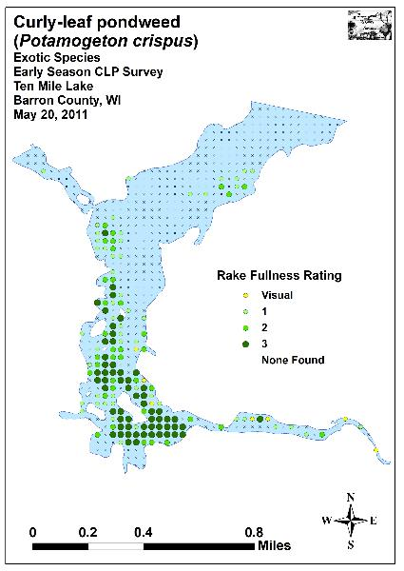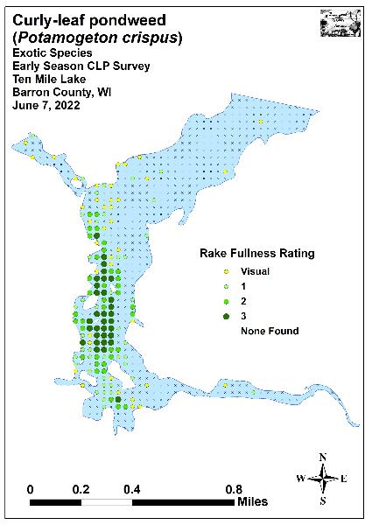
Figure 3: 2011 and 2022 Early-season Curly-leaf Pondweed
Density and Distribution

Comparison of Curly-leaf Pondweed in 2011 and 2022:
In 2011, our spring point-intercept survey recorded Curly-leaf pondweed at 146 sites – 27.6% of the entire lake and 27.9% of the then 9.0ft spring littoral zone. We rated 59 points a rake fullness of 3, 36 a rake of 2 (18.0% of the total lake/18.2% littoral zone with a significant infestation), and 51 a rake 1 for a mean rake fullness of 2.05. We also recorded CLP as a visual at seven points (Figure 3) (Appendix III). From 2011-2022, our results suggested a nearly significant decline (p=0.09) in CLP mean density; a significant decline (p=0.04) in total distribution; a moderately significant decline (p=0.008) in rake fullness 3; and a highly significant increase (p<0.001) in visual sightings (Figure 4).
+***
-**
-*
Significant differences = * p<0.05, ** p<0.01, *** p<0.001
Figure 4: 2011 and 2022 Changes in Early-season CLP Rake Fullness

Curly-leaf Pondweed Bed Mapping Survey:
In 2011, we mapped seven Curly-leaf pondweed beds that covered 68.10 acres (25.60% of the lake’s 266 acres) (Figure 5). These beds dominated much of the southern half of the lake and the Ten Mile Creek Inlet; and, especially in the southern bay and along the western shorelines, likely caused moderate to severe impairment for area residents.

The 2022 bed-mapping survey delineated three beds totaling 42.13 acres (15.84% of the lake’s surface area) (Table 1). This represented a 25.97-acre decline (-38.14%) from our 2011 bed mapping survey (Figure 5) (Appendix III).

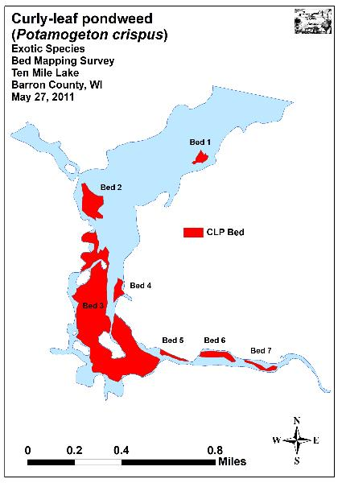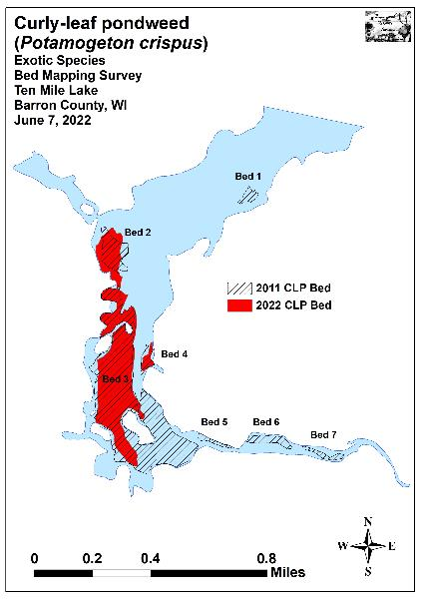
Figure 5: 2011 and 2022 Early-season Curly-leaf Pondweed Beds

Descriptions of Past and Present Curly-leaf Pondweed Beds:
Bed 1 – We saw only a handful of Curly-leaf pondweed plants established around the shallow bar in the northeast corner of the main basin.

Bed 2 – CLP was canopied and nearly monotypic in this area. Near shore, it formed a dense canopied mat, but the bed became more fragmented in deeper water. We noted there were prop-trails and uprooted plants throughout, and it seemed likely the bed was at least a moderate impairment for residents.

Bed 3 – This bed again dominated much of the south bay. However, compared to 2011, it was patchier and mixed with more native species, especially on the south end. North and east of the southeast island, in areas that had been solid mats in 2011, we saw almost no CLP plants at all. Overall, the bed appeared to be a major impairment to navigation as we saw prop-trails and uprooted plants throughout where boats had cut their way through.

Bed 4 – The majority of this bed occurred around and in a shallow uninhabited bay. People were fishing the patchy western edges by anchoring in the creek channel where flowing water coupled with regular boat traffic was keeping a reasonable navigation lane open. Despite this, for boaters accessing the resort docks or those motoring directly through the bed, it likely would have been a moderate impairment.

Beds 5-7 – We saw almost no CLP plants in these former beds scattered along the Ten Mile Creek Inlet.
Table 1: Curly-leaf Pondweed Bed Summary
Ten Mile Lake - Barron County, WI
June 7, 2022

Bed Number | 2022 Acreage | 2011 Acreage | Diff. | Rake Range; Mean Rake | Depth Range; Mean Depth | Canopied | Potential Navigation Impairment  Level | 2022  Field Notes
1 | 0.00 | 1.26 | -1.26 | <<<1 | 4-6; 5 | Near | None | Only a few CLP plants seen.
2 | 7.46 | 5.80 | 1.66 | <<1-3; 2 | 1-7; 6 | Yes | Moderate | Prop-trails throughout.
3 | 33.44 | 54.90 | -21.46 | <<<1-3; 3 | 1-6; 5 | Yes | Severe | Dense canopied mat at core.
4 | 1.22 | 1.68 | -0.46 | <<1-2; 2 | 2-6; 5 | Yes | Moderate | Patchy on the west side.
5 | 0.00 | 0.91 | -0.91 | <<<1 | 1-5; 3 | Yes | None | Only a few CLP plants seen.
6 | 0.00 | 2.37 | -2.37 | <<<1 | 1-5; 3 | Yes | None | Widely scattered CLP.
7 | 0.00 | 1.18 | -1.18 | <<<1 | 1-5; 3 | Yes | None | Widely scattered CLP.
Total Acres | 42.13 | 68.10 | -25.97

Warm-water Full Point-intercept Macrophyte Survey:
Depth readings taken at the lake’s 529 survey points (Appendix I) revealed a generally uniform increase in depth from the Ten Mile Creek Inlet and the shallow bays (2-6ft) on the south end of the lake towards the deeper flat (7-10ft) on the north end. A 10ft hole northwest of the midlake point on the east side, and a 4ft gravel bar just to the northeast of this hole were two notable exceptions to the lake’s otherwise fairly uniform topography (Figure 6) (Appendix IV).

We characterized the lake’s substrate as 92.1% organic and sandy muck (487 points), 1.3% gravel and rock (seven points), and 6.6% pure sand (35 points). Most of the main basin was sandy muck with the side bays, sloughs, and Ten Mile Creek Inlet having the thickest and most organic-rich substrates. The majority of nearshore areas had at least a narrow ring of pure sand, while most of the rocky areas occurred on exposed points, around the islands, in the creek channel, or on sunken bars (Figure 6) (Appendix IV).

In July 2022, we found plants growing to 9.0ft putting all surveyed points within the littoral zone (up from 7.0ft in 2011) (Table 2). The 252 points with vegetation (approximately 47.6% of the entire lake bottom/littoral zone) were a moderately significant increase (p=0.008) from the 2011 survey when we found plants growing at 210 points (39.6% of the bottom and 66.7% of the littoral zone) (Figure 7) (Appendix V). Growth in 2022 was slightly skewed to deep water as the mean plant depth of 3.4ft was greater than the median depth of 3.0ft. In 2011, growth was more equally distributed throughout the littoral zone as both the mean and median were 3.3ft (Figure 8).

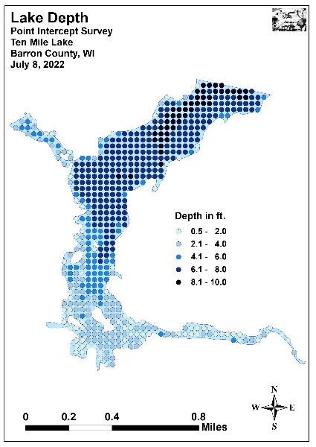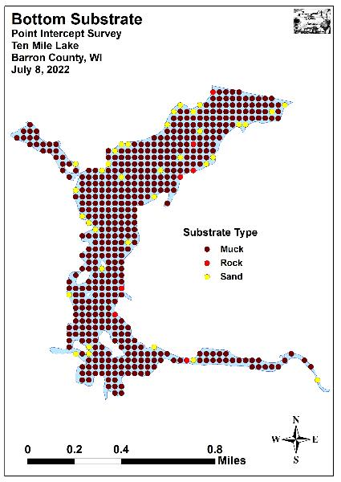
Figure 6: Lake Depth and Bottom Substrate
Table 2: Aquatic Macrophyte P/I Survey Summary Statistics
Ten Mile Lake - Barron County, WI
July 7-8, 2011 and July 8, 2022

Summary Statistics: | 2011 | 2022
Total number of points sampled | 529 | 529
Total number of sites with vegetation | 210 | 252
Total number of sites shallower than the maximum depth of plants | 315 | 529
Frequency of occurrence at sites shallower than maximum depth of plants | 66.7 | 47.6
Simpson Diversity Index | 0.89 | 0.90
Maximum depth of plants (ft) | 7.0 | 9.0
Mean depth of plants (ft) | 3.3 | 3.4
Median depth of plants (ft) | 3.3 | 3.0
Average number of all species per site (shallower than max depth) | 3.10 | 2.29
Average number of all species per site (veg. sites only) | 4.64 | 4.81
Average number of native species per site (shallower than max depth) | 2.92 | 2.23
Average number of native species per site (sites with native veg. only) | 4.47 | 4.68
Species richness | 29 | 26
Species richness (including visuals) | 30 | 32
Species richness (including visuals and boat survey) | 34 | 35
Mean rake fullness (veg. sites only) | 1.91 | 2.13

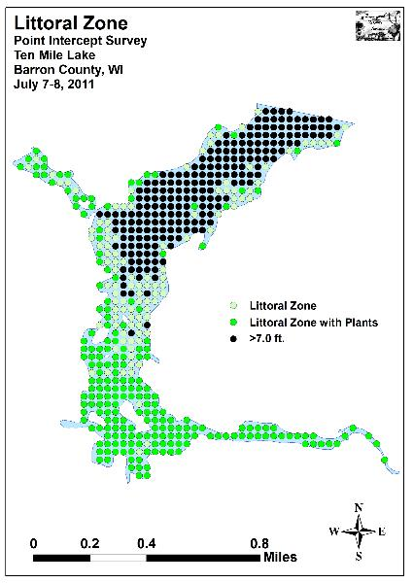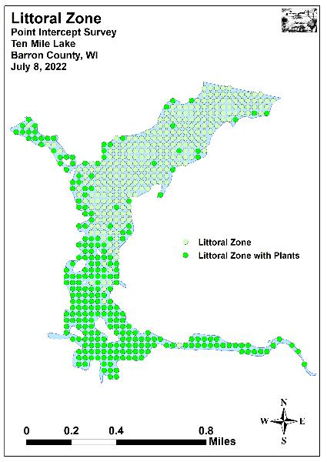
Figure 7: 2011 and 2022 Littoral Zone
Figure 8: 2011 and 2022 Plant Colonization Depth Chart

Plant diversity was high in 2022 with a Simpson Index value of 0.90 – up slightly from a moderately high 0.89 in 2011. However, total richness was only low/moderate with 26 species found in the rake (down from 29 in 2011). This total increased to 35 species when including visuals and plants seen during the boat survey – up slightly from the 34 total species we documented in 2011. Mean native species richness at sites with native vegetation saw a non-significant increase (p=0.15) from 4.47 species/site in 2011 to 4.68/site in 2022. Visual analysis of the maps showed most of these gains in richness occurred around the islands in the south bay (Figure 9) (Appendix V).

Total rake fullness experienced a moderately significant increase (p=0.001) from a moderate 1.91 in 2011 to a moderate 2.13 in 2022. Similar to the increases in local richness, most of the growth in biomass occurred in the southern bays and sloughs around the islands in areas that were dominated by CLP in 2011, but had only patchy CLP in 2022 (Figure 10) (Appendix V).

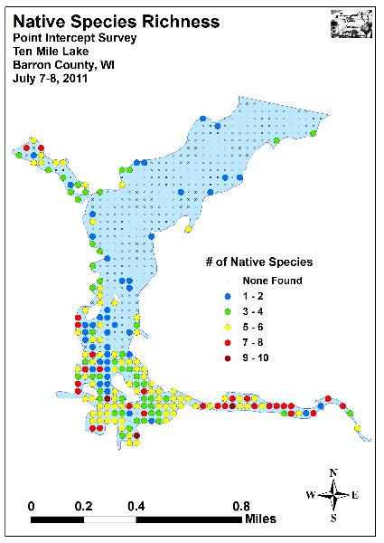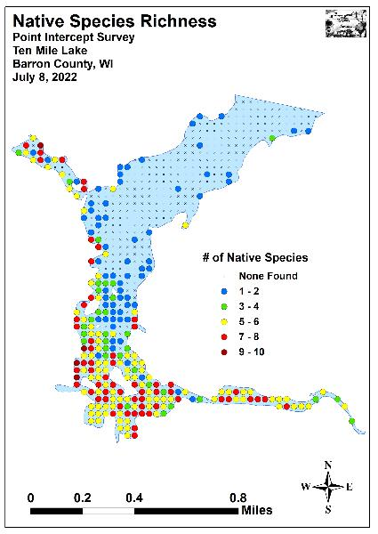
Figure 9: 2011 and 2022 Native Species Richness

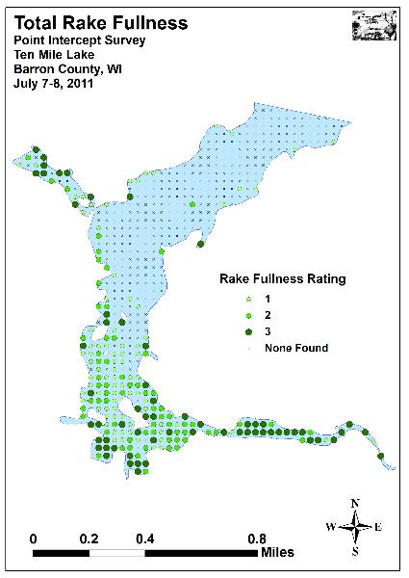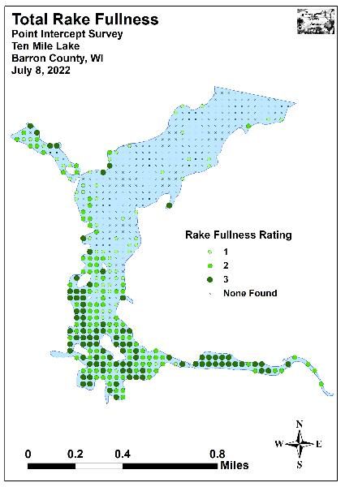
Figure 10: 2011 and 2022 Total Rake Fullness

Ten Mile Lake Plant Community:
The Ten Mile Lake ecosystem is home to a plant community that is typical of high-nutrient lakes with poor to very poor water clarity and quality. This community can be subdivided into four distinct zones (emergent, floating-leaf, shallow submergent, and deep submergent) with each zone having its own characteristic functions in the aquatic ecosystem. Depending on the local bottom type (sand, rock, sandy muck, or nutrient-rich organic muck), these zones often had somewhat different species present.

In shallow areas, beds of emergent plants prevent erosion by stabilizing the lakeshore, break up wave action, provide a nursery for baitfish and juvenile gamefish, offer shelter for amphibians, and give waterfowl and predatory wading birds like herons a place to hunt. These areas also provide important habitat for invertebrates like dragonflies and mayflies.

In disturbed areas at the water’s edge, the exotic species Reed canary grass (Phalaris arundinacea) was common along the lake’s developed shorelines. Exposed sandy and rocky areas near the shoreline had few emergents, but, in sheltered gravel and sandy areas, we found a few small beds of Common bur-reed (Sparganium eurycarpum) and, in the lake’s southwest sloughs, Hybrid cattail (Typha X glauca). Away from the immediate shoreline, shallow sand and sandy muck areas in the creek inlet supported patches of Short-stemmed bur-reed (Sparganium emersum) and Northern wild rice (Zizania palustris).

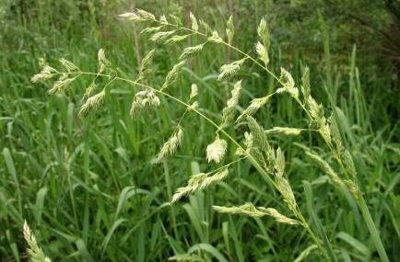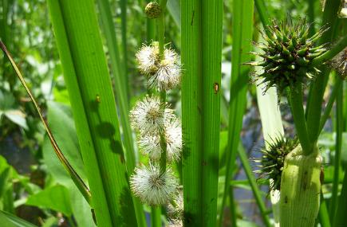
Reed canary grass (Collins 2017) Common bur-reed (Raymond 2011)

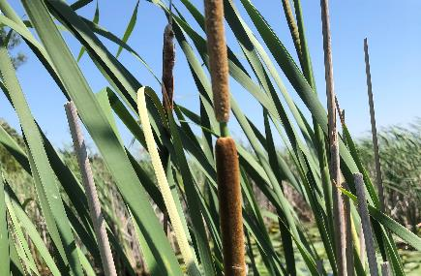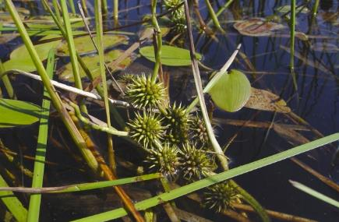
Hybrid cattail (Berg 2020) Short-stemmed bur-reed (Cameron 2016)

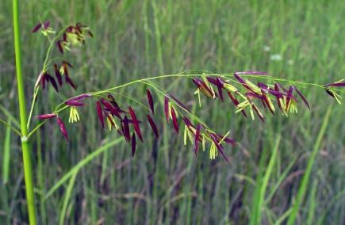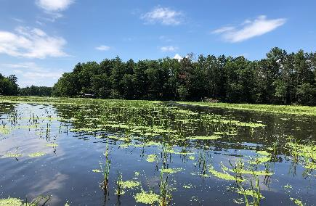
Northern wild rice inflorescence (Cameron 2017) Goose cropped Northern wild rice in the Ten Mile Creek Inlet 7/8/22

On the margins of the lake’s southern bays and sloughs in areas with more nutrient-rich organic muck, we found scattered patches of Wild calla (Calla palustris), Bottle brush sedge (Carex comosa), Bald spikerush (Eleocharis erythropoda), Common arrowhead (Sagittaria latifolia), Sessile-fruited arrowhead (Sagittaria rigida), and Softstem bulrush (Schoenoplectus tabernaemontani).

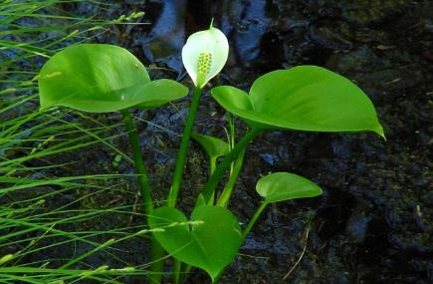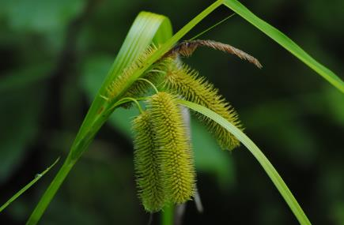
Wild calla (Pierce 2001) Bottle-brush sedge (Penta 2009)

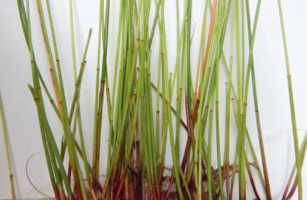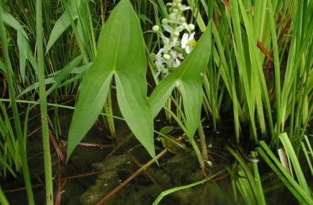
Bald spikerush (Schipper 2019) Common arrowhead (Young 2009)

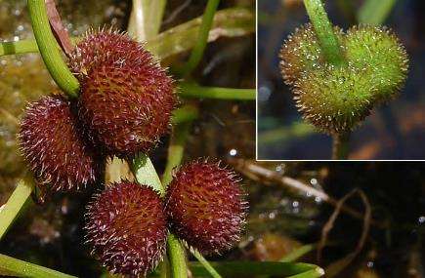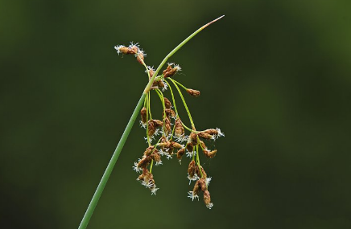
Sessile-fruited arrowhead (Chayka 2013) Softstem bulrush (Schwarz 2011)

Just beyond the emergents, in sheltered muck-bottomed areas in up to 4ft of water, the floating-leaf species Spatterdock (Nuphar variegata) and White-water lily (Nymphaea odorata) was common throughout. We also found a limited number of pondweeds that occasionally produce floating leaves in this habitat. They included Large-leaf pondweed (Potamogeton amplifolius), Ribbon-leaf pondweed (Potamogeton epihydrus), and Long-leaf pondweed (Potamogeton nodosus). In and around the Ten Mile Creek Inlet, we also found large numbers of Arum-leaved arrowhead (Sagittaria cuneata). The canopy cover these species provides is often utilized by panfish and bass for protection.

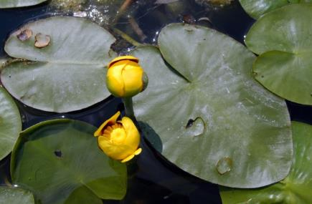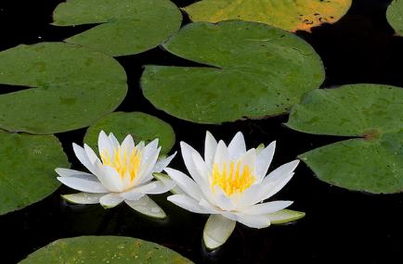
Spatterdock (CBG 2014) White water lily (Falkner 2011)

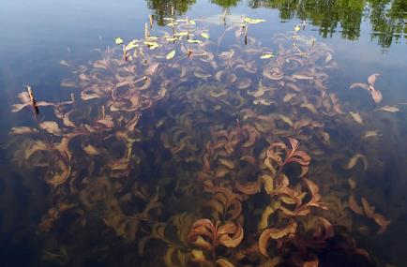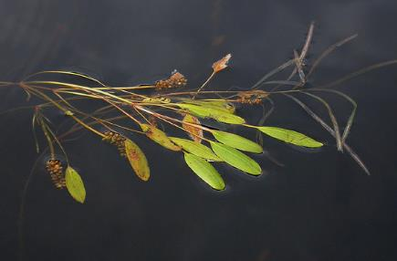
Large-leaf pondweed (Dziuk 2018) Ribbon-leaf pondweed (Petroglyph 2007)
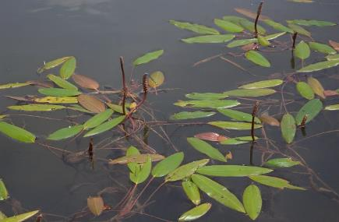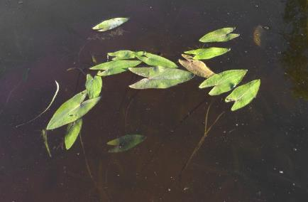
Long-leaf pondweed (Curtis 2010) Arum-leaved arrowhead (Cameron 2018)

Growing among the lilypads, we frequently encountered the submergent species Coontail (Ceratophyllum demersum) and Common waterweed (Elodea canadensis). In addition to these plants, a large number of “duckweeds” including Small duckweed (Lemna minor), Forked duckweed (Lemna trisulca), Large duckweed (Spirodela polyrhiza), and Common watermeal (Wolffia columbiana) were often found floating among the lilypads and emergents.

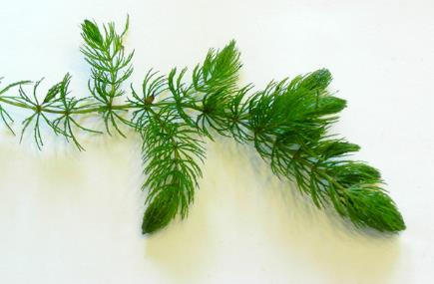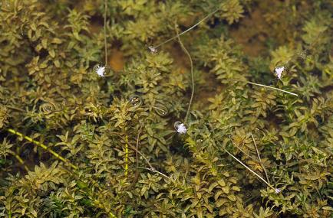
Coontail (Hassler 2011) Common waterweed (Fischer 2011)

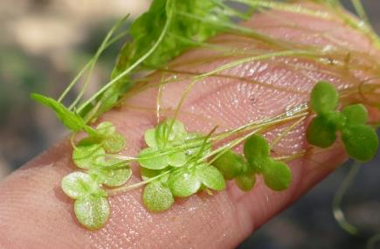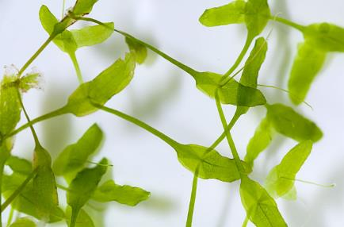
Small duckweed (Kramer 2013) Forked duckweed (Curtis 2010)

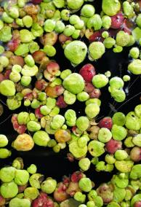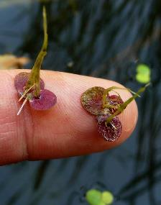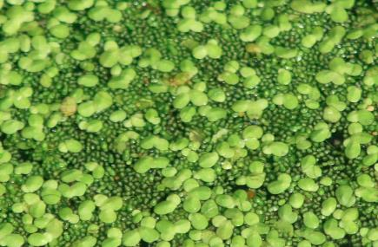
Large duckweed (Thomas 2022) Small duckweed and Common watermeal (Kieron 2011)

Although rare, Common bladderwort (Utricularia vulgaris) was also found in this environment. Rather than drawing nutrients up through roots like other plants, the carnivorous bladderworts trap zooplankton and minute insects in their bladders, digest their prey, and use the nutrients to further their growth.

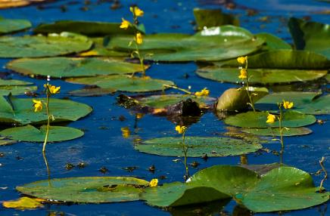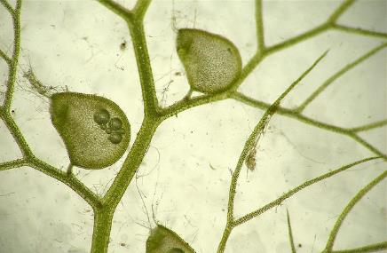
Common bladderwort flowers among lilypads (Hunt 2010) Bladders for catching plankton and insect larvae (Wontolla 2007)

Shallow rocky areas were almost entirely devoid of plants, and most pure sand and sandy-muck areas also had limiting rooted plant growth. Even when plants were present, these nutrient-poor substrates tended to have low total biomass as they provide habitat most suited to relatively fine-leaved species. In this environment, especially near the Ten Mile Creek Inlet, we found Muskgrass (Chara sp.), Water star-grass (Heteranthera dubia), Northern water-milfoil (Myriophyllum sibiricum), Slender naiad (Najas flexilis), Clasping-leaf pondweed (Potamogeton richardsonii), and Wild celery (Vallisneria americana). The roots, shoots, and seeds of these species are heavily utilized by both resident and migratory waterfowl for food. They also provide important habitat for the lake’s fish throughout their lifecycles, as well as a myriad of invertebrates like scuds, dragonfly and mayfly nymphs, and snails.

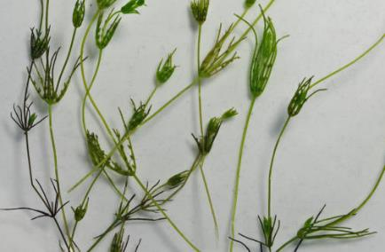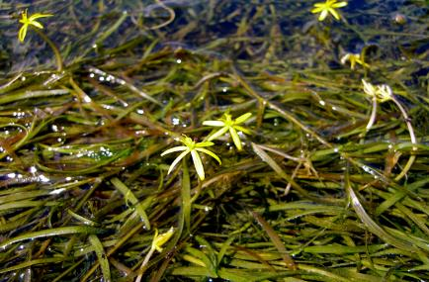
Muskgrass (Fischer 2018) Water star-grass (Mueller 2010)

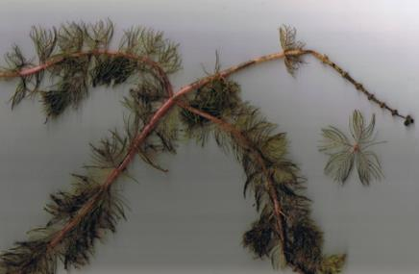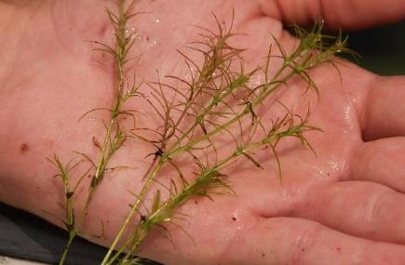
Northern water-milfoil (Berg 2007) Slender naiad (Cameron 2013)

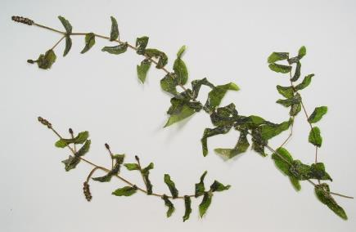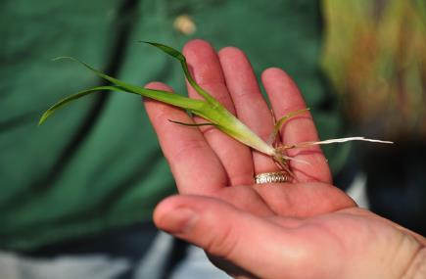
Clasping-leaf pondweed (Cameron 2014) Wild celery (Dalvi 2009)
Organic muck areas in water greater than 4ft were dominated by Coontail, Common waterweed, and, in the early spring, Curly-leaf pondweed. We also found Large-leaf pondweed, Small pondweed (Potamogeton pusillus), Fern pondweed (Potamogeton robbinsii), Flat-stem pondweed (Potamogeton zosteriformis), and Nitella (Nitella sp.) in this environment. Predatory fish like the lake’s pike are often found along the edges of these deeper beds waiting in ambush.

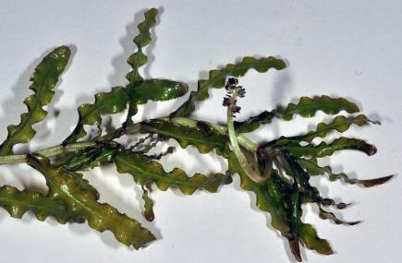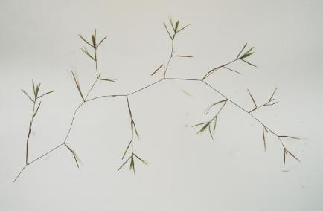
Curly-leaf pondweed (USGS 2022) Small pondweed (Cameron 2013)

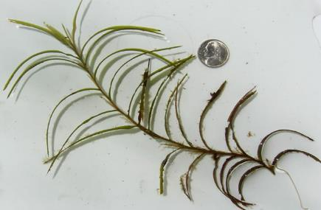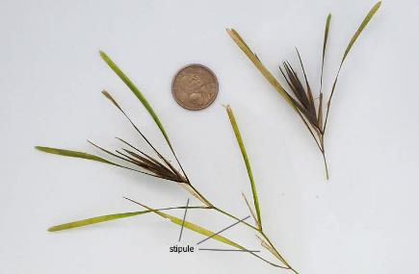
Fern pondweed (Apipp 2011) Flat-stem pondweed (Dziuk 2019)

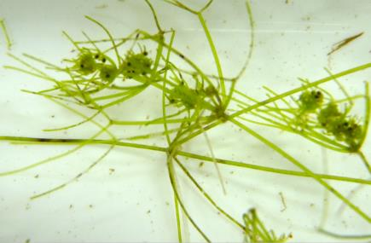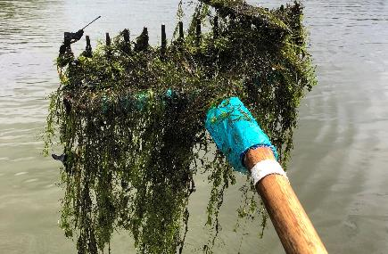
Nitella (USGS 2008) Rake of Nitella on Ten Mile Lake’s south side 7/8/22

Comparison of Native Macrophyte Species in 2011 and 2022:
In July 2011, Small duckweed, Large duckweed, Common watermeal, and Coontail were the most common macrophyte species (Table 3). They were present at 76.19%, 72.86%, 72.38%, and 58.10% of survey points with vegetation respectively and accounted for 60.21% of the total relative frequency. Flat-stem pondweed (7.69%), Curly-leaf pondweed (5.54%), and Fern pondweed (5.54%) also had relative frequencies over 4.00% (Maps for all native species found in July 2011 are located in Appendix VI).

In 2022, Coontail, Small duckweed, Common watermeal, and Large duckweed were the most common macrophyte species (Table 4). We found them at 66.67%, 64.29%, 64.29%, and 63.89% of sites with vegetation, and they captured 53.88% of the total relative frequency. Nitella (8.42%), White water lily (6.44%), Common waterweed (6.35%), and Flat-stem pondweed (5.28%) also had relative frequencies over 4.00% (Species accounts for all macrophytes found in the Chetek Chain in 2011 and 2022, and maps for all native species found in July 2022 are located in Appendixes VII and VIII).

Lakewide, 15 species showed significant changes in distribution from 2011 to 2022 (Figure 11). Common waterweed, White water lily, filamentous algae, Nitella, and Water star-grass enjoyed highly significant increases (p<0.001); and Short-stemmed bur-reed and Arum-leaved arrowhead saw moderately significant increases (p=0.001/p=0.006). Conversely, Curly-leaf pondweed and Blunt-leaf pondweed suffered highly significant declines (p<0.001); Small duckweed** underwent a moderately significant decline (p=0.006); and Large duckweed** (p=0.04), Flat-stem pondweed (p=0.02), Fern pondweed (p=0.01), Forked duckweed (p=0.02), and Stiff pondweed (p=0.01) all saw significant declines.

**Although found at more points than in 2011, several species “declined” statistically due to the significant expansion in the number of points in the littoral zone with plants. Based on the overall increase in vegetation from 2011 to 2022, these species should have expanded more than they did, hence the statistical “decline”.
-**
-*
+**
+**
+***
+***
+***
+***
+***
-*
-***
-*
-*
-***
-*
Significant differences = * p<0.05, ** p<0.01, *** p<0.001
Figure 11: Macrophytes Showing Significant Changes from 2011-2022

Table 3: Frequencies and Mean Rake Sample of Aquatic Macrophytes
Ten Mile Lake - Barron County, WI
July 7-8, 2011

Species | Common Name | Total  Sites | Relative Freq. | Freq. in Veg. | Freq. in Lit. | Mean Rake | Visual  Sight.
Lemna minor | Small duckweed | 160 | 16.41 | 76.19 | 50.79 | 2.09 | 0
Spirodela polyrhiza | Large duckweed | 153 | 15.69 | 72.86 | 48.57 | 1.78 | 0
Wolffia columbiana | Common watermeal | 152 | 15.59 | 72.38 | 48.25 | 1.73 | 0
Ceratophyllum demersum | Coontail | 122 | 12.51 | 58.10 | 38.73 | 1.57 | 6
Potamogeton zosteriformis | Flat-stem pondweed | 75 | 7.69 | 35.71 | 23.81 | 1.52 | 4
Potamogeton crispus | Curly-leaf pondweed | 54 | 5.54 | 25.71 | 17.14 | 1.31 | 8
Potamogeton robbinsii | Fern pondweed | 54 | 5.54 | 25.71 | 17.14 | 1.50 | 6
Elodea canadensis | Common waterweed | 36 | 3.69 | 17.14 | 11.43 | 1.28 | 1
Nymphaea odorata | White water lily | 31 | 3.18 | 14.76 | 9.84 | 1.65 | 5
Nuphar variegata | Spatterdock | 28 | 2.87 | 13.33 | 8.89 | 1.86 | 4
Potamogeton pusillus | Small pondweed | 27 | 2.77 | 12.86 | 8.57 | 1.48 | 0
 | Filamentous algae | 22 | * | 10.48 | 6.98 | 1.68 | 0
Potamogeton amplifolius | Large-leaf pondweed | 13 | 1.33 | 6.19 | 4.13 | 1.62 | 7
Potamogeton obtusifolius | Blunt-leaf pondweed | 11 | 1.13 | 5.24 | 3.49 | 1.45 | 0
Zizania palustris | Northern wild rice | 11 | 1.13 | 5.24 | 3.49 | 1.18 | 10
Nitella sp. | Nitella | 9 | 0.92 | 4.29 | 2.86 | 1.78 | 0
Lemna trisulca | Forked duckweed | 7 | 0.72 | 3.33 | 2.22 | 1.43 | 0
Heteranthera dubia | Water star-grass | 5 | 0.51 | 2.38 | 1.59 | 1.40 | 0
Potamogeton strictifolius | Stiff pondweed | 5 | 0.51 | 2.38 | 1.59 | 2.40 | 1
Sagittaria rigida | Sessile-fruited arrowhead | 4 | 0.41 | 1.90 | 1.27 | 1.25 | 2
Najas flexilis | Slender naiad | 3 | 0.31 | 1.43 | 0.95 | 1.33 | 0
Potamogeton epihydrus | Ribbon-leaf pondweed | 3 | 0.31 | 1.43 | 0.95 | 2.00 | 0
Potamogeton richardsonii | Clasping-leaf pondweed | 3 | 0.31 | 1.43 | 0.95 | 1.00 | 0
Potamogeton friesii | Fries' pondweed | 2 | 0.21 | 0.95 | 0.63 | 1.00 | 0

* Excluded from relative frequency analysis Exotic species in bold
Table 3: Frequencies and Mean Rake Sample of Aquatic Macrophytes
Ten Mile Lake - Barron County, WI
July 7-8, 2011

Species | Common Name | Total  Sites | Relative Freq. | Freq. in Veg. | Freq. in Lit. | Mean Rake | Visual  Sight.
Utricularia vulgaris | Common bladderwort | 2 | 0.21 | 0.95 | 0.63 | 1.50 | 0
 | Aquatic moss | 2 | * | 0.95 | 0.63 | 1.00 | 0
Calla palustris | Wild calla | 1 | 0.10 | 0.48 | 0.32 | 1.00 | 0
Eleocharis erythropoda | Bald spikerush | 1 | 0.10 | 0.48 | 0.32 | 3.00 | 0
Myriophyllum verticillatum | Whorled water-milfoil | 1 | 0.10 | 0.48 | 0.32 | 1.00 | 0
Sparganium eurycarpum | Common bur-reed | 1 | 0.10 | 0.48 | 0.32 | 2.00 | 1
Vallisneria americana | Wild celery | 1 | 0.10 | 0.48 | 0.32 | 2.00 | 0
Potamogeton nodosus | Long-leaf pondweed | ** | ** | ** | ** | ** | 1
Phalaris arundinacea | Reed canary grass | *** | *** | *** | *** | *** | ***
Sagittaria latifolia | Common arrowhead | *** | *** | *** | *** | *** | ***
Schoenoplectus tabernaemontani | Softstem bulrush | *** | *** | *** | *** | *** | ***
Typha latifolia | Broad-leaved cattail | *** | *** | *** | *** | *** | ***

* Excluded from relative frequency analysis ** Visual Only *** Boat survey only Exotic species in bold

Table 4: Frequencies and Mean Rake Sample of Aquatic Macrophytes
Ten Mile Lake - Barron County, WI
July 8, 2022

Species | Common Name | Total  Sites | Relative Freq. | Freq. in Veg. | Freq. in Lit. | Mean Rake | Visual  Sight.
Ceratophyllum demersum | Coontail | 168 | 13.86 | 66.67 | 31.76 | 1.58 | 9
Lemna minor | Small duckweed | 162 | 13.37 | 64.29 | 30.62 | 1.93 | 0
Wolffia columbiana | Common watermeal | 162 | 13.37 | 64.29 | 30.62 | 1.56 | 0
Spirodela polyrhiza | Large duckweed | 161 | 13.28 | 63.89 | 30.43 | 1.68 | 0
 | Filamentous algae | 142 | * | 56.35 | 26.84 | 1.88 | 0
Nitella sp. | Nitella | 102 | 8.42 | 40.48 | 19.28 | 1.63 | 0
Nymphaea odorata | White water lily | 78 | 6.44 | 30.95 | 14.74 | 1.50 | 36
Elodea canadensis | Common waterweed | 77 | 6.35 | 30.56 | 14.56 | 1.48 | 0
Potamogeton zosteriformis | Flat-stem pondweed | 64 | 5.28 | 25.40 | 12.10 | 1.36 | 10
Potamogeton robbinsii | Fern pondweed | 41 | 3.38 | 16.27 | 7.75 | 1.49 | 5
Heteranthera dubia | Water star-grass | 40 | 3.30 | 15.87 | 7.56 | 1.40 | 6
Potamogeton crispus | Curly-leaf pondweed | 33 | 2.72 | 13.10 | 6.24 | 1.06 | 8
Nuphar variegata | Spatterdock | 27 | 2.23 | 10.71 | 5.10 | 2.33 | 13
Potamogeton amplifolius | Large-leaf pondweed | 27 | 2.23 | 10.71 | 5.10 | 1.67 | 7
Potamogeton pusillus | Small pondweed | 24 | 1.98 | 9.52 | 4.54 | 1.13 | 1
Sparganium emersum | Short-stemmed bur-reed | 12 | 0.99 | 4.76 | 2.27 | 1.92 | 3
Sagittaria cuneata | Arum-leaved arrowhead | 9 | 0.74 | 3.57 | 1.70 | 1.89 | 2
Zizania palustris | Northern wild rice | 6 | 0.50 | 2.38 | 1.13 | 1.00 | 14
Sagittaria rigida | Sessile-fruited arrowhead | 5 | 0.41 | 1.98 | 0.95 | 1.20 | 4
Chara sp. | Muskgrass | 4 | 0.33 | 1.59 | 0.76 | 2.25 | 0
Utricularia vulgaris | Common bladderwort | 3 | 0.25 | 1.19 | 0.57 | 1.00 | 2
Najas flexilis | Slender naiad | 2 | 0.17 | 0.79 | 0.38 | 1.00 | 0

* Excluded from relative frequency analysis Exotic species in bold

Table 4 (continued): Frequencies and Mean Rake Sample of Aquatic Macrophytes
Ten Mile Lake - Barron County, WI
July 8, 2022

Species | Common Name | Total  Sites | Relative Freq. | Freq. in Veg. | Freq. in Lit. | Mean Rake | Visual  Sight.
Lemna trisulca | Forked duckweed | 1 | 0.08 | 0.40 | 0.19 | 1.00 | 0
Myriophyllum sibiricum | Northern water-milfoil | 1 | 0.08 | 0.40 | 0.19 | 1.00 | 0
Potamogeton richardsonii | Clasping-leaf pondweed | 1 | 0.08 | 0.40 | 0.19 | 2.00 | 1
Sparganium eurycarpum | Common bur-reed | 1 | 0.08 | 0.40 | 0.19 | 1.00 | 2
Typha X glauca | Hybrid cattail | 1 | 0.08 | 0.40 | 0.19 | 1.00 | 2
Calla palustris | Wild calla | ** | ** | ** | ** | ** | 1
Carex comosa | Bottle brush sedge | ** | ** | ** | ** | ** | 1
Eleocharis erythropoda | Bald spikerush | ** | ** | ** | ** | ** | 1
Phalaris arundinacea | Reed canary grass | ** | ** | ** | ** | ** | 2
Potamogeton epihydrus | Ribbon-leaf pondweed | ** | ** | ** | ** | ** | 1
Schoenoplectus tabernaemontani | Softstem bulrush | ** | ** | ** | ** | ** | 2
Potamogeton nodosus | Long-leaf pondweed | *** | *** | *** | *** | *** | ***
Sagittaria latifolia | Common arrowhead | *** | *** | *** | *** | *** | ***
Vallisneria americana | Wild celery | *** | *** | *** | *** | *** | ***

** Visual Only *** Boat survey only Exotic species in bold

Found throughout the lake’s organic muck bottom bays, Coontail was the fourth most common species in 2011 and the most common in 2022 (Figure 12). Its distribution underwent a nearly significant increase (p=0.05) from 122 sites in 2011 to 168 sites in 2022; however, its mean density was almost unchanged (mean rake fullness of 1.57 in 2011/1.58 in 2022). Most expansion occurred in areas of the south bays that CLP had dominated in 2011 but was reduced or absent in during the 2022 survey.

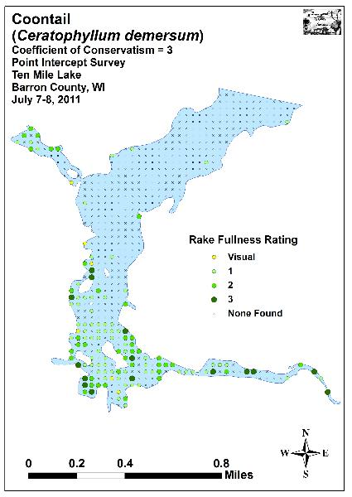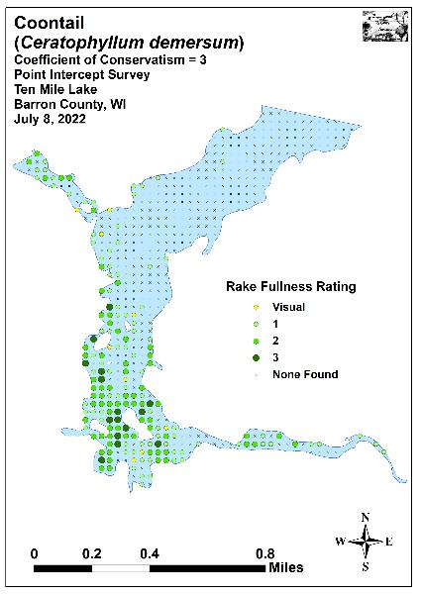
Figure 12: 2011 and 2022 Coontail Density and Distribution

Flat-stem pondweed was the fifth most common macrophyte in 2011 (75 sites) before falling to the eight most common in 2022 (64 sites) (Figure 13). This decline in distribution was significant (p=0.02), but the accompanying decline in density from a mean rake of 1.52 in 2011 to a mean rake of 1.36 in 2022 was only nearly significant (p=0.06).

Fern pondweed was the seventh most common macrophyte in 2011, but just the ninth most common 2022. It also suffered a significant decline (p=0.01) in coverage from 54 sites in 2011 to 41 sites in 2022 (Figure 14). Despite these loses in coverage, its mean density was almost unchanged from 1.50 in 2011 to 1.49 in 2022.

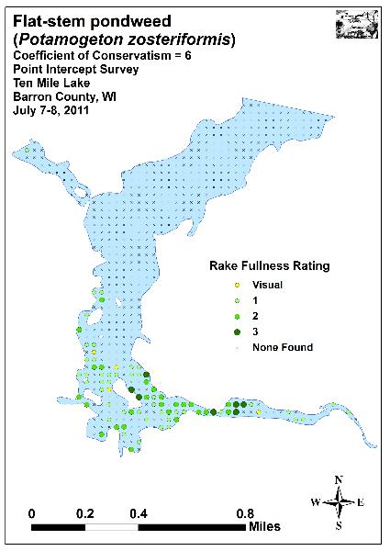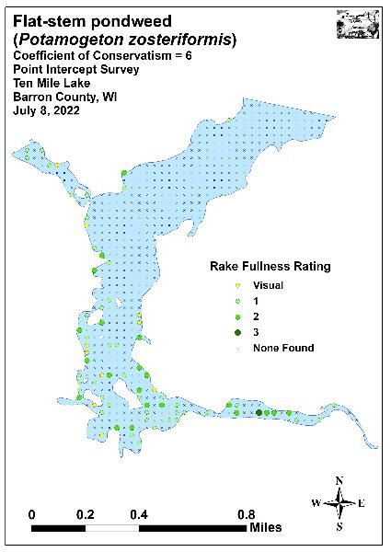
Figure 13: 2011 and 2022 Flat-stem Pondweed Density and Distribution

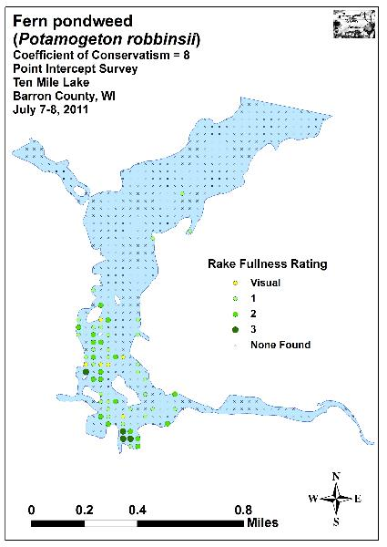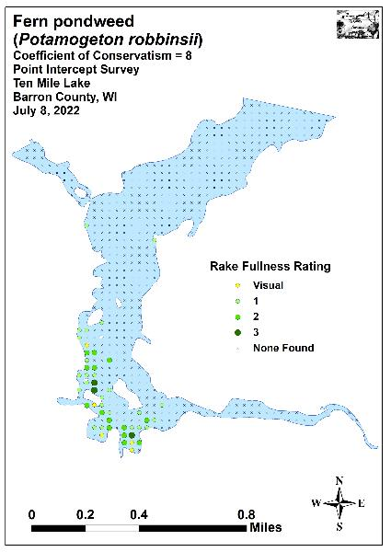
Figure 14: 2011 and 2022 Fern Pondweed Density and Distribution

Common waterweed underwent a highly significant expansion (p<0.001) in distribution as it increased from the eighth-ranked species in 2011 (36 sites) to the seventh-ranked species in 2022 (77 sites) (Figure 15). Its accompanying increase in density from a mean rake fullness of 1.28 in 2011 to 1.48 in 2022 was also significant (p=0.04).

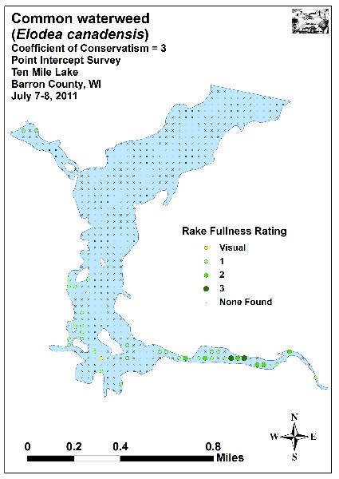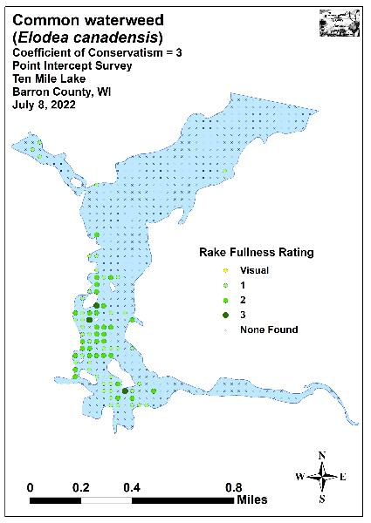
Figure 15: 2011 and 2022 Common Waterweed Density and Distribution

The important habitat-producing species White water lily and Spatterdock were the ninth and tenth ranked species in 2011. White water lily underwent a highly significant increase (p<0.001) in distribution (31 sites in 2011/78 sites in 2022) as it jumped to the sixth-ranked species (Figure 16). Despite the increase in distribution, its density fell from a mean rake of 1.65 in 2011 to 1.50 in 2022; however, this was not significant (p=0.18). Spatterdock fell in rank to the twelfth most common species as it declined in distribution from 28 sites in 2011 to 27 sites in 2022 (Figure 17). Although this was not significant (p=0.18), its increase in density from a mean rake of 1.86 in 2011 to 2.33 in 2022 was significant (p=0.02).

Largely restricted to the Ten Mile Creek Inlet and south bays during the original 2011 survey, both Nitella (nine sites/mean rake fullness of 1.40) (Figure 18) and Water star-grass (five sites/mean rake fullness of 1.78) (Figure 19) were relatively uncommon when then were just the fifteenth and seventeenth most common species. In 2022, both underwent highly significant increases (p<0.008) in distribution as Nitella jumped to the fifth most common species (102 sites) and Water star-grass became the tenth most common (40 sites). Despite their increases in coverage, Nitella saw a non-significant increase in density (p=0.31) to a mean rake of 1.63, and Water star-grass was unchanged with a mean rake of 1.40.

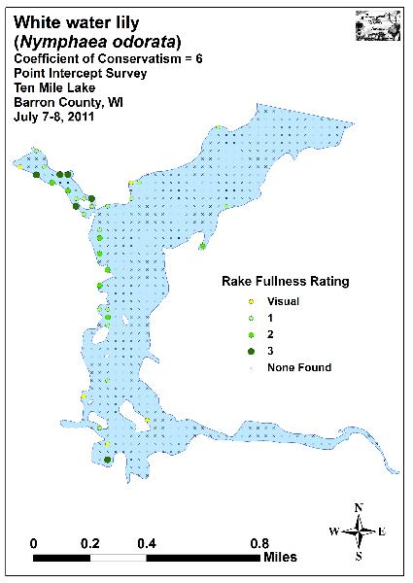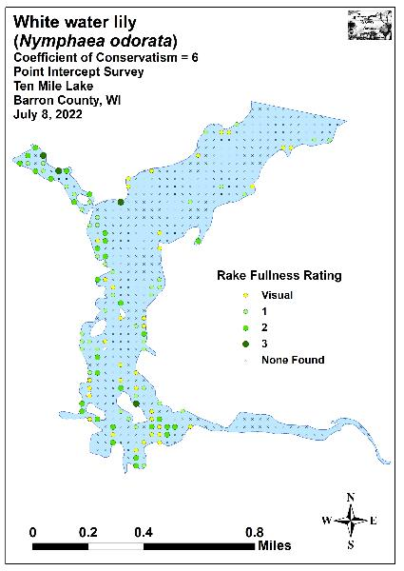
Figure 16: 2011 and 2022 White Water Lily Density and Distribution

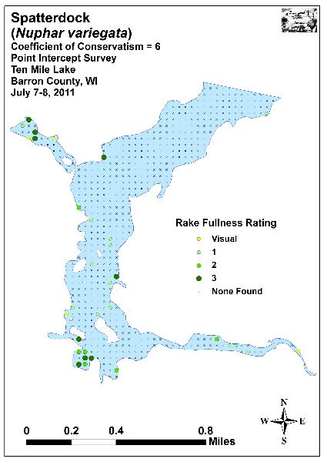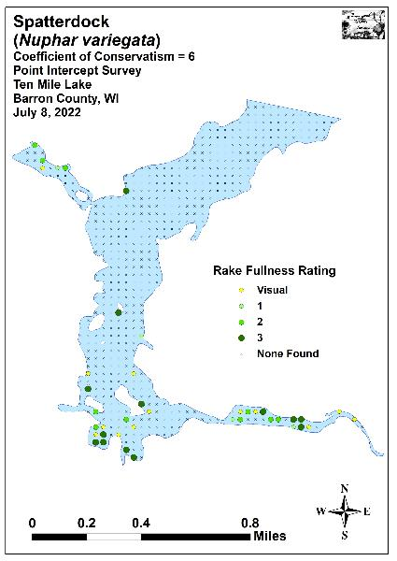
Figure 17: 2011 and 2022 Spatterdock Density and Distribution
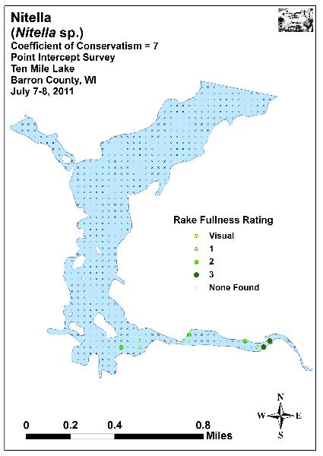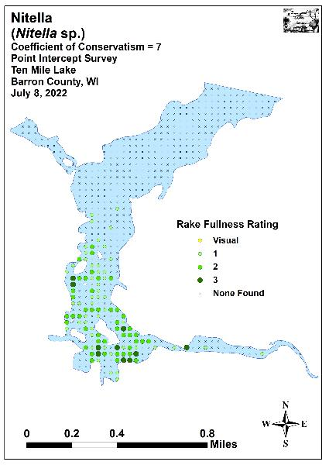
Figure 18: 2011 and 2022 Nitella Density and Distribution

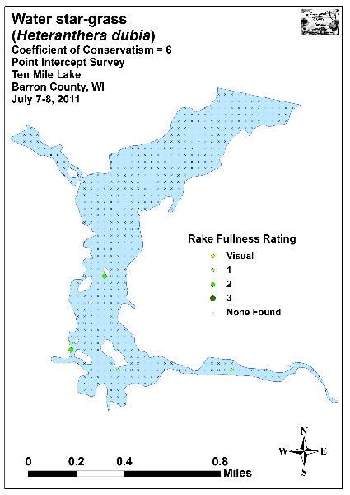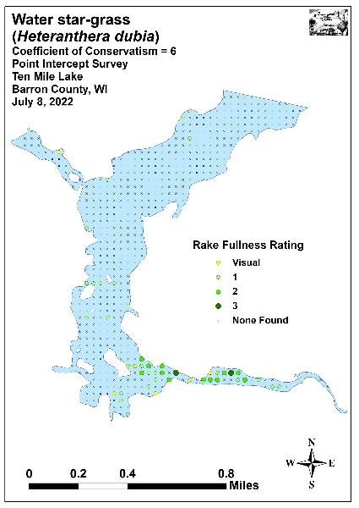
Figure 19: 2011 and 2022 Water Star-grass Density and Distribution

Comparison of Floristic Quality Indexes in 2011 and 2022:
In 2011, we identified a total of 28 native index species in the rake during the point-intercept survey (Table 5). They produced a mean Coefficient of Conservatism of 6.3 and a Floristic Quality Index of 33.4.

Table 5: Floristic Quality Index of Aquatic Macrophytes
Ten Mile Lake - Barron County, WI
July 7-8, 2011

Species | Common Name | C
Calla palustris | Wild calla | 9
Ceratophyllum demersum | Coontail | 3
Eleocharis erythropoda | Bald spikerush | 3
Elodea canadensis | Common waterweed | 3
Heteranthera dubia | Water star-grass | 6
Lemna minor | Small duckweed | 4
Lemna trisulca | Forked duckweed | 6
Myriophyllum verticillatum | Whorled water-milfoil | 8
Najas flexilis | Slender naiad | 6
Nitella sp. | Nitella | 7
Nuphar variegata | Spatterdock | 6
Nymphaea odorata | White water lily | 6
Potamogeton amplifolius | Large-leaf pondweed | 7
Potamogeton epihydrus | Ribbon-leaf pondweed | 8
Potamogeton friesii | Fries' pondweed | 8
Potamogeton obtusifolius | Blunt-leaf pondweed | 9
Potamogeton pusillus | Small pondweed | 7
Potamogeton richardsonii | Clasping-leaf pondweed | 5
Potamogeton robbinsii | Fern pondweed | 8
Potamogeton strictifolius | Stiff pondweed | 8
Potamogeton zosteriformis | Flat-stem pondweed | 6
Sagittaria rigida | Sessile-fruited arrowhead | 8
Sparganium eurycarpum | Common bur-reed | 5
Spirodela polyrhiza | Large duckweed | 5
Utricularia vulgaris | Common bladderwort | 7
Vallisneria americana | Wild celery | 6
Wolffia columbiana | Common watermeal | 5
Zizania palustris | Northern wild rice | 8
N |  | 28
Mean C |  | 6.3
FQI |  | 33.4

During the 2022 survey, we found a total of 24 native index plants in the rake during the point-intercept survey. They produced a mean Coefficient of Conservatism of 6.1 and a Floristic Quality Index of 29.8 (Table 6). Nichols (1999) reported an average mean C for the North Central Hardwood Forests Region of 5.6 putting Ten Mile Lake above average for this part of the state. The FQI was also above the median FQI of 20.9 for the North Central Hardwood Forests (Nichols 1999).

Table 6: Floristic Quality Index of Aquatic Macrophytes
Ten Mile Lake - Barron County, WI
July 8, 2022

Species | Common Name | C
Ceratophyllum demersum | Coontail | 3
Chara sp. | Muskgrass | 7
Elodea canadensis | Common waterweed | 3
Heteranthera dubia | Water star-grass | 6
Lemna minor | Small duckweed | 4
Lemna trisulca | Forked duckweed | 6
Myriophyllum sibiricum | Northern water-milfoil | 6
Najas flexilis | Slender naiad | 6
Nitella sp. | Nitella | 7
Nuphar variegata | Spatterdock | 6
Nymphaea odorata | White water lily | 6
Potamogeton amplifolius | Large-leaf pondweed | 7
Potamogeton pusillus | Small pondweed | 7
Potamogeton richardsonii | Clasping-leaf pondweed | 5
Potamogeton robbinsii | Fern pondweed | 8
Potamogeton zosteriformis | Flat-stem pondweed | 6
Sagittaria cuneata | Arum-leaved arrowhead | 7
Sagittaria rigida | Sessile-fruited arrowhead | 8
Sparganium emersum | Short-stemmed bur-reed | 8
Sparganium eurycarpum | Common bur-reed | 5
Spirodela polyrhiza | Large duckweed | 5
Utricularia vulgaris | Common bladderwort | 7
Wolffia columbiana | Common watermeal | 5
Zizania palustris | Northern wild rice | 8
N |  | 24
Mean C |  | 6.1
FQI |  | 29.8

Comparison of Northern Wild Rice in 2011 and 2022:
Northern wild rice, a plant of significant wildlife and cultural value, occurred throughout the Ten Mile Creek Inlet (Figure 20). During the 2011 survey, we found rice at 11 points with ten additional visual sightings. In 2022, rice was present in the rake at just six points with 14 additional visual sightings. Both the decline in distribution and the accompanying drop in density from a mean rake fullness of 1.18 in 2011 to a mean of 1.00 in 2022 were nearly but not significant (p=0.10/p=0.08).

Although we saw what were likely 1,000’s of rice plants during each survey, they all appeared to be “goose cropped” making it unclear if the majority of them would produce grain. This likely meant that there was no potential for human harvest, and, even if densities increased in the future, the fact that almost all rice occurred in mud flats that were less than 2ft deep would have made accessing the beds in a canoe difficult to impossible. Because of these factors, it’s likely that the beds will continue to be what they have been – a great benefit to wildlife, but inaccessible to human harvest.

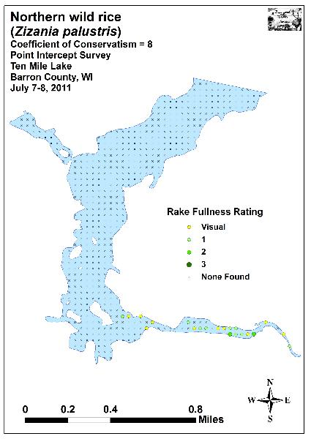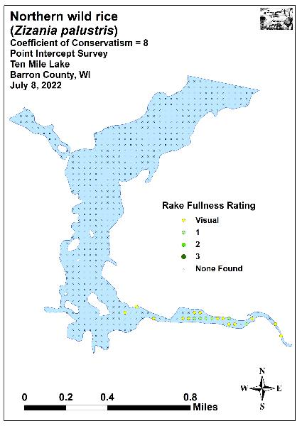
Figure 20: 2011 and 2022 Northern Wild Rice Density and Distribution

Comparison of Filamentous Algae in 2011 and 2022:
Filamentous algae and floating algae are normally associated with excessive nutrients in the water column, and both were common to abundant throughout the lake during each survey (Figure 21). In 2011, we found filamentous algae at 22 points with a mean rake fullness of 1.68. During the 2022 survey, we documented a highly significant expansion (p<0.001) in distribution to 142 points, and a nearly-significant increase (p=0.10) in density to a mean rake fullness of 1.88. We noted that floating mats of algae and duckweeds dominated many areas of the southern bays and sloughs. These mats made boating difficult as strands of algae tended to foul the water intakes on our motor. Because of this, we ended up using a kayak to survey much of this area (see front cover of the report).

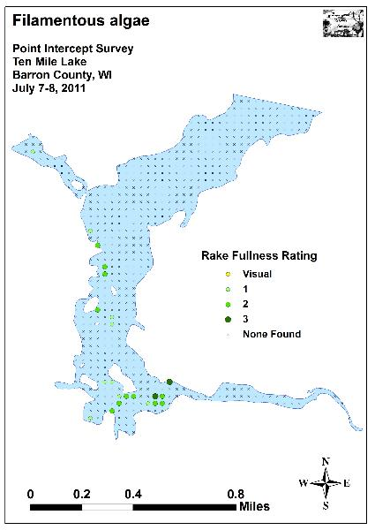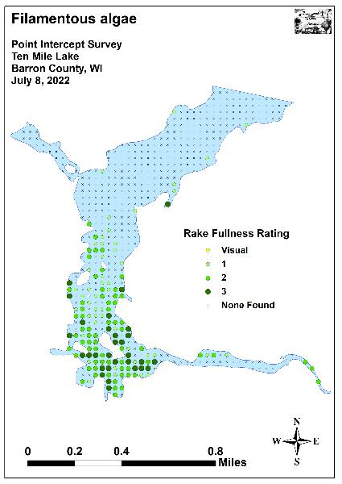
Figure 21: 2011 and 2022 Filamentous Algae Density and Distribution

Comparison of July Curly-leaf Pondweed in 2011 and 2022:
Curly-leaf pondweed normally completes its annual life cycle by late June, and most plants have set turions and senesced by early July. In Ten Mile Lake, this senescence was typical as we continued to find scattered CLP plants into July during both surveys, but at much reduced densities compared to the spring surveys.

In 2011, CLP was still tied for the sixth most common macrophyte (54 sites) found during the July survey. This extrapolated to 10.2% coverage of the entire lake and 17.1% of the then 7.0ft summer littoral zone. Of these, we found five had a rake fullness value of 3, seven rated a 2, and the remaining 42 were a 1 for a combined mean rake fullness of 1.31. We also noted CLP as a visual at eight points. The 12 points with a rake fullness of a 2 or a 3 suggested 2.3% of the entire lake and 3.8% of the littoral zone still had a significant infestation (Figure 22) (Appendix IX).

The 2022 July survey found CLP at 33 points (6.2% of the entire lake/9.0ft summer littoral zone) with eight additional visual sightings. No points rated a rake fullness of 3, two were a 2 (0.4% significant infestation), and the other 31 rated a 1 for a combined mean rake fullness of 1.06 (Figure 22) (Appendix IX). These results suggested that, from July 2011-2022, summer CLP had undergone a highly significant decline (p<0.001) in distribution; a moderately significant decline (p=0.005) in mean density; and a significant decline in rake fullness 3 (p=0.01), rake fullness 2 (p<0.05), and rake fullness 1 (p=0.02) (Figure 23).

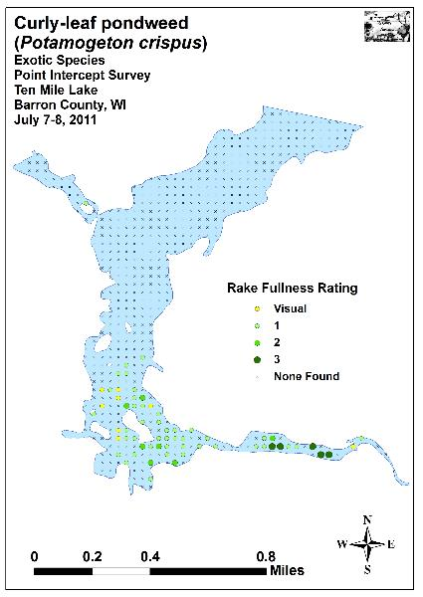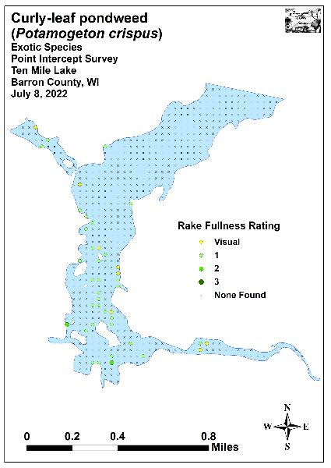
Figure 22: 2011 and 2022 July CLP Density and Distribution
-*
-*
-*
-***
Significant differences = * p<0.05, ** p<0.01, *** p<0.001
Figure 23: 2011 and 2022 Changes in July CLP Rake Fullness

Other Exotic Plant Species:
We did NOT find any evidence or Eurasian water-milfoil in Ten Mile Lake during any of our surveys. However, in addition to Curly-leaf pondweed, we documented two other exotic species growing around the lake: Reed canary grass and Hybrid cattail. Despite only being recorded as a visual at two points (Figure 24), Reed canary grass was often a dominant plant just beyond the lakeshore in adjacent wetlands and next to mowed or otherwise disturbed shoreline areas. A ubiquitous plant in the state, there’s likely little that can be done about it (Appendix IX).

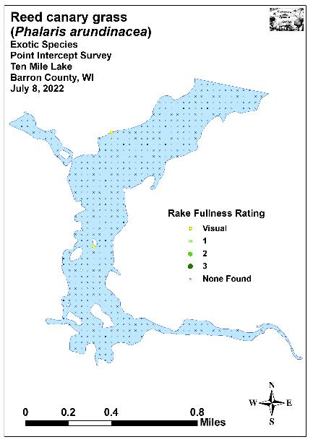
Figure 24: 2011 and 2022 Reed Canary Grass Density and Distribution

Native to southern but not northern Wisconsin, Narrow-leaved cattail (Typha angustifolia) and its hybrids with Broad-leaved cattail are becoming increasingly common in Barron County where they also tend to be invasive. Present at a single point with two additional visual sightings, we found several large monotypic stands had established along the shoreline in the lake’s southeastern bays and sloughs as well as in scattered patches on the eastern shoreline (Figure 25) (Appendix IX).

Besides having narrower leaves, the exotics can be told from our native cattails by having a relatively narrower and longer “hotdog-shaped” tan female cattail flower, whereas our native species tends to produce a fatter and shorter “bratwurst-shaped” dark chocolate colored female flower. Narrow-leaved cattail and its hybrids also have a male flower that is separated from the female flower by a thin green stem while the native Broad-leaved cattail has its male and female flowers connected (Figure 26) (Maps for all exotic species found in July 2011 and 2022 and additional information on a sampling of aquatic exotic invasive plant species can be found in Appendix IX).
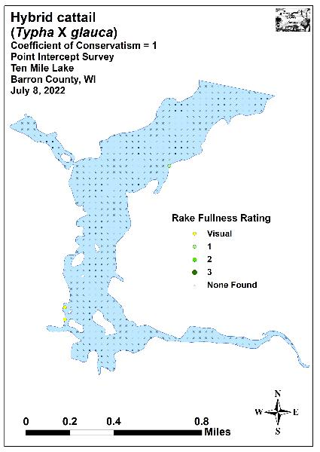
Figure 25: 2022 Hybrid Cattail Density and Distribution

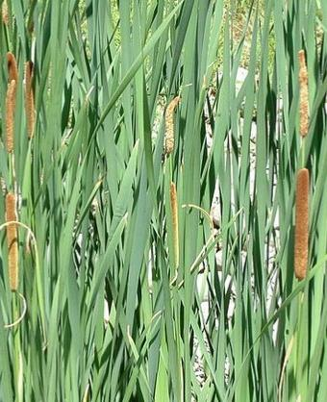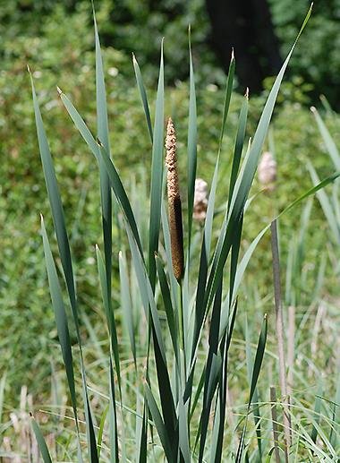
Figure 26: Exotic Hybrid and Native Broad-leaved Cattail Identification
DISCUSSION AND CONSIDERATIONS FOR MANAGEMENT:
Water Clarity, Nutrient Inputs, and the Role of Native Macrophytes:
Like trees in a forest, a lake’s native plants are the basis of the aquatic ecosystem. They capture the sun’s energy and turn it into usable food, “clean” the water of excess nutrients, and provide habitat for other organisms like aquatic invertebrates and the lake’s fish populations. Because of this, preserving them is critical to maintaining the lake’s overall health. Unfortunately, when phosphorus and nitrogen levels exceed what the lake’s macrophytes can utilize, it tends to promote algae blooms which impact these sensitive species as well as general lake esthetics.

Although upstream agricultural runoff can be a major contributor to a lake’s overall nutrient load, soil erosion and nutrient inputs from along the immediate lakeshore can also have significant impacts. Because of this, all lake residents have the opportunity to help reduce runoff by evaluating how their shoreline practices may be affecting the lake. Simple things like establishing or maintaining their own buffer strip of native vegetation along the shore to prevent erosion, building rain gardens, bagging grass clippings, switching to a phosphorus-free fertilizer or preferably eliminating fertilizer near the lake altogether, collecting pet waste, and disposing of the ash from fire pits away from the lakeshore can all significantly reduce the amount of nutrients entering the ecosystem. Hopefully, a greater understanding of how all property owners can have lakewide impacts will result in more people taking appropriate conservation actions to not only help improve water clarity and quality, but also to benefit the lake’s important habitat-producing native plant species.

Northern Wild Rice Management:
Despite being largely off limits to human use and access because they are so shallow, the Ten Mile Creek Inlet’s wild rice beds are one of the most important habitats on the lake for wildlife. The rice serves as an important “nursery” for both baitfish and juvenile gamefish – a place where they can feed on plankton and insects while avoiding most predators. Specifically, we noticed schools of young of the year and yearling bluegills, crappies, bass and pike utilizing these plant beds. In addition to fish, rice shoots are fed on by geese and muskrats throughout the growing season, and the seeds are an important food sources for migrating birds. The current marked navigation channel through the area seems to allow owner access while maintaining this hot spot of diversity.

Curly-leaf Pondweed Management:
During both our 2011 and 2022 early-season surveys, we found that Curly-leaf pondweed was the dominant species in much of the southern half of the lake where it severely impaired navigation. Elsewhere, although CLP beds were occasionally dense, they were generally small enough that watercraft could likely navigate around them. Even in the south bay, by July, we noted that other native species (predominantly Coontail and Common waterweed in 2022) had recolonized most of the areas CLP occupied earlier in the growing season. This suggests that CLP’s growth is not excluding the native community.

Ultimately, if mechanical removal and/or herbicide treatments are decided on to control CLP as part of the updated APMP, we strongly encourage the CLPA to adopt management goals that focus on small-scale management to relieve navigation impairment rather than a large-scale blanket treatment. By taking a measured approach, it is less likely that any management would collaterally damage the lake’s native vegetation and the important habitat this community provides; especially as these plant beds relate to the lake’s fish populations.

LITERATURE CITED

Borman, S., R. Korth, and J. Temte 1997. Through the Looking Glass…A Field Guide to Aquatic Plants. Wisconsin Lakes Partnership. DNR publication FH-207-97.

Chadde, Steve W. 2002. A Great Lakes Wetland Flora: A complete guide to the aquatic and wetland plants of the Upper Midwest. Pocketflora Press; 2nd edition

Crow, G. E., C. B. Hellquist. 2005. Aquatic and Wetland Plants of Northeastern North America, Volume I + II: A Revised and Enlarged Edition of Norman C. Fassett's A Manual of Aquatic Plants. University of Wisconsin Press.

Nichols, Stanley A. 1999. Floristic Quality Assessment of Wisconsin Lake Plant communities with Example Applications. Journal of Lake and Reservoir Management 15 (2): 133-141.

Sather, L., R. Hopke, M. Perkins, and E. Eaton. [online]. 1964. Ten Mile Lake Bathymetric Map. Available from https://dnr.wi.gov/lakes/maps/DNR/2089500a.pdf (2022, November).

Skawinski, Paul. 2019. Aquatic Plants of the Upper Midwest: A photographic field guide to our underwater forests. 4th Edition, Wausau, WI.

Sullman, Josh. [online] 2010. Sparganium of Wisconsin Identification Key and Description. Available from University of Wisconsin-Madison http://www.botany.wisc.edu/jsulman/Sparganium%20identification%20key%20and%20description.htm (2016, July).

UWEX Lakes Program. [online]. 2010. Pre/Post Herbicide Comparison. Available from http://www.uwsp.edu/cnr-ap/UWEXLakes/Documents/ecology/Aquatic%20Plants/Appendix-D.pdf (2022, November).

Voss, Edward G. 1996. Michigan Flora Vol I-III. Cranbrook Institute of Science and University of Michigan Herbarium.

WDNR. [online]. 2022. Citizen Lake Monitoring Water Quality Data Report for Ten Mile Lake. https://dnr.wi.gov/lakes/waterquality/Station.aspx?id=033152 (2022, December)

WDNR. [online]. 2010. Curly-leaf pondweed fact sheet. http://dnr.wi.gov/invasives/fact/curlyleaf_pondweed.htm (2010, August).

WDNR. [online]. 2010. Eurasian Water-milfoil fact sheet. http://dnr.wi.gov/invasives/fact/milfoil.htm (2010, August).

WDNR. [online]. 2022. Lake Information Pages for Ten Mile Lake. https://dnr.wi.gov/lakes/lakepages/LakeDetail.aspx?wbic=2089500 (2022, December)

WDNR. [online]. 2010. Purple loosestrife fact sheet. http://dnr.wi.gov/invasives/fact/loosestrife.htm (2010, August).

WDNR. [online]. 2010. Reed canary grass fact sheet. http://dnr.wi.gov/invasives/fact/reed_canary.htm (2010, August).

Appendix I: Survey Sample Points Map
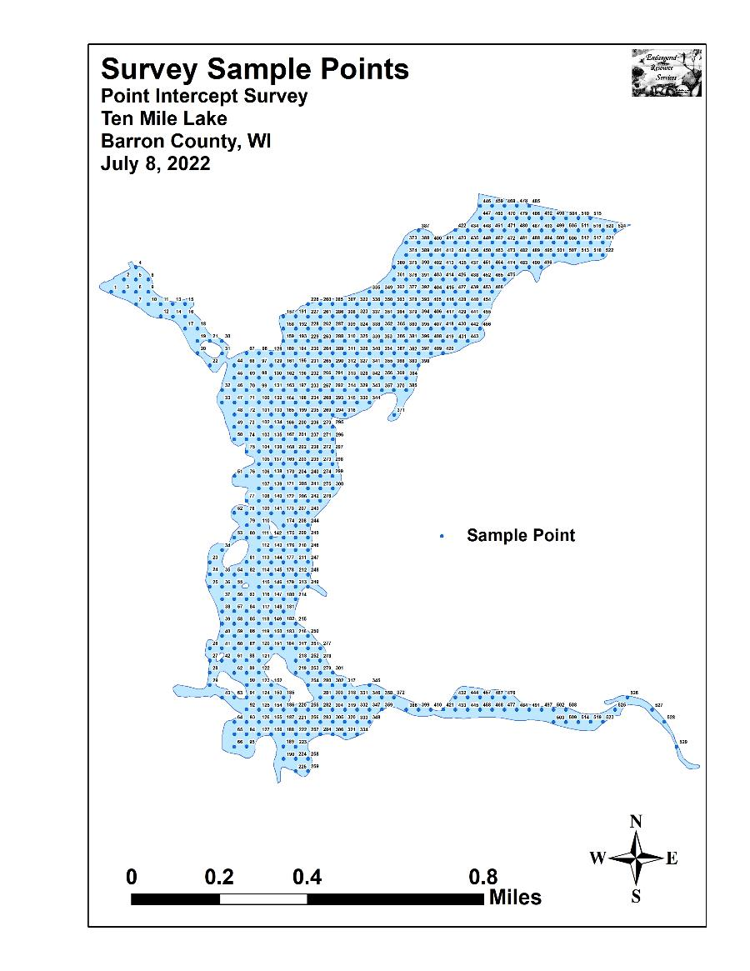

Appendix II: Boat and Vegetative Survey Datasheets

Boat Survey
Lake Name
County
WBIC
Date of Survey
(mm/dd/yy)
workers
Nearest Point | Species seen, habitat information

Observers for this lake: names and hours worked by each:
Lake: |  |  |  |  |  |  |  |  | WBIC |  |  |  |  |  |  |  |  | County |  |  |  |  |  | Date:
Site # | Depth (ft) | Muck (M), Sand (S), Rock (R) | Rake pole (P) or rake rope (R) | Total Rake Fullness | EWM | CLP | 1 | 2 | 3 | 4 | 5 | 6 | 7 | 8 | 9 | 10 | 11 | 12 | 13 | 14 | 15 | 16 | 17 | 18 | 19
1
2
3
4
5
6
7
8
9
10
11
12
13
14
15
16
17
18
19
20

Appendix III: 2011 and 2022 Early-season
CLP Density and Distribution and CLP Bed Maps
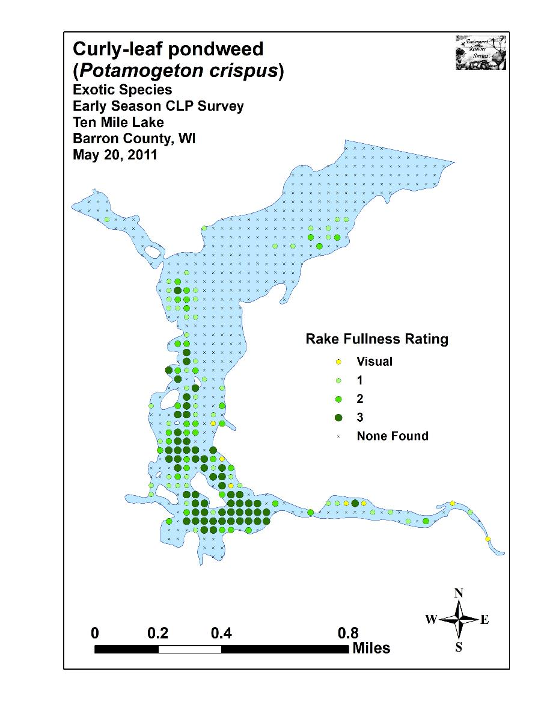
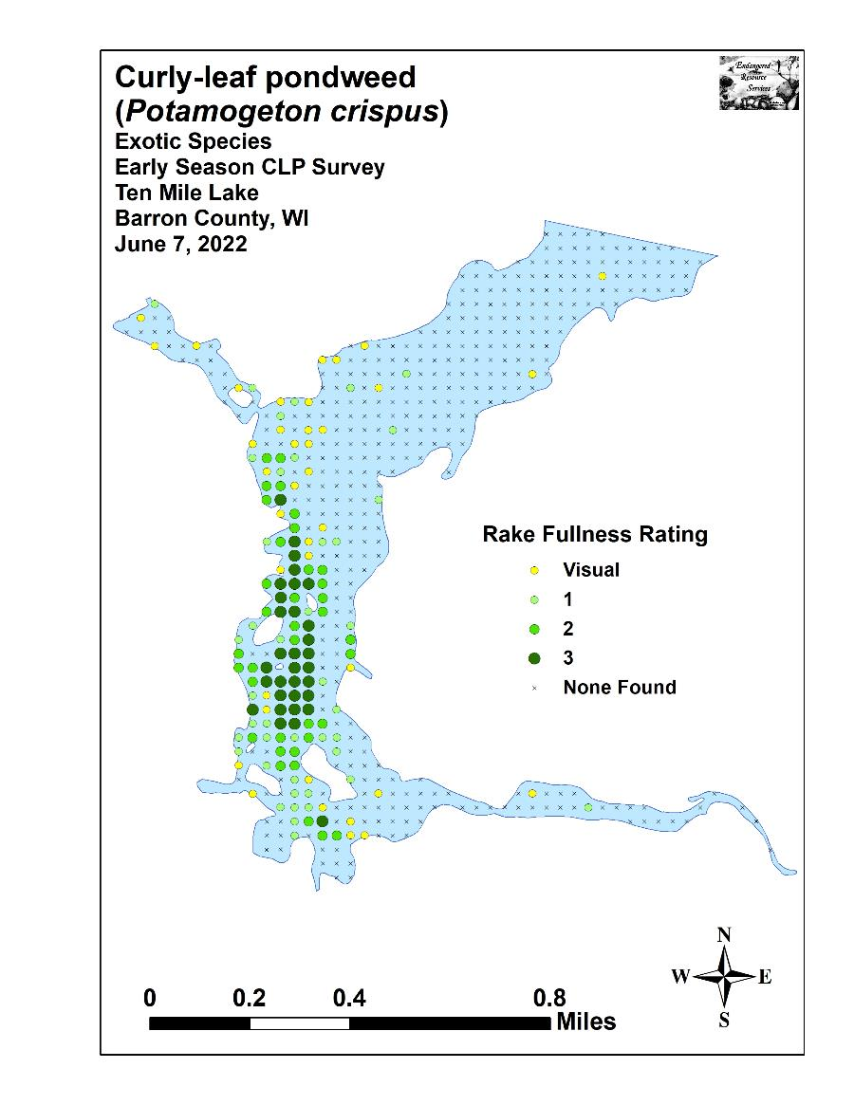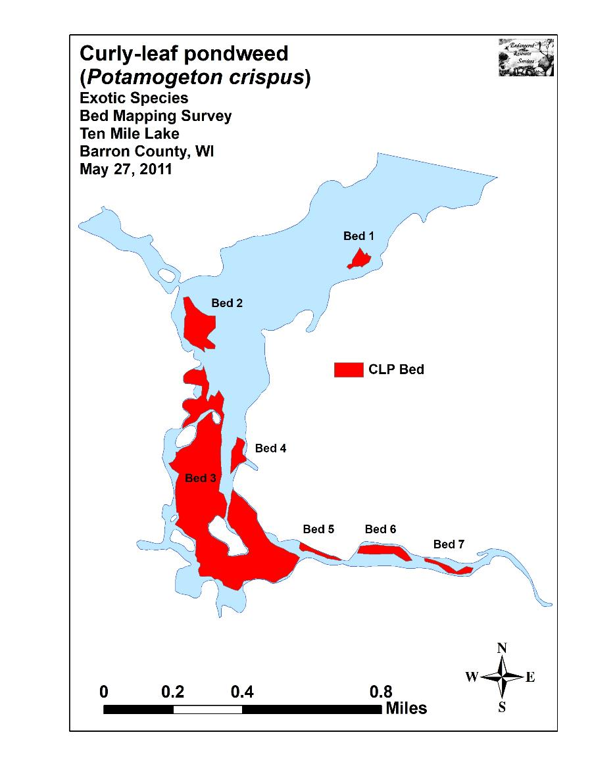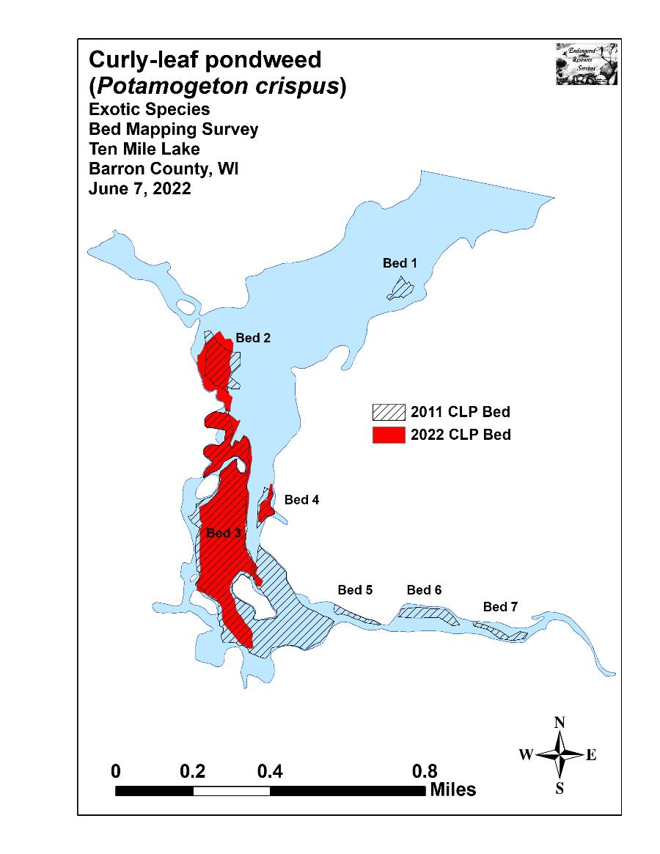

Appendix IV: Habitat Variable Maps
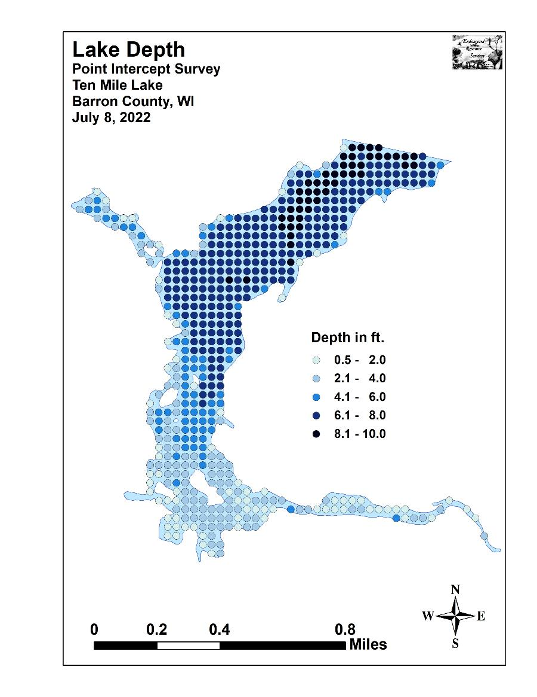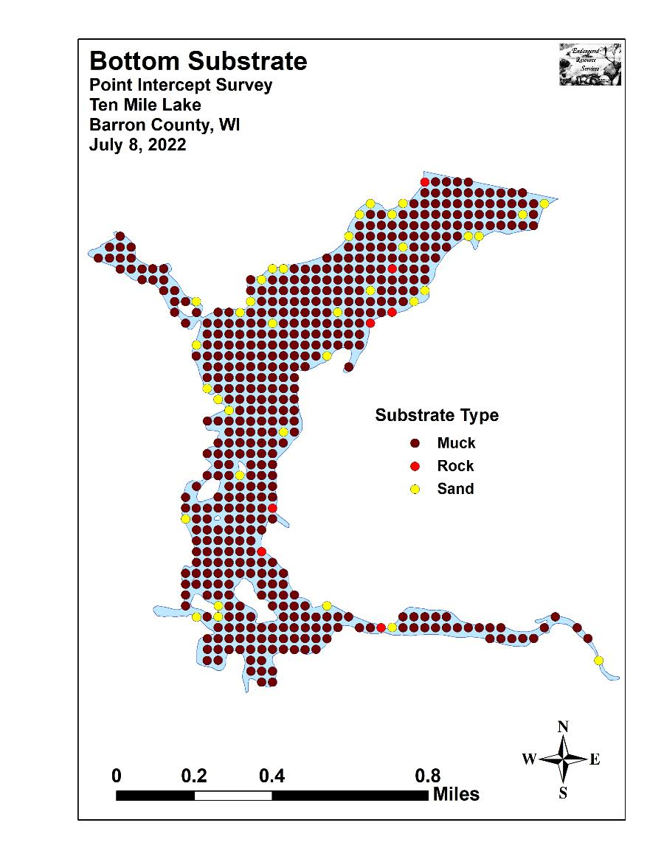

Appendix V: 2011 and 2022 Littoral Zone, Native Species Richness, and Total Rake Fullness Maps

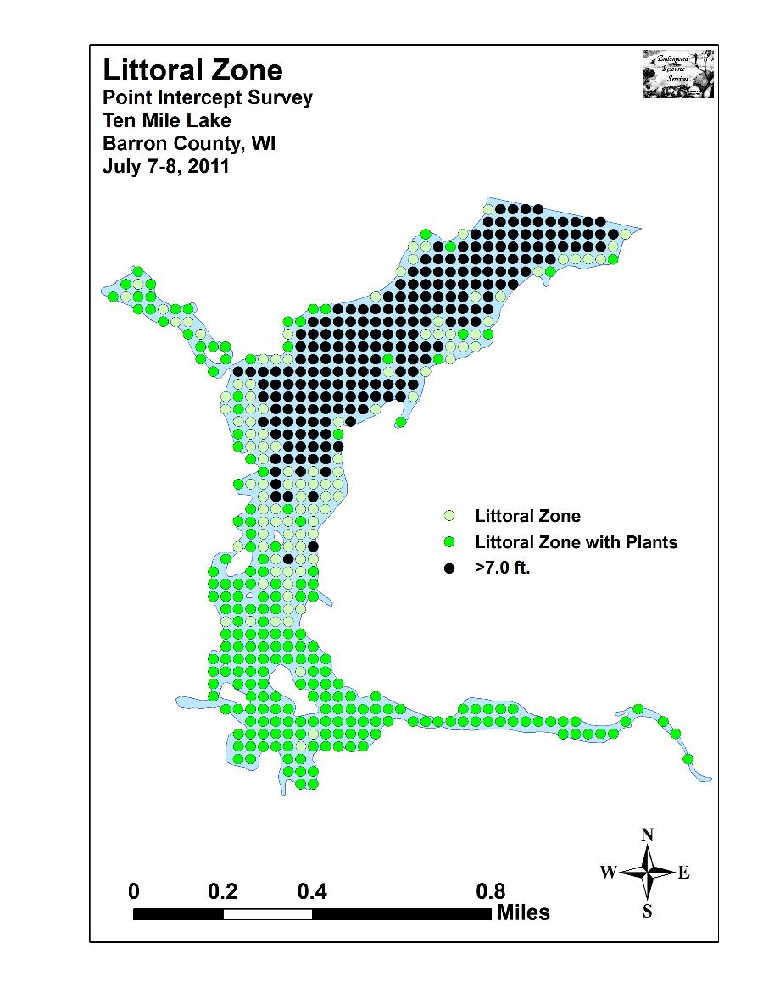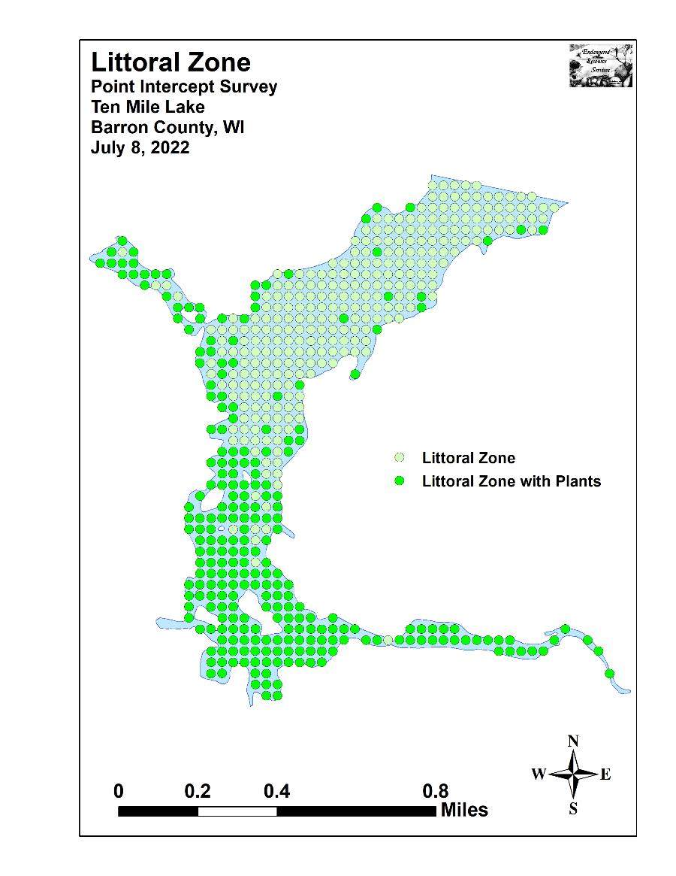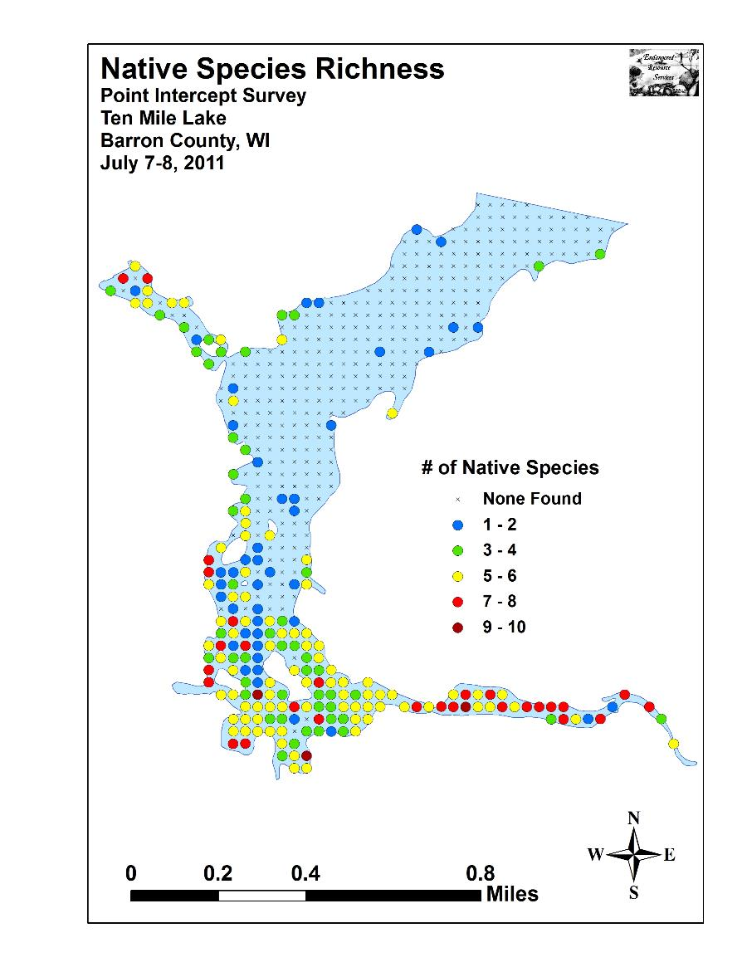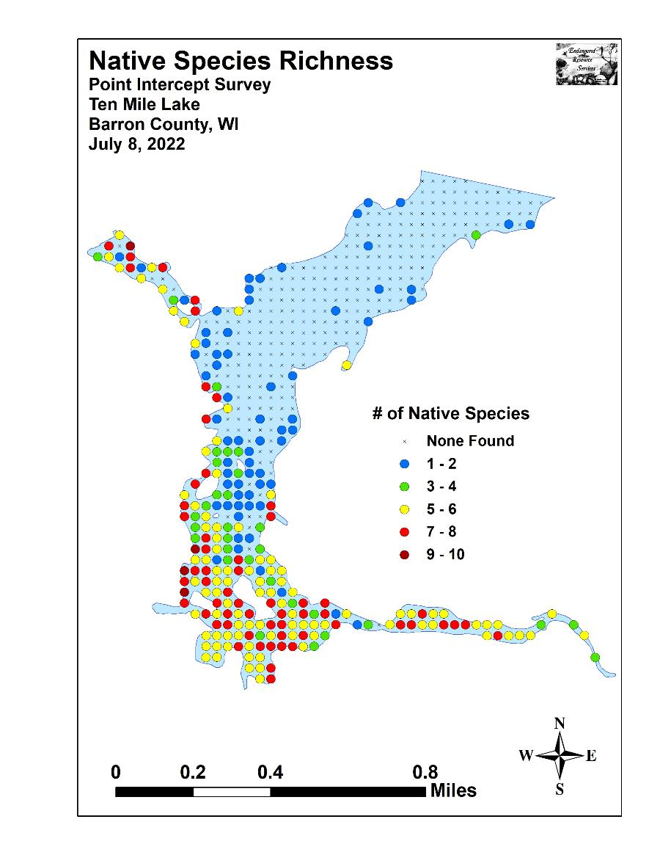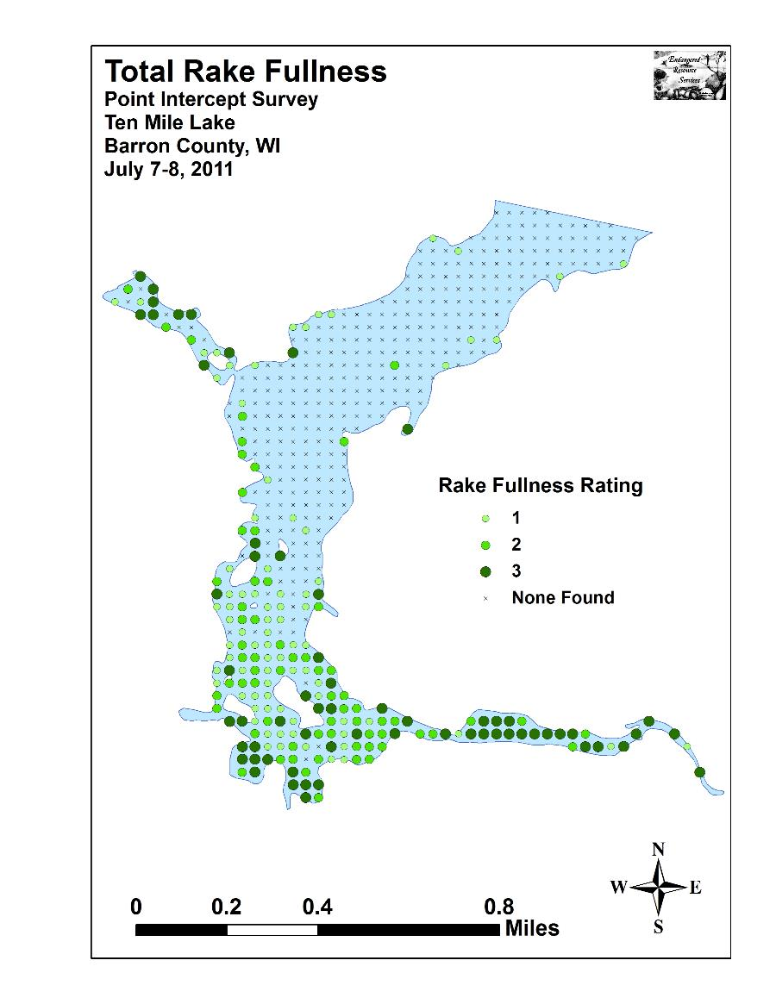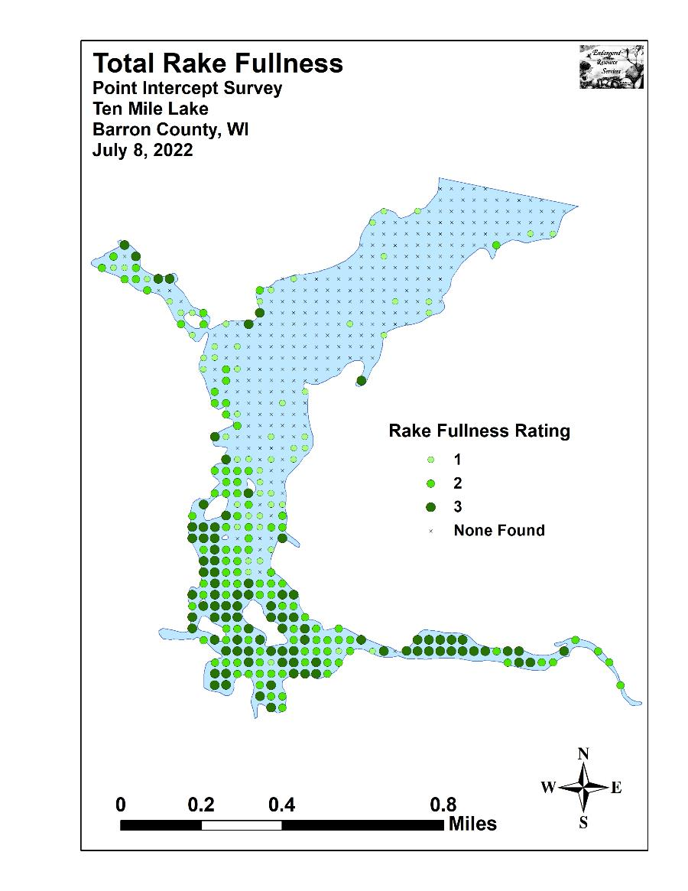

Appendix VI: July 2011 Native Species Density and Distribution Maps

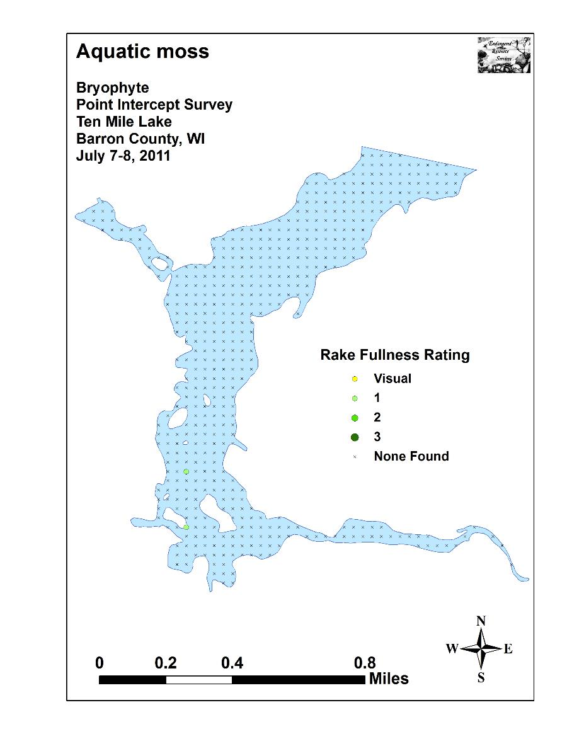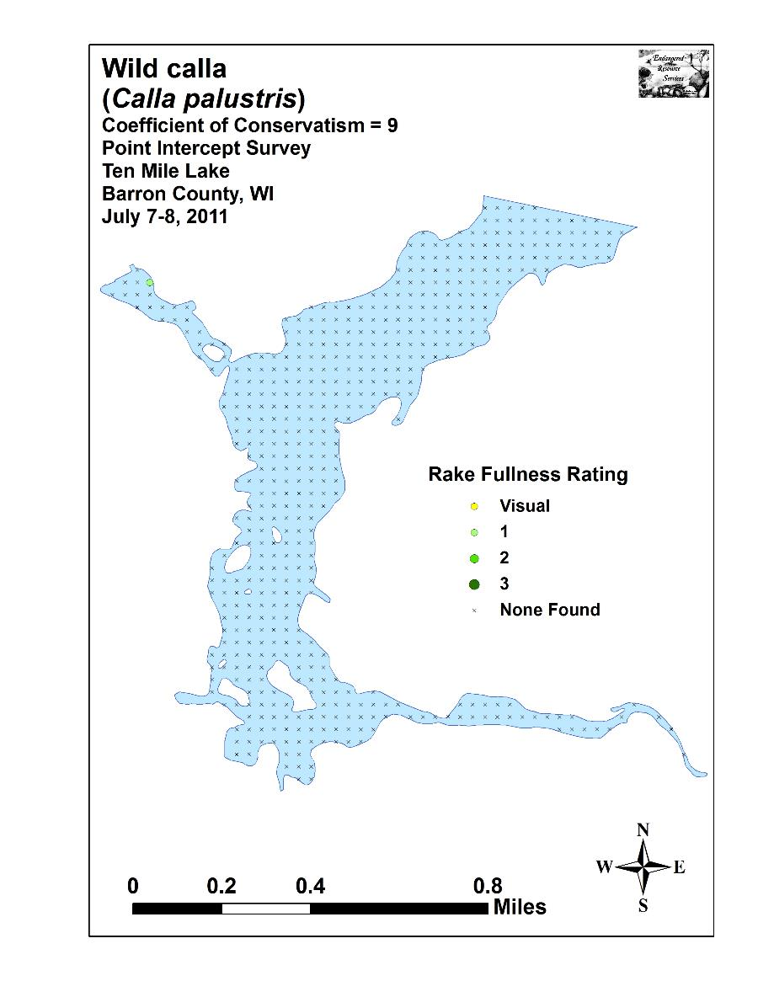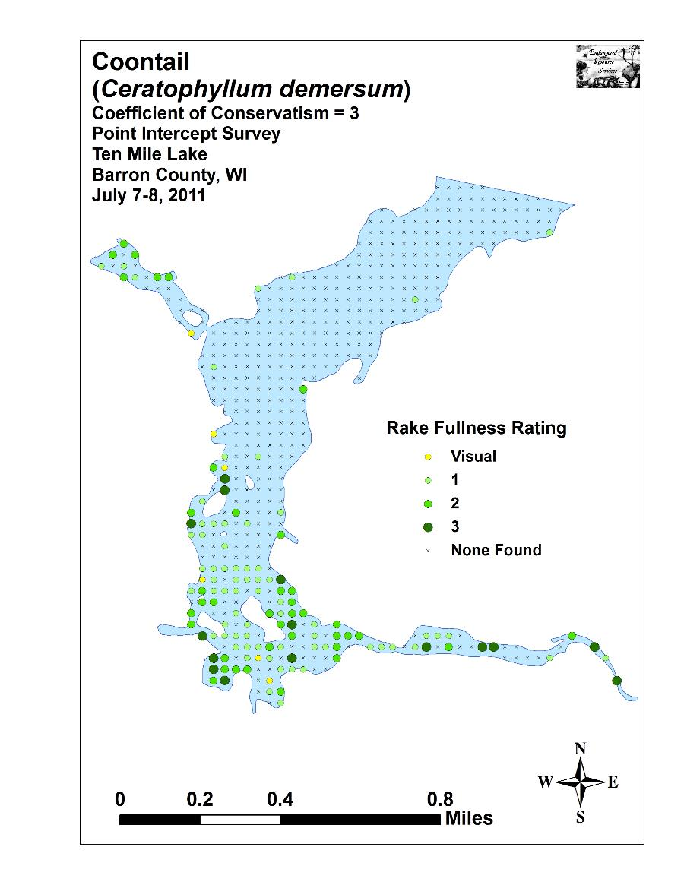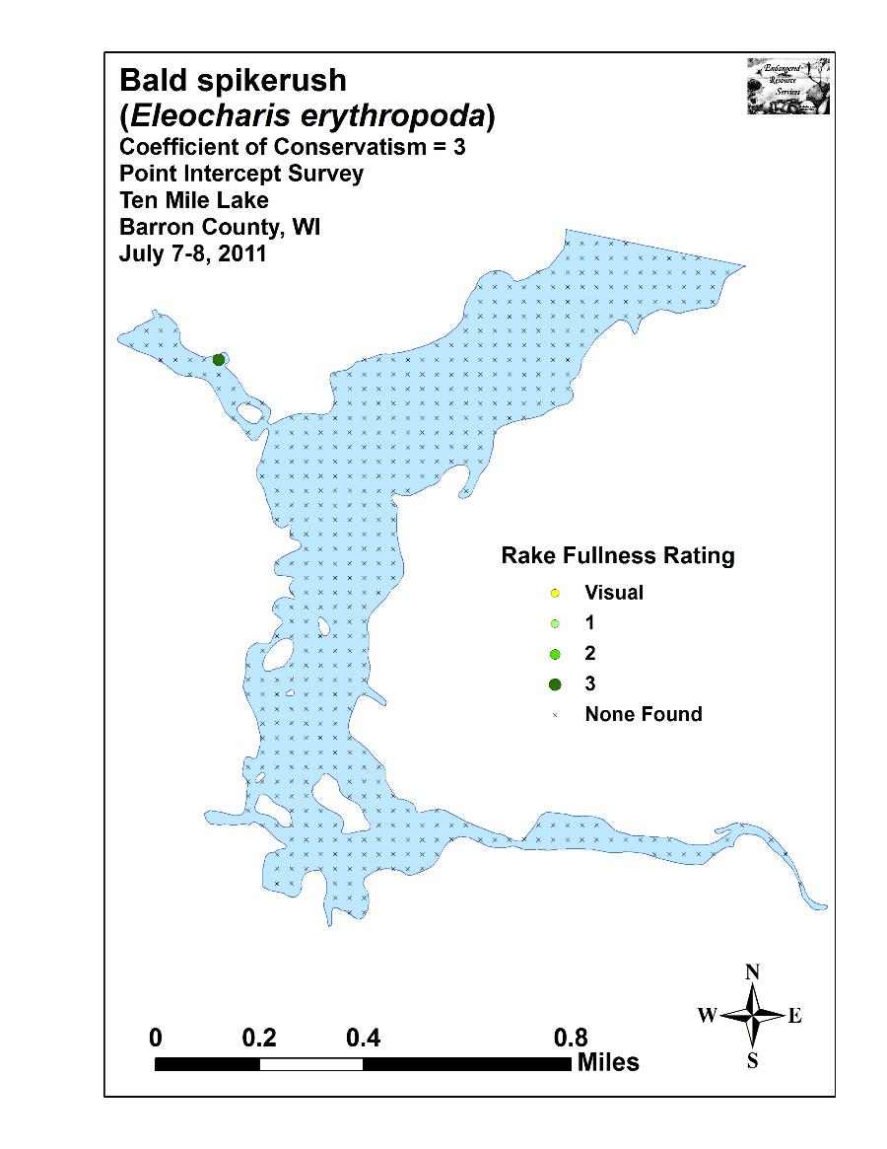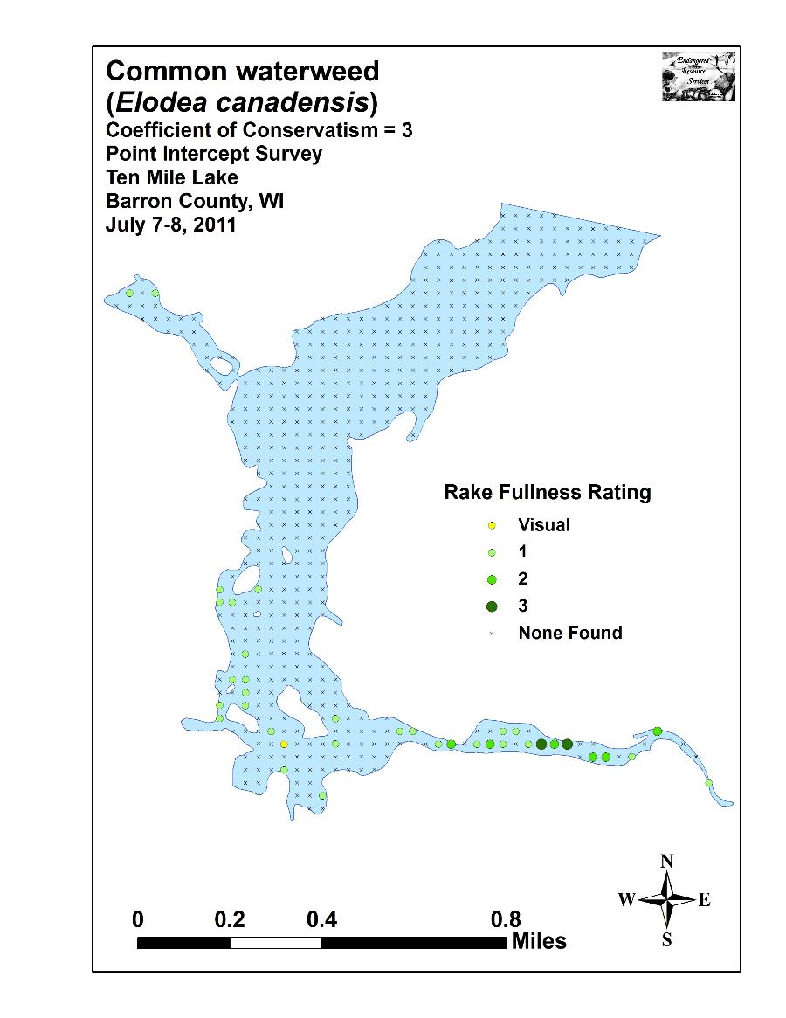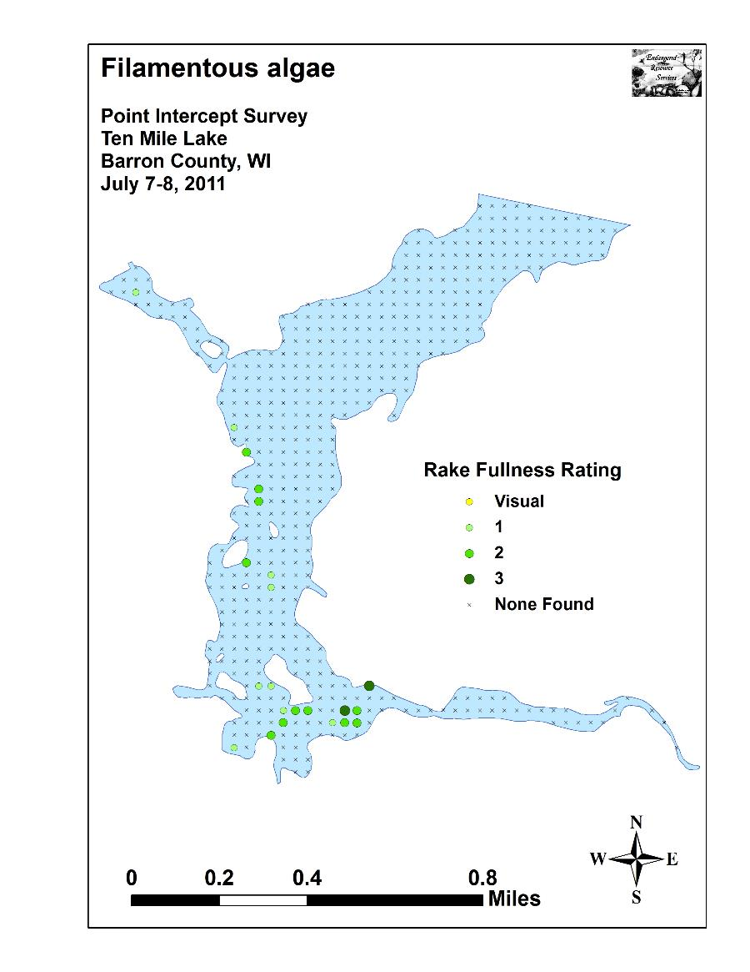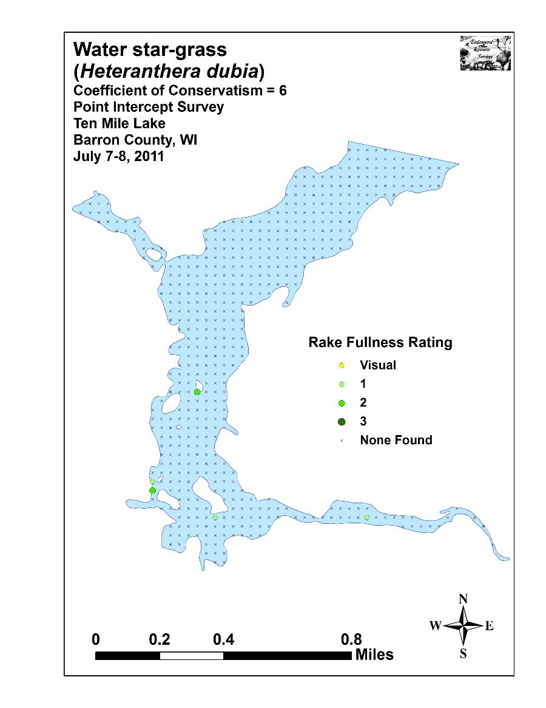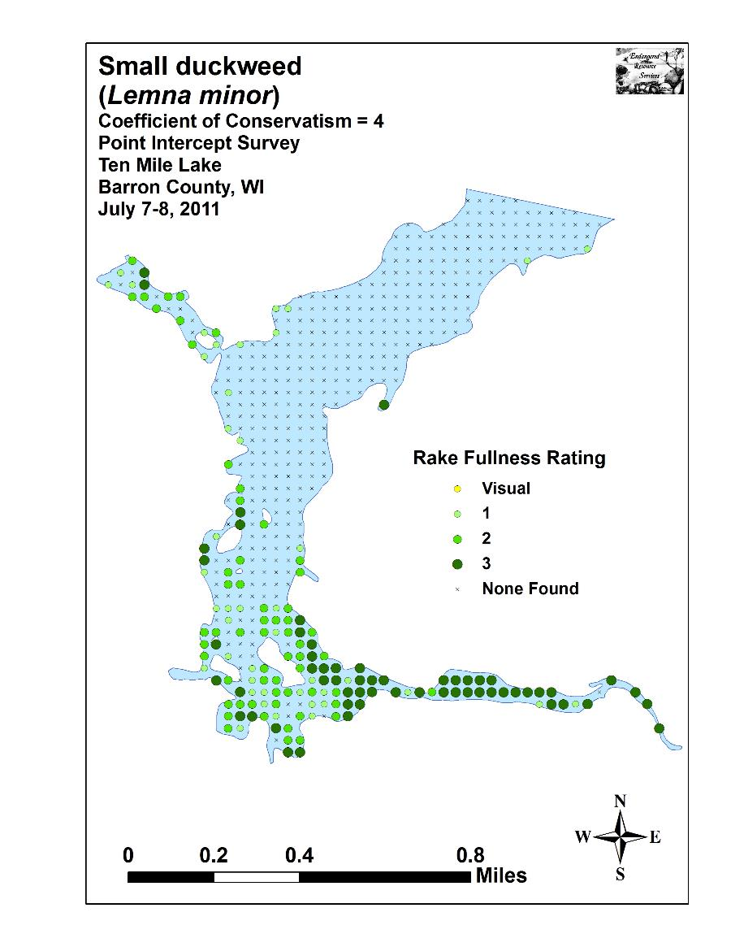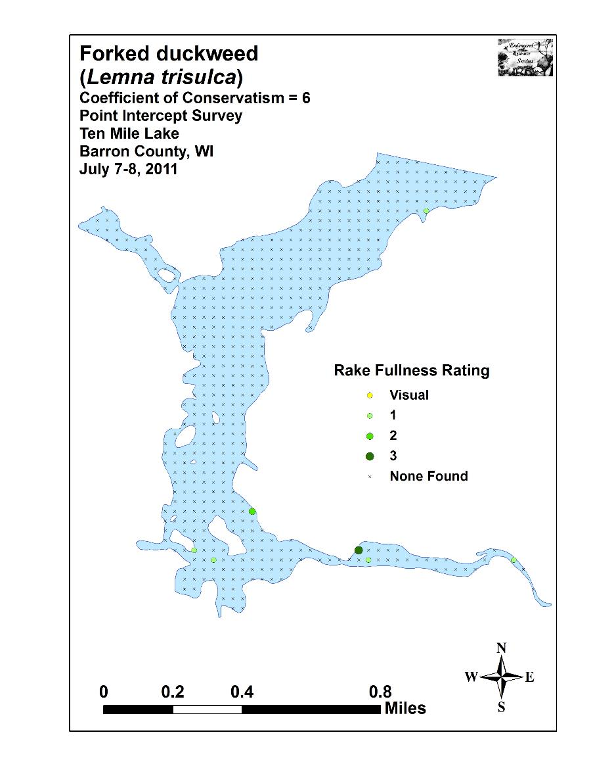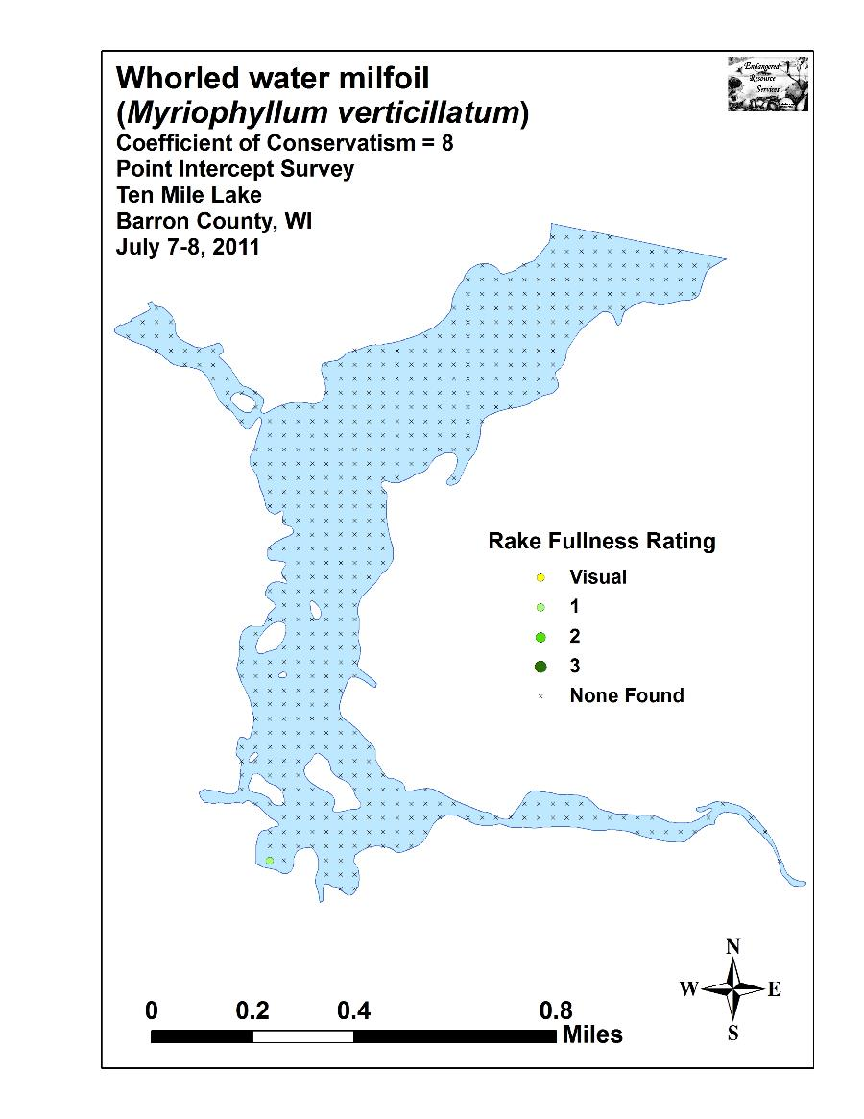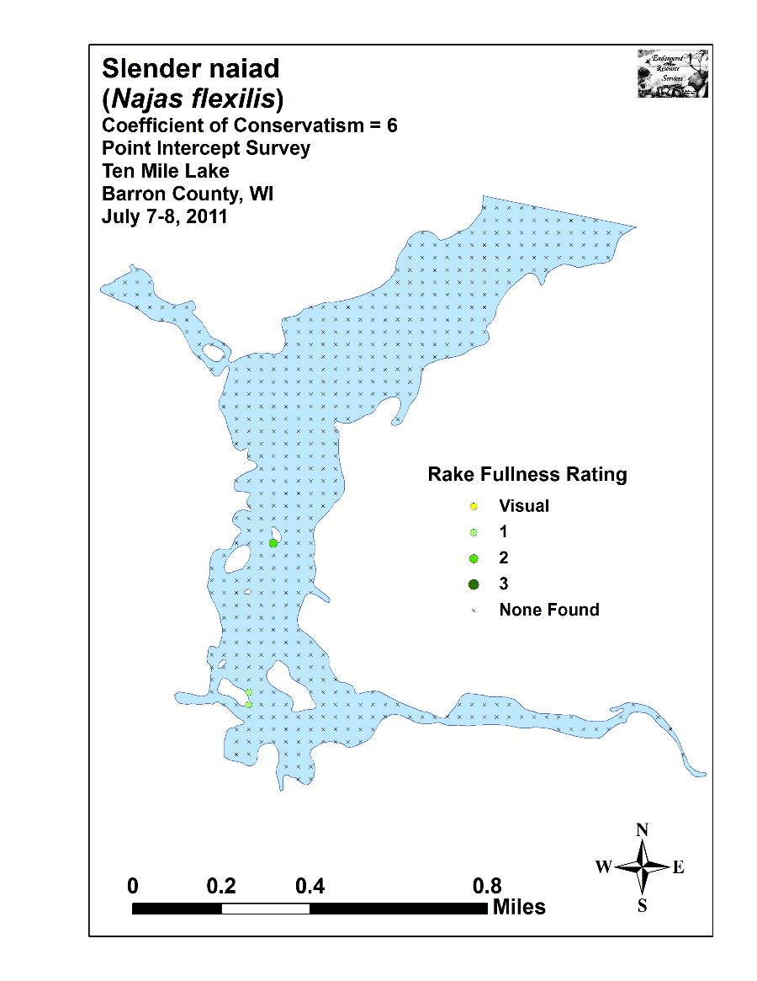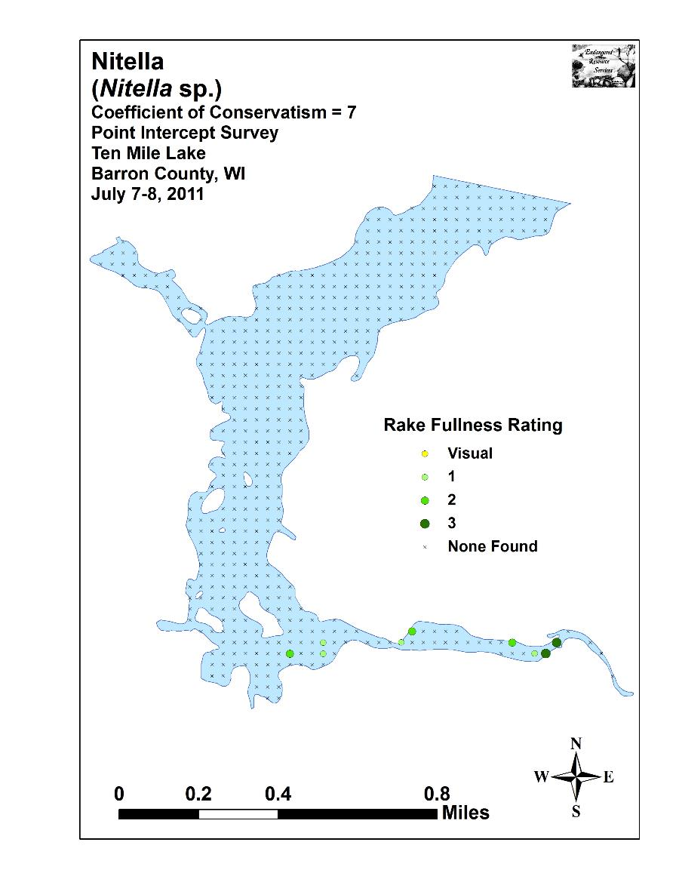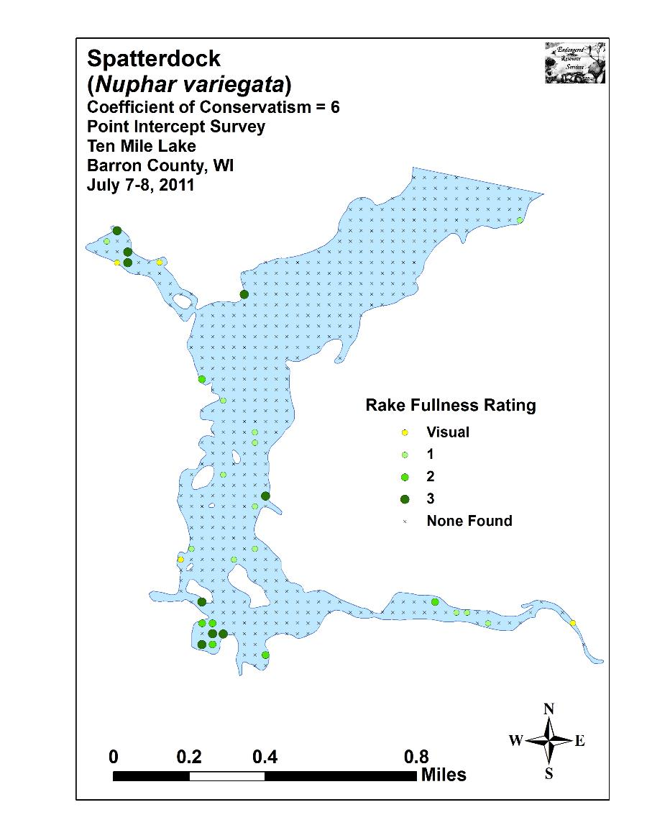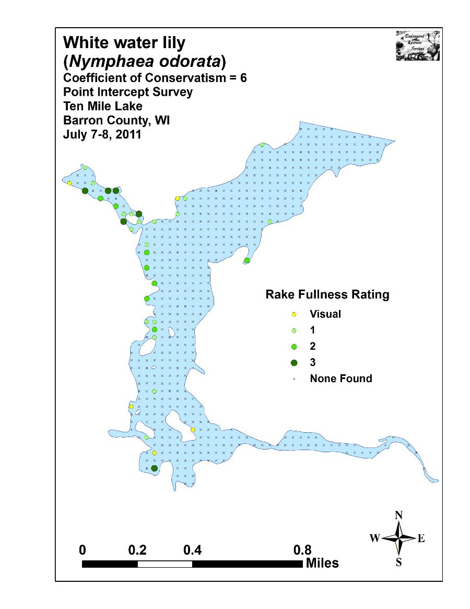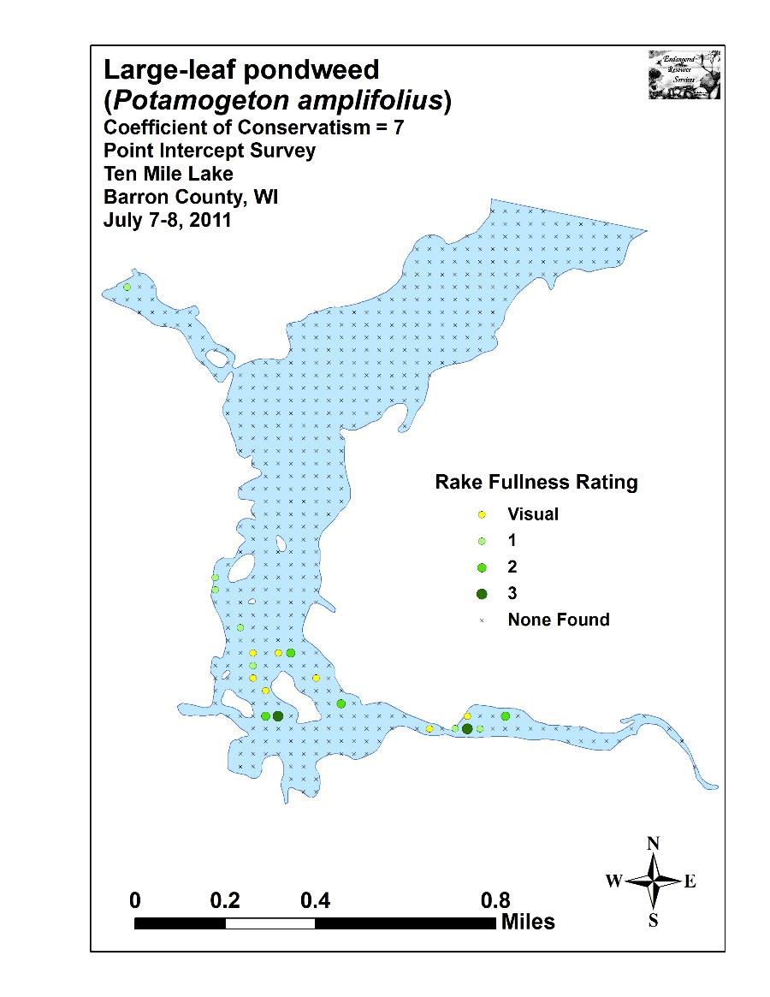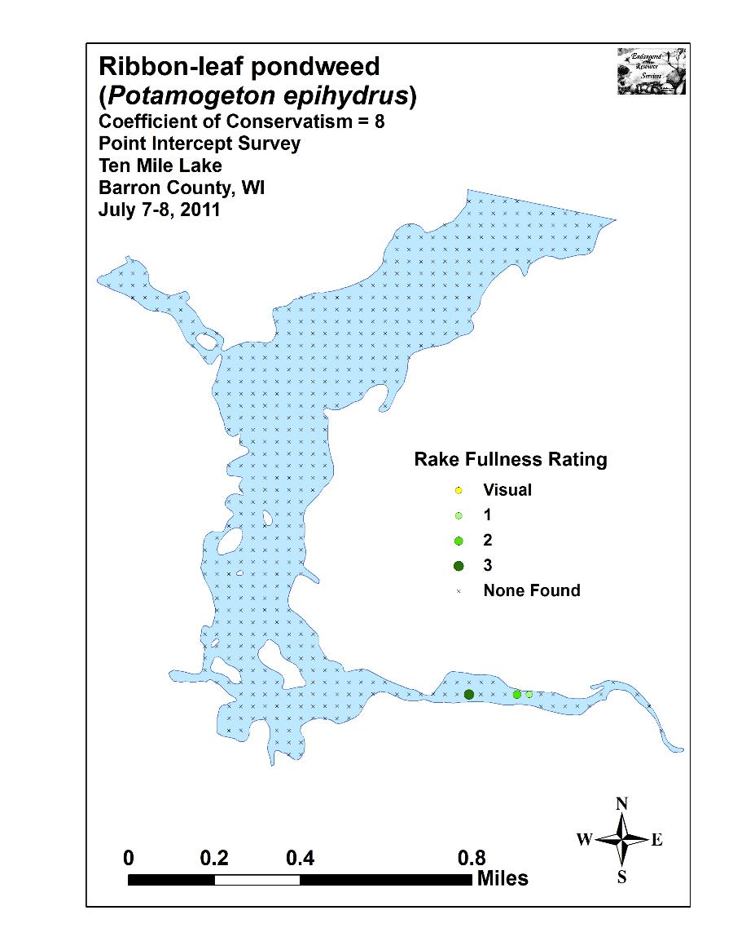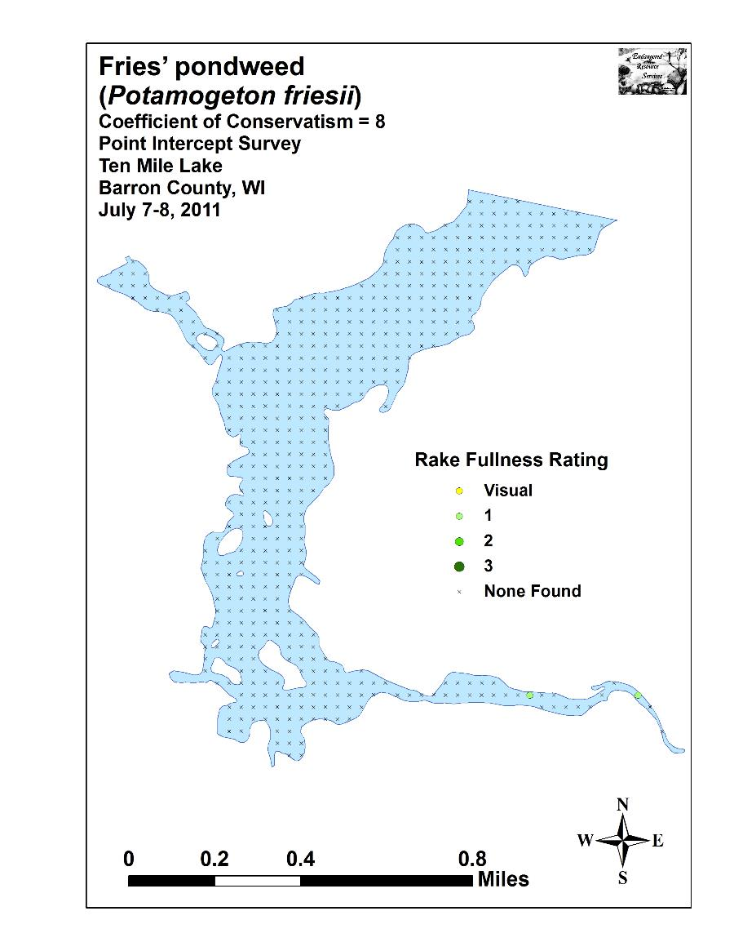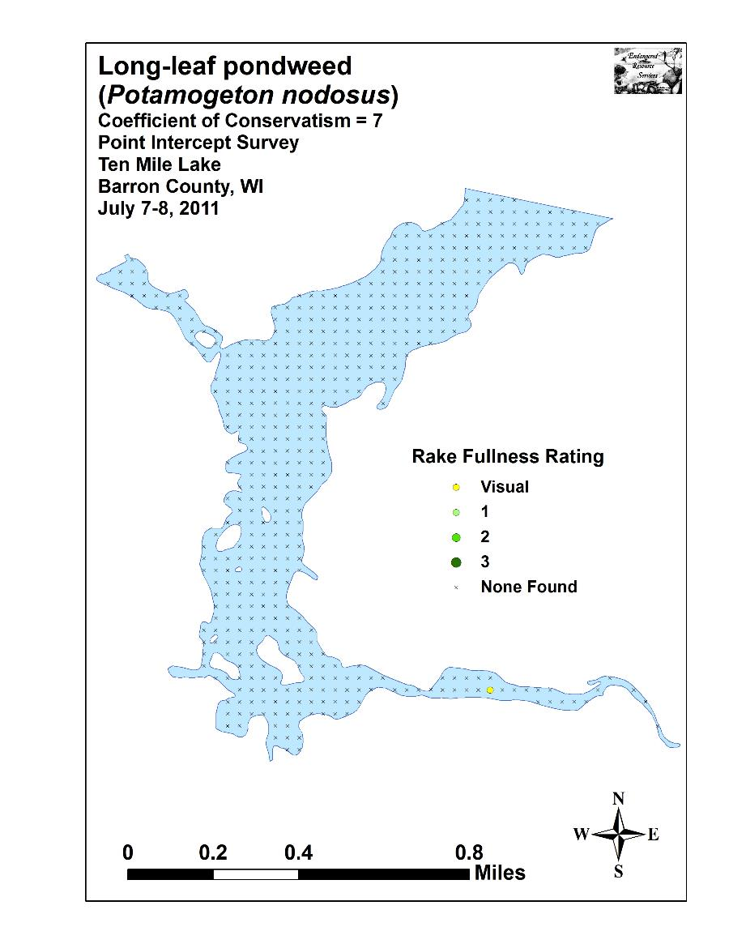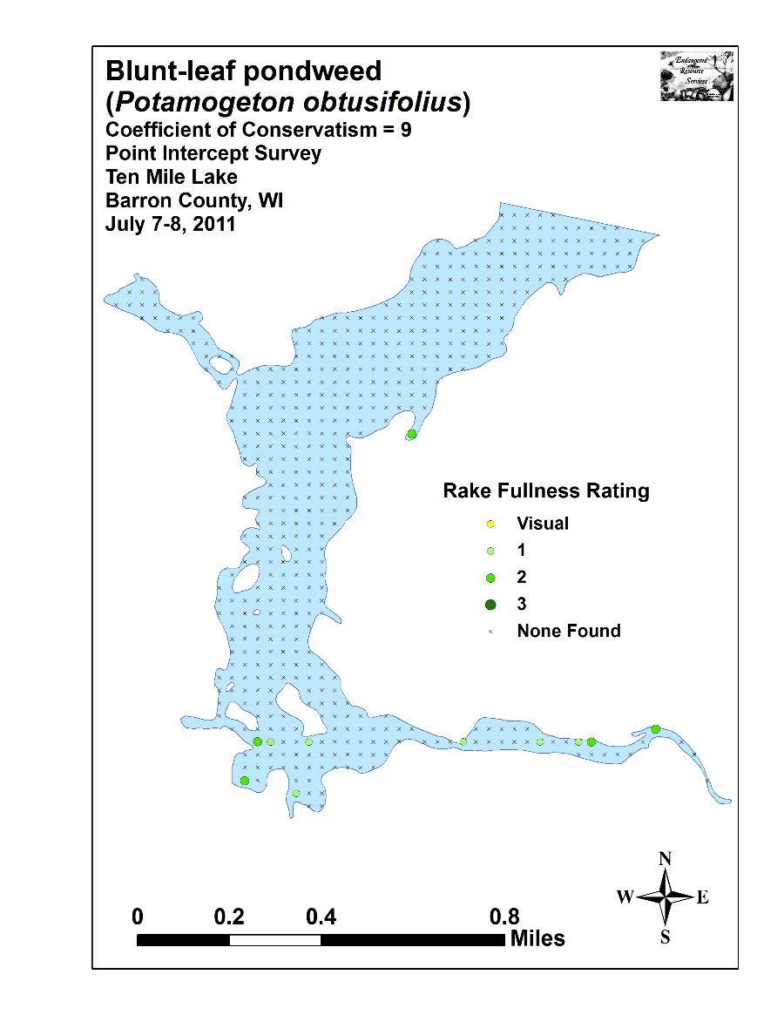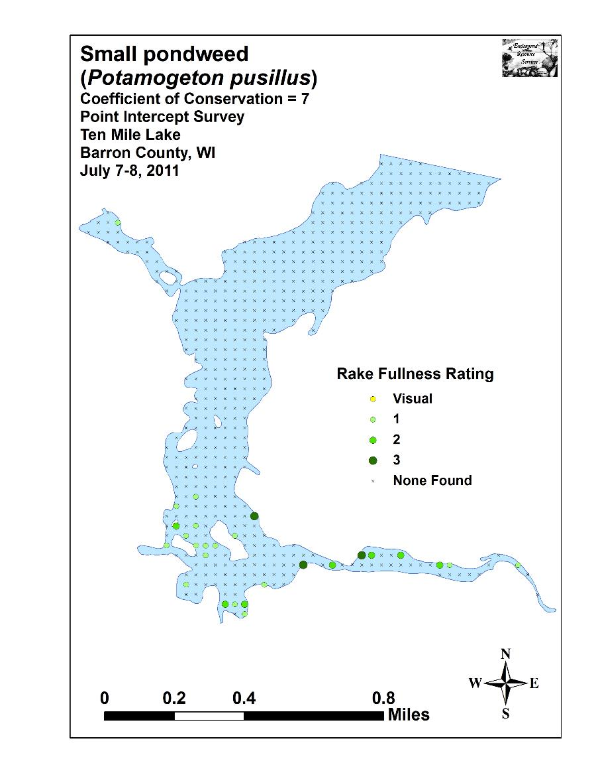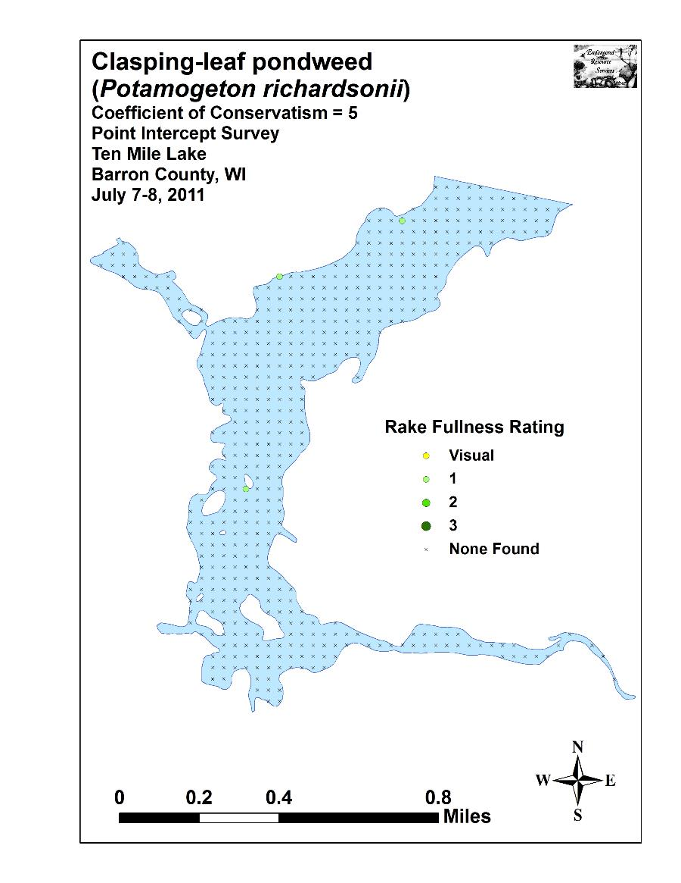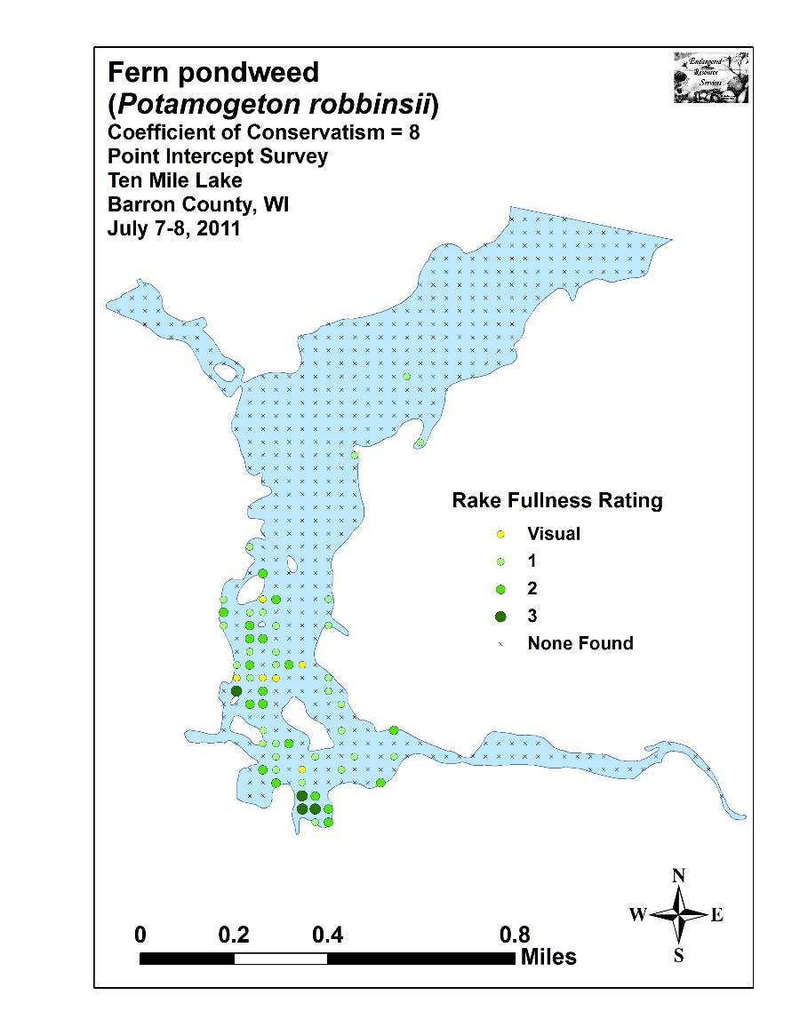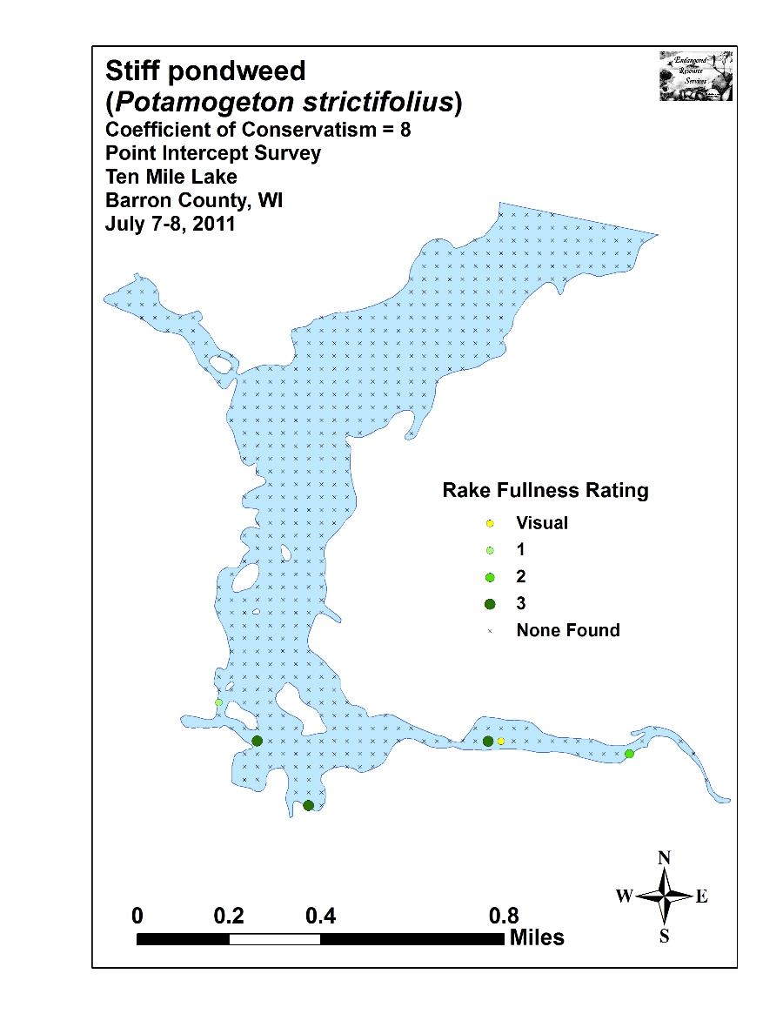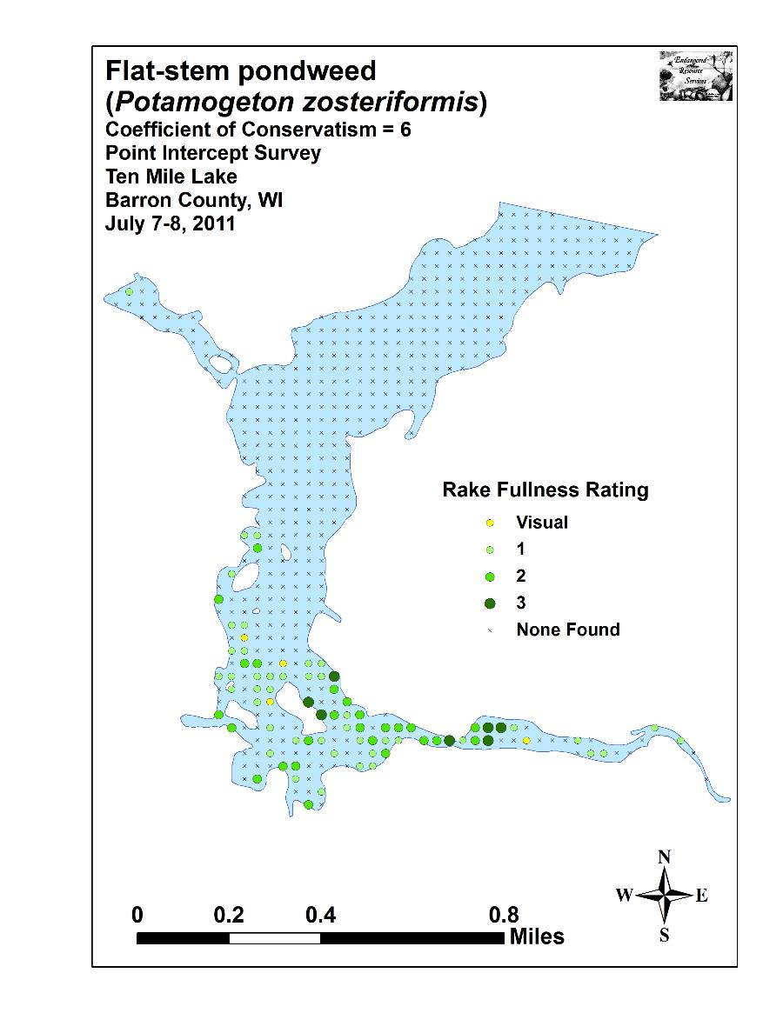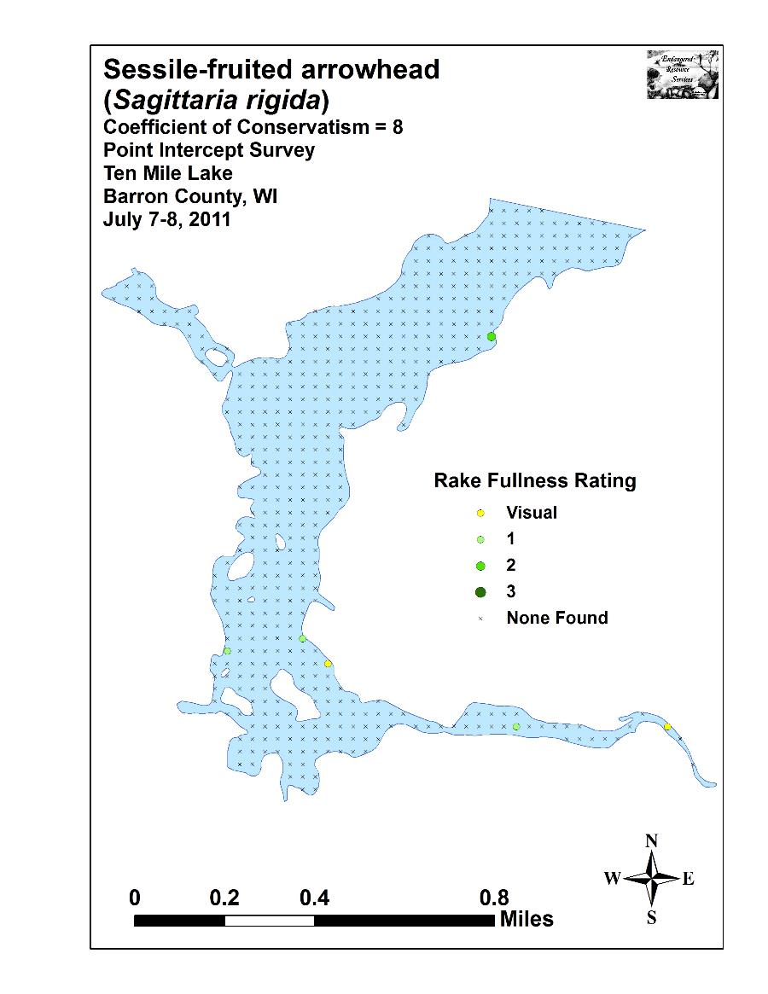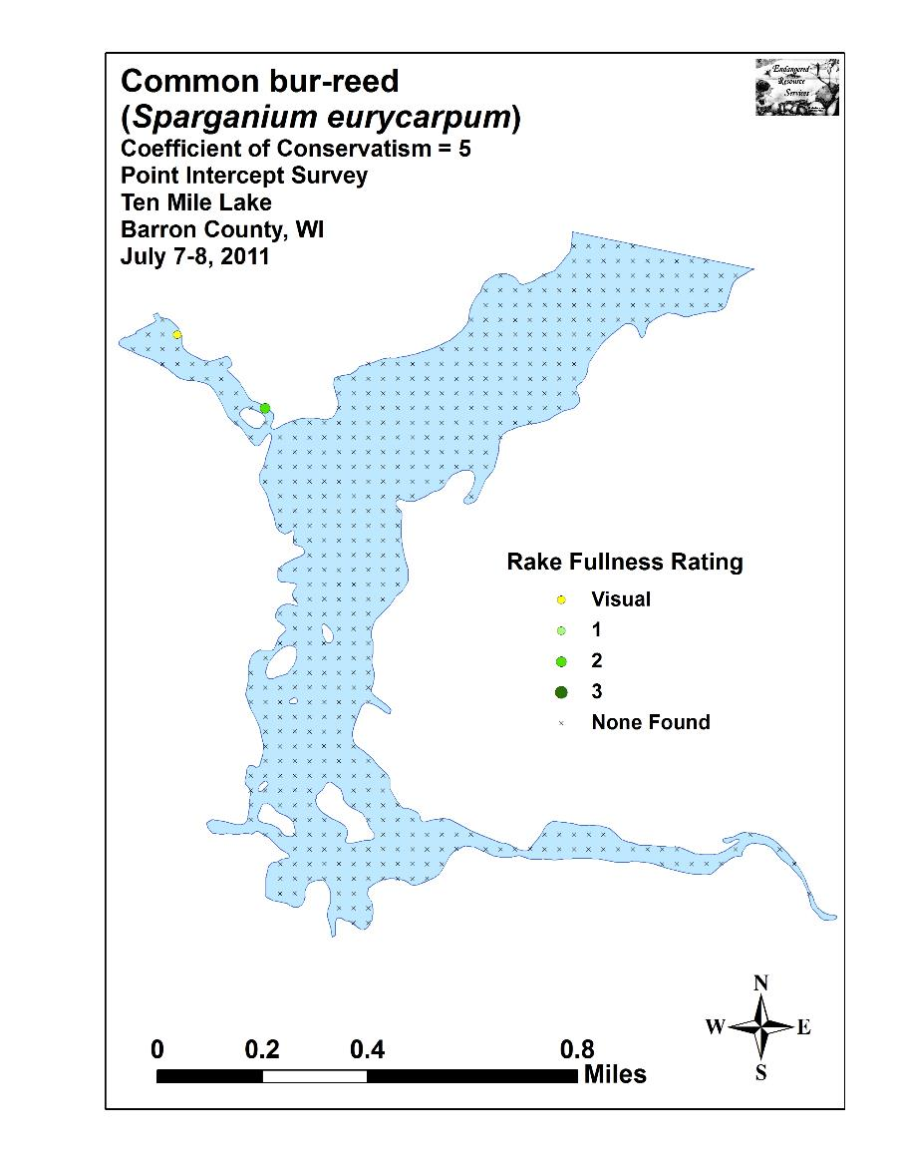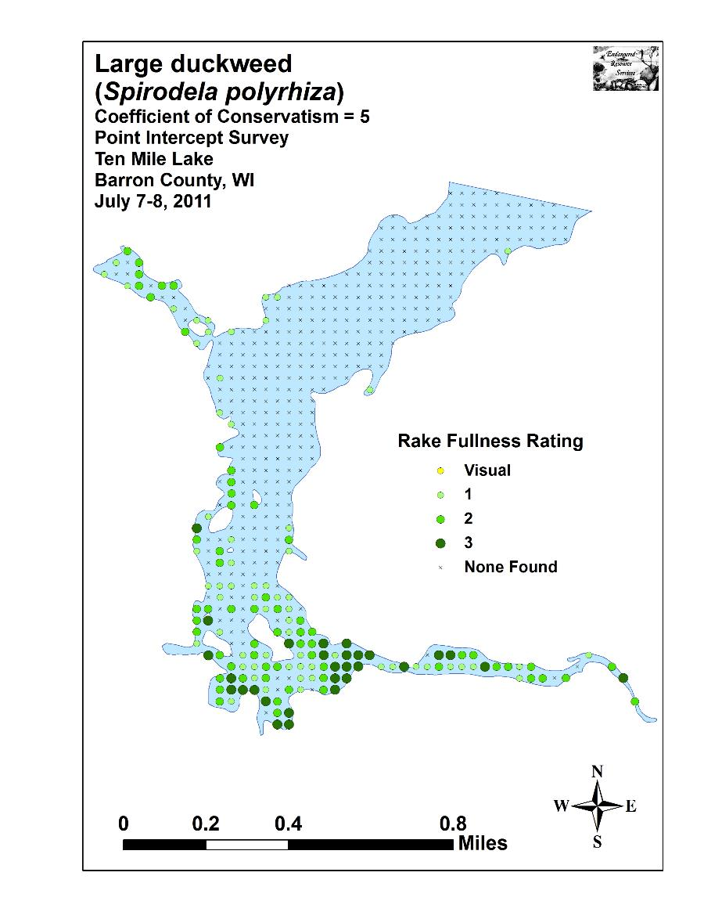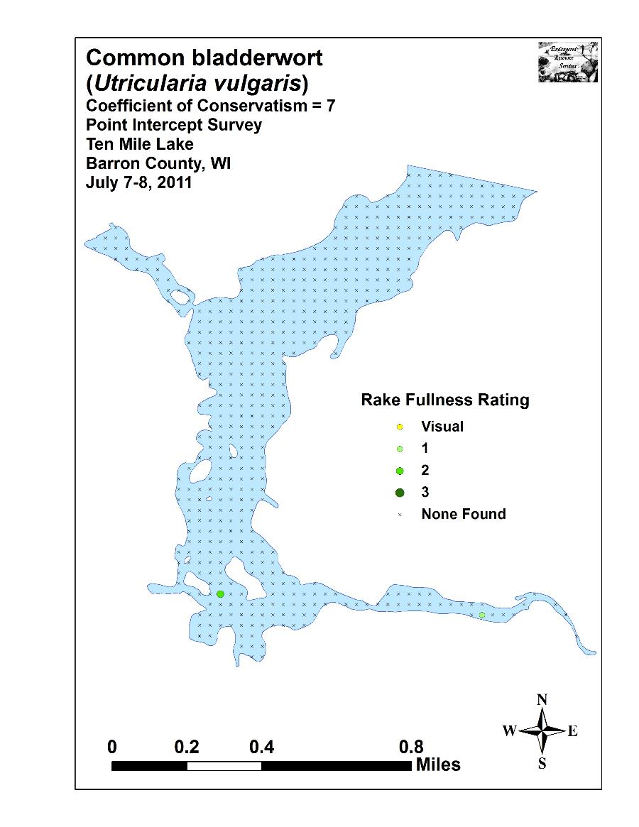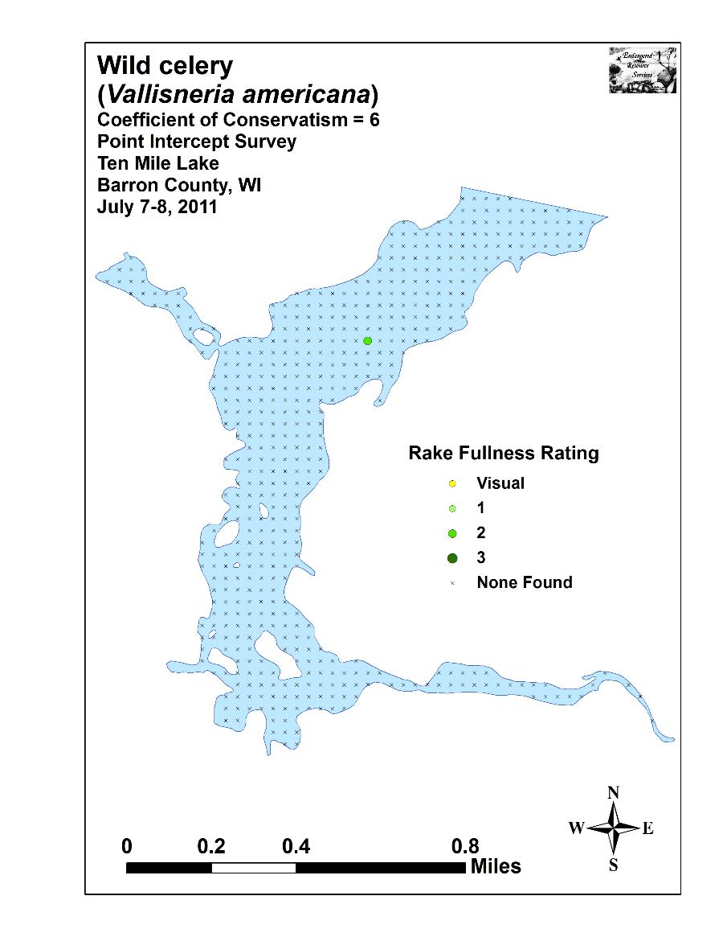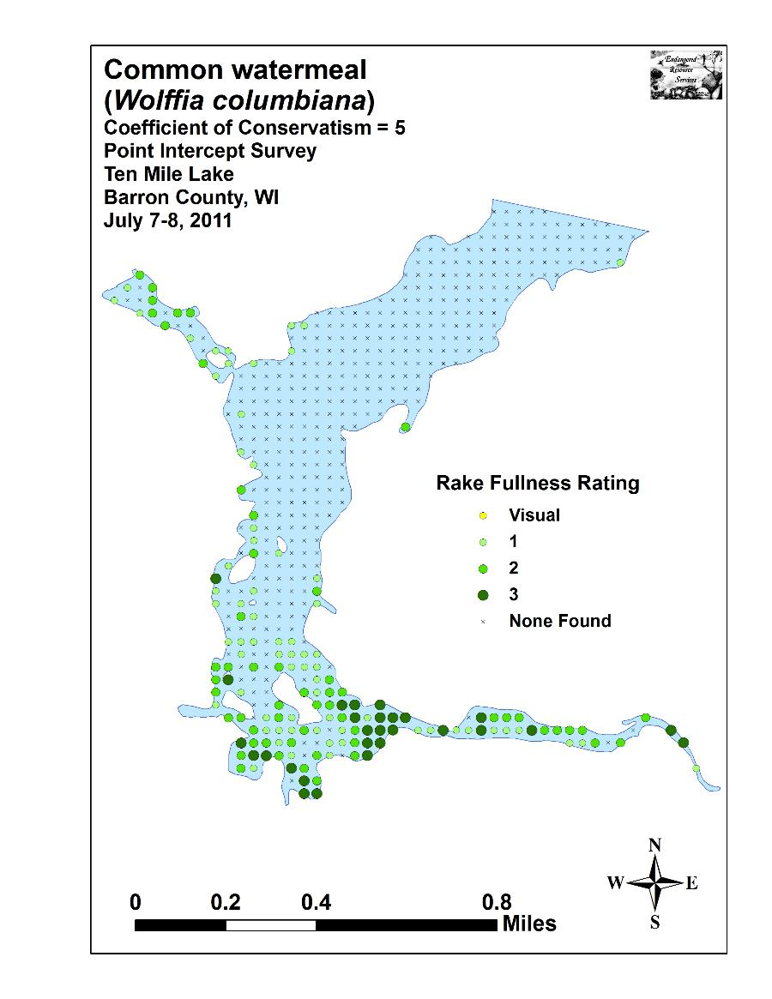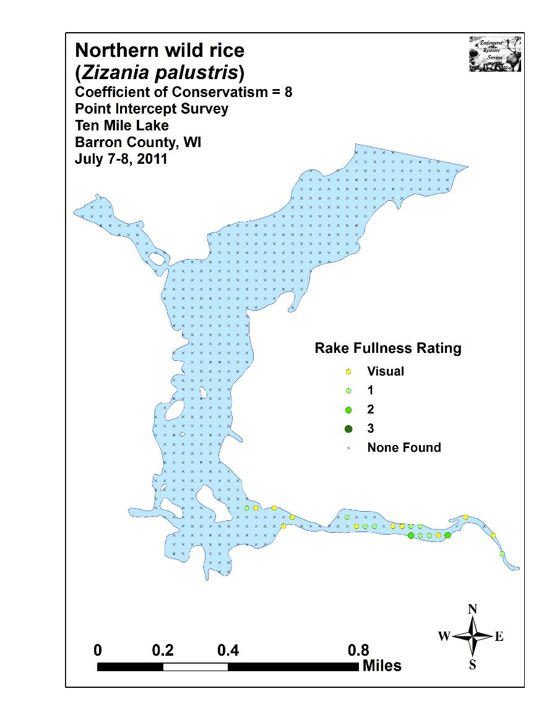

Appendix VII: Chetek Chain Plant Species Accounts

County/State: Barron County, Wisconsin Date: 7/7/11
Species: Aquatic moss
Specimen Location: Ten Mile Lake; N45.29275°, W91.62194°
Collected/Identified by: Matthew S. Berg Col. #: MSB-2011-127
Habitat/Distribution: Sand to muck bottoms in 0-1 meters. Rare being found at only two locations in the lake.
Common Associates: Potamogeton crispus) Curly-leaf pondweed, (Potamogeton pusillus) Small pondweed, (Nymphaea odorata) White water lily, (Ceratophyllum demersum) Coontail

County/State: Barron County, Wisconsin Date: 7/10/11
Species: (Calla palustris) Wild calla
Specimen Location: Mud (Ojaski) Lake; N45.36087°, W91.66114°
Also found in Pokegama, Prairie, and Ten Mile Lake
Collected/Identified by: Matthew S. Berg Col. #: MSB-2011-128
Habitat/Distribution: Muck bottom at the shoreline in 0 – 0.25 meters of water. Rare with only a few scattered individuals located along shore and on the bogs on Prairie Lake.
Common Associates: (Sagittaria latifolia) Common arrowhead, (Typha latifolia) Broad-leaved cattail, (Eleocharis erythropoda) Bald spikerush

County/State: Barron County, Wisconsin Date: 9/25/11
Species: (Callitriche hermaphroditica) Autumnal water-starwort
Specimen Location: Mud (Ojaski) Lake; N45.37993°, W91.65740°
Collected/Identified by: Matthew S. Berg Col. #: MSB-2011-129
Habitat/Distribution: Sand to sandy muck bottom in <0.5m of water in areas of moderate current. Plants carpeted the bottom in the Pokegama Creek inlet.
Common Associates: (Elodea canadensis) Common waterweed, (Sparganium americanum) American bur-reed, (Najas flexilis) Slender naiad, (Ranunculus aquatilis) White water crowfoot

County/State: Barron County, Wisconsin Date: 7/10/11
Species: (Carex comosa) Bottle-brush sedge
Specimen Location: Mud (Ojaski) Lake; N45.37952°, W91.65617°
Also found in Pokegama and Prairie Lakes.
Collected/Identified by: Matthew S. Berg Col. #: MSB-2011-130
Habitat/Distribution: Firm muck bottoms in 0-0.25 m. Rare; a few scattered individuals were interspersed with other emergents at the shoreline in undeveloped low areas.
Common Associates: (Sagittaria latifolia) Common arrowhead, (Calla palustris) Wild calla, (Typha latifolia) Broad-leaved cattail, (Eleocharis erythropoda) Bald spikerush

County/State: Barron County, Wisconsin Date: 7/7/11
Species: (Ceratophyllum demersum) Coontail
Specimen Location: Ten Mile Lake; N45.29275°, W91.62194°
Also found in Chetek, Mud (Ojaski), Pokegama and Prairie Lakes.
Collected/Identified by: Matthew S. Berg Col. #: MSB-2011-131
Habitat/Distribution: Abundant in calm areas over muck in water generally <2meters.
Common Associates: (Potamogeton crispus) Curly-leaf pondweed, (Potamogeton zosteriformis) Flat-stem pondweed, (Potamogeton robbinsii) Fern pondweed, (Nuphar variegata) Spatterdock, (Nymphaea odorata) White water lily, (Elodea canadensis) Common waterweed

County/State: Barron County, Wisconsin Date: 7/10/11
Species: (Comarum palustre) Marsh cinquefoil
Specimen Location: Mud (Ojaski) Lake; N45.37185°, W91.64859°
Collected/Identified by: Matthew S. Berg Col. #: MSB-2011-132
Habitat/Distribution: Common at the shoreline and on the floating bogs on the northeast end of the lake; especially at the edge of tamaracks and on the backside channels of the islands.
Common Associates: (Eleocharis erythropoda) Bald spikerush, (Calla palustris) Wild calla, (Sagittaria latifolia) Common arrowhead

County/State: Barron County, Wisconsin Date: 7/11/11
Species: (Decodon verticillatus) Swamp loosestrife
Specimen Location: Prairie Lake; N45.36745°, W91.68224°
Collected/Identified by: Matthew S. Berg Col. #: MSB-2011-133
Habitat/Distribution: Abundant at the shoreline and on the floating bogs on the north end of Prairie Lake; especially at the edge of tamaracks around Horseshoe Island.
Common Associates: (Typha latifolia) Broad-leaved cattail, (Calla palustris) Wild calla, (Sagittaria latifolia) Common arrowhead

County/State: Barron County, Wisconsin Date: 7/8/11
Species: (Dulichium arundinaceum) Three-way sedge
Specimen Location: Pokegama Lake; N45.33013°, W91.63926°
Also found in Mud (Ojaski) Lake.
Collected/Identified by: Matthew S. Berg Col. #: MSB-2011-134
Habitat/Distribution: Rare; a few individuals were found growing at the shore around the spring holes in Pokegama, and in boggy areas behind the island on the northeast end of Mud (Ojaski) Lake.
Common Associates: (Eleocharis erythropoda) Bald spikerush, (Sagittaria rigida) Sessile-fruited arrowhead

County/State: Barron County, Wisconsin Date: 7/11/11
Species: (Eleocharis acicularis) Needle spikerush
Specimen Location: Prairie Lake; N45.36140°, W91.68736°
Submerged individuals from Pokegama Lake N45.33289°, W91.62219°.
Collected/Identified by: Matthew S. Berg Col. #: MSB-2011-135
Habitat/Distribution: Rare; scattered emergent individuals occurred on the floating bogs in Prairie Lake. A few submergent individuals were found on the rocky/sandy flat in the east bay of Pokegama.
Common Associates: (Eleocharis intermedia) Matted spikerush, (Sagittaria cristata) Crested arrowhead

County/State: Barron County, Wisconsin Date: 7/8/11
Species: (Eleocharis erythropoda) Bald spikerush
Specimen Location: Pokegama Lake; N45.33013°, W91.63926°
Also found in Mud (Ojaski), and Ten Mile Lakes.
Collected/Identified by: Matthew S. Berg Col. #: MSB-2011-136
Habitat/Distribution: Muck bottoms at the shoreline. Scattered undeveloped shoreline locations.
Common Associates: (Typha latifolia) Broad-leaved cattail, (Calla palustris) Wild calla, (Sagittaria latifolia) Common arrowhead

County/State: Barron County, Wisconsin Date: 7/11/11
Species: (Eleocharis intermedia) Matted spikerush
Specimen Location: Prairie Lake; N45.36523°, W91.68112°
Collected/Identified by: Matthew S. Berg Col. #: MSB-2011-137
Habitat/Distribution: Plants were growing on floating bogs in the north end of Prairie Lake in thick muck.
Common Associates: (Eleocharis acicularis) Needle spikerush

County/State: Barron County, Wisconsin Date: 5/26/11
Species: (Elodea canadensis) Common waterweed
Specimen Location: Mud (Ojaski) Lake; N45.36269°, W91.65506°
Also found in Chetek, Pokegama, Prairie, and Ten Mile Lakes
Collected/Identified by: Matthew S. Berg Col. #: MSB-2011-138
Habitat/Distribution: Muck bottom in 0-2 meters of water.
Common to abundant where creeks enter the lakes. Leaves were unexpectedly fine, but measured out in the 1.7-2.2mm range and were crowded at the tops suggesting it was E. canadensis not E. nuttallii. Specimens viewed at the site in July confirmed this.
Common Associates: (Potamogeton crispus) Curly-leaf pondweed, (Potamogeton robbinsii) Fern pondweed, (Ceratophyllum demersum) Coontail, (Potamogeton zosteriformis) Flat-stem pondweed

County/State: Barron County, Wisconsin Date: 7/6/11
Species: (Heteranthera dubia) Water star-grass
Specimen Location: Chetek Lake; N45.31278°, W91.59543°
Also found in Mud (Ojaski), Prairie, and Ten Mile Lakes
Collected/Identified by: Matthew S. Berg Col. #: MSB-2011-139
Habitat/Distribution: Firm muck and sand bottoms usually in water < 1 meter deep. Scattered patches were almost exclusively located in the creek inlets. In Ten Mile Creek, it was common to abundant but, elsewhere in the system, uncommon to rare.
Common Associates: (Potamogeton nodosus) Long-leaf pondweed, (Potamogeton amplifolius) Large-leaf pondweed, (Elodea canadensis) Common waterweed

County/State: Barron County, Wisconsin Date: 7/10/11
Species: (Juncus effusus) Common rush
Specimen Location: Mud (Ojaski) Lake; N45.38124°, W91.65683°
Collected/Identified by: Matthew S. Berg Col. #: MSB-2011-140
Habitat/Distribution: Sandy muck at the shoreline. Plants were on the bank of the Pokegama Creek Inlet.
Common Associates: (Schoenoplectus tabernaemontani) Softstem bulrush, (Typha latifolia) Broad-leaved cattail, (Typha angustifolia) Narrow-leaved cattail

County/State: Barron County, Wisconsin Date: 7/11/11
Species: (Leersia oryzoides) Rice cut-grass
Specimen Location: Prairie Lake; N45.39235°, W91.71585°
Collected/Identified by: Matthew S. Berg Col. #: MSB-2011-141
Habitat/Distribution: Plants were growing on the edge of a bog in the northwest end of the lake.
Common Associates: (Typha latifolia) Broad-leaved cattail, (Sagittaria latifolia) Common arrowhead

County/State: Barron County, Wisconsin Date: 9/25/11
Species: (Lemna minor) Small duckweed
Specimen Location: Ten Mile Lake; N45.30645°, W91.62693°
Also found in Chetek, Pokegama, Prairie, and Mud (Ojaski) Lakes.
Collected/Identified by: Matthew S. Berg Col. #: MSB-2011-142
Habitat/Distribution: Located floating at or just under the surface in sheltered areas. Common to abundant in all five lakes.
Common Associates: (Nymphaea odorata) White water lily, (Nuphar variegata) Spatterdock, (Spirodela polyrhiza) Large duckweed, (Wolffia columbiana) Common watermeal

County/State: Barron County, Wisconsin Date: 9/25/11
Species: (Lemna trisulca) Forked duckweed
Specimen Location: Ten Mile Lake; N45.30645°, W91.62693°
Also found in Mud Lake.
Collected/Identified by: Matthew S. Berg Col. #: MSB-2011-143
Habitat/Distribution: Located entangled in other plants and along the bottom. Uncommon; only found at a handful of locations with just a few individuals at each during the July survey; more common in Sept.
Common Associates: (Potamogeton amplifolius) Large-leaf pondweed, (Potamogeton pusillus) Small pondweed, (Potamogeton zosteriformis) Flat-stem pondweed, (Ceratophyllum demersum) Coontail, (Elodea canadensis) Common waterweed

County/State: Barron County, Wisconsin Date: 7/6/11
Species: (Myriophyllum sibiricum) Northern water milfoil
Specimen Location: Chetek Lake; N45.31142°, W91.59818°
Also found in Mud (Ojaski) Lake.
Collected/Identified by: Matthew S. Berg Col. #: MSB-2011-144
Habitat/Distribution: Muck to sandy muck bottom in water up to 1.5 m. Rare; almost all plants were found near the Pokegama and Moose Ear Creek Inlets.
Common Associates: (Ceratophyllum demersum) Coontail, (Elodea canadensis) Common waterweed, (Potamogeton robbinsii) Fern pondweed

County/State: Barron County, Wisconsin Date: 7/7/11
Species: (Myriophyllum verticillatum) Whorled water milfoil
Specimen Location: Ten Mile Lake; N45.29112°, W91.62247°
Collected/Identified by: Matthew S. Berg Col. #: MSB-2011-145
Habitat/Distribution: Determination is tentative as no plants were in flower/found when we returned later in the summer. Single cluster of plants was found growing at the point in <1m of water over muck in a stump bay. Note curved base, dark green/brown stem and most internodes <1.5cm (Skowinski key, 2011).
Common Associates: (Nuphar variegata) Spatterdock, (Ceratophyllum demersum) Coontail, (Potamogeton obtusifolius) Blunt-leaf pondweed

County/State: Barron County, Wisconsin Date: 7/7/11
Species: (Najas flexilis) Slender naiad
Specimen Location: Chetek Lake; N45.31278°, W91.59543°
Also found in Mud(Ojaski) and Ten Mile Lakes
Collected/Identified by: Matthew S. Berg Col. #: MSB-2011-146
Habitat/Distribution: Rare in sand or muck in water up to 2m deep. Most plants were found in the creek inlets.
Common Associates: (Nitella sp.) Nitella, (Potamogeton spirillus) Spiral-fruited pondweed, (Potamogeton zosteriformis) Flat-stem pondweed, (Myriophyllum sibiricum) Northern water milfoil

County/State: Barron County, Wisconsin Date: 7/10/11
Species: (Nitella sp.) Nitella
Specimen Location: Mud (Ojaski) Lake; N45.37568°, W91.65299°
Also found in Chetek and Ten Mile Lakes.
Collected/Identified by: Matthew S. Berg Col. #: MSB-2011-147
Habitat/Distribution: Muck bottom area in water generally less than 1 meter deep. Rare; primarily restricted to creek entrances into the lakes.
Common Associates: (Elodea canadensis) Common waterweed, (Ceratophyllum demersum) Coontail, (Potamogeton zosteriformis) Flat-stem pondweed, (Potamogeton robbinsii) Fern pondweed, (Potamogeton amplifolius) Large-leaf pondweed

County/State: Barron County, Wisconsin Date: 7/10/11
Species: (Nuphar variegata) Spatterdock
Specimen Location: Mud (Ojaski) Lake; N45.36269°, W91.65506°
Also found in Chetek, Pokegama, Prairie, and Ten Mile Lakes.
Collected/Identified by: Matthew S. Berg Col. #: MSB-2011-148
Habitat/Distribution: Muck bottom in 0-1.5 meters where it forms dense canopies with other floating leaf species. Relatively common in shallow sheltered bays.
Common Associates: (Nymphaea odorata) White water lily,
(Elodea canadensis) Common waterweed, (Ceratophyllum demersum) Coontail, (Spirodela polyrhiza) Large duckweed, (Lemna minor) Small duckweed, (Wolffia columbiana) Common watermeal

County/State: Barron County, Wisconsin Date: 7/10/11
Species: (Nymphaea odorata) White water lily
Specimen Location: Mud (Ojaski) Lake; N45.36269°, W91.65506°
Also found in Chetek, Pokegama, Prairie, and Ten Mile Lakes.
Collected/Identified by: Matthew S. Berg Col. #: MSB-2011-149
Habitat/Distribution: Muck bottom in 0-1.5 meters where it formed dense canopies with other floating leaf species. Relatively common in shallow sheltered bays.
Common Associates: (Nuphar variegata) Spatterdock,
(Elodea canadensis) Common waterweed, (Ceratophyllum demersum) Coontail, (Spirodela polyrhiza) Large duckweed, (Lemna minor) Small duckweed, (Wolffia columbiana) Common watermeal

County/State: Barron County, Wisconsin Date: 7/11/11
Species: (Phalaris arundinacea) Reed canary grass
Specimen Location: Prairie Lake; N45.39235°, W91.71585°
Also found in Chetek, Mud (Ojaski), Pokegama, and Ten Mile Lakes.
Collected/Identified by: Matthew S. Berg Col. #: MSB-2011-150
Habitat/Distribution: Common but not abundant in mucky soil in and out of water <0.25 meters. Primarily found on shore in undeveloped low areas. Present in all five lakes.
Common Associates: (Typha latifolia) Broad-leaved cattail, (Sagittaria latifolia) Common arrowhead, (Calla palustris) Wild calla

County/State: Barron County, Wisconsin Date: 5/26/11
Species: (Potamogeton amplifolius) Large-leaf pondweed
Specimen Location: Mud (Ojaski) Lake; N45.37611°, W91.65300°
Also found in Chetek, Pokegama, Prairie, and Ten Mile Lakes.
Collected/Identified by: Matthew S. Berg Col. #: MSB-2011-151
Habitat/Distribution: Found in mucky bottom areas in water from 0.5-1.5m deep. Uncommon to rare; A single large bed occurred at the point. Elsewhere, it was largely restricted to creek inlets.
Common Associates: (Potamogeton zosteriformis) Flat-stem pondweed, (Potamogeton robbinsii) Fern pondweed, (Ceratophyllum demersum) Coontail, (Myriophyllum sibiricum) Northern water milfoil, (Potamogeton epihydrus) Ribbon-leaf pondweed

County/State: Barron County, Wisconsin Date: 5/26/11
Species: (Potamogeton crispus) Curly-leaf pondweed
Specimen Location: Ten Mile Lake; N45.30645°, W91.62693°
Also found in Chetek, Mud (Ojaski), Pokegama, and Prairie Lakes.
Collected/Identified by: Matthew S. Berg Col. #: MSB-2011-152
Habitat/Distribution: Found in most mucky bottom areas in water from 1-2.5m deep. Common to abundant and widely distributed throughout the early season littoral zone on the north end of Prairie Lake, the south end of Ten Mile Lake, and throughout Mud Lake. In Chetek, it was abundant near the Moose Creek Inlet. In Pokegama, it was restricted to the Six Lakes Bay.
Common Associates: (Potamogeton pusillus) Small pondweed, (Elodea canadensis) Common waterweed, (Ceratophyllum demersum) Coontail, (Potamogeton zosteriformis) Flat-stem pondweed, (Potamogeton robbinsii) Fern pondweed

County/State: Barron County, Wisconsin Date: 5/26/11
Species: (Potamogeton epihydrus) Ribbon-leaf pondweed
Specimen Location: Mud (Ojaski) Lake; N45.36170°, W91.66361°
Also found in Ten Mile Lake.
Collected/Identified by: Matthew S. Berg Col. #: MSB-2011-153
Habitat/Distribution: Found in mucky bottom conditions in shallow water 0.5-1.5 meters deep. All plants were found in the Ten Mile and Pokegama Creek Inlets.
Common Associates: (Myriophyllum sibiricum) Northern water milfoil, (Elodea canadensis) Common waterweed, (Potamogeton crispus) Curly-leaf pondweed, (Sparganium americanum) American bur-reed

County/State: Barron County, Wisconsin Date: 7/7/11
Species: (Potamogeton friesii) Fries’ pondweed
Specimen Location: Ten Mile Lake; N45.29261°, W91.60300°
Collected/Identified by: Matthew S. Berg Col. #: MSB-2011-154
Habitat/Distribution: Muck in <1m. Only found at two points in the whole system both of which were in the Ten Mile Creek Inlet.
Common Associates: (Potamogeton pusillus) Small pondweed, (Elodea canadensis) Common waterweed, (Ceratophyllum demersum) Coontail, (Potamogeton zosteriformis) Flat-stem pondweed, (Potamogeton epihydrus) Ribbon-leaf pondweed

County/State: Barron County, Wisconsin Date: 7/10/11
Species: (Potamogeton natans) Floating-leaf pondweed
Specimen Location: Mud (Ojaski) Lake; N45.36798°, W91.64725°
Collected/Identified by: Matthew S. Berg Col. #: MSB-2011-155
Habitat/Distribution: Muck bottom in <1meter of water. Rare; A few individuals were found in the eastern boggy channel of Mud (Ojaski) Lake.
Common Associates: (Ceratophyllum demersum) Coontail, (Nymphaea odorata) White water lily, (Nuphar variegata) Spatterdock, (Spirodela polyrhiza) Large duckweed, (Lemna minor) Small duckweed

County/State: Barron County, Wisconsin Date: 7/6/11
Species: (Potamogeton nodosus) Long-leaf pondweed
Specimen Location: Chetek Lake; N45.31278°, W91.59543°
Also found in Mud, Prairie, and Ten Mile Lakes.
Collected/Identified by: Matthew S. Berg Col. #: MSB-2011-156
Habitat/Distribution: Rare; a few individuals were found in shallow water 0.5-1 meter deep. Most sites had some current.
Common Associates: (Nitella sp.) Nitella, (Potamogeton amplifolius) Large-leaf pondweed, (Elodea canadensis) Common waterweed

County/State: Barron County, Wisconsin Date: 7/7/11
Species: (Potamogeton obtusifolius) Blunt-leaf pondweed
Specimen Location: Ten Mile Lake; N45.29075°, W91.62016°
Collected/Identified by: Matthew S. Berg Col. #: MSB-2011-157
Habitat/Distribution: Most common in thick muck bottom conditions in shallow water 0.5-1 meter deep. Fairly common in patches in the Ten Mile Creek Inlet. Some individuals were a small morph that may be a hybrid. We returned to the area in Sept., and none of the plants had fruit. Winter buds looked intermittent with P. pusillus.
Common Associates: (Ceratophyllum demersum) Coontail, (Potamogeton robbinsii) Fern pondweed, (Elodea canadensis) Common waterweed, (Potamogeton crispus) Curly-leaf pondweed

County/State: Barron County, Wisconsin Date: 7/6/11
Species: (Potamogeton pusillus) Small pondweed
Specimen Location: Chetek Lake; N45.32460°, W91.64233°
Also found in Mud (Ojaski), Pokegama, and Ten Mile Lakes.
Collected/Identified by: Matthew S. Berg Col. #: MSB-2011-158
Habitat/Distribution: Uncommon to rare over sandy and organic muck. A very few plants were found in each lake except Prairie. Most plants were located in Ten Mile Lake near the creek inlet.
Common Associates: (Potamogeton crispus) Curly-leaf pondweed, (Ceratophyllum demersum) Coontail, (Potamogeton zosteriformis) Flat-stem pondweed, (Elodea canadensis) Common waterweed

County/State: Barron County, Wisconsin Date: 7/6/11
Species: (Potamogeton richardsonii) Clasping-leaf pondweed
Specimen Location: Chetek Lake; N45.32414°, W91.62835°
Also found in Pokegama, Prairie Lakes, and Ten Mile.
Collected/Identified by: Matthew S. Berg Col. #: MSB-2011-159
Habitat/Distribution: Found in a narrow strip at the shoreline in water generally <1 meter deep. Common and widely distributed throughout Prairie and Chetek Lakes (Rare in Ten Mile and Pokegama) where it and Wild celery dominated the nearshore community over sandy bottom areas.
Common Associates: (Vallisneria americana) Wild celery

County/State: Barron County, Wisconsin Date: 7/10/11
Species: (Potamogeton robbinsii) Fern pondweed
Specimen Location: Mud (Ojaski) Lake; N45.36831°, W91.65461°
Also found in Chetek, Pokegama, Prairie, and Ten Mile Lakes.
Collected/Identified by: Matthew S. Berg Col. #: MSB-2011-160
Habitat/Distribution: Found in 0-2 meters of water over muck. Abundant in Ten Mile and Mud near creek entrances; rare elsewhere.
Common Associates: (Potamogeton crispus) Curly-leaf pondweed, (Ceratophyllum demersum) Coontail, (Potamogeton amplifolius) Large-leaf pondweed, (Potamogeton zosteriformis) Flat-stem pondweed, (Elodea canadensis) Common waterweed

County/State: Barron County, Wisconsin Date: 7/7/11
Species: (Potamogeton strictifolius) Stiff pondweed
Specimen Location: Ten Mile Lake; N45.29249°, W91.61161°
Also found in Chetek Lake.
Collected/Identified by: Matthew S. Berg Col. #: MSB-2011-161
Habitat/Distribution: Muck bottom in <1.5 meters of water. Scattered individuals occurred in the Ten Mile Creek Inlet, and two other individuals were found in the Moose Ear and Pokegama Creek Inlets.
Common Associates: (Ceratophyllum demersum) Coontail, (Potamogeton robbinsii) Fern pondweed, (Elodea canadensis) Common waterweed, (Potamogeton crispus) Curly-leaf pondweed, (Potamogeton zosteriformis) Flat-stem pondweed

County/State: Barron County, Wisconsin Date: 7/6/11
Species: (Potamogeton spirillus) Spiral-fruited pondweed
Specimen Location: Chetek Lake; N45.31278°, W91.59543°
Collected/Identified by: Matthew S. Berg Col. #: MSB-2011-162
Habitat/Distribution: Found only at the point near the Moose Ear Creek Inlet. Plants were growing in water <0.5m deep in sand and sandy muck.
Common Associates: (Potamogeton zosteriformis) Flat-stem pondweed, (Najas flexilis) Slender naiad, (Nitella sp.) Nitella, (Potamogeton nodosus) Long-leaf pondweed

County/State: Barron County, Wisconsin Date: 7/6/11
Species: (Potamogeton zosteriformis) Flat-stem pondweed
Specimen Location: Chetek Lake; N45.31278°, W91.59543°
Also found in Mud (Ojaski), Pokegama, and Ten Mile Lakes.
Collected/Identified by: Matthew S. Berg Col. #: MSB-2011-163
Habitat/Distribution: Thick organic muck usually in water <1.5m. Most plants were near creek inlets. It was especially common on the south end of Ten Mile Lake.
Common Associates: (Ceratophyllum demersum) Coontail, (Potamogeton amplifolius) Large-leaf pondweed, (Elodea canadensis) Common waterweed, (Potamogeton robbinsii) Fern pondweed, (Potamogeton crispus) Curly-leaf pondweed

County/State: Barron County, Wisconsin Date: 5/26/11
Species: (Ranunculus aquatilis) White water crowfoot
Specimen Location: Mud (Ojaski) Lake; N45.37993°, W91.65740°
Collected/Identified by: Matthew S. Berg Col. #: MSB-2011-164
Habitat/Distribution: Restricted to Mud Lake; almost all individuals were in the Pokegama Creek Inlet where it was common in sandy muck in areas of flowing water.
Common Associates: (Sparganium americanum) American bur-reed, (Ceratophyllum demersum) Coontail, (Elodea canadensis) Common waterweed, (Callitriche hermaphroditica) Autumnal water-starwort, (Najas flexilis) Slender naiad

County/State: Barron County, Wisconsin Date: 7/8/11
Species: (Sagittaria cristata) Crested arrowhead
Specimen Location: Pokegama Lake; N45.33289°, W91.62219°
Collected/Identified by: Matthew S. Berg Col. #: MSB-2011-165
Habitat/Distribution: A few submergent individuals were found on the rocky/sandy flat in the east bay of Pokegama in 1m of water.
Common Associates: (Eleocharis acicularis) Needle spikerush, (Potamogeton richardsonii) Clasping-leaf pondweed

County/State: Barron County, Wisconsin Date: 7/11/11
Species: (Sagittaria latifolia) Common arrowhead
Specimen Location: Prairie Lake; N45.39385°, W91.71590°
Also found on Chetek, Mud (Ojaski), and Ten Mile Lakes.
Collected/Identified by: Matthew S. Berg Col. #: MSB-2011-166
Habitat/Distribution: Uncommon in scattered mucky shoreline locations. Most plants were in undeveloped boggy areas of Prairie and Mud Lake.
Common Associates: (Typha latifolia) Broad-leaved cattail, (Phalaris arundinacea) Reed canary grass, (Decodon verticillatum) Swamp loosestrife, (Calla palustris) Wild calla

County/State: Barron County, Wisconsin Date: 9/25/11
Species: (Sagittaria rigida) Sessile-fruited arrowhead
Specimen Location: Ten Mile Lake; N45.29289°, W91.61219°
Also found in Chetek, Mud (Ojaski), Pokegama, and Prairie Lakes.
Collected/Identified by: Matthew S. Berg Col. #: MSB-2011-167
Habitat/Distribution: Submerged forms were only found in Prairie Lake sand and rock bottom areas (plants were in bloom and clearly not S. cristata/gramineus) while the emergent form was more common in mucky areas. Found in 0-1 meters of water.
Common Associates: (Schoenoplectus tabernaemontani) Softstem bulrush, (Vallisneria americana) Wild celery, (Potamogeton richardsonii) Clasping-leaf pondweed

County/State: Barron County, Wisconsin Date: 7/10/11
Species: (Schoenoplectus tabernaemontani) Softstem bulrush
Specimen Location: Mud (Ojaski) Lake; N45.37952°, W91.65617°
Also found in Chetek, Prairie and Ten Mile Lakes.
Collected/Identified by: Matthew S. Berg Col. #: MSB-2011-168
Habitat/Distribution: Firm muck bottoms in 0-0.25 m. Rare; a few scattered individuals were interspersed with other emergents at the shoreline. Most plants were adjacent to flowing water areas near the creek inlets.
Common Associates: (Sagittaria latifolia) Common arrowhead, (Calla palustris) Wild calla, (Juncus effusus) Common rush, (Carex comosa) Bottlebrush sedge

County/State: Barron County, Wisconsin Date: 9/25/11
Species: (Sparganium americanum) American bur-reed (likely)
Specimen Location: Mud (Ojaski) Lake; N45.37993°, W91.65740°
Collected/Identified by: Matthew S. Berg Col. #: MSB-2011-169
Habitat/Distribution: Sand to sandy muck bottom in <0.5m of water in areas of moderate current. Dense clones carpeted acres of the bottom in the Pokegama Creek inlet. Beaks are at the long end for this species, but we suspect this is due to the high nutrient growth conditions. Achenes are dull green rather than shiny tan as in (S. androcladum) and not constricted.
Common Associates: (Elodea canadensis) Common waterweed, (Callitriche hermaphroditica) Autumnal water-starwort, (Najas flexilis) Slender naiad

County/State: Barron County, Wisconsin Date: 7/5/11
Species: (Sparganium eurycarpum) Common bur-reed
Specimen Location: Chetek Lake; N45.32460°, W91.64233°
Also found in Mud (Ojaski), Pokegama, Prairie, and Ten Mile Lakes.
Collected/Identified by: Matthew S. Berg Col. #: MSB-2011-170
Habitat/Distribution: Common in and out of water <0.25 meters. Found in firm muck and sandy bottom, undeveloped shoreline areas throughout all five lakes. Especially common in Chetek and Pokegama in small stagnant side bays.
Common Associates: (Typha latifolia) Broad-leaved cattail, (Phalaris arundinacea) Reed canary grass, (Calla palustris) Wild calla

County/State: Barron County, Wisconsin Date: 7/7/11
Species: (Spirodela polyrhiza) Large duckweed
Specimen Location: Ten Mile Lake; N45.30645°, W91.62693°
Also found in Chetek, Pokegama, Prairie, and Mud (Ojaski) Lakes.
Collected/Identified by: Matthew S. Berg Col. #: MSB-2011-171
Habitat/Distribution: Located floating at or just under the surface in calm areas – especially in stagnant bays. Abundant in sheltered areas throughout where they were interspersed with other duckweeds between the lilypads.
Common Associates: (Nymphaea odorata) White water lily, (Nuphar variegata) Spatterdock, (Wolffia columbiana) Common watermeal, (Lemna minor) Small duckweed

County/State: Barron County, Wisconsin Date: 7/10/11
Species: (Typha angustifolia) Narrow-leaved cattail
Specimen Location: Mud (Ojaski) Lake; N45.37952°, W91.65617°
Collected/Identified by: Matthew S. Berg Col. #: MSB-2011-172
Habitat/Distribution: Thick muck soil in and out of water <0.25 meters. Restricted to a bed in the Pokegama Creek Inlet.
Common Associates: (Typha latifolia) Broad-leaved cattail, (Sagittaria latifolia) Common arrowhead, (Calla palustris) Wild calla, (Schoenoplectus tabernaemontani) Softstem bulrush

County/State: Barron County, Wisconsin Date: 7/10/11
Species: (Typha latifolia) Broad-leaved cattail
Specimen Location: Mud (Ojaski) Lake; N45.36753°, W91.64846°
Also found in Chetek, Pokegama, Prairie Lakes, and Ten Mile.
Collected/Identified by: Matthew S. Berg Col. #: MSB-2011-173
Habitat/Distribution: Thick muck soil in and out of water <0.25 meters. Found in undeveloped shoreline areas throughout all five lakes.
Common Associates: (Calla palustris) Wild calla, (Schoenoplectus tabernaemontani) Softstem bulrush, (Sparganium eurycarpum) Common bur-reed, (Phalaris arundinacea) Reed canary grass

County/State: Barron County, Wisconsin Date: 7/8/11
Species: (Utricularia vulgaris) Common bladderwort
Specimen Location: Ten Mile Lake; N45.29276°, W91.62137°
Also found in Mud (Ojaski) and Pokegama Lakes.
Collected/Identified by: Matthew S. Berg Col. #: MSB-2011-174
Habitat/Distribution: Thick muck bottom in shallow water 0-1.5 meters deep. Rare; A handful of individuals were found in the spring holes on Pokegama, the Ten Mile Creek Inlet, and around the islands in the northeast corner of Mud Lake.
Common Associates: (Ceratophyllum demersum) Coontail, (Elodea canadensis) Common waterweed, (Potamogeton zosteriformis) Flat-stem pondweed

County/State: Barron County, Wisconsin Date: 7/6/11
Species: (Vallisneria americana) Wild celery
Specimen Location: Chetek Lake; N45.32414°, W91.62835°
Also found in Mud (Ojaski), Pokegama, Prairie, and Ten Mile Lakes.
Collected/Identified by: Matthew S. Berg Col. #: MSB-2011-175
Habitat/Distribution: Found in a narrow strip at the shoreline in water generally <1 meter deep. Common and widely distributed throughout Chetek and Prairie Lakes (rare elsewhere) where it and Clasping-leaf pondweed dominated the nearshore community over sandy bottom areas.
Common Associates: (Potamogeton richardsonii) Clasping-leaf pondweed

County/State: Barron County, Wisconsin Date: 7/7/11
Species: (Wolffia columbiana) Common watermeal
Specimen Location: Ten Mile Lake; N45.30645°, W91.62693°
Also found in Chetek, Mud (Ojaski), Pokegama, and Prairie Lakes.
Collected/Identified by: Matthew S. Berg Col. #: MSB-2011-176
Habitat/Distribution: Located floating at or just under the surface in sheltered areas. Common to abundant in all five lakes.
Common Associates: (Nymphaea odorata) White water lily, (Nuphar variegata) Spatterdock, (Spirodela polyrhiza) Large duckweed, (Lemna minor) Small duckweed

County/State: Barron County, Wisconsin Date: 7/8/11
Species: (Zizania palustris) Northern wild rice
Specimen Location: Ten Mile Lake; N45.29249°, W91.61161°
Collected/Identified by: Matthew S. Berg Col. #: MSB-2011-177
Habitat/Distribution: Muck bottom in <1.5 meters of water. A moderately dense bed surrounded the channel in the Ten Mile Creek Inlet. Most plants were heavily cropped by wildlife.
Common Associates: (Ceratophyllum demersum) Coontail, (Elodea canadensis) Common waterweed, (Potamogeton crispus) Curly-leaf pondweed, (Potamogeton zosteriformis) Flat-stem pondweed, (Spirodela polyrhiza) Large duckweed, (Lemna minor) Small duckweed, (Wolffia columbiana) Common watermeal

Appendix VIII: July 2022 Native Species Density and Distribution Maps
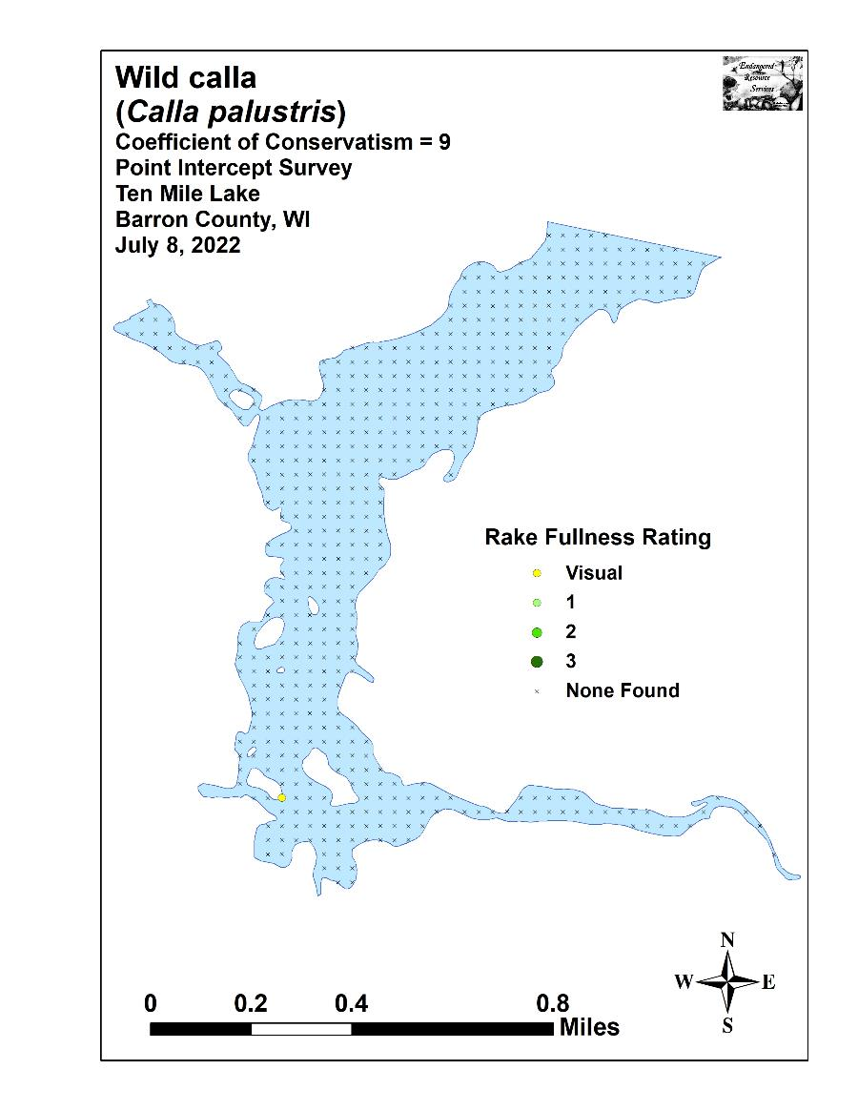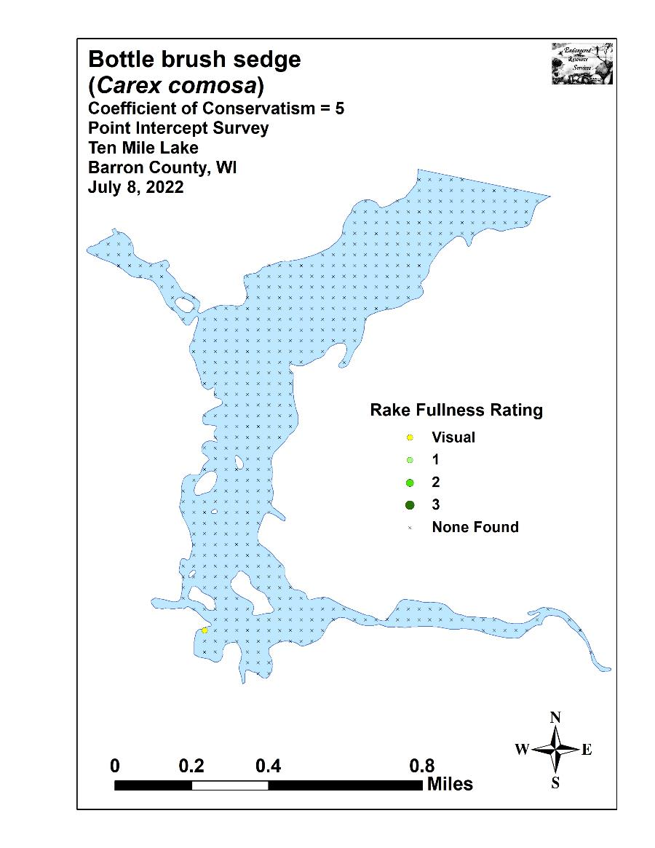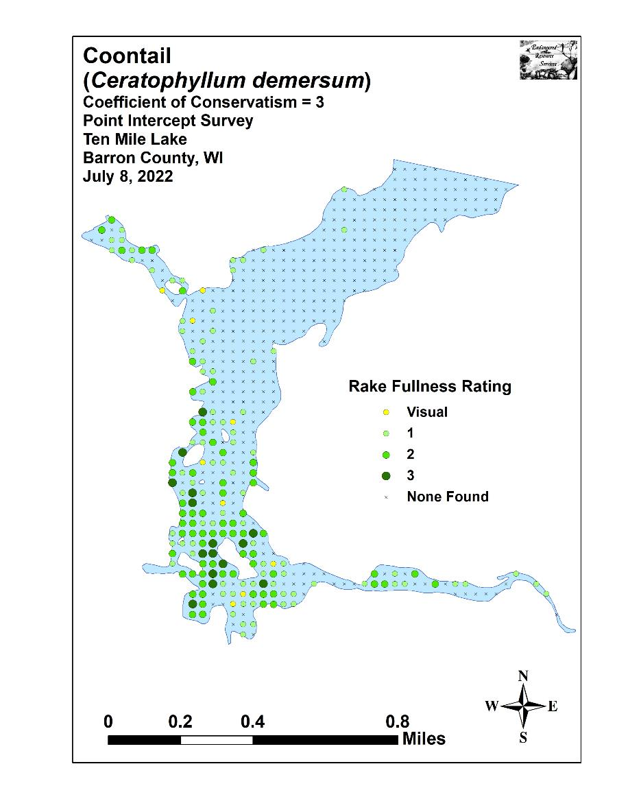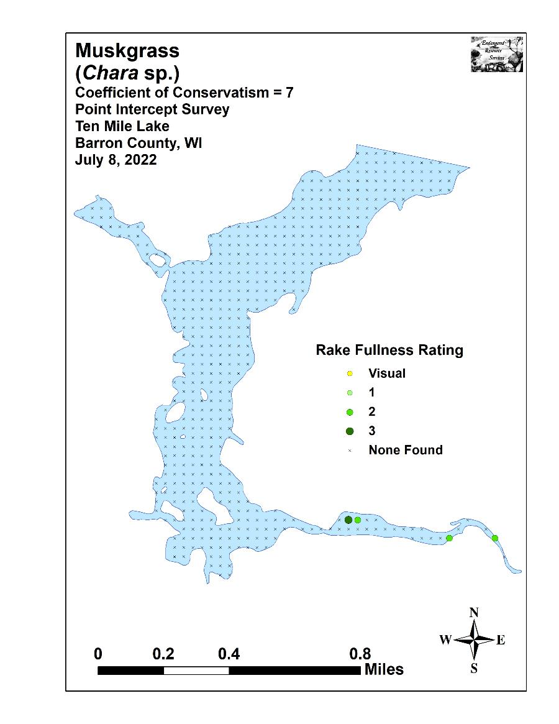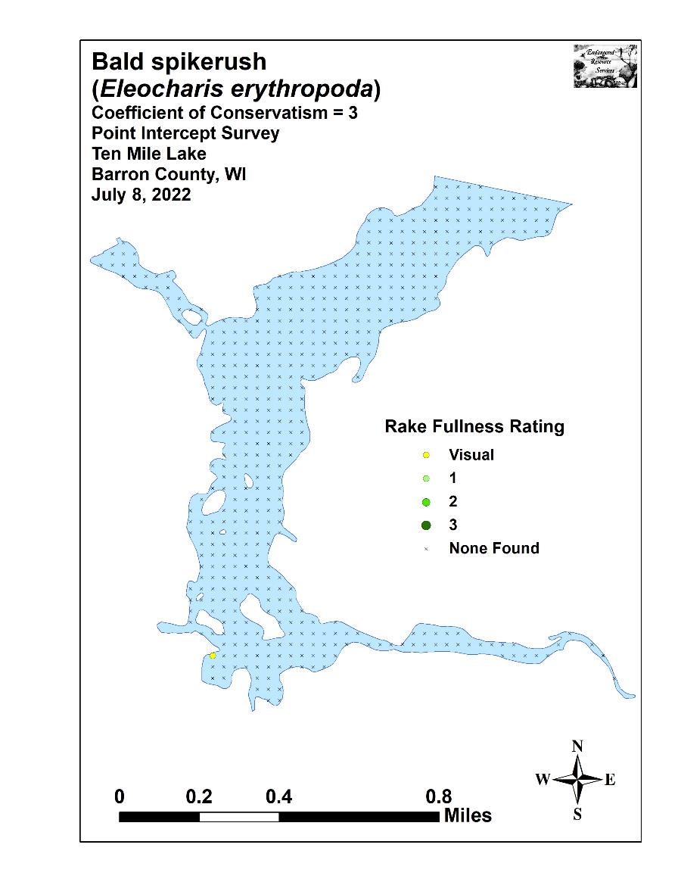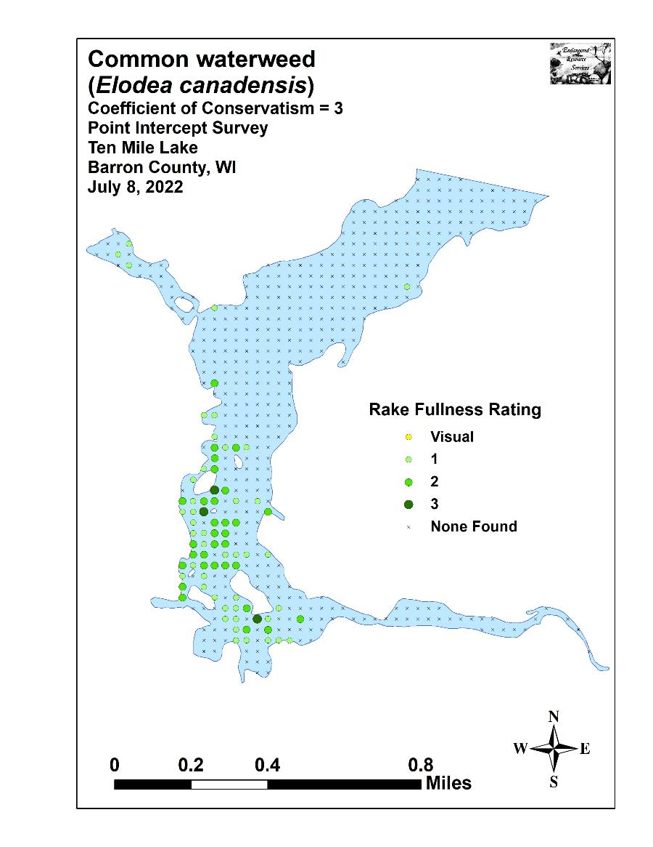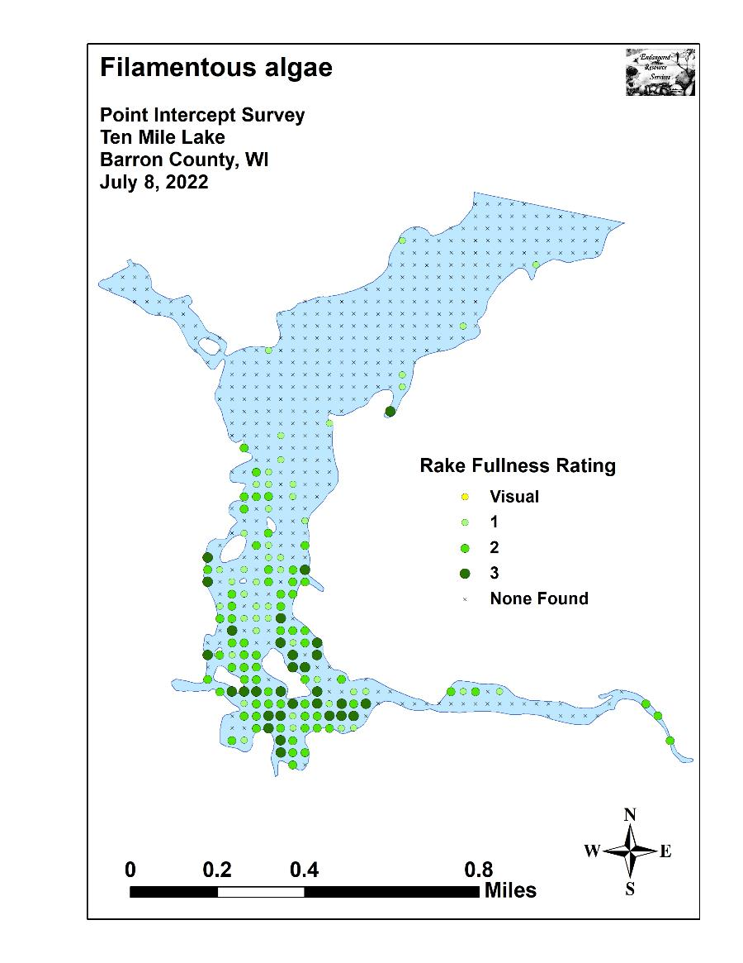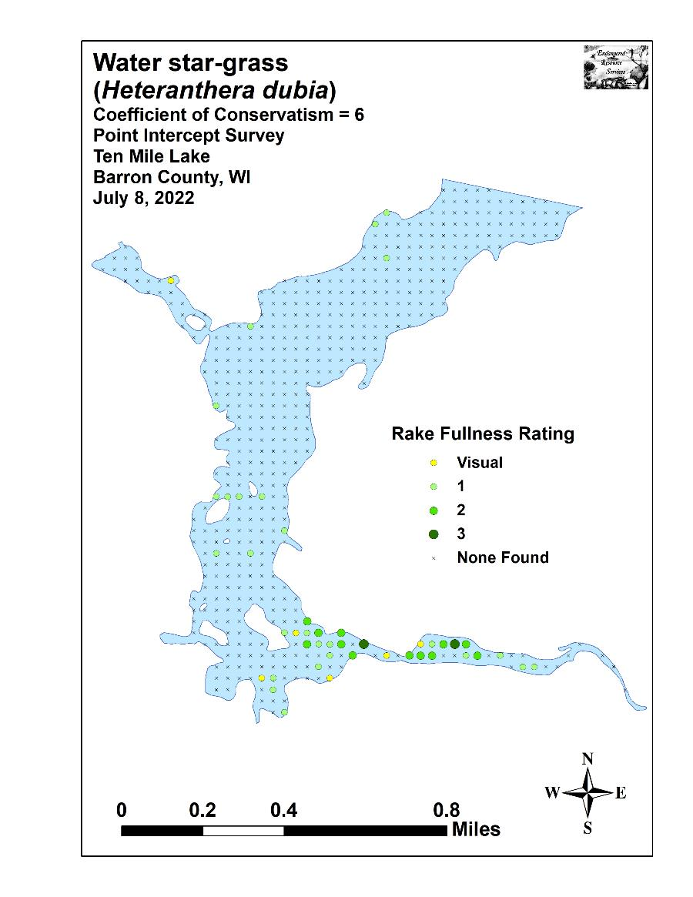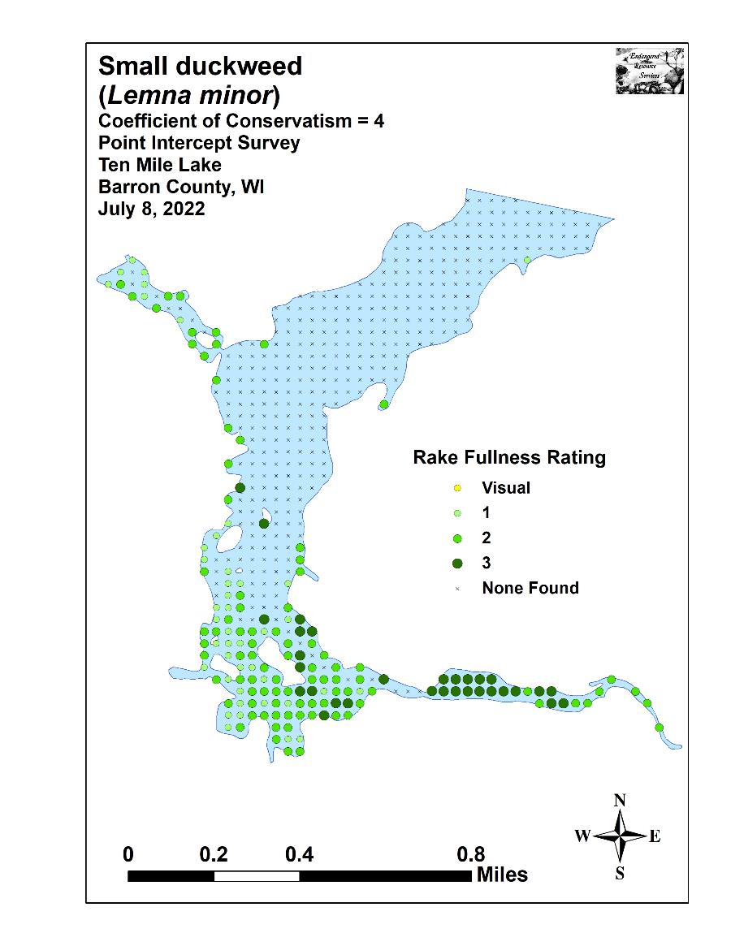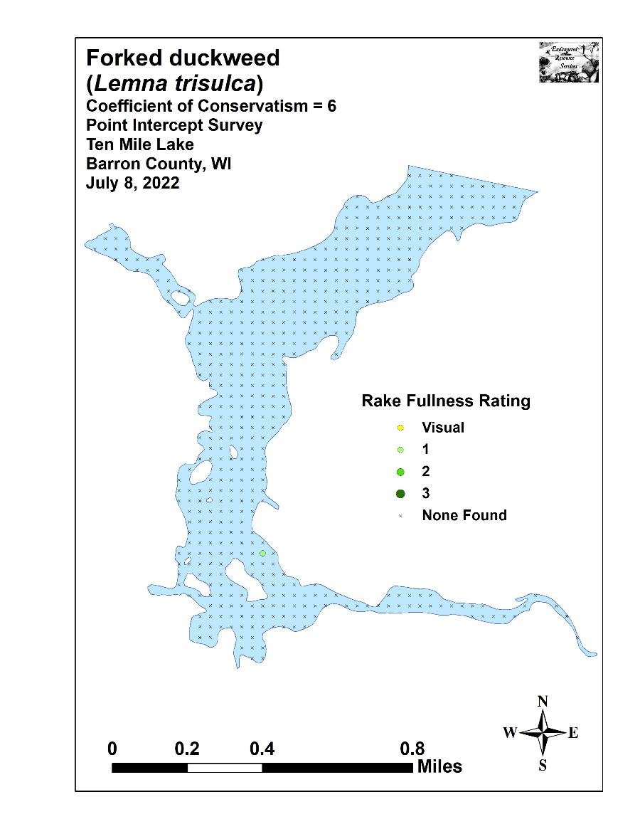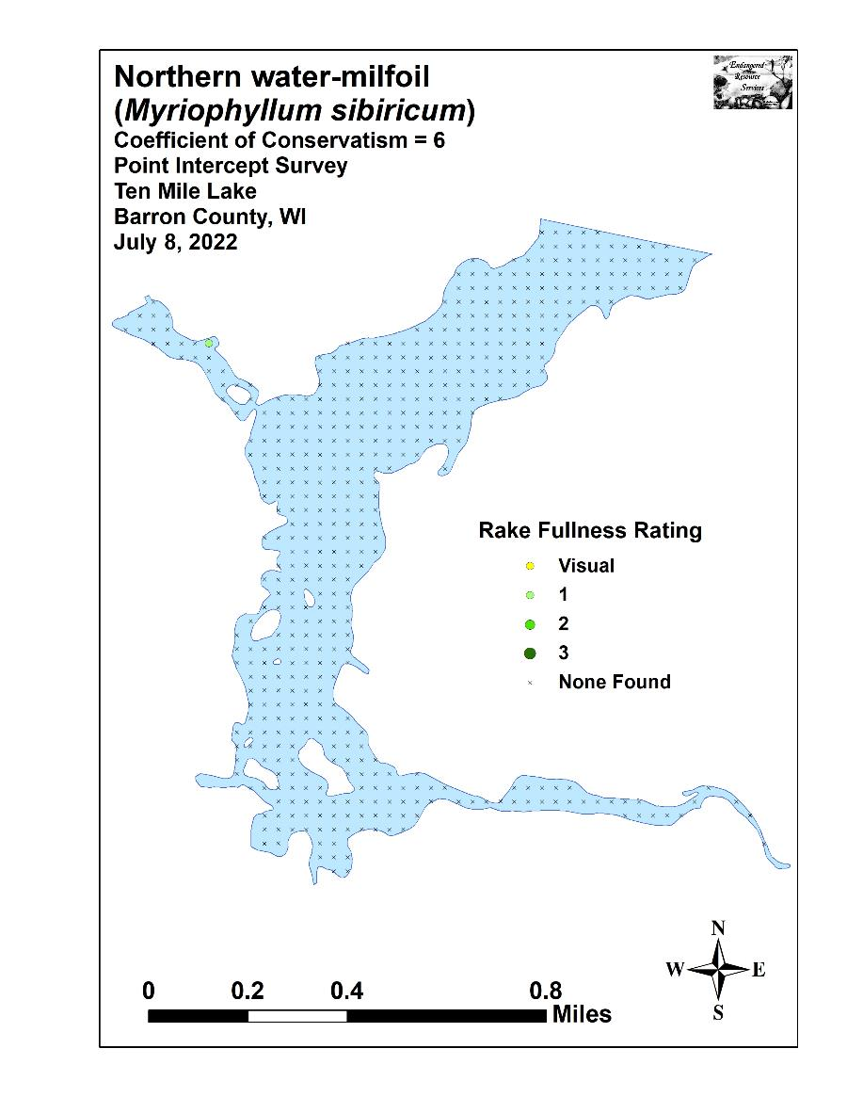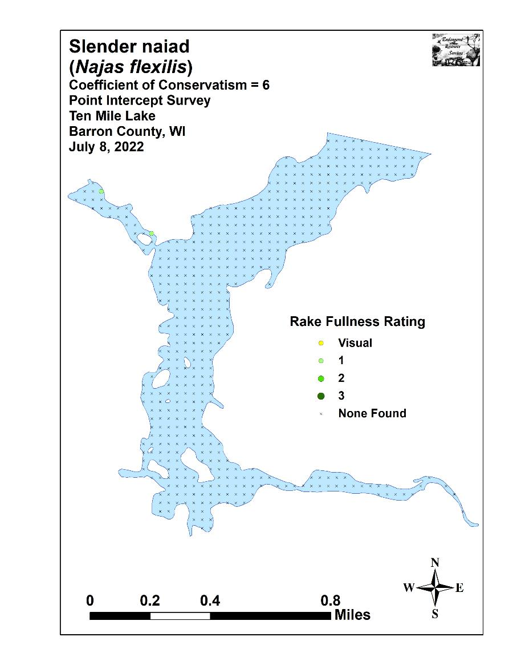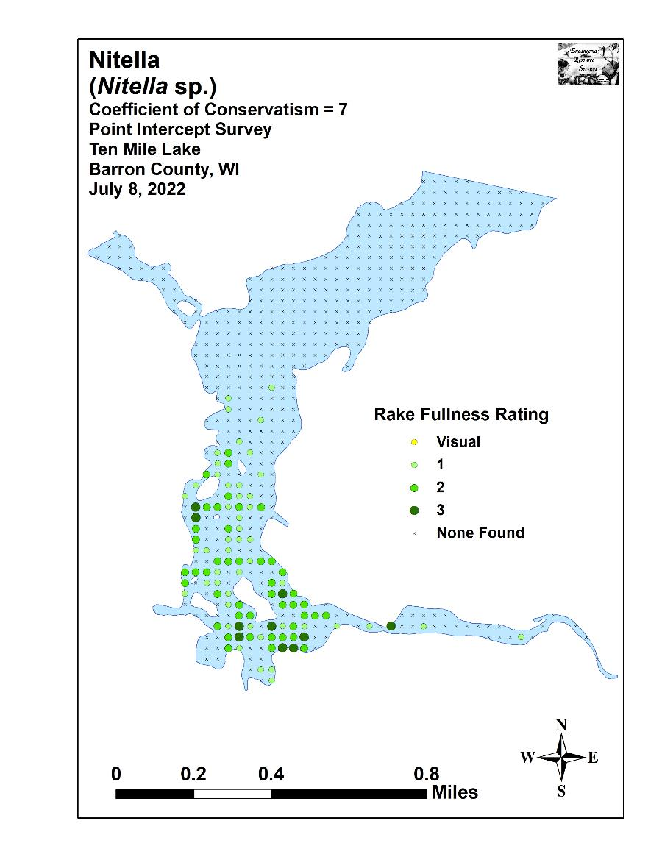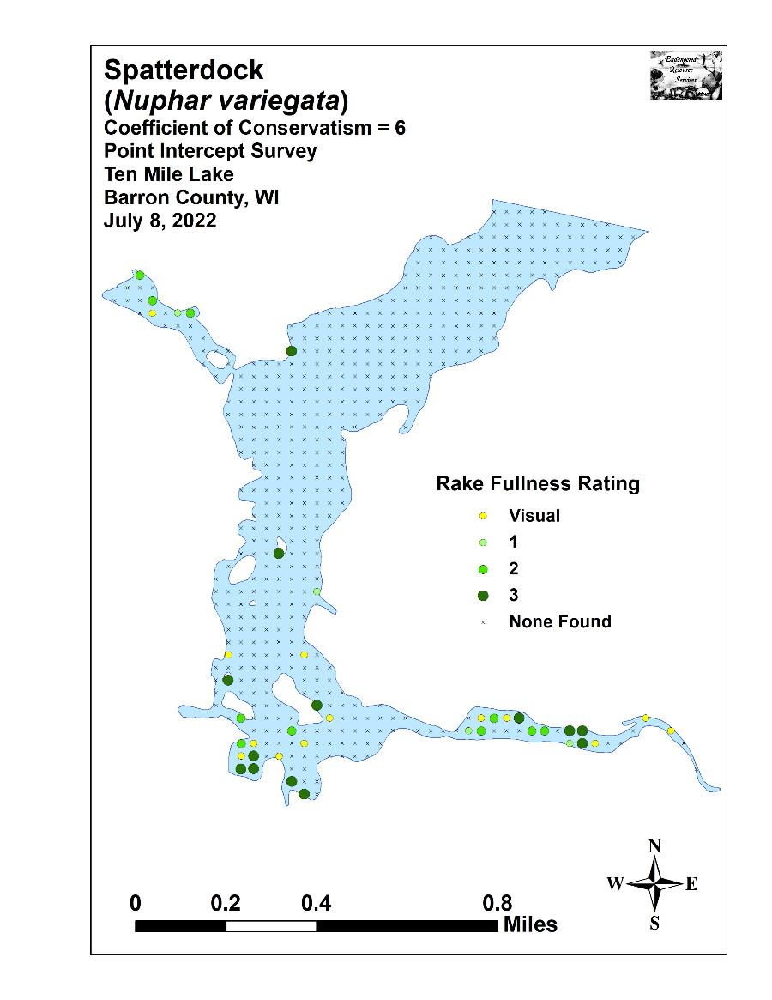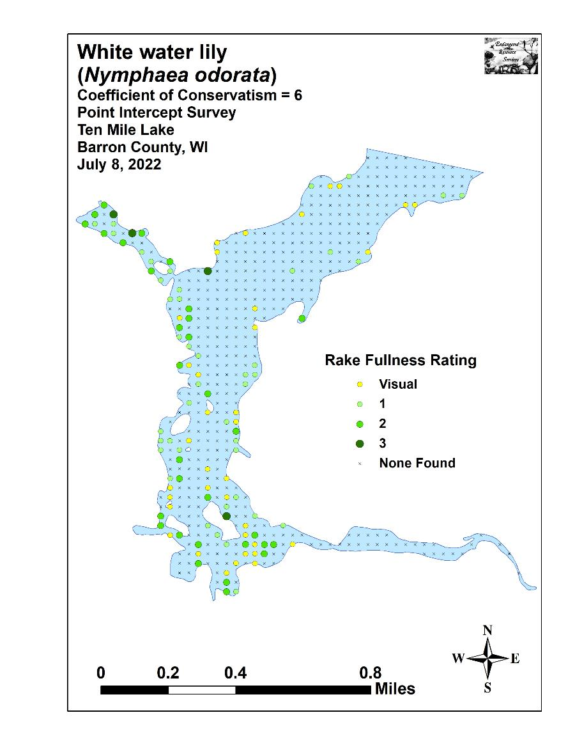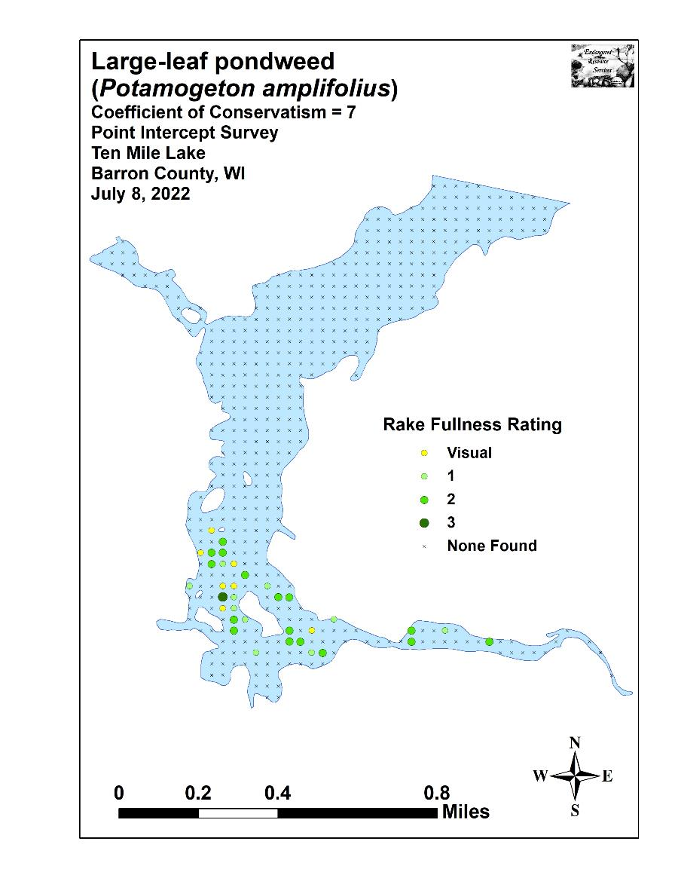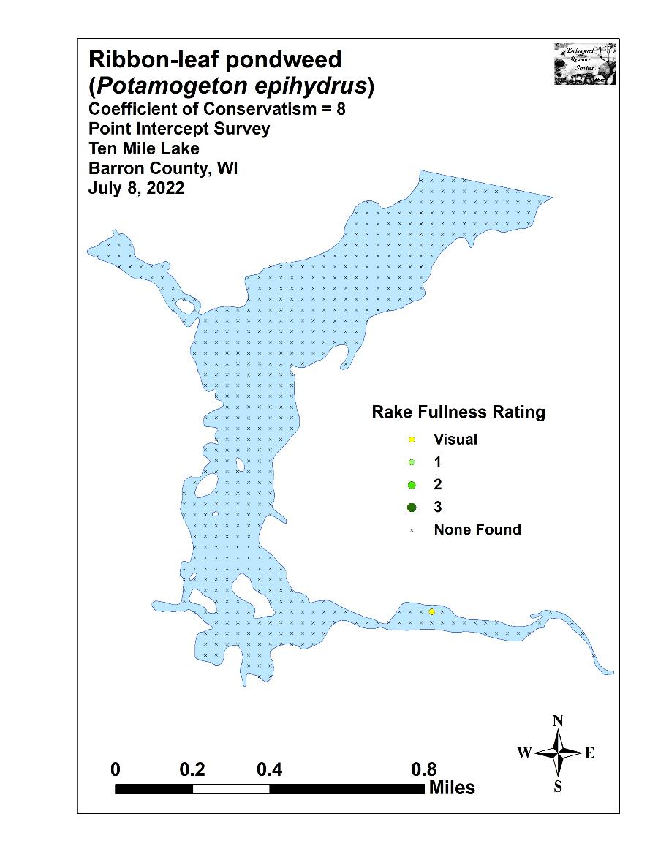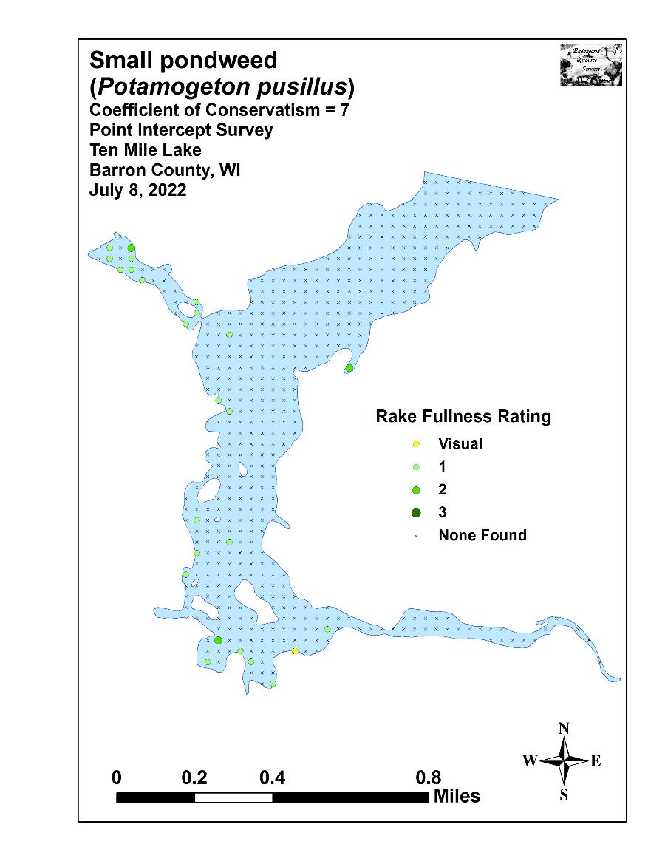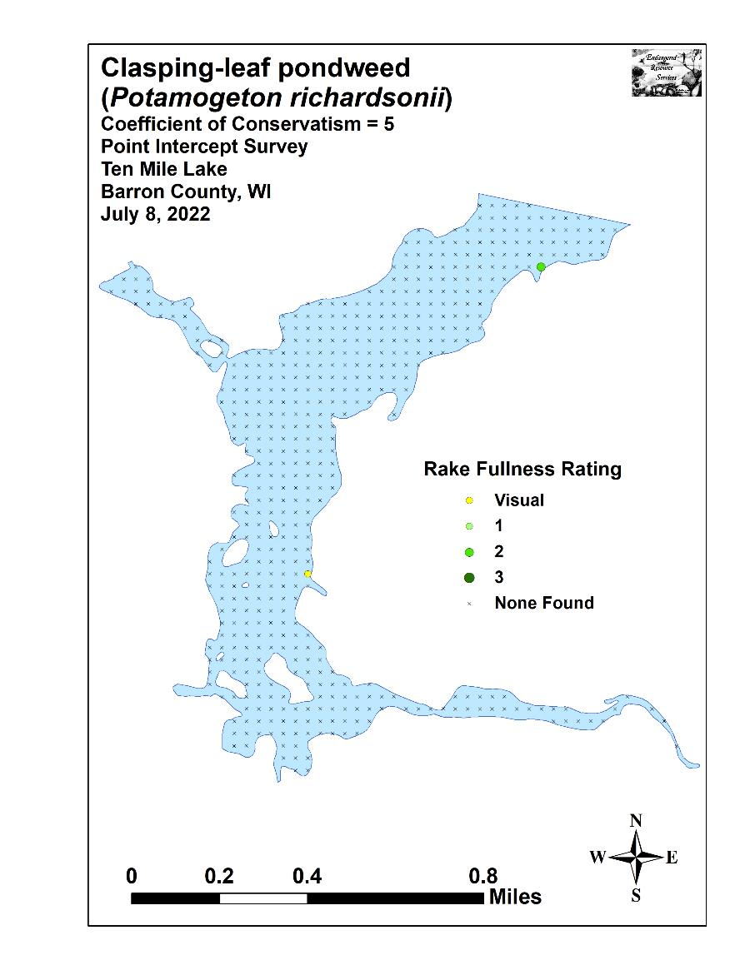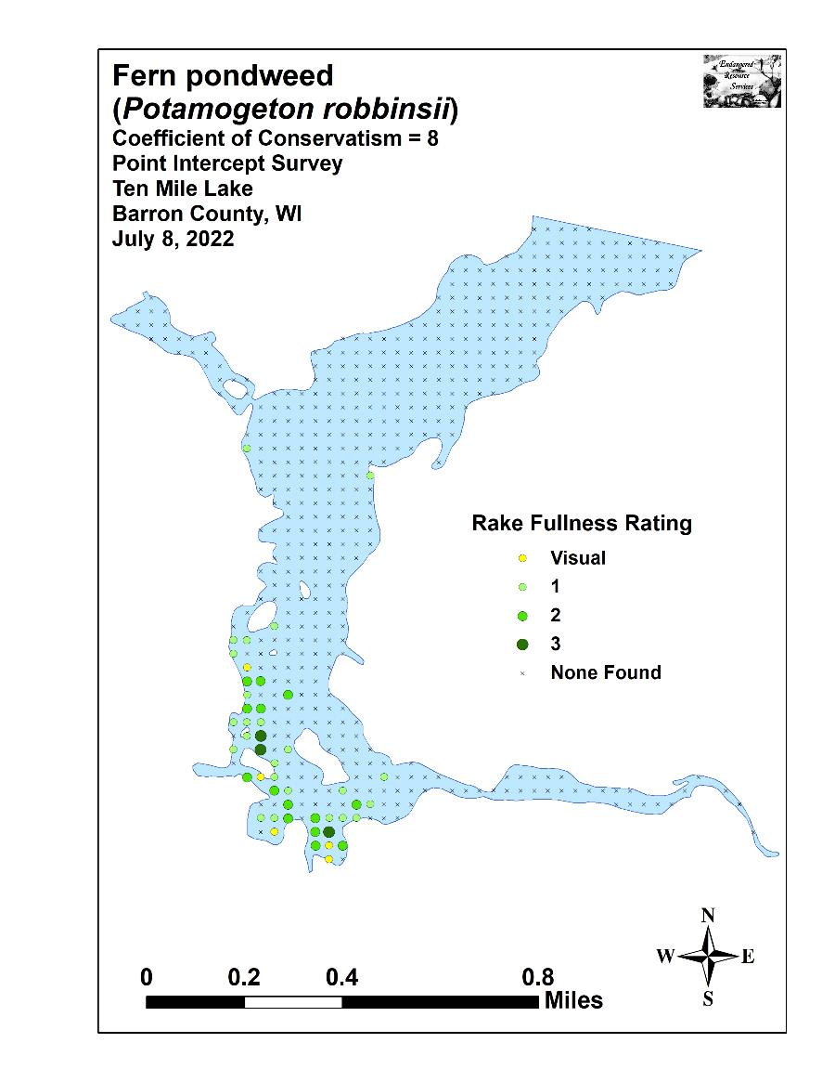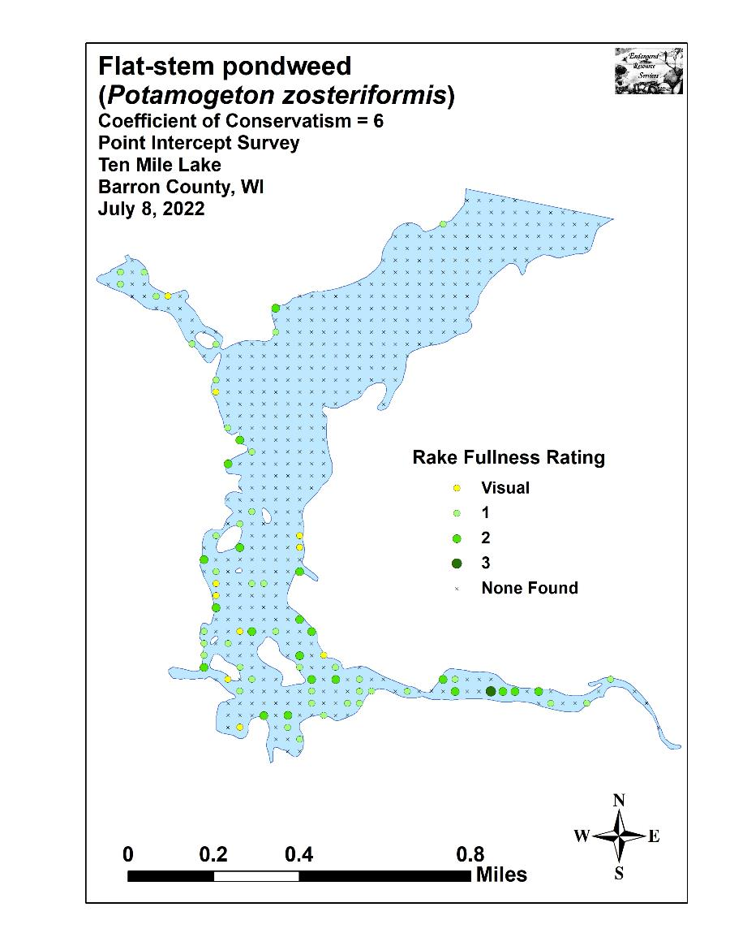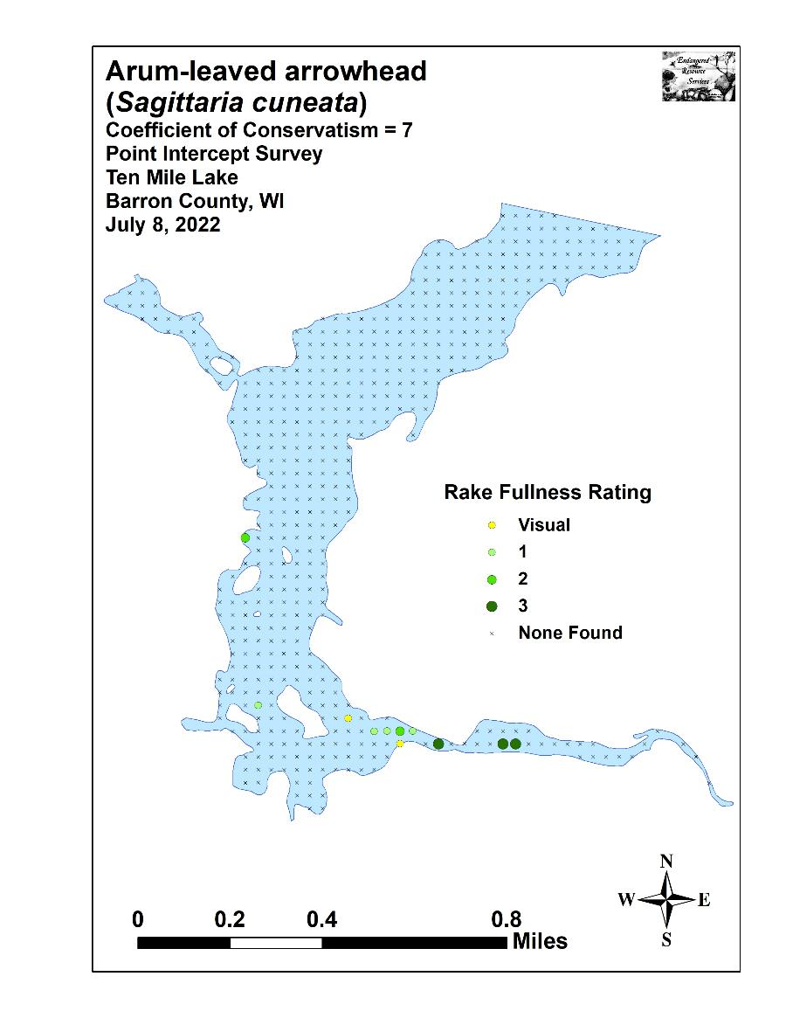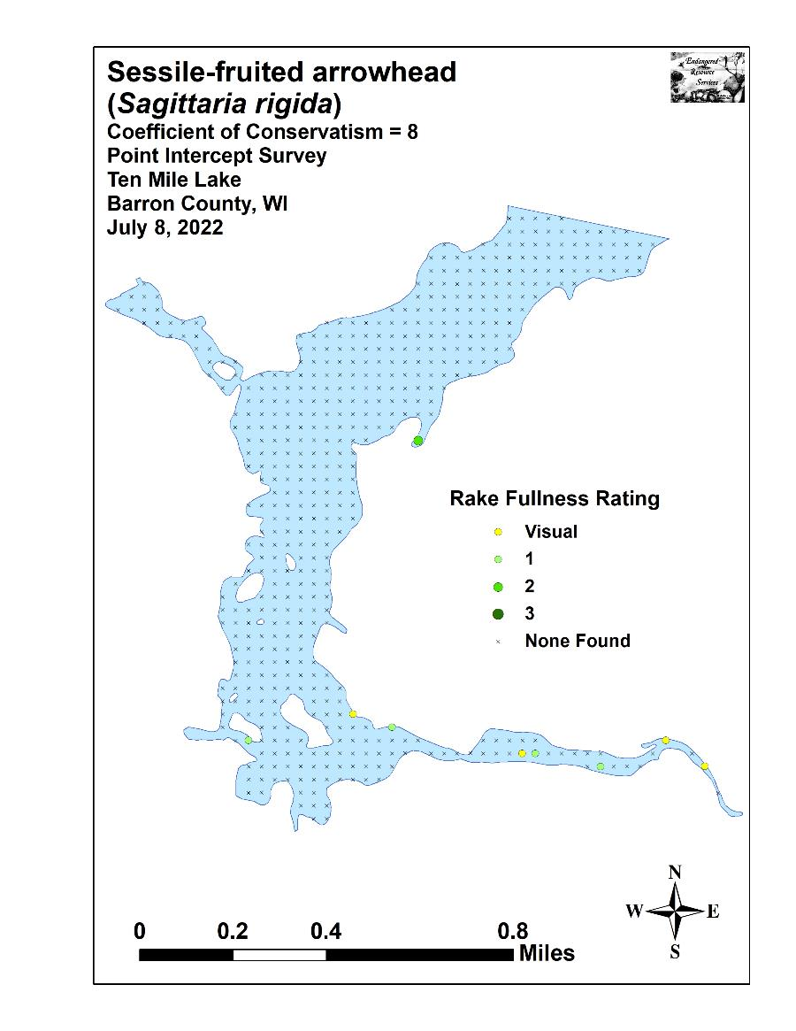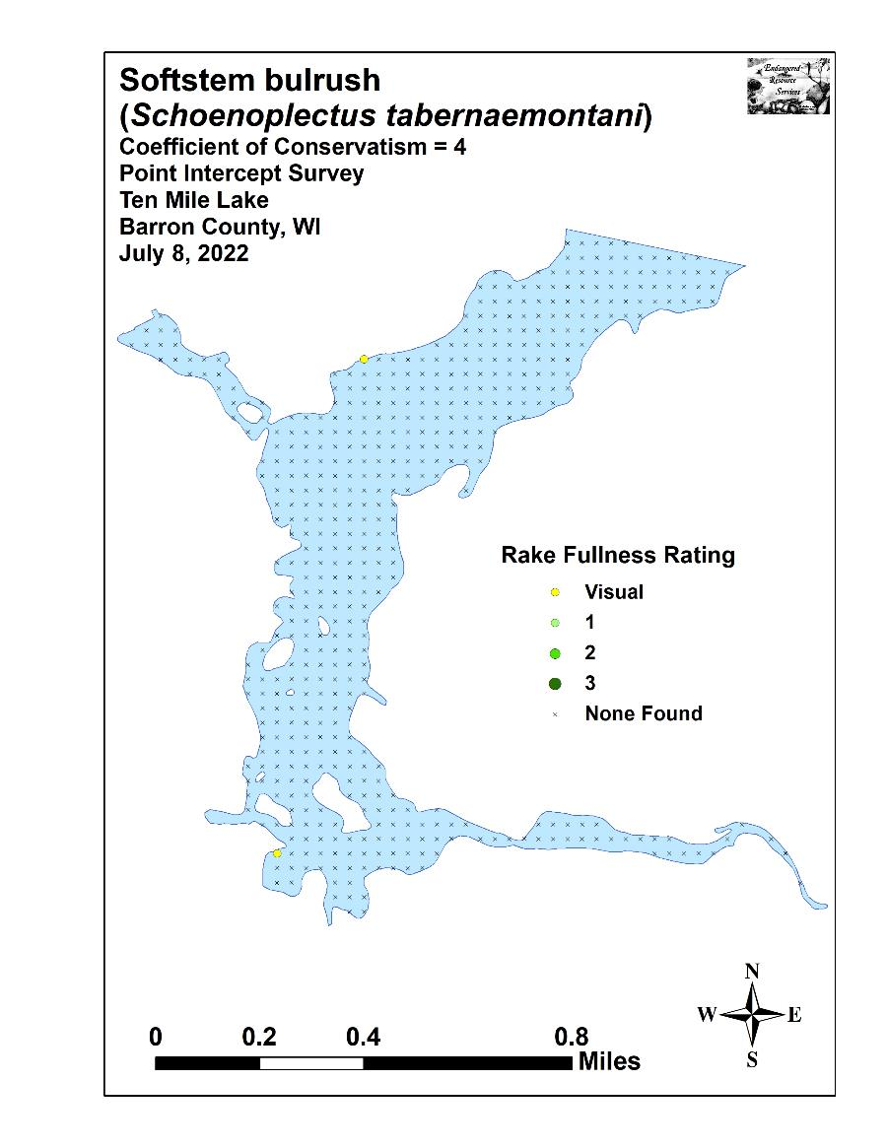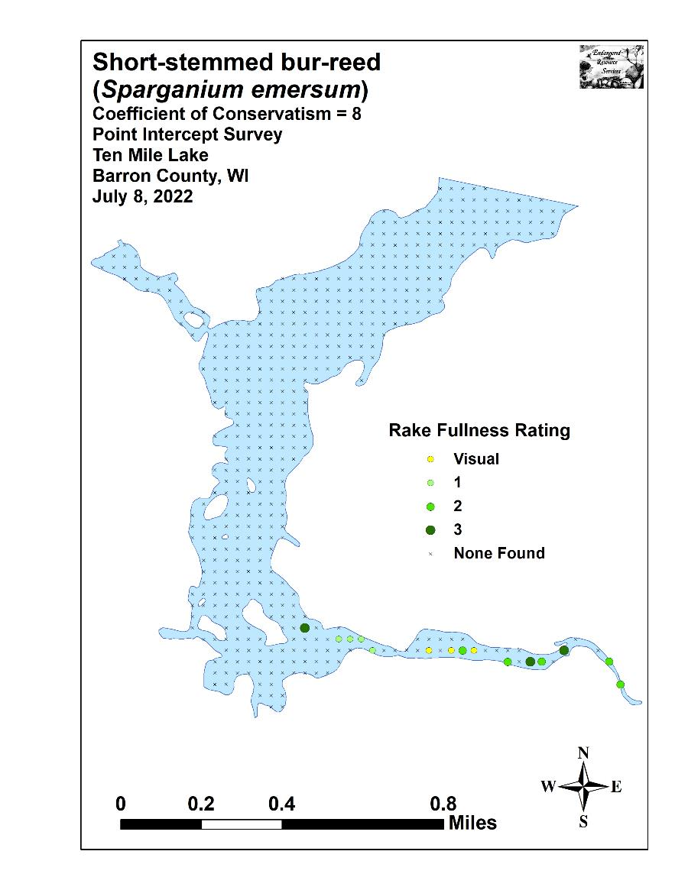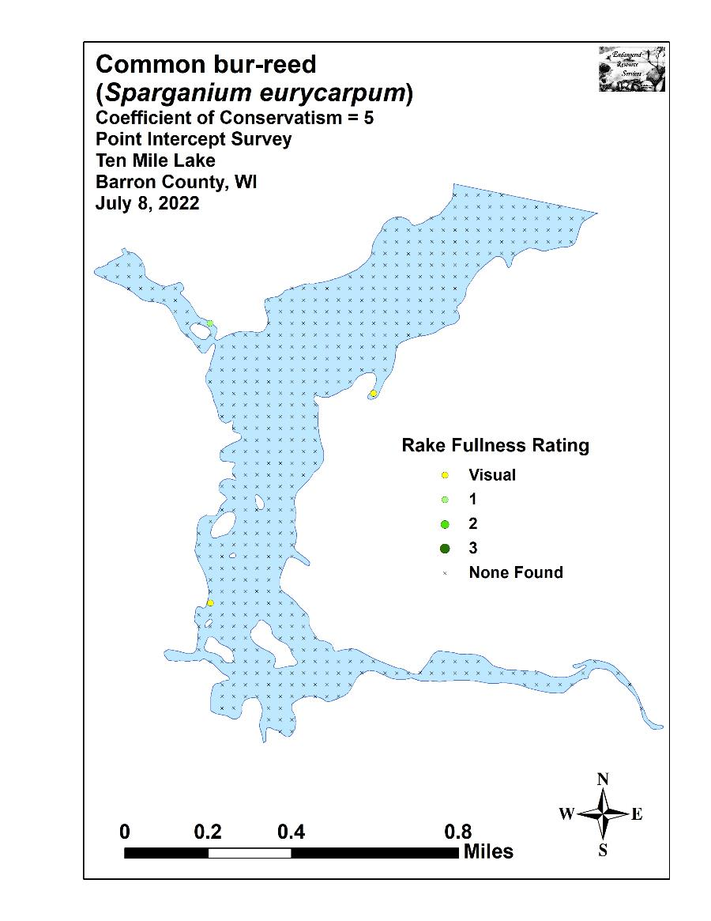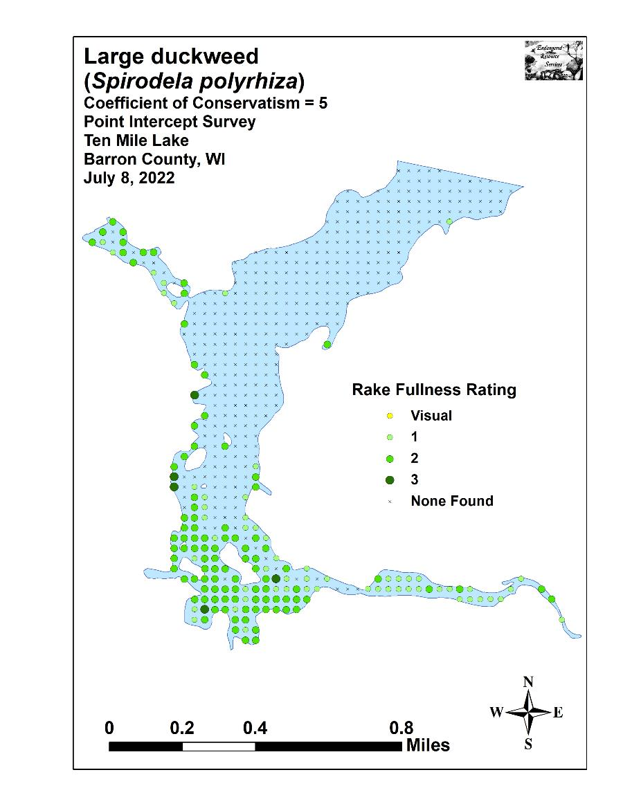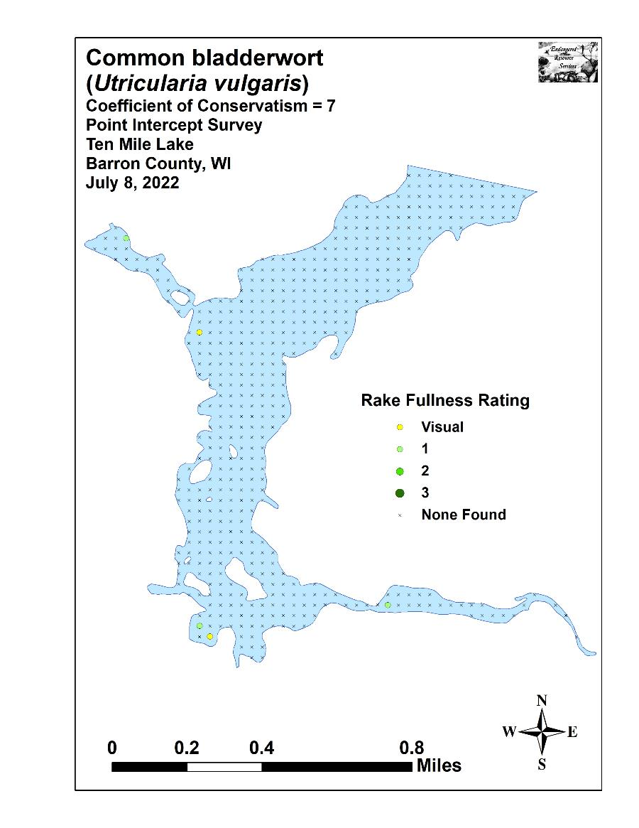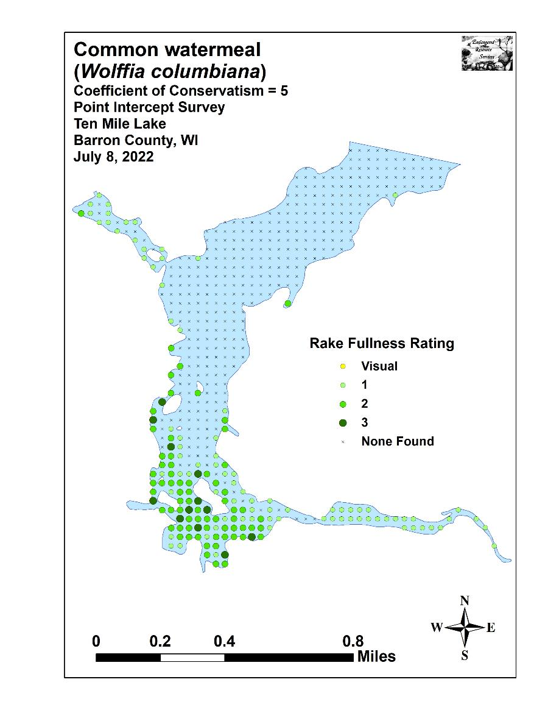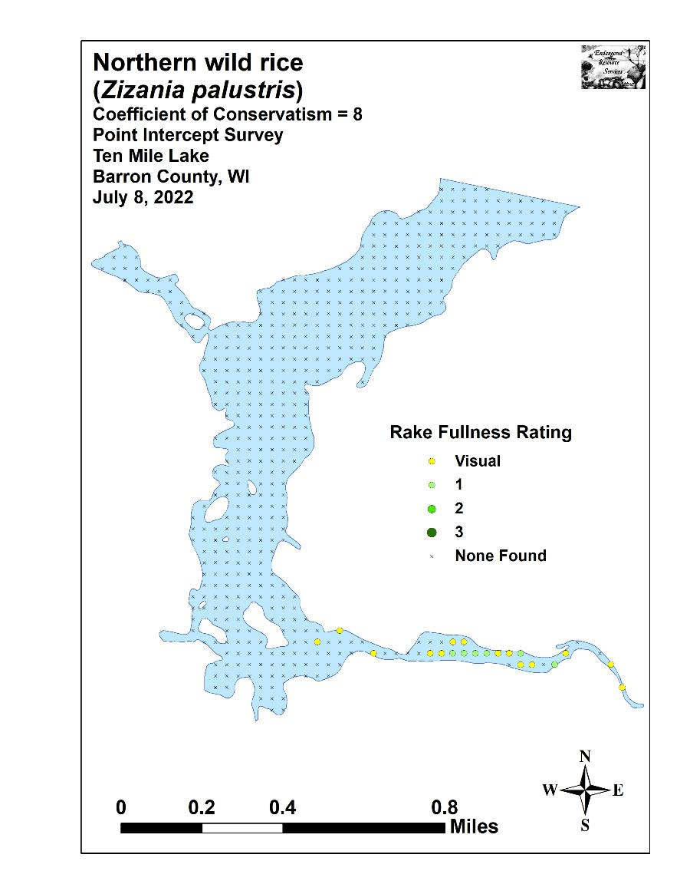

Appendix IX: July 2011 and 2022 Exotic Species
Density and Distribution Maps and
Aquatic Exotic Invasive Plant Species Information
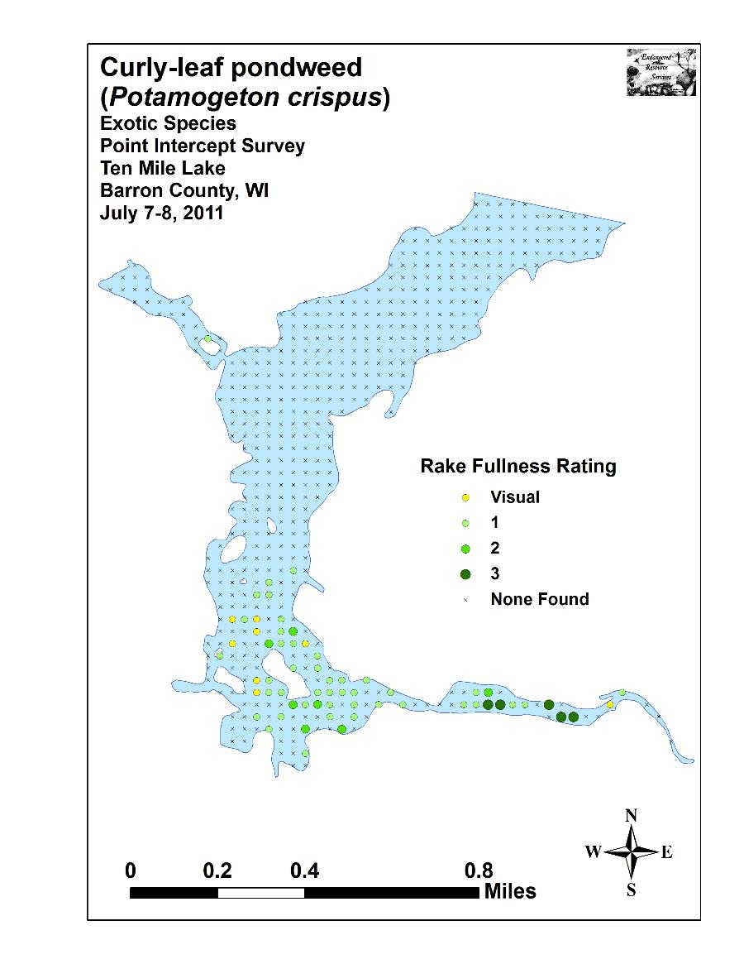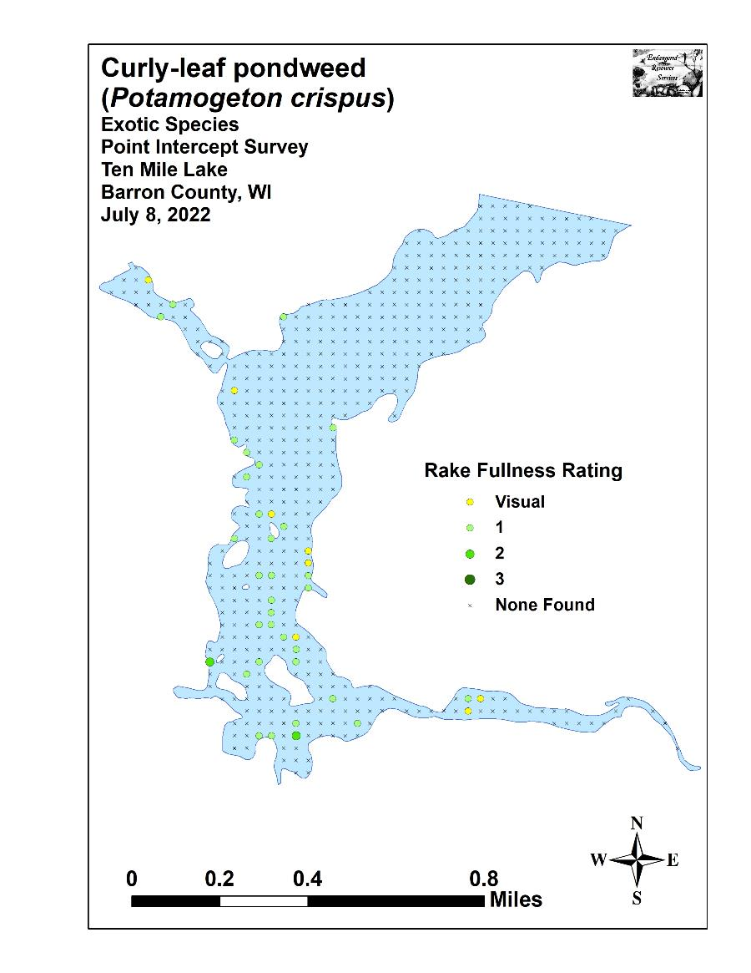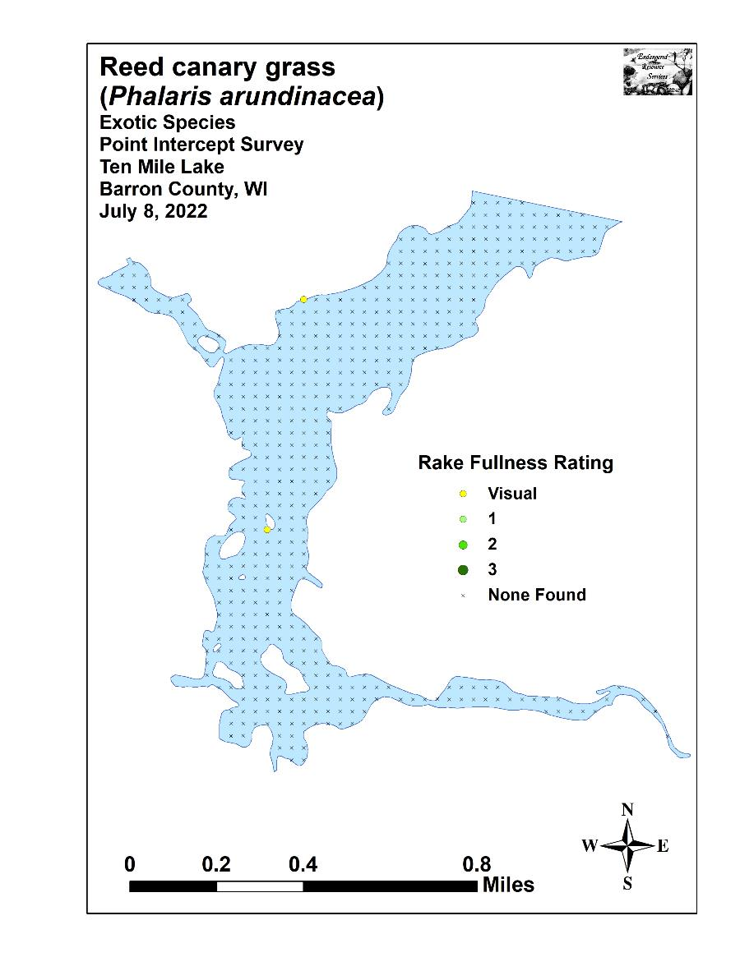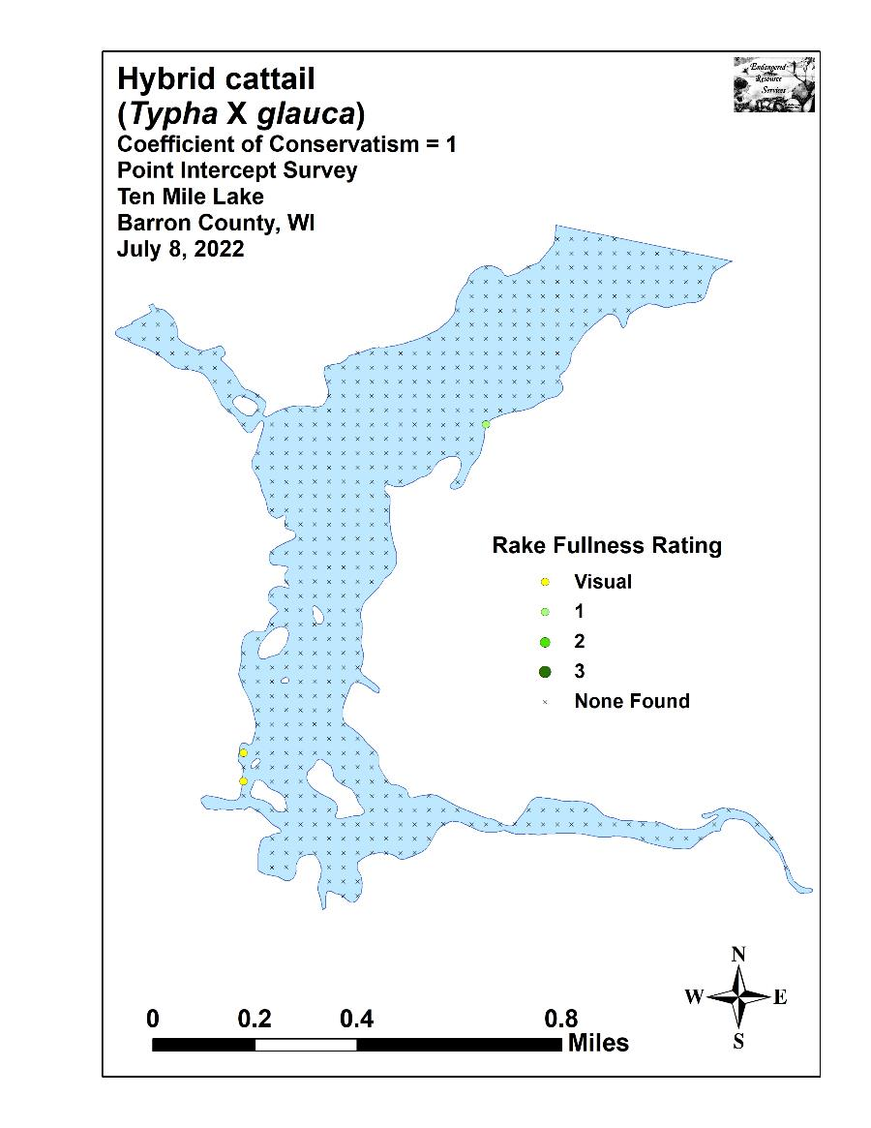
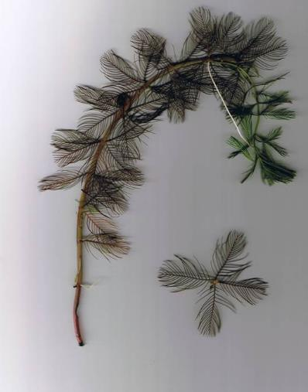
Eurasian Water-milfoil
DESCRIPTION: Eurasian Water-milfoil is a submersed aquatic plant native to Europe, Asia, and northern Africa. It is the only non-native milfoil in Wisconsin. Like the native milfoils, the Eurasian variety has slender stems whorled by submersed feathery leaves and tiny flowers produced above the water surface. The flowers are located in the axils of the floral bracts and are either four-petaled or without petals. The leaves are threadlike, typically uniform in diameter, and aggregated into a submersed terminal spike. The stem thickens below the inflorescence and doubles its width further down, often curving to lie parallel with the water surface. The fruits are four-jointed nut-like bodies. Without flowers or fruits, Eurasian Water-milfoil is nearly impossible to distinguish from Northern Water-milfoil. Eurasian Water-milfoil has 9-21 pairs of leaflets per leaf, while Northern milfoil typically has 7-11 pairs of leaflets. Coontail is often mistaken for the milfoils but does not have individual leaflets.
DISTRIBUTION AND HABITAT: Eurasian milfoil first arrived in Wisconsin in the 1960's. During the 1980's, it began to move from several counties in southern Wisconsin to lakes and waterways in the northern half of the state. As of 1993, Eurasian milfoil was common in 39 Wisconsin counties (54%) and at least 75 of its lakes, including shallow bays in Lakes Michigan and Superior and Mississippi River pools.
Eurasian Water-milfoil grows best in fertile, fine-textured, inorganic sediments. In less productive lakes, it is restricted to areas of nutrient-rich sediments. It has a history of becoming dominant in eutrophic, nutrient-rich lakes, although this pattern is not universal. It is an opportunistic species that prefers highly disturbed lake beds, lakes receiving nitrogen and phosphorous-laden runoff, and heavily used lakes. Optimal growth occurs in alkaline systems with a high concentration of dissolved inorganic carbon. High water temperatures promote multiple periods of flowering and fragmentation.
LIFE HISTORY AND EFFECTS OF INVASION: Unlike many other plants, Eurasian Water-milfoil does not rely on seed for reproduction. Its seeds germinate poorly under natural conditions. It reproduces vegetatively by fragmentation, allowing it to disperse over long distances. The plant produces fragments after fruiting once or twice during the summer. These shoots may then be carried downstream by water currents or inadvertently picked up by boaters. Milfoil is readily dispersed by boats, motors, trailers, bilges, live wells, or bait buckets, and can stay alive for weeks if kept moist.
Once established in an aquatic community, milfoil reproduces from shoot fragments and stolons (runners that creep along the lakebed). As an opportunistic species, Eurasian Water-milfoil is adapted for rapid growth early in spring. Stolons, lower stems, and roots persist over winter and store the carbohydrates that help milfoil claim the water column early in spring, photosynthesize, divide, and form a dense leaf canopy that shades out native aquatic plants. Its ability to spread rapidly by fragmentation and effectively block out sunlight needed for native plant growth often results in monotypic stands. Monotypic stands of Eurasian milfoil provide only a single habitat, and they threaten the integrity of aquatic communities in a number of ways; for example, dense stands disrupt predator-prey relationships by fencing out larger fish and reducing the number of nutrient-rich native plants available for waterfowl.
Dense stands of Eurasian Water-milfoil also inhibit recreational uses like swimming, boating, and fishing. Some stands have been dense enough to obstruct industrial and power generation water intakes. The visual impact that greets the lake user on milfoil-dominated lakes is the flat yellow-green of matted vegetation, often prompting the perception that the lake is "infested" or "dead". Cycling of nutrients from sediments to the water column by Eurasian Water-milfoil may lead to deteriorating water quality and algae blooms of infested lakes. (Taken in its entirety from WDNR, 2010 http://www.dnr.state.wi.us/invasives/fact/milfoil.htm)

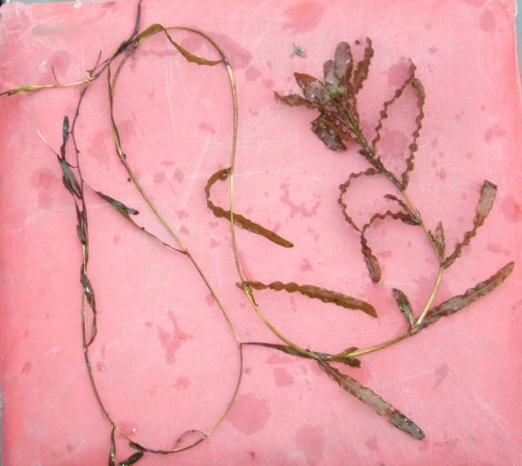
Curly-leaf pondweed
DESCRIPTION: Curly-leaf pondweed is an invasive aquatic perennial that is native to Eurasia, Africa, and Australia. It was accidentally introduced to United States waters in the mid-1880s by hobbyists who used it as an aquarium plant. The leaves are reddish-green, oblong, and about 3 inches long, with distinct wavy edges that are finely toothed. The stem of the plant is flat, reddish-brown and grows from 1 to 3 feet long. The plant usually drops to the lake bottom by early July.
DISTRIBUTION AND HABITAT: Curly-leaf pondweed is commonly found in alkaline and high nutrient waters, preferring soft substrate and shallow water depths. It tolerates low light and low water temperatures. It has been reported in all states but Maine
LIFE HISTORY AND EFFECTS OF INVASION: Curly-leaf pondweed spreads through burr-like winter buds (turions), which are moved among waterways. These plants can also reproduce by seed, but this plays a relatively small role compared to the vegetative reproduction through turions. New plants form under the ice in winter, making curly-leaf pondweed one of the first nuisance aquatic plants to emerge in the spring.
It becomes invasive in some areas because of its tolerance for low light and low water temperatures. These tolerances allow it to get a head start on and out compete native plants in the spring. In mid-summer, when most aquatic plants are growing, curly-leaf pondweed plants are dying off. Plant die-offs may result in a critical loss of dissolved oxygen. Furthermore, the decaying plants can increase nutrients which contribute to algal blooms, as well as create unpleasant stinking messes on beaches. Curly-leaf pondweed forms surface mats that interfere with aquatic recreation. (Taken in its entirety from WDNR, 2010 http://www.dnr.state.wi.us/invasives/fact/curlyleaf_pondweed.htm)
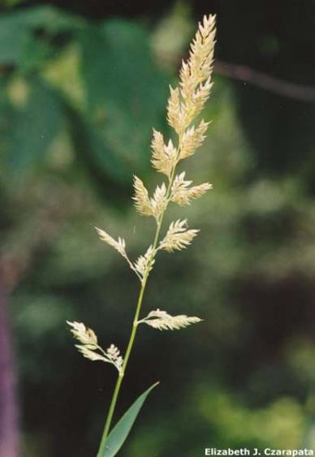
Reed canary grass
DESCRIPTION: Reed canary grass is a large, coarse grass that reaches 2 to 9 feet in height. It has an erect, hairless stem with gradually tapering leaf blades 3 1/2 to 10 inches long and 1/4 to 3/4 inch in width. Blades are flat and have a rough texture on both surfaces. The lead ligule is membranous and long. The compact panicles are erect or slightly spreading (depending on the plant's reproductive stage) and range from 3 to 16 inches long with branches 2 to 12 inches in length. Single flowers occur in dense clusters in May to mid-June. They are green to purple at first and change to beige over time. This grass is one of the first to sprout in spring and forms a thick rhizome system that dominates the subsurface soil. Seeds are shiny brown in color.
Both Eurasian and native ecotypes of reed canary grass are thought to exist in the U.S. The Eurasian variety is considered more aggressive, but no reliable method exists to tell the ecotypes apart. It is believed that the vast majority of our reed canary grass is derived from the Eurasian ecotype. Agricultural cultivars of the grass are widely planted.
Reed canary grass also resembles non-native orchard grass (Dactylis glomerata), but can be distinguished by its wider blades, narrower, more pointed inflorescence, and the lack of hairs on glumes and lemmas (the spikelet scales). Additionally, bluejoint grass (Calamagrostis canadensis) may be mistaken for reed canary in areas where orchard grass is rare, especially in the spring. The highly transparent ligule on reed canary grass is helpful in distinguishing it from the others. Ensure positive identification before attempting control.

DISTRIBUTION AND HABITAT: Reed canary grass is a cool-season, sod-forming, perennial wetland grass native to temperate regions of Europe, Asia, and North America. The Eurasian ecotype has been selected for its vigor and has been planted throughout the U.S. since the 1800's for forage and erosion control. It has become naturalized in much of the northern half of the U.S. and is still being planted on steep slopes and banks of ponds and created wetlands.
Reed canary grass can grow on dry soils in upland habitats and in the partial shade of oak woodlands, but does best on fertile, moist organic soils in full sun. This species can invade most types of wetlands, including marshes, wet prairies, sedge meadows, fens, stream banks, and seasonally wet areas; it also grows in disturbed areas such as berms and spoil piles.
LIFE HISTORY AND EFFECTS OF INVASION: Reed canary grass reproduces by seed or creeping rhizomes. It spreads aggressively. The plant produces leaves and flower stalks for 5 to 7 weeks after germination in early spring, then spreads laterally. Growth peaks in mid-June and declines in mid-August. A second growth spurt occurs in the fall. The shoots collapse in mid to late summer, forming a dense, impenetrable mat of stems and leaves. The seeds ripen in late June and shatter when ripe. Seeds may be dispersed from one wetland to another by waterways, animals, humans, or machines.
This species prefers disturbed areas but can easily move into native wetlands. Reed canary grass can invade a disturbed wetland in less than twelve years. Invasion is associated with disturbances including ditching of wetlands, stream channelization, deforestation of swamp forests, sedimentation, and intentional planting. The difficulty of selective control makes reed canary grass invasion of particular concern. Over time, it forms large, monotypic stands that harbor few other plant species and are subsequently of little use to wildlife. Once established, reed canary grass dominates an area by building up a tremendous seed bank that can eventually erupt, germinate, and recolonize treated sites. (Taken in its entirety from WDNR, 2010 http://www.dnr.state.wi.us/invasives/fact/reed_canary.htm)
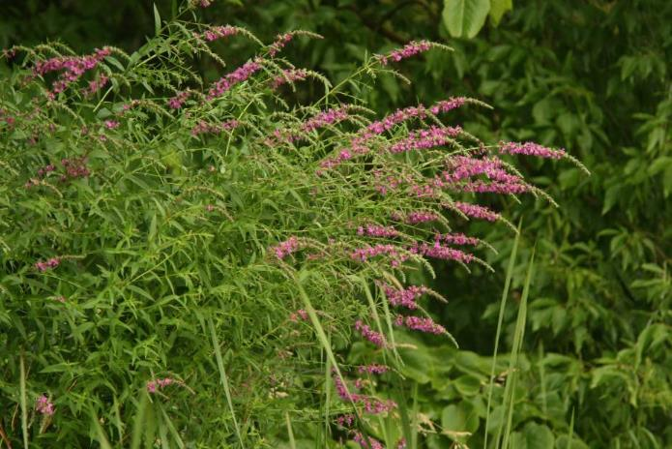
Purple loosestrife
(Photo Courtesy Brian M. Collins)
DESCRIPTION: Purple loosestrife is a perennial herb 3-7 feet tall with a dense bushy growth of 1-50 stems. The stems, which range from green to purple, die back each year. Showy flowers vary from purple to magenta, possess 5-6 petals aggregated into numerous long spikes, and bloom from August to September. Leaves are opposite, nearly linear, and attached to four-sided stems without stalks. It has a large, woody taproot with fibrous rhizomes that form a dense mat.
This species may be confused with the native wing-angled loosestrife (Lythrum alatum) found in moist prairies or wet meadows. The latter has a winged, square stem and solitary paired flowers in the leaf axils. It is generally a smaller plant than the Eurasian loosestrife.
By law, purple loosestrife is a nuisance species in Wisconsin. It is illegal to sell, distribute, or cultivate the plants or seeds, including any of its cultivars.
DISTRIBUTION AND HABITAT: Purple loosestrife is a wetland herb that was introduced as a garden perennial from Europe during the 1800's. It is still promoted by some horticulturists for its beauty as a landscape plant, and by beekeepers for its nectar-producing capability. Currently, about 24 states have laws prohibiting its importation or distribution because of its aggressively invasive characteristics. It has since extended its range to include most temperate parts of the United States and Canada. The plant's reproductive success across North America can be attributed to its wide tolerance of physical and chemical conditions characteristic of disturbed habitats, and its ability to reproduce prolifically by both seed dispersal and vegetative propagation. The absence of natural predators, like European species of herbivorous beetles that feed on the plant's roots and leaves, also contributes to its proliferation in North America
LIFE HISTORY AND EFFECTS OF INVASION: Purple loosestrife can germinate successfully on substrates with a wide range of pH. Optimum substrates for growth are moist soils of neutral to slightly acidic pH, but it can exist in a wide range of soil types. Most seedling establishment occurs in late spring and early summer when temperatures are high.
Purple loosestrife spreads mainly by seed, but it can also spread vegetatively from root or stem segments. A single stalk can produce from 100,000 to 300,000 seeds per year. Seed survival is up to 60-70%, resulting in an extensive seed bank. Mature plants with up to 50 shoots grow over 2 meters high and produce more than two million seeds a year. Germination is restricted to open, wet soils and requires high temperatures, but seeds remain viable in the soil for many years. Even seeds submerged in water can live for approximately 20 months. Most of the seeds fall near the parent plant, but water, animals, boats, and humans can transport the seeds long distances. Vegetative spread through local perturbation is also characteristic of loosestrife; clipped, trampled, or buried stems of established plants may produce shoots and roots. Plants may be quite large and several years old before they begin flowering. It is often very difficult to locate non-flowering plants, so monitoring for new invasions should be done at the beginning of the flowering period in mid-summer.
Any sunny or partly shaded wetland is susceptible to purple loosestrife invasion. Vegetative disturbances such as water drawdown or exposed soil accelerate the process by providing ideal conditions for seed germination. Invasion usually begins with a few pioneering plants that build up a large seed bank in the soil for several years. When the right disturbance occurs, loosestrife can spread rapidly, eventually taking over the entire wetland. The plant can also make morphological adjustments to accommodate changes in the immediate environment; for example, a decrease in light level will trigger a change in leaf morphology. The plant's ability to adjust to a wide range of environmental conditions gives it a competitive advantage; coupled with its reproductive strategy, purple loosestrife tends to create monotypic stands that reduce biotic diversity.
Purple loosestrife displaces native wetland vegetation and degrades wildlife habitat. As native vegetation is displaced, rare plants are often the first species to disappear. Eventually, purple loosestrife can overrun wetlands thousands of acres in size, and almost entirely eliminate the open water habitat. The plant can also be detrimental to recreation by choking waterways. (Taken in its entirety from WDNR, 2010 http://www.dnr.state.wi.us/invasives/fact/loosestrife.htm)

Appendix X: Glossary of Biological Terms
(Adapted from UWEX 2010)

Aquatic:
organisms that live in or frequent water.

Cultural Eutrophication:
accelerated eutrophication that occurs as a result of human activities in the watershed that increase nutrient loads in runoff water that drains into lakes.

Dissolved Oxygen (DO):
the amount of free oxygen absorbed by the water and available to aquatic organisms for respiration; amount of oxygen dissolved in a certain amount of water at a particular temperature and pressure, often expressed as a concentration in parts of oxygen per million parts of water.

Diversity:
number and evenness of species in a particular community or habitat.

Drainage lakes:
Lakes fed primarily by streams and with outlets into streams or rivers. They are more subject to surface runoff problems but generally have shorter residence times than seepage lakes. Watershed protection is usually needed to manage lake water quality.

Ecosystem:
a system formed by the interaction of a community of organisms with each other and with the chemical and physical factors making up their environment.

Eutrophication:
the process by which lakes and streams are enriched by nutrients, and the resulting increase in plant and algae growth. This process includes physical, chemical, and biological changes that take place after a lake receives inputs for plant nutrients--mostly nitrates and phosphates--from natural erosion and runoff from the surrounding land basin. The extent to which this process has occurred is reflected in a lake's trophic classification: oligotrophic (nutrient poor), mesotrophic (moderately productive), and eutrophic (very productive and fertile).

Exotic:
a non-native species of plant or animal that has been introduced.

Habitat:
the place where an organism lives that provides an organism's needs for water, food, and shelter. It includes all living and non-living components with which the organism interacts.

Limnology:
the study of inland lakes and waters.

Littoral:
the near shore shallow water zone of a lake, where aquatic plants grow.

Macrophytes:
Refers to higher (multi-celled) plants growing in or near water. Macrophytes are beneficial to lakes because they produce oxygen and provide substrate for fish habitat and aquatic insects. Overabundance of such plants, especially problem species, is related to shallow water depth and high nutrient levels.

Nutrients:
elements or substances such as nitrogen and phosphorus that are necessary for plant growth. Large amounts of these substances can become a nuisance by promoting excessive aquatic plant growth.

Organic Matter:
elements or material containing carbon, a basic component of all living matter.

Photosynthesis:
the process by which green plants convert carbon dioxide (CO2) dissolved in water to sugar and oxygen using sunlight for energy. Photosynthesis is essential in producing a lake's food base, and is an important source of oxygen for many lakes.

Phytoplankton:
microscopic plants found in the water. Algae or one-celled (phytoplankton) or multicellular plants either suspended in water (Plankton) or attached to rocks and other substrates (periphyton). Their abundance, as measured by the amount of chlorophyll a (green pigment) in an open water sample, is commonly used to classify the trophic status of a lake. Numerous species occur. Algae are an essential part of the lake ecosystem and provides the food base for most lake organisms, including fish. Phytoplankton populations vary widely from day to day, as life cycles are short.

Plankton:
small plant organisms (phytoplankton and nanoplankton) and animal organisms (zooplankton) that float or swim weakly though the water.

ppm:
parts per million; units per equivalent million units; equal to milligrams per liter (mg/l)

Richness:
number of species in a particular community or habitat.

Rooted Aquatic Plants:
(macrophytes) Refers to higher (multi-celled) plants growing in or near water. Macrophytes are beneficial to lakes because they produce oxygen and provide substrate for fish habitat and aquatic insects. Overabundance of such plants, especially problem species, is related to shallow water depth and high nutrient levels.

Runoff:
water that flows over the surface of the land because the ground surface is impermeable or unable to absorb the water.

Secchi Disc:
An 8-inch diameter plate with alternating quadrants painted black and white that is used to measure water clarity (light penetration). The disc is lowered into water until it disappears from view. It is then raised until just visible. An average of the two depths, taken from the shaded side of the boat, is recorded as the Secchi disc reading. For best results, the readings should be taken on sunny, calm days.

Seepage lakes:
Lakes without a significant inlet or outlet, fed by rainfall and groundwater. Seepage lakes lose water through evaporation and groundwater moving on a down gradient. Lakes with little groundwater inflow tend to be naturally acidic and most susceptible to the effects of acid rain. Seepage lakes often have long, residence times. and lake levels fluctuate with local groundwater levels. Water quality is affected by groundwater quality and the use of land on the shoreline.

Turbidity:
degree to which light is blocked because water is muddy or cloudy.

Watershed:
the land area draining into a specific stream, river, lake or other body of water. These areas are divided by ridges of high land.

Zooplankton:
Microscopic or barely visible animals that eat algae. These suspended plankton are an important component of the lake food chain and ecosystem. For many fish, they are the primary source of food.

Appendix XI: June and July 2022 Survey Data Spreadsheets

TenMileLakeBarronCoWBIC2089500CLPPISurvey6722MBerg ERSLLC.xlsx

TenMileLakeBarronCoWBIC2089500PISurvey7822MBerg ERSLLC.xlsx

