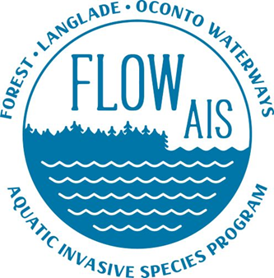

FLOW AIS Update
For LCWA since 5/18/2022
6/15/2022

- PL plants are still growing at my house. I have 5 set aside for Sawyer Lake at the moment. Gathering beetles to put on the plants should happen with the next couple of weeks.

- FLOW AIS conducted a Citizens Lake Monitoring Network training for Perch Lake off of HWY U in Elcho, Saturday June 4th. Clarity reading for the lake will be taken by Mike Tennessen.

- Snapshot day is August 20th this year volunteer registration is open. Let me know if you are interested and I can send you the link. The site leader for Langlade County is Katie and the meeting site for this year is summit lake park. Further coordination with Katie will happen after the meeting.

- The landing Blitz towel give away will be July 1-5th. FLOW AIS has white lake in mind for the event in Langlade County. Which day is still being decided.

- FLOW AIS and lumberjack had a meeting with the DNR lakes biologists and county conservation staff in Forest and Langlade to discuss the possibility of a county wide lakes project for FLOW to take on next year. Further details are still being worked out.

