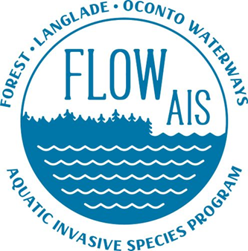

FLOW AIS Update
For LCWA Since 7/23/2022
8/17/2022

- FLOW AIS conducted boater behavior as part of the North East Region Clean Boats Clean Waters Program at Both Lower Post Lake, and Summit Lake. Data collected will be given to Erin MacFarland the Statewide CBCW Coordinator

- FLOW AIS along with Katie Bender Ream conducted River Monitoring in Deer Creek off of HWY 64 for Faucet Snails. Monitoring at Elton Creek of of HWY 64 will be conducted around the end of August to the first part of September.

- Snapshot Day in Langlade County will be at Summit Lake Park this Saturday starting at 9:30a.m interested participants please register online at water action volunetters.org. if I site of interest is too far from summit lake. please bring a sample from the area you monitored, and it can be identified at Summit Lake.

