Fall Point Intercept Macrophyte Survey
West End - Saint Croix Flowage
WBIC 2740300: Douglas County, Wisconsin

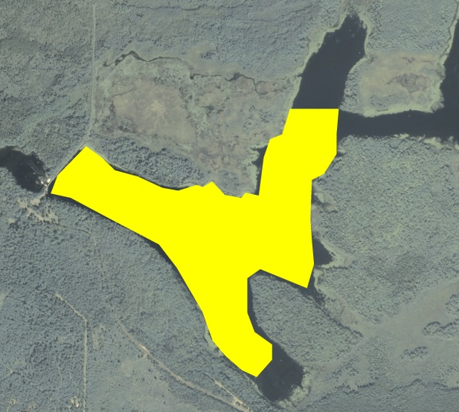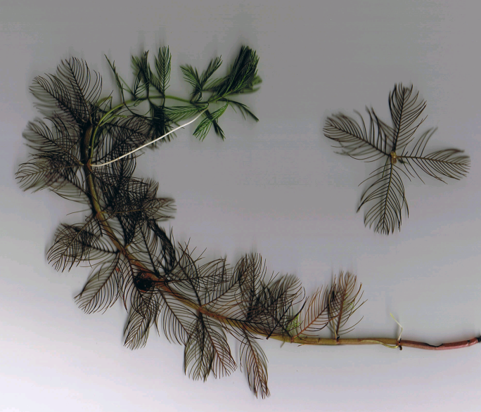

Potential 2014 EWM Treatment Area in West Basin EWM (Berg 2007)

Project Initiated by:
Gordon - Saint Croix Flowage Association, Short Elliott Hendrickson Inc., and the Wisconsin Department of Natural Resources

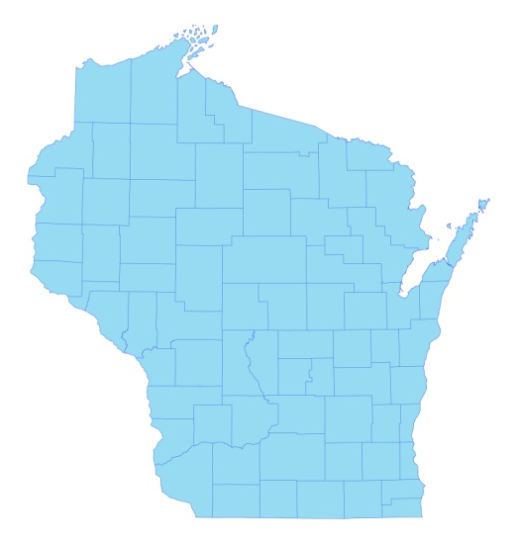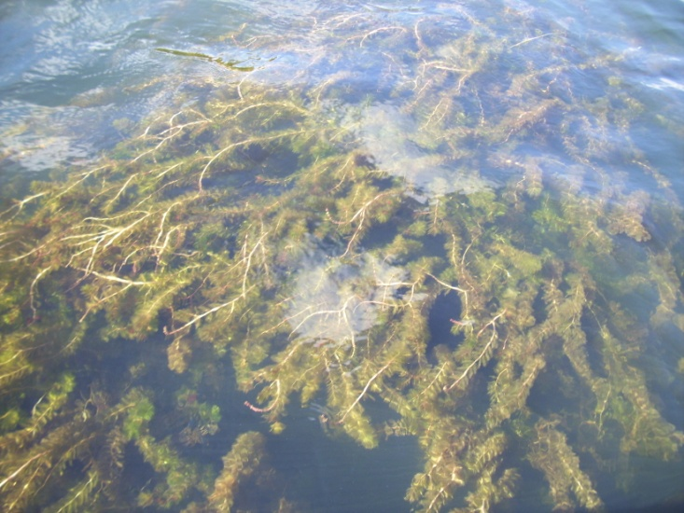

* Saint Croix
Flowage

Canopied EWM on the St. Croix Flowage

Survey Conducted by and Report Prepared by:
Endangered Resource Services, LLC
Matthew S. Berg, Research Biologist
St. Croix Falls, Wisconsin
September 22, 2013
TABLE OF CONTENTS

Page
LIST OF FIGURES AND TABLES..……..………………………………………………... ii

INTRODUCTION……….…..……..………………………………………………………. 1

METHODS……………………………………………………………….………………… 2

RESULTS AND DISCUSSION……………………………………………………………. 3

LITERATURE CITED……….……………………….……………………………………. 10

APPENDIXES……….…….………………………………………………….……………. 11

I: Survey Sample Points and Proposed EWM Treatment Area………………………… 11

II: Vegetative Survey Data Sheet.………………………………………………………. 14

III: Habitat Variable Maps.…………………..……….……………………………...…... 16

IV: Fall Native Species Richness and Total Rake Fullness…….………..……………...... 19

V: Fall EWM Density and Distribution…………………..……………..……………..... 22

VI: Fall Native Species Density and Distribution…...…………………..……………...... 24

LIST OF FIGURES AND TABLES

Page
Figure 1: Potential 2014 West Basin EWM Treatment Area.….…………….……….….... 1
Figure 2: Survey Sample Points and Proposed Treatment Areas………………………… .. 2
Figure 3: Rake Fullness Ratings……………………………….…….…………………….. 3
Figure 4: Depths and Bottom Substrate….………………………....……………………… 4
Table 1: Fall Point Intercept Survey Summary Statistics
West End - St. Croix Flowage, Douglas County – September 22, 2013………………..….. 4

Figure 5: Fall Native Species Richness and Total Rake Fullness……..…………………… 5
Figure 6: Fall EWM Density and Distribution….……………………..…………………... 6
Figure 7: Fall EWM Rake Fullness Ratings……………………………….………………. 6
Figure 8: Fall Fern Pondweed and Coontail Density and Distribution.……………………. 7
Figure 9: Fall Northern Wild Rice Density and Distribution.….………………………….. 7
Table 2: Frequencies and Mean Rake Sample of Aquatic Macrophytes – Fall PI Survey
West End – St. Croix Flowage, Douglas County – September 22, 2013………………..… 8

INTRODUCTION:
The Saint Croix Flowage (WBIC 2740300) is a 1,913 acre stratified drainage lake in south-central Douglas County, Wisconsin in the Town of Gordon (T44N R13W S36 NE SE). The flowage has a maximum depth of 28ft and an average depth of 7ft. It is mesotrophic bordering on eutrophic in nature, and water clarity is fair with summer Secchi readings averaging from 7-12ft in the deep hole by the dam over the past 20 years (WDNR 2013). In 2013, the fall littoral zone extended to approximately 12ft. Bottom substrate is variable with muck bottoms in most bays and along the river channel, and rock/sand areas around the flowage’s numerous islands (Sather et al. 1967).

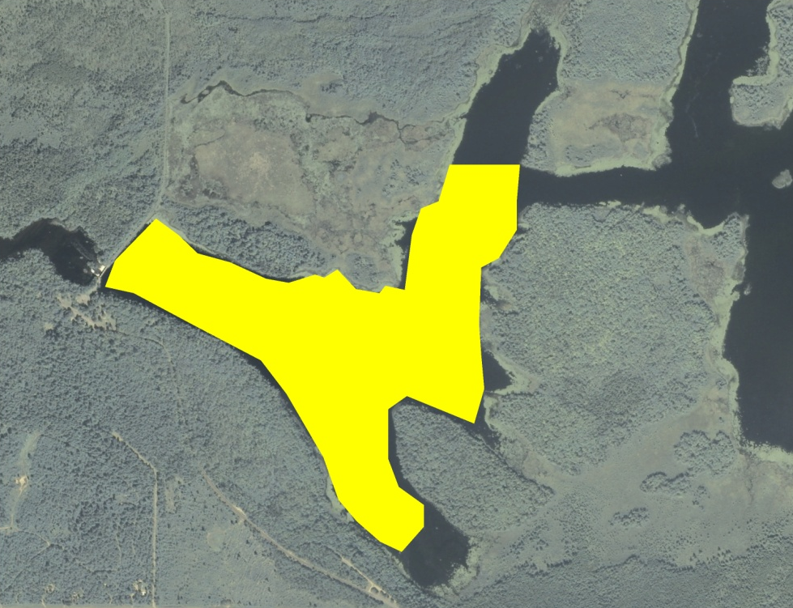
Figure 1: Potential 2014 West Basin EWM Treatment Area

Eurasian water milfoil (Myriophyllum spicatum) (EWM) was discovered in the summer of 2007 at the Gordon Dam County Park’s boat launch, and the Gordon - Saint Croix Flowage Association (GSCFA) has been working to manage this exotic invasive species ever since. Despite treating fourteen areas totaling over 6 acres on June 25, 2013, the August full point intercept survey of the entire flowage found that EWM was continuing to expand throughout the west basin and towards the narrows leading to the rest of the flowage. Because of this, the GSCFA, under the direction of Short Elliott Hendrickson Inc. (SEH), decided to explore the possibility of chemically treating the majority of the western basin rather than continuing the current small spot treatment program. The potential future treatment would cover 137.16 acres or 7.17% of the flowage’s total surface area (Figure 1).

As a perquisite to applying for a treatment permit, the Wisconsin Department of Natural Resources (WDNR) requested a full fall macrophyte point intercept survey at twice the resolution of the August survey. If ultimately approved, this survey would function as a baseline pretreatment survey. This report is the summary analysis of this survey conducted on September 22, 2013.
METHODS:
Aquatic Macrophyte Survey:
WDNR biologist Michelle Nault produced a survey sampling grid that contained 435 points at 50m resolution in the area west of the narrows. Approximately 220 of these points fell within the 137 acre proposed treatment area. This equated to just over 1.6pts/acre which was well below the 4pts/acre minimum that is normally required by WDNR protocol for pretreatment surveys. This low effort was approved based on the large size of the proposed treatment area (Figure 2) (Appendix I).

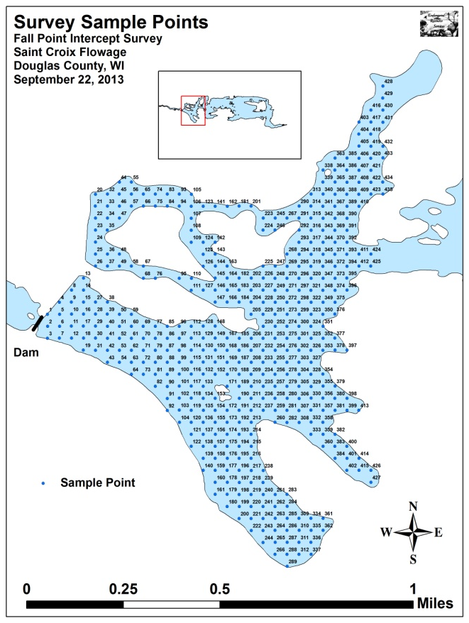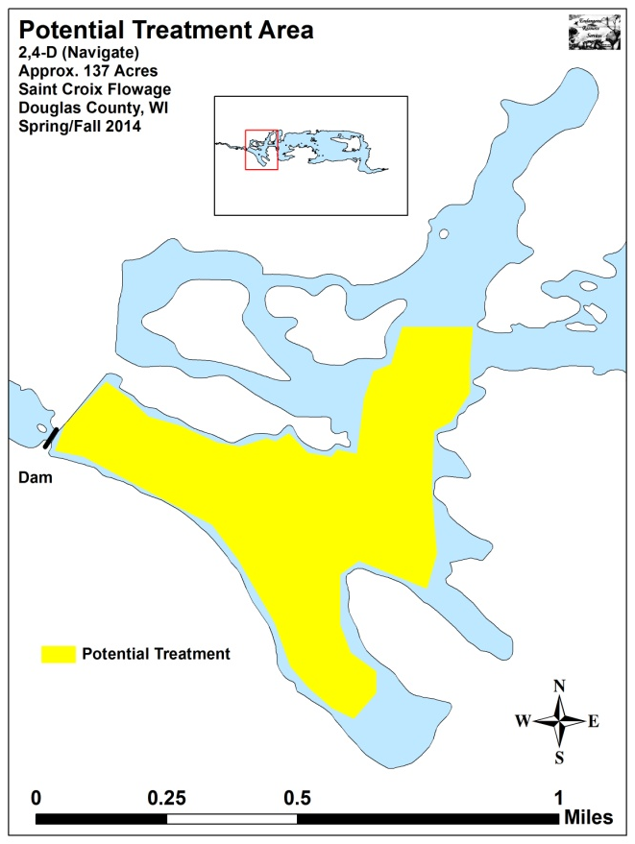
Figure 2: Survey Sample Points and Proposed Treatment Area

During the survey, we located each point using a handheld mapping GPS unit (Garmin 76CSx) and used a rake to sample an approximately 2.5ft section of the bottom. All plants on the rake were assigned a rake fullness value of 1-3 as an estimation of abundance, and a total rake fullness for all species was also recorded (Figure 3). Visual sightings of EWM were noted if they occurred within 6ft of the point. In addition to plant data, we recorded the lake depth using a hand held sonar (Vexilar LPS-1) and the bottom substrate (bottom type) when we could see it or reliably determine it with the rake.

Data Analysis:
We entered all data collected into the standard APM spreadsheet (Appendix II). These data were then analyzed using the linked statistical summary sheet (UWEX 2010).

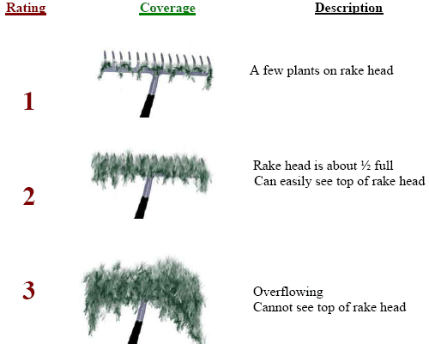
Figure 3: Rake Fullness Ratings

RESULTS AND DISCUSSION:
During the survey, we found that 92 of the 435 points were not accessible by boat. A handful of these were terrestrial, but most occurred in the expansive Cattail (Typha spp.) marsh in the northwest corner of the study area or in stream/seep inlets in finger bays where the water was <0.5ft deep. Of the 342 sites surveyed, plants were found at 284 of them (83%). Depths within the survey area were generally <10ft with the exceptions of the river channel and in the southeast bay’s spring holes. Bottom substrate was highly variable as we found that most bays were muck-bottomed while areas in the channel, along the shoreline, and around the islands were some combination of sand and rock (Figure 4) (Appendix III).

The littoral zone extended to a maximum of 12.0ft, and 95% of this zone had plants present (Table 1). The mean and median depths for all plants were 5.1ft and 5.0ft respectively. Overall diversity was high with a Simpson Diversity Index of 0.90 and a Floristic Quality Index of native plants scoring a 33.2. We identified 26 species in the rake, and mean native species richness at sites with vegetation was 3.70/site (Table 1). We also found that mean total rake fullness at sites with vegetation was a moderately high 2.36 (Figure 5) (Appendix IV).

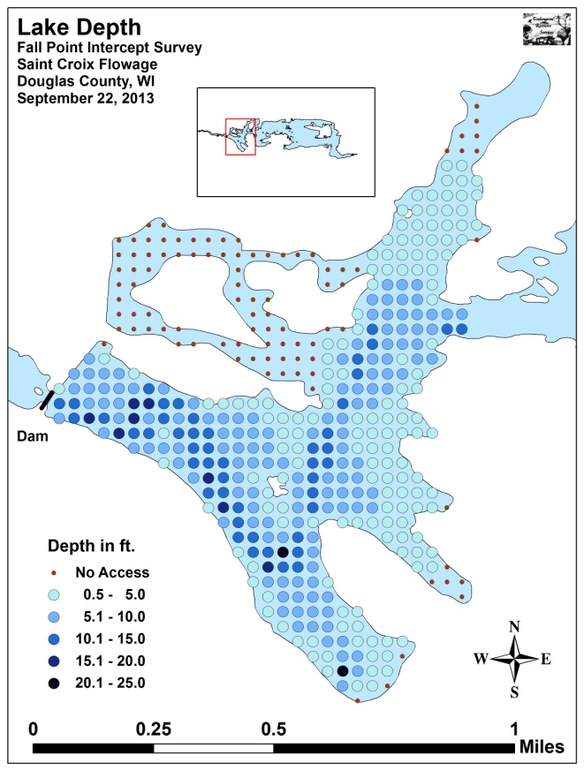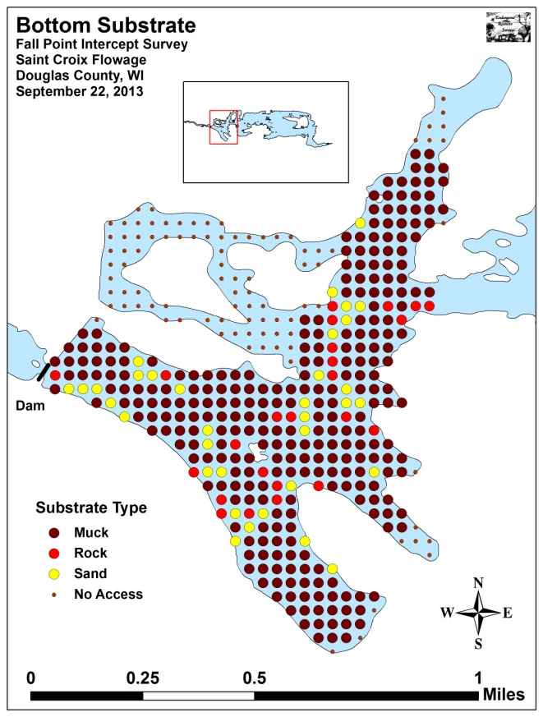
Figure 4: Depths and Bottom Substrate

Table 1: Fall Point Intercept Survey Summary Statistics
West End - St. Croix Flowage, Douglas County
September 22, 2013

Summary Statistics: | Fall 2013
Total number of points sampled | 342
Total number of sites with vegetation | 284
Total number of sites shallower than the maximum depth of plants | 299
Frequency of occurrence at sites shallower than maximum depth of plants | 94.98
Simpson Diversity Index | 0.90
Floristic Quality Index of Native Species | 33.2
Mean Coefficient of Conservatism | 6.6
Maximum depth of plants (ft) | 12.0
Mean depth of plants (ft) | 5.1
Median depth of plants (ft) | 5.0
Average number of all species per site (shallower than max depth) | 3.56
Average number of all species per site (veg. sites only) | 3.75
Average number of native species per site (shallower than max depth) | 3.49
Average number of native species per site (sites with native veg. only) | 3.70
Species richness | 26
Mean rake fullness (veg. sites only) | 2.36

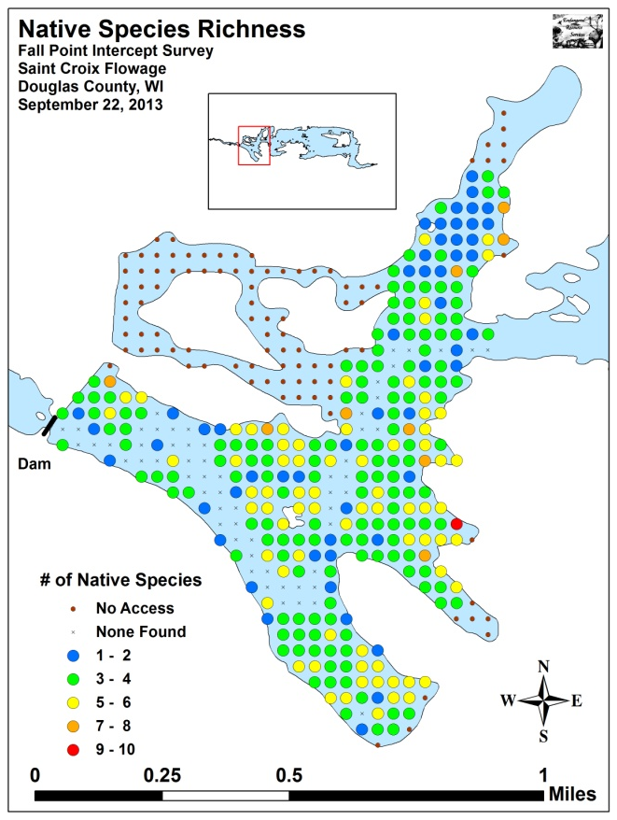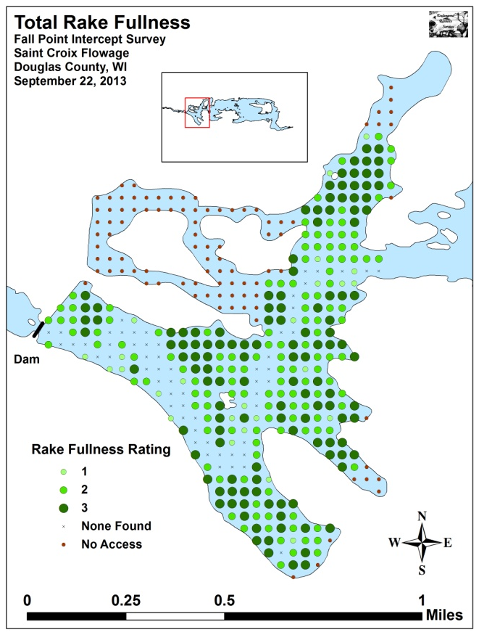
Figure 5: Fall Native Species Richness and Total Rake Fullness

We located Eurasian water milfoil at 21 sites during the survey. Of these, one rated a 3, six were a two, and the other 14 had a rake fullness rating of 1 for a mean rake fullness of 1.38 (Figures 6 and 7). We also recorded it as a visual at 17 points (Table 2) (Appendix V). EWM was found growing throughout the littoral zone with the majority of plants occurring over organic muck. Although most EWM was found interspersed with native vegetation, it tended to become monotypic at the deep end of the littoral zone, near the river channel, and where native vegetation had been disturbed by boat traffic such as near the landing/campground.

Fern pondweed (Potamogeton robbinsii) and Coontail (Ceratophyllum demersum) dominated the native plant community (Table 2) (Figure 8). They were present at 78.17% and 54.58% of survey points with vegetation and had a relative frequency of 20.86 and 14.57 respectively. Common waterweed (Elodea canadensis) (11.84), White-stem pondweed (Potamogeton praelongus) (7.89), and Northern water milfoil (Myriophyllum sibiricum) (6.48) were the only other species with relative frequencies over 5.00 (Maps for all native species are available in Appendix VI).

Northern wild rice (Zizania palustris), a species of significant wildlife and cultural value, was found at a single point near a creek inlet north of the proposed treatment area (Figure 9). Rice plants in this area numbered <50, and, due to herbivory, none produced grain in 2013.

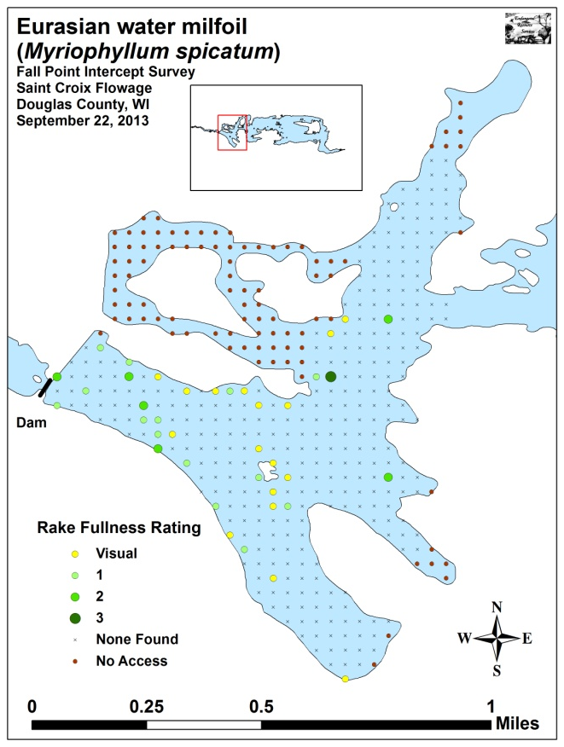
Figure 6: Fall EWM Density and Distribution

Figure 7: Fall EWM Rake Fullness Ratings

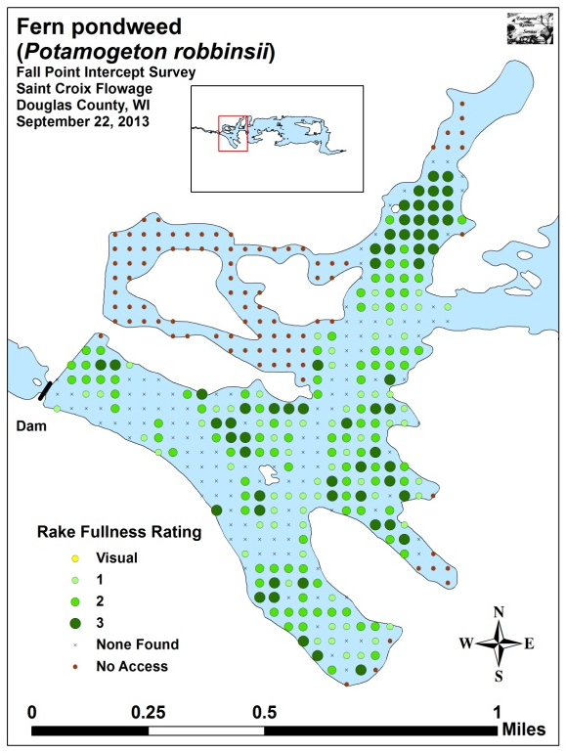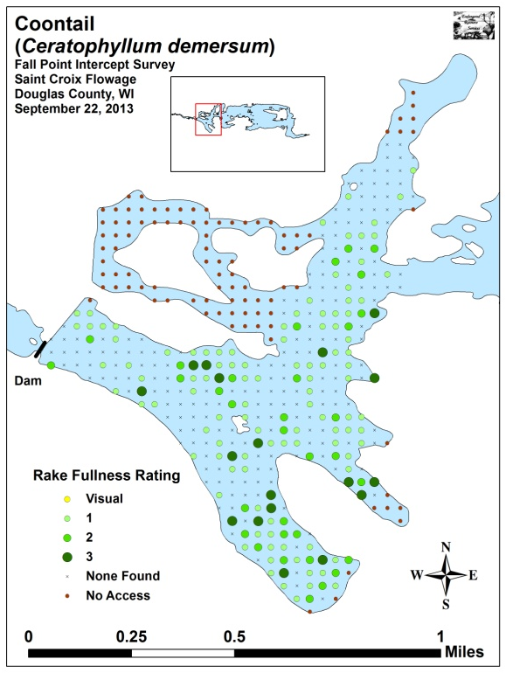
Figure 8: Fall Fern Pondweed and Coontail Density and Distribution

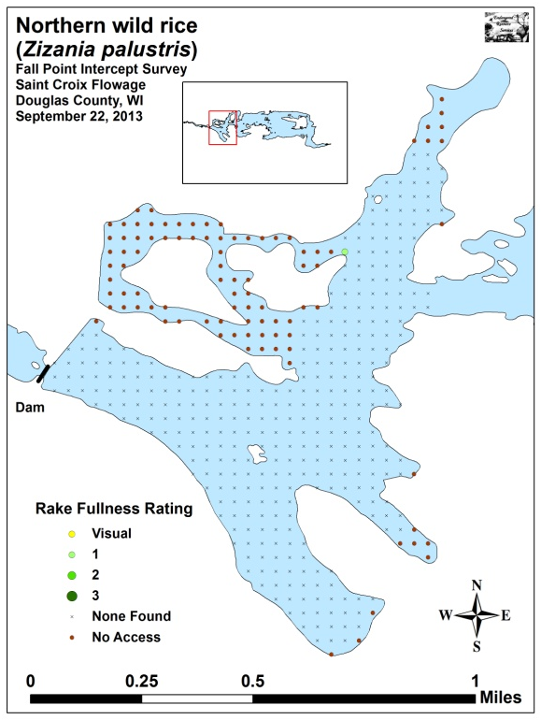
Figure 9: Fall Northern Wild Rice Density and Distribution

Table 2: Frequencies and Mean Rake Sample of Aquatic Macrophytes
Fall Point Intercept Survey – West End - St. Croix Flowage, Douglas County
September 22, 2013

Species | Common Name | Total  Sites | Relative Freq. | Freq. in Veg. | Freq. in Lit. | Mean Rake | Visual Sites
Potamogeton robbinsii | Fern pondweed | 222 | 20.86 | 78.17 | 74.25 | 1.98 | 0
Ceratophyllum demersum | Coontail | 155 | 14.57 | 54.58 | 51.84 | 1.45 | 0
Elodea canadensis | Common waterweed | 126 | 11.84 | 44.37 | 42.14 | 1.33 | 0
Potamogeton praelongus | White-stem pondweed | 84 | 7.89 | 29.58 | 28.09 | 1.42 | 0
Myriophyllum sibiricum | Northern water-milfoil | 69 | 6.48 | 24.30 | 23.08 | 1.14 | 0
Vallisneria americana | Wild celery | 53 | 4.98 | 18.66 | 17.73 | 1.17 | 0
Potamogeton amplifolius | Large-leaf pondweed | 50 | 4.70 | 17.61 | 16.72 | 1.14 | 0
Nymphaea odorata | White water lily | 47 | 4.42 | 16.55 | 15.72 | 1.66 | 0
Bidens beckii | Water marigold | 44 | 4.14 | 15.49 | 14.72 | 1.07 | 0
Potamogeton richardsonii | Clasping-leaf pondweed | 37 | 3.48 | 13.03 | 12.37 | 1.19 | 0
Brasenia schreberi | Watershield | 32 | 3.01 | 11.27 | 10.70 | 1.44 | 0
Potamogeton zosteriformis | Flat-stem pondweed | 28 | 2.63 | 9.86 | 9.36 | 1.07 | 0
Myriophyllum spicatum | Eurasian water milfoil | 21 | 1.97 | 7.39 | 7.02 | 1.38 | 17
Sparganium eurycarpum | Common bur-reed | 15 | 1.41 | 5.28 | 5.02 | 2.33 | 0
Nuphar variegata | Spatterdock | 13 | 1.22 | 4.58 | 4.35 | 1.69 | 0
Myriophyllum verticillatum | Whorled water-milfoil | 12 | 1.13 | 4.23 | 4.01 | 1.50 | 0
Utricularia minor | Small bladderwort | 10 | 0.94 | 3.52 | 3.34 | 1.10 | 0
Potamogeton pusillus | Small pondweed | 9 | 0.85 | 3.17 | 3.01 | 1.00 | 0
Utricularia vulgaris | Common bladderwort | 9 | 0.85 | 3.17 | 3.01 | 1.11 | 0
Chara sp. | Muskgrass | 8 | 0.75 | 2.82 | 2.68 | 1.25 | 0
Lemna trisulca | Forked duckweed | 7 | 0.66 | 2.46 | 2.34 | 1.29 | 0
Utricularia intermedia | Flat-leaf bladderwort | 6 | 0.56 | 2.11 | 2.01 | 1.50 | 0
Heteranthera dubia | Water star-grass | 3 | 0.28 | 1.06 | 1.00 | 1.00 | 0

Table 2 (cont’): Frequencies and Mean Rake Sample of Aquatic Macrophytes
Fall Point Intercept Survey – West End - St. Croix Flowage, Douglas County
September 22, 2013

Species | Common Name | Total  Sites | Relative Freq. | Freq. in Veg. | Freq. in Lit. | Mean Rake | Visual Sites
 | Aquatic moss | 3 | * | 1.06 | 1.00 | 2.00 | 0
Ranunculus aquatilis | White water crowfoot | 2 | 0.19 | 0.70 | 0.67 | 1.00 | 0
Nitella sp. | Nitella | 1 | 0.09 | 0.35 | 0.33 | 1.00 | 0
Zizania palustris | Northern wild rice | 1 | 0.09 | 0.35 | 0.33 | 1.00 | 0

* Excluded from the Relative Frequency Calculation

LITERATURE CITED

Sather, L, C. Busch, C., R. Housel, and J. Roth. [online]. 1967. St. Croix Flowage Map.
Available from http://dnr.wi.gov/lakes/maps/DNR/2740300a.pdf (2013, November).

UWEX Lakes Program. [online]. 2010. Aquatic Plant Management in Wisconsin. Available from http://www.uwsp.edu/cnr/uwexlakes/ecology/APMguide.asp (2013, November).

WDNR. [online]. 2013. St. Croix Flowage - Citizen Lake Water Quality Monitoring Database. Available from http://dnr.wi.gov/lakes/lakepages/LakeDetail.aspx?wbic=2740300&page=waterquality (2013, November).

Appendix I: Survey Sample Points and Proposed EWM Treatment Area
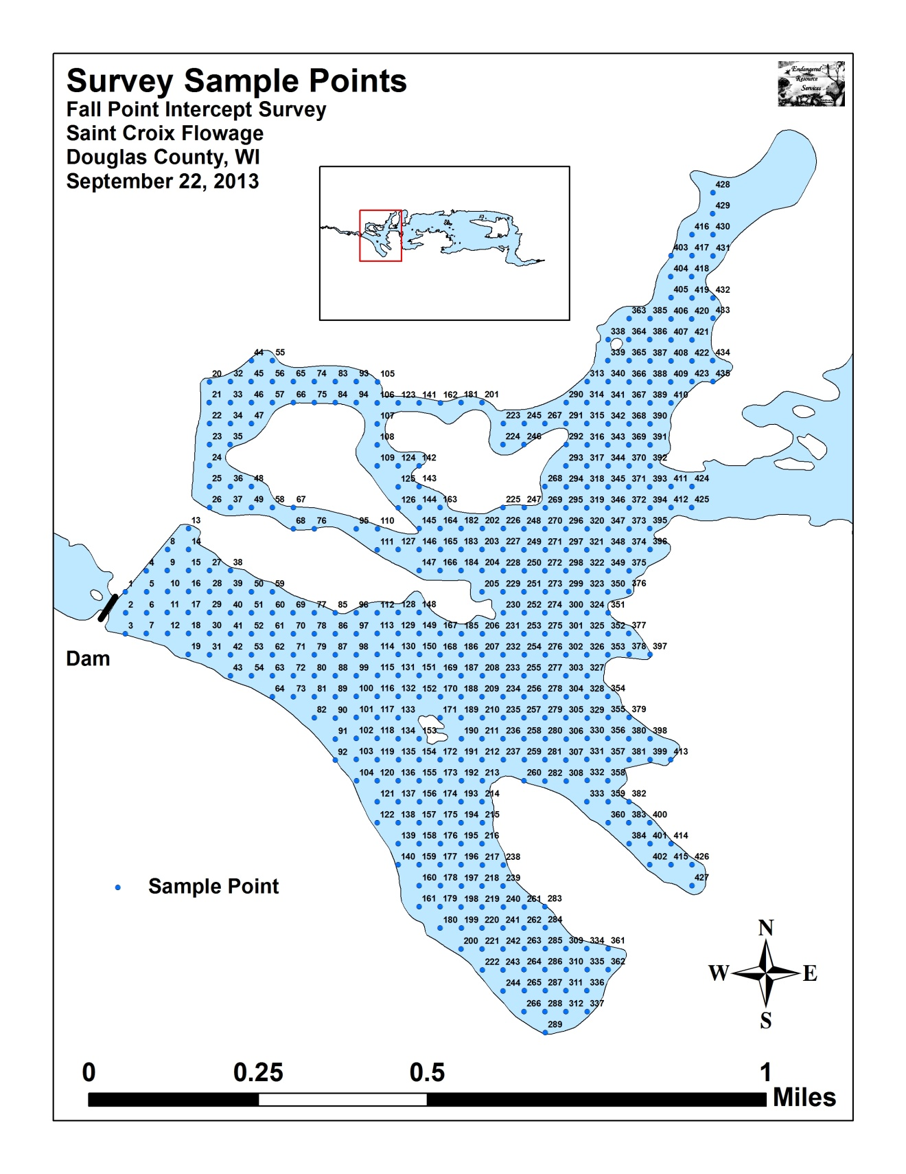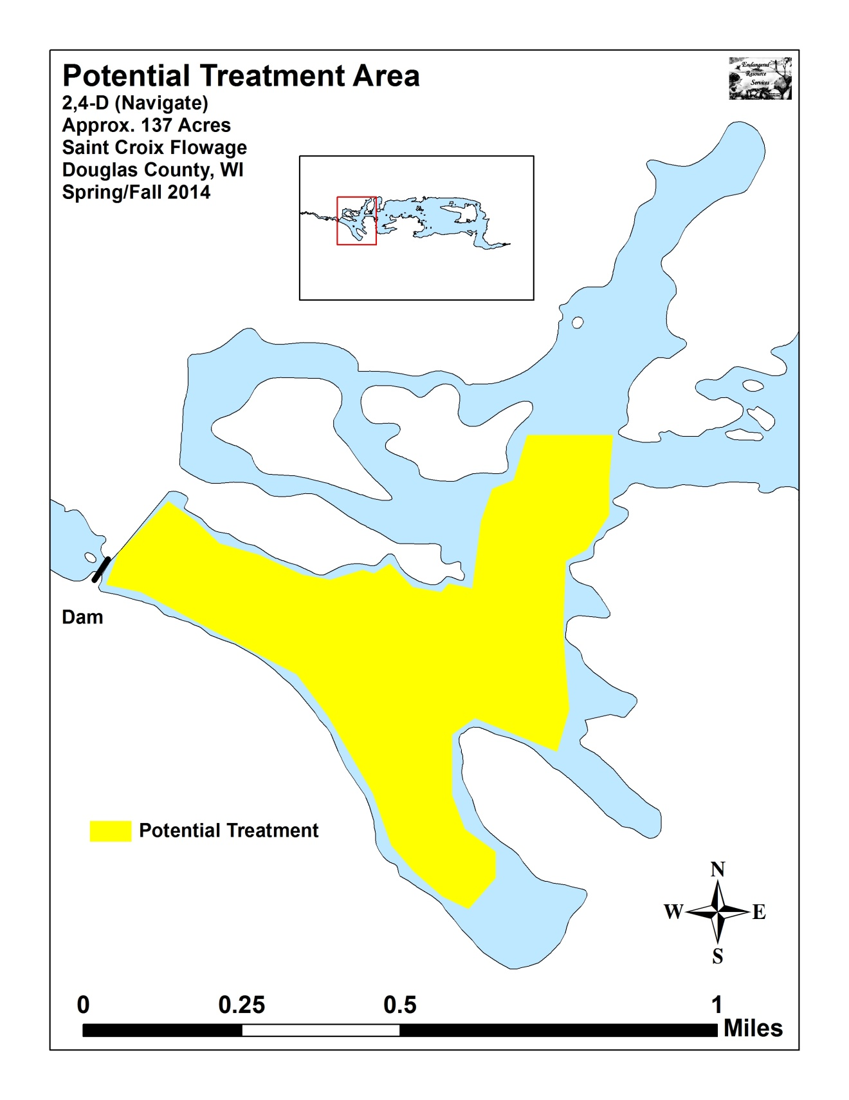

Appendix II: Vegetative Survey Data Sheet

Observers for this lake: names and hours worked by each:
Lake: |  |  |  |  |  |  |  |  | WBIC |  |  |  |  |  |  |  |  | County |  |  |  |  |  | Date:
Site # | Depth (ft) | Muck (M), Sand (S), Rock (R) | Rake pole (P) or rake rope (R) | Total Rake Fullness | EWM | CLP | 1 | 2 | 3 | 4 | 5 | 6 | 7 | 8 | 9 | 10 | 11 | 12 | 13 | 14 | 15 | 16 | 17 | 18 | 19
1
2
3
4
5
6
7
8
9
10
11
12
13
14
15
16
17
18
19
20

Appendix III: Habitat Variable Maps
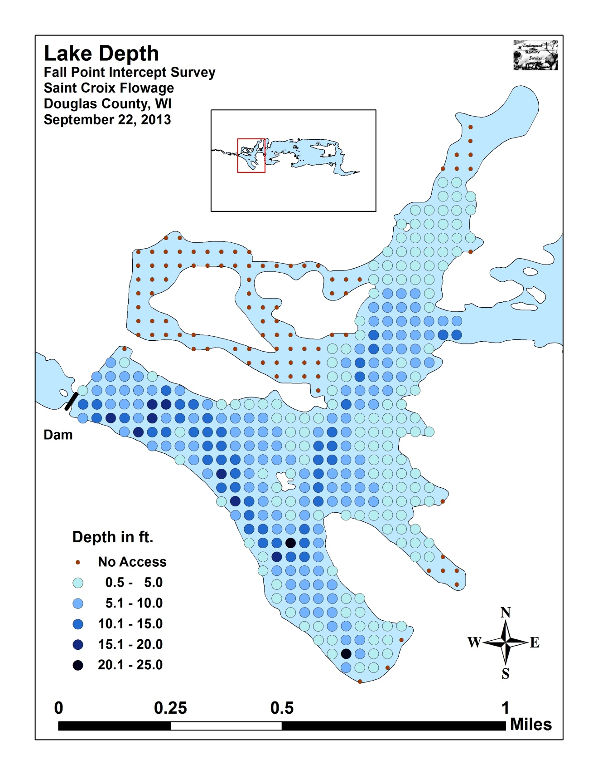
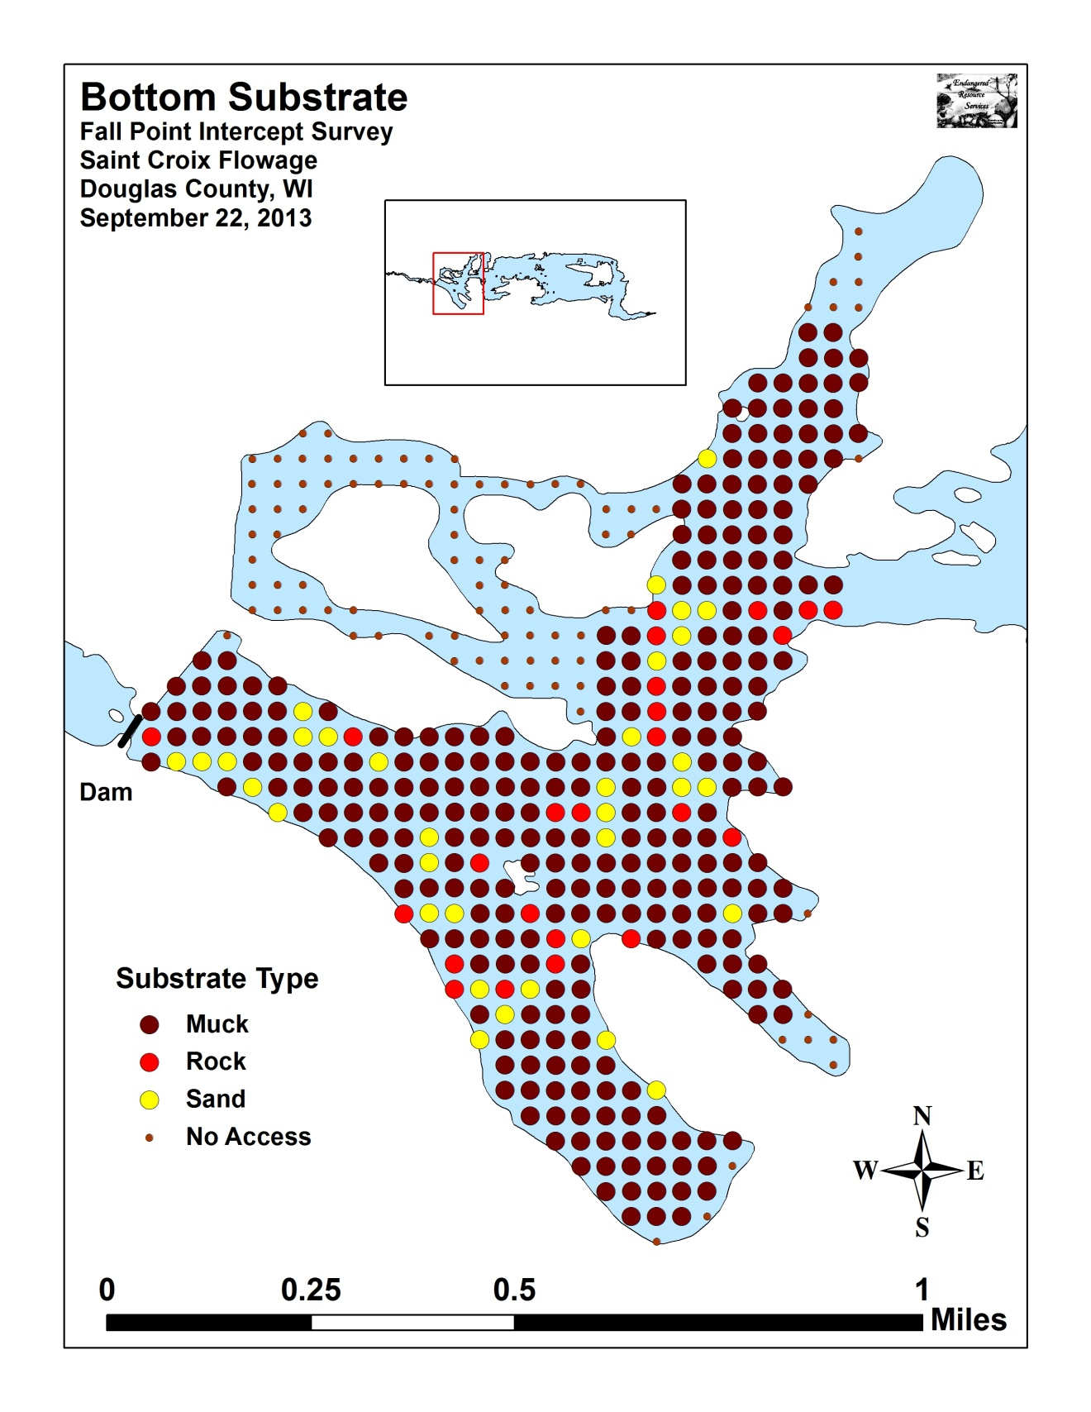

Appendix IV: Fall Native Species Richness and Total Rake Fullness
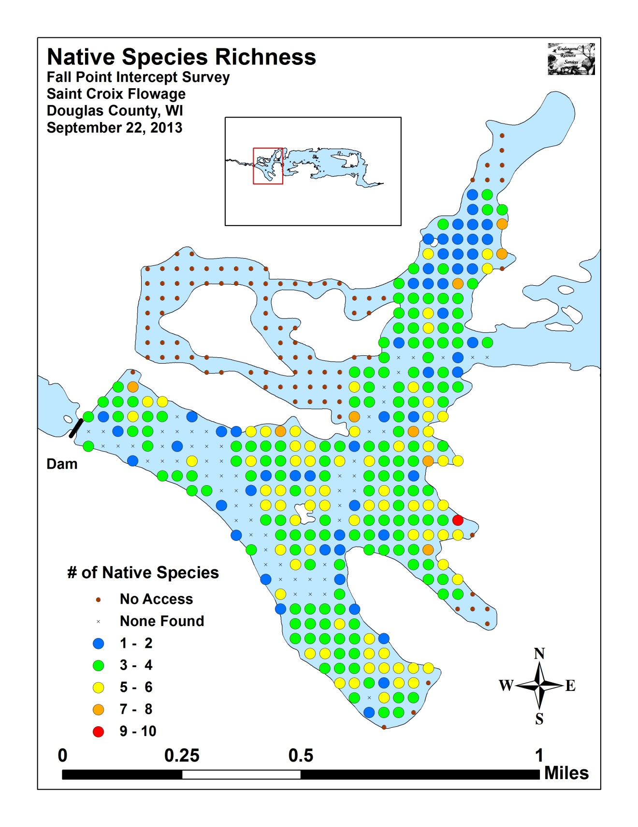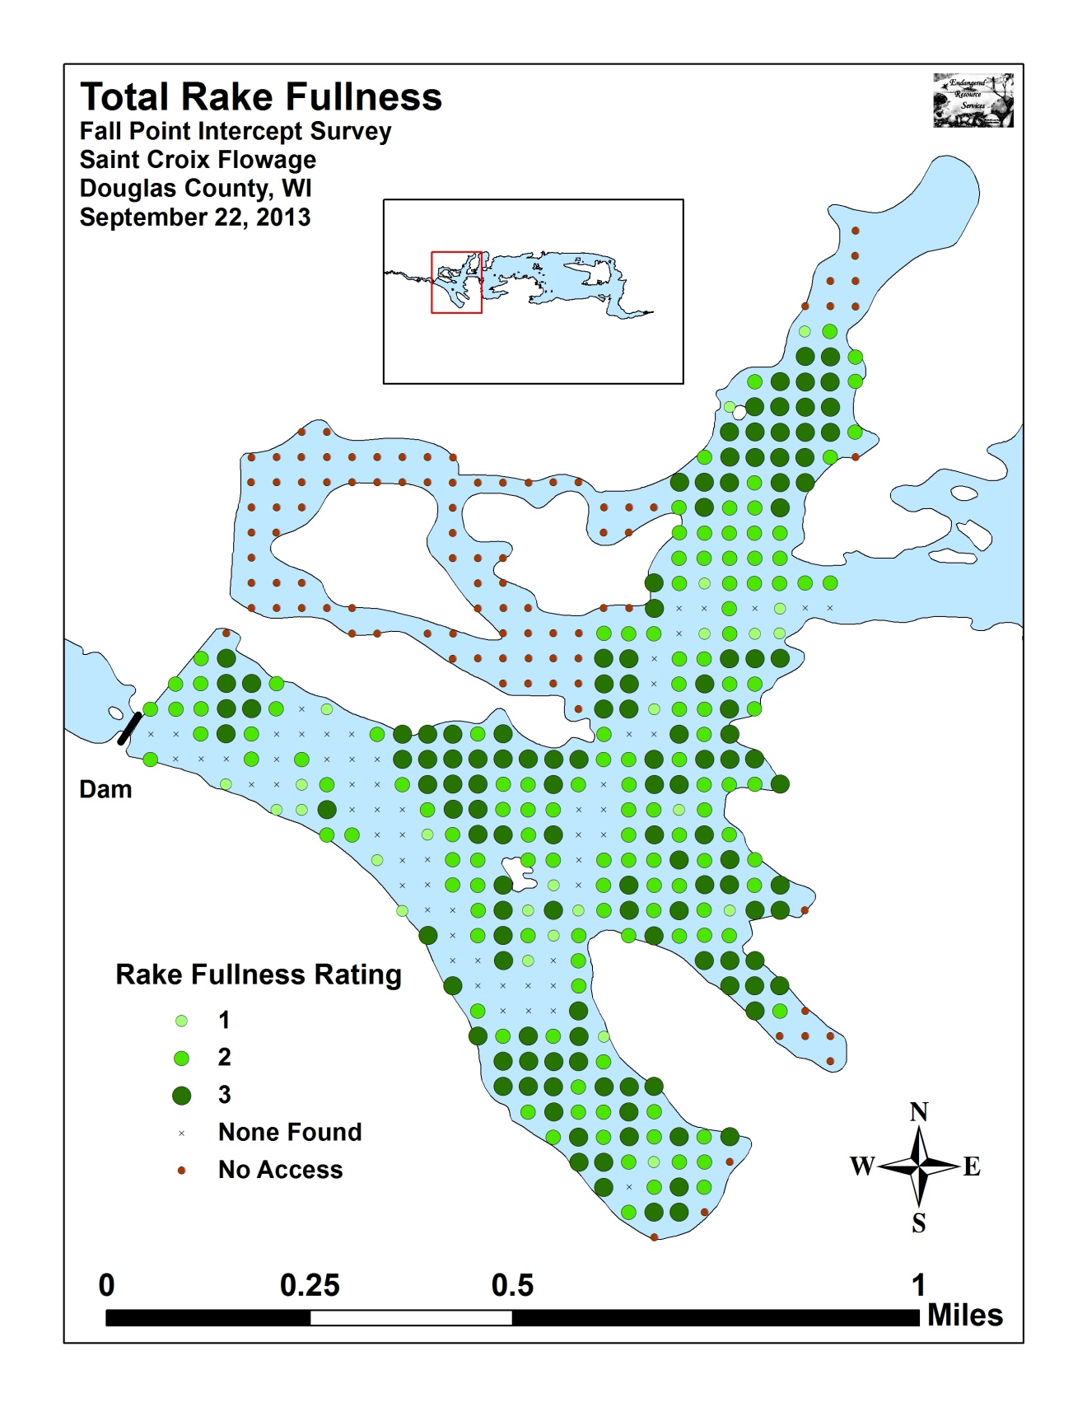

Appendix V: Fall EWM Density and Distribution

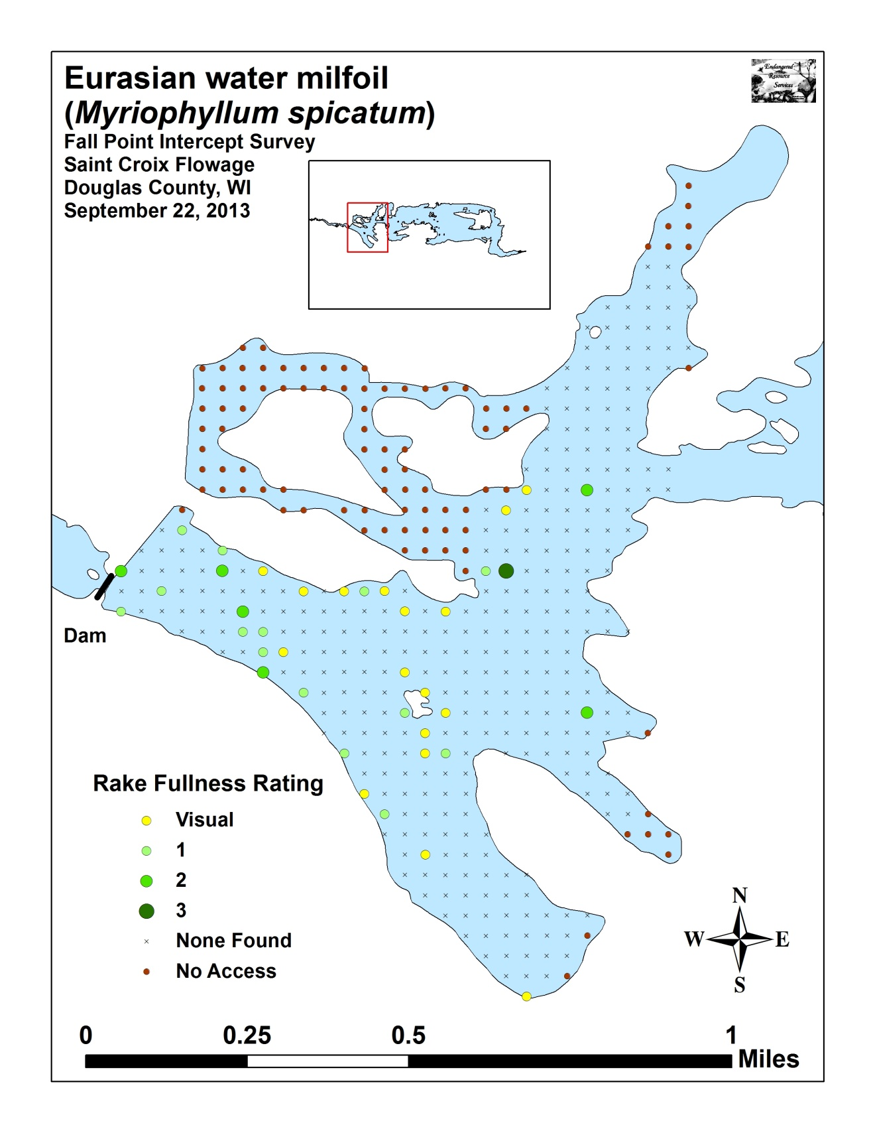

Appendix VI: Fall Native Species Density and Distribution

