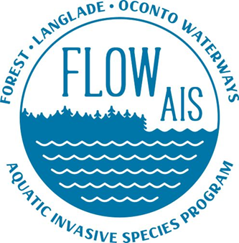

Update For FCAL Since 2022 Fall Forum
9/16/2022

- FLOW AIS worked on submitting a preproposal of a County Wide Lake Grant with Steve Kircher for Forest and Langlade County.
  - Grant to include Crystal Lake and Big Twin Lake
  - Project will follow the directed lakes protocol set by WI DNR
  - Project will focus on around two lakes a year
  - More information will be coming as the project develops.

Fund FLOW Challenge

The challenge is as follows:

OCLAWA agrees to fund $1,000 in support of the FLOW-AIS position to make up for the shortfall in funding. This $1,000 payment will be made provided it is matched by the other stakeholders, ie: Each of the county wide lake associations of Forest and Langlade counties and each of the Land & Water Conservation Departments in Forest, Langlade & Oconto counties would commit to $1,000 each. Finally, Lumberjack R C & D would commit $2,000 (to be voted on by the Council at their January 2023 meeting.) All stakeholders making the assigned amounts of support will enable the FLOW-AIS position to be fully funded for 2023. Please respond with your acceptance of the challenge by September 15, 2022. Thanks…

Fund FLOW Challenge to Date

Lumberjack $2000.00 Pending Other Funding Sources
OCLAWA $1,000.00 Pending other Funding Sources
Forest County $1,000.00 Submitted for 2023 Budget, Needs approval
Langlade County $1,000.00 Needs County Board Approval
LCWA $1,000.00 Pending the rest of their grant award
DWKLA $500.00 One Time Donation

Total $6,500

- Butternut Franklin Association is planning to discuss challenge
- Other individual lake associations are welcome to pledge
- Pledges need to be sent to 315 S. Oneida Ave. Suite 206, Rhinelander WI 54501 by the end of December (hard date coming soon)

- Kayala and I are waiting to hear back from WRISC about Phrag in Laona Lumberyard

- FLOW AIS removed PL along HWY 8 in Laona

