Curly-leaf Pondweed (Potamogeton crispus)
Fall Turion Survey
East Balsam Lake – WBIC: 2620600
Polk County, Wisconsin

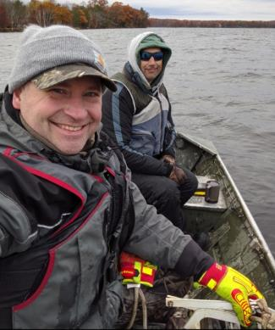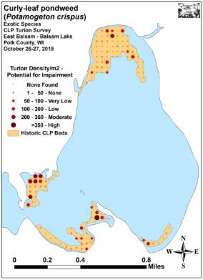
Ponar Field Crew – East Balsam (10/27/19) 2019 Fall Turion Density – East Balsam

Project Initiated by:
Balsam Lake Protection and Rehabilitation District and the
Wisconsin Department of Natural Resources – Grant ACEI21218
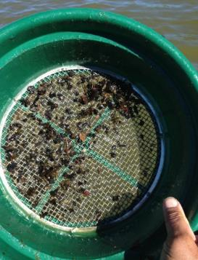
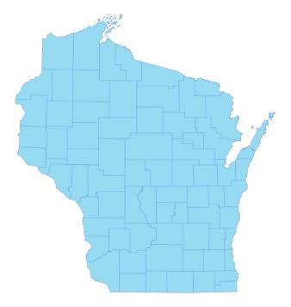

* Balsam Lake

Sieve with turions (Berg 2013)

Survey Conducted by and Report Prepared by:
Endangered Resource Services, LLC
Matthew S. Berg, Research Biologist
St. Croix Falls, Wisconsin
October 26-27, 2019
TABLE OF CONTENTS

Page
LIST OF FIGURES AND TABLES..……..……………………………………………….. ii

INTRODUCTION……….…..……..………………………………………………………. 1

BACKGROUND AND STUDY RATIONALE………………………….………………... 1

CLP LIFE HISTORY AND STUDY OBJECTIVES…………………….………………... 2

METHODS……………………………………………………………….………………… 3

DATA ANALYSIS…………………………………………………………………………. 5

RESULTS AND DISCUSSION……………………………………………………………. 6

2014 Fall Ponar Dredge CLP Turion Survey...…………………………………… 6

2015 Fall Ponar Dredge CLP Turion Survey...…………………………………… 7

2016 Fall Ponar Dredge CLP Turion Survey...…………………………………… 9

2017 Fall Ponar Dredge CLP Turion Survey...…………………………………… 11

2018 Fall Ponar Dredge CLP Turion Survey...…………………………………… 13

2019 Fall Ponar Dredge CLP Turion Survey...…………………………………… 15

Considerations for Future Management…………....……………………………... 17

LITERATURE CITED……….……………………….……………………………………. 18

APPENDIXES……….…….………………………………………………….……………. 19

I: Survey Sample Points and Historic CLP Treatment Areas…………………………... 19

II: 2014-2019 Fall Curly-leaf Pondweed Turion Density & Distribution Maps………... 22

LIST OF FIGURES AND TABLES

Page
Figure 1: Balsam Lake with Proposed 2019 CLP Treatment Areas.….……………….….. 1
Figure 2: Germinating CLP Turion……………………………………..…………………. 2
Figure 3: Turion Survey Sample Points in Historical Treatment Areas..…………..……… 3
Figure 4: East Balsam Ponar Grab and Turion Sieving………………..………………….. 4
Figure 5: Predicted Navigation Impairment Based on Turion Density.…….……………... 5
Figure 6: 2014 Fall CLP Turion Survey Density and Distribution..………………………. 6
Figure 7: 2015 Fall CLP Turion Survey Density and Distribution..………………………. 7
Table 1: CLP Turion Surveys - Summary Statistics – East Balsam Lake, Polk County
November 8-9, 2014 and October 31-November 1, 2015….………………………………. 8

Figure 8: 2016 Fall CLP Turion Survey Density and Distribution..………………………. 9
Table 2: CLP Turion Surveys - Summary Statistics – East Balsam Lake, Polk County
October 31-November 1, 2015 and October 29-30, 2016….………………………………. 10

Figure 9: 2017 Fall CLP Turion Survey Density and Distribution..………………………. 11
Table 3: CLP Turion Surveys - Summary Statistics – East Balsam Lake, Polk County
October 29-30, 2016 and October 28-29, 2017…………….………………………………. 12

Figure 10: 2018 Fall CLP Turion Survey Density and Distribution..……………………… 13
Table 4: CLP Turion Surveys - Summary Statistics – East Balsam Lake, Polk County
October 28-29, 2017 and October 26-27, 2018…………….………………………………. 14

Figure 11: 2018 Fall CLP Turion Survey Density and Distribution..……………………… 15
Table 5: CLP Turion Surveys - Summary Statistics – East Balsam Lake, Polk County
October 28-29, 2017 and October 26-27, 2018…………….………………………………. 16

Figure 12: Total Live Turions Found – Fall 2014-2019…………...………………………. 17

INTRODUCTION:
Balsam Lake (WBIC 2620600) is a 2,054 acre stratified drainage lake in central Polk County, Wisconsin in the Towns of Balsam Lake, Milltown, Georgetown, and Apple River (T34N R17W S10 NE NE). It reaches a maximum depth of 37ft north of Cedar Island in the western basin and has an average depth of 20ft (Hopke et al. 1964). The lake is mesotrophic bordering on eutrophic in nature, and water clarity is fair with historical summer Secchi readings averaging 5ft in East Balsam, 6ft in Little Balsam, and 8ft in the deep hole north of Cedar Island (WDNR 2019). Bottom substrate is variable with organic muck in most bays, and rock/sand in the Big and Little Narrows and around the lake’s many islands.
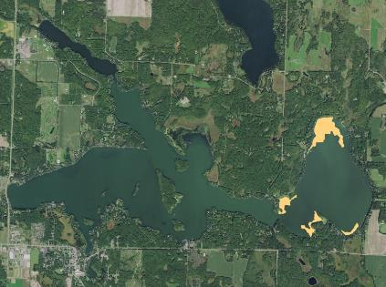
Figure 1: Balsam Lake with Proposed 2019 CLP Treatment Areas

BACKGROUND AND STUDY RATIONALE:
Curly-leaf pondweed (Potamogeton crispus) (CLP) is an invasive exotic plant that is common to abundant in parts of Balsam Lake. In their 2010 and 2015 Wisconsin Department of Natural Resources (WDNR) approved Aquatic Plant Management Plans (APMP), the Balsam Lake Protection and Rehabilitation District’s (BLPRD) identified a) reducing overall lake coverage of CLP to <20 acres and b) relieving navigation impairment caused by canopied CLP beds as management goals (Clemens 2010, Clemens 2015). As part of their continuing efforts to meet these goals, in May 2014, 2015, 2016, and 2017, the BLPRD and the WDNR authorized the herbicide treatment of five CLP beds in East Balsam Lake. These beds were selected based on the 2013 spring CLP bed mapping survey that found they were the largest areas of CLP on the lake, and because they were interfering with boat traffic and/or restricting resident access to the lake from their docks.

Despite a fall 2017 turion survey that suggested there would again be Curly-leaf pondweed throughout East Balsam, near record late ice-out followed by a rapid warm up appeared to have produced unfavorable growing conditions for CLP. After our 2018pretreatment survey found almost no CLP, it was decided to cancel the entire chemical treatment and focus on harvesting. Because the fall 2018 survey again found turions scattered through East Balsam, the BLPRD planned to treat approximately 50.00 acres (2.43% of the lake’s total surface area) in the spring of 2019 (Figure 1). However, after another winter with near record snowfall resulted in low CLP germination rates, it was decided to also cancel the proposed 2019 herbicide treatment. Hoping CLP’s recovery without treatment would be minimal, the BLPRD requested another late fall survey to determine the level of any latent CLP turions within the lake’s substrate.
CLP LIFE HISTORY AND STUDY OBJECTIVES:
Although Curly-leaf pondweed occasionally reproduces by seed, the vast majority of plants resprout from stiff overwintering buds called turions that are normally produced in number by the plants prior to their late June/early July senescence (Figure 2). After the pinecone-like turions germinate in late fall or early winter, plants continue to grow slowly under the ice. Following ice out, growth accelerates, and plants rapidly canopy allowing them a competitive advantage over slower growing native species (Capers 2005).

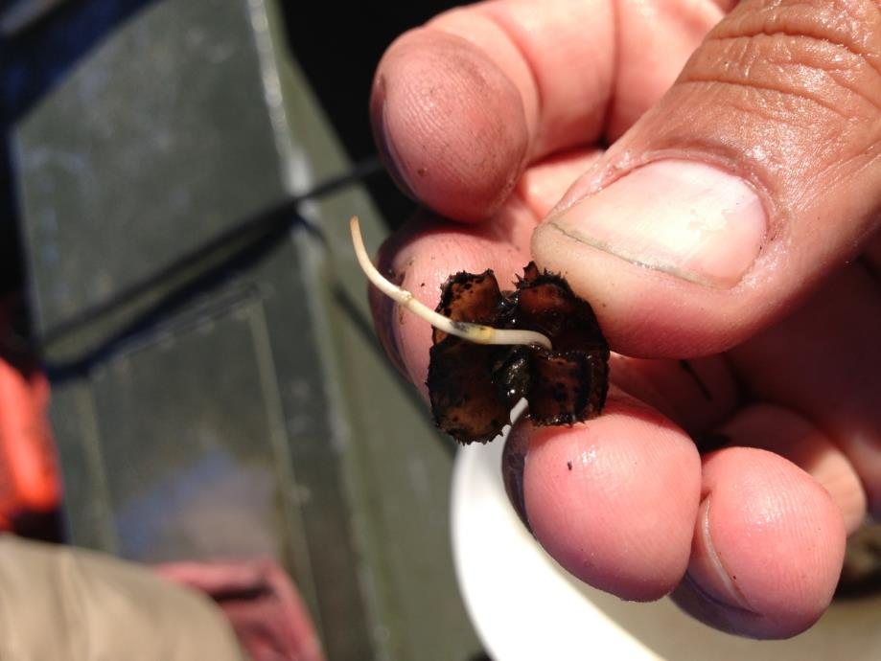
Figure 2: Germinating CLP Turion

Research suggests approximately 50% of turions germinate in a growing season while the rest remain dormant until the following growing season when another 50% will germinate (Johnson 2012). Depending on the level of turions at a given location, and knowing that latent turions may be able to survive for over 5 years in the sediment, it may take several years of control to exhaust the “turion bank” (R. Newman – U of M unpublished data).

Following the 2019 summer growing season, we conducted a fall turion survey. The goals of the study were to determine the level of remaining CLP turions within the lake’s historic high density CLP areas; and, if there were any present, to predict whether their numbers suggested there would likely be enough to cause navigation issues in 2020. This report is the summary analysis of that survey conducted on October 26-27, 2019.
METHODS:
Ponar Dredge Turion Survey:
After merging the 2014 treatment areas and the 2009 treatment of Bed 14C into a single shapefile, we used Hawth’s Analysis Tools Extension to ArcGIS 9.3.1 to generate regular points at the rate of approximately 1.7 points/acre. This produced a 120 point sampling grid of which 18 were in Bed 12, 65 were in Bed 13, seven were in Bed 14, and the remaining 30 were in the combined area of Beds 14B and 14C. This same sampling grid was also used in 2015, 2016, 2017, 2018, and 2019 to allow for the most accurate comparisons possible (Figure 3) (Appendix I). For ease in determining the total impact of the current treatment program, we also left the 2014, 2015, 2016, 2017, and 2018 narratives in the results section of this report.

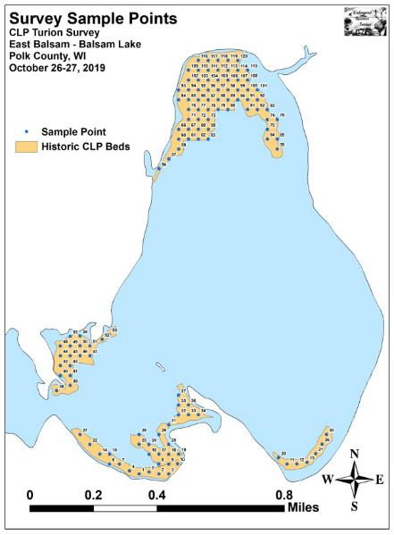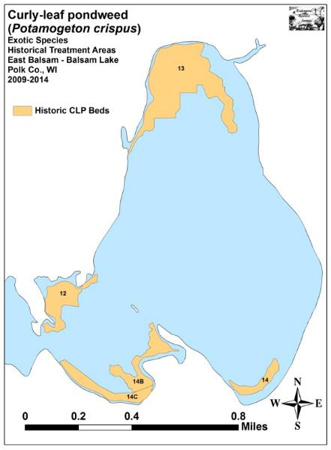
Figure 3: Turion Survey Sample Points in Historical Treatment Areas

During the surveys, we located each point with a handheld mapping GPS unit (Garmin 76CSx) and used a Petite Ponar dredge with a 0.0232m² (36in²) sample area to take a bottom sediment grab from each side of the boat at each location. These samples were then rinsed in a fine sieve to separate out the sediment (Figure 4). Samples with high numbers of turions or significant amounts of detritus were bagged for later analysis; at which time we discarded all rotten turions, tallied all live turions, and multiplied the combined total live turions from the two samples by 21.53 to estimate turions/m² at each location. This value gives an idea of how many CLP plants will germinate in an area during the 2020 growing season.

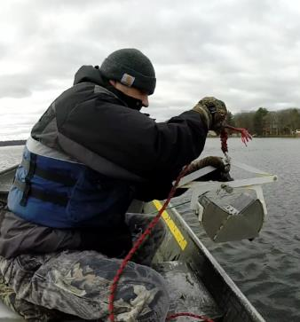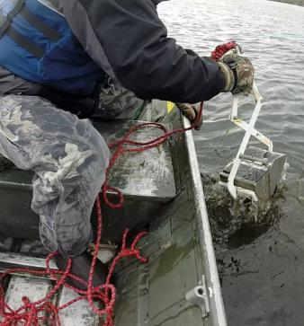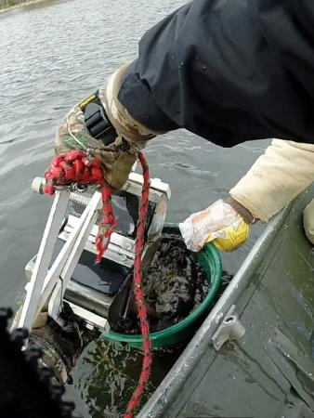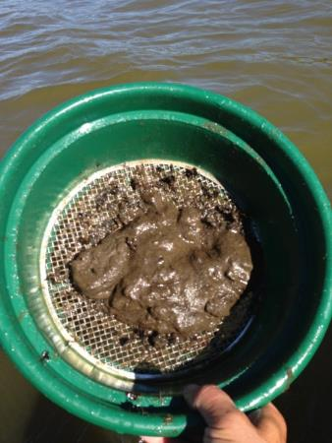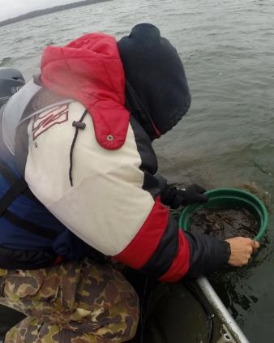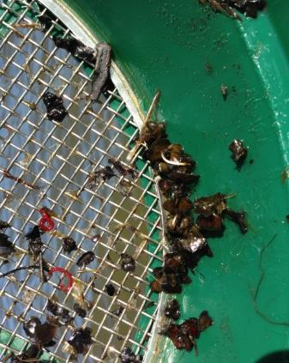
CLP Turions
Figure 4: East Balsam Ponar Grab and Turion Sieving

DATA ANALYSIS:
We entered all data collected into an Excel spreadsheet and used standard formulas in the data analysis tool pack to calculate the following:

Total number of points sampled: This value is the total number of points on the lake within each study area. We took two Ponar samples at each sample point.

Total number of live turions: This value includes all live turions found at all sites within a study area.

Total number of points with live turions: This number includes all survey sites that had at least one turion in either of the Ponar samples taken at the site.

Frequency of occurrence: The frequency of turions is generally reported as a percentage of occurrences at all sample points. The value is used to extrapolate coverage within the study area. For example, if 20% of all sample sites have turions, it suggests that 20% of the study area will have at least some Curly-leaf pondweed coverage the following year.

Points at or above nuisance level: This value gives the number of survey sites within the study area that were above the predicted nuisance threshold (Figure 5). Research suggests that when the turion density is at or above 200/m², the following year’s CLP growth has the potential to at least moderately impair navigation (Johnson 2012).

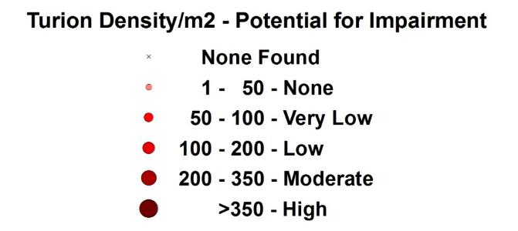
Figure 5: Predicted Navigation Impairment Based on Turion Density

Percent nuisance level: The percentage of nuisance points divided by the total number of survey points can be extrapolated to determine what percent of the study area has the potential to have at least moderate navigation impairment during the next growing season.

Mean turions/m²: This value is the average number of turions/m² when pooling the data from all survey sites regardless of whether or not they had turions present.

Standard deviation of turions/m²: This value tells us how far apart the data is from the mean. A low standard deviation suggests most points have a turion density that was similar to the mean, while a high value suggests there was greater variability in turion density within the sample area.
Year-over-Year Significant Differences:
Data from the 2014-2019 surveys was compared using paired t-tests as we returned to the same sites during each survey. Year-over-year differences were determined to be significant at p<0.05, moderately significant at p<0.01, and highly significant at p<0.001 (Tables 1-5).

RESULTS AND DISCUSSION:
2014 Fall Ponar Dredge CLP Turion Survey:
The November 8-9, 2014 survey revealed CLP turions were present throughout much of the 2014 treatment areas with 92 of 120 points having live turions (76.67%) (Figure 6) (Appendix II). Despite this, only six points (5.00%) suggested CLP growth in 2015 had the potential to exceed the nuisance threshold with densities >200 turions/m² (Table 1). When broken down by area, Bed 12 had the highest rate with over 22% of the bed projected to exceed this level. Bed 13 was the only other area with any nuisance points, and both of them were located at the very northern edge of the bed. All of the nuisance points were in areas with shallow water (<5ft) that historically have also had dense canopied CLP.

The overall mean turion density was 61.53 turions/m². This value suggested that the average potential for impairment would be very low. Turion densities were somewhat variable with all standard deviations values being greater than the mean. However, only Bed 12 was more than 25% higher than the mean, and none were double the mean.

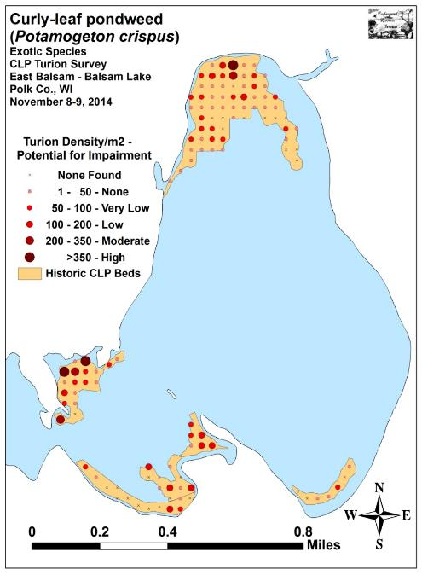
Figure 6: 2014 Fall CLP Turion Survey Density and Distribution
2015 Fall Ponar Dredge CLP Turion Survey:
During the October 31- November 1, 2015 survey, we found live CLP turions at 67 of 120 points (55.83%) (Figure 7) (Appendix II). This was a decline in distribution of 27.17% from the 92 points with turions in 2014. When broken down by area, all beds showed a decline in distribution except for Bed 14B/C which increased from 56.67% coverage in 2014 to 60.00% coverage in 2015 (Table 1).

The number of high density “predictive nuisance” locations also declined fractionally from six points (5.00%) in 2014 to five points (4.17%) in 2015. As in 2014, Bed 12 had the highest percentage of high density points (11.11%). Outside this area, no other bed had more that 3.33% (Bed 14B/C). The majority of the highest density turion points again occurred in areas with shallow water (<5ft) that historically have had dense canopied CLP growth in the spring as well as moderate levels later in the summer. These areas may be producing a “second crop” of plants that sprout from latent turions after the treatment and, consequently, are able to produce turions/maintain the bank at these locations.

We calculated the overall mean density within the study areas at 44.13 turions/m² with a standard deviation of 75.04 turions/m². This was a nearly significant decline from 2014 (p=0.057) when we found a mean of 61.53turions/m² with a standard deviation of 114.47 turions/m². Visual analysis of the 2014 and 2015 maps suggested the turion bank has been nearly exhausted in most deep water areas over 8ft while shallow areas continue to have regular turions present. Densities continued to be variable with all standard deviations values being greater than the mean. With the exception of Bed 14 (southeast bay) which showed a slight increase, all other areas declined; although none of these changes were significant.

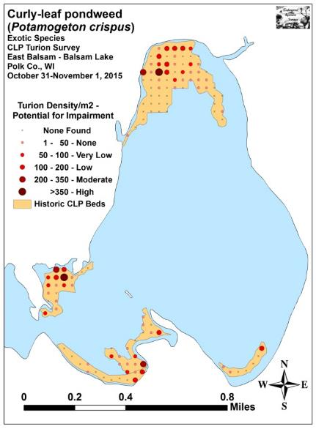
Figure 7: 2015 Fall CLP Turion Survey Density and Distribution
Table 1: CLP Turion Surveys - Summary Statistics
East Balsam Lake, Polk County
November 8-9, 2014 and October 31-November 1, 2015

2014 2015
Summary Statistics: | Total | Bed 12 | Bed 13 | Bed 14 | Bed  14B/C | Total | Bed 12 | Bed 13 | Bed 14 | Bed  14B/C
Total number of points sampled | 120 | 18 | 65 | 7 | 30 | 120 | 18 | 65 | 7 | 30
Total live turions | 343 | 127 | 142 | 7 | 67 | 246 | 69 | 111 | 10 | 56
Total number of points with live turions | 92 | 17 | 54 | 4 | 17 | 67 | 14 | 32 | 3 | 18
Frequency of occurrence (in percent) | 76.67 | 94.44 | 83.08 | 57.14 | 56.67 | 55.83 | 77.78 | 49.23 | 42.86 | 60.00
Points at or above nuisance level (+200/m²) | 6 | 4 | 2 | 0 | 0 | 5 | 2 | 2 | 0 | 1
% nuisance level | 5.00 | 22.22 | 3.08 | 0.00 | 0.00 | 4.17 | 11.11 | 3.08 | 0.00 | 3.33
Maximum turions/m² | 1,012 | 1,012 | 388 | 65 | 194 | 431 | 409 | 431 | 172 | 258
Mean turions/m² | 61.53 | 151.89 | 47.03 | 21.53 | 48.08 | 44.13 | 82.52 | 36.76 | 30.75 | 40.19
Standard deviation/m² | 114.47 | 249.58 | 58.70 | 24.86 | 58.39 | 75.04 | 107.58 | 71.07 | 63.20 | 57.02
Standard error of the paired difference |  |  |  |  |  | 0.51 | 2.70 | 0.47 | 1.23 | 0.58
Degrees of freedom |  |  |  |  |  | 119 | 17 | 64 | 6 | 29
t-statistic |  |  |  |  |  | -1.59 | -1.19 | -1.01 | 0.34 | -0.63
p - value |  |  |  |  |  | 0.057 | 0.12 | 0.15 | 0.37 | 0.27

Significant differences = * p<0.05, ** p<0.01, *** p<0.001

2016 Fall Ponar Dredge CLP Turion Survey:
During the October 29-30, 2016 survey, we found live CLP turions at 45 of 120 points (37.50%) (Figure 8) (Appendix II). This 32.84% decline in distribution from the 67 points with turions (55.83%) in 2015 and a further decline from the 92 points with turions in 2014 (76.67%) suggests the current treatment program has significantly reduced the “turion bank”. When broken down by area, all beds showed a decline except for Bed 12 which remained at 77.78%. No other bed had coverage higher than 33.33% (Table 2).

The total number of high density “predictive nuisance” locations ticked back up to six points (5.00%) from five points in 2015 (4.17%) with all but one occurring in Bed 12. Although Bed 12 has always had the largest percentage of high density points (27.78% of the bed in 2016), the nearly significant increase in density (82.52/m² in 2015 to 145.91/m² in 2016 (p=0.057), and the more than doubling of the number of high density points from two (11.11% of bed) in 2015 to five in 2016 was unexpected based on the successful treatments in this area from 2014-2016.

We calculated the overall mean density within the study areas at 35.70 turions/m² with a standard deviation of 85.86 turions/m². This was a further decline (p=0.17) from the 44.13 turions/m² with a standard deviation of 75.04 turions/m² in 2015, and the 61.53turions/m² with a standard deviation of 114.47 turions/m² in 2014. Visual analysis of the 2016 map continues to show that the turion bank appears to have been nearly exhausted in most deep water areas over 8ft, and many shallow areas now have only scattered turions present. Densities continue to be variable with all beds having standard deviations values that were greater than the mean. With the exception of Bed 12 (southwest bay), all other area mean densities declined with Bed 14B/C showing a moderately significant decline (p=0.002), and Bed 13 (north bay) a nearly significant decline (p=0.06).
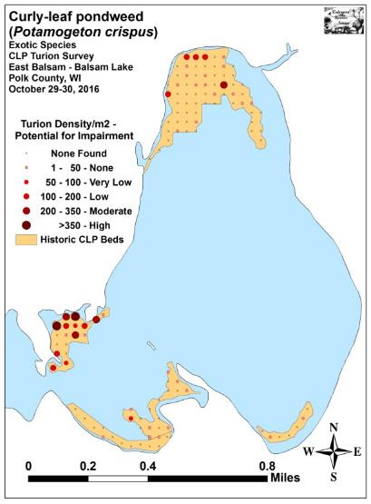
Figure 8: 2016 Fall CLP Turion Survey Density and Distribution
Table 2: CLP Turion Surveys - Summary Statistics
East Balsam Lake, Polk County
October 31-November 1, 2015 and October 29-30, 2016

2015 2016
Summary Statistics: | Total | Bed 12 | Bed 13 | Bed 14 | Bed  14B/C | Total | Bed 12 | Bed 13 | Bed 14 | Bed  14B/C
Total number of points sampled | 120 | 18 | 65 | 7 | 30 | 120 | 18 | 65 | 7 | 30
Total live turions | 246 | 69 | 111 | 10 | 56 | 199 | 122 | 61 | 2 | 14
Total number of points with live turions | 67 | 14 | 32 | 3 | 18 | 45 | 14 | 19 | 2 | 10
Frequency of occurrence (in percent) | 55.83 | 77.78 | 49.23 | 42.86 | 60.00 | 37.50 | 77.78 | 29.23 | 28.57 | 33.33
Points at or above nuisance level (+200/m²) | 5 | 2 | 2 | 0 | 1 | 6 | 5 | 1 | 0 | 0
% nuisance level | 4.17 | 11.11 | 3.08 | 0.00 | 3.33 | 5.00 | 27.78 | 1.54 | 0.00 | 0.00
Maximum turions/m² | 431 | 409 | 431 | 172 | 258 | 560 | 560 | 323 | 22 | 65
Mean turions/m² | 44.13 | 82.52 | 36.76 | 30.75 | 40.19 | 35.70 | 145.91 | 20.20 | 6.15 | 10.05
Standard deviation/m² | 75.04 | 107.58 | 71.07 | 63.20 | 57.02 | 85.86 | 157.26 | 54.21 | 10.50 | 16.71
Standard error of the paired difference |  |  |  |  |  | 0.41 | 1.77 | 0.50 | 1.16 | 0.46
Degrees of freedom |  |  |  |  |  | 119 | 17 | 64 | 6 | 29
t-statistic |  |  |  |  |  | -0.95 | 1.66 | -1.54 | -0.98 | -3.07
p - value |  |  |  |  |  | 0.17 | 0.057 | 0.06 | 0.18 | **0.002

Significant differences = * p<0.05, ** p<0.01, *** p<0.001

2017 Fall Ponar Dredge CLP Turion Survey:
During the October 28-29, 2017 survey, we found live CLP turions at 59 of 120 points (49.17%) (Figure 9) (Appendix II). This 31.11% increase from 45 points with turions (37.50%) in 2016 was the first expansion in distribution since treatment began. However, it was still below the 67 points with turions (55.83%) in 2015 and 92 points with turions in 2014 (76.67%). When broken down by area, only Bed 12 (northeast of the Big Narrows) showed a decline in points with turions (Table 3).

We calculated the overall mean density within the study areas at 23.32 turions/m² with a standard deviation of 33.33turions/m². This was a nearly significant decline (p=0.06) from 35.70 turions/m² with a standard deviation of 85.86 turions/m² in 2016. It was also a further decline (p=0.17) from the 44.13 turions/m² with a standard deviation of 75.04 turions/m² in 2015, and the 61.53turions/m² with a standard deviation of 114.47 turions/m² in 2014. This means that, despite the uptick in distribution, the mean density was the lowest it has been since treatment started. We also noted that, for the first time ever, there were no high density “predictive nuisance” points in any of the beds.

Visual analysis of the 2017 map showed that most of the expansion in distribution occurred in deep water areas that were not treated in 2017 because they did not have any turions in fall 2016 and few CLP plants during the 2017 pretreatment survey. In the past, when these low density areas were trimmed from the treatment plan, they still appeared to have experienced residual control; however; that doesn’t seem to have been the case in 2017. This may be because, for whatever reason, the 2017 treatment wasn’t as effectively as in years past when plants immediately and completely disintegrated. Rather, CLP was only severely burned by the herbicide, and, based on several follow-up visits we did in June, took up to five weeks posttreatment to fall over/decompose. Fortunately, none of these “slow dying” CLP plants were ever found to have produced turions.
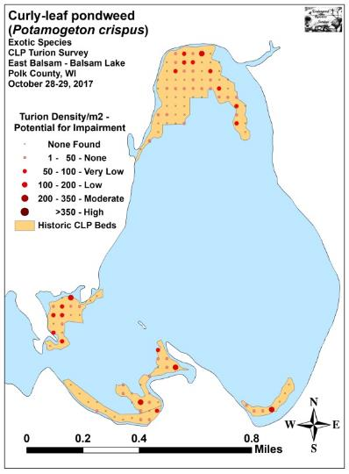
Figure 9: 2017 Fall CLP Turion Survey Density and Distribution
Table 3: CLP Turion Surveys - Summary Statistics
East Balsam Lake, Polk County
October 29-30, 2016 and October 28-29, 2017

2016 2017
Summary Statistics: | Total | Bed 12 | Bed 13 | Bed 14 | Bed  14B/C | Total | Bed 12 | Bed 13 | Bed 14 | Bed  14B/C
Total number of points sampled | 120 | 18 | 65 | 7 | 30 | 120 | 18 | 65 | 7 | 30
Total live turions | 199 | 122 | 61 | 2 | 14 | 130 | 26 | 58 | 11 | 35
Total number of points with live turions | 45 | 14 | 19 | 2 | 10 | 59 | 10 | 30 | 4 | 15
Frequency of occurrence (in percent) | 37.50 | 77.78 | 29.23 | 28.57 | 33.33 | 49.17 | 55.56 | 46.15 | 57.14 | 50.00
Points at or above nuisance level (+200/m²) | 6 | 5 | 1 | 0 | 0 | 0 | 0 | 0 | 0 | 0
% nuisance level | 5.00 | 27.78 | 1.54 | 0.00 | 0.00 | 0.00 | 0.00 | 0.00 | 0.00 | 0.00
Maximum turions/m² | 560 | 560 | 323 | 22 | 65 | 194 | 108 | 108 | 129 | 194
Mean turions/m² | 35.70 | 145.91 | 20.20 | 6.15 | 10.05 | 23.32 | 31.10 | 19.21 | 33.83 | 25.12
Standard deviation/m² | 85.86 | 157.26 | 54.21 | 10.50 | 16.71 | 33.33 | 34.02 | 27.21 | 46.27 | 41.19
Standard error of the paired difference |  |  |  |  |  | 0.37 | 1.70 | 0.34 | 0.89 | 0.34
Degrees of freedom |  |  |  |  |  | 119 | 17 | 64 | 6 | 29
t-statistic |  |  |  |  |  | -1.53 | -3.13 | -0.13 | +1.44 | +2.08
p - value |  |  |  |  |  | 0.06 | **0.003 | 0.44 | 0.10 | *0.02

Significant differences = * p<0.05, ** p<0.01, *** p<0.001

2018 Fall Ponar Dredge CLP Turion Survey:
The September 26-27, 2018 survey found live CLP turions at just 36 of 120 points (30.0%) (Figure 10) (Appendix II). This was a 38.98% decrease in coverage from the 59 points (49.17%) we found turions at in 2017, and it represented the fewest points with turions since surveying began (45 points with turions (37.50%) in 2016; 67 points with turions (55.83%) in 2015; and 92 points with turions in 2014 (76.67%)). When broken down by area, every bed experienced a decline in turion distribution (Table 4).

We calculated the overall mean density within the study areas at 28.52 turions/m² with a very high standard deviation of 138.32 turions/m². This was a non-sign significant increase (p=0.33) from 23.32 turions/m² with a standard deviation of 33.33turions/m² in 2017, but it was still below all other previous years (35.70 turions/m² - SD 85.86 turions/m² in 2016; 44.13 turions/m² - SD 75.04 turions/m² in 2015; and 61.53turions/m² - SD 114.47 turions/m² in 2014). This means that, despite the decline in distribution, the average density jumped; however, this was almost entirely due to the high turion counts at a couple of points as evidenced by the standard deviation which was nearly four times the mean. These two points (one in Bed 13 and one in Bed 14) were also the only high density “predictive nuisance” points.

Visual analysis of the 2018 map showed that most turions were either found in very shallow water in areas that have historically produced two “crops” of plants with the second occurring after herbicide/mechanical harvesting, or they were in deep areas that were not treated in 2017 and likely beyond the reach of the harvester in 2018. This is likely the cause of the localized jump at two points in Bed 14 as our June follow-up survey found CLP in this area only grew a few feet before falling over and dying.

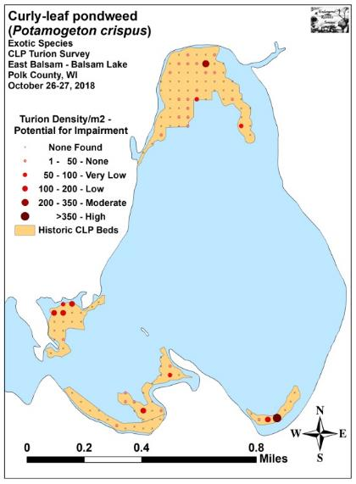
Figure 10: 2018 Fall CLP Turion Survey Density and Distribution
Table 4: CLP Turion Surveys - Summary Statistics
East Balsam Lake, Polk County
October 28-29, 2017 and October 26-27, 2018

2017 2018
Summary Statistics: | Total | Bed 12 | Bed 13 | Bed 14 | Bed  14B/C | Total | Bed 12 | Bed 13 | Bed 14 | Bed  14B/C
Total number of points sampled | 120 | 18 | 65 | 7 | 30 | 120 | 18 | 65 | 7 | 30
Total live turions | 130 | 26 | 58 | 11 | 35 | 159 | 24 | 42 | 75 | 18
Total number of points with live turions | 59 | 10 | 30 | 4 | 15 | 36 | 5 | 20 | 3 | 8
Frequency of occurrence (in percent) | 49.17 | 55.56 | 46.15 | 57.14 | 50.00 | 30.00 | 27.78 | 30.77 | 42.86 | 26.67
Points at or above nuisance level (+200/m²) | 0 | 0 | 0 | 0 | 0 | 2 | 0 | 1 | 1 | 0
% nuisance level | 0.00 | 0.00 | 0.00 | 0.00 | 0.00 | 1.67 | 0.00 | 1.54 | 14.29 | 0.00
Maximum turions/m² | 194 | 108 | 108 | 129 | 194 | 1,464 | 172 | 301 | 1,464 | 151
Mean turions/m² | 23.32 | 31.10 | 19.21 | 33.83 | 25.12 | 28.52 | 28.70 | 13.91 | 230.66 | 12.92
Standard deviation/m² | 33.33 | 34.02 | 27.21 | 46.27 | 41.19 | 138.32 | 55.75 | 39.81 | 545.85 | 30.76
Standard error of the paired difference |  |  |  |  |  | 0.56 | 0.57 | 0.28 | 8.84 | 0.36
Degrees of freedom |  |  |  |  |  | 119 | 17 | 64 | 6 | 29
t-statistic |  |  |  |  |  | +0.43 | -0.20 | -0.87 | +1.03 | -1.56
p - value |  |  |  |  |  | 0.33 | 0.42 | 0.19 | 0.17 | 0.07

Significant differences = * p<0.05, ** p<0.01, *** p<0.001

2019 Fall Ponar Dredge CLP Turion Survey:
On September 26-27, 2019, we found live CLP turions at 60 of 120 points (50.0%) (Figure 11) (Appendix II). This was a 66.67% increase in coverage from the 36 points (30.00%) with turions in 2018, and it was almost identical to the 59 points (49.17%) with turions in 2017. Although it was also above 2016 distribution levels (45 points/37.50% coverage), it was still below peak numbers in 2015 (67 points/55.83% coverage) and 2014 (92 points/76.67% coverage). When broken down by area, every bed experienced an increase in turion distribution (Table 5).

We calculated the overall mean density within the study areas at 39.47 turions/m² with a standard deviation of 66.42 turions/m². This was a non-sign significant increase (p=0.42) from 2018 when we found a mean of 28.52 turions/m² and a very high standard deviation of 138.32 turions/m². However, when compared to 2017 (23.32 turions/m² - SD 33.33turions/m²) it suggested there has been a moderately significant increase (p=0.003) since the cessation of chemical control. Similar to the changes noted with distribution, the density in 2019 was also above the 2016 mean density (35.70 turions/m² - SD 85.86 turions/m²), but below the peak years of 2015 (44.13 turions/m² - SD 75.04 turions/m²) and 2014 (61.53turions/m² - SD 114.47 turions/m² in 2014).

Although the overall mean still predicts that the majority of locations in East Balsam will have no navigational issues, there were seven points (5.83%) that had enough turions to suggest there would be at least moderate impairment. This was an increase from 2018 when only two points (1.67%) exceeded the “nuisance” threshold. Visual analysis of the 2018 and 2019 maps showed continuous, but low level expansion in the deep areas of the north bay (Bed 13). However, there were significant increases in the shallow mucky areas of Beds 12 and 14B. In the southeast bay (Bed 14), after having a sample with 68 turions during the 2018 survey, mean density declined sharply, but distribution ticked up.
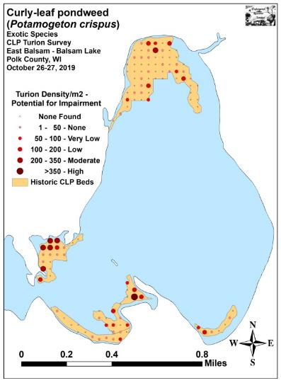
Figure 11: 2019 Fall CLP Turion Survey Density and Distribution
Table 5: CLP Turion Surveys - Summary Statistics
East Balsam Lake, Polk County
October 26-27, 2018 and October 26-27, 2019

2018 2019
Summary Statistics: | Total | Bed 12 | Bed 13 | Bed 14 | Bed  14B/C | Total | Bed 12 | Bed 13 | Bed 14 | Bed  14B/C
Total number of points sampled | 120 | 18 | 65 | 7 | 30 | 120 | 18 | 65 | 7 | 30
Total live turions | 159 | 24 | 42 | 75 | 18 | 220 | 73 | 69 | 11 | 67
Total number of points with live turions | 36 | 5 | 20 | 3 | 8 | 60 | 13 | 25 | 4 | 18
Frequency of occurrence (in percent) | 30.00 | 27.78 | 30.77 | 42.86 | 26.67 | 50.00 | 72.22 | 38.46 | 57.14 | 60.00
Points at or above nuisance level (+200/m²) | 2 | 0 | 1 | 1 | 0 | 7 | 5 | 1 | 0 | 1
% nuisance level | 1.67 | 0.00 | 1.54 | 14.29 | 0.00 | 5.83 | 27.78 | 1.54 | 0.00 | 3.33
Maximum turions/m² | 1,464 | 172 | 301 | 1,464 | 151 | 366 | 258 | 215 | 129 | 366
Mean turions/m² | 28.52 | 28.70 | 13.91 | 230.66 | 12.92 | 39.47 | 87.31 | 22.85 | 33.83 | 48.08
Standard deviation/m² | 138.32 | 55.75 | 39.81 | 545.85 | 30.76 | 66.42 | 98.37 | 43.54 | 47.91 | 75.15
Standard error of the paired difference |  |  |  |  |  | 0.63 | 0.71 | 0.31 | 9.88 | 0.59
Degrees of freedom |  |  |  |  |  | 119 | 17 | 64 | 6 | 29
t-statistic |  |  |  |  |  | +0.80 | +3.84 | +1.35 | -0.93 | +2.77
p - value |  |  |  |  |  | 0.42 | ***<0.001 | 0.09 | 0.20 | **=0.005

Significant differences = * p<0.05, ** p<0.01, *** p<0.001

CONSIDERATIONS FOR FUTURE MANAGMENT:
Following two years without chemical control, turion numbers ticked up in all areas of East Balsam relative to the last posttreatment survey in 2017 (Figure 12). Although levels are not severe and most areas are predicted to have no or low navigation impairment, an increase in some form of active management will likely be needed to maintain or reduce Curly-leaf pondweed from current levels. Ultimately, the amount of CLP growth the BLPRD is comfortable with will determine how much, if any, management occurs in East Balsam in 2020.

Figure 12: Total Live Turions Found – Fall 2014-2019

LITERATURE CITED

Clemens, C. [online]. 2010. Aquatic Plant Management Plan - Balsam Lake Polk County, WI. Sponsored by Balsam Lake Protection and Rehabilitation District - Prepared by Harmony Environmental – October 2010. Available from http://www.blprd.com/docs/BalsamLakeAPMfinal101810.pdf (2019, November).

Clemens, C. [online]. 2015. Aquatic Plant Management Plan - Balsam Lake Polk County, WI. Sponsored by Balsam Lake Protection and Rehabilitation District - Prepared by Harmony Environmental – September 2015. Available from http://www.blprd.com/docs/BalsamLakeAPM2015FINAL.pdf (2019, November).

Hopke, R., E. Nelson, and E. Eaton [online]. 1964. Balsam Lake Maps. Available from http://dnr.wi.gov/lakes/maps/DNR/2620600a.pdf (2019, November).

UWEX Lakes Program. [online]. 2010. Aquatic Plant Management in Wisconsin. Available from http://www.uwsp.edu/cnr-ap/UWEXLakes/Pages/ecology/aquaticplants/default.aspx (2019, November).

UWEX Lakes Program. [online]. 2010. Pre/Post Herbicide Comparison. Available from http://www.uwsp.edu/cnr-ap/UWEXLakes/Documents/ecology/Aquatic%20Plants/Appendix-D.pdf (2019, November).

WDNR. [online]. 2019. Balsam Lake Citizen Monitoring Water Quality Database. Available from http://dnr.wi.gov/lakes/lakepages/LakeDetail.aspx?wbic=2620600&page=waterquality (2019, November).

Appendix I: Survey Sample Points and Historic CLP Treatment Areas

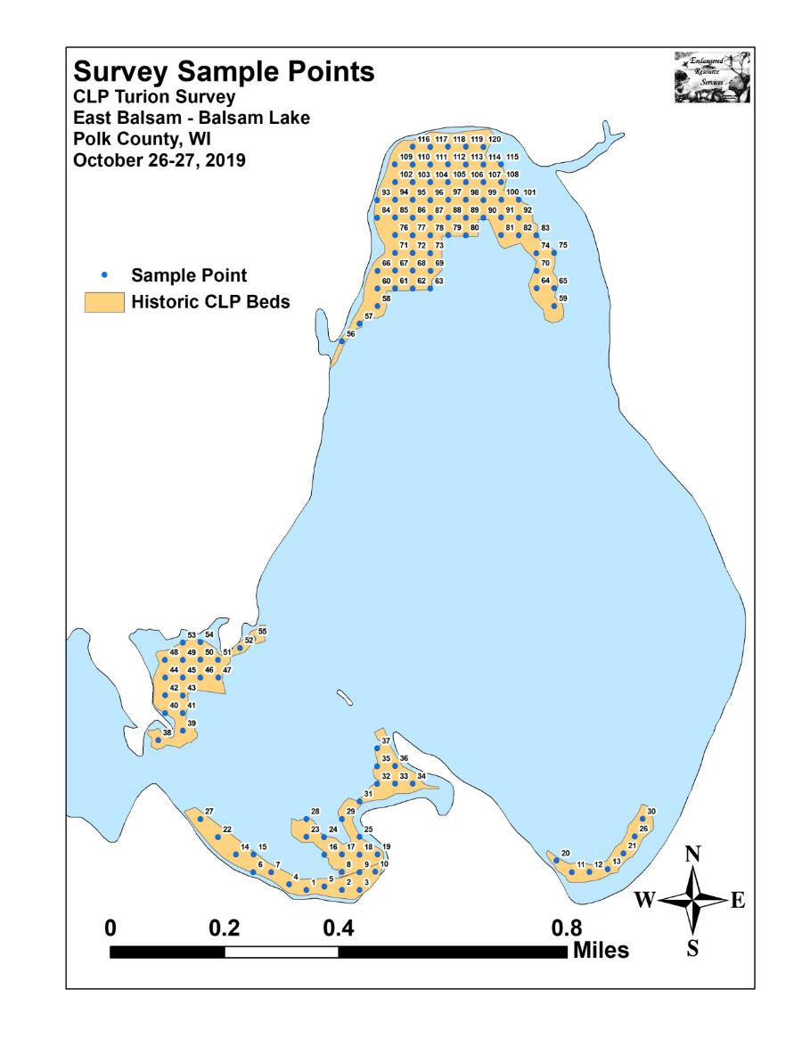

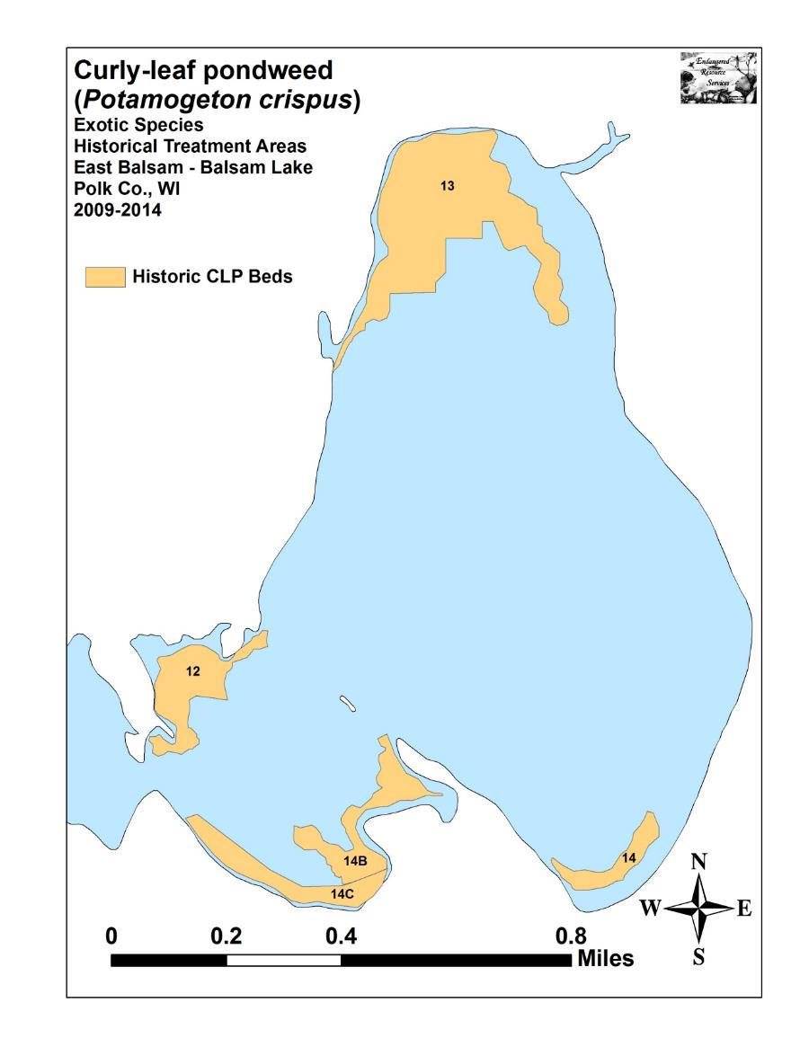

Appendix II: 2014-2019 Fall Curly-leaf Pondweed Turion
Density & Distribution Maps

