Curly-leaf Pondweed (Potamogeton crispus) and
Eurasian Water-milfoil (Myriophyllum spicatum) Pre/Post Herbicide and Fall EWM Bed Mapping Surveys
Round Lake – WBIC: 2640100
Burnett County, Wisconsin

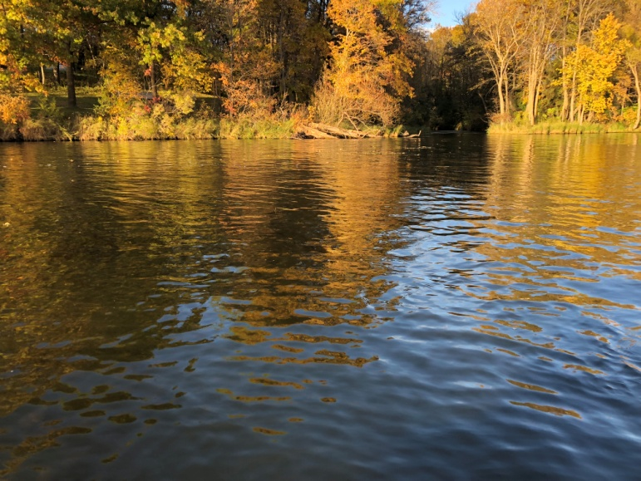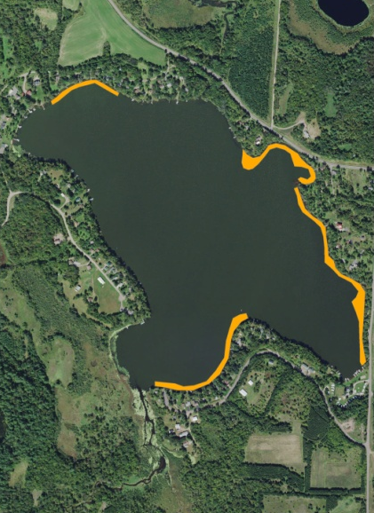
Bright sunshine and mostly calm survey conditions (10/16/18) 2018 CLP/EWM Final Treatment Areas
Project Initiated by:
Round-Trade Lakes Improvement Association Inc., Lake Education and Planning Services, LLC, and the Wisconsin Department of Natural Resources
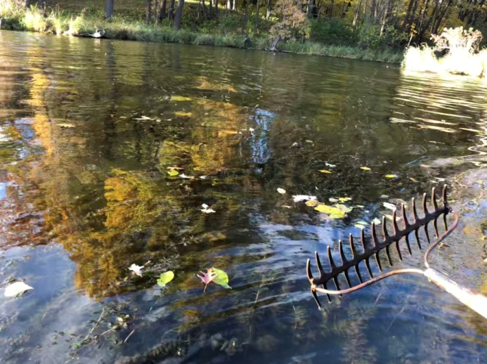
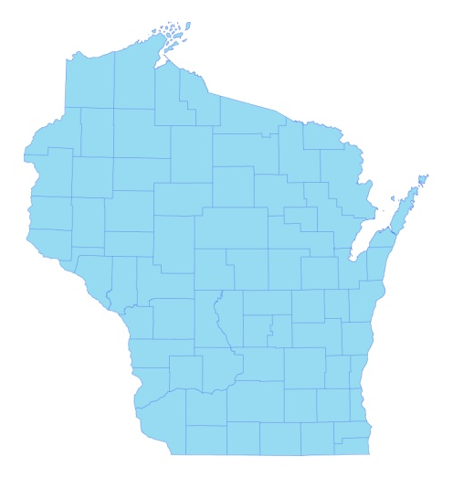

* Round Lake

Canopied EWM bed at the lake outlet (10/16/18)

Surveys Conducted by and Report Prepared by:
Endangered Resource Services, LLC
Matthew S. Berg, Research Biologist
St. Croix Falls, Wisconsin
May 19, June 25, and October 16, 2018
TABLE OF CONTENTS

Page
LIST OF FIGURES.………………..……..………………………………………………... ii

LIST OF TABLES…………………..……..……………………………………………….. iii

INTRODUCTION.……….…..……..……………………………………………………… 1

BACKGROUND AND STUDY RATIONALE…..……………………………………….. 1

METHODS……………………………………………………………….………………… 2

RESULTS AND DISCUSSION……………………………………………………………. 3

Finalization of Treatment Areas………………………………………………….…. 3

Pre/Post Herbicide Surveys…...………………………..……………………….…... 4

Fall Eurasian Water-milfoil Bed Mapping Survey…………………………….……. 13

Descriptions of Current and Former Eurasian Water-milfoil Beds…………………. 15

LITERATURE CITED……….……………………….……………………………………. 16

APPENDIXES……….…….………………………………………………….……………. 17

I: Survey Sample Points and Treatment Areas…………………………………………. 17

II: Vegetative Survey Datasheet...………………………………………………………. 20

III: Pre/Post Habitat Variable Maps………………………………………………………. 22

IV: Pre/Post Littoral Zone, Native Species Richness and Total Rake Fullness.………..… 25

V: CLP and EWM Pre/Post Density and Distribution.…………………………….…...... 32

VI: Pretreatment Native Species Density and Distribution…...………………………...... 37

VII: Posttreatment Native Species Density and Distribution…...……………………….... 47

VIII: Fall 2017 and 2018 EWM Bed Maps……….……………………………………….. 64

LIST OF FIGURES

Page
Figure 1: 2018 EWM Treatment Areas................................................................................. 1
Figure 2: Rake Fullness Ratings……………………………….…….…………………….. 2
Figure 3: 2018 Survey Sample Points and Final Treatment Areas………………………… 3
Figure 4: Treatment Area Depths and Bottom Substrate….………..……………………… 4
Figure 5: Pre/Post Littoral Zone.…………..…………………………..…………………… 5
Figure 6: Pre/Post Native Species Richness……………………………………………….. 6
Figure 7: Pre/Post Total Rake Fullness…………………………………………………….. 6
Figure 8: Pre/Post CLP Density and Distribution………….…………………………….… 7
Figure 9: Pre/Post Changes in CLP Rake Fullness….….………………………………….. 7
Figure 10: Pre/Post EWM Density and Distribution………….…………………………… 8
Figure 11: Pre/Post Changes in EWM Rake Fullness…..…………………………………. 8
Figure 12: Pre/Post Coontail Density and Distribution..……………………………..……. 9
Figure 13: Pre/Post Common Waterweed Density and Distribution..……...……………… 9
Figure 14: Pre/Post Macrophyte Changes…………………..……………………………... 12
Figure 15: 2017 and 2018 Fall EWM Bed Maps….…………………………..….…….….. 13

LIST OF TABLES

Page
Table 1: Spring CLP and EWM Treatment Summary –
Round Lake, Burnett County – May 29, 2018……………………………………………… 3

Table 2: Pre/Post Surveys Summary Statistics –
Round Lake, Burnett County – May 19 and June 25, 2018………………………………… 4

Table 3: Frequencies and Mean Rake Sample of Aquatic Macrophytes
Pretreatment Survey - Round Lake, Burnett County - May 19, 2018……………………… 10

Table 4: Frequencies and Mean Rake Sample of Aquatic Macrophytes
Posttreatment Survey - Round Lake, Burnett County - June 25, 2018……………………... 11

Table 5: Fall Eurasian Water-milfoil Bed Mapping Summary –
Round Lake, Burnett County – October 16, 2018……………………………………………. 14

INTRODUCTION:
Round Lake (WBIC 2640100) is a 208 acre drainage lake in southwest/south-central Burnett County, Wisconsin in the Town of Trade Lake (T37N R18W S27 NE SW). It reaches a maximum depth of 27ft in two spots near the eastern shoreline midlake and has an average depth of approximately 15ft. The lake is eutrophic in nature with summer Secchi disc readings from 1986 to 2018 ranging from 1.7-5.5ft and averaging 3.4ft (WDNR 2018). This very poor clarity produced a littoral zone that extended to approximately 10ft in 2018. The bottom substrate is predominately muck in the main basin and in the lake’s bays, while the shoreline and midlake bars and humps are dominated by gravel and sand (Sather et al 1967).
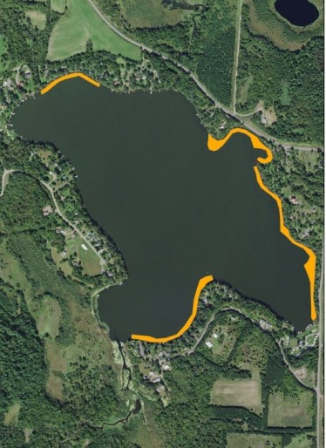
Figure 1: 2018 EWM Treatment Areas

BACKGROUND AND STUDY RATIONALE:
In 2003, the Wisconsin Department of Natural Resources (WDNR) confirmed the presence of Eurasian water-milfoil (Myriophyllum spicatum) (EWM) in Round Lake. Following the development of a WDNR approved Aquatic Plant Management Plan (APMP) that outlined strategies to control EWM and Curly-leaf pondweed (Potamogeton crispus) (CLP), another invasive exotic species that occurs sparingly throughout the lake’s spring littoral zone, the Round-Trade Lake Improvement Association, Inc. (RTLIA) began using manual removal and herbicide treatments to control these species.

In 2018, the RTLIA – under the direction of Dave Blumer (Lake Education and Planning Services, LLC - LEAPS) – applied for and was awarded a WDNR Aquatic Invasive Species control grant (ACEI21618) to help cover the costs associated with management. These funds were used to chemically treat four areas totaling 8.86 acres (4.26% of the lake’s surface area) for EWM (Figure 1). On May 19th, we conducted a pretreatment survey to gather baseline data from these areas and to allow LEAPS/RTLIA to finalize treatment plans. After the May 29th herbicide application, we completed a June 25th posttreatment survey to evaluate the effectiveness of the treatment. We also conducted an October 16th EWM bed mapping survey to determine where control might be considered in 2019. This report is the summary analysis of these three field surveys.

METHODS:
Pre/Post Herbicide Surveys:
LEAPS provided treatment shapefiles, and we generated pre/post survey points based on the size and shape of the proposed areas that covered 16.75 acres. The requested 115 point sampling grid approximated to almost 7 pts/acre – well within the minimum of 4-10 pts/acre required by WDNR protocol for pre/post treatment surveys (Appendix I).

During the surveys, we located each point using a handheld mapping GPS unit (Garmin 76CSx) and used a rake to sample an approximately 2.5ft section of the bottom. All plants on the rake were assigned a rake fullness value of 1-3 as an estimation of abundance, and a total rake fullness for all species was also recorded (Figure 2). Visual sightings of EWM and CLP were noted if they occurred within 6ft of the point; however, visuals of other species were not recorded as they do not figure into the pre/posttreatment calculation. In addition to plant data, we recorded the lake depth using a metered pole and the substrate (bottom) type when we could see it or reliably determine it with the rake.

We entered all data collected into the standard APM spreadsheet (Appendix II). Data was analyzed using the linked statistical summary sheet and the WDNR pre/post analysis worksheet. For pre/post differences of individual plant species as well as count data, we used the Chi-square analysis on the WDNR pre/post survey worksheet (UWEX 2010). For comparing averages (mean species/point and mean rake fullness/point), we used t-tests. Differences were determined to be significant at p<0.05, moderately significant at p<0.01 and highly significant at p<0.001.

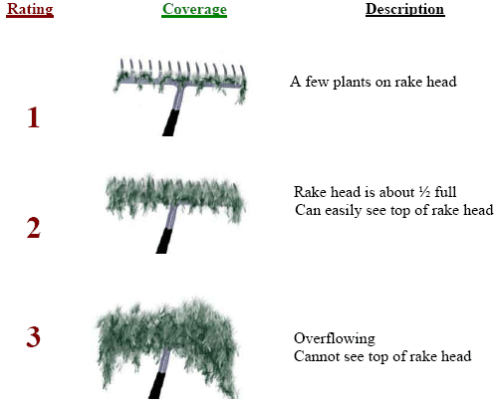
Figure 2: Rake Fullness Ratings

Fall Eurasian Water-milfoil Bed Mapping:
During the fall survey, we searched the entire visible littoral zone of the lake and mapped all known beds of EWM. A “bed” was determined to be any area where we visually estimated that EWM made up >50% of the area’s plants and was generally continuous with clearly defined borders. After we located a bed, we motored around the perimeter of the area, took GPS coordinates at regular intervals, and estimated both the range and mean rake fullness rating of EWM within the bed (Figure 2). Using the WDNR’s Forestry Tool’s Extension to ArcGIS 9.3.1, we plotted these coordinates to generate bed shapefiles and determine the acreage to the nearest hundredth of an acre. We also took waypoints of EWM plants outside these beds as they were generally few in number.
RESULTS AND DISCUSSION:
Finalization of Treatment Areas:
Initial expectations were to treat six beds for Curly-leaf pondweed and Eurasian water-milfoil using both liquid Endothall (Aquathol K) and 2,4-D (Shredder Amine 4) at concentrations of 2ppm and 4ppm respectively (Figure 3) (Appendix III). Following the pretreatment survey that found almost no CLP within the proposed Aquathol treatment zones totaling 5.30 acres, these areas were eliminated from the final treatment plan. Low EWM levels near shore, on the outer edge of the littoral zone, and in the eastern lobe of Area 1 also resulted in significant pullback. Ultimately, four areas totaling 8.86 acres were treated for only EWM. This represented a 7.89 acre decrease (-47.1%) over initial expectations (Table 1).

Northern Aquatic Services (Dale Dressel – Dresser) carried out the treatment on May 29th. The reported water temperature at the time of application was 72°F, the ambient air temperature was 85°F, and winds were out of the southeast at 4mph.

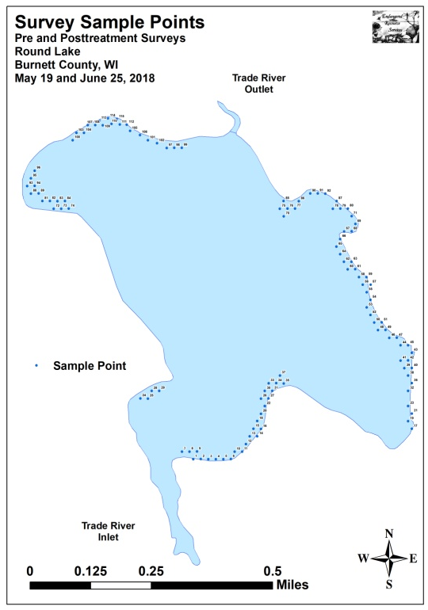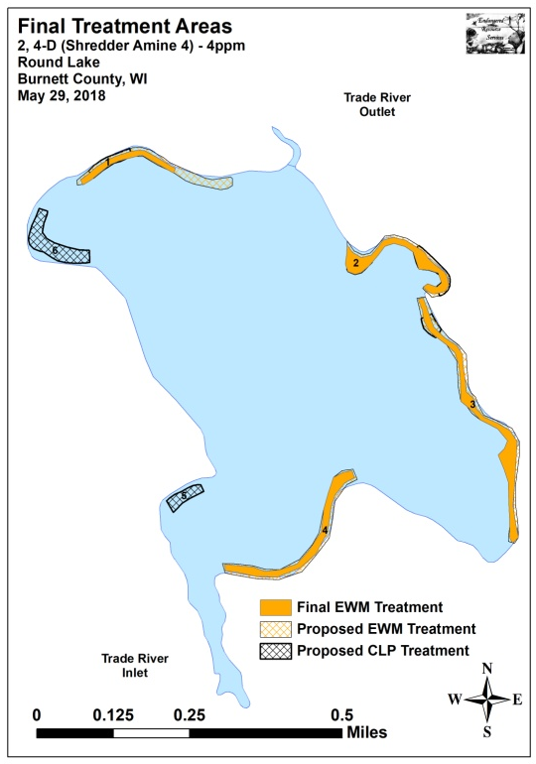
Figure 3: 2018 Survey Sample Points and Final Treatment Areas

Table 1: Spring CLP and EWM Treatment Summary
Round Lake, Burnett County - May 29, 2018

Treatment Area | Proposed  Acreage | Final Acreage | Difference  +/- | Chemical – Dosage Total Gallons
1 | 2.60 | 1.03 | -1.57 | 2,4-D – 4ppm – 11.70gal.
2 | 2.93 | 2.27 | -0.66 | 2,4-D – 4ppm – 22.56gal.
3 | 4.90 | 3.27 | -1.63 | 2,4-D – 4ppm – 32.50gal.
4 | 3.58 | 2.29 | -1.29 | 2,4-D – 4ppm – 22.76gal.
5 | 0.70 | 0.00 | -0.70 | None
6 | 2.04 | 0.00 | -2.04 | None
Total Acres | 16.75 | 8.86 | -7.89

Pre/Post Herbicide Surveys:
All points occurred in areas between 1.0ft and 14.0ft of water. The mean and median depths of plant growth were almost unchanged at 3.3ft/2.5ft respectively pretreatment and 2.9ft /2.5ft posttreatment (Table 2). We found most Eurasian water-milfoil and Curly-leaf pondweed plants were established in a thin layer of muck over sand and rock (Figure 4) (Appendix III).

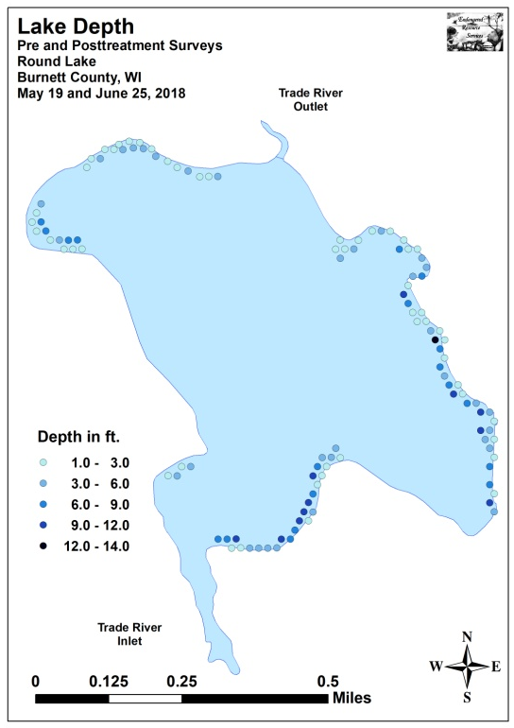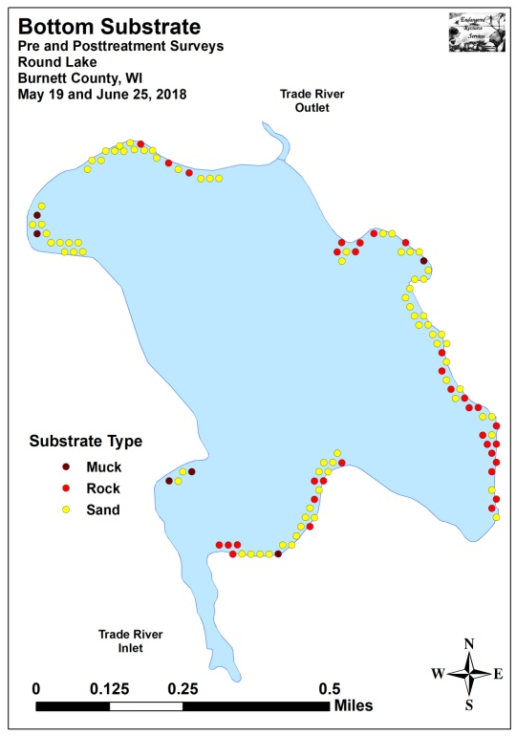
Figure 4: Treatment Area Depths and Bottom Substrate

Table 2: Pre/Post Surveys Summary Statistics
Round Lake, Burnett County
May 19 and June 25, 2018
Summary Statistics: | Pre | Post
Total number of points sampled | 115 | 115
Total number of sites with vegetation | 49 | 71
Total number of sites shallower than the maximum depth of plants | 109 | 110
Freq. of occur. at sites shallower than max. depth of plants (in percent) | 45.0 | 64.5
Simpson Diversity Index | 0.79 | 0.89
Mean Coefficient of Conservatism | 5.3 | 5.2
Floristic Quality Index | 14.8 | 20.1
Maximum depth of plants (ft) | 10.0 | 10.0
Mean depth of plants (ft) | 3.3 | 2.9
Median depth of plants (ft) | 2.5 | 2.5
Average number of all species per site (shallower than max depth) | 0.73 | 1.56
Average number of all species per site (veg. sites only) | 1.63 | 2.42
Average number of native species per site (shallower than max depth) | 0.61 | 1.43
Average number of native species per site (sites with native veg. only) | 1.47 | 2.28
Species richness | 10 | 16
Mean rake fullness (veg. sites only) | 1.35 | 1.49
The littoral zone within the planned treatment areas extended to 10.0ft during both the pre and posttreatment surveys. Within this zone, plants were patchy in distribution as only 45.0% of points had vegetation during the pretreatment survey, although this increased to 64.5% posttreatment (Figure 5) (Appendix IV). Total richness jumped from ten species pretreatment to 16 posttreatment. The Simpson’s Diversity Index also increased from a moderately high pretreatment value of 0.79 to a very high posttreatment value of 0.89. The Floristic Quality Index (another measure of native plant community health) climbed from 14.8 pretreatment to 20.1 posttreatment.

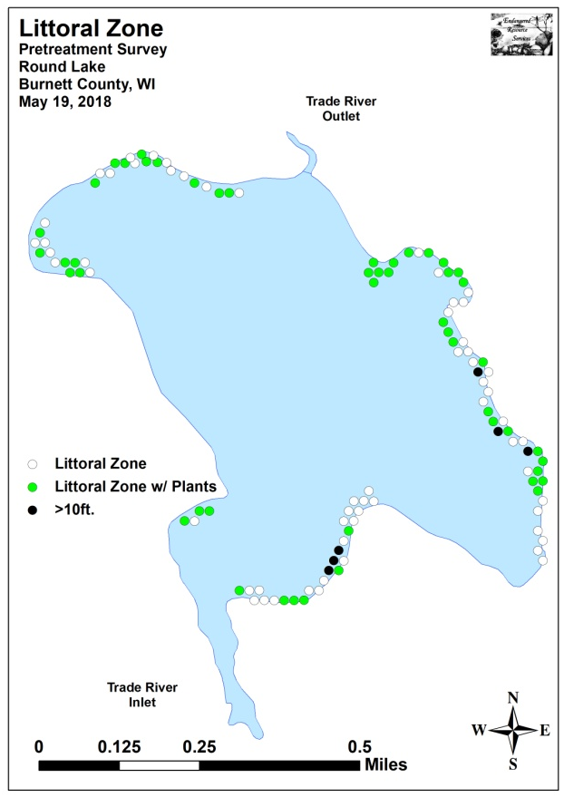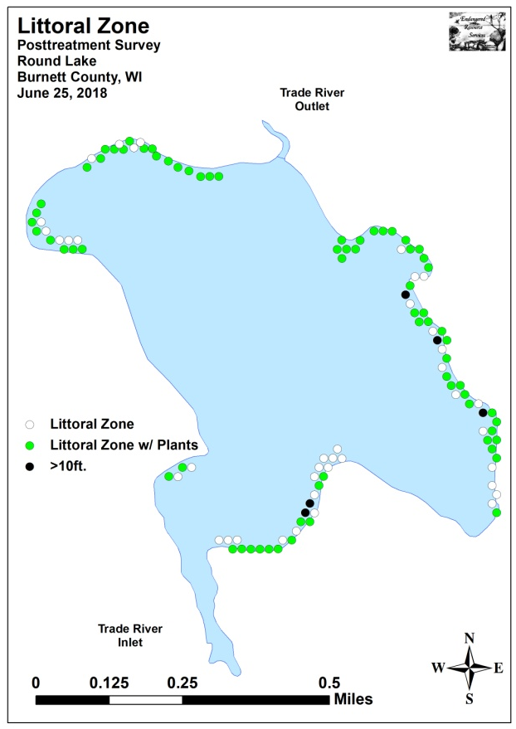
Figure 5: Pre/Post Littoral Zone

Mean native species richness at points with native vegetation experienced a highly significant increase (p<0.001) from 1.47 species/point pretreatment to 2.28 species/point posttreatment. Visual analysis of the maps showed much of this increase occurred along the north shoreline and in the northeast bay (Figure 6). Total mean rake fullness experienced a non-significant increase (p=0.10) from a low 1.35 pretreatment to a low/moderate 1.49 posttreatment (Figure 7) (Appendix IV).
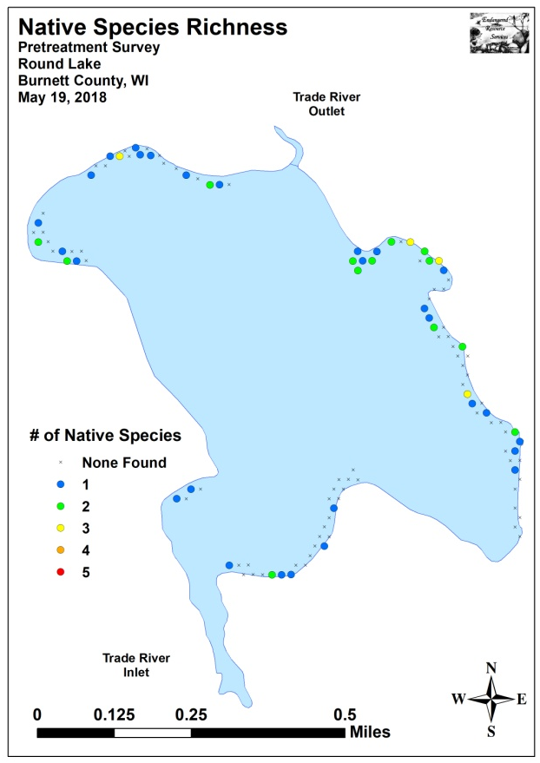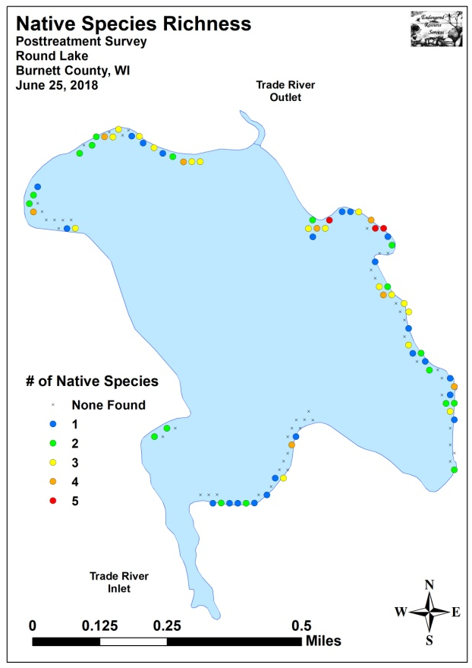
Figure 6: Pre/Post Native Species Richness
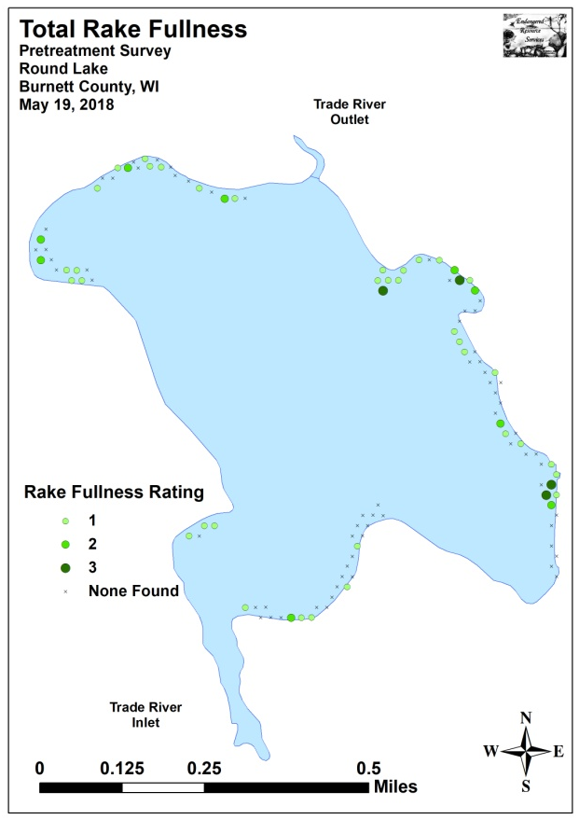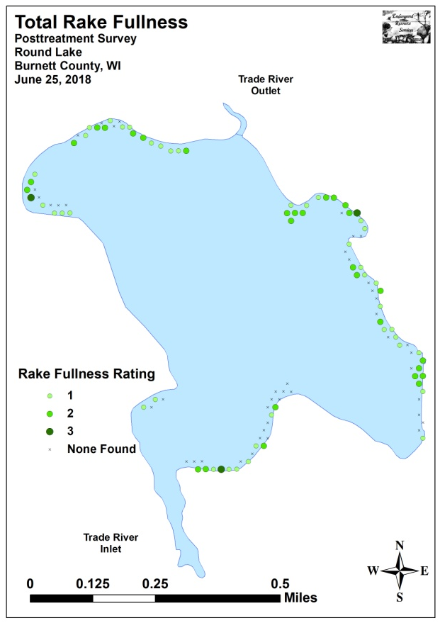
Figure 7: Pre/Post Total Rake Fullness

We found Curly-leaf pondweed at seven of 115 sites during the pretreatment survey (6.1% coverage) (Figure 8). Of these, none had a rake fullness rating of 3, one rated a 2, and the remaining six were a 1. This produced a mean rake fullness of 1.14 and suggested that just 0.9% of the proposed treatment areas had a significant infestation (rake fullness 2 and 3). During the posttreatment survey, we found CLP at 15 points (13.0% coverage) with none rating a 3, two a 2, and 13 a 1 for a mean rake fullness of 1.13. Even without active management, this extrapolated to only 1.7% of the proposed areas having a significant infestation. Despite these overall increases in CLP, none of the changes were statistically significant (Figure 9) (Appendix V).
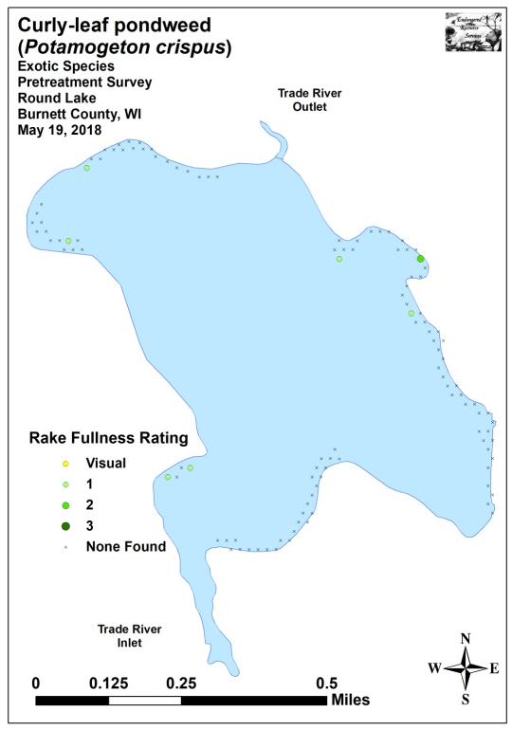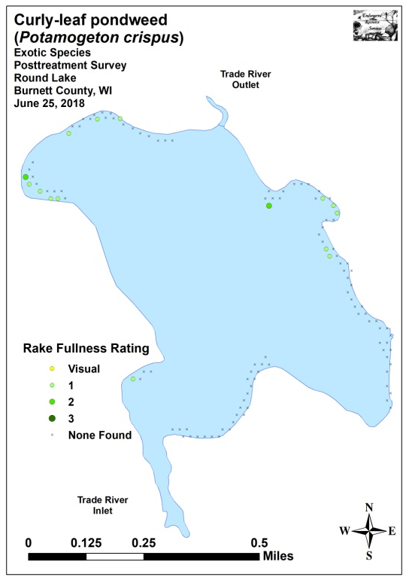
Figure 8: Pre/Post CLP Density and Distribution

Significant differences = * p<0.05, ** p<0.01, *** p<0.001
Figure 9: Pre/Post Changes in CLP Rake Fullness
Eurasian water-milfoil was present at seven of 115 sites during the pretreatment survey (6.1% coverage) (Figure 10). We rated three points a 3, three a 2, and one a 1. This extrapolated to 5.2% of the proposed treatment areas having a significant infestation (rake fullness 2 and 3) and produced a mean rake fullness of 2.29. During the posttreatment survey, we didn’t see any evidence of EWM at or between any survey points. Statistically, this overall reduction was moderately significant for only total EWM (Figure 11) (Appendix V).
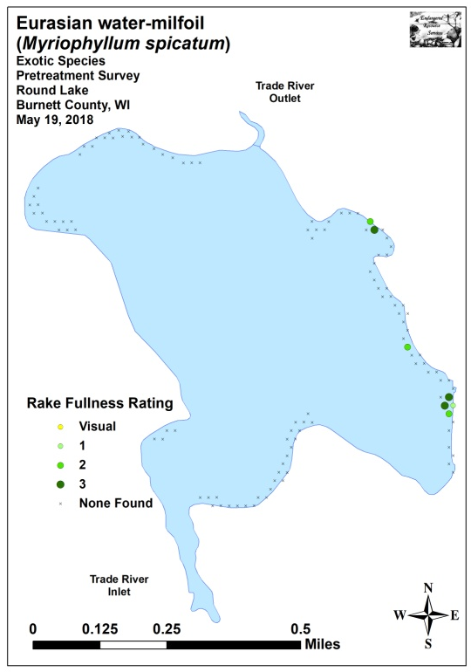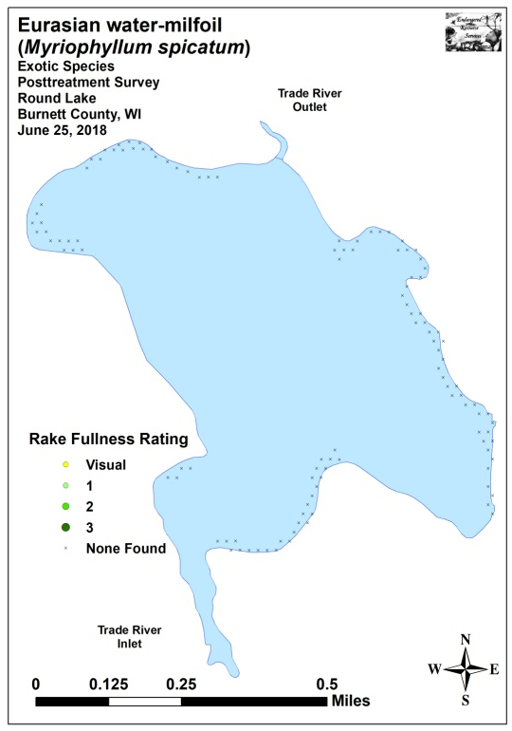
Figure 10: Pre/Post EWM Density and Distribution
_**
Significant differences = * p<0.05, ** p<0.01, *** p<0.001
_*
Figure 11: Pre/Post Changes in EWM Rake Fullness
Coontail (Ceratophyllum demersum) (Figure 12) and Common waterweed (Elodea canadensis) (Figure 13) were the most common native species during both the pre and posttreatment surveys (Tables 3 and 4). Present at 24 sites with a mean rake fullness of 1.21 during the pretreatment survey, Coontail experienced a nearly-significant increase (p=0.07) in distribution to 36 sites, and a non-significant increase (p=0.24) in mean rake fullness to 1.31 posttreatment. Common waterweed (24 sites – mean rake 1.13 pretreatment) was almost unchanged in distribution posttreatment (25 sites), but its increase in mean rake fullness to 1.44 was moderately significant (p=0.007). Other than EWM, no other species experienced a decline posttreatment; however, many species saw significant increases in range. Specifically, Wild celery (Vallisneria americana) and Slender naiad (Najas flexilis) experienced highly significant increases; filamentous algae, Clasping-leaf pondweed (Potamogeton richardsonii), and Long-leaf pondweed (Potamogeton nodosus) had moderately significant increases; and Small pondweed (Potamogeton pusillus) and Sago pondweed (Stuckenia pectinata) demonstrated significant increases (Figure 14). Maps for all native species from the pre and posttreatment surveys are available in Appendixes VI and VII.
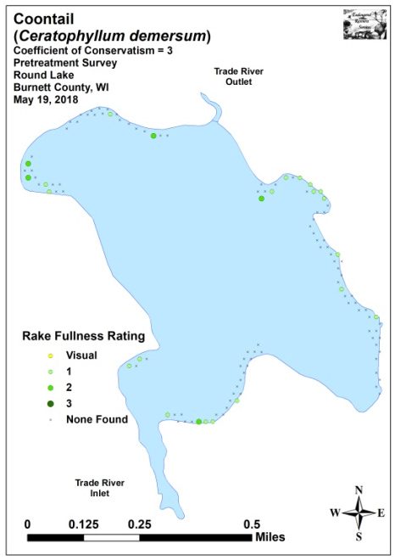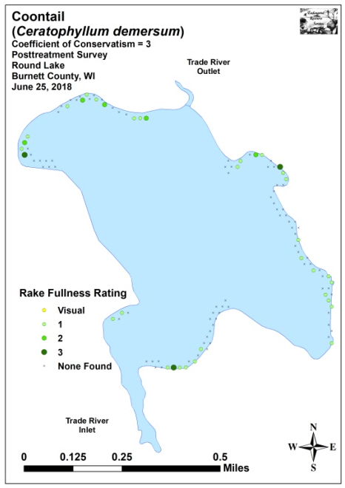
Figure 12: Pre/Post Coontail Density and Distribution
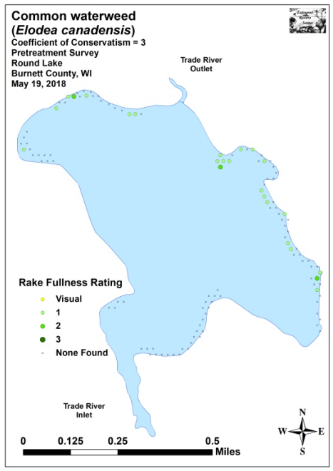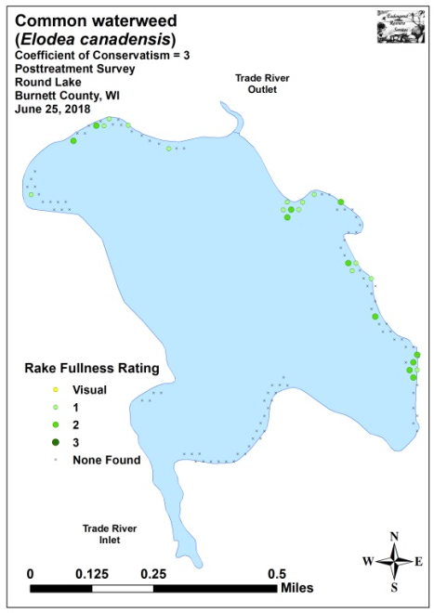
Figure 13: Pre/Post Common Waterweed Density and Distribution

Table 3: Frequencies and Mean Rake Sample of Aquatic Macrophytes
Pretreatment Survey – Round Lake, Burnett County
May 19, 2018

Species | Common Name | Total  Sites | Relative Freq. | Freq. in Veg. | Freq. in Lit. | Mean Rake
 | Filamentous algae | 30 | * | 61.22 | 27.52 | 1.37
Ceratophyllum demersum | Coontail | 24 | 30.00 | 48.98 | 22.02 | 1.21
Elodea canadensis | Common waterweed | 24 | 30.00 | 48.98 | 22.02 | 1.13
Myriophyllum spicatum | Eurasian water-milfoil | 7 | 8.75 | 14.29 | 6.42 | 2.29
Potamogeton crispus | Curly-leaf pondweed | 7 | 8.75 | 14.29 | 6.42 | 1.14
Potamogeton pusillus | Small pondweed | 6 | 7.50 | 12.24 | 5.50 | 1.00
Potamogeton zosteriformis | Flat-stem pondweed | 5 | 6.25 | 10.20 | 4.59 | 1.00
Heteranthera dubia | Water star-grass | 3 | 3.75 | 6.12 | 2.75 | 1.00
Potamogeton richardsonii | Clasping-leaf pondweed | 2 | 2.50 | 4.08 | 1.83 | 1.00
Nymphaea odorata | White water lily | 1 | 1.25 | 2.04 | 0.92 | 1.00
Vallisneria americana | Wild celery | 1 | 1.25 | 2.04 | 0.92 | 1.00

* Excluded from relative frequency analysis
Table 4: Frequencies and Mean Rake Sample of Aquatic Macrophytes
Posttreatment Survey – Round Lake, Burnett County
June 25, 2018

Species | Common Name | Total  Sites | Relative Freq. | Freq. in Veg. | Freq. in Lit. | Mean Rake
 | Filamentous algae | 52 | * | 73.24 | 47.27 | 1.38
Ceratophyllum demersum | Coontail | 36 | 20.93 | 50.70 | 32.73 | 1.31
Elodea canadensis | Common waterweed | 25 | 14.53 | 35.21 | 22.73 | 1.44
Potamogeton pusillus | Small pondweed | 17 | 9.88 | 23.94 | 15.45 | 1.12
Vallisneria americana | Wild celery | 16 | 9.30 | 22.54 | 14.55 | 1.19
Potamogeton crispus | Curly-leaf pondweed | 15 | 8.72 | 21.13 | 13.64 | 1.13
Potamogeton richardsonii | Clasping-leaf pondweed | 15 | 8.72 | 21.13 | 13.64 | 1.33
Potamogeton zosteriformis | Flat-stem pondweed | 12 | 6.98 | 16.90 | 10.91 | 1.08
Najas flexilis | Slender naiad | 11 | 6.40 | 15.49 | 10.00 | 1.00
Potamogeton nodosus | Long-leaf pondweed | 8 | 4.65 | 11.27 | 7.27 | 1.38
Stuckenia pectinata | Sago pondweed | 4 | 2.33 | 5.63 | 3.64 | 1.25
Heteranthera dubia | Water star-grass | 3 | 1.74 | 4.23 | 2.73 | 1.00
Nymphaea odorata | White water lily | 3 | 1.74 | 4.23 | 2.73 | 1.33
Lemna minor | Small duckweed | 2 | 1.16 | 2.82 | 1.82 | 1.50
Spirodela polyrhiza | Large duckweed | 2 | 1.16 | 2.82 | 1.82 | 1.50
Wolffia columbiana | Common watermeal | 2 | 1.16 | 2.82 | 1.82 | 1.00
Nuphar variegata | Spatterdock | 1 | 0.58 | 1.41 | 0.91 | 2.00

* Excluded from relative frequency analysis
+*
+**
+***
+***
+**
-*
-**
+**
Significant differences = * p<0.05, ** p<0.01, *** p<0.001
_*
Figure 14: Pre/Post Macrophyte Changes

Fall Eurasian Water-milfoil Bed Mapping Survey:
On October 16th, 2018, we located and mapped seven areas on the lake ranging in size from <0.01acre (Bed 19) to 1.72 acres (Bed 3) (Figure 15) (Appendix VIII). In total, these beds covered 2.18 acres (1.05% of the lake’s surface area) (Table 5). This was a reduction of 0.58 acre (-21.01%) from the 15 beds totaling 2.76 acres (1.28% coverage) that we mapped in fall 2017, and a further decline from the 7.57 acres (3.64% coverage) mapped in 2016. Outside these beds, EWM was uncommon and widely scattered as we marked just 14 additional plants.

The majority of areas that were chemically treated with 2,4-D in May experienced noticeable reductions in both EWM density and distribution. Although some areas were apparently experiencing recolonization (young plants based on small EWM plant size/low stem count per cluster), the majority of the 2018 treatment areas continued to have little to no EWM into the fall. Conversely, the untreated areas near the lake outlet experienced typical expansion.

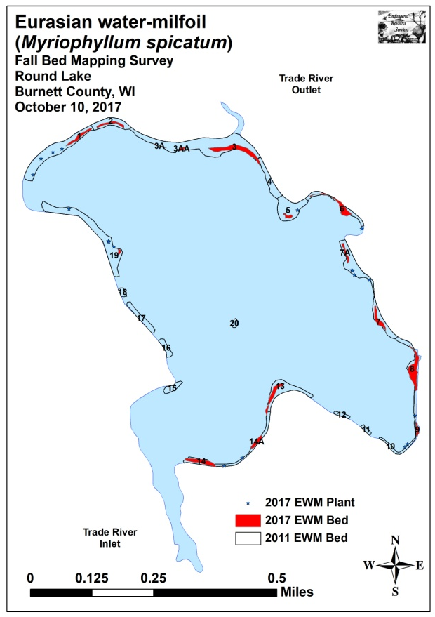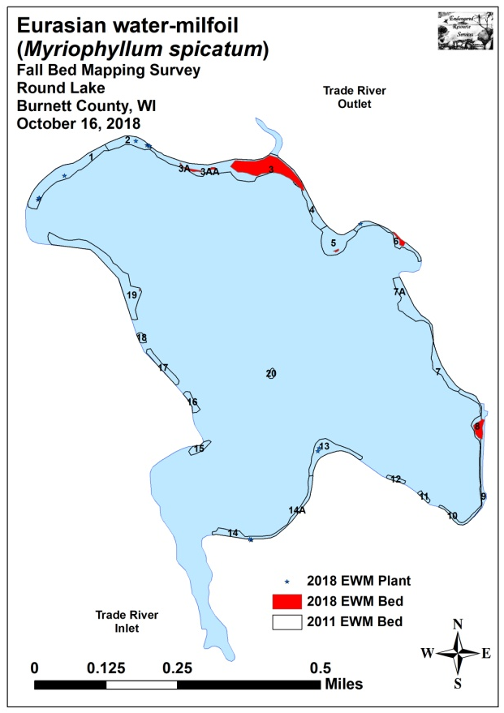
Figure 15: 2017 and 2018 Fall EWM Bed Maps

Table 5: Fall Eurasian Water-milfoil Bed Mapping Summary
Round Lake, Burnett County
October 16, 2018

Bed  Number | 2018  Area  (in Acres) | 2017  Area | 2016  Area | 2015  Area | 2014  Area | 2013  Area | 2012  Area | 2011  Area | 2018  Acreage  Change | 2018 Rake Range;  Mean Rake Fullness | 2018  Field Notes
Merged 1-6 | 1.93 | 1.24 | 5.66 | 2.16 | - | - | - | - | 0.69 | - | Former bed fragmented
1 | 0 | 0.17 | Merged | 0 | 0 | 0 | 0.52 | 1.91 | -0.17 | <<<1 | 4 EWM plants
2 | 0 | 0.14 | Merged | 0 | 0.16 | 0.10 | 0.47 | 0.74 | -0.14 | <<<1 | 4 EWM plants
3A/AA and 3 | 1.82 | 0.59 | Merged | 1.55 | 1.81 | 1.00 | 2.58 | 3.57 | 1.23 | <<1-3; 2 | Solid mat in front of outlet
4 | Merg. w/3 | Merg. w/3 | Merged | Merg. w/ 3 | Merg. w/ 3 | 0.11 | 0.68 | 0.63 | - | -
5 | 0.02 | 0.06 | Merged | 0.49 | 0.26 | 0 | 0.46 | 1.21 | -0.04 | <1-3; 1 | Microbed on point
6 | 0.09 | 0.28 | Merged | 0.11 | 0.06 | 0 | 0.43 | 0.61 | -0.19 | <<1-2; 1 | Regular towers
7 and 7A | 0 | 0.28 | 0.78 | 0.65 | 0.05 | 0 | 0.80 | 1.73 | -0.28 | 0 | No EWM seen
8 | 0.25 | 0.52 | 0.57 | 0.43 | 0.23 | 0 | 0.19 | 0.55 | -0.27 | <1-3; 2 | Fragmented canopied mat
9 | 0 | 0.06 | 0 | 0 | 0 | 0 | 0.20 | 0.26 | -0.06 | 0 | No EWM seen
10 | 0 | 0 | 0 | 0 | 0 | 0 | 0.06 | 0.11 | 0 | 0 | No EWM seen
11 | 0 | 0 | 0 | 0 | 0 | 0 | 0.06 | 0.11 | 0 | 0 | No EWM seen
12 | 0 | 0 | 0 | 0 | 0 | 0 | 0 | 0.13 | 0 | 0 | No EWM seen
13 | 0 | 0.25 | 0.08 | 0.28 | 0 | 0 | 0.44 | 1.04 | -0.25 | <<<1 | Raked out 2 EWM plants
14 and 14A | 0 | 0.39 | 0.19 | 0.06 | 0.07 | 0 | 0.39 | 0.92 | -0.39 | <<<1 | Raked out 3 EWM plants
15A | 0 | 0 | 0.01 | 0.04 | 0 | 0 | 0 | 0 | 0 | 0 | No EWM seen
15 | 0 | 0 | 0 | 0 | 0 | 0 | 0.12 | 0.27 | 0 | 0 | No EWM seen
16 | 0 | 0 | 0 | 0 | 0 | 0 | 0.09 | 0.26 | 0 | 0 | No EWM seen
17 | 0 | 0 | 0 | 0 | 0.10 | 0 | 0.15 | 0.46 | 0 | 0 | No EWM seen
18 | 0 | 0 | 0 | 0 | 0 | 0 | 0 | 0.13 | 0 | 0 | No EWM seen
19 and 19A | <0.01 | 0.03 | 0.27 | 0.03 | 0.46 | 0.19 | 1.15 | 2.27 | -0.02 | <<1-2; 1 | 10+ large towers
20 | 0 | 0 | 0 | 0 | 0 | 0.01 | 0.05 | 0.10 | 0 | 0 | No EWM seen
Total | 2.18 | 2.76 | 7.57 | 3.65 | 3.20 | 1.41 | 8.84 | 17.01 | -0.58

Descriptions of Current and Former Eurasian Water-milfoil Beds:
Beds 1 and 2 – There were only a handful of Eurasian water-milfoil plants along the far northwestern shoreline, and we rake removed them.

Beds 3A and 3AA – The area west of the outlet that included Beds 3A and 3AA supported very low levels of EWM. Although plants were still more or less continuous within the two small mapped beds, they were too sparse to be much of a navigational issue.

Beds 3 and 4 – The EWM bed in front of the outlet formed a solid canopied mat that filled the water column in 3-5ft of water. Although there were no residences directly adjacent to the bed, it represented a severe impairment to navigation for anyone trying to motor through it. Moving to the east, we found that densities steadily declined before plants disappeared altogether near the northern tip of what had been Bed 4.

Bed 5 – A few large multi-stemmed plants on the deepwater edge of the point appeared to have survived the treatment. They were actively fragmenting, and we noted there were satellite plants radiating north from them onto the rock bar. Clasping-leaf pondweed and Wild celery, two valuable native species, dominated the majority of the rest of the area.

Bed 6 – A small nearshore area of the bed adjacent to HWY 48 still had regular large EWM towers that appeared to have survived the treatment. Elsewhere in the former bed, we saw and removed a single additional plant.

Beds 7 and 7A – This part of the treatment area remained completely free of EWM.

Bed 8 – The core of the bed was rapidly reestablishing into a monotypic mat, and we estimated that it was at least a minor and possibly a moderate impairment to local residents. On the periphery, EWM was mixed with Clasping-leaf pondweed and Common waterweed.

Beds 9, 10, 11 and 12 – We didn’t see any EWM in these former beds.

Bed 13 – We found and rake removed two surviving EWM plants on the southern point.

Beds 14 and 14B – We found and rake removed three surviving EWM plants in the bay east of the boat landing.

Beds 15A-18 – We saw no evidence of EWM in these former beds along the western midlake shoreline.

Beds 19 and 19A – Located on the southeast flat in Bed 19, this small monotypic patch contained 10+ large EWM plants. Unfortunately, they had extensive root systems that were impacted in the sand and gravel making it impossible to completely rake them out. No other EWM was seen anywhere else in the rest of these former beds.

Bed 20 – We again found no EWM plants on the midlake rock bars.

LITERATURE CITED

Sather, L, C. Busch, R. House, and C. Harrison [online]. 1967. Round Lake Map. Available from
http://dnr.wi.gov/lakes/maps/DNR/2640100a.pdf (2018, December).

UWEX Lakes Program. [online]. 2010. Aquatic Plant Management in Wisconsin. Available from http://www.uwsp.edu/cnr-ap/UWEXLakes/Pages/ecology/aquaticplants/default.aspx (2018, December).

UWEX Lakes Program. [online]. 2010. Pre/Post Herbicide Comparison. Available from http://www.uwsp.edu/cnr-ap/UWEXLakes/Documents/ecology/Aquatic%20Plants/Appendix-D.pdf (2018, December).

WDNR. [online]. 2018. Round Lake - Citizen Lake Water Quality Monitoring Database. Available from http://dnr.wi.gov/lakes/waterquality/Station.aspx?id=073039 (2018, December).

Appendix I: Survey Sample Points and Treatment Areas

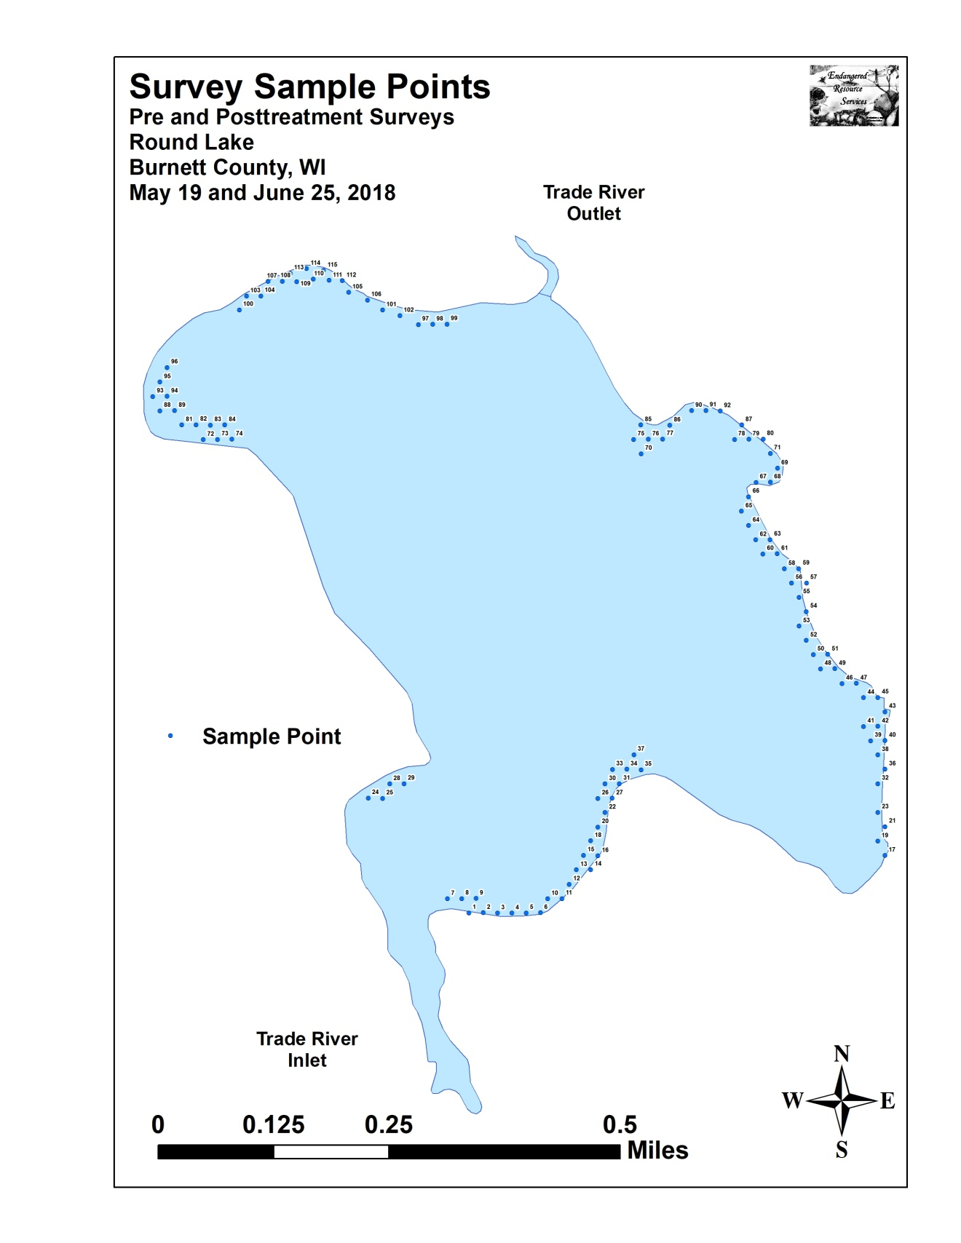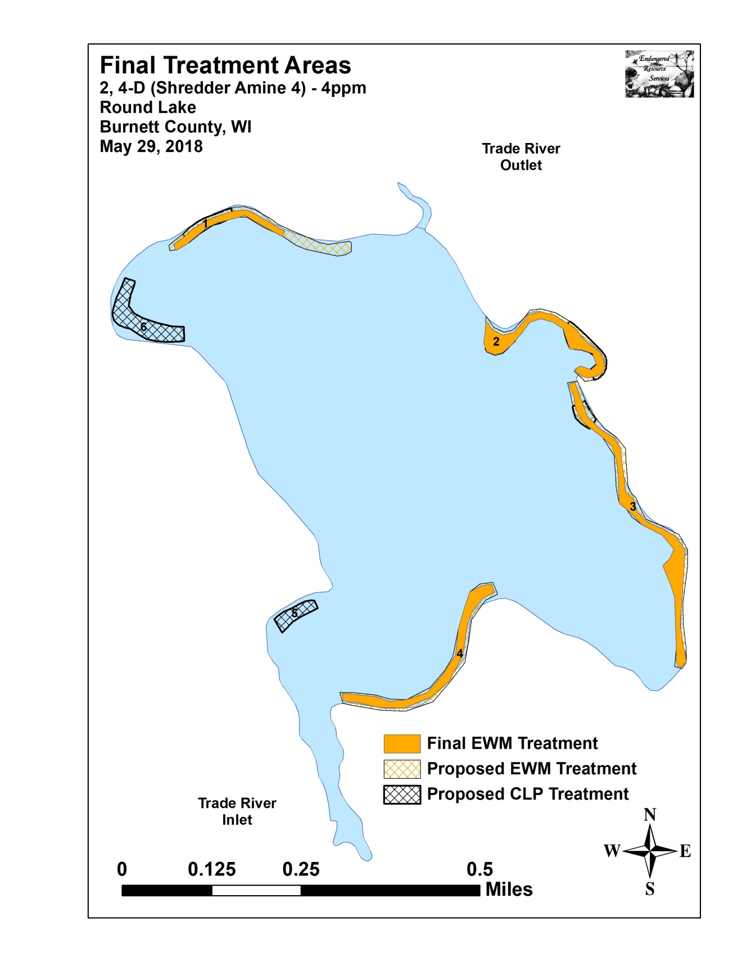

Appendix II: Vegetative Survey Datasheet

Observers for this lake: names and hours worked by each:
Lake: |  |  |  |  |  |  |  |  | WBIC |  |  |  |  |  |  |  |  | County |  |  |  |  |  | Date:
Site # | Depth (ft) | Muck (M), Sand (S), Rock (R) | Rake pole (P) or rake rope (R) | Total Rake Fullness | EWM | CLP | 1 | 2 | 3 | 4 | 5 | 6 | 7 | 8 | 9 | 10 | 11 | 12 | 13 | 14 | 15 | 16 | 17 | 18 | 19
1
2
3
4
5
6
7
8
9
10
11
12
13
14
15
16
17
18
19
20

Appendix III: Pre/Post Habitat Variable Maps

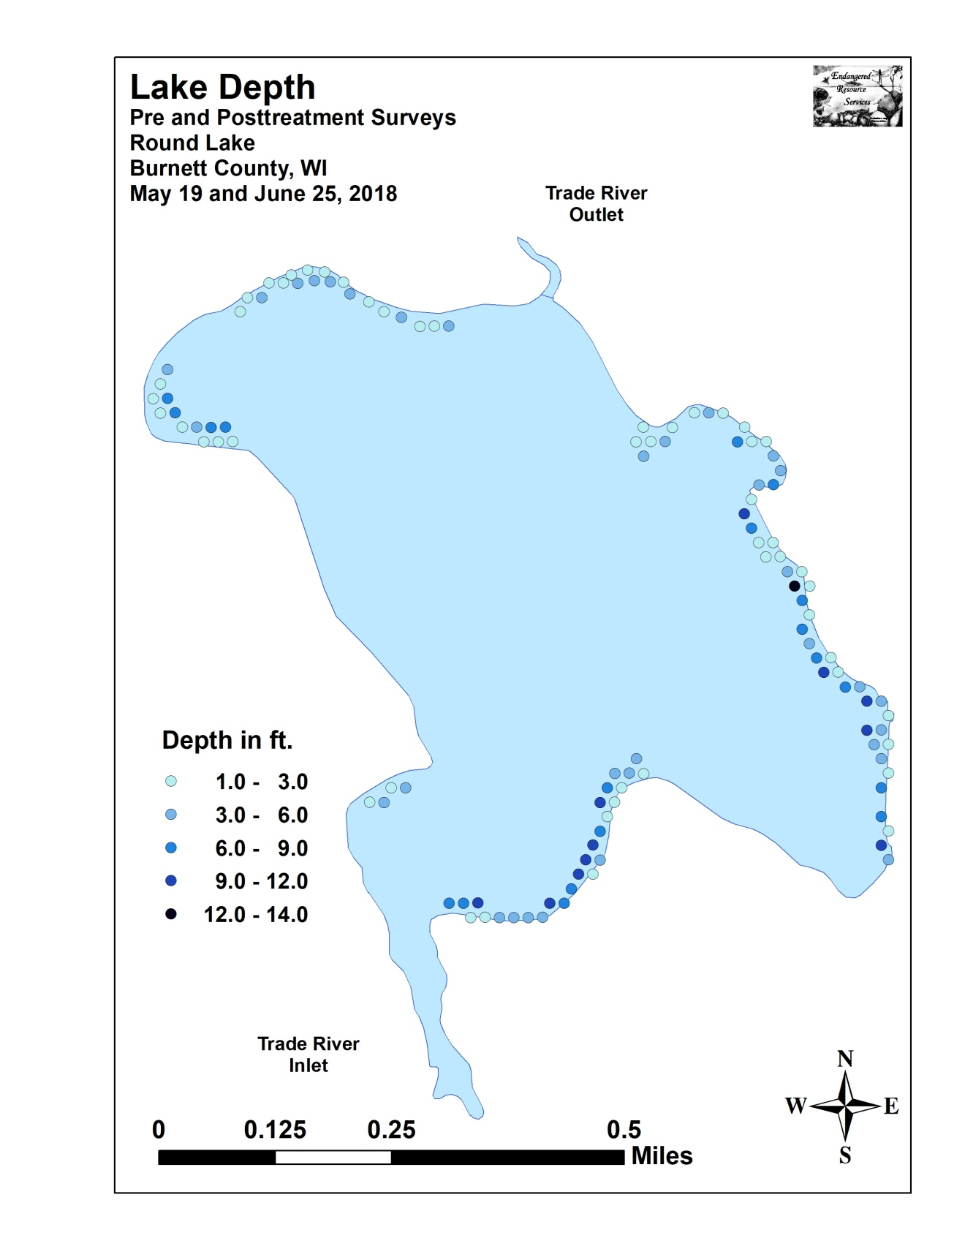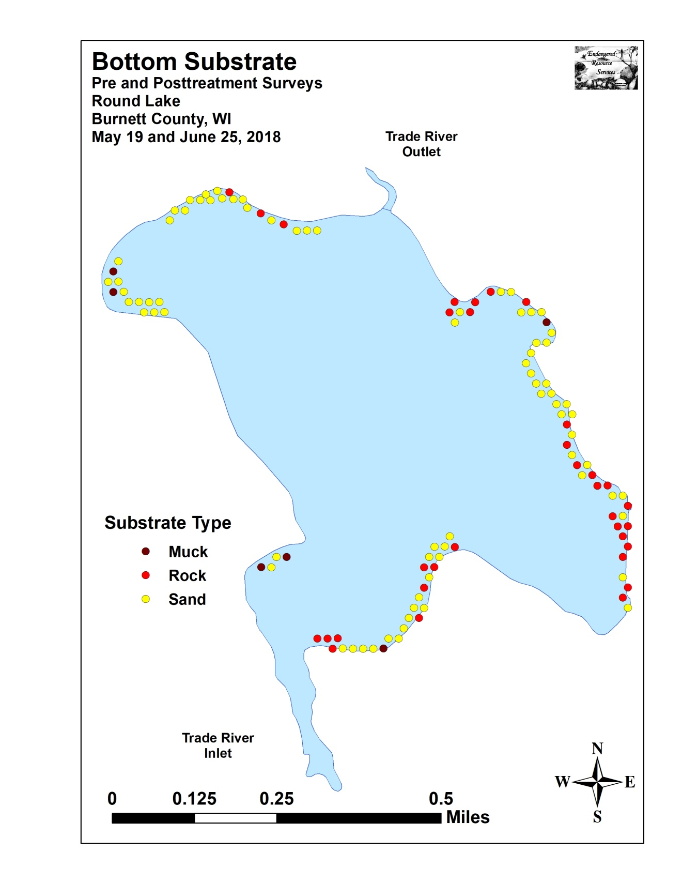

Appendix IV: Pre/Post Littoral Zone, Native Species Richness and
Total Rake Fullness

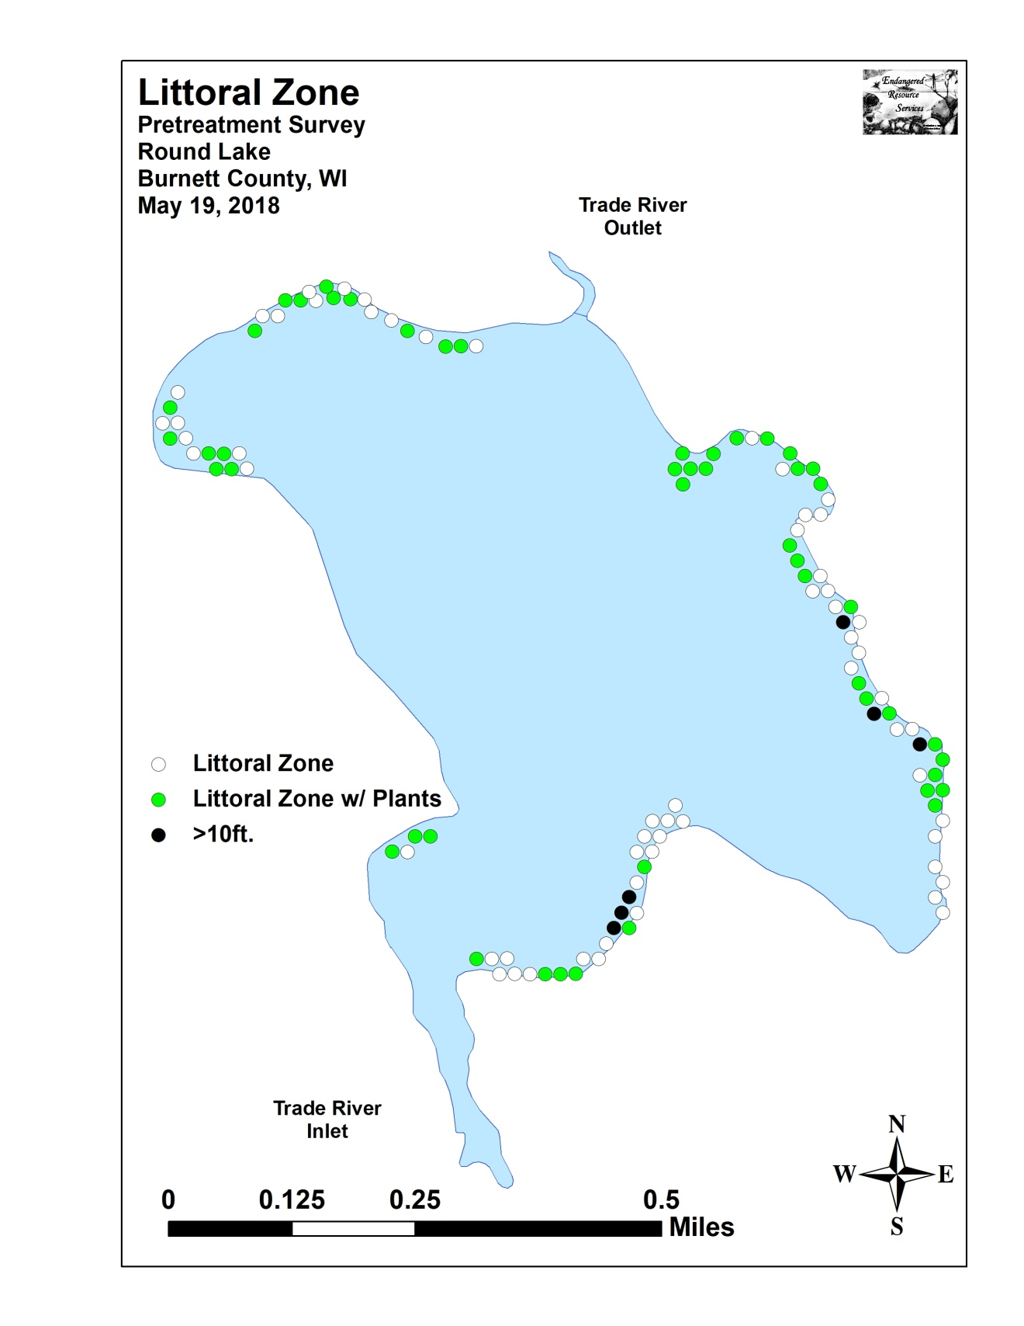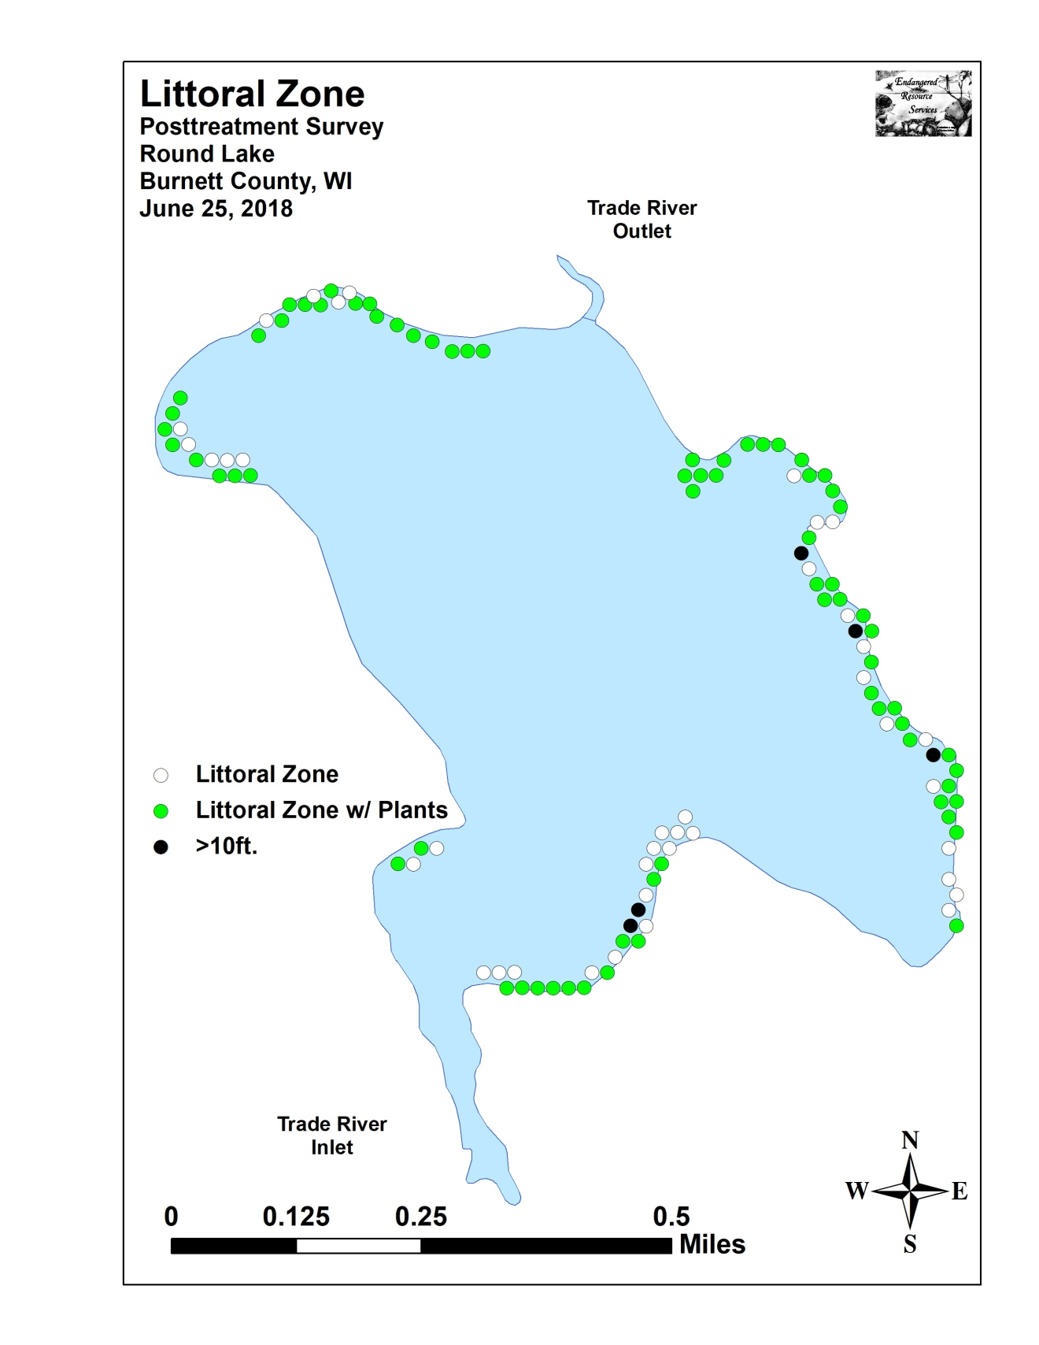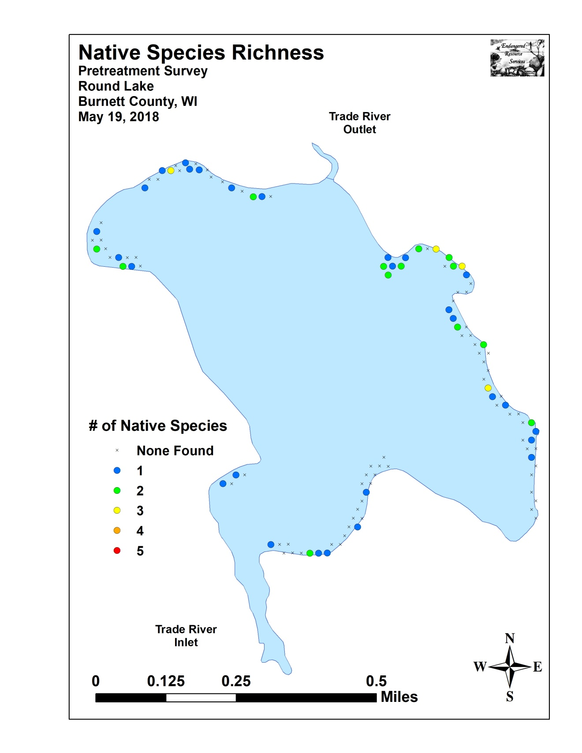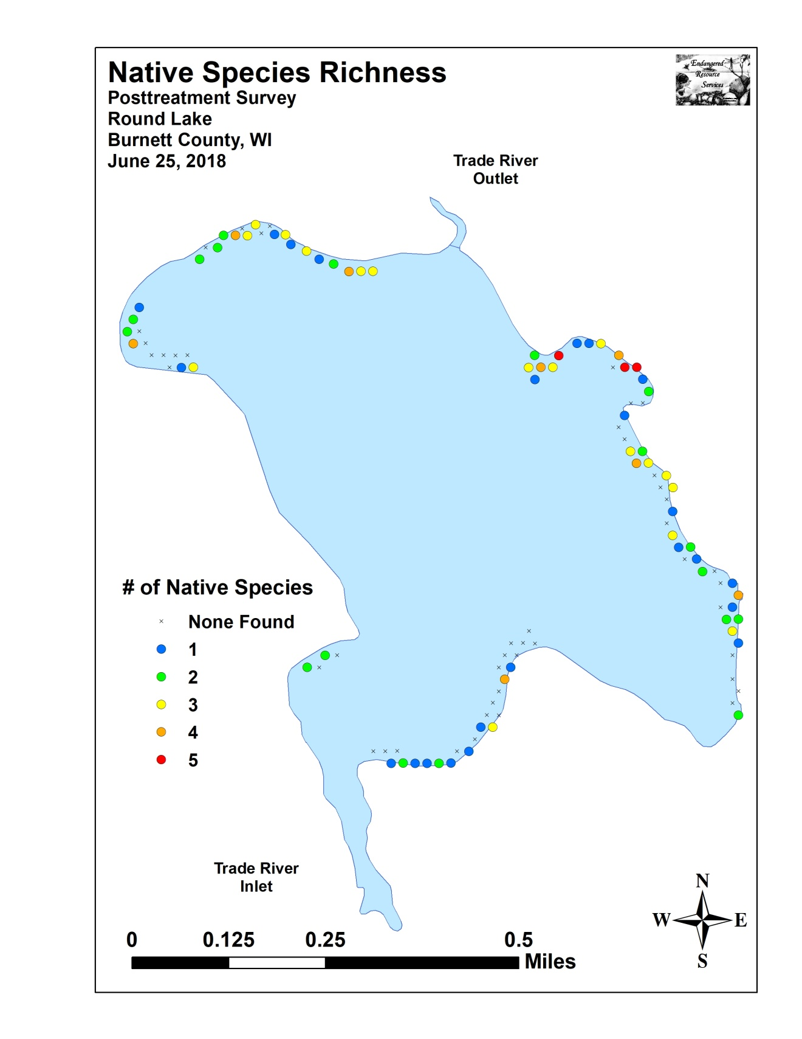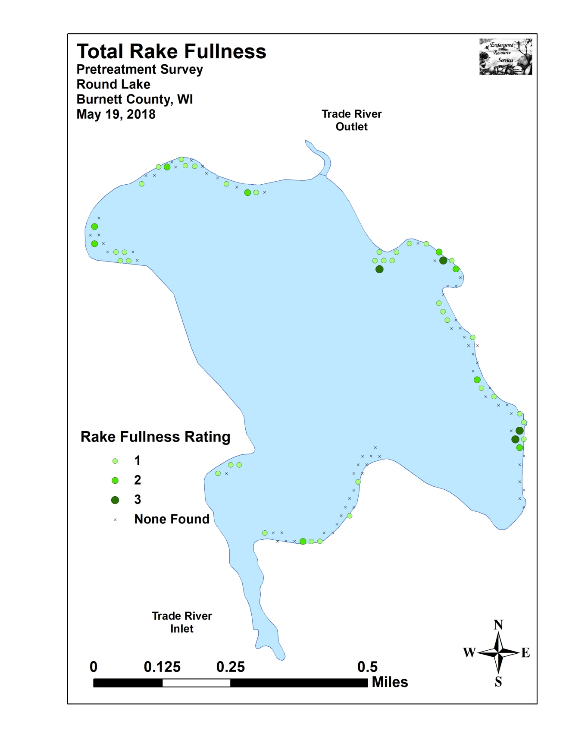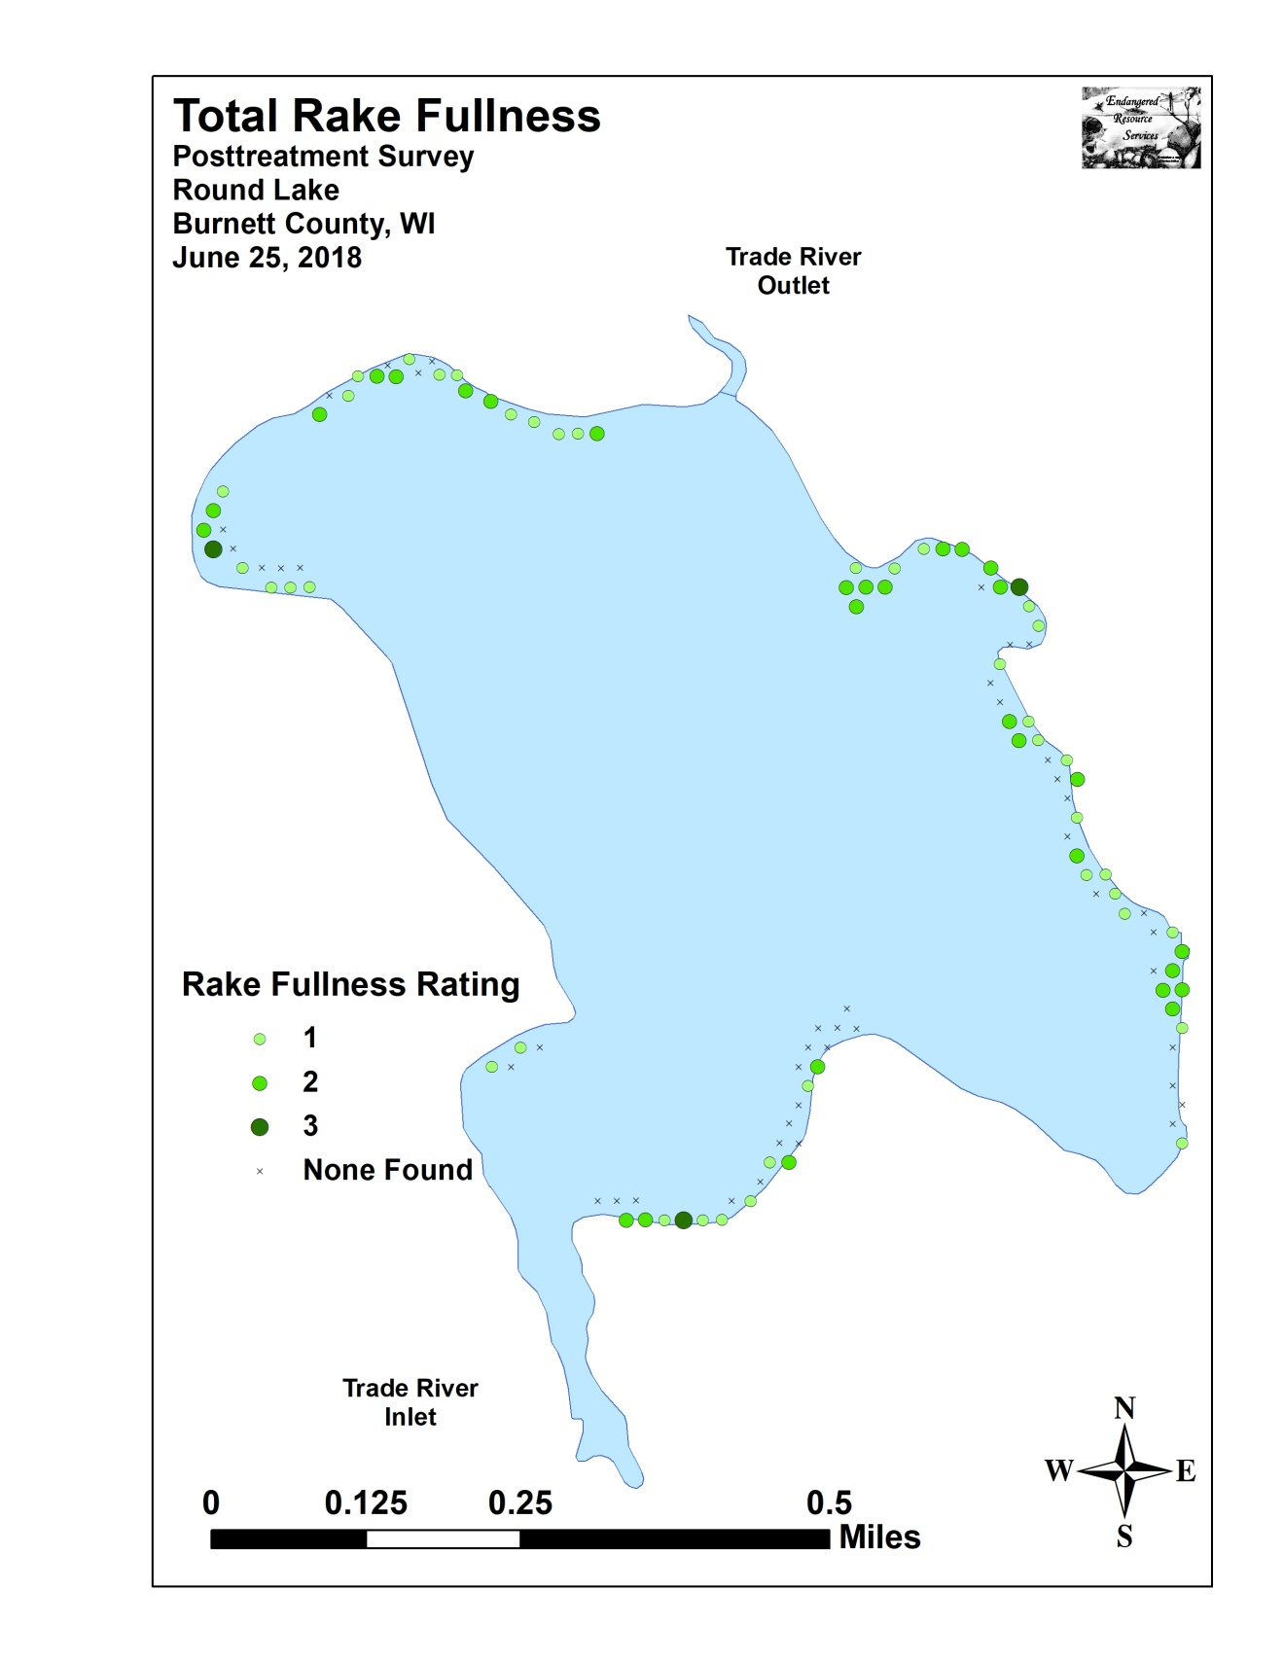

Appendix V: CLP and EWM Pre/Post Density and Distribution

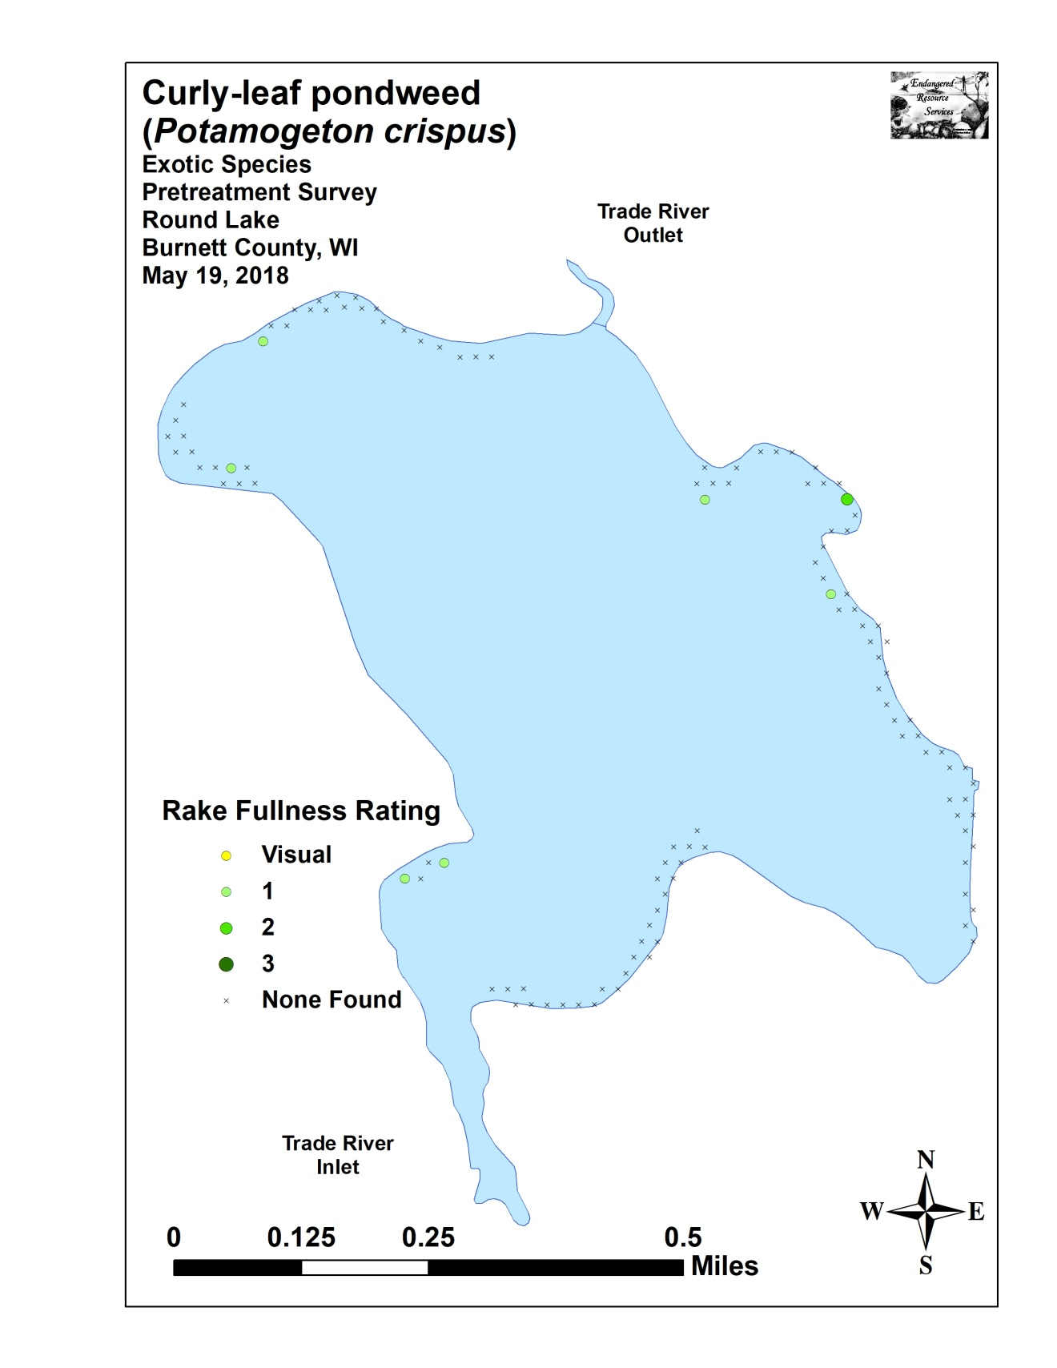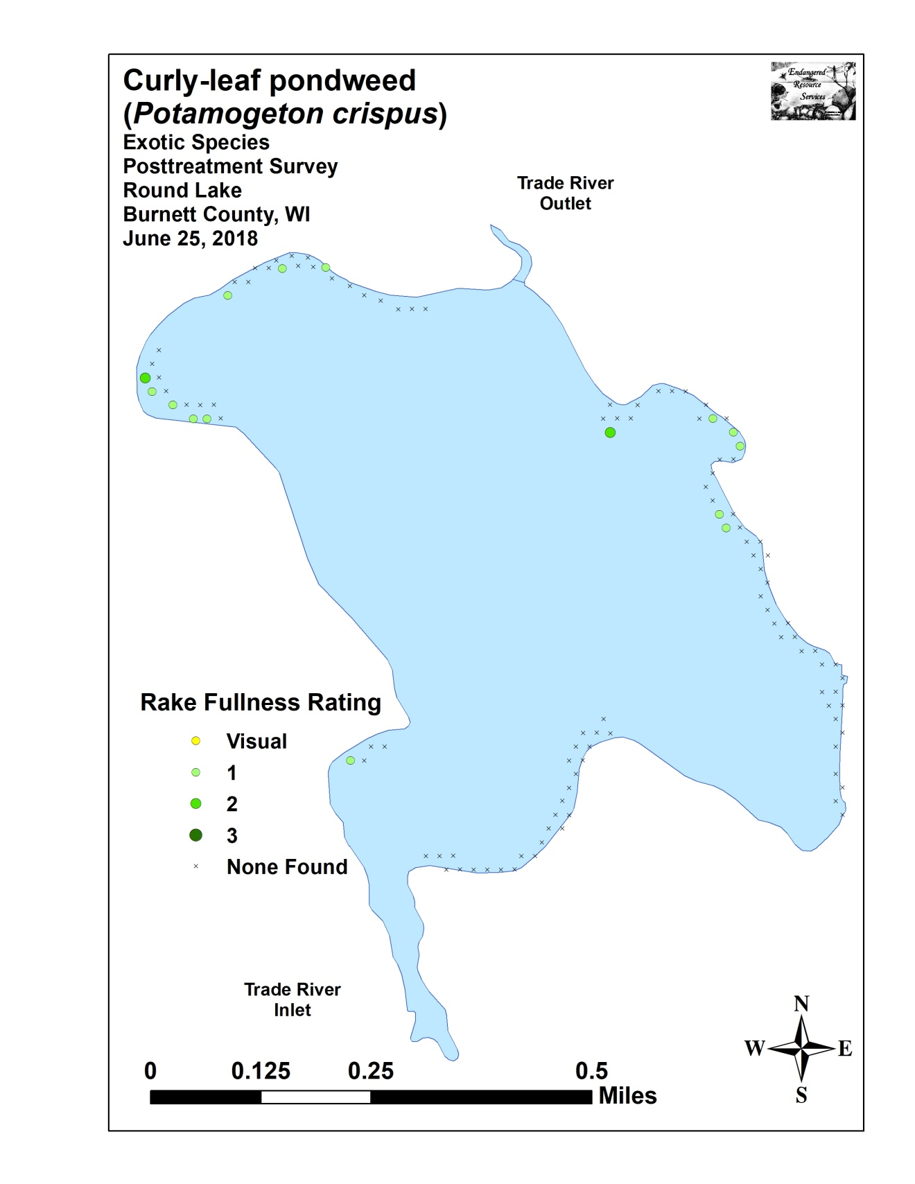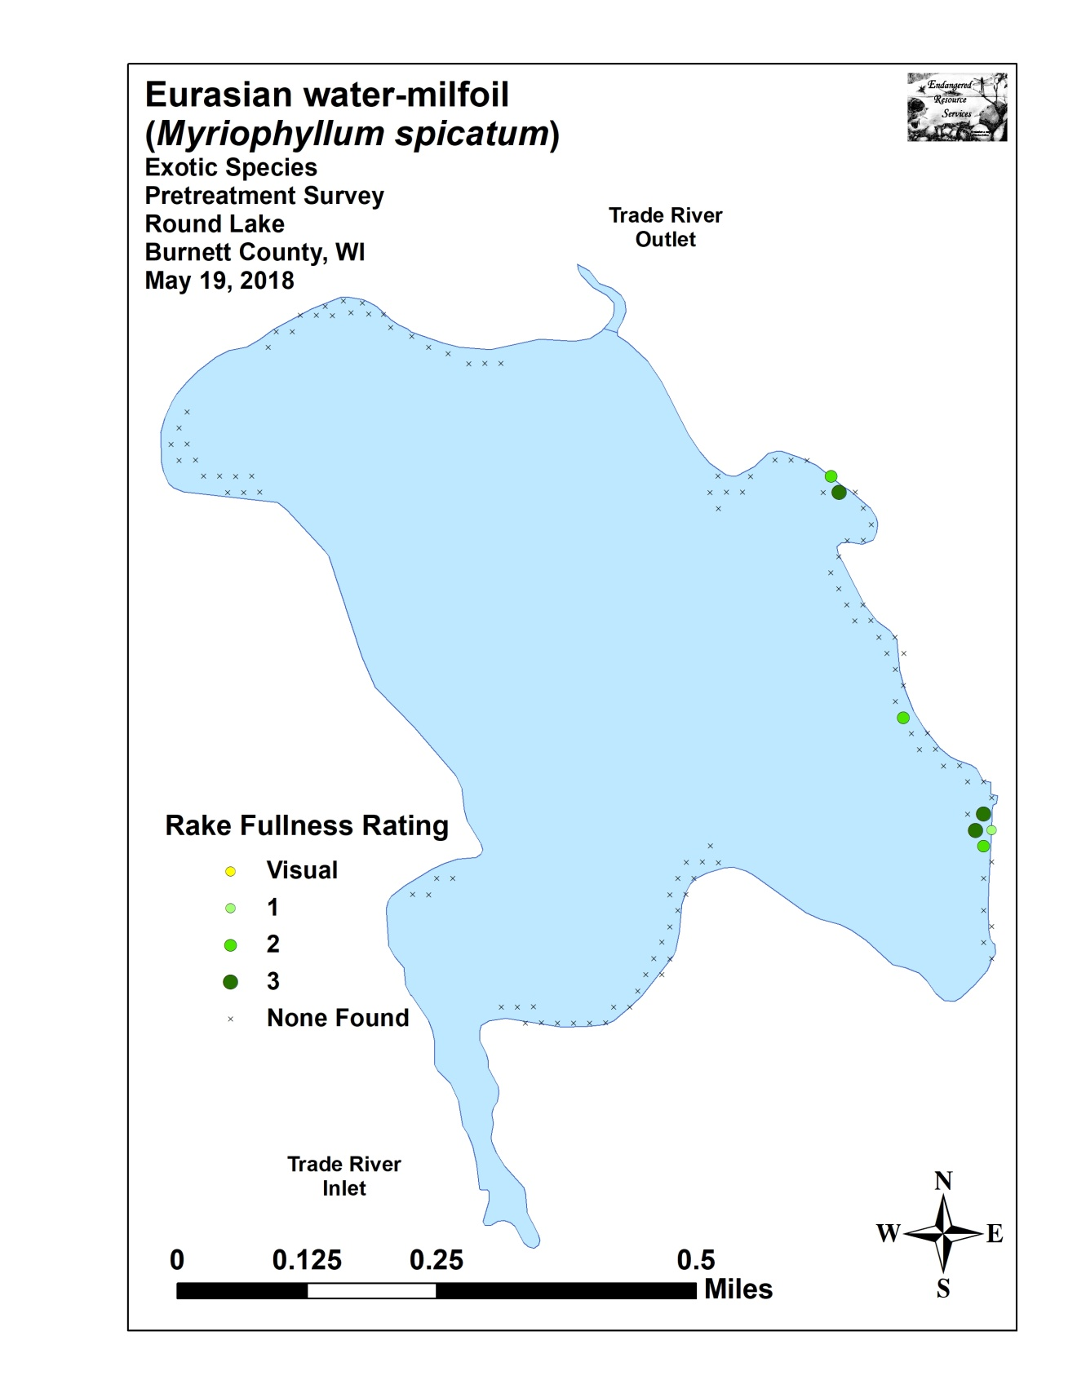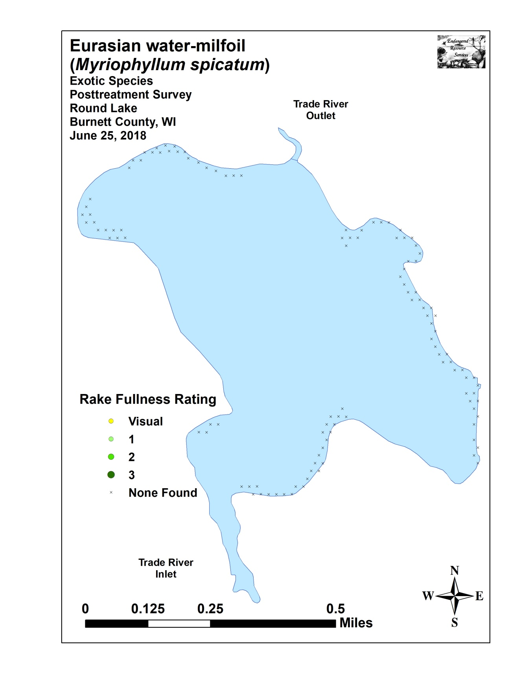

Appendix VI: Pretreatment Native Species Density and Distribution
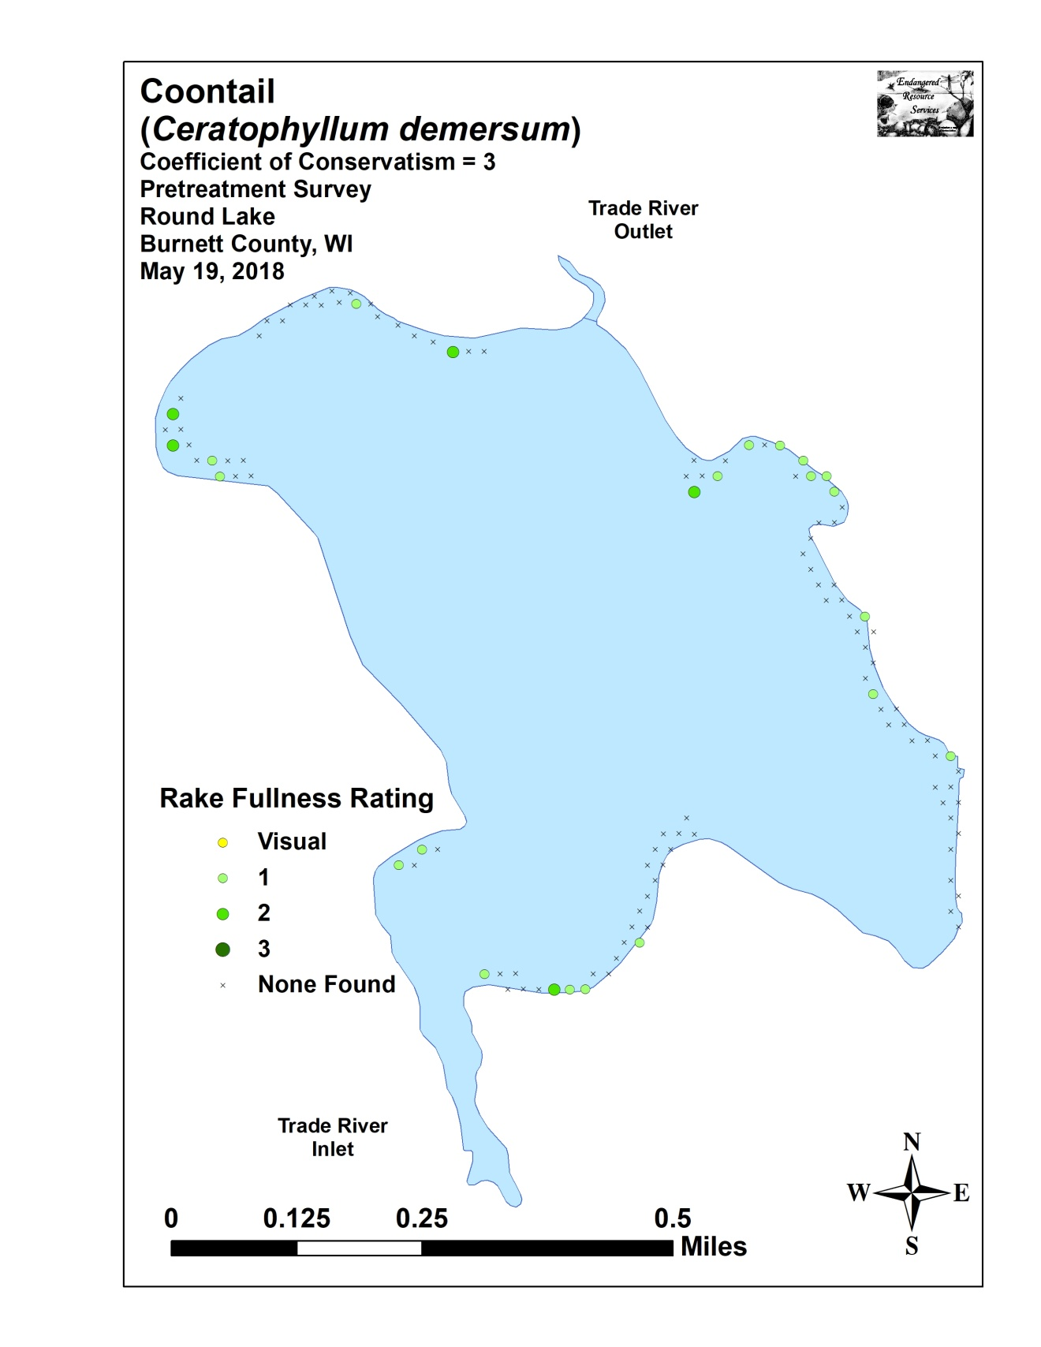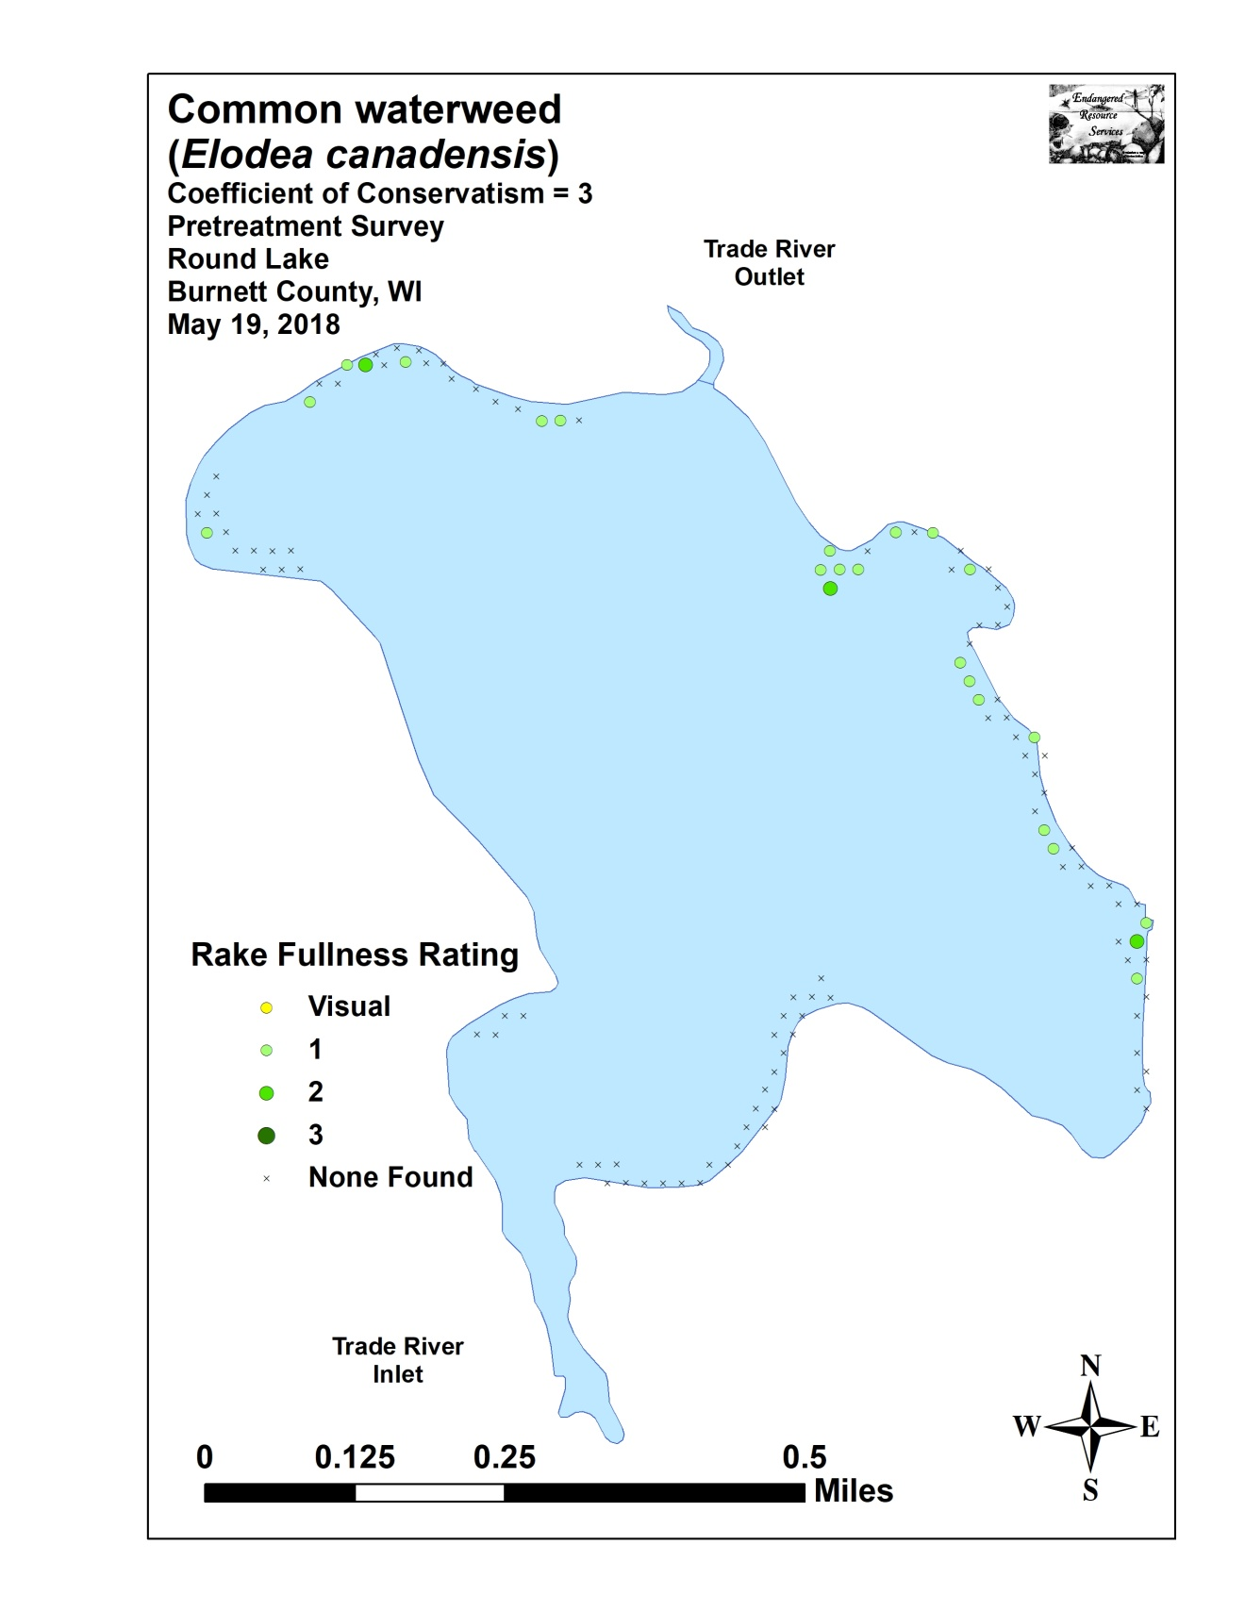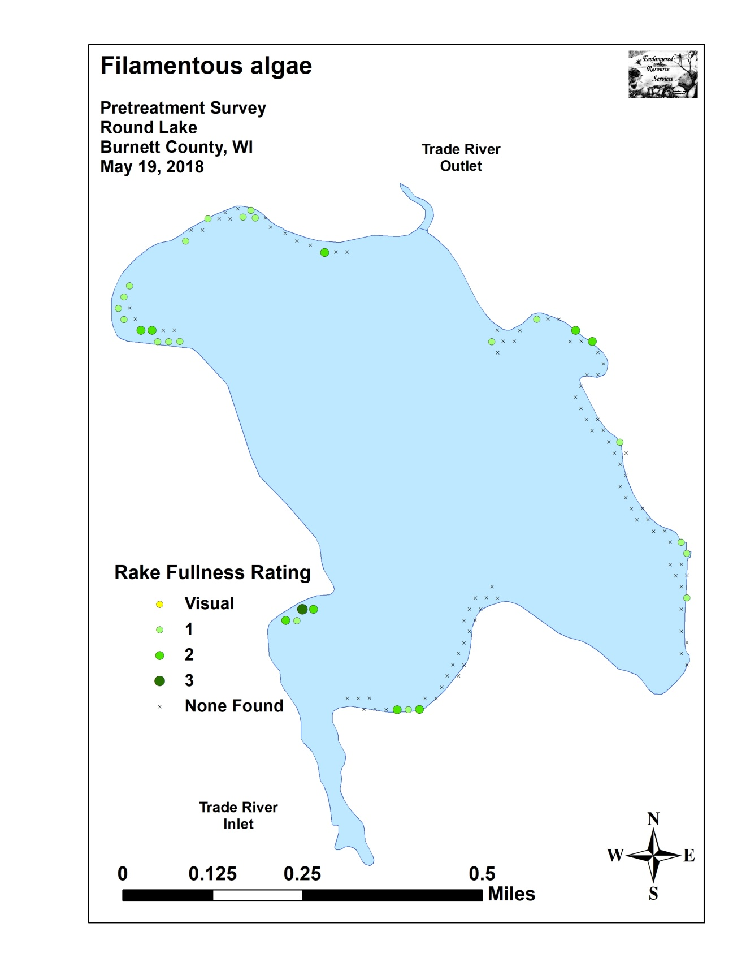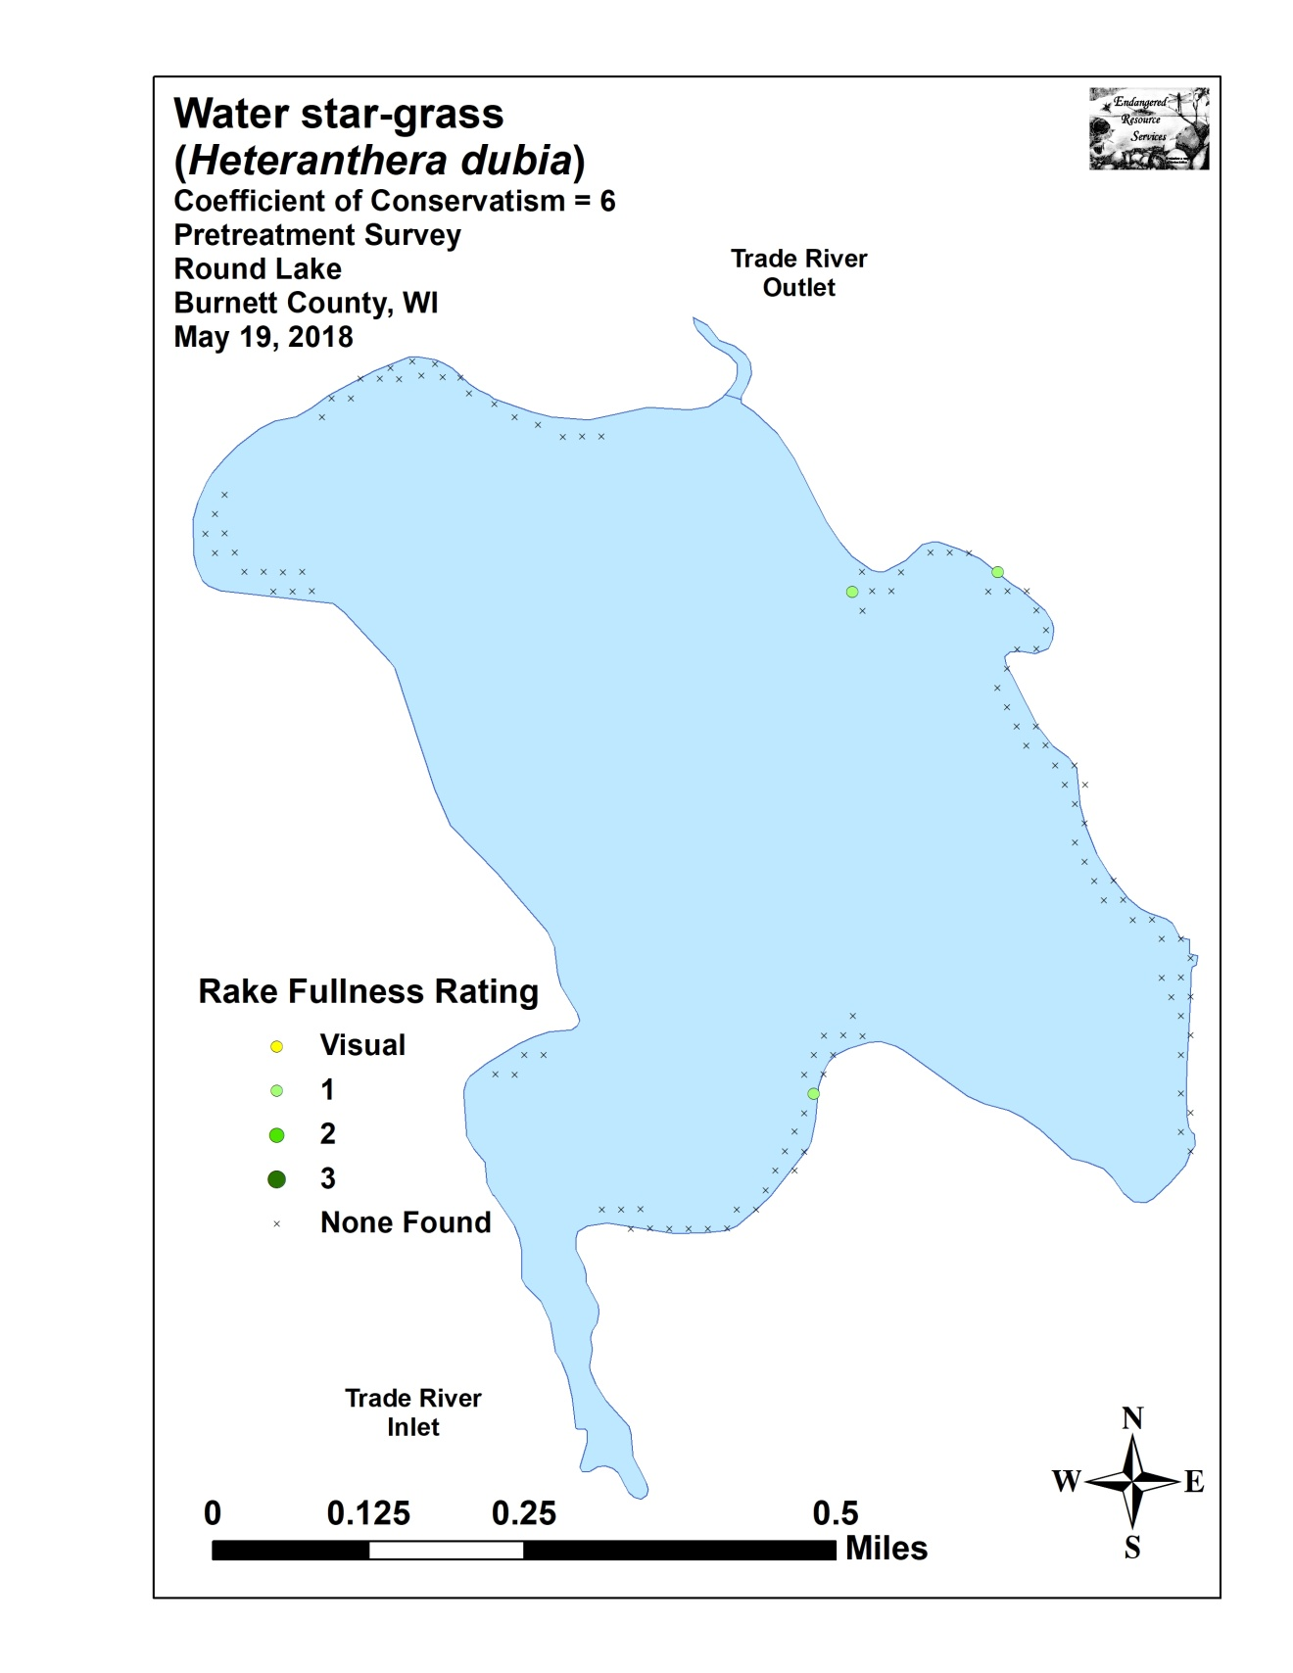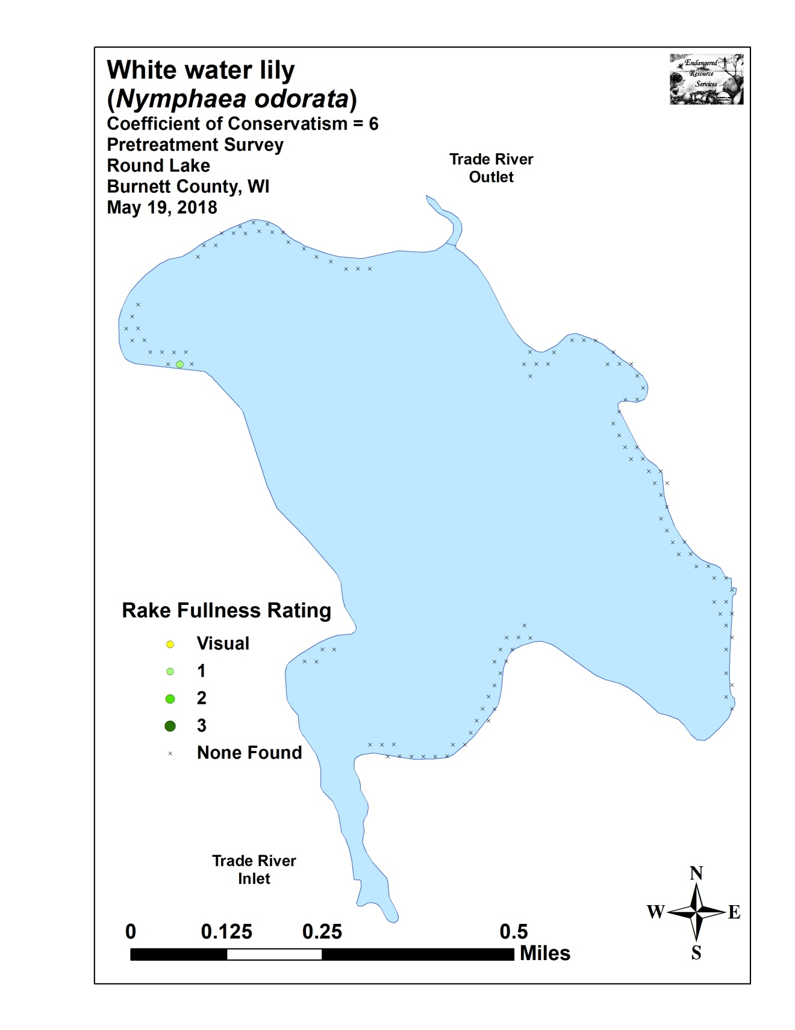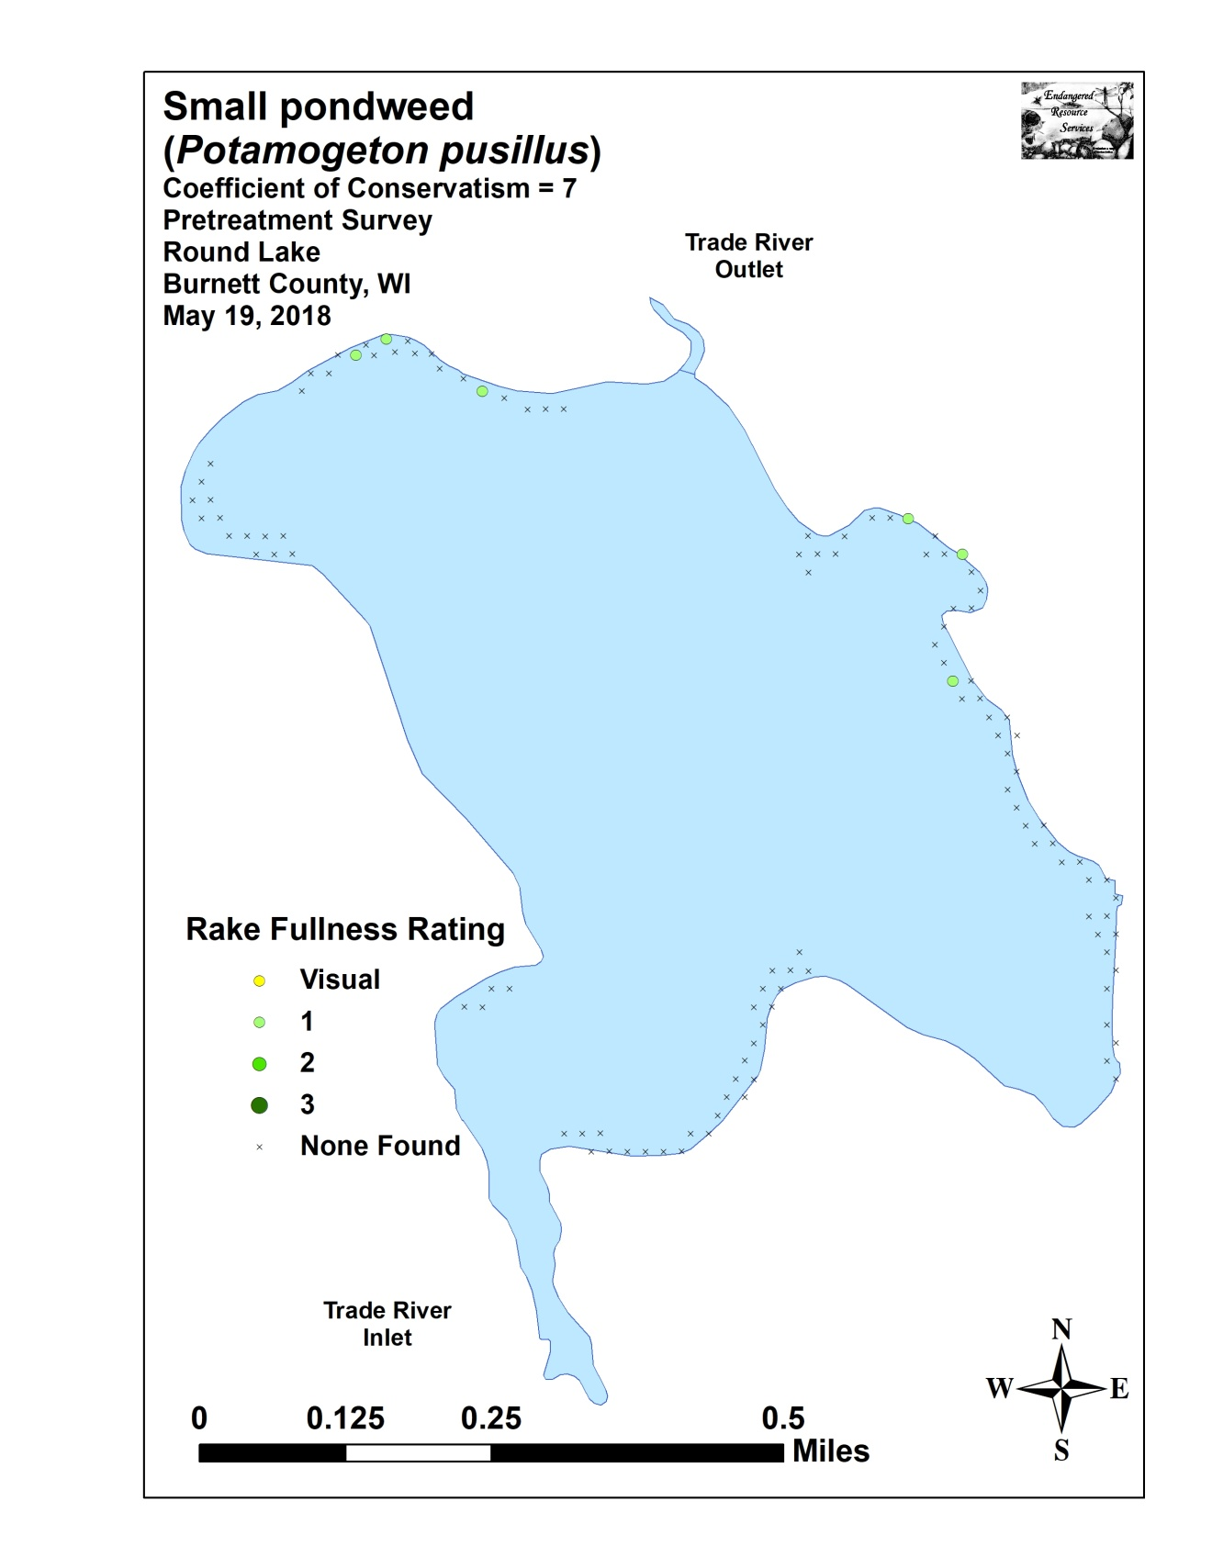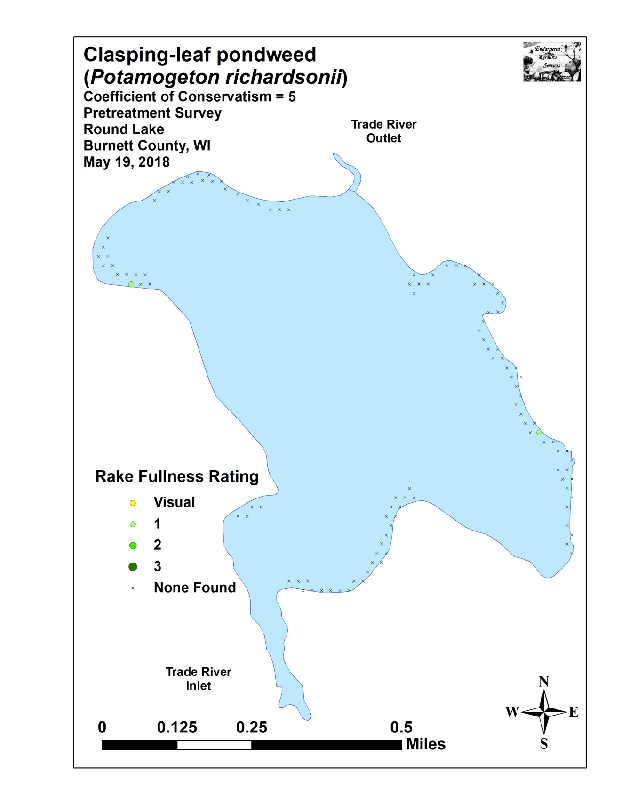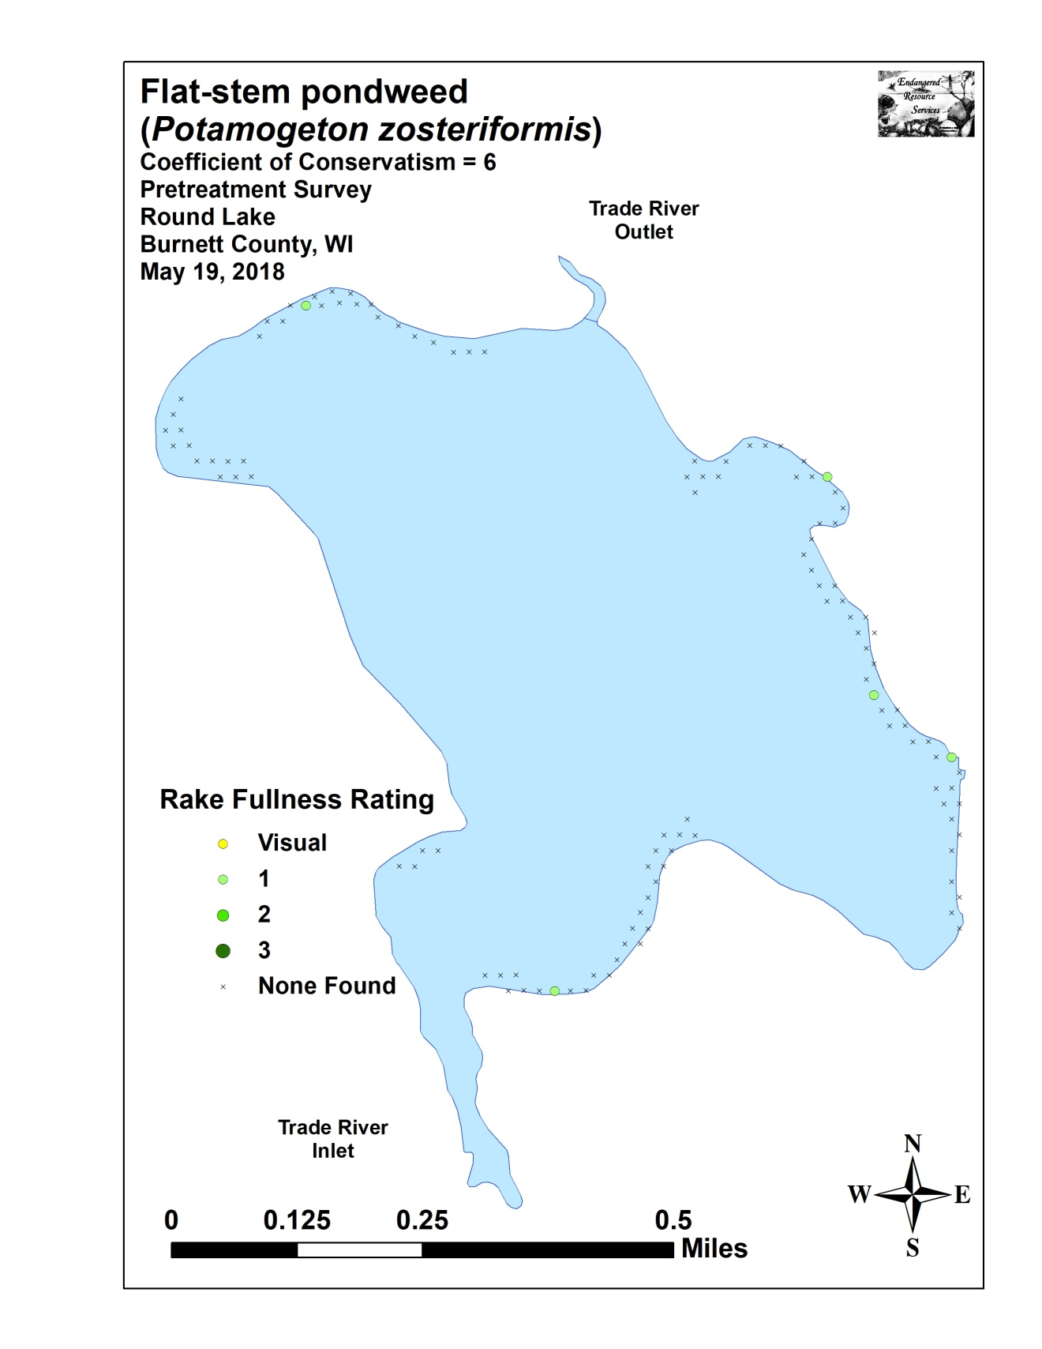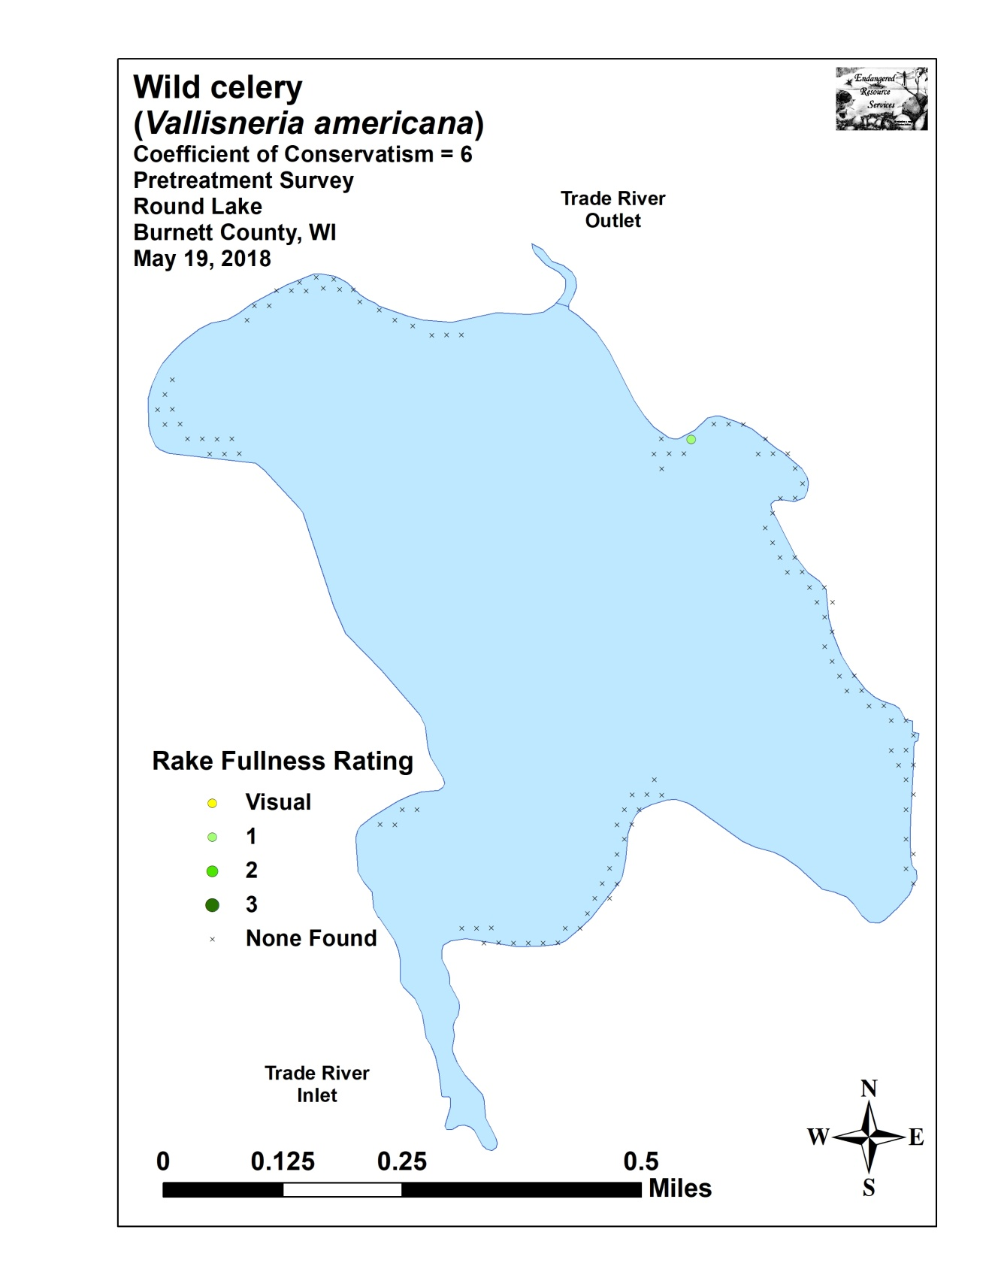

Appendix VII: Posttreatment Native Species Density and Distribution
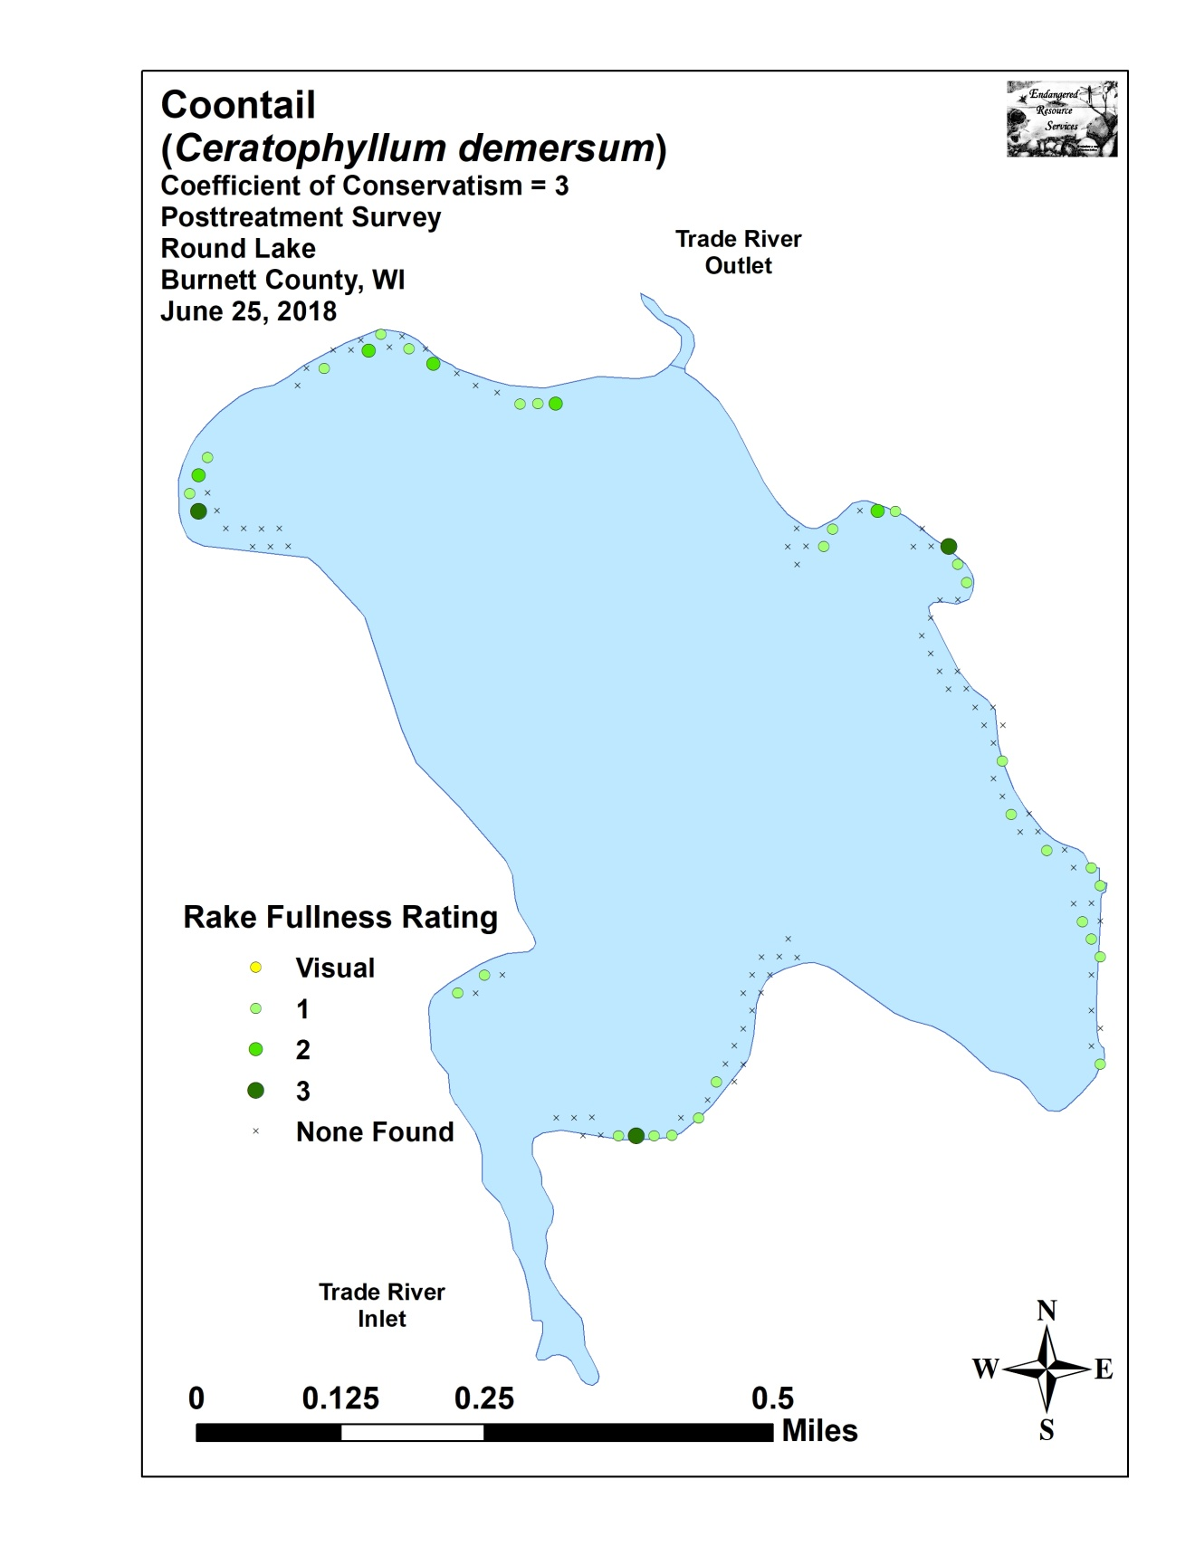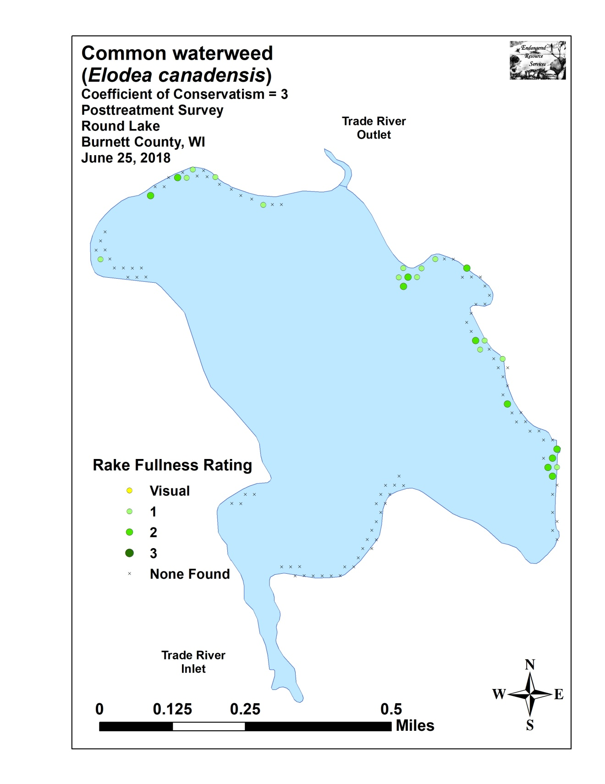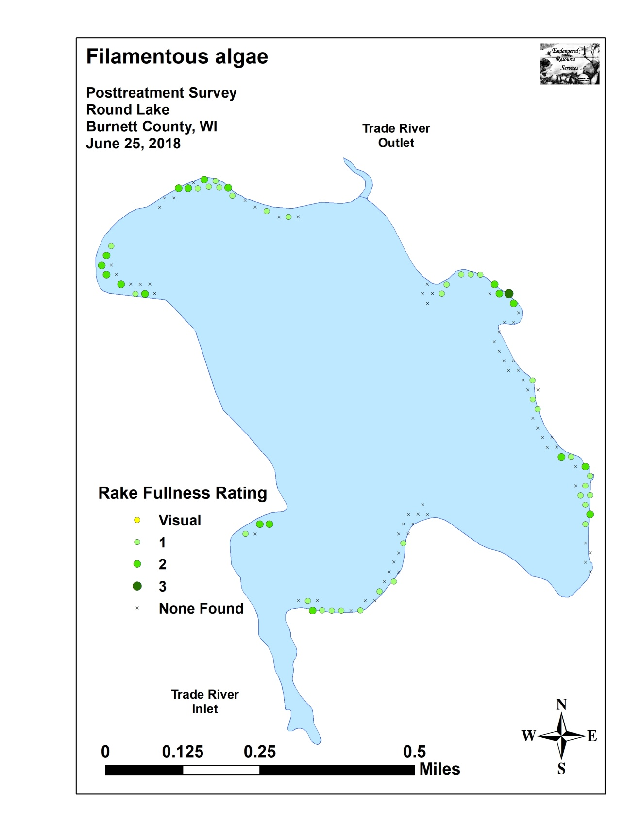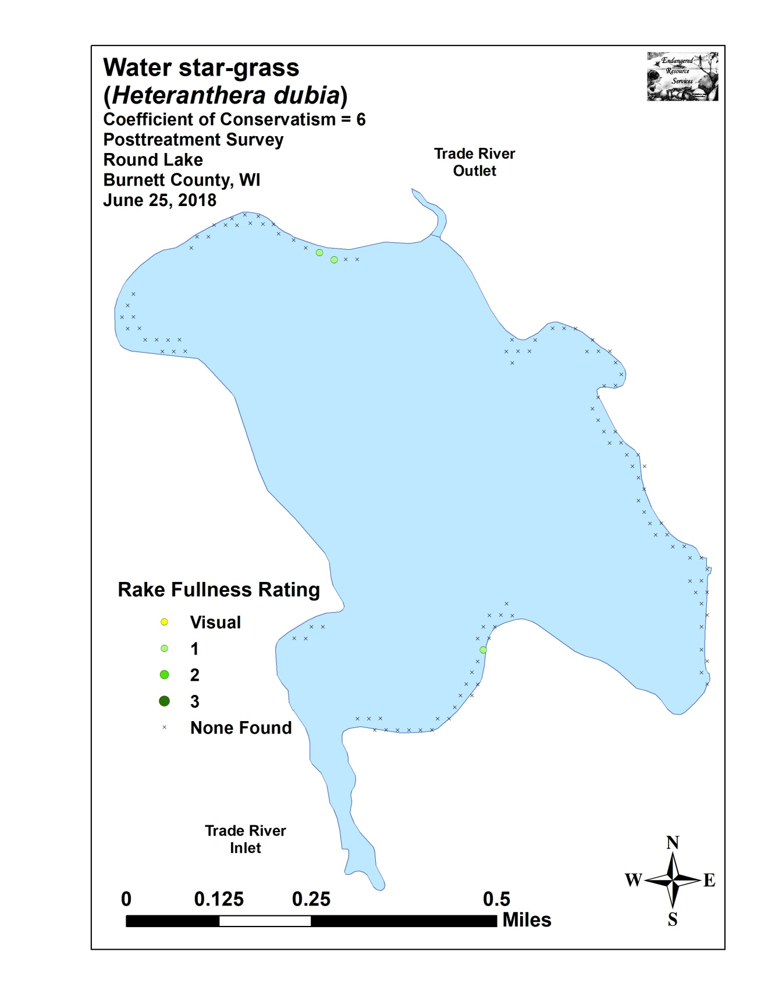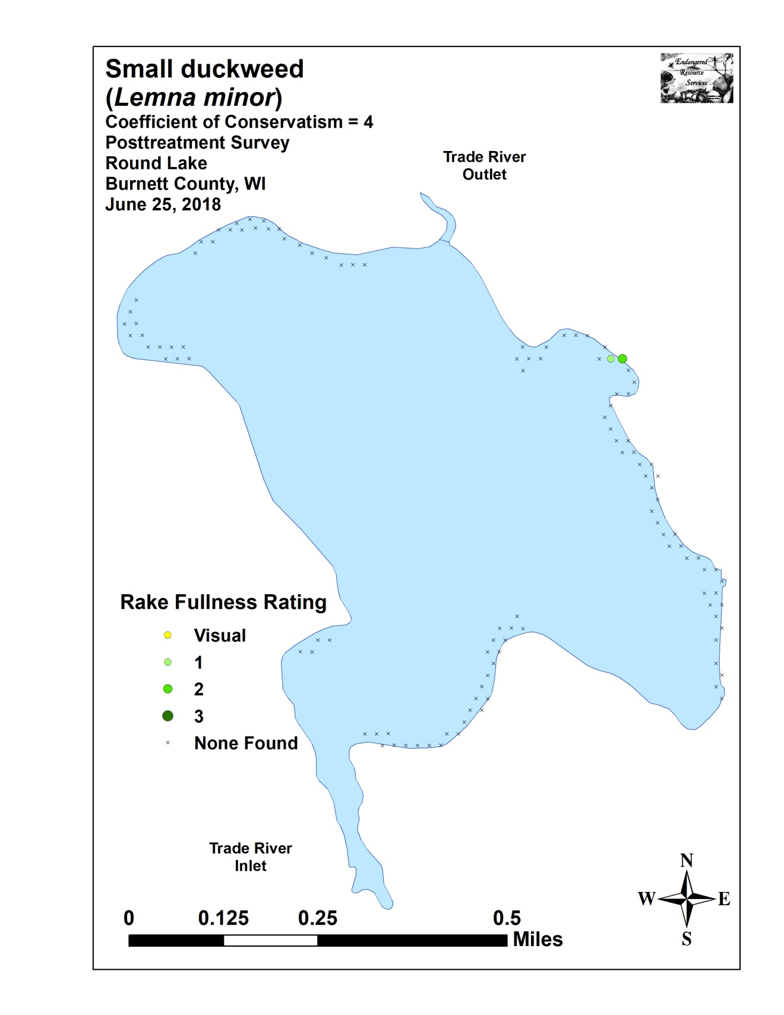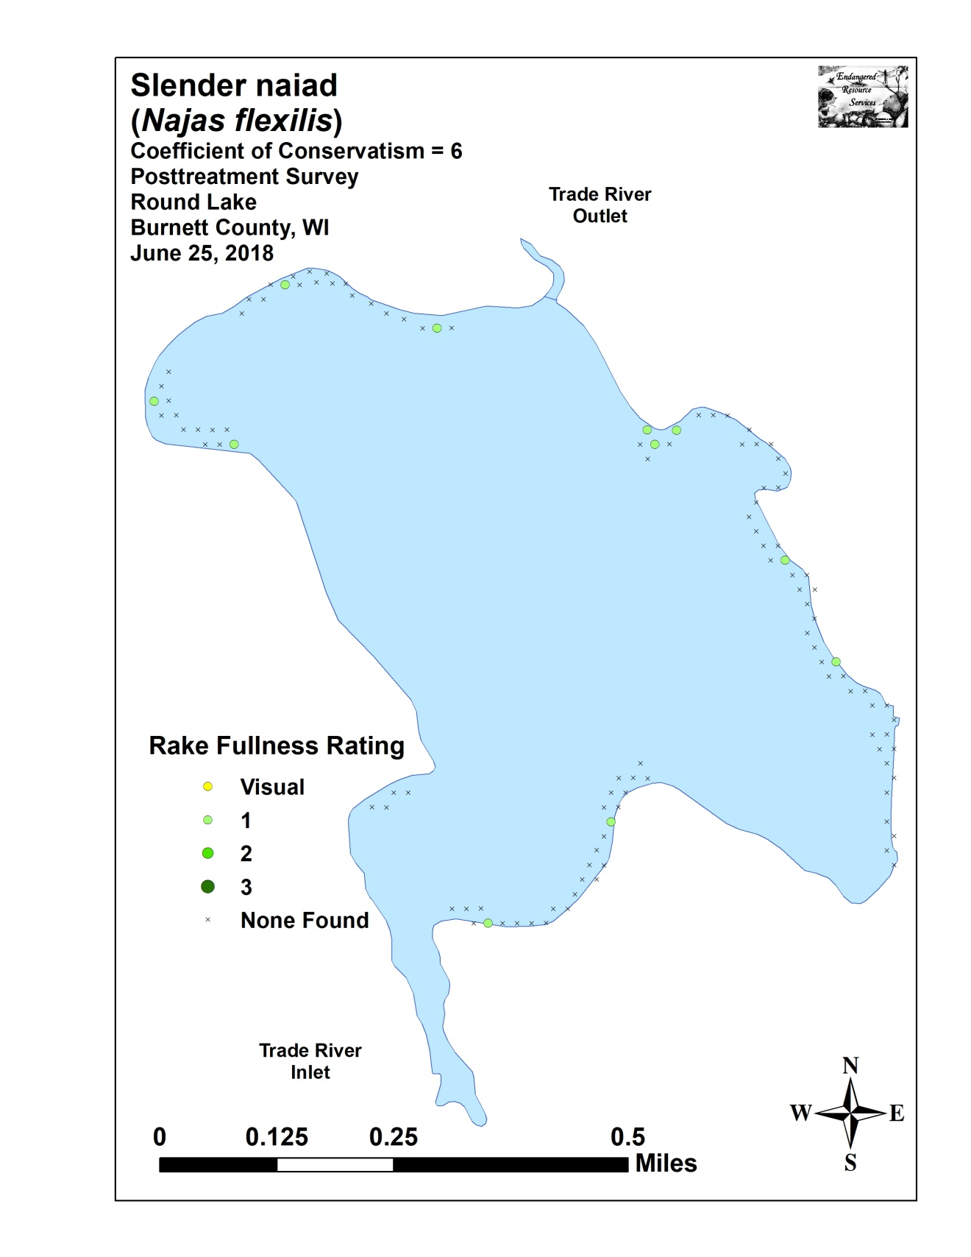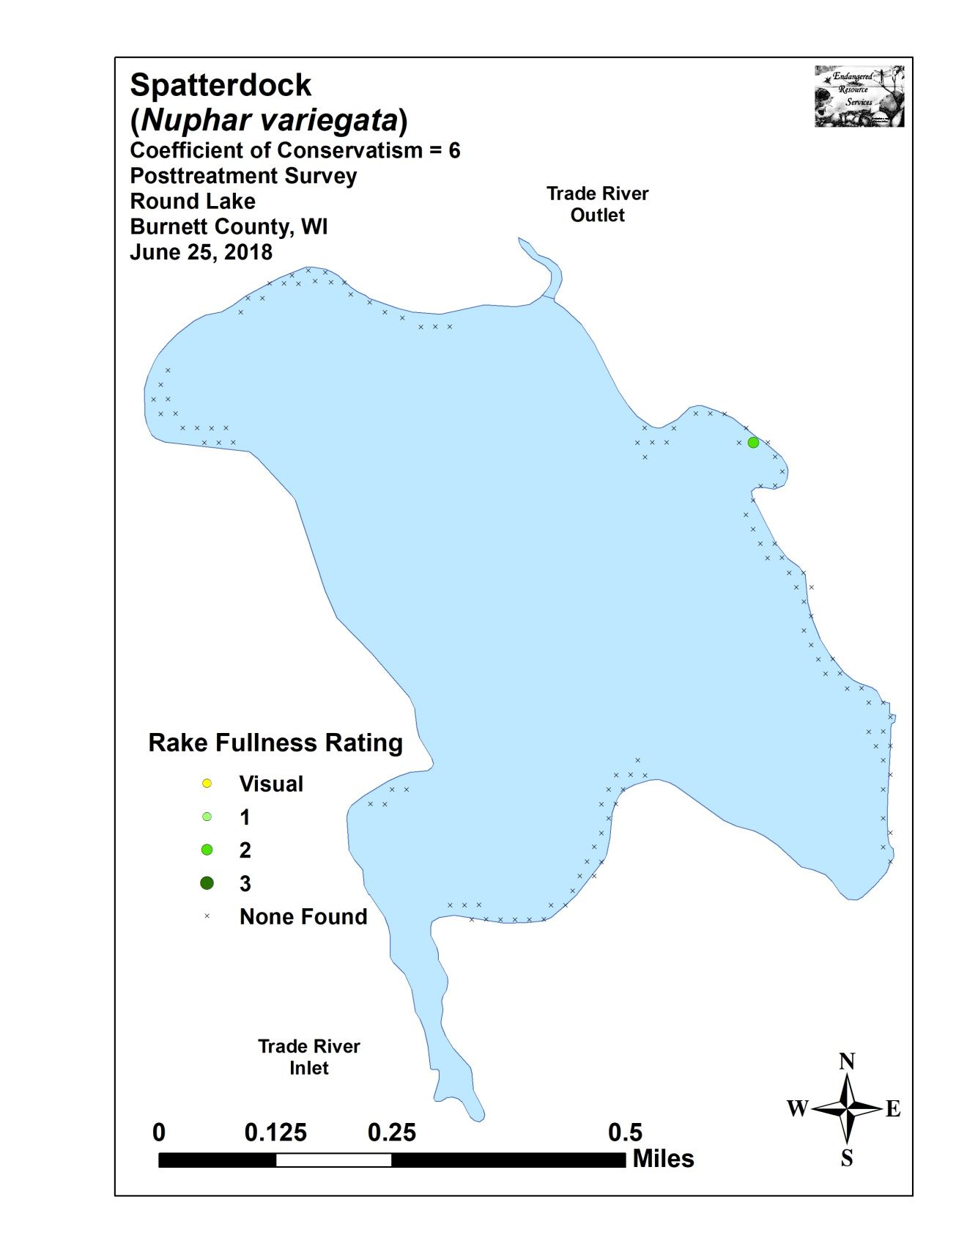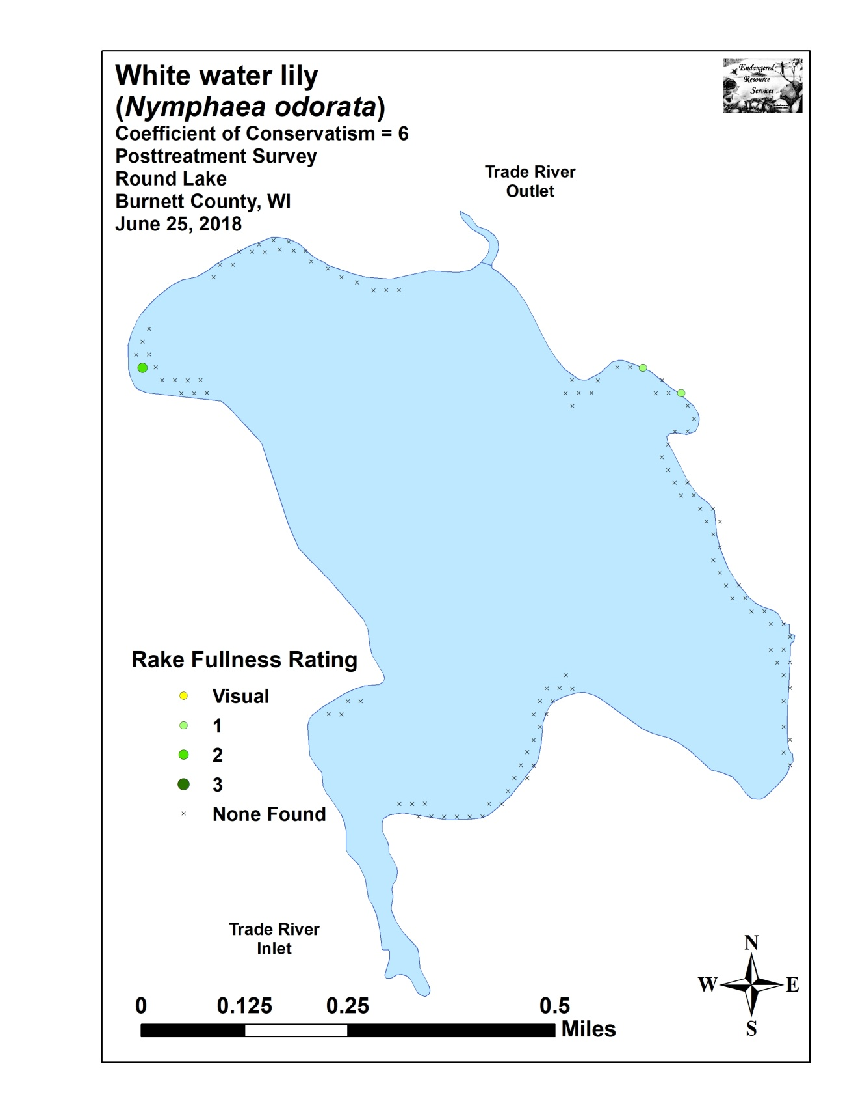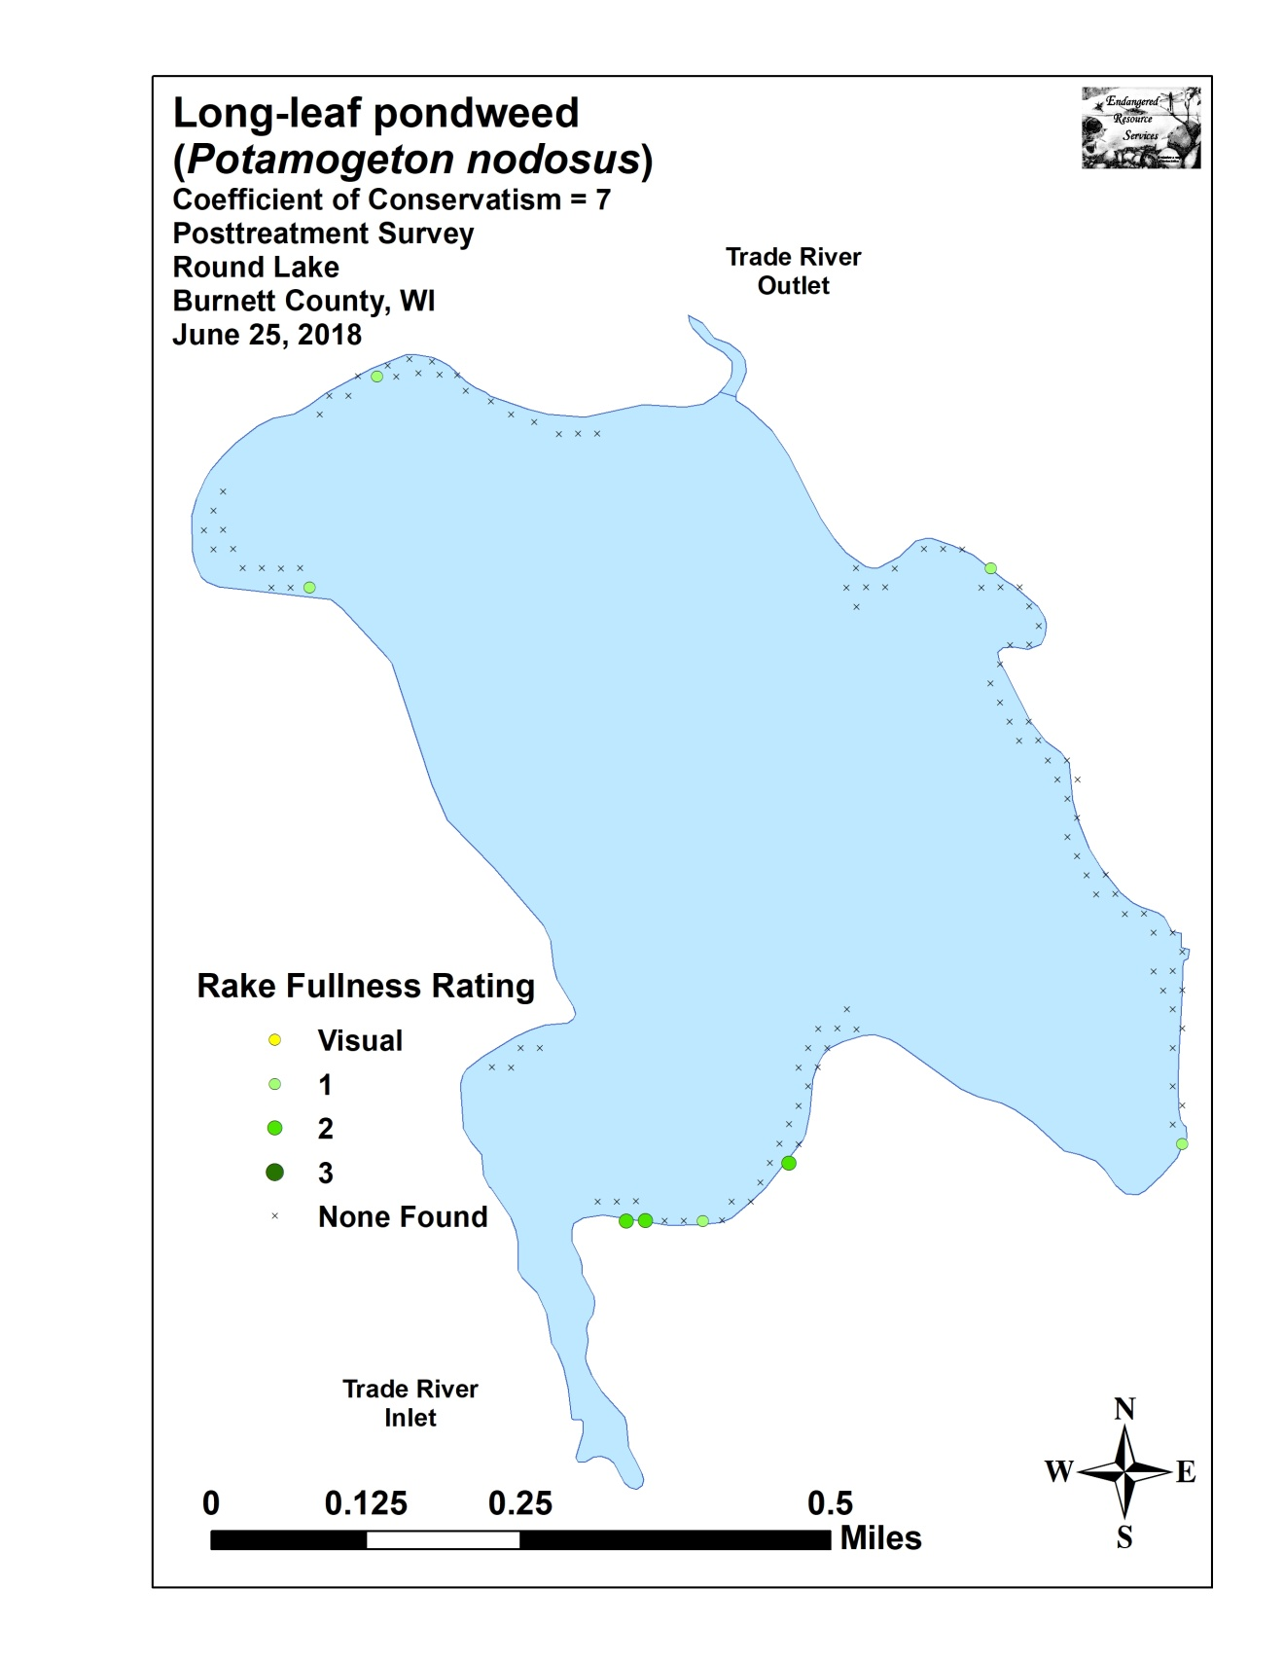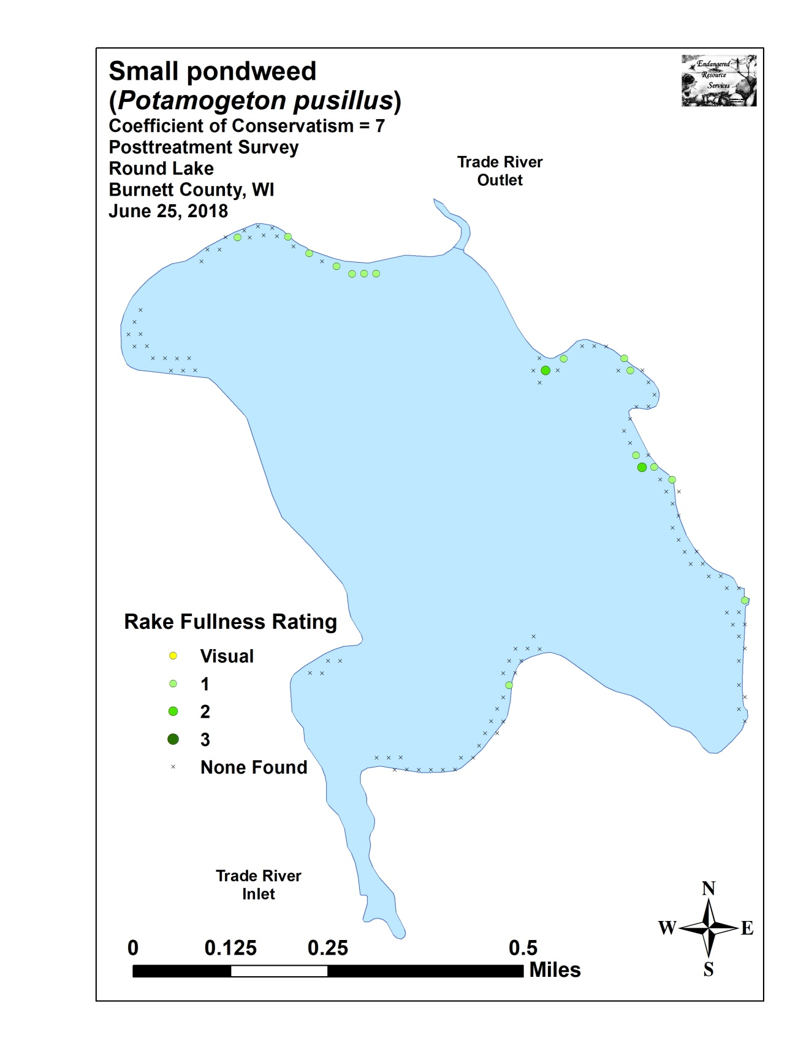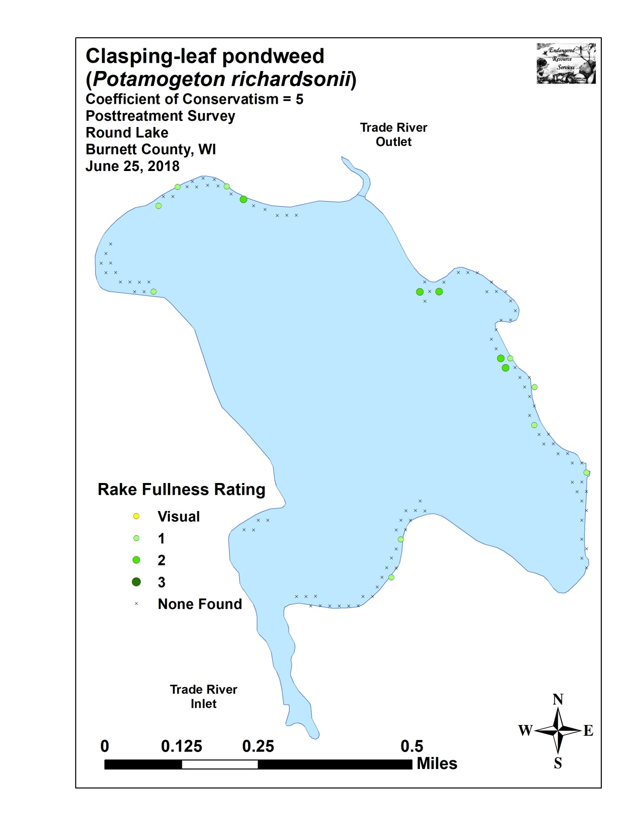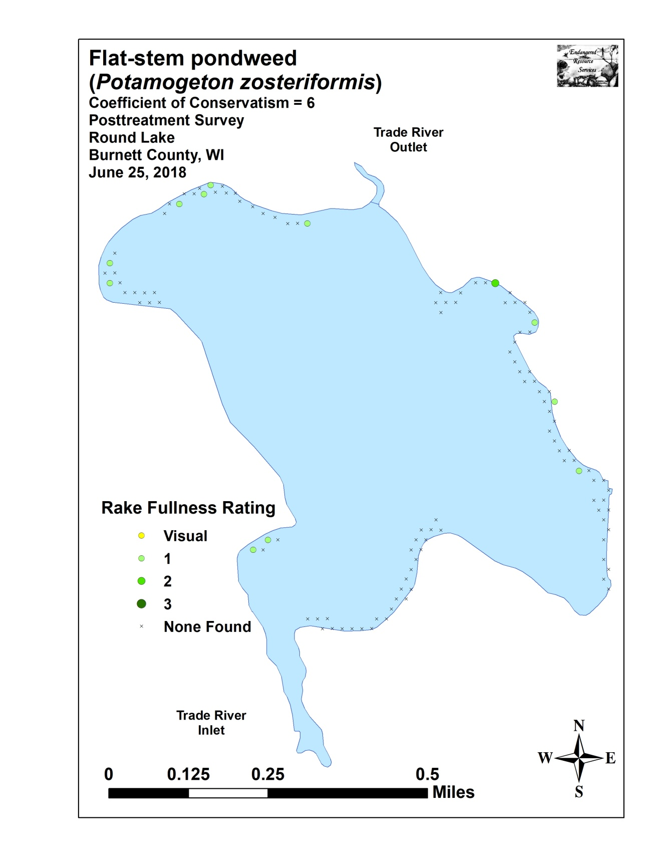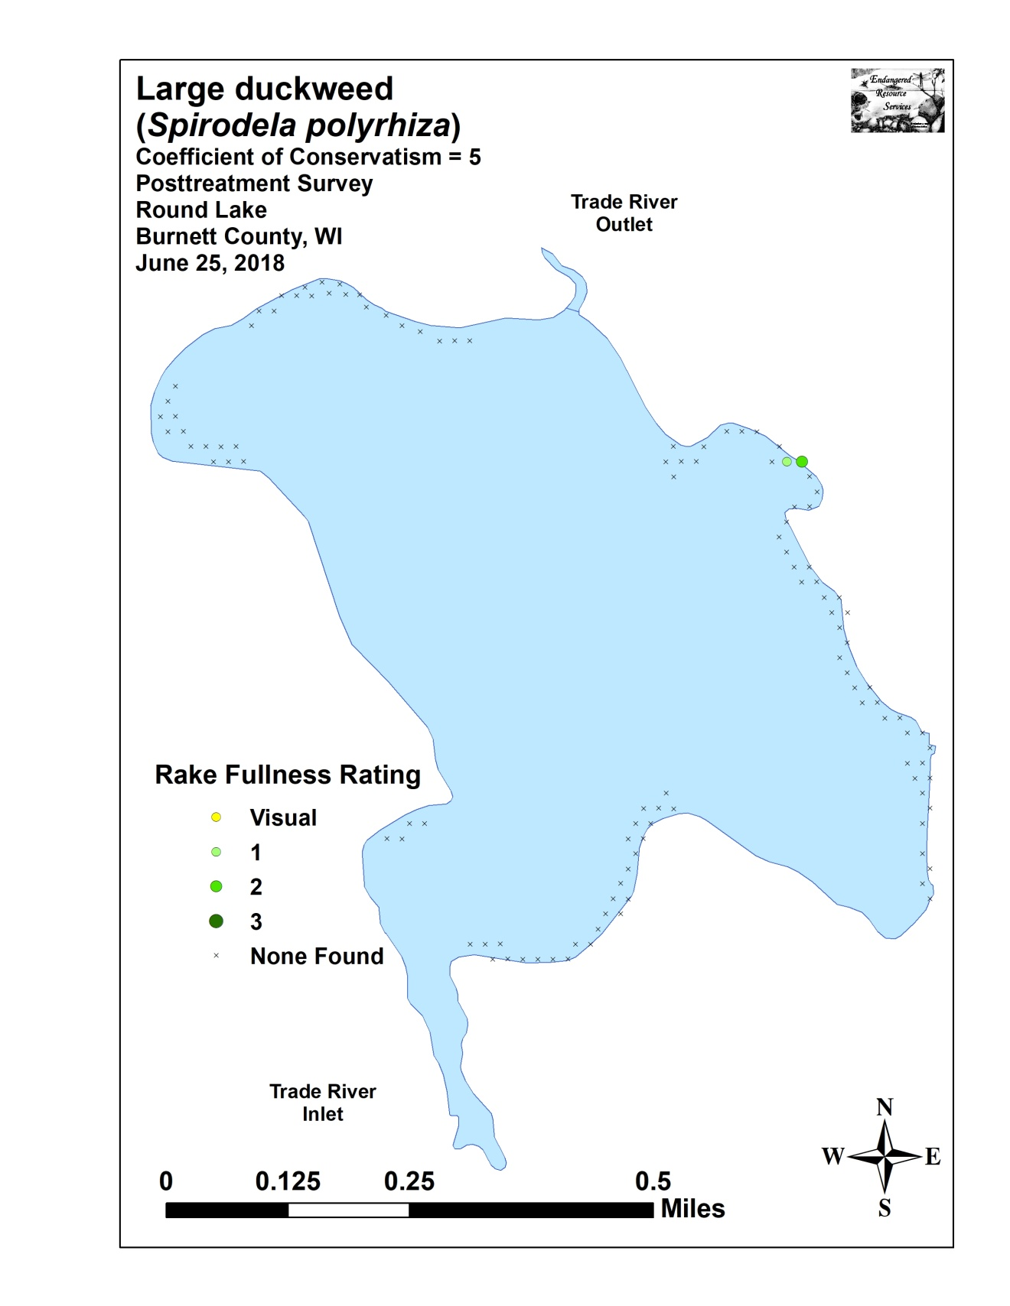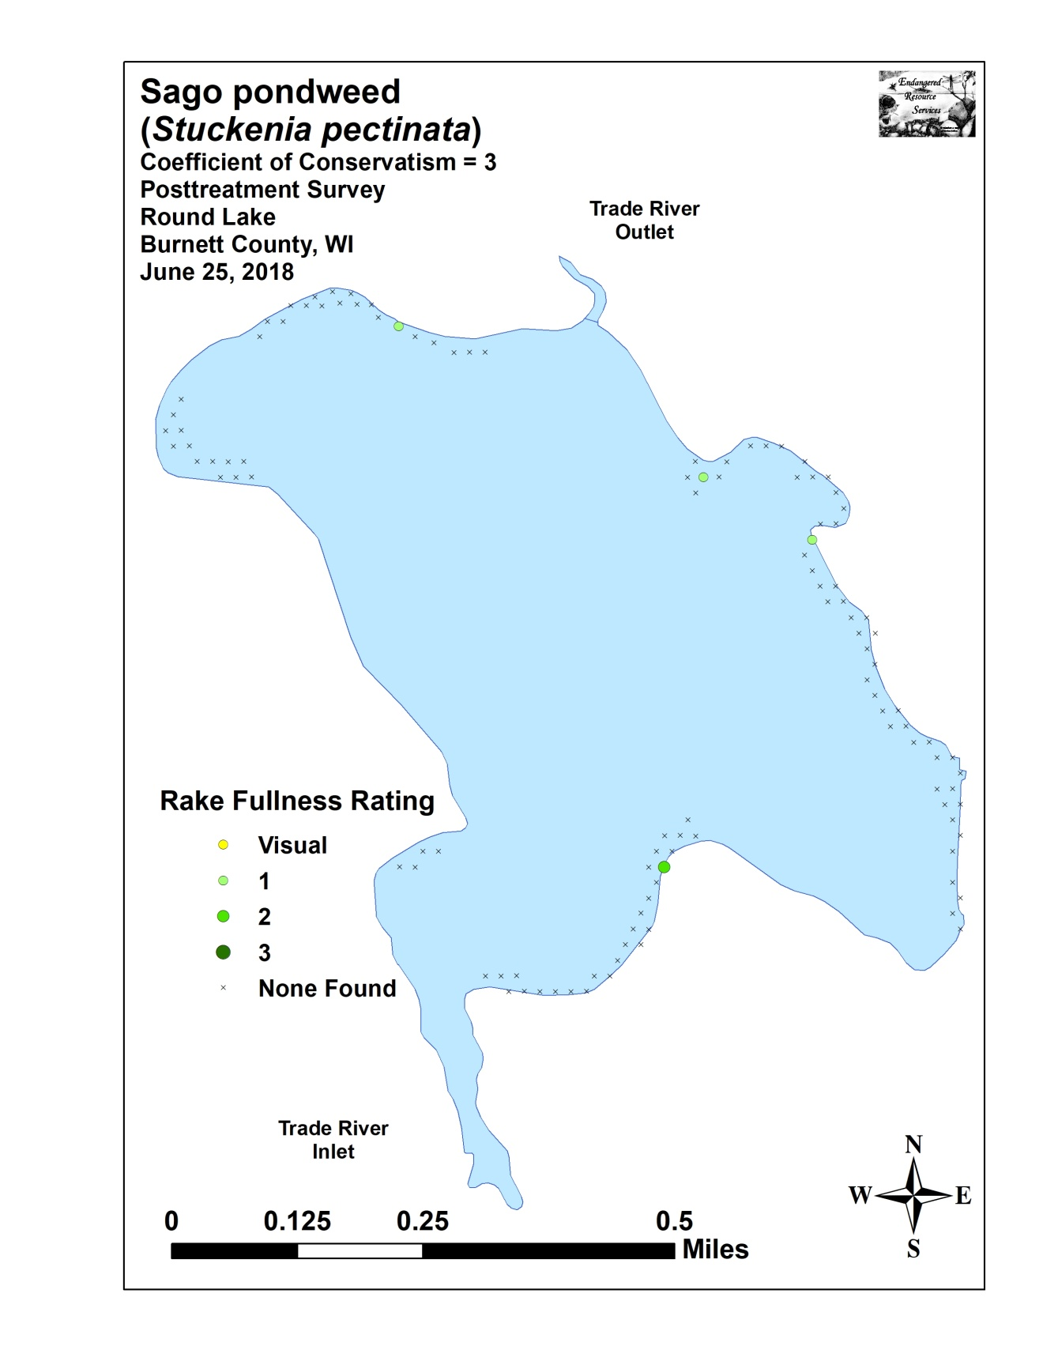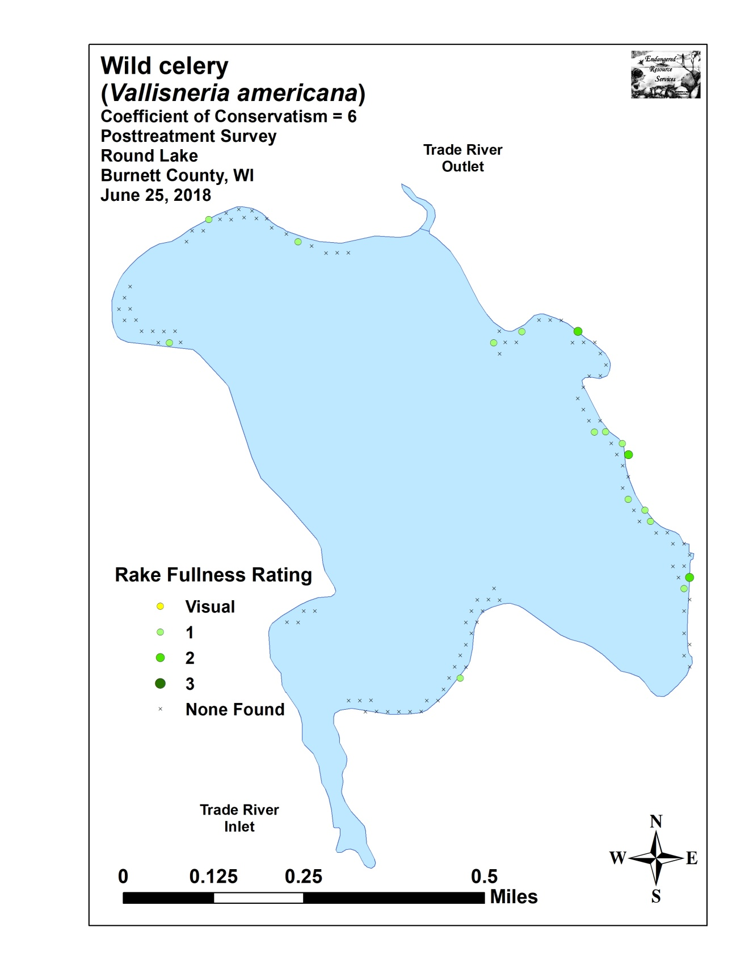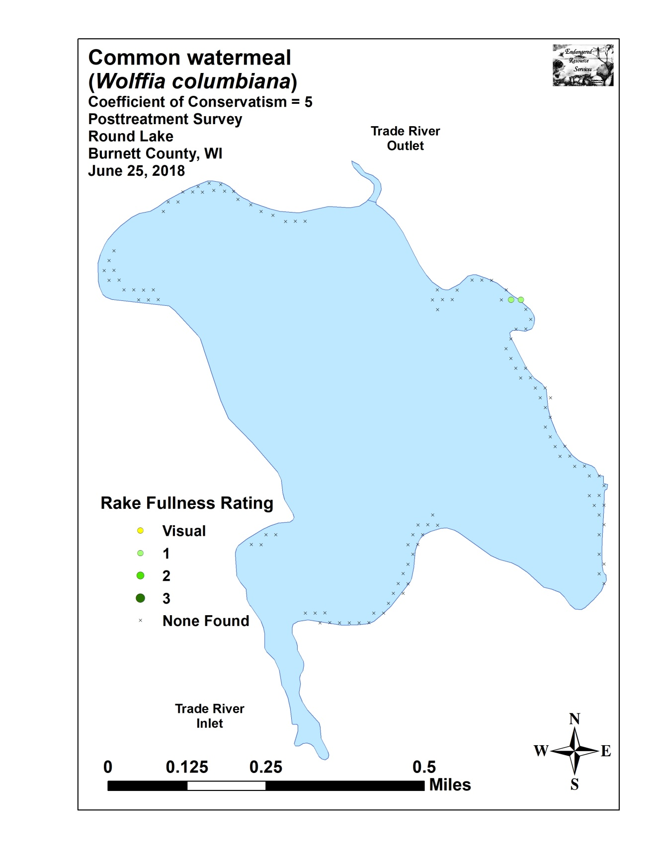

Appendix VIII: Fall 2017 and 2018 EWM Bed Maps
