Catch, release, and clean your gear
By: Matthew Wallrath – Invasive Species Program Coordinator with the Upper Sugar River Watershed Association
Catch and release season is back for some trout streams. While we may take a holiday off to fish and reflect on our year, invasive species are tireless in our rivers and wetlands as they hitchhike on wheels and gear. Many of you reading this have been fishing longer than I have been alive. But please listen: there are new threats to our rivers. Seriously, some of the plants and critters that currently inhabit the Driftless Mississippi Valley are NOT good neighbors. Biologists call them “aquatic invasive species”, which are nonnative plants, animals and pathogens that harm our environment and our economy.
Wading anglers are reminded to do their part to help stop aquatic hitchhikers this fishing season. When moving between streams, anglers need to remove all plants, animals and debris from gear, and to drain all water from equipment.

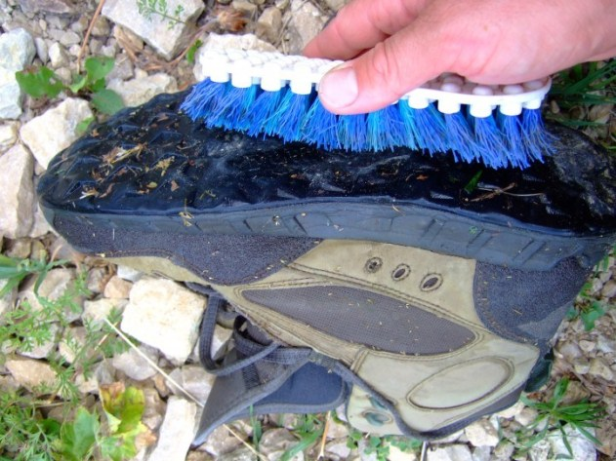
Caption: A stiff brush to scrub gear is often helpful in removing small, hard-to-see invasive species, like the recently discovered New Zealand mudsnail, from gear. Plus it’s good for your gear.

Also, please assess risk. When and where will you fish next?

LOWER RISK. If you’ve finished fishing for the day and your next trip is more than five days away, inspecting, scrubbing and air-drying gear greatly reduces the risk of transporting invasive species.

HIGHER RISK. If you are fishing in multiple bodies of water on the same day or plan to fish again in less than five days, consider taking extra steps to stop invasive species:

To further lower risk, consider fishing in locations without known invasive species first, and fishing in locations with invasive species last. USGS (nas.er.usgs.gov) and the WDNR Lakes and AIS Viewer tool (dnrmaps.wi.gov/H5/?viewer=Lakes_AIS_Viewer) can help you determine where invasive species occur. Note that these resources are not comprehensive as these species can be sneaky and go undetected.

To best prevent spread as an angler, consider using different waders on new bodies of water, freezing your gear, or using a chemical treatment on your gear before visiting a new stream. You can contact me or your local state agency for specific recommendations. Find your contact at https://bit.ly/2Ctp8sT, and https://dnr.wi.gov/lakes/invasives/topics.aspx in Wisconsin.

In order to prevent the spread of aquatic invasive species, all water users are required by law to:
- INSPECT your boat, trailer, and equipment.
- REMOVE any attached aquatic plants or animals (before launching, after loading, and before transporting on a public highway)
- DRAIN all water from boats, motors and all equipment
- NEVER MOVE live fish away from a waterbody.
- DISPOSE of unwanted bait in the trash.
I serve as a multi-county coordinator, and I am happy (and paid) to answer your questions or further explain techniques and importance of this effort. We are also actively recruiting stream stewards to receive identification and reporting training to increase citizen science in the Driftless. Get me on my email at matt@uppersugar.org if any of that sounds important to you. Thanks for protecting our waters!

