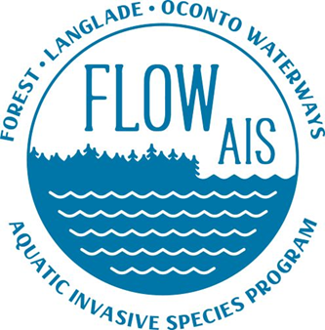

FLOW AIS Update
FCAL meeting
4/22/2022

- Working with area lakes biologist to secure bids for lake arbutus management plant update, so removal can begin, so far one group has showed interest waiting to hear more

- Lake and rivers convention update: milfoil give away idea For FCAL from golden sands. Press and laminate strands of milfoil or whorls to give away.

- Trolling update. Zach Wilson Iron county mentioned about MN finding that trolling was a prime suspect for transporting SWF could be used for your trolling argument. I can ask for more information if you like

- Still waiting to get in AIS towels for LB and DC

- If the meetings say the same week. I will miss the next one I will be out of town for a family wedding May 18th-22nd

