Hybrid Eurasian water-milfoil
(Myriophyllum spicatum X sibiricum)
Fall Bed Mapping Survey
Namekagon Lake System - Bayfield County, Wisconsin

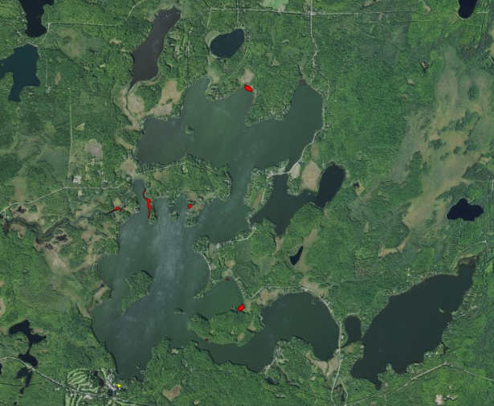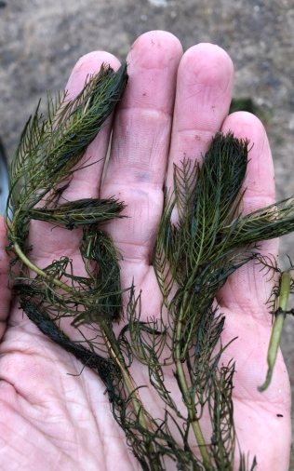

HWM Beds (Red) and HDAs (Yellow) Fall 2019 Canopied HWM (Berg 2019) HWM - 24-30 Leaflets (Berg 2019)

Project Initiated by:
The Wisconsin Department of Natural Resources, the Namekagon Lake
Association, the Bayfield County Land & Water Conservation Department, and Harmony Environmental

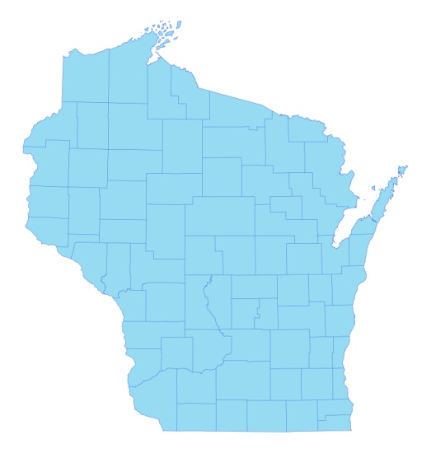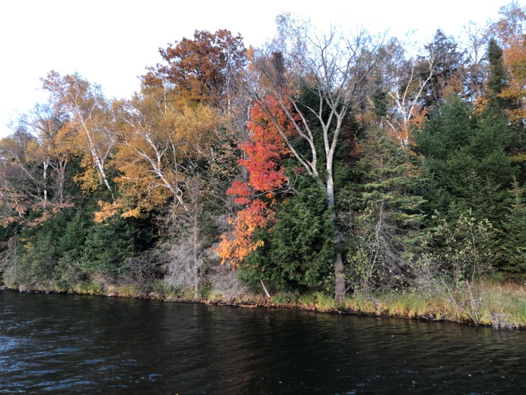

* Namekagon
Lake

Fall Namekagon Lake Shoreline (10/18/19)

Survey Conducted by and Report Prepared by:
Endangered Resource Services, LLC
Matthew S. Berg, Research Biologist
Saint Croix Falls, Wisconsin
October 18, 2019
TABLE OF CONTENTS

LIST OF FIGURES AND TABLES…………………..……..………………..……. ii
INTRODUCTION.……………………………………………………………………. 1
STUDY BACKGROUND AND RATIONALE….………………………………… 1
METHODS………………..……………………………………….……………….. 3
RESULTS..……………………..………………………………………….……….. 4
Fall Hybrid Water-milfoil Bed Mapping Survey……....…………………… 4
Descriptions of Past and Present Hybrid Water-milfoil Beds………………. 6
DISCUSSION AND CONSIDERATIONS FOR MANAGEMENT………………. 9
LITERATURE CITED……………….…………………………………….………. 11
APPENDIXES……….…….……………………………………………….………. 12
I: 2019 Hybrid Water-milfoil Fall Bed Maps……………...…………………… 12

LIST OF FIGURES AND TABLES

Page
Figure 1: Namekagon Lake Aerial Photo.....……………….……….….…….……. 1
Figure 2: HWM Locations – Early Detection Survey 8/15/16...…….…………….. 2
Figure 3: Rake Fullness Ratings……………………………….…….…………….. 3
Figure 4: October 18, 2019 HWM Littoral Zone Survey – GPS Tracks…………... 4
Table 1: Fall Hybrid Water-milfoil Bed Mapping Summary –
Namekagon Lake, Bayfield County – October 18, 2019…..…..…………………… 5

Figure 5: 2019 Fall HWM Bed Map/HDAs 1-3 and 22 – Southwest Bays..………. 6
Figure 6: Beds 4-11 – River Outlet and Governor’s Island...…....…..…………….. 7
Figure 7: Beds 12-15 – Upper Lake/Beds 16-21, 23 –
Anderson Island, Mumm’s Bay, and Lower Lake………………………………...... 8

Figure 8: Eurasian, Hybrid, and Northern Water-milfoil Identification…..……….. 9

Figure 9: Limp Nature of EWM/HWM Leaflets along Stem –
Stiff Nature of NWM Leaflets along Stem and Overwintering Turions……………. 10

INTRODUCTION:
Namekagon Lake (WBIC 2732600) is a 2,897 acre drainage lake in south-central Bayfield County, Wisconsin in the Towns of Namekagon and Grand View (T43/44N R5/6W). It has a maximum depth of 51ft and an average depth of approximately 16ft. The lake is eutrophic bordering on mesotrophic in nature, and water clarity is generally fair with summer Secchi readings ranging from 6-14ft and averaging 8.1ft in the deep hole northeast of Paines Island from 1995-2018 (the last year data was available) (Figure 1) (WDNR 2019). This clarity produced a littoral zone that extended to approximately 8.0ft in October 2019. The lake’s bottom substrate is variable with sand and rock occurring along the majority of shorelines and around the lake’s numerous islands, while sandy and organic muck dominate the deep flats and sheltered bays (Holt et al. 1971).

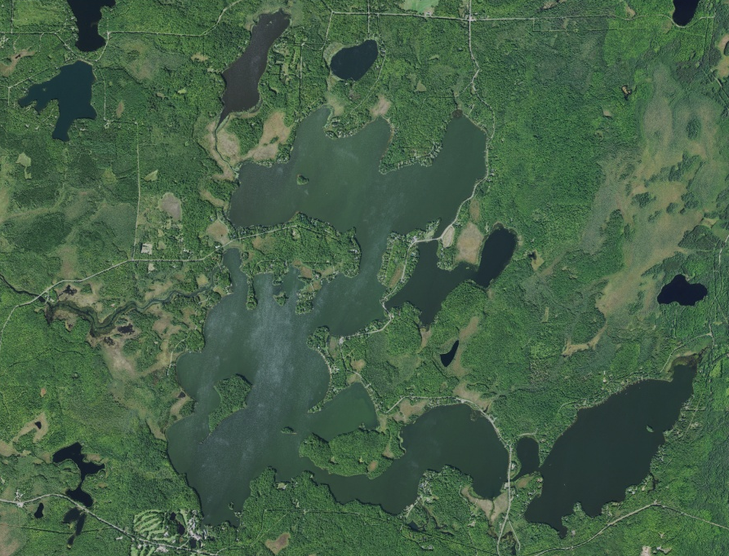
Lakewoods Resort
Marina
Echo
Point
Sugar
Point
Eagle
Point
Missionary
Point
Junek’s
Point
Bergundy
Point
Upper
Lake
Governor’s
Island
Namekagon
Island
Champaign
Island
Namekagon
Lake
National
Forest Campground
Jackson
Lake
Sugar
Bay
Anderson
Island
Mumm’s
Bay
Namekagon River Outlet
Paines
Island
Middle
Lake
Lower
Lake
Garden
Lake
Figure 1: Namekagon Lake Aerial Photo

STUDY BACKGROUND AND RATIONALE:
On June 17, 2016, while doing bird surveys on the lake, we discovered plants at the Lakewoods Resort Marina boat landing that looked to be intermittent between the exotic invasive Eurasian water-milfoil (Myriophyllum spicatum) (EWM) and native Northern water-milfoil (Myriophyllum sibiricum) (NWM). Wisconsin Department of Natural Resources (WDNR) and Bayfield County Land and Water Conservation Department (BCLWCD) immediately followed-up with a collection of plants on June 20th that were sent to the state lab where DNA analysis confirmed them as Hybrid water-milfoil (HWM) on July 15th.
On August 15th, a team of professionals from the WDNR and BCLWCD conducted a shoreline survey of the lake. They found and rake removed a few scattered plants in the bay immediately northwest of the Lakewoods Resort Marina Landing/southwest of Paines Island as well as two additional plants in the bay near the river outlet (Figure 2). This survey was followed by hand removal efforts coordinated and overseen by the WDNR (Pamela Toshner – Regional Lake Biologist), BCLWCD (Andrew Teal – Bayfield County Aquatic Invasive Species Coordinator), and the University of Wisconsin Extension (Paul Skawinski - Citizen Lake Monitoring Network) on both August 15th and 23rd. On these dates, volunteers from the Namekagon Lake Association (NLA) and employees from the Lakewoods Resort joined the professionals in rake removing dozens of HWM plants from the marina area.

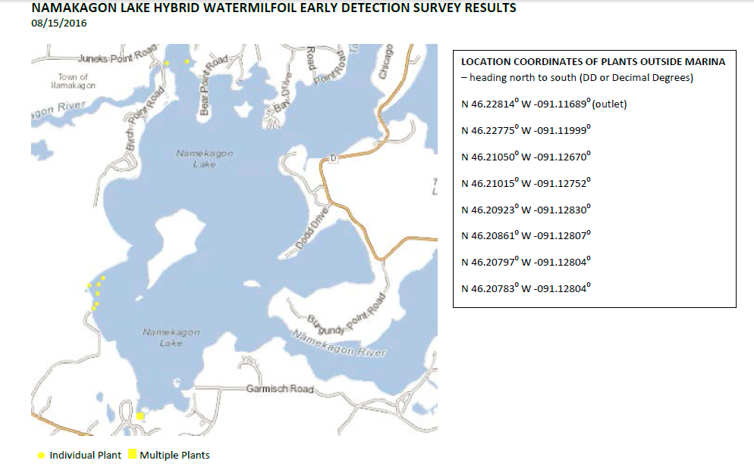
Figure 2: HWM Locations – Early Detection Survey - 8/15/16

In anticipation of developing an initial Aquatic Plant Management Plan (APMP) to guide a response to the new infestation, we were asked to complete a full warm-water point-intercept macrophyte survey on Namekagon Lake from August 23-25, 2016. The goals of this survey were to establish data on the richness, diversity, abundance and distribution of the lake’s native aquatic plant populations and to determine the extent of the HWM infestation. At that time, we found HWM was still largely confined to the Lakewoods Marina, although we also found scattered plants in the bay southwest of Paines Island. After continuing to manually remove plants from the marina in 2017 and 2018, we were asked to search the lake’s littoral zone again in the fall of 2018. This survey found that HWM had broken out of these original areas and was spreading throughout the entire lake. In 2019, after chemically treating (Diquat – Tribune – 2gal/acre) four areas totaling 6.92 acres (0.24% of the lake’s total surface area) on June 11th and leading seven additional hand pulling workshops, we were asked to complete another fall bed mapping survey to quantify HWM levels in the system. This report is the summary analysis of that field survey conducted on October 18, 2019.
METHODS:
Fall Hybrid Water-milfoil Bed Mapping Survey:
During the fall survey, we searched the visible littoral zone throughout the entire system. By definition, a “bed” was determined to be any area where we visually estimated that HWM made up >50% of the area’s plants, was generally continuous with clearly defined borders, and was canopied or close enough to being canopied that it would likely interfere with boat traffic. After we located a bed, we motored around the perimeter taking GPS coordinates at regular intervals. We also estimated the rake density range and mean rake fullness of the bed (Figure 3), the range and mean depth of the bed, whether it was canopied, and the impact it was likely to have on navigation (none – easily avoidable with a natural channel around or narrow enough to motor through/minor – one prop clear to get through or access open water/moderate – several prop clears needed to navigate through/severe – multiple prop clears and difficult to impossible to row through). These data were then mapped using ArcMap 9.3.1, and we used the WDNR’s Forestry Tools Extension to determine the acreage of each bed to the nearest hundredth of an acre. Because the infestation is still a relatively new one, we also mapped “high density areas” where HWM plants were continuous, but didn’t meet all of the other “bed” criteria. When isolated individual HWM plants were found outside of the mapped beds and high density areas, we GPS marked them and attempted to rake remove them as these satellite plants are likely to become beds in the near future.

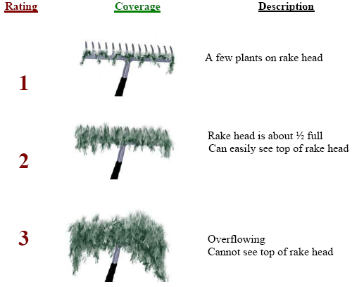
Figure 3: Rake Fullness Ratings (UWEX 2010)

RESULTS:
Fall Hybrid Water-milfoil Bed Mapping Survey:
On October 18, 2019, we searched 87.8km (54.6miles) of transects throughout the system’s visible littoral zone (Figure 4). Fortunately, Garden and Jackson Lakes remained free of Hybrid water-milfoil. In Namekagon Lake, although we found most areas that had been chemically treated had reduced amounts of HWM, many other areas of the lake showed significant expansion. In total, we mapped 18 areas covering 12.30 acres (0.42% of the lake’s surface area). Of these, 17 areas were true beds (red polygons) with continuous plants (11.57 acres) while one was better described as a “high density area” (yellow polygon) with only scattered plants (0.73 acre) (Table 1). Outside of these areas, we marked an additional 37 plants (Figure 5) (Appendix I). Although this was a nearly 40% drop in acreage from 2018 when we found four true beds (6.89 acres) and 13 high density areas (13.48 acres) that covered 20.37 acres (0.70% of the lake’s 2,897 acres), it represented a further expansion into many parts of the lake that showed no evidence of HWM during previous surveys.

As is often the case with new infestations, we found the majority of HWM plants were near highly developed and/or disturbed shorelines; especially near resort docks and boat landings. These areas have high volume watercraft traffic which tends to disturb the bottom making it easy for HWM to establish. Once canopied, these plants also frequently suffer prop-clipping which accelerates their natural spread from fragmentation.

Figure 4: October 18, 2019 HWM Littoral Zone Survey – GPS Tracks

Table 1: Fall Hybrid Water-milfoil Bed Mapping Summary
Namekagon Lake, Bayfield County
October 18, 2019

Bed/HDA Number | 2019  Fall  Acreage | 2018  Fall  Acreage | 2018-2019 Change in Acreage | Rake Range and Mean Rake Fullness | Range and Mean Depth | Canopied? | Navigation Impairment | 2019 Field Notes
HDA 1 | 0.73 | 1.89 | -1.16 | <<<1 | 2-6; 4 | Yes | None | 10 plants – all raked out
HDA 2 | 0 | 0.38 | -0.38 | <<<1 | 4-6; 5 | Yes | None | 1 HWM plant raked out
HDA 3 | 0 | 0.11 | -0.11 | 0 | - | - | - | No HWM seen
Bed 4 | 0.07 | 0.05 | 0.02 | <<1-2; 1 | 3-5; 4 | Yes | Minor | Many prop-clipped
HDA 5 | 0 | 0.32 | -0.32 | <<<1 | 2-6; 4 | Yes | None | 3 small plants
Bed 6 | 0 | 0.09 | -0.09 | 0 | - | - | - | No HWM seen
Bed 7A/B | 0.37 | 2.94 | -2.57 | <<1-2; 1 | 2-5; 4 | Yes | None | Regular towers/microbeds
Bed 8 | 0.89 | 3.92 | -3.03 | <<1-2; 1 | 2-5; 4 | Yes | None | Regular towers/microbeds
Bed 9 | 0 | 6.54 | -6.54 | <<<1 | 3-8; 5 | Near | None | Scattered young plants
Bed 10 | 3.09 | 0.63 | 2.46 | <<<1-3; 1 | 3-7; 5 | Near | Minor | Merging towers
Bed 10A | <0.01 | 0 | <0.01 | <1-1; 1 | 3-5; 4 | Yes | None | Merging microbeds
Bed 11 | 0.80 | 0.45 | 0.35 | <<<1-1; <1 | 3-5; 4 | Near | None | Expanding in all directions
Bed 12 | 1.98 | 0.21 | 1.77 | <<1-3; 1 | 3-5; 4 | Yes | Minor | Many prop-clipped
Bed 13 | 0.06 | 0 | 0.06 | 1-3; 1 | 3-5; 4 | Near | Minor | Growing microbed
Bed 14 | <0.01 | 0 | <0.01 | 1-2; 1 | 3-5; 4 | Near | None | Microbed
Bed 15 | 0.01 | 0 | 0.01 | <<1-1; 1 | 2-4; 3 | Near | None | Microbed
Bed 16 | 0.01 | 0 | 0.01 | <<1-1; 1 | 2-4; 3 | Near | None | Microbed
Bed 17 | 0.03 | 0.04 | -0.01 | <<<1 | 3-5; 4 | Yes | Minor | Scattered large clusters
HDA 18 | 0 | 0.02 | -0.02 | 0 | - | - | - | No HWM seen
Bed 19 | 0.01 | 0 | 0.01 | <1-2; 1 | 3-4; 3 | Yes | Minor | Microbed near docks
Bed 20 | 0.90 | 0.83 | 0.07 | <1-3; 2 | 3-5; 4 | Yes | Minor | Canopied mat at core
Bed 21 | 3.18 | 1.85 | 1.33 | <1-2; 1 | 3-5; 4 | Yes | Minor | Fragmented on edges
HDA 22 | 0 | 0.10 | -0.10 | 0 | - | - | - | No HWM seen
Bed 23 | 0.15 | 0. | 0.15 | <1-2; 1 | 3-5; 4 | Yes | Minor | Microbed in uninhabited bay
Total | 12.30 | 20.37 | -8.07

Descriptions of Past and Present Hybrid Water-milfoil Beds:
HDA 1 – Hybrid water-milfoil continued to be scattered around the Lakewoods Marina, although no true beds existed suggesting past treatments and manual removal have been successful in keeping it in check. In total, we marked and rake removed just ten plants from this area (Figure 5) (Appendix I).

HDAs 2 and 3, and the west-central shoreline – We found and rake removed just two plants. This was an unexpectedly low total as we also found scattered plants in these areas during the summer of 2016 and the fall of 2018. Hopefully prevailing currents and continued rake removals will continue to limit the spread in this area.

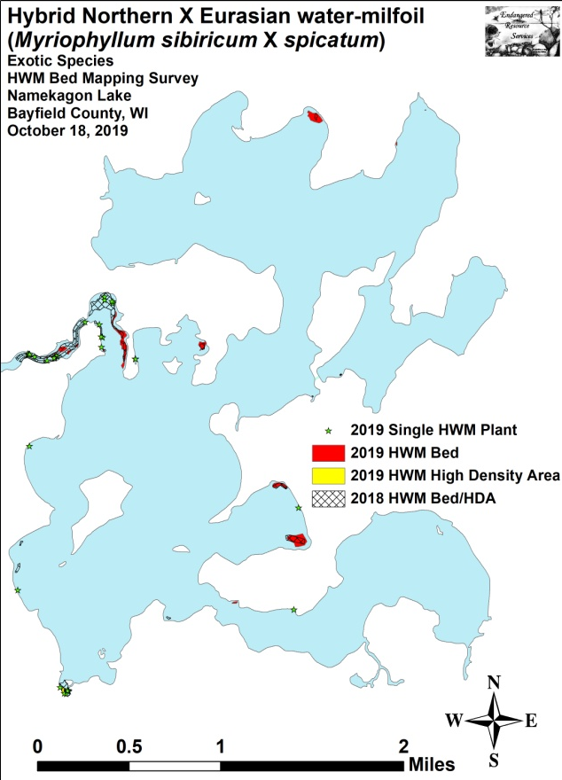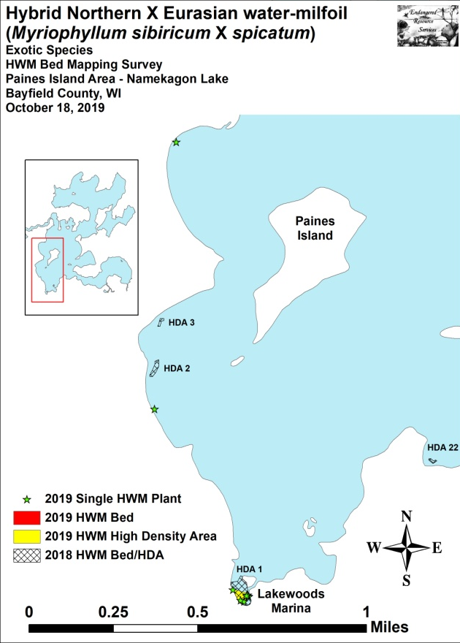
Figure 5: 2019 Fall HWM Bed Map/HDAs 1-3 and 22 – Southwest Bays

Bed 4 – Located just beyond the western shoreline docks of the Four Seasons Resort, Bed 4 was an expanding collection of towers on the outside edge of a Hardstem bulrush (Schoenoplectus acutus) stand (Figure 6) (Appendix I). We estimated there were at least 100 different plants mixed in with the greater Northern water-milfoil bed. We also noted that many had been repeatedly prop-clipped by incoming/outgoing boat traffic.

HDA 5 and Bed 6 – We found just three plants in HDA 5, and no plants in the former Bed 6. Residual chemical pulled into this area by the lake outflow likely explains the lack of surviving plants in this area.

Beds 7 and 8 – Areas with HWM were noticeably reduced in the majority of the outlet channel. However, in side bays out of the current, we found nearly continuous plants.
Beds 9 and 10 – The majority of the treated area of Bed 9 remained relatively free of HWM. However, Bed 10 had grown from a high density area to a true bed throughout the majority of the area. On the northern edge, it was invading the area formerly occupied by the southeastern finger of Bed 9 although here it was more fragmented than in the rest of the bed.

Bed 10A – This small area contained several canopied microbeds that had satellite plants radiating out in all directions.

Bed 11 – After having only a few dozen plants in 2018, Bed 11 now had 100s. Although it still had a very low overall density and was fragmented on its borders, plants were clearly spreading in all directions as the total area nearly doubled.

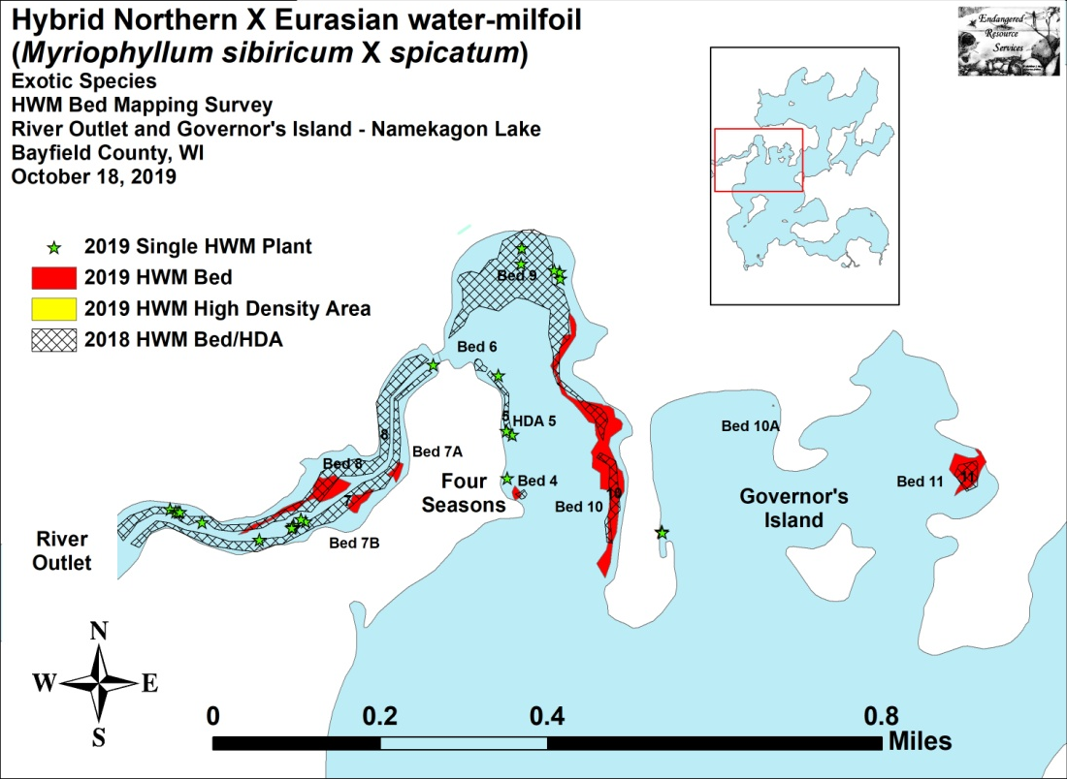
Figure 6: Beds 4-11 – River Outlet and Governor’s Island

Bed 12 – The acreage in the bed near Mogasheen Resort grew by over 840% to become the second largest area on the lake. Many plants were prop-clipped suggesting this could potentially be a significant source population (Figure 7) (Appendix I).

Beds 13-15 – These three beds were growing near the National Forest Campground and represented a significant expansion into a new area of the lake. None were big, but they were already canopied or near canopied and actively fragmenting.

Bed 16 – This microbed was located along the east shoreline just southeast of the north Anderson Island Bridge. It was little more than a few large multi-stemmed towers, but they were already canopied and actively fragmenting.
Bed 17 – This small bed was located along the south shoreline just east of the southern Anderson Island Bridge. It was little more than a few large multi-stemmed towers, but they were canopied and actively fragmenting.

HDA 18 – After rake removing the plants in this area in 2018, we saw no evidence of HWM here in 2019.

Beds 20 and 21 – In 2018, Mumm’s Bay had pioneering clusters located on both the northeast and southeast ends of the bay. By 2019, these areas had merged at their cores to become canopied mats with satellite plants radiating out into the shallows (Figure 7) (Appendix I).

HDA 22 – We didn’t find any HWM in this area where we had rake removed all plants found in the fall of 2018.

Bed 23 – Just into Lower Lake, we found a small isolated bed in an uninhabited bay. Plants were canopied at the core, and there were scattered satellite plants radiating off to the west.

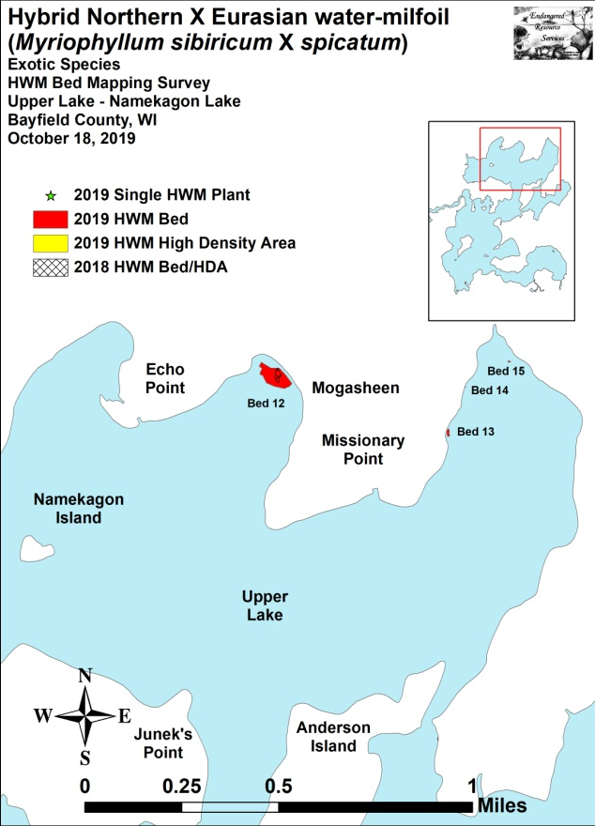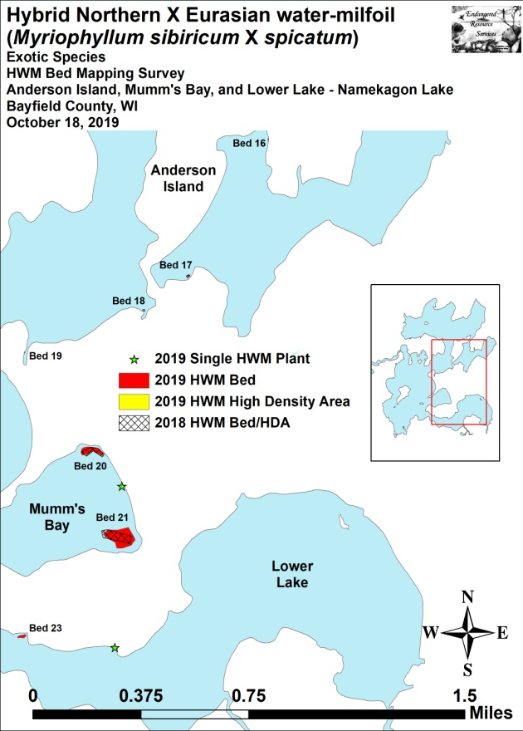
Figure 7: Beds 12-15 – Upper Lake/
Beds 16-21, 23 – Anderson Island, Mumm’s Bay, and Lower Lake

DISCUSSION AND CONSIDERATIONS FOR MANAGEMENT:
Hybrid water-milfoil:
Hybrid water-milfoil currently occupies a low overall percentage of Namekagon Lake’s surface area, but it is now widely-established making eradication an unrealistic expectation. Complicating matters, HWM also appears to be spreading rapidly, and it will likely continue to do so without sustained active management. With these realities in mind, working to control its spread in the most cost effective manner possible while simultaneously minimizing its impact on the lake’s aquatic ecosystem will likely be important goals for the lake association moving forward. To assist with these efforts, regular littoral zone surveys to locate new beds and address them before small problems become big ones will likely become an annual necessity prior to developing a management strategy for the following year. Educating as many residents as possible to be on the lookout for new plants/beds is also strongly encouraged as a way to assist with early detection. If volunteers find anything they think even looks suspicious, they are invited to promptly contact us (email at saintcroixdfly@gmail.com and/or text to 715-338-7502) with a picture, specimen, description of, and/or preferably GPS coordinates, and we will add these locations to the existing map for management consideration.

Because native Northern water-milfoil is also widely distributed throughout the lake and closely resembles Hybrid water-milfoil, finding and identifying HWM will likely be challenging for volunteers. To assist in identification, surveyors should remember that NWM has leaflets numbering <24 whereas EWM normally has >26 with HWM tending to have leaflet numbers that range from 20-30 – intermittent between both parent species (Figure 8). EWM and HWM also tend to have a bright red growth tip on the top of the plant, whereas NWM has a bright lime-green growth tip. In the fall, NWM also forms winter buds on the tips of shoots whereas EWM/HWM have none (Figure 9).

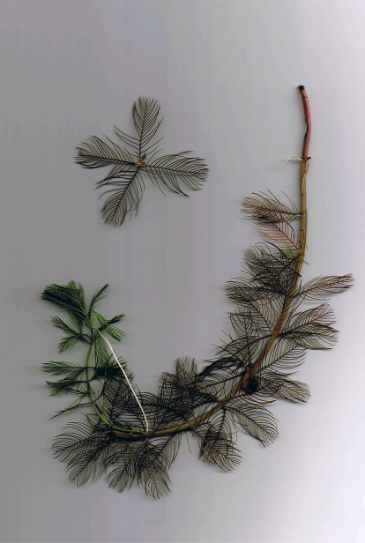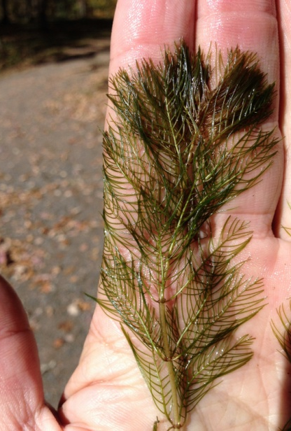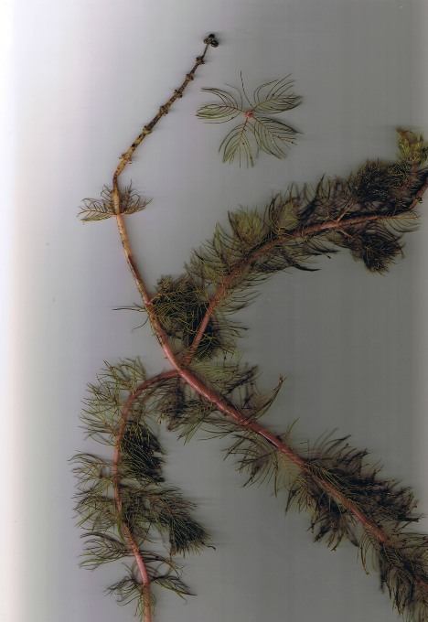
Eurasian Water-milfoil Hybrid Water-milfoil Northern Water-milfoil
Figure 8: Eurasian, Hybrid, and Northern Water-milfoil Identification
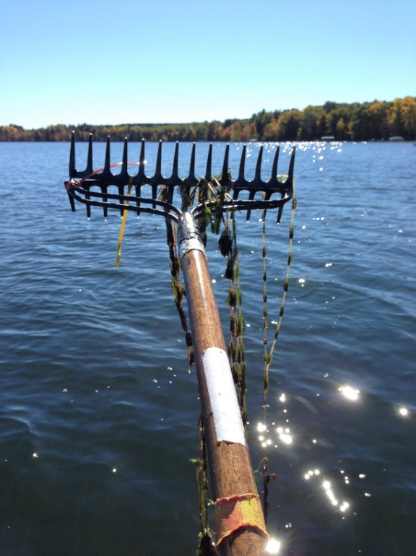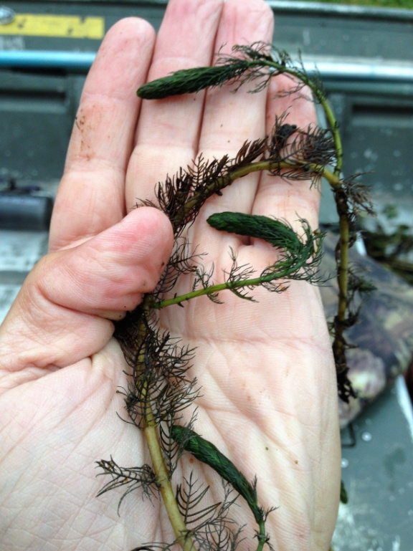
Figure 9: Limp Nature of EWM/HWM Leaflets along Stem –
Stiff Nature of NWM Leaflets along Stem and Overwintering Turions

LITERATURE CITED

Holt, C., C. Busch, C., L. Holt, and L. Sather. [online]. 1971. Namekagon Lake Map.
Available from http://dnr.wi.gov/lakes/maps/DNR/2732600a.pdf (2019, December).

WDNR. [online]. 2019. Namekagon Lake - Citizen Lake Water Quality Monitoring Database. Available from http://dnr.wi.gov/lakes/lakepages/LakeDetail.aspx?wbic=2732600&page=waterquality (2019, December).

WDNR. [online]. 2019. Namekagon Lake - Wisconsin Lakes Information. http://dnr.wi.gov/lakes/lakepages/lakedetail.aspx?wbic=2732600 (2019, December).

Appendix I: 2019 Hybrid Water-milfoil Fall Bed Maps
