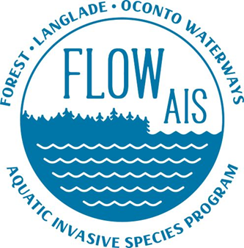

FLOW AIS Update For FCAL
Since 5/20/2022
6/17/2022

Hi all I just wanted to say the reason I am not at the meeting this month is because Jeanne Scherer, the statewide Purple Loosestrife Biocontrol Coordinator is in the northern area of the state this week and is touring PL sites. My sites were listed to be visited on Friday (today).

FLOW AIS Update

- FLOW conducted a Clean Boats Clean Waters Training for Lake Lucerne and Lake Metonga at the Lake Lucerne boat landing on Sunday the 5th… The training was organized by Mark Orlovsky. There were 19 inspectors in attendance.

- There is a confirmed location of Phragmites in Forest County. The site was first brought to the attention of FLOW AIS by Steve and Kayla with the county. Verification was done by FLOW AIS shortly afterwards. Removal and control of the phragmites will be done by WRISC this year.

- Forest County along with FLOW AIS is looking into a county wide Clean Boats Clean Waters Grant. Steve was approached by Gary Mueller the past president of the Lake Metonga association about the idea. This grant could create a smoother hiring process of interns and Clean Boats Clean Waters productively if Forest County were to pursue the grant. Forest County is looking for support of FCAL and help with the match requirements of the grant. The match requirements could be up to, but no more than a value $6,000.00. Depending on the number of lakes in the grant. The match can come from multiple sources, volunteer time and several different types of donations. Details of the grant are still being worked out at this time. If you have questions, contact myself or Steve.

- AIS towels came in the mail and were distributed to the following lakes: Butternut Franklin, Lake Lucerne, and Lake Metonga. More towels will be dropped off at Forest the Forest County Courthouse if lakes run out of stock that they have.

- SNAPSHOT DAY HAS BEEN CHANGED TO AUGUST 19TH FOR FOREST COUNTY TO MEET THE REQUIREMENTS OF THE FALL FORUM…Thank you Jim Zach for helping to coordinate the change of date.

  - Volunteer registration for the event is now open. For those of you interested please email me and I can send you the registration link. It only takes a few minutes to register.
  - A volunteer training will be held on August 12th by the statewide Snapshot Day coordinator from noon to 1pm. If interested let me know and I can send you the registration link.

- Derek attended the Roberts Lake Association Spring Meeting, Memorial Day weekend. The association discussed an idea about a multi organizational group work being created to help lakes that have new found invasive species or lakes that are struggling with their current invasive species Organizations involved could be as followed: FLOW AIS, Forest County, FCAL, individual lake associations… Lee Lames may have more detail to add.

- Continued work with Lake Arbutus as they begin their Milfoil removal process

Please let me know of any educational program updates or Kentuck Days information.

