Labslips - Quality Control (Duplicates and Blanks)
Last modified 02/2015
About ten percent (10%) of your samples should be quality controlled by taking duplicate samples and/or blanks. This requires additional creation of labslips.
If you want to sample for duplicates or blanks at your sites, you will need to create additional labslips for these in SWIMS; they are considered separate samples.
Regular sample + a Duplicate sample = 2 labslips
Regular sample + a Field Blank = 2 labslips
Regular sample + a Duplicate + a Blank = 3 labslips

When creating the labslips in SWIMS, you can mark that it is a Duplicate or Blank sample when you create the labslip. This will auto-fill the box on the printed labslip.
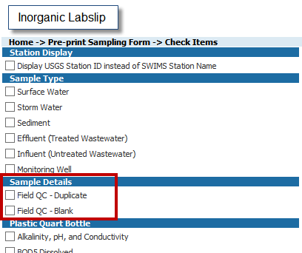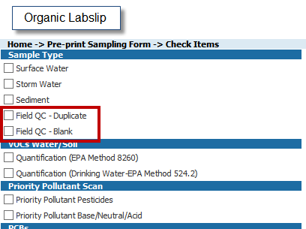
If you forget the above step in SWIMS, or are making MANY sets of labslips at one time, or decide that you want to use a spare existing labslip as a Duplicate or Blank, you can also just check the correct boxes on the paper labslip. Often this is the most flexible way to do it when making many labslips at the same time.
(*Also note that if you have a printed labslip that has Duplicate or Blank boxes checked and you decide that you just want to use it for a regular sample INSTEAD of a Duplicate or Blank, just White Out the check box)

Printed Organic Labslip indicating where the Duplicate and Blank check boxes are located:
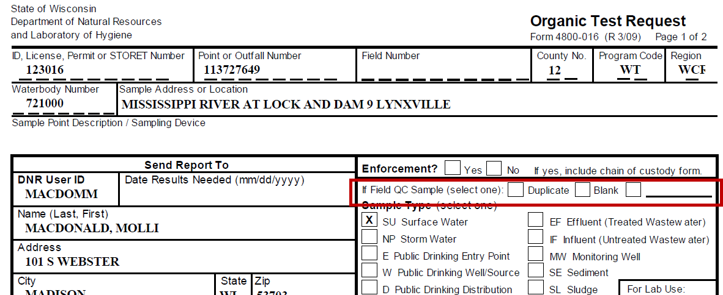
Printed Inorganic Labslip indicating where the Duplicate and Blank check boxes are located:
