2021 Lake Superior Basin AIS Monitoring Year Summary
Primary Collectors: Dara Fillmore and Alex Selle
July 2021 to November 2021

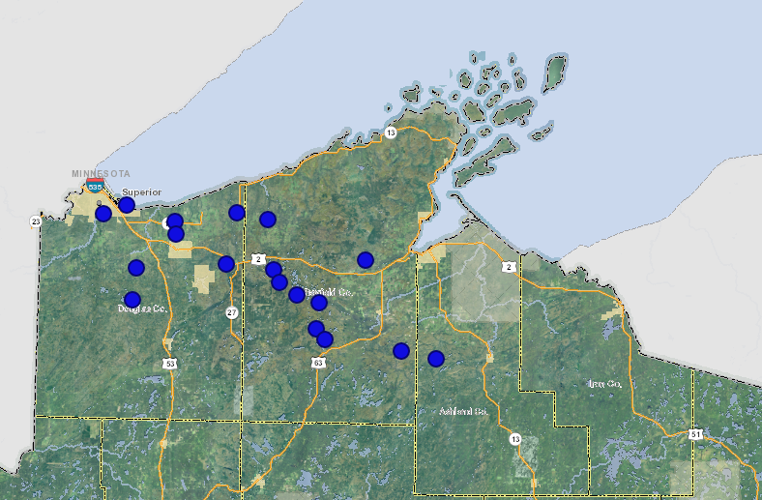
Caption: Blue Dots represent Early Detection monitoring locations in 2021.

AIS Early Detection Surveys (18 site surveys completed):
- Eight Lakes: Specific lakes were selected based on proximity to known AIS populations and last known date of a prior survey. Four of the eight lakes had AIS surveys completed for the first time according to DNR’s SWIMS Database.
- Ten Stream/River Sites: Specific stream sites were selected based on proximity to known AIS populations and last known date of a prior survey. Six of the ten stream sites had AIS surveys completed for the first time according to DNR’s SWIMS Database.
Summary of Survey Results
- Lakes and Stream/River AIS Early Detection: 10 new populations of 5 different NR40 Restricted Species
  - 6 - Aquatic Forget-Me-Not
  - 1 - Chinese Mystery Snails
  - 1 - Purple Loosestrife
  - 1 - Rusty Crayfish
  - 1 - Yellow Iris
- Of the 18 early detection surveys completed, 9 survey sites were found to contain AIS, 8 of which were previously unknown. 44% of surveys detected new AIS populations.

Additional AIS Monitoring & Work
- Response Monitoring
  - One instance of response monitoring completed in Vilas County due to report of Spiny Water Fleas (“SWF”) in Presque Isle Lake. No SWF were identified during collection, but analysis results are pending from the State Lab of Hygiene.
- Clough Island
  - Lake Superior Staff completed buckthorn monitoring and control efforts
  - GLIFWC Staff identified and treated several patches of Non-Native Phragmites on north side of island throughout the growing season
  - Additional monitoring along shorelines recommended for 2022.
- Michelle Wheeler Wetland Restoration
  - WDNR’s Lake Superior Team Staff completed control efforts on Cattails with assistance from DNR NHC staff
- Wild Rice Work – Allouez Bay
  - Early Detection methodology used while completing Wild Rice surveys on Allouez Bay
- Incidental Monitoring
  - 2 new populations of Knotweed (Bohemian) were identified by Alex while traveling to monitoring locations
  - Several other populations of knotweed were reported to NCWMA during Dara’s travels as well
- Genetic Analysis
  - 4 Knotweed samples from Bayfield County were selected for genetic analysis to be analyzed by Tippery Lab at UW-Whitewater to determine speciation
  - 4 Milfoil samples from Hay Lake and Delta Lake (Bayfield County) were selected to determine if aggressive milfoil has hybridized. Samples were desiccated and sent to Thum Lab at Montana State University
  - Analyses on all genetic samples are still processing and pending completion
Special thanks to our partners who assisted with fieldwork and monitoring activities in 2021:
- Andy Teal, Bayfield County
- Zach Stewart, Douglas County
- Logan Servinsky – Northwoods Cooperative Weed Management Area
- Stacy Dietrich – Northwoods Cooperative Weed Management Area
- Caitlin Hoenig –USFS Washburn District
- Lake Superior Water Resources Team
- Ryan Magana – DNR NHC
- Alexander Streitz – DNR NHC
- Shaun McCabe – DNR NHC
- Ty Krajewski – DNR Woodruff

Waterbody Name | Type | County | WBIC | Species Know to be Present | New Species Identified | Comments
Iron Lake | Lake | Bayfield | 2877000 | None | CMS, PL, YI | First time monitored by DNR
Marengo Lake | Lake | Bayfield | 2921100 | Sea Lamprey | None | First time monitored by DNR
Lake Ruth | Lake | Bayfield | 2765900 | Freshwater Jellyfish | None
Reynard Lake | Lake | Bayfield | 2772200 | None | None | First time monitored by DNR
Canthook Lake | Lake | Bayfield | 2757800 | None | None | First time monitored by DNR
Cisco Lake | Lake | Bayfield | 2899200 | None | None
Star Lake | Lake | Bayfield | 2898400 | None | None
Presque Isle Lake | Lake | Vilas | 2956500 | Rusty Crayfish | None | Response Monitoring
Allouez Bay | Lake | Douglas | 2751220 | EWM, CLP, ZM, Gobies, Ruffe, NN-Phragmites, NN-Cattails, PL, YI | None | Wild Rice Work
Lake Three | Lake | Ashland | 2915800 | None | None | Proximal to Marengo Lake
Little Pokegama | Stream | Douglas | 2845200 | None | None
Nemadji River | Stream | Douglas | 2835300 | None | None
SF of White River | Stream | Bayfield | 2904200 | None | AQFMN | State Property
Middle River | Stream | Douglas | 2858800 | None | Rusty Crayfish | First time monitored by DNR
Copper Creek | Stream | Douglas | 2836100 | None | AQFMN | First time monitored by DNR
Cranberry Creek | Stream | Douglas | 2856000 | None | None | First time monitored by DNR
Silver Creek | Stream | Douglas | 2851900 | None | AQFMN | First time monitored by DNR
Poplar River | Stream | Douglas | 2859800 | None | AQFMN | First time monitored by DNR
Trask Creek | Stream | Douglas | 2861900 | None | AQFMN | First time monitored by DNR
Nebagamon Creek | Stream | Douglas | 2864200 | None | AQFMN

Species Key:
- AQFMN: Aquatic Forget-Me-Not (Myosotis scorpiodes)
- CLP: Curly Leaf Pondweed (Potamogeton crispus)
- EWM: Eurasian Watermilfoil (Myriophyllum spicatum)
- Freshwater Jellyfish: (Craspedacusta sowerbii)
- NN-Phragmites: Non-Native Phragmites (Phragmites australis subsp. australis)
- NN-Cattails: Hybrid and Narrow Leaf Cattail (Typha x glauca) and (Typha angustifolia)
- Gobies: Round Goby (Neogobius melanostomus)
- Ruffe: Eurasian Ruffe (Gymnocephalus cernua)
- Rusty Crayfish: Rusty Crayfish (Orconectes rusticus)
- PL: Purple Loosestrife (Lythrum salicaria)
- Sea Lamprey: (Petromyzon marinus)
- YI: Yellow Iris (Iris pseudacorus)
- ZM: Zebra Mussels (Dreissena polymorpha)

