2023 Interim Report for Door County AIS Control: Door County AIS Control
Grant# ACEI27422
Door County Soil & Water Conservation Department
Grant Period of Performance: 3/15/2022-12/31/2024
Report Period of Performance: 1/1/2023-12/31/2023
Report Provided to: Amanda Smith, Mary Gansberg, & Gina Keenan
9/20/2023

This document outlines to the accomplishments of Door County Soil & Water Conservation Department (SWCD) pertaining to Aquatic Invasive Species Control in Door County in 2023 as it pertains to deliverables specified in the WDNR AIS Control Grant ACEI27422.

During 2023 SWCD made substantial progress towards grant deliverables spelled out in the grant agreement ACEI27422. During 2023 SWCD began working towards grant deliverables through match and billable funds. In 2024 SWCD anticipates continuing to achieve and meet deliverables.

Activity 1a. Generate a targeted map using a variety of data including the Renz Lab Invasive Species suitability modeling data to identify project areas of interest. Overlay the map with existing Green Print Initiative data to identify areas that are considered of high ecological importance and highly susceptible to the invasion of Phragmites & Purple Loosestrife.

Door County SWCD performed a GIS analysis utilizing the Renz lab data and the Door County Greenprint data. This analysis aims to focus efforts for inventory. The following maps are the results of this analysis. For both non-native phragmites and purple loosestrife SWCD included the intial analysis map and the final map which outlines the priority efforts for this grant. For reportings sake these maps are PDF that have been exported as JPEGs resulting in a degredation of the map image qulaity. If funders or others interested parties would like a higher resolution PDF please reach out to SWCD.

These maps were made in 2022, and provided the foundation for inventory efforts in 2023.

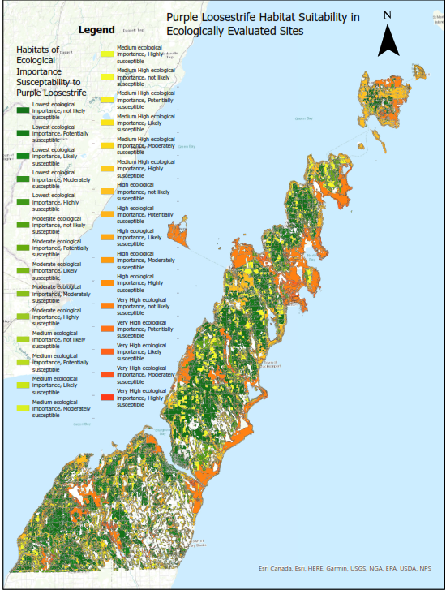
Figure 1 Purple loosestrife habitat suitability modeling in habitat assessed for ecological importance. This map is the first iteration of data displaying the total data set.

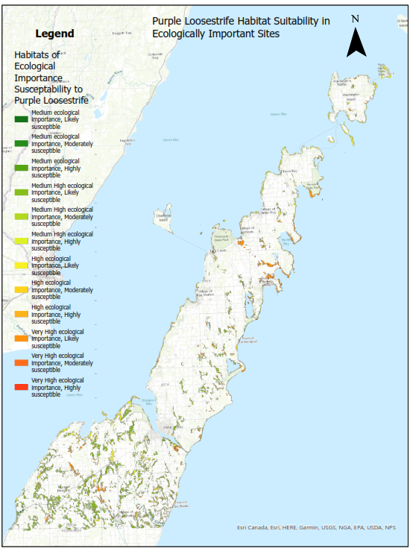
Figure 2 Purple loosestrife habitat suitability modeling in ecologically important habitat as determined by the Door County Greenprint model. This map is the final iteration of data, creating a focus area to inventory purple loosestrife that could most great impact Door County’s most ecologically important areas.
Figure 3 Non-native Phragmites habitat suitability modeling in habitat assessed for ecological importance. This map is the first iteration of data displaying the total data set.

Figure 4 Non-native Phragmites habitat suitability modeling in ecologically important habitat as determined by the Door County Greenprint model. This map is the final iteration of data, creating a focus area to inventory non-native phragmites that could most great impact Door County’s most ecologically important areas.

Activity 1b. Inventory target areas for Phragmites using maps generated in activity 1.a. Inventory purple loosestrife and Japanese knotweed in wetlands, riparian coordinators, drainage ways, and shoreline areas.

Door County utilized the models from 1a. to imform inventory efforts. During 2023 SWCD inventoried 333 acres of non-native phragmites, 9.7 acres of purple loosestrife, and 9.7 acres of knotweed. Of the 333 acres of non-native 291 acres occur within the high priority project area, and of the 9.7 acres of purple loosestrife inventoried 6 acres occurs in the high priority area. Additionally, SWCD inventoried Ephraim Creek, Rieobolts Creek, Strawberry Creek, Samuelson Creek and Lost Creek (for a total of 13.1 miles inventoried, 8% of stream/creek cooridors inventoried). Additionally, Lost Lake, Clark Lake, and Mudd Lake, were inventoried in 2023.

SWCD inventoried 12.9 acres of knotweed in 2023. Of those 12.9 acres, 2.1 acres occur within 2000 ft of a riparian area, 2.8 acres occur within 150 ft of a wetland, 2.4 acres occur within 300 ft of the 100 year flood zone.

SWCD collected mailed them out for genomic sequencing as part of another state project to identify populations of Japanese, bohemien, and giant knotweed. The following maps are the results of inventory efforts for 2023.
Figure 5 Non-native Phragmites inventoried and treated in 2023 in priority project areas determined in activity 1a. described above.

Figure 6 Purple loosestrife inventoried and controlled with biocontrol in 2023 in priority project areas determined in activity 1a. described above.
Figure 7 Knotweed inventoried and treated in 2023 throughout Door County.
Activity 1c. Control Phragmites australis, Japanese knotweed, and purple loosestrife using best management practices, following site specific control recommendations, recommendations by PAMF, and adhering to all federal and state requirements including permits. Control efforts will be consistent with the Door County Invasive Species Strategic Plan utilizing integrated pest management strategies. Control methods will consist of manual means (ex small singular plant occurrences, populations in critical habitats, etc), biological control (ex. large populations able to host the control agent) and chemical consisting of applications made by a certified and licensed applicator utilizing aquatic approved herbicides including but not limited to glyphosate (ex Aquaneat, Rodeo, and Touchdown) and imazapyr (Habitat, and Polaris).

SWCD through funding provided in part of this grant, treated and retreated 130 acres of non-native phragmites between 2022 and 2023, and in 2023 treated for the first time 64 acres, for a total of 194 acres treated in 2023 (exceeding the 70-acre mark specified in deliverables). Sites treated in 2022 saw remarkable reduction with the median density of populations between 5-25%.

SWCD through funding provided in part of this grant, treated and retreated 4.1 acres of knotweed between 2022 and 2023, and in 2023 treated for the first time 4.1 acres, for a total of 8.2 acres treated in 2023 (exceeding the 8-acre mark specified in deliverables). Sites treated in 2022 saw remarkable reduction with the median density of populations between 1-5%. SWCD for knotweed utilized herbicide to control populations.

SWCD treated 5.2 acres in 2022 of purple loosestrife (exceeding 5-acre mark specified in deliverables). In 2023 SWCD monitored and released purple loosestrife beetles to provide sustained control. Out of the 9.7 acres inventoried 4.7 occurred within 2,000 feet of the biocontrol sites helping manage populations. The remainder of sites reported density of 1-5%. Future efforts will look to utilize chemical and mechanical control to manage straggler or isolated populations.

Control efforts for each of these species were site and population dependent. SWCD contracted with a contractor to control non-native phragmites in 2023. They were required to meet all environmental considerations including utilizing glyphosate in Hines emerald habitat, utilizing various control techniques including hand swiping and foliar applications.

Maps of the control efforts can be seen above.

Activity 1d. Monitor treatment progress.

SWCD saw considerable population improvement across all target species populations. For non-native phragmites, SWCD observed the median density of populations treated in 2022 between 5-25% (Figure 5). For knotweed, SWCD observed median density of populations between 1-5% for populations treated in 2022 (Figure 7). SWCD observed at the 5.2 acres treated in 2022 purple loosestrife densities were between 1-5% (Figure 6).

