Warm-water Point-intercept Survey
Sand Lake (WBIC: 2661100)
Barron County, Wisconsin

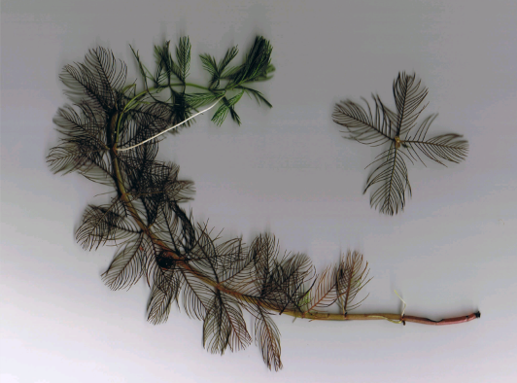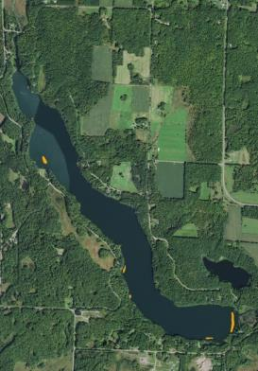
Eurasian Water-milfoil (Berg 2007) 2019 Sand Lake EWM Treatment Areas

Project Initiated by:
Sand Lake Management District, Lake Education and Planning Services, LLC, and the Wisconsin Department of Natural Resources

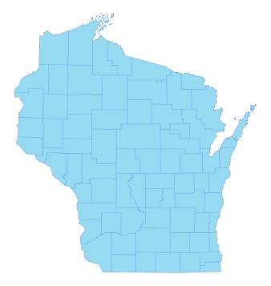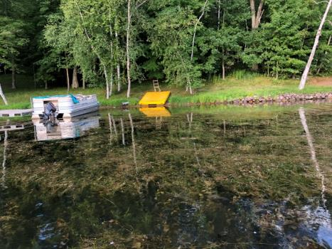

* Sand
Lake
Dense canopied native pondweeds 8/15/19

Survey Conducted by and Report Prepared by:
Endangered Resource Services, LLC
Matthew S. Berg, Research Biologist
St. Croix Falls, Wisconsin
August 15, 2019
TABLE OF CONTENTS

Page
ABSTRACT……… ………………..……..…………………………………………………………. ii

LIST OF FIGURES..………………..……..………………………………………………...……….. iv

LIST OF TABLES…………………..……..………………………………………………..……….. v

INTRODUCTION.……….…..……..………………………………………………………..………. 1

STUDY BACKGROUND AND RATIONALE…….………………………………………..……… 1

METHODS.……………………………………………………………….………………………….. 2

DATA ANALYSIS……………………………………………………….………………………….. 3

RESULTS.……………………..…………………………………………………………….……….. 6

Warm-water Full Point-intercept Macrophyte Survey.……………………………………... 6

Comparison of Eurasian Water-milfoil in 2016, 2017, 2018, and 2019.…………………… 11

Comparison of Native Species in 2016, 2017, 2018, and 2019….…………………………. 14

Comparison of Filamentous Algae in 2016, 2017, 2018, and 2019……………………...…. 31

Comparison of Floristic Quality Indexes in 2016, 2017, 2018, and 2019.…………………. 36

Other Exotic Species………….………………………....…………………………….….… 41

DISCUSSION AND CONSIDERATIONS FOR MANAGEMENT……………………….……….. 42

LITERATURE CITED……….……………………….…………………………………….……….. 44

APPENDIXES……….…….………………………………………………….…………….……….. 45

I: Boat and Vegetative Survey Datasheets…..…………………………………………………… 45

II: Survey Sample Points Map.…………….…….……..…………………………………….…… 48

III: Habitat Variable Maps……………………………………...………..……………………........ 50

IV: 2016, 2017, 2018, and 2019 Lit. Zone, Native Species Richness and Total Rake Fullness Maps 53

V: 2016, 2017, 2018, and 2019 EWM Density and Distribution, and Bed Maps..………………... 66

VI: 2019 Species Density and Distribution Maps……………………….. …………...…………… 75

VII: Aquatic Exotic Invasive Plant Species Information.…………………….…………………...... 123

VIII: Glossary of Biological Terms.……………….…………...……………………….………........ 132

IX: 2019 Raw Data Spreadsheets………………………………………………………………….. 136
ABSTRACT
Sand Lake (WBIC 2661100) is a 322 acre mesotrophic drainage lake located in northwestern Barron County, Wisconsin. The lake’s average depth is 30ft, and the bottom substrate is predominantly sand and sandy muck. Water clarity is good to very good with Secchi values averaging 13.2ft from 2000-2019. Eurasian water-milfoil (Myriophyllum spicatum) was first discovered in the lake in 2002, and the Sand Lake Management District (SLMD) is actively managing the infestation with herbicides. In 2016, the SLMD, Lake Education and Planning Services, LLC (LEAPS), and the Wisconsin Department of Natural Resource (WDNR) commissioned an expanded point-intercept survey to take the place of annual pre/post monitoring and fall EWM bed mapping. The reason for the change to a year-over-year monitoring strategy was to quantify the effectiveness of the current management programs on EWM, to better assess any potential impacts on native plants, and to locate deep water EWM beds that were not visible from the surface. The 2019 survey found macrophytes at 472 points (95.0% of the 17.0ft littoral zone), and this was nearly identical to each of the three previous surveys (2018 - 474 points/96.3% of the then 16.0ft littoral zone; 2017 - 474 points/91.9% - 19.0ft littoral zone; and 2016 - 470 points/90.9% - 18.5ft littoral zone). We identified 49 species growing in and immediately adjacent to the lake, and the 45 species in the rake (similar to 48/43 species in 2018, 52/44 in 2017, and 51/43 in 2016) produced a Simpson Diversity Index Value of 0.94 (up from 0.93 in 2018 and identical to 2017/2016). Mean species richness at sites with native species was a high 3.99 species/site – a non-significant increase (p=0.32) from 3.93 species/site in 2018 and nearly identical to 2017’s 4.01 species/site. However, each of these values represented a highly significant increase (p<0.001) from the moderate value of 3.62 species/site in 2016. In 2019, plant growth, after being moderate dense and nearly identical for three years (mean rake fullness of 2.16 in 2016, 2.19 in 2017, and 2.18), experienced a highly significant expansion (p<0.001) to a moderately high density of 2.37. The 2019 survey found EWM at 17 points (3.60% of points with vegetation) with a mean rake fullness of 1.53. Compared to 2018 (11 points – 2.32% of points with vegetation/mean rake 2.09), neither the increase in distribution (p=0.25), nor the decrease in density (p=0.06) were significant. It was also similar to 2017 (20 points – 4.22% of points with vegetation/mean rake 1.75) and 2016 (15 points – 3.19% of points with vegetation/mean rake of 1.73). We documented nine significant EWM beds surrounding survey points; this was up from five in 2018, two in 2017, and six in 2016. Our 2019 survey found Coontail (Ceratophyllum demersum), Small pondweed (Potamogeton pusillus), Flat-stem pondweed (Potamogeton zosteriformis), and Forked duckweed (Lemna trisulca) were the most common species. They were present at 51.69%, 41.53%, 40.47%, and 27.33% of survey points with vegetation and accounted for 40.23% of the relative frequency. This was similar to 2018 when Coontail, Small pondweed, Flat-stem pondweed, and Muskgrass (Chara sp.) were the most widely distributed species (47.26%, 45.78%, 43.25%, and 28.27% of survey points with vegetation/41.67% of the relative frequency). In 2017, Coontail, Flat-stem pondweed, Small pondweed, and Northern water-milfoil (Myriophyllum sibiricum) were the most common species (52.95%, 39.66%, 35.02% and 26.16% of survey points with vegetation/38.13% of the relative frequency). These same four species were also the most common in 2016 when Coontail was found at 49.79% of points with vegetation, Flat-stem pondweed at 41.06%, Small pondweed at 30.21%, and Northern water-milfoil at 28.51% (40.94% of the total relative frequency). Following the 2019 survey, we documented 15 species that underwent significant changes in distribution when compared to 2018. Muskgrass, Slender naiad (Najas flexilis), and Fries’ pondweed (Potamogeton friesii) all suffered highly significant declines; Small duckweed (Lemna minor) and Illinois pondweed (Potamogeton illinoensis) saw moderately significant declines; and Common waterweed (Elodea canadensis) and Common watermeal (Wolffia columbiana) had significant declines. Despite these losses, we found Clasping-leaf pondweed (Potamogeton richardsonii), Fern pondweed (Potamogeton robbinsii), Northern water-milfoil, and Variable pondweed (Potamogeton gramineus) all enjoyed highly significant expansions; Water star-grass (Heteranthera dubia) and Water marigold (Bidens beckii) saw moderately significant increases; and Wild celery (Vallisneria americana) had a significant increase. From 2017 to 2018, 12 species experienced significant changes in distribution. Northern water-milfoil, Variable pondweed, White water crowfoot (Ranunculus aquatilis), and Nitella (Nitella sp.) suffered highly significant declines; Large-leaf pondweed (Potamogeton amplifolius) demonstrated a moderately significant decline; and Common waterweed and Water star-grass saw significant declines. Conversely, we saw highly significant increases in Small pondweed and Slender naiad; and moderately significant increases in Muskgrass, Forked duckweed, and Common watermeal. From 2016 to 2017, nine species experienced significant changes in distribution: Illinois pondweed suffered a highly significant decline; and Slender naiad a significant decline. However, Common waterweed and filamentous algae demonstrated highly significant increases; Fries’ pondweed, Fern pondweed, Small duckweed, and Nitella saw moderately significant increases; and Large duckweed (Spirodela polyrhiza) had a significant increase. In 2019, Filamentous algae were found at 112 sites with a mean rake fullness of 1.29 (similar to 111 points with a mean rake of 1.17 in 2018/91 points – mean rake of 1.31 in 2017/50 points – mean rake 1.38 in 2016). A total of 43 native index species (42 in 2018/43 in 2017/41 in 2016) produced an above average mean Coefficient of Conservatism of 5.9 (6.0 in 2018/6.1 in 2017/6.0 in 2016), and a Floristic Quality Index of 38.6 (38.7 in 2018/39.8 in 2017/38.3 in 2016) that was nearly twice the median for this part of the state. In addition to EWM, other exotic species found included Purple loosestrife (Lythrum salicaria) scattered midlake (all removed by us) and Reed canary grass (Phalaris arundinacea) in disturbed shoreline areas. Continuing to work to maintain the EWM population at its current low levels while preserving native species, removing Purple loosestrife from all areas along the lakeshore, and deciding on a course of action for future macrophyte surveys are all topics for the SLMD, LEAPS, and the WDNR to discuss moving forward.
LIST OF FIGURES

Page
Figure 1: Sand Lake Bathymetric Map……………………………….……………….…… 1
Figure 2: Rake Fullness Ratings……………………………….…….…………………….. 2
Figure 3: Lake Depth and Bottom Substrate………………………………………………. 6
Figure 4: 2016, 2017, 2018, and 2019 Littoral Zone.………………………..…………….. 7
Figure 5: 2016, 2017, 2018, and 2019 Native Species Richness…………………………... 9
Figure 6: 2016, 2017, 2018, and 2019 Total Rake Fullness……..………………………… 10
Figure 7: 2016, 2017, 2018, and 2019 EWM Density and Distribution….………………... 11
Figure 8: 2016-2019 Changes in EWM Rake Fullness……….…………………………… 12
Figure 9: 2016, 2017, 2018, and 2019 Significant Summer EWM Beds………………….. 13
Figure 10: 2016-2019 Coontail Density and Distribution………………….……………… 27
Figure 11: 2016-2019 Flat-stem Pondweed Density and Distribution…………….……….. 28
Figure 12: 2016-2019 Small Pondweed Density and Distribution.…………..……………. 29
Figure 13: 2016-2019 Northern Water-milfoil Density and Distribution.…………………. 30
Figure 14: Macrophytes Showing Significant Changes from 2016-2017…………………. 32
Figure 15: Macrophytes Showing Significant Changes from 2017-2018…………………. 33
Figure 16: Macrophytes Showing Significant Changes from 2018-2019…………………. 34
Figure 17: 2016-2019 Filamentous Algae Density and Distribution………………….…… 35
Figure 18: Purple Loosestrife Flowers and 2019 Locations……………………………….. 41
Figure 19: Sand Lake Treatment Areas 6/6/19…………………………………………….. 43

LIST OF TABLES

Page
Table 1: Aquatic Macrophyte P/I Survey Summary Statistics – Sand Lake, Barron County
July 25, 2016, July 23-24, 2017, July 31-August 1, 2018, and August 15, 2019…………... 8

Table 2: Frequencies and Mean Rake Sample of Aquatic Macrophytes
Sand Lake, Barron County – July 25, 2016………………………………………………… 15

Table 3: Frequencies and Mean Rake Sample of Aquatic Macrophytes
Sand Lake, Barron County – July 23-24, 2017………………...…………………………… 18

Table 4: Frequencies and Mean Rake Sample of Aquatic Macrophytes
Sand Lake, Barron County – July 31-August 1, 2018…………...…………………………. 21

Table 5: Frequencies and Mean Rake Sample of Aquatic Macrophytes
Sand Lake, Barron County – August 15, 2019……….……….............................................. 24

Table 6: Floristic Quality Index of Aquatic Macrophytes –
Sand Lake, Barron County – July 25, 2016………………………………………………… 36

Table 7: Floristic Quality Index of Aquatic Macrophytes –
Sand Lake, Barron County – July 23-24, 2017…………………………………………….. 37

Table 8: Floristic Quality Index of Aquatic Macrophytes –
Sand Lake, Barron County – July 31-August 1, 2018.………...........................................… 38

Table 9: Floristic Quality Index of Aquatic Macrophytes –
Sand Lake, Barron County – August 15, 2019……….……….............................................. 40

Table 10: Spring Eurasian Water-milfoil Treatment Summary
Sand Lake, Barron County – June 6, 2019.………............................................................… 42

INTRODUCTION:
Sand Lake (WBIC 2661100) is a 322 acre stratified drainage lake in northwestern Barron County, Wisconsin in the Town of Maple Plain (T36N R14W S17 NW NE). It reaches a maximum depth of 57ft in the south basin and has an average depth of approximately 30ft. The lake is mesotrophic bordering on oligotrophic in nature with good to very good water clarity. From 1988 to 2019, summer Secchi readings have ranged from 10-18ft with an average of 13.2ft (WDNR 2019). This clarity produced a littoral zone that extended to at least 17ft in 2019. The bottom substrate is predominately sand and sandy muck with scattered gravel primarily along the shoreline. Nutrient-rich organic muck occurs in bays on the west side of the lake and at the far north and south ends (Miller et al. 1965) (Figure 1).

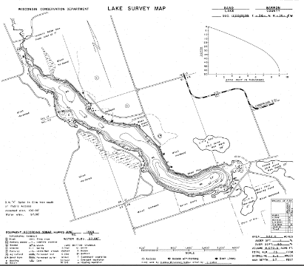
Figure 1: Sand Lake Bathymetric Map

STUDY BACKGROUND AND RATIONALE:
Eurasian water-milfoil (Myriophyllum spicatum) (EWM) was discovered in Sand Lake in 2002, and the Sand Lake Management District (SLMD), under the direction of Dave Blumer - Lake Education and Planning Services, LLC (LEAPS), is engaged in active management using herbicides to control this invasive exotic plant species. In the past, fall bed mapping surveys have been used to determine where treatments might be considered during the following growing season. Unfortunately, many of the EWM beds on the lake occur in deep water (10ft+) making it difficult to locate them as they seldom canopy and water clarity tends to decline in the fall as vegetation senesces. These factors have occasionally led to beds going undetected.

In 2016, LEAPS, the SLMD, and the Wisconsin Department of Natural Resources (WDNR) decided that an annual warm-water point-intercept survey at a higher resolution than the original WDNR survey grid would replace the annual pre/posttreatment monitoring and the fall bed-mapping surveys. This change in methodology was made because a regular quantitative survey allows for statistical year-over-year comparisons to assess the effectiveness of the lake’s active management while simultaneously providing a way to more closely measure any potential impacts on the lake’s native plants. It should also allow for better detection of EWM beds that are not visible from the surface. This report is the summary analysis of the August 15, 2019 field survey and its comparison to the July 25, 2016, July 23-24, 2017, and July 31-August 1, 2018 surveys.
METHODS:
Warm-water Full Point-intercept Macrophyte Survey:
Prior to beginning the point-intercept survey, we conducted a general boat survey of the lake to regain familiarity with the species present (Appendix I). All plants found were identified (Voss 1996, Boreman et al. 1997; Chadde 2002; Crow and Hellquist 2006, Skawinski 2014), and a field datasheet was developed.

In 2016, we used the <20ft bathymetric contour shapefile provided by LEAPS to create a 518 regular offset point survey grid at 25m resolution – double the approximately 250 littoral points in the original WDNR 932 point grid at 37m resolution (Appendix II). Using this same grid in 2017, 2018, and 2019, we located each point with a handheld mapping GPS unit (Garmin 76CSx), recorded a depth reading with a metered pole rake or hand held sonar (Vexilar LPS-1), and used a rake to sample an approximately 2.5ft section of the bottom. All plants on the rake, as well as any that were dislodged by the rake, were identified and assigned a rake fullness value of 1-3 as an estimation of abundance (Figure 2). We also recorded visual sightings of all plants within six feet of the sample point not found in the rake. In addition to a rake rating for each species, a total rake fullness rating was also noted. Substrate (bottom) type was assigned at each site where the bottom was visible or it could be reliably determined using the rake.

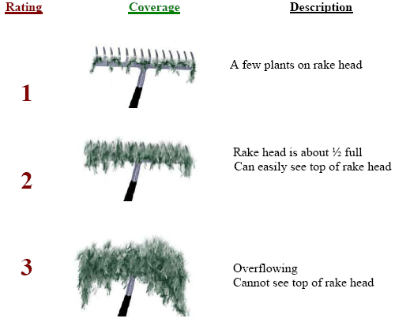
Figure 2: Rake Fullness Ratings (UWEX 2010)

To further assist with management, we also noted the location of any visible Eurasian water-milfoil beds surrounding or between survey points. Although the perimeters/areas of these beds were not delineated, we mapped them separately from the point-intercept data for ease in locating them.

DATA ANALYSIS:
Following the survey, we entered all data collected into the standard APM spreadsheet (Appendix I) (UWEX 2010). From this, we calculated the following:

Total number of sites visited: This included the total number of points on the lake that were accessible to be surveyed by boat.

Total number of sites with vegetation: These included all sites where we found vegetation after doing a rake sample. For example, if 20% of all sample sites have vegetation, it suggests that 20% of the lake has plant coverage.

Total number of sites shallower than the maximum depth of plants: This is the number of sites that are in the littoral zone. Because not all sites that are within the littoral zone actually have vegetation, we use this value to estimate how prevalent vegetation is throughout the littoral zone. For example, if 60% of the sites shallower than the maximum depth of plants have vegetation, then we estimate that 60% of the littoral zone has plants.

Frequency of occurrence: The frequency of all plants (or individual species) is generally reported as a percentage of occurrences within the littoral zone. It can also be reported as a percentage of occurrences at sample points with vegetation.

Frequency of occurrence example:

Plant A is sampled at 70 out of 700 total littoral points = 70/700 = .10 = 10%
This means that Plant A’s frequency of occurrence = 10% when considering the entire
littoral zone.

Plant A is sampled at 70 out of 350 total points with vegetation = 70/350 = .20 = 20%
This means that Plant A’s frequency of occurrence = 20% when only considering the
sites in the littoral zone that have vegetation.

From these frequencies, we can estimate how common each species was at depths
where plants were able to grow, and at points where plants actually were growing.
Note the second value will be greater as not all the points (in this example, only ½)
had plants growing at them.

Simpson’s Diversity Index: A diversity index allows the entire plant community at one location to be compared to the entire plant community at another location. It also allows the plant community at a single location to be compared over time thus allowing a measure of community degradation or restoration at that site. With Simpson’s Diversity Index, the index value represents the probability that two individual plants (randomly selected) will be different species. The index values range from 0 -1 where 0 indicates that all the plants sampled are the same species to 1 where none of the plants sampled are the same species. The greater the index value, the higher the diversity in a given location. Although many natural variables like lake size, depth, dissolved minerals, water clarity, mean temperature, etc. can affect diversity, in general, a more diverse lake indicates a healthier ecosystem. Perhaps most importantly, plant communities with high diversity also tend to be more resistant to invasion by exotic species.

Maximum depth of plants: This indicates the deepest point that vegetation was sampled. In clear lakes, plants may be found at depths of over 20ft, while in stained or turbid locations, they may only be found in a few feet of water. While some species can tolerate very low light conditions, others are only found near the surface. In general, the diversity of the plant community decreases with increased depth.

Mean and median depth of plants: The mean depth of plants indicates the average depth in the water column where plants were sampled. Because a few samples in deep water can skew this data, median depth is also calculated. This tells us that half of the plants sampled were in water shallower than this value, and half were in water deeper than this value.

Number of sites sampled using rope/pole rake: This indicates which rake type was used to take a sample. We use a 15ft pole rake and a 35ft rope rake for sampling.

Average number of species per site: This value is reported using four different considerations. 1) shallower than maximum depth of plants indicates the average number of plant species at all sites in the littoral zone. 2) vegetative sites only indicate the average number of plants at all sites where plants were found. 3) native species shallower than maximum depth of plants and 4) native species at vegetative sites only excludes exotic species from consideration.

Species richness: This value indicates the number of different plant species found in and directly adjacent to (on the waterline) the lake. Species richness alone only counts those plants found in the rake survey. The other two values include those seen at a sample point during the survey but not found in the rake, and those that were only seen during the initial boat survey or inter-point. Note: Per DNR protocol, filamentous algae, freshwater sponges, aquatic moss and the aquatic liverworts Riccia fluitans and Ricciocarpus natans are excluded from these totals.

Average rake fullness: This value is the average rake fullness of all species in the rake at all sites. It only takes into account those sites with vegetation (Table 1).

Relative frequency: This value shows a species’ frequency relative to all other species. It is expressed as a percentage, and the total of all species’ relative frequencies will add up to 100%. Organizing species from highest to lowest relative frequency value gives us an idea of which species are most important within the macrophyte community (Tables 2-5).

Relative frequency example:

Suppose that we sample 100 points and found 5 species of plants with the following results:

Plant A was located at 70 sites. Its frequency of occurrence is thus 70/100 = 70%
Plant B was located at 50 sites. Its frequency of occurrence is thus 50/100 = 50%
Plant C was located at 20 sites. Its frequency of occurrence is thus 20/100 = 20%
Plant D was located at 10 sites. Its frequency of occurrence is thus 10/100 = 10%

To calculate an individual species’ relative frequency, we divide the number of sites a plant is sampled at by the total number of times all plants were sampled. In our example that would be 150 samples (70+50+20+10).

Plant A = 70/150 = .4667 or 46.67%
Plant B = 50/150 = .3333 or 33.33%
Plant C = 20/150 = .1333 or 13.33%
Plant D = 10/150 = .0667 or 6.67%

This value tells us that 46.67% of all plants sampled were Plant A.

Floristic Quality Index (FQI): This index measures the impact of human development on an area’s aquatic plants. The 124 species** in the index are assigned a Coefficient of Conservatism (C) which ranges from 1-10. The higher the value assigned, the more likely the plant is to be negatively impacted by human activities relating to water quality or habitat modifications. Plants with low values are tolerant of human habitat modifications, and they often exploit these changes to the point where they may crowd out other species. The FQI is calculated by averaging the conservatism value for each native index species found in the lake during the point-intercept survey, and multiplying it by the square root of the total number of plant species (N) in the lake (FQI=(Σ(c1+c2+c3+…cn)/N)*√N). Statistically speaking, the higher the index value, the healthier the lake’s macrophyte community is assumed to be. Nichols (1999) identified four eco-regions in Wisconsin: Northern Lakes and Forests, Northern Central Hardwood Forests, Driftless Area and Southeastern Wisconsin Till Plain. He recommended making comparisons of lakes within ecoregions to determine the target lake’s relative diversity and health. Sand Lake is in the Northern Central Hardwood Forests Ecoregion (Tables 6-9).

** Species that were only recorded as visuals or during the boat survey, and species found in the rake that are not included in the index are excluded from FQI analysis.

Comparison to Past Surveys: For ease in determining the total impact of the current treatment program, data from 2016, 2017, 2018, and the current 2019 survey were included in the results section of this report. We compared data from the 2016 and 2017 surveys, the 2017 and 2018 surveys, and the 2018 and 2019 surveys to identify any significant changes in the lake’s vegetation. For individual plant species as well as count data, we used the Chi-square analysis on the WDNR Pre/Post survey worksheet. For comparing averages (mean species/point and mean rake fullness/point), we used t-tests. Differences were considered significant at p<0.05, moderately significant at p<0.01 and highly significant at p<0.001 (UWEX 2010). It should be noted that we used the number of littoral points with vegetation as the basis for “sample points” in the statistical calculations (470 in 2016 and 474 in both 2017 and 2018, and 472 in 2019).

RESULTS:
Warm-water Full Point-intercept Macrophyte Survey:
Depth soundings taken at the 518 survey points (Appendix II) ranged from 0.5-24.5ft. Even with narrowing the spacing between points, the lake’s sharp drop-offs resulted in the majority of the lake having a single point between the shoreline and the edge of the littoral zone (Figure 3) (Appendix III).

Organic and sandy muck in the lake’s sheltered bays and flats accounted for 41.5% (215 points) of the substrate within the littoral zone. Pure sand shorelines that ringed the majority of the central basins covered 52.9% (274 points) of the bottom, and scattered gravel and cobble areas, especially on the south shoreline adjacent to the lake’s deepest point, made up the remaining 5.6% (29 points) (Figure 3) (Appendix III).

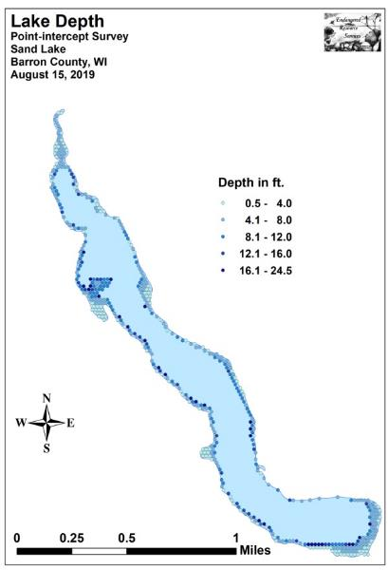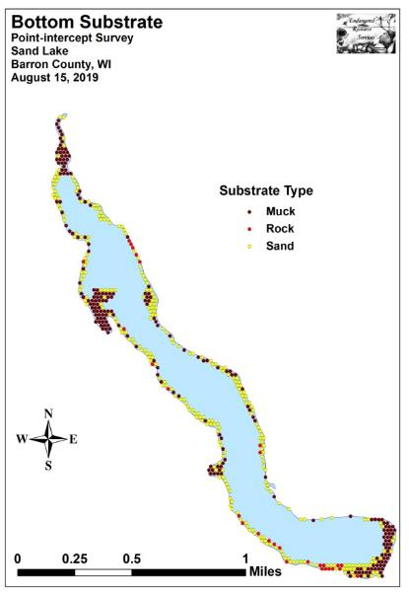
Figure 3: Lake Depth and Bottom Substrate

In 2016, we found plants at 470 points (90.9% of the then 18.5ft littoral zone) (Figure 4). This increased to 474 points in both 2017 and 2018 (91.9% of the 19.0ft littoral zone in 2017 and 96.3% of the 16.0ft littoral zone in 2018). During the 2019 survey, plants were present at 472 sites (95.0% of the 17.0ft littoral zone) (Appendix IV). The mean and median depths of plants were almost unchanged during the four year study (6.3ft/6.0ft in 2016 – 6.6ft/6.0ft in 2017 – 6.2ft/6.0ft in 2018, and 6.5ft/6.5ft in 2019 (Table 1).
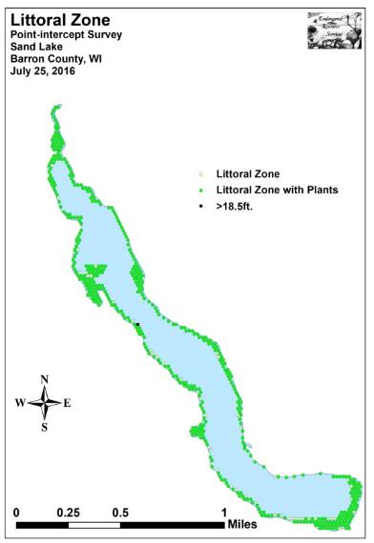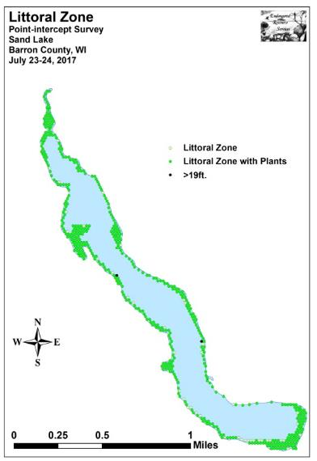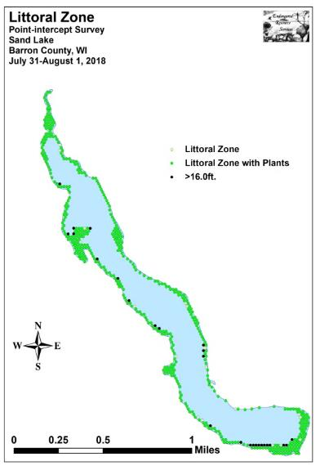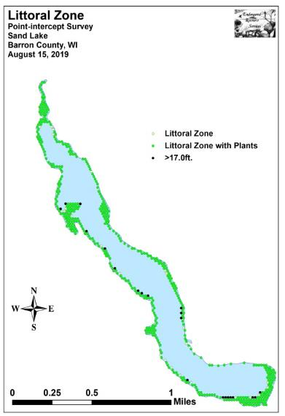
Figure 4: 2016, 2017, 2018, and 2019 Littoral Zone

Table 1: Aquatic Macrophyte P/I Survey Summary Statistics
Sand Lake, Barron County
July 25, 2016, July 23-24, 2017, July 31-August 1, 2018, and
August 15, 2019

Summary Statistics: | 2016 | 2017 | 2018 | 2019
Total number of points sampled | 518 | 518 | 518 | 518
Total number of sites with vegetation | 470 | 474 | 474 | 472
Total number of sites shallower than the max. depth of plants | 517 | 516 | 492 | 497
Freq. of occurrence at sites shallower than max. depth of plants | 90.9 | 91.9 | 96.3 | 95.0
Simpson Diversity Index | 0.94 | 0.94 | 0.93 | 0.94
Maximum depth of plants (ft) | 18.5 | 19.0 | 16.0 | 17.0
Mean depth of plants (ft) | 6.3 | 6.6 | 6.2 | 6.5
Median depth of plants (ft) | 6.0 | 6.0 | 6.0 | 6.5
Ave. number of all species per site (shallower than max depth) | 3.32 | 3.71 | 3.80 | 3.80
Ave. number of all species per site (veg. sites only) | 3.65 | 4.03 | 3.95 | 4.00
Ave. number of native species per site (shallower than max depth) | 3.29 | 3.67 | 3.78 | 3.77
Ave. number of native species per site (veg. sites only) | 3.62 | 4.01 | 3.93 | 3.99
Species richness | 43 | 44 | 43 | 45
Species richness (including visuals) | 47 | 49 | 46 | 45
Species richness (including visuals and boat survey) | 51 | 52 | 48 | 49
Mean rake fullness (veg. sites only) | 2.16 | 2.19 | 2.18 | 2.37

Plant diversity in 2019 was exceptionally high with a Simpson Diversity Index value of 0.94 (identical to 2016 and 2017, and up from 0.93 in 2018). Total richness was also moderately high as we found 45 species in the rake (similar to the 43 species in 2016, 44 in 2017, and 43 in 2018). This number jumped to 49 when including visuals and species seen during the boat survey (also similar to 51 in 2016, 52 in 2017, and 48 in 2018).

In 2016, we found the mean native species richness at sites with native vegetation was a moderate 3.62 species/site. Following a highly significant increase (p<0.001) to a high 4.01 species/site in 2017, the 2018 average underwent a non-significant decline (p=0.27) to 3.93 species/site. In 2019, mean richness experienced a non-significant increase (p=0.32) back to a high 3.99 native species/site (Figure 5) (Appendix IV).
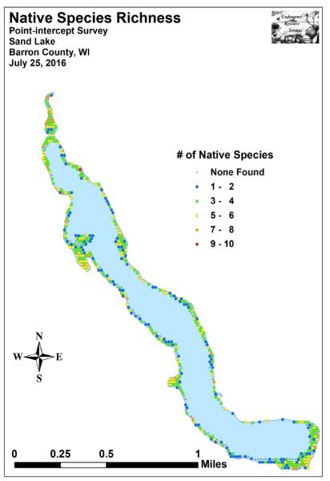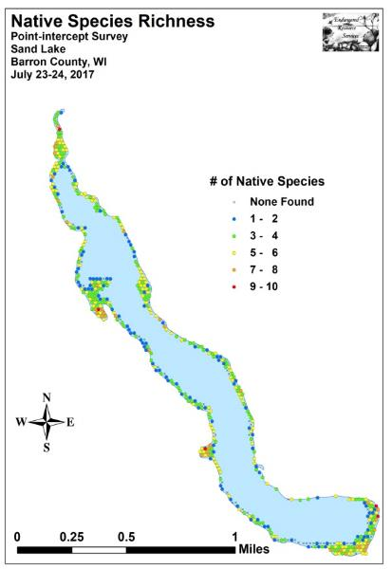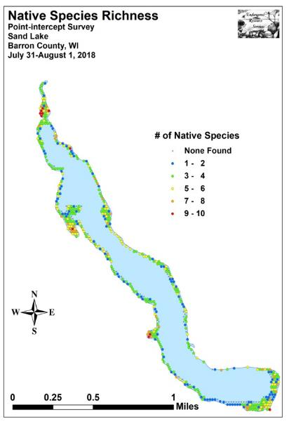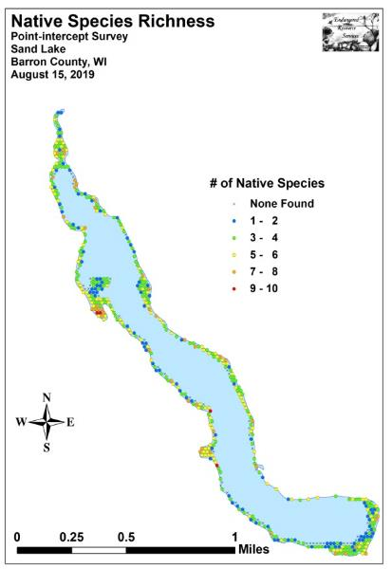
Figure 5: 2016, 2017, 2018, and 2019 Native Species Richness
From 2016 to 2017, mean total rake fullness experienced a non-significant increase (p=0.24) from a moderately dense 2.16 to 2.19 (Figure 6). In 2018, this value was nearly unchanged at 2.18 before experiencing a highly significant increase (p<0.001) to a moderately high density of 2.37 in 2019 (Appendix IV).

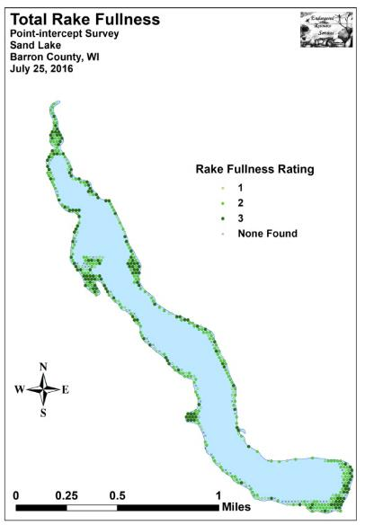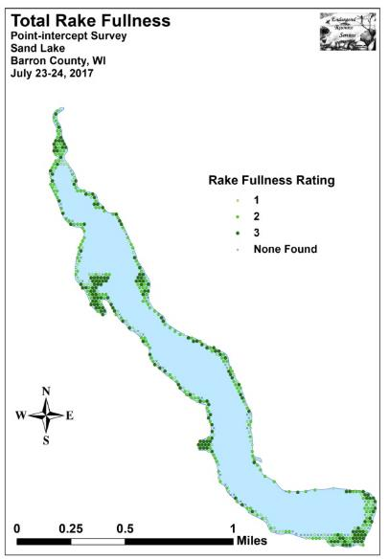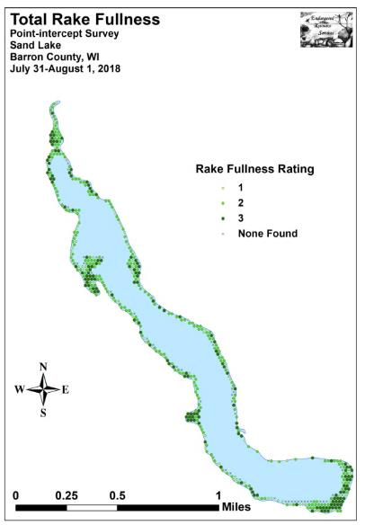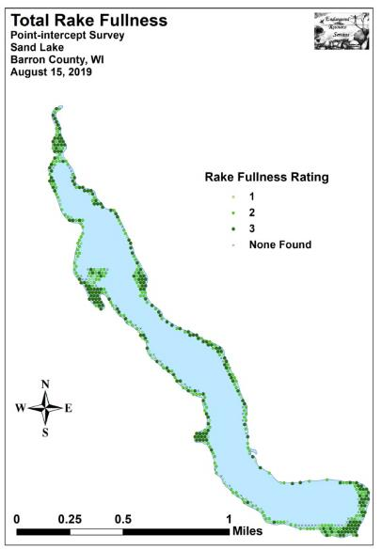
Figure 6: 2016, 2017, 2018, and 2019 Total Rake Fullness

Comparison of Eurasian Water-milfoil in 2016, 2017, 2018, and 2019:
The 2016 survey found Eurasian water-milfoil at 15 sites (3.19% of points with vegetation) which resulted in a relative frequency of 0.87% (Table 2). Of these, three had a rake fullness of 3, five were a 2, and the remaining seven were a 1 for a mean rake fullness of 1.73. EWM was also recorded as a visual at eight points (Figure 7) (Appendix V).

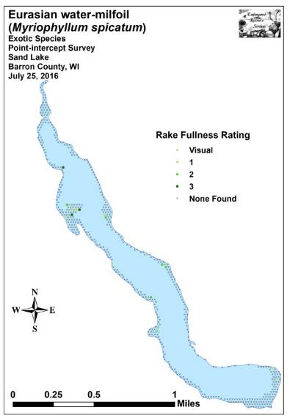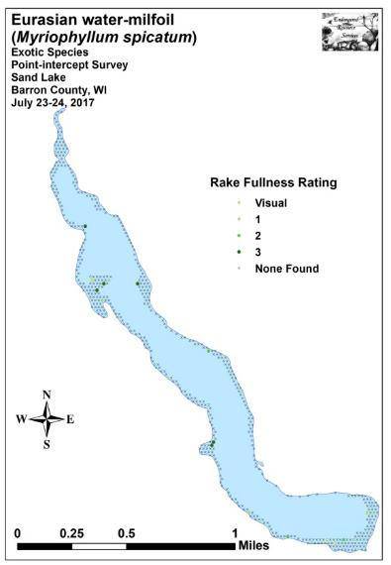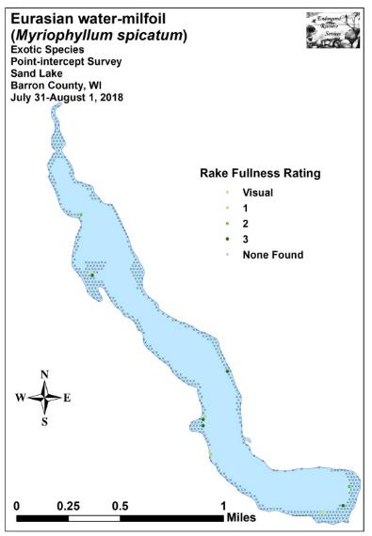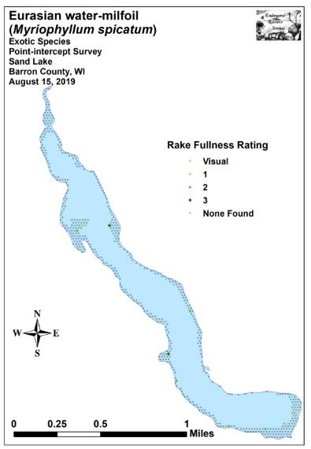
Figure 7: 2016, 2017, 2018, and 2019 EWM Density and Distribution
During the 2017 survey, we found EWM at 20 sites (4.22% of points with vegetation), and it accounted for 1.05% of the total relative frequency (Table 3). Six points had a rake fullness of 3, three were a 2, and 11 were a 1 for a mean rake of 1.75. We also recorded EWM as a visual at five points (Figure 7) (Appendix V). Although both the distribution and density increased in 2017, none of these values represented a significant change over the 2016 survey. Likewise, none of the changes in rake fullness were significant (Figure 8).

In 2018, EWM was present at 11 sites (2.32% of points with vegetation), and it contributed just 0.59% to the total relative frequency (Table 4). We rated five points a rake fullness of 3, two points a 2, and four points a 1 for a mean rake of 2.09. We again recorded EWM as a visual at five points (Figure 7) (Appendix V). Similar to the changes noted in 2017, we found that neither the increase in density (p=0.17), nor the decline in distribution (p=0.10) were significant (Figure 8).

Our 2019 survey found EWM in the rake at 17 sites (3.60% of points with vegetation), and it contributed 0.90% of the total relative frequency (Table 5). We rated two points a rake fullness of 3, five points a 2, and ten points a 1 for a mean rake of 1.53. We also recorded EWM as a visual at four points (Figure 7) (Appendix V). Just as in each year since 2016, we found that none of the changes in rake fullness were significant. Similarly, the overall decrease in mean density (p=0.06), and the increase in distribution (p=0.25) were not significant (Figure 8).

Significant differences = * p<0.05, ** p<0.01, *** p<0.001
Figure 8: 2016 - 2019 Changes in EWM Rake Fullness
The July 2016 survey identified six significant beds of Eurasian water-milfoil (Figure 9). In July 2017, we noted just two significant beds – both of which were located along the western shoreline in the southern third of the lake. This total jumped back up to five beds in 2018 and nine beds in 2019. Each of these areas represent continued “trouble spots” where herbicide control has been difficult because the EWM is located in 8-12ft of water on the outer edge of the littoral zone adjacent to sharp drop-offs into deep water (Appendix V).
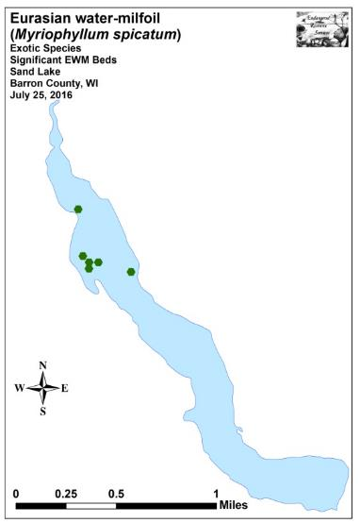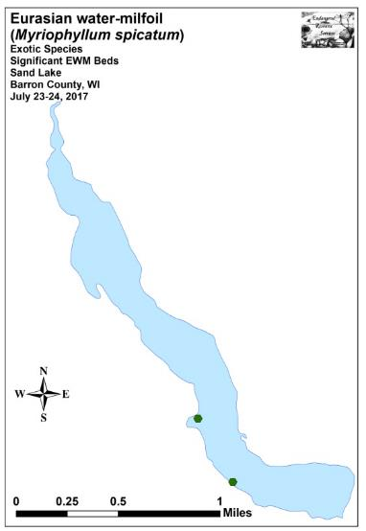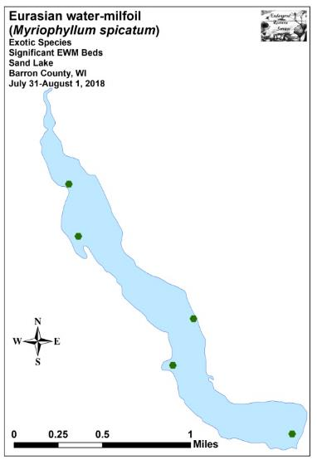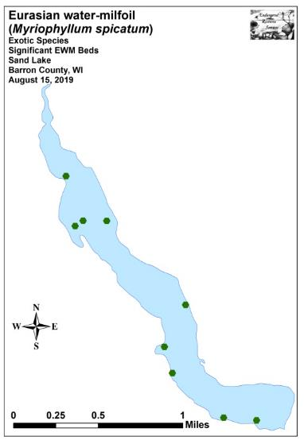
Figure 9: 2016, 2017, 2018, and 2019 Significant Summer EWM Beds
Comparison of Native Species in 2016, 2017, 2018, and 2019:
In 2016, Coontail (Ceratophyllum demersum), Flat-stem pondweed (Potamogeton zosteriformis), Small pondweed (Potamogeton pusillus), and Northern water-milfoil (Myriophyllum sibiricum) were the most common species (Table 2). Found at 49.79%, 41.06%, 30.21%, and 28.51% of survey points with vegetation respectively, they accounted for 40.94% of the total relative frequency. Muskgrass (Chara sp.) (5.94%), Illinois pondweed (Potamogeton illinoensis) (4.66%), Clasping-leaf pondweed (Potamogeton richardsonii) (4.60%), Forked duckweed (Lemna trisulca) (4.37%), Common waterweed (Elodea canadensis) (4.19%), and Slender naiad (Najas flexilis) (4.14%) were the only other species with relative frequencies over 4.00% (Maps for all species from the 2016 survey can be found in the CD attached to this report).

During the 2017 survey, these four species were again the most common with Coontail present at 52.95% of sites with vegetation, Flat-stem pondweed at 39.66%, Small pondweed at 35.02%, and Northern water-milfoil at 26.16% (Table 3). Collectively, they accounted for 38.13% of the total relative frequency. Common waterweed (5.81%), Muskgrass (5.07%), Clasping-leaf pondweed (4.65%), Variable pondweed (Potamogeton gramineus) (4.60%), Forked duckweed (4.34%), and Fries’ pondweed (Potamogeton friesii) (4.18%) also had relative frequency values over 4.00% (Maps for all plants observed in 2017 can also be found in the CD attached to this report).

In 2018, we found Coontail, Small pondweed, Flat-stem pondweed, and Muskgrass were the most common species. Present at 47.26%, 45.78%, 43.25%, and 28.27% of survey points with vegetation respectively, they accounted for 41.67% of the total relative frequency (Table 4). Forked duckweed (6.30%), Slender naiad (6.09%), and Common waterweed (4.59%) also had relative frequency values over 4.00% (Maps for all plants found in 2018 can be found in the CD attached to this report).

Our 2019 survey identified Coontail, Small pondweed, Flat-stem pondweed, and Forked duckweed as the most common species. Found at 51.69%, 41.53%, 40.47%, and 27.33% of survey points with vegetation respectively, they accounted for 40.23% of the total relative frequency (Table 5). Other species with relative frequency values over 4.00% included Northern water-milfoil (6.19%), Clasping-leaf pondweed (5.98%), Wild celery (Vallisneria americana) (4.98%), Fern pondweed (Potamogeton robbinsii) (4.66%), and Muskgrass (4.18%) (Maps for all species found during the 2019 survey are located in Appendix VI).

Table 2: Frequencies and Mean Rake Sample of Aquatic Macrophytes
Sand Lake, Barron County
July 25, 2016

Species | Common Name | Total  Sites | Relative Freq. | Freq. in Veg. | Freq. in Lit. | Mean Rake | Visual  Sight.
Ceratophyllum demersum | Coontail | 234 | 13.63 | 49.79 | 45.26 | 1.50 | 0
Potamogeton zosteriformis | Flat-stem pondweed | 193 | 11.24 | 41.06 | 37.33 | 1.58 | 22
Potamogeton pusillus | Small pondweed | 142 | 8.27 | 30.21 | 27.47 | 1.43 | 4
Myriophyllum sibiricum | Northern water-milfoil | 134 | 7.80 | 28.51 | 25.92 | 1.55 | 19
Chara sp. | Muskgrass | 102 | 5.94 | 21.70 | 19.73 | 1.61 | 0
Potamogeton illinoensis | Illinois pondweed | 80 | 4.66 | 17.02 | 15.47 | 1.34 | 5
Potamogeton richardsonii | Clasping-leaf pondweed | 79 | 4.60 | 16.81 | 15.28 | 1.86 | 14
Lemna trisulca | Forked duckweed | 75 | 4.37 | 15.96 | 14.51 | 1.28 | 1
Elodea canadensis | Common waterweed | 72 | 4.19 | 15.32 | 13.93 | 1.25 | 1
Najas flexilis | Slender naiad | 71 | 4.14 | 15.11 | 13.73 | 1.25 | 4
Potamogeton gramineus | Variable pondweed | 67 | 3.90 | 14.26 | 12.96 | 1.27 | 10
Nuphar variegata | Spatterdock | 57 | 3.32 | 12.13 | 11.03 | 2.60 | 13
Stuckenia pectinata | Sago pondweed | 56 | 3.26 | 11.91 | 10.83 | 1.61 | 12
Vallisneria americana | Wild celery | 53 | 3.09 | 11.28 | 10.25 | 1.26 | 3
 | Filamentous algae | 50 | * | 10.64 | 9.67 | 1.38 | 0
Potamogeton friesii | Fries' pondweed | 48 | 2.80 | 10.21 | 9.28 | 1.25 | 0
Nymphaea odorata | White water lily | 44 | 2.56 | 9.36 | 8.51 | 1.95 | 10
Potamogeton amplifolius | Large-leaf pondweed | 36 | 2.10 | 7.66 | 6.96 | 1.53 | 23
Potamogeton robbinsii | Fern pondweed | 25 | 1.46 | 5.32 | 4.84 | 1.24 | 0
Ranunculus aquatilis | White water crowfoot | 25 | 1.46 | 5.32 | 4.84 | 1.16 | 1
Lemna minor | Small duckweed | 19 | 1.11 | 4.04 | 3.68 | 1.58 | 0
Spirodela polyrhiza | Large duckweed | 17 | 0.99 | 3.62 | 3.29 | 1.65 | 0
Myriophyllum spicatum | Eurasian water-milfoil | 15 | 0.87 | 3.19 | 2.90 | 1.73 | 8
Heteranthera dubia | Water star-grass | 13 | 0.76 | 2.77 | 2.51 | 1.15 | 2

* Algae are excluded from the relative frequency calculation
Table 2 (cont’): Frequencies and Mean Rake Sample of Aquatic Macrophytes
Sand Lake, Barron County
July 25, 2016

Species | Common Name | Total  Sites | Relative Freq. | Freq. in Veg. | Freq. in Lit. | Mean Rake | Visual  Sight.
Potamogeton natans | Floating-leaf pondweed | 10 | 0.58 | 2.13 | 1.93 | 1.90 | 3
Wolffia columbiana | Common watermeal | 9 | 0.52 | 1.91 | 1.74 | 2.56 | 0
Sparganium eurycarpum | Common bur-reed | 6 | 0.35 | 1.28 | 1.16 | 2.17 | 2
Eleocharis acicularis | Needle spikerush | 4 | 0.23 | 0.85 | 0.77 | 1.00 | 0
Nitella sp. | Nitella | 4 | 0.23 | 0.85 | 0.77 | 1.50 | 0
Sagittaria cristata | Crested arrowhead | 4 | 0.23 | 0.85 | 0.77 | 1.00 | 3
Calla palustris | Wild calla | 3 | 0.17 | 0.64 | 0.58 | 1.67 | 0
Equisetum fluviatile | Water horsetail | 3 | 0.17 | 0.64 | 0.58 | 2.33 | 0
Typha latifolia | Broad-leaved cattail | 3 | 0.17 | 0.64 | 0.58 | 2.00 | 0
Bidens beckii | Water marigold | 2 | 0.12 | 0.43 | 0.39 | 1.00 | 0
Polygonum amphibium | Water smartweed | 2 | 0.12 | 0.43 | 0.39 | 2.00 | 1
Schoenoplectus tabernaemontani | Softstem bulrush | 2 | 0.12 | 0.43 | 0.39 | 1.50 | 0
Brasenia schreberi | Watershield | 1 | 0.06 | 0.21 | 0.19 | 2.00 | 0
Eleocharis erythropoda | Bald spikerush | 1 | 0.06 | 0.21 | 0.19 | 2.00 | 1
Leersia oryzoides | Rice cut-grass | 1 | 0.06 | 0.21 | 0.19 | 3.00 | 0
Potamogeton nodosus | Long-leaf pondweed | 1 | 0.06 | 0.21 | 0.19 | 2.00 | 1
Schoenoplectus acutus | Hardstem bulrush | 1 | 0.06 | 0.21 | 0.19 | 3.00 | 0
Sparganium emersum | Short-stemmed bur-reed | 1 | 0.06 | 0.21 | 0.19 | 1.00 | 1
Utricularia gibba | Creeping bladderwort | 1 | 0.06 | 0.21 | 0.19 | 1.00 | 0
Utricularia vulgaris | Common bladderwort | 1 | 0.06 | 0.21 | 0.19 | 1.00 | 0
Carex comosa | Bottle brush sedge | ** | ** | ** | ** | ** | 1
Juncus effusus | Common rush | ** | ** | ** | ** | ** | 1
Phalaris arundinacea | Reed canary grass | ** | ** | ** | ** | ** | 2
Potamogeton epihydrus | Ribbon-leaf pondweed | ** | ** | ** | ** | ** | 1

** Visual Only
Table 2 (cont’): Frequencies and Mean Rake Sample of Aquatic Macrophytes
Sand Lake, Barron County
July 25, 2016

Species | Common Name | Total  Sites | Relative Freq. | Freq. in Veg. | Freq. in Lit. | Mean Rake | Visual  Sight.
Sagittaria latifolia | Common arrowhead | *** | *** | *** | *** | *** | ***
Sagittaria rigida | Sessile-fruited arrowhead | *** | *** | *** | *** | *** | ***
Scirpus atrovirens | Black bulrush | *** | *** | *** | *** | *** | ***
Scirpus cyperinus | Woolgrass | *** | *** | *** | *** | *** | ***

*** Boat Survey Only

Table 3: Frequencies and Mean Rake Sample of Aquatic Macrophytes
Sand Lake, Barron County
July 23-24, 2017

Species | Common Name | Total  Sites | Relative Freq. | Freq. in Veg. | Freq. in Lit. | Mean Rake | Visual  Sight.
Ceratophyllum demersum | Coontail | 251 | 13.13 | 52.95 | 48.64 | 1.35 | 1
Potamogeton zosteriformis | Flat-stem pondweed | 188 | 9.83 | 39.66 | 36.43 | 1.41 | 12
Potamogeton pusillus | Small pondweed | 166 | 8.68 | 35.02 | 32.17 | 1.55 | 3
Myriophyllum sibiricum | Northern water-milfoil | 124 | 6.49 | 26.16 | 24.03 | 1.33 | 16
Elodea canadensis | Common waterweed | 111 | 5.81 | 23.42 | 21.51 | 1.19 | 0
Chara sp. | Muskgrass | 97 | 5.07 | 20.46 | 18.80 | 1.37 | 0
 | Filamentous algae | 91 | * | 19.20 | 17.64 | 1.31 | 0
Potamogeton richardsonii | Clasping-leaf pondweed | 89 | 4.65 | 18.78 | 17.25 | 1.80 | 13
Potamogeton gramineus | Variable pondweed | 88 | 4.60 | 18.57 | 17.05 | 1.48 | 14
Lemna trisulca | Forked duckweed | 83 | 4.34 | 17.51 | 16.09 | 1.25 | 0
Potamogeton friesii | Fries' pondweed | 80 | 4.18 | 16.88 | 15.50 | 1.15 | 0
Nuphar variegata | Spatterdock | 67 | 3.50 | 14.14 | 12.98 | 2.58 | 13
Stuckenia pectinata | Sago pondweed | 55 | 2.88 | 11.60 | 10.66 | 1.36 | 8
Potamogeton robbinsii | Fern pondweed | 49 | 2.56 | 10.34 | 9.50 | 1.12 | 2
Vallisneria americana | Wild celery | 48 | 2.51 | 10.13 | 9.30 | 1.08 | 1
Najas flexilis | Slender naiad | 46 | 2.41 | 9.70 | 8.91 | 1.09 | 4
Potamogeton amplifolius | Large-leaf pondweed | 46 | 2.41 | 9.70 | 8.91 | 1.48 | 14
Nymphaea odorata | White water lily | 43 | 2.25 | 9.07 | 8.33 | 1.60 | 6
Lemna minor | Small duckweed | 40 | 2.09 | 8.44 | 7.75 | 1.35 | 0
Spirodela polyrhiza | Large duckweed | 34 | 1.78 | 7.17 | 6.59 | 1.41 | 0
Potamogeton illinoensis | Illinois pondweed | 33 | 1.73 | 6.96 | 6.40 | 1.15 | 3
Ranunculus aquatilis | White water crowfoot | 30 | 1.57 | 6.33 | 5.81 | 1.07 | 2
Heteranthera dubia | Water star-grass | 21 | 1.10 | 4.43 | 4.07 | 1.00 | 0
Myriophyllum spicatum | Eurasian water-milfoil | 20 | 1.05 | 4.22 | 3.88 | 1.75 | 5

* Algae are excluded from the relative frequency calculation
Table 3 (cont’): Frequencies and Mean Rake Sample of Aquatic Macrophytes
Sand Lake, Barron County
July 23-24, 2017

Species | Common Name | Total  Sites | Relative Freq. | Freq. in Veg. | Freq. in Lit. | Mean Rake | Visual  Sight.
Nitella sp. | Nitella | 19 | 0.99 | 4.01 | 3.68 | 1.21 | 0
Wolffia columbiana | Common watermeal | 17 | 0.89 | 3.59 | 3.29 | 1.29 | 0
Potamogeton natans | Floating-leaf pondweed | 11 | 0.58 | 2.32 | 2.13 | 1.18 | 4
Sagittaria cristata | Crested arrowhead | 9 | 0.47 | 1.90 | 1.74 | 1.33 | 3
Calla palustris | Wild calla | 5 | 0.26 | 1.05 | 0.97 | 2.20 | 0
Potamogeton nodosus | Long-leaf pondweed | 5 | 0.26 | 1.05 | 0.97 | 1.40 | 1
Sparganium eurycarpum | Common bur-reed | 5 | 0.26 | 1.05 | 0.97 | 1.60 | 4
Typha latifolia | Broad-leaved cattail | 4 | 0.21 | 0.84 | 0.78 | 1.25 | 1
Utricularia vulgaris | Common bladderwort | 4 | 0.21 | 0.84 | 0.78 | 1.00 | 1
Bidens beckii | Water marigold | 3 | 0.16 | 0.63 | 0.58 | 1.00 | 0
Brasenia schreberi | Watershield | 3 | 0.16 | 0.63 | 0.58 | 1.67 | 0
Eleocharis erythropoda | Bald spikerush | 3 | 0.16 | 0.63 | 0.58 | 1.67 | 0
Potamogeton foliosus | Leafy pondweed | 3 | 0.16 | 0.63 | 0.58 | 1.67 | 0
Utricularia gibba | Creeping bladderwort | 3 | 0.16 | 0.63 | 0.58 | 1.00 | 1
Equisetum fluviatile | Water horsetail | 2 | 0.10 | 0.42 | 0.39 | 1.50 | 2
Riccia fluitans | Slender riccia | 2 | * | 0.42 | 0.39 | 1.00 | 0
Schoenoplectus tabernaemontani | Softstem bulrush | 2 | 0.10 | 0.42 | 0.39 | 1.50 | 2
Eleocharis acicularis | Needle spikerush | 1 | 0.05 | 0.21 | 0.19 | 1.00 | 0
Leersia oryzoides | Rice cut-grass | 1 | 0.05 | 0.21 | 0.19 | 1.00 | 0
Potamogeton epihydrus | Ribbon-leaf pondweed | 1 | 0.05 | 0.21 | 0.19 | 2.00 | 1
Potamogeton praelongus | White-stem pondweed | 1 | 0.05 | 0.21 | 0.19 | 2.00 | 1
Schoenoplectus acutus | Hardstem bulrush | 1 | 0.05 | 0.21 | 0.19 | 2.00 | 0

* Bryophytes (moss) are excluded from the relative frequency calculation

Table 3 (cont’): Frequencies and Mean Rake Sample of Aquatic Macrophytes
Sand Lake, Barron County
July 23-24, 2017

Species | Common Name | Total  Sites | Relative Freq. | Freq. in Veg. | Freq. in Lit. | Mean Rake | Visual  Sight.
Juncus effusus | Common rush | ** | ** | ** | ** | ** | 1
Polygonum amphibium | Water smartweed | ** | ** | ** | ** | ** | 1
Sagittaria latifolia | Common arrowhead | ** | ** | ** | ** | ** | 1
Scirpus cyperinus | Woolgrass | ** | ** | ** | ** | ** | 1
Sparganium emersum | Short-stemmed bur-reed | ** | ** | ** | ** | ** | 1
Carex comosa | Bottle brush sedge | *** | *** | *** | *** | *** | ***
Lythrum salicaria | Purple loosestrife | *** | *** | *** | *** | *** | ***
Phalaris arundinacea | Reed canary grass | *** | *** | *** | *** | *** | ***

** Visual Only *** Boat Survey Only

Table 4: Frequencies and Mean Rake Sample of Aquatic Macrophytes
Sand Lake, Barron County
July 31-August 1, 2018

Species | Common Name | Total  Sites | Relative Freq. | Freq. in Veg. | Freq. in Lit. | Mean Rake | Visual  Sight.
Ceratophyllum demersum | Coontail | 224 | 11.97 | 47.26 | 45.53 | 1.29 | 3
Potamogeton pusillus | Small pondweed | 217 | 11.59 | 45.78 | 44.11 | 1.63 | 2
Potamogeton zosteriformis | Flat-stem pondweed | 205 | 10.95 | 43.25 | 41.67 | 1.37 | 24
Chara sp. | Muskgrass | 134 | 7.16 | 28.27 | 27.24 | 1.50 | 1
Lemna trisulca | Forked duckweed | 118 | 6.30 | 24.89 | 23.98 | 1.21 | 0
Najas flexilis | Slender naiad | 114 | 6.09 | 24.05 | 23.17 | 1.19 | 2
 | Filamentous algae | 111 | * | 23.42 | 22.56 | 1.17 | 0
Elodea canadensis | Common waterweed | 86 | 4.59 | 18.14 | 17.48 | 1.23 | 1
Nuphar variegata | Spatterdock | 73 | 3.90 | 15.40 | 14.84 | 2.40 | 8
Potamogeton friesii | Fries' pondweed | 73 | 3.90 | 15.40 | 14.84 | 1.18 | 1
Stuckenia pectinata | Sago pondweed | 71 | 3.79 | 14.98 | 14.43 | 1.42 | 8
Potamogeton richardsonii | Clasping-leaf pondweed | 70 | 3.74 | 14.77 | 14.23 | 1.59 | 16
Vallisneria americana | Wild celery | 65 | 3.47 | 13.71 | 13.21 | 1.09 | 3
Potamogeton robbinsii | Fern pondweed | 51 | 2.72 | 10.76 | 10.37 | 1.27 | 5
Myriophyllum sibiricum | Northern water-milfoil | 49 | 2.62 | 10.34 | 9.96 | 1.35 | 12
Lemna minor | Small duckweed | 43 | 2.30 | 9.07 | 8.74 | 1.23 | 0
Nymphaea odorata | White water lily | 37 | 1.98 | 7.81 | 7.52 | 1.70 | 8
Potamogeton illinoensis | Illinois pondweed | 37 | 1.98 | 7.81 | 7.52 | 1.03 | 6
Spirodela polyrhiza | Large duckweed | 37 | 1.98 | 7.81 | 7.52 | 1.46 | 0
Wolffia columbiana | Common watermeal | 37 | 1.98 | 7.81 | 7.52 | 1.30 | 0
Potamogeton gramineus | Variable pondweed | 28 | 1.50 | 5.91 | 5.69 | 1.00 | 7
Potamogeton amplifolius | Large-leaf pondweed | 25 | 1.34 | 5.27 | 5.08 | 1.20 | 6
Myriophyllum spicatum | Eurasian water-milfoil | 11 | 0.59 | 2.32 | 2.24 | 2.09 | 5
Potamogeton natans | Floating-leaf pondweed | 10 | 0.53 | 2.11 | 2.03 | 1.60 | 3

* Algae are excluded from the relative frequency calculation
Table 4 (cont’): Frequencies and Mean Rake Sample of Aquatic Macrophytes
Sand Lake, Barron County
July 31-August 1, 2018

Species | Common Name | Total  Sites | Relative Freq. | Freq. in Veg. | Freq. in Lit. | Mean Rake | Visual  Sight.
Heteranthera dubia | Water star-grass | 9 | 0.48 | 1.90 | 1.83 | 1.11 | 0
Sagittaria cristata | Crested arrowhead | 9 | 0.48 | 1.90 | 1.83 | 1.00 | 7
Utricularia vulgaris | Common bladderwort | 6 | 0.32 | 1.27 | 1.22 | 1.00 | 0
Calla palustris | Wild calla | 4 | 0.21 | 0.84 | 0.81 | 2.00 | 0
Ranunculus aquatilis | White water crowfoot | 4 | 0.21 | 0.84 | 0.81 | 1.00 | 0
Utricularia gibba | Creeping bladderwort | 4 | 0.21 | 0.84 | 0.81 | 1.00 | 0
Brasenia schreberi | Watershield | 3 | 0.16 | 0.63 | 0.61 | 2.00 | 0
Equisetum fluviatile | Water horsetail | 3 | 0.16 | 0.63 | 0.61 | 2.00 | 1
Sparganium eurycarpum | Common bur-reed | 3 | 0.16 | 0.63 | 0.61 | 1.00 | 1
Schoenoplectus tabernaemontani | Softstem bulrush | 2 | 0.11 | 0.42 | 0.41 | 2.50 | 3
Bidens beckii | Water marigold | 1 | 0.05 | 0.21 | 0.20 | 1.00 | 0
Carex comosa | Bottle brush sedge | 1 | 0.05 | 0.21 | 0.20 | 1.00 | 0
Eleocharis acicularis | Needle spikerush | 1 | 0.05 | 0.21 | 0.20 | 1.00 | 0
Eleocharis erythropoda | Bald spikerush | 1 | 0.05 | 0.21 | 0.20 | 3.00 | 0
Nitella sp. | Nitella | 1 | 0.05 | 0.21 | 0.20 | 1.00 | 0
Potamogeton foliosus | Leafy pondweed | 1 | 0.05 | 0.21 | 0.20 | 1.00 | 0
Potamogeton nodosus | Long-leaf pondweed | 1 | 0.05 | 0.21 | 0.20 | 2.00 | 2
Sagittaria rigida | Sessile-fruited arrowhead | 1 | 0.05 | 0.21 | 0.20 | 1.00 | 0
Schoenoplectus acutus | Hardstem bulrush | 1 | 0.05 | 0.21 | 0.20 | 2.00 | 0
Typha latifolia | Broad-leaved cattail | 1 | 0.05 | 0.21 | 0.20 | 2.00 | 4

Table 4 (cont’): Frequencies and Mean Rake Sample of Aquatic Macrophytes
Sand Lake, Barron County
July 31-August 1, 2018

Species | Common Name | Total  Sites | Relative Freq. | Freq. in Veg. | Freq. in Lit. | Mean Rake | Visual  Sight.
Phalaris arundinacea | Reed canary grass | ** | ** | ** | ** | ** | 2
Polygonum amphibium | Water smartweed | ** | ** | ** | ** | ** | 1
Potamogeton epihydrus | Ribbon-leaf pondweed | ** | ** | ** | ** | ** | 1
Lythrum salicaria | Purple loosestrife | *** | *** | *** | *** | *** | ***
Potamogeton praelongus | White-stem pondweed | *** | *** | *** | *** | *** | ***

** Visual Only *** Boat Survey Only

Table 5: Frequencies and Mean Rake Sample of Aquatic Macrophytes
Sand Lake, Barron County
August 15, 2019

Species | Common Name | Total  Sites | Relative Freq. | Freq. in Veg. | Freq. in Lit. | Mean Rake | Visual  Sight.
Ceratophyllum demersum | Coontail | 244 | 12.92 | 51.69 | 49.09 | 1.52 | 4
Potamogeton pusillus | Small pondweed | 196 | 10.38 | 41.53 | 39.44 | 1.54 | 1
Potamogeton zosteriformis | Flat-stem pondweed | 191 | 10.11 | 40.47 | 38.43 | 1.57 | 16
Lemna trisulca | Forked duckweed | 129 | 6.83 | 27.33 | 25.96 | 1.39 | 0
Myriophyllum sibiricum | Northern water-milfoil | 117 | 6.19 | 24.79 | 23.54 | 1.78 | 24
Potamogeton richardsonii | Clasping-leaf pondweed | 113 | 5.98 | 23.94 | 22.74 | 1.73 | 20
 | Filamentous algae | 112 | * | 23.73 | 22.54 | 1.29 | 0
Vallisneria americana | Wild celery | 94 | 4.98 | 19.92 | 18.91 | 1.32 | 5
Potamogeton robbinsii | Fern pondweed | 88 | 4.66 | 18.64 | 17.71 | 1.42 | 3
Chara sp. | Muskgrass | 79 | 4.18 | 16.74 | 15.90 | 1.59 | 1
Potamogeton gramineus | Variable pondweed | 70 | 3.71 | 14.83 | 14.08 | 1.36 | 16
Nuphar variegata | Spatterdock | 69 | 3.65 | 14.62 | 13.88 | 2.57 | 12
Najas flexilis | Slender naiad | 68 | 3.60 | 14.41 | 13.68 | 1.32 | 1
Elodea canadensis | Common waterweed | 63 | 3.34 | 13.35 | 12.68 | 1.10 | 1
Stuckenia pectinata | Sago pondweed | 55 | 2.91 | 11.65 | 11.07 | 1.40 | 12
Nymphaea odorata | White water lily | 39 | 2.06 | 8.26 | 7.85 | 1.72 | 7
Spirodela polyrhiza | Large duckweed | 27 | 1.43 | 5.72 | 5.43 | 1.56 | 0
Heteranthera dubia | Water star-grass | 25 | 1.32 | 5.30 | 5.03 | 1.40 | 0
Potamogeton amplifolius | Large-leaf pondweed | 25 | 1.32 | 5.30 | 5.03 | 1.52 | 15
Potamogeton friesii | Fries' pondweed | 25 | 1.32 | 5.30 | 5.03 | 1.20 | 1
Lemna minor | Small duckweed | 20 | 1.06 | 4.24 | 4.02 | 1.10 | 0
Wolffia columbiana | Common watermeal | 19 | 1.01 | 4.03 | 3.82 | 1.37 | 0
Myriophyllum spicatum | Eurasian water-milfoil | 17 | 0.90 | 3.60 | 3.42 | 1.53 | 4
Potamogeton illinoensis | Illinois pondweed | 17 | 0.90 | 3.60 | 3.42 | 1.24 | 2

* Algae are excluded from the relative frequency calculation
Table 5 (cont’): Frequencies and Mean Rake Sample of Aquatic Macrophytes
Sand Lake, Barron County
August 15, 2019

Species | Common Name | Total  Sites | Relative Freq. | Freq. in Veg. | Freq. in Lit. | Mean Rake | Visual  Sight.
Bidens beckii | Water marigold | 13 | 0.69 | 2.75 | 2.62 | 1.08 | 5
Potamogeton natans | Floating-leaf pondweed | 11 | 0.58 | 2.33 | 2.21 | 2.09 | 3
Nitella sp. | Nitella | 10 | 0.53 | 2.12 | 2.01 | 1.20 | 0
Ranunculus aquatilis | White water crowfoot | 7 | 0.37 | 1.48 | 1.41 | 1.29 | 1
Utricularia vulgaris | Common bladderwort | 7 | 0.37 | 1.48 | 1.41 | 1.14 | 3
Sparganium eurycarpum | Common bur-reed | 6 | 0.32 | 1.27 | 1.21 | 1.33 | 3
Potamogeton nodosus | Long-leaf pondweed | 5 | 0.26 | 1.06 | 1.01 | 1.80 | 2
Sagittaria cristata | Crested arrowhead | 5 | 0.26 | 1.06 | 1.01 | 1.20 | 5
Utricularia gibba | Creeping bladderwort | 5 | 0.26 | 1.06 | 1.01 | 1.00 | 1
Brasenia schreberi | Watershield | 4 | 0.21 | 0.85 | 0.80 | 2.00 | 0
Eleocharis erythropoda | Bald spikerush | 4 | 0.21 | 0.85 | 0.80 | 2.25 | 0
Calla palustris | Wild calla | 3 | 0.16 | 0.64 | 0.60 | 1.67 | 0
Eleocharis acicularis | Needle spikerush | 3 | 0.16 | 0.64 | 0.60 | 2.00 | 0
Equisetum fluviatile | Water horsetail | 3 | 0.16 | 0.64 | 0.60 | 1.67 | 1
Schoenoplectus tabernaemontani | Softstem bulrush | 3 | 0.16 | 0.64 | 0.60 | 2.33 | 1
Polygonum amphibium | Water smartweed | 2 | 0.11 | 0.42 | 0.40 | 2.50 | 1
Potamogeton epihydrus | Ribbon-leaf pondweed | 2 | 0.11 | 0.42 | 0.40 | 1.50 | 0
Typha latifolia | Broad-leaved cattail | 2 | 0.11 | 0.42 | 0.40 | 1.50 | 0
 | Freshwater sponge | 2 | * | 0.42 | 0.40 | 1.00 | 0
Carex comosa | Bottle brush sedge | 1 | 0.05 | 0.21 | 0.20 | 1.00 | 0
Leersia oryzoides | Rice cut-grass | 1 | 0.05 | 0.21 | 0.20 | 1.00 | 0
Sagittaria latifolia | Common arrowhead | 1 | 0.05 | 0.21 | 0.20 | 1.00 | 0
Schoenoplectus acutus | Hardstem bulrush | 1 | 0.05 | 0.21 | 0.20 | 3.00 | 0
 | Aquatic moss | 1 | * | 0.21 | 0.20 | 1.00 | 0

* Poriferan animals (sponges) and Bryophytes (moss) are excluded from the relative frequency calculation
Table 5 (cont’): Frequencies and Mean Rake Sample of Aquatic Macrophytes
Sand Lake, Barron County
August 15, 2019

Species | Common Name | Total  Sites | Relative Freq. | Freq. in Veg. | Freq. in Lit. | Mean Rake | Visual  Sight.
Lythrum salicaria | Purple loosestrife | *** | *** | *** | *** | *** | ***
Phalaris arundinacea | Reed canary grass | *** | *** | *** | *** | *** | ***
Sagittaria rigida | Sessile-fruited arrowhead | *** | *** | *** | *** | *** | ***
Sparganium emersum | Short-stemmed bur-reed | *** | *** | *** | *** | *** | ***

*** Boat Survey Only

Coontail was the most common species in 2016, 2017, 2018, and 2019. It experienced a non-significant increase (p=0.28) in distribution from 234 sites in 2016 to 251 sites in 2017. However, its decline in density from a mean rake fullness of 1.50 in 2016 to 1.35 in 2017 was moderately significant (p=0.002). In 2018, it saw a nearly significant (p=0.08) loss in distribution to 224 points. It also suffered a further decline in density to a mean rake of 1.29. Although this loss was not significant (p=0.11) when compared to 2017 data, it represented a highly significant decline (p<0.001) compared to the 2016 baseline. As 2, 4-D is toxic to Coontail as well as EWM, it is possible that this reduction is at least partially related to the herbicide program. Perhaps in response to less area being treated in 2019, it underwent a non-significant increase (p=0.27) in distribution to 244 points, and a highly significant increase (p<0.001) in density to a mean rake of 1.52 (Figure 10).

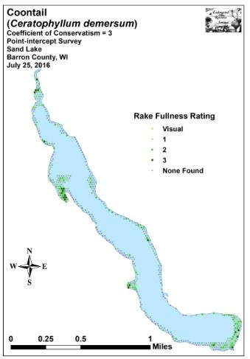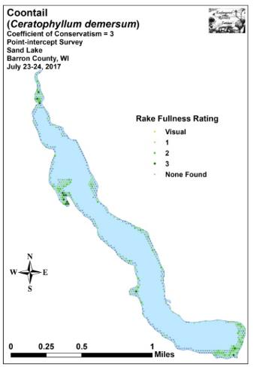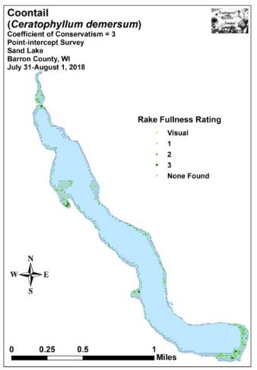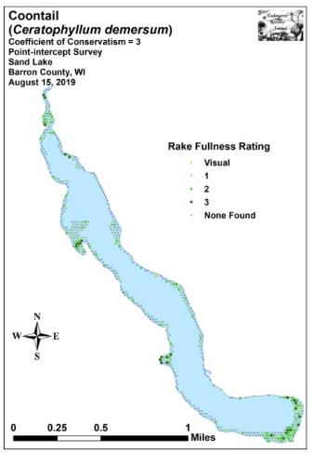
Figure 10: 2016-2019 Coontail Density and Distribution
Flat-stem pondweed, the second most common species in both 2016 and 2017, experienced a non-significant decline (p=0.76) in distribution from 193 sites in 2016 to 188 sites in 2017 (Figure 11). However, the accompanying decline in density (mean rake of 1.58 in 2016 to 1.41 in 2017) was moderately significant (p=0.006). Although it fell to become the third most common species in 2018, it underwent a non-significant rebound (p=0.20) in distribution to 205 sites. Its further drop in density to a mean rake fullness of 1.37 was also not significant (p=0.20) compared to 2017; but, like Coontail, its decline in density was highly significant (p<0.001) when compared to the 2016 baseline. In 2019, it remained the third most common species despite a non-significant drop (p=0.39) in distribution to 191 sites. Its highly significant increase (p<0.001) in density to a mean rake of 1.57 returned it full circle to 2016 levels.

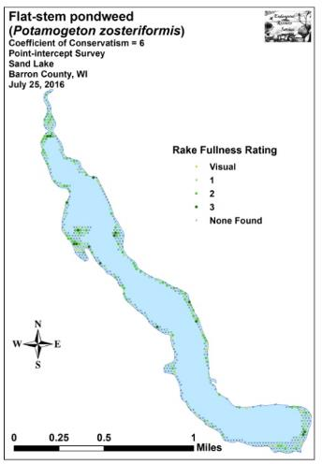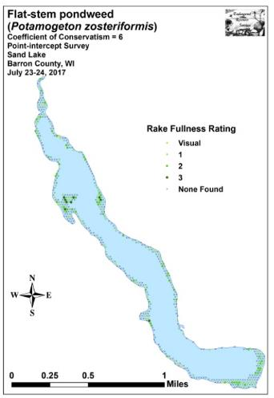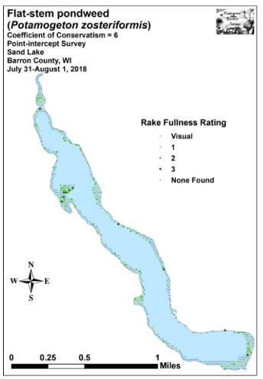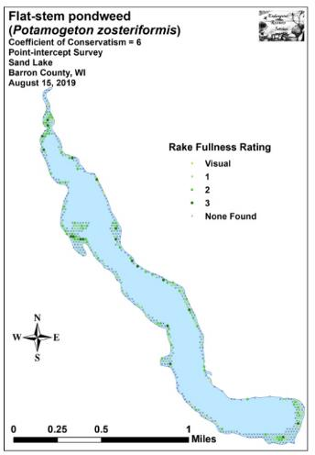
Figure 11: 2016-2019 Flat-stem Pondweed Density and Distribution
We documented Small Pondweed as the third most common species in both 2016 and 2017 (Figure 12). Present at 142 sites with a mean rake of 1.43 in 2016, it experienced a non-significant increase (p=0.10) in distribution to 166 sites in 2017. The increase in mean rake fullness to 1.55 in 2017 was nearly significant (p=0.06). In 2018, it enjoyed a further and highly significant expansion (p<0.001) in distribution to become the second most common species. Although the accompanying increase in density to a mean rake fullness of 1.63 was not significant (p=0.13), when compared to the baseline density in 2016, it suggested this species has undergone a moderately significant increase (p=0.002). The 2019 survey found it underwent non-significant declines (p=0.19/0.08) in both distribution and density (196 sites/mean rake 1.54); however, it remained the second most common species.

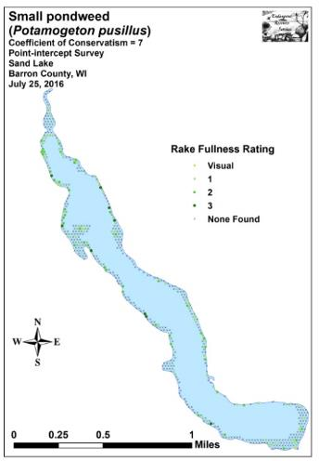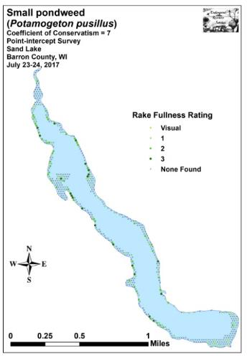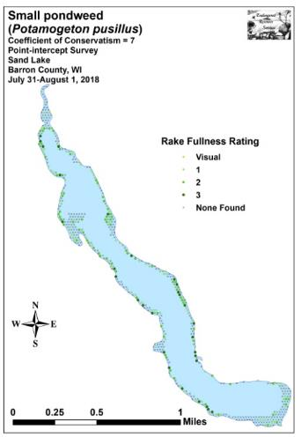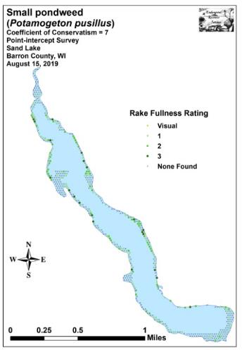
Figure 12: 2016-2019 Small Pondweed Density and Distribution
Northern water-milfoil was the fourth most common species in both 2016 and 2017 (Figure 13). Its reduction in distribution from 134 sites to 124 sites was not significant (p=0.48); however, the decline in mean rake fullness from 1.55 to 1.33 was moderately significant (p=0.003). In 2018, although its mean rake fullness was almost unchanged at 1.35, it suffered a dramatic and highly significant decline (p<0.001) in distribution (49 sites) as it fell to become just the 14th most common species. Fortunately, the 2019 survey saw an equally dramatic and highly significant increase (p<0.001) in both distribution and density (117 sites/mean rake of 1.78) bringing it back up to the fifth most common species.

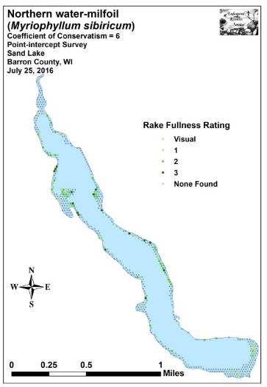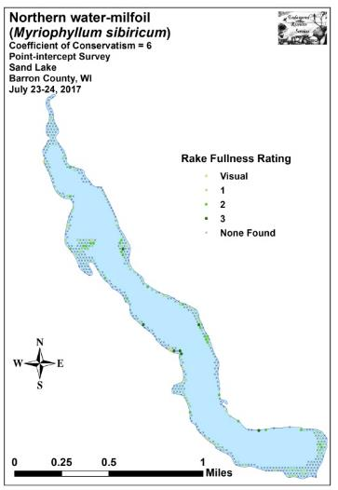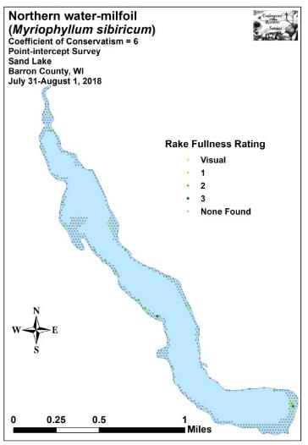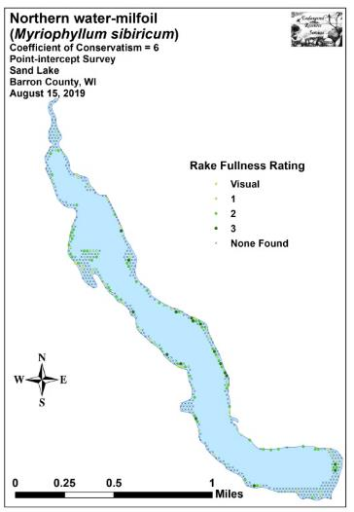
Figure 13: 2016-2019 Northern Water-milfoil Density and Distribution
When considering only distribution, nine species experienced significant changes from 2016 to 2017. We documented a highly significant decline in Illinois pondweed, and a significant decline in Slender naiad. Conversely, we found highly significant increases in Common waterweed and filamentous algae; moderately significant increases in Fries’ pondweed, Fern pondweed, Small duckweed (Lemna minor), and Nitella (Nitella sp.); and a significant increase in Large duckweed (Spirodela polyrhiza) (Figure 14).

From 2017 to 2018, 12 species experienced significant changes in distribution. Northern water-milfoil, Variable pondweed, White water crowfoot (Ranunculus aquatilis), and Nitella suffered highly significant declines; Large-leaf pondweed (Potamogeton amplifolius) demonstrated a moderately significant decline; and Common waterweed and Water star-grass (Heteranthera dubia) saw significant declines. Despite these losses, we found highly significant increases in Small pondweed and Slender naiad; and moderately significant increases in Muskgrass, Forked duckweed, and Common watermeal (Wolffia columbiana) (Figure 15).

During the 2019 survey, we documented 15 species that underwent significant changes in distribution when compared to 2018. Muskgrass, Slender naiad, and Fries’ pondweed all suffered highly significant declines; Small duckweed and Illinois pondweed saw moderately significant declines; and Common waterweed and Common watermeal had significant declines. Conversely, Clasping-leaf pondweed, Fern pondweed, Northern water-milfoil, and Variable pondweed all enjoyed highly significant expansions; Water star-grass and Water marigold (Bidens beckii) saw moderately significant increases; and Wild celery had a significant increase (Figure 16).

Comparison of Filamentous Algae in 2016, 2017, 2018, and 2019:
Filamentous algae, normally associated with excessive nutrients in the water column, were located at 91 survey points in 2017 – up from 50 points in 2016 (Figure 17). Although this was a highly significant increase in distribution (p<0.001), the decline in mean rake fullness from 1.38 in 2016 to 1.31 in 2017 was not significant (p=0.25). In 2018, filamentous algae were found at 111 points. This was more than twice the number seen in 2016, but a non-significant increase (p=0.11) from 2017. Fortunately, the mean density experienced a significant decline (p=0.02) to a mean rake fullness of 1.17. Although the 2019 distribution was essentially unchanged (112 sites), the 2018 decline in density proved to be short-lived as we documented a significant increase (p=0.02) back to a mean rake fullness of 1.29 – almost identical to 2017 levels.

As in the past, most sites with algae were located on the western shoreline along residences with no shoreline vegetation buffer, over nutrient-rich organic muck like in “Silo Bay”, or over areas that had been chemically treated for EWM such as near the public boat landing. In these cases, nutrient runoff from yards, nutrient recycling from the substrate, or nutrient release from dead and decomposing plants, are the most likely explanations for the increases observed in these respective parts of the lake.

+**
+***
-*
+**
+*
+**
+**
+**
-***
Significant differences = * p<0.05, ** p<0.01, *** p<0.001
Figure 14: Macrophytes Showing Significant Changes from 2016-2017

-***
-***
+**
-*
-**
-***
+***
+**
+***
+**
-*
-***
Significant differences = * p<0.05, ** p<0.01, *** p<0.001
Figure 15: Macrophytes Showing Significant Changes from 2017-2018
+**
+**
+**
-*
-**
-**
+***
+***
+***
+*
+***
-***
-*
-***
-***
Significant differences = * p<0.05, ** p<0.01, *** p<0.001
Figure 16: Macrophytes Showing Significant Changes from 2018-2019
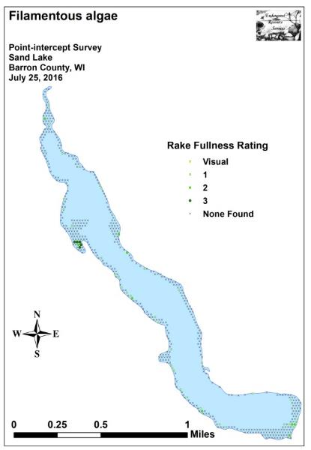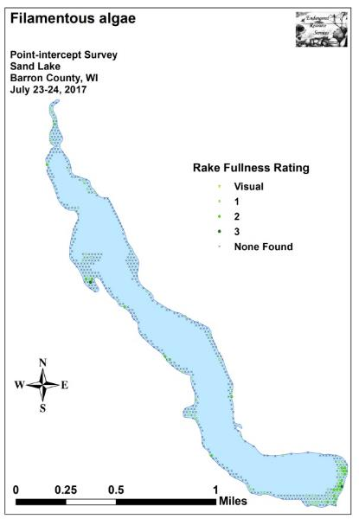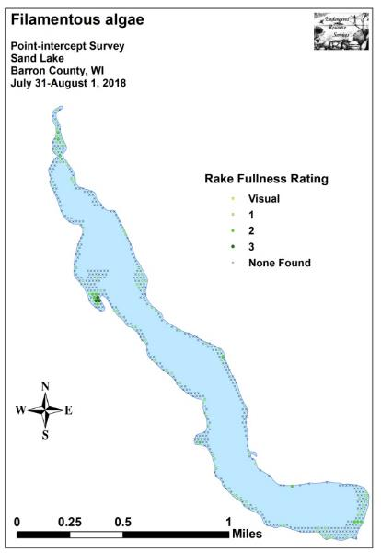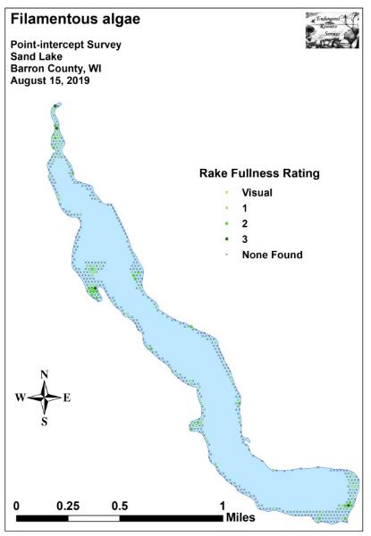
Figure 17: 2016-2019 Filamentous Algae Density and Distribution

Comparison of Floristic Quality Indexes in 2016, 2017, 2018, and 2019:
In 2016, we identified a total of 41 native index species in the rake during the point-intercept survey (Table 6). They produced a mean Coefficient of Conservatism of 6.0 and a Floristic Quality Index of 38.3.

Table 6: Floristic Quality Index of Aquatic Macrophytes
Sand Lake, Barron County
July 25, 2016

Species | Common Name | C
Bidens beckii | Water marigold | 8
Brasenia schreberi | Watershield | 6
Calla palustris | Wild calla | 9
Ceratophyllum demersum | Coontail | 3
Chara sp. | Muskgrass | 7
Eleocharis acicularis | Needle spikerush | 5
Eleocharis erythropoda | Bald spikerush | 3
Elodea canadensis | Common waterweed | 3
Equisetum fluviatile | Water horsetail | 7
Heteranthera dubia | Water star-grass | 6
Lemna minor | Small duckweed | 4
Lemna trisulca | Forked duckweed | 6
Myriophyllum sibiricum | Northern water-milfoil | 6
Najas flexilis | Slender naiad | 6
Nitella sp. | Nitella | 7
Nuphar variegata | Spatterdock | 6
Nymphaea odorata | White water lily | 6
Polygonum amphibium | Water smartweed | 5
Potamogeton amplifolius | Large-leaf pondweed | 7
Potamogeton friesii | Fries' pondweed | 8
Potamogeton gramineus | Variable pondweed | 7
Potamogeton illinoensis | Illinois pondweed | 6
Potamogeton natans | Floating-leaf pondweed | 5
Potamogeton nodosus | Long-leaf pondweed | 7
Potamogeton pusillus | Small pondweed | 7
Potamogeton richardsonii | Clasping-leaf pondweed | 5
Potamogeton robbinsii | Fern pondweed | 8
Potamogeton zosteriformis | Flat-stem pondweed | 6
Ranunculus aquatilis | White water crowfoot | 8
Sagittaria cristata | Crested arrowhead | 9
Schoenoplectus acutus | Hardstem bulrush | 6
Schoenoplectus tabernaemontani | Softstem bulrush | 4
Sparganium emersum | Short-stemmed bur-reed | 8
Sparganium eurycarpum | Common bur-reed | 5
Spirodela polyrhiza | Large duckweed | 5
Stuckenia pectinata | Sago pondweed | 3
Typha latifolia | Broad-leaved cattail | 1
Utricularia gibba | Creeping bladderwort | 9
Table 6 (cont’): Floristic Quality Index of Aquatic Macrophytes
Sand Lake, Barron County
July 25, 2016

Species | Common Name | C
Utricularia vulgaris | Common bladderwort | 7
Vallisneria americana | Wild celery | 6
Wolffia columbiana | Common watermeal | 5
N |  | 41
Mean C |  | 6.0
FQI |  | 38.3

During the 2017 survey, we found a total of 43 native index plants in the rake. They produced a mean Coefficient of Conservatism of 6.1 and a Floristic Quality Index of 39.8 (Table 7).

Table 7: Floristic Quality Index of Aquatic Macrophytes
Sand Lake, Barron County
July 23-24, 2017

Species | Common Name | C
Bidens beckii | Water marigold | 8
Brasenia schreberi | Watershield | 6
Calla palustris | Wild calla | 9
Ceratophyllum demersum | Coontail | 3
Chara sp. | Muskgrass | 7
Eleocharis acicularis | Needle spikerush | 5
Eleocharis erythropoda | Bald spikerush | 3
Elodea canadensis | Common waterweed | 3
Equisetum fluviatile | Water horsetail | 7
Heteranthera dubia | Water star-grass | 6
Lemna minor | Small duckweed | 4
Lemna trisulca | Forked duckweed | 6
Myriophyllum sibiricum | Northern water-milfoil | 6
Najas flexilis | Slender naiad | 6
Nitella sp. | Nitella | 7
Nuphar variegata | Spatterdock | 6
Nymphaea odorata | White water lily | 6
Potamogeton amplifolius | Large-leaf pondweed | 7
Potamogeton epihydrus | Ribbon-leaf pondweed | 8
Potamogeton foliosus | Leafy pondweed | 6
Potamogeton friesii | Fries' pondweed | 8
Potamogeton gramineus | Variable pondweed | 7
Potamogeton illinoensis | Illinois pondweed | 6
Potamogeton natans | Floating-leaf pondweed | 5
Potamogeton nodosus | Long-leaf pondweed | 7
Table 7 (cont’): Floristic Quality Index of Aquatic Macrophytes
Sand Lake, Barron County
July 23-24, 2017

Species | Common Name | C
Potamogeton praelongus | White-stem pondweed | 8
Potamogeton pusillus | Small pondweed | 7
Potamogeton richardsonii | Clasping-leaf pondweed | 5
Potamogeton robbinsii | Fern pondweed | 8
Potamogeton zosteriformis | Flat-stem pondweed | 6
Ranunculus aquatilis | White water crowfoot | 8
Riccia fluitans | Slender riccia | 7
Sagittaria cristata | Crested arrowhead | 9
Schoenoplectus acutus | Hardstem bulrush | 6
Schoenoplectus tabernaemontani | Softstem bulrush | 4
Sparganium eurycarpum | Common bur-reed | 5
Spirodela polyrhiza | Large duckweed | 5
Stuckenia pectinata | Sago pondweed | 3
Typha latifolia | Broad-leaved cattail | 1
Utricularia gibba | Creeping bladderwort | 9
Utricularia vulgaris | Common bladderwort | 7
Vallisneria americana | Wild celery | 6
Wolffia columbiana | Common watermeal | 5
N |  | 43
Mean C |  | 6.1
FQI |  | 39.8

In 2018, we identified a total of 42 native index plants on the rake during the point-intercept survey. They produced a mean Coefficient of Conservatism of 6.0 and a Floristic Quality Index of 38.7 (Table 8).

Table 8: Floristic Quality Index of Aquatic Macrophytes
Sand Lake, Barron County
July 31-August 1, 2018

Species | Common Name | C
Bidens beckii | Water marigold | 8
Brasenia schreberi | Watershield | 6
Calla palustris | Wild calla | 9
Carex comosa | Bottle brush sedge | 5
Ceratophyllum demersum | Coontail | 3
Chara sp. | Muskgrass | 7
Eleocharis acicularis | Needle spikerush | 5
Eleocharis erythropoda | Bald spikerush | 3
Elodea canadensis | Common waterweed | 3
Equisetum fluviatile | Water horsetail | 7
Heteranthera dubia | Water star-grass | 6
Table 8 (cont’): Floristic Quality Index of Aquatic Macrophytes
Sand Lake, Barron County
July 31-August 1, 2018

Species | Common Name | C
Lemna minor | Small duckweed | 4
Lemna trisulca | Forked duckweed | 6
Myriophyllum sibiricum | Northern water-milfoil | 6
Najas flexilis | Slender naiad | 6
Nitella sp. | Nitella | 7
Nuphar variegata | Spatterdock | 6
Nymphaea odorata | White water lily | 6
Potamogeton amplifolius | Large-leaf pondweed | 7
Potamogeton foliosus | Leafy pondweed | 6
Potamogeton friesii | Fries' pondweed | 8
Potamogeton gramineus | Variable pondweed | 7
Potamogeton illinoensis | Illinois pondweed | 6
Potamogeton natans | Floating-leaf pondweed | 5
Potamogeton nodosus | Long-leaf pondweed | 7
Potamogeton pusillus | Small pondweed | 7
Potamogeton richardsonii | Clasping-leaf pondweed | 5
Potamogeton robbinsii | Fern pondweed | 8
Potamogeton zosteriformis | Flat-stem pondweed | 6
Ranunculus aquatilis | White water crowfoot | 8
Sagittaria cristata | Crested arrowhead | 9
Sagittaria rigida | Sessile-fruited arrowhead | 8
Schoenoplectus acutus | Hardstem bulrush | 6
Schoenoplectus tabernaemontani | Softstem bulrush | 4
Sparganium eurycarpum | Common bur-reed | 5
Spirodela polyrhiza | Large duckweed | 5
Stuckenia pectinata | Sago pondweed | 3
Typha latifolia | Broad-leaved cattail | 1
Utricularia gibba | Creeping bladderwort | 9
Utricularia vulgaris | Common bladderwort | 7
Vallisneria americana | Wild celery | 6
Wolffia columbiana | Common watermeal | 5
N |  | 42
Mean C |  | 6.0
FQI |  | 38.7

During the 2019 survey, we identified a total of 43 native index plants in the rake. They produced a mean Coefficient of Conservatism of 5.9 and a Floristic Quality Index of 38.6 (Table 9). Nichols (1999) reported an average mean C for the Northern Central Hardwood Forests Region of 5.6 putting Sand Lake above average for this part of the state. The FQI was also nearly double the median FQI of 20.9 for the Northern Central Hardwood Forests Region (Nichols 1999).
Table 9: Floristic Quality Index of Aquatic Macrophytes
Sand Lake, Barron County
August 15, 2019

Species | Common Name | C
Bidens beckii | Water marigold | 8
Brasenia schreberi | Watershield | 6
Calla palustris | Wild calla | 9
Carex comosa | Bottle brush sedge | 5
Ceratophyllum demersum | Coontail | 3
Chara sp. | Muskgrass | 7
Eleocharis acicularis | Needle spikerush | 5
Eleocharis erythropoda | Bald spikerush | 3
Elodea canadensis | Common waterweed | 3
Equisetum fluviatile | Water horsetail | 7
Heteranthera dubia | Water star-grass | 6
Lemna minor | Small duckweed | 4
Lemna trisulca | Forked duckweed | 6
Myriophyllum sibiricum | Northern water-milfoil | 6
Najas flexilis | Slender naiad | 6
Nitella sp. | Nitella | 7
Nuphar variegata | Spatterdock | 6
Nymphaea odorata | White water lily | 6
Polygonum amphibium | Water smartweed | 5
Potamogeton amplifolius | Large-leaf pondweed | 7
Potamogeton epihydrus | Ribbon-leaf pondweed | 8
Potamogeton friesii | Fries' pondweed | 8
Potamogeton gramineus | Variable pondweed | 7
Potamogeton illinoensis | Illinois pondweed | 6
Potamogeton natans | Floating-leaf pondweed | 5
Potamogeton nodosus | Long-leaf pondweed | 7
Potamogeton pusillus | Small pondweed | 7
Potamogeton richardsonii | Clasping-leaf pondweed | 5
Potamogeton robbinsii | Fern pondweed | 8
Potamogeton zosteriformis | Flat-stem pondweed | 6
Ranunculus aquatilis | White water crowfoot | 8
Sagittaria cristata | Crested arrowhead | 9
Sagittaria latifolia | Common arrowhead | 3
Schoenoplectus acutus | Hardstem bulrush | 6
Schoenoplectus tabernaemontani | Softstem bulrush | 4
Sparganium eurycarpum | Common bur-reed | 5
Spirodela polyrhiza | Large duckweed | 5
Stuckenia pectinata | Sago pondweed | 3
Typha latifolia | Broad-leaved cattail | 1
Utricularia gibba | Creeping bladderwort | 9
Utricularia vulgaris | Common bladderwort | 7

Table 9 (cont’): Floristic Quality Index of Aquatic Macrophytes
Sand Lake, Barron County
August 15, 2019

Species | Common Name | C
Vallisneria americana | Wild celery | 6
Wolffia columbiana | Common watermeal | 5
N |  | 43
Mean C |  | 5.9
FQI |  | 38.6

Other Exotic Species:
In addition to Eurasian water-milfoil, we found two other exotic plant species directly adjacent to the lake. A few Purple loosestrife (Lythrum salicaria) plants were scattered along the shoreline in the central part of the lake (Figure 18). Although we again dug out ever plant we saw, it’s clear the lake has a seed bank as plants continue to pop up in new locations annually.

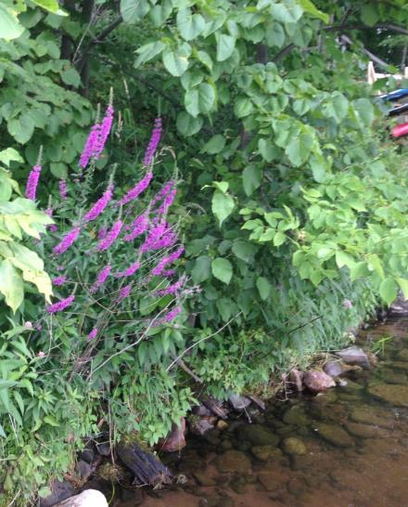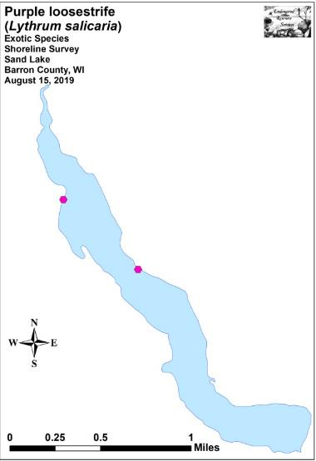
Figure 18: Purple Loosestrife Flowers and 2019 Locations

Reed canary grass continues to be widely distributed in undeveloped shoreline areas of the lake. Because this ubiquitous plant does provide some habitat for wildlife and there is no easy or cheap way to eliminate it, management is likely not needed. Curly-leaf pondweed, another common exotic invasive in many area lakes, was not found during this or any other surveys we have conducted on the lake (For more information on these common aquatic exotic invasive species, see Appendix VII).

DISCUSSION AND CONSIDERATIONS FOR MANAGEMENT:
Native Aquatic Macrophytes and EWM:
Sand Lake continues to have a rich and diverse native plant community that is typical of muck/sandy bottomed drainage lakes. Unfortunately, Eurasian water-milfoil will pose a continued threat to that diversity and the resource as a whole moving forward as it is unlikely that EWM will ever be totally eliminated from the lake. This threat to the lake’s native plant communities is a significant one because they are the base of the aquatic food pyramid, provide habitat for fish and other aquatic organisms, are important food sources for waterfowl and other wildlife, stabilize the shoreline, and work to improve water clarity by absorbing excess nutrients from the water. To minimize EWM’s impact on the lake’s native plants, every effort should be made to maintain it at or further reduce it from its current low levels.

In 2019, five areas totaling 2.54 acres (0.79% of the lake’s surface area) were treated for EWM (Table 10) (Figure 19). Although our posttreatment results documented an uptick in plants compared to 2018, it was not significant. As has often been the case in the past, this suggests that the current management strategy of targeted small-scale herbicide treatments seems to be holding the EWM population in check rather than eliminating it.

The significant reduction of the native species Northern water-milfoil (NWM) in 2018 following the increased utilization of whole area (eight areas totaling 14.66 acres - 4.6% of the lake’s surface area) rather than smaller spot treatments was potentially concerning. Fortunately, with a smaller treatment in 2019, NWM staged a highly significant recovery. Balancing EWM management with collateral damage on native species like NWM will continue to be a challenge for lake managers in the future. Regardless of what management is utilized, we again remind stakeholders that EWM favors the same habitat that supports NWM. Because NWM is common to abundant throughout the lake’s littoral zone, it is likely that EWM will eventually expand into these areas if left unchecked. There is also the danger that EWM could more quickly recolonize areas currently occupied by NWM if wide-scale herbicide treatments occurred after NWM starts growing in the spring, or before NWM can form overwintering turions in the fall.

Table 10: Spring Eurasian Water-milfoil Treatment Summary
Sand Lake, Barron County
June 6, 2019

Treatment Area | Final Acreage | Chemical (Brand) – Rate – Total lbs
1 | 1.22 | 2,4-D (Sculpin G) – 4ppm – 838lbs
2 | 0.25 | 2,4-D (Sculpin G) – 4ppm – 172lbs
3 | 0.32 | 2,4-D (Sculpin G) – 4ppm – 157lbs
4 | 0.60 | 2,4-D (Sculpin G) – 4ppm – 373lbs
5 | 0.15 | 2,4-D (Sculpin G) – 4ppm – 74lbs
Total Acres | 2.54
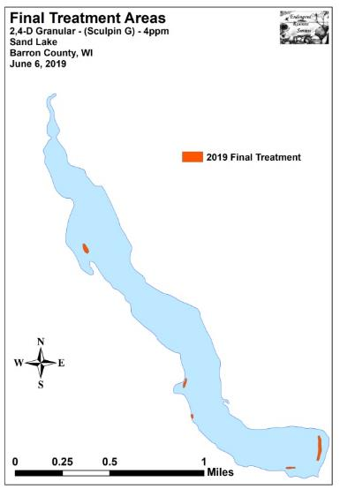
Figure 19: Sand Lake Treatment Areas 6/6/19

Purple Loosestrife:
The pulling of Purple loosestrife that we and other volunteers have done along the shoreline appears to be holding this species in check. However, because the lake has many undeveloped, muck bottom areas that provide suitable habitat for this invasive wetland plant to expand into, residents should continue to be vigilant in watching for and removing plants. Although plants could appear anywhere, the Silo Bay, the other finger bays on the west side, and the beaver pond bay are especially likely places for new populations to establish. As in the past, it might be a good idea to send out a reminder to all lake residents why it is important that they identify and remove all loosestrife plants when they bloom in late July/early August before they go to seed. Bagging the plants immediately and disposing of them well away from any wetland should prevent further spread. Also, as the plant can resprout from root fragments, using a shovel is recommended to ensure total root removal.

Future EWM and Native Macrophyte Monitoring Strategies:
After four years of intensively monitoring the lake’s summer littoral zone, a review of the value of the data these surveys have produced is likely needed prior to determining monitoring strategies for the future. On the positive side and as intended, the surveys are detecting EWM in deep water at a higher rate than traditional fall bed monitoring. They are also providing annual lakewide data on native plants which would ultimately allow long term trends to be established. On the negative side, the survey is labor intensive, and, consequently, costly. Ultimately, it will be up to the SLMD, LEAPS, and the WDNR to decide if the positives of these intensive summer survey continue to outweigh the negatives. If these intensive surveys are discontinued, it will likely mean returning to pre/post treatment surveys with fall EWM bed mapping, or simply doing fall bed mapping.

LITERATURE CITED

Borman, S., R. Korth, and J. Temte 1997. Through the Looking Glass…A Field Guide to Aquatic Plants. Wisconsin Lakes Partnership. DNR publication FH-207-97.

Busch, C., G. Winter, L. Sather, and C. Holt. [online]. 1967. Sand Lake Map. Available from http://dnr.wi.gov/lakes/maps/DNR/2661100a.pdf (2019, November).

Chadde, Steve W. 2002. A Great Lakes Wetland Flora: A complete guide to the aquatic and wetland plants of the Upper Midwest. Pocketflora Press; 2nd edition

Crow, G. E., C. B. Hellquist. 2006. Aquatic and Wetland Plants of Northeastern North America, Volume I + II: A Revised and Enlarged Edition of Norman C. Fassett's A Manual of Aquatic Plants. University of Wisconsin Press.

Nichols, Stanley A. 1999. Floristic Quality Assessment of Wisconsin Lake Plant communities with Example Applications. Journal of Lake and Reservoir Management 15 (2): 133-141.

Sullman, Josh. [online] 2010. Sparganium of Wisconsin Identification Key and Description. Available from University of Wisconsin-Madison http://www.botany.wisc.edu/jsulman/Sparganium%20identification%20key%20and%20description.htm (2012, February).

UWEX Lakes Program. [online]. 2010. Aquatic Plant Management in Wisconsin. Available from http://www.uwsp.edu/cnr-ap/UWEXLakes/Pages/ecology/aquaticplants/default.aspx (2019, November).

UWEX Lakes Program. [online]. 2010. Pre/Post Herbicide Comparison. Available from http://www.uwsp.edu/cnr-ap/UWEXLakes/Documents/ecology/Aquatic%20Plants/Appendix-D.pdf (2019, November).

Voss, Edward G. 1996. Michigan Flora Vol I-III. Cranbrook Institute of Science and University of Michigan Herbarium.

WDNR. [online]. 2010. Curly-leaf pondweed fact sheet. http://www.dnr.state.wi.us/invasives/fact/curlyleaf_pondweed.htm (2010, November).

WDNR. [online]. 2010. Eurasian water-milfoil fact sheet. http://www.dnr.state.wi.us/invasives/fact/milfoil.htm (2010, November).

WDNR. [online]. 2010. Purple loosestrife fact sheet. http://www.dnr.state.wi.us/invasives/fact/loosestrife.htm (2010, November).

WDNR. [online]. 2010. Reed canary grass fact sheet. http://www.dnr.state.wi.us/invasives/fact/reed_canary.htm (2010, November).

WDNR. [online]. 2009. Wisconsin Lakes. PUB-FH-800 2016. Available from http://dnr.wisconsin.gov/lakes/lakebook/wilakes2016bma.pdf (2019, November).

WDNR. [online]. 2019. Wisconsin Lakes – Sand Lake Citizen Lake Water Quality Monitoring Database. Available from http://dnr.wi.gov/lakes/waterquality/Station.aspx?id=033143 (2019, November).

Appendix I: Boat and Vegetative Survey Datasheets

Boat Survey
Lake Name
County
WBIC
Date of Survey
(mm/dd/yy)
workers
Nearest Point | Species seen, habitat information

Observers for this lake: names and hours worked by each:
Lake: |  |  |  |  |  |  |  |  | WBIC |  |  |  |  |  |  |  |  | County |  |  |  |  |  | Date:
Site # | Depth (ft) | Muck (M), Sand (S), Rock (R) | Rake pole (P) or rake rope (R) | Total Rake Fullness | EWM | CLP | 1 | 2 | 3 | 4 | 5 | 6 | 7 | 8 | 9 | 10 | 11 | 12 | 13 | 14 | 15 | 16 | 17 | 18 | 19
1
2
3
4
5
6
7
8
9
10
11
12
13
14
15
16
17
18
19
20

Appendix II: Survey Sample Points Map

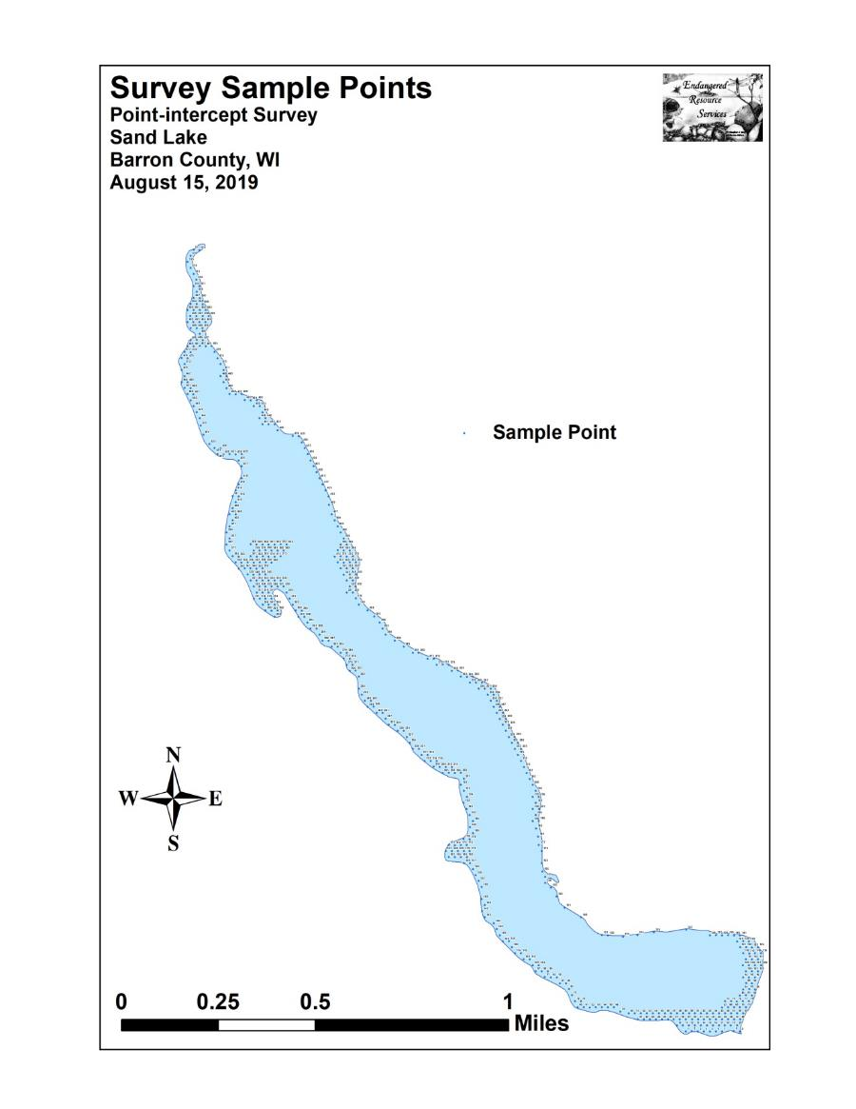

Appendix III: Habitat Variable Maps
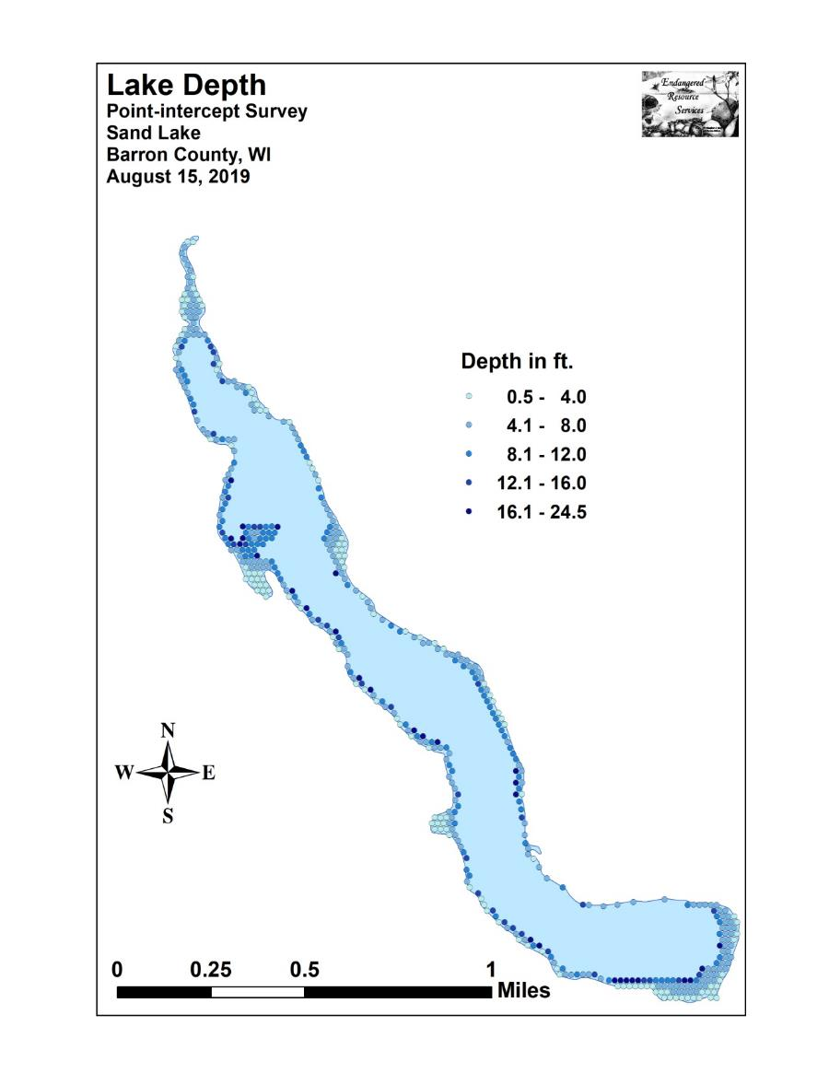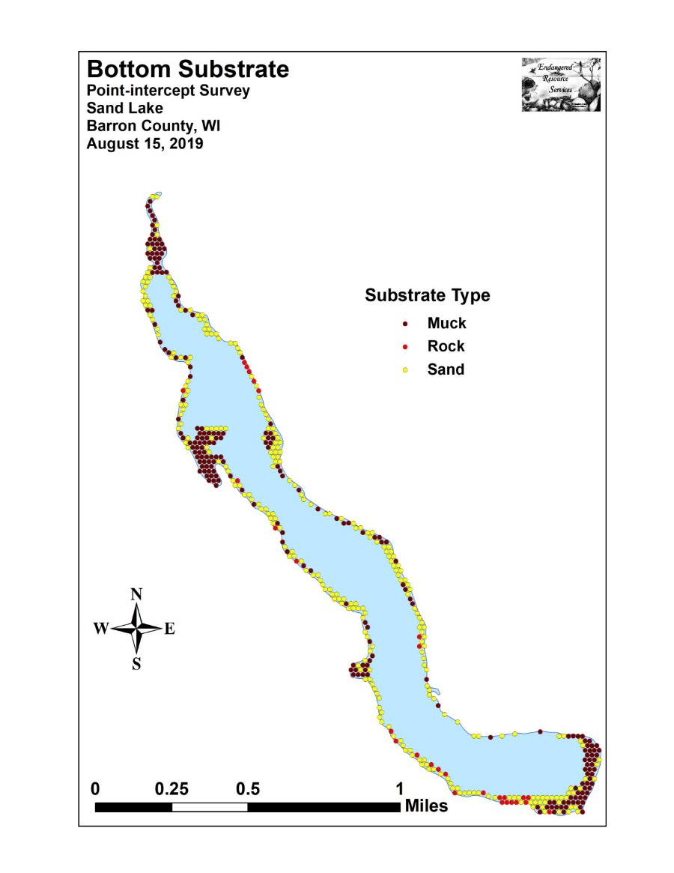

Appendix IV: 2016, 2017, 2018, and 2019 Littoral Zone,
Native Species Richness and Total Rake Fullness Maps

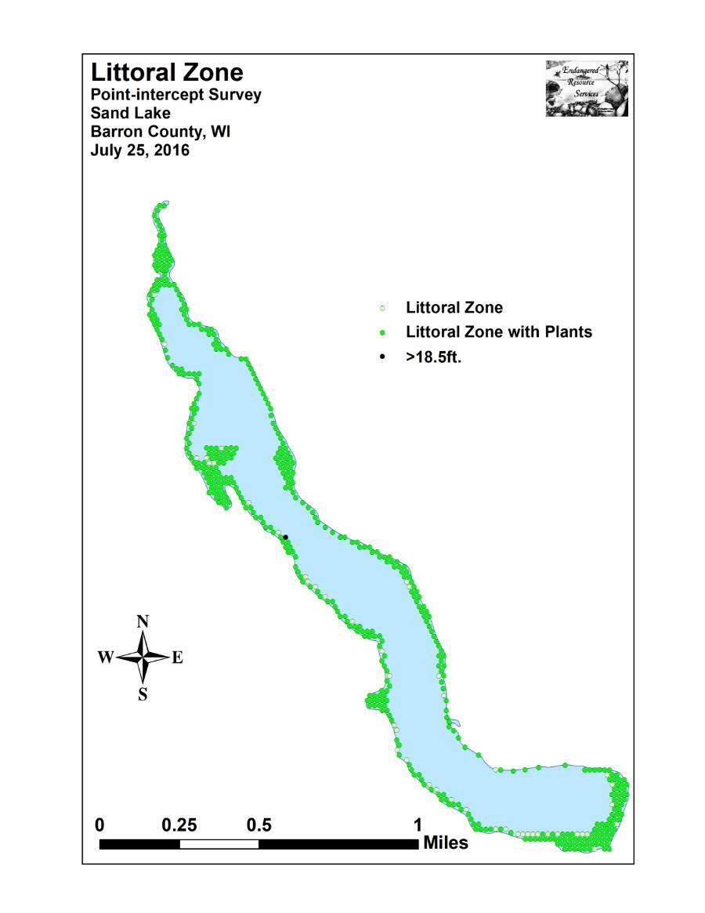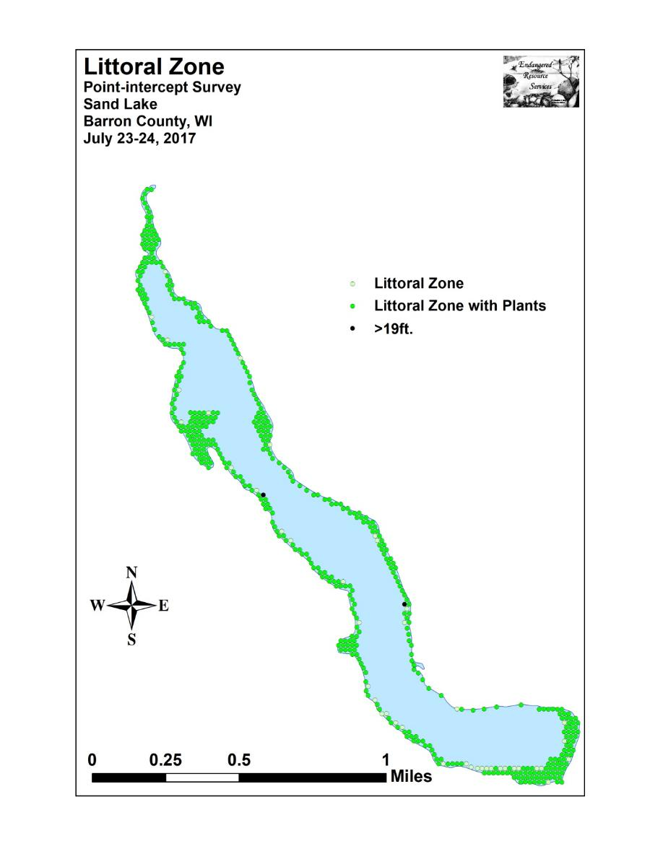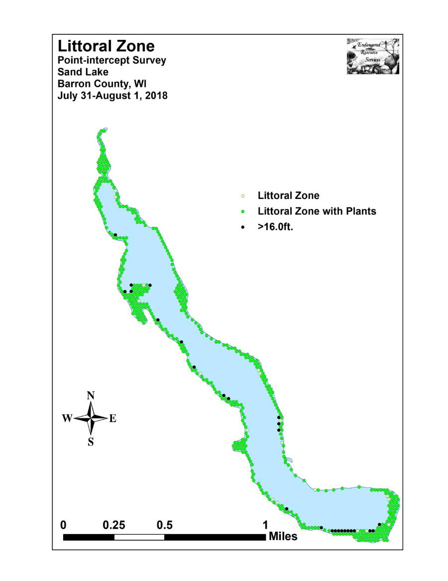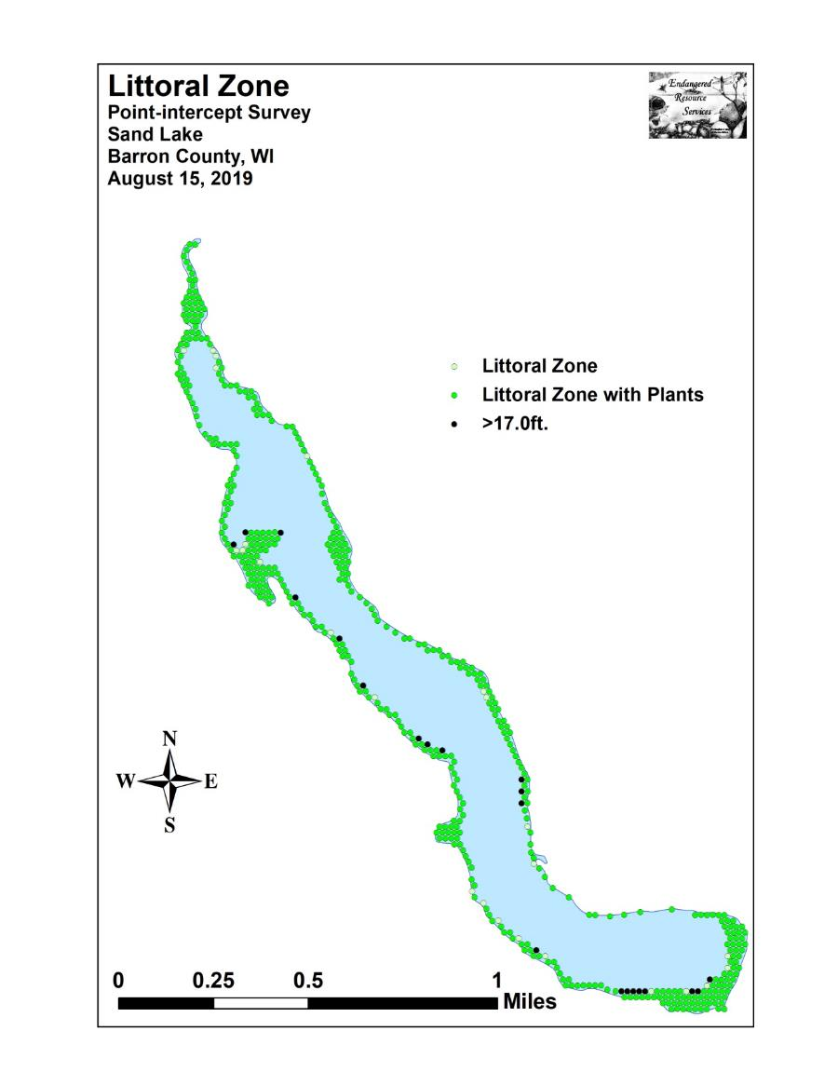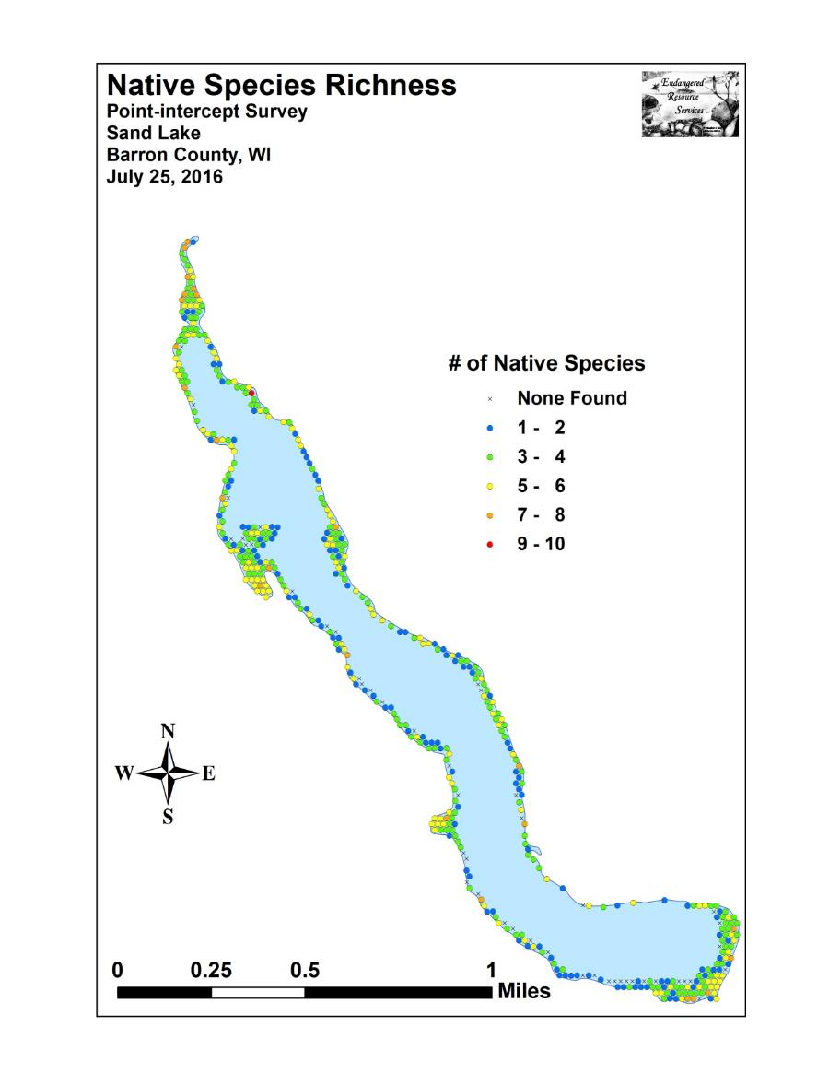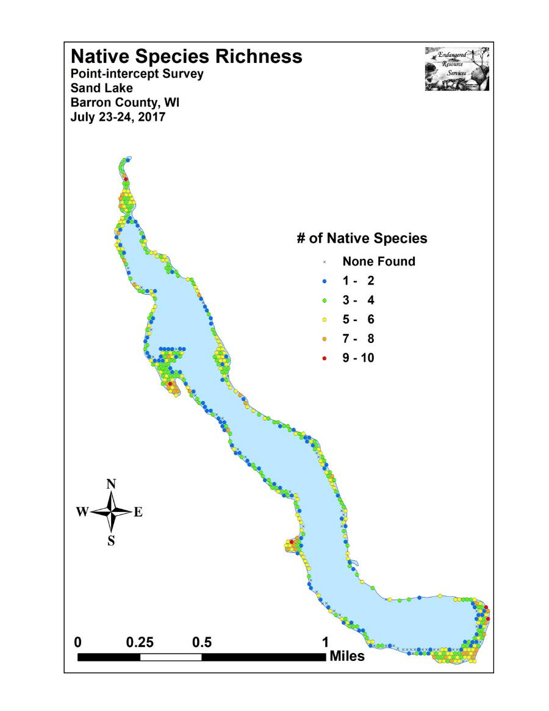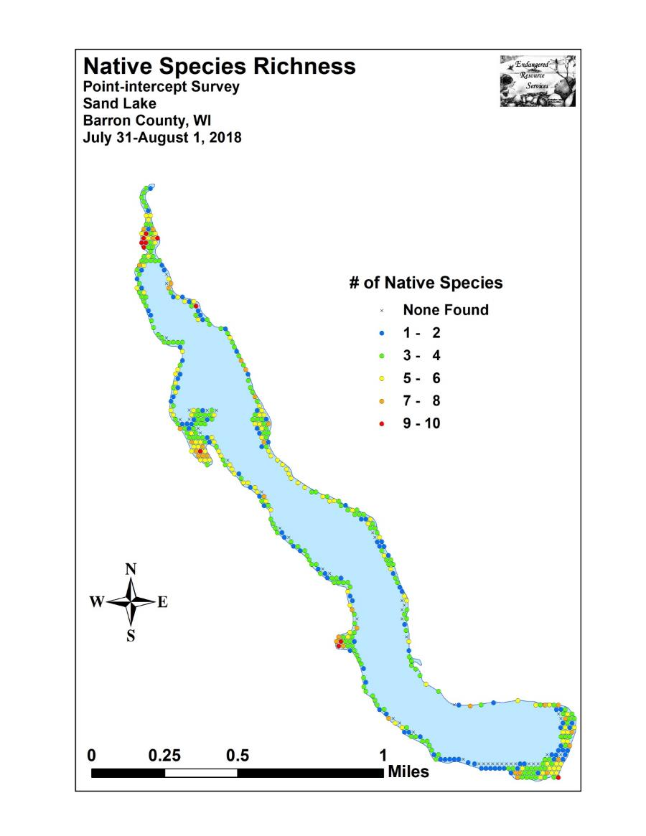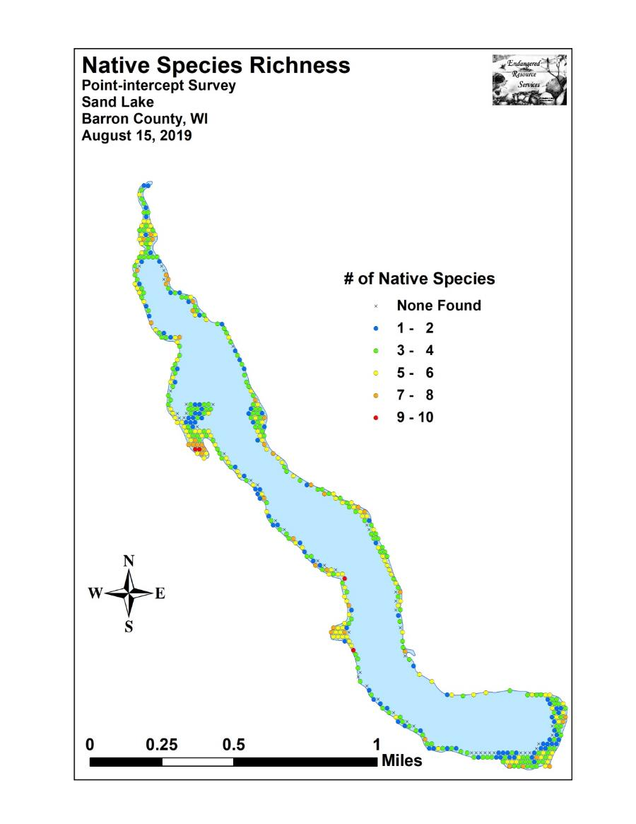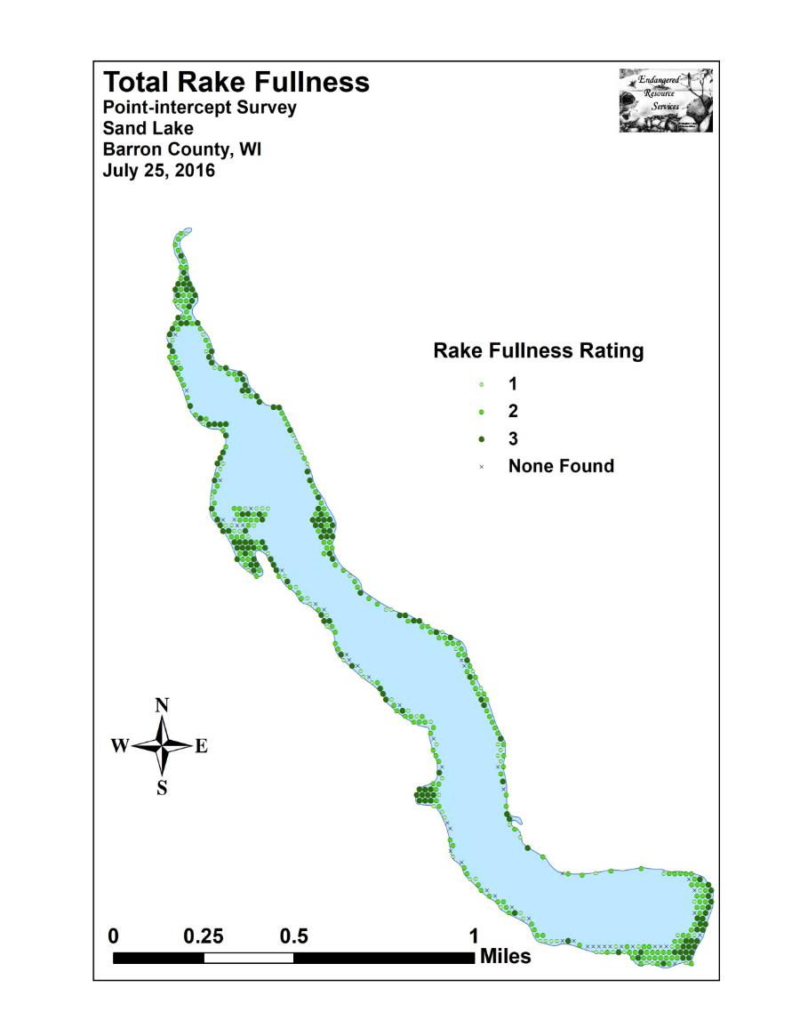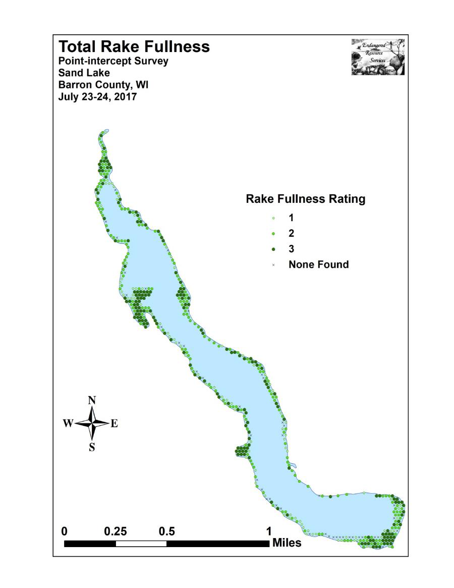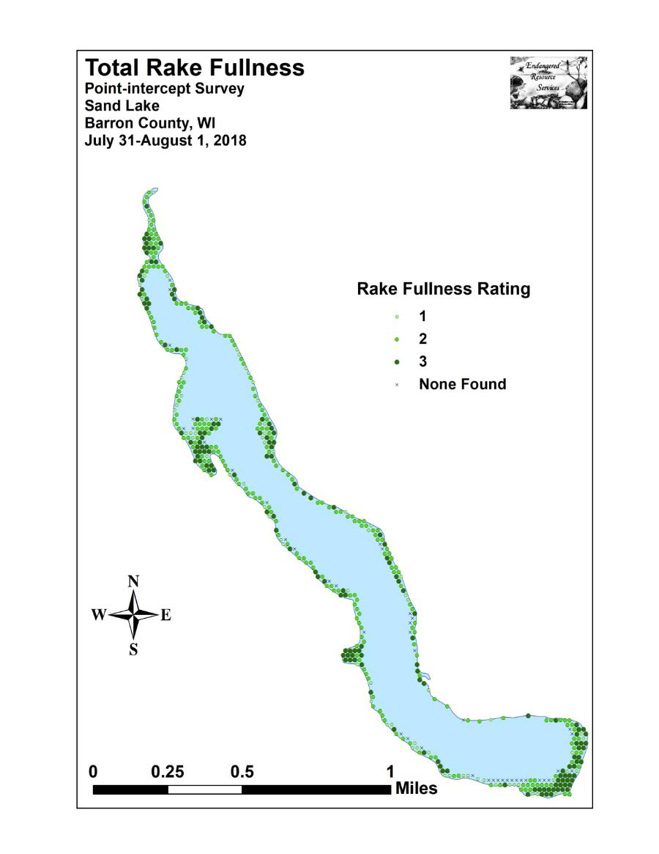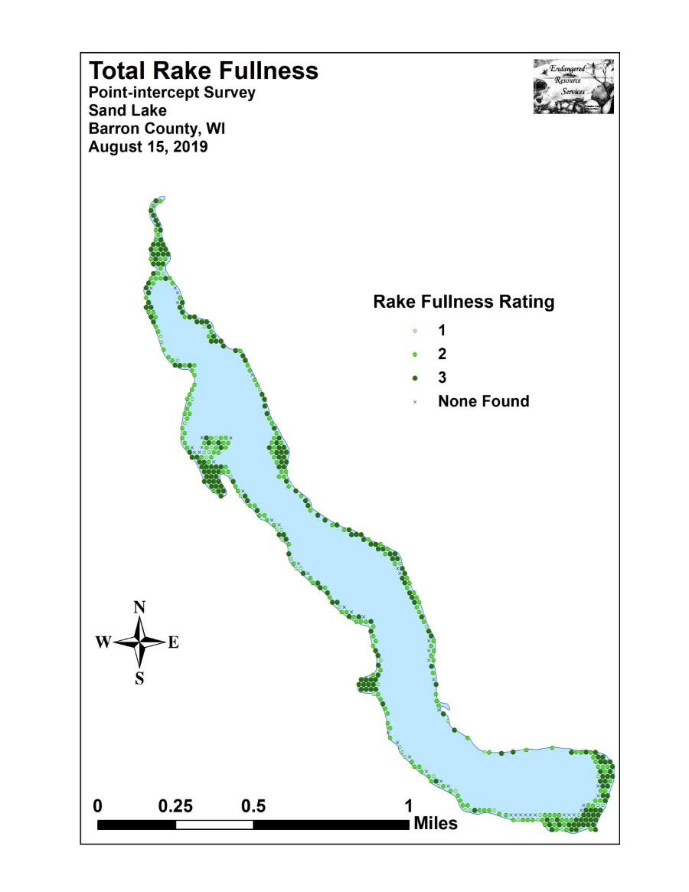

Appendix V: 2016, 2017, 2018, and 2019 Eurasian Water-milfoil
Density and Distribution, and Bed Maps

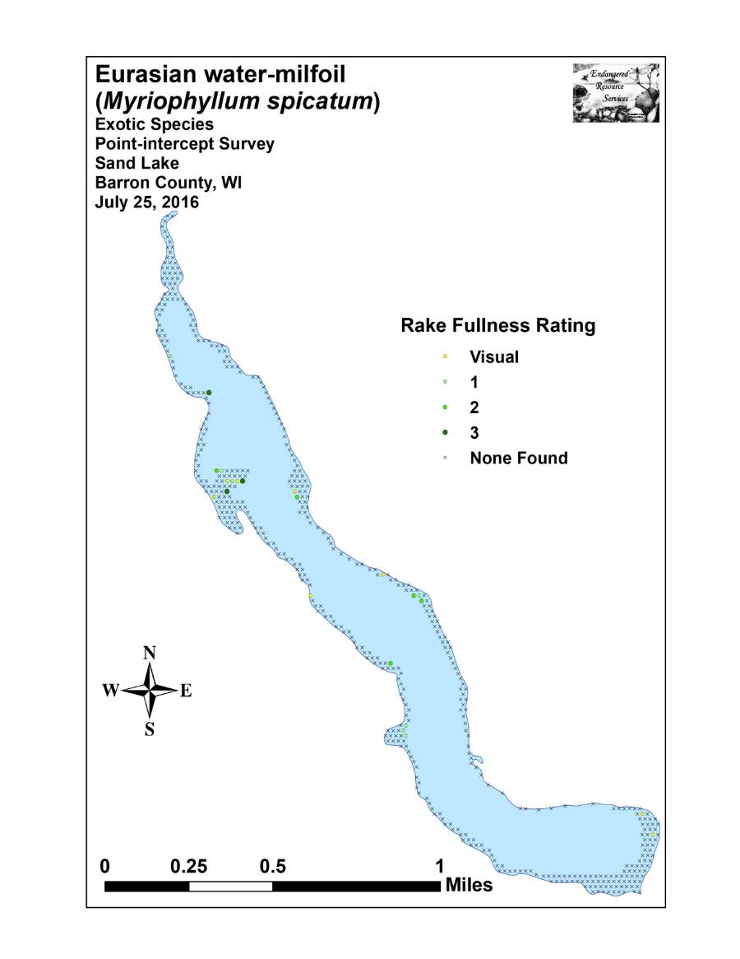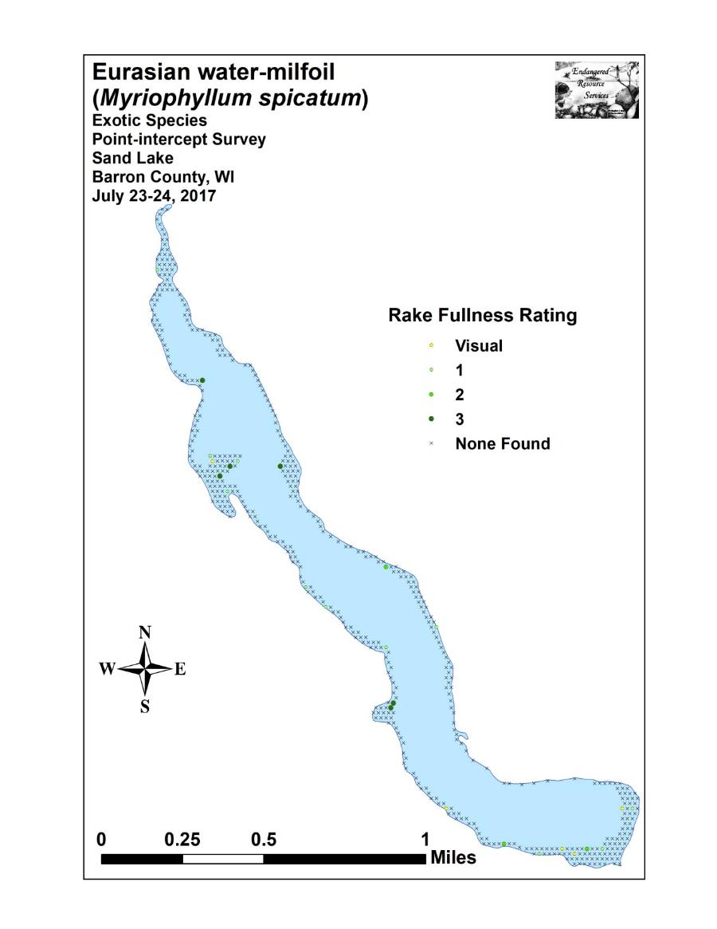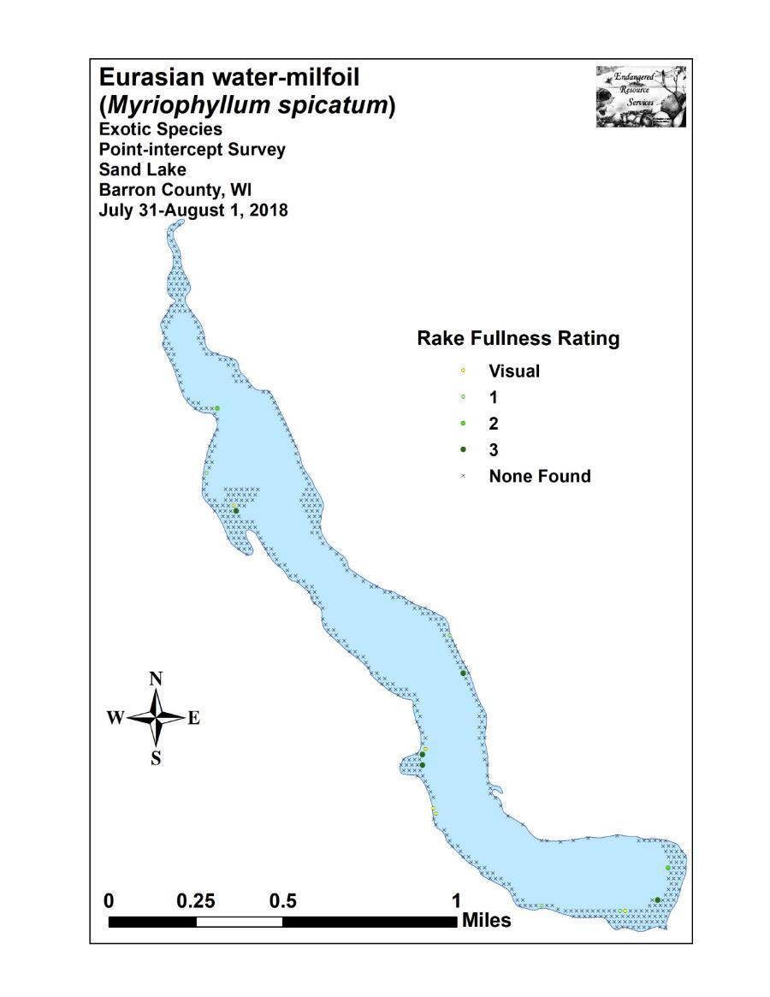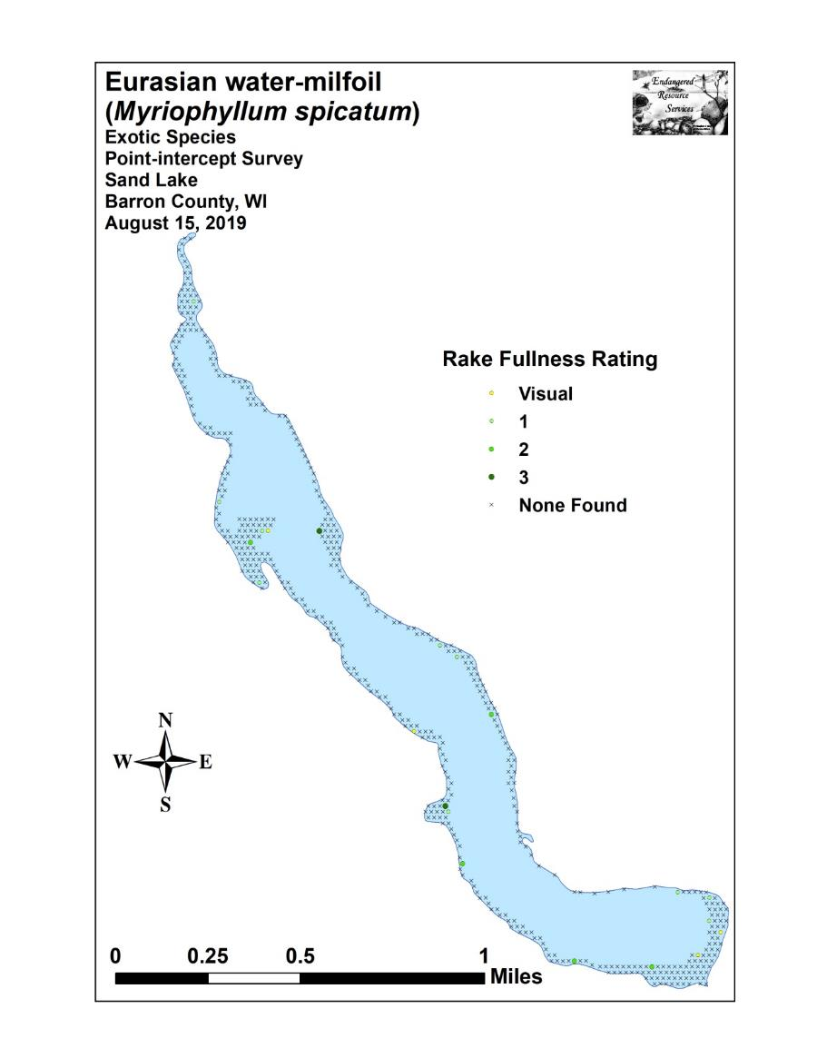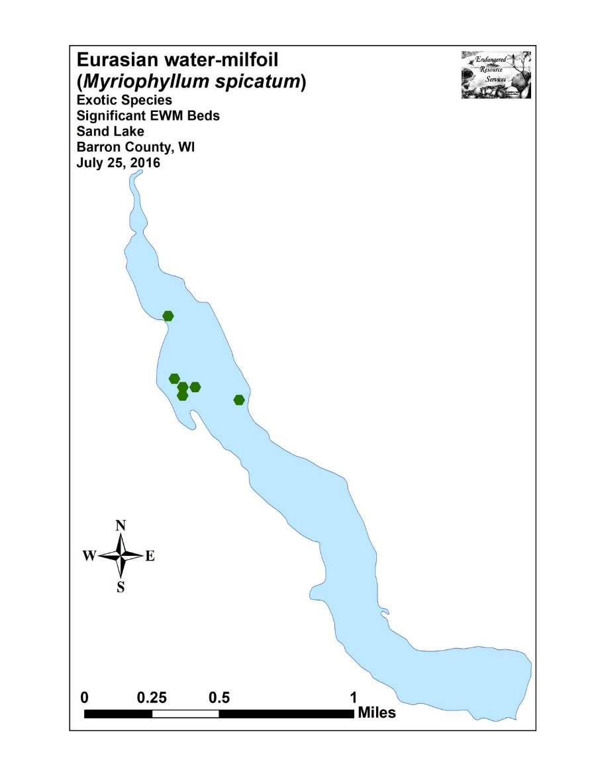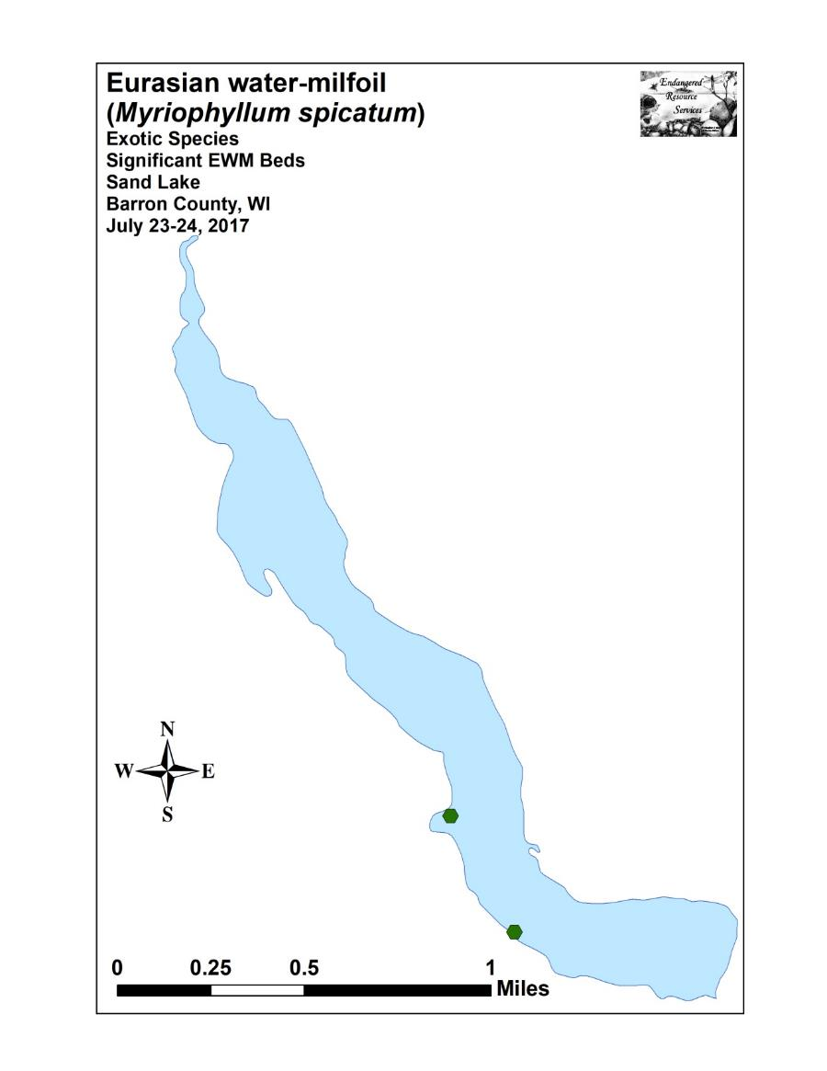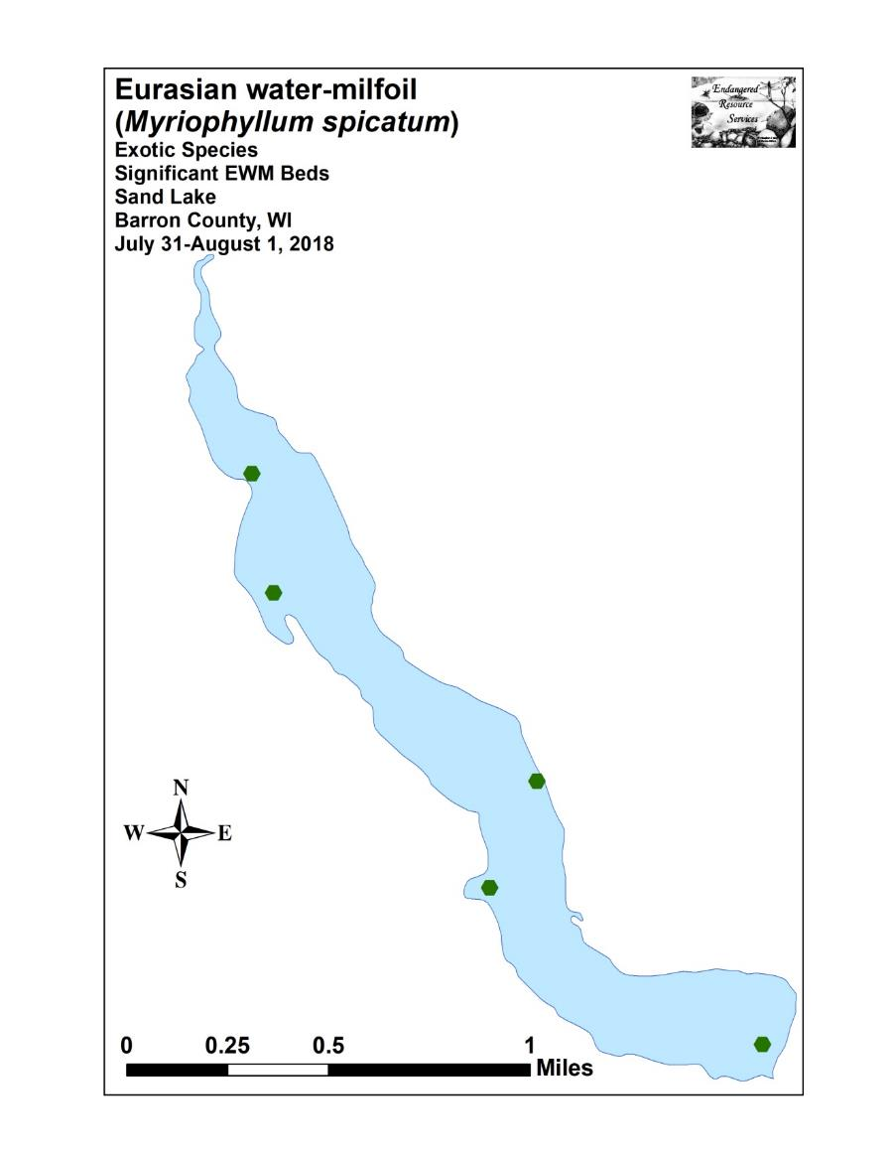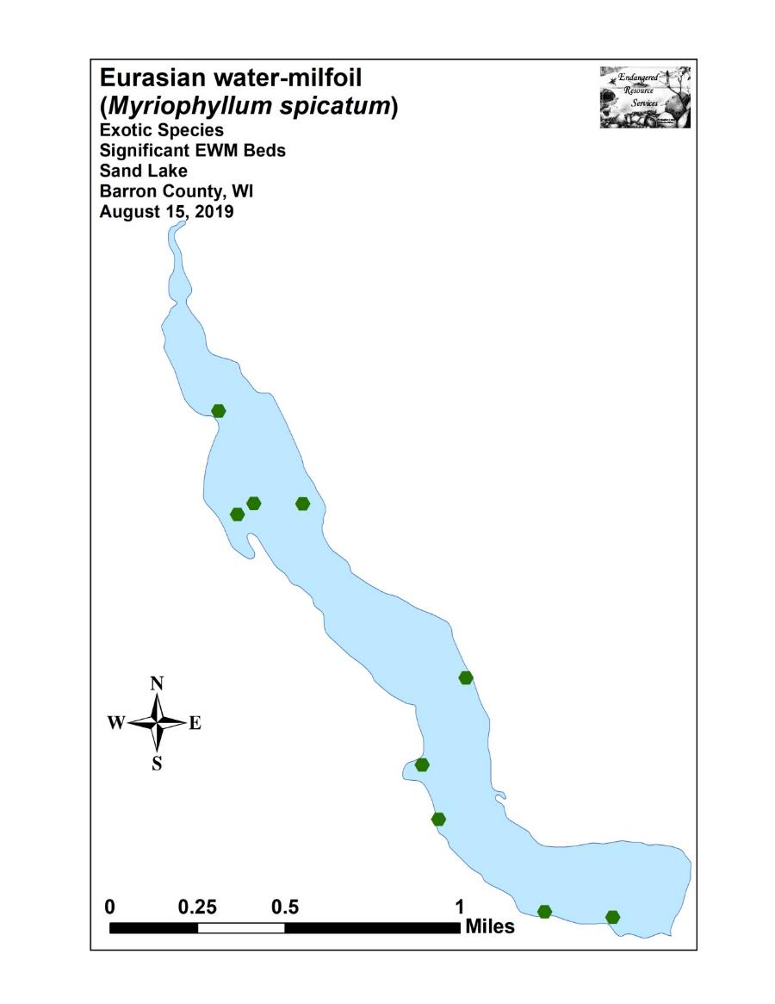

Appendix VI: 2019 Species Density and Distribution Maps

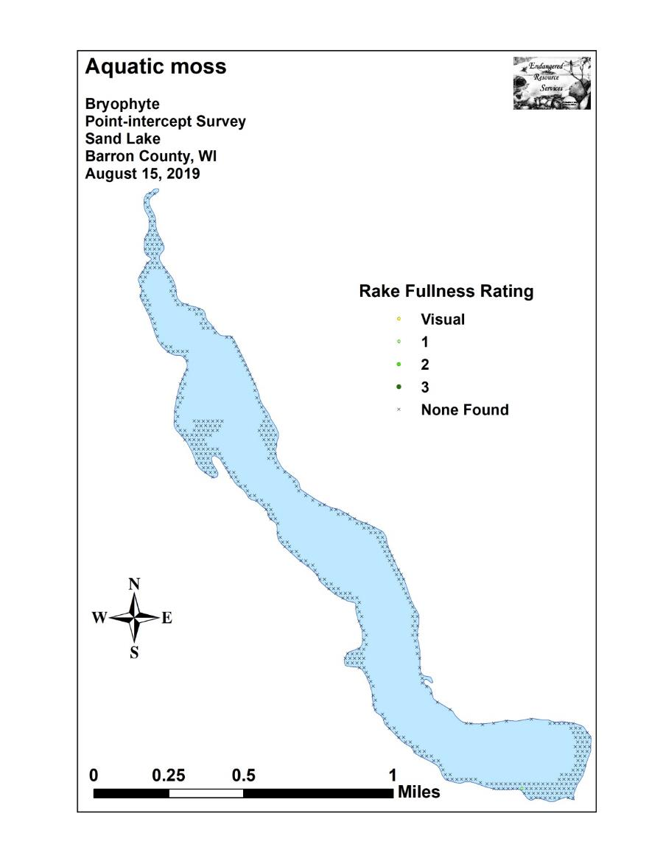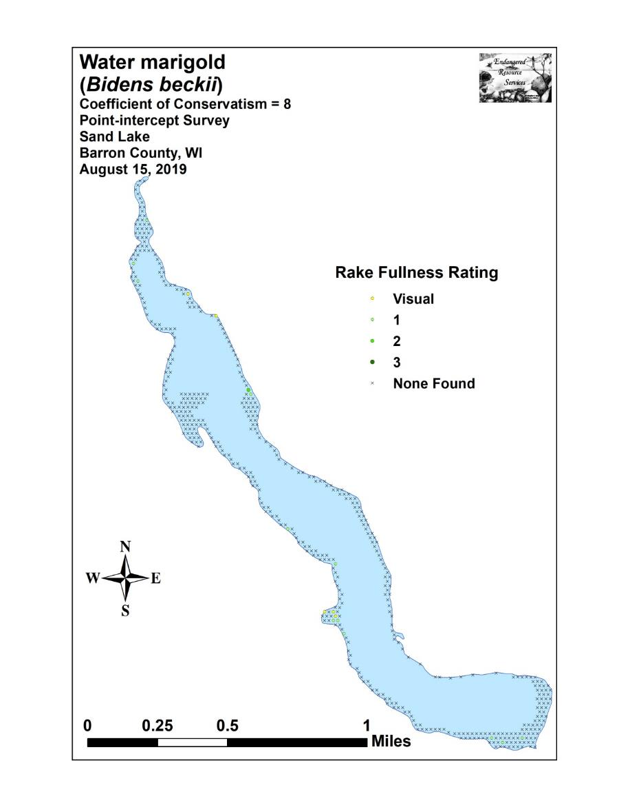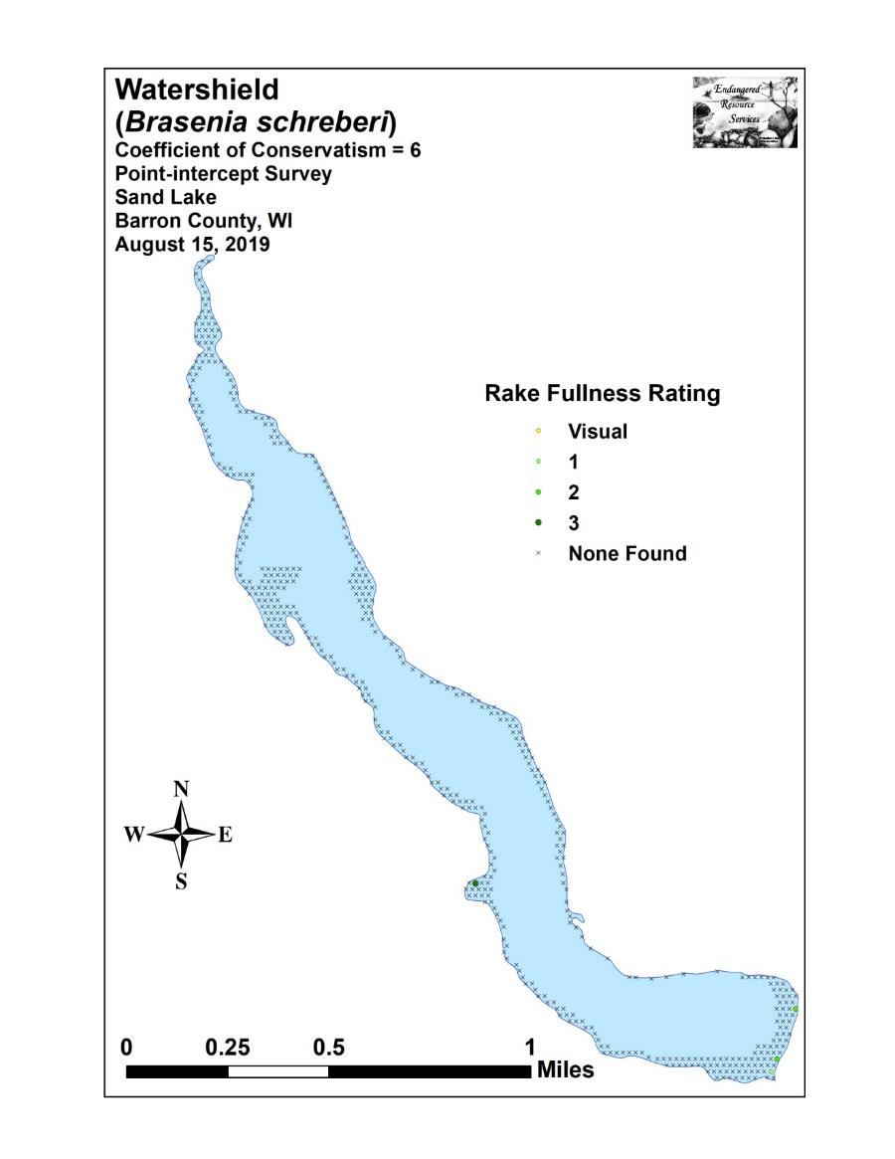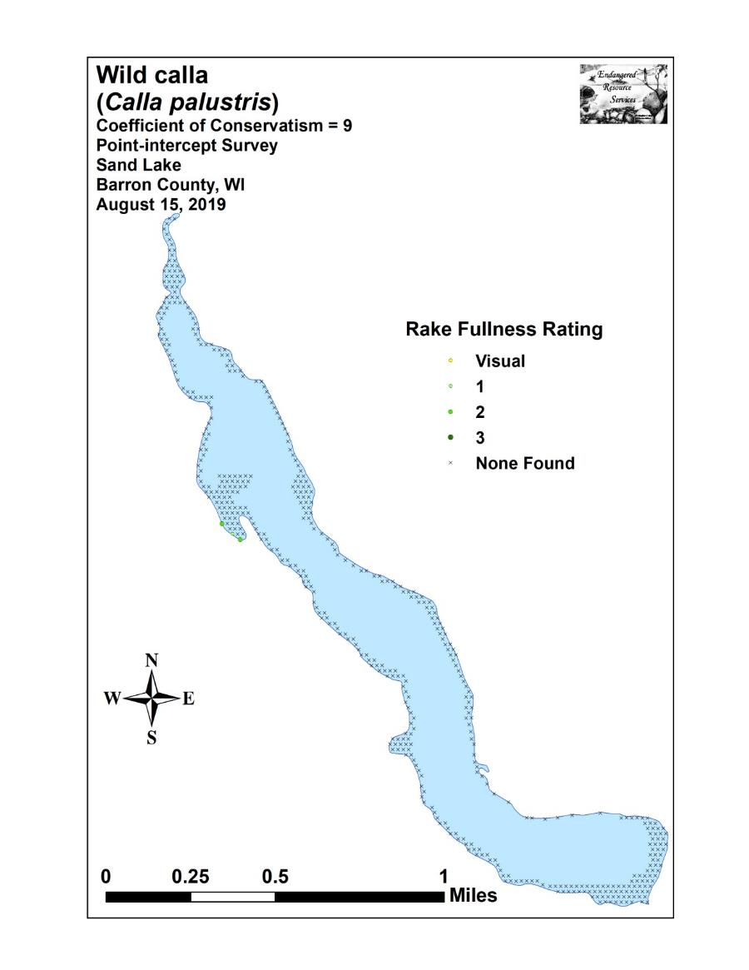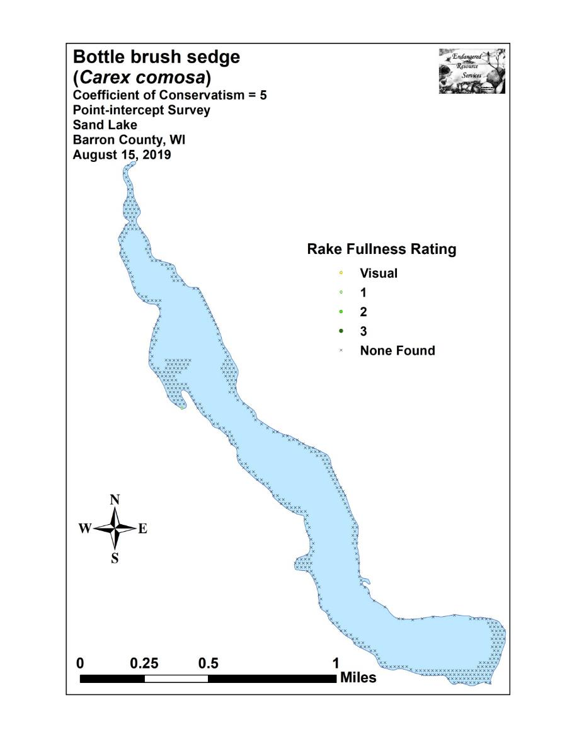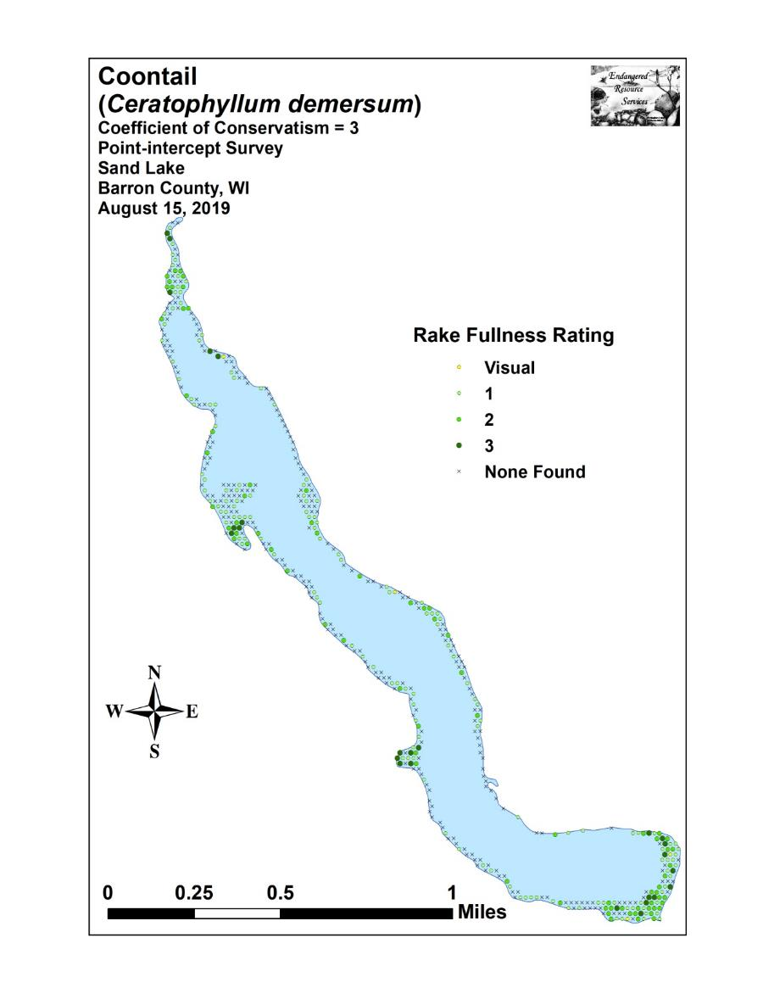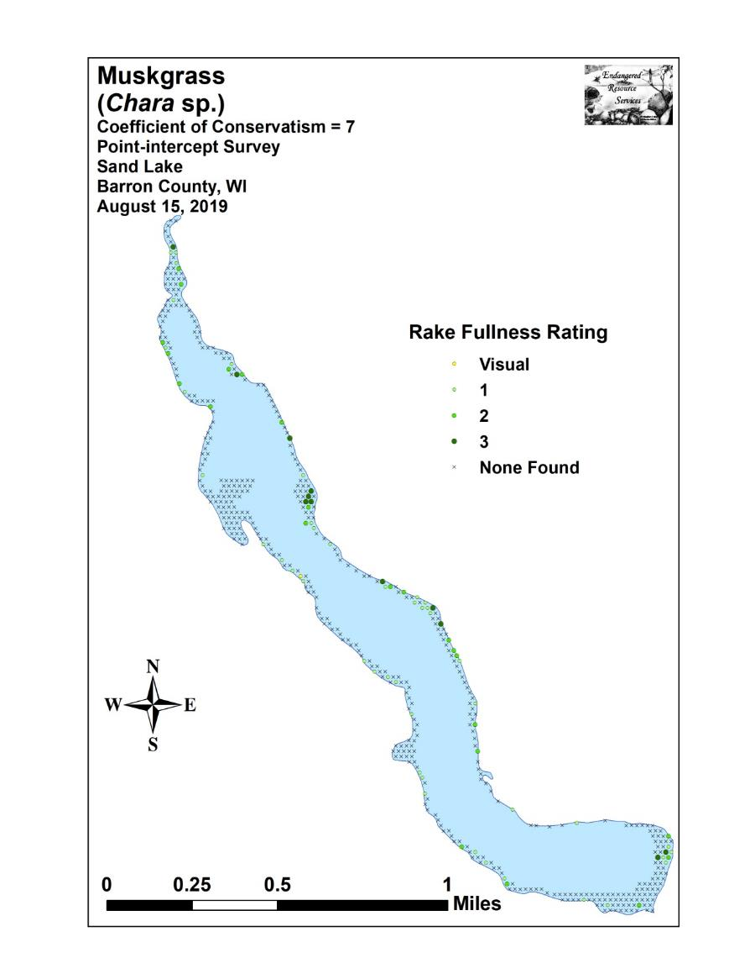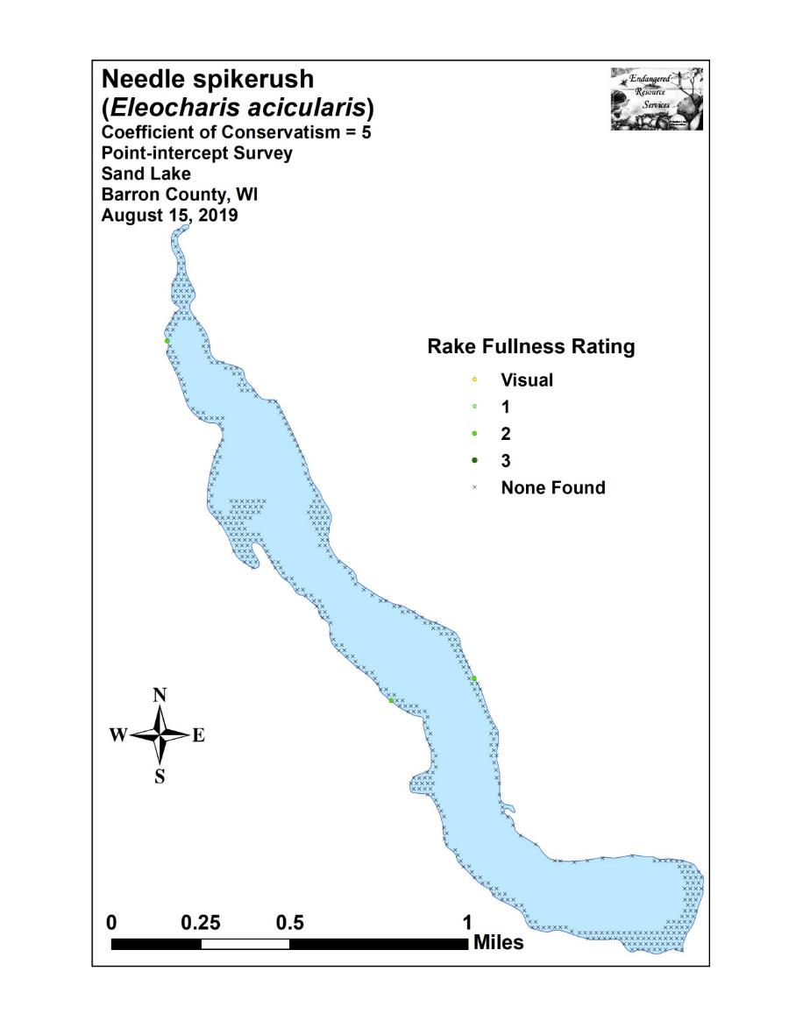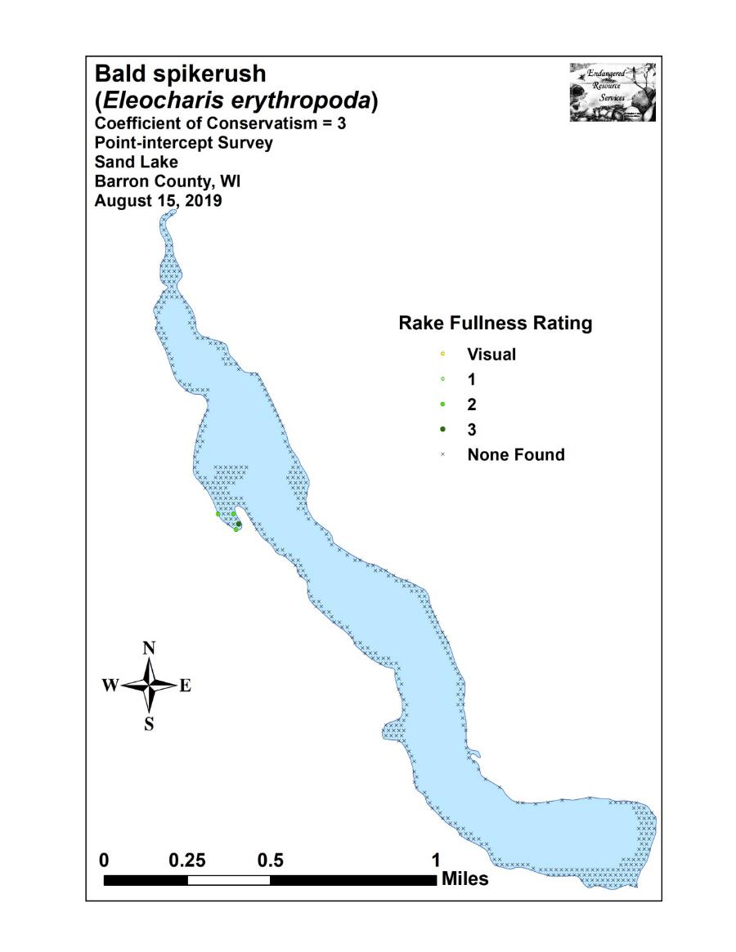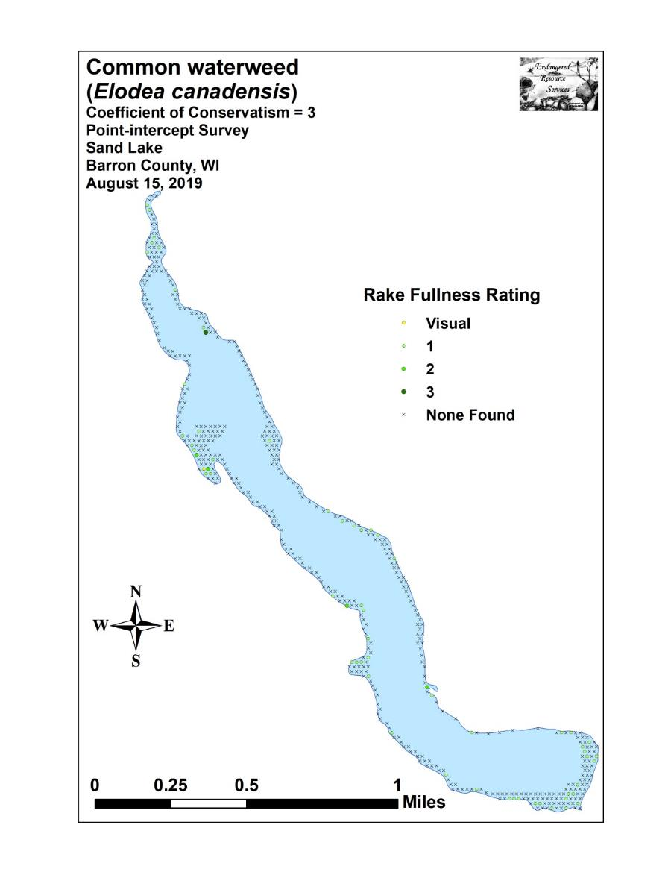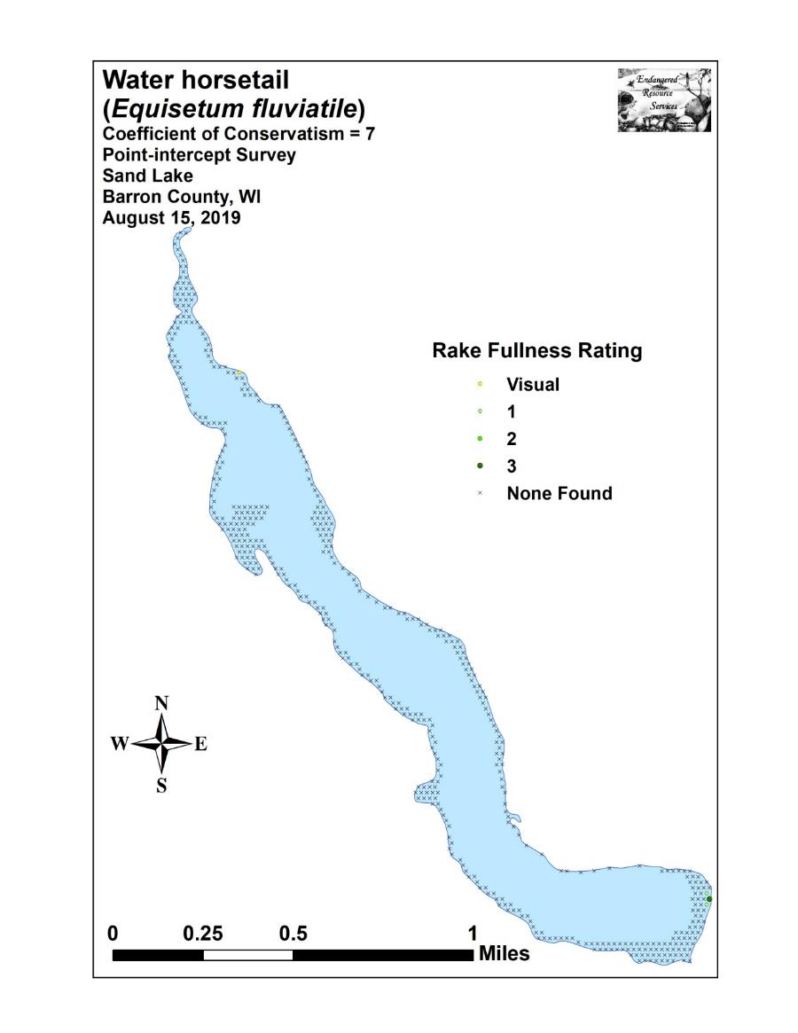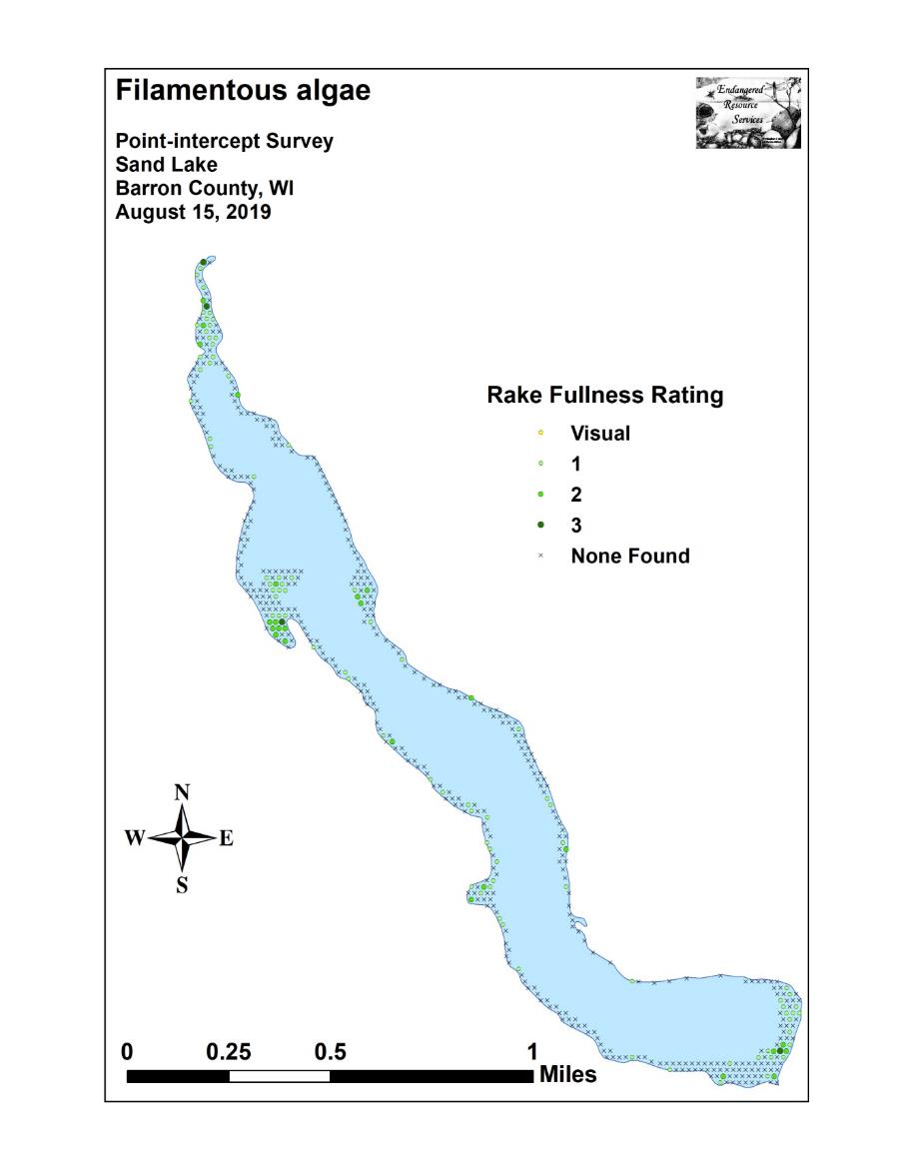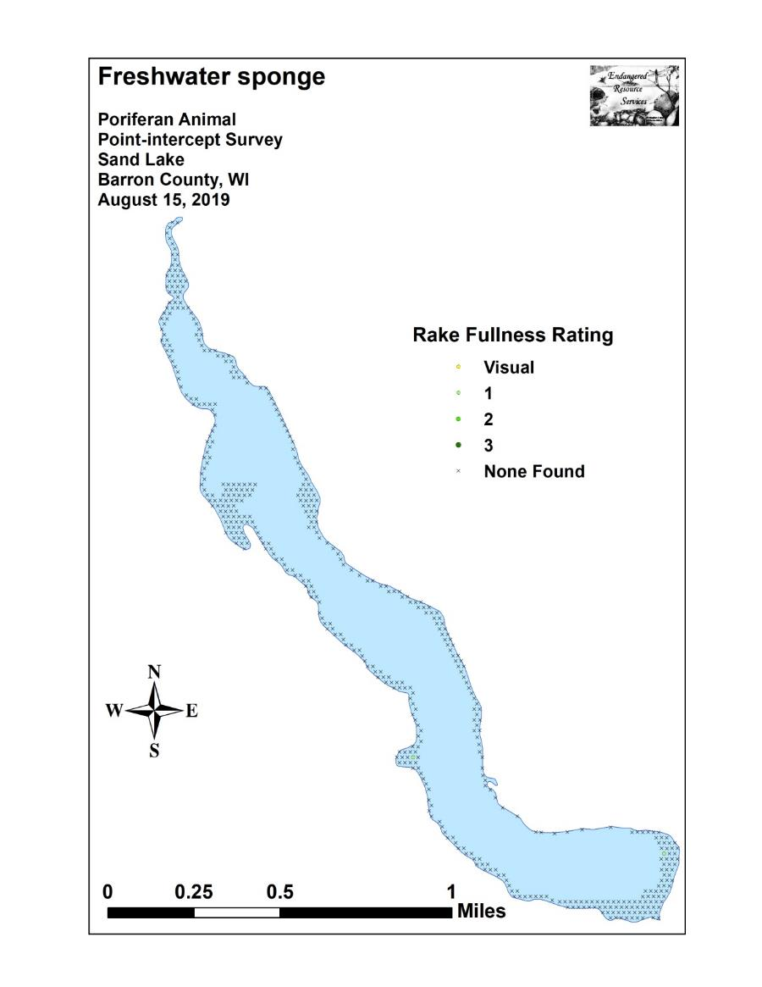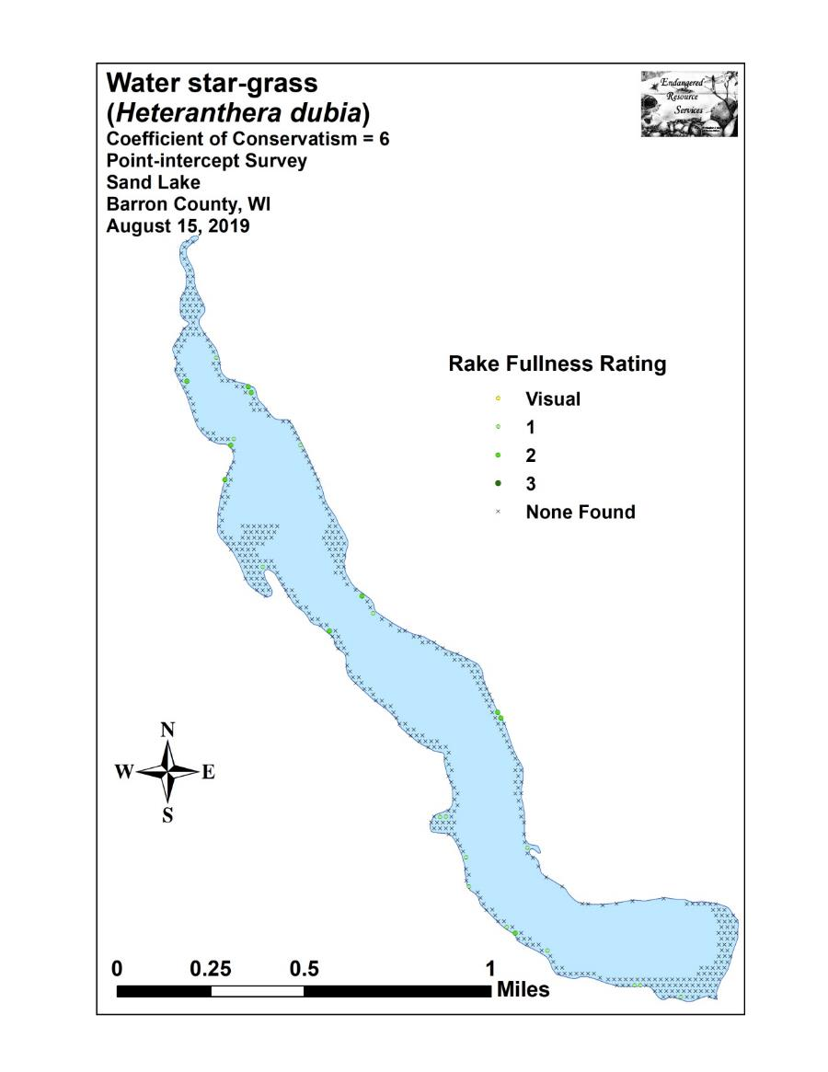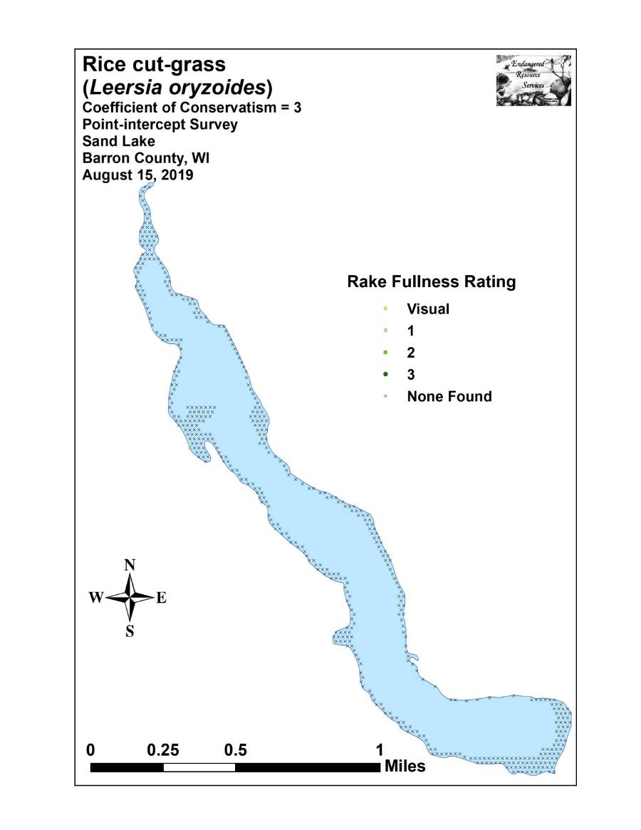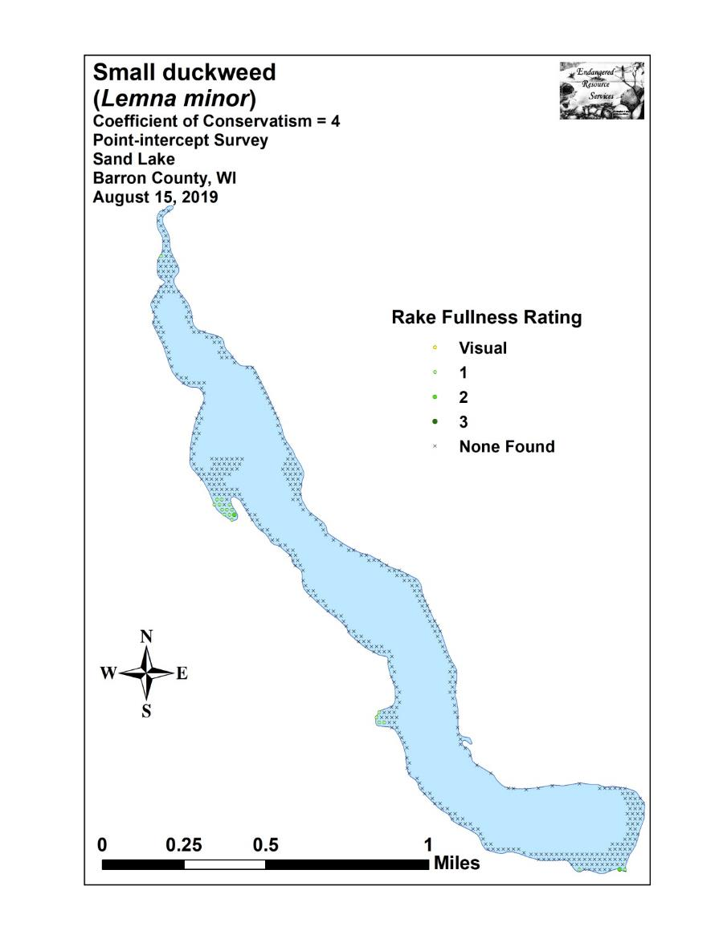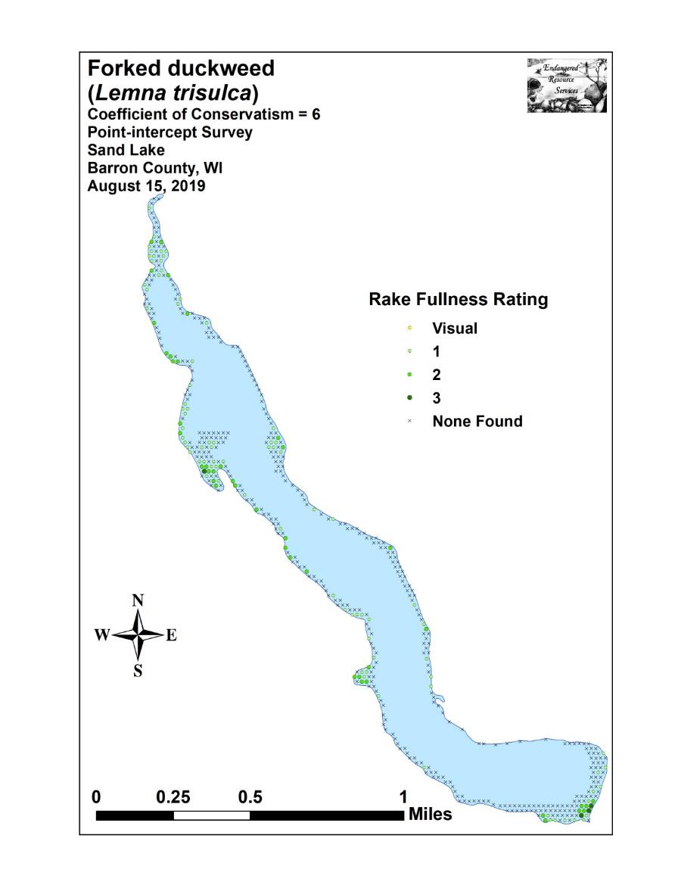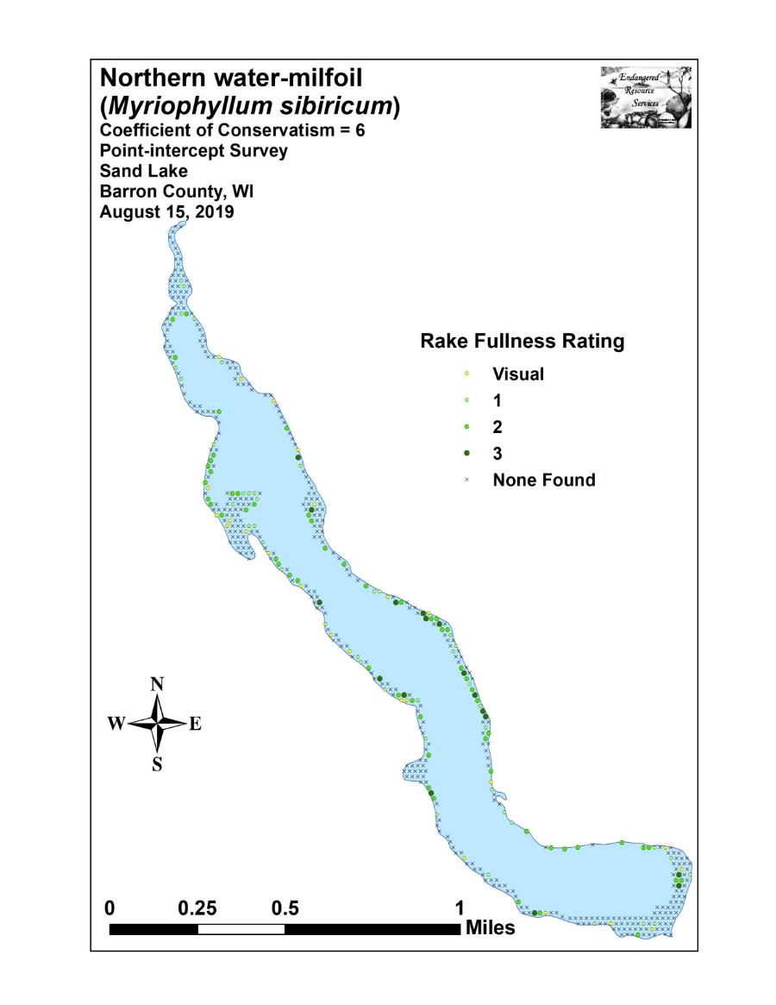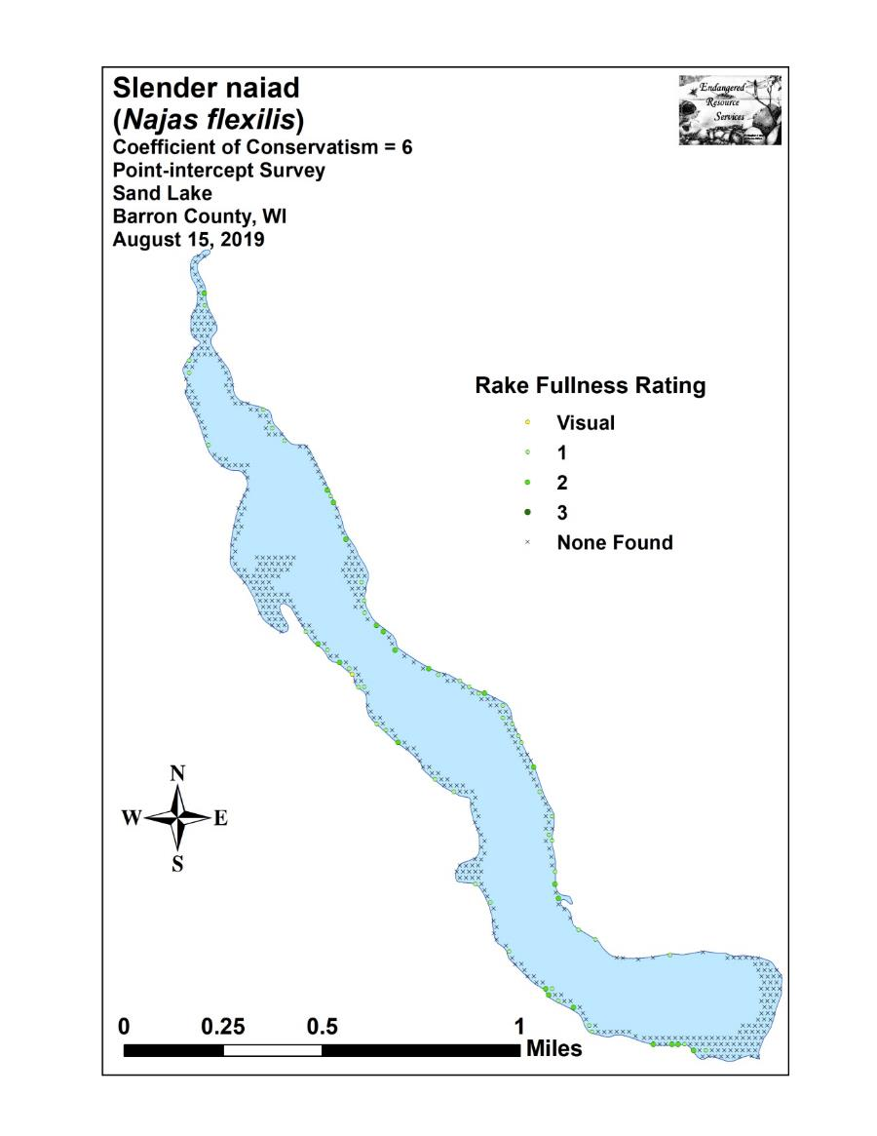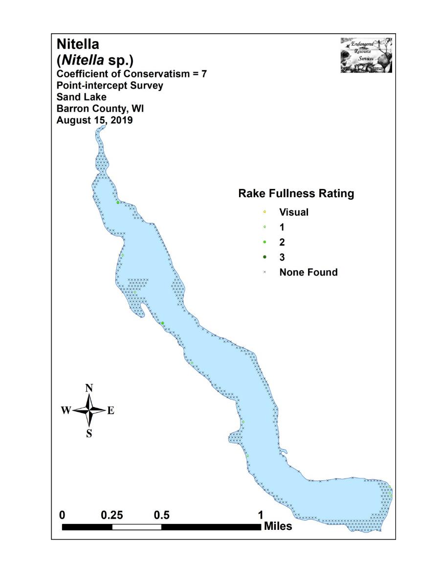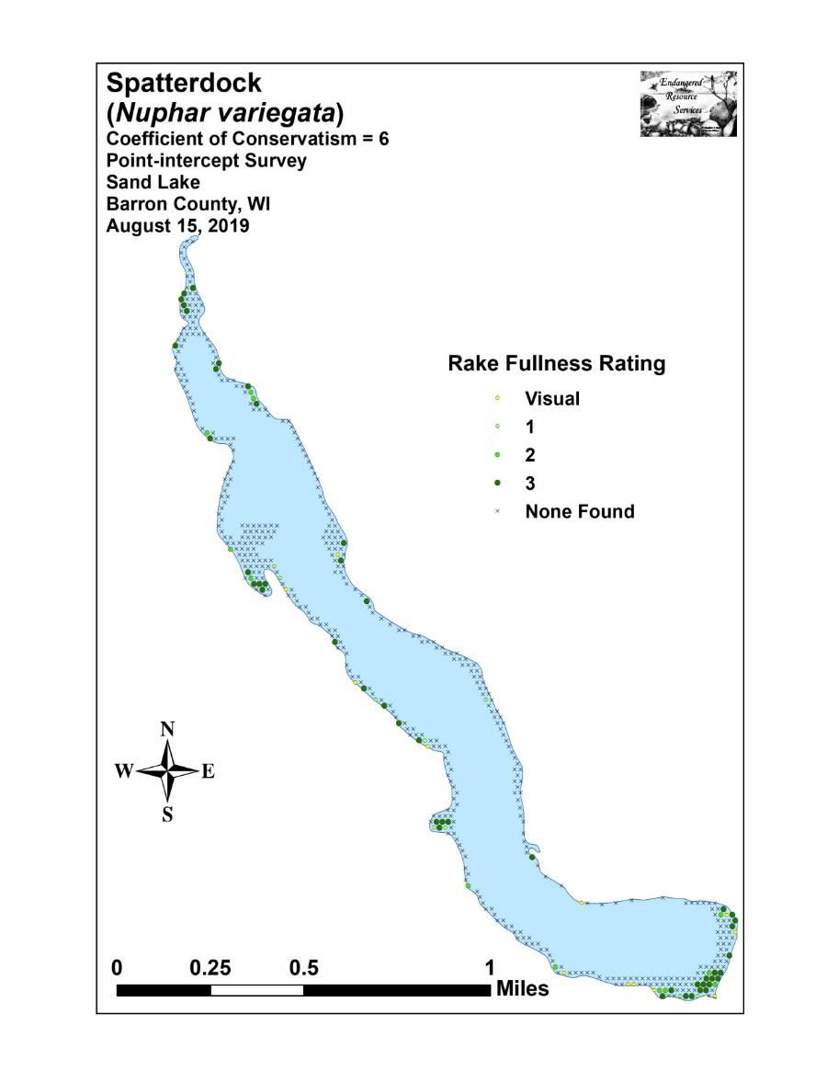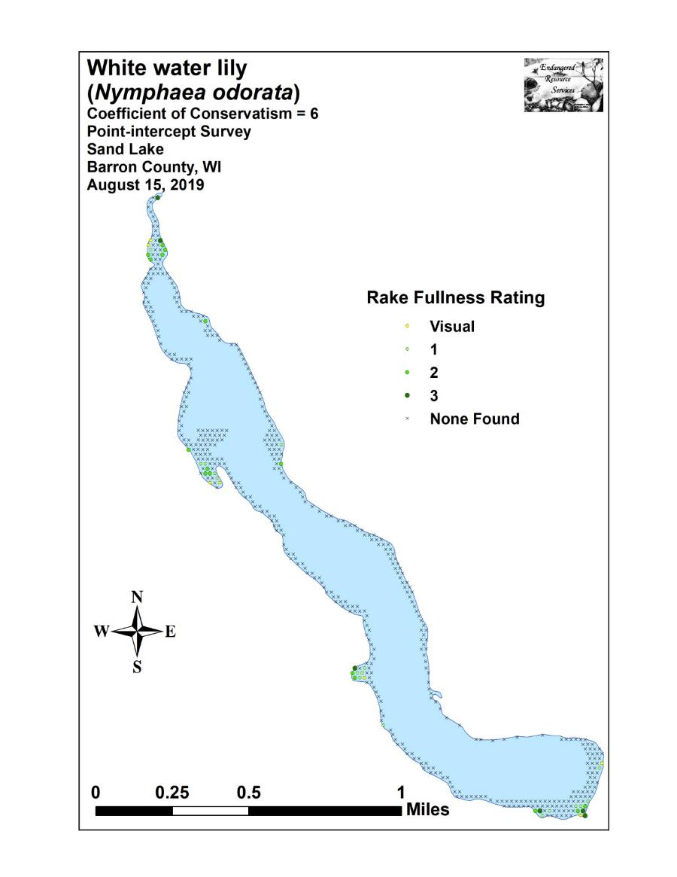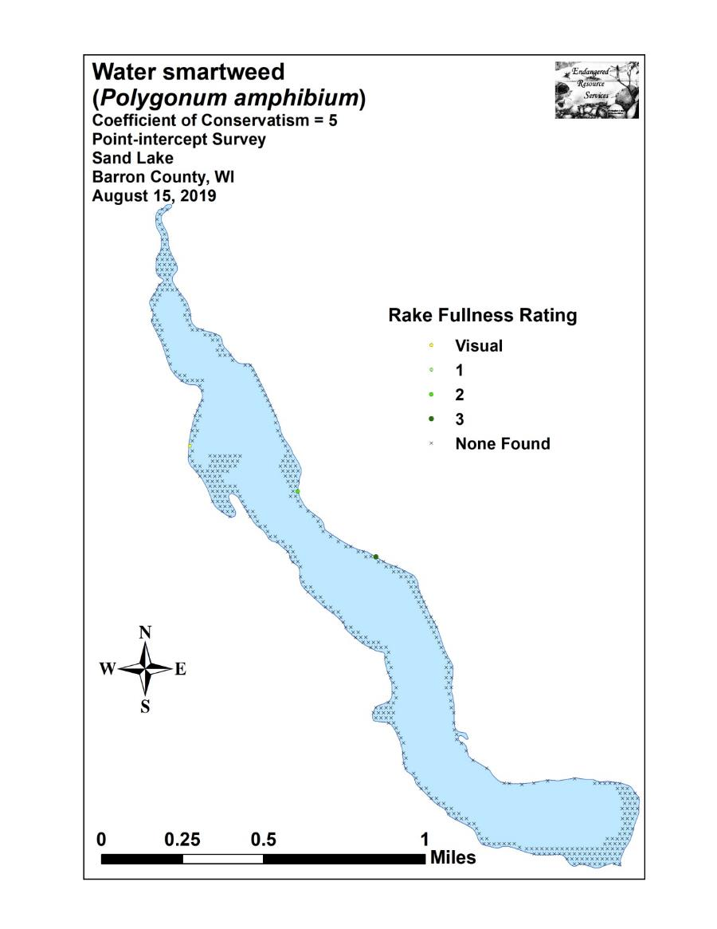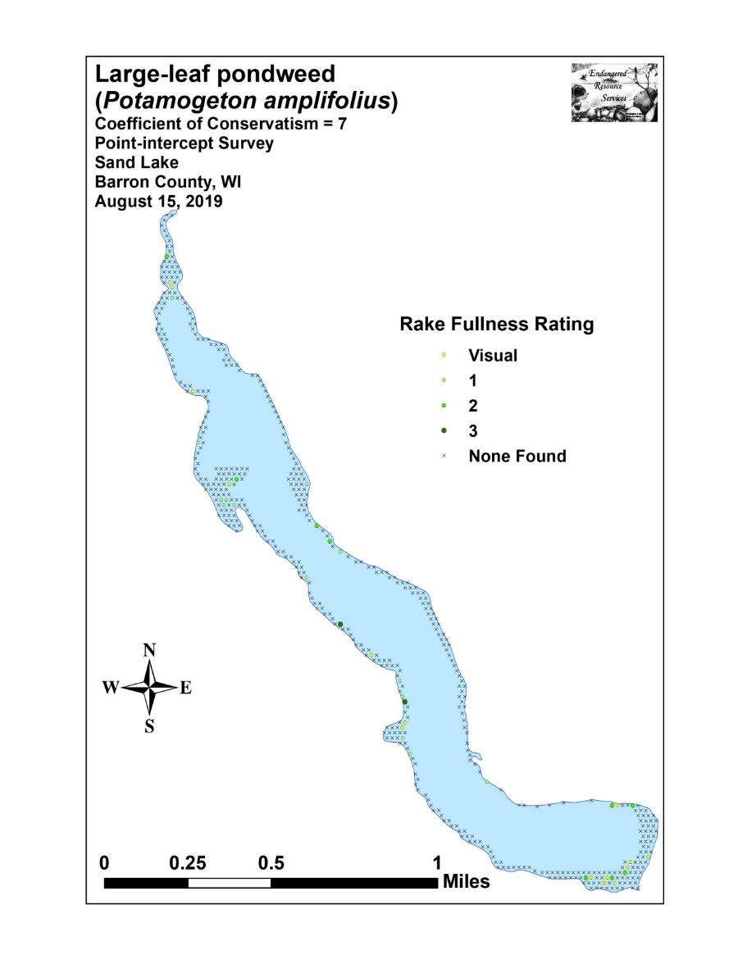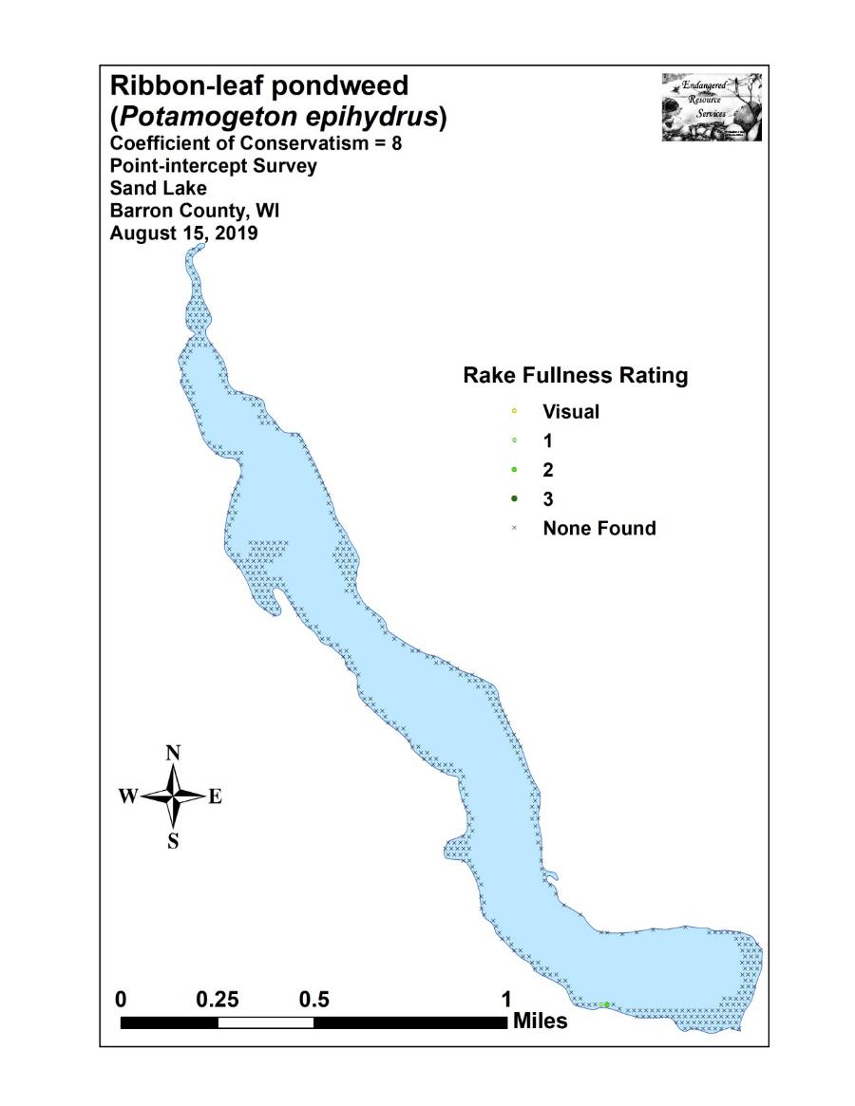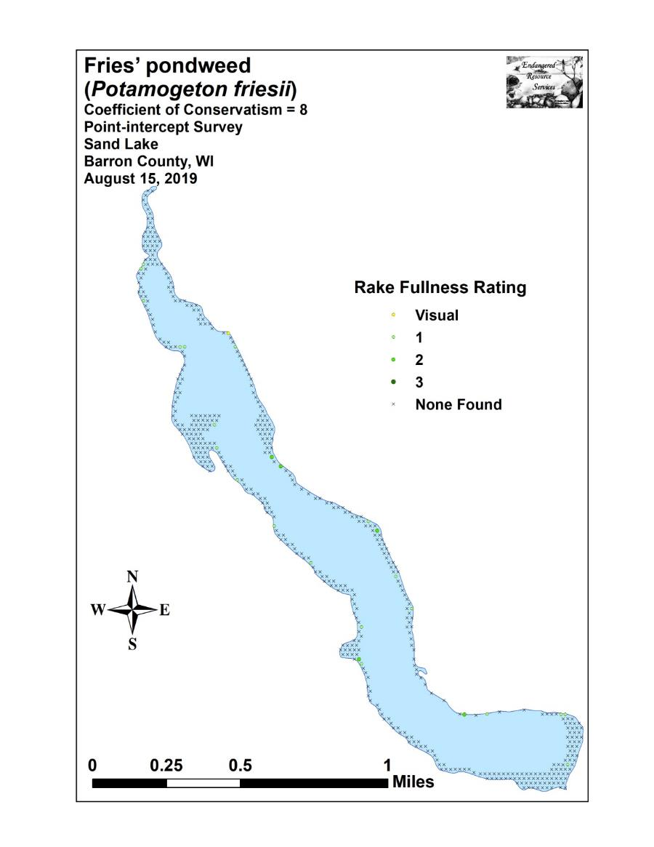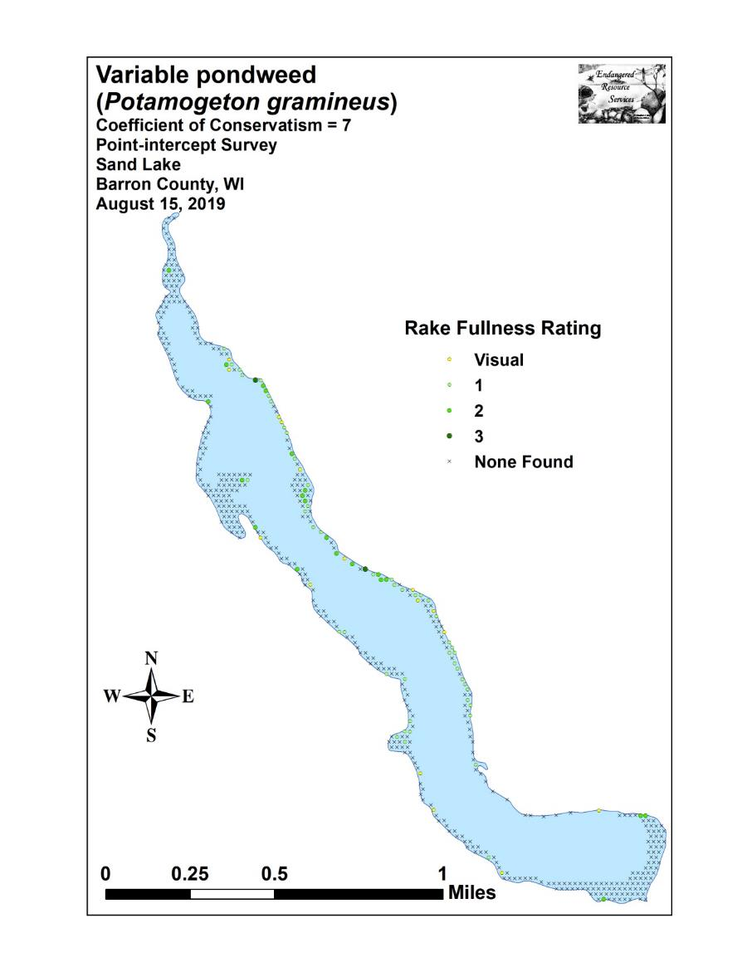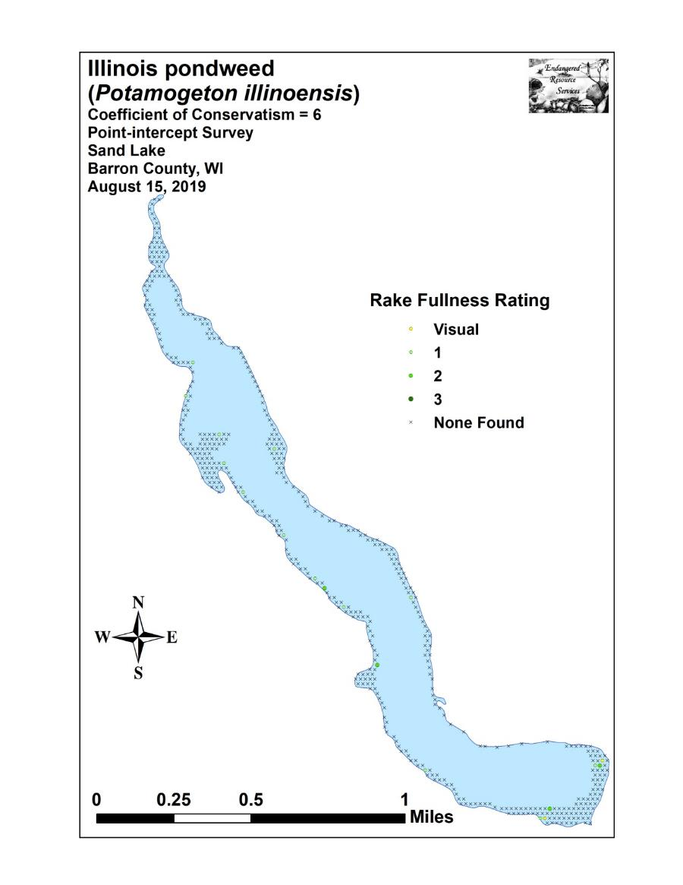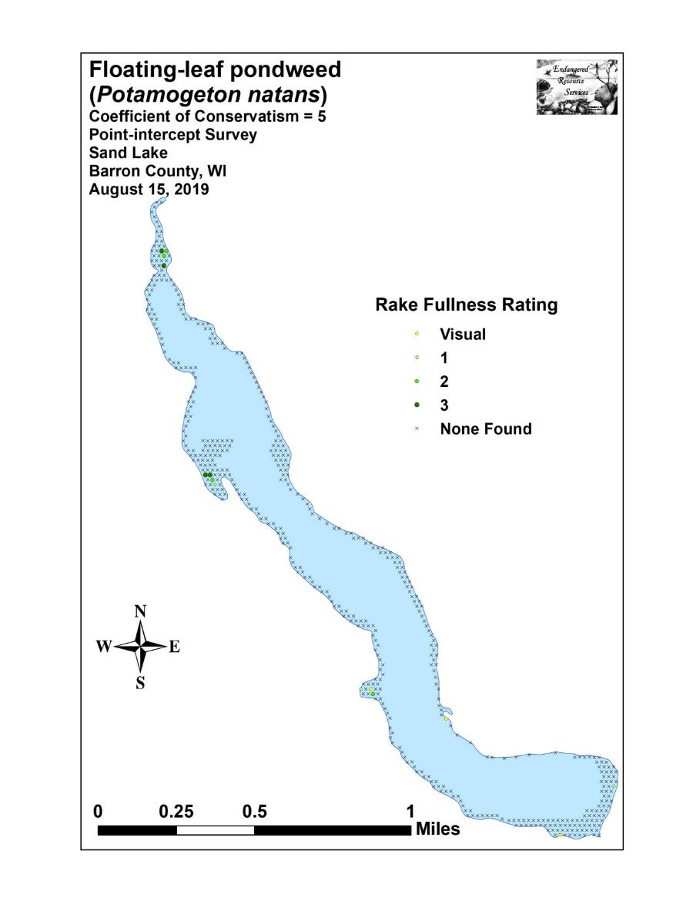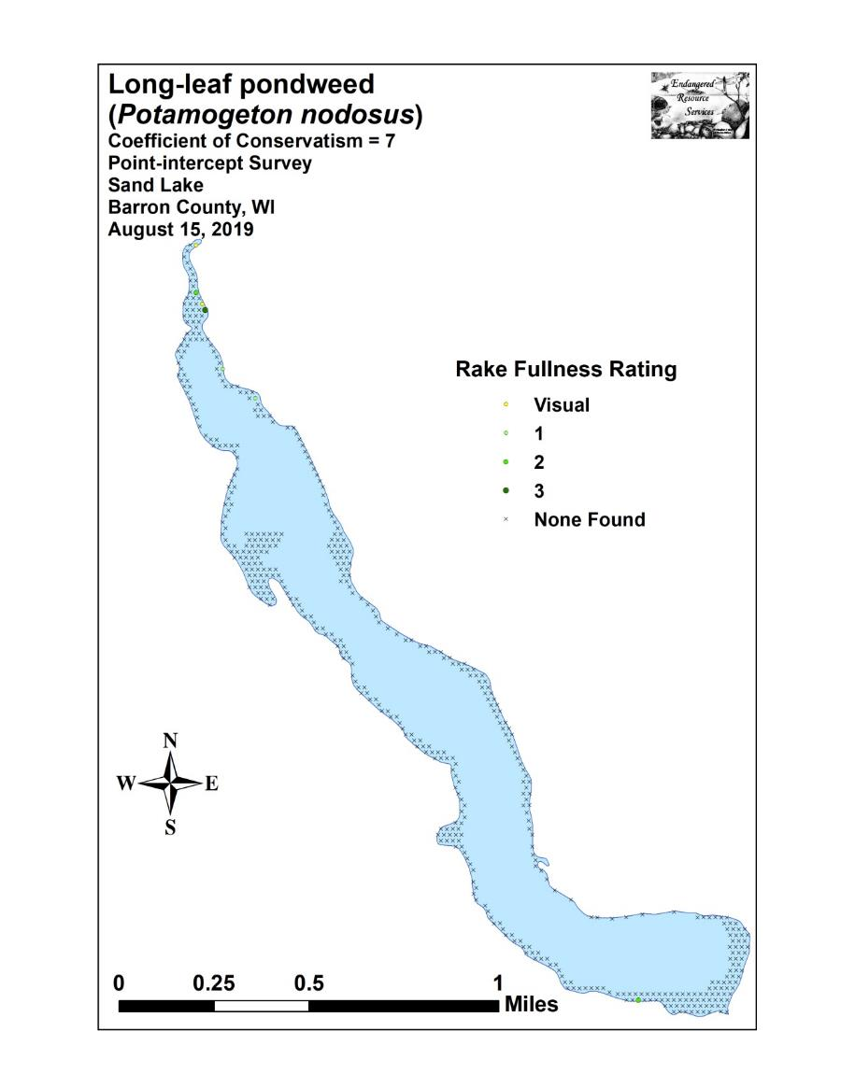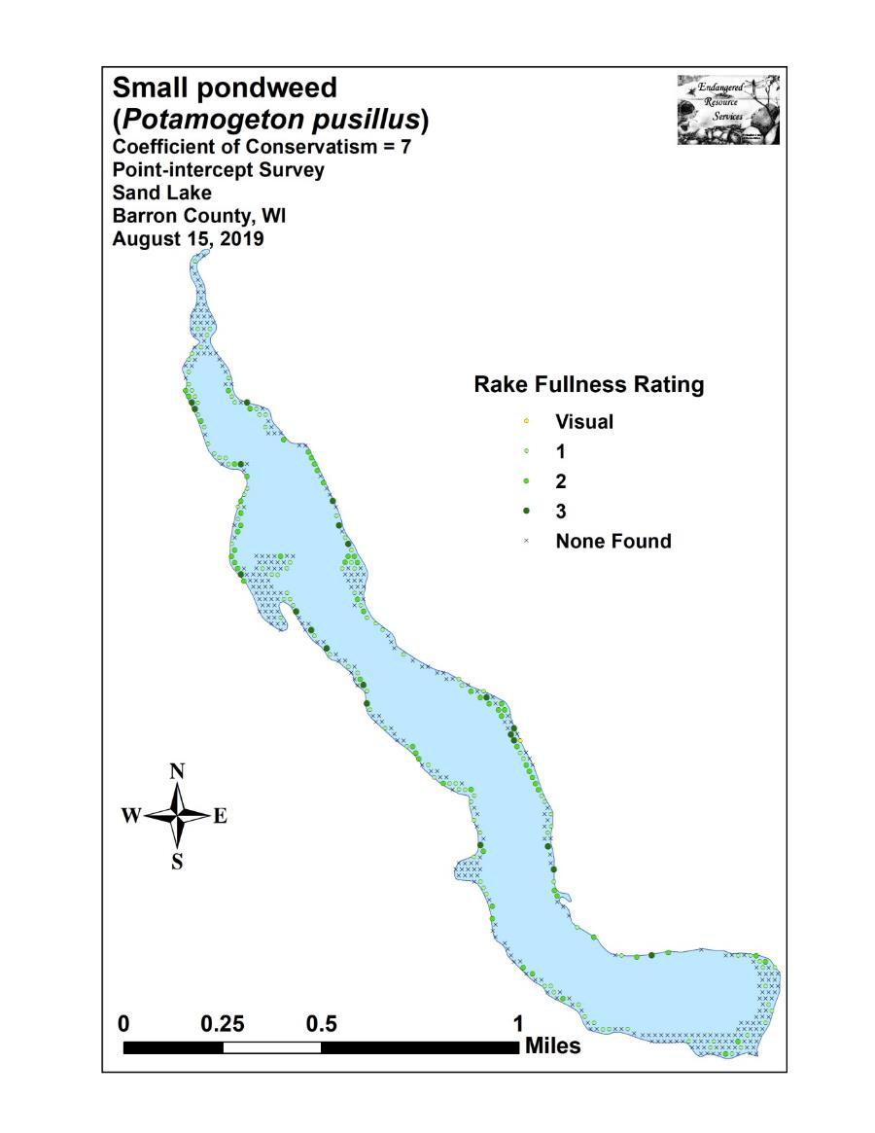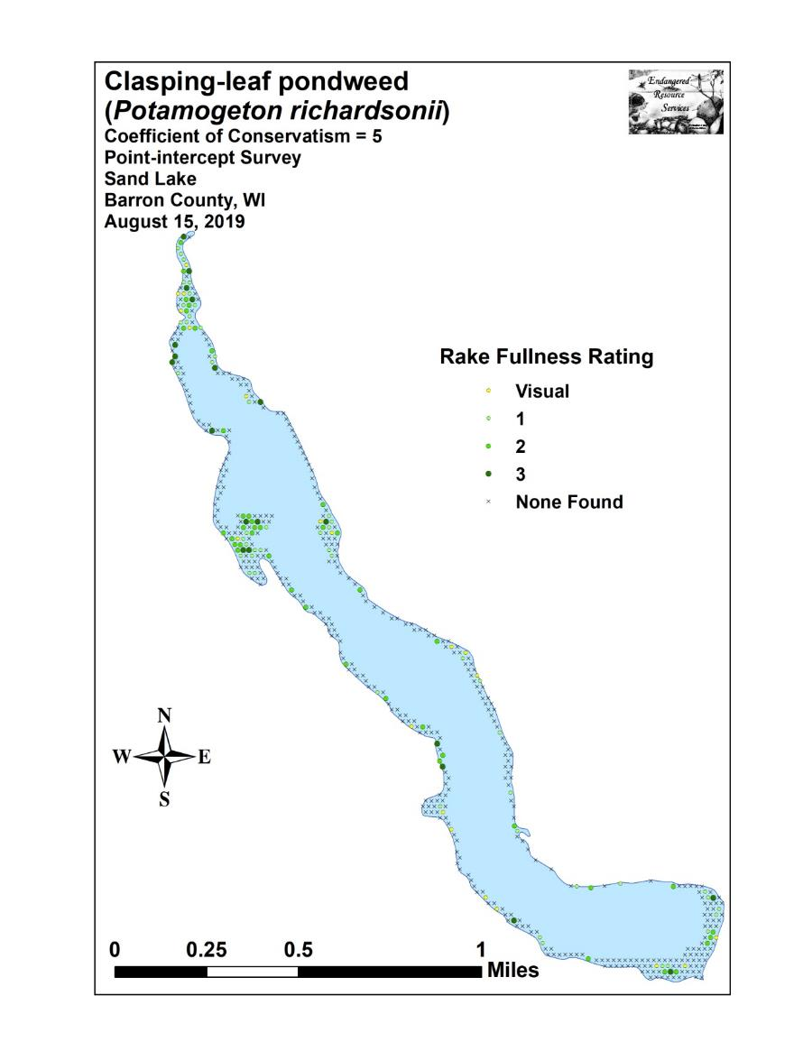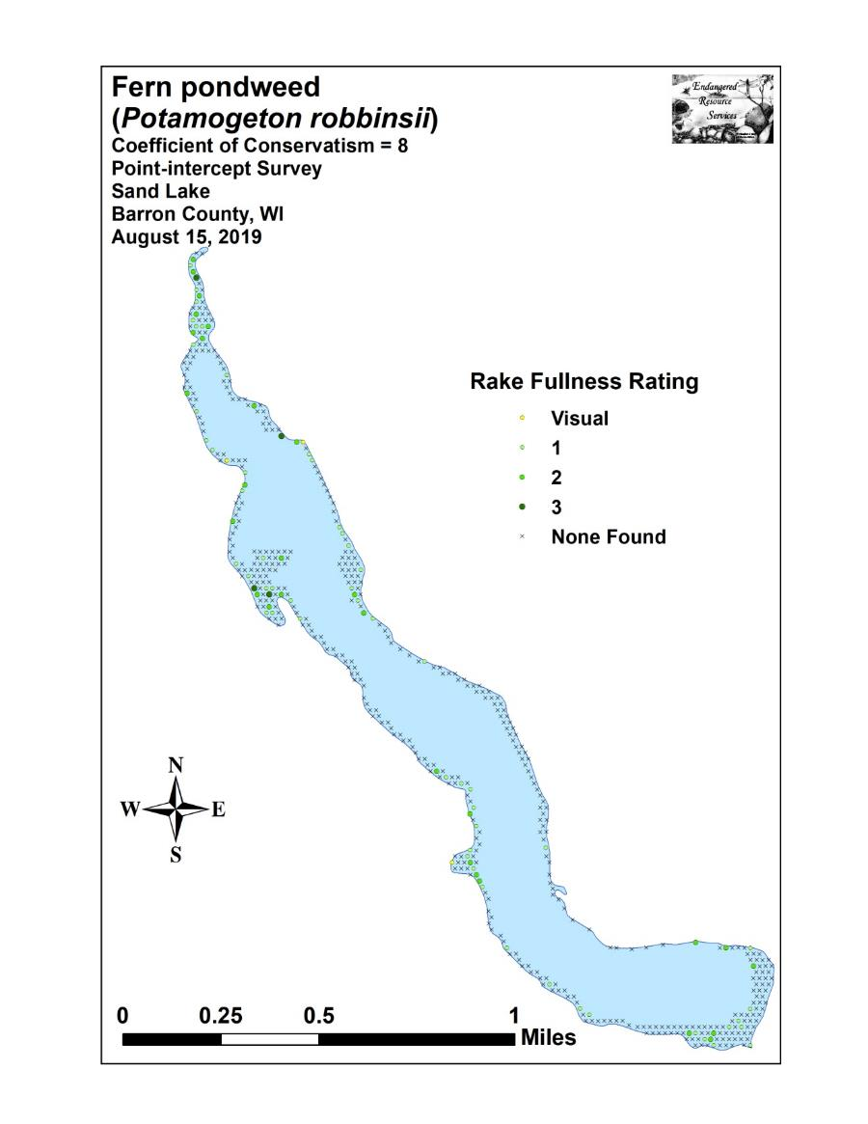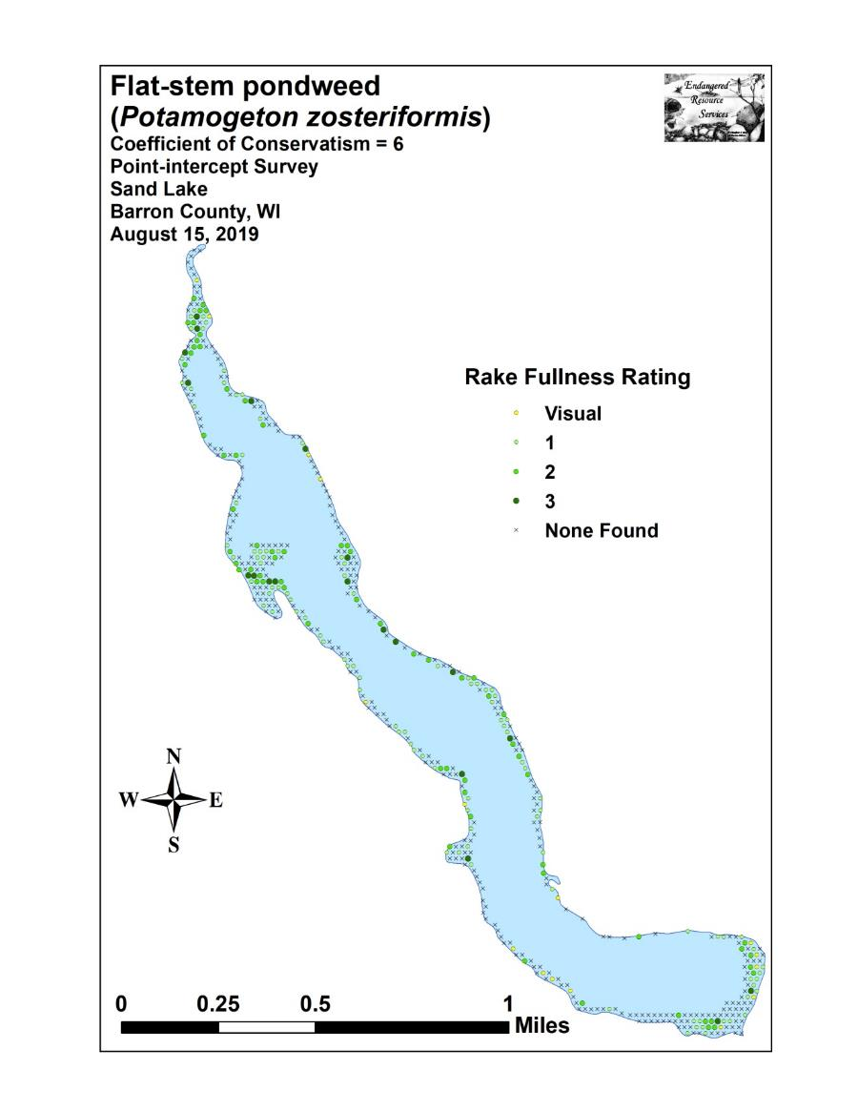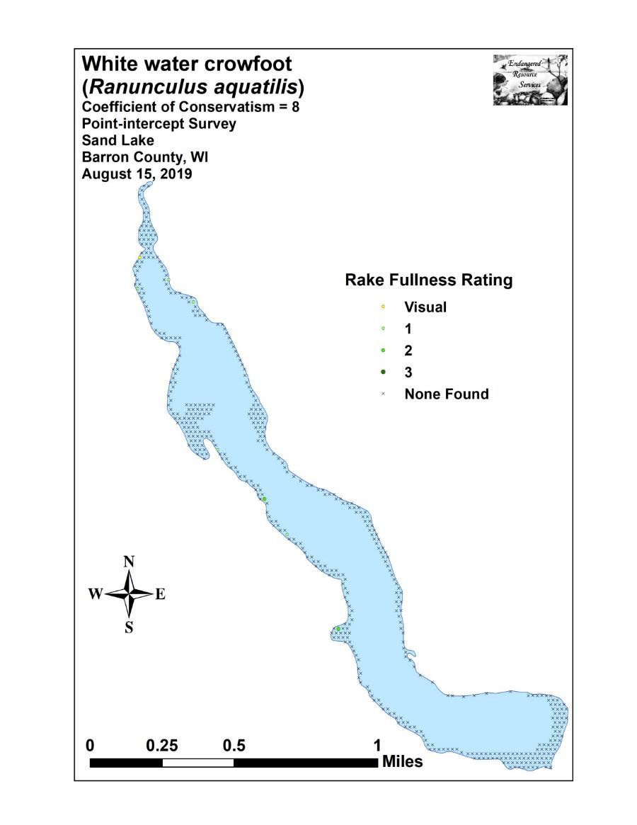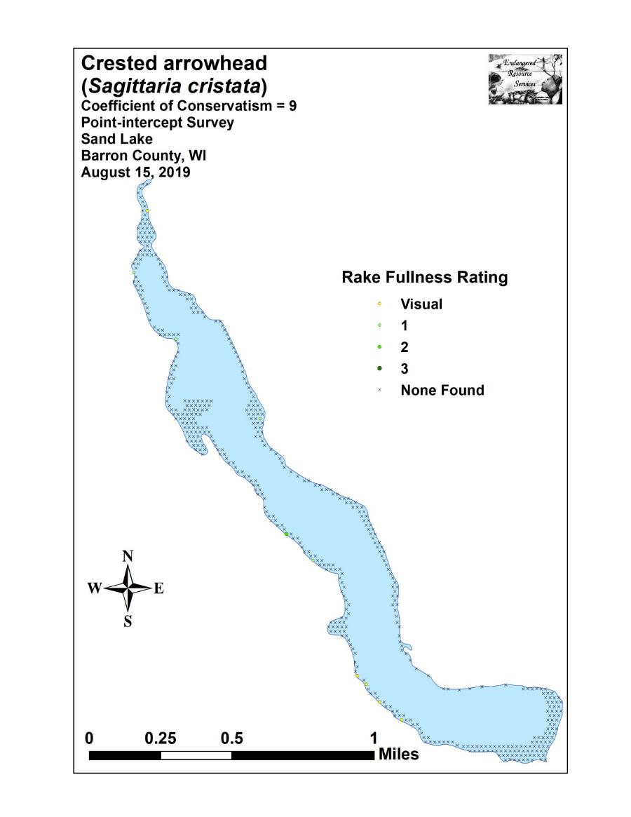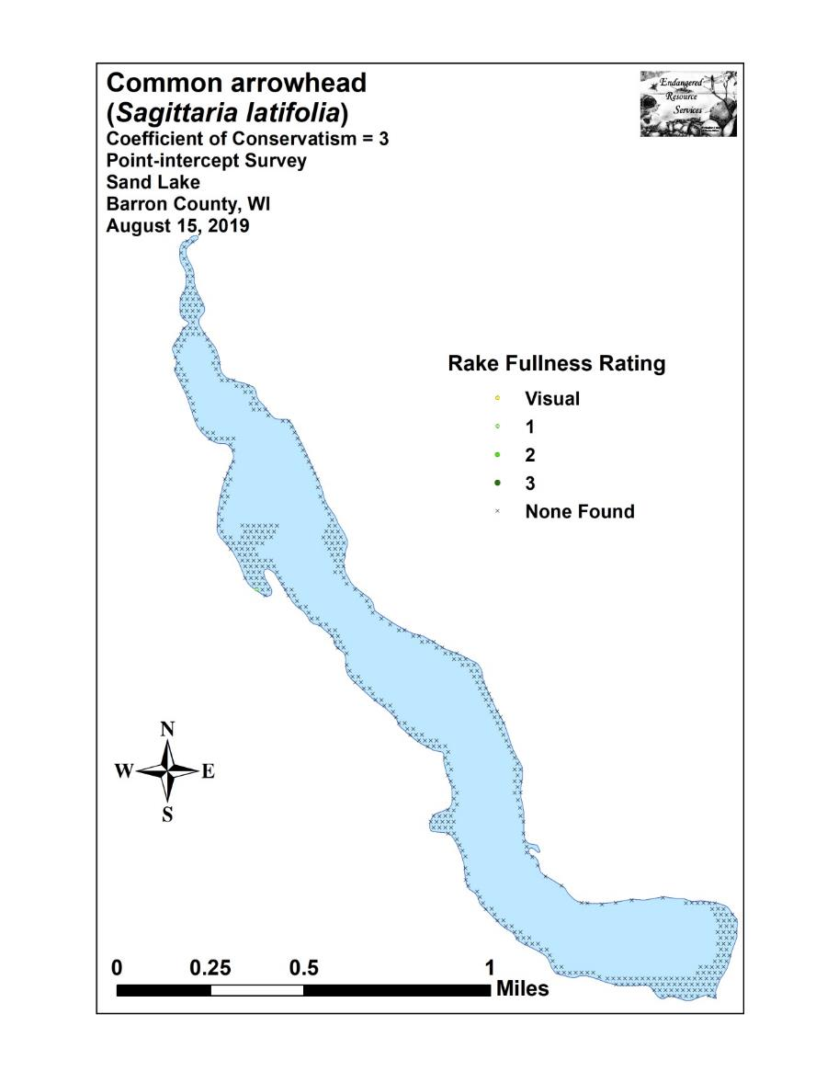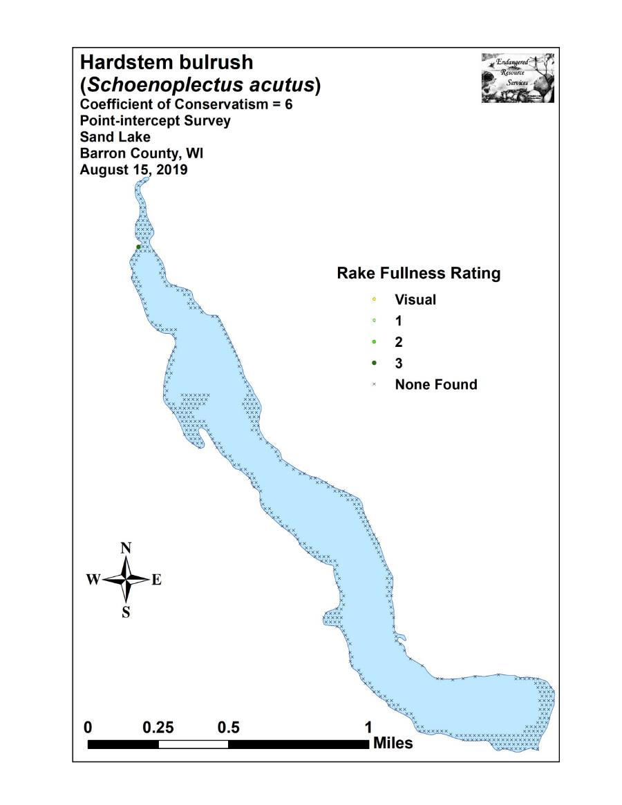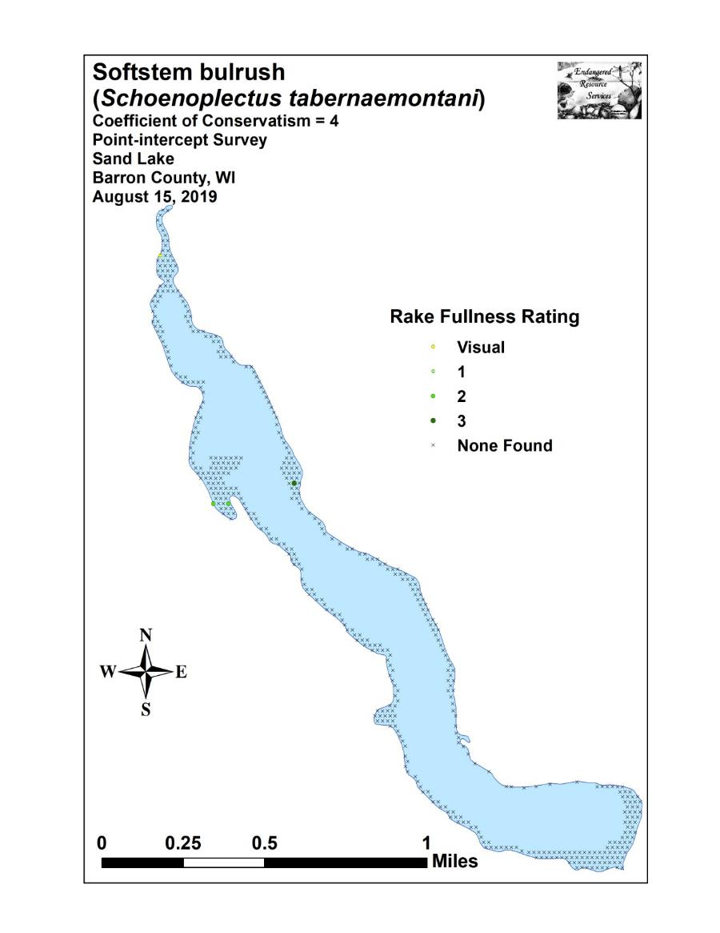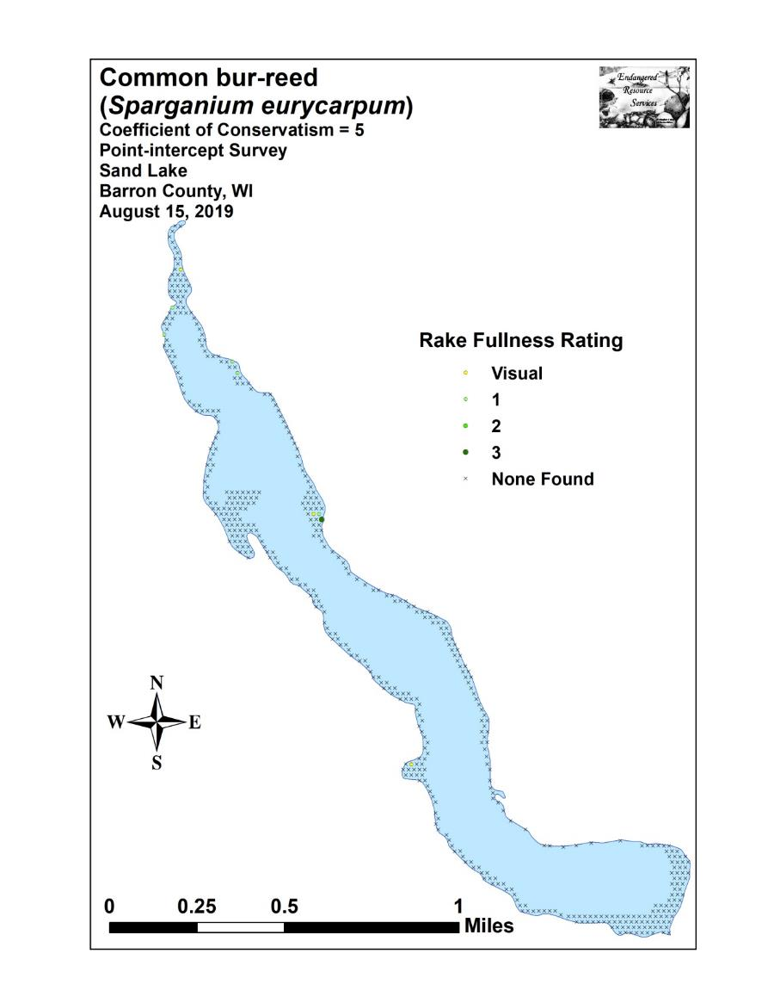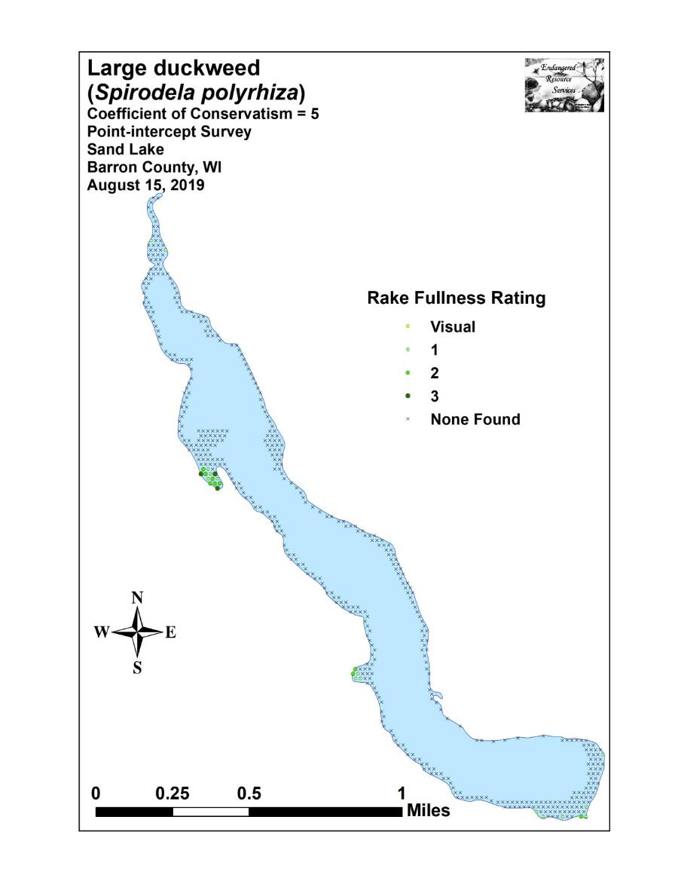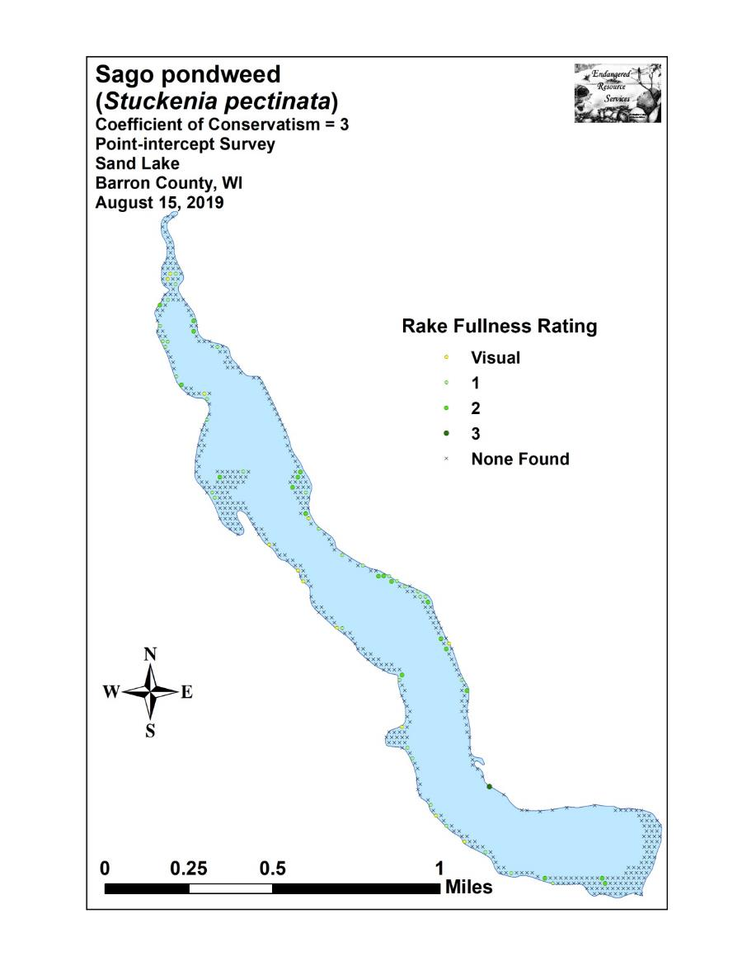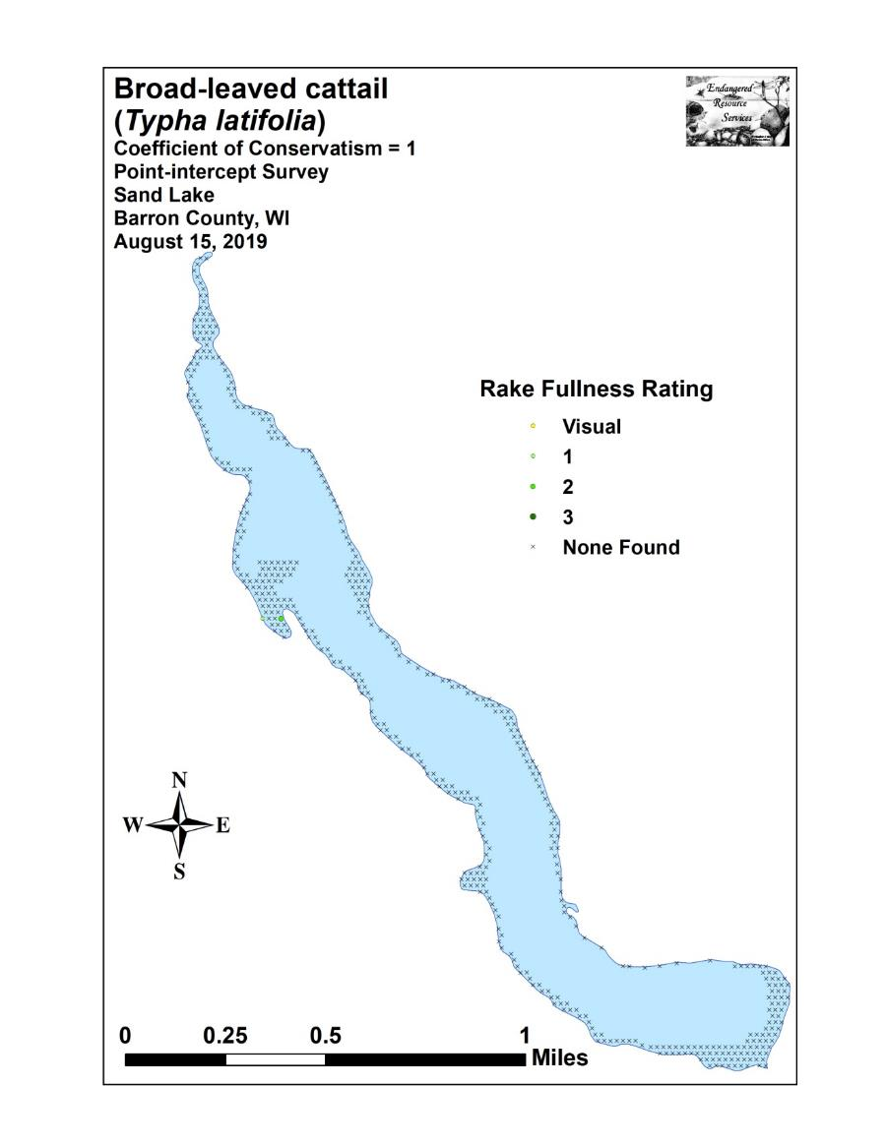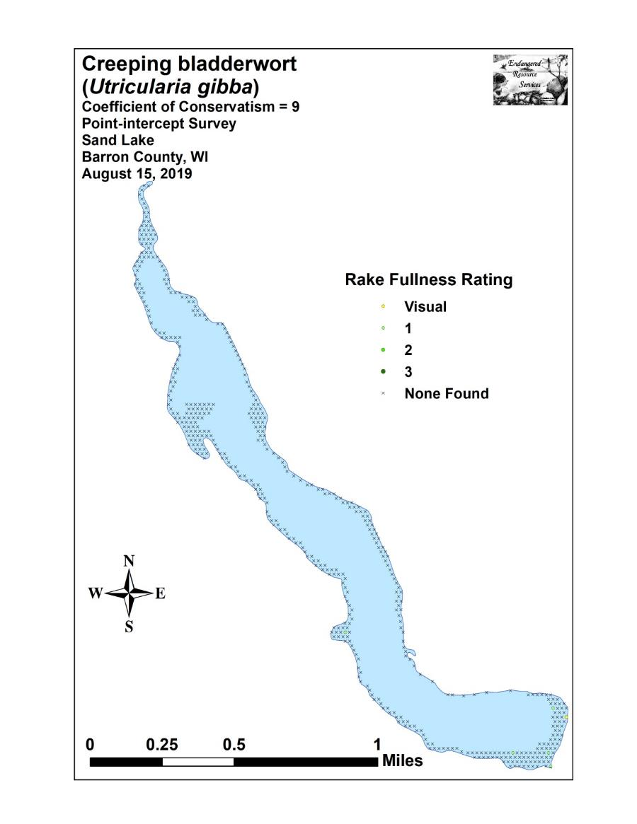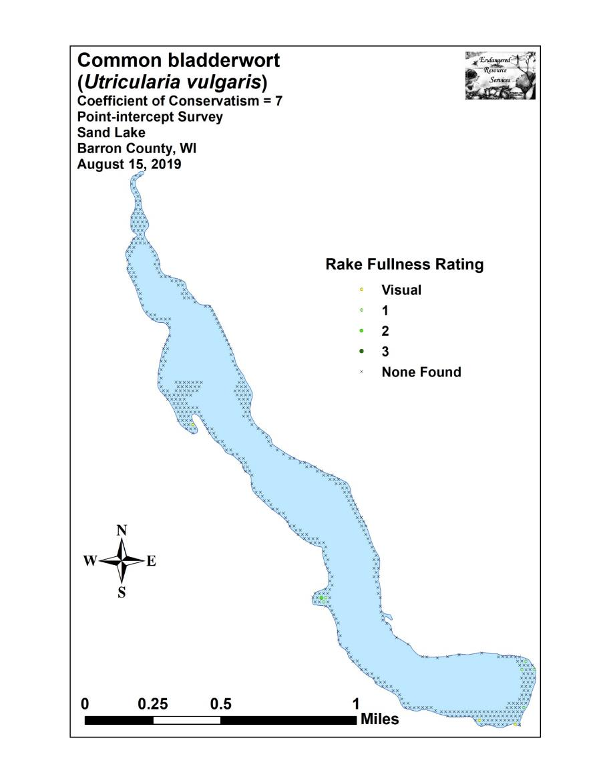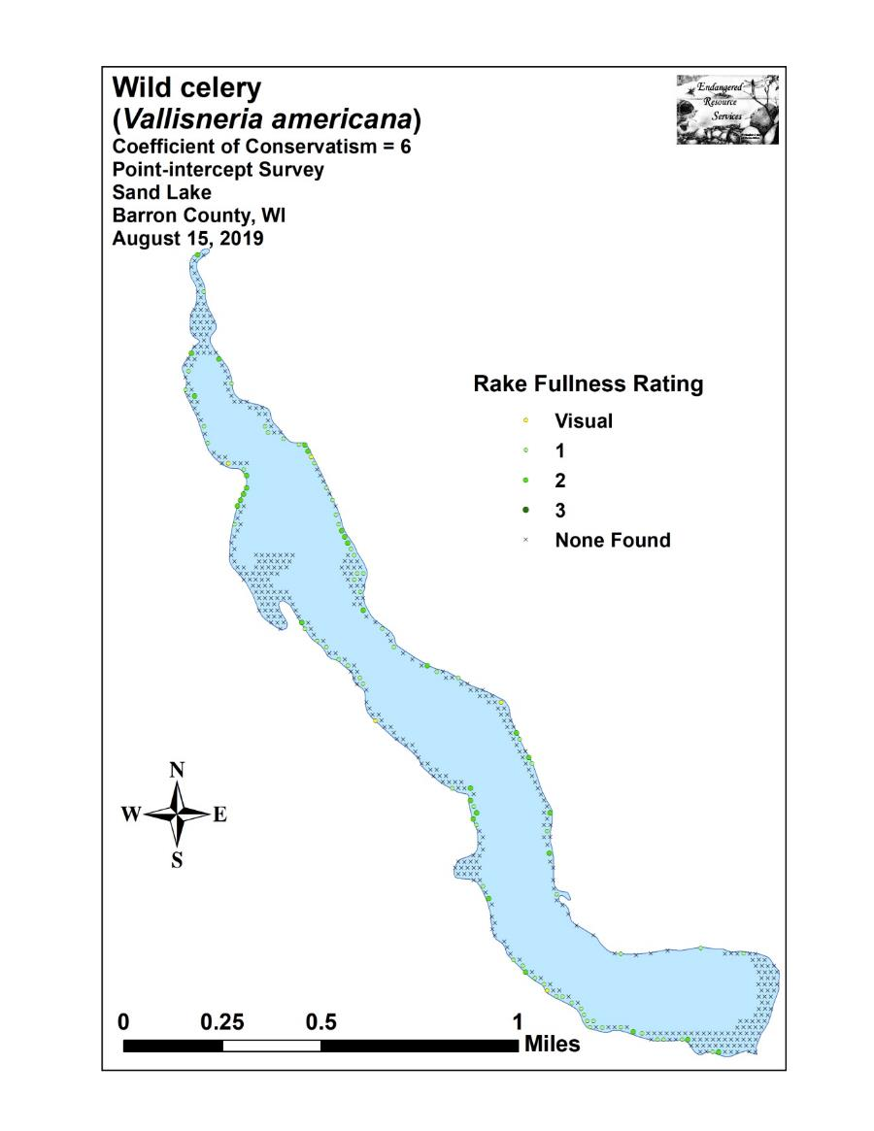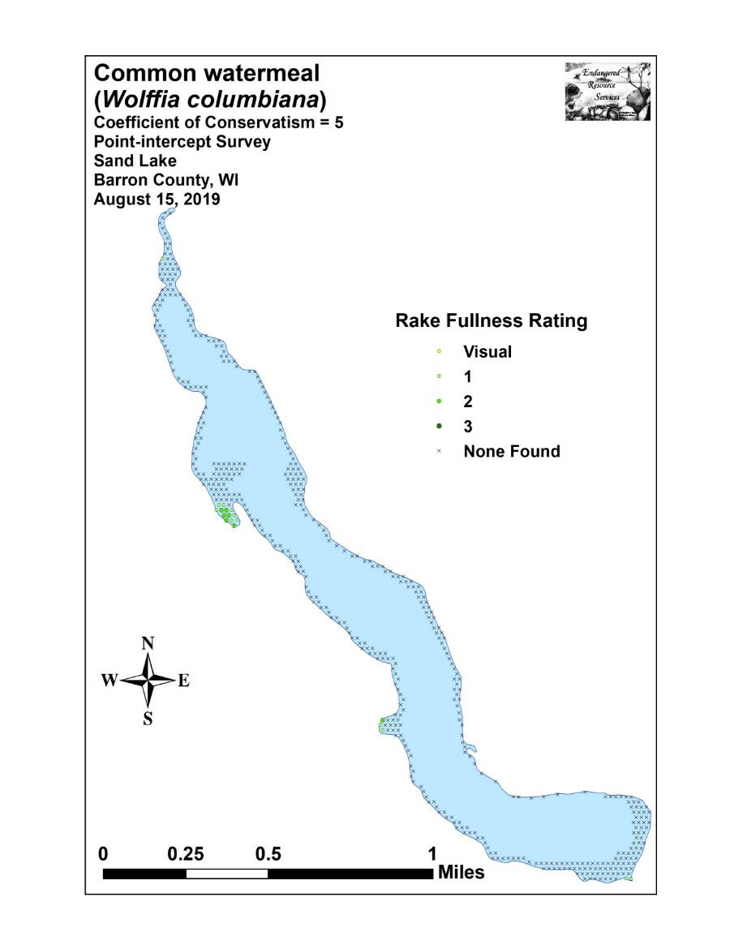

Appendix VII: Aquatic Exotic Invasive Plant Species Information

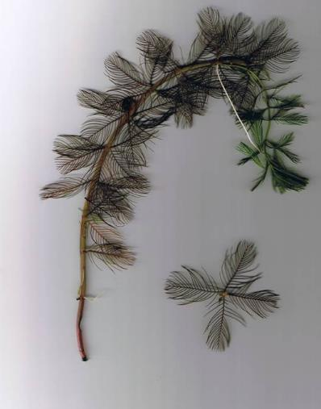
Eurasian water-milfoil
DESCRIPTION: Eurasian water-milfoil is a submersed aquatic plant native to Europe, Asia, and northern Africa. It is the only non-native milfoil in Wisconsin. Like the native milfoils, the Eurasian variety has slender stems whorled by submersed feathery leaves and tiny flowers produced above the water surface. The flowers are located in the axils of the floral bracts, and are either four-petaled or without petals. The leaves are threadlike, typically uniform in diameter, and aggregated into a submersed terminal spike. The stem thickens below the inflorescence and doubles its width further down, often curving to lie parallel with the water surface. The fruits are four-jointed nut-like bodies. Without flowers or fruits, Eurasian water-milfoil is nearly impossible to distinguish from Northern water-milfoil. Eurasian water-milfoil has 9-21 pairs of leaflets per leaf, while Northern milfoil typically has 7-11 pairs of leaflets. Coontail is often mistaken for the milfoils, but does not have individual leaflets.
DISTRIBUTION AND HABITAT: Eurasian milfoil first arrived in Wisconsin in the 1960's. During the 1980's, it began to move from several counties in southern Wisconsin to lakes and waterways in the northern half of the state. As of 1993, Eurasian milfoil was common in 39 Wisconsin counties (54%) and at least 75 of its lakes, including shallow bays in Lakes Michigan and Superior and Mississippi River pools.
Eurasian water-milfoil grows best in fertile, fine-textured, inorganic sediments. In less productive lakes, it is restricted to areas of nutrient-rich sediments. It has a history of becoming dominant in eutrophic, nutrient-rich lakes, although this pattern is not universal. It is an opportunistic species that prefers highly disturbed lake beds, lakes receiving nitrogen and phosphorous-laden runoff, and heavily used lakes. Optimal growth occurs in alkaline systems with a high concentration of dissolved inorganic carbon. High water temperatures promote multiple periods of flowering and fragmentation.
LIFE HISTORY AND EFFECTS OF INVASION: Unlike many other plants, Eurasian water-milfoil does not rely on seed for reproduction. Its seeds germinate poorly under natural conditions. It reproduces vegetatively by fragmentation, allowing it to disperse over long distances. The plant produces fragments after fruiting once or twice during the summer. These shoots may then be carried downstream by water currents or inadvertently picked up by boaters. Milfoil is readily dispersed by boats, motors, trailers, bilges, live wells, or bait buckets, and can stay alive for weeks if kept moist.
Once established in an aquatic community, milfoil reproduces from shoot fragments and stolons (runners that creep along the lake bed). As an opportunistic species, Eurasian water-milfoil is adapted for rapid growth early in spring. Stolons, lower stems, and roots persist over winter and store the carbohydrates that help milfoil claim the water column early in spring, photosynthesize, divide, and form a dense leaf canopy that shades out native aquatic plants. Its ability to spread rapidly by fragmentation and effectively block out sunlight needed for native plant growth often results in monotypic stands. Monotypic stands of Eurasian milfoil provide only a single habitat, and threaten the integrity of aquatic communities in a number of ways; for example, dense stands disrupt predator-prey relationships by fencing out larger fish, and reducing the number of nutrient-rich native plants available for waterfowl.
Dense stands of Eurasian water-milfoil also inhibit recreational uses like swimming, boating, and fishing. Some stands have been dense enough to obstruct industrial and power generation water intakes. The visual impact that greets the lake user on milfoil-dominated lakes is the flat yellow-green of matted vegetation, often prompting the perception that the lake is "infested" or "dead". Cycling of nutrients from sediments to the water column by Eurasian water-milfoil may lead to deteriorating water quality and algae blooms of infested lakes. (Taken in its entirety from WDNR, 2010 http://www.dnr.state.wi.us/invasives/fact/milfoil.htm)

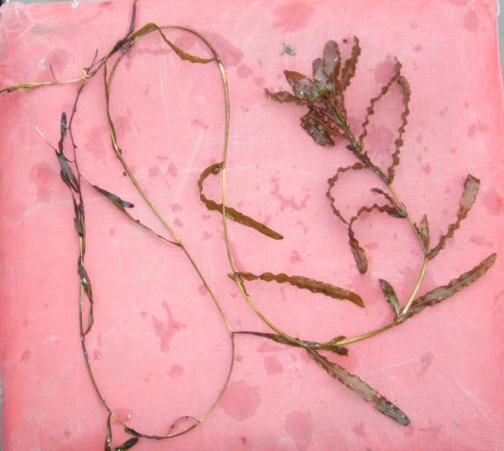
Curly-leaf pondweed
DESCRIPTION: Curly-leaf pondweed is an invasive aquatic perennial that is native to Eurasia, Africa, and Australia. It was accidentally introduced to United States waters in the mid-1880s by hobbyists who used it as an aquarium plant. The leaves are reddish-green, oblong, and about 3 inches long, with distinct wavy edges that are finely toothed. The stem of the plant is flat, reddish-brown and grows from 1 to 3 feet long. The plant usually drops to the lake bottom by early July.
DISTRIBUTION AND HABITAT: Curly-leaf pondweed is commonly found in alkaline and high nutrient waters, preferring soft substrate and shallow water depths. It tolerates low light and low water temperatures. It has been reported in all states but Maine
LIFE HISTORY AND EFFECTS OF INVASION: Curly-leaf pondweed spreads through burr-like winter buds (turions), which are moved among waterways. These plants can also reproduce by seed, but this plays a relatively small role compared to the vegetative reproduction through turions. New plants form under the ice in winter, making curly-leaf pondweed one of the first nuisance aquatic plants to emerge in the spring.
It becomes invasive in some areas because of its tolerance for low light and low water temperatures. These tolerances allow it to get a head start on and out compete native plants in the spring. In mid-summer, when most aquatic plants are growing, curly-leaf pondweed plants are dying off. Plant die-offs may result in a critical loss of dissolved oxygen. Furthermore, the decaying plants can increase nutrients which contribute to algal blooms, as well as create unpleasant stinking messes on beaches. Curly-leaf pondweed forms surface mats that interfere with aquatic recreation. (Taken in its entirety from WDNR, 2010 http://www.dnr.state.wi.us/invasives/fact/curlyleaf_pondweed.htm)
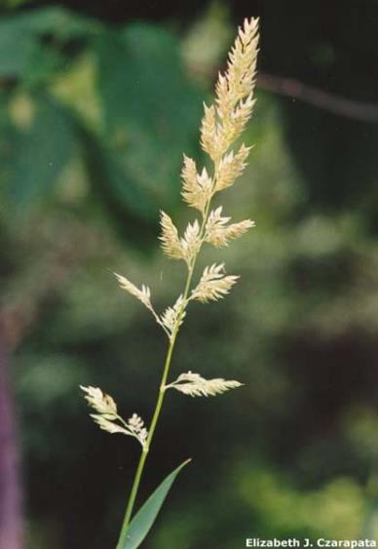
Reed canary grass
DESCRIPTION: Reed canary grass is a large, coarse grass that reaches 2 to 9 feet in height. It has an erect, hairless stem with gradually tapering leaf blades 3 1/2 to 10 inches long and 1/4 to 3/4 inch in width. Blades are flat and have a rough texture on both surfaces. The lead ligule is membranous and long. The compact panicles are erect or slightly spreading (depending on the plant's reproductive stage), and range from 3 to 16 inches long with branches 2 to 12 inches in length. Single flowers occur in dense clusters in May to mid-June. They are green to purple at first and change to beige over time. This grass is one of the first to sprout in spring, and forms a thick rhizome system that dominates the subsurface soil. Seeds are shiny brown in color.
Both Eurasian and native ecotypes of reed canary grass are thought to exist in the U.S. The Eurasian variety is considered more aggressive, but no reliable method exists to tell the ecotypes apart. It is believed that the vast majority of our reed canary grass is derived from the Eurasian ecotype. Agricultural cultivars of the grass are widely planted.
Reed canary grass also resembles non-native orchard grass (Dactylis glomerata), but can be distinguished by its wider blades, narrower, more pointed inflorescence, and the lack of hairs on glumes and lemmas (the spikelet scales). Additionally, bluejoint grass (Calamagrostis canadensis) may be mistaken for reed canary in areas where orchard grass is rare, especially in the spring. The highly transparent ligule on reed canary grass is helpful in distinguishing it from the others. Ensure positive identification before attempting control.

DISTRIBUTION AND HABITAT: Reed canary grass is a cool-season, sod-forming, perennial wetland grass native to temperate regions of Europe, Asia, and North America. The Eurasian ecotype has been selected for its vigor and has been planted throughout the U.S. since the 1800's for forage and erosion control. It has become naturalized in much of the northern half of the U.S., and is still being planted on steep slopes and banks of ponds and created wetlands.
Reed canary grass can grow on dry soils in upland habitats and in the partial shade of oak woodlands, but does best on fertile, moist organic soils in full sun. This species can invade most types of wetlands, including marshes, wet prairies, sedge meadows, fens, stream banks, and seasonally wet areas; it also grows in disturbed areas such as bergs and spoil piles.
LIFE HISTORY AND EFFECTS OF INVASION: Reed canary grass reproduces by seed or creeping rhizomes. It spreads aggressively. The plant produces leaves and flower stalks for 5 to 7 weeks after germination in early spring, then spreads laterally. Growth peaks in mid-June and declines in mid-August. A second growth spurt occurs in the fall. The shoots collapse in mid to late summer, forming a dense, impenetrable mat of stems and leaves. The seeds ripen in late June and shatter when ripe. Seeds may be dispersed from one wetland to another by waterways, animals, humans, or machines.
This species prefers disturbed areas, but can easily move into native wetlands. Reed canary grass can invade a disturbed wetland in less than twelve years. Invasion is associated with disturbances including ditching of wetlands, stream channelization, deforestation of swamp forests, sedimentation, and intentional planting. The difficulty of selective control makes reed canary grass invasion of particular concern. Over time, it forms large, monotypic stands that harbor few other plant species and are subsequently of little use to wildlife. Once established, reed canary grass dominates an area by building up a tremendous seed bank that can eventually erupt, germinate, and recolonize treated sites. (Taken in its entirety from WDNR, 2010 http://www.dnr.state.wi.us/invasives/fact/reed_canary.htm)
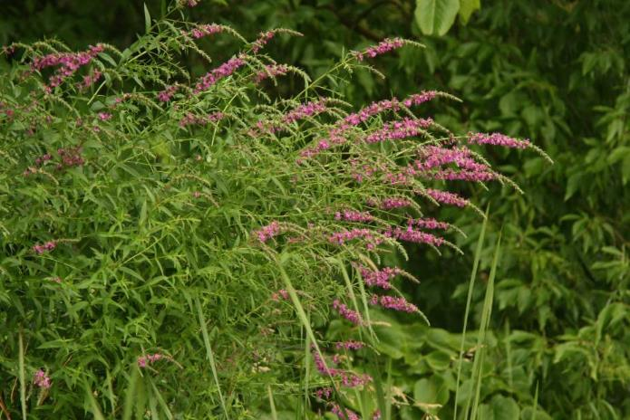
Purple loosestrife
(Photo Courtesy Brian M. Collins)
DESCRIPTION: Purple loosestrife is a perennial herb 3-7 feet tall with a dense bushy growth of 1-50 stems. The stems, which range from green to purple, die back each year. Showy flowers vary from purple to magenta, possess 5-6 petals aggregated into numerous long spikes, and bloom from July to September. Leaves are opposite, nearly linear, and attached to four-sided stems without stalks. It has a large, woody taproot with fibrous rhizomes that form a dense mat.
This species may be confused with the native wing-angled loosestrife (Lythrum alatum) found in moist prairies or wet meadows. The latter has a winged, square stem and solitary paired flowers in the leaf axils. It is generally a smaller plant than the Eurasian loosestrife.
By law, purple loosestrife is a nuisance species in Wisconsin. It is illegal to sell, distribute, or cultivate the plants or seeds, including any of its cultivars.

Distribution and Habitat: Purple loosestrife is a wetland herb that was introduced as a garden perennial from Europe during the 1800's. It is still promoted by some horticulturists for its beauty as a landscape plant, and by beekeepers for its nectar-producing capability. Currently, about 24 states have laws prohibiting its importation or distribution because of its aggressively invasive characteristics. It has since extended its range to include most temperate parts of the United States and Canada. The plant's reproductive success across North America can be attributed to its wide tolerance of physical and chemical conditions characteristic of disturbed habitats, and its ability to reproduce prolifically by both seed dispersal and vegetative propagation. The absence of natural predators, like European species of herbivorous beetles that feed on the plant's roots and leaves, also contributes to its proliferation in North America.
Purple loosestrife was first detected in Wisconsin in the early 1930's, but remained uncommon until the 1970's. It is now widely dispersed in the state, and has been recorded in 70 of Wisconsin's 72 counties. Low densities in most areas of the state suggest that the plant is still in the pioneering stage of establishment. Areas of heaviest infestation are sections of the Wisconsin River, the extreme southeastern part of the state, and the Wolf and Fox River drainage systems.
This plant's optimal habitat includes marshes, stream margins, alluvial flood plains, sedge meadows, and wet prairies. It is tolerant of moist soil and shallow water sites such as pastures and meadows, although established plants can tolerate drier conditions. Purple loosestrife has also been planted in lawns and gardens, which is often how it has been introduced to many of our wetlands, lakes, and rivers.

Life History and Effects of Invasion: Purple loosestrife can germinate successfully on substrates with a wide range of pH. Optimum substrates for growth are moist soils of neutral to slightly acidic pH, but it can exist in a wide range of soil types. Most seedling establishment occurs in late spring and early summer when temperatures are high.
Purple loosestrife spreads mainly by seed, but it can also spread vegetatively from root or stem segments. A single stalk can produce from 100,000 to 300,000 seeds per year. Seed survival is up to 60-70%, resulting in an extensive seed bank. Mature plants with up to 50 shoots grow over 2 meters high and produce more than two million seeds a year. Germination is restricted to open, wet soils and requires high temperatures, but seeds remain viable in the soil for many years. Even seeds submerged in water can live for approximately 20 months. Most of the seeds fall near the parent plant, but water, animals, boats, and humans can transport the seeds long distances. Vegetative spread through local perturbation is also characteristic of loosestrife; clipped, trampled, or buried stems of established plants may produce shoots and roots. Plants may be quite large and several years old before they begin flowering. It is often very difficult to locate non-flowering plants, so monitoring for new invasions should be done at the beginning of the flowering period in mid-summer.

Any sunny or partly shaded wetland is susceptible to purple loosestrife invasion. Vegetative disturbances such as water drawdown or exposed soil accelerate the process by providing ideal conditions for seed germination. Invasion usually begins with a few pioneering plants that build up a large seed bank in the soil for several years. When the right disturbance occurs, loosestrife can spread rapidly, eventually taking over the entire wetland. The plant can also make morphological adjustments to accommodate changes in the immediate environment; for example, a decrease in light level will trigger a change in leaf morphology. The plant's ability to adjust to a wide range of environmental conditions gives it a competitive advantage; coupled with its reproductive strategy, purple loosestrife tends to create monotypic stands that reduce biotic diversity.
Purple loosestrife displaces native wetland vegetation and degrades wildlife habitat. As native vegetation is displaced, rare plants are often the first species to disappear. Eventually, purple loosestrife can overrun wetlands thousands of acres in size, and almost entirely eliminate the open water habitat. The plant can also be detrimental to recreation by choking waterways. (Taken in its entirety from WDNR, 2010 http://www.dnr.state.wi.us/invasives/fact/loosestrife.htm)

Appendix VIII: Glossary of Biological Terms
(Adapted from UWEX 2010)

Aquatic:
organisms that live in or frequent water.

Cultural Eutrophication:
accelerated eutrophication that occurs as a result of human activities in the watershed that increase nutrient loads in runoff water that drains into lakes.

Dissolved Oxygen (DO):
the amount of free oxygen absorbed by the water and available to aquatic organisms for respiration; amount of oxygen dissolved in a certain amount of water at a particular temperature and pressure, often expressed as a concentration in parts of oxygen per million parts of water.

Diversity:
number and evenness of species in a particular community or habitat.

Drainage lakes:
Lakes fed primarily by streams and with outlets into streams or rivers. They are more subject to surface runoff problems but generally have shorter residence times than seepage lakes. Watershed protection is usually needed to manage lake water quality.

Ecosystem:
a system formed by the interaction of a community of organisms with each other and with the chemical and physical factors making up their environment.

Eutrophication:
the process by which lakes and streams are enriched by nutrients, and the resulting increase in plant and algae growth. This process includes physical, chemical, and biological changes that take place after a lake receives inputs for plant nutrients--mostly nitrates and phosphates--from natural erosion and runoff from the surrounding land basin. The extent to which this process has occurred is reflected in a lake's trophic classification: oligotrophic (nutrient poor), mesotrophic (moderately productive), and eutrophic (very productive and fertile).

Exotic:
a non-native species of plant or animal that has been introduced.

Habitat:
the place where an organism lives that provides an organism's needs for water, food, and shelter. It includes all living and non-living components with which the organism interacts.

Limnology:
the study of inland lakes and waters.

Littoral:
the near shore shallow water zone of a lake, where aquatic plants grow.

Macrophytes:
Refers to higher (multi-celled) plants growing in or near water. Macrophytes are beneficial to lakes because they produce oxygen and provide substrate for fish habitat and aquatic insects. Overabundance of such plants, especially problem species, is related to shallow water depth and high nutrient levels.

Nutrients:
elements or substances such as nitrogen and phosphorus that are necessary for plant growth. Large amounts of these substances can become a nuisance by promoting excessive aquatic plant growth.

Organic Matter:
elements or material containing carbon, a basic component of all living matter.

Photosynthesis:
the process by which green plants convert carbon dioxide (CO2) dissolved in water to sugar and oxygen using sunlight for energy. Photosynthesis is essential in producing a lake's food base, and is an important source of oxygen for many lakes.

Phytoplankton:
microscopic plants found in the water. Algae or one-celled (phytoplankton) or multicellular plants either suspended in water (Plankton) or attached to rocks and other substrates (periphyton). Their abundance, as measured by the amount of chlorophyll a (green pigment) in an open water sample, is commonly used to classify the trophic status of a lake. Numerous species occur. Algae are an essential part of the lake ecosystem and provides the food base for most lake organisms, including fish. Phytoplankton populations vary widely from day to day, as life cycles are short.

Plankton:
small plant organisms (phytoplankton and nanoplankton) and animal organisms (zooplankton) that float or swim weakly though the water.

ppm:
parts per million; units per equivalent million units; equal to milligrams per liter (mg/l)

Richness:
number of species in a particular community or habitat.

Rooted Aquatic Plants:
(macrophytes) Refers to higher (multi-celled) plants growing in or near water. Macrophytes are beneficial to lakes because they produce oxygen and provide substrate for fish habitat and aquatic insects. Overabundance of such plants, especially problem species, is related to shallow water depth and high nutrient levels.

Runoff:
water that flows over the surface of the land because the ground surface is impermeable or unable to absorb the water.

Secchi Disc:
An 8-inch diameter plate with alternating quadrants painted black and white that is used to measure water clarity (light penetration). The disc is lowered into water until it disappears from view. It is then raised until just visible. An average of the two depths, taken from the shaded side of the boat, is recorded as the Secchi disc reading. For best results, the readings should be taken on sunny, calm days.

Seepage lakes:
Lakes without a significant inlet or outlet, fed by rainfall and groundwater. Seepage lakes lose water through evaporation and groundwater moving on a down gradient. Lakes with little groundwater inflow tend to be naturally acidic and most susceptible to the effects of acid rain. Seepage lakes often have long, residence times and lake levels fluctuate with local groundwater levels. Water quality is affected by groundwater quality and the use of land on the shoreline.

Turbidity:
degree to which light is blocked because water is muddy or cloudy.

Watershed:
the land area draining into a specific stream, river, lake or other body of water. These areas are divided by ridges of high land.

Zooplankton:
Microscopic or barely visible animals that eat algae. These suspended plankton are an important component of the lake food chain and ecosystem. For many fish, they are the primary source of food.

Appendix IX: 2019 Raw Data Spreadsheets

