Yellow Floating Heart – Dane County – Private Pond
Progress Report
Fall 2018
Background

In the Fall of 2017, the Department was notified of a possible Yellow Floating Heart (Nymphoides peltata) population in Northern Dane County. Friends of the landowners were visiting the property and noticed that the plant was possibly an invasive species. The friends contacted Kelly Kearns (Terrestrial Invasive Plant, NHC, WI DNR), who contacted Maureen Ferry (AIS Statewide Monitoring Coordinator, Lakes & Rivers Section, WI DNR), who contacted Kevin Olson (Former SCR AIS/Lakes Coordinator, WI DNR) and Susan Graham (SCR Lakes Biologist, WI DNR). It was confirmed that the plant was N. peltata. Sue and Kevin visited the site shortly after the discovery to take photos and make contact with the landowners. Kevin took another position within the Department and the response efforts were put on hold until a replacement was hired.
In January of 2018, Amanda Smith (Former SCR AIS/Lakes Coordinator, WI DNR) began initiating response efforts by letting the landowners know that the Department was researching management methods and that the population would need to be eradicated since this was a Prohibited species per NR40. Sue Graham and Amanda Smith reached out to other WI DNR and county staff throughout the state who have dealt with this species in the past (i.e. Heidi Bunk, Greg Cleereman). Jeanne Scherer put Amanda in touch with Dr. Nick Tippery (UW-Whitewater Professor) who does genetic work on Nymphoides species to see if he had any input. Dr. Tippery did not have much experience with control methods, but referred to a resource manager in Northeastern Unites States who assisted with a glyphosate treatment of Nymphoides in a public waterbody. This employee no longer worked for the agency and this search led to a dead end. Amanda contacted agencies in Southern states since Nymphoides populations have been commonly present there. Staff did not have advice as to how to eradicate it. Sue and Amanda also consulted with Dr. Scott Stoodley of the University of Oklahoma. The conversation was very insightful and eye opening. Dr. Scott Stoodley is dealing with Lake Carl Beckenwell, a large reservoir near the University, that is infected with N. peltata. He has tried convincing the University and city to allow for a chemical treatment, but it is the main source of drinking water so officials were opposed to any risk of human illness. A YouTube video filmed from the air via a drone shows the extent of the Oklahoma population (https://www.youtube.com/watch?v=DZpbg7e6mXM). A situation like the YouTube video would be worst case scenario if the plant got into Lake Wisconsin which is only ~6 miles away from the pond.
Needless to say, this response project was considered a top priority for the 2018 field season. It was confirmed that whichever management method was chosen, that it would require funding. Pete Jopke from the Dane County Land and Water Conservation Department agreed to be the AIS Response Grant sponsor.

Site
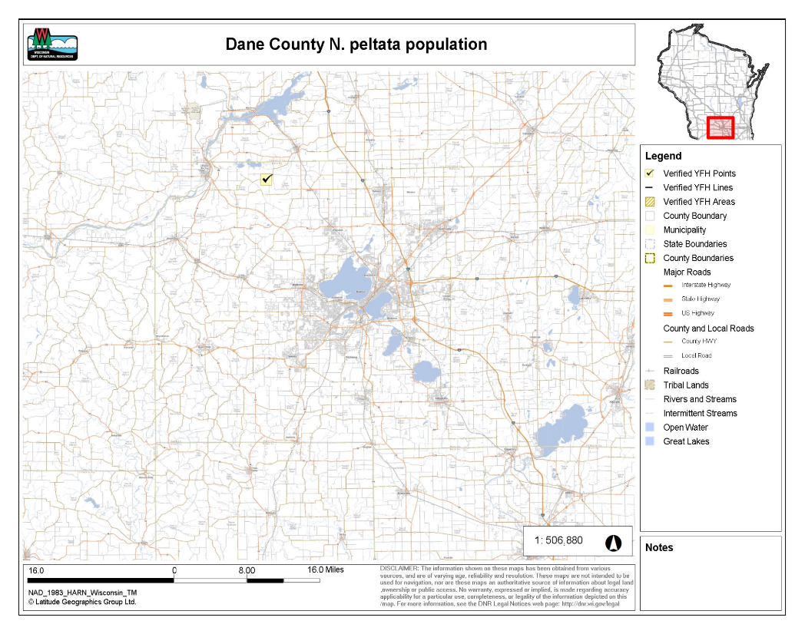
The site is located at 7888 County Road Y, Lodi, WI. The pond is 0.14 acres with a maximum depth of about 12 feet and a mean depth of 8 feet resulting in a steep bowl-like bathymetry. The pond is a completely self-contained system with no inlet or outlet connected to waters of the state. In the center of the pond is an aerator to maintain dissolved oxygen levels for the stocked fish. Amanda Smith has observed blue gills and largemouth bass in the pond. The landowners thought that they remembered stocking trout as well, but this species has not been observed. There is also a pumping system that aids in water circulation. The pump is located on the middle of the shoreline that is closest to the road. The pump takes in water, circulates it outside of the pond through a waterline, and outputs the water into a small sub-pond (the landowners refer to this as the ‘bog’) where the water then trickles down a stream of cobble and spills back into the pond. N. peltata leaves have been observed to be growing among the cobble stream.

Methodology
Decision making
Sue Graham, Amanda Smith, Chelsey Blanke, and Pete Jopke met with the landowners at their property on June 26, 2018. At this point in time, the population was not quite to max capacity and the flowers had only just started to bloom (Fig. 1). Three options were presented to the landowners:
- Fill in the pond.
- Rebuild the pond. This is what the ponds in Lake Geneva resorted to after numerous failed herbicide treatments (See Heidi’s PowerPoint in Yellow Floating Heart “Species File”).
- Try an experimental herbicide treatment. Sue and Amanda had attended a webinar for a newly registered herbicide in Wisconsin called ProcellaCor by SePRO Corporation. Mesocosm experiments had shown it to be effective on Nymphoides spp.
The options were presented to the landowners with a deadline to give them time to think about it. The caveat of Option 3 was that if the population persisted after 5 years (i.e. the max number of grant years) that they would be financially responsible for the continuation of eradication efforts. The landowners let the response team know immediately that they would like to pursue Option 3.
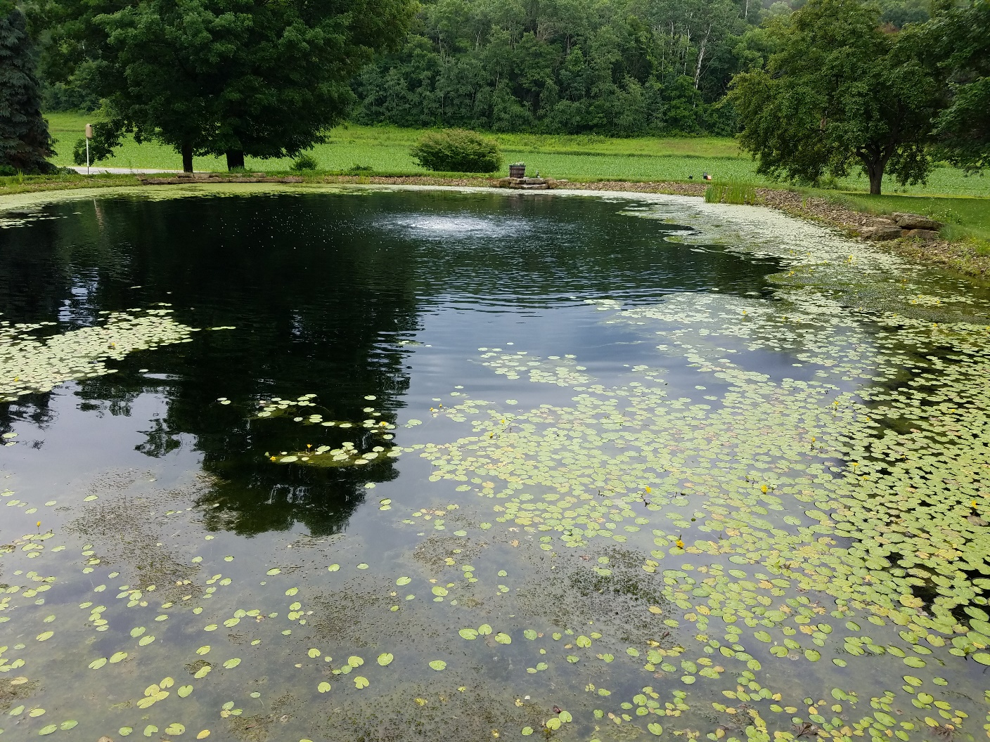
Figure 1. Sue Graham, Amanda Smith, Chelsey Blanke, and Pete Jopke met with the landowners at their property on June 26, 2018. At this point in time, the population was not quite to max capacity and the flowers had only just started to bloom

Treatment
Pete Jopke began working on drafting the grant application while Amanda requested quotes from area applicators who were certified to conduct ProcellaCor treatments. SePRO requires a certification to anyone working with this chemical. Lake and Pond Solutions LLC resulted in the lowest bid and had availability to schedule the treatment during the 2018 field season. The treatment was scheduled for the morning of August 2nd as this was the earliest availability to accommodate all of the moving components (i.e. applicator schedule, grant submission, pre-monitoring).

Monitoring
The WI DNR agreed to be responsible for the pre- and post-monitoring in addition to the herbicide concentration monitoring. On July 13, 2018, staff (i.e. Amanda Smith, Chelsey Blanke, Scott Van Egeren, Maureen Ferry) met via Skype to devise a monitoring plan. Ultimately, the team decided to collect 1x quantitative data and weekly qualitative data. Maureen, Amanda, and the summer LTE staff conducted a trial run of the monitoring on July 19, 2018. The official pre-treatment monitoring was conducted on July 24, 2018 and the treatment occurred as scheduled on August 2, 2018.
Herbicide concertation monitoring was conducted by Amanda and the 2 summer LTE staff members but funded by the grant and SePRO. SePRO agreed to cover half of the analysis costs. Herbicide concentration monitoring will continue in 2019 to see if the results are similar to the 2018 results, after which herbicide concentration monitoring will cease.

Results
*Note: HAT = hours after treatment; DAT = days after treatment
24 HAT: The treatment began showing signs of effectiveness within 24 hours. The flowers began to droop, and the leaves began turning yellow (Fig. 2). During the 3 hours after treatment (HAT) herbicide concentration monitoring, summer LTE staff noticed a dead bird floating in the water (Fig. 3).
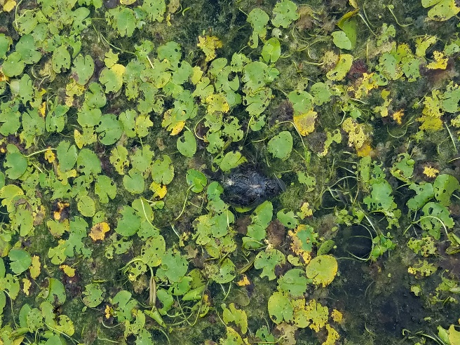
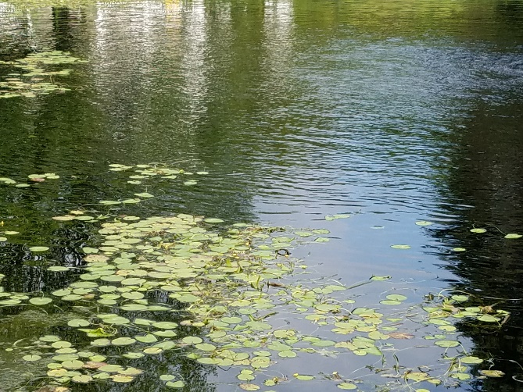

Figure 3. During the 3 hours after treatment (HAT) herbicide concentration monitoring, summer LTE staff noticed a dead bird floating in the water.
Figure 2. The flowers began to droop, and the leaves began turning yellow.

3 DAT: No flowers were visible and the stems seemed to be stringy and elongated to the surface, almost like spaghetti (Fig. 4). The leaves continued to show signs of discoloration (Fig. 5).
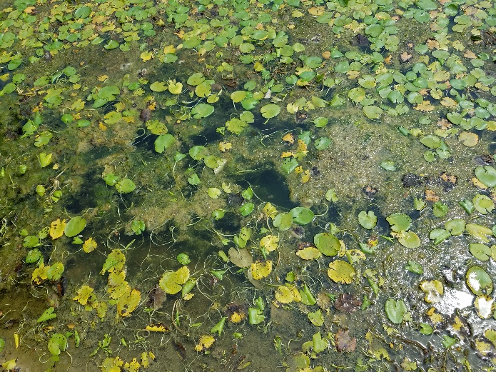
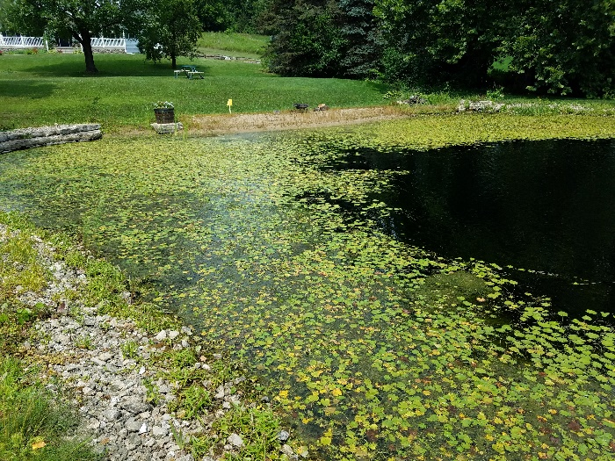
Figure 4. No flowers were visible and the stems seemed to be stringy and elongated to the surface, almost like spaghetti.
Figure 5. The leaves continued to show signs of discoloration.

7 DAT: Flowers continued to be absent and the stems became even more stringy and spaghetti-like (Fig. 6). The leaves were more yellow than green and the edges of some even appeared burnt or blackened (Fig. 7). Arrowhead plants that were growing along the North shoreline showed signs of severe damage. The leaves were brown and some were even dark brown and crisp as if they had been burnt (Fig. 8).
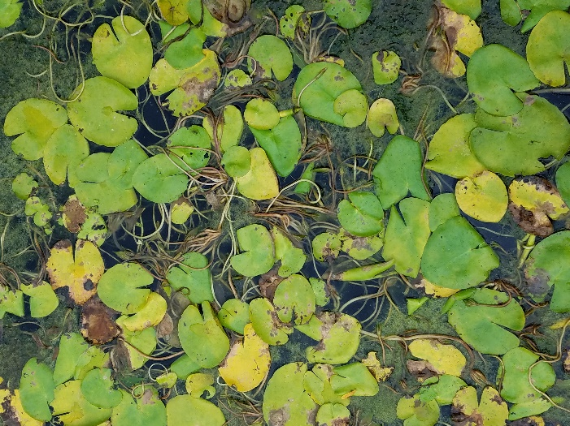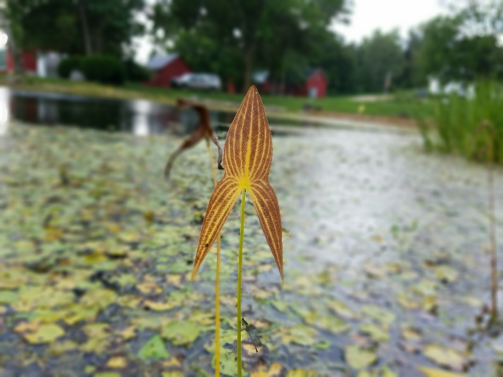
Figure 7. The leaves were more yellow than green and the edges of some even appeared burnt or blackened.
Figure 6. Flowers continued to be absent and the stems became even more stringy and spaghetti-like.

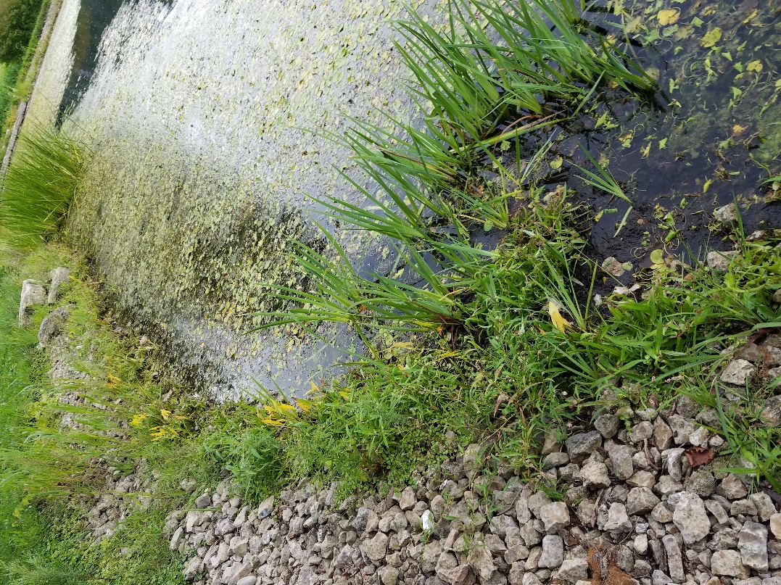
Figure 8. The leaves were brown and some were even dark brown and crisp as if they had been burnt.

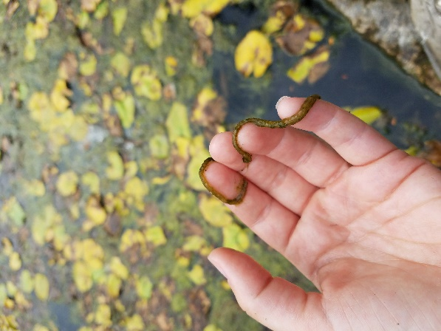
14 DAT: Flowers continued to be absent and the stems seemed to be decomposing starting at about 1 foot below the leaf (Fig. 9). The stems were worm-like (Fig. 10). A majority of the stems were bright yellow or dark brown (Fig. 11).
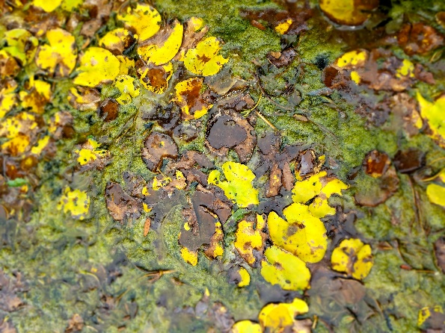
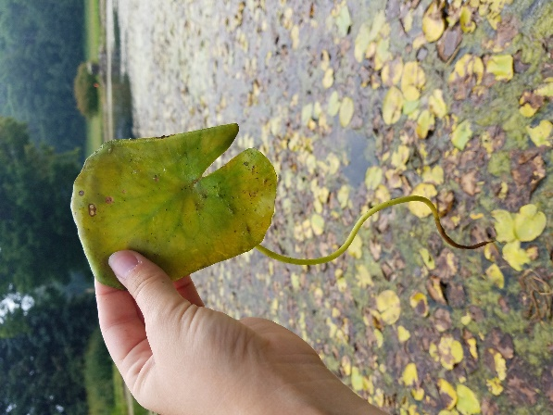
Figure 9. Flowers continued to be absent and the stems seemed to be decomposing starting at about 1 foot below the leaf.
Figure 11. A majority of the stems were bright yellow or dark brown.
Figure 10. The stems were worm-like.
21 DAT: Flowers continued to be absent. There were noticeably fewer floating leaves suggesting that the decomposed leaves began to sink (Fig. 12). This was the first observation of the seed pods. The pods were floating on the surface in clusters and the seeds appeared to be intact (Fig. 13, 14).
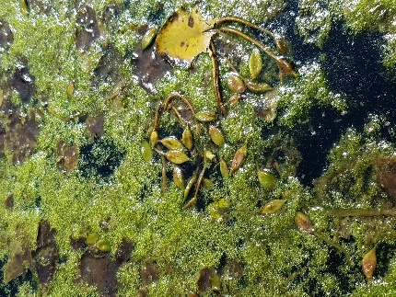
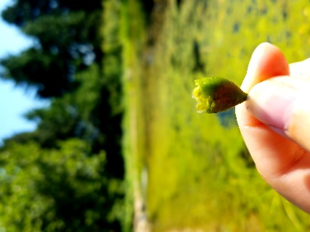
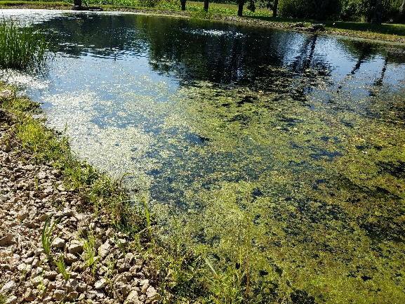
Figure 14. The pods were floating on the surface in clusters and the seeds appeared to be intact.
Figure 13. Seed pod.
Figure 12. Flowers continued to be absent. There were noticeably fewer floating leaves suggesting that the decomposed leaves began to sink.

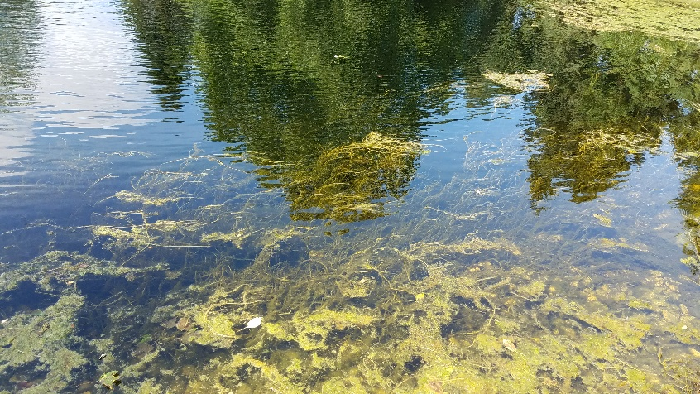
28 DAT: Unfortunately, the landowners removed vegetation prior to the scheduled post-treatment monitoring. They were concerned about internal nutrient loading, so they raked out much of the decomposing plant material and some of the filamentous algae and aquatic moss (Fig. 15, 16).
Figure 15. They were concerned about internal nutrient loading, so they raked out much of the decomposing plant material and some of the filamentous algae and aquatic moss.

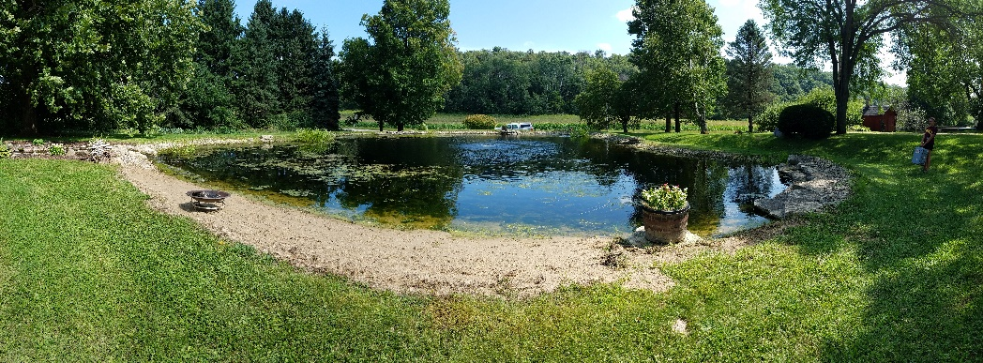
Figure 16. They were concerned about internal nutrient loading, so they raked out much of the decomposing plant material and some of the filamentous algae and aquatic moss.

September 19, 2018: Amanda contacted the landowners to see how the pond was doing. They said that they did not observe any regrowth thus far.

Future Plans
The grant was written for 5 years’ worth of treatment so as of Fall 2018, there are 4 treatments remaining. Even though the landowners removed vegetation in advance of the scheduled post-treatment monitoring rendering any valid scientific comparison of pre-/post-treatment monitoring data, the monitoring plan should still take place. It will be good to at least have some data available to compare over the years. Ultimately, the chemical treatment and hand removal have resulted in a great example of integrated pest management (IPM).
Timeline
Month | Task
December or January | - Meeting with Pete Jopke (Dane County) to discuss plan for 2019  - Schedule treatment with Lake and Pond Solution LLC  - Contact William Keiper from Michigan to discuss his recent experience with using ProcellaCor as a treatment method for N. peltata
March | - Request that the landowners begin visiting the pond daily after ice off.  - They should:  - Send at least 2 photos of the pond (specifically any plant growth)  - Record their time spent monitoring the pond in order to consider this effort a match towards the grant
April | - Visit the pond to observe plant growth
May | - Visit the pond to observe plant growth
June | - Pre-treatment monitoring  - Qualitative  - Quantitative  - Water chemistry  - Treatment  - Continue weekly monitoring  - Herbicide concentration monitoring regime  *Theses tasks are an estimated time frame. We are unsure as to the exact timeframe that this plant will be flowering. Aim to treat as plants are nearly fully grown, but have not yet flowered (to avoid any addition to the seed bank). In 2018, this would have been about late June.
July | - Continue weekly monitoring
August | - Conduct post-treatment monitoring
September | - Contact landowners to see status of pond  - Are there any signs of regrowth?  - Any other observations?

Important Contacts
Landowners
- K.C. and Cindy Brooks
- drbrooks@lodivet.com
- 608-576-1457
- Amanda has had the best luck contacting them via e-mail
Dane County
- Pete Jopke, Water Resources Planner
- jopke@countyofdane.com
- (608) 224-3733

Lake and Pond Solutions LLC
- Jeff Stelzer, Biologist/Applicator
- jeff@lakeandpondsolutions.com
- 866-525-3489

SePRO
- Michael Hiatt, Aquatic Technical Specialist
- michaelh@sepro.com
- 608.416.0537 (Cell)
- Michael is assigned to the Great Lakes West region so he travels around a lot, but he conveniently lives in Madison so he visited the pond a couple of times with Amanda and crew in 2018. It would be good to invite him to the 2019 treatment and maybe the first few site visits.

Michigan DEQ
- Chelsey Blank, the former statewide AIS Response Coordinator, attended UMISC (Upper Midwest Invasive Species Conference) and saw a talk by William Keiper on his recent experiences with N. peltata control.
- William Keiper, Michigan DEQ
- keiperw@michigan.gov
- 517-342-4087
- Abstract: Yellow floating heart (Nymphoides peltata) is a State of Michigan watch list AIS species, meaning this species has been identified as posing a significant and immediate threat to Michigan’s natural resources. To date there have been 6 occurrences of yellow floating heart in Michigan, all in landscape ponds. We have actively been working toward eradication at all the sites and will present an update on these occurrences.

Miscellaneous Notes
Herbicide concentration monitoring - Boxes and Styrofoam coolers are located on the shelves in the Water Lab along with the small glass amber sample bottles provided by SePRO. Address labels, sampling and shipping instructions are located in the Monitoring folder.
Shipping will be expensive (~$70) since it requires overnight shipping and is somewhat of a large package going a long distance. Just be sure to pack it with plenty of ice in multiple resealable bags so that it stays cool and there are no leaks. Ship the first couple of samples (i.e. 3HAT, 24HAT) together to save on shipping.

Monitoring - The monitoring protocol and data are in the Monitoring folder.

Data entry - SWIMS Project Name = Yellow Floating Heart – Dane County Pond
Project ID = YFH20182022

Investigating Plant Source - Amanda tried contacting Carmen Samz (the friend of the landowner who gifted them the plant) in early spring of 2018 with little success. Finally, Samz (returned Amanda’s phone calls but was not able to recall the address of her deceased mother-in-law who gave her the plant but promised to get back to us. She did however provide a general area (“HWY K between Shawano and Clintonville
“). After a few weeks, Amanda tried following up via phone with no success. On October 4, 2018 and enforcement style letter was sent to Samz (9461 Bolton Road Sauk City, Wisconsin; 608-643-2606) requesting the address of her mother-in-law. As of November 7, 2018, we have heard no response.

