Landing Exotic/Invasive Species Inspections
Balsam Lake WBIC: 2620600
Polk County, Wisconsin
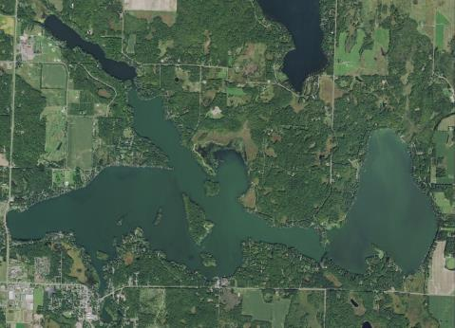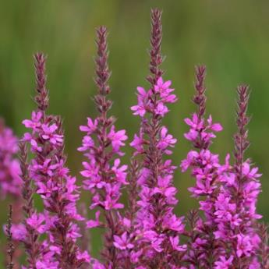
Balsam Lake Aerial (2015) Purple loosestrife in bloom
Project Initiated by:
Balsam Lake Protection and Rehabilitation District, and the
Wisconsin Department of Natural Resources

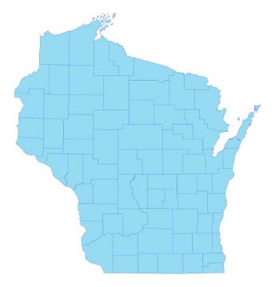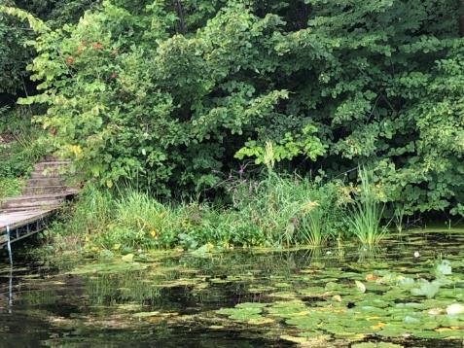

* Balsam Lake
Purple loosestrife just west of the Village Beach Landing 8/18/19

Surveys Conducted by and Report Prepared by:
Endangered Resource Services, LLC
Matthew S. Berg, Research Biologist
St. Croix Falls, Wisconsin
June-October 2019
TABLE OF CONTENTS

Page
LIST OF FIGURES ………………..……..………………………………………... ii

INTRODUCTION …..……..………………………………………………………. 1

METHODS ………………………………………………………………….……… 2

RESULTS AND DISCUSSION……………………………………………………. 3

LITERATURE CITED ……………………….……………………………………. 4

LIST OF FIGURES

Page
Figure 1: Aerial Photo of Balsam Lake……..……..……………….……………… 1

Figure 2: Balsam Lake Landings..…………………….…….……………………... 2

Figure 3: Purple Loosestrife with Adult Beetles/Larvae/Holes in Leaves.………... 3

Figure 4: Purple Loosestrife at the Village Beach Docks – 8/18/19.…………….... 4

INTRODUCTION:
Balsam Lake (WBIC 2620600) is a 2,054 acre stratified drainage lake in central Polk County, Wisconsin in the Towns of Balsam Lake, Milltown, Georgetown, and Apple River (T34N R17W S10 NE NE). It reaches a maximum depth of 37ft north of Cedar Island in the western basin and has an average depth of 20ft (Hopke et al. 1964). The lake is mesotrophic bordering on eutrophic in nature, and water clarity is fair with historical summer Secchi readings averaging 5ft in East Balsam, 6ft in Little Balsam, and 8ft in the deep hole north of Cedar Island (WDNR 2019). Bottom substrate is variable with organic muck in most bays, and rock/sand in the Big and Little Narrows and around the lake’s many islands (Figure 1).

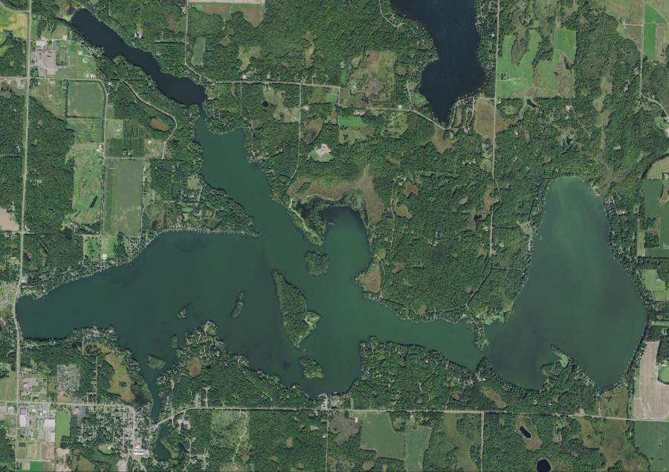
Figure 1: Aerial Photo of Balsam Lake
Stump
Bay
Harder
Creek
East Balsam

Cedar
Island
Raskin
Bay

Paradise
Island
First
Island
Big
Island
Mill
Pond
Idlewild
Bay

Big Narrows
Rice
Creek
The Balsam Lake Protection and Rehabilitation District (BLPRD) and the Wisconsin Department of Natural Resources (WDNR) commissioned a series of 2019 boat landing/ exotic invasive plant species surveys in accordance with the lake’s 2015 Aquatic Plant Management Plan (Clemens 2015). This report is the summary analysis of the six landing inspections surveys conducted on June 10th, July 11th, July 31st, August 18th, September 28th and October 27th, 2019.

METHODS:
Landing Inspection Survey
Throughout the 2019 growing season, we conducted landing inspections at the four main public landings, two unimproved public landings, and the private landing at Paradise Landing/Sunnyside Marina (Figure 2). Using three 100-150m parallel transects approximately 15, 30 and 45m from shore; we motored at idle speed looking for any evidence of Eurasian water-milfoil’s (Myriophyllum spicatum) characteristic red growth top, or any other exotic/invasive plant species we might encounter. Once we had finished the three transects, we returned to our starting point using a stitch pattern that crossed back and forth over all three lines to look for any plants we may have missed between the transects.

Figure 2: Balsam Lake Landings

RESULTS AND DISCUSSION:
During the 2019 growing season, we saw NO evidence or Eurasian water-milfoil or any other new aquatic exotic species. Other than Curly-leaf pondweed (Potamogeton crispus) and Reed canary grass (Phalaris arundinacea), Purple loosestrife (Lythrum salicaria) (PL) was the only other exotic plant species found on the lake during any of the surveys.

We first noted a few PL plants on the lake near the village beach in 2009 when we completed a full point-intercept survey of the lake’s plants. In 2013, we found a series of large beds had established in Idlewild Bay northwest of the beach. PL was common along the shoreline directly down the hill (north) from the Minit Mart station/store, and, since then, has spread all around the bay. Because the area is largely inaccessible to people/potential hand removal, at that time, we contacted the Polk County Land and Water Resources Department (PCLWRD), notified them of the infestations, and clarified that plans were in place to release Galerucella beetles – a natural biocontrol that specializes in eating loosestrife – during the 2014 growing season. Although beetles were released and we found them to be doing a highly effective job at controlling PL in this area by late 2014, during the August 2015 survey, we found little evidence of beetle damage suggesting they may not have survived the winter and raising concern an additional release may be necessary. Fortunately, the beetles seem to have rebounded, and most PL plants in the Idlewild Bay area have shown at least some evidence of beetle herbivory each year since then (Figure 3).

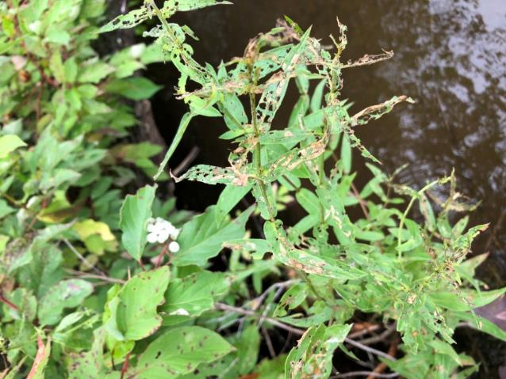
Beetle Larvae
Adult Beetle
Figure 3: Purple Loosestrife with Adult Beetles/Larvae/Holes in Leaves
Unfortunately, away from the source bay and spreading up the eastern shoreline all the way to Raskin Bay, we again found that pioneer PL plants showed little or usually no evidence of beetle damage. We also noticed than several shoreline owners continue to remove all the vegetation down to the lakeshore, but mowed around loosestrife plants or simply leave them as part of their landscaping (Figure 4). Although we clipped the flowering heads off several of these plants that we could reach from the boat and gently pulled plants where we could, we can’t trespass/dig roots without landowner permission. We again encourage the BLPRD to put out an annual reminder to its members in July/August to be on the lookout for loosestrife and remove it immediately if they find it. As in the past, we will continue to hand remove where we can, but any help from residents would go a long ways to help slow the spread of this beautiful, but highly invasive wetland plant.

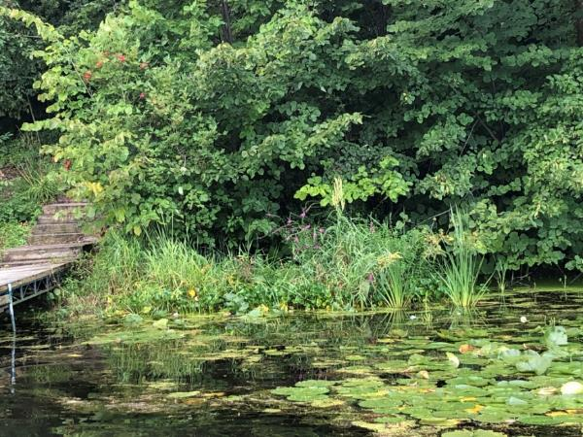
Figure 4: Purple Loosestrife at the Village Beach Docks 8/18/19

LITERATURE CITED

Clemens, C. [online]. 2010. Aquatic Plant Management Plan - Balsam Lake Polk County, WI. Sponsored by Balsam Lake Protection and Rehabilitation District - Prepared by Harmony Environmental – October 2010. Available from http://www.blprd.com/docs/BalsamLakeAPMfinal101810.pdf (2019, November).

Clemens, C. [online]. 2015. Aquatic Plant Management Plan - Balsam Lake Polk County, WI. Sponsored by Balsam Lake Protection and Rehabilitation District - Prepared by Harmony Environmental – September 2015. Available from http://www.blprd.com/docs/BalsamLakeAPM2015FINAL.pdf (2019, November).

UWEX Lakes Program. [online]. 2010. Aquatic Plant Management in Wisconsin. Available from http://www.uwsp.edu/cnr-ap/UWEXLakes/Pages/ecology/aquaticplants/default.aspx (2019, November).

WDNR. [online]. 2019. Balsam Lake Citizen Monitoring Water Quality Database. Available from http://dnr.wi.gov/lakes/lakepages/LakeDetail.aspx?wbic=2620600&page=waterquality (2019, November)

